**Building a Terminal-Based Chat Application with a Given Dataset**

**Introduction:**

In this document, we will guide you through the creation of a basic terminal-based chat application using a provided dataset. Instead of real-time user interactions, we will simulate a chat conversation using pre-defined messages. This project can serve as a foundation for more complex chat applications or for testing and experimenting with chat-related features.

**Prerequisites:**

Before you begin, ensure you have the following:

* Python (3.x) installed on your system.
* A provided dataset of chat messages.
* Basic knowledge of Python programming.
* Terminal or Command Prompt

**Implementation:**

Follow these steps to create a basic terminal-based chat application using a given dataset:

**1.Create Project Directory:**

Start by creating a project directory for your application.

**2. Create Python Script:**

Create a Python script for the chat application. You can use your favorite code editor to create a file, e.g., chat_app.py

**3. Import Libraries:**

Import the necessary libraries at the beginning of your Python script.

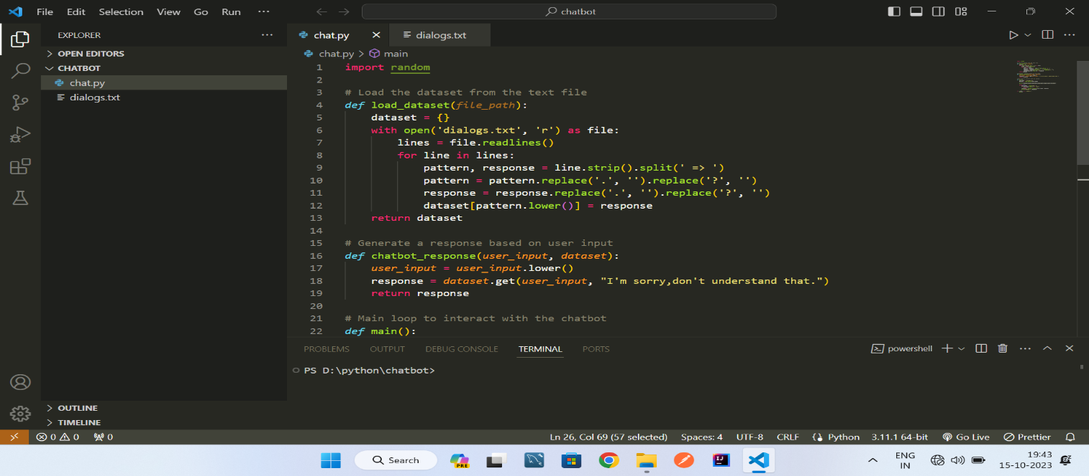

**4.Load the Dataset:**

Load the provided dataset into your Python script. You can store the messages in a list or a data structure of your choice

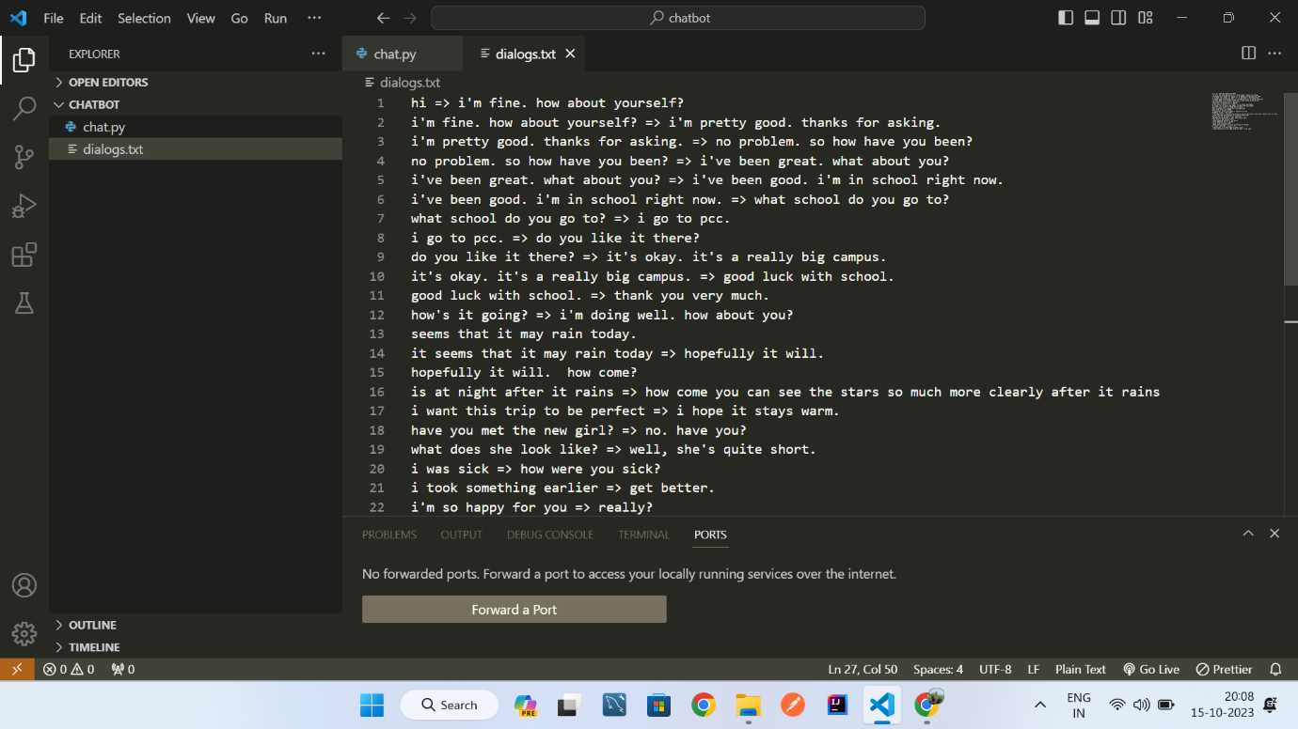

**5.Simulate the Chat:**

Write code to simulate the chat using the loaded dataset. You can create a loop that iterates through the messages and prints them in the terminal

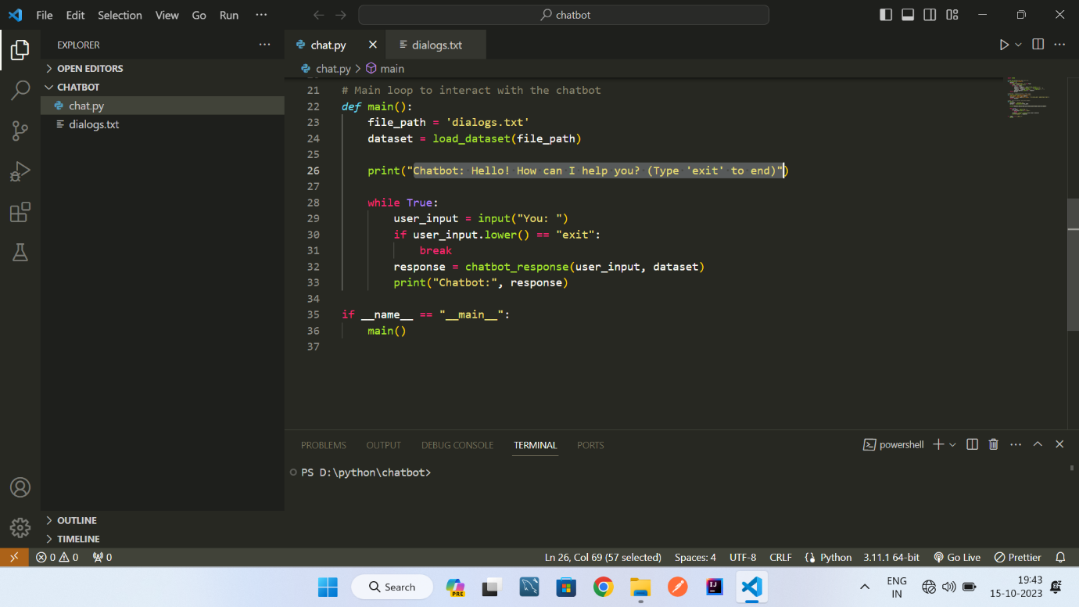

**6. User Interface:**

You can create a basic user interface that allows you to start and stop the chat simulation.

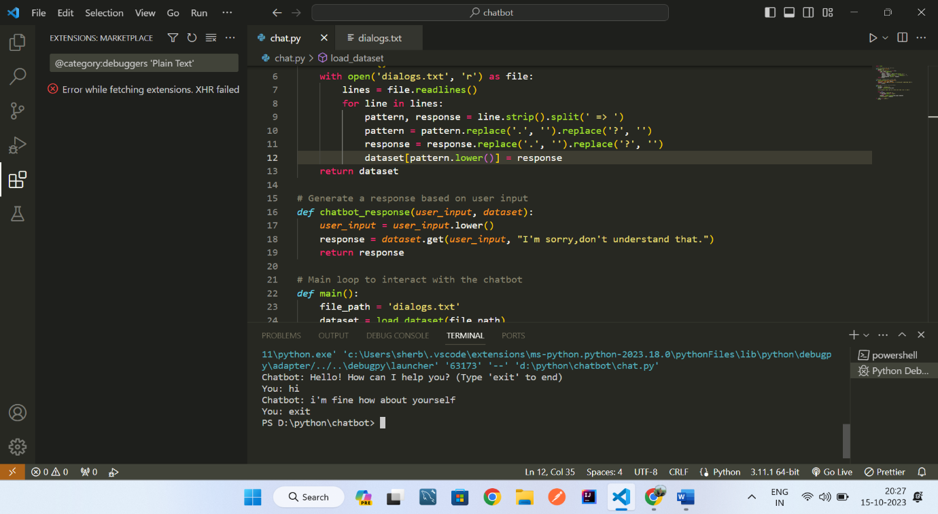

**Sample Code:**

import random

# Load the dataset from the text file

*def* load_dataset(*file_path*):

    dataset = {}

    with open('dialogs.txt', 'r') as file:

        lines = file.readlines()

        for line in lines:

            pattern, response = line.strip().split(' => ')

            pattern = pattern.replace('.', '').replace('?', '')

            response = response.replace('.', '').replace('?', '')

            dataset[pattern.lower()] = response

    return dataset

# Generate a response based on user input

*def* chatbot_response(*user_input*, *dataset*):

*user_input* = *user_input*.lower()

    response = *dataset*.get(*user_input*, "I'm sorry,don't understand that.")

    return response

# Main loop to interact with the chatbot

*def* main():

    file_path = 'dialogs.txt'

    dataset = load_dataset(file_path)

    print("Chatbot: Hello! How can I help you? (Type 'exit' to end)")

    while True:

        user_input = input("You: ")

        if user_input.lower() == "exit":

            break

        response = chatbot_response(user_input, dataset)

        print("Chatbot:", response)

if __name__ == "__main__":

    main()

**Conclusion:**

This document provides a basic foundation for creating a terminal-based chat application using a given dataset to simulate a chat conversation. You can extend this application by adding more features and interactivity, or by using larger and more complex datasets for testing and experimentation