**Git and GitHub**

Assume you have already created a local repository and have added all the files related to your team project to it-- A **repository** is usually used to organize a single project. It is time to push that onto GitHub to allow others view/modify/ collaborate on the project (i.e. Create an online version of the local repository in the cloud). **Note**: If you have not done this part yet, please consider to do so (*read slides*) before proceeding to the rest of the assignment.

1. Create an account (or login) to GitHub at <https://github.com>
2. Log in and go to the GitHub home page. You should see a green '+ New repository' button (or in the upper right corner, next to your photo, click + and then select **New repository.)**
3. After clicking the button, GitHub will ask you to name your repo and provide a brief description:

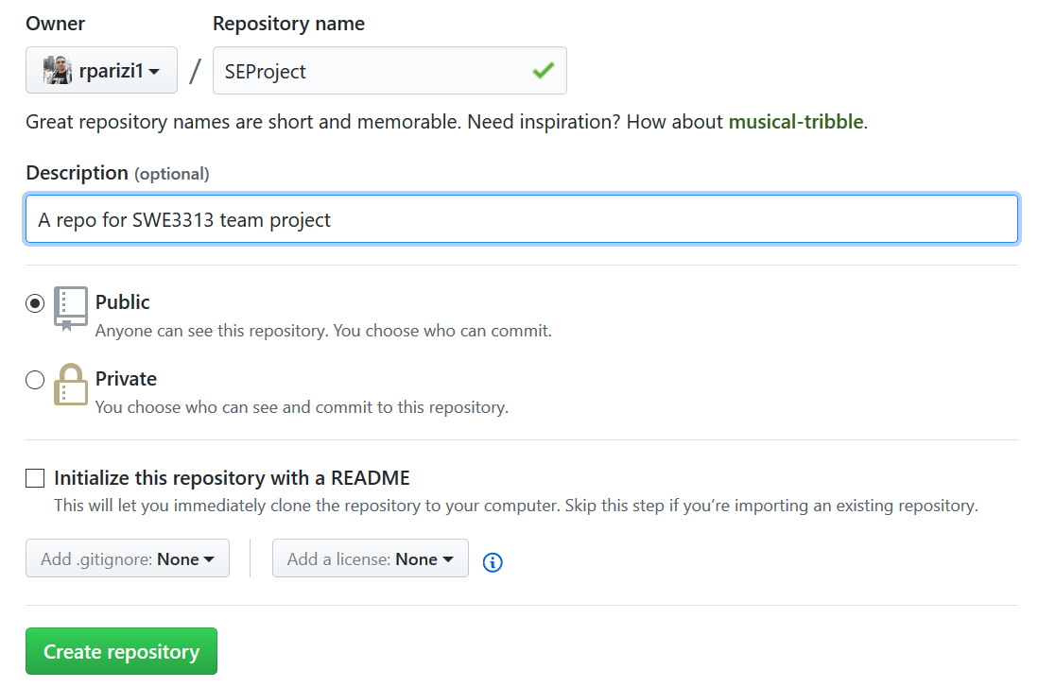

1. When you're done filling out the information, press the 'Create repository' button to make your new repo.
2. GitHub will ask if you want to create a new repo from scratch or if you want to add a repo you have created locally. In this case, since you've already created a repo locally, you want to push that onto GitHub so follow the **'....or push an existing repository from the command line'** section:
   1. copy the first line under …or push an existing repository from the command line, and paste it in the terminal (Git CMD) where you’ve been working up till now.
   2. Doing so won’t display any output. Now copy the second line and paste it into your terminal.

(If this is your first time using GitHub locally, it might prompt you to log in with your GitHub username and password).

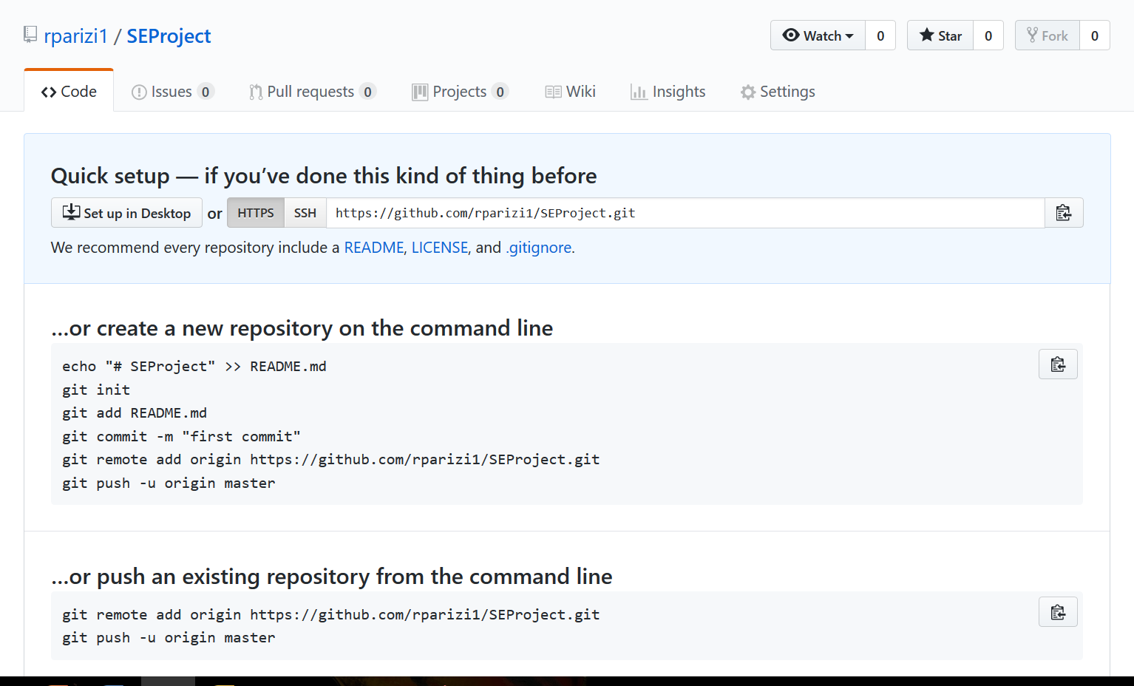

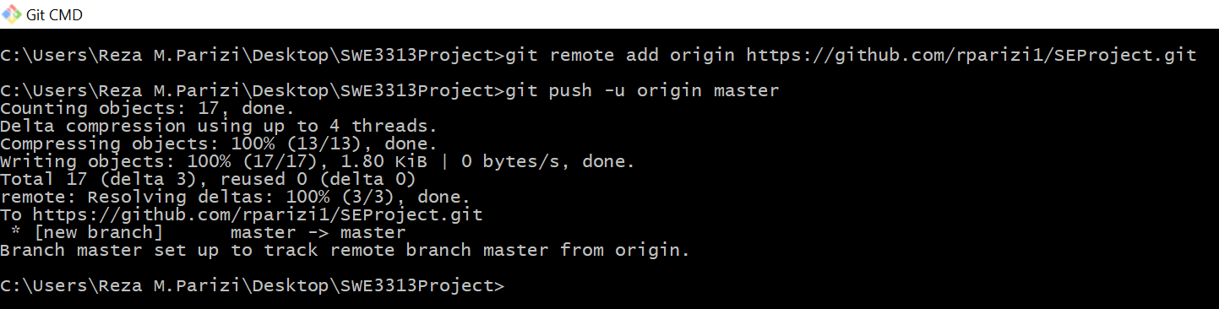

* 1. Go back to GitHub in your browser and refresh the page, you should be able to see everything (files and history—commits etc.) there—remote version created!!

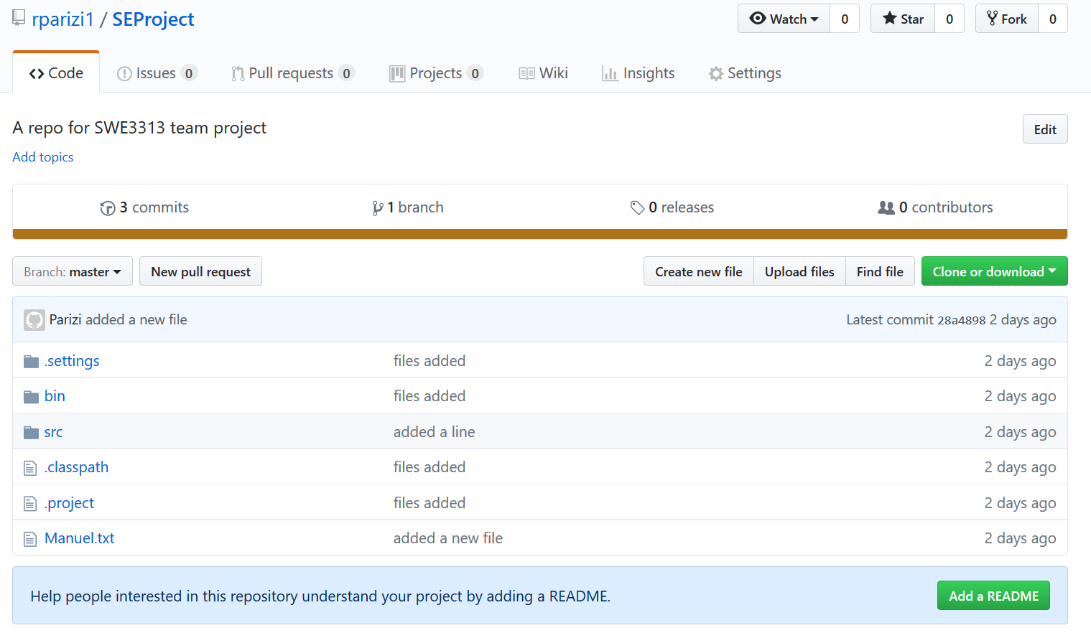

1. **Making Commits**

* Clone the forked repository to your terminal (using git clone <yourUrl>)

Ex) git clone https://github.com/rparizi1/SEProject.git

* Modify any files (in your copy of the repository on your computer) —then stage the changes (using git add file)

Ex) git add src/Print.java

(The content of Print.java in the online version of the repository on GitHub- before changes)

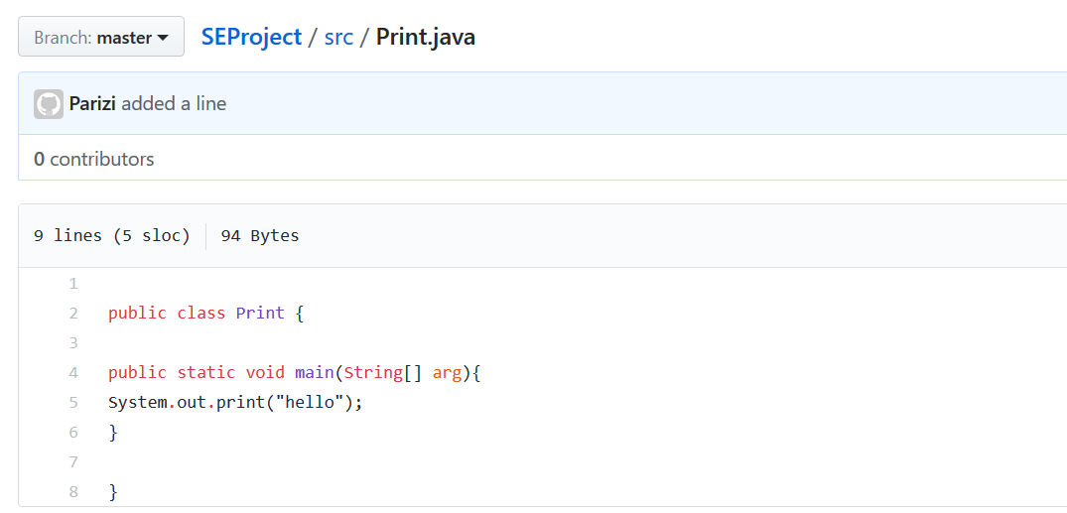

* Commit the new changes (make more changes if you wish to) using:

$ git commit -m "message"

* Push the commit(s) back to your remote repository using:

$ git push

(for instance, the content of Print.java in the online version of the repository on GitHub after pushing the changes and refreshing the page)

### 

1. **Create a Pull Request (PR) of your own choice**

Pull Requests are the heart of collaboration on GitHub. A pull request (or PR) is a way to alert a repo's owner(s) that you want to make some changes to their code/files. It allows them to review the code and make sure it looks good before putting your changes on the master branch. In other words, when you open a *pull request*, you’re proposing your changes and requesting that owners review and pull in your contribution and merge them into their branch.

**Note**, I did not mean you open pull requests in your own repository and merge them yourself (of course, you can do so but that’s not the point). It works when you are trying to make changes to someone else’s repo.

It is important to note that the changes are proposed in a branch (that’s you must create a branch contains proposed changes first), which ensures that the master branch only contains finished and approved work.

Pull requests can only be opened if there are differences between your branch and the upstream branch (normally master). You can specify which branch you'd like to merge your changes into when you create your pull request.

If you don't have write access to the repository where you'd like to create a pull request, you must create a fork, or copy, of the repository first. For more information, see "[Creating a pull request from a fork](https://help.github.com/articles/creating-a-pull-request-from-a-fork)"

Steps to create a PR:

* On GitHub, navigate to the main page of the repository
* In the "Branch" menu, choose the branch that contains your commits

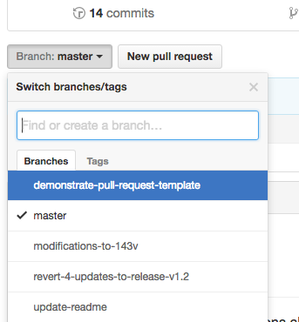

* To the right of the Branch menu, click **New pull request**.

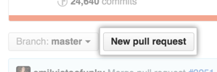

* Use the base branch dropdown menu to select the branch you'd like to merge your changes into, then use the compare branch drop-down menu to choose the topic branch you made your changes in.

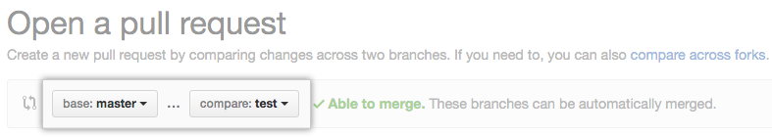

* Type a title and description for your pull request.

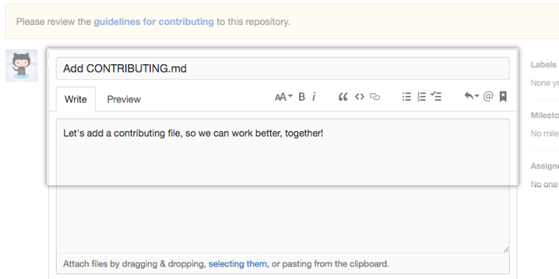

* Click **Create pull request**.

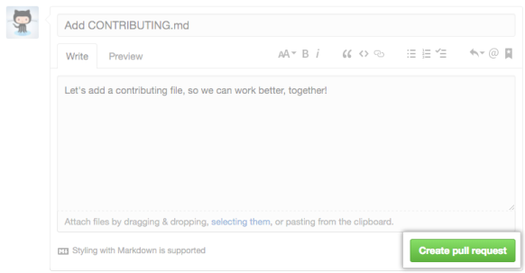

--------

*Submission*: Submit the URL to your created repository, reflecting the above-mentioned steps. If you like to add any companying file, feel free to do so.

*Weightage:* This assignment is an individual work and is worth 100 points.

If you have any questions about the assignment, please use this open discussion forum: Questions & Discussion about Assignment #5