Supplementary Information
Table S1. Environmental variables (non-standardized) used in vector and surface fitting to NMDS ordinations. Temperature and salinity values are measured in situ. Dissolved oxygen, nitrate, phosphate and silicate concentrations are interpolated using megx.net GIS tools. NA: not available.
Site | Temperature  (ºC) | Salinity  (PSU) | Dissolved oxygen  (mL L⁻¹) | Nitrate  (μmol L⁻¹) | Phosphate  (μmol L⁻¹) | Silicate  (μmol L⁻¹) | Chlorophyll a  (μg kg⁻¹)
GS000a | 20.5 | 36.7 | 5.12 | 0.11 | 0.06 | 0.79 | 0.17
GS000b | 20.5 | 36.7 | 5.14 | 0.24 | 0.06 | 0.81 | 0.17
GS000c | 19.8 | 36.7 | 5.18 | 0.38 | 0.06 | 0.96 | 0.17
GS000d | 20 | 36.6 | 5.12 | 0.11 | 0.06 | 0.79 | 0.17
GS001 | 22.9 | 36.7 | 5.14 | 0.1 | 0.05 | 0.91 | 0.1
GS002 | 18.2 | 29.2 | 5.88 | 0.29 | 0.21 | 2.18 | 1.4
GS003 | 11.7 | 29.9 | 5.84 | 0.33 | 0.21 | 2.21 | 1.4
GS004 | 13.86 | 28.3 | 6.58 | 0.05 | 0.09 | 0.55 | 0.4
GS005 | 15 | 30.2 | 6.58 | 0.07 | 0.12 | 0.71 | 6
GS006 | 11.2 | 28.9 | 0.15 | 0.07 | 0.13 | 0.81 | 2.8
GS007 | 17.9 | 31.7 | 6.21 | 0.35 | 0.28 | 2.86 | 1.4
GS008 | 9.4 | 26.5 | 2.94 | 0.34 | 0.6 | 0.76 | 2.2
GS009 | 11 | 31 | 3.91 | 1.39 | 0.63 | 0.83 | 4
GS010 | 12 | 31 | 5.86 | 1.95 | 0.48 | 1.02 | 2
GS011 | 11 | 19.94 | 4.33 | 3.33 | 0.53 | 0.67 | 4.8
GS012 | 1 | 3.5 | NA | NA | NA | NA | 21
GS013 | 9.3 | 33.95 | 5.37 | 1.06 | 0.25 | 1.27 | 3
GS014 | 18.6 | 36.04 | 5.08 | 0.15 | 0.2 | 1.14 | 1.7
GS015 | 25 | 36 | 4.84 | 0.95 | 0.04 | 1.22 | 0.2
GS016 | 26.4 | 35.8 | 4.86 | 0.59 | 0.04 | 1.32 | 0.16
GS017 | 27 | 35.8 | 4.59 | 0.31 | 0.14 | 1.82 | 0.13
GS018 | 27.4 | 35.4 | 4.63 | 0.45 | 0.1 | 2.21 | 0.14
GS019 | 27.7 | 35.4 | 4.59 | 0 | 0.05 | 2.25 | 0.23
GS020 | 28.6 | 0.1 | 4.85 | 0.02 | 0.52 | 3.55 | NA
GS021 | 27.6 | 30.7 | 4.64 | 0.01 | 0.21 | 2.71 | 0.5
GS022 | 29.3 | 32.3 | 4.65 | 1.86 | 0.33 | 2.17 | 0.33
GS023 | 28.7 | 32.6 | 4.71 | 6.5 | 0.69 | 4.5 | 0.07
GS025 | 28.3 | 31.4 | 4.71 | 6.63 | 0.71 | 4.42 | 0.11
GS026 | 27.8 | 32.6 | 4.72 | 0.69 | 0.28 | 3.02 | 0.22
GS027 | 25.5 | 34.9 | 4.47 | 3.2 | 0.52 | 6.42 | 0.4
GS028 | 25.22 | 34.39 | 4.48 | 3.17 | 0.52 | 6.37 | 0.35
GS029 | 26.2 | 34.5 | 4.4 | 1.95 | 0.48 | 6.45 | 0.4
GS030 | 26.9 | 34.4 | 4.45 | 4.95 | 0.48 | 6.91 | NA
GS031 | 18.6 | 29.07 | 3.48 | 0.87 | 0.12 | 0.5 | 0.35
GS032 | 25.4 | 29.47 | 3.85 | 0.56 | 0.09 | 0.36 | NA
GS033 | 37.6 | 63.4 | 4.5 | 2.89 | 0.49 | 5.97 | NA
GS034 | 27.5 | 34.23 | 4.4 | 1.95 | 0.48 | 6.45 | 0.36
GS035 | 21.8 | 34.5 | 4.61 | 2.55 | 0.5 | 3.22 | 0.28
GS036 | 25.8 | 34.6 | 4.26 | 2.69 | 0.64 | 1.1 | 0.65
GS037 | 28 | 34.38 | 4.75 | 5.61 | 0.56 | 4.83 | 0.21
GS047 | 28.6 | 37.3 | 4.7 | 2.14 | 0.4 | 1.35 | NA
GS048 | 28.9 | 35.1 | 4.69 | 0.01 | 0.19 | 0.8 | 0.1
GS049 | 28.8 | 32.6 | 4.69 | 0.01 | 0.19 | 0.8 | 0.1
GS051 | 27.3 | 34.2 | 4.51 | 0.08 | 0.24 | 0.73 | NA
GS108a | 25.8 | 32.4 | 4.52 | 0.02 | 0.21 | 1.43 | 0.11
GS109 | 27.2 | 32.6 | 4.43 | 0.03 | 0.13 | 2.15 | 0.14
GS110 | 27 | 32.7 | 4.61 | 0.12 | 0.11 | 3.44 | 0.13
GS111 | 26.4 | 32.3 | 4.69 | 0.15 | 0.08 | 2.6 | 0.2
GS112 | 26.6 | 32.5 | 4.62 | 0.2 | 0.05 | 2.97 | 0.13
GS113 | 27.5 | 33.3 | 4.5 | 0.3 | 0.16 | 4.37 | 0.24
GS114 | 28.2 | 33.1 | 4.55 | 0.11 | 0.23 | 2.75 | 0.14
GS115 | 27.9 | 33.2 | 4.46 | 0.13 | 0.27 | 4.15 | 0.14
GS116 | 26.2 | 33.1 | 4.76 | 0.18 | 0.13 | 2.93 | 0.29
GS117 | 26.4 | 35.5 | 4.75 | 0.25 | 0.19 | 2.29 | 0.21
GS119 | 23.8 | 35.4 | 5.37 | 0.17 | 0.17 | 2.93 | 0.08
GS120 | 22.5 | 35.6 | 5.32 | 0.12 | 0.2 | 3.18 | 0.12
GS121 | 23.1 | 35.4 | 5.29 | 0.72 | 0.17 | 3.52 | 0.14
GS122 | 20.2 | 35.8 | 5.4 | 1.01 | 0.15 | 2.71 | 0.15
GS123 | 20.4 | 35.8 | 5.13 | 0.15 | 0.22 | 3.55 | 0.23
GS148 | 21.27 | 29.28 | 4.19 | NA | 0.16 | 3 | NA
GS149 | 21.27 | 29.28 | 4.19 | NA | 0.16 | 3 | NA

Table S2. Bottle data extracted from HOT-ALOHA (2) station (22.75N -158W) between dates 01/01/2000-31/12/2009 and depth interval 0-5 meters. NA: not available. Sigma: seawater density, Boxy: bottle dissolved oxygen concentration.
Botid | Date  (mmddyy) | Pressure  (dbar) | Sigma  (kg m⁻³) | Boxy  (mL L⁻¹) | Phosphate (μmol L⁻¹) | Nitrate (μmol L⁻¹) | Silicate  (μmol L⁻¹)
1220200124 | 11601 | 4.10 | 23.59 | 4.82 | 0.11 | 0 | NA
1220200224 | 11601 | 3.40 | 23.60 | 4.83 | 0.11 | 0.01 | 1.65
1220200618 | 11701 | 4.20 | 23.58 | 4.84 | 0.12 | 0 | 1.60
1340200124 | 11502 | 4.70 | 23.84 | 4.78 | 0.02 | 0.13 | 1.27
1340200224 | 11502 | 4 | 23.99 | 4.81 | 0.03 | 0.11 | 1.23
1440200124 | 11603 | 4.10 | 23.99 | NA | 0.02 | 0.03 | 1.04
1440200224 | 11603 | 4.90 | 23.99 | NA | 0.02 | 0.03 | 1.06
1550200124 | 12104 | 4.20 | 23.74 | 4.80 | 0 | 0.08 | 1.06
1550200224 | 12104 | 4.10 | 23.73 | NA | 0.01 | 0.01 | 1.03
1110200124 | 20200 | 5 | 24.22 | 4.91 | 0.11 | NA | NA
1110200224 | 20200 | 4.70 | 24.22 | 4.92 | 0.11 | 0 | 1.34
1110200517 | 20300 | 4.20 | 24.16 | 4.91 | 0.12 | 0 | 1.32
1110200622 | 20300 | 4.40 | 24.18 | 4.92 | 0.10 | NA | 1.46
1120200124 | 22900 | 5 | 23.94 | 4.92 | 0.12 | 0.01 | NA
1230200224 | 21401 | 4.30 | 24.03 | 4.87 | 0.07 | 0.03 | 1.98
1230200319 | 21501 | 4.20 | 24.06 | 4.88 | 0.07 | 0 | 1.52
1230200724 | 21501 | 4.10 | 24.07 | 4.88 | 0.06 | 0 | 1.56
1350200124 | 22002 | 4.80 | 24.13 | 4.93 | 0.02 | 0.02 | 1.42
1350200224 | 22002 | 3.90 | 24.13 | NA | 0.04 | 0.02 | 1.40
1450200124 | 22503 | 4.90 | 24.09 | NA | 0.01 | 0.03 | 1.09
1450200224 | 22503 | 3.90 | 24.10 | NA | 0.01 | 0.05 | 1.07
1560200124 | 22404 | 4.80 | 23.35 | 4.80 | 0.02 | 0.07 | 1.07
1560200224 | 22404 | 3.80 | 23.32 | 4.80 | 0.02 | 0.05 | 0.99
1670200224 | 20105 | 4.30 | 23.60 | NA | 0.01 | 0.04 | 0.79
1670200324 | 20105 | 4.60 | 23.60 | 4.79 | 0.02 | 0.06 | 0.96
1890200424 | 20607 | 3.30 | 23.89 | 4.81 | 0.01 | 0.06 | 1.10
1890200524 | 20607 | 4.50 | 23.84 | 4.80 | 0.02 | 0.01 | NA
1120200722 | 30100 | 4.50 | 23.93 | 4.93 | 0.12 | 0 | 1.29
1130200224 | 32800 | 4.40 | 24.06 | 4.86 | 0.12 | 0.01 | 1.36
1130200522 | 32900 | 4.20 | 24.07 | 4.87 | 0.08 | 0.01 | 1.09
1130200622 | 32900 | 4.60 | 24.08 | 4.87 | 0.10 | 0 | NA
1240200121 | 32101 | 4.10 | 23.78 | 4.92 | 0.07 | 0.05 | 1.84
1240200224 | 32101 | 4.10 | 23.79 | 4.83 | 0.13 | NA | NA
1240200324 | 32101 | 2.90 | 23.66 | 4.90 | 0.14 | NA | 2.26
1240201524 | 32301 | 4 | 23.79 | 4.91 | 0.09 | NA | 1.56
1240201624 | 32301 | 3.80 | 23.79 | 4.90 | 0.11 | NA | 1.67
1360200224 | 31202 | 4.80 | 24.28 | 4.98 | 0.03 | 0.01 | 1.29
1460200224 | 32803 | 3.60 | 23.94 | NA | 0.04 | 0.14 | 1.09
1570200224 | 31904 | 4.50 | 24.02 | 4.87 | 0.01 | 0.08 | 1.06
1900200424 | 32007 | 4.80 | 23.95 | 4.90 | 0.01 | 0.13 | 1.47
1140200124 | 42500 | 4.40 | 23.66 | 4.87 | 0.09 | 0 | 2.73
1140200622 | 42600 | 4.90 | 23.66 | 4.88 | 0.09 | 0 | 1.48
1250200124 | 41701 | 3.70 | 23.91 | 4.89 | 0.12 | 0.35 | NA
1250200224 | 41701 | 3.70 | 23.91 | 4.90 | 0.08 | 0.27 | 1.70
1470200124 | 42303 | 3.90 | 23.45 | NA | 0.03 | 0.03 | 1.07
1470200224 | 42303 | 4.10 | 23.45 | NA | 0.03 | 0.02 | 1.05
1580200124 | 42004 | 4.30 | 23.73 | 4.87 | 0.01 | 0.09 | 1.14
1580200224 | 42004 | 3.70 | 23.72 | 4.87 | 0.10 | 0.03 | 1.05
1150200124 | 52300 | 5 | 23.45 | 4.84 | 0.08 | 0.01 | 1.68
1150200624 | 52400 | 4.90 | 23.35 | 4.82 | 0.12 | 0 | 1.39
1260200124 | 51601 | 4.80 | 23.84 | 4.86 | 0.15 | 0.42 | NA
1260200618 | 51701 | 4.80 | 23.83 | NA | 0.09 | 0.07 | 1.73
1370200124 | 52002 | 4.50 | 23.43 | 4.83 | 0.03 | 0.02 | 1.15
1370200224 | 52002 | 4 | 23.40 | 4.82 | 0.03 | 0.04 | 1.15
1480200124 | 52003 | 4.30 | 23.32 | 4.84 | 0.03 | 0.03 | 0.81
1480200224 | 52003 | 4.10 | 23.32 | 4.77 | 0.05 | 0.08 | 0.76
1590200124 | 51804 | 4.40 | 23.11 | 4.84 | 0 | 0.01 | 1.02
1590200224 | 51804 | 4.10 | 23.06 | 4.85 | 0.11 | 0.03 | 1.12
1810200424 | 52606 | 4.80 | 23.95 | 4.89 | 0.01 | 0.04 | 0.75
1160200324 | 62000 | 4.70 | 23.38 | 4.86 | 0.09 | 0 | 1.05
1160200722 | 62100 | 4.60 | 23.32 | NA | 0.08 | 0 | NA
1270200124 | 61301 | 4 | 23.56 | 4.79 | 0.04 | 0.04 | 1.45
1270200224 | 61301 | 3.60 | 23.56 | 4.81 | 0.04 | 0.03 | 1.66
1380200224 | 62902 | 4.40 | 23.16 | 4.74 | 0.02 | 0.05 | 0.94
1490200124 | 61903 | 5 | 23.25 | 4.76 | 0.03 | 0.02 | 0.86
1490200224 | 61903 | 4.70 | 23.25 | 4.76 | 0.04 | 0.05 | 0.79
1600200224 | 61504 | 4.40 | 22.93 | 4.75 | 0.03 | 0.08 | 1.24
1600200324 | 61504 | 4.70 | 22.92 | 4.76 | 0.02 | 0.14 | NA
1170200124 | 72500 | 5 | 23.34 | 4.87 | 0.03 | NA | 1.12
1170200224 | 72500 | 4.10 | 23.32 | 4.87 | 0.07 | NA | 0.73
1170200522 | 72600 | 4.50 | 23.31 | 4.88 | 0.04 | 0 | 0.74
1280201324 | 71201 | 4.10 | 23.12 | 4.83 | 0.03 | 0.08 | 1.33
1280201424 | 71201 | 3.90 | 23.14 | 4.83 | 0.04 | 0.04 | 1.43
1500200124 | 71903 | 4.50 | 23.31 | NA | 0.03 | 0.04 | 1.66
1610200224 | 71304 | 4.90 | 22.59 | 4.82 | 0.01 | 0.09 | 1.12
1610200322 | 71404 | 4.90 | 22.58 | 4.82 | 0.01 | 0.05 | 0.94
1710201624 | 71805 | 5 | 23.15 | 4.88 | 0.03 | 0.05 | 0.99
1180200324 | 82200 | 1.90 | 23.39 | 4.71 | 0.05 | NA | 1.21
1180200323 | 82200 | 2.40 | 23.39 | 4.71 | 0.08 | 0 | 1.20
1180200722 | 82300 | 5 | 23.41 | 4.71 | 0.05 | 0.02 | 1.26
1290201624 | 80901 | 5 | 23.30 | 4.79 | 0.03 | 0.04 | 1.58
1390200224 | 82702 | 4.80 | 22.96 | 4.70 | 0.05 | 0.04 | 1.08
1510200124 | 82003 | 4.80 | 22.94 | 4.74 | 0.02 | NA | 1.19
1620200224 | 81504 | 4.70 | 22.67 | 4.65 | 0.01 | 0.02 | 0.83
1620200324 | 81504 | 4.70 | 22.67 | 4.65 | 0.03 | 0 | 0.85
1630200324 | 92804 | 4.90 | 22.53 | 4.61 | 0.02 | 0.05 | 0.86
1190200224 | 101700 | 3.90 | 23.38 | 4.69 | 0.06 | 0.01 | 2.04
1190200720 | 101800 | 4.90 | 23.38 | 4.69 | 0.09 | NA | 1.55
1310200124 | 102201 | 4.60 | 23.52 | 4.72 | 0.03 | 0.03 | 1.15
1310200224 | 102201 | 4.40 | 23.52 | 4.74 | 0.04 | 0.02 | 1.13
1400200124 | 100602 | 4.40 | 22.95 | 4.67 | 0.04 | 0.03 | 1.08
1520200124 | 101403 | 4.90 | 22.79 | 4.66 | 0.02 | 0.01 | 0.76
1640200224 | 103004 | 4.80 | 23.20 | 4.67 | 0.01 | NA | 0.83
1640200324 | 103004 | 4.60 | 23.18 | 4.66 | 0.01 | NA | 0.79
1200200324 | 112900 | 4.90 | 23.39 | 4.77 | 0.10 | 0.01 | 1.60
1200200622 | 113000 | 4.60 | 23.35 | 4.77 | 0.12 | 0.01 | 1.43
1320200124 | 111601 | 4.20 | 23.49 | 4.73 | 0.04 | 0.03 | 1.29
1320200224 | 111601 | 3.70 | 23.50 | 4.75 | 0.03 | 0.01 | 1.25
1530200224 | 110903 | 5 | 23.03 | 4.66 | 0.01 | 0.04 | 0.66
1650200224 | 112704 | 4.80 | 22.84 | 4.65 | 0.02 | 0 | 0.85
2160200424 | 110309 | 4.40 | 23.17 | 4.67 | 0.08 | 0.03 | 1.20
1210200224 | 121900 | 4.70 | 23.37 | 4.77 | 0.08 | 0 | 2.19
1210200324 | 121900 | 3.90 | 23.37 | 4.78 | 0.13 | 0 | NA
1210200818 | 122000 | 4.60 | 23.37 | 4.80 | 0.12 | 0 | 1.63
1330200524 | 121501 | 4.80 | 23.72 | 4.79 | 0.01 | 0.03 | 1.28
1330200624 | 121501 | 4.40 | 23.74 | 4.77 | 0.01 | 0.02 | 1.28
1430200124 | 121802 | 4.80 | 23.81 | NA | 0.02 | 0.07 | 1
1540200124 | 121903 | 4.70 | 23.65 | 4.81 | 0.01 | 0.06 | 1.01
1540200224 | 121903 | 4.10 | 23.67 | 4.79 | 0.01 | 0 | 1.06
1660200324 | 122004 | 4.90 | 23.23 | 4.70 | 0.03 | 0.01 | 0.94
1760200324 | 121205 | 4.50 | 23.50 | 4.73 | 0.02 | 0.05 | 1.15
1760200424 | 121205 | 4.50 | 23.49 | 4.73 | 0.02 | 0.04 | 1.02
2170200424 | 120909 | 4.80 | 23.80 | NA | 0.07 | 0.07 | NA
2170200524 | 120909 | 4.10 | 23.79 | 4.83 | 0.06 | 0.02 | 1.16

Table S3. Environment Ontology term annotations of GOS sampling sites at three different levels, along with tags. NA: not available.
Site | Biome | Feature | Material | Tags
GS000a | oceanic epipelagic zone biome | photic zone | ocean water | marine wind mixed layer
GS000b | oceanic epipelagic zone biome | photic zone | ocean water | marine wind mixed layer
GS000c | oceanic epipelagic zone biome | photic zone | ocean water | marine wind mixed layer
GS000d | oceanic epipelagic zone biome | photic zone | ocean water | marine wind mixed layer
GS001 | oceanic epipelagic zone biome | photic zone | ocean water | marine wind mixed layer
GS002 | neritic epipelagic zone biome | photic zone | coastal water | eastern boundary current, marine wind mixed layer
GS003 | neritic epipelagic zone biome | photic zone | coastal water | marine reef, eastern boundary current, marine wind mixed layer
GS004 | neritic epipelagic zone biome | photic zone | coastal water | eastern boundary current, marine wind mixed layer
GS005 | neritic epipelagic zone biome | photic zone | coastal water | bay, marine wind mixed layer
GS006 | estuarine biome | estuarine bulk water | estuarine water | bay
GS007 | neritic epipelagic zone biome | photic zone | coastal water | eastern boundary current, marine wind mixed layer
GS008 | neritic epipelagic zone biome | photic zone | coastal water | natural harbour, eastern boundary current, marine wind mixed layer
GS009 | neritic epipelagic zone biome | photic zone | coastal water | eastern boundary current, island, marine wind mixed layer
GS010 | neritic epipelagic zone biome | photic zone | coastal water | eastern boundary current, western boundary current, peninsula, marine wind mixed layer
GS011 | estuarine biome | estuarine bulk water | estuarine water | bay, natural harbour
GS012 | estuarine biome | estuarine bulk water | estuarine water | NA
GS013 | neritic epipelagic zone biome | photic zone | coastal water | western boundary current, marine wind mixed layer
GS014 | neritic epipelagic zone biome | photic zone | coastal water | western boundary current, marine wind mixed layer
GS015 | marginal sea biome | photic zone | coastal water | neritic epipelagic zone biome, marine wind mixed layer
GS016 | marginal sea biome | photic zone | coastal water | oceanic epipelagic zone biome, marine wind mixed layer
GS017 | marginal sea biome | photic zone | coastal water | oceanic epipelagic zone biome, marine wind mixed layer
GS018 | marginal sea biome | photic zone | coastal water | oceanic epipelagic zone biome, marine wind mixed layer
GS019 | marginal sea biome | photic zone | coastal water | oceanic epipelagic zone biome, marine wind mixed layer
GS020 | Large lake biome | artificial lake | fresh water | NA
GS021 | neritic epipelagic zone biome | photic zone | coastal water | NA
GS022 | oceanic epipelagic zone biome | photic zone | ocean water | NA
GS023 | oceanic epipelagic zone biome | photic zone | ocean water | island
GS025 | marine reef biome | photic zone | coastal water | NA
GS026 | oceanic epipelagic zone biome | photic zone | ocean water | NA
GS027 | marine coral reef biome | photic zone | coastal water | island
GS028 | neritic epipelagic zone biome | photic zone | coastal water | island
GS029 | neritic epipelagic zone biome | photic zone | coastal water | island, bay
GS030 | marine warm seep biome | photic zone | hydrothermal fluid | NA
GS031 | neritic epipelagic zone biome | marine upwelling | coastal water | island
GS032 | mangrove biome | mangrove swamp | brackish water | coastal water
GS033 | marine salt marsh biome | lagoon | hypersaline water | island
GS034 | neritic epipelagic zone biome | photic zone | coastal water | island
GS035 | neritic epipelagic zone biome | photic zone | coastal water | island
GS036 | neritic epipelagic zone biome | photic zone | coastal water | island
GS037 | oceanic epipelagic zone biome | photic zone | ocean water | NA
GS047 | oceanic epipelagic zone biome | photic zone | ocean water | NA
GS048 | marine coral reef biome | bay | coastal water | island
GS049 | neritic epipelagic zone biome | photic zone | coastal water | island
GS051 | marine coral reef biome | atoll | coastal water | NA
GS108a | marine coral reef biome | lagoon | coastal water | NA
GS109 | oceanic epipelagic zone biome | photic zone | ocean water | NA
GS110 | oceanic epipelagic zone biome | photic zone | ocean water | NA
GS111 | oceanic epipelagic zone biome | photic zone | ocean water | NA
GS112 | oceanic epipelagic zone biome | photic zone | ocean water | NA
GS113 | oceanic epipelagic zone biome | photic zone | ocean water | NA
GS114 | oceanic epipelagic zone biome | photic zone | ocean water | NA
GS115 | oceanic epipelagic zone biome | photic zone | ocean water | NA
GS116 | oceanic epipelagic zone biome | photic zone | ocean water | NA
GS117 | neritic epipelagic zone biome | photic zone | coastal water | island
GS119 | oceanic epipelagic zone biome | photic zone | ocean water | NA
GS120 | oceanic epipelagic zone biome | photic zone | ocean water | NA
GS121 | oceanic epipelagic zone biome | photic zone | ocean water | NA
GS122 | oceanic epipelagic zone biome | photic zone | ocean water | NA
GS123 | oceanic epipelagic zone biome | photic zone | ocean water | NA
GS148 | marine reef biome | photic zone | coastal water | NA
GS149 | neritic epipelagic zone biome | photic zone | coastal water | NA

Table S4. Whole genome sequences of both marine and non-marine isolates from which the single copy domains (SCDs) were selected.
Alteromonas macleodii 'Deep ecotype' | Psychromonas ingrahamii 37
“Candidatus Pelagibacter ubique” HTCC1062 | Rhodobacter sphaeroides ATCC 17025
“Candidatus Protochlamydia amoebophila” UWE25 | Rhodopirellula baltica SH 1
Chlorobium phaeobacteroides DSM 266 | Rickettsia felis URRWXCal2
Coxiella burnetii RSA 493 | Shewanella amazonensis SB2B
Erythrobacter litoralis HTCC2594 | Shewanella baltica OS185
Flavobacterium johnsoniae UW101 | Shewanella baltica OS195
Flavobacterium psychrophilum JIP02/86 | Shewanella oneidensis MR-1
Geobacillus kaustophilus HTA426 | Shewanella sediminis HAW-EB3
Geobacillus thermodenitrificans NG80-2 | Shewanella sp. ANA-3
Gramella forsetii KT0803 | Shewanella sp. MR-7
Idiomarina loihiensis L2TR | Shewanella sp. W3-18-1
Magnetospirillum magneticum AMB-1 | Shewanella woodyi ATCC 51908
Marinobacter aquaeolei VT8 | Silicibacter pomeroyi DSS-3
Nitrosococcus oceani ATCC 19707 | Sphingomonas wittichii RW1
Nostoc punctiforme PCC 73102 | Sphingopyxis alaskensis RB2256
Novosphingobium aromaticivorans DSM 12444 | Synechocystis sp. PCC 6803
Pelobacter carbinolicus DSM 2380 | Thiomicrospira crunogena XCL-2
Photobacterium profundum SS9 | Trichodesmium erythraeum IMS101
Prosthecochloris vibrioformis DSM 265 | Vibrio fischeri ES114
Pseudoalteromonas atlantica T6c | Vibrio parahaemolyticus RIMD 2210633
Pseudoalteromonas haloplanktis TAC125 | --

Table S5. Counts of 16S rRNA gene fragments longer than 100 bases retrieved from each GOS site.
Site | Count | Site | Count
GS000a | 767 | GS031 | 567
GS000b | 454 | GS032 | 202
GS000c | 455 | GS033 | 853
GS000d | 438 | GS034 | 212
GS001 | 266 | GS035 | 190
GS002 | 112 | GS036 | 129
GS003 | 80 | GS037 | 85
GS004 | 85 | GS039 | 2
GS005 | 46 | GS040 | 1
GS006 | 59 | GS045 | 3
GS007 | 73 | GS047 | 109
GS008 | 296 | GS048 | 187
GS009 | 100 | GS049 | 123
GS010 | 119 | GS050 | 2
GS011 | 177 | GS051 | 162
GS012 | 146 | GS108a | 56
GS013 | 149 | GS109 | 79
GS014 | 155 | GS110 | 151
GS015 | 166 | GS111 | 91
GS016 | 158 | GS112 | 152
GS017 | 337 | GS113 | 151
GS018 | 197 | GS114 | 402
GS019 | 196 | GS115 | 68
GS020 | 313 | GS116 | 102
GS021 | 152 | GS117 | 490
GS022 | 164 | GS119 | 106
GS023 | 188 | GS120 | 52
GS025 | 77 | GS121 | 156
GS026 | 103 | GS122 | 178
GS027 | 322 | GS123 | 145
GS028 | 251 | GS148 | 148
GS029 | 162 | GS149 | 179
GS030 | 446 | -- | --

Table S6. Number of taxa at each rank level.
Rank | Count
Phylum | 10
Class | 21
Subclass | 1
Order | 42
Suborder | 2
Family | 90
Genus | 370

Table S7. Table showing number of endemic taxa at each phylum.
Taxa | Count
TM6 | 1
Candidate division WS3 | 1
Deinococcus-Thermus | 1
RF3 | 1
Chlorobi | 1
Thermodesulfobacteria | 1
Aquificae | 1
Nitrospirae | 1
Lentisphaerae | 1
Crenarchaeota | 1
Candidate division OP10 | 1
Fusobacteria | 2
Spirochaetes | 2
Tenericutes | 2
Deferribacteres | 2
Gemmatimonadetes | 4
Planctomycetes | 5
Cyanobacteria | 5
Chloroflexi | 5
Chlamydiae | 5
Acidobacteria | 7
Euryarchaeota | 9
Verrucomicrobia | 9
Firmicutes | 18
Actinobacteria | 18
Bacteroidetes | 37
Proteobacteria | 149

Table S8. The overall taxonomic makeup of the GOS metagenome.
Taxa | Percent
Proteobacteria | 67
Actinobacteria | 9
Bacteroidetes | 8
Cyanobacteria | 7
Deferribacteres | 3
Euryarchaeota | 2
Verrucomicrobia | 0.7
Crenarchaeota | 0.6
Chloroflexi | 0.5
Candidate division OD1, Planctomycetes, Acidobacteria, Firmicutes | 0.1-0.5
Candidate division OP11, Chlamydiae, BD1-5, Deinococcus-Thermus, Gemmatimonadetes, Tenericutes | 0.05-0.1
TM6, Chlorobi, Candidate division SR1, Candidate division OP3, Lentisphaerae, Fusobacteria, Spirochaetes, Candidate division TM7 | 0.01-0.05
Candidate division OP10, Aquificae, Nitrospirae, Thermodesulfobacteria, Candidate division WS3, RF3 | <0.01

Table S9. Pearson rank correlation coefficients for marine clades and environmental factors. Correlations were considered to be significant if the P value was below or equal to 0.01. ‘-‘ indicates that no significant correlation was found.
 | Temperature | Salinity | Dissolved oxygen | Phosphate | Silicate | Chlorophyll a
Prochlorococcus | 0.562 | - | - | - | 0.376 | -0.746
Synechococcus | 0.382 | - | - | - | - | -0.570
SAR83 | 0.366 | - | - | - | - | -0.575
Surface 2 | 0.334 | - | - | - | - | -
Marine Group III | - | - | - | - | - | -
SAR324 clade (Marine group B) | - | - | - | - | - | -0.406
DS008 | - | - | -0.398 | - | - | -
Deep 2 | - | 0.370 | - | -0.481 | - | -0.630
Surface 3 | - | 0.380 | - | - | - | -
Flavobacterium | - | - | - | - | - | 0.410
Surface 4 | - | - | - | -0.371 | - | -
Fluviicola | - | - | - | - | - | 0.416
Deep 1 | - | - | - | - | -0.363 | -
Polaribacter | - | - | - | - | - | 0.352
Candidatus Aquiluna | - | - | - | - | - | 0.431
Marine Group I | -0.352 | - | - | - | - | -
OM43 clade | -0.369 | -0.360 | - | - | -0.334 | 0.482
Roseobacter clade NAC11-7 lineage | -0.396 | - | - | - | - | -
Chesapeake Delaware Bay | -0.403 | - | - | - | - | 0.551
NS3a marine group | -0.422 | -0.349 | - | - | -0.366 | 0.470
Formosa | -0.432 | - | - | - | - | 0.417
Owenweeksia | -0.531 | - | - | - | - | 0.546

Figure S1. Average in situ dissolved oxygen (A), nitrate (B), phosphate (C), and silicate (D) concentrations at HOT-ALOHA (2) station over a ten year time period and depth interval between 0-5 meters (solid lines), in comparison to interpolated values from the WOA05 over depth interval between 0-5 meters for the same coordinates and same months (dashed lines). Standard deviation of in situ values represents the daily, yearly and depth variation, while standard deviation of WOA05 interpolated values represents only depth variation. September in situ values do not include a standard deviation, since there was only one data point available.

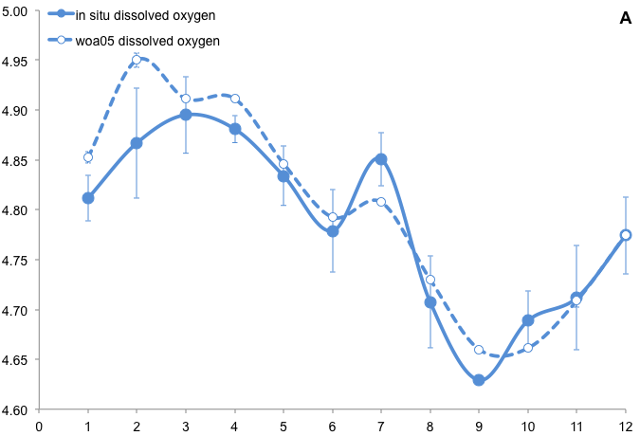
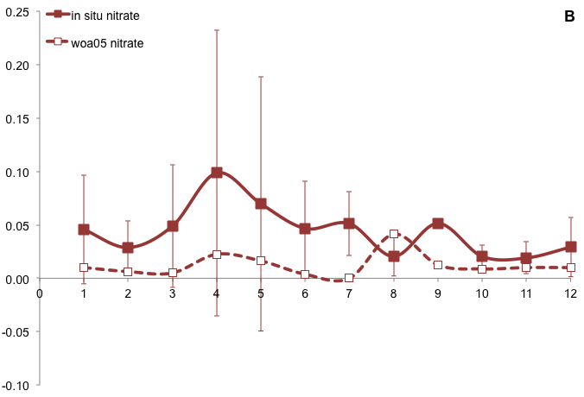

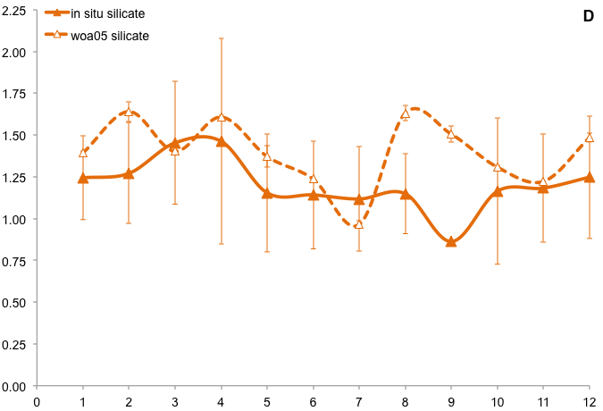
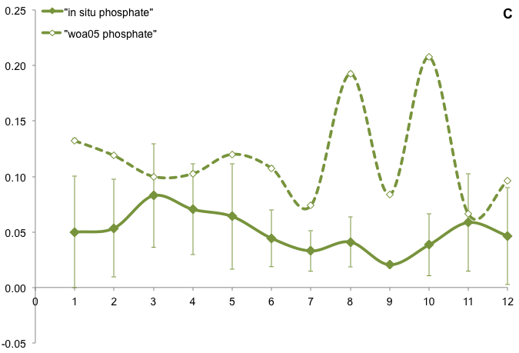

Figure S2.The relative abundances of different phyla (rows) at each GOS sampling site (columns). Presence of a spot indicates the presence of a phylum, and the size of a spot area represents the relative abundance.
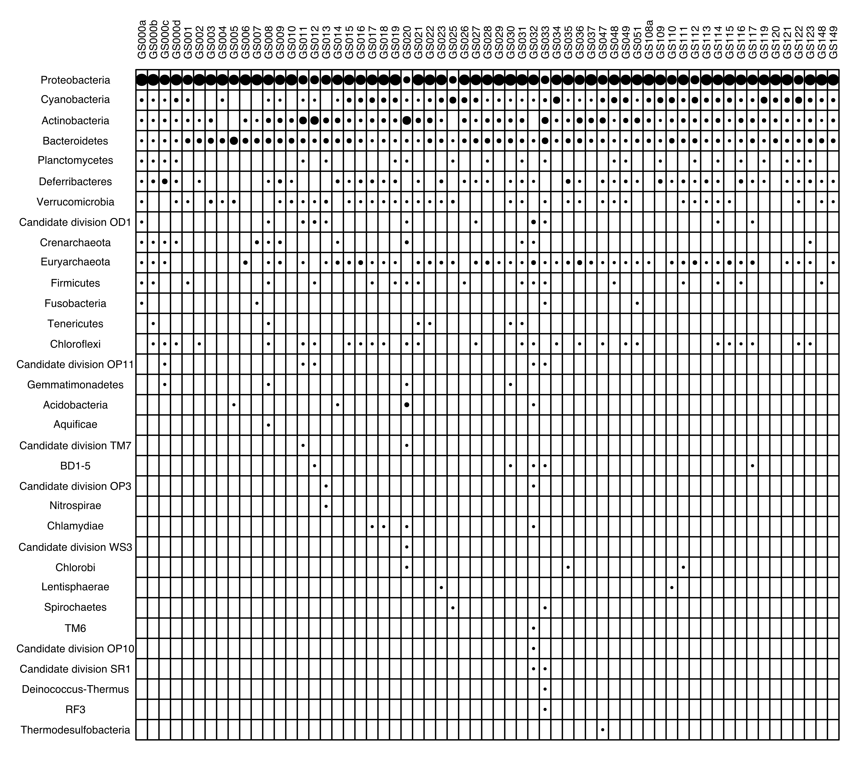
Figure S3. NMDS ordinations at phylum and class levels, with taxa weighted average scores plotted, alongside sampling sites (black dots). Perpendicular projections of some taxa on to environmental variable vectors are shown by grey-dotted lines in order to indicate their placement on the variable gradient.
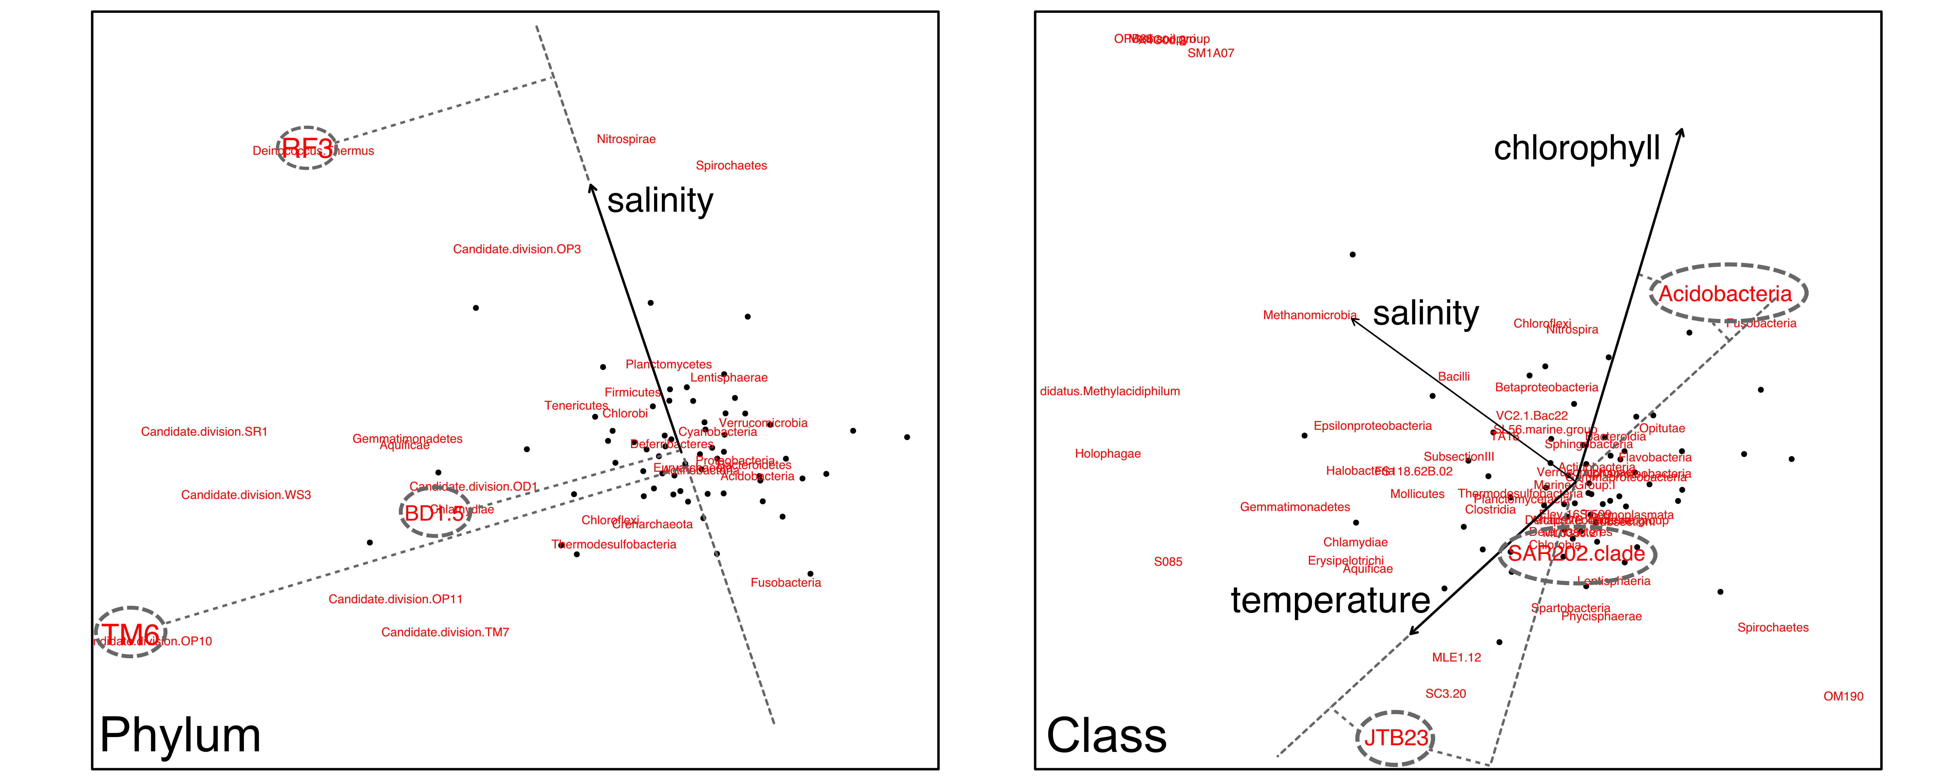
Figure S4. Latitudinal distribution patterns for other clades belonging to Archaea, Actinobacteria, Bacteroidetes, Rhodobacteraceae, SAR11, Gammaproteobacteria, and other Proteobacteria, respectively. X- axis corresponds to 50-40, 40-30, 30-20, 20-10, 10-0, -4- -0, -10- -4, -20- -10, -30- -20 and -40- -30 latitude intervals.
