A Machine-Learning Framework for
Depression-Severity Classification from Eyes-Closed EEG
Revised Competition Report
Submitted by
Shereen Shaban Mahmoud Hamed
Independent Research Project
Healthcare Solutions Category
AYAIR 2026

Executive Summary
This project investigates whether participant-level features extracted from eyes-closed resting-state EEG can classify adolescents into three depression-severity groups: Minimal, Mild, and Moderate. The final dataset contained 85 participants and 600 EEG-derived features per participant. Clinical questionnaire scores and demographic variables were retained for description and validation, but were not used as model inputs.
A leakage-controlled machine-learning workflow was implemented. The workflow includes participant-level data preparation, stratified train-test splitting, imputation and feature selection inside scikit-learn Pipelines, baseline model comparison, and hyperparameter tuning of an Extra Trees classifier. The final tuned model achieved 64.7% accuracy, 64.4% balanced accuracy, and 63.8% macro-F1 on the held-out test set of 17 participants.
Because the dataset is small relative to the feature dimensionality, the result is reported together with repeated cross-validation stability estimates. The repeated training-set evaluation produced a mean balanced accuracy of 52.1% (SD 11.3 percentage points) and a mean macro-F1 of 50.6% (SD 11.8 percentage points). These findings indicate promising signal but substantial uncertainty and limited generalizability.
Outcome | Value
Participants | 85
EEG features per participant | 600
Target classes | Minimal, Mild, Moderate
Held-out test participants | 17
Final model | Tuned Extra Trees
Test accuracy | 0.647
Test balanced accuracy | 0.644
Test macro-F1 | 0.638
Repeated-CV balanced accuracy | 0.521 ± 0.113
Repeated-CV macro-F1 | 0.506 ± 0.118

Abstract
Depression severity assessment in adolescents commonly relies on clinical interviews and self-report instruments. This study explores a complementary EEG-based machine-learning approach using eyes-closed resting-state EEG features. The dataset comprised 85 participants divided into Minimal (n=30), Mild (n=27), and Moderate (n=28) depression groups. After data-quality checking, reshaping, and participant-level merging, each participant was represented by 600 EEG-derived features.
Three baseline classifiers—Logistic Regression, Support Vector Machine, and Extra Trees—were evaluated. The final workflow placed imputation and univariate feature selection inside the training pipeline to reduce the risk of information leakage. Extra Trees was then tuned using stratified five-fold cross-validation on the training set only. On the held-out test set, the tuned model achieved 0.647 accuracy, 0.644 balanced accuracy, and 0.638 macro-F1. Repeated cross-validation showed a lower and variable mean performance, emphasizing the effect of the small sample size. The results support the feasibility of EEG-based severity classification while highlighting the need for larger, externally validated datasets.
Keywords: EEG; depression severity; adolescents; eyes-closed EEG; machine learning; Extra Trees; balanced accuracy; macro-F1; mental-health AI.

1. Introduction
Depression in adolescence can affect learning, social functioning, emotional development, and long-term health. Early identification of severity may support timely referral and more individualized assessment. However, EEG-based models should be understood as research screening tools rather than diagnostic replacements for qualified mental-health professionals.
Electroencephalography provides a non-invasive measurement of electrical brain activity. Spectral and related EEG-derived features may capture patterns associated with arousal, cognition, and affective processing. This project evaluates whether such features can distinguish three ordered severity groups in an adolescent sample.

1.1 Objectives
- Prepare a reproducible participant-level dataset from eyes-closed EEG features.
- Classify participants into Minimal, Mild, and Moderate depression groups using EEG features only.
- Compare baseline Logistic Regression, SVM, and Extra Trees models.
- Tune the strongest baseline using training-set cross-validation.
- Report test performance, class-wise errors, and stability rather than relying on a single accuracy value.

2. Dataset and Label Definition
The analysis used the eyes-closed EEG file together with a participant-characteristics table containing participant identifiers, group labels, gender, BDI-II scores, and PHQ-9 scores. The eyes-open file was not included in the current experiment and is reserved for a future comparison or multimodal analysis.
Group | Severity label | Participants
1 | Minimal depression | 30
2 | Mild depression | 27
3 | Moderate depression | 28

The Group variable was used as the classification target. Group & ID, Label, Gender, BDI-II, and PHQ-9 were excluded from the input feature matrix. This prevents the model from using participant identity, demographic information, or questionnaire-derived information that could reveal the target label.

3. Methodology

3.1 Data Preparation
- Removed empty and repeated-header records.
- Removed the non-informative Total (AP) row.
- Reshaped the EEG table so that each participant contributed one row.
- Merged the participant-level EEG features with the participant-characteristics table.
- Validated group labels, missing values, unique participant identifiers, and final dimensions.
Data property | Final value
Participants | 85
EEG-derived features | 600
Missing values in model matrix | 0
Training participants | 68
Test participants | 17

3.2 Exploratory Analysis
The EDA notebook produced class-distribution, demographic, clinical-score, missing-value, EEG-band, outlier, correlation, and group-wise feature visualizations. Outlier and correlation analyses were descriptive only. No participant was removed automatically, and no feature was removed solely because of a high correlation in the EDA stage.

3.3 Modeling Pipeline
The dataset was divided into stratified training and held-out test sets. Imputation and feature selection were placed inside scikit-learn Pipelines. The primary tuned pipeline used median imputation, SelectKBest with ANOVA F-scores, and Extra Trees. The selected configuration used 100 features, 300 trees, log2 maximum-feature sampling, and a minimum leaf size of 1.

3.4 Evaluation Metrics
Accuracy measures the proportion of all correct predictions. Balanced accuracy averages recall across classes and is more informative when class sizes differ. Macro-F1 gives each class equal weight, making it suitable for assessing whether the model performs reasonably across Minimal, Mild, and Moderate rather than favoring one group.

4. Results

4.1 Baseline Model Comparison
Model | Accuracy | Balanced accuracy | Macro precision | Macro recall | Macro-F1
Logistic Regression | 0.588 | 0.589 | 0.597 | 0.589 | 0.568
Extra Trees | 0.588 | 0.589 | 0.590 | 0.589 | 0.587
SVM | 0.529 | 0.522 | 0.519 | 0.522 | 0.504

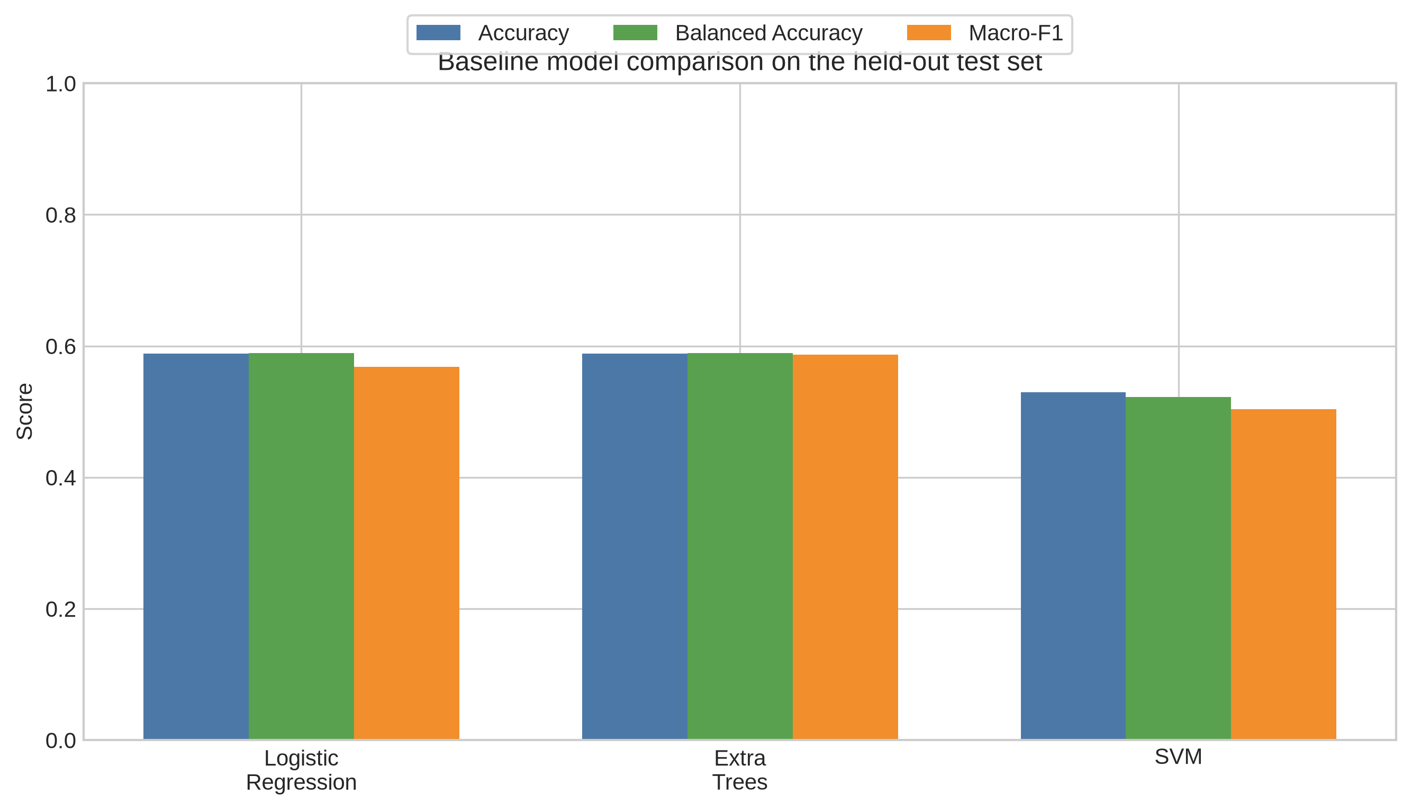
Figure 1. Baseline model comparison on the held-out test set. The plot is generated from the current code rather than manually entered values.

4.2 Tuned Extra Trees Performance
Metric | Held-out test value
Accuracy | 0.647
Balanced accuracy | 0.644
Macro precision | 0.658
Macro recall | 0.644
Macro-F1 | 0.638

The tuned model correctly classified 11 of 17 held-out participants. Performance was strongest for the Mild group and weaker for Minimal, indicating overlap between severity groups in the current EEG feature representation.

4.3 Class-wise Performance
Class | Precision | Recall | F1-score | Support
Minimal | 0.60 | 0.50 | 0.55 | 6
Mild | 0.80 | 0.80 | 0.80 | 5
Moderate | 0.57 | 0.67 | 0.62 | 6

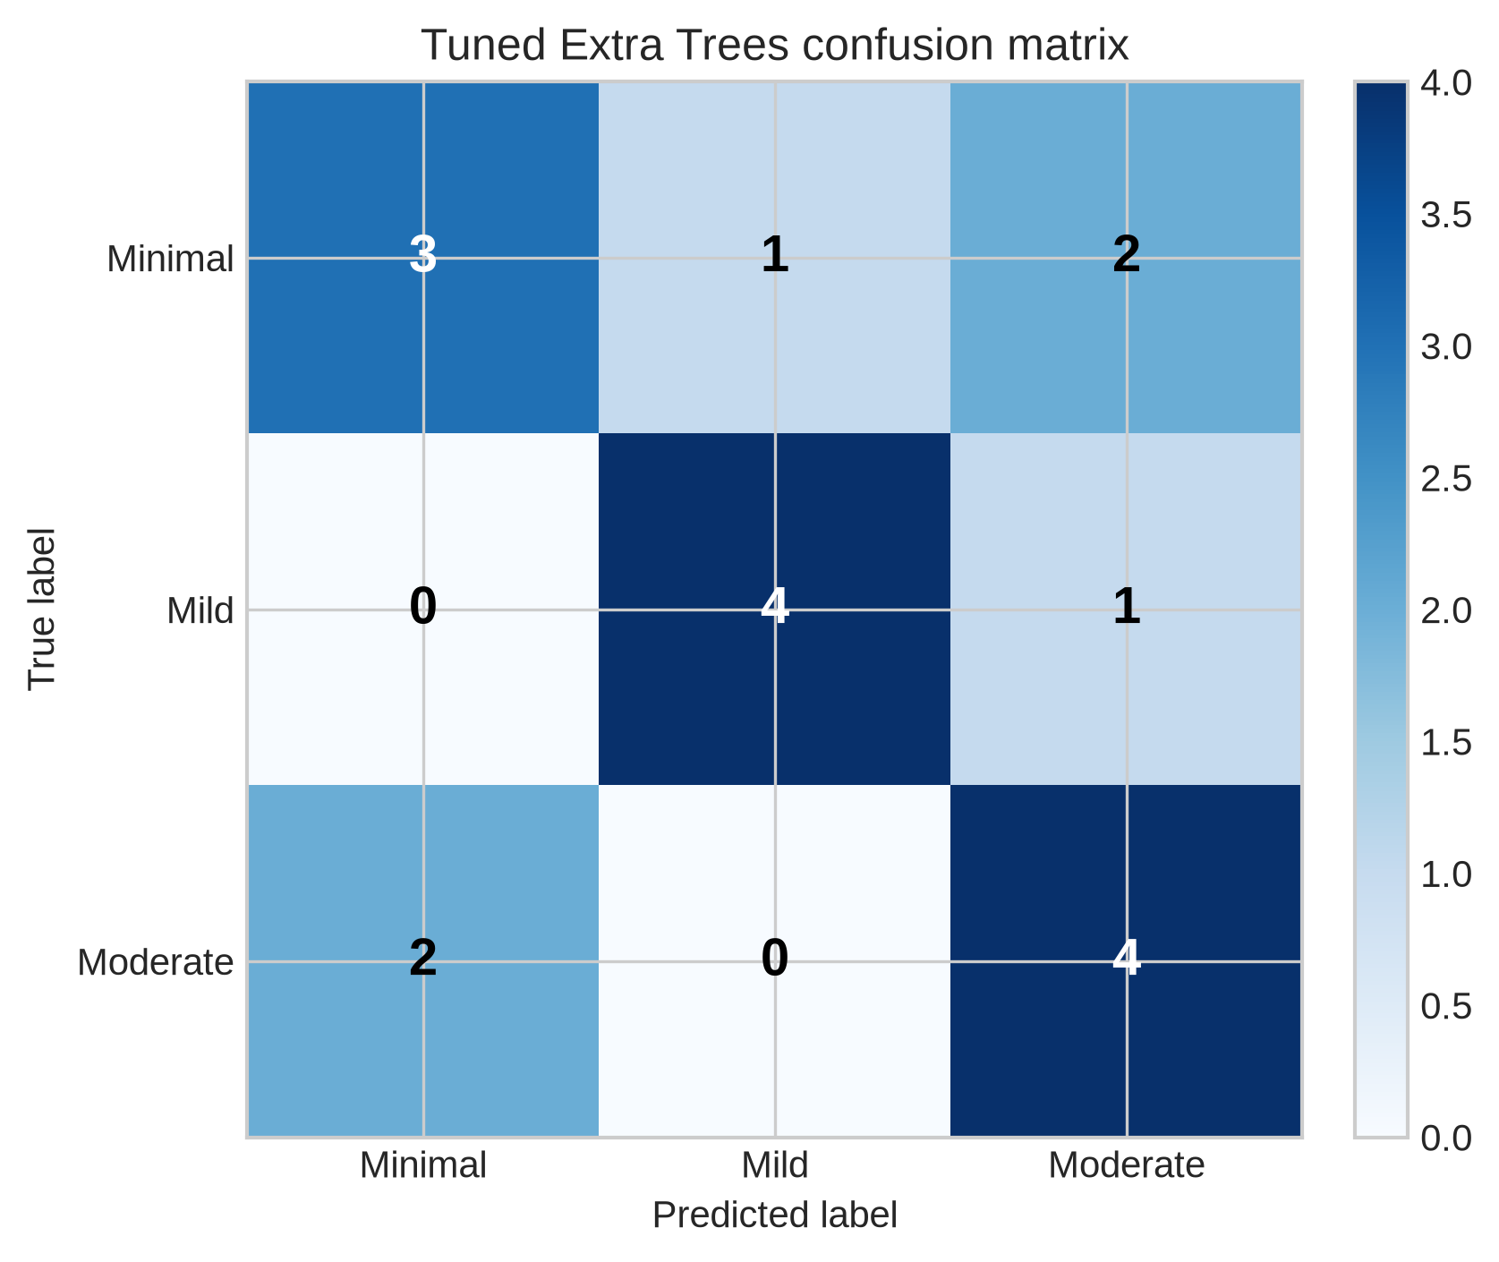
Figure 2. Confusion matrix for the tuned Extra Trees model. Rows represent true labels and columns represent predicted labels.
The confusion matrix was [[3, 1, 2], [0, 4, 1], [2, 0, 4]] for Minimal, Mild, and Moderate, respectively. The largest errors involved confusion between Minimal and Moderate, while Mild was classified more consistently in this split.

4.4 Stability Analysis
Metric | Mean | SD | Minimum | Maximum
Balanced accuracy | 0.521 | 0.113 | 0.317 | 0.833
Macro-F1 | 0.506 | 0.118 | 0.323 | 0.839

The repeated cross-validation results show substantial variability across participant splits. Therefore, the held-out test score should not be interpreted as a guaranteed population-level performance estimate. The stability analysis is included to make this uncertainty explicit.

5. Comparison with the Preliminary Modeling Notebook
The preliminary notebook reported PCA followed by Logistic Regression as its best classification pipeline, with approximately 0.544 cross-validation accuracy, 0.543 recall, and 0.534 F1. The revised notebook reports a tuned Extra Trees test accuracy of 0.647, balanced accuracy of 0.644, and macro-F1 of 0.638.
These values should not be compared as if they were identical measurements. The preliminary 0.544 value was a five-fold cross-validation average, whereas 0.647 is a single held-out-test result on 17 participants. In the revised workflow, repeated cross-validation produced 0.521 ± 0.113 balanced accuracy and 0.506 ± 0.118 macro-F1. The revised workflow is therefore more reproducible and transparent, but the evidence does not establish a large, stable improvement in generalization.

6. Discussion
The results suggest that eyes-closed EEG features may contain information relevant to three-class depression-severity classification in the present split; however, this should not be interpreted as statistically established evidence of generalizable performance. Extra Trees performed best among the tested pipelines, likely because it can model nonlinear relationships and interactions among EEG-derived features. However, the repeated-CV variability indicates that the model is sensitive to which participants appear in training and validation folds.
The main methodological strength is the separation of EEG inputs from questionnaire scores and demographic variables. BDI-II and PHQ-9 were not used as predictors, so the model is not simply reconstructing the clinical questionnaire from a leaked version of the same information. The main limitation is the small sample relative to the 600-dimensional feature space.

7. Limitations and Responsible Interpretation
- The study includes only 85 participants and one recording condition, eyes-closed.
- The held-out test set contains only 17 participants, so individual predictions can change substantially under another split.
- The repeated-CV standard deviations indicate substantial performance uncertainty.
- The dataset represents a specific population and acquisition setting; external generalization is unknown.
- The system is a research screening framework and is not a clinical diagnostic device.
- The current report does not claim that EEG alone can replace psychiatric assessment or validated clinical instruments.

8. Potential Impact
A validated EEG-based screening aid could support earlier referral and more consistent triage in settings where access to mental-health specialists is limited. Potential applications include research screening, school or university health programs, and community health initiatives. Any future deployment would require external validation, fairness analysis, clinical collaboration, privacy protection, and prospective evaluation.

9. Future Work
- Increase the number of participants and collect data from multiple centers.
- Evaluate eyes-open EEG separately and compare it with eyes-closed EEG.
- Investigate multimodal fusion only as a separate experiment, while keeping EEG-only results as the primary baseline.
- Use nested cross-validation or repeated outer testing for more reliable model comparison.
- Apply explainability methods such as permutation importance or SHAP after the evaluation protocol is fixed.
- Test ordinal-classification approaches because Minimal, Mild, and Moderate represent ordered severity levels.
- Validate the final pipeline on an external dataset before making clinical claims.

10. Conclusion
This revised study developed a reproducible machine-learning workflow for classifying Minimal, Mild, and Moderate depression severity from eyes-closed EEG-derived features. The tuned Extra Trees model achieved 0.647 accuracy, 0.644 balanced accuracy, and 0.638 macro-F1 on the held-out test set. However, repeated cross-validation produced lower and variable estimates, demonstrating that the small participant sample limits confidence in a single test split.
The primary contribution is therefore methodological as well as predictive: the project separates EDA from Modeling, prevents questionnaire and identity leakage, computes results directly from the models, reports class-wise errors, and makes uncertainty visible. Larger and externally validated datasets are required before the framework can be considered for practical clinical use.

References and Reproducibility Resources
[1] Original public methodological notebook: EEG-Based Depression Screening. Available at: https://github.com/ugail/EEG_Based_Depression_Screening
[2] Rachamanee S, Wongupparaj P. Resting-state EEG datasets of adolescents with mild, minimal, and moderate depression. BMC Research Notes. 2021;14:256. doi:10.1186/s13104-021-05673-x. The associated open dataset is available through the Open Science Framework at https://doi.org/10.17605/OSF.IO/4HQ3Y.
[3] The final reproducibility files are `EDA.ipynb`, `Modeling.ipynb`, `final_df.csv`, `final_participant_predictions.csv`, and the `eda_figures` directory.

