Computer:
- Computer is an electronic device that is designed to work with Information.
- The term computer is derived from the Latin term ‘computare’, this means to calculate or programmable machine.
- Computer can not do anything without a Program.
- It represents the decimal numbers through a string of binary digits.
- Charles Babbage is called the "Father" of the computer. The First mechanical computer designed by Charles Babbage was called Analytical Engine.
- Computer is an advanced electronic device that takes raw data as input from the user and processes these data under the control of set of instructions (called program) and gives the result (output) and saves output for the future use.
- It can process both numerical and non-numerical (arithmetic and logical) calculations.

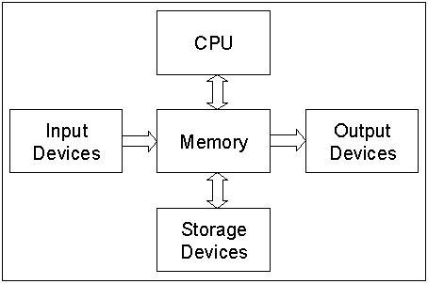
Functional components of a computer system:

FUNCTIONAL UNITS In order to carry out the operations the computer allocates the task between its various functional units. The computer system is divided into three separate units for its operation.
They are
1) arithmetic logical unit
2) control unit.
3) central processing unit.

Input (Data):
Input is the raw information entered into a computer from the input devices. It is the collection of letters, numbers, images etc.

Output:
Output is the processed data given by computer after data processing. Output is also called as Result. We can save these results in the storage devices for the future use.

Process:
Process is the operation on data as per given instruction. It is totally internal process of the computer system.

Input Unit
- Inputting is a basic operation of a computer system. This is the act of feeding in the data and instruction to the computer (by computer here it means the processing unit).
- The devices that help us to input data and instructions are known as Input Devices.
- Examples: Keyboard, Mouse, Light Pen, Joystick, Scanners, Microphone etc.

Processing Unit
- The task of performing calculations and comparisons are known as processing.
- The unit in Computer System that is responsible for processing is ALU (Arithmetic and Logical Unit).
- ALU is the place where actual execution of the instructions takes place during the processing operations. All calculations & comparisons are made in the ALU.
- Number of arithmetic & logical operation that a computer can perform is determined by the design to perform the four basic arithmetic operations. They are +,-,*,/. The logic operations like <,=,>.

Output Unit
- This unit takes care of receiving processed information from processing unit and present it to the user in suitable form.
- A computer produces results in binary form and output unit does decoding to make it usable to the users.
- The devices that can output information from computer are known as output unit devices.
- Examples: Monitors, Speakers, Projectors are soft output devices whereas printers, plotters produces hard copy output.
- Softcopy output is something that is temporary or is available only as long as output device is turned on.
- Contrary to these are hard copy output which are permanent. The printout in a paper is not lost because printer is turned off!

Storage Unit
- Before actual processing start, data & instructions entered to the computer must be stored somewhere inside the computer. Similarly, results produced by the computer are required to be stored before it is passed to the output unit. The intermediate result produced by the computer must also be stored for further processing. Thus the importance of storage Unit in a computer system is vital.
- Based on whether storage device is inside the main machine or not, it can be internal or external storage. Similarly, looking at whether the storage device works close with CPU or works as backup media, they can be primary storage or secondary storage.
- Primary storage are also called primary memory. Secondary storage are known with other names such as backup storage or secondary memory.
- It stores all the data to be process.
- It stores intermedial results.
- It stores final result are realize an output device.
- For the storage purpose, a computer system may have different devices such as registers, cache, RAM/ROM, flash, magnetic disks, optical disks and so on.

Control Unit
- ALU does not know what should be done with the data likewise, output unit does not know when the result should be displayed. By selecting, enterning and seeing to the execution of the program the CU is able to maintain order and direct the operations of the entire system. CU doesn’t perform any actual processing on data yet it is known as a central nervous system for the comforts of the computer.
- It manages co-ordinates the entire system.

5 Basic Operations of a Computer System:
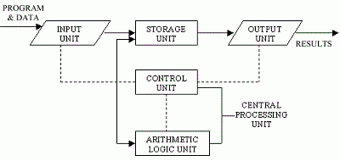
Figure: Basic Operations of a Computer System
- Inputting
- Processing
- Outputting
- Storing
- Controlling

Computer Classification:

Computers differ based on their data processing abilities. They are classified according to purpose, data handling and functionality.
According to functionality, computers are classified as:
- Digital computer:
- Analog Computer:
- Hybrid Computers:

Personal computer:-
A personal computer is a computer of small and low cost. The term personal computer" is used to describe desktop computers (desktops).
Workstation:-
A terminal or desktop computer in a network are workstation. In this context, workstation is just a generic term for a user's machine (client machine) in contrast to a "server" or "mainframe."
Mainframe:-
It refers to the kind of large computer that runs an entire corporation.
Supercomputer:-
It is the biggest, fastest, and most expensive computers on earth.
Minicomputer:-
Microcomputer:-

Hardware & Software:

Types of Software:

Operating System:

An Operating System runs on computer hardware and serves as a platform for other software’s to run on the computer system.

An Operating system is the program (System Software) which acts as an interface between user and computer hardware.

A Computer system can be logically divided into four components:

Computer Hardware,
USERS

Operating System,
APPLICATION PROGRAMS

Application Program,
OPERATING SYSTEM

Users.
COMPUTER HARDWARE

Fig. Logical Computer Hierarchy

Objective of O.S.:

An Operating System has main two Objectives;

Convenience: An operating system makes a computer more convenient to use.

Efficiency: An Operating system allows the computer resources to be used in an efficient manner

Functions of O.S.:

An Operating System manages four major resources of the computer system: Memory, Processor, Input/ Output devices and Files. So, an operating system provides four operations:

Memory Management function finds free space in memory and allocate it to different processes.

Processor Management function allocates the processor to executes a chosen process.

I/O Device Management function allocates a device to a process.

File Management function keeps track of all information about files that how they are opened or closed.

Types of O.S.:

Batch Processing, Multiprogramming, Multitasking or time sharing, Network operating system (NOS), Distributed Operating System, Real Time Operating System.

Memory

Primary and secondary memory

Types of primary memory

Storage devices

Processor: CPU

Fundamentals of Computer Networks

