**Website Layout**

Main contents should contain interactive graphics like globe with words popping as 5G, IOT (Internet of Things), M2M (machine to machine), NFV, SDN, Advanced LTE, VoWiFi, Wireless Services, Mobility Architecture & Design etc.

1. **ABOUT US (HOME/Main Page)**
2. **Meet The Team**
3. **Services**
4. **Products**
5. **Contact Us**
6. **Careers**

**HOME Screen Vision**

**Vision: Driving Disruptive Innovation**

**Mission Statement: We deliver innovative business strategies for a connected future**

See Examples: <http://www.alessiobresciani.com/foresight-strategy/51-mission-statement-examples-from-the-worlds-best-companies/>

** The vision needs to be an ACTION like ‘To Deliver’

**ABOUT US -**

Wireless Cloud Services is a Seattle based technology consulting firm. We are adept in the art and science of Business transformation and innovative technology solutions. We take pride in offering our customers an insight to industry trends and cutting edge technology with future roadmaps. We believe in staying ahead of the curve and be disruptive not disrupted. We also strongly believe that great things happen when people team up, collaborate and focus therefore our business model is customer focused with an attitude of ‘In it to win it’. We love to partner with our clients and business partners in delivering the disruptive innovation we are so known for. More important than the initials that follow our names is the experience we bring to the table gained by years in the trenches of tech industry. We thrive on innovative ideas and translating them into intelligent business solutions.

MEET THE TEAM-

Our team of technology evangelists have over 20 years of diverse industry experience from startups to leading tech companies. Our think tank has provided services in four continents across the globe for Tier 1 communication service providers, vendors and partners. Our team works closely with our customers to deliver successful future strategies and help develop new business verticals. We are passionate about the Connected Planet Vision and Smart Networks. We are spear heading the disruptive technology convergence for Virtualization, IoT and 5G.

Values:

*Value statement on top of a picture with punch line underneath*

* Innovation : Be disruptive, not disrupted
* Agility - We improvise and embrace the change
* In It to Win It : the attitude with breath with
* Integrity – Professionalism and mutual request is our norm

Services

Disruptive Innovation Zone

Wireless Cloud Services offers a full stack of technology consulting to empower its customers and business partners transform their network and services to benefit from the digital economy. We have been actively involved in 4G, 5G, IoT, M2M, SDN, NFV and telco cloud domains.

* Technology Strategy Consulting

We believe in the use of technology to increase the value and efficiency of all aspects of your business. Our team is at the forefront of technological advancements in the ICT industry. Our core competency is to partner with CSP’s and vendors to strategize and realize new technology and business offerings. We have successfully delivered strategy roadmaps while working on Network Function Virtualization, Software Defined Networks, Automation, Web Scaling and related technologies. Our breath of knowledge spans from cellular to non-cellular domains. We have worked on connected cars, smart cities, health cares and other enterprise solutions with our partners.

* [Technology infrastructure Transformation](https://www2.deloitte.com/us/en/pages/technology/solutions/technology-infrastructure-transformation-services.html)

We have successful delivered strategies and implemented network transformation for Communication Service Providers while they transit from 3G to 4G Technologies. We are on the mission to continue this transition and transformation in to 5G technologies for our customers and partners. Our technology team has worked with Tier 1 CSP’s for Infrastructure transformations and ramping up networks and services for new business verticals under the realm of IoT, M2M and Telco cloud based services. We understand the business needs behind the massive infrastructure transformation and work with our partners in ensuring that desired goals are achieved and unexplored business verticals are tethered.

We take pride in sharing our success story in transforming legacy networks to 4G Mobility Core and adding IMS services on top in the most robust and cost effective manner. Our VoLTE and VoWiFi solutions are recognized by the industry and we have over 30 industry patents in this space. We have been actively involved in one the first virtualized EPC deployments driven by Automation and Service Orchestration in the North America.

* IoT

The Internet of everything has revolutionized business models - many, if not all, services will need to interact and serve across heterogeneous networks and domains. The need for this dynamic, diverse and agile service delivery model has paved the path for many new disrupting technologies. Our team has been actively involved and believe that we should have a holistic view - an approach that is platform and underlying technology agnostic, yet focused on service delivery with utmost agility, quality and reliability. We have worked with a variety of IoT players ranging from CSP’s, Automotive Manufacturers, and Retail Giants to enterprise and consumer customers. We also have expertise in working with AEP’s to help our customers pick for the right option while they plan to monetize from Internet of Things.

* Technology Trainings

We have delivered strategy and roadmap technology sessions for the CSP executives and leads. We believe in sharing and collaborating information that results in the positive changes, the effective change. We are equipped in offering detailed technology trainings on NFV, SDN, Automation, Telco Cloud, Network Slicing, Mobile Edge Computing, IoT (NB, LPWAN, AEP), IMS Core, Packet Core, VoLTE, VoWifi for the Engineering teams and broader audience. Our trainings not only cover the technological aspects but also business reasoning behind these technologies and used cases driving these transformations. We have also partnered with industry renowned contributors for trainings that bring diversity and an outside view to the industry.

* Business transformation and Process improvement

We have realized that dynamic nature of today’s businesses demand agile and inventive processes. The smarter and out of box ideas have an inherit need of business transformation towards dev ops model. Our team has helped CSP’s to adopt agile methodologies and transform legacy business processes in to effective service delivery tools. We have expertise in developing smarter delivery stints, automation Portals, Service management and validation, Customized API’s and Application Enablement Platforms. Additionally we have an extensive set of IT services offerings.

Contact Center Services

We not only cater to our clients’ needs of a traditional contact center through inbound services but take it one step ahead by facilitating their customer base with further channels of interaction including (but not limited to) SMS, e-mail and live web chat and social media support. Our Contact Center Services are available round the clock, throughout the year.

Contact Center Consultancy

Our Consultants design Contact Center systems to parallel overall business strategies by evaluating business systems and user needs. We do an In-depth understanding of business issues and identify, analyze, and translate business needs into functional specifications. Analyzing requirements, developing detailed designs for implementation of technical work, defining implementation and testing procedures is carried out in order to ensure that the business strategies are achieved. We specialize in designing IVR and call routing flows. Providing in-depth technical knowledge and troubleshooting skills for IVR applications and Contact Center Routing.

Workforce Management

In order to effectively manage the large number of Workforce we have developed a solution for profiling of all relevant personnel covering information related to scheduling, knowledge management and leave management. This centralized portal also comes in handy to contain and disseminate all sorts of operational information.

Process Development

Since operations run throughout the year, they need to be governed by policies and procedures in order to ensure smooth execution of services. This is achieved by continually developing and updating standard operating procedures (SOPs) as per the changing requirements of our clients. Our team specializes in helping clients streamlining their operations by developing efficient and effective process ensuring business targets are achieved.

Software Development

We take pride in developing scalable software customized according to the client’s requirement. Our software developers are the best experts when it comes to developing Customer Relationship Management (CRM) and Complaint Management System (CMS). The modular design of our software makes it highly customizable to cater all the needs of our clients from diversified industries.

**Products**

**Idea Realization Zone**

Wireless Cloud Services offer a wide variety of products ranging from IoT and cloud management tools to customized APP development. We are actively engaged in launching innovative products for our valued customers - Our value proposition is that the products are built ground up for modern business by offering API abstraction to interwork with different platforms and services. The intelligence and compute functions are natively hosted to ensure data security and faster processing times ideally suited for real time services.

Wireless Cellular Services Platform

WCS-P is commercially deployed IoT product which serves as a wireless cellular service enablement platform. This product offers a variety of services by interworking with different network elements for provisioning, subscription and real time policy enforcements. The product empowers the CSP’s to manage subscriber profiles virtually from anywhere and help reduce significant OPEX cost. Additionally, WCS-P opens new business streams for CSP’s and help them offer services on the go.

W - Apps

Our team has customized apps focusing on particular business needs ranging from Performance Alerts to a full blows service and provisioning delivery application.

W – Cloud and W - IOT

Our team is working on some awesome ideas in the telco cloud space, the offerings will enable the CSP’s and Vendors to have better visibility in to different moving pieces of the cloud as the information traverse.

Awesomeness in the making!

* W- Cloud Analyzer
* W- Cloud Optimizer
* W- Network AEP
* W- IoT Profiler
* W – Telco SE

**Contact Us**

* Let’s push the technology envelope to innovate something awesome
* Get in touch

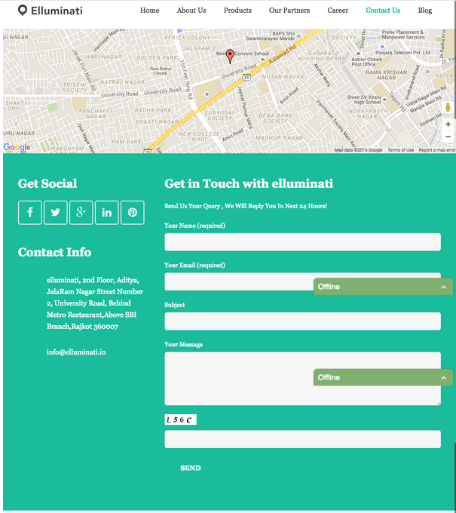

**Website Bottom – Every Page – Left Corner (like Arrows group)**

*Logo*

*Wireless Cloud Services delivers innovative strategies to translate business ideas in to tangible solutions that impact the bottom line. We are passionate about the connected planet vision and we are constantly engaged with our customers and partners in delivering disruptive innovation. We are In It to Win It!*

Address: 15803 Bear Creek Parkway, Suite E209 Redmond Washington 98052

**TIPS**

Tips for the website: <http://www.jimdo.com/2015/01/23/7-tips-to-build-a-great-consultants-website/>

## 1. Clearly communicate your value

## 2. Pick a user-friendly website design

## 3. Deliver informative, client-focused content

## 4. Make it easy to interact and get in touch

## 5. Build client relationships through interaction

## 6. Legitimize your business

## 7. Keep your site fresh and SEO-friendly

# **The Most Prestigious Consulting Firms In 2015**

<http://www.forbes.com/sites/susanadams/2015/09/03/the-most-prestigious-consulting-firms-2/#78f5c5de7382>