**Deep Learning ICP-5**

Hyper Parameters are changed and can be seen in the screenshots and the results corresponding to the optimizer.

**Set-1:**

Adam Optimizer: Loss is very less compared to the other Optimizers used below.

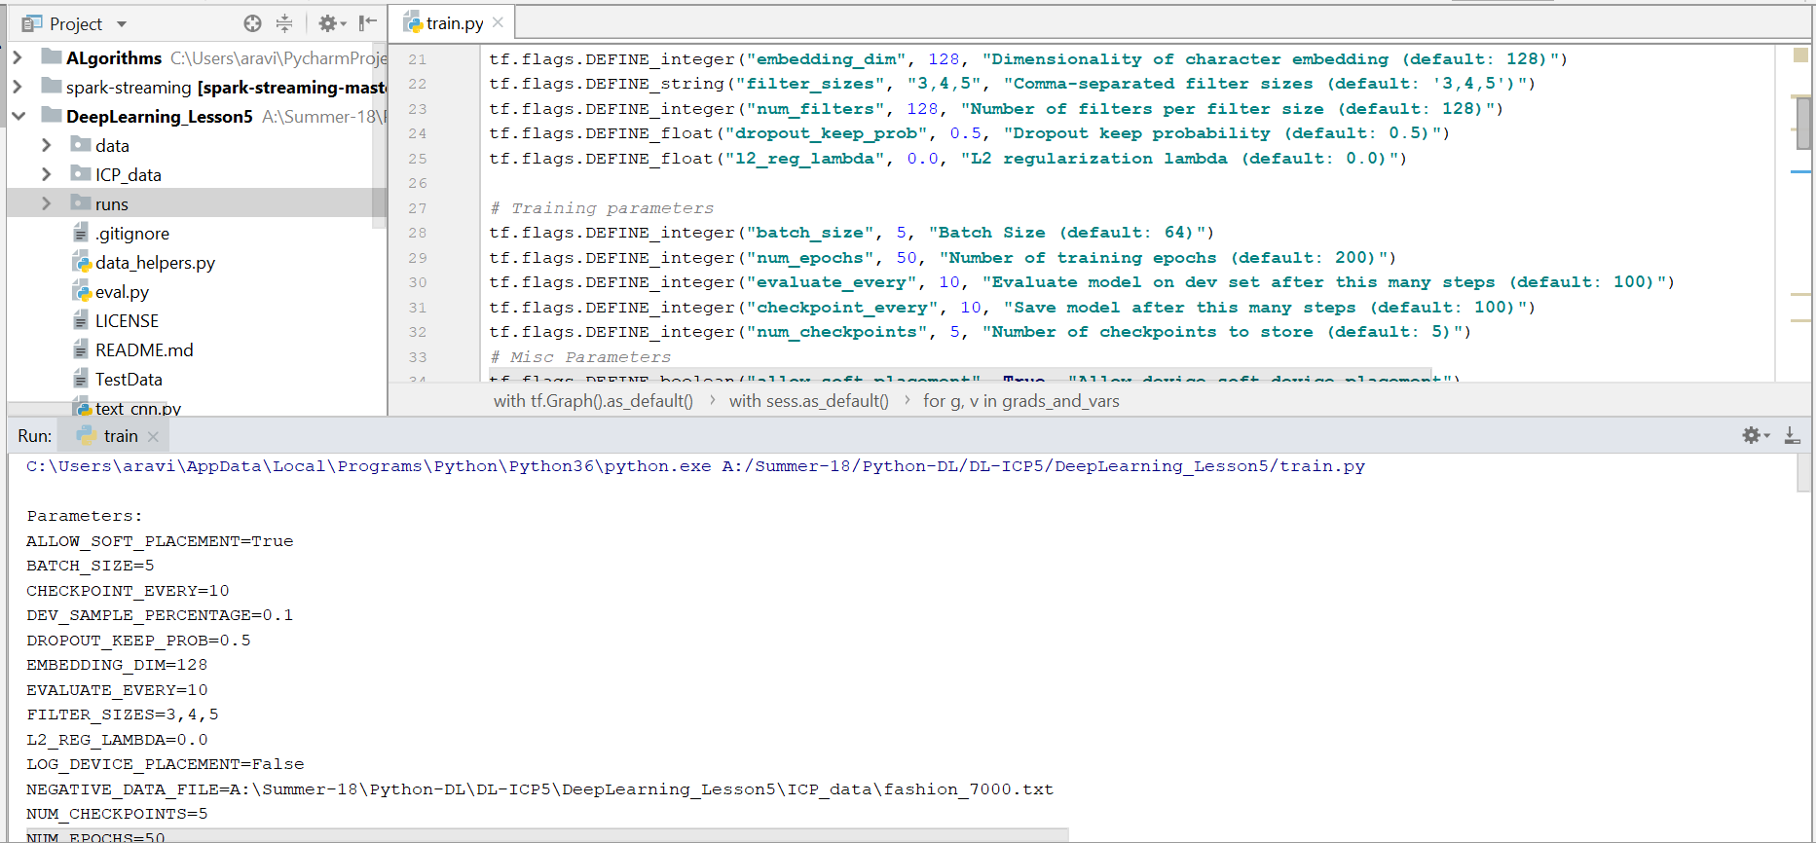

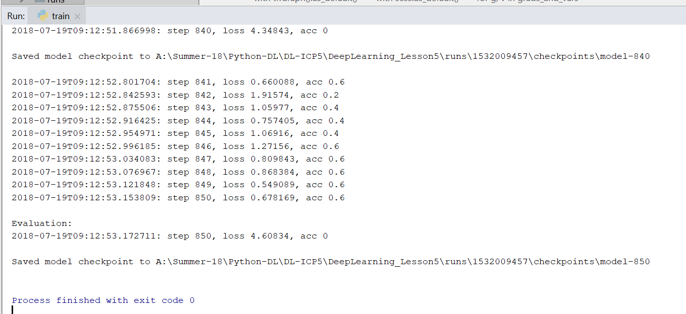

Set-2:

Gradient Descent Optimizer: Loss is greater than Adam Optimizer and less than the below optimizers.

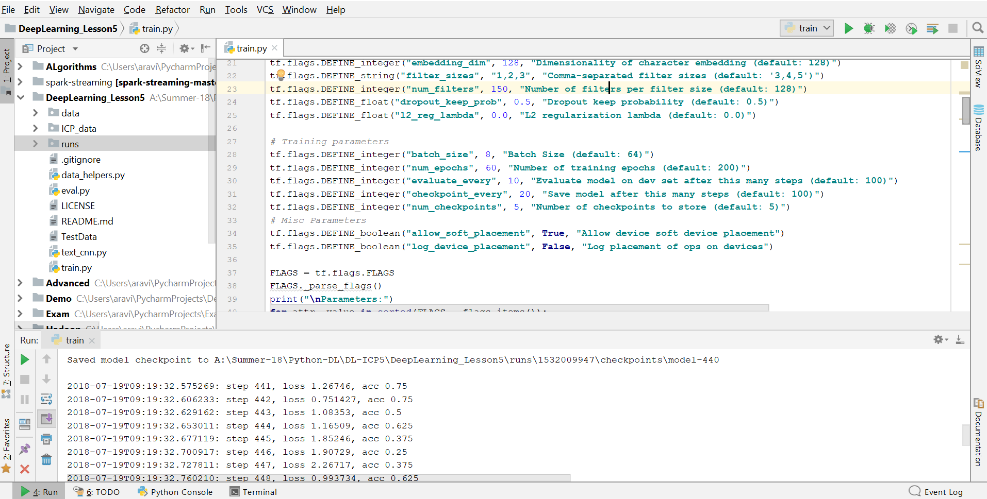

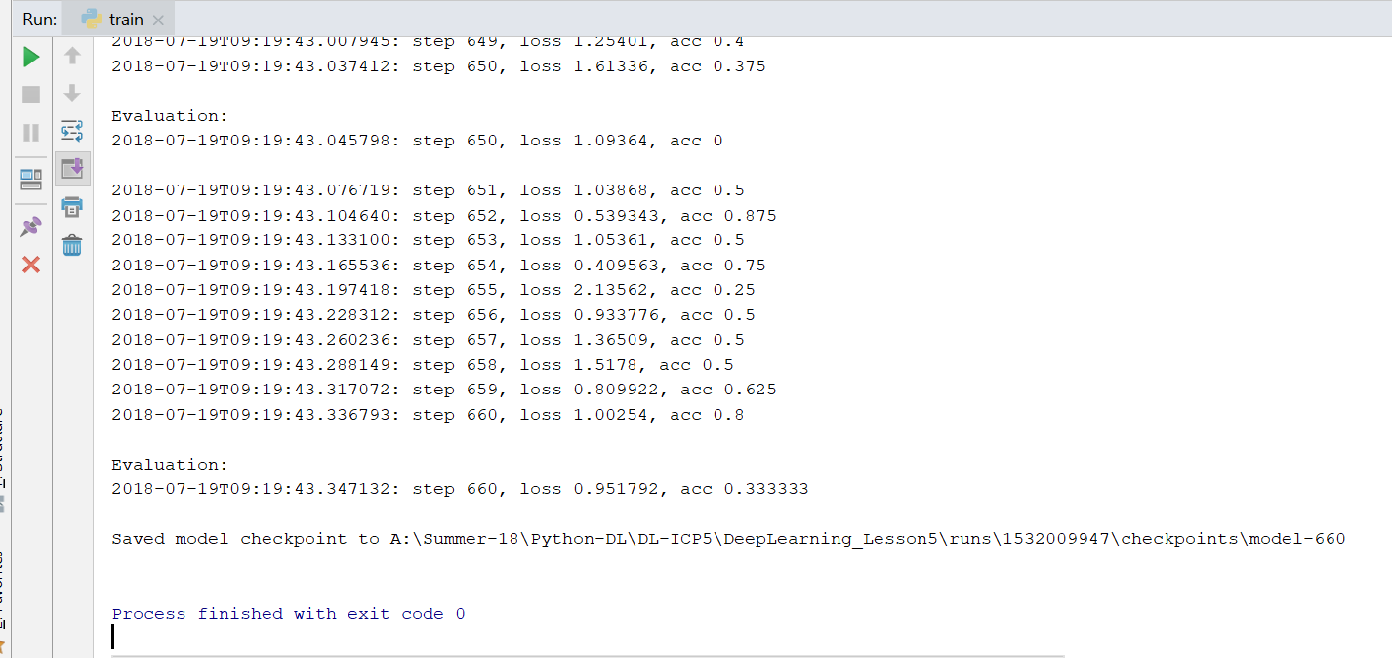

Set – 3:

Proximal Gradient Descent Optimizer: Loss is higher when the Proximal Gradient Descent Optimizer is used.

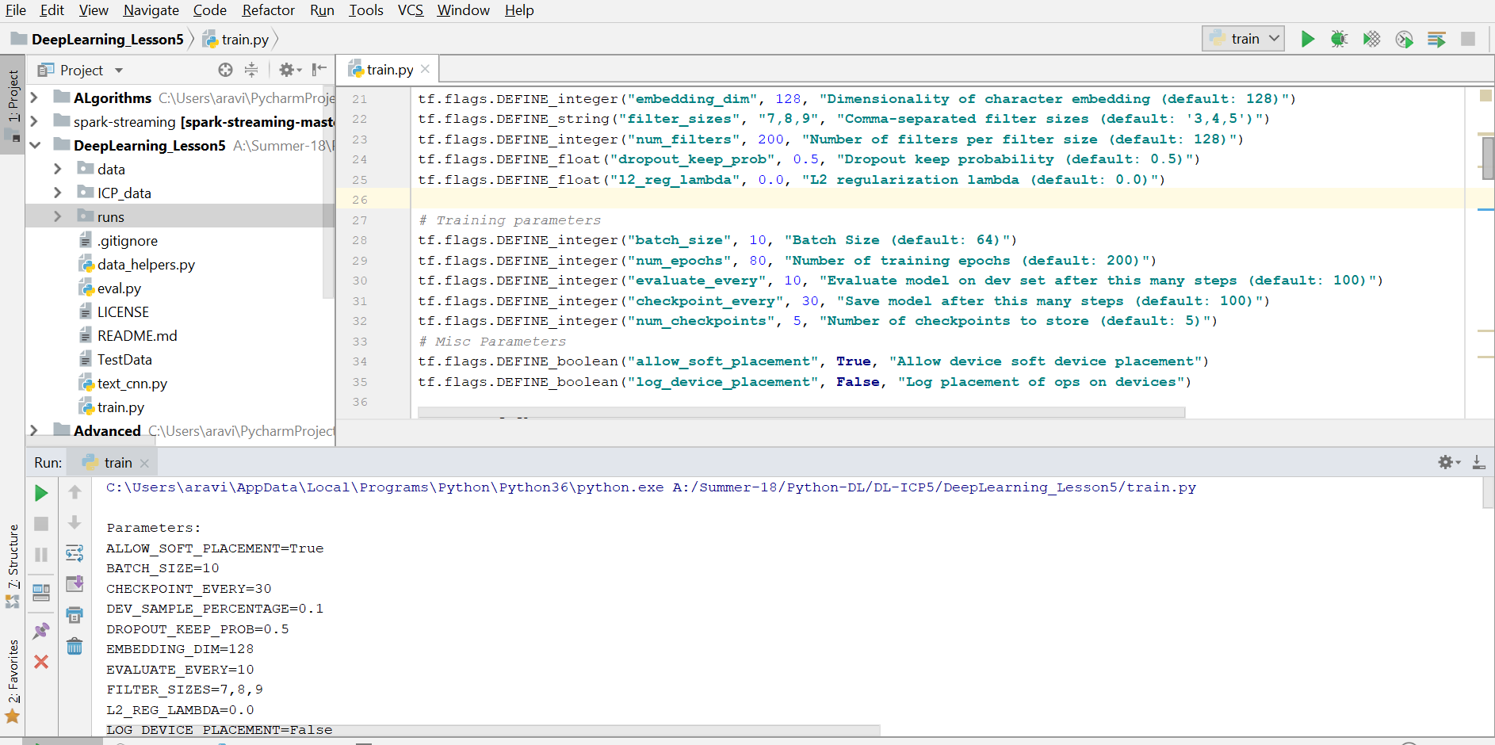

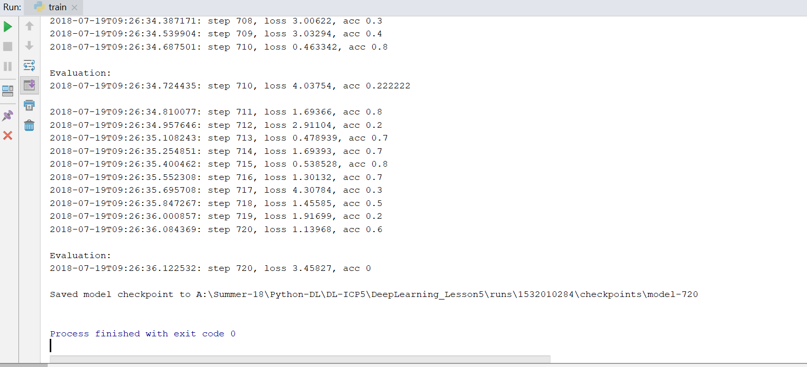

Set – 4:

Adadelta Optimizer: When Adadelta Optimizer is used the loss is very high when compared to the above optimizers.

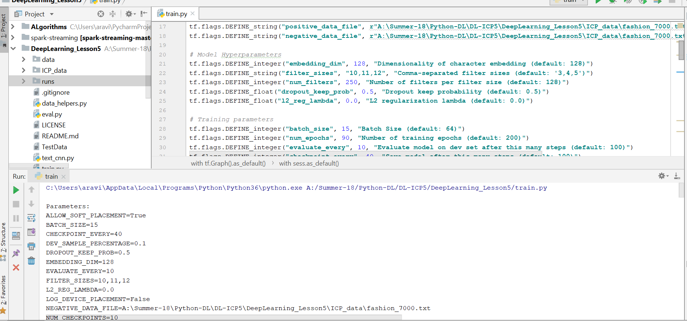

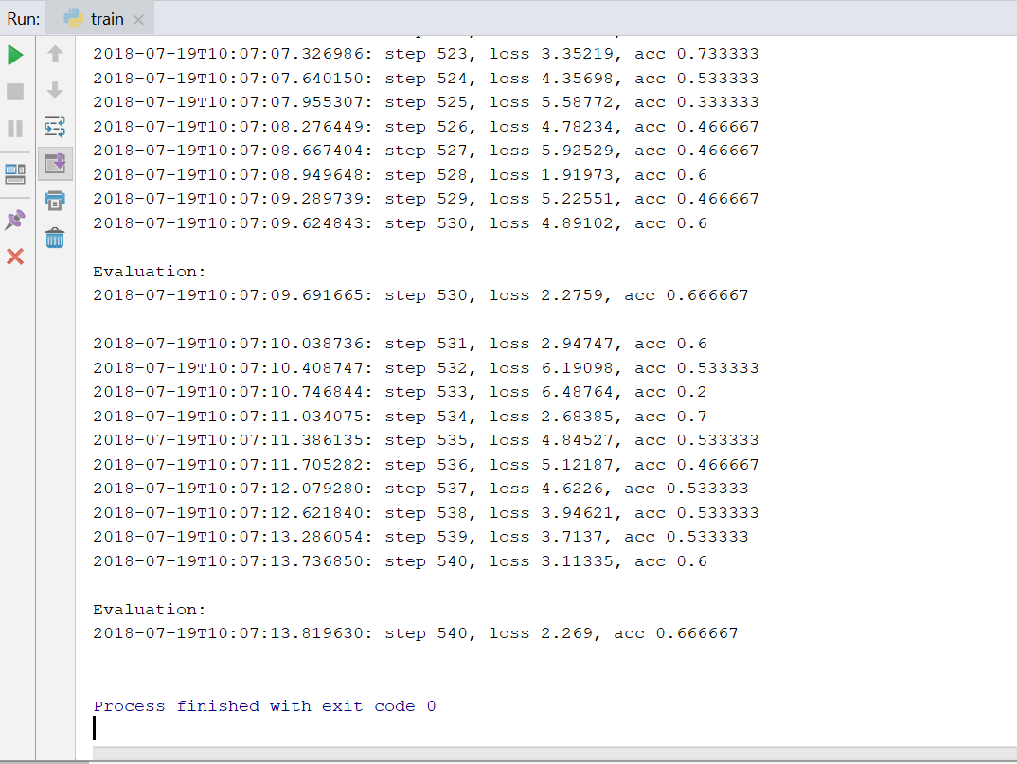

Graph:

