**Spark ICP-6**

**Classification Algorithms:**

Input is given as a CSV file and it is loaded into the model and calculated the predictions. Below are the screenshots for the classification algorithms and the implementation.

Decision Tree Algorithm:

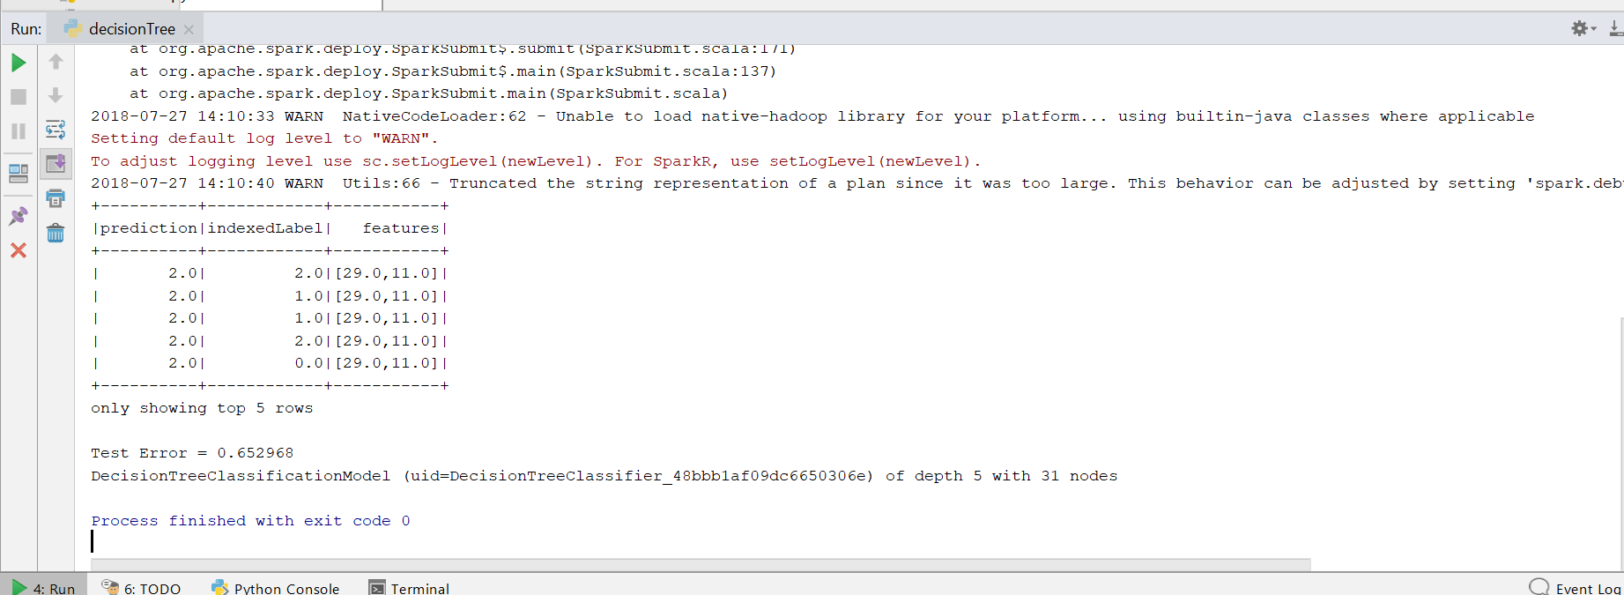

Naïve Bayes Algorithm:

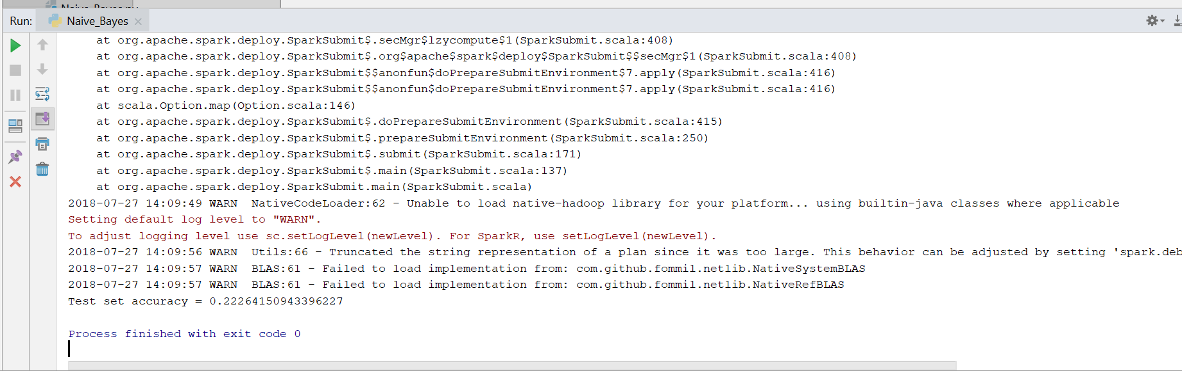

Random Forest:

