# C:\Users\Messom\Desktop\Monash.jpg

# FIT5032 Design Report (Major Application Development Credit/Distinction/High Distinction)

# Lets Fly!

Sheridan Reis Gomes:30356660

INSTRUCTIONS: Substitute all RED text with your information. DELETE all BLUE instructions before final submission (in PDF format). Feel free to edit the format of the document to improve presentation

**Contents Page**

**Your design report must include the following:**

**Credit Level**

1. Overview of your application's goals
2. User stories
3. Functional diagram
4. Usability Design Review
5. Checklist of site functionality.

**Additional Distinction Level (the above and the following)**

1. Your selected approach when constructing the application
2. Class Diagram or Entity Relation Diagram
3. Data dictionary

**Additional High Distinction Level (the above and the following)**

1. Development Methodology
2. Versioning
3. **Overview**

The goals of my application are to provide an easy way for customers to book flight tickets via computer or mobile device, secure web browsing experience, a fully functional and easy to use user interface and a responsive web application to the meet the customers need by providing an interactive experience in the form of sending emails for confirmations.

1. **User stories and Use case diagrams**

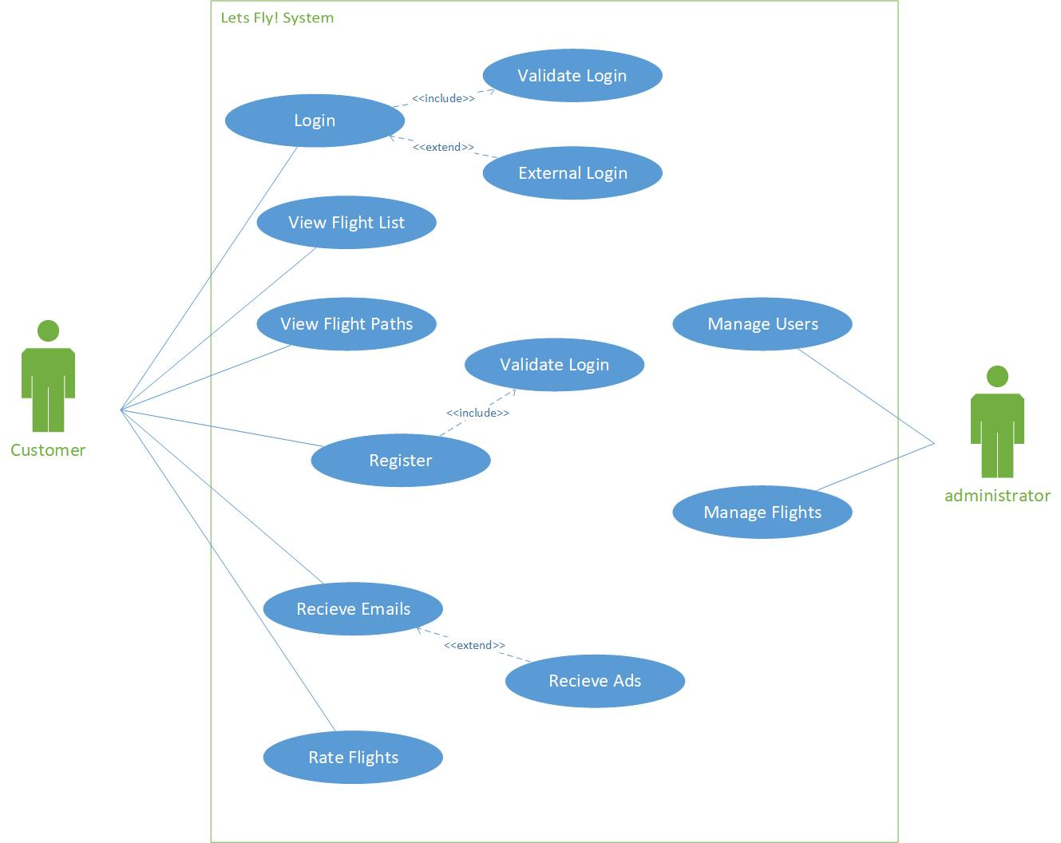

User stories:

As Customer I want to register, so I can register in the system.

As Customer I want to login, so I can login to the system.

As Customer I want to view flight list, so I can view the list of flights.

As Customer I want to view flight paths, so I can view the paths of flights.

As Customer I want to receive emails, so I can get confirmation of events like booking confirmation.

As Customer I want to rate flights, so I can rate flights which are good or bad.

As Administrator I want to manage users, so I can manage user list, like disable users and perform CRUD operations.

As Administrator I want to manage Flights, so I can manage flight list, like add new flights and perform CRUD operations.

1. **Functional diagram**

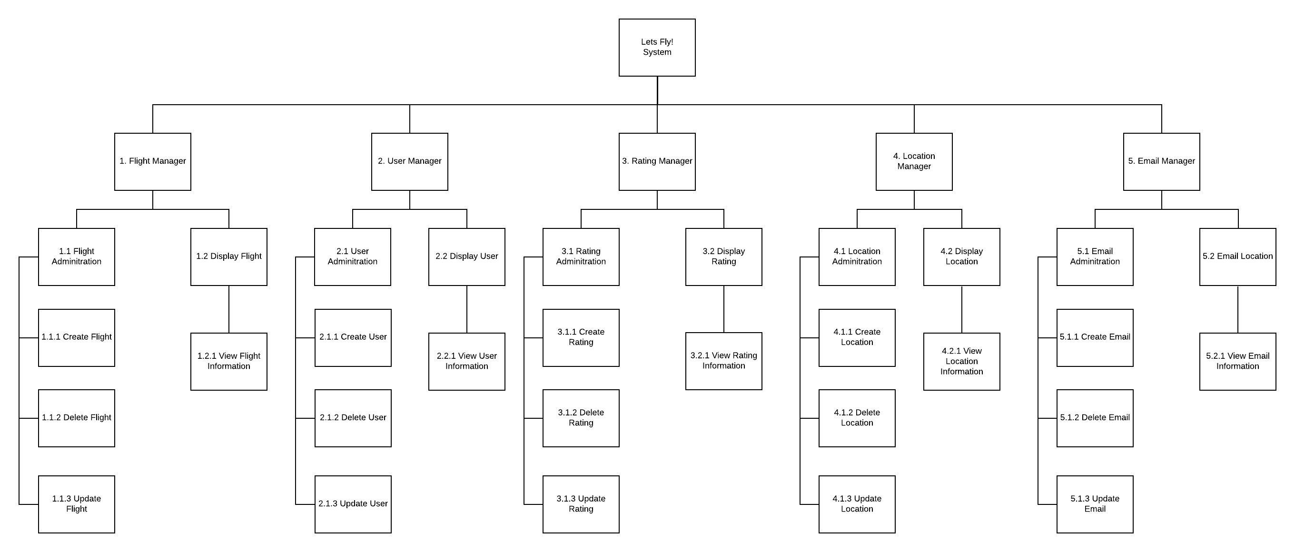

1. **Usability Design Review**
2. Navigation-

Easy to navigate website, with different ways of using the website, for example different tabs for users, flights, check booking, hidden admin login and easy to access login and registration page.

1. Familiarity-

The website is familiar to other flight booking websites, with different sections offering different functionalities. The website will have a similar user interface with login, registration and booking home page.

1. Consistency-

The website will be consistent, the fights page will have a steady view of different flights available based on dates, followed by logos of the airline and a review page for the user to review airlines and flights.

1. Error Prevention

The website will have multiple validations for users when logging in, there will be a label displaying mistakes to the user, if the user inputs a date prior to the current date then a red label will appear telling the user to re-enter correct information.

1. Feedback

The website will give feedback in the form of images and sounds. For example, when the user confirms a flight booking the color of the button will change and a notification will appear saying booking confirmed.

1. Visual Clarity

All data will have a clear visual view to the customer and admin, like the flight list will be shown clearly one after the other and the poplar destinations will be shown in a graph form.

1. Flexibility

The website will have flexibility to show more data to the user like most popular flights or highest rated airlines to pick and choose based on the popular consensus.

References:

<https://enginess.io/insights/6-principles-design-la-donald-norman>

http://architectingusability.com/2012/06/28/donald-normans-design-principles-for-usability/

1. **Checklist of site functionality**

|  |  |
| --- | --- |
| **1. (Layout Page)** | **TICK**  **if complete** |
| Good Design | x |
| Stylesheet | x |
| JavaScript | x |
| Menu | x |
|  |  |
| **2. (Home page)** |  |
| Design and content | x |
| Banner Image | x |
|  |  |
| **3. (User Log in)** |  |
| Web form and validation controls | x |
| Formatted data entry display | x |
| Overall page design | x |
|  |  |
| **4. (Customised Views and Controllers)** |  |
| Customised Views | x |
| Customised Controllers | x |
| Other customisations | x |
|  |  |
| **5. (Documentation)** |  |
| Code Comments | x |
| Attribution of Source of any code used | x |
|  |  |
| **6 Business Requirements** |  |
| **BR(A1): for C to C+** | x |
| **BR(A2): for C to C+** | x |
| **BR(B1): for C to C+** | x |
| **BR(B2): for C to C+** | x |
| **BR(C1): for C+ to C++** | x |
| **BR(C2): for C+ to C++** | x |
| **BR(C3): for C+ to C++** | x |
| **BR(D1): for D to D++** | x |
| **BR(D2): for D to D++** | x |
| **BR(D3): for D to D++** | x |
| **BR(D4): for D to D++** | x |
| **BR(E1): for HD to HD+** |  |
| **BR(E2): for HD to HD+** | x |
| **BR(E3): for HD to HD+** | x |
| **BR(E4): for HD to HD+** |  |
| **BR(E5): for HD to HD+** | x |
|  |  |
| **Audit** |  |
| No breaking of copyright |  |

**Additional Distinction Level (the above and the following)**

1. **Your selected approach when constructing the application.**

For constructing the application, I used Model First approach. This approach was used because I found it easier than the code first approach, as all my controllers and models would generate automatically, as well as my database. I avoided using the database first approach because if I had to update my database, I would have to drop my models and change my controllers and views to reflect the change in the database, this would be tedious. Therefore, I chose to go with the model first approach.

1. **Class Diagram or Entity Relation Diagram** (If you are using the Model First or Code First approach, you will need to provide a class diagram. An Entity Relationship Diagram (ERD using Crows Feet or Chen Notation) should be provided if you decide to use the Database First methodology.)

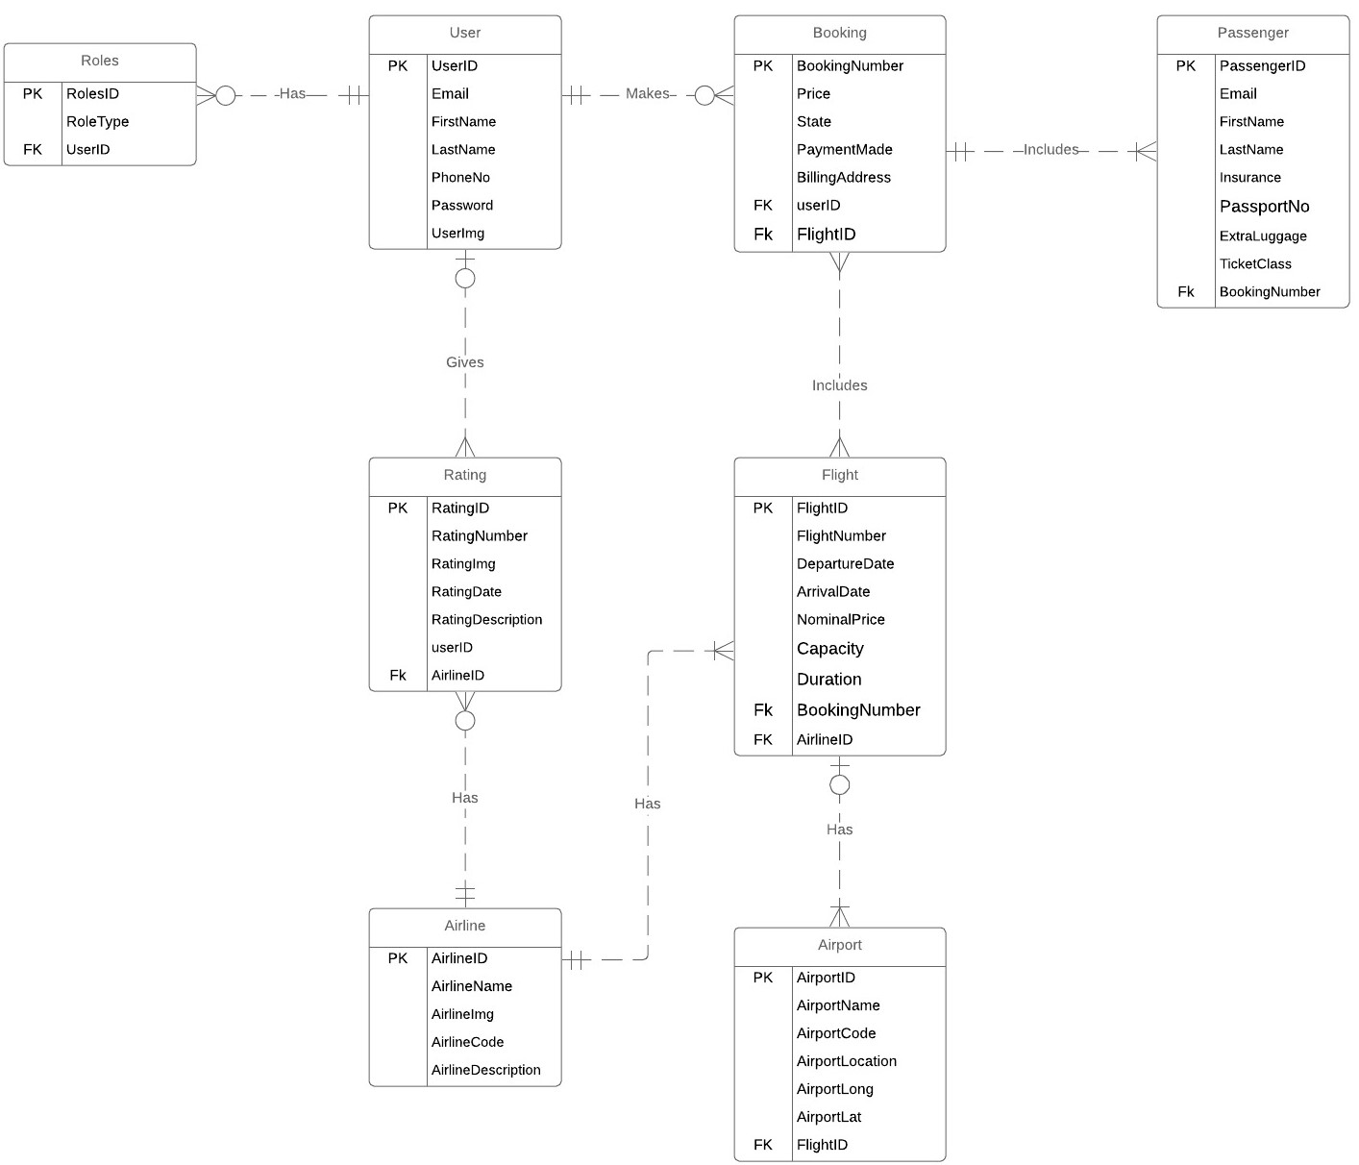

1. **Data dictionary** (This includes the justification of the data types which you use)

|  |  |  |  |  |
| --- | --- | --- | --- | --- |
| **Entity Name** | **Attributes** | **Description** | **Data Type & Length** | **Example** |
| User | UserID | Unique user identifier | nvarchar(128) | 16cfafb0-5bd8-48f5-8347-1dc89ffec2e7 |
| Email | User Email | NVARCHAR (256) | sheridangomes@ymail.com |
| FirstName | User first name | NVARCHAR (MAX) | sheridan |
| LastName | User last name | NVARCHAR (MAX) | gomes |
| PhoneNo | Phone number of the user | NVARCHAR (MAX) | 423143299 |
| Password | Password of the user | NVARCHAR (MAX) | ********* |
| UserImg | User profile image | NVARCHAR (MAX) | Sherry_img.jpg |
| Booking | BookingNumber | Unique booking identifier | INT | 1001 |
| Price | Price of the booking | NVARCHAR (MAX) | 250 |
| State | State of the booking | NVARCHAR (MAX) | Active |
| PaymentMade | PaymentMade for the booking | Bit | 0 or 1 |
| BillingAddress | Billing address for the booking | NVARCHAR (MAX) | Max street, clayton, Melbourne, 3029 |
| Passenger | PassengerID | Unique passenger identifier | Int | 1001 |
| Email | Email of the passenger | NVARCHAR (256) | sheridangomes@ymail.com |
| FirstName | First name of the passenger | NVARCHAR (MAX) | Sheridan |
| lastName | Last name of the passenger | NVARCHAR (MAX) | Gomes |
| Insurance | Passenger insurance | BIT | 0 or 1 |
| PassportNo | Passport number | NVARCHAR (MAX) | AU32450 |
| ExtraLuggage | Extra luggage for the passenger | BIT | 0 or 1 |
| TicketClass | Ticket class for passenger | NVARCHAR (MAX) | Business class |
| Flight | FlightID | Unique flight identifier | Int | 1001 |
| FlightNumber | Flight number for the flight | NVARCHAR (MAX) | VA342 |
| DepartureDate | Departure date for the flight | Datetime | 20/09/2019 |
| ArrivalDate | Arrival date for the flight | Datetime | 20/09/2019 |
| NominalPrice | Price for flight before add-ons | NVARCHAR (MAX) | 230 |
| Capacity | Capacity available on the flight | Int | 200 |
| Duration | Duration of the flight | NVARCHAR (MAX) | 1 hour |
| Airport | AirportID | Unique Airport identifier | Int | 1001 |
| AirportName | Airport name | NVARCHAR (MAX) | Kingford airport |
| AirportCode | Airport code | NVARCHAR (MAX) | SY05 |
| AirportLocation | Location of the airport | NVARCHAR (MAX) | Sydney |
| AirportLong | Notes of the ServiceItem | NVARCHAR (MAX) | -34.09 |
| AirportLat | Status of the ServiceItem | NVARCHAR (MAX) | 235.09 |
| Airline | AirlineID | Unique airline identifier | Int | 1001 |
| AirlineName | Name of the airline | NVARCHAR (MAX) | Virgin airlines |
| AirlineImg | Image of the airline | NVARCHAR (MAX) | virginAirline.jpg |
| AirlineCode | Code of the airline | NVARCHAR (MAX) | VA |
| AirlineDescription | Airline description | NVARCHAR (MAX) | Virgin airlines provides flights to domestic locations |
| Rating | RatingID | Unique rating identifier | Int | 1001 |
| RatingNumber | Rating number | NVARCHAR (MAX) | 4 |
| RatingImg | Image of the rating | NVARCHAR (MAX) | Rating_star.jpg |
| RatingDate | Date of the rating | NVARCHAR (MAX) | 20/09/2019 |
| RatingDescription | Description of the rating | NVARCHAR (MAX) | Great airline, good service |
| Roles | RolesID | Unique Role identifier | Int | 1 |
| RoleType | Role type | NVARCHAR (256) | Admin |

**Additional High Distinction Level (the above and the following)**

1. **Development Methodology** (A description of your development methodology for this portfolio submission. (For example, did you approach the portfolio submission using a Code and Fix method or using a Test Driven Development). Most students are expected to use the Code & Fix model. (This is completely normal for all assignments))
2. **Versioning** (Description of how you handled the versioning of your project. For example, if you have used [Git](https://www.atlassian.com/git/tutorials/what-is-git), [Mercurial](https://www.mercurial-scm.org/), [CVS](https://en.wikipedia.org/wiki/Concurrent_Versions_System), or [SVN](https://subversion.apache.org/). Please provide evidence of your repository if you have done so. (If you did not use it, justify why). It is not a requirement to use these tools but if you have done so, please state it.)