Assignment 4.1

16-bit ALU

**Introduction: -**

**ALU_TOP**is the fundamental building block of the processor, which is responsible for carrying out different functions: -

**- Arithmetic** functions through **ARITHMETIC_UNIT** block.

**- Logic** functions through **LOGIC_UNIT** block.

**- Shift** functions through **SHIFT _UNIT** block.

**- Comparison** functions through **CMP_UNIT** block.

And **Decoder Unit** responsibles for enable which Function to operate according to the highest Most significant **2-bit** of the ALU_FUNC control bus **ALU_FUNC [3:2].**

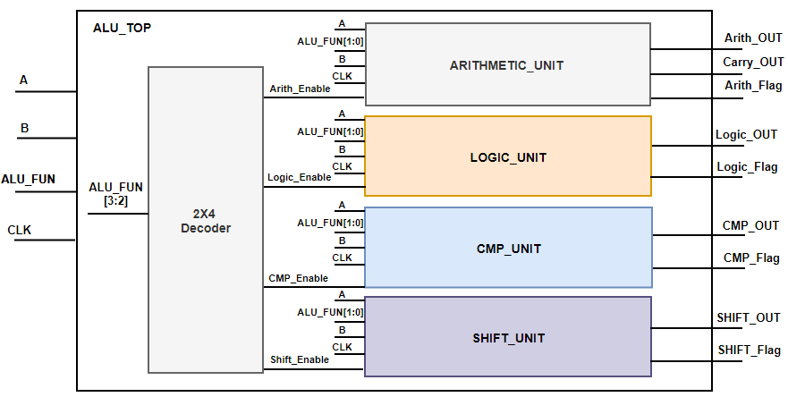**Block Diagram**

**TOP Module (ALU_TOP) Port Description**:

|  |  |
| --- | --- |
| Width (bits) | Signal Name |
| parameterized | A |
| parameterized | B |
| 4 | ALU_FUNC |
| 1 | CLK |
| parameterized | Arith_OUT |
| 1 | Carry_OUT |
| 1 | Arith_Flag |
| parameterized | Logic_OUT |
| 1 | Logic_Flag |
| parameterized | CMP_OUT |
| 1 | CMP_Flag |
| parameterized | SHIFT_OUT |
| 1 | SHIFT_Flag |

**Specifications: -**

* All Outputs are registered.
* **Arith_flag** is activated "High" only when ALU performs one of the arithmetic operations (Addition, Subtraction, Multiplication, division), otherwise "LOW"
* **Logic_flag** is activated "High" only when ALU performs one of the Boolean operations (AND, OR, NAND, NOR), otherwise "LOW"
* **CMP_flag** is activated "High" only when ALU performs one of the Comparison operations (Equal, Greater than, less than) or NOP, otherwise "LOW"
* **Shift_flag** is activated "High" only when ALU performs one of the shifting operations (shift right, shift left), otherwise "LOW"
* The ALU function is carried out according to the value of the **ALU_FUN** input signal stated in the following table.

**ALU_FUN Table**

|  |  |  |
| --- | --- | --- |
| ALU_OUT | Operation | ALU_FUN |
|  | Arithmatic : **Addition** | 0000 |
|  | Arithmatic : **Subtraction** | 0001 |
|  | Arithmatic : **Multiplication** | 0010 |
|  | Arithmatic : **Division** | 0011 |
|  | Logic : **AND** | 0100 |
|  | Logic : **OR** | 0101 |
|  | Logic : **NAND** | 0110 |
|  | Logic : **NOR** | 0111 |
| Equal to 0 | **NOP** | 1000 |
| Equal to 1 | CMP: **A = B** | 1001 |
| Equal to 2 | CMP: **A > B** | 1010 |
| Equal to 3 | CMP: **A < B** | 1011 |
|  | SHIFT: **A >> 1** | 1100 |
|  | SHIFT: **A << 1** | 1101 |
|  | SHIFT: **B >> 1** | 1110 |
|  | SHIFT: **B << 1** | 1111 |

**Hint: Use Case statement to describe the behavior of this table and use default case if needed.**

**Hint: You can use if statement inside case branches.**

**Note: Arith_Enable, Logic_Enable, SHIFT_Enable** and **CMP_Enable** are called block enable which responsible for enabling the function of the block or not.

**Decoder Truth Table**

|  |  |  |  |  |
| --- | --- | --- | --- | --- |
| **SHIFT_EN** | **CMP_EN** | **Logic_En** | **Arith_En** | **ALU_FUNC[3:2]** |
| **0** | **0** | **0** | **1** | **00** |
| **0** | **0** | **1** | **0** | **01** |
| **0** | **1** | **0** | **0** | **10** |
| **1** | **0** | **0** | **0** | **11** |

**Hint: How to use the enable signal inside the code of each block.**

**always @(*)**

**begin**

**if(Arith_Enable)**

**begin**

**case(ALU_FUN)**

**2’b00 : {ALU_Carry, ALU_Arith } = A + B ;**

**………..**

**endcase**

**end**

**else**

**begin**

**ALU_Arith = 16’b0 ;**

**End**

**End**

**Requirements: -**

1. Write a Verilog Codes of the following **6 modules**
   * **ARITHMETIC_UNIT**
   * **LOGIC_UNIT**.
   * **SHIFT _UNIT**
   * **CMP_UNIT**
   * **Decoder Unit**
   * **ALU_TOP**
2. Write a testbench to test all the ALU functions with operating clock frequency 100 KHz with duty cycle 40% low and 60% high

