**Printr Test Guide**

1. Install all packages required using the command (npm install)
2. Run the server using the command (node app.js)
3. To browse the app navigate to <http://localhost:8080/static/index.html>

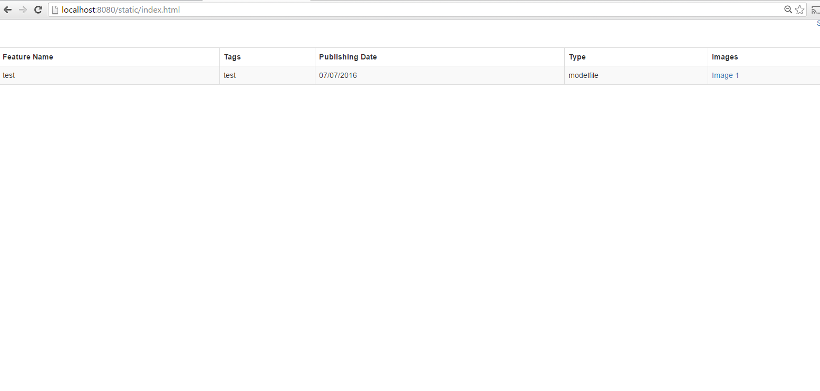

1. Create an admin user by using PostMan and post on the endpoint <http://localhost:8080/AddFeature>

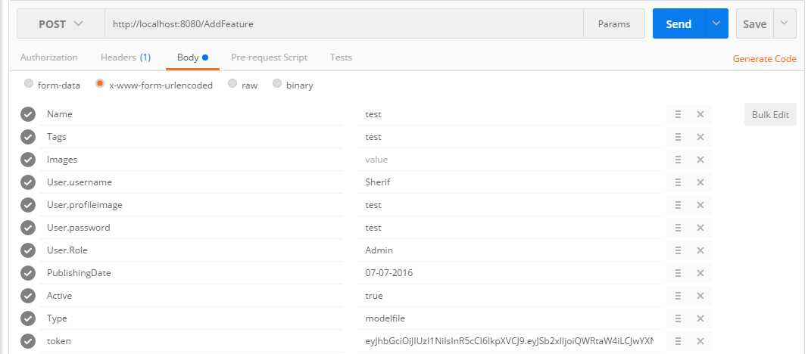

1. Sign in using the user name and password used to create the dummy feature

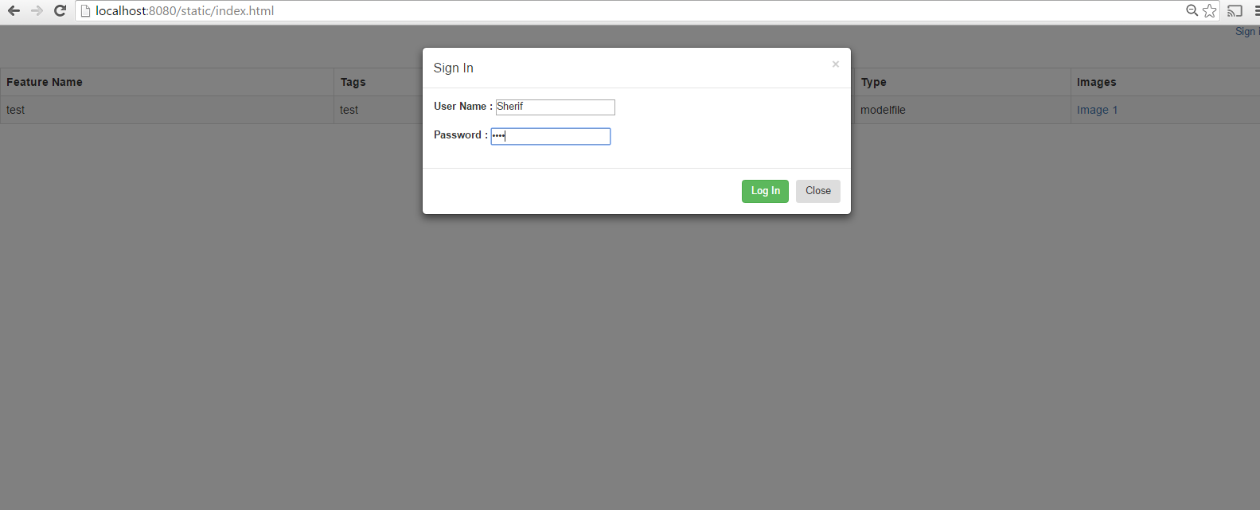

1. You will be redirected to the admin page

