Compliance-Constrained Semantic Fingerprinting for Detecting Coordinated Synthetic Advocacy in Alternative Nicotine Delivery System Discourse: A Synthetic Proof-of-Concept Study
Original research
Authors: [Author One]¹, [Author Two]², [Author Three]¹ [author names and ORCID identifiers to be completed on submission]
Affiliations:
¹ Tobacco Control Research Group, Department for Health, University of Bath, Bath, UK
² [Department of Computer Science / Computational Social Science unit], [Institution], [City], [Country]
Correspondence to: [Corresponding Author], Tobacco Control Research Group, Department for Health, University of Bath, Claverton Down, Bath BA2 7AY, UK; [email@institution.ac.uk]
Word count: approximately 4,500 words (main text, excluding abstract, tables, figure legends and references).
Tables: 3. Figures: 5.
Keywords: Surveillance and monitoring; Public policy; Electronic nicotine delivery devices; Advocacy; Social marketing.

Abstract
Background and significance. Generative language models make it inexpensive to produce large volumes of fluent, individually plausible social-media posts that promote alternative nicotine delivery systems (ANDS) while staying within the bounds of advertising and marketing rules. Existing detectors of machine-generated text and of coordinated inauthentic behaviour each have well-documented weaknesses when used alone. We propose and test, under controlled conditions, a privacy-preserving, cluster-level method—Compliance-Constrained Semantic Fingerprinting (CCSF)—that combines linguistic, behavioural and semantic signals rather than relying on any single one.
Methods. We generated a fully synthetic, seeded corpus of 524 posts from 78 simulated accounts across eight ANDS policy topics, comprising organic users (including fluent harm-reduction advocates as hard negatives), a coordinated synthetic-advocacy campaign, legitimate professional advocacy, and human-edited synthetic posts. For each account we derived five anonymised, aggregate feature families: language-model perplexity (with its within-account variance), sentence-length burstiness, lexical compliance regularity, stance variance, and embedding-space convergence; the equal-weight composite anomaly score used five scalar inputs (mean perplexity, burstiness, compliance density, stance variance, convergence). We assessed group differences (Mann-Whitney U, Cliff's delta), single-feature and composite detection performance (area under the receiver-operating-characteristic curve, AUC, with bootstrap 95% confidence intervals), feature importance by leave-one-out ablation, and unsupervised separability.
Results. In this synthetic corpus, coordinated synthetic accounts showed markedly lower perplexity (Cliff's delta = -1.00 versus organic), lower perplexity variance, lower sentence-length burstiness, higher compliance-term density and higher semantic convergence; stance variance did not differ (delta = -0.10, p = 0.56). A five-feature composite separated synthetic from human accounts with AUC = 0.989 (95% CI 0.965-1.00; logistic-regression cross-validated AUC = 0.975, SD 0.028) and still achieved AUC = 0.935 for the hardest, human-edited case. Compliance regularity was the most important single contributor in ablation; perplexity and convergence were the strongest individual features (AUC 0.989 and 0.948), whereas stance variance performed at chance (AUC 0.50). Coordinated accounts combined low lexical overlap with high semantic similarity, a pattern we term coordinated originality.
Conclusions. In a transparent simulation, a compliance-aware, multi-signal fingerprint identified coordinated synthetic ANDS advocacy more reliably than any single signal, while operating only on de-identified, aggregate cluster-level features (privacy preservation is a design property of the pipeline rather than something tested empirically here). The approach is offered as a hypothesis-generating surveillance aid for tobacco-control researchers and regulators, not as a validated detector and not for attributing or penalising individuals. Because the generator was built to express the same regularities the detector measures, these results establish construct validity rather than operational accuracy; validation on independent generators and real platform data is the essential next step.

Key messages
What is already known on this topic
- The tobacco and nicotine industries and affiliated third parties have a long record of using ostensibly independent voices and digital campaigns to shape policy debate, including around alternative nicotine delivery systems (ANDS).
- Generative language models now allow fluent, low-cost, individually plausible advocacy content to be produced at scale; existing detectors of machine text and of coordinated inauthentic behaviour each have important limitations when used in isolation.

What this study adds
- It introduces and tests, in a transparent fully synthetic simulation, a privacy-preserving method that flags clusters whose aggregate features are consistent with coordinated synthetic advocacy, by combining language-model perplexity, burstiness, compliance-term regularity, stance variance and semantic convergence.
- Combining signals out-performed every single signal; compliance regularity and semantic convergence were especially informative, while stance variance was uninformative—an instructive negative result. Because the synthetic data were built to express these signals, the findings show construct validity, not real-world accuracy.

How this study might affect research, practice or policy
- The method offers tobacco-control researchers and regulators a hypothesis-generating surveillance aid that flags suspicious clusters for human review without profiling or penalising individuals.
- Because legitimate professional advocacy was distinguishable from coordinated synthetic advocacy, the approach may help protect genuine public-health voices while supporting enforcement of marketing and disclosure rules.

Introduction
Tobacco-industry influence on public debate has historically relied on third parties—front groups, sponsored researchers and apparently grassroots organisations—whose ties to commercial interests are not always disclosed.[1-5] These techniques have been documented across decades and jurisdictions, including in low- and middle-income countries where regulatory capacity is often weaker.[3,4] Contemporary analyses show that the same playbook has migrated to digital platforms and to the marketing of alternative nicotine delivery systems (ANDS) such as e-cigarettes and heated-tobacco products, where the framing of ‘harm reduction’ and ‘adult choice’ features prominently.[6,7,8]
Social-media platforms are now central to ANDS promotion and to the policy conversations that surround them.[9,10] Studies have mapped influencer networks, branded promotion and the circulation of vaping content, and have linked coordinated online mobilisation to regulatory debates.[11,12,13,14] Investigations of organisations such as consumer-vaping advocacy networks have raised concerns that some apparently spontaneous campaigns are organised and resourced in ways that are not transparent to the public.[15,16] Distinguishing genuine consumer and public-health advocacy from organised, undisclosed campaigning is therefore a recognised challenge for tobacco-control surveillance.[7,8,16]
Two largely separate technical literatures bear on this problem. The first concerns the detection of coordinated inauthentic behaviour: methods that infer organisation from synchronised posting, shared links, near-duplicate content or unusual network structure.[17-24] The second concerns the detection of machine-generated text, including zero-shot approaches based on a model’s own probability estimates and stylometric classifiers.[27-33] Both literatures report a consistent lesson: single-signal detectors are brittle. Coordination detectors that rely on near-duplication can be defeated by paraphrase; machine-text detectors degrade sharply under light human editing or paraphrase attacks, and several high-profile classifiers have been withdrawn or shown to be unreliable.[28,30,31,33,34] Recent tobacco-control scholarship has explicitly called for better methods to identify automated or coordinated communication in nicotine-product discourse.[25,26]
A further, under-appreciated complication is specific to a regulated product. Advocacy that is designed to influence ANDS policy has an incentive to remain within advertising and marketing rules, for example by avoiding explicit health claims and by using a consistent, compliant vocabulary. Paradoxically, the very discipline that keeps coordinated messaging lawful may also make it unusually regular: low in linguistic surprise, low in stylistic variability and tightly clustered in meaning. We hypothesised that this regularity is detectable in aggregate, without identifying or profiling any individual, by combining complementary signals rather than relying on any one.
We therefore propose Compliance-Constrained Semantic Fingerprinting (CCSF): a cluster-level, privacy-preserving approach that characterises a group of accounts using five anonymised feature families—language-model perplexity and its variance, sentence-length burstiness, lexical compliance regularity, stance variance and embedding-space convergence—and combines them into a single anomaly score. The method is deliberately conservative: it operates on de-identified, aggregate features, it is intended to flag clusters for human review rather than to attribute authorship, and it treats legitimate advocacy as a class to be protected, not suppressed.
Because real coordinated campaigns are, by design, unlabelled, we evaluate the approach here in a transparent, fully synthetic simulation in which ground truth is known by construction. This proof-of-concept design lets us quantify how well each signal and the combined fingerprint separate coordinated synthetic advocacy from organic users, from legitimate professional advocacy, and from the hardest case of human-edited synthetic content. We address four questions: (RQ1) do coordinated synthetic accounts differ from organic users on the proposed features, and in the hypothesised directions? (RQ2) does a combined fingerprint outperform single signals? (RQ3) which signals matter most? and (RQ4) can the method distinguish coordinated synthetic advocacy from legitimate professional advocacy?

Methods

Study design and overview
We conducted a controlled simulation study. All data were generated synthetically; no human participants, real accounts, or scraped platform data were involved. The design follows a validation strategy proposed for this kind of surveillance method, in which a corpus with known ground truth is constructed so that detection performance can be measured directly. The full analysis pipeline is summarised in figure 1. All randomness was controlled by a fixed seed (20260604) so that the corpus and every result are exactly reproducible.
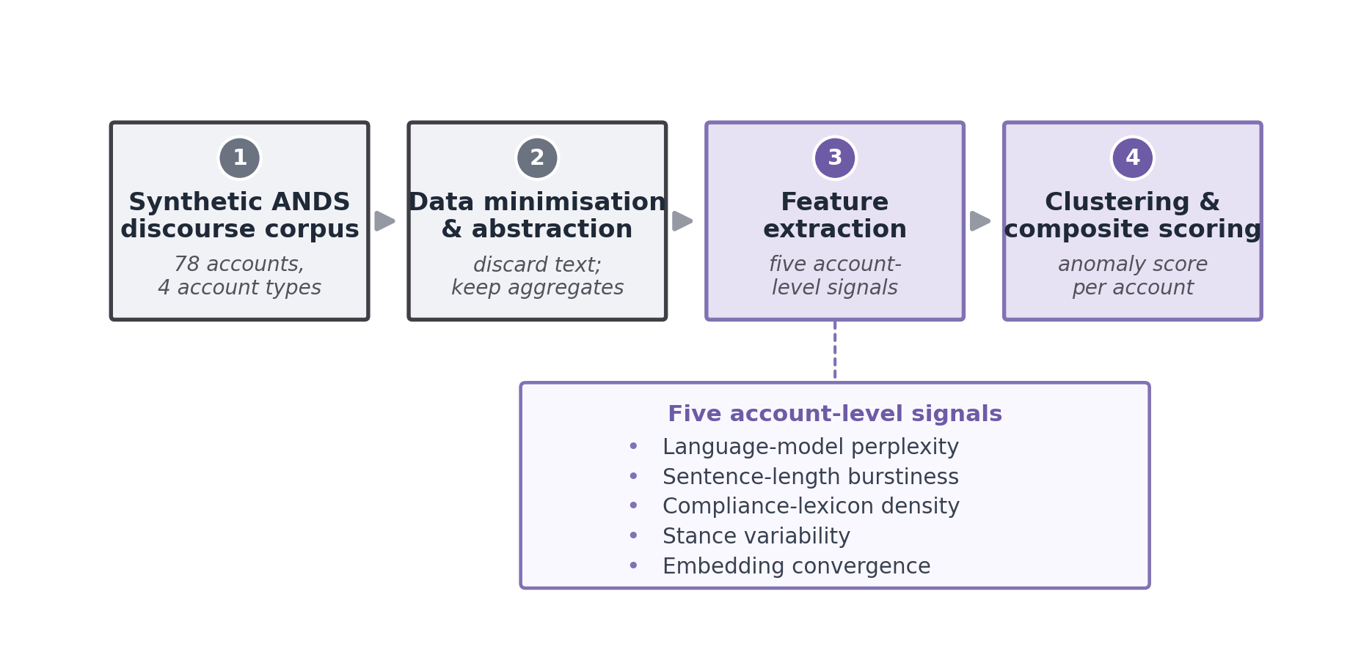
Figure 1. The four stages of the Compliance-Constrained Semantic Fingerprinting (CCSF) pipeline as applied in this study. A fully synthetic corpus with four account types is reduced to de-identified, account-level aggregates, from which five feature families are extracted (language-model perplexity [account mean and within-account variance], sentence-length burstiness, compliance-lexicon density, stance variability, and embedding-space convergence). Standardised features are combined into a composite anomaly score and evaluated against known ground truth using effect sizes, ROC analysis, ablation and clustering. In operational deployment—not part of this study—the highest-scoring clusters would be routed to human expert review rather than labelled automatically; the pipeline retains no usernames, post text or individual-level identifiers in its output.

Synthetic corpus
The corpus contained 524 posts written by 78 accounts, distributed across eight ANDS-relevant policy topics (for example flavour restrictions, taxation, advertising rules, and harm-reduction framing). Four account types were generated to represent the classes a real surveillance system must separate (table 1):
- Organic users (40 accounts, 200 posts) — heterogeneous individual voices. To create demanding ‘hard negatives’, roughly 30% were fluent harm-reduction advocates who naturally use compliance-style vocabulary, about 15% wrote in a formal register, and the remainder wrote casually with slang, typographical errors and emoji.
- Coordinated synthetic advocacy (16 accounts, 160 posts) — generated by a talking-point engine that drew from a shared pool of twelve core propositions, each available in four paraphrases. Each campaign account used a 6–9 proposition subset, so the messaging was semantically convergent but lexically non-duplicative, with a compliant vocabulary woven throughout.
- Legitimate professional advocacy (12 accounts, 84 posts) — specific, evidence-oriented messaging of the kind produced by clinicians or non-governmental organisations, included as a specificity control so that the method could be tested for false positives against real public-health voices.
- Human-edited synthetic (10 accounts, 80 posts) — synthetic content lightly rewritten to introduce human variation, representing the realistic and hardest-to-detect adversarial case.
This construction reflects a deliberately conservative test: organic harm-reduction advocates share vocabulary with the synthetic campaign, and professional advocates are highly consistent, so neither vocabulary nor consistency alone can succeed.

Feature extraction
Language-model perplexity (P) and its variance. For every post we computed perplexity under a pretrained autoregressive language model (GPT-2), a standard measure of how ‘surprising’ a text is to a general model of language.[35] Highly templated or model-generated text tends to be less surprising, giving lower perplexity. For each account we recorded the mean perplexity and the within-account variance of perplexity. We treat perplexity as a feature family: the account-level mean enters the composite score, while the within-account variance is reported descriptively (and as a robustness indicator) but is not added to the composite, to avoid double-weighting the perplexity family.
Sentence-length burstiness (B). We measured the coefficient of variation of sentence length within each account. Human writing is typically uneven (bursty); templated generation is often more uniform, giving a lower coefficient of variation.
Lexical compliance regularity (L). Using a fixed lexicon of seventeen industry/commercial-framing terms and phrases (for example ‘harm reduction’, ‘adult choice’, ‘evidence-based’, ‘reduced-risk’), we computed the per-word density of these terms for each account. The lexicon was specified in advance and applied identically to all accounts; each phrase was matched independently on word boundaries (a single, documented matching rule). A density of zero therefore means no matches to this pre-specified framing lexicon, not an absence of policy or public-health vocabulary.
Stance variance (S). Each post was scored for stance using similarity to fixed semantic anchors, and we recorded the within-account variance of stance. Coordinated messaging was expected to vary less.
Embedding-space convergence (E). Posts were embedded with a sentence-embedding model (all-MiniLM-L6-v2).[36] For each account we computed the mean pairwise cosine similarity among that account’s own posts (an intra-account measure), capturing how tightly an account’s content clusters in meaning. Coordinated messaging that repeats a small set of talking points is expected to show higher intra-account convergence than organic posting.
Anonymisation. All five features are account-level aggregates. In a deployment setting the pipeline can be configured to discard post text after feature extraction and to retain only de-identified numeric summaries, with no usernames, post text or individual-level identifiers in its output, consistent with the method’s privacy-preserving design and with guidance on protecting public-health activity from interference.[1] For this study, by contrast, the fully synthetic post text is deliberately shared in the reproducibility package to permit exact audit and replication; because the corpus is synthetic, it contains no real accounts or personal data. Privacy preservation is thus a design property of the operational pipeline rather than a claim tested empirically here.

Composite anomaly score
The composite uses five scalar inputs—mean perplexity, sentence-length burstiness, compliance density, stance variance and embedding convergence (perplexity variance is excluded, as noted above). Each input was standardised (z-scored) across accounts and oriented so that higher values indicate the hypothesised coordinated pattern: lower perplexity, lower burstiness, higher compliance density, lower stance variance and higher convergence. The composite anomaly score for an account is the mean of its five oriented standardised inputs. We report results for this equally weighted composite to avoid overfitting weights to this particular corpus; using the mean rather than the sum sets the score on an interpretable scale and does not affect any AUC.

Statistical analysis
Group differences were tested at the account level with the Mann-Whitney U test and quantified with Cliff’s delta, a non-parametric effect size bounded between -1 and 1. Given the number of feature-by-comparison tests in this proof-of-concept, we treat p-values as descriptive evidence of separation under the simulation rather than as confirmatory tests of population-level hypotheses, and we emphasise effect sizes and AUCs. Detection performance was summarised by the area under the receiver-operating-characteristic curve (AUC) for single features and for the composite score; for the two headline composite targets we report bootstrap 95% confidence intervals (2000 resamples, stratified by class). The composite was additionally validated by five-fold cross-validated logistic regression trained to separate coordinated synthetic accounts from all other account types (organic, professional and the human-edited synthetic group together), so that the human-edited synthetic accounts act as a difficult non-target class. Feature importance was assessed by leave-one-out ablation (removing one input and re-computing the equally weighted composite AUC). Unsupervised structure was examined with k-means (k = 4) and DBSCAN on the standardised features, summarised by silhouette, cluster purity and the adjusted Rand index. t-distributed stochastic neighbour embedding (t-SNE) was used for visualisation only and does not constitute independent evidence of separability; all quantitative analyses are account-level.[37] Coordination realism was checked by comparing within-group lexical overlap (Jaccard) against semantic similarity (cosine). Analyses used Python with scikit-learn, transformers and sentence-transformers.[36,38] Code and the synthetic corpus generator are available (see Data availability).

Ethics and data
No human participants or personal data were involved; all text was synthetically generated for methodological evaluation, so research-ethics approval was not required, although applicable ethics requirements should be confirmed with the authors’ institution before any extension to real data. The method is explicitly designed for aggregate, cluster-level surveillance and not for identifying, profiling or penalising individuals. We discuss the attendant ethical considerations, including the risk of misclassifying genuine advocacy, in the Discussion.

Results

Corpus composition
Table 1 summarises the simulated corpus. The four account types span the realistic spectrum from heterogeneous organic users to a tightly coordinated synthetic campaign, with legitimate professional advocacy and human-edited synthetic content as the two most demanding comparison classes.
Account type | Accounts | Posts | Role in evaluation
Organic users | 40 | 200 | Heterogeneous humans; ~30% fluent harm-reduction advocates as hard negatives
Coordinated synthetic | 16 | 160 | Target class: talking-point campaign, convergent but non-duplicative
Professional advocacy | 12 | 84 | Legitimate NGO/clinician voices; false-positive control
Human-edited synthetic | 10 | 80 | Hardest adversarial case: synthetic text lightly rewritten by a human
Total | 78 | 524 | Eight ANDS policy topics; seed = 20260604
Table 1. Composition of the synthetic evaluation corpus.

RQ1: Do coordinated synthetic accounts differ from organic users?
Coordinated synthetic accounts differed from organic users on every feature in the hypothesised direction except stance variance (table 2; figure 2). Synthetic accounts had much lower perplexity (mean 100 vs 295; Cliff’s delta = -1.00, p < 0.001), indicating far less linguistic surprise, and lower variance of perplexity (delta = -0.89). Their writing was less bursty (coefficient of variation 0.23 vs 0.48; delta = -0.90), more saturated with compliance vocabulary (density 0.054 vs 0.017; delta = 0.75), and more tightly converged in embedding space (0.596 vs 0.376; delta = 0.87). Stance variance did not differ (0.062 vs 0.067; delta = -0.10, p = 0.56), a clear negative result we return to below. A Cliff’s delta of -1.00 for perplexity means the two groups did not overlap at all on that feature in this corpus.
Feature | Organic (mean±SD) | Synthetic (mean±SD) | Prof. (mean±SD) | Cliff's d (syn vs org) | p (syn vs org)
Perplexity (mean) | 295±103 | 100±22 | 158±29 | -1.00 | <0.001
Perplexity (variance) | 52.0k±71.3k | 3.4k±5.0k | 5.9k±7.8k | -0.89 | <0.001
Burstiness (CV) | 0.48±0.15 | 0.23±0.06 | 0.12±0.02 | -0.90 | <0.001
Compliance density | 0.017±0.026 | 0.054±0.014 | 0.000±0.000 | +0.75 | <0.001
Stance variance | 0.067±0.025 | 0.062±0.016 | 0.053±0.014 | -0.10 | 0.56 (NS)
Convergence | 0.376±0.133 | 0.596±0.041 | 0.388±0.047 | +0.87 | <0.001
Table 2. Account-level feature descriptives by group, with effect size (Cliff’s delta) and Mann-Whitney p value for the synthetic-versus-organic comparison. ‘k’ denotes thousands. NS, not significant.

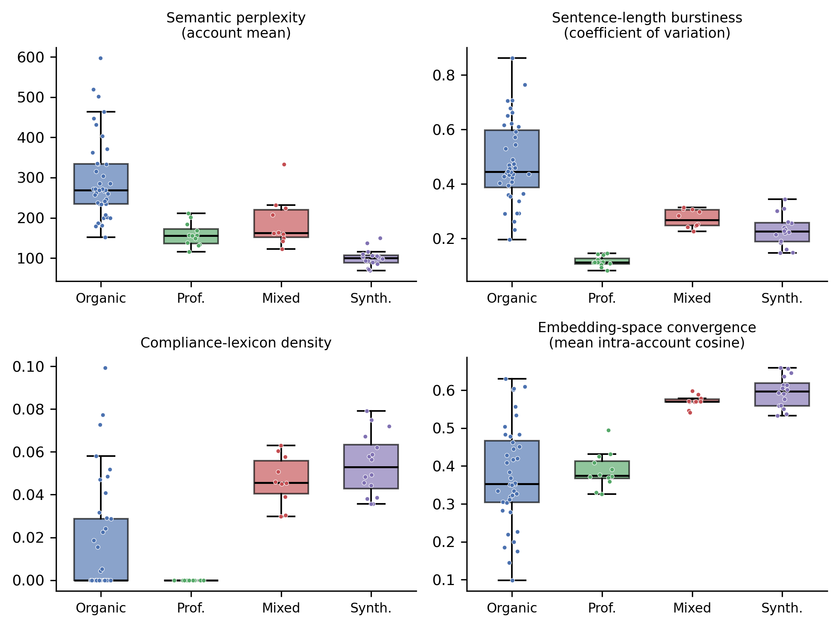
Figure 2. Distributions of four key account-level features by group (perplexity, sentence-length burstiness, compliance-lexicon density and embedding-space convergence). Coordinated synthetic accounts (and, to a lesser degree, human-edited synthetic accounts) show lower perplexity and burstiness, higher compliance density and higher convergence than organic users. Professional advocacy is the smoothest group on burstiness yet uses essentially no compliance vocabulary, illustrating why no single feature suffices. Stance variance (not shown) overlapped across all groups; see table 2.

RQ2: Does a combined fingerprint outperform single signals?
Single features varied widely in discriminative power when separating synthetic accounts from all human accounts (organic plus professional) in this synthetic corpus: perplexity achieved AUC = 0.989 and convergence AUC = 0.948, compliance density AUC = 0.905 and burstiness AUC = 0.732, whereas stance variance was essentially at chance (AUC = 0.50). The equally weighted five-feature composite reached AUC = 0.989 (bootstrap 95% CI 0.965-1.00) against both human classes combined, 0.991 against organic users and 0.984 against professional advocacy (figure 3; figure 4; table 3). A five-fold cross-validated logistic regression on the same features gave AUC = 0.975 (SD 0.028), confirming the result is not an artefact of a single split. Crucially, on the hardest case—human-edited synthetic content versus organic users—the composite still achieved AUC = 0.935, and a broader machine-origin-versus-human comparison (treating both synthetic and human-edited synthetic as machine-origin) gave AUC = 0.957 (95% CI 0.912-0.990). All AUCs are within-corpus estimates under known ground truth and should be read as construct-validity checks rather than expected real-world performance.
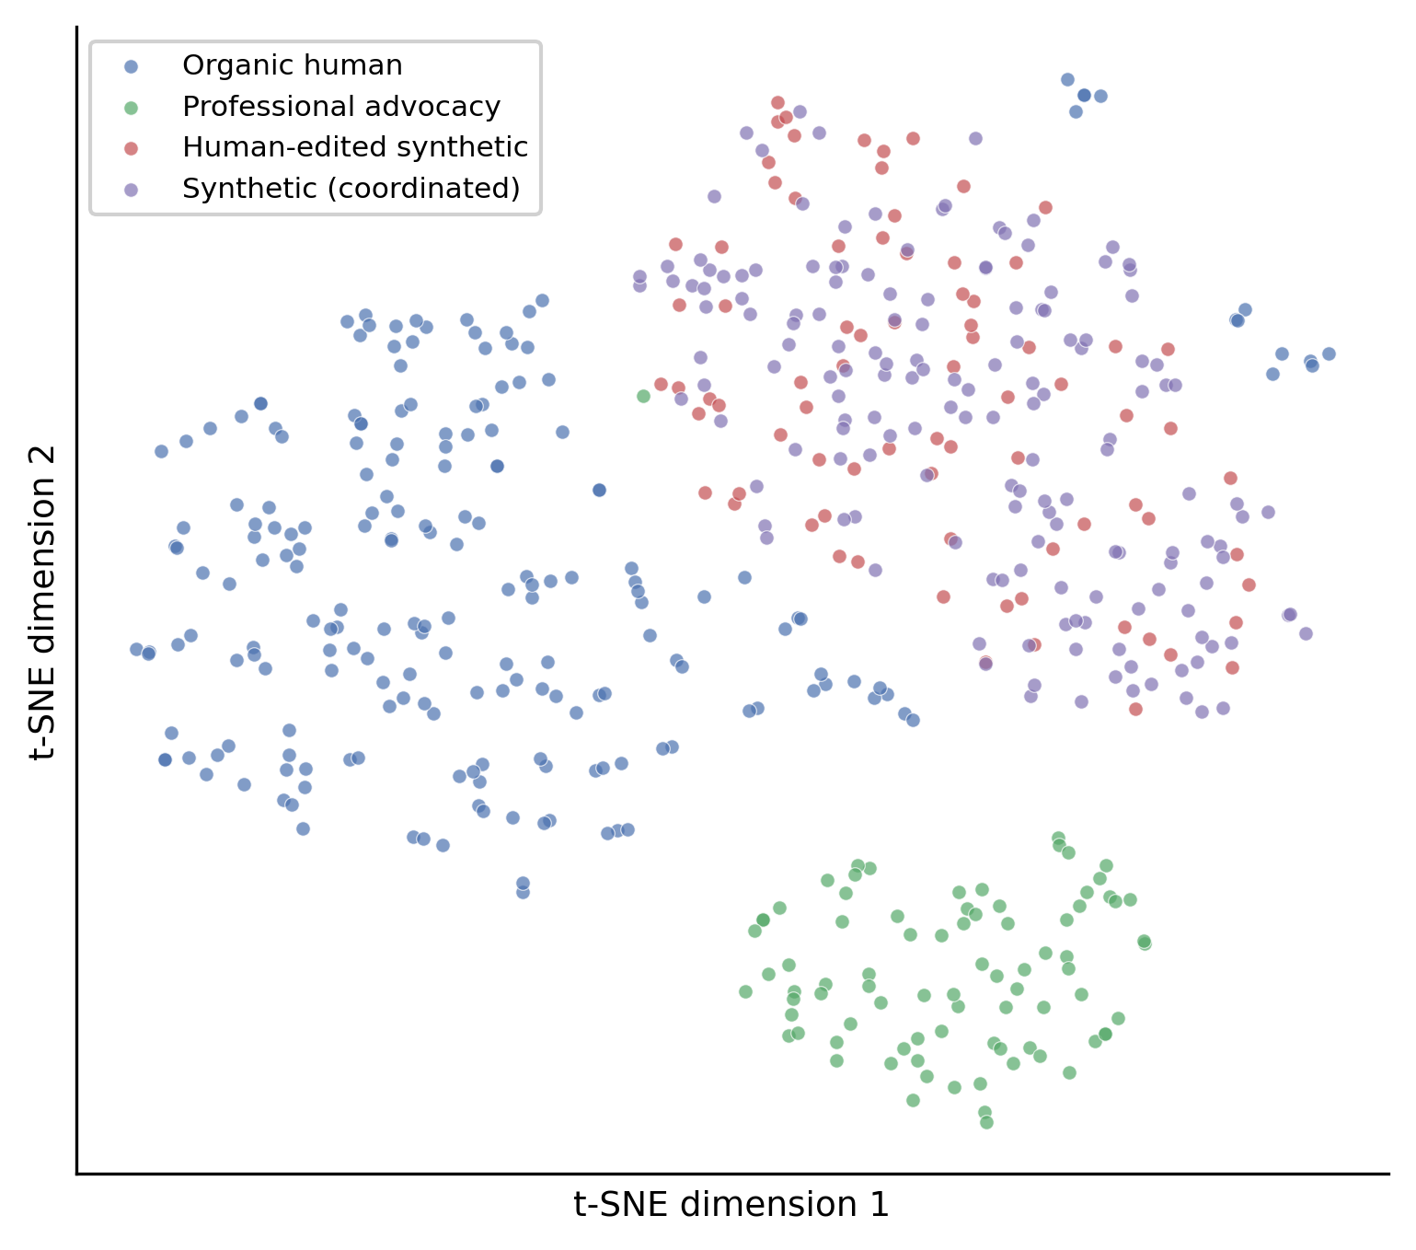
Figure 3. Two-dimensional t-SNE projection of post-level sentence embeddings, coloured by ground-truth group. Coordinated synthetic and human-edited synthetic posts occupy a shared region; professional advocacy forms a separate cluster; organic posts are dispersed, with some sitting near the synthetic region (the fluent harm-reduction advocates that serve as hard negatives). This visualises the semantic convergence that the account-level features quantify.

RQ3: Which signals matter most?
Leave-one-out ablation (table 3) showed that removing compliance regularity caused the largest drop in composite AUC (from 0.989 to 0.938, change -0.052), making it the single most important contributor despite not being the strongest stand-alone feature. Removing burstiness, convergence or perplexity each reduced AUC by a smaller amount (to 0.962, 0.964 and 0.968 respectively). Removing stance variance slightly improved performance (to 0.995, change +0.006), consistent with its at-chance individual AUC: it added noise rather than signal, and on this evidence stance variance should be treated as exploratory and is a candidate for removal in future models. These findings illustrate the central rationale for CCSF—complementary signals contribute jointly, and the weakest signal can safely be dropped—while also showing that the most useful feature in combination need not be the best in isolation.
Configuration | AUC | Note
Perplexity only | 0.989 | Strongest single feature
Convergence only | 0.948 | Second strongest
Compliance density only | 0.905 | —
Burstiness only | 0.732 | —
Stance variance only | 0.502 | At chance (negative result)
Composite (all five) | 0.989 | Equally weighted; vs all human (95% CI 0.965-1.00)
drop compliance | 0.938 | Largest decrease (-0.052)
drop burstiness | 0.962 | -0.028
drop convergence | 0.964 | -0.025
drop perplexity | 0.968 | -0.022
drop stance variance | 0.995 | Improves (+0.006)
Composite vs organic | 0.991 | —
Composite vs professional | 0.984 | Legitimate-advocacy control
Composite, human-edited vs organic | 0.935 | Hardest adversarial case
Composite, machine-origin vs human | 0.957 | 95% CI 0.912-0.990
Logistic regression (5-fold CV) | 0.975 (SD 0.028) | Synthetic vs all other types
Table 3. Detection performance. AUC for single features, the equally weighted composite, leave-one-out ablations, and cross-validated logistic regression. Unless stated, comparisons are synthetic versus all human accounts (organic plus professional).

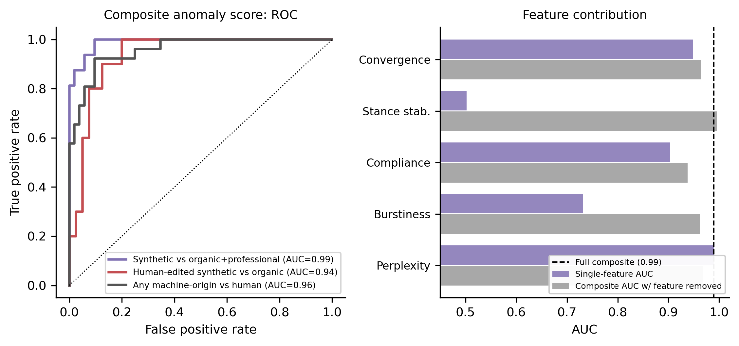
Figure 4. Left: receiver-operating-characteristic curves for the composite score (synthetic versus organic plus professional, AUC 0.99; human-edited synthetic versus organic, AUC 0.94; any machine-origin versus human, AUC 0.96). Right: each feature’s single-feature AUC (purple) alongside the composite AUC when that feature is removed (grey); the dashed line marks the full five-feature composite. Compliance regularity is the most important contributor in combination, whereas removing stance stability slightly improves performance.

RQ4: Can the method separate coordinated synthetic from legitimate professional advocacy?
Professional advocacy was distinguishable from coordinated synthetic advocacy, but for instructive reasons. Professional accounts were actually the smoothest group on burstiness (coefficient of variation 0.12, lower even than the synthetic accounts; Cliff’s delta for synthetic versus professional = +1.00), so a burstiness-only detector would misrank them. What separated them decisively was vocabulary and meaning: professional advocates produced no matches to the pre-specified industry/commercial-framing lexicon (compliance density 0.000; delta = +1.00)—which reflects an absence of that specific framing vocabulary, not an absence of policy or public-health language—and showed much lower intra-account convergence than the synthetic campaign (0.388 vs 0.596; delta = +1.00). The composite therefore separated synthetic from professional accounts at AUC = 0.984 without penalising legitimate, evidence-based advocacy for being internally consistent. This directly addresses the principal false-positive risk for a tobacco-control application.

Coordination realism and unsupervised structure
To confirm that the synthetic campaign was realistic rather than trivially duplicative, we compared lexical overlap with semantic similarity within each group (figure 5). Coordinated synthetic accounts combined low lexical overlap (mean Jaccard 0.135) with high semantic similarity (mean cosine 0.583)—a signature of paraphrased, on-message content we term coordinated originality. Organic users were low on both (0.066, 0.309). Notably, professional advocates had the highest lexical overlap of any group (mean Jaccard 0.145; maximum 0.738), reflecting shared boilerplate, yet remained semantically diffuse—again showing why duplication-based detectors alone can mislabel legitimate advocacy.
Unsupervised analysis was deliberately reported without using labels. K-means (k = 4) gave a silhouette of 0.329, cluster purity of 0.731 and an adjusted Rand index of 0.259: professional advocacy formed its own clean cluster, the coordinated synthetic and human-edited synthetic accounts grouped together with a minority of organic hard-negatives, and the remaining organic users split across clusters. A density-based alternative (DBSCAN) likewise placed most synthetic and human-edited synthetic accounts together while leaving many organic accounts as unclustered noise, consistent with the k-means picture. The modest adjusted Rand index is an honest reflection of how hard fully unsupervised separation is when fluent human advocates deliberately resemble the campaign; it reinforces our framing of CCSF as a tool to prioritise clusters for human review rather than to label accounts automatically.
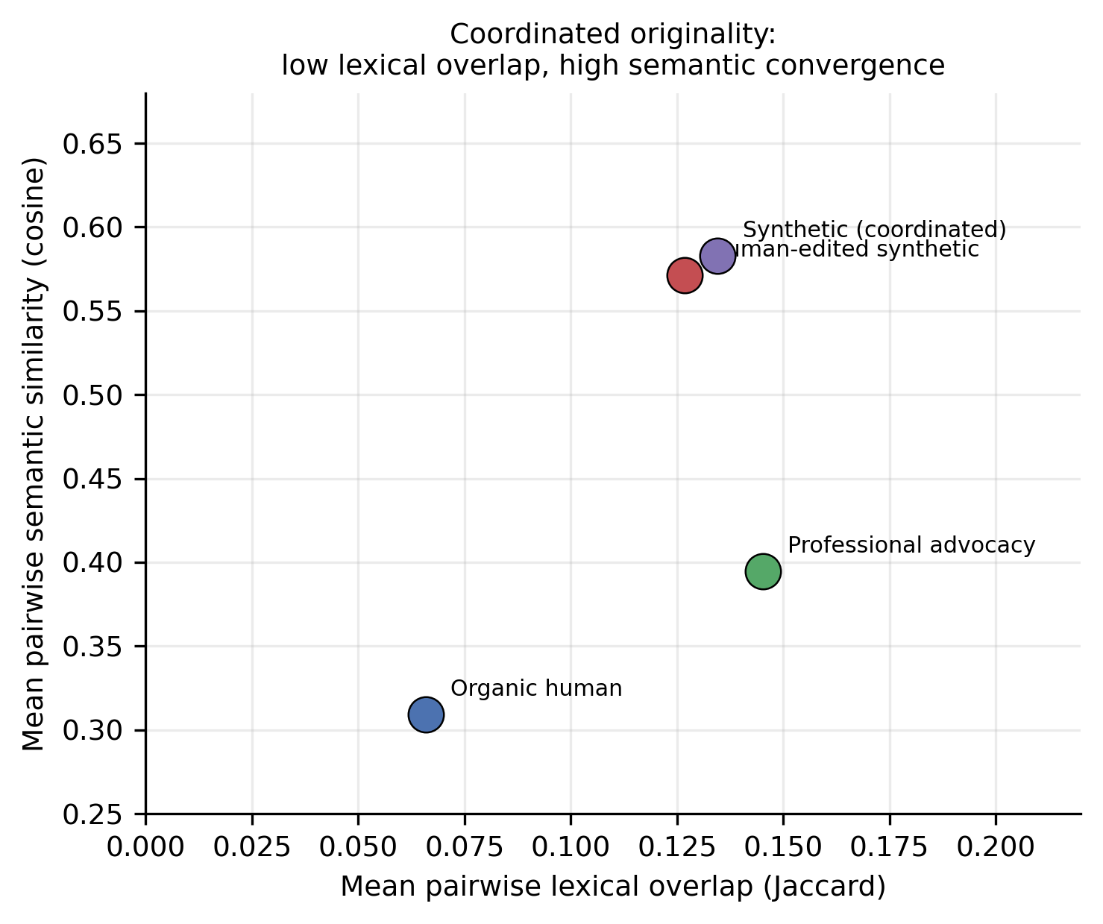
Figure 5. Within-group lexical overlap (Jaccard) versus semantic similarity (cosine). Coordinated synthetic content shows ‘coordinated originality’: low lexical overlap but high semantic convergence. Professional advocacy shows the opposite—higher lexical overlap (shared boilerplate) but diffuse meaning.

Discussion
In a transparent, fully synthetic simulation, a compliance-aware fingerprint that combines language-model perplexity, burstiness, compliance regularity, stance variance and semantic convergence identified coordinated synthetic ANDS advocacy more reliably than any single signal (composite AUC 0.989 in this synthetic corpus; cross-validated 0.975), and retained useful performance against the hardest, human-edited case (AUC 0.935). The method achieved this using only de-identified, account-level aggregate features, consistent with its privacy-preserving design. Because the corpus was generated to instantiate the very regularities the detector measures, these figures should be read as a construct-validity demonstration under known ground truth, not as an estimate of operational accuracy on real platforms.

Principal findings and their interpretation
Three findings have practical significance for tobacco-control surveillance. First, the value of the method lies in combination, not in any single metric. This matters because the wider literature shows single-signal detectors are fragile: machine-text classifiers degrade under paraphrase and editing, and coordination detectors built on duplication can be evaded.[30,31,33,34,39] A multi-signal fingerprint is harder to defeat on every axis at once. Second, compliance regularity—a feature motivated specifically by the regulated nature of nicotine marketing—was the most important contributor in combination, even though perplexity was the strongest single feature. This supports the paper’s core intuition that the discipline required to stay within marketing rules leaves a measurable trace. Third, the method distinguished coordinated synthetic advocacy from legitimate professional advocacy, which is essential if such tools are not to chill genuine public-health speech.
Two negative results are as informative as the positive ones. Stance variance performed at chance and slightly degraded the composite; in this corpus, both coordinated and organic accounts held reasonably steady positions, so stance stability did not mark coordination. And burstiness alone was misleading, because professional advocates were even more uniform than the synthetic campaign. Reporting these honestly is important: it shows which signals genuinely carry weight and guards against over-claiming.

Comparison with existing work
Our approach is complementary to established coordination-detection methods that emphasise synchronised actions, shared links or network structure,[17-24] and to machine-text detection based on model probabilities or stylometry.[27,29,32] By fusing linguistic, behavioural and semantic signals and adding a domain-specific compliance feature, CCSF targets the particular problem of lawful, on-message advocacy for a regulated product, a setting in which both families of single-purpose detector are individually vulnerable. It also responds to explicit calls in the tobacco-control literature for methods to identify automated or coordinated nicotine-product communication.[25,26]

Strengths and limitations
Strengths. The study uses a fully reproducible, seeded design with known ground truth, deliberately demanding comparison classes (fluent organic advocates and legitimate professionals), pre-specified features and lexicon, cross-validation, ablation and an explicit test against the human-edited adversarial case. Results are reported transparently, including features that did not work.
Limitations. The central limitation is one of construct validity: the synthetic campaign was generated by rules designed to instantiate the hypothesised CCSF signals, so the detector was, in effect, evaluated on data built to express the patterns it looks for. The reported AUCs therefore demonstrate that the signals behave as theorised under known ground truth; they are not an estimate of performance on real platforms and should not be cited as such. Several further limitations follow. (i) There has been no real-world validation; absolute performance on real, noisy, multilingual, image- and link-rich, adversarially adaptive discourse will be lower and must be measured directly. (ii) There is no independent human-authored or expert-adjudicated corpus; the organic and professional classes are themselves simulated. (iii) The compliance lexicon was author-specified and has not been externally validated; it is English-language and ANDS-specific and would need localisation and independent construction. (iv) The synthetic sample is small (78 accounts), so confidence intervals are wide and the clustering estimates in particular are unstable. (v) We report discrimination (AUC) but not prevalence-sensitive operating metrics such as precision or false-discovery rate, which in realistic settings—where coordinated accounts are a small minority—would be far less favourable and are essential before any deployment. (vi) Perplexity computed with one pretrained model may shift with model choice and with the generator a real campaign uses, and any deployed detector invites evasion; the multi-signal design raises the cost of evasion but does not eliminate it.

Ethical considerations
Surveillance methods in this space carry real risks: misclassifying sincere consumers or advocates, enabling overreach, or being repurposed against the public-health community itself. We have therefore framed CCSF strictly as an aggregate, cluster-level, hypothesis-generating aid, and we propose explicit governance constraints for any future use. The method should never be used to make public accusations against, or to penalise, individual accounts; its outputs are signals for investigation, not findings. Detection thresholds should be calibrated and audited before use, with documented false-positive analysis and review by domain experts. Use of any such method must comply with platform terms of service and applicable data-protection law, and must be designed so as not to chill legitimate public-health advocates or genuine consumer voices. The demonstrated ability to spare legitimate professional advocacy is a necessary—though not sufficient—safeguard, and was shown only in simulation. We anchor these commitments in guidance on protecting policy-making from commercial interference.[1]

Implications and future work
The immediate priority is validation on labelled real-world data, for example campaigns identified through platform transparency disclosures or investigative reporting, with prospective human adjudication of flagged clusters. Further work should test robustness across languages and platforms, across alternative perplexity and embedding models, and against adaptive adversaries; should explore learned rather than equal feature weights with proper out-of-sample validation; and should integrate CCSF with network-level coordination signals. If validated, the method could give regulators and researchers an early-warning signal that complements, rather than replaces, existing monitoring of tobacco- and nicotine-industry influence.

Conclusion
Coordinated synthetic advocacy for alternative nicotine delivery systems is likely to grow as generative tools become cheaper and more capable. In a fully synthetic proof-of-concept, a privacy-preserving fingerprint that combines linguistic, behavioural and semantic signals—anchored by a domain-specific compliance feature—separated such advocacy from human discourse far more reliably than any single signal, while protecting legitimate professional voices and operating only on de-identified, aggregate data. Because the evaluation used data built to express the detector’s target signals, these results establish construct validity rather than operational accuracy. The approach is offered to the tobacco-control community as a hypothesis-generating surveillance aid whose real value now depends on validation against independent generators and real platform data.

Declarations
Contributors. [To be completed. Example: All authors designed the study. [Author] implemented the simulation and analysis and drafted the manuscript. All authors interpreted the results, revised the manuscript critically, and approved the final version. [Author] is the guarantor.]
Funding. [To be completed. State grant numbers or insert: ‘This research received no specific grant from any funding agency in the public, commercial or not-for-profit sectors.’]
Competing interests. None declared. [Confirm or amend on submission; complete the ICMJE form.]
Patient and public involvement. This computational study used no patient or public data and involved no patient or public participants.
Patient consent for publication. Not applicable.
Ethics approval. Not required: the study used only synthetically generated text and involved no human participants or personal data.
Data availability statement. All data are synthetic and contain no real accounts, platform data or personal data. The full synthetic corpus, corpus-generation code, feature-extraction and figure-generation scripts, derived account-level features, results, the fixed random seed and a verification script are available at [repository URL / DOI to be inserted on deposit, e.g. Zenodo or OSF], enabling exact reproduction of the corpus and all reported statistics.
Provenance and peer review. Not commissioned; externally peer reviewed.

References
1. World Health Organization. Guidelines for implementation of Article 5.3 of the WHO Framework Convention on Tobacco Control on the protection of public health policies with respect to tobacco industry interests. Geneva: WHO, 2008.
2. Hird TR, Gallagher AWA, Evans-Reeves K, et al. Understanding the long-term policy influence strategies of the tobacco industry: two contemporary case studies. Tob Control 2022;31:e1–e10.
3. Gilmore AB, Fooks G, Drope J, et al. Exposing and addressing tobacco industry conduct in low-income and middle-income countries. Lancet 2015;385:1029–43.
4. Apollonio DE, Bero LA. The creation of industry front groups: the tobacco industry and ‘get government off our back’. Am J Public Health 2007;97:419–27.
5. Ulucanlar S, Fooks GJ, Gilmore AB. The Policy Dystopia Model: an interpretive analysis of tobacco industry political activity. PLoS Med 2016;13:e1002125.
6. Savell E, Gilmore AB, Fooks G. How does the tobacco industry attempt to influence marketing regulations? A systematic review. PLoS One 2014;9:e87389.
7. Watts C, Egger S, Dessaix A, et al. New image, same tactics: global tobacco and vaping industry strategies to promote youth vaping. Health Promot Int 2024;39:daae050.
8. Crosbie E, Bialous S, Glantz SA, et al. Tobacco industry strategies to influence the regulation of new and emerging tobacco and nicotine products in Latin America and the Caribbean. Rev Panam Salud Publica 2024;48:e1.
9. O’Brien EK, Hoffman L, Navarro MA, et al. Social media use by leading US e-cigarette, cigarette, smokeless tobacco, cigar and hookah brands. Tob Control 2020;29:e87–e97.
10. McCausland K, Maycock B, Leaver T, et al. The messages presented in electronic cigarette–related social media promotions and discussion: scoping review. J Med Internet Res 2019;21:e11953.
11. Vassey J, Valente T, Barker J, et al. E-cigarette brands and social media influencers on Instagram: a social network analysis. Tob Control 2022. doi:10.1136/tobaccocontrol-2021-056992.
12. Allem JP, Ferrara E, Uppu SP, et al. E-cigarette surveillance with social media data: social bots, emerging topics, and trends. JMIR Public Health Surveill 2017;3:e98.
13. Haupt MR, Li J, Mackey TK. Characterizing vaping industry political influence and mobilization on Facebook: social network analysis. J Med Internet Res 2021;23:e28069.
14. Xu Q, Yang Y, Wang Y, et al. Digital surveillance to identify California alternative and emerging tobacco industry policy influence and mobilization on Facebook. Int J Environ Res Public Health 2021;18:9140.
15. Silver N, Kucherenko Y, Vallone D, et al. The influence of provaping ‘gatewatchers’ on the dissemination of COVID-19 misinformation on Twitter: analysis of Twitter discourse regarding nicotine and the COVID-19 pandemic. J Med Internet Res 2022;24:e36180.
16. Evans-Reeves K, Dance S, Gilmore AB. Worldwide news and comment: investigations reveal lobbying activities of supposed grassroots movements (World Vapers’ Alliance) are tobacco-industry funded. Tob Control 2022;31:139–41.
17. Giglietto F, Righetti N, Rossi L, et al. It takes a village to manipulate the media: coordinated link sharing behavior during 2018 and 2019 Italian elections. Inf Commun Soc 2020;23:867–91.
18. Sharma K, Zhang Y, Ferrara E, et al. Identifying coordinated accounts on social media through hidden influence and group behaviours (AMDN-HAGE). In: Proc. 27th ACM SIGKDD Conf. Knowledge Discovery and Data Mining. New York: ACM, 2021:1441–51.
19. Weber D, Neumann F. Amplifying influence through coordinated behaviour in social networks. Soc Netw Anal Min 2021;11:111.
20. Smith DH, Ehrett C, Vishwamitra N, et al. Unsupervised detection of coordinated information operations in the wild. EPJ Data Sci 2024;13:14.
21. Magelinski T, Carley KM. Synchronized action framework for detection of coordination on social media. J Online Trust Saf 2022;1(4).
22. Graham T, Bruns A, Angus D, et al. The coordination network toolkit: a framework for detecting and analysing coordinated behaviour on social media. J Comput Soc Sci 2024;7:1–26.
23. Nwala AC, Flammini A, Menczer F. A language framework for modeling social media account behavior (BLOC). EPJ Data Sci 2023;12:33.
24. Loru E, Nudo G, Di Marco N, et al. A compression-based approach to detecting automated and coordinated behavior on social media. ACM Trans Knowl Discov Data 2025.
25. Lee EW, Bao H, Wang Y, et al. An analysis of arguments advanced via Twitter in an advocacy campaign to promote electronic nicotine delivery systems. Nicotine Tob Res 2022;24:1953–61.
26. Li Z, Xu Y, Chen L, et al. The dilemma of coordinated communication in China’s e-cigarette governance: a computational discourse analysis of a social media controversy. Tob Induc Dis 2026;24.
27. Mitchell E, Lee Y, Khazatsky A, et al. DetectGPT: zero-shot machine-generated text detection using probability curvature. In: Proc. 40th Int. Conf. Machine Learning (ICML). PMLR 2023;202:24950–62.
28. OpenAI. New AI classifier for indicating AI-written text (subsequently withdrawn for low accuracy). 2023. https://openai.com/index/new-ai-classifier-for-indicating-ai-written-text/ (accessed 2026).
29. Wu J, Yang S, Zhan R, et al. A survey on LLM-generated text detection: necessity, methods, and future directions. Comput Linguist 2025;51:1–66.
30. Sadasivan VS, Kumar A, Balasubramanian S, et al. Can AI-generated text be reliably detected? 2023. arXiv:2303.11156.
31. Chakraborty S, Bedi AS, Zhu S, et al. On the possibilities of AI-generated text detection. 2023. arXiv:2304.04736.
32. Zaitsu W, Jin M. Stylometry can reveal artificial intelligence authorship, but humans struggle: a comparison of human and seven large language models in Japanese. PLoS One 2025;20:e0317460.
33. Shi Z, Wang Y, Yin F, et al. Red teaming language model detectors with language models. Trans Assoc Comput Linguist 2024;12:174–89.
34. Schuster T, Schuster R, Shah DJ, et al. The limitations of stylometry for detecting machine-generated fake news. Comput Linguist 2020;46:499–510.
35. Radford A, Wu J, Child R, et al. Language models are unsupervised multitask learners (GPT-2). OpenAI technical report, 2019.
36. Reimers N, Gurevych I. Sentence-BERT: sentence embeddings using Siamese BERT-networks. In: Proc. 2019 Conf. Empirical Methods in Natural Language Processing (EMNLP-IJCNLP). Stroudsburg, PA: ACL, 2019:3982–92.
37. van der Maaten L, Hinton G. Visualizing data using t-SNE. J Mach Learn Res 2008;9:2579–605.
38. Pedregosa F, Varoquaux G, Gramfort A, et al. Scikit-learn: machine learning in Python. J Mach Learn Res 2011;12:2825–30.
39. Weber-Wulff D, Anohina-Naumeca A, Bjelobaba S, et al. Testing of detection tools for AI-generated text. Int J Educ Integr 2023;19:26.

