Compliance-Constrained Semantic Fingerprinting for Detecting Coordinated Synthetic Advocacy in Alternative Nicotine Delivery Systems Discourse: A Synthetic Proof-of-Concept Study
Original research
Authors: Sherif Elmitwalli1
Affiliations:
¹ Tobacco Control Research Group, Department for Health, University of Bath, Bath, UK
Correspondence to: Sherif Elmitwalli, Tobacco Control Research Group, Department for Health, University of Bath, Claverton Down, Bath BA2 7AY, UK
Word count: approximately 3,700 words (main text, excluding abstract, tables, figure legends and references).
Tables: 3. Figures: 5.
Keywords: Surveillance and monitoring; Public policy; Electronic nicotine delivery devices; Advocacy; Social marketing.

Abstract
Objective. To propose and test, under controlled conditions, a privacy-preserving, cluster-level method for flagging coordinated synthetic advocacy in alternative nicotine delivery systems (ANDS) discourse. Compliance-Constrained Semantic Fingerprinting (CCSF) combines linguistic, behavioural and semantic signals rather than relying on machine-text detection or coordination detection alone.
Methods. We generated a fully synthetic, seeded corpus of 524 posts from 78 simulated accounts across eight ANDS policy topics, comprising organic users (including fluent harm-reduction advocates as hard negatives), a coordinated synthetic-advocacy campaign, legitimate professional advocacy, and human-edited synthetic posts. For each account we derived five anonymised, aggregate feature families: language-model perplexity (with its within-account variance), sentence-length burstiness, lexical compliance regularity, stance variance, and embedding-space convergence; the equal-weight composite anomaly score used five scalar inputs (mean perplexity, burstiness, compliance density, stance variance, convergence). We assessed group differences (Mann-Whitney U, Cliff's delta), single-feature and composite detection performance (area under the receiver-operating-characteristic curve, AUC, with bootstrap 95% confidence intervals), feature importance by leave-one-out ablation, and unsupervised separability.
Results. In this synthetic corpus, coordinated synthetic accounts showed lower perplexity (Cliff's delta = -1.00 versus organic), lower perplexity variance, lower sentence-length burstiness, higher compliance-term density and higher semantic convergence; stance variance did not differ (delta = -0.10, p = 0.56). A five-feature composite separated synthetic from human accounts with AUC = 0.989 (95% CI 0.965-1.00; logistic-regression cross-validated AUC = 0.975, SD 0.028) and achieved AUC = 0.935 for human-edited synthetic content versus organic users. Compliance regularity was the most important contributor in ablation; perplexity and convergence were the strongest individual features (AUC 0.989 and 0.948). Coordinated accounts combined low lexical overlap with high semantic similarity, a pattern we term coordinated originality.
Conclusions. In a transparent simulation, a compliance-aware, multi-signal fingerprint separated coordinated synthetic ANDS advocacy from comparison classes while operating on de-identified, aggregate cluster-level features. CCSF is proposed as a hypothesis-generating surveillance and triage aid for tobacco-control researchers and regulators, not as a validated detector and not for attributing or penalising individuals. These results establish construct validity under controlled conditions; validation on independent generators and real platform data is the essential next step.

What this paper adds
What is already known on this subject?
The tobacco and nicotine industries and affiliated third parties have a long record of using ostensibly independent voices and digital campaigns to shape policy debate, including around alternative nicotine delivery systems (ANDS).
Generative language models now allow fluent, low-cost, individually plausible advocacy content to be produced at scale; existing detectors of machine text and of coordinated inauthentic behaviour each have important limitations when used in isolation.

What this study adds?
It introduces and tests, in a transparent fully synthetic simulation, a privacy-preserving method that flags clusters whose aggregate features are consistent with coordinated synthetic advocacy, by combining language-model perplexity, burstiness, compliance-term regularity, stance variance and semantic convergence.
Combining signals out-performed every single signal; compliance regularity and semantic convergence were especially informative, while stance variance did not contribute meaningfully and is treated as exploratory. Because this was a controlled synthetic evaluation, the findings show construct validity rather than real-world accuracy.

How this study might affect research, practice or policy
- The method offers tobacco-control researchers and regulators a hypothesis-generating surveillance aid that flags suspicious clusters for human review without profiling or penalising individuals.
- Because legitimate professional advocacy was distinguishable from coordinated synthetic advocacy, the approach may help protect genuine public-health voices while supporting enforcement of marketing and disclosure rules.

Introduction
Tobacco-industry influence on public debate has historically relied on third parties—front groups, sponsored researchers and apparently grassroots organisations—whose ties to commercial interests are not always disclosed.[1-5] These techniques have been documented across decades and jurisdictions, including in low- and middle-income countries where regulatory capacity is often weaker.[3,4] Contemporary analyses show that the same playbook has migrated to digital platforms and to the marketing of alternative nicotine delivery systems (ANDS) such as e-cigarettes and heated-tobacco products, where the framing of ‘harm reduction’ and ‘adult choice’ features prominently.[6,7,8]
Social-media platforms are now central to ANDS promotion and to the policy conversations that surround them.[9,10] Studies have mapped influencer networks, branded promotion and the circulation of vaping content, and have linked coordinated online mobilisation to regulatory debates.[11,12,13,14] Investigations of organisations such as consumer-vaping advocacy networks have raised concerns that some apparently spontaneous campaigns are organised and resourced in ways that are not transparent to the public.[15,16] Distinguishing genuine consumer and public-health advocacy from organised, undisclosed campaigning is therefore a recognised challenge for tobacco-control surveillance.[7,8,16]
Two largely separate technical literatures bear on this problem. The first concerns the detection of coordinated inauthentic behaviour: methods that infer organisation from synchronised posting, shared links, near-duplicate content or unusual network structure.[17-24] The second concerns the detection of machine-generated text, including zero-shot approaches based on a model’s own probability estimates and stylometric classifiers.[27-33] Both literatures report a consistent lesson: single-signal detectors are brittle. Coordination detectors that rely on near-duplication can be defeated by paraphrase; machine-text detectors degrade sharply under light human editing or paraphrase attacks, and several high-profile classifiers have been withdrawn or shown to be unreliable.[28,30,31,33,34] Recent tobacco-control scholarship has explicitly called for better methods to identify automated or coordinated communication in nicotine-product discourse.[25,26]
A further, under-appreciated complication is specific to a regulated product. Advocacy that is designed to influence ANDS policy has an incentive to remain within advertising and marketing rules, for example by avoiding explicit health claims and by using a consistent, compliant vocabulary. Paradoxically, the very discipline that keeps coordinated messaging lawful may also make it unusually regular: low in linguistic surprise, low in stylistic variability and tightly clustered in meaning. We hypothesised that this regularity is detectable in aggregate, without identifying or profiling any individual, by combining complementary signals rather than relying on any one.
We therefore propose Compliance-Constrained Semantic Fingerprinting (CCSF): a cluster-level, privacy-preserving approach that characterises a group of accounts using five anonymised feature families—language-model perplexity and its variance, sentence-length burstiness, lexical compliance regularity, stance variance and embedding-space convergence—and combines them into a single anomaly score. The method is deliberately conservative: it operates on de-identified, aggregate features, it is intended to flag clusters for human review rather than to attribute authorship, and it treats legitimate advocacy as a class to be protected, not suppressed.
Because independently labelled examples of real coordinated synthetic advocacy are difficult to obtain, we first evaluate the approach in a transparent, fully synthetic simulation in which ground truth is known by construction. This proof-of-concept design lets us test whether the proposed signals behave as expected, whether their combination improves discrimination, and whether legitimate professional advocacy can be distinguished from the synthetic campaign in a controlled setting. We address four questions: (RQ1) do coordinated synthetic accounts differ from organic users on the proposed features, and in the hypothesised directions? (RQ2) does a combined fingerprint outperform single signals? (RQ3) which signals matter most? and (RQ4) can the method distinguish coordinated synthetic advocacy from legitimate professional advocacy?

Methods

Study design and overview
We conducted a controlled simulation study. All data were generated synthetically; no human participants, real accounts, or scraped platform data were involved. This design provides a first-stage validation strategy for a surveillance method whose intended real-world targets are difficult to label independently: a corpus with known ground truth is constructed so that the behaviour of the proposed features can be measured directly. The full analysis pipeline is summarised in figure 1. All randomness was controlled by a fixed seed (20260604) so that the corpus and every result are exactly reproducible.
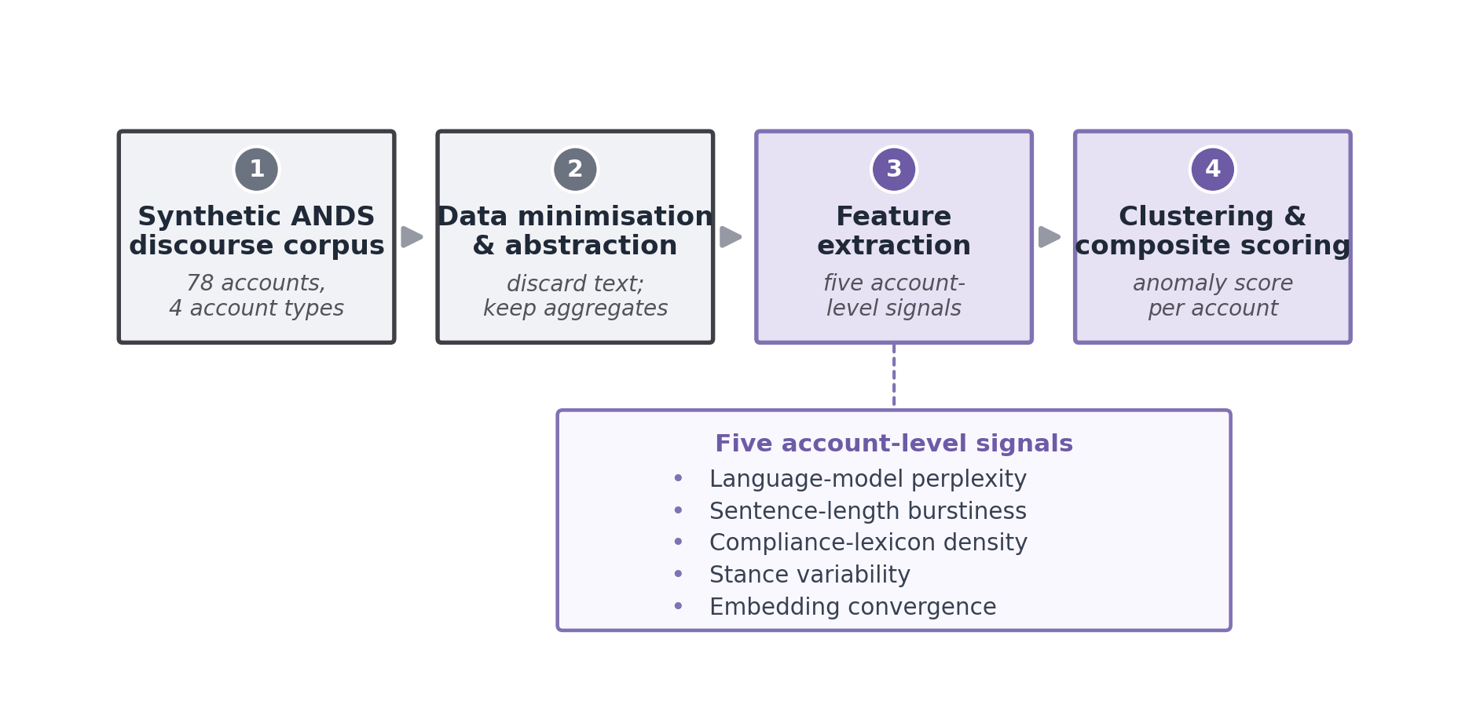
Figure 1. The CCSF pipeline as applied in this proof-of-concept and proposed for future deployment. A de-identified discourse corpus is abstracted into account-level aggregates, five feature families are extracted, standardised features are combined into a composite anomaly score, and high-scoring clusters would be routed to human expert review rather than labelled automatically. The pipeline retains no usernames, post text or individual-level identifiers in its analytic output.

Synthetic corpus
The corpus contained 524 posts written by 78 accounts, distributed across eight ANDS-relevant policy topics (for example flavour restrictions, taxation, advertising rules, and harm-reduction framing). Four account types were generated to represent the classes a real surveillance system must separate (table 1):
- Organic users (40 accounts, 200 posts) — heterogeneous individual voices. To create demanding ‘hard negatives’, roughly 30% were fluent harm-reduction advocates who naturally use compliance-style vocabulary, about 15% wrote in a formal register, and the remainder wrote casually with slang, typographical errors and emoji.
- Coordinated synthetic advocacy (16 accounts, 160 posts) — generated by a talking-point engine that drew from a shared pool of twelve core propositions, each available in four paraphrases. Each campaign account used a 6–9 proposition subset, so the messaging was semantically convergent but lexically non-duplicative, with a compliant vocabulary woven throughout.
- Legitimate professional advocacy (12 accounts, 84 posts) — specific, evidence-oriented messaging of the kind produced by clinicians or non-governmental organisations, included as a specificity control so that the method could be tested for false positives against real public-health voices.
- Human-edited synthetic (10 accounts, 80 posts) — synthetic content lightly rewritten to introduce human variation, representing a more difficult adversarial case.
This construction reflects a deliberately conservative test: organic harm-reduction advocates share vocabulary with the synthetic campaign, and professional advocates are highly consistent, so neither vocabulary nor consistency alone can succeed.

Feature extraction
Language-model perplexity (P) and its variance. For every post we computed perplexity under a pretrained autoregressive language model (GPT-2), a standard measure of how ‘surprising’ a text is to a general model of language.[35] In this simulation, templated or repeatedly constrained generation was expected to produce lower perplexity than heterogeneous organic writing. For each account we recorded the mean perplexity and the within-account variance of perplexity. We treat perplexity as a feature family: the account-level mean enters the composite score, while the within-account variance is reported descriptively (and as a robustness indicator) but is not added to the composite, to avoid double-weighting the perplexity family.
Sentence-length burstiness (B). We measured the coefficient of variation of sentence length within each account. In the simulated corpus, heterogeneous organic writing was expected to be more uneven (bursty), whereas templated generation was expected to be more uniform, giving a lower coefficient of variation.
Lexical compliance regularity (L). Using a fixed lexicon of seventeen industry/commercial-framing terms and phrases (for example ‘harm reduction’, ‘adult choice’, ‘evidence-based’, ‘reduced-risk’), we computed the per-word density of these terms for each account. The lexicon was specified in advance and applied identically to all accounts; each phrase was matched independently on word boundaries (a single, documented matching rule). A density of zero therefore means no matches to this pre-specified framing lexicon, not an absence of policy or public-health vocabulary.
Stance variance (S). Each post was scored for stance using similarity to fixed semantic anchors, and we recorded the within-account variance of stance. Coordinated messaging was expected to vary less.
Embedding-space convergence (E). Posts were embedded with a sentence-embedding model (all-MiniLM-L6-v2).[36] For each account we computed the mean pairwise cosine similarity among that account’s own posts (an intra-account measure), capturing how tightly an account’s content clusters in meaning. Coordinated messaging that repeats a small set of talking points is expected to show higher intra-account convergence than organic posting.
Anonymisation. All five features are account-level aggregates. In an operational implementation, CCSF can be run as a data-minimising pipeline: post text is used only to compute numeric summaries, after which outputs retain no usernames, post text or individual-level identifiers. This supports cluster-level review while reducing the risk of profiling individual users. In the present study the synthetic post text is shared solely to enable audit and exact replication; it contains no real accounts or personal data.

Composite anomaly score
The composite uses five scalar inputs—mean perplexity, sentence-length burstiness, compliance density, stance variance and embedding convergence (perplexity variance is excluded, as noted above). Each input was standardised (z-scored) across accounts and oriented so that higher values indicate the hypothesised coordinated pattern: lower perplexity, lower burstiness, higher compliance density, lower stance variance and higher convergence. The composite anomaly score for an account is the mean of its five oriented standardised inputs. We report results for this equally weighted composite to avoid overfitting weights to this particular corpus; using the mean rather than the sum sets the score on an interpretable scale and does not affect any AUC.

Statistical analysis
Group differences were tested at the account level with the Mann-Whitney U test and quantified with Cliff’s delta, a non-parametric effect size bounded between -1 and 1. Given the number of feature-by-comparison tests in this proof-of-concept, we treat p-values as descriptive evidence of separation under the simulation rather than as confirmatory tests of population-level hypotheses, and we emphasise effect sizes and AUCs. Detection performance was summarised by the area under the receiver-operating-characteristic curve (AUC) for single features and for the composite score; for the two headline composite targets we report bootstrap 95% confidence intervals (2000 resamples, stratified by class). The composite was additionally validated by five-fold cross-validated logistic regression trained to separate coordinated synthetic accounts from all other account types (organic, professional and the human-edited synthetic group together), so that the human-edited synthetic accounts act as a difficult non-target class. Feature importance was assessed by leave-one-out ablation (removing one input and re-computing the equally weighted composite AUC). Unsupervised structure was examined with k-means (k = 4) and DBSCAN on the standardised features, summarised by silhouette, cluster purity and the adjusted Rand index. t-distributed stochastic neighbour embedding (t-SNE) was used for visualisation only and does not constitute independent evidence of separability; all quantitative analyses are account-level.[37] Coordination realism was checked by comparing within-group lexical overlap (Jaccard) against semantic similarity (cosine). Analyses used Python with scikit-learn, transformers and sentence-transformers.[36,38] Code and the synthetic corpus generator are available (see Data availability).

Ethics and data
No human participants or personal data were involved; all text was synthetically generated for methodological evaluation, so research-ethics approval was not required for this proof-of-concept study. Any extension to real platform data would require institutional review and compliance with applicable data-protection, platform and research-ethics requirements. The method is explicitly designed for aggregate, cluster-level surveillance and not for identifying, profiling or penalising individuals. We discuss the attendant ethical considerations, including the risk of misclassifying genuine advocacy, in the Discussion.

Results

Corpus composition
Table 1 summarises the simulated corpus. The four account types span the realistic spectrum from heterogeneous organic users to a tightly coordinated synthetic campaign, with legitimate professional advocacy and human-edited synthetic content as the two most demanding comparison classes.
Account type | Accounts | Posts | Role in evaluation
Organic users | 40 | 200 | Heterogeneous humans; ~30% fluent harm-reduction advocates as hard negatives
Coordinated synthetic | 16 | 160 | Target class: talking-point campaign, convergent but non-duplicative
Professional advocacy | 12 | 84 | Legitimate NGO/clinician voices; false-positive control
Human-edited synthetic | 10 | 80 | Hardest adversarial case: synthetic text lightly rewritten by a human
Total | 78 | 524 | Eight ANDS policy topics; seed = 20260604
Table 1. Composition of the synthetic evaluation corpus.

RQ1: Do coordinated synthetic accounts differ from organic users?
Coordinated synthetic accounts differed from organic users on every feature in the hypothesised direction except stance variance (table 2; figure 2). Synthetic accounts had much lower perplexity (mean 100 vs 295; Cliff’s delta = -1.00, p < 0.001), indicating far less linguistic surprise, and lower variance of perplexity (delta = -0.89). Their writing was less bursty (coefficient of variation 0.23 vs 0.48; delta = -0.90), more saturated with compliance vocabulary (density 0.054 vs 0.017; delta = 0.75), and more tightly converged in embedding space (0.596 vs 0.376; delta = 0.87). Stance variance did not differ (0.062 vs 0.067; delta = -0.10, p = 0.56), a clear negative result we return to below. A Cliff’s delta of -1.00 for perplexity means the two groups did not overlap at all on that feature in this corpus.
Feature | Organic (mean±SD) | Synthetic (mean±SD) | Prof. (mean±SD) | Cliff's d (syn vs org) | p (syn vs org)
Perplexity (mean) | 295±103 | 100±22 | 158±29 | -1.00 | <0.001
Perplexity (variance) | 52.0k±71.3k | 3.4k±5.0k | 5.9k±7.8k | -0.89 | <0.001
Burstiness (CV) | 0.48±0.15 | 0.23±0.06 | 0.12±0.02 | -0.90 | <0.001
Compliance density | 0.017±0.026 | 0.054±0.014 | 0.000±0.000 | +0.75 | <0.001
Stance variance | 0.067±0.025 | 0.062±0.016 | 0.053±0.014 | -0.10 | 0.56 (NS)
Convergence | 0.376±0.133 | 0.596±0.041 | 0.388±0.047 | +0.87 | <0.001
Table 2. Account-level feature descriptives by group, with effect size (Cliff’s delta) and Mann-Whitney p value for the synthetic-versus-organic comparison. ‘k’ denotes thousands. NS, not significant.

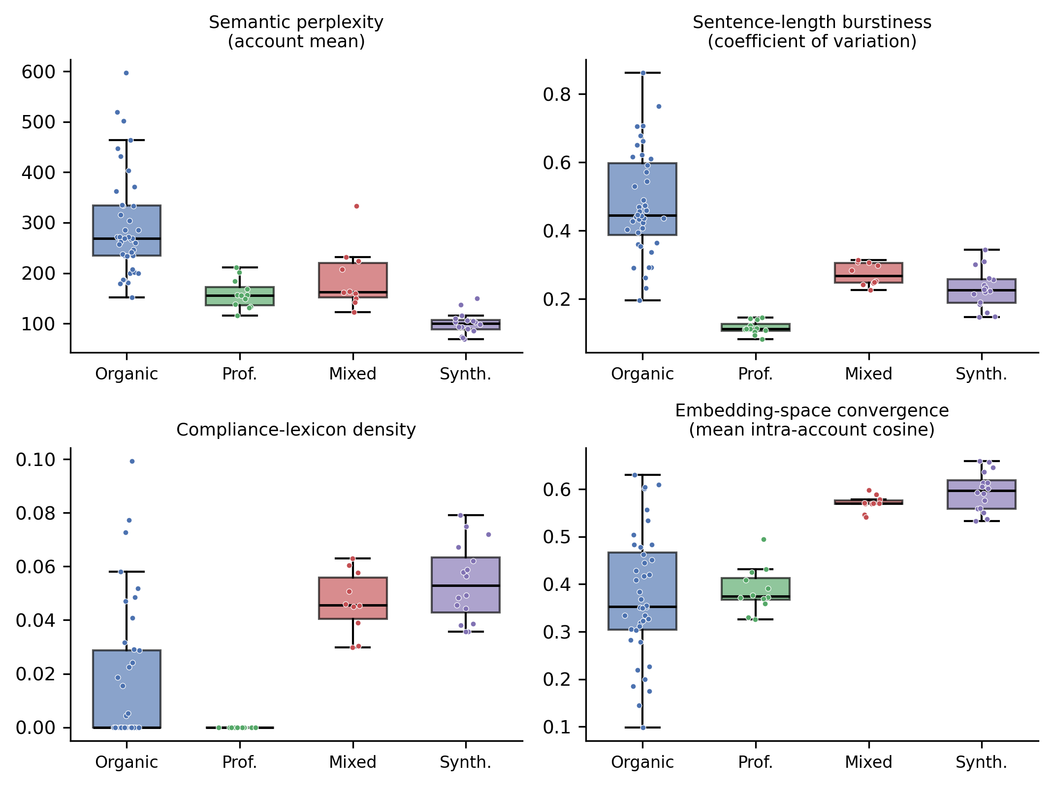
Figure 2. Distributions of four key account-level features by group (perplexity, sentence-length burstiness, compliance-lexicon density and embedding-space convergence). Coordinated synthetic accounts (and, to a lesser degree, human-edited synthetic accounts) show lower perplexity and burstiness, higher compliance density and higher convergence than organic users. Professional advocacy is the smoothest group on burstiness yet uses essentially no compliance vocabulary, illustrating why no single feature suffices. Stance variance (not shown) overlapped across all groups; see table 2.

RQ2: Does the combined fingerprint improve separation over most individual signals?
Single features varied widely in discriminative power when separating synthetic accounts from all human accounts (organic plus professional) in this synthetic corpus: perplexity achieved AUC = 0.989 and convergence AUC = 0.948, compliance density AUC = 0.905 and burstiness AUC = 0.732, whereas stance variance was essentially uninformative (AUC = 0.50). The equally weighted five-feature composite reached AUC = 0.989 (bootstrap 95% CI 0.965-1.00) against both human classes combined, 0.991 against organic users and 0.984 against professional advocacy (figure 3; figure 4; table 3). A five-fold cross-validated logistic regression on the same features gave AUC = 0.975 (SD 0.028), confirming that the result was not dependent on a single train-test split. For the human-edited synthetic comparison, the composite achieved AUC = 0.935 versus organic users; a broader machine-origin-versus-human comparison (treating both synthetic and human-edited synthetic as machine-origin) gave AUC = 0.957 (95% CI 0.912-0.990). All AUCs are within-corpus estimates under known ground truth and should be read as construct-validity checks rather than expected real-world performance.
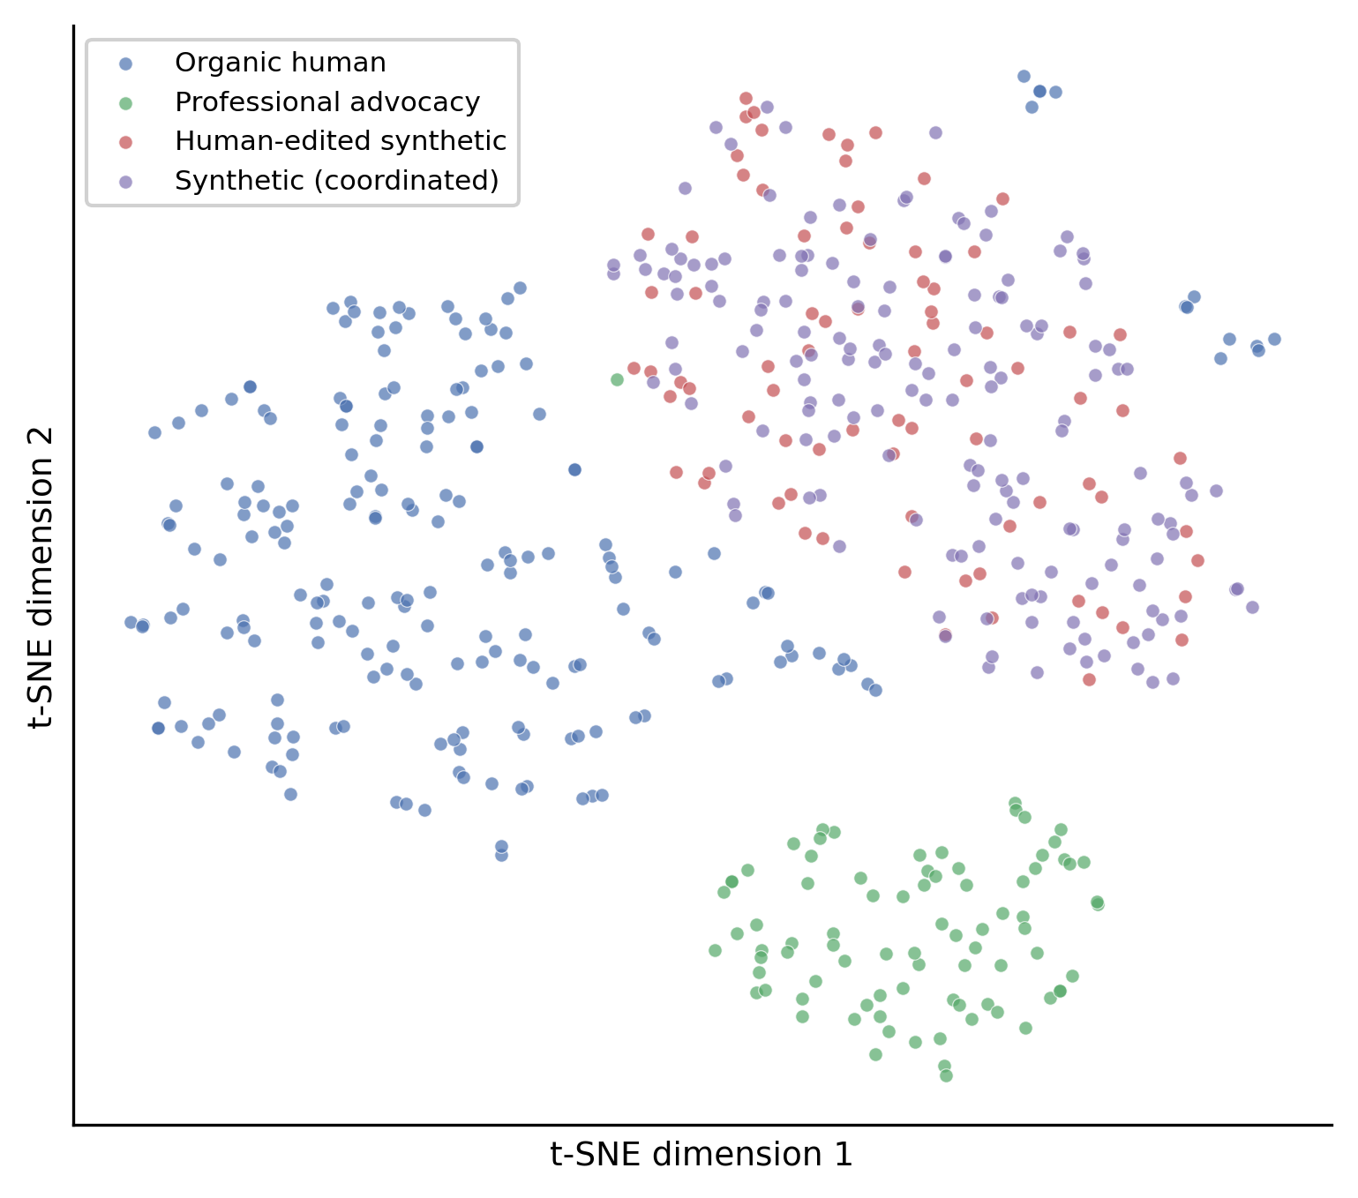
Figure 3. Two-dimensional t-SNE projection of post-level sentence embeddings, coloured by ground-truth group. Coordinated synthetic and human-edited synthetic posts occupy a shared region; professional advocacy forms a separate cluster; organic posts are dispersed, with some sitting near the synthetic region (the fluent harm-reduction advocates that serve as hard negatives). This visualises the semantic convergence that the account-level features quantify.

RQ3: Which signals matter most?
Leave-one-out ablation (table 3) showed that removing compliance regularity caused the largest drop in composite AUC (from 0.989 to 0.938, change -0.052), making it the single most important contributor despite not being the strongest stand-alone feature. Removing burstiness, convergence or perplexity each reduced AUC by a smaller amount (to 0.962, 0.964 and 0.968 respectively). Removing stance variance slightly improved performance (to 0.995, change +0.006), consistent with its at-chance individual AUC; in this corpus it added noise rather than signal and should be treated as exploratory. These findings illustrate the central rationale for CCSF—complementary signals can contribute jointly, while weak candidate signals can be reconsidered before future validation—while also showing that the most useful feature in combination need not be the best in isolation.
Configuration | AUC | Note
Perplexity only | 0.989 | Strongest single feature
Convergence only | 0.948 | Second strongest
Compliance density only | 0.905 | —
Burstiness only | 0.732 | —
Stance variance only | 0.502 | At chance (negative result)
Composite (all five) | 0.989 | Equally weighted; vs all human (95% CI 0.965-1.00)
drop compliance | 0.938 | Largest decrease (-0.052)
drop burstiness | 0.962 | -0.028
drop convergence | 0.964 | -0.025
drop perplexity | 0.968 | -0.022
drop stance variance | 0.995 | Improves (+0.006)
Composite vs organic | 0.991 | —
Composite vs professional | 0.984 | Legitimate-advocacy control
Composite, human-edited vs organic | 0.935 | Hardest adversarial case
Composite, machine-origin vs human | 0.957 | 95% CI 0.912-0.990
Logistic regression (5-fold CV) | 0.975 (SD 0.028) | Synthetic vs all other types
Table 3. Detection performance. AUC for single features, the equally weighted composite, leave-one-out ablations, and cross-validated logistic regression. Unless stated, comparisons are synthetic versus all human accounts (organic plus professional).

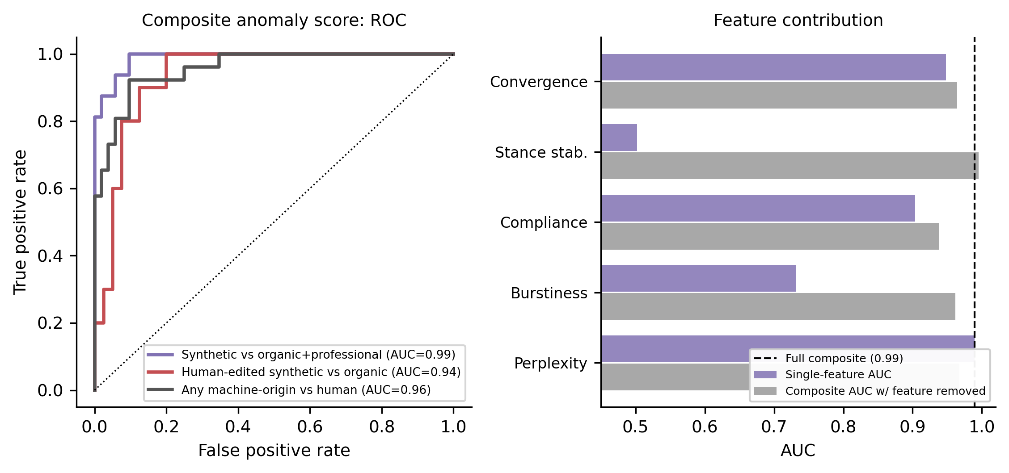
Figure 4. Left: receiver-operating-characteristic curves for the composite score (synthetic versus organic plus professional, AUC 0.99; human-edited synthetic versus organic, AUC 0.94; any machine-origin versus human, AUC 0.96). Right: each feature’s single-feature AUC (purple) alongside the composite AUC when that feature is removed (grey); the dashed line marks the full five-feature composite. Compliance regularity is the most important contributor in combination, whereas removing stance stability slightly improves performance.

RQ4: Can the method distinguish coordinated synthetic advocacy from legitimate professional advocacy?
Professional advocacy was distinguishable from coordinated synthetic advocacy, but for instructive reasons. Professional accounts were the smoothest group on burstiness (coefficient of variation 0.12, lower even than the synthetic accounts; Cliff’s delta for synthetic versus professional = +1.00), so a burstiness-only detector would misrank them. What separated them was vocabulary and meaning: professional advocates produced no matches to the pre-specified industry/commercial-framing lexicon (compliance density 0.000; delta = +1.00)—which reflects an absence of that specific framing vocabulary, not an absence of policy or public-health language—and showed much lower intra-account convergence than the synthetic campaign (0.388 vs 0.596; delta = +1.00). The composite therefore separated synthetic from professional accounts at AUC = 0.984 without penalising legitimate, evidence-based advocacy for being internally consistent. This supports CCSF’s intended role as a triage tool that prioritises clusters for review rather than a detector of advocacy per se.

Coordination realism and unsupervised structure
To test whether the synthetic campaign relied on simple duplication, we compared lexical overlap with semantic similarity within each group (figure 5). Coordinated synthetic accounts combined low lexical overlap (mean Jaccard 0.135) with high semantic similarity (mean cosine 0.583)—a signature of paraphrased, on-message content we term coordinated originality. Organic users were low on both (0.066, 0.309). Notably, professional advocates had the highest lexical overlap of any group (mean Jaccard 0.145; maximum 0.738), reflecting shared boilerplate, yet remained semantically diffuse—again showing why duplication-based detectors alone can mislabel legitimate advocacy.
Unsupervised analysis was deliberately reported without using labels. K-means (k = 4) gave a silhouette of 0.329, cluster purity of 0.731 and an adjusted Rand index of 0.259: professional advocacy formed its own clean cluster, the coordinated synthetic and human-edited synthetic accounts grouped together with a minority of organic hard-negatives, and the remaining organic users split across clusters. A density-based alternative (DBSCAN) likewise placed most synthetic and human-edited synthetic accounts together while leaving many organic accounts as unclustered noise, consistent with the k-means picture. The modest adjusted Rand index indicates the difficulty of fully unsupervised separation when fluent human advocates resemble the campaign; it reinforces our framing of CCSF as a tool to prioritise clusters for human review rather than to label accounts automatically.
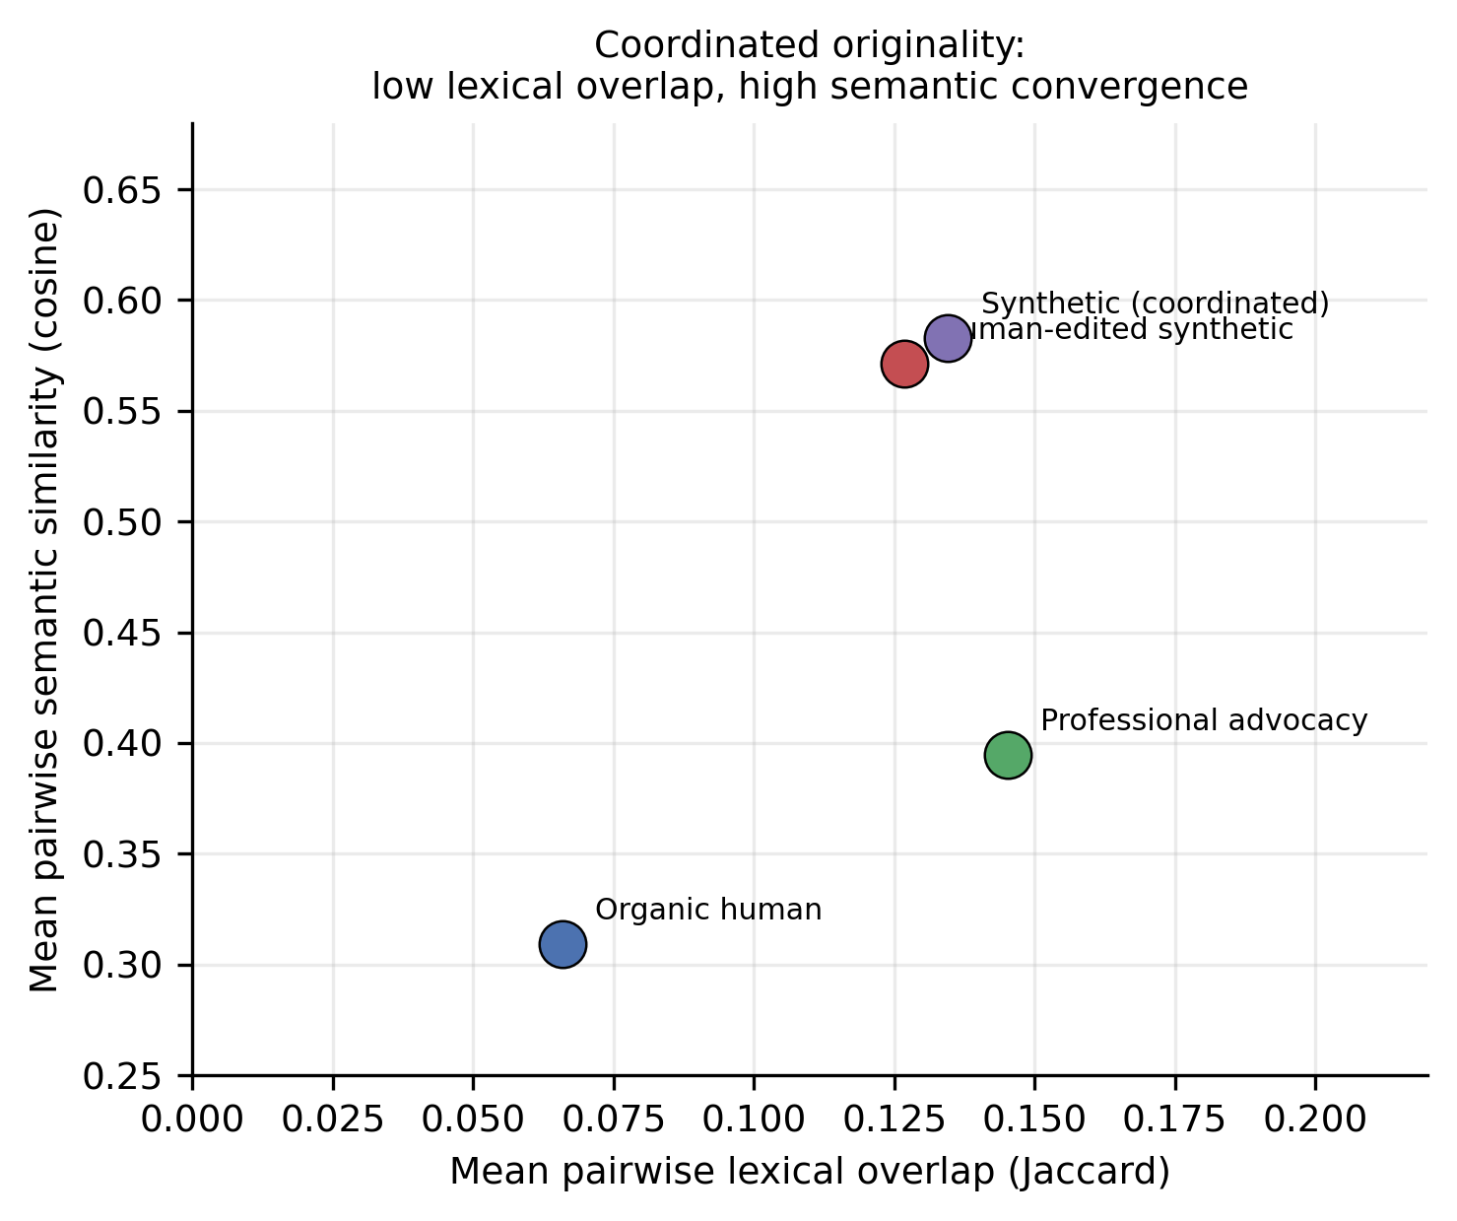
Figure 5. Within-group lexical overlap (Jaccard) versus semantic similarity (cosine). Coordinated synthetic content shows ‘coordinated originality’: low lexical overlap but high semantic convergence. Professional advocacy shows the opposite—higher lexical overlap (shared boilerplate) but diffuse meaning.

Discussion
In a transparent, fully synthetic simulation, a compliance-aware fingerprint combining language-model perplexity, burstiness, compliance regularity, stance variance and semantic convergence separated coordinated synthetic ANDS advocacy from comparison classes (composite AUC 0.989 in this corpus; cross-validated AUC 0.975), and retained useful separation for human-edited synthetic content (AUC 0.935 versus organic users). The method used de-identified, account-level aggregate features, consistent with a privacy-preserving surveillance design. These figures should be read as a construct-validity demonstration under known ground truth, not as estimates of operational accuracy on real platforms.

Principal findings and their interpretation
Three findings have methodological significance for tobacco-control surveillance. First, the value of the method lies in combining complementary signals rather than relying on any single metric. Second, compliance regularity—a feature motivated by the regulated nature of nicotine marketing—was the most important contributor in combination, even though perplexity was the strongest single feature. Third, the method distinguished coordinated synthetic advocacy from legitimate professional advocacy, which is essential if such tools are not to chill genuine public-health speech.
Two findings help define the method’s boundaries. Stance variance was uninformative in this corpus, because both coordinated and organic accounts often held steady positions. Burstiness alone was also misleading, because professional advocates were more uniform than the synthetic campaign. These results support the multi-signal framing and identify stance variance as exploratory rather than central.

Comparison with existing work
Our approach is complementary to established coordination-detection methods that emphasise synchronised actions, shared links or network structure,[17-24] and to machine-text detection based on model probabilities or stylometry.[27,29,32] By fusing linguistic, behavioural and semantic signals and adding a domain-specific compliance feature, CCSF targets the particular problem of lawful, on-message advocacy for a regulated product, a setting in which both families of single-purpose detector are individually vulnerable. It also responds to explicit calls in the tobacco-control literature for methods to identify automated or coordinated nicotine-product communication.[25,26]

Strengths and limitations
Strengths. The study uses a fully reproducible, seeded design with known ground truth, deliberately demanding comparison classes, pre-specified features and lexicon, cross-validation, ablation and an explicit human-edited synthetic comparison. The generator includes fluent harm-reduction advocates and legitimate professional advocacy as hard negatives, reducing the chance that the method is simply detecting vaping vocabulary or formal style.
Limitations. CCSF was evaluated in a controlled synthetic setting rather than on real platform data. This is appropriate for an initial proof-of-concept because it provides known ground truth, reproducibility and comparison classes that are difficult to obtain for undisclosed coordinated campaigns. The AUCs therefore show that the proposed signals behave as expected under controlled conditions; they do not estimate operational performance. Further limitations are that the organic and professional comparison groups were simulated, the compliance lexicon was author-specified, English-language and ANDS-specific, the sample was modest (78 accounts), and prevalence-sensitive metrics such as precision, false-discovery rate and positive predictive value were not estimated. Real-world use would require independent validation across platforms, languages, generators and adaptive adversarial settings.

Ethical considerations
Surveillance methods in this space carry risks of misclassifying sincere consumers or advocates, enabling overreach, or chilling public-health speech. CCSF is therefore framed strictly as an aggregate, cluster-level, hypothesis-generating aid. It should not be used to accuse or penalise individual accounts; outputs should trigger human review, threshold calibration, false-positive auditing and compliance with platform terms and data-protection law. These safeguards are consistent with guidance on protecting policy-making from commercial interference.[1]

Implications and future work
The immediate priority is validation on independently curated real-world datasets, including campaigns identified through platform transparency disclosures, investigative reporting or prospective expert adjudication of flagged clusters. Future work should test robustness across languages, platforms, perplexity and embedding models, and adaptive adversaries; compare learned with equal feature weights under out-of-sample validation; and integrate CCSF with network-level coordination signals. If validated, CCSF could provide an early-warning signal that complements existing monitoring of tobacco- and nicotine-industry influence.

Conclusion
Coordinated synthetic advocacy for alternative nicotine delivery systems is likely to grow as generative tools become cheaper and more capable. In a fully synthetic proof-of-concept, a privacy-preserving fingerprint that combines linguistic, behavioural and semantic signals—anchored by a domain-specific compliance feature—separated such advocacy from human discourse more reliably than any single signal, while preserving legitimate professional voices and operating only on de-identified, aggregate data. Because the evaluation was conducted under controlled synthetic conditions, these results establish construct validity rather than operational accuracy. The approach is offered to the tobacco-control community as a hypothesis-generating surveillance aid whose real value now depends on validation against independent generators and real platform data.

Declarations
Contributors. Sherif Elmitwalli designed the proof-of-concept, implemented the simulation and analysis, interpreted the results, drafted and revised the manuscript, and is the guarantor.
Funding. This research received no specific grant from any funding agency in the public, commercial or not-for-profit sectors.
Competing interests. None declared.
Patient and public involvement. This computational study used no patient or public data and involved no patient or public participants.
Patient consent for publication. Not applicable.
Ethics approval. Not required: the study used only synthetically generated text and involved no human participants or personal data.
Data availability statement. All data are synthetic and contain no real accounts, platform data or personal data. The reproducibility package, provided as supplementary material, includes the full synthetic corpus, corpus-generation code, feature-extraction and figure-generation scripts, derived account-level features, results, the fixed random seed and a verification script.
Provenance and peer review. Not commissioned; externally peer reviewed.

References
1. World Health Organization. Guidelines for implementation of Article 5.3 of the WHO Framework Convention on Tobacco Control on the protection of public health policies with respect to tobacco industry interests. Geneva: WHO, 2008.
2. Hird TR, Gallagher AWA, Evans-Reeves K, et al. Understanding the long-term policy influence strategies of the tobacco industry: two contemporary case studies. Tob Control 2022;31:e1–e10.
3. Gilmore AB, Fooks G, Drope J, et al. Exposing and addressing tobacco industry conduct in low-income and middle-income countries. Lancet 2015;385:1029–43.
4. Apollonio DE, Bero LA. The creation of industry front groups: the tobacco industry and ‘get government off our back’. Am J Public Health 2007;97:419–27.
5. Ulucanlar S, Fooks GJ, Gilmore AB. The Policy Dystopia Model: an interpretive analysis of tobacco industry political activity. PLoS Med 2016;13:e1002125.
6. Savell E, Gilmore AB, Fooks G. How does the tobacco industry attempt to influence marketing regulations? A systematic review. PLoS One 2014;9:e87389.
7. Watts C, Egger S, Dessaix A, et al. New image, same tactics: global tobacco and vaping industry strategies to promote youth vaping. Health Promot Int 2024;39:daae050.
8. Crosbie E, Bialous S, Glantz SA, et al. Tobacco industry strategies to influence the regulation of new and emerging tobacco and nicotine products in Latin America and the Caribbean. Rev Panam Salud Publica 2024;48:e1.
9. O’Brien EK, Hoffman L, Navarro MA, et al. Social media use by leading US e-cigarette, cigarette, smokeless tobacco, cigar and hookah brands. Tob Control 2020;29:e87–e97.
10. McCausland K, Maycock B, Leaver T, et al. The messages presented in electronic cigarette–related social media promotions and discussion: scoping review. J Med Internet Res 2019;21:e11953.
11. Vassey J, Valente T, Barker J, et al. E-cigarette brands and social media influencers on Instagram: a social network analysis. Tob Control 2022. doi:10.1136/tobaccocontrol-2021-056992.
12. Allem JP, Ferrara E, Uppu SP, et al. E-cigarette surveillance with social media data: social bots, emerging topics, and trends. JMIR Public Health Surveill 2017;3:e98.
13. Haupt MR, Li J, Mackey TK. Characterizing vaping industry political influence and mobilization on Facebook: social network analysis. J Med Internet Res 2021;23:e28069.
14. Xu Q, Yang Y, Wang Y, et al. Digital surveillance to identify California alternative and emerging tobacco industry policy influence and mobilization on Facebook. Int J Environ Res Public Health 2021;18:9140.
15. Silver N, Kucherenko Y, Vallone D, et al. The influence of provaping ‘gatewatchers’ on the dissemination of COVID-19 misinformation on Twitter: analysis of Twitter discourse regarding nicotine and the COVID-19 pandemic. J Med Internet Res 2022;24:e36180.
16. Evans-Reeves K, Dance S, Gilmore AB. Worldwide news and comment: investigations reveal lobbying activities of supposed grassroots movements (World Vapers’ Alliance) are tobacco-industry funded. Tob Control 2022;31:139–41.
17. Giglietto F, Righetti N, Rossi L, et al. It takes a village to manipulate the media: coordinated link sharing behavior during 2018 and 2019 Italian elections. Inf Commun Soc 2020;23:867–91.
18. Sharma K, Zhang Y, Ferrara E, et al. Identifying coordinated accounts on social media through hidden influence and group behaviours (AMDN-HAGE). In: Proc. 27th ACM SIGKDD Conf. Knowledge Discovery and Data Mining. New York: ACM, 2021:1441–51.
19. Weber D, Neumann F. Amplifying influence through coordinated behaviour in social networks. Soc Netw Anal Min 2021;11:111.
20. Smith DH, Ehrett C, Vishwamitra N, et al. Unsupervised detection of coordinated information operations in the wild. EPJ Data Sci 2024;13:14.
21. Magelinski T, Carley KM. Synchronized action framework for detection of coordination on social media. J Online Trust Saf 2022;1(4).
22. Graham T, Bruns A, Angus D, et al. The coordination network toolkit: a framework for detecting and analysing coordinated behaviour on social media. J Comput Soc Sci 2024;7:1–26.
23. Nwala AC, Flammini A, Menczer F. A language framework for modeling social media account behavior (BLOC). EPJ Data Sci 2023;12:33.
24. Loru E, Nudo G, Di Marco N, et al. A compression-based approach to detecting automated and coordinated behavior on social media. ACM Trans Knowl Discov Data 2025.
25. Lee EW, Bao H, Wang Y, et al. An analysis of arguments advanced via Twitter in an advocacy campaign to promote electronic nicotine delivery systems. Nicotine Tob Res 2022;24:1953–61.
26. Li Z, Xu Y, Chen L, et al. The dilemma of coordinated communication in China’s e-cigarette governance: a computational discourse analysis of a social media controversy. Tob Induc Dis 2026;24.
27. Mitchell E, Lee Y, Khazatsky A, et al. DetectGPT: zero-shot machine-generated text detection using probability curvature. In: Proc. 40th Int. Conf. Machine Learning (ICML). PMLR 2023;202:24950–62.
28. OpenAI. New AI classifier for indicating AI-written text (subsequently withdrawn for low accuracy). 2023. https://openai.com/index/new-ai-classifier-for-indicating-ai-written-text/ (accessed 2026).
29. Wu J, Yang S, Zhan R, et al. A survey on LLM-generated text detection: necessity, methods, and future directions. Comput Linguist 2025;51:1–66.
30. Sadasivan VS, Kumar A, Balasubramanian S, et al. Can AI-generated text be reliably detected? 2023. arXiv:2303.11156.
31. Chakraborty S, Bedi AS, Zhu S, et al. On the possibilities of AI-generated text detection. 2023. arXiv:2304.04736.
32. Zaitsu W, Jin M. Stylometry can reveal artificial intelligence authorship, but humans struggle: a comparison of human and seven large language models in Japanese. PLoS One 2025;20:e0317460.
33. Shi Z, Wang Y, Yin F, et al. Red teaming language model detectors with language models. Trans Assoc Comput Linguist 2024;12:174–89.
34. Schuster T, Schuster R, Shah DJ, et al. The limitations of stylometry for detecting machine-generated fake news. Comput Linguist 2020;46:499–510.
35. Radford A, Wu J, Child R, et al. Language models are unsupervised multitask learners (GPT-2). OpenAI technical report, 2019.
36. Reimers N, Gurevych I. Sentence-BERT: sentence embeddings using Siamese BERT-networks. In: Proc. 2019 Conf. Empirical Methods in Natural Language Processing (EMNLP-IJCNLP). Stroudsburg, PA: ACL, 2019:3982–92.
37. van der Maaten L, Hinton G. Visualizing data using t-SNE. J Mach Learn Res 2008;9:2579–605.
38. Pedregosa F, Varoquaux G, Gramfort A, et al. Scikit-learn: machine learning in Python. J Mach Learn Res 2011;12:2825–30.
39. Weber-Wulff D, Anohina-Naumeca A, Bjelobaba S, et al. Testing of detection tools for AI-generated text. Int J Educ Integr 2023;19:26.

