Apple Music Report
Introduction
Good or bad design can often the making or the downfall of an app or service, good design often goes unnoticed as it is expected from a premium service and a user expects to be able to use the product with ease and fluidity. And if they can use the product that way then they do not even give the design a second thought. Bad design on the other hand is almost instantly recognisable to the user, either consciously or subconsciously and can lead to them not liking the product and even to stop using it and switching to a competitor. My objective is to provide and suggest solutions to the design and UI of Apple Music, a music streaming service, by using my own expert evaluation and data collected from users.
Apple Music is a music streaming services owned and operated by one of the world’s largest companies, Apple. As of December 2021 Apple music has a library of over 75 million songs with new songs being added every day. Most of Apple music’s users come to listen to the worlds largest artists such as Justin Bieber and Ariana Grande, however Apple Music has a large range of Artists and genres so there is something for everyone. The app uses clever algorithms to create custom playlists and recommend music it thinks you will like based off of your listening history. Users can also create their own playlists and save albums and songs to their own personal library, anything in the library can be downloaded to a device and played locally when there is no internet connection. There is also a large selection of radio stations available that can be listened to or episodes saved for later. Apple music has some of the best audio quality among competitors, so it is great for real music lovers and casual listeners alike.
Apple music employs a card/tile based aesthetic for its UI that has become common and standard for basically all major music streaming services. It has bright thumbnails for each new category or playlist to engage and entice users. The Listen now section contains playlists that are more personalised for the users music taste whereas the browse section contains less personalised but currently popular playlists. The radio section contains a large range of popular radio show as well as live radio. The library contains all the users personal saved music, and the search section allows the user to view music categories as well as search for songs, artists, albums, playlists, lyrics, videos etc.
Before deciding to analyse Apple music I took a look at some of their competitors, Spotify, Amazon Music and SoundCloud. All of these services have fairly similar interfaces on the surface with all of them employing a card/tile based aesthetic. The similarities do not end there with all 3 of them having large library’s with over 70 million songs each and them all letting you make personal playlists and save music whilst also providing custom made personalised playlist as well as premade ones. However, there were reasons for choosing Apple music over all of them.
Firstly, I chose Apple Music over Spotify because despite them both being very similar in terms of music choice and pricing, Spotify is the older more established service that has far more many users and is widely accepted as having the cleanest and easiest to use interface as well as providing better personalised playlists whilst also having a free non premium version of the app. I felt that Apple music would have a slightly less refined UI than the more established brand despite Apple music being run by Apple who are known for their clean design.
I also looked at Amazon music. Amazon music have a very similar UI to Apple music and both services are very well matched in terms of audio quality, number of songs and browser capability. My reasoning for choosing Apple music to review over Amazon was because Amazon also has a free albeit restricted version of the service and the paid for service is cheaper than Apple music and provide almost the same service, so I wanted to see what made Apple music cost more and be a more premium service.
Lastly, I looked at SoundCloud. SoundCloud has a much larger library of music than any of the other services I looked at. It also puts more emphasis on discovering and sharing music from independent artists rather than playing the big hits. It places a larger emphasis on community and has comments on songs and allows users to follow each other and artists. I chose Apple music as I wanted to take a look at a more traditional music streaming service.
Evaluation Approach
I used two different evaluation approaches to evaluate Apple music in order to gain a more fair, unbiased, and accurate evaluation. There would firstly be an expert evaluation performed by me to try identify problems within the applications design and usability. Next a group of users will be asked to use the application and their use and experience whilst using the application would be recorded and analysed.
I decided the best course to begin my expert evaluation would be to perform a heuristic evaluation of the application to gain an effective analysis without users. I chose to use Nielsens heuristics to guide my evaluation as this method is widely regarded and accepted as a good way to test if the application has violated what is perceived as good design guidelines.
The first course of action was to give myself a first pass of the application in order to gain an understanding of how the app works. This was also my first time properly using Apple music so it also gave me insight into how friendly the app would be for other first time users. The next thing to do was to have a second but much more thorough pass through of the app. I would look for design elements of the app that violated the heuristics and their impact on how the app functioned. Every time I found something that violated one of the ten heuristics, I would note it down with how severe the problem was along with what heuristic was violated and then thought of a quick possible fix. Once I was happy that I had found all I could find I went back to my list and went through all the violations one-by-one trying to look for any secondary impacts they could cause, however I found none.
For the second part of my evaluation, I needed to evaluate the app with users. I began to design my task scenarios using my own knowledge I had gained from using the app. These task scenarios were simple tasks that my test user would be asked to perform within the app. When completing these tasks all actions would be recorded so I could analyse how different users really used the app. The tasks were designed to test flaws in the design that I had found to see if they really were issues for users and also designed to explore other areas of the app to try and identify other design flaws I missed. I created a set of 29 tasks that I would ask users to perform all of which can be found in the appendix of this report under ‘task scenarios’. When users are to complete tasks, I will record the screen and any touches the user makes in order to get an accurate representation of how they use the app and how the UI impacts the user experience. The results can be found in the ‘Test Results’ section of the appendix.
After the task scenarios were composed, I created a usability test plan so that the procedure was planned out and familiar to me before conducting the tests. The next step was to write the interview script. The script was composed of an introduction to be read out to the users so they know the process, followed by the task scenarios, after the task scenarios were completed there was an interview containing questions to get a brief understanding of the user on things such as their familiarity with Apple Music and also other music streaming services prior to the test. After that interview was complete there would be a few more questions about their experience with the app and the task scenarios along with any suggestions the users had. There was then a debrief and then the test was complete. The entire script can be found in the appendix under ‘Test Script’.
My user tests were conducted in person. Once the introduction was complete, I handed the users my phone which was screen recording and logging touches and then began the task scenarios. I would later write up the results into a table based off of the recording. I then proceeded through the rest of the script recording the interview answers on my phone, that I would later write up.
I gained enough data from these two different methods that I could then triangulate my findings into a table with problems the severity and possible fixes.
Findings and Discussion
All findings will be in the from both the expert evaluation and user testing can be found in the appendix.
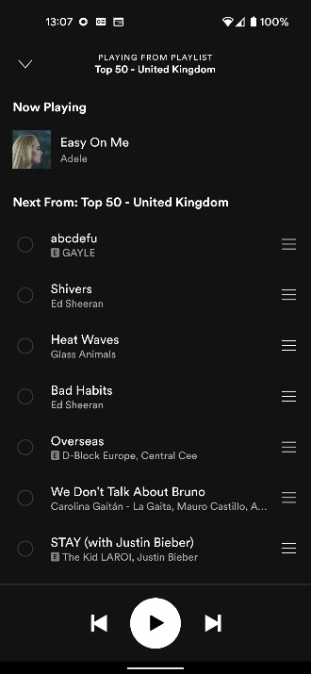
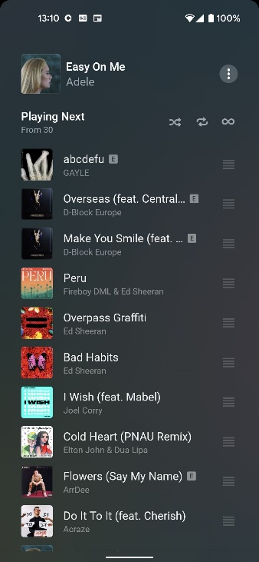
Both users and expert found very similar issues with the design of the app. 14 main issues were identified during the evaluation of the app however there are most probably more that would come to light with an extended use of the app and more users as there were only 4 different users and each only used the app for around 30 minutes.
What became apparent in the interviews was that none of them had used Apple music before or had used it but a very limited amount, years ago. They all used Spotify as their primary service and had been using it daily for years, so they had become accustomed to Spotifys UI. Many of the issues found may just be down to Apple music not following the same conventions as Spotify. However, they are still issues for new users. One such issue that caused one user in particular problems was exiting the queue screen. Apple music has the issue where to get back from the queue screen you either click the queue button again or swipe down. Easy if you know. But when you scroll a bit the buttons disappear, and some users can get confused. Whereas on Spotify you can either swipe down or press the back button in the top left corner. A simple fix to this problem would be to simply add a back button on this page on Apple music. Although this problem is not confined to this page as many pages throughout the app do not contain back buttons and I believe to make the app more new user friendly that back buttons should be on all pages. It would also follow the convention set by Spotify and other popular apps and would instantly make the app friendlier to new users.
Figure 2 - Queue Screens
Another issue was the inconsistencies in the swiping gestures. Certain pages can be closed by swiping down, you could go backwards or forwards by swiping, queue songs by swiping on them but you could not change the song by swiping backwards or forwards. Both users and experts experienced this by trying to change the song by swiping in the direction only for it to do nothing. On most other apps this would change the song and it also creates inconsistencies whithin the app that can be confusing and slightly frustrating to the user. A fix for this would be to just add the swipe gesuture back and forward on the large and minimised music player to stay consitent within the app and other similar apps.
Certain features within the app are very hard to find, infact 2 of the 3 test users could not find the listening history and I had to google how to find it, which is the opossit of intuitive design. Once the user knows how to find it it is a simple task however finiding out how was the problem. A simple fix would be to add a separate way to find it in either the account page or even library. This gives the user more freedom to find it and should make it less frustrating trying to find it, a simple thing like this could lead to the losing users.
When using the app it felt like something was missing, this was experienced in both the expert evaluation and the user tests. And that was the lack of a proper home screen. Apps such as Spotify and SoundCloud both have these and are clearly labeled home. These pages are personalised pages that contain things such as personalised playlists, recenlty played songs/playlists and other suggesed playlists along with settings and the history. Apple music attempts to do that with their listen now page but it feels cluttered with not as curated content and a bit messy. This page could easily be combined with the browse page or converted into a proper homescreen in order to make the app more cohesive and user friendly.
Again there are more inconsistencies within the app that can confuse and annoy users. One such inconsistency is when you click on a song in the queue it instantly starts playing that song and removes all previous songs from the queue, this could be changed in itself. However on the same queue page of you scroll up is the Listening History. When a song in the history is clicked instead of playing like a song from the queue would it simply moves to the top of the queue. This could lead to errors from the user. A fix for this could be to make clicking a song from the queue and the history behave the same. Also a way to prevent the rest of the queue from being deleted would be to warn the user the queue will be deleted if they play the song. These simple changes would make the app less error prone and reduce inconsistencies.
There seems to be no offline mode for Apple music. Users can download music and it will be shown in the downloaded section howver there is no set offline mode. The issue with this is if a user doesn’t want to use any data they have to be careful to only play songs from the downloaded section. One way to fix this would be to add an offline mode that only allows the user to play downloaded songs to reduce the error of a user accidentally using their data.
Conclusion
Overall, there did not seem to be too much wrong in terms of Apple musics UI and design which is to be expected from Apple and a lot of the issues found were problems for new users only that once learned the mistakes would most likey not be repeated again however that is often enough to put people, especially not tech savy people off the app. There were also some limitations to my evaluation methods. Firstly the expert evaluation was using heuristics which are really just rules of thumb and not a set rule that must be followed in design. Also more user tests should have been done with a wider demographic than just computer science students who are all comfortable with technology and use music streaming services daily. Also a 30 minute test is rarely long enough to discover all the flaws within an apps design. Im sure Apple have tested the app on thousands of people and gained far more feedback than I could to improve the app however I believe all my suggestions would help to improve the app based off of my research and findings.

Apendix
Item- Expert Analysis
Apple Music Heuristic Evaluation
Problem | Heuristic Violated | Severity
Swiping the direction to change song backwards or forwards does nothing, button has to be pressed. | Consistency and standards  Flexibility and efficiency of use | 2
When the lyrics are showing on screen to bring the play button and others back you need to press the screen, however if you accidentally click on a different line of lyrics then the song will skip to those lyrics | Error prevention | 3
Music videos do not show up in the searches consistently unless the music video filter is selected. | Recognition rather than recall | 2
When clicking on the artists name from a premade playlist it will not take you to the artist but to the playlist | Error Prevention  Consistency and Standards | 3
Clicking on a song in the queue removes all previously queued songs from the queue | Error prevention | 3
Lack of back buttons on numerous pages in the app | Consistency and standards  User control and freedom | 2
Difficult to exit queue screen | Error prevention  User control and freedom | 3
No offline mode, has downloaded section as replacement | Consistency and standards  Flexibility and efficiency of use  Error prevention | 3
Cannot change to previous song from minimized music player | Consistency and standards | 1
Browse and Listen Now sections have very similar content and could just be one section | Aesthetic and minimalist design | 2
Lack of home screen | Consistency and standards | 2
Listening history hard to find | Error prevention  Recognition rather than recall | 3
Some icons look similar such as queue and options | Error prevention | 2
When clicking on the songs from the history it adds it to the top of the queue instead of playing the song | Error prevention  Recognition rather than recall  Consistency and standards | 2

Item – Task Scenarios
Task Scenarios for Usability Testing
- Log into Apple Music with the given account details
- Find the playlist ‘Todays Hits’ by ‘Apple Music Hits’
- Shuffle the playlist
- Navigate to the songs playback menu
- Skip to 2:10 in the song
- Open the lyrics for the song
- Pause the song
- Move the third song in the queue to the top of the queue
- Skip to the next song
- Navigate to the share song menu and copy the song link to clipboard
- ‘Love’ the song
- View Listening history
- Create a Playlist and name it ‘Party Songs’
- Add the song currently playing to the playlist you just created
- Go to the artist of the song currently playing’s profile
- View this artists top songs
- View this artists bio
- Search for ‘Elvis Presley’ and go to his profile
- Remove the song you added to the playlist ‘Party Songs’
- Find ‘Hot Tracks’ currently in the Hip-Hop genre
- Play the ‘Chill’ radio station
- Add the first song that plays to the library
- Remove the song you just added from the library
- Search for the lyrics ‘your hearts been aching’ and play the song that comes up
- Play the ‘Rockstar’ Music video by Post Malone
- Turn the crossfade off between songs
- Change the display them to the opposite (either light or dark)
- Turn off notifications
- Log out of the account
Item – Usability Test plan
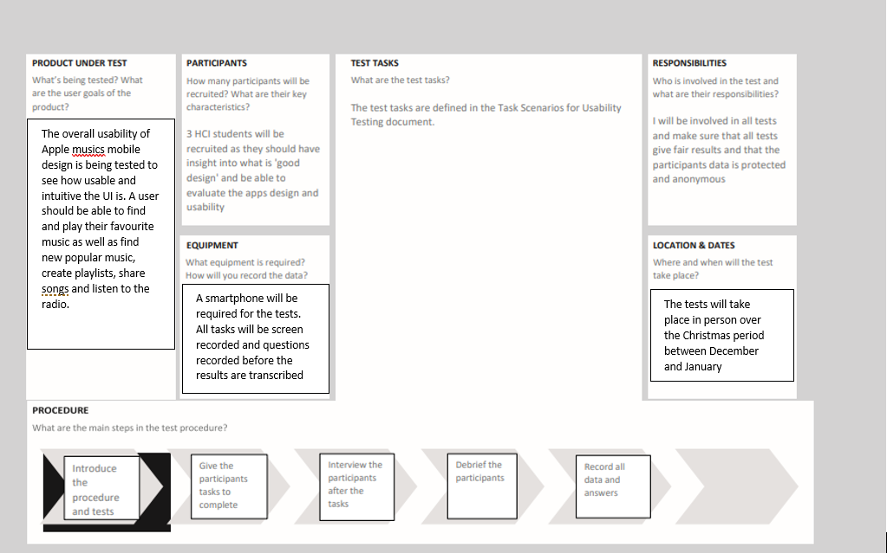Item – Test Script
Test Script
Introduction -
Hello how are you doing today? Thank you for agreeing to participate in this test today. There are a few things I am going to be asking you to do today in order to analyse how users interact with the music streaming service Apple Music as well as get your personal insight and thoughts on how intuitive and useable the user interface of the application is for the purpose of finding ways to improve the design. I will ask you to complete a series of tasks within the app and these will be recorded. There will then be a short interview afterwards just to understand a little bit more about yourself and we will ask for some feedback from you if you are happy to do so. All personal data gained today will be kept secure and none of your information will be shared with any third parties.
Tasks –
- Log into Apple Music with the given account details
- Find the playlist ‘Todays Hits’ by ‘Apple Music Hits’
- Shuffle the playlist
- Navigate to the song’s playback menu
- Skip to 2:10 in the song
- Open the lyrics for the song
- Pause the song
- Move the third song in the queue to the top of the queue
- Skip to the next song
- Navigate to the share song menu and copy the song link to clipboard
- ‘Love’ the song
- View Listening history
- Create a Playlist and name it ‘Party Songs’
- Add the song currently playing to the playlist you just created
- Go to the artist of the song currently playing’s profile
- View this artists top songs
- View this artists bio
- Search for ‘Elvis Presley’ and go to his profile
- Remove the song you added to the playlist ‘Party Songs’
- Find ‘Hot Tracks’ currently in the Hip-Hop genre
- Play the ‘Chill’ radio station
- Add the first song that plays to the library
- Remove the song you just added from the library
- Search for the lyrics ‘your hearts been aching’ and play the song that comes up
- Play the ‘Rockstar’ Music video by Post Malone
- Turn the crossfade off between songs
- Change the display them to the opposite (either light or dark)
- Turn off notifications
- Log out of the account
Interview -
General
- What is your age?
- Do you use any music streaming apps? If so which ones?
- How often do you use these apps?
- How long have you been using them?
- When do you typically use these music streaming apps?
- Do you typically use the mobile or desktop version of these apps?
- Do you pay for these services?
- What do you like about these services?
- What do you dislike about the services?
- Have you used Apple Music before?
- How much have you used Apple Music?
- When do/did you use it?
- How was your experience with it?
Task related
- What was your general view of Apple Music design?
- Were there any features you liked that were not included on other services?
- What features design features were missing that are on other services?
- What was the hardest part about using this app?
- What would you do to improve the user experience?
- What design features do you think should be added or removed?

Debrief –
Ok great that completes this Interview. Thanks for coming in today and completing these tasks and answering my questions. Your feedback will be used to try and implement new possible design features to improve the user experience of Apple Music mobile app. If you have any questions for me, please ask now. Aright well if that is everything thank you and goodbye.
Item – Test Results
Test Results

# | Task / Interview Question |  | Responses |  | Summary
# | Task / Interview Question | User 1 | User 2 | User 3 | Summary
1 | Log into Apple Music with the given account details | Successful login | Successful login | Successful login | No problems
2 | Find the playlist ‘Todays Hits’ by ‘Apple Music Hits’ | User used search bar to find playlist | User scrolled down the browse page and found the playlist | User scrolled down page and found playlist | No problems but used 2 different methods
3 | Shuffle the playlist | User pressed the shuffle button | User pressed the shuffle button | User pressed the shuffle button | No problems
4 | Navigate to the song’s playback menu | User pressed the bar to open the playback | User pressed the bar to open the playback | User pressed the bar to open the playback | No problems
5 | Skip to 2:10 in the song | User swiped along the bar to 2:10 | User swiped along the bar to 2:10 | User swiped along the bar to 2:10 | No problems
6 | Open the lyrics for the song | User pressed the lyrics button | User clicked the options button and then on the show lyrics button | User clicked the options button and then on the show lyrics button came out and spotted the other lyric button and pressed it | User 1 and 3 clicked on the lyric button I intended them to in the end however user 2 technically got the lyrics up but they wouldn’t show the real time lyrics.
7 | Pause the song | User pressed pause button | User pressed screen and the controls reappeared | Controls disappeared so the user tried to press the screen to get the controls back but pressed on the lyrics and the song skipped, then they could pause. | Controls disappear when the lyrics come up and this led to some problems for user 3 who ended up accidentally skipping the song
8 | Move the third song in the queue to the top of the queue | User pressed the queue button and dragged the third song to the top using the correct button | User pressed the queue button and clicked the move button thinking it would give the option to move but then realised it was a slider and dragged the song to the top | User pressed the queue button and dragged the song to the top | No real issues other than a brief mistake thinking the slider was a button
9 | Skip to the next song | User couldn’t navigate back and pressed the options button and scrolled up and down until they finally figured it out and could skip the song | User dragged down from the top then pressed the skip button | User pressed the queue button again and returned to the main music player and skipped to the next song | Multiple ways to do this however user 1 had real issues navigating back to the main music player screen due to lack of back button
10 | Navigate to the share song menu and copy the song link to clipboard | User pressed option button and copied the link no problem | User pressed option button and copied the link no problem | User pressed option button and copied the link no problem | No issues
11 | ‘Love’ the song | Pressed the option button and clicked the button after searching a bit | Didn’t understand the task until told to like the song, then they pressed options and love | Pressed the options button and ‘loved’ the song | Only real issue caused is the fact that the naming was different to the app the user usually uses, once task was understood then it was easy
12 | View Listening history | User couldn’t find history until told how to | User couldn’t find history until told how to | User accidentally found the history trying to close the queue page | Way too difficult to find
13 | Create a Playlist and name it ‘Party Songs’ | User made playlist through the add song option | User went to library then clicked on playlists and create playlist and created it | User went to library then clicked on playlists and create playlist and created it | Used multiple ways to create the playlist but both were done without issue
14 | Add the song currently playing to the playlist you just created | Already done from previous step | Clicked on the song currently playing then on options and then add to playlist | Clicked on edit playlist then add to playlist and searched for the song currently playing to add | Nobody had any issues and all 3 used different methods to add to the playlist
15 | Go to the artist of the song currently playing’s profile | Clicked on options then the artist’s name in red | Clicked on the artists name that was currently playing but it took them to the playlist. They then just used the search bar and clicked on the correct profile | Clicked on the artists name that was currently playing but it took them to the playlist. Then clicked on options and then the artists name in red | 2 users had issues with the fact that the artist’s name takes them to the playlist playing and not the artist but both got there in the end albeit different ways
16 | View this artists top songs | Scrolled down to correct section | Scrolled down to correct section | Scrolled down to correct section | No issues
17 | View this artists bio | Scrolled to bottom | Clicked on the options button to look for it didn’t find then scrolled down and got it | Scrolled to bottom | No real issues
18 | Search for ‘Elvis Presley’ and go to his profile | Clicked search bar and typed in name and clicked on the correct icon | Clicked search bar and typed in name and clicked on the top option which played a song by Elvis then clicked on the correct icon | Clicked search bar and typed in name and clicked on the correct icon | No issues for user 1 and 3 but user 2 accidentally clicked the wrong option out of habit as they are used to the top option being the artist not a song
19 | Remove the song you added to the playlist ‘Party Songs’ | Clicked on options on the song then found the right option after a while | Went to the library then clicked on the playlist, clicked options, and removed the song | Had same issue as user 1 by clicking on the wrong options button and looking for a while before finding the right option | User 1 and 3 had issues finding the correct button to remove a song
20 | Find ‘Hot Tracks’ currently in the Hip-Hop genre | Searched through the browse section, couldn’t find, scrolled to bottom clicked category, and then found hip-hop and the tracks | Used the search bar and typed in Hip-Hop and then clicked on the category, they then scrolled down until they found it | Clicked on the search bar and saw the Hip-Hop category below and clicked on it and scrolled until they found it | All 3 used separate methods but all completed the task
21 | Play the ‘Chill’ radio station | Clicked radio, scrolled down, and found it | Clicked on radio and scrolled down until they found it | Searched for Chill radio on the search bar and clicked on the first option | User 1 and 2 used the same method but all 3 got to the station in a quick manner
22 | Add the first song that plays to the library | Clicked add to playlist by accident then clicked add to library | Clicked on the options button then add to library | Clicked on the options button then add to library | No real issues
23 | Remove the song you just added from the library | Clicked options and removed | Clicked on library, saw it in recently added and held down on the song until the options came up and removed | Clicked on library then on songs scrolled to the song and pressed the options button then deleted from library | Task completed 2 different ways but no real issues for any user
24 | Search for the lyrics ‘your hearts been aching’ and play the song that comes up | Searched for the lyrics in the search bar and clicked on the top song that matched lyrics | Searched for the lyrics in the search bar and clicked on the top song that matched lyrics | Searched for the lyrics in the search bar and clicked on the top song that matched lyrics | No issues
25 | Play the ‘Rockstar’ Music video by Post Malone | Searched for Rockstar in the search bar and could not see the music video but then scrolled through the filters and clicked on music video and played it | Searched for Rockstar in the search bar and could not see the music video but did not realise you could scroll through the filter and thought there were only 3 filters, failed task | Searched for Rockstar music video in the search bar and could not see the music video. Then scrolled through the filters found and played it. | All 3 had issues finding it but user 1 and 3 scrolled through and found it using the filters. User 2 did not know there was more filters and did not find the music video
26 | Turn the crossfade off between songs | Clicked options on the song, went home clicked settings and then turned off | Went back to the browse screen and found the settings button and then found the correct option and turned it off | Went back to the browse screen and found the settings button and then found the correct option and turned it off | No real issues other than a slight hesitation by user 1 where they tried to look in options first
27 | Change the display them to the opposite (either light or dark) | Went back from previous screen scrolled down and clicked the right option | Had previously spotted the option when looking for the crossfade so went back and changed the theme no issue | Had previously spotted the option when looking for the crossfade so went back and changed the theme no issue | No issues
28 | Turn off notifications | Scrolled through the settings page couldn’t find, then went to account and found the right option and turned off notifications | Scrolled through the settings page couldn’t find, then went to account and found the right option and turned off notifications | Scrolled through the settings page couldn’t find, then went to account and found the right option and turned off notifications | No issues other than thinking it might be in the settings page first
29 | Log out of the account | Logged out successfully | Went to the account page and logged out successfully | Went to the account page and logged out successfully | No issues
1 | What is your age? | 21 | 21 | 22 | 21
2 | Do you use any music streaming apps? If so which ones? | Spotify | Spotify and SoundCloud | Spotify and Soundcloud | Had all used a Music streaming application most commonly Spotify and SoundCloud
3 | How long have you been using them? | At least 5 years | Probably around 2013 | Not Sure maybe around 2013 | None of them too sure but all at least 5 years
4 | How often do you use these apps? | Everyday | Everyday | Everyday | They all use them everyday
5 | When do you typically use them? | All the time, mostly in the gym, car and when studying | Mostly when studying, exercising and when cooking | At the gym, when studying, walking, cooking, and chilling out | They mostly use them when exercising, cooking, and studying.
6 | Do you usually use the mobile app or the desktop version of the app? | Mainly phone but both | Both but mostly phone | Probably both equally | They all use both but mostly use the mobile version
7 | Do you pay for these services? | Yes | Yes, for Spotify | Yes, for Spotify | They all only pay for Spotify
8 | What do you like about these services? | Likes the fact that that there is a huge easily accessible library of music that can be downloaded and listened to offline easily as they mostly use it away from Wi-Fi. | Likes the huge range of premade and personalised playlists based off of their listening habits that helps them discover new music they like as well as the huge collection of music available. | Likes the easy integration of device switching as they have multiple devices in the house that can play music as well as being able to download music for when they go on walks where signal may drop. | They like the large library of music that is easily downloadable, device switching and the premade and personal playlists for discovering music.
9 | What do you dislike about these services? | The free version of the app is nowhere near as good and doesn’t have all the main features I like. | I don’t like the fact that I have to pay for the app if I don’t want to listen to nonstop ads and also don’t like the fact that it doesn’t show song length until you click on the song. | Sometimes my daily mixes are really varied in genres when they should be one genre really and can ruin the mood, also the number of ads in the free version of the app | They all dislike paying for the premium version of the app because they feel the free version is unusable, the premade playlists can be odd sometimes and little things like song length not showing until the song is played.
10 | Have you used Apple music before? | No | No | Yes | Only 1 had
11 | How much have you used Apple Music? | n/a | n/a | Barely used it, it was a free trial | They had barely used it
12 | When do or did you use it? | n/a | n/a | Maybe about 3 or 4 years ago | Years ago, so the app has changed
13 | How was your experience with it? | n/a | n/a | Didn’t really like it and found it a bit confusing to use especially for an Apple product as they are used to them. | Found it a bit confusing
1 | What was your overall impression of Apple Music’s design? | Generally liked the design, found it similar to Spotify so they were comfortable with it, the search function was designed well, also used to apple products, so the design was also familiar | Overall impressed with the design but it felt a bit clunkier and harder to navigate than other apps they were used to. Found it easy to find new playlists. | The browse screen and radio were easy to navigate and find new stuff and the search function was clear, overall liked the interface but prefers Spotify still. | All liked the design of the app but all preferred Spotify’s design maybe due to unfamiliarity with Apple Music. The search function was well liked as well as the browse section and the premade playlists there.
2 | Were there any features that you liked that were not included in other services that you use? | Liked that there were music videos and knew that Apple music had a larger library of music than Spotify which is nice to have. | The on screen lyrics looked much better than Spotifys lyrics | Not particularly but maybe the radio section | The users liked that there were music videos, a large library and liked the aesthetics of the lyrics better than other services
3 | What design features were missing that you like on other services? | Simple things like a lack of back buttons and a home screen | On Soundcloud I really like the Audio visualiser when playing music as well as the comments on songs and the large amount of user made remixes and other song that aren’t available on apple music or Spotify | I missed that there was a dedicated podcast section on Spotify and the lack of a real home screen | Lack of back buttons and a home screen, and features on SoundCloud such as an audio visualiser and comments on songs
4 | What was the hardest part about using this app? | Lack of back buttons can make it hard to navigate and finding certain features such as song history was too difficult. The browse and listen now sections could get a little overwhelming at times and were not the easiest to navigate. | Got a bit confused between the listen now and browse sections and didn’t think there was too much difference in them. Found it difficult to find the music videos | Found it generally straightforward to use just certain things didn’t follow the standard conventions such as lack of back buttons and swipe gestures for songs as well as clicking on the artist’s name to get to the profile | Lack of back buttons and not following some of the industry standard conventions.
5 | What would you do to improve the user experience? | Add back buttons, make the history easier to find and add a Home screen like Spotifys | Try cleaning up the listen now and browse sections and have music videos show up in the original search | Follow the standard conventions such as back buttons and swipe gestures. | Add back buttons and more swipe gestures as well as cleaning up the listen now and browse sections.
6 | What design features do you think should be added or removed? | Add back buttons  Make the history easier to find  Add a home screen | Have music videos show up in top results  Clean up the listen now and browse sections or just merge them | Add back buttons  Add more swipe gestures  Have clicking on the artist’s name take the user to the artist page not the playlist | Add a home screen  Add back buttons  Make history easier to find  Add more swipe gestures  Merge Listen now and Browse section  Make music videos easier to find

Item – Triangulation
Triangulation
Problem | Found in User test or Expert evaluation | Severity | Fix Suggestion
Swiping the direction to change song backwards or forwards does nothing, button has to be pressed. | Both | 2 | Add more swipe gestures
When the lyrics are showing on screen to bring the play button and others back you need to press the screen, however if you accidentally click on a different line of lyrics then the song will skip to those lyrics | Both | 3 | Have a set button on screen that will bring back controls
Music videos do not show up in the searches consistently unless the music video filter is selected. | Both | 2 | Have music videos show up in the top searches category
When clicking on the artists name from a premade playlist it will not take you to the artist but to the playlist | Both | 3 | Have the artist name take the user to the artist not the playlist they are listening to
Clicking on a song in the queue removes all previously queued songs from the queue | Expert Evaluation | 3 | Have it move the song to the top of the queue or give a prompt warning users this will happen
Lack of back buttons on numerous pages in the app | Both | 2 | Pages can still be navigated back from with swipes, but a simple fix would just be to add back buttons
Difficult to exit queue screen | Both | 3 | Add a back button or have controls appear on screen easier
No offline mode, has downloaded section as replacement | Expert evaluation | 3 | Have button or option in the settings that allows the user to only play downloaded songs
Cannot change to previous song from minimized music player | Both | 1 | Add a swipe gesture or previous song button to the bar
Browse and Listen Now sections have very similar content and could just be one section | Both | 2 | Merge the sections
Lack of home screen | Both | 2 | Add a home screen
Listening history hard to find | Both | 3 | Add a button on the home screen or in the account page
Some icons look similar such as queue and options | Expert evaluation | 2 | Change the icons to be more distinguishable
When clicking on the songs from the history it adds it to the top of the queue instead of playing the song | Expert evaluation | 2 | Change to the same scheme as when clicking on a song in the queue as they are on the same page but follow different conventions
Item – App review
Spotify -
# | Pros | Cons
1 | Great tailor made playlists based on user listening habits compared to apple music | Smaller Music Library at around 70 million songs compared to 75 million
2 | Cleaner and clearer UI | Lower max streaming quality
3 | Has more EQ settings | Has smaller radio collection
4 | Works with more voice assistants | Doesn’t support Dolby Atmos surround sound
5 | More community friendly with collaborative playlists
6 | Has a free version of the app
7 | Has more connectivity between smart devices
8 | Has large collection of podcasts

Spotify has a slightly smaller library than Apple music and slightly worse audio quality however they make up for that with their cleaner design, better connectivity, and better algorithms to make better tailored playlists for their users. It is commonly known that Spotify is the market leader in Music streaming services and is known for its clean interface which is why I believe that Apple music would have some issues or else it should be more widely used.
Amazon Music
# | Pros | Cons
1 | Has a free version of the service | Free version has limited library
2 | Cheaper membership if prime member | Does not have spatial 360 degree audio
3 | Just as good audio quality but cheaper | worse offline listening capabilities
4 | Just as much browser capability but cheaper
5 | Both create custom playlists but amazon cheaper
6 | Amazon has better integrated social media sharing capabilities
7 | Interfaces pretty similar and have the same functionality but amazon is cheaper

Along with having a free albeit restricted library Amazon music offers the same size library of music as Apple music along with being the cheaper service, it has just as much functionality as Apple music with a slight edge in some areas and on the surface the interfaces look to be fairly similar. So I would prefer to take a look at the more expensive service and find out what makes it more premium or to try and make it more premium.
SoundCloud –
# | Pros | Cons
1 | Has a free version of the service | Doesn’t sync across devices as well
2 | Much larger library | Voice assistant not as good
3 | Can follow Artists and other people | Search not as advanced
4 | More interactive with comments | Audio quality not as advanced
5 | Has a lot of pre releases
6 | Better personalised music feed
7 | Smaller app size and data usage

SoundCloud is a slightly different type of Music streaming service with more of a focus on discovering independent artists and for independent artists to upload their own music without hassle. It has a much larger catalogue of music than Apple music and also a free version. There is a much larger sense of community on SoundCloud, and I would prefer to analyse the interface and usability of a more traditional music streaming service.

