

JDBC

**Name : Bassam Rageh Ibrahim ID:13**

**Name : Hazem Morsy Hassan ID:16**

**Name : Ahmed Ali Abdel Megeed ID:5**

**Name : Sherif Mohamed Mostafa ID:20**



# Description:

JDBC provides standard interfaces that is used to access databases, regardless of the driver and database product.

# Classes Design:

MyDriver:

Checks for url of the database and establishes new connection with the url and properties of the database (eg. Path).

MyConnection:

It is a connection to the database that allows us to create statement and closes connection to this database.

MyStatement:

Executes different sql queries separately or add them to list and execute them at once, can be closed.

MyResultSet:

A table of data representing a database result set, which is usually generated by executing a statement that queries the database.

MyResultSetMetaData:

Get column names , count and types of the table selected.

# User Interface

This project uses javaFX.

# User Guide

At first, you should database name or path to establish connection to this database.

Then you should enter structural queries , select queries and update queries.

After writing each query you can select :

* Execute button : to execute this query
* Add to batch button : to add this query to list of queries
* Execute batch button: to execute all queries in the list

Close connection button : closes the connection to this database (you no longer have access to this database)

for select queries : after the user select execute button we show table contains all data , column names and their types

for logger text area : it shows results of every operation done.

# Log Files

These files are created to show the time and result for every operation by using JDK logger

It shows different messages :

* Warning : for eg. If user input invalid query
* Severe : for eg. error in connection
* Info : show that operation is done successfully or data that user needs (eg. Number of rows updated ).

# Design Decisions:

We added to DBMS interface few functions which helps us to capture data of table and database:

* SetDB_name(string db_name) : sets name for database while creating connection.
* getDB_name() : gets the name of database.
* getTbl_name() : gets the name of table.
* dtdmap() : gets map of selected columns as keys and their types as values.

# Data Structures Used:

* Arrays.
* Lists.

# Division of Labor :

* Driver, connection and statement -> bassam and sherif.
* Result set and result set meta date -> hazem and ahmed.
* Logger -> sherif.
* GUI -> ahmed.
* Report and UML diagrams -> bassam and hazem.

# UML Class Diagram:

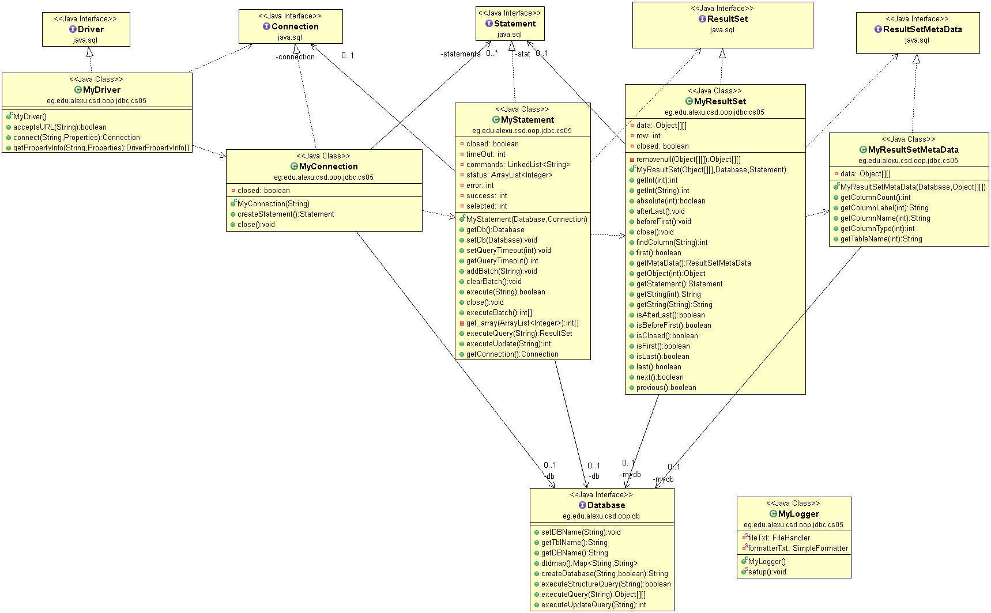

# Use Case:

# State Diagram:

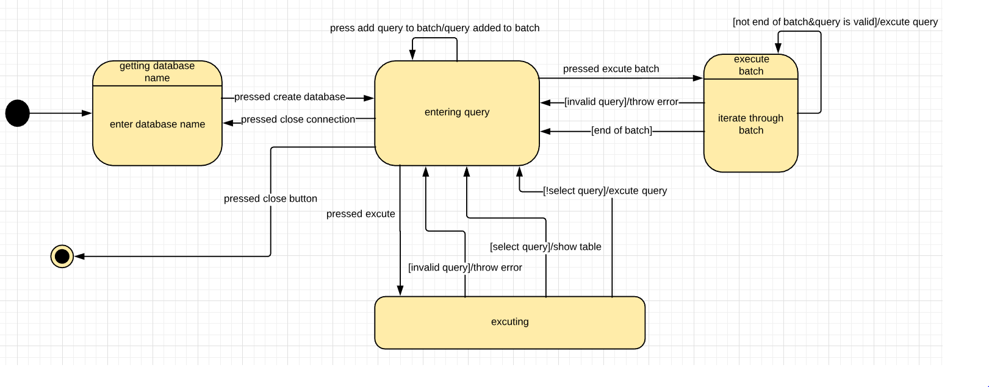

# Sequence Diagram:

# Screenshots

