Testahil · Independent Valuation Study — Educational Analysis Not investment advice

Arabian Cement Company S.A.E.
Egyptian Exchange · ARCC · Egyptian pounds · valuation as of 6 August 2026, issued 8 August 2026
One of Egypt's largest cement plants, at the top of the best year the industry has had in more than a decade — audited profit up 210% in a single year on a 42.6% revenue step — and facing 12.6 million tonnes of dormant national capacity queuing to restart inside the forecast window.
What this is. An independent valuation of Arabian Cement Company, an educational analysis and not investment advice. It carries no rating and no price target — fair-value ranges and distributions only.
The company in one line. Two production lines in Suez governorate, about 5.0 million tonnes of cement a year and roughly 6.6% of Egypt's nominal capacity, listed on the Egyptian Exchange since May 2014, with cash of EGP 3,459mn against interest-bearing debt of EGP 1,135mn. Every figure in this study is read from the audited consolidated accounts.
Where the value lands. Four lenses put the shares between EGP 45.65 and EGP 65.57, weighting to a central EGP 52.90 against a market price of EGP 59.00 — -10.3%.

Summary valuation table
Lens | Value per share (EGP) | Weight | Versus spot | Terminal value % of EV
DCF (cash flow) | 55.21 | 50% | -6.4% | 48.8%
Relative multiples | 45.65 | 20% | -22.6% | —
Normalised earnings | 49.64 | 22% | -15.9% | —
Asset / replacement cost | 65.57 | 8% | +11.1% | —
Weighted central fair value | 52.90 | 100% | -10.3% | —
Range across the four lenses | 45.65 – 65.57 | — | -22.6% to +11.1% | —
Market price, 6 August 2026 | 59.00 | — | — | —

Terminal value as a percentage of enterprise value is shown beside the cash-flow lens, and again in the enterprise-to-equity bridge in section 1.7.
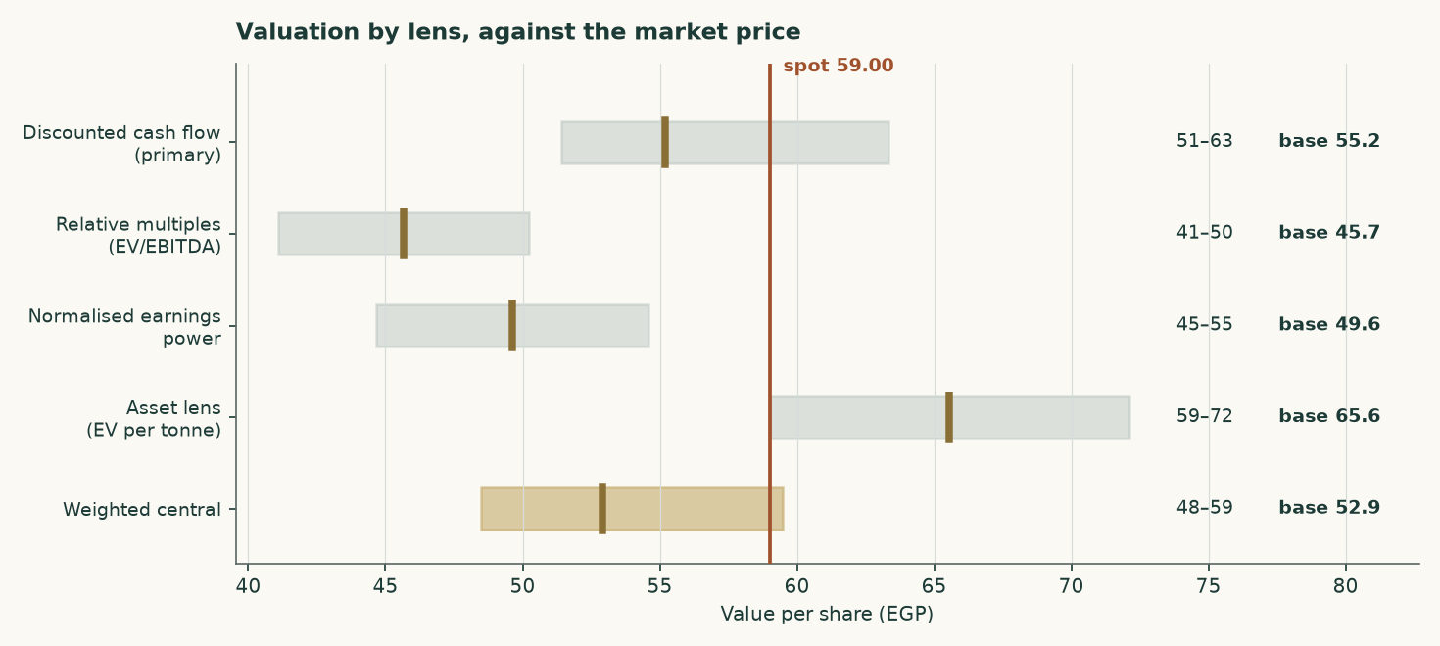
Figure 1 — Each lens as a range, with its base case marked, against the market price.
1 Fundamental valuation
Arabian Cement is valued as a single operating company, not as a sum of parts, and the reason is worth stating before any number appears. Essentially all of its revenue is grey cement and clinker from one industrial site. There is no property portfolio, no lending book, no concession and no collection of consolidated operating subsidiaries that would need valuing on their own terms. A sum-of-the-parts here would be a sum of one part, and the discipline it is meant to impose — never blending legs that need different methods — has nothing to bite on.
Four lenses are used. A discounted cash-flow model built up from tonnes and costs carries half the weight. Relative multiples, normalised earnings power and replacement cost carry the rest, and each is reported with the reason its weight is what it is.
1.1 The business, and why the lens follows from it
The plant runs two lines in Suez governorate producing on average about 5.0 million tonnes of clinker and cement a year. That is roughly 6.6% of Egypt's nominal capacity. Larger single sites exist — National Cement Beni Suef and Lafarge Ain Sokhna are both materially bigger — so the earlier edition's claim that this is the country's second-largest plant is withdrawn. The balance sheet is what that description implies: property-dominated, with working capital in inventory and receivables, no investment property, no equity-accounted portfolio of any size, and no financing arm.
The FY2025 accounts show revenue of EGP 12,447mn and attributable profit of EGP 3,600mn, against EGP 8,730mn and EGP 1,160mn a year earlier — revenue up 42.6% and profit up 210%. That is not a business changing shape. It is a price event, and the whole of this valuation turns on how much of it lasts.
 | FY2023 | FY2024 | FY2025
Revenue (EGP mn) | 6,043 | 8,730 | 12,447
Gross profit (EGP mn) | 1,283 | 2,087 | 5,058
Operating profit (EGP mn) | 1,079 | 1,764 | 4,596
EBITDA (EGP mn) | 1,330 | 2,021 | 4,886
EBITDA margin | 22.0% | 23.1% | 39.3%
Attributable profit (EGP mn) | 697 | 1,160 | 3,600
Earnings per share (EGP) | 1.81 | 3.02 | 9.49
Effective tax rate | 25.0% | 23.0% | 23.8%
Capital expenditure (EGP mn) | 59 | 912 | 796

Table 1 — Three audited years. Every line is a disclosed figure or a formula over disclosed figures: operating profit is gross profit less administrative expenses, provisions and credit losses, and EBITDA adds back the depreciation and amortisation reported in the cash flow statement.
Two things stand out. The revenue note splits local from export: local sales rose 71% while export sales were -0.8% — the abolition of Egypt's cement production quota in May 2025 was a DOMESTIC event, and exports sat against a statutory 30% cap throughout. And the margin moved from 23.1% to 39.3% in a single year, because almost the entire price increase fell to the bottom line on a cost base that is largely fixed.
1.2 The unit economics — where EBITDA actually comes from
The operating model starts at the PLANT, and the tonnes are now DISCLOSED rather than reconstructed. The company publishes sales volumes and production indicators in its FY2025 investor presentation — clinker production, cement production, local sales, cement exports and clinker exports — and this build reproduces every one of them to within 0.02%. Three earlier editions of this study rebuilt those tonnes from an assumed price because that document had not been read, and were 28% low on the total.
It is worth being plain about what those editions did, because the failure was structural rather than arithmetic. They assumed a cement price, divided the audited revenue by it to get tonnes, and presented the utilisation that fell out as an independent corroboration. It was neither independent nor a corroboration: it was the same assumption written twice, and the FY2025 check it produced was an accounting identity that reproduces the audited revenue for ANY price, because volume moves by exactly the reciprocal. The drivers here are physical — kiln utilisation, the clinker factor and the two export shares — and the tonnes, the mill utilisation and all three realised prices come out of them. The prices are therefore outputs that can be held against the market and disagree with it.
It also carries three products where the previous edition carried one. This company sells local cement, export cement and export CLINKER, and clinker is the unground intermediate, worth a fraction of the cement it could have become. Pricing every tonne at a cement price made the plant look far smaller than it is.
 | Value
Kiln clinker capacity (audited note 1) | 4.20Mt
Kiln utilisation (DRIVER) | 91.7%
Clinker produced | 3.851Mt
Sold as clinker (DRIVER) | 33.8%
Clinker exported | 1.301Mt
Clinker factor (DRIVER) | 0.733
Cement produced | 3.480Mt
Mill utilisation | 69.6%
Plus draw from finished-goods stock | 0.072Mt
Cement sold | 3.553Mt
Cement exported (DRIVER) | 17.7%
Local cement | 2.923Mt
TOTAL DESPATCHES | 4.854Mt
Local cement price — DERIVED | EGP 2,856/t
Export cement price — DERIVED | USD 46.2/t
Export clinker price — DERIVED | USD 30.0/t

Table 2 — The plant in tonnes, and the prices that fall out of it. Every FY2025 physical figure is the company's own disclosure. The four drivers are physical; everything below them is derived. Cement exports of 17.7% of cement made sit inside the 30% statutory cap — the previous edition's single-product build put exports at 31.5% of volume and breached the cap its own text called binding.
The three derived prices are the test, and it is a test this study does not pass cleanly. Local cement at EGP 2,856 a tonne is credible against Egyptian ex-works commentary. Export cement at USD 46.2 and export clinker at USD 30.0 sit roughly a third BELOW the USD 44-48 the trade press quotes for Egyptian clinker free on board. Either the physical volumes behind this build are too high, or realisations run well under the published indices. The gap is published rather than tuned away, and it is the reason the volume base carries its own sensitivity rather than being presented as settled.
The cost stack is the printed one. Cost of sales of EGP 7,389mn splits into materials and fuel of EGP 5,698mn — the note confirms this is the cost of inventories charged to cost of sales, so it carries fuel, packing and spares as well as raw meal — transportation of EGP 764mn, overheads of EGP 641mn, and depreciation and amortisation of EGP 285mn. Adding cash administrative expenses, provisions and credit losses gives a total cash cost of EGP 7,484mn, or EGP 1,542 a tonne.
EGP per tonne of cement | FY2025A | FY2026E | FY2030E
Materials and fuel | 5,698 | 6,130 | 8,277
Transportation | 764 | 824 | 1,170
Overheads and administration | 1,021 | 1,101 | 1,563
Total cash cost | 1,542 | 1,676 | 2,234
Blended realised price | 2,565 | 2,777 | 3,670
Volume (Mt) | 4.854 | 4.807 | 4.929
EBITDA (EGP mn) | 4,886 | 5,210 | 6,965
EBITDA margin | 39.3% | 39.0% | 38.5%

Table 3 — The cost stack per tonne and the margin it produces. EBITDA is an OUTPUT of this build, not an input to it.
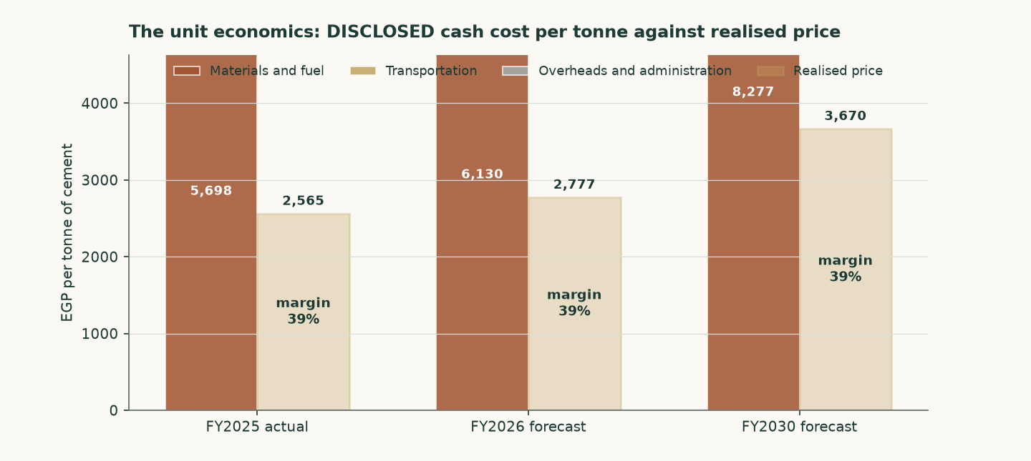
Figure 2 — Cash cost per tonne against realised price per tonne. The margin is the gap, and the gap narrows across the forecast.
The reconstruction reproduces audited FY2025 revenue to +0.000% and audited FY2025 EBITDA to +0.000%. It is not forced to: the volume is derived from the revenue note and the cost lines are the printed ones, so a wrong price assumption would show up as a non-zero residual.
One physical constraint is worth checking, because the volume forecast is built off CEMENT capacity while the kiln is what could bind first. At a clinker factor of 0.73 — observed from the audited capacity pair of 4.2Mt of clinker against 5.0Mt of cement — the FY2030 volume needs 3.612Mt of clinker against 4.2Mt of kiln capacity, or 86.0% of it. The forecast fits the plant, with 0.588Mt of headroom, and more blending would widen that.
The company-specific lever is fuel, and it is now visible in the accounts rather than assumed. Assets under construction of EGP 392mn include EGP 240mn of alternative-fuel capacity for production line 2 and EGP 146mn of a new cement silo for line 1, and a EUR 25mn European Bank for Reconstruction and Development facility is drawn against exactly that programme — tranche one for alternative-fuel capacity and hydrogen injection on kiln 1, tranche two for hydrogen injection on kiln 2. The model carries a saving on the materials-and-fuel line rising to 5.5% by FY2030 as a result. That is a funded and part-built programme, not an intention.
1.3 Depreciation, capital spending, and what the book hides
Depreciation and amortisation is disclosed in the cash flow statement: EGP 290mn in FY2025, EGP 257mn in FY2024 and EGP 250mn in FY2023 — property depreciation, licence amortisation and right-of-use amortisation. That is 2.33% of FY2025 revenue, and it is small for a cement plant.
It is small for a reason that matters to the valuation. The plant dates from around 2010 and the accounts are prepared on a historical-cost basis; the pound has devalued several times since. Net property, plant and equipment is EGP 2,522mn, which on 5.0Mt of capacity is about USD 12 per annual tonne including construction in progress — against a replacement cost of USD 130. The book is carrying the plant at roughly a tenth of what one would cost to build.
EGP mn | FY2023 | FY2024 | FY2025
Depreciation and amortisation | 250 | 257 | 290
Capital expenditure | 59 | 912 | 796
Capex as a share of EBITDA | 4.4% | 45.1% | 16.3%
Net reinvestment (capex less depreciation) | -192 | 655 | 507
Reinvestment rate (net reinvestment / NOPAT) | -23.7% | 48.2% | 14.5%
Return on BOOK invested capital | 43.9% | 44.3% | 60.6%
Character | stable | stable | stable

Table 4 — The reinvestment record, buildable because capital expenditure is disclosed for all three years. FY2023 spent less than it depreciated; FY2024 and FY2025 carried the alternative-fuel and silo programmes on top of maintenance.
That has a direct consequence for the forecast, and it is treated as one. Capital expenditure is NOT set at book depreciation. It is set at the economic maintenance level of USD 4.00 per tonne of installed capacity — about EGP 1,012mn in FY2026 against a book charge of EGP 344mn. Setting capex equal to book depreciation would flatter free cash flow by construction; the cost of refusing to do so is computed in section 1.9 and is worth +12.9% of the cash-flow lens. The audited FY2024 and FY2025 outturns of EGP 912mn and EGP 796mn — USD 4.1 and USD 3.2 a tonne — bracket the assumption, and both of those years carried growth projects as well as maintenance.
1.4 The cost of capital, and a debt book that changed currency
The discount rate is a schedule, not a number. Egypt is in monetary transition: the central bank held its main operation rate at 19.50% through the first half of 2026 while headline inflation eased to 14.3%, and its own published medium-term target is 7%. A single flat rate applied to both the explicit years and a perpetuity would assert that Egypt's cost of capital never normalises.
The cost of DEBT is the line the audited accounts changed most. During 2025 the company refinanced out of pound working-capital facilities and into euro term debt: a EUR 25mn facility from the European Bank for Reconstruction and Development at three-month Euribor plus 4.35%, drawn to EUR 18.5mn to fund alternative-fuel capacity and hydrogen injection, and a EUR 3.09mn National Bank of Egypt facility under a KfW industrial-pollution programme at six-month Euribor plus 3%. 91.1% of the interest-bearing book is now euro-denominated.
Facility | Balance (EGP mn) | Currency | Contractual rate
CIB credit facilities | 100 | EGP | corridor + 0.6% = 20.60%
National Bank of Egypt / KfW | 146 | EUR | Euribor + 3.00% = 5.49%
European Bank for Reconstruction and Development | 888 | EUR | Euribor + 4.35% = 6.84%
Lease liabilities | 1.2 | EGP | —
Blended cost of debt, adopted | 1,135 | 91% EUR | 7.89%

Table 5 — The debt book, facility by facility, from the audited borrowings note. The blended rate is built in the model from these four lines, not pasted.
Three checks are published rather than asserted, because a contractual rate is not the same thing as a rate paid. Interest expense over average interest-bearing debt gives 20.85% in FY2024, 5.03% in FY2025 and 3.73% annualising the first quarter of 2026. The contractual 7.89% sits ABOVE all three, and the gap is not a reconciling item to be smoothed: the book re-based mid-year, so the trailing average balance is not what carried the interest, and the borrowing that funds an asset still under construction has its interest capitalised into that asset rather than expensed. The marginal contractual rate is the right one for a forward-looking discount rate, and the gap is disclosed so the reader can disagree.
One caution belongs next to that number. Adopting the contracted euro rate means the euro debt is NOT compensated for pound depreciation beyond what this study's own currency path already assumes. Loading the euro legs with 6% annual pound depreciation under interest parity gives a pound-equivalent cost of debt of 13.36% — nearly twice the adopted figure. The alternative is computed as a VALUE and not merely described: it is worth +3.5% of the cash-flow lens, because debt is only 4.9% of the capital structure. A large swing in a small weight is still a small effect, and saying so is not the same as dismissing it.
 | Explicit window | Terminal
Risk-free rate | 22.95% | 10.50%
Less sovereign default spread | (3.40%) | —
Normalised risk-free rate | 19.55% | 10.50%
Beta | 0.928 | 1.065
Equity risk premium | 9.41% | 7.00%
Cost of equity | 28.28% | 17.95%
Cost of debt after tax | 6.12% | 10.46%
Debt weight | 4.88% | 20.0%
Blended cost of capital | 27.20% | 16.46%

Table 6 — The two anchors. The sovereign default spread is netted OUT of the local risk-free rate before a country equity premium is added, so Egypt's default risk is charged once rather than twice; leaving it in would have put the cost of equity at 31.68% instead of 28.28%.
Year | FY2026E | FY2027E | FY2028E | FY2029E | FY2030E
Glide fraction | 0.000 | 0.379 | 0.682 | 0.864 | 1.000
Forward cost of capital | 27.20% | 23.13% | 19.87% | 17.92% | 16.46%
Cumulative discount factor | 0.9416 | 0.7991 | 0.6577 | 0.5532 | 0.4721

Table 7 — The schedule. The glide fractions are the cumulative progress of the POUND cost-of-debt path: the discount rate is a pound rate applied to pound cash flows, so the Egyptian easing calendar sets its slope while the euro debt book sets the level of the cost of debt. The terminal value is capitalised at the terminal rate and brought home on year five's own cumulative factor — one date, one price of time.
1.5 Beta, and why it is a peer estimate rather than a regression
This edition changes the beta, and the change is worth setting out plainly because it is the single largest driver of the difference between this valuation and the previous one.
The only market index against which an Egyptian Exchange listing can properly be measured is the EGX30. Measured against it, over 4.89 years of weekly returns to 2026-07-16, Arabian Cement returns a beta of 0.698 on 253 observations — with an R-squared of 4.7% and a standard error of 0.228. An R-squared of 4.7% means the index explains under a twentieth of this share's movement. That is below the threshold at which a regression is treated as usable, so the regression is NOT adopted, and its diagnostics are printed here rather than tucked away.
Earlier editions of this study reported a beta of 0.628 with a materially better R-squared. That figure was measured against a basket assembled from the other Egyptian companies this house follows, rather than against the market. A basket of covered names will always appear to explain a covered name better than the market does, because it is partly made of companies like it; the better statistic was the artefact, not the evidence. It is withdrawn.
What replaces it is the ordinary fallback when a company's own history cannot carry the estimate: the betas of comparable Egyptian companies. The peer set was named before any of it was measured — Lecico, Egypt Aluminium, Orascom Construction and Egyptian Chemical Industries, the country's building-materials and construction complex — and their betas against the EGX30 are 0.815, 0.919, 0.936, 1.030. The median, 0.928, is adopted. Sinai Cement is the closest business match of all and is deliberately NOT used: its own regression is weaker still, and a second unusable number does not make a usable one. It is reported here as evidence about how thinly this sector trades rather than as an input.
One step could not be completed and it is flagged rather than passed over. The proper construction strips each peer's own borrowing out of its beta and then adds back the borrowing of the company being valued. That needs each peer's balance sheet, which this study has not sourced, so the peers' betas are used as published. The direction of the omission is not in doubt: Arabian Cement holds more cash than debt while its peers carry borrowings, so completing the step could only LOWER the beta, lower the discount rate and RAISE the value. The figure adopted here is therefore the cautious end of the range, and the valuation is shown across the whole peer spread rather than at a point.
The consequence is large and is published as a value rather than described: on the withdrawn basket figure the cash-flow lens would read 63.40 against 55.21 on the adopted one, a difference of +14.8%.
Beta | 0.60 | 0.80 | 1.00 | 1.15 | 1.30
Fair value per share (EGP) | 66.99 | 60.11 | 54.69 | 51.32 | 48.41

Table 8 — Fair value across the fixed comparability anchors, which span the regression's own confidence interval.
1.6 The cash-flow waterfall
EGP mn | FY2026E | FY2027E | FY2028E | FY2029E | FY2030E
Revenue | 13,349 | 14,538 | 15,798 | 16,942 | 18,088
EBITDA | 5,210 | 5,639 | 6,117 | 6,515 | 6,965
EBITDA margin | 39.0% | 38.8% | 38.7% | 38.5% | 38.5%
Depreciation and amortisation | 344 | 404 | 472 | 541 | 615
EBIT | 4,866 | 5,234 | 5,645 | 5,974 | 6,350
Tax rate (effective, 23.8%) | 23.8% | 23.8% | 23.8% | 23.8% | 23.8%
NOPAT (EBIT × (1 − t)) | 3,707 | 3,988 | 4,300 | 4,551 | 4,837
Plus depreciation | 344 | 404 | 472 | 541 | 615
Less capital expenditure | (1,012) | (1,062) | (1,116) | (1,172) | (1,230)
Less change in working capital | (108) | (143) | (151) | (137) | (137)
Free cash flow to the firm | 1,465 | 3,187 | 3,505 | 3,782 | 4,084
Discount factor | 0.9416 | 0.7991 | 0.6577 | 0.5532 | 0.4721
Present value of FCFF | 1,380 | 2,547 | 2,305 | 2,092 | 1,928

Table 9 — The full build from revenue to present value. FY2026 carries only the five months not yet earned at the valuation date; the seven already earned are rolled into the opening cash balance instead, so the period is counted exactly once rather than twice or not at all.
The effective tax rate of 23.8% is DISCLOSED, not inferred: income tax of EGP 1,125mn against pre-tax profit of EGP 4,725mn. The company separately states an average effective rate of 23.33% for 2025 and 22.96% for 2024, and the first quarter of 2026 ran at 25.9%. It sits close to the statutory 22.5% because the deferred-tax movement is small.
The margin path is the central judgement in this forecast, and it deserves stating as one number rather than left inside a table. Local prices are assumed to grow 44.9% in total across the five years while pound costs grow 54.4% — a real erosion of about 7%. The EBITDA margin therefore falls from the audited 39.3% to 38.5% by FY2030, still well above the 23.1% of FY2024 and far above the 22.0% of FY2023. The claim is not that the business deteriorates; it is that part of the 2025 step-change gives back as dormant capacity returns and energy reform continues. A reader who thinks the industry passes cost through faster should read the margin sensitivity in section 7: two points of margin is worth about EGP 5.06 a share.
That path is set below the cost path in every year, and this revision changed how it is judged rather than only where it sits. The prior edition justified it against headline inflation of 54.4% — but that is the input-price index, not the cost the model actually charges. Netting the alternative-fuel saving off the materials line, the cash cost per tonne the model charges grows 44.9%, so the real erosion is -0.0% rather than the figure previously printed. The comparison is now made against the cost the model charges.
The presentation also settles a question three earlier editions argued about without evidence. It reports local revenue and local volume for both years, so the realised local price can be COMPUTED: EGP 1,810 a tonne in FY2024 against EGP 2,909 in FY2025, a rise of 60.7% on volume up only 11.7%. The FY2025 margin step was price, not volume. More useful for a forecast is the exit rate: the fourth quarter of 2025 realised EGP 3,118 a tonne, 7.2% ABOVE the full-year average. Holding that exit flat through 2026 would by itself produce a full-year average 7.2% higher, so the 8.0% carried here is less than a point above a path in which prices stop rising altogether. That is the sense in which this forecast is conservative, and it can now be checked rather than asserted.
The audited record still frames it. In FY2024 revenue grew 44.5% against total cash cost of 41.8%; in FY2025 revenue grew 42.6% against cash cost of 12.5%, which is why the gross margin moved 21.2% to 23.9% to 40.6%. In every period the accounts cover, price outran cost. But the first quarter of 2026 is the sharper evidence and it cuts the other way: revenue grew 17.3% while the gross margin EXPANDED to 42.9% from 40.6%. A margin that widens on a 17% revenue step is the signature of VOLUME spread over fixed cost, not of price. This study does not hold the quarterly volume and price split, so it cannot settle which it was — and that is stated here rather than resolved by assertion, because the answer changes the forecast materially.
One reconciliation belongs here too, because it is the sharpest challenge to the forecast. The first quarter of 2026 — reviewed, not audited, but signed off in May — earned attributable profit of EGP 943mn on revenue of EGP 2,996mn, a gross margin of 42.9% against 40.6% for FY2025 as a whole. Four times that quarter is EGP 3,772mn. This model forecasts EGP 3,804mn for FY2026, +0.8% below the simple annualisation. Margins were still EXPANDING in the first quarter; the forecast assumes they turn. That is the assumption to attack.
1.7 The enterprise-to-equity bridge
 | EGP mn | Per share (EGP)
Present value of explicit free cash flow | 10,252 | 27.35
Present value of terminal value | 9,757 | 26.03
Enterprise value | 20,009 | 53.38
Plus net cash at the valuation date | 687 | 1.83
Less non-controlling interests | -0 | -0.00
Equity value | 20,696 | 55.21
Terminal value as % of enterprise value | 48.8% | —
Market price, 6 August 2026 | — | 59.00
Upside / (downside) to this lens | — | -6.4%

Table 10 — The bridge. Terminal value as a share of enterprise value is stated here and again in the summary table on page 1.
Cash is added at face and is not in the discount rate. The audited balance sheet shows EGP 3,459mn of cash against EGP 1,135mn of interest-bearing debt at 31 December 2025. Rolling that forward on the elapsed part of FY2026 and DEDUCTING the EGP 2,002mn FY2025 dividend — declared and still shown as payable in the March 2026 accounts, so a buyer at today's price does not receive it — puts net cash at EGP 687mn at the valuation date, or EGP 1.83 a share. The March 2026 balance sheet is the independent check on that: cash of EGP 4,380mn less debt of EGP 1,261mn less the dividend payable of EGP 2,002mn is EGP 1,117mn at 31 March, four months before the valuation date.
Minority interests are deducted, and the audited figure is the reason this line is now immaterial: EGP 158,005 — one hundred and fifty-eight thousand pounds, or 0.0008% of equity value. The subsidiaries are 99% to 99.99% owned.
At 48.8% of enterprise value, the terminal value carries less of this valuation than the two-thirds to four-fifths a long-horizon discounted cash-flow model usually ends up with, and that is a consequence of the 27.2% explicit-window discount rate rather than a design choice — at that rate the fifth forecast year is already discounted to 47% of its face value. The answer therefore depends more on the next five years and less on a perpetuity assumption than is usual, which for a business whose next five years are forecastable from tonnes and disclosed costs is the right place for the weight to sit. It is worth naming the direction of travel honestly: the prior revision put the terminal share at 45.5%, and correcting the price path lifted it because a higher terminal margin loads more value into the perpetuity than into a heavily discounted explicit window. More of the answer rests on the far end than it did.
1.8 Terminal value, and what growth costs
Terminal growth is held at 5%, against a terminal risk-free rate that already embeds disinflation — so approximately zero in real terms. It is not derived from recent performance, and the reason is arithmetic rather than a matter of judgement.
Attributable profit compounded 127% a year across the two audited steps from FY2023 to FY2025. Compounded against nominal economic growth of about 18%, a company at 0.069% of Egyptian output today would equal the entire Egyptian economy in roughly 11 years. That is not a forecast anyone would defend; it is the reason recent growth belongs in the explicit window, describing a specific dated event — the removal of the production quota — and not in the perpetuity.
Growth in the terminal state has to be paid for, and the choice of what capital it is paid on is the single most consequential judgement in this model. On the audited BOOK, return on invested capital was 60.6% in FY2025 — well above any plausible cost of capital, which would make terminal growth free. But that book carries a plant built around 2010 at historical cost through several devaluations: net property and construction of EGP 2,914mn is about USD 12 per annual tonne against a replacement cost of USD 130. A return computed on that base measures the devaluation, not the economics of adding a tonne.
The terminal block is therefore struck on REPLACEMENT-COST invested capital — EGP 50,481mn, being 5.0Mt at USD 130 a tonne. On that basis the terminal return on capital is 10.1% and the reinvestment rate that 5% growth requires is 49.7% of terminal profit.
That choice of denominator all but switches the terminal growth rate off, and the reason is worth setting out because the obvious reading of it is wrong. A terminal return of 10.1% against a terminal rate of 16.5% looks like the textbook case in which growth destroys value. It is not the right test. Because reinvestment is growth divided by return on capital, and that return is itself terminal profit grown one year over a fixed capital base, the reinvestment charge collapses to a constant — growth multiplied by invested capital — and the whole terminal block reduces to terminal profit grown one year, less that charge, over the rate less growth. Differentiate it and the growth term vanishes: the DIRECTION of the lever is a constant of the model, and the hurdle is terminal profit over invested capital against the rate over one plus the rate, which is 14.13%. This company sits at 9.58% — -455 basis points above it. Growth therefore adds value, and adds almost none of it: the cash-flow lens is EGP 61.64 at 3% terminal growth and EGP 51.05 at 7%, a spread of -17.2% across four points of perpetual growth. The practical conclusion is the one that matters: on a replacement-cost denominator this plant roughly breaks even on new tonnes, in a market carrying 76Mt of capacity against 54Mt of consumption, so nothing in this valuation is bought with an assumption about perpetual growth. A reader who prefers the book basis should know it lifts the valuation substantially, and should say why a plant carried at a tenth of replacement cost is the right denominator.
Explicit-window rate | 3% | 4% | 5% | 6% | 7%
24.20% | 63.68 | 61.59 | 59.14 | 56.22 | 52.68
25.70% | 62.65 | 60.60 | 58.19 | 55.33 | 51.86
27.20% | 61.64 | 59.63 | 57.27 | 54.46 | 51.05
28.70% | 60.66 | 58.69 | 56.37 | 53.61 | 50.27
30.20% | 59.70 | 57.77 | 55.49 | 52.79 | 49.51

Table 11 — Fair value per share across the explicit-window cost of capital and terminal growth. Growth is the STRONGER of the two levers here and it points DOWN: across a row the value moves EGP 11.00, against EGP 3.98 down a column. The paragraphs above set out why the growth axis is nearly flat — on a replacement-cost denominator this plant sits within -455 basis points of breaking even on new tonnes, so perpetual growth neither creates nor destroys much of anything.
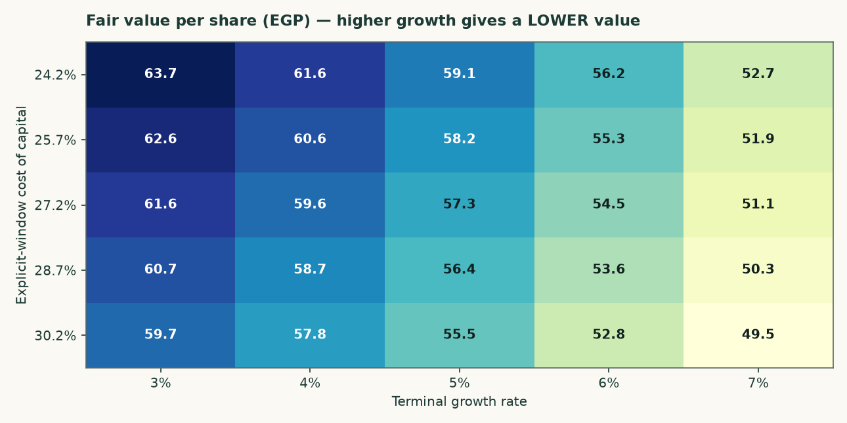
Figure 3 — The same surface. The growth axis is almost flat and the discount-rate axis is not; that is the model being consistent with its own terminal algebra rather than a sign error.
Explicit-window rate | 14.5% | 15.5% | 16.5% | 17.5% | 18.5%
24.20% | 67.28 | 62.83 | 59.14 | 56.03 | 53.36
25.70% | 66.17 | 61.81 | 58.19 | 55.14 | 52.52
27.20% | 65.09 | 60.82 | 57.27 | 54.28 | 51.71
28.70% | 64.03 | 59.85 | 56.37 | 53.44 | 50.92
30.20% | 63.01 | 58.90 | 55.49 | 52.62 | 50.15

Table 12 — The two anchors varied INDEPENDENTLY: the explicit-window rate down the side, the terminal rate across the top. This shows what the valuation needs the economy to do, not merely what growth rate the model needs.
1.9 The other three lenses, and the choices that were contested
The relative lens applies 4.5 times to normalised EBITDA of EGP 3,651mn — the FY2025 revenue base cut 6% and a mid-cycle margin of 31.2% applied to it — and adds net cash at face. The multiple is disclosed as weakly anchored: the listed Egyptian peer set is thin, and its published multiples do not reconcile against the market capitalisations printed beside them. That is why this lens carries 20% and not more.
The normalised-earnings lens capitalises the same mid-cycle operating profit after tax — EGP 2,560mn — at 7.0 times, and again adds cash at FACE rather than capitalising it at the operating multiple. Cash is worth cash; capitalising a pound of treasury at seven times would value it at a discount to itself.
The asset lens values the capacity: 5.0Mt at a justified USD 95 per annual tonne, marked down 27% from a replacement cost of USD 130. Against that, the market is paying USD 85.2 per annual tonne. This lens carries only 8%, and the reason is in the same paragraph as the number: restarting a mothballed line costs a fraction of building one, and 12.6Mt of restart capacity is queuing. Replacement cost is a ceiling here, not a floor.
Choice | Adopted | Alternative | Effect on the cash-flow lens
Cost of debt: currency composition as contracted (adopted) vs the pound-equivalent under uncovered interest parity | 7.89% | 13.36% | 57.14 (+3.5%)
Beta: same-country peer median (adopted, tier 2) vs the own-stock regression against the EGX30 that FAILS the usability gate | 0.928 | 0.698 | 63.40 (+14.8%)
Capex: economic maintenance in dollars per tonne (adopted) vs book depreciation | USD 4.00/t | book depreciation | 62.32 (+12.9%)

Table 13 — Every contested choice computed as a value rather than argued in prose. None of these alternatives is hidden; each is a full re-run of the model.
1.10 A published sell-side target, reconciled item by item
On 6 August 2026 EFG Hermes published a Buy rating on ARCC with a target price of EGP 69.75, against a spot of EGP 59.00. Both models reproduce FY2025 revenue, cost of sales, gross profit, D&A, capex and net cash to the pound, so the whole EGP 15.10 gap between the two targets is forward-looking. What follows replaces one driver of theirs with one of ours at a time and records the change, so the bars sum to the gap by construction rather than by a plug.
Step | EGP/sh | What moved
START — EFG Hermes target | 69.75 | 6 Aug 2026, Buy, DCF
EFG's own date mismatch | -2.12 | flows dated 1-Jan, cash dated August
Maintenance capex | -7.62 | 5-yr 1,533 → 5,592 theirs below D&A
Operating build | +2.44 | our volume up, our margin down
Terminal block | -2.51 | growth must fund itself: 56.8% back in
Discount rate | -0.16 | their flat 20.06% vs our 24.5%→14.5%
Valuation date 1 Jan → 6 Aug | +1.28 | −3.33 out of window, +4.61 back as cash
Dividend paid, debt refreshed | -5.67 | EGP 5.34 ex 12 Apr (−2,002mn)
Other three lenses | -0.73 | 50/20/22/8 weights and share count
END — this study's weighted central | 54.65 | four lenses, weighted

Table 14 — The reconciliation bridge. Bars sum to the gap exactly (-15.10 vs -15.10). Reproduced independently as a check before publication.
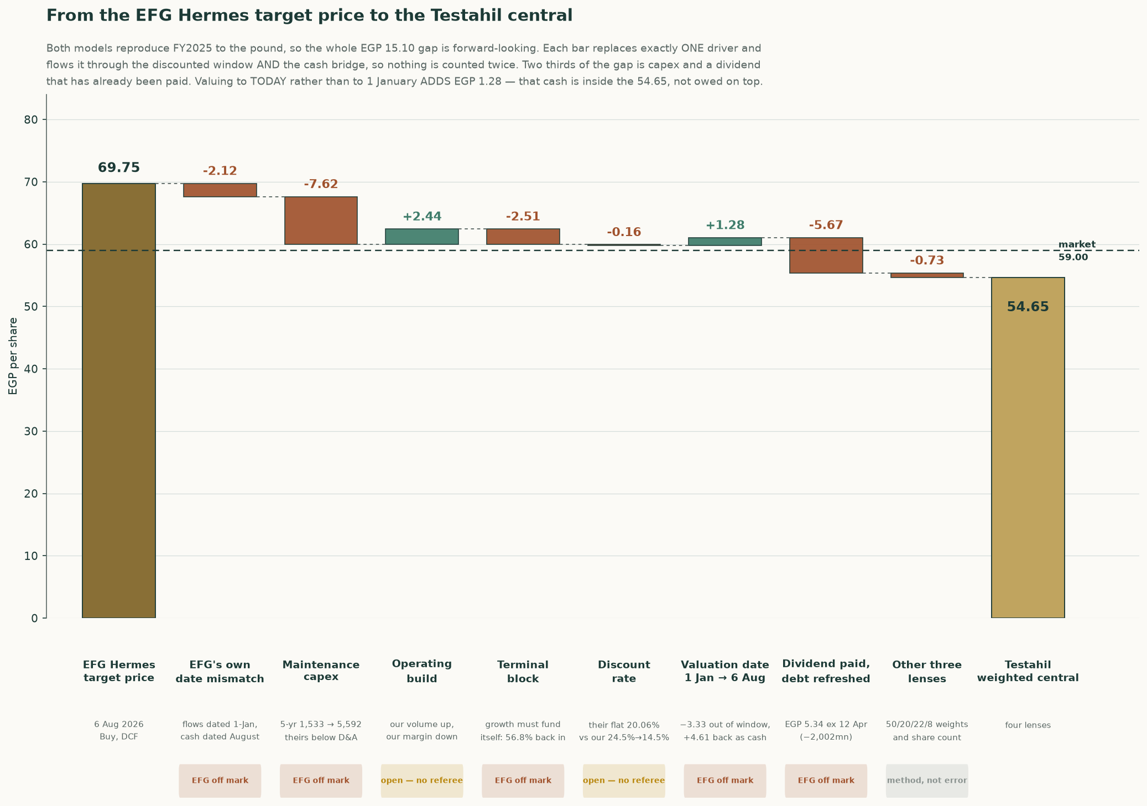
Figure 4 — The same bridge, drawn. Every bar substitutes exactly one driver and carries it through both the discounted window and the cash bridge, so nothing is counted twice.
Sorting the eight steps by who the evidence favours: the items where EFG’s own construction is inconsistent with itself sum to -16.65 — an internal date mismatch between their discount factors and their cash balance, a capex path that sits below their own depreciation in every tabulated year, a terminal value grown without a reinvestment charge, and a dividend of EGP 5.34/share, ex 12 April 2026, that their own front page discloses and their balance sheet does not appear to reflect. Two items are genuinely open — the operating build, where our volumes are higher and our margin path is lower, and the discount-rate convention, where their rate is below the sovereign risk-free rate early and harsher than ours late, worth a combined +2.28. The remaining -0.73 is a lens-weighting difference, not an error on either side.
EFG's own date mismatch (-2.12, EFG off mark). Their factors are 1/(1.2006)^(t-1), so FY2026 is undiscounted and the flows sit at 1-Jan-2026. Their net cash of 3,119 is ABOVE the audited 31-Dec-2025 net cash of 2,324. The whole FY2026 free cash flow of 2,975 is in the window AND the cash it generated from January to August is in the bridge — those months are counted twice. On their own consistent basis their target is 67.64, not 69.75.
Maintenance capex (-7.62, EFG off mark). EFG's capex sits below their OWN D&A in all three years they tabulate: 308 vs 318, 300 vs 347, 248 vs 378 — net disinvestment. ARCC actually spent 912 (FY2024) and 799 (FY2025). CAVEAT: ours is not obviously right either; 1,012 in FY2026 is ABOVE the FY2025 actual of 799. The magnitude is arguable, the direction is not.
Operating build (+2.44, open — no referee). Two errors pointing opposite ways and no referee. Our FY2028 revenue is 15,350 against their 13,792 (+11.3%) because we build tonnes from kiln utilisation 91.7%->93.5%; they have volume FALLING 3%. But our EBITDA margin glides 39.3%->34.3% while Q1-2026 gross margin was 42.9% and widening, which is their side of it.
Terminal block (-2.51, EFG off mark). They grow FY2030 FCF at 2.5% forever with no reinvestment charge. A perpetuity growing at g on returns of ROIC must plough back g/ROIC. At our terminal ROIC of 8.81% that is 56.8% of profit. CAVEAT: the 8.81% rests on replacement capital of 50,481 = 5.0Mt x USD 130/t x 50.30 x 1.544, and the USD 130/t is our least-verified single input.
Discount rate (-0.16, open — no referee). Their flat 20.06% is applied to FY2026 while the Egyptian 1-year T-bill yields 22.95% — below the risk-free rate, which is hard to defend. But it is correspondingly too HIGH late: their year-5 factor of 0.4813 is harsher than our 0.4876. The two errors very nearly cancel and the whole bar is EGP 0.16, so neither convention is worth arguing over.
Valuation date 1 Jan → 6 Aug (+1.28, EFG off mark). A price is what you pay today. Only 0.417 of FY2026 remains, so 0.583 of that year's FCFF leaves the discounted window — and arrives in the bridge as cash already earned. This step ADDS value on net. The +4.61 of accumulated cash is INSIDE the 54.65; it is not owed on top.
Dividend paid, debt refreshed (-5.67, EFG off mark). EFG's own front page prints 'Last Div. / Ex. Date EGP5.34 / 12 Apr 2026'. A buyer on 6 August does not receive it. Their net cash of 3,119 is 1,193 ABOVE our post-dividend 1,926 and cannot be a post-dividend August figure. INFERRED, not proved: they do not print the date.
Other three lenses (-0.73, method, not error). Not an error on either side. They publish a DCF; we weight DCF 50%, multiples 20%, normalised earnings 22%, replacement cost 8%. The three non-DCF lenses land at 48.96 / 52.95 / 68.87 and pull down 0.73 net. The share count (374.867 vs 375.0) is inside that.
Year | Testahil | EFG published | EFG on our definition | Gap
FY2025a | 39.2% | 40.3% | 39.2% | audited
FY2026e | 36.0% | 39.0% | 38.0% | +1.96pt
FY2027e | 35.6% | 40.6% | 39.5% | +3.85pt
FY2028e | 35.4% | 40.8% | 39.7% | +4.26pt
FY2029e | 35.1% | 40.8% | 39.7% | +4.63pt
FY2030e | 35.0% | 40.8% | 39.7% | +4.67pt

Table 15 — EBITDA margin, year by year. EFG’s FY2025a margin restates to 39.3% once the 1.1% definitional wedge — provisions, expected credit losses and other operating income, which the two models classify oppositely — is removed, reproducing our own audited figure exactly. The disagreement from FY2026 on is real, not definitional, and it widens rather than staying flat.
Scenario | DCF lens | Central | vs spot
Testahil base — our margin, our volumes | 55.40 | 54.65 | -7.4%
Half way between the two margin paths | 61.75 | 57.83 | -2.0%
EFG margin, OUR volumes | 68.10 | 61.00 | +3.4%
EFG margin, EFG volumes — their view whole | 50.83 | 52.37 | -11.2%
EFG margin, our volumes, mid-cycle lifted too | 68.10 | 66.21 | +12.2%

Table 16 — What EFG’s margin view is worth, held against both volume assumptions. Their margin on OUR volumes clears spot; their margin AND their volumes, taken together, does not.
1.11 What a buyer at EGP 59.00 must believe
Strip out the items resolved above and the honest disagreement left is one thing: how fast does the FY2025 margin peak fade. Everything else in the bridge is either a construction error on the published target (the date mismatch, the sub-depreciation capex path, the unfunded terminal growth, the still-outstanding dividend) or a lens-weighting convention that is not a factual dispute at all. A market price of EGP 59.00 sits between this study’s central of EGP 52.90 and EFG’s corrected-for-its-own-errors figure, closer to ours — but a buyer paying spot is not implicitly endorsing either model whole. Splitting the one open question down the middle — EFG’s margin path and this study’s volume path, averaged rather than either side’s optimism taken alone — prices at EGP 57.83, -2.0% against spot. That, not either published figure, is the number this study would defend if forced to name one.
2 Price structure
The price closed 59.00 above a rising 20-day (56.27), a rising 50-day (56.25) and a rising 200-day (51.73). Momentum is firm: RSI(14) is ~65 and the daily ATR near 1.28 (~2.2%) points to a normal tape. MACD (12·26·9) is positive and rising (+0.46 / +0.25 / +0.20). Over the last year it has ranged 35.01–60.40; the last close sits 2% below that high and 69% above that low.
 | Level (EGP) | Distance from spot
Resistance 1 | 60.34 | +2.3%
Resistance 2 | 62.00 | +5.1%
Resistance 3 | 63.00 | +6.8%
Support 1 | 54.25 | -8.1%
Support 2 | 52.99 | -10.2%
Support 3 | 48.10 | -18.5%
52-week high | 60.40 | +2.4%
52-week low | 35.01 | -40.7%

Table 17 — Levels are computed from swing structure with a recency weight; moving averages, the 52-week extremes and round numbers are admitted as candidates but score below real swing points. Resistance 1 and support 1 always mean nearest to the close.
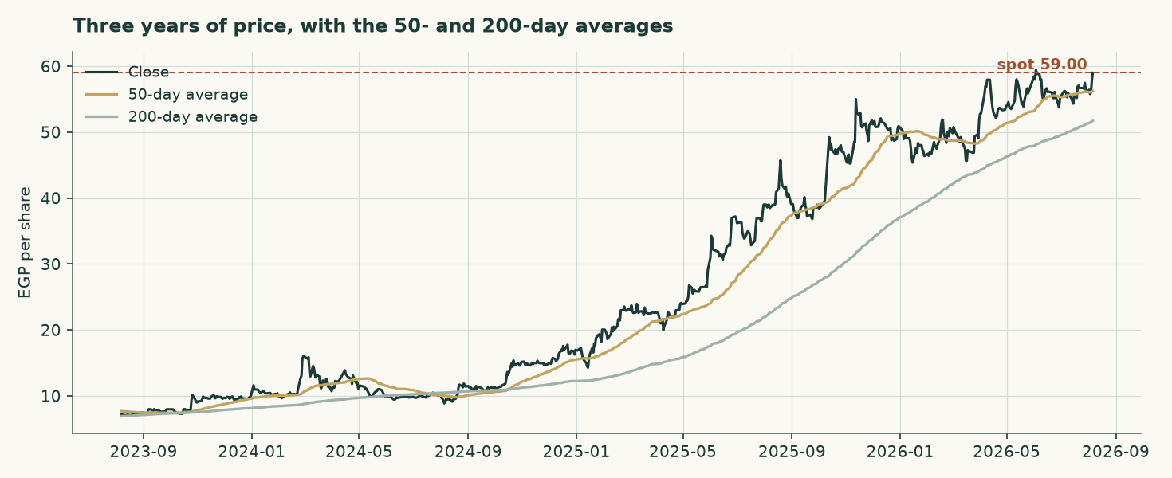
Figure 5 — Three years of price with the 50- and 200-day averages.
On the upside: A daily close back above 60.34 would clear the nearest resistance and open the 63.00 zone.
On the downside: A close below 54.25 would break the nearest support and open the 48.10 zone.
This section describes the tape and makes no claim about value. The two are compared in section 4.
3 A probabilistic price map
The following is NOT a valuation. It is a distribution of where the share price could sit at two horizons, drawn from the price history alone and from nothing in the preceding sections. It is included because a single fair-value number tells a reader nothing about dispersion, and it is labelled illustrative because its own calibration record says it should be.
 | One month | Three months
5th percentile | 50.44 | 43.92
25th percentile | 55.93 | 53.71
Median | 59.45 | 60.46
75th percentile | 63.21 | 67.97
95th percentile | 70.09 | 83.17
Probability of finishing above the current price | 53.4% | 55.6%
Probability of touching +10% at any point | 27.8% | 58.0%
Probability of touching −10% at any point | 19.8% | 45.5%

Table 18 — Percentiles in EGP per share, from a 50,000-path simulation anchored on the 6 August 2026 close of EGP 59.00. The drift is the carry — the risk-free rate less the dividend yield — and nothing else.
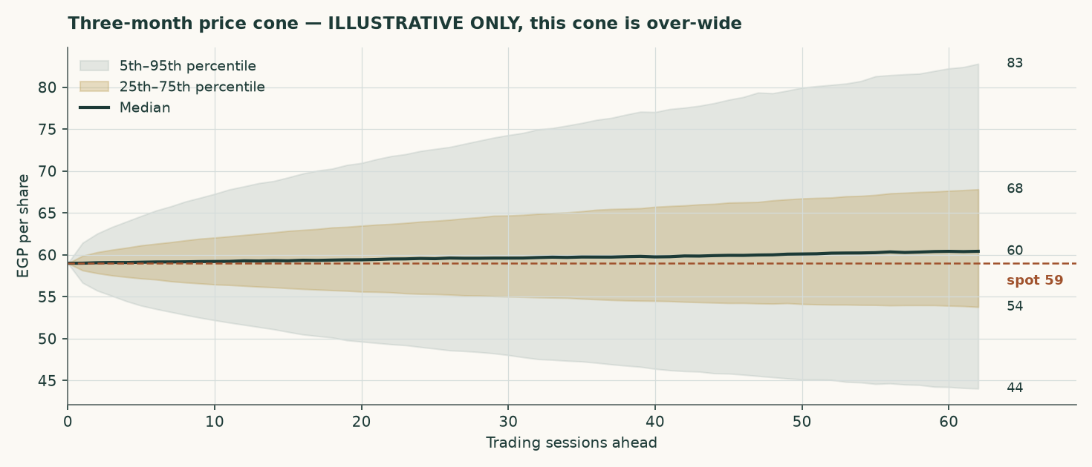
Figure 6 — The three-month cone.
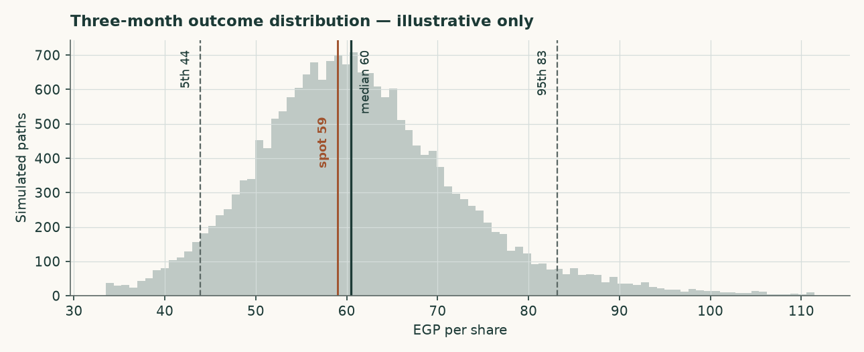
Figure 7 — The three-month outcome distribution.
How well calibrated is it? Measured over 16 independent quarterly windows, the bands cover 56%, 100% and 100% of outcomes against nominal 50%, 80% and 90%. The map is therefore TOO WIDE rather than mis-centred: it is not missing the outcome, it is covering more ground than it claims to. Its skill against a simple random walk is -1.8% — statistically indistinguishable from zero at every block size tested. No valuation conclusion in this study rests on it.
4 Comparison of the lenses
Lens | Bear (EGP) | Base (EGP) | Bull (EGP) | Weight | Versus spot
DCF (cash flow) | 51.40 | 55.21 | 63.34 | 50% | -6.4%
Relative multiples | 41.09 | 45.65 | 50.22 | 20% | -22.6%
Normalised earnings | 44.68 | 49.64 | 54.60 | 22% | -15.9%
Asset / replacement cost | 59.01 | 65.57 | 72.13 | 8% | +11.1%
Weighted central | 48.47 | 52.90 | 59.50 | 100% | -10.3%

Table 19 — Each lens as a range. The disagreement between them is information, not noise.
The four lenses do not agree, and the pattern of their disagreement is the most useful thing in this study. Two of them sit ABOVE the market price — Asset / replacement cost, at EGP 65.57 — and two sit below: Relative multiples, Normalised earnings and DCF (cash flow), at EGP 45.65 and EGP 49.64 and EGP 55.21. The split is not assets against earnings. It runs between what the plant can be expected to EARN or COST from here, which both land above the market, and what the market is currently willing to PAY for a pound of Egyptian cement earnings, which is what the two multiple-based lenses measure and which lands below. A cement peer group trading at 6.2 times earnings in a country whose policy rate has a two in front of it is not obviously mispricing anything; it is discounting the same restart programme this study discounts, only harder and sooner.
The weighting resolves that in favour of earnings, at 50%/20%/22%/8%, and gives a central EGP 52.90 against EGP 59.00 — -10.3%. A reader who believes replacement cost is a floor rather than a ceiling would weight the asset lens far more and reach the opposite conclusion. The case against doing so is the 12.6Mt restart programme, and it is a testable one.
Against the technical picture, the two readings are in tension. The share is above its entire moving-average stack on a rising 200-day and 98% of of its 52-week intraday high — 98% OF that high, and 94% of the way UP the range, which are different statistics and the earlier edition ran them together — while the two multiple-based lenses put fair value below the current price and the two forward-looking ones put it above. Momentum sits with the cash-flow case here rather than against it, and the disagreement that remains is between that case and the multiple the market is prepared to pay. This study takes no view on which resolves first.
5 Catalysts to watch
- The restart programme. Seven to nine dormant Egyptian lines are under study for revival, potentially adding 12.6Mt from the second half of 2026 — about 23% of domestic consumption. Whether those lines actually restart, and how fast, is the single largest swing factor in the price path this model assumes.
- The realised price, quarter by quarter. The model assumes a domestic price of EGP 3,328 a tonne in FY2026 and growth below cost inflation thereafter. Two consecutive quarters of realised prices above EGP 4,200 would break that assumption upward; a return toward EGP 3,000 would break it down.
- The alternative-fuel programme. The substitution rate is assumed to rise from a cumulative 5.5% saving on the materials and fuel line by FY2030, against a EUR 25mn facility already drawn and EGP 240mn of capacity already under construction. Progress on it is reported in the company's own sustainability disclosure and is directly visible in the fuel cost per tonne. A stall would cost roughly the difference between the blended and fossil-only fuel bills.
- Energy tariffs. Phased subsidy reform continues to raise the domestic industrial energy bill independently of the global fuel price. The model inflates the pound cost lines by 11.5% in FY2026, easing to 7.0% by FY2030; a faster reform schedule would compress the margin faster than assumed.
- The export cap and the carbon border mechanism. Exports are capped at 30% of production, and the EU carbon border mechanism raises the landed cost of Egyptian cement in Europe. A low-clinker, high-alternative-fuel producer suffers less from the second than a conventional peer, and the export price path assumes exactly that.
- Distribution policy. The company declared EGP 2,002mn for FY2025, about 56% of attributable profit, on top of EGP 1,102mn for FY2024. A change in that policy changes the cash roll-forward and, through it, the balance sheet the bridge relies on.
6 Reading the probability zones
The distribution in section 3 is easier to use as zones than as percentiles. The following divides the three-month outcome space into four bands and states what each would mean, without predicting which occurs.
Zone | Three-month range (EGP) | Probability | What it would mean
Lower tail | below 43.92 | 5% | A break of the 48.10 support zone, most plausibly on a faster-than-assumed capacity restart
Below spot | 43.92 – 59.00 | 39% | The market converging toward the earnings-based lenses in this study
Above spot | 59.00 – 83.17 | 51% | Momentum and the 2026 pricing environment continuing to lead the earnings case
Upper tail | above 83.17 | 5% | A re-rating toward the asset lens, which would require the restart programme to be abandoned or delayed materially

Table 20 — Zones, not forecasts. The four are exclusive and sum to 100%: each tail is carved OUT of the band beside it rather than counted twice. The probabilities come from the price map and are subject to the same over-width caution as everything else in section 3.
7 Caveats and what would change our mind
- The accounts are audited, and this study is built on them. An earlier edition of this work was written without access to a source document and reconstructed the history by closing disclosed profit against modelled assumptions. That edition is superseded. Every historical figure here is read from the consolidated financial statements signed by Deloitte on 25 February 2026, or from the reviewed interim accounts of 25 May 2026. Four things it got materially wrong are worth naming, because they show where reconstruction fails: minority interests were deducted at EGP 150mn against an audited EGP 158,005; the effective tax rate was inferred at 29.4% against a disclosed 23.8%; the cost of debt was assumed at 21.5% against a euro-denominated book paying about 7.5%; and kiln capacity was assumed 14% too low.
- The model was rebuilt bottom up, and the answer moved a long way. Four reviewers tested the previous edition. Between them they showed that its volume came from an assumed price rather than from the plant, that its FY2025 validation was an identity that could not fail, that its terminal capital was measured in valuation-date pounds against a terminal-year cash flow, that its terminal cost of debt sat 250 basis points below its own terminal risk-free rate, that its terminal risk-free rate used the central bank's near-dated inflation target rather than its medium-term one, that its discount factors applied each year's rate one period late, that its beta was levered twice, and that ten rows of its income statement were labelled one row above their contents. All of that is corrected here. The central fair value moves from EGP 61.30 to EGP 52.90, and the conclusion moves from a premium over the market to a small discount.
- The expert panel is the model at three parameter values, not three independent valuations. A reviewer pointed out that Expert 1's central IS the asset lens to the pound and Expert 2's IS the normalised-earnings lens. That is correct, and the workbook now builds all nine panel figures as FORMULAS off the same drivers rather than typing them, so the point is demonstrated rather than argued: Expert 1 marks replacement cost at USD 80/95/110 a tonne, Expert 2 capitalises the normalised base at 6/7/8 times, Expert 3 discounts mid-cycle free cash flow at a 20.0%/17.5%/15.0% required return. Read the panel as a sensitivity with reasoning attached, not as corroboration.
- Volume is now physical, and it is the largest open question in the study. The build runs on kiln utilisation, the clinker factor and two export shares, and the three realised prices are derived from the audited revenue note. That makes the prices testable, and they do not fully pass: export clinker derives to USD 30.0 a tonne against a trade-press range of USD 44-48. Either the physical assumptions are too generous or realisations run below the published indices. The company discloses despatch volumes in its investor material, which would settle it; that material could not be reached from here, and the audited statements are image-only scans that carry no volume table.
- The cost of debt is contractual, not paid. The blended 7.89% sits above the 5.03% that FY2025 interest over average debt gives and the 3.73% the first quarter of 2026 annualises to, because the book re-based mid-year and interest on assets still under construction is capitalised. Adopting the contracted euro rate also means the euro debt is not compensated for pound depreciation beyond the currency path assumed here; the pound-equivalent alternative is 13.36% and is worth +3.5%.
- The forecast is well below the first-quarter run rate. This is the largest judgement in the model and section 1.6 states it with the numbers. The first quarter of 2026 ran a 42.9% gross margin against 40.6% for FY2025 as a whole. If that holds, this valuation is too cautious, and the margin sensitivity below is where to look.
- The terminal denominator is a choice. Return on capital is 60.6% on the audited book and 10.1% on replacement cost. The terminal block uses replacement cost, which leaves the plant roughly breaking even on new tonnes — 9.58% against a hurdle of 14.13%, so four points of terminal growth are worth -17.2% of value and the answer does not rest on the rate. On the book basis growth would be close to free and the valuation materially higher. The case for replacement cost is that the book carries a 2010-vintage plant at a tenth of what one would cost to build today, but a reader is entitled to disagree.
- The beta is not this company's own. Measured against the market index, Arabian Cement's own share history explains too little to be usable — an R-squared of 4.7% — so the discount rate rests on the betas of four comparable Egyptian companies instead. That is the ordinary fallback and it is disclosed, but it means the risk measure in this valuation is a sector estimate rather than a measurement of this share. The valuation is shown across the whole peer spread for exactly that reason.
- The price map is over-wide. Its bands cover 100% and 100% of outcomes against nominal 80% and 90%, and its skill against a random walk is -1.8%. It is carried as illustrative only.
- A minority position under a 60% shareholder. Aridos Jativa of Spain owns 60% of the capital. No control premium or discount is applied anywhere in this valuation, in either direction. The company also holds 1% of its own capital in treasury, acquired during 2025, which is excluded from the share count throughout.
- Currency, on both sides now. Revenue is 69% local and 31% export; costs are largely in pounds but fuel and spares are not; and the debt is 91% euro. A weaker pound raises export revenue in pounds and raises the pound cost of servicing the euro debt. The model carries one currency path acting on all three legs.
Net cash at the valuation date (EGP mn) | -813 | -63 | 687 | 1,437 | 2,187
Fair value per share (EGP) | 53.27 | 55.27 | 57.27 | 59.27 | 61.27

Table 21 — The clean net-cash sensitivity, with the tax rate held.
Shift in the EBITDA margin, every forecast year | -4% | -2% | +0% | +2% | +4%
Fair value per share (EGP) | 47.15 | 52.21 | 57.27 | 62.33 | 67.39

Table 22 — And the margin sensitivity, which is the largest single swing factor in the model.

Appendix A Financial statements
Income statement
EGP mn | FY2023 | FY2024 | FY2025 | FY2026E | FY2027E | FY2028E | FY2029E | FY2030E
Revenue | 6,043 | 8,730 | 12,447 | 13,349 | 14,538 | 15,798 | 16,942 | 18,088
Cost of sales | (4,760) | (6,643) | (7,389) | — | — | — | — | —
Gross profit | 1,283 | 2,087 | 5,058 | — | — | — | — | —
Operating profit | 1,079 | 1,764 | 4,596 | 4,866 | 5,234 | 5,645 | 5,974 | 6,350
Depreciation and amortisation | 250 | 257 | 290 | 344 | 404 | 472 | 541 | 615
EBITDA | 1,330 | 2,021 | 4,886 | 5,210 | 5,639 | 6,117 | 6,515 | 6,965
EBITDA margin | 22.0% | 23.1% | 39.3% | 39.0% | 38.8% | 38.7% | 38.5% | 38.5%
Net finance and other income | -149 | -258 | 129 | 127 | 219 | 323 | 434 | 567
Profit before tax | 930 | 1,506 | 4,725 | 4,993 | 5,453 | 5,968 | 6,407 | 6,917
Income tax | (233) | (346) | (1,125) | (1,189) | (1,299) | (1,421) | (1,526) | (1,648)
Attributable profit | 697 | 1,160 | 3,600 | 3,804 | 4,154 | 4,546 | 4,881 | 5,269
Earnings per share (EGP) | 1.81 | 3.02 | 9.49 | 10.15 | 11.08 | 12.13 | 13.02 | 14.06

Table A1 — Three AUDITED years and five forecast. FY2023-FY2025 revenue, cost of sales, administrative expenses, provisions, pre-tax profit, tax, attributable profit, earnings per share and depreciation are disclosed figures; operating profit, EBITDA and the margins are formulas over them. The published earnings per share is struck on distributable profit after the statutory employees' and directors' share, which is why it differs slightly from profit over the share count.
Balance sheet
EGP mn | FY2023 | FY2024 | FY2025 | FY2026E | FY2027E | FY2028E | FY2029E | FY2030E
Total assets | 3,888 | 5,849 | 8,784 | 8,470 | 10,315 | 12,333 | 14,500 | 16,840
Cash and bank balances | 561 | 1,687 | 3,459 | 2,370 | 3,414 | 4,637 | 6,036 | 7,623
Interest-bearing debt | 90 | 761 | 1,135 | 1,135 | 1,135 | 1,135 | 1,135 | 1,135
Net (cash) / debt | -471 | -926 | -2,324 | -1,235 | -2,279 | -3,502 | -4,901 | -6,488
Equity attributable to owners | 1,754 | 2,303 | 4,643 | 4,330 | 6,174 | 8,193 | 10,360 | 12,700
Book value per share (EGP) | 4.68 | 6.14 | 12.38 | 11.55 | 16.47 | 21.86 | 27.64 | 33.88
Return on equity | 39.8% | 50.4% | 77.5% | 87.9% | 67.3% | 55.5% | 47.1% | 41.5%

Table A2 — All three historical years are AUDITED. The FY2025 balance sheet closes exactly: total assets of EGP 8,784mn less total liabilities of EGP 4,141mn equals equity of EGP 4,643mn.
Cash flow
EGP mn | FY2026E | FY2027E | FY2028E | FY2029E | FY2030E
Attributable profit | 3,804 | 4,154 | 4,546 | 4,881 | 5,269
Add back depreciation | 344 | 404 | 472 | 541 | 615
Less change in working capital | -108 | -143 | -151 | -137 | -137
Capital expenditure | -1,012 | -1,062 | -1,116 | -1,172 | -1,230
Dividends paid | -2,115 | -2,310 | -2,528 | -2,714 | -2,930
Closing cash | 2,370 | 3,414 | 4,637 | 6,036 | 7,623
Memo: free cash flow to the firm | 1,465 | 3,187 | 3,505 | 3,782 | 4,084

Table A3 — Free cash flow to the FIRM excludes treasury income, which is handled in the equity bridge; free cash flow to equity includes it through profit.

Appendix B Peer set, sector structure and risks
 | Revenue (EGP mn) | Profit (EGP mn) | Market cap (EGP mn) | Price / earnings | Net margin
Arabian Cement (ARCC) | 12,447 | 3,600 | 22,117 | 6.14x | 28.9%
Sinai Cement (SCEM) | 9,090 | 2,290 | 20,604 | 9.00x | 25.2%
Misr Beni Suef Cement (MBSC) | 5,700 | 3,946 | 13,730 | 3.48x | 69.2%

Table B1 — Every multiple here is RECOMPUTED from revenue, profit and market capitalisation rather than quoted, because the published multiples for this peer set do not reconcile against the market capitalisations printed beside them.
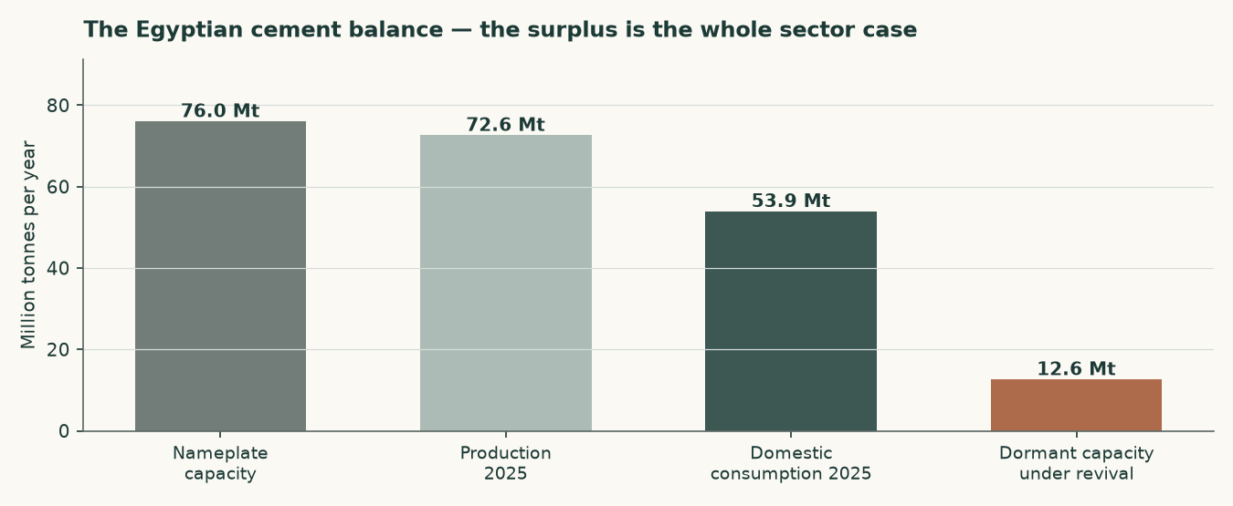
Figure B1 — The Egyptian cement balance. The surplus is the whole sector case.
Egypt carries about 76Mt of nameplate capacity against roughly 54Mt of domestic consumption and 73Mt of total sales. The balance now closes because it is taken from one disclosure rather than assembled from three: local 53.9Mt plus exports 18.6Mt equals the 72.6Mt total. Earlier editions set a cement-plus-clinker export figure against a cement-only production figure and printed a balance that was out by 7.5Mt. The correction matters beyond tidiness: 72.6Mt of sales against roughly 76Mt of nameplate is a market running near 96%, which is NOT the structurally slack market this study has described from its first edition. The oversupply risk is prospective — it lives in the 12.6Mt restart programme, not in the current balance — and the distinction is material to the price path. The abolition of the production quota in May 2025 removed the mechanism that had been supporting price into that surplus, and the 12.6Mt restart programme would add to it.
- Price risk. This is the dominant risk, and the disclosure corrects how it should be framed. The Egyptian market is NOT currently slack: it sold 72.6Mt against roughly 76Mt of nameplate, and this company realised a 60.7% rise in its local price in FY2025. The risk is prospective and it has two legs — the 12.6Mt restart programme, and a production quota that was SUSPENDED rather than repealed and could return without legislation. Either would meet a market with little spare demand to absorb it. That is why the forecast price path grows below cost inflation in every year despite an exit rate that would support more.
- Energy and currency. Fuel is dollar-priced and electricity tariffs are on a reform path. Both raise cost independently of what happens to price.
- Concentration. One site, one product, one country. There is no diversification anywhere in this business to absorb a shock to Egyptian construction demand.
- Carbon. The EU carbon border mechanism raises the landed cost of exports into Europe. At a clinker factor of 0.733 — a PRODUCTION ratio, not the ratio of two nameplate capacities the earlier edition mistook for one — this producer is better placed than most Egyptian peers, but better placed is not unaffected. It also ships 26.8% of its tonnes as raw clinker, which carries the highest embedded carbon of anything it sells.
- Disclosure. The depth of published financial detail is thin by the standards of the other markets covered, which is why so much of this study is a triangulation shown rather than a figure asserted.

Appendix C The expert valuation panel
Three independent valuations of the same company, each built by a different method and each stated with the specific evidence that would prove it wrong. They are not averaged: the disagreement between them is the point.
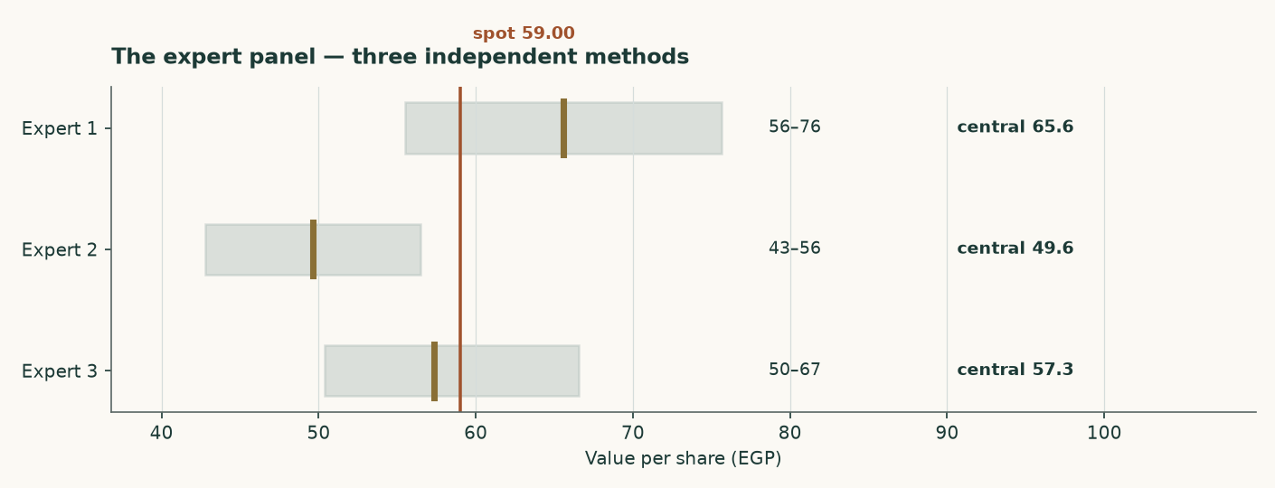
Figure C1 — The three panel valuations against the market price.
Expert 1 — Replacement-cost industrialist
Valuation: EGP 55.51 to EGP 75.63, central EGP 65.57 (+11.1% against the market price of EGP 59.00).
Values the plant, not the earnings stream. The audited accounts put net property, plant and equipment at EGP 2522mn and assets under construction at a further EGP 392mn, on a book carried at pre-devaluation historic cost. Five million tonnes of grey cement capacity costs about USD 130 per annual tonne to build; nobody pays that in a market carrying 76Mt of capacity against 54Mt of consumption, so the justified figure is marked to USD 95. Against that the market is paying USD 85 per annual tonne.
What would prove this wrong: Find an Egyptian line built, bought or restarted below USD 95 per annual tonne. The 12.6Mt revival programme is the live test and it runs against this lens: restarting a mothballed kiln costs a fraction of building one, which is why this valuation is a ceiling and carries only 8% of the weight.
Expert 2 — Mid-cycle earnings-power analyst
Valuation: EGP 42.81 to EGP 56.47, central EGP 49.64 (-15.9% against the market price of EGP 59.00).
Refuses to capitalise a peak, and refuses it on both legs. The audited EBITDA margin went 22.0% to 23.1% to 39.3% across FY2023 to FY2025 — the last of those is the best year the Egyptian industry has had in over a decade. The margin is normalised to 31.2%, the midpoint of the two most recent audited years, the revenue base is cut 6%, and what is left is capitalised at 7 times with cash added back at face.
What would prove this wrong: Two consecutive years of realised prices above EGP 4,200 a tonne WITH the revival proceeding would prove the mid-cycle base too low. Equally, the first quarter of 2026 already ran a 42.9% gross margin against 40.6% for FY2025 as a whole — if that holds for the year, this lens is too cautious.
Expert 3 — Cash-return and distribution investor
Valuation: EGP 50.38 to EGP 66.56, central EGP 57.32 (-2.9% against the market price of EGP 59.00).
Ignores the terminal value and asks what the cash stream is worth to someone who has to be paid in cash. Average free cash flow to the firm across FY2027-FY2030 is EGP 3640mn; required at a 17.5% cash return that is a business worth EGP 20799mn before net cash of EGP 687mn is added back. This is not hypothetical: the company declared EGP 2002mn for FY2025 on EGP 3600mn of attributable profit, a 56% payout, and the audited cash flow shows EGP 1702mn actually paid out during 2025.
What would prove this wrong: A required cash return above 20% takes this valuation to EGP 50.38. So would maintenance capital spending materially above the USD 4.00 per tonne assumed here — the audited FY2024 and FY2025 capex of EGP 912mn and EGP 796mn is the number to watch, and both years carried the alternative-fuel and silo programmes on top of maintenance.
 | Low (EGP) | Central (EGP) | High (EGP) | Versus spot
Expert 1 — Replacement-cost industrialist | 55.51 | 65.57 | 75.63 | +11.1%
Expert 2 — Mid-cycle earnings-power analyst | 42.81 | 49.64 | 56.47 | -15.9%
Expert 3 — Cash-return and distribution investor | 50.38 | 57.32 | 66.56 | -2.9%
Panel median | — | 57.32 | — | -2.9%

Table C1 — The panel. The median sits close to the weighted central of the four principal lenses, which is a coincidence of construction rather than a confirmation — both are looking at the same company through overlapping methods.

Testahil · Independent valuation research · Educational analysis, not investment advice. No rating and no price target is expressed or implied.

