Testahil · Independent Valuation Study — Educational Analysis Not investment advice

Independent Valuation Study — Educational Analysis
Savola Group Company (Saudi Exchange: 2050)
Savola · Kingdom of Saudi Arabia · Food and retail platform (edible oils · sugar · pasta · nuts & spices · grocery retail · quick-service restaurants · frozen food) Anchor 2026-08-18 · Spot SAR 25.40 (settled close) · Market capitalisation SAR 7,620mn
SECOND EDITION — 19-Aug-2026. This edition restrikes the 18-Aug-2026 first edition after a four-critique external audit, worked finding by finding (82 findings; the response record accompanies the study's repository). The principal corrections and what each is worth are listed in About; the weighted central moved SAR 28.02 to SAR 27.24.
READ FIRST. This study is an educational analysis, not investment advice, a recommendation or a solicitation. It never issues a rating or a price target: it publishes fair-value RANGES and probability DISTRIBUTIONS, and it separates what the business may be worth (sections 1, 4, 5) from where the price could plausibly trade (sections 2, 3, 6) — two different questions that are never blended. All figures are in Saudi riyals (SAR); the company reports, lists and pays dividends in SAR, and its Egyptian, Algerian and Emirati operations are translated in its own audited consolidation — no separate currency translation enters the model. Historical financials come exclusively from the company's own audited and reviewed consolidated financial statements (through the Q2-2026 reviewed interims) and its own results releases, read from savola.com/investors; every input is listed with source and date in the companion bibliography document.
Headline
The business. Savola is the Gulf's largest food platform: FY2025 revenue of SAR 26,081mn across five reported segments — food processing SAR 13,280mn (51% of segment revenue: edible oil 1,322 thousand tonnes, sugar 2,162 thousand tonnes, pasta, nuts & spices), grocery retail through Panda (SAR 11,328mn, 227 stores), Herfy's 'quick-service restaurants, and Al Kabeer frozen food. Roughly three quarters of revenue is Arabia, a fifth Egypt.
The reset that redefined it. In 2024 Savola raised SAR 6.0bn in rights, repaid SAR 5.8bn of debt, then cancelled 833.98mn shares (a SAR 8.3bn capital reduction) and distributed its entire 34.52% Almarai stake — SAR 21.1bn at fair value at settlement, of which SAR 12.75bn was the in-kind dividend leg and the rest settled the capital reduction — to its own shareholders. The holding-company era ended there: what remains is an operating food and retail group with 300mn shares, borrowings of SAR 1,894mn (all short-term trade finance) and lease liabilities of SAR 3,952mn.
The valuation. Weighted central SAR 27.24 per share against a spot of SAR 25.40 (+7%), inside a weighted bear-to-bull range of SAR 18.89 to 32.61 and a wider span across the four lenses of SAR 10.75 to SAR 39.51. The cash-flow lens alone reads SAR 24.99; the market-anchored relative lens reads SAR 28.22; the book lens reads SAR 24.49. The spread is the study's honest tension — section 4 explains it rather than hiding it.
The contested judgement. Is Panda's 20-store-a-year expansion creating value or burning it? Sales per store FELL between 6.0% and 7.1% in the first half of 2026 (a range, because the mid-2025 store count is not published) as new, smaller stores opened into a discounter-crowded market. Let density stabilise as the store-refresh programme matures and the model reads SAR 24.99; hold the measured erosion forever and the same model reads SAR 19.63. The judgement is worth SAR 5.36 per share, and both framings are published side by side — never averaged.
The moment. This study is struck twelve days after the company's own first-half results: revenue +3.9% to SAR 13,588mn, recurring net profit up 40% to SAR 372mn, oil volumes up 16%, the Sudan exit completed, and a bolt-on acquisition signed in July (Al Mehbaj Al Shamiya, SR 11.4mn per the Q2-2026 interims). Against that: the company itself warns of replacement-cost pressure in the second half as vegetable-oil benchmarks sit at four-year highs, and grocery competition is compressing Panda's densities. Both halves of that picture are in the model.

Valuation summary — every read at a glance
Lens | Bear | Base | Bull | Weight | vs spot
Discounted cash flow (primary) | 10.75 | 24.99 | 32.59 | 45% | -2%
Relative multiples | 24.69 | 28.22 | 31.75 | 25% | +11%
Normalised earnings power | 30.73 | 35.12 | 39.51 | 15% | +38%
Book value & sustainable return | 21.78 | 24.49 | 27.20 | 15% | -4%
Weighted central | 18.89 | 27.24 | 32.61 | 100% | +7%
Span across lenses (min/max, not weighted) | 10.75 |  | 39.51 | —
Contested judgement, other way — Framing B (−6% then −3% forever) |  | 19.63 |  | — | -23%
Store path at the H1 run-rate (+8/yr, judgement variant) |  | 19.53 |  | — | -23%
Terminal return held at 10.5% (retired first-edition input, as a variant) |  | 25.49 |  | — | +0%
Expert panel median (Appendix C) |  | 21.96 |  | — | -14%
DCF terminal value share of enterprise value: 79%

Table 1 — the valuation summary. Weighted central SAR 27.24, its bear and bull columns weighted on the same 45/25/15/15 basis; beneath it the wider min/max span across lenses, which is NOT a weighted figure. Dating, stated per lens: the cash-flow lens is dated 31-Dec-2025 and its Dec-dated legs are rolled to the 2026-08-18 anchor net of the SAR 1.70 dividend (ex-date 07-May-2026); the relative and normalised lenses are anchor-dated by construction (their multiples are 18-Aug quotes); the book lens stands on the 30-Jun-2026 reviewed equity. The terminal value is 79% of the DCF enterprise value — higher than the first edition's 76% because charging the full lease additions back-loads the free cash flow — and what that terminal implies is priced explicitly in sections 1.1 and 1.9.
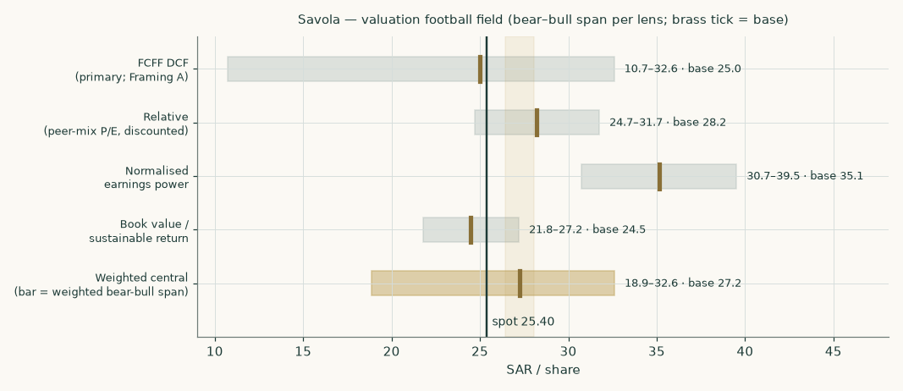
Figure 1 — the valuation football field: bear-to-bull span per lens, brass tick = base, dark line = spot.
Company overview — Savola at a glance
Savola Group was founded in Jeddah in 1979 as a Saudi edible-oils company and grew into the region's dominant staple-foods and grocery platform. Its operating structure today: Savola Foods Company (100%) manufactures and distributes edible oils, sugar, pasta, specialty fats and nuts & spices across Saudi Arabia, Egypt, Algeria and the UAE (with the July-2026 Al Mehbaj acquisition adding Saudi nuts-and-spices scale); Panda Retail Company (100%) runs one of the Kingdom's largest grocery networks; Herfy Food Services (49%-owned but consolidated — Savola is the dominant shareholder of a widely held register, and Herfy is separately listed) runs the home-grown quick-service chain; Good Food Company holds the Al Kabeer frozen-food business; and a 29.9% associate stake in Kinan International carries the legacy real-estate book. The controlling shareholder group around the Al-Muhaidib family anchors the register.
The revenue mix that decides the company's class: food processing SAR 13,280mn and grocery retail SAR 11,328mn together are 93% of segment revenue; food services and frozen food make up most of the rest. (The audited segment note also lists an investments segment at SAR 29mn — INTER-SEGMENT rent charged to sister companies and fully eliminated on consolidation, so it contributes nothing to external revenue; its property backs a bridge asset instead.) The balance-sheet shape says the same thing: owned plant of SAR 5,486mn and store right-of-use assets of SAR 3,417mn against lease liabilities of SAR 3,952mn; inventories of SAR 4,681mn turning through payables of SAR 3,916mn; short-term commodity-finance borrowings of SAR 1,894mn and zero long-term debt. After the Almarai distribution the listed-stake layer that once defined Savola is gone: what is left to value is an OPERATING COMPANY — a diversified consumer-staples operator — and the study therefore runs the operating-company lens set: a full free-cash-flow model as the primary lens, cross-read by relative multiples, normalised earnings power and a book/sustainable-return lens, with the small non-operating pocket (government sukuk, the residual Almarai shares, Kinan) valued separately in the bridge. No leg is large enough or different enough to need a separate valuation method: Herfy, the one listed piece, enters the bridge at its own market price through the outside shareholders' interest.
Two structural facts organise everything else. First, margins here are thin and mix-driven — the group operating margin before depreciation is 9.0% and every point of it is fought for in commodity pass-through (oils, sugar, wheat) and grocery price investment; the model therefore builds each category on its own volumes and unit economics and lets every margin fall out as a result. Second, the group is mid-rebuild: the 2024-2026 portfolio rationalisation (Iran, Sudan and Türkiye all exited) has concentrated capital on Arabia and Egypt, dividends have restarted under a stated 50-60% payout policy, and the expansion budget is pointed at Panda stores and a new Jeddah nuts facility. Whether that expansion earns its keep is the study's central question.
1 Fundamental valuation
Four lenses, weighted into one field: the discounted cash flow carries 45%, relative multiples 25%, normalised earnings power 15% and the book lens 15%.
1.1 The cash-flow model — the primary lens, with the full waterfall
The model builds five explicit years from the segment engine of section 1.6 — category volumes times unit prices and unit gross profits for food processing, stores times sales per store for Panda — charges the combined zakat-and-tax take, funds owned capital expenditure and the FULL lease additions (lease renewals equal to right-of-use depreciation PLUS the lease-book growth the store programme creates: leases are debt, so lease-funded growth is reinvestment like any other, and the first edition's renewals-only charge let the growth ride free — the largest single correction of this edition), and invests working capital at the measured component days, with the Tiryaki sale-proceeds receivable carved out of working capital into the bridge. The full waterfall — every line of it a live formula in the companion workbook:
SAR mn | 2026 | 2027 | 2028 | 2029 | 2030
Revenue | 27,060 | 28,349 | 29,726 | 31,029 | 32,131
EBITDA | 2,391 | 2,484 | 2,595 | 2,706 | 2,801
less depreciation & amortisation | -1,223 | -1,265 | -1,313 | -1,353 | -1,387
EBIT | 1,168 | 1,219 | 1,283 | 1,353 | 1,414
NOPAT — EBIT × (1 − 19.5%) | 940 | 982 | 1,032 | 1,089 | 1,138
add back depreciation & amortisation | 1,223 | 1,265 | 1,313 | 1,353 | 1,387
less capital expenditure | -810 | -900 | -880 | -860 | -850
less lease renewals (right-of-use depreciation) | -559 | -584 | -607 | -629 | -647
less lease-book growth (new-store leases) | -198 | -187 | -173 | -158 | -140
less change in working capital | -28 | -35 | -38 | -36 | -30
Free cash flow to the firm | 569 | 540 | 647 | 761 | 858
discount factor | 0.9275 | 0.8602 | 0.7979 | 0.7400 | 0.6863
PV of FCFF | 527 | 465 | 516 | 563 | 589

Table 2 — the FCFF waterfall. The EBITDA margin path (8.8% to 8.7%) is an OUTPUT of the segment build, never an input; capital expenditure follows the company's own programme (FY2025 actual SAR 858mn, first half of 2026 SAR 385mn); the working-capital line is built from measured days of inventory, receivables and payables (ex the Tiryaki receivable); the lease charge is the FULL additions — renewals plus growth — matching the lease book the balance sheet itself rolls forward.
Terminal value: terminal-year NOPAT grown at 2.5% with a reinvestment rate set by the growth itself — g / return on capital = 2.5% / 10.07% = 24.8% of NOPAT — capitalised at the terminal cost of capital of 8.42% less growth. The terminal return is not an assumption: it is COMPUTED as the model's own year-five NOPAT on year-five opening invested capital, so the terminal continues exactly the economics the forecast itself produces (the return path runs 9.62% to 10.07%). The first edition set 10.5% as an input — a step-up above every forecast year that an external audit rightly flagged; that case is retired to a labelled variant worth SAR 25.49 (the brands/shelf-position argument, published beside the base, never averaged). The terminal value is SAR 14,811mn, whose present value is SAR 10,165mn — 79% of enterprise value, HIGHER than the first edition's 76% because the corrected lease charge back-loads the explicit years. A reader should sit with that number: four fifths of this valuation is the going concern beyond 2030, priced at a return on capital modestly above its cost. Section 1.9 prices the moves.
The enterprise-to-equity bridge
Step | SAR mn | Per share
Present value of the five forecast years | 2,660 | 8.96
Present value of the terminal value | 10,165 | 34.26
Enterprise value (operating) | 12,825 | 43.23
+ Government sukuk and other investments (audited carrying) | 762 | 2.57
+ Tiryaki sale-proceeds receivable (on the audited 31-Dec-2025 balance sheet; settled in Tiryaki shares in H1-2026) | 275 | 0.93
+ Investment property (its inter-segment rent sits outside group EBITDA) | 158 | 0.53
+ Cash and cash equivalents | 904 | 3.05
− Loans and borrowings | -1,894 | -6.38
− Lease liabilities | -3,952 | -13.32
− Employee benefits liabilities | -748 | -2.52
− Asset-restoration provision | -165 | -0.56
− Other net liabilities (tax and zakat accruals, deferred tax, net) | -333 | -1.12
− Other minority interests at book | -515 | -1.74
Dec-2025-dated legs, subtotal — the roll to the anchor at the cost of equity (factor 1.0644) takes this to SAR 7,788mn | 7,317 | 24.66
+ Kinan at capitalized earnings (an H1-2026 run-rate value — anchor-dated, unrolled) | 653 | 2.20
− Herfy's 51% outside interest at Herfy's own settled 18-Aug price (anchor-dated, unrolled) | -511 | -1.72
− Al Mehbaj consideration (Jul-2026; its revenue is in the forecast) | -11 | -0.04
Equity value attributable to owners AT THE ANCHOR | 7,918 | 26.69
less the SAR 1.70 dividend gone ex inside the window — fair value per share at the anchor |  | 24.99
Terminal value share of enterprise value: 79%

Table 3 — from enterprise value to equity. Dating discipline (a first-edition defect, corrected): the Dec-2025-dated legs are rolled 230 days to the 2026-08-18 anchor at the cost of equity; the three legs that are already anchor-dated — Kinan capitalized on H1-2026 run-rate earnings, Herfy's minority at its 18-Aug market price, and the July-2026 Mehbaj consideration — sit OUTSIDE the roll at their own dates. Per share: SAR 25.10 on the Dec-2025 basis, SAR 24.99 at the anchor after the SAR 1.70 dividend (ex 07-May-2026), on the 296.7mn ex-treasury divisor from the company's own Q2-2026 EPS note. Kinan alternatives are disclosed in the workbook: audited carrying SAR 436mn (floor), share of net assets SAR 601mn, capitalized earnings SAR 653mn (used).
1.2 Book value and sustainable return
Equity attributable to owners at 30-Jun-2026 (reviewed) is SAR 5,361mn — SAR 18.07 per share on the ex-treasury divisor, after the FY2025 dividend left the book. The sustainable return is the model's OWN FY2026E attributable profit (the recurring construction of the engine, SAR 729mn) on opening equity: 13.2% — one FY2026 earnings base across every lens (the first edition ran this lens on a +15% step it labelled first-half-evidenced while its own engine said +35%; an external audit caught the inconsistency and this edition removes it). Against a cost of equity of 10.41% and 2.5% growth, the justified multiple of book is 1.36x — value SAR 24.49 per share. The lens now says something sharper than the first edition's floor argument: at the H1-evidenced recurring run-rate Savola earns a spread over its cost of equity, and this lens prices that spread on the freshest reviewed book with no growth beyond inflation. What it refuses to pay for is the expansion — that claim lives in the cash-flow lens, priced both ways.
1.3 Relative multiples
Company | Listing | P/E (trailing) | Role in the multiple
NADEC | Tadawul 6010 | 13.0x | processing leg (median with Wilmar)
Wilmar International | SGX F34 | 12.5x | processing leg (median with NADEC)
Al Othaim Markets | Tadawul 4001 | n/m | n/m — its 11-Aug-2026 announcement shows an H1 attributable LOSS of SAR 53.5mn, so trailing earnings (~SAR 79mn) no longer support a meaningful multiple; excluded exactly as Herfy is
BinDawood Holding | Tadawul 4161 | 20.2x | retail leg (alone)
Almarai | Tadawul 2280 | 19.8x | quoted, excluded — dairy-platform premium
Herfy Food Services | Tadawul 6002 | n/m | loss-making; enters the bridge instead

Table 4 — the peer frame (settled closes of 18-Aug-2026; cross-check data, not a source for any Savola figure). The first edition carried Al Othaim at 19.4x from a pre-announcement earnings window and dated three quotes one session stale — both corrected here.
The multiple is built, not picked, and applied like-for-like: the processing leg (median 12.8x) is weighted 53.5% and the Saudi grocery leg (BinDawood, 20.2x) 46.5% — the weight is COMPUTED from the model's own FY2026E segment EBITDA, not asserted — giving 16.2x, to which a 20% conglomerate and Egypt-mix discount is applied (a fifth of revenue sits in a Caa1-rated economy, and a holding level sits over four legs): 13.0x. These are TRAILING multiples, so they are put on TRAILING earnings — recurring profit for the twelve months to 30-Jun-2026, SAR 645mn (FY2025's 539.1 less H1-2025's 266 plus H1-2026's 372, every leg company-disclosed), SAR 2.17 per share: value SAR 28.22. The first edition put the trailing multiple on FORWARD earnings — importing the peers' growth twice — and read SAR 30.90; the forward construction is retained as a labelled variant (SAR 31.90) in the workbook. The discount is priced, not asserted: at 30% the lens reads SAR 24.69, at 10% SAR 31.75. One number in this construction deserves suspicion, and section 4 gives it: the dividend-discount multiple this study's own cost of equity supports is only 7.0x-8.2x (the Gordon form and a two-stage form on the model's own earnings growth — both derivations sit in the workbook now). The peer market pays for Saudi consumer earnings at a price of capital this study's measured beta refuses; the relative lens knowingly imports the market's cheaper capital. That is what a relative lens is for.
1.4 Normalised earnings power
Take FY2026E revenue (SAR 27,060mn — the trailing-multiple year; the first edition used FY2027E, which under a trailing multiple double-counts a further growth year), apply a normalised mid-cycle operating margin of 9.2% — inside the observed FY2023-FY2025 envelope of 8.9%-9.5% and between FY2025's 9.0% and the stronger first half of 2026 — and run it through the same depreciation, finance, tax and minority frame as the model: normalised earnings of SAR 2.71 per share, at the same applied multiple 13.0x = SAR 35.12. This lens deliberately looks past the second-half replacement-cost squeeze the base case carries; the gap between it and the cash-flow lens is, in one number, what that squeeze, Panda's density drag and the full lease charge are worth.
1.5 Synthesis — four lenses, one field
The cash-flow lens (SAR 24.99) carries 45% because it is the only lens that prices the business bottom-up on its own disclosed units. Relative multiples (SAR 28.22) carry 25%: market-anchored, but imported capital. Normalised earnings power and the book lens carry 15% and 15% as the optimistic and the disciplined cross-reads. Weighted central: SAR 27.24 — +7% against spot — with the four bases spanning SAR 24.49 to SAR 35.12. The field is wide because the honest questions are wide: what price of capital, and does the expansion earn.
1.6 The drivers — each segment on its own build, margins as outputs
Driver | Basis | FY2026E | FY2030E
Oil volume (k tonnes) | bottom-up: disclosed volumes; first half +16.1% actual, moderated | 1,487 | 1,666
Oil gross profit / tonne (SAR) | anchored on the disclosed first-half actual 762; second half held BELOW it on the company's own replacement-cost warning | 740 | 745
Sugar volume (k tonnes) | bottom-up: disclosed volumes; first half +7.2% | 2,281 | 2,469
Sugar gross profit / tonne (SAR) | first-half actual 218 held near; world sugar soft | 215 | 212
Pasta volume (k tonnes) | bottom-up: DISCLOSED volumes (FY2025 deck p17: 263k t, gross profit SAR 445/tonne); first half +3.1% as the company states it | 271 | 298
Nuts & spices revenue (SAR mn) | category revenue path from the FY2025 base of SAR 769mn — FY2026E steps DOWN 5%, anchored on the H1-2026 actual of SAR 337mn (the season is second-half weighted); Al Mehbaj folded in small (SR 11.4mn consideration, Q2-2026 interims note 19) | 730 | 926
Panda stores (year end) | company guidance: 20+ per year (FY2025 delivered +18 net); the +8/yr H1 run-rate alternative is priced as a variant in 1.9 | 247 | 312
Panda sales / average store (SAR mn) | derived (no like-for-like series is published, and the mid-2025 store count is not disclosed): measured first-half change -6.0% to -7.1% depending on that count; the build opens at −6% and fades to flat by FY2029 (Framing A) | 48.8 | 46.9
Herfy revenue growth | glide anchored on the first-half actual (−6.8%) | -4.5% | 2.0%
Al Kabeer revenue growth | glide anchored on the first-half actual (−1.4%) | 1.0% | 3.0%
Group EBITDA margin — AN OUTPUT | falls out of the lines above | 8.8% | 8.7%

Table 5 — the driver set. Oil, sugar and pasta are true unit builds on disclosed volumes; nuts & spices and the two smaller segments carry revenue paths because no unit is disclosed — each such gap is flagged rather than filled. Margin status, stated plainly: Food Processing margins are OUTPUTS of the unit build; Herfy's and Al Kabeer's margins are INPUTS held at their H1-2026 actuals (18.7% and 13.7%) because those segments disclose only revenue and margin — the finest sourced level; Panda's margin is the identity of its gross-margin and opex-ratio inputs; the GROUP margin is an output of the mix. Cost discipline: the pass-through test in the workbook proves the built margins are outputs — raising a category's selling price per tonne with its unit gross profit held LOWERS the valuation, because only the revenue-linked costs scale.
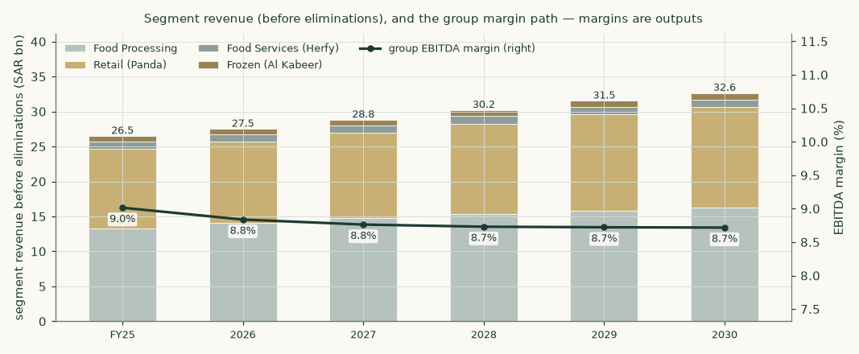
Figure 2 — segment revenue before eliminations and the group margin path. The mix shifts toward retail as the store programme runs; the group margin is flat-to-slightly-down because Panda's expansion dilutes near-term and processing margins are held rather than improved.
1.7 The crux — Panda's expansion, priced both ways
Panda is 43% of revenue, most of the lease book, and most of the capital programme (SAR 567mn of FY2025's SAR 858mn capex). Its economics moved the wrong way in the first half of 2026: four net new stores, revenue up only +0.9%, which is sales per average store DOWN 6.0% to 7.1% (the range reflects the undisclosed mid-2025 store count; the derivation follows the framing table) — the growth programme is currently buying revenue at the expense of density, in a market the company itself calls value-focused and discounter-crowded. Whether that is a J-curve or a treadmill is the single judgement that moves this valuation most, so it is computed BOTH WAYS and never averaged:
Framing | Sales-density path | Store-cost path | Fair value
A — the programme matures (base) | measured −6% fades: −3%, −1%, then flat | scale gains of 10bp/yr from FY2028 | SAR 24.99
B — the erosion persists | −6% in FY2026E, then −3% every year forever | no scale gains, ever | SAR 19.63
The judgement is worth |  |  | SAR 5.36 /share

Table 6 — the contested judgement, with every path stated exactly as computed. Framing A is the base case everywhere in this study; Framing B is not a stress test but a coherent alternative reading of the same first-half evidence, and it sits far below the current share price — farther than in the first edition, because under the corrected conventions Framing B carries the full lease charge AND its own computed (lower) terminal return: a world of permanent density erosion is a world of structurally lower returns on capital, priced as such. A third judgement is priced beside these two: hold the store programme at the H1-2026 run-rate of +8 a year instead of guidance and the model reads SAR 19.53 — fewer stores, less lease debt, less density pressure, and a smaller terminal base. What would settle the crux: two or three quarters of like-for-like density — which Panda does not publish — or, failing that, the third-quarter revenue print against the store count, and the second-half store openings against the +16 the guidance base requires.
The density figure itself is published as a derivation with its range, not as a fact: sales per average store requires a mid-2025 store count the company does not disclose. On the assumption of 213 stores at June-2025 (Dec-2024's 209 plus the same +4 net cadence H1-2026 showed) the first-half change is -7.1%; on a straight interpolation (218) it is -6.0%. The build opens at −6%, the interpolation end; the −7.1% end is priced in 1.9. The first edition quoted −7.1% as a measured fact — an external audit correctly objected, and the register now carries the store-count assumption as an assumption.
The second tension the model carries: the company warns that second-half processing margins face replacement-cost pressure (vegetable-oil benchmarks are at four-year highs), so the oil book's unit gross profit is held at SAR 740/tonne for FY2026 — BELOW the SAR 762 actually earned in the first half — and the improvement observed in sugar and pasta is retained but not extended. Nothing in the forecast projects a margin the filings have not already shown.
1.8 Macro and country — the cost of capital, built and priced
Saudi macro is the benign part of this story: inflation of 1.8% (July 2026), a pegged currency, policy rates tracking the Fed down, and staple-food demand growing with population. The priced risks sit elsewhere: a fifth of revenue is Egypt (translation and repatriation), the commodity complex sets the cost side, and the capital structure carries a store-lease book at more than half of enterprise debt.
Component | Value | Source / construction
10Y SAR risk-free rate — OBSERVED | 5.52% | the published SAR sovereign curve: FTSE Saudi Government Bond Index factsheet, 31-Jul-2026, 7-10 year bucket yield 5.52% (whole index 5.48%, curve 5.22-5.83%); the exchange's iBoxx SAR sukuk index (5.44% at 6.07-year duration, 31-Mar-2026) corroborates. The first edition used a constructed proxy (US 10Y + new-issue spread = 5.53%) believing no direct series was accessible; the published curve confirms the level and replaces the construction. Priced ±50bp below
less sovereign default spread | −0.48% | Moody's Aa3 basis, July-2026 country-risk dataset — netted so country risk is not double-counted
risk-free rate used | 5.04% | the two lines above
Beta | 1.087 | Savola weekly returns against the exchange's own published index, five years, lead-lag adjusted; n=254, R²=0.159, 90% interval 0.73-1.44 — wide, and priced in section 1.9
Equity risk premium | 4.94% | Saudi total premium, rating basis, July-2026 dataset (4.20% mature + 0.74% country); the CDS basis (5.72% against a 0.98% spread) is run in parallel and shown below — its legs remain the January-2026 vintage (the July CDS file was not retrievable), flagged wherever quoted
Cost of equity | 10.41% | risk-free + beta × premium
Cost of loans (blended) | 5.88% | Saudi-riyal tranche (66% of the book) at 3M SAIBOR 4.74% + ~100bp murabaha spread; Egyptian-pound tranche (22%) at its SAR-equivalent parity cost, NOT its ~25% nominal coupon; other currencies at 5.5%. The tranche SPLIT is constructed from the audited currency note (the note discloses currencies, not countries or rates) and the rates are estimates — stated as such; all sit above the 1-year sovereign, as corporate debt must
Cost of leases | 5.86% | measured effective rate: FY2025 lease interest over the average lease balance
Weights (market) | 54% / 19% / 27% | freshest observable per leg: equity at the 18-Aug settled close; loans (SAR 2,665mn) and leases (SAR 3,717mn) at the 30-Jun-2026 reviewed balance sheet — the first edition mixed an 18-Aug numerator with 31-Dec-2025 debt while the newer balance sheet was public
Cost of capital — explicit | 7.82% | the rows above
Cost of capital — terminal | 8.42% | terminal weights re-based to 65% equity

Table 7 — the cost of capital, every component sourced and dated in the companion bibliography. Contested constructions are PRICED, not just named: at the CDS sovereign basis (Jan-2026 legs, flagged) the fair value is SAR 23.27; at −50bp / +50bp on the risk-free rate it is SAR 27.70 / SAR 22.55; the beta interval is priced in section 1.9.
Egypt, stated plainly: the Egyptian operations (sugar, oils, pasta, snacks — about a fifth of revenue) run in a serially devaluing currency. The balance sheet is partially self-hedged — the group carries a net EGP LIABILITY position of about EGP 7.4bn, so devaluation produces translation gains on the funding side even as it shrinks reported revenue — and the model carries Egyptian growth in SAR terms net of that drag. The Egyptian tranche of debt is carried at its SAR-equivalent cost in the blended rate above; carrying its 25%+ nominal coupon in a SAR model would misstate both the cost of debt and the hedge.
1.9 Sensitivity — in real, observable units
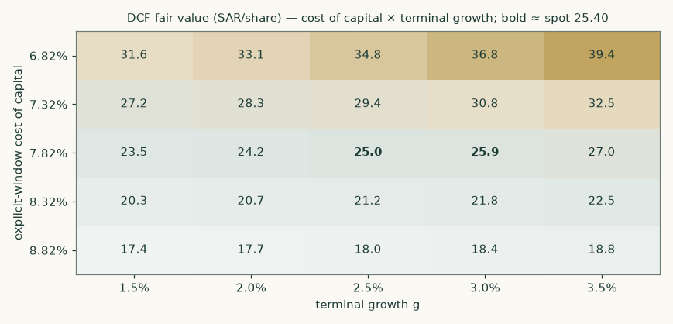
Figure 3 — fair value across the cost of capital and terminal growth. Spot sits in the neighbourhood of the higher-rate, lower-growth cells; the base case is the centre.
Beta | Fair value (SAR/share) | Reading
0.73 | 36.16 | interval floor
0.90 | 30.25
1.00 | 27.30
1.09 | 24.99 | measured
1.20 | 22.28
1.44 | 17.43 | interval cap

Table 8 — the beta interval, priced. The regression is usable but wide (R² 0.159): across its own 90% interval the fair value runs from SAR 17.43 to SAR 36.16. Every cost-of-equity-dependent leg re-runs inside these sensitivities — the Kinan capitalization included (the first edition froze it at the base rate). The single most valuable thing a longer post-restructuring trading history will give this valuation is a tighter beta.
The judgement variants, priced in one place: the store path at the H1 run-rate reads SAR 19.53; the density opening at −7.1% (the 213-store assumption end of the derivation range) reads SAR 24.34 against SAR 25.01 at the −6.0% interpolation end; the 10.5% terminal-return case reads SAR 25.49. The bear/bull scenario levers are published in full in the summary table's basis column and in the workbook.
2 Technical and price structure
The price closed 25.40 below a falling 20-day (25.98), a falling 50-day (27.39) and a flat 200-day (25.42). Momentum is soft: RSI(14) is ~40 and the daily ATR near 0.67 (~2.6%) points to a normal tape. MACD (12·26·9) is below zero but turning up (−0.41 / −0.42 / +0.01). Over the last year it has ranged 20.45–30.30; the last close sits 16% below that high and 24% above that low.
Resistance sits at SAR 26.29, 27.19 and 27.98; support at SAR 24.90, 24.33 and 22.59 — levels from recency-weighted pivot clusters on the same cleaned series the rest of this study runs on. A daily close back above 26.29 would clear the nearest resistance and open the 27.98 zone. A close below 24.90 would break the nearest support and open the 22.59 zone.
Conventions, stated so the read is reproducible: moving-average slope states are measured over the last ten sessions against a 0.30% flatness band — the "flat" 200-day describes its RECENT slope (over longer windows the line has been rising); support and resistance come from fractal pivots (two-bar swing highs/lows) clustered within an ATR-scaled tolerance and scored by recency and touch count; unrounded momentum values: MACD line -0.407, signal -0.421, histogram +0.013; RSI(14) 39.8; ATR(14) 0.666.
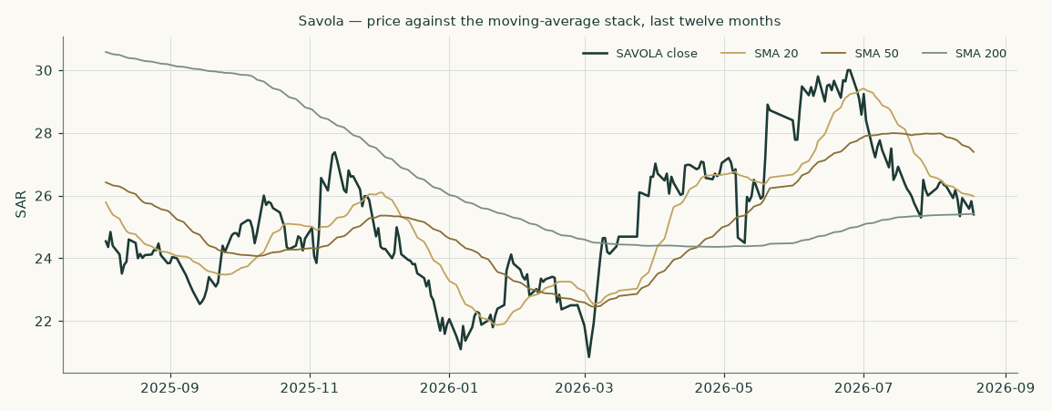
Figure 4 — twelve months of price against the moving-average stack. The 2026 shape is a round trip: the February-March slide into the low 20s, the June-July recovery to 30, and the August give-back to the flat 200-day near 25.4.
3 A probabilistic price map
Where could the price plausibly trade — a different question from what the business is worth. The map below is a 50,000-path simulation calibrated on Savola's own price history and anchored, like every simulation in this series, so that it can never manufacture return out of the time value of money.
Horizon | p5 | p25 | p50 | p75 | p95 | P(above spot)
One month (to 2026-09-20) | 21.87 | 24.02 | 25.47 | 27.04 | 29.72 | 51%
Three months (to 2026-11-18) | 19.76 | 23.19 | 25.68 | 28.42 | 33.35 | 53%

Table 9 — the forward percentile map from the 2026-08-18 close of SAR 25.40. Annualized volatility at the anchor is about 30%; no dividend falls inside either window (the next expected ex-date is around May 2027), so the drift is the financing rate alone.
Level within three months | +5% | +10% | +15% | −5% | −10% | −15%
Probability the level trades at least once | 71% | 51% | 34% | 66% | 42% | 24%

Table 10 — the level-touch ladder: the chance each threshold prints at least once on any path, not the chance of finishing there.
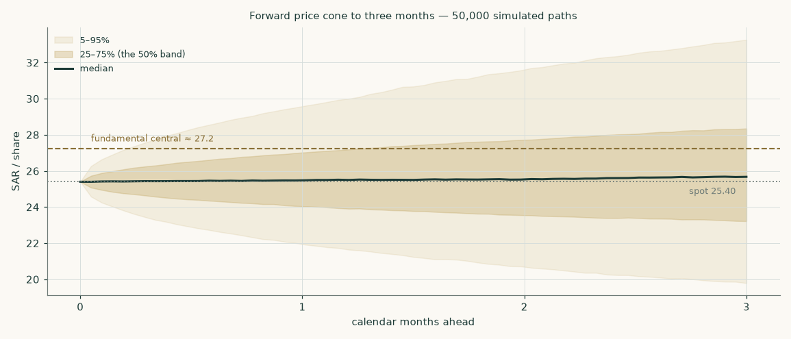
Figure 5 — the three-month price cone against the fundamental central of SAR 27.24. The fundamental read sits between the median and the upper quartile of the price map: a re-rating to the fundamental value is well inside ordinary three-month variation.
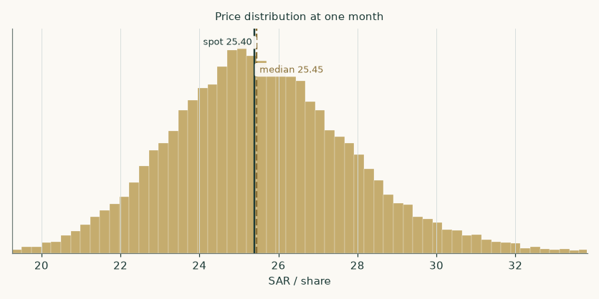
Figure 6 — the one-month distribution.
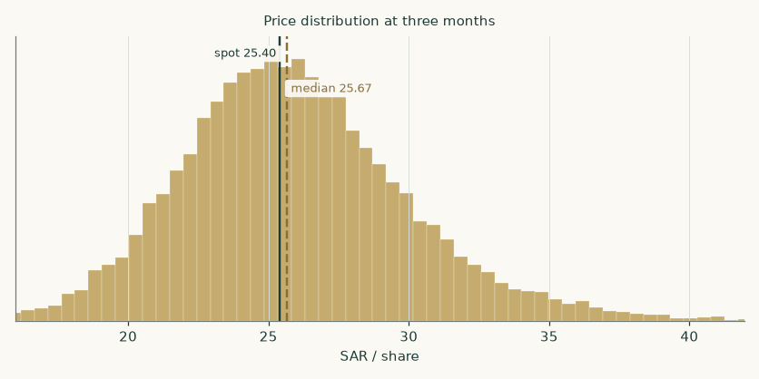
Figure 7 — the three-month distribution.
How honest is this map? It was backtested on Savola's own history before being published: over the last five years, 19 non-overlapping three-month forecasts scored +0.9% against a benchmark random walk carrying the same financing anchor — statistically indistinguishable from the benchmark, which is the honest claim: the map prices dispersion, it does not predict direction. Realized outcomes fell inside the 50/80/90% bands 53%, 79% and 84% of the time, and the percentile ranks of outcomes were roughly uniform (chi-square p = 0.28, Kolmogorov-Smirnov p = 0.64). Across the full cleaned history (58 windows since 2012) the same score was +0.4% with coverage of 52%/84%/91% — bands a touch wide, disclosed rather than tuned away.
4 Comparison of the lenses
The four lenses span SAR 24.49 to SAR 35.12, and the ordering is information, not noise. The book lens (SAR 24.49) is lowest: at recurring profitability Savola earns about its cost of equity, so undiscounted book is the floor. The cash-flow lens (SAR 24.99) adds the non-operating pocket and a terminal return modestly above cost. The market-anchored lenses (relative SAR 28.22, normalised SAR 35.12) are highest — and the reason is one number. The dividend-discount multiple this study's own cost of equity supports is 7.0x-8.2x (Gordon and two-stage forms — both computed in the workbook, alongside the 7.7x Expert 2's dividend model implies); Saudi consumer names trade at a mix-weighted 16.2x. The market prices these earnings at a cost of equity three to four and a half points cheaper than Savola's measured beta demands. Close that gap from either side — the beta drifting toward the market's implied risk, or the multiple de-rating toward the model's — and the lenses converge; until then the weighted central holds the tension explicitly.
The expert panel (Appendix C) widens the same disagreement: SAR 18.52 (dividend stream) to SAR 37.44 (segment multiples), median SAR 21.96. Note what the panel does that the lens field cannot: Expert 3 prices the possibility that the return-on-capital spread never persists at all, and still lands within a riyal of book — the floor argument again, from a third direction.
5 Catalysts to watch
- Third-quarter 2026 results (around early November). The replacement-cost claim meets the print: oil unit margins against four-year-high benchmarks, and Panda's revenue against its store count — the closest public proxy for the density question in section 1.7.
- The Al Mehbaj integration and the Jeddah nuts facility. The one leg growing by acquisition. The consideration IS disclosed — SR 11.4mn (5.4 paid, 6.0 deferred), Q2-2026 reviewed interims, note 19, subject to general-assembly ratification as a related-party deal — small enough that the nuts build carries it as a modest revenue step, with the full consideration deducted in the bridge. The business-combination note in the second-half statements will show the assets acquired; a materially larger earn-out there would be the surprise.
- The store programme itself. The company guides to 20+ new stores and 20+ refreshed stores in 2026; 231 stood at June. Slippage would cut near-term capex and — under Framing B — raise the valuation; that irony is the crux in one sentence.
- The FY2026 dividend (recommendation around March 2027, ex around May 2027). The stated policy is 50-60% of profit. The model's payout at the midpoint implies about SAR 1.35 per share for FY2026E against the SAR 1.70 just paid for FY2025; the market reads this stock partly as an income claim, so the recommendation is a repricing event.
- Commodity tape. Vegetable-oil benchmarks at four-year highs are the cost side of half the processing book; world sugar is soft, which flatters refining spreads but deflates the sugar top line. Both directions are already in the driver set; a sharp move in either re-anchors it.
- Egypt. A step-devaluation would cut the SAR value of about a fifth of revenue while producing a translation gain on the net EGP liability; the model carries trend depreciation, not a step. The Egyptian sugar and oils volumes themselves have been the resilient part of the story.
- Herfy's turnaround. Consolidated at a loss through FY2025, EBITDA margin 18.7% and the loss nearly closed in the first half of 2026. It is small in the group P&L, but its own listed price feeds this valuation through the bridge; a credible return to profit moves both.
6 Reading the probability zones
Put sections 1 and 3 side by side. The weighted central of SAR 27.24 sits between the median and the upper quartile of the three-month price map — the market needs nothing unusual to close the gap; ordinary variation covers it. The Framing B reading of SAR 19.63 now sits near the map's fifth percentile: under the corrected conventions the no-turn story is a tail outcome, and the current price sits well above it — the market is pricing neither collapse nor the full base case, but the space between the run-rate variant (SAR 19.53) and the central. The zones to watch: below SAR 22.59 the price has broken the year's shelf and the market is moving toward the erosion framings with conviction; above SAR 26.29-27.19 the recovery leg is re-established and the first half's operating momentum is being paid for. Neither price move would change the fundamental work — but each would say which framing the market believes, and section 1.7 says exactly what evidence would justify believing it.
7 Caveats — and what would change our mind
- The terminal is four fifths of the answer — more than the first edition. 79% of enterprise value is beyond 2030, at a computed terminal return (10.07%) modestly above the terminal cost of capital (8.42%). The share ROSE from the first edition's 76% because charging the full lease additions back-loads the explicit cash flows — the honest consequence of the correction, stated rather than smoothed. We would rather own that than an inflated five-year ramp; section 1.9 prices the alternatives.
- The beta is wide. R² of 0.159 and a 90% interval of 0.73-1.44 — partly the 2024-2025 restructuring distorting the return series. Eighteen more months of clean post-reset trading would tighten the single most consequential input in the study.
- Panda's density is unobservable. No like-for-like series is published, and even sales-per-store needs a mid-2025 store count the company does not disclose — the driver is a derivation published with its range (−7.1% to −6.0%) and its assumption named in the register. If the company begins disclosing like-for-like growth, the crux resolves and this model should be restruck the same week.
- The second half of 2026 carries the company's own warning. Replacement-cost pressure in oils is management's statement, adopted here (unit gross profit held below the first-half actual). If the second half instead HOLDS the first-half unit margins, the base case is too low by construction — that is the direction of surprise this model accepts.
- Egypt can step. The model carries drift, not a crisis. A 2016- or 2024-style step devaluation would cut the processing top line faster than the natural hedge compensates in reported profit.
- The store cadence is the near watch. The guidance base needs +16 net openings in H2-2026 after +4 in H1. FY2025 delivered +18 net over the full year, so an H2-weighted cadence has precedent — but the half-split is not disclosed, and the +8/yr run-rate variant is worth SAR 5.45 per share on the cash-flow lens. The H2 openings count is the cheapest single piece of evidence this valuation can receive.
- What would flip the verdict. Two more quarters of density erosion at the measured pace (Framing B: SAR 19.63, below spot) — or a second-half margin print above the first half plus a stabilising store base (the bull scenario: SAR 32.59). The evidence that decides is named in section 1.7.
Appendix A — Financial statements
A.1 Income statement — three audited years and the five-year forecast
SAR mn | FY2023 | FY2024 | FY2025 | 2026 | 2027 | 2028 | 2029 | 2030
Revenues | 24,150 | 23,046 | 26,081 | 27,060 | 28,349 | 29,726 | 31,029 | 32,131
Cost of revenues | -19,104 | -18,213 | -20,992 | — | — | — | — | —
Gross profit | 5,046 | 4,833 | 5,089 | — | — | — | — | —
Operating EBITDA | 2,302 | 2,062 | 2,351 | 2,391 | 2,484 | 2,595 | 2,706 | 2,801
Depreciation & amortisation | -1,065 | -1,100 | -1,190 | -1,223 | -1,265 | -1,313 | -1,353 | -1,387
EBIT | 1,237 | 962 | 1,161 | 1,168 | 1,219 | 1,283 | 1,353 | 1,414
Net finance cost | — | — | -276 | -285 | -288 | -295 | -298 | -295
Share of Kinan (net of tax) | — | — | 51.8 | 68.0 | 70.0 | 72.1 | 74.3 | 76.5
Profit attributable to owners | 899 | 9,974 | 874 | 729 | 767 | 811 | 864 | 914
Earnings per share (SAR) | — | — | 2.93 | 2.46 | 2.59 | 2.73 | 2.91 | 3.08

Table 11 — income statement. Bases differ and are stated rather than smoothed: FY2023 is the continuing basis of the FY2024 statements and still contains the Türkiye business (disposed 2025; its FY2024 revenue was SAR 941mn); FY2024-25 are the FY2025 audited basis. FY2024 attributable profit contains the SAR 11,554.7mn Almarai distribution gain (audited FY2024 statements, segment note). FY2025 recurring profit is SAR 539.1mn on the company's own bridge, whose zakat item is a 300.0 zakat-and-other-accrual reversal; the audited FS note 29 carries a 217.4 net zakat credit and the results announcement quotes 247.3 gross of related expenses — three disclosed figures on three bases, reconciled in the bibliography. The forecast is built on the recurring construction, with associates outside the tax line as the statements present them.
A.2 Balance sheet
SAR mn | FY2023 | FY2024 | FY2025 | 2026 | 2027 | 2028 | 2029 | 2030
Property, plant & equipment (owned) | 6,046 | 5,438 | 5,486 | 5,632 | 5,851 | 6,026 | 6,161 | 6,271
Right-of-use assets | 3,040 | 3,058 | 3,417 | 3,614 | 3,801 | 3,975 | 4,133 | 4,273
Net working capital (ex the Tiryaki receivable) | — | — | 712 | 740 | 776 | 813 | 849 | 879
Tiryaki stake (sale-proceeds receivable, reclassified) | — | — | 274.6 | 274.6 | 274.6 | 274.6 | 274.6 | 274.6
Cash and cash equivalents | 1,213 | 2,235 | 904 | 1,038 | 1,108 | 1,240 | 1,438 | 1,689
Loans and borrowings | 8,644 | 3,404 | 1,894 | 1,894 | 1,894 | 1,894 | 1,894 | 1,894
Lease liabilities | 3,523 | 3,593 | 3,952 | 4,150 | 4,337 | 4,510 | 4,668 | 4,808
Equity attributable to owners | 8,397 | 4,620 | 5,516 | 5,844 | 6,189 | 6,554 | 6,943 | 7,355
Net debt (loans less cash and current investments) | 6,693 | 1,168 | 904 | 770 | 700 | 568 | 370 | 119

Table 12 — balance sheet. The FY2023 column is the pre-reset structure: SAR 8.6bn of borrowings against the Almarai stake. The reset removed both sides. The forecast columns are the model's roll-forward, which foots exactly in every year (the companion workbook carries the zero-check row). At 30-Jun-2026 the company reported net debt of SAR 851mn on its own definition.
A.3 Forecast cash-flow markers
SAR mn | 2026 | 2027 | 2028 | 2029 | 2030
Net cash from operating activities | 1,931 | 2,005 | 2,096 | 2,195 | 2,286
Capital expenditure | -810 | -900 | -880 | -860 | -850
Lease principal (right-of-use depreciation) | -559 | -584 | -607 | -629 | -647
Dividends (owners + minorities) | -428 | -451 | -477 | -508 | -537
Free cash flow to the firm | 569 | 540 | 647 | 761 | 858
Closing cash | 1,038 | 1,108 | 1,240 | 1,438 | 1,689

Table 13 — the cash walk that closes the balance sheet: operations fund the programme and the dividend with a widening surplus; net debt on the company's definition falls from SAR 770mn to SAR 119mn by FY2030E.
Appendix B — Peer frame, risk register, research register
B.1 Peer frame
The peer table and the multiple construction sit in section 1.3; the workbook's Peer & Sector sheet carries the same quotes with Savola's own implied multiples beside them: at the model's fair value Savola stands at 10.17x FY2026E earnings and 5.36x FY2026E EBITDA (lease-inclusive), against 10.33x and the peer set's 12-20x earnings range.
B.2 Risk register
Risk | Direction | Where it is priced
Vegetable-oil replacement costs run past pass-through | margin down | oil unit gross profit held below the H1 actual; bear cuts it 40 SAR/t
Panda density never stabilises | value down | Framing B, published side by side
Grocery price war intensifies (discounters) | margin down | store-opex ratio held; no gross-margin recovery assumed
Egypt step-devaluation | revenue down, partial hedge | trend depreciation in the build; net EGP liability disclosed in 1.8
Commodity finance rates | finance cost | blended marginal cost of debt above sovereign; sensitivity on the rate build
Herfy stays loss-making | drag | glide anchored on the actual; its market price in the bridge
Store cadence misses guidance (+16 needed in H2-2026) | value down under Framing A | the +8/yr run-rate variant is priced: SAR 19.53
Mehbaj integration disappoints | small | consideration SR 11.4mn disclosed and deducted; revenue step kept small
Zakat assessments | one-off | FY2025's release treated as non-recurring; normalized rate 19.5% carried
Terminal return fades to cost of capital | value down | Expert 3 prices exactly this; section 1.9 grid

Table 14 — the risk register: every named risk points at the place in the study where it is PRICED, not merely mentioned.
B.3 Research register — what was read, and what was searched and not found
Source (all read from official homes) | Date | What was taken
FY2025 audited consolidated financial statements (Deloitte, unmodified) | 05-Mar-2026 | the base year: statements, segments, notes 1-46
FY2024 audited consolidated financial statements (KPMG) | 10-Mar-2025 | FY2023 comparatives; the rights issue / capital reduction / Almarai distribution
FY2023 audited consolidated financial statements | 14-Mar-2024 | FY2022 comparatives; pre-reset balance sheet
Q1-2026 reviewed interim statements | 06-May-2026 | first-quarter actuals; 31-Mar-2026 balance sheet
Q2-2026 reviewed interim statements (authorized 05-Aug-2026) | 05-Aug-2026 | the Mehbaj consideration (note 19); the 30-Jun-2026 balance sheet (WACC weights, book-lens base); the ex-treasury EPS divisor; Tiryaki settlement
H1-2026 earnings release (company) | 06-Aug-2026 | half-year actuals; net debt 851; Sudan exit; Mehbaj; the H2 cost warning
Q2-2026 investor presentation (company) | 06-Aug-2026 | category volumes and unit gross profits; store network; segment debt and leases
FY2025 investor presentation (company) | 09-Mar-2026 | full-year category units; the reported-to-recurring bridge; capex by unit
Annual Report 2025 (company) | 30-Mar-2026 | dividend policy; governance; the Mehbaj related-party context; store programme
Saudi Exchange announcements 93502 / 93503 / 94980 | Mar-May 2026 | official FY2025 results, dividend recommendation, Q1-2026 results
Federal Reserve economic data (US 10Y and 1Y) | 14-Aug-2026 | the risk-free construction's dollar leg
Sovereign risk dataset (July-2026 update) | 01-Jul-2026 | Saudi default spread 0.48% and equity risk premium 4.94% (rating basis)
Sovereign risk dataset (Jan-2026 update) | 05-Jan-2026 | the CDS-basis legs (July CDS file not retrievable — flagged wherever quoted)
FTSE Saudi Government Bond Index factsheet | 31-Jul-2026 | the observed SAR sovereign curve: 7-10y yield 5.52% — the risk-free rate
iBoxx Tadawul SAR Government Sukuk Index publications | 31-Mar-2026 | corroboration of the SAR curve level (5.44% at 6.07y duration)
National Debt Management Center announcements | Aug-2026 | the observed 1-year SAR sovereign savings-sukuk rate (4.70%)
FAO Food Price Index | 07-Aug-2026 | vegetable-oil, sugar and cereal price levels for the cost side
GASTAT consumer prices (July 2026) | 14-Aug-2026 | Saudi CPI 1.8%
Market quotes: Savola, Herfy, four peers, SAIBOR (settled closes, verified against the following session's prior-close field) | 18-Aug-2026 | prices and multiples — cross-checks and the bridge's Herfy leg only

Table 15 — the research register. Searched and NOT found, recorded as such: a Panda like-for-like sales series (not published); the mid-2025 store count (carried as a named assumption with the derivation range); numeric FY2026 revenue or margin guidance (none exists — only store-count targets). Two first-edition register entries are corrected here for the record: the Al Mehbaj consideration was recorded searched-and-not-found when the filed Q2-2026 interims disclosed it (SR 11.4mn, note 19) — the first edition read the release and presentation but not the filed interims, a sourcing failure this edition repairs; and the 10-year SAR yield was recorded inaccessible when the index publisher's own factsheet carried the curve — the constructed proxy happened to land on the published level (5.53% vs 5.52%), which is luck, not method.
Appendix C — The expert panel
Three experts, three genuinely different methods, each with its worldview, its worked numbers, a named sensitivity and a falsifier stated in advance. They are labelled Expert 1, 2 and 3; their disagreement is the appendix's product, not a defect.
C.1 Expert 1 — the segment sum-of-the-parts investor
Worldview: a conglomerate is worth what its pieces would fetch, and the market tells you what pieces fetch. Works best when segments have clean listed comparables and central costs are small; fails when the multiples themselves are mispriced or the pieces cannot actually be separated (shared brands, shared logistics, a controlling family that will never sell).
Line | Basis | SAR mn
Food processing at 6.5x FY2026E EBITDA | EBITDA 1,186 | 7,711
Panda at 7.0x FY2026E EBITDA | EBITDA 1,030 | 7,212
Al Kabeer at 7.0x FY2026E EBITDA | EBITDA 111 | 780
Central costs capitalized at 6.5x | −130/yr | -845
Segment enterprise value |  | 14,858
Non-operating pocket + cash (sukuk, Almarai residual, Tiryaki, property) | Dec-2025 legs | 2,099
Less loans, leases, benefits, restoration, other net liabilities |  | -7,092
ADD BACK Herfy's own balance-sheet items inside those group lines | NC liabilities 462.0 (note 20) + current-lease est. 80 − cash est. 45 — the two estimates constructed and flagged | 497
Less other minorities at book |  | -515
Dec legs rolled to the anchor, then the anchor-dated legs:
Savola's 49% of Herfy at Herfy's own settled 18-Aug price | market cap 1,003 | 491
Kinan at capitalized earnings; less the Mehbaj consideration | 653 − 11.4 | 642
Equity value at the anchor |  | 10,979
Per share at the anchor (ex-dividend) |  | 37.44

Table 16 — Expert 1's worked table. The first edition deducted 100% of the consolidated liabilities against a 49%-of-market-equity Herfy leg — charging Herfy's own debt twice; the carve-out above corrects it using the audited note-20 aggregates, with its two constructed splits flagged. Named sensitivity: one multiple turn across the three operating legs is worth about SAR 8.35 per share (range SAR 31.18-43.71 at ±0.75 turns). Falsifier, stated in advance: if Saudi consumer multiples de-rate toward the dividend-discount multiple in section 4, this whole frame deflates with them.
C.2 Expert 2 — the dividend-stream investor
Worldview: for a policy-driven payer under a family anchor, the dividend IS the security. Works best when the policy is stated and the balance sheet can fund it; fails when value is building inside the firm faster than it is paid out — this method structurally under-values retained growth.
Year | Dividend per share (SAR) | Present value at the cost of equity
2026 | 1.35 | 1.22
2027 | 1.42 | 1.17
2028 | 1.50 | 1.12
2029 | 1.60 | 1.08
2030 | 1.69 | 1.03
Terminal (grown at 2.5%) | 1.74 | 13.38
Value at 31-Dec-2025 → at the anchor | 19.00 | 18.52

Table 17 — Expert 2's worked table. Named sensitivity: the policy band itself — at 50% payout the value is SAR 16.68, at 60% with a stronger terminal SAR 21.49. Falsifier: a second consecutive year outside the stated 50-60% band, in either direction, breaks the premise that the policy is the security.
C.3 Expert 3 — the economic-profit sceptic
Worldview: value is invested capital plus the present value of returns ABOVE the cost of capital — and excess returns decay, because competition exists. Works best at exposing how much of a valuation is faith in persistence; fails for businesses with genuinely durable moats, which it structurally under-values.
Line | SAR mn
Operating invested capital, 31-Dec-2025 (equity + minorities + debt + leases − cash − investments − Kinan − Tiryaki − investment property) | 9,778
Economic profit 2026 (NOPAT 940 less capital charge at 7.82% on opening capital) | 176
Economic profit 2027 (NOPAT 982 less capital charge at 7.82% on opening capital) | 188
Economic profit 2028 (NOPAT 1,032 less capital charge at 7.82% on opening capital) | 204
Economic profit 2029 (NOPAT 1,089 less capital charge at 7.82% on opening capital) | 231
Economic profit 2030 (NOPAT 1,138 less capital charge at 7.82% on opening capital) | 254
Present value of the five economic-profit years | 833
Fade tail (spread decays to zero over five more years) | 301
Operating value | 10,912
+ cash, current and non-current investments, Kinan AT CARRYING (the sceptic's choice), Tiryaki, investment property | 2,535
− loans and leases; − other minorities at book | -6,362
Dec legs rolled to the anchor; less Herfy minority at market, less Mehbaj | 6,562
Per share at the anchor (ex-dividend) | 21.96

Table 18 — Expert 3's worked table, rebuilt line by line on the accounting identity (with zero excess profit and zero fade it reproduces audited total equity exactly — asserted in the build; the first edition's hand-built bridge failed that identity by ~SAR 648mn and its no-tail case printed ABOVE its base, both caught by external audit). The capital charge runs on the same invested-capital path (lease additions included) the terminal return uses. Named sensitivity: the fade — no tail at all gives SAR 20.88 (below the base by the tail's value, as it must be); 40% of the year-five spread persisting for another five years gives SAR 24.15. Falsifier: returns on capital RISING through FY2027-28 while the store programme runs would refute the decay premise directly.
C.4 Cross-examination
- Expert 2 to Expert 1: your multiples pay for growth Savola has not delivered — recurring profit only recovered to SAR 539mn in FY2025. — Expert 1, partially conceded: the multiples are the market's, not mine; I hold the discount at one turn below the quoted medians for exactly that reason. But rejected on the frame: first-half recurring profit rose 40% — the recovery is in the prints, not projected.
- Expert 1 to Expert 2: you price a POLICY as if it were a covenant; the same board paid nothing for FY2024. — Expert 2, conceded in part: FY2024 was the reset year, and I read the policy through the reset. My low case prices the 50% floor; a policy break is my stated falsifier, not a hidden assumption.
- Expert 3 to both: neither of you asks whether the returns exist. My table says the business earns barely above its capital charge in every forecast year. — Expert 1, rejected: your capital base includes SAR 3.95bn of store leases at a retail margin trough — you are measuring the programme at its worst moment. Expert 2, conceded: that is why my number is closest to yours.
- The panel to the model: your Framing B sits below every one of our low cases except Expert 2's. — Accepted as information: the framing the market appears to price is more pessimistic than any panel construction — either an opportunity or a warning, and section 6 says which evidence decides.
C.5 Three in one room
Force the three to one number and the argument, not the average, is the output. Expert 1 (SAR 37.44) prices the pieces at the market's capital; Expert 2 (SAR 18.52) prices the payout at the model's capital; Expert 3 (SAR 21.96) prices the capital itself and finds little excess. The median — SAR 21.96 — lands below the study's weighted central of SAR 27.24, and the gap is the same single disagreement running through the whole study: what return this capital deserves, and whether the expansion earns above it.
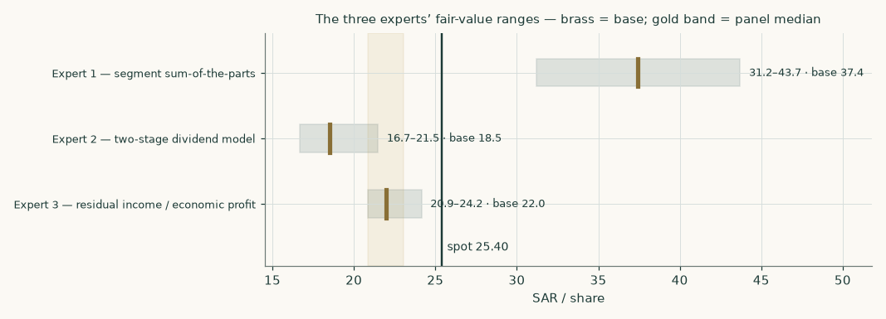
Figure 8 — the three experts' ranges against spot; the gold band marks the panel median.
C.6 Reading the divergence
Assumption | Expert 1 | Expert 2 | Expert 3 | What the gap is worth
Price of capital | the market's (in the multiples) | the model's (10.41%) | the model's (7.82%) | E1 vs E2: SAR 18.92/share — the study's largest gap
Retained growth | in the multiple | ignored beyond payout | earns only the spread | E2 vs E3: SAR 3.44/share
Return persistence | implicit | implicit | decays to zero by 2035 | E3's own fade sensitivity: SAR 3.28/share

Table 19 — which assumption drives which gap. One judgement — the price of capital — explains most of the panel's spread, exactly as it explains the lens spread in section 4.
Revision note — what changed in this edition, and what it was worth
This second edition (19-Aug-2026) answers four independent external critiques of the 18-Aug-2026 first edition, worked finding by finding under the project's critique-response procedure: 82 findings enumerated, each priced through the model before any verdict. The corrections that moved value, at the first edition's central: charging the FULL lease additions in the cash-flow waterfall rather than renewals only (−3.97% — the largest, and the one the first edition's own balance sheet already implied); computing the terminal return from the model's own year five instead of inputting 10.5% (−1.6%); the relative lens rebuilt trailing-on-trailing with Al Othaim n/m (−3.2% before the offsetting quote refresh); the Tiryaki receivable moved from working capital to the bridge (+1.6%); the book lens on one consistent FY2026 base (+2.5%); the settled 18-Aug close of SAR 25.40 replacing an intraday 25.30 print; the published SAR sovereign curve replacing a constructed proxy; 30-Jun-2026 debt in the capital-structure weights; the ex-treasury share divisor (+0.7%); the investment property retained in the bridge after the audited segment note showed its rent is inter-segment and outside group EBITDA — a reversal of one accepted critique finding, with the receipt in the response record; and the three anchor-dated bridge legs held outside the Dec-2025 roll. Net: weighted central SAR 28.02 → SAR 27.24 (-2.8%), and against the settled close the premium reads +7% where the first edition claimed +11% against the stale print. Expert 3 and Expert 1 were rebuilt (their appendix tables say how); the panel median moved SAR 19.82 → SAR 21.96. Two critiques were rejected in full where their receipts failed — one would have removed the lease charge entirely (+13.8% of central, the mirror image of the real defect), the other affirmed the first edition without qualification; the full ledger, including what each rejected finding would have been worth, sits in the response record beside this study's repository.
About this series
These studies are independent educational analyses of listed companies and commodities. Each one builds its financial model exclusively from the subject's own audited and reviewed statements and disclosures, prices its probability maps with a simulation engine backtested on the subject's own history, and publishes fair-value ranges and distributions — never ratings, never price targets. The companion workbook is formula-driven so every figure can be traced to a driver and repriced; the companion bibliography lists every input with its source and date.
Disclosure & Disclaimer
This document is educational analysis, not investment advice, not a recommendation, and not a solicitation to buy or sell any security. It was prepared without compensation from, or communication with, the subject company. All historical figures derive from public official sources believed reliable but not independently audited by the author; forecasts are model outputs, not promises. Markets are risky; distributions are wide for a reason. Do your own work or engage a licensed adviser before acting.

