PALM HILLS DEVELOPMENTS
Egyptian Exchange · PHDC · Egyptian pounds · edition of 30 August 2026

READ FIRST
This is a valuation study, not advice. It carries no rating, no recommendation and no price target. What it publishes is a range of value and the reasoning behind it, so that a reader can disagree with the reasoning rather than with a number.
It supersedes the edition of 11 June 2026. Two things in that edition were wrong and are corrected here, and both are set out plainly in section 1.8 rather than buried: the discount rate was below Egypt's own government bond yield, and the project-level price and cost table it valued the company on is not disclosed by the company anywhere.
The company's own audited statements are the only source used for its reported history. Where something needed is not disclosed, this study says so and does not fill the hole. There are five such gaps and they are listed in section 7.
Information set: everything the company had published as at 30 August 2026, which ends at its first-quarter 2026 results. No half-year 2026 figures had been released at that date.

Headline
Palm Hills is worth between EGP 9.17 and EGP 38.74 a share on the company's own audited figures, and which end of that range is right depends almost entirely on one thing the company does not disclose.
- The discount rate in the previous edition was 18.00%. Egypt's ten-year government bond yields 23.00%. Rebuilt from the ground up, the company's cost of capital is 26.25%.
- Value turns on how quickly contracted sales become cash. Over the three years the company has published a cash-flow statement, operating cash was 4.3%, 17.9% and 3.9% of revenue. At the low end the shares are worth EGP 9.17; at the high end, EGP 38.74.
- At the closing price of EGP 15.20 the market is paying for a conversion rate of 6.8% — above the two weak years, well below the strong one.
- The contracted order book stands at EGP 263bn against 2025 revenue of EGP 36.2bn. What limits this company is how fast it can build and hand over, not whether it can sell.

Valuation summary — every read at a glance
Lens | Value per share (EGP) | What it rests on
Cash-flow value, weak conversion | 9.17 | operating cash at 3.9% of revenue, the 2023 and 2025 outcome
Cash-flow value, average conversion | 19.30 | operating cash at 8.7%, the three-year mean
Cash-flow value, strong conversion | 38.74 | operating cash at 17.9%, the 2024 outcome
Same, on the alternative country-risk basis | 21.44 | identical model at a 25.24% discount rate
Book value of equity | 6.56 | audited shareholders' funds at 31 December 2025
Market price | 15.20 | closing price, 23 August 2026
Previous edition, for reference | 7.62 – 24.92 | edition of 11 June 2026, discounted at 18%
Every figure recomputes from the audited 2025 statements and the cost of capital in section 1.8. No single number is put forward as the fair value; section 1.7 explains why.
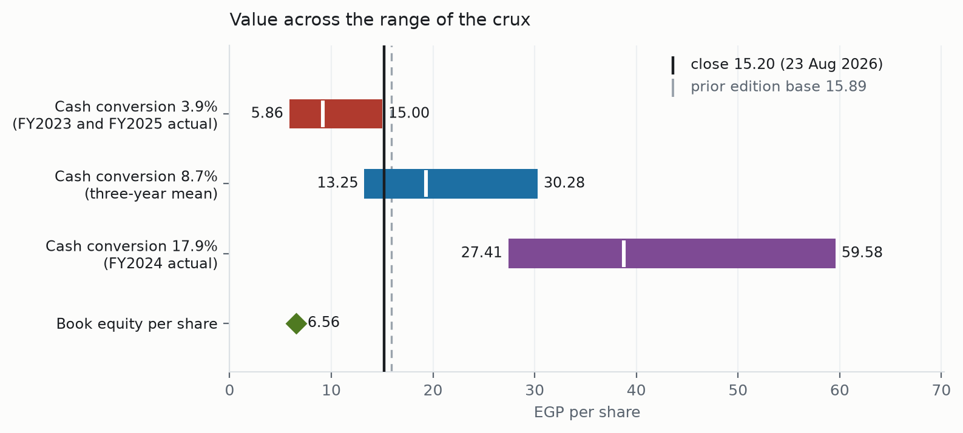
Figure 1 — each bar is one observed rate of cash conversion; the bar spans the discount rate from four points below the rebuilt cost of capital to four points above, and the white tick marks the value at the rebuilt rate itself. Shown against the closing price and the previous edition's central figure.

Company overview
Palm Hills Developments builds and sells residential and commercial property in Egypt, principally in West Cairo, East Cairo, and the North Coast and Alexandria. It has been listed on the Egyptian Exchange since 2008. Units are sold off plan and paid for in instalments over several years, so the company collects cash long before, and long after, it recognises the sale.
Two things follow from that model and they shape everything in this study. First, revenue is recognised as construction completes rather than when a contract is signed, so the order book and the income statement move on different clocks. Second, the balance sheet carries a very large receivable book — EGP 103.5bn at the end of 2025 — against customer advances of EGP 69.4bn.
 | 2025 | 2024
Revenue (EGP mn) | 36,169 | 27,167
Gross profit (EGP mn) | 14,888 | 9,330
Gross margin | 41.2% | 34.3%
Profit after tax and minority (EGP mn) | 4,217 | 3,255
Cash from operations (EGP mn) | 1,424 | 4,855
Order book (EGP mn) | 263,000 (at 31 Mar 2026) | 147,000
Total assets (EGP mn) | 172,130 | 123,437
Shareholders' funds (EGP mn) | 18,766 | 14,625
Source: the company's audited consolidated financial statements and its own results releases.

1 Fundamental valuation

1.1 The cash-flow model
The model runs ten years from the audited 2025 base and then a terminal value. Revenue is limited by how much the company can build and hand over, not by how much it has sold: the order book is EGP 263bn against 2025 revenue of EGP 36.2bn, so sales are not the binding constraint and have not been for some years. Delivery capacity is grown with construction inflation and the order book is rolled behind it, converging back to the multiple of revenue it stood at in 2024.
Cost is recognised on the same completion schedule as revenue. That sounds obvious and it is the single most important correction in this edition. Since January 2016 the company has recognised revenue on standalone units as construction progresses; a model that accrues revenue that way but accrues cost on handover has the two legs on different clocks, and it systematically overstates profit. Gross margin here is an output of price against cost, never an input.
Year | Revenue | Gross profit | Margin | Pre-tax profit | Operating cash | Free cash flow
2026 | 45,284 | 17,354 | 38.3% | 828 | 3,946 | 10,124
2027 | 56,696 | 21,727 | 38.3% | 3,193 | 4,940 | 11,004
2028 | 70,983 | 27,202 | 38.3% | 6,154 | 6,185 | 12,106
2029 | 88,870 | 34,057 | 38.3% | 9,861 | 7,744 | 13,486
2030 | 111,266 | 42,640 | 38.3% | 14,502 | 9,695 | 15,214
2031 | 139,305 | 53,385 | 38.3% | 20,312 | 12,139 | 17,376
EGP million, central case. The full ten-year path and the bridge from enterprise value to equity are in the accompanying workbook.
Bridge from enterprise value to equity, central case | EGP mn
Present value of the explicit ten years | 49,460
Present value of the terminal value | 25,237
Enterprise value | 74,697
less net debt | (24,133)
plus investments in associates | 3,612
plus investment property | 1,032
Equity value | 55,208
Shares outstanding (millions) | 2,859.9
Value per share (EGP) | 19.30
The terminal value is 34% of enterprise value in the central case, which is high and is one of the reasons no single figure is published.

1.2 Book value and sustainable return
Shareholders' funds were EGP 18,766 million at the end of 2025, or EGP 6.56 a share, against a market price of EGP 15.20 — the shares change hands at about 2.3 times book. Profit after tax and minority interest of EGP 4,217 million on average shareholders' funds gives a return on equity of roughly 25.3%. Against a cost of equity of 31.3%, the company is not currently earning its cost of capital on book, which is why book value sits well below every cash-flow read in this study rather than acting as a floor.

1.3 Relative multiples
The Egyptian listed developers are compared in Appendix B on the measures that can actually be sourced for all of them on the same basis. Earnings and book multiples for the peer group are NOT published here: no peer discloses figures this study can obtain on a consistent basis, and a multiple assembled from inconsistent or unsourced inputs would look precise and mean nothing. What is comparable is market risk, and on that measure Palm Hills sits in the middle of its sector.

1.4 Normalised earnings power
Normalising on the three disclosed years, revenue converts to gross profit at about 38.3%, overheads absorb about 17.6% of revenue, and interest on the disclosed borrowings absorbs a further large share. The result is a company whose accounting profit is real but whose cash profit is small and volatile: EGP 1,424 million of operating cash in 2025 on EGP 36,169 million of revenue, against EGP 4,855 million on EGP 27,167 million the year before.

1.5 Synthesis — the lenses in one field
The cash-flow lens spans EGP 9.17 to EGP 38.74 depending on cash conversion. Book value is EGP 6.56. The market is at EGP 15.20. The lenses do not disagree about the business; they disagree about one number, and Figure 1 shows how far apart that one number pushes them.

1.6 Drivers
The company discloses new sales in Egyptian pounds and units sold, in total and by region, and it discloses units delivered and construction spending. It does not disclose unit mix, average unit size, price per square metre or construction cost per square metre for any project. The forecast is therefore built at the level the disclosure supports, and that limit is stated rather than disguised. The previous edition carried a full table of per-project areas, unit mixes, prices per square metre and construction costs per square metre for fifteen named projects. None of those figures is disclosed by the company. They are not used here.

1.7 The crux
How fast do contracted sales become cash?
Everything else in this study is secondary to that question. Palm Hills sells off plan on long instalment terms, so a sale signed today produces cash over several years on a schedule the company does not publish — no down-payment percentage, no instalment tenor, no post-handover tail. The previous edition assumed all three. This edition measures the outcome instead, from the three years in which the company has published a cash-flow statement.
Year | Cash from operations (EGP mn) | Revenue (EGP mn) | Cash as a share of revenue
2023 | 757 | 17,462 | 4.3%
2024 | 4,855 | 27,167 | 17.9%
2025 | 1,424 | 36,169 | 3.9%
The 2024 figure is the one in the audited statements. The company's own results release for that year reported EGP 3,132 million and the figure was later restated; the audited number is used.
A spread of 3.9% to 17.9% over three consecutive years is not noise around a stable rate — it is the absence of a stable rate. Until the company discloses its collection terms, or until more years accumulate, this is the honest width of the answer.

1.8 Macro, country risk and the cost of capital
The previous edition discounted at 18%. Egypt's ten-year government bond yields 23.00%. A discount rate below the sovereign yield prices this company as safer than the government that taxes it, which cannot be right, and it is not a real-versus-nominal mismatch: that edition escalated selling prices at 14 per cent a year, so its cash flows were in nominal pounds throughout.
Cost of capital | On the credit-rating basis | On the credit-default-swap basis
Egyptian ten-year government bond yield | 23.00% | 23.00%
less Egypt's own sovereign default spread | 6.37% | 3.41%
Normalised risk-free rate | 16.63% | 19.59%
Equity risk premium for Egypt | 13.94% | 9.41%
Beta | 1.0493 | 1.0493
Cost of equity | 31.26% | 29.46%
Cost of debt before tax | 25.50% | 25.50%
Cost of debt after tax at 22.5% | 19.76% | 19.76%
Equity weight at market value | 56.4% | 56.4%
Debt weight | 43.6% | 43.6%
Weighted average cost of capital | 26.25% | 25.24%
Country risk is counted once, inside the equity risk premium, and the government bond yield is reduced by Egypt's own default spread on the matching basis before that premium is added. Both bases are published because both are defensible and they differ by about a point.
The beta is measured on Palm Hills' own weekly price history against the EGX30 index over 4.85 years: 1.0493, with a standard error of 0.1823, an R-squared of 29.9% and 251 weekly observations. A cross-check adjustment toward the market gives 1.0329. Appendix B shows the same measurement for every listed Egyptian developer.
The cost of debt is the one cost-of-capital input in this study that is not sourced, and it is flagged. The right anchor exists: the company closed an EGP 2,015 million securitisation on 4 February 2026, the first draw on a newly approved EGP 30 billion programme, in four tranches of 13, 36, 60 and 84 months rated AA+, AA, A+ and A- on the Egyptian national scale. No coupon is published for any tranche. The cost of debt is therefore built as the sovereign yield plus a 250 basis point corporate spread, which puts it above the sovereign as it must be. The accounting rate is deliberately not used: EGP 3,348 million of finance cost on average gross borrowings of about EGP 26,700 million implies 12.5 per cent, far below the sovereign, because much of the balance does not bear interest and part of the charge is capitalised into work in progress.

1.9 Sensitivity
The table below prices the crux against the discount rate. Read it down a column rather than across a row: moving the discount rate by the whole 800 basis points of the previous edition's error changes value by less than moving cash conversion from one observed year to another.
Cash conversion | 22.25% | 24.25% | 26.25% | 28.25% | 30.25%
3.9% | 15.00 | 11.61 | 9.17 | 7.31 | 5.86
6.0% | 21.60 | 16.91 | 13.54 | 11.02 | 9.05
8.7% | 30.28 | 23.87 | 19.30 | 15.89 | 13.25
12.0% | 40.80 | 32.31 | 26.28 | 21.79 | 18.33
17.9% | 59.58 | 47.38 | 38.74 | 32.33 | 27.41
Value per share in Egyptian pounds. The closing price on 23 August 2026 was EGP 15.20.
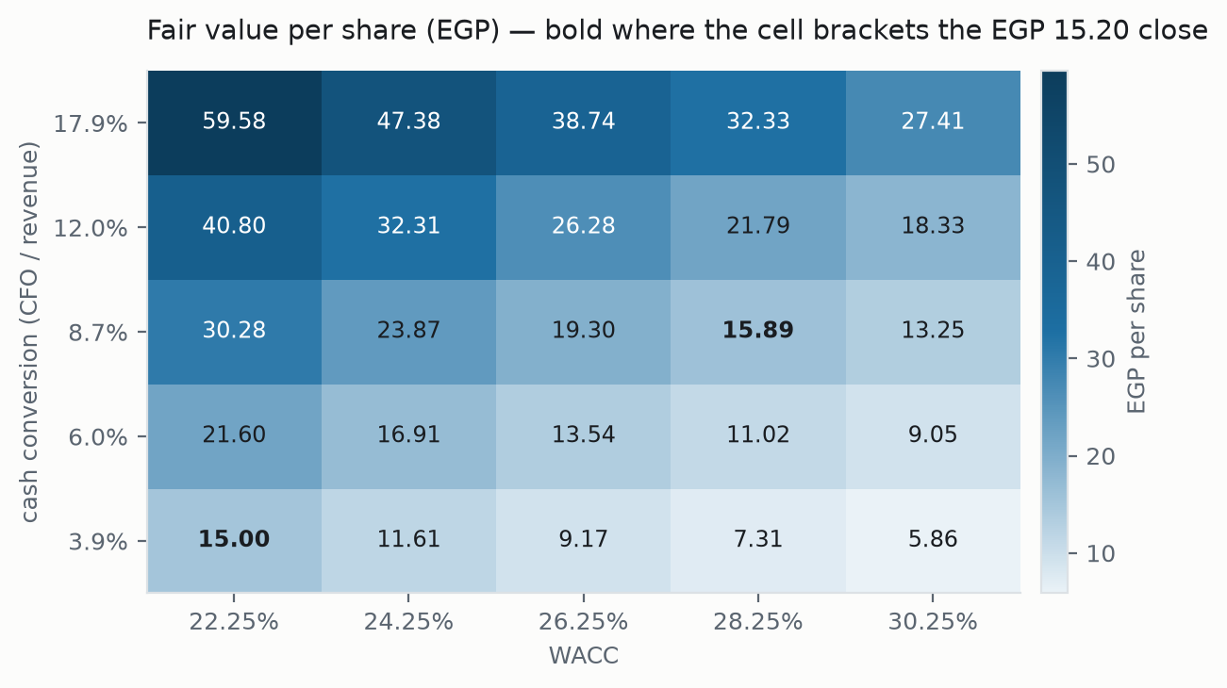
Figure 2 — the same grid. Darker cells are higher values; the two axes are the discount rate and the rate at which contracted sales turn into cash.
Solving the model back to the closing price gives a cash-conversion rate of 6.8%. That is the clearest single statement this study can make about the current price: the market is paying for conversion better than 2023 and 2025 delivered, and materially worse than 2024 did.

2 Technical and price structure
The shares closed at EGP 15.20 on 23 August 2026, above a rising 20-day average at 15.15, a rising 50-day at 15.10 and a rising 200-day at 10.95. The whole moving-average stack is beneath the price and sloping up, which is the least ambiguous configuration a trend read produces.
Resistance | EGP | Support | EGP
First | 15.38 | First | 14.99
Second | 15.73 | Second | 14.40
Third | 16.08 | Third | 13.01
Levels are computed from the same cleaned price history the distribution in section 3 is built on; first resistance and first support are always the nearest to the close.
The levels sit close together — first resistance is 1.2 per cent above the close and first support 1.4 per cent below — so the near-term structure is tight and offers little information on its own. The 200-day average at 10.95 is far below the price, which is a consequence of how much the shares have risen, not a signal.

3 A probabilistic price map
This section is not a forecast and does not connect to the valuation above. It is a statement of how widely the price has historically moved over one and three months, expressed as a distribution.
Percentile | One month (EGP) | Three months (EGP)
5th | 13.08 | 11.98
25th | 14.67 | 14.61
50th | 15.64 | 16.34
75th | 16.68 | 18.27
95th | 18.71 | 22.26
Resolving 2026-09-23 and 2026-11-23 respectively.
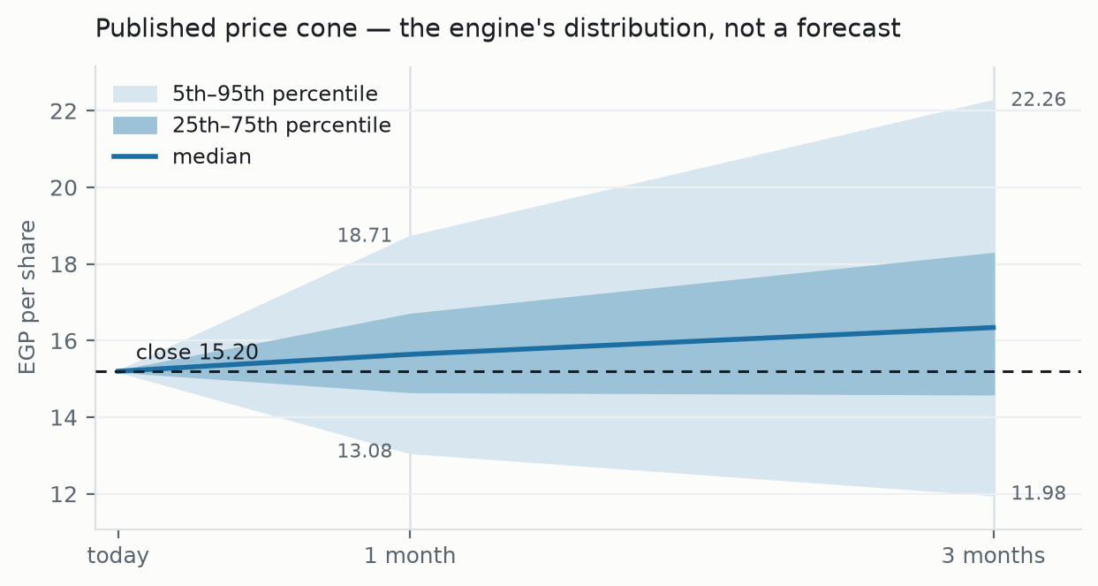
Figure 3 — the same distribution drawn as a cone. The shaded bands are the middle half and the 5th-to-95th range.
Over 57 resolved three-month forecasts on this company, the price finished inside the 90 per cent band 91.2% of the time, and inside the middle band 50.9% of the time. That is a long record by the standards of this series. The bands are about 1.47 times as wide as a simple random-walk band over the same horizon, which is what Egyptian devaluation risk costs in width.
Level (EGP) | Chance of touching within one month | Within three months
20.00 | 3% | 19%
18.50 | 9% | 35%
17.50 | 20% | 51%
16.50 | 43% | 71%
15.55 | 80% | 90%
The chance that the price trades at or through each level at any point in the window, not the chance it ends there.
Price data to 2026-08-23, computed 2026-08-24; the trend read uses data to 2026-08-23, computed 2026-08-25.

4 Comparison of the lenses
The three readings are deliberately independent — none is an input to another — so where they agree, the agreement carries information.
Lens | What it says | Relative to the EGP 15.20 close
Fundamental value | EGP 9.17 to EGP 38.74 depending on cash conversion | the close sits inside the range, near its lower half
Price distribution | three-month middle band EGP 14.61 to 18.27 | the distribution is centred slightly above the close
Trend structure | above a rising 20-, 50- and 200-day average | constructive, with resistance only 1.2 per cent away
They point the same way without being made to. The fundamental range brackets the price, the distribution is mildly positive and the trend is intact. None of that resolves the crux in section 1.7.

5 Catalysts to watch
- The half-year 2026 results. None had been published as at 30 August 2026, which is itself notable this late in the year.
- The full-year 2025 results release. The audited statements were published but the accompanying release, which is where units sold, new sales, deliveries and construction spending are disclosed, was not.
- Any disclosure of collection terms — down payment, instalment tenor, post-handover tail. This is the single disclosure that would most narrow the range in this study.
- Progress on the EGP 30 billion securitisation programme. Selling receivables converts the instalment book to cash and is the direct lever on the crux; pricing on any tranche would also fix the cost of debt.
- The Village de La Capitale launch, which contributed EGP 24 billion of the EGP 52 billion of first-quarter 2026 sales. Whether that rate of launch sales repeats materially changes the order book path.
- Egyptian interest rates. The cost of capital here is built on a 23.00% sovereign yield; a sustained fall would raise every figure in section 1.9.

6 Reading the probability zones
The bands in section 3 describe where the price has tended to go, not where it should go. They are wide because Egyptian equities are genuinely volatile: the middle half of the three-month distribution spans EGP 14.61 to EGP 18.27, a range of about 24 per cent of the current price. A reader who wants a narrower band is asking for a less honest one.
The touch ladder answers a different question from the percentile map. A level with a 51 per cent chance of being touched inside three months is not a level with a 51 per cent chance of holding — prices pass through levels far more often than they settle at them.

7 Caveats and what would change our mind
Five things are not disclosed by the company and are therefore not in this study. Each is named with what would close it.
What is missing | Why it matters | What would close it
Collection schedule | Down payment, instalment tenor and post-handover tail are not published. This is the crux; it is measured from outcomes instead of built from terms. | Disclosure of contract terms.
Project unit economics | No per-project unit mix, unit area, price per square metre or construction cost per square metre is disclosed. | Project-level disclosure or an investor presentation carrying them.
Cost of debt | The February 2026 securitisation publishes sizes, tenors and ratings but no coupon. | A coupon on any tranche.
Full-year 2025 operating figures | The audited statements were published; the results release, which carries units and new sales, was not. | The 2025 results release.
Half-year 2026 | Nothing newer than the first quarter of 2026 had been published as at this edition's date. | The half-year filing.
What would change our mind, in order of force:
- Two more years of cash conversion clustering. Three observations spanning 3.9% to 17.9% cannot distinguish a volatile business from a mismeasured one; five could.
- Disclosure of collection terms, which would replace the measured range with a built schedule and narrow the answer directly.
- A sustained fall in Egyptian interest rates, which lifts every cell in the sensitivity table.
- Evidence that the order book converts at the rate the company's delivery history implies rather than more slowly. The order book is now more than seven times revenue, against 5.4 times in 2024 and 3.4 times in 2023; that ratio has risen every year and cannot rise indefinitely.
A note on this study's own track record. Tested across ten annual starting points on this company's history from 2011 to 2025, this method forecast revenue tolerably but overstated net profit by about three times, consistently and in 97 per cent of tested cases, and did worse than simply assuming no change. The cause was the mismatched recognition clock corrected in section 1.1. That is why this edition publishes ranges rather than a central figure, and why the reader should treat the upper end of section 1.9 with more suspicion than the lower.

Appendix A Financial statements

A.1 Income statement
EGP million | 2023 | 2024 | 2025
Revenue | 17,462.1 | 27,167.3 | 36,169.3
Cost of revenue | -11,907.2 | -17,837.2 | -21,118.9
Gross profit | 5,507.6 | 9,330.1 | 14,887.6
Overheads | -2,060.5 | -3,435.8 | -6,365.6
Depreciation and amortisation | -178.6 | -239.9 | -353.7
Finance cost |  | -2,311.4 | -3,347.5
Profit before tax and minority | 2,300.7 | 4,320.6 | 6,251.1
Tax | -567.3 | -917.1 | -1,827.2
Profit after tax and minority | 1,581.5 | 3,254.9 | 4,216.7
Three years as reported in the company's audited statements.
Forecast, EGP million | Revenue | Gross profit | Pre-tax profit | Operating cash
2026 | 45,284 | 17,354 | 828 | 3,946
2027 | 56,696 | 21,727 | 3,193 | 4,940
2028 | 70,983 | 27,202 | 6,154 | 6,185
2029 | 88,870 | 34,057 | 9,861 | 7,744
2030 | 111,266 | 42,640 | 14,502 | 9,695
Five forecast years, central case. Years three to five should be read as the corresponding rows of the range in section 1.9, not as points.

A.2 Balance sheet
EGP million | 2025 | 2024
Non-current assets | 65,900.2 | 54,166.4
of which notes receivable, long term | 56,319.8 | 46,309.1
Current assets | 106,229.6 | 69,270.9
of which work in progress | 17,570.9 | 13,209.8
of which trade receivables | 28,118.1 | 15,561.1
of which cash | 9,419.5 | 6,372.4
Total assets | 172,129.8 | 123,437.3
Current liabilities | 105,099.0 | 74,496.9
of which advances from customers | 69,354.1 | 47,403.8
Non-current liabilities | 48,265.1 | 34,315.7
Total liabilities | 153,364.1 | 108,812.6
Shareholders' funds | 18,765.8 | 14,624.7
Total equity and liabilities | 172,129.8 | 123,437.3
As reported. Total assets equal total liabilities plus shareholders' funds in both years, and each subtotal reconciles to its components.

A.3 Forecast balance sheet and cash-flow markers
Marker | 2025 actual | Basis carried forward
Gross borrowings (EGP mn) | 33,552.7 | held at the 2025 level; no repayment schedule is disclosed
Net debt (EGP mn) | 24,133.2 | gross borrowings less cash
Order book (EGP mn) | 263,000 at 31 Mar 2026 | converges to 5.4 times revenue, its 2024 level
Cash from operations | 1,424.2 | modelled as a share of revenue across the observed range
Overheads as a share of revenue | 17.6% | held at the 2025 rate

Appendix B Peer frame, risk register and research register

B.1 The Egyptian listed developers
Code | Company | Beta | R-squared | Std error | Volatility | Worst fall
TMGH | Talaat Moustafa Group Holding | 1.4718 | 32.6% | 0.185 | 43.9% | -44.2%
PHDC | Palm Hills Developments | 1.0493 | 29.9% | 0.182 | 43.9% | -48.7%
ORHD | Orascom Development Egypt | 0.8837 | 32.1% | 0.173 | 46.4% | -42.9%
HELI | Heliopolis Housing and Develop | 0.7653 | 28.8% | 0.181 | 44.4% | -39.6%
EMFD | Emaar Misr for Development | 0.7388 | 24.4% | 0.169 | 41.1% | -47.1%
PRDC | Pioneers Properties for Urban | 0.7067 | 25.8% | 0.186 | 42.2% | -52.0%
OCDI | Sixth of October Development & | 0.4938 | 10.3% | 0.224 | 47.1% | -46.6%
Every measure computed on the same five-year window, through the same cleaning, against the same index. Volatility is annualised from weekly returns; worst fall is the deepest peak-to-trough decline over five years.
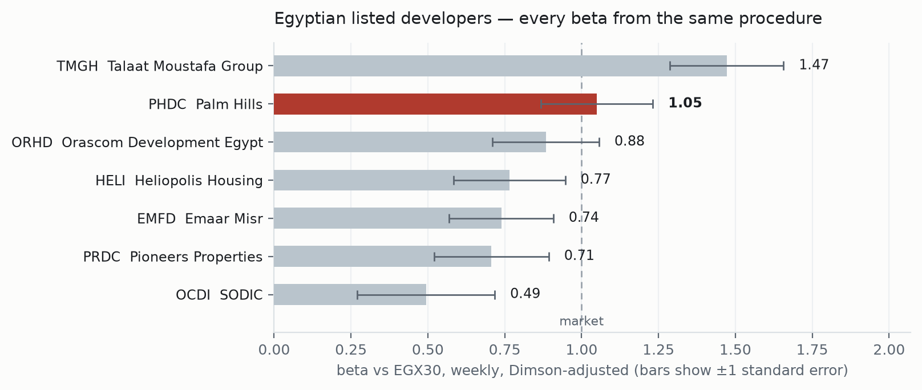
Figure 4 — the same betas with their standard errors. Palm Hills sits mid-sector: more market-sensitive than most of its peers, materially less so than the largest.
Earnings and book multiples for the peer group are not published in this study. No peer discloses financial statements this study can obtain on a consistent basis, and a multiple built from inconsistent inputs would carry more authority than it deserves. What is measured here is measured the same way for every name.

B.2 Risk register
Risk | How it would show up | Where it is priced
Cash conversion stays at the 2023 and 2025 rate | operating cash near 3.9% of revenue | bottom row of the table in section 1.9
Egyptian rates stay high or rise | cost of capital above 26.25% | right-hand columns of the same table
Order book converts more slowly than delivery history implies | the order book keeps rising as a multiple of revenue | section 7, fourth bullet
Currency devaluation | nominal figures rise, real value does not | the whole study is in nominal pounds; a devaluation moves the denominator too
Cost of debt above the assumed spread | finance cost above the modelled level | section 1.8; the spread is the one unsourced input

B.3 Research register
This study is built on 69 sourced inputs. Every reported historical comes from the company's own audited statements or its own results releases. The only third-party inputs are the exogenous macroeconomic series and the market price. A full register, with the value, source, date and provenance of each input, is published in the accompanying bibliography.

Appendix C Expert panel
Three readings of the same company by three different methods. The experts are identified by method, not by name.

C.1 Expert 1 — the discounted cash-flow analyst
Worldview: a company is worth the cash it will hand its owners, discounted at what that cash costs. When it works: businesses with stable conversion of profit to cash. When it fails: businesses where that conversion is the unknown — which is exactly this one.
Working | EGP mn
Present value of ten explicit years | 49,460
Present value beyond year ten | 25,237
Enterprise value | 74,697
less net debt | (24,133)
plus associates and investment property | 4,644
Equity | 55,208
Per share (EGP) | 19.30
Named sensitivity: a move in cash conversion from 3.9% to 17.9% takes the answer from EGP 9.17 to EGP 38.74. Falsifier stated in advance: if the 2026 and 2027 cash-flow statements show conversion inside two percentage points of 8.7%, this reading is right and the range should collapse toward its centre; if they straddle the full observed spread again, the method should be abandoned for this company.

C.2 Expert 2 — the asset-based analyst
Worldview: a developer is a pile of land, work in progress and receivables, less what it owes. Earnings are an accident of timing. When it works: asset-heavy businesses in distress or in wind-down. When it fails: going concerns whose value is in execution.
Working | EGP mn
Work in progress | 17,571
Receivables, trade and instalment | 103,511
Cash | 9,420
Investments and investment property | 4,644
less advances from customers | (69,354)
less gross borrowings | (33,552.7)
less other liabilities, balancing | (50,457.3)
Shareholders' funds as reported | 18,766
Per share (EGP) | 6.56
Named sensitivity: the instalment receivable book is carried at face value less unwinding discount. A 10 per cent write-down of that book would remove roughly EGP 10,106 million, about EGP 3.53 a share. Falsifier: evidence of material cancellations or receivable impairment would confirm this reading and invalidate the cash-flow one.

C.3 Expert 3 — the market-implied analyst
Worldview: do not value the company; ask what the price already assumes, then judge whether that assumption is reasonable. When it works: where a single variable dominates. When it fails: where the market is wrong about many things at once.
Working: holding the cost of capital at 26.25% and every other input at the audited 2025 base, the closing price of EGP 15.20 implies cash conversion of 6.8%. The company achieved 4.3% in 2023, 17.9% in 2024 and 3.9% in 2025. Named sensitivity: at a 25.24% cost of capital the implied rate would be lower still. Falsifier: if 2026 conversion prints above 6.8%, the price was too low.

C.4 Cross-examination
- Expert 2 to Expert 1: your terminal value is 34% of your answer, so you are mostly valuing years you cannot see. CONCEDED — it is why no single figure is published.
- Expert 1 to Expert 2: book value ignores that the company sells at roughly 41.2% gross margin, so its inventory is worth more than cost. CONCEDED — book is a floor, not a value.
- Expert 3 to both: you disagree by a factor of four and the market sits between you, so neither of you is adding information. REJECTED — the range is the information; a false point estimate would not be.
- Expert 2 to Expert 3: the price also reflects Egyptian equity risk appetite, not just this company's conversion rate. CONCEDED — the implied figure is a single-variable solve and is labelled as one.

C.5 The three in one room
They agree on the facts and disagree on one number. All three accept the audited 2025 base, the 26.25% cost of capital and the order book. Expert 1 needs a conversion rate to produce an answer; Expert 2 refuses to forecast one and prices the assets instead; Expert 3 asks what rate is already in the price. The room's joint position is that Palm Hills is worth between EGP 9.17 and EGP 38.74, that the price of EGP 15.20 sits in the lower half of that range, and that the width is a property of the disclosure rather than of the analysis.

C.6 Reading the divergence
Assumption | Expert 1 | Expert 2 | Expert 3 | Drives the gap?
Cash conversion | 3.9% to 17.9% | not forecast | 6.8% implied | YES — this is the whole gap
Cost of capital | 26.25% | not used | 26.25% | no — shared
Receivable book | collected on schedule | at carrying value | as the market judges | partly
Terminal value | 34% of the answer | none | none | yes for Expert 1 alone
One assumption explains almost all of the divergence, which is the clearest evidence that section 1.7 has identified the right crux.

About this series
These studies value a company from its own disclosures, publish the reasoning alongside the answer, and record what the method has historically got right and wrong on that company. They carry no rating and no price target. Where a company does not disclose something the valuation needs, the study says so and prices the consequence rather than filling the gap.

Disclosure and disclaimer
This document is for information and education. It is not investment advice, not a recommendation, and not an offer or solicitation to buy or sell any security. It contains no rating and no price target. Figures are drawn from the company's published financial statements and results releases and from the named third-party sources; they may contain errors and are not warranted. Valuations are estimates that depend on assumptions stated in the text, and small changes in those assumptions produce large changes in the result, as section 1.9 shows directly. Past price behaviour does not predict future returns. Readers must reach their own conclusions and should take professional advice before acting. Edition of 30 August 2026; information set ends at the company's first-quarter 2026 results.

