Testahil · Independent Valuation Study — Educational Analysis Not investment advice

Palm Hills Developments (EGX:PHDC)
Independent valuation study — fundamentals refreshed on the 30 June 2026 statements
Anchor EGP 15.01 (22-Jul-2026) · 2.82 bn shares outstanding after treasury · market value about EGP 42.40bn · fundamentals rebuilt on the reviewed statements as of 30 June 2026 · price and probability sections carried forward from the 22 July 2026 data
READ FIRST — what this document is, and is not. This study is a valuation exercise and an expression of personal analytical opinion, published free of charge for educational purposes: it shows how one analyst applies fundamental and probabilistic methods to a listed company, and invites scrutiny of that methodology. It is NOT investment advice, NOT a recommendation or solicitation to buy, sell or hold any security, and NOT directed at the circumstances of any reader. The preparer is not licensed by the Egyptian Financial Regulatory Authority or any other regulator, provides no financial consultancy, manages no money, and accepts no fees, funds or clients. All values are model outputs presented as ranges and distributions because no single number should be relied on. Consult a licensed financial advisor before any investment decision.

Headline
One question decides this company, and the accounts pose it plainly. Palm Hills holds EGP 34.34bn of customers' maintenance money on behalf of residents' associations that have not yet been legally constituted. Take that balance's growth out of the cash-flow statement and reported operating cash flow is negative in every period the company has ever disclosed: EGP -3,716mn in the first half of 2026, EGP -5,592mn in the first half of 2025, EGP -6,963mn in 2024 and EGP -3,024mn in 2023. Whether that float is permanent funding of the business or third-party money held in trust is worth more than any forecast in this document, so the study computes the whole valuation both ways and publishes the two answers side by side. It never averages them.
Treat the float as operating funding and the four lenses centre on EGP 15.82, about +5% against the EGP 15.01 market price, inside a range of EGP 9.81 to EGP 21.82. Treat it as restricted and the same four lenses centre on EGP 5.79. The study adopts the first as its base case, because that is how the company has actually operated for a decade — the balance has risen in every disclosed period, no association has been constituted, and the invested proceeds earn for the company — and it publishes the second in full as the downside rather than as a haircut.
The second question is what the first half actually said about margins. The reported gross margin fell from 42.8% to 35.5% year on year, and the earnings-before-interest measure the company itself publishes fell from 28.5% to 20.8%. That reads as deterioration until the audited history is put beside it: the same measure was 19.7% in 2023 and 21.6% in 2024. The first half of 2026 is not below the company's own history — 2025 was above it, and about EGP 661mn of the 2025 half-year came from selling investments and other items that carried no cost at all. The compression began in the fourth quarter of 2025, at 17.5%, and has since recovered to 20.5% and 21.1% in the two quarters of 2026.
The third is the cost of capital, and it is where the last edition of this study was simply wrong. It discounted at a flat 18% while the Egyptian government was paying more than that to borrow. On 17 August 2026 the three-year Egyptian government bond cleared at 23.27%. Rebuilt properly, the cost of equity is 31.5% on the rating basis and 29.9% on the credit-default-swap basis, the marginal cost of debt is 25.1%, and the weighted cost of capital is 25.9% to 26.9% today, gliding to 14.8% as the central bank's own inflation target takes hold. A discount rate below the local risk-free rate is not available to a leveraged equity, and every number in the last edition rested on one.
What the shares are priced for. At EGP 15.01 the market pays 2.24x book value against a trailing return on equity of 22.2%. Solve that for the discount rate the market is applying and it comes out near 14.3% — very close to the normalised cost of equity in this study, and far below the spot rate. The market is already pricing Egypt's disinflation. That is a defensible view. It is also the single assumption that has to hold.
Valuation summary
 | Framing A — float is operating funding | Framing B — float restricted
Cash-flow lens | EGP 11.67 – 34.56 | EGP -4.82 – 6.51
Book value and sustainable return | EGP 4.35 – 10.02 | EGP 4.35 – 10.02
Relative multiples | EGP 9.68 – 12.15 | EGP 9.68 – 12.15
Normalised earnings power | EGP 11.69 – 12.21 | EGP 11.69 – 12.21
Weighted centre | EGP 15.82 | EGP 5.79
Weighted low | EGP 9.81 | EGP 2.39
Weighted high | EGP 21.82 | EGP 9.19
Against the EGP 15.01 market price | +5.4% | -61.4%

Table 1. The contested judgement computed both ways. The three lenses that do not depend on it are identical in both columns by construction; only the cash-flow lens moves. Within each column the range is the cost of capital: the low end holds today's spot rate constant, the high end glides to the normalised rate. The two columns are never blended.
What this study publishes | EGP per share | Where it comes from
Low case | 5.79 | the weighted centre under framing B — the alternative reading of the balance sheet, computed in full
Base case | 15.82 | the weighted centre under framing A, the adopted framing
High case | 21.82 | the weighted high under framing A
Market price | 15.01 | close of 22-Jul-2026

Table 2. The low case is not a stress test bolted onto the base. It is the other framing of the float, run through all four lenses.
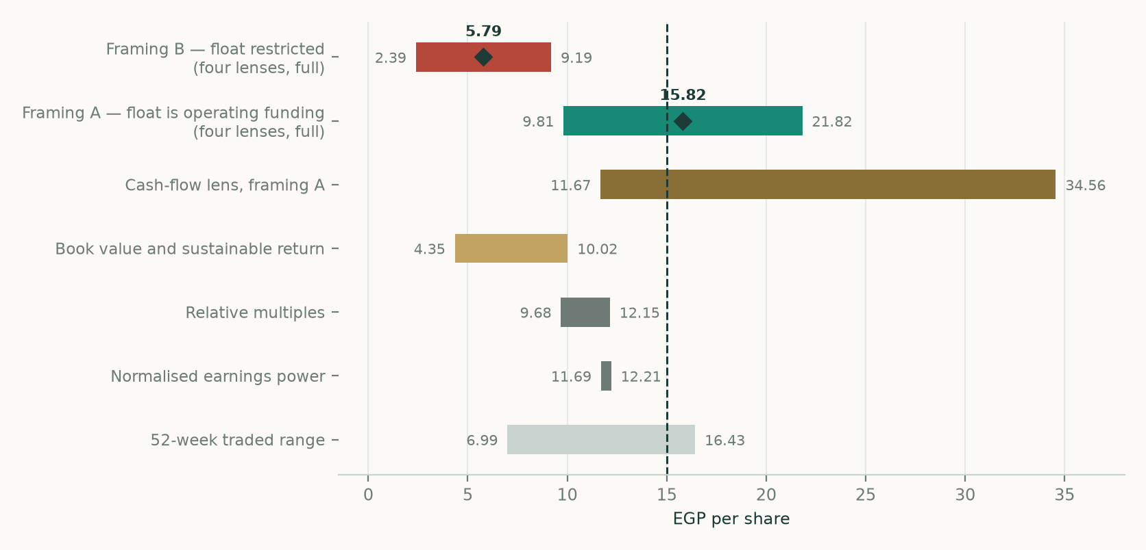
Figure 1. Valuation field, EGP per share. The two framings of the contested judgement sit at the top; the four lenses beneath them; the traded range at the bottom. The dashed line is the market price. Every bar is defined in the tables above and rebuilt from the company's own statements.
What the previous edition got wrong
The last edition of this study was published on 11 June 2026, before the 30 June statements existed. Every forecast it made for a period that has since been disclosed is scored below against the actual. A miss of more than five per cent of the central value is treated as material and is explained by naming which part of the driver stack was wrong, not merely that the number differed.
Item | Previous edition | Disclosed actual | Miss | Which driver was wrong
FY2026 revenue | 50,042 | 39,056 | -22% ▲ | Actual is H1-2026 annualised at the H1 run-rate. The prior model carried no interim actuals; it started from a project-by-project unit build with no disclosed base period.
FY2026 gross margin | 41.6% | 35.5% | -15% ▲ | H1-2026 reported gross operating margin. The prior figure was an output of assumed unit prices and assumed construction costs per square metre, none of them disclosed.
FY2026 EBITDA | 13,874 | 8,132 | -41% ▲ | On the definition the company itself publishes, recovered from the statements as gross profit less administrative and selling cost less expected credit losses. H1-2025 is the only period for which the company published an EBITDA figure AND the statements disclose its components; there the recovered definition reproduces the published EGP 4,458.5mn to within 0.32%.
FY2026 net income | 6,373 | 4,530 | -29% ▲ | Attributable net profit, H1-2026 annualised.
FY2026 capital expenditure | 250 | 665 | +166% ▲ | Payments for fixed assets plus projects under construction, H1-2026 annualised.
Net debt at the anchor | 12,000 | 5,660 | -53% ▲ | Against the company's own definition (interest-bearing obligations from note 34 less cash and treasury investments). Under the broader definition that also carries notes payable and land liabilities the figure is EGP 14,532mn.
Construction run-rate | 17,000 | 23,943 | +41% ▲ | Work carried out per note 43, H1-2026 annualised, against the prior study's stated pacing of about EGP 14-20bn per year.
Shares outstanding | 2,860 | 2,824 | -1% | The prior model divided by issued shares and ignored the treasury holding disclosed in note 62.
Return on equity | 26.9% | 22.2% | -17% ▲ | Trailing twelve months on average controlling equity.
Price to sales | 0.92x | 1.06x | +15% ▲ | At the same published spot of EGP 15.01, on trailing twelve-month revenue.
EV to EBITDA | 8.10x | 5.88x | -27% ▲ | On the company's net-debt definition and trailing twelve-month EBITDA.
Price to earnings | 10.30x | 10.54x | +2% | On trailing twelve-month attributable earnings and the ex-treasury share count.
Debt to equity | 1.58x | 1.40x | -11% ▲ | Interest-bearing obligations over controlling equity. On the broader debt definition the ratio is 1.87.
Weighted cost of capital | 18.0% | 25.9% | +44% ▲ | The prior study discounted at 18% while the three-year Egyptian government bond was clearing at 23.27%. A weighted cost of capital below the local risk-free rate is not available to a leveraged equity.
Terminal growth | 5.0% | 8.0% | +60% ▲ | The prior 5% nominal terminal growth sat about nine points below the inflation embedded in its own 14% price escalator — a deeply negative real terminal.
Backlog | 263,000 | 149,118 | -43% ▲ | Against note 72, the only backlog figure that appears in an audited or reviewed statement: the contractual value of undelivered-unit contracts concluded between 1-Jan-2023 and 30-Jun-2026. The company's own wider definition stood at EGP 263bn at 1Q2026.

Table 3. Scoring the previous edition. EGP mn unless the item says otherwise; ratios and multiples as stated. A triangle marks a miss beyond five per cent of the central value. Fourteen of the sixteen lines miss materially, which is why this is a rebuild rather than an update.
Company overview
Palm Hills Developments is an Egyptian joint-stock company incorporated in 2005 and listed on the Egyptian Exchange since 2008. It builds and sells integrated residential communities, mostly in West Cairo, East Cairo, the North Coast and Alexandria, and it runs hotels and sports clubs alongside them. Its land bank runs to about 46 million square metres across Egypt and Abu Dhabi. Its headquarters is at Smart Village, Sixth of October City.
Three features of the business decide how it has to be valued, and all three come off the face of the accounts rather than from any description of the company.
- Percentage of completion. It sells on multi-year instalments and recognises revenue as it builds, unit by unit, measured by its own engineering department. So revenue is a function of construction executed, not of units sold. In the first half of 2026 the company carried out EGP 11,971mn of work and recognised EGP 17,547mn of real-estate revenue against it.
- The customer is the lender. Receivables run to about 1,056 days of revenue and work in progress to another 348 days, but customer advances run to 1,215 days. The cycle nets to about 22 days: the customer funds the build. That is the whole financial architecture, and it is why the balance sheet carries EGP 194.77bn of assets against EGP 18.91bn of equity.
- Land is often rented against revenue, not bought. Several of the largest projects are revenue-sharing arrangements rather than owned land: the New Urban Communities Authority takes 26 per cent of Badya's revenue, the partner in Alamein takes 30 per cent, and Palm New Cairo, Capital Gardens and El Fouka run on the same basis. Those shares are a cost of revenue, not a financing item, and they sit inside the cost line the study decomposes in section 1.6.
Half-year to 30 June, EGP mn | 2026 | 2025 | Change
Revenue | 19,528 | 15,579 | +25.3%
Cost of revenues | 12,539 | 8,860 | +41.5%
Gross operating profit | 6,926 | 6,665 | +3.9%
Administrative, selling and marketing | 2,846 | 2,206 | +29.0%
Finance costs and interest | 1,677 | 1,338 | +25.3%
Profit before tax | 3,138 | 3,588 | -12.5%
Attributable profit | 2,265 | 2,443 | -7.3%
Gross margin | 35.5% | 42.8% | -7.3 pts
Earnings before interest, tax and depreciation | 4,066 | 4,444 | -8.5%

Table 4. The reviewed half-year and its comparative, read from the face of the statements.
1. Fundamental valuation
Four independent lenses are run on the same set of company-issued numbers, then reconciled into one field. The cash-flow lens is built from the physical driver — construction executed — through selling price per unit of build cost, with each cost class carrying its own escalator and the margin falling out as an output rather than being set as an input.
1.1 Cash-flow model
The model values the firm before financing, then bridges to equity. It runs from a half-year stub covering the second half of 2026 through five full years to 2031, then a terminal value that is made consistent with the return on capital the model itself computes, so growth is never free. Discounting is mid-period from the 30 June 2026 balance-sheet date.
EGP mn | H2-2026E | FY2027E | FY2028E | FY2029E | FY2030E | FY2031E
Revenue | 21,414 | 47,322 | 55,707 | 63,478 | 70,638 | 77,487
Earnings before interest, tax and depreciation | 5,008 | 10,927 | 12,757 | 14,420 | 15,932 | 17,389
Depreciation and amortisation | -306 | -677 | -796 | -907 | -1,010 | -1,108
Unwind of the discount on instalment receivables | 574 | 1,268 | 1,492 | 1,701 | 1,893 | 2,076
Income on invested balances (framing A only) | 500 | 1,104 | 1,300 | 1,481 | 1,648 | 1,808
Operating profit after the items above | 5,776 | 12,623 | 14,752 | 16,695 | 18,462 | 20,165
Tax at the measured effective rate of 26.9% | -1,556 | -3,400 | -3,974 | -4,497 | -4,973 | -5,432
Operating profit after tax | 4,220 | 9,222 | 10,778 | 12,197 | 13,489 | 14,733
Add back depreciation and amortisation | 306 | 677 | 796 | 907 | 1,010 | 1,108
Capital expenditure | -364 | -805 | -948 | -1,080 | -1,202 | -1,319
Change in working capital | -6,324 | -7,277 | -13,712 | -12,711 | -11,691 | -11,097
Residents' Association float (framing A only) | 4,179 | 4,993 | 8,832 | 8,580 | 8,294 | 8,271
FREE CASH FLOW TO THE FIRM | 2,017 | 6,810 | 5,747 | 7,893 | 9,900 | 11,696
Discount factor | 0.9441 | 0.8086 | 0.6779 | 0.5900 | 0.5334 | 0.5016
Present value | 1,904 | 5,506 | 3,896 | 4,657 | 5,281 | 5,867

Table 5. The free-cash-flow waterfall in full, under framing A, and every line foots. Interest is excluded throughout because this is a pre-financing measure; the EGP 1,192mn of interest the company capitalised into work in progress in the first half is added back inside the earnings line for the same reason. Two items sit between that line and operating profit because the accounts put them there: the discount on instalment receivables unwinds into income as the instalments run off, and the invested balances earn treasury-bill income — the second of which exists only in framing A, since framing B does not treat those balances as the company's. The float line beneath is the whole of the remaining difference between the two framings, and it too is zero in framing B.
Bridge from firm to equity, EGP mn | Framing A | Framing B
Present value of the explicit forecast | 27,111 | 5,424
Present value of the terminal value | 77,891 | 39,661
ENTERPRISE VALUE | 105,002 | 45,084
Less net debt | (5,660) | (24,983)
Less non-controlling interests | (1,723) | (1,723)
EQUITY VALUE | 97,619 | 18,378
Shares outstanding after treasury, mn | 2,824 | 2,824
VALUE PER SHARE, EGP | 34.56 | 6.51
Terminal value as a share of enterprise value | 74.2% | 88.0%

Table 6. The two bridges. Net debt differs between the framings for the same reason the cash flows do: framing A treats the cash and treasury bills as the enterprise's, framing B treats EGP 19.32bn of them as the associations' invested money and leaves only EGP 1,497mn free. The terminal share is high in both — it is higher in framing B because the explicit years generate almost nothing without the float, which is itself part of the answer.
Reconciliation to the last reported period. Scaled back onto the reported half-year — same revenue, capitalised interest added back on both sides — the model's first forecast period reproduces the reported earnings before interest, tax and depreciation to within 1.28%. On cash the comparison needs two bridging items, both read off the balance sheet: the company paid down EGP 990mn of income tax payable and EGP 1,611mn of the joint-arrangement partners' balance in the half, neither of which is a run-rate item. Reported unlevered cash flow of EGP 3,822mn becomes EGP 6,423mn on a like-for-like basis against the model's EGP 2,017mn, a residual of EGP 4,406mn that the study does not paper over: it is the difference between a ratio-driven roll and one actual half-year of a working-capital-driven developer.
1.2 Book value and sustainable return
Controlling equity at 30 June 2026 was EGP 18,911mn, or EGP 6.70 a share on the 2,824 million shares outstanding after the treasury holding. Trailing attributable profit of EGP 4,038mn on average controlling equity gives a return on equity of 22.2%. A business earning more than its cost of equity is worth more than its book; one earning less is worth less. At the spot cost of equity of 29.9% the justified multiple is 0.65x and the value is EGP 4.35. At the normalised cost of equity of 17.5% it is 1.50x and EGP 10.02. The market pays 2.24x.
1.3 Relative multiples
Company | Listing | Price to earnings | Enterprise value to EBITDA
Talaat Moustafa Group Holding | EGX:TMGH | 10.20x
Emaar Misr for Development | EGX:EMFD | 6.10x
SODIC | EGX:OCDI | 6.10x
Heliopolis Housing | EGX:HELI | 7.50x
Madinet Masr | EGX:MASR
Emaar Properties | DFM:EMAAR | 6.50x | 3.60x
Aldar Properties | ADX:ALDAR | 7.70x | 6.60x
Palm Hills Developments | EGX:PHDC | 10.54x | 5.88x

Table 7. Peers inside and outside the country. Peer multiples are market-data quotes dated 11 August 2026 for the Egyptian names and June to August 2026 for the Gulf names; they are used as a cross-check and never as a source for anything Palm Hills itself reported. Palm Hills' own figures are computed from its statements at the EGP 15.01 published price: trailing earnings per share of EGP 1.42 and trailing EBITDA of EGP 8,174mn.
The median Egyptian peer trades at 6.80x trailing earnings and the median Gulf peer at 7.10x. Applied to trailing earnings of EGP 1.42 a share those give EGP 9.68 and EGP 10.11. Capitalising trailing EBITDA at the Gulf median of 5.10x enterprise value and bridging to equity gives EGP 12.15. Palm Hills already trades at 10.54x earnings, a premium to both peer sets, and at 5.88x EBITDA, in line with Aldar and above Emaar. It is not a cheap stock on multiples.
1.4 Normalised earnings power
This lens strips out the cycle. It takes the current revenue base — trailing twelve months of EGP 40,145mn — and applies the average of the margins the company earned in 2023, 2024 and the first half of 2026, which is 20.7%. That gives EGP 8,309mn of earnings before interest, tax and depreciation. Depreciation, the unwinding of the discount on instalment receivables, the return on the treasury-bill book and interest on the disclosed debt at its measured rate leave EGP 6,648mn of pre-tax profit and EGP 4,857mn after tax, or EGP 1.72 a share. At the peer range of 6.80x to 7.10x that is EGP 11.69 to EGP 12.21.
1.5 Synthesis — four lenses, one field
Lens | Weight | Low | Centre | High | What it is most sensitive to
Cash flow | 45% | 11.67 | 23.12 | 34.56 | the float, then the cost of capital, then the crux ratio
Book value and return | 20% | 4.35 | 7.19 | 10.02 | the cost of equity — nothing else moves it
Relative multiples | 20% | 9.68 | 10.91 | 12.15 | peer multiples, which are themselves depressed by Egyptian country risk
Normalised earnings | 15% | 11.69 | 11.95 | 12.21 | the margin taken as mid-cycle and the interest charge
Weighted field, framing A | 100% | 9.81 | 15.82 | 21.82
Weighted field, framing B | 100% | 2.39 | 5.79 | 9.19

Table 8. The four lenses and their weights. The cash-flow lens carries the largest weight because it is the only one built from the company's own physical drivers; it is also the only one that moves between the framings.
1.6 Drivers — every disclosed line on its own driver
Revenue is volume times price and cost is cost per unit of volume, with growth projected in both. The volume driver is construction executed, which the company discloses. The price driver is revenue recognised per Egyptian pound of construction cost charged to the income statement. Margin is what falls out of the two; it is never set.
Driver | Measured value | How it is measured, and what escalates it
Construction executed | EGP 11,971mn in the half | Disclosed. Annualises to EGP 23,943mn against EGP 18,015mn for 2025, up +32.9%. Cash construction spending rose 60 per cent year on year in the first quarter and 71 per cent over the first nine months of 2025, which is the independent check on the same driver. The path then decelerates: 12% real growth in 2027 falling to 3% by 2031.
Revenue per pound of build cost — THE CRUX | 3.12x | EGP 17,547mn of real-estate revenue against EGP 5,626mn of construction cost charged to the income statement in the half. Escalates at the selling-price path over the build-cost path, so it falls only if costs outrun prices.
Land and partners' share of revenue | 37.1% | The residual of the disclosed cost of real-estate development after the construction block. It cannot be split into its two parts from anything the company publishes — see below — so it is carried at its measured rate and moves with revenue, not with cost inflation.
Selling price | 9% a year in 2027 | Anchored on a measured market outcome, not an assumption: the ten largest Egyptian developers sold 2.9% more by value in the first half of 2026 on 5% fewer units, an implied average-ticket rise of 8.3%. Later years converge on the central bank's disinflation path.
Build cost | 10.2% a year in 2027 | Four physically distinct classes, one escalator each, never one blended index. Steel at 6% in 2027 on the measured August producer prices, cement at 9% on the disclosed Egyptian price path, finishing at 11.5% on the published inflation path, site labour at 13.5%.
Salaries and wages | EGP 678mn in the half | Disclosed separately from other administrative cost. Rose +40.8% year on year against revenue growth of +25.3%. Escalates on the wage path plus 2% of real headcount growth.
Administration and marketing | 11.1% | Held at its measured share of revenue, which is stable: 11.10% in the first half of 2026 against 11.07% a year earlier.
Residents' Association float | 1.00x revenue | Solved from the company's own movements rather than assumed. For every pound of revenue growth the balance rose by 0.98x in 2023, 1.04x in 2024 and 1.32x in the first half of 2026 on a like-for-like basis. The study lets the balance glide from its measured 0.88x of revenue today to 1.00x and stop there — near the bottom of that range, and bounded, rather than rising without limit.

Table 9. The driver table. Every measured value is read from a company-issued document; every escalator names its own physical class.
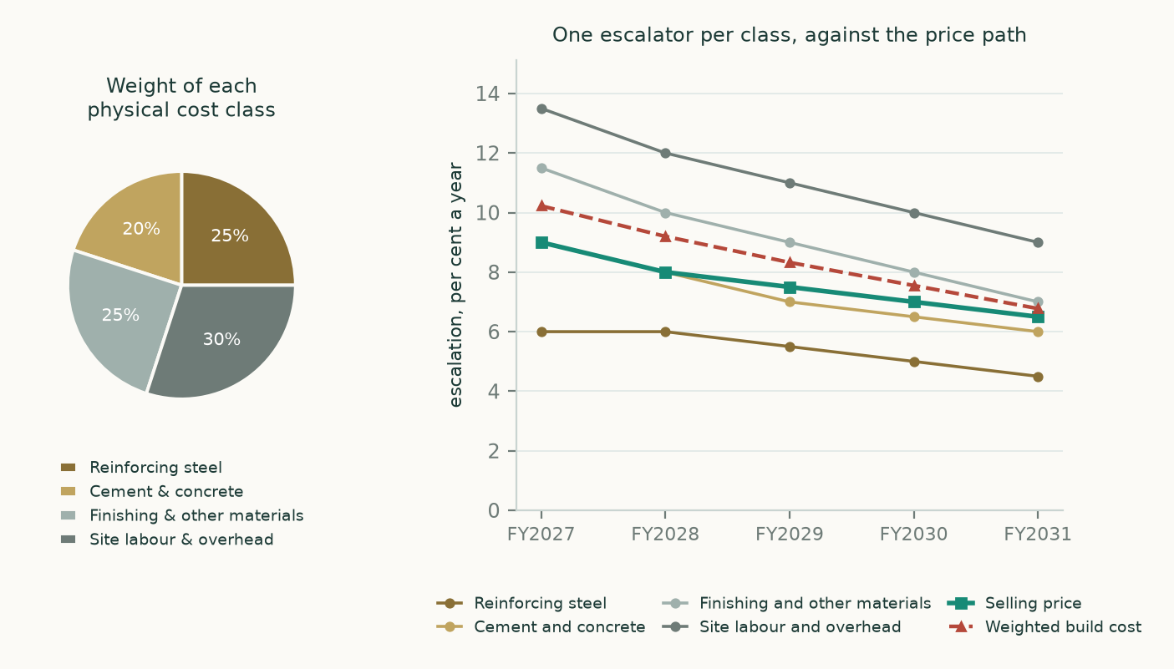
Figure 2. Left: the weight of each physically distinct construction cost class. These weights are estimated — no filing discloses a cost-by-nature split of construction — and they are carried through the sensitivity. Right: each class on its own escalator, against the selling-price path and the weighted build-cost path. Build cost runs above selling price in every year, which is why the margin drifts down slowly rather than holding flat.
A split the accounts do not identify, demonstrated rather than asserted. The cost of real estate development is one line. Note 43 pins the construction half of it at EGP 5,626mn for the half by giving the cumulative charge to the income statement at two dates. The remaining EGP 6,507mn is the land cost of contracted units plus the joint-arrangement partners' share of revenue, together. Nothing the company publishes separates them: note 43 states that work in progress is struck after excluding the cost of contracted lands, note 65 stops at the single line, and note 58 gives the partners' balance by project but not the charge. One equation, two unknowns. The study therefore carries the block whole and states the bound it can put on the year-on-year margin move instead of inventing a split.
1.7 The crux
The real-estate gross margin fell 7.59 points year on year, from 38.4% to 30.9%. Exactly two things can have done it: the price of the work fell against its cost, or the land-and-partners block grew. Both bounds can be computed and the truth is between them.
If all of the move is … | Then the driver went | Read
… price against cost | from 4.09x to 3.12x, a fall of 23.7% | Selling prices lost almost a quarter of their cover over build cost in a year. If that is structural the model is too generous; if it is the mix of projects delivering, it reverses.
… land and partners | from 29.5% to 37.1% of revenue | A higher share of revenue came from revenue-sharing projects, where the partner takes 26 to 30 per cent off the top. That is mix, and mix is knowable in advance from the project list.

Table 10. The bound on the margin move. The study does not pick a point inside it; it holds the measured rates flat and sensitises the price-to-cost ratio directly.
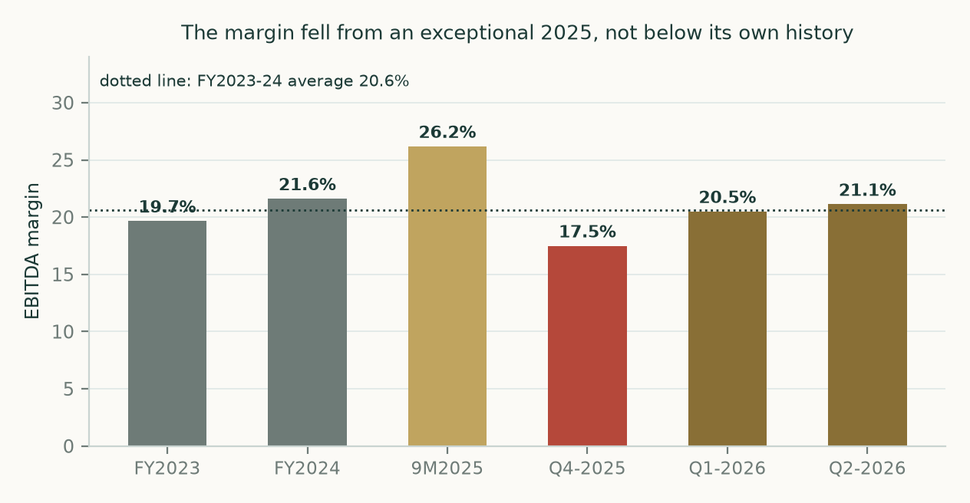
Figure 3. Operating margin on the company's own definition, on every period that can be built from what it has issued. Three provenances, and they are not the same thing: 9M2025 and Q1-2026 are published figures; FY2023 and FY2024 are rebuilt from the audited statements on the definition recovered from them; Q4-2025 and Q2-2026 are differences between two disclosed cumulative periods. The first half of 2026 sits at 20.8%, above 2023 and marginally above 2024. The fall is from an exceptional 2025, and it began in the fourth quarter of that year, not in 2026.
Why the crux is held flat rather than extrapolated. The two most recent quarters read 20.5% and 21.1% — the compression stopped and reversed slightly. The measured mechanisms point in opposite directions: Egyptian producers left August steel prices unchanged after earlier falls, which is disinflationary, while the company's own subsequent-events note warns that currency and hydrocarbon moves are pushing up the cost of works. When measured mechanisms conflict, the disciplined answer is to hold the last reviewed rate and let the sensitivity carry the argument.
1.8 Macro, country and the cost of capital
Input | Value | Source and construction
Observed risk-free rate | 23.269% | Three-year Egyptian government bond, accepted weighted-average yield at the auction of 17 August 2026 — 22 accepted bids and EGP 18.9bn placed out of EGP 39.7bn bid, the deepest print in the auction. The two-year cleared at 22.691% and the five-year at 19.700%, each on a single accepted bid; neither is a usable clearing level. A ten-year yield of 22.95%, taken independently in early August for another Egyptian study, corroborates it.
Sovereign default spread, rating basis | 5.970% | Egypt at Caa1, from the July 2026 original country-premium file
Sovereign default spread, swap basis | 3.420% | Egyptian sovereign credit-default swap net of Swiss, same file, spreads as at 30 June 2026
Normalised risk-free rate | 17.299% / 19.849% | The observed yield less the sovereign's own default spread, so country risk enters once and only once. The rating basis is stated first.
Equity risk premium | 13.481% / 9.516% | Total premium for Egypt on each basis, same file. Both are carried through to a published cost of capital; the two are never mixed.
Beta | 1.06 | Own-stock weekly regression against the published index of the exchange the shares are listed on, 255 observations over 4.93 years to 2026-07-16, R-squared 29.8%, standard error 0.182. It clears the usability test, so no peer or default beta is needed. The adjusted cross-check is 1.04.
Cost of equity | 31.5% / 29.9% | Normalised risk-free rate plus beta times the premium, on each basis
Marginal cost of debt | 25.1% | Built from the company's own numbers, not a house assumption. It paid EGP 2,655mn of interest in the half including EGP 1,192mn capitalised, on average interest-bearing obligations of EGP 25,326mn — an all-in rate of 21.0%. Over the same period its own treasury-bill book earned 19.1%. The difference, 1.86%, is its measured credit spread, and it is added to the same government bond used for the risk-free rate so the two sit on one curve.
Capital structure | 61.6% equity / 38.4% debt | Equity at market value — the published price times the share count after treasury — and debt at the company's own schedule of interest-bearing obligations, EGP 26,480mn
WEIGHTED COST OF CAPITAL | 26.9% / 25.9% | Published on both premium bases, as the method requires
Terminal cost of capital | 14.8% | On a risk-free rate of 10.5% built from the central bank's own longest published inflation target of 5 per cent for the fourth quarter of 2028 plus a standard emerging-market real rate, a normalised premium of 7.0% and a beta of 1.0

Table 11. The cost of capital, built rather than assumed. Every line names its own source and date.
Local currency and foreign currency. Every facility in the debt note is denominated in Egyptian pounds — the syndicated Bank Misr and National Bank of Egypt lines, the Ahli United revolvers, the overdrafts. The only foreign-currency liability is EGP 121mn of bank credit balances. Against that the company holds EGP 2,569mn of foreign-currency cash and deposits and reports a net foreign-currency position that is an ASSET of EGP 2,448mn. A pound devaluation therefore helps the balance sheet and hurts the cost stack, which is exactly how the currency lever on the ticker page is now specified.
Two contested constructions, both priced. First, net debt. On the company's own definition — interest-bearing obligations less cash and treasury bills — it is EGP 5,660mn. Carry the notes payable to the land authority and under the sale-and-leaseback contracts, and the land purchase liabilities, and it is EGP 14,532mn. Treat the invested residents' money as restricted and it is EGP 24,983mn. All three are shown, and the framings use the first and the third. Second, the backlog. The only figure that appears in a reviewed statement is the contractual value of undelivered-unit contracts concluded since the start of 2023: EGP 149.12bn, against nominal notes receivable of EGP 116.54bn held off balance sheet and a present value of EGP 59.40bn. The company's own wider definition stood at EGP 263bn at the first quarter. The study anchors on the first and says so.
Does growth create value here? The answer depends on which capital you count, so both counts are given. Measured on every pound standing in the business, the return on invested capital is 11.3% against a spot weighted cost of capital of 25.9% and a normalised one of 14.8% — below both. Read that way, a single year of growth consumes more working capital than it produces above about 12.4% nominal, or about 21.1% once the residents' money is credited as funding. But 59.2% of that capital base is customer money, not shareholder money: net of it the return is 27.6%, comfortably above the normalised cost of capital. The full model carries the terminal value that the single-year arithmetic cannot, and it moves with the second measure — a half-again volume path is worth EGP 40.19 a share against EGP 25.05 at no growth at all under the first framing, and EGP 7.98 against EGP 4.01 under the second. Growth is not free here; it is also not value-destroying. What decides the valuation is whether the customer money is the company's to use.
1.9 Sensitivity
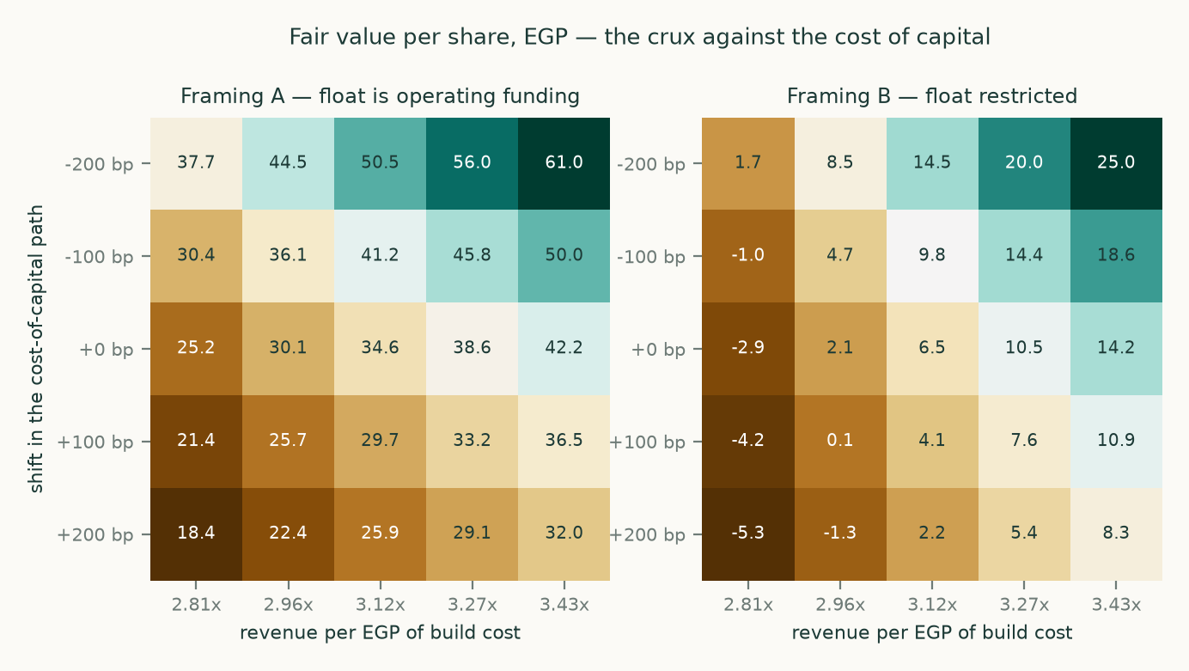
Figure 4. Fair value per share against the crux ratio and the cost of capital, computed separately under each framing. The crux runs from 2.81x to 3.43x around the measured 3.12x; the cost of capital shifts the whole path by up to two hundred basis points either way.
Driver moved | Range tested | Effect on the cash-flow lens, framing A
Real construction volume growth | from no growth at all to half again the base path | EGP 25.05 at no growth to EGP 40.19 at half again
Build-cost escalation, all four classes together | two hundred basis points either way | EGP 27.51 to EGP 41.14
Cost of capital, whole path | two hundred basis points either way, crux held at its measured level | EGP 25.91 to EGP 50.52
The crux ratio alone | 2.81x to 3.43x | EGP 25.20 to EGP 42.22
Both together, worst corner against best | crux 2.81x and the cost of capital two hundred basis points higher, against 3.43x and two hundred lower | EGP 18.41 to EGP 60.98
The contested judgement | framing B against framing A | EGP 6.51 against EGP 34.56 on this lens; EGP 5.79 against EGP 15.82 on the published four-lens range

Table 12. Every axis in observable units. The first row runs the right way round — more volume is worth more — because most of the capital funding that volume is the customers', not the shareholders'. Strip the customer money out of the denominator and the return on what shareholders actually contributed is 27.6%, above the normalised cost of capital; leave it in and the return is 11.3%, below it. Section 1.8 gives both.
2. Technical and price structure
Carried forward unchanged. This is a fundamentals-only refresh. Sections 2 and 3 reproduce the last published technical read and probability map exactly as they stand, so a reader can see which half of this document is as of the new fundamentals and which half is as of the last price update. The stamps are quoted verbatim below.

Stamp | Data as of | Computed on
Probability map | 2026-07-22 | 2026-07-28
Technical read | 2026-07-22 | 2026-08-17
Fundamentals (this document) | 2026-06-30 | 2026-08-19

Table 13. The three clocks. Both price-side stamps read 2026-07-22 for data, four weeks before this document. Nothing in sections 2 or 3 has been recomputed.
The read as published: trading above the whole moving-average stack, on a rising 200-day. The price closed at EGP 15.01 above a falling twenty-day mean, a rising fifty-day and a rising two-hundred-day. Over the preceding year it ranged EGP 6.99 to EGP 16.43.
Resistance | Support
16.08 | 14.85
16.43 | 14.34
17.00 | 13.01

Table 14. The published level ladder, nearest first, carried forward unchanged.
3. Probabilistic price map
The probability map below is the last published one, struck on the 2026-07-22 close and computed on 2026-07-28. It is reproduced here without recomputation. Because this refresh moves the fundamental value and not the price data, the two should be read on their own clocks: the cone answers where the price might be in one and three months, the fundamental sections answer what the business appears to be worth.
A note on how much weight the cone carries. The simulation behind it was tested by re-running it across five years of history, striking a forecast every quarter and scoring the result against what actually happened, with each window scored on a scale-free basis so that a high-priced name cannot dominate a low-priced one. On this market the pooled result beats a carry-anchored random walk, which is the honest benchmark: a model that cannot beat it is adding nothing. The width of the bands, not their centre, is what the test mostly disciplines.
Horizon | 5% | 25% | Median | 75% | 95% | Resolves
One month | 12.89 | 14.32 | 15.23 | 16.22 | 18.01 | 2026-08-23
Three months | 11.52 | 14.01 | 15.72 | 17.59 | 21.39 | 2026-10-22

Table 15. The published percentile map, EGP per share, anchored on the EGP 15.01 close of 2026-07-22.
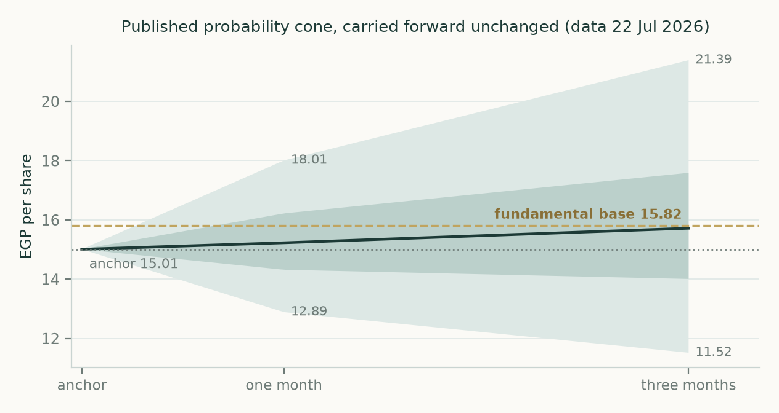
Figure 5. The published cone, with this study's fundamental base value drawn across it. The base sits inside the three-month middle half, which is not a forecast of convergence — it is simply where the two clocks happen to stand.
Level, EGP | Chance of touching within one month | Within three months
20.00 | 1% | 15%
18.50 | 5% | 28%
17.50 | 12% | 42%
16.50 | 31% | 62%
15.55 | 66% | 83%

Table 16. Level-touch probabilities as published. A descriptive output of the simulation: how often paths reach each level, nothing more.
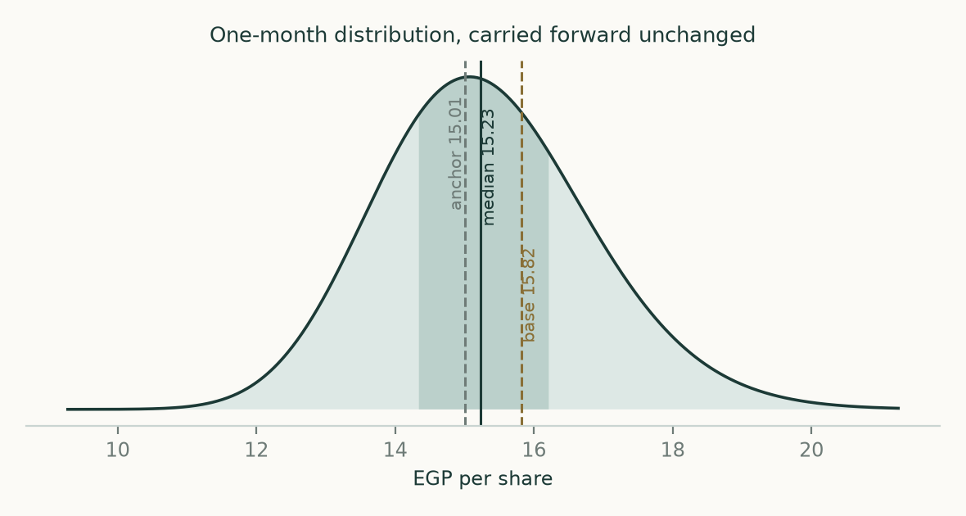
Figure 6. The one-month distribution as published.
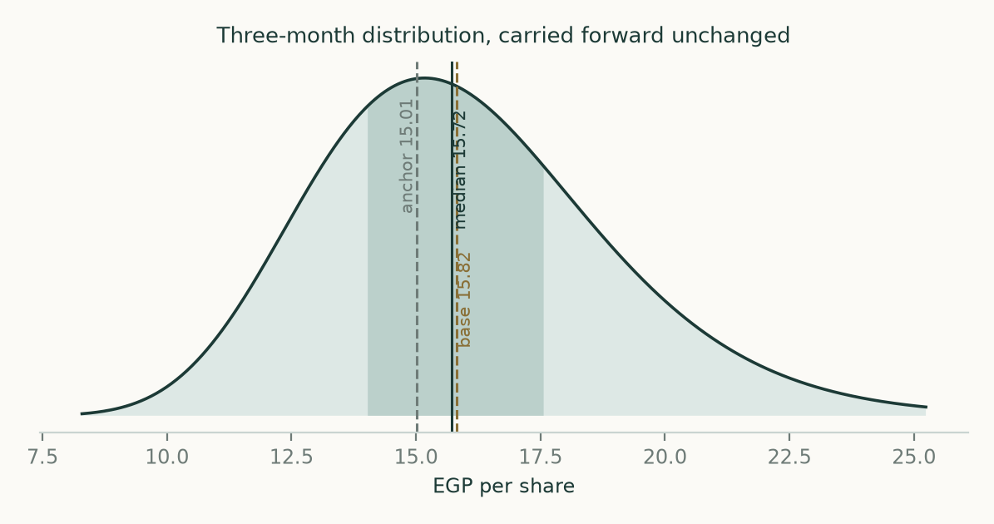
Figure 7. The three-month distribution as published.
4. Comparison of the lenses
Lens | What it says | On what clock | Where it can be wrong
Cash flow | EGP 11.67 to EGP 34.56 under the adopted framing; EGP -4.82 to EGP 6.51 under the other | five and a half years plus a terminal value | The terminal carries 74% of the value under framing A and 88% under framing B. A model that leans that hard on year six is fragile by construction, and the study says so rather than burying it.
Book value and return | EGP 4.35 at the spot cost of equity, EGP 10.02 at the normalised one | today | It assumes the trailing return on equity of 22.2% is sustainable. Half of that return is the unwinding of discount on instalment receivables and the return on the treasury-bill book, neither of which is an operating return.
Relative multiples | EGP 9.68 to EGP 12.15 | today | Egyptian peers trade at 6.10x to 10.20x because the country risk premium is 9.3%. Marking Palm Hills to them prices in that risk twice if the cash-flow lens has already discounted for it.
Normalised earnings | EGP 11.69 to EGP 12.21 | mid-cycle | The mid-cycle margin of 20.7% is an average of three periods, one of which is a half-year. Three observations is not a cycle.

Table 17. Where the lenses agree and where they do not. Three of the four cluster between EGP 4.35 and EGP 12.21. The cash-flow lens is the outlier in both directions, and the reason is the float.
The verdict. Three lenses that do not depend on the contested judgement put the shares between EGP 4.35 and EGP 12.21 against a market price of EGP 15.01 — that is, expensive. The cash-flow lens agrees with them under framing B and disagrees violently under framing A. So the whole argument for the current price rests on the float being permanent funding and on Egyptian rates normalising. Neither is unreasonable. Both are assumptions, and this study prices them rather than assuming them away.
5. Catalysts
What | When | Why it matters here
The results release for the first half | expected imminently | It was not published on the company's own channel as of 19 August 2026 — the newest financial result there is the first-quarter release of 20 May. Press reporting attributes a record backlog of EGP 284bn and EGP 75bn of launch sales to it. None of that has been verified against a company document and no number in this study reads it.
The audited statements for 2025 | overdue | Neither the 2025 annual statements nor a 2025 results release is published on the company's investor-relations channel. That is why the three-year history in appendix A shows blanks for 2025 gross profit and finance costs rather than estimates.
A residents' association taking legal personality | unscheduled | This is the falsifier for the base case. Under Building Law 119 the assets and liabilities held for an association separate in its favour on constitution. The first one to do so at scale converts the study from framing A to framing B, which is worth EGP 10.02 a share.
The central bank's rate decision and the inflation print | monthly | The whole gap between the spot and normalised costs of capital is a bet on the disinflation path. July's urban print of 14.9% was the first acceleration in four months.
Third-quarter results | November | The first period in which the North Coast launch sales, whatever they prove to be, are recognised as contracted sales — and the first read on whether the crux ratio held.

Table 18. What would move this, and in which direction.
6. Reading the probability zones
This section translates the published map into the price zones where the lenses say something analytically distinct. It is a description of a distribution, not a plan, and it is not calibrated to any reader's circumstances.
- Below EGP 12.21 — the three lenses that do not depend on the contested judgement all sit here. A price inside this band is consistent with the float being restricted and with Egyptian rates staying where they are.
- EGP 15.01 to EGP 15.82 — the adopted base case. The published cone puts the three-month median at EGP 15.72, so the map and the fundamentals are close to agreement here, on different clocks.
- EGP 15.82 to EGP 21.82 — this requires both the float to be permanent and rates to normalise. The published map gives a 42 per cent chance of touching EGP 17.50 within three months.
- Below EGP 5.79 — the market would be paying less than the alternative framing of the balance sheet implies even on generous assumptions about the cost of capital. That is the level at which the downside case in this study would itself need rebuilding.
7. Caveats, and what would change our mind
- A document is missing. The results release for the first half of 2026 could not be obtained from the company. Its operating anchors — the company's own backlog figure, its own net-debt definition, first-half contracted sales and construction spending — are carried as unverified press reporting and no model driver reads them. Attaching that document would sharpen the volume path and the catalyst calendar.
- So is another. The 2025 audited statements are not published either. Gross profit, cost of revenues and finance costs for 2025 are shown blank in appendix A rather than estimated, so the three-year history has a hole in the middle of it.
- One cost block is not identified. The split between land cost and the joint-arrangement partners' share cannot be identified from anything the company publishes. The study demonstrates that rather than asserting a split, but it means one of the two largest cost blocks is carried whole.
- Some weights are estimates. The weights of the four construction cost classes are estimated. No filing discloses a cost-by-nature split of construction. They are carried through the sensitivity, and a two-hundred-basis-point error in the blended escalator is worth EGP 13.62 a share.
- The terminal is large. The terminal value carries 74% of enterprise value under the adopted framing. A model that leans that hard on the far future is fragile, and the reinvestment charge that keeps growth from being free is itself computed from a return on capital of 11.3% that the study measures rather than assumes.
- Two sections are stale by design. Sections 2 and 3 are four weeks older than the rest of this document. They have not been recomputed and their stamps say so.
What would change our mind. A residents' association taking legal personality and its assets with it would move the study from framing A to framing B. A first-half results release showing the crux ratio below 2.81x would break the flat-margin assumption. An inflation path that stops falling would remove the normalisation the market is already paying for. Any of the three is observable within two quarters.
Appendix A — the statements
A.1 Income statement: three years of history and five years forward
EGP mn | FY2023 | FY2024 | FY2025 | H1-2025 | H1-2026 | FY2027E | FY2028E | FY2029E | FY2030E | FY2031E
Revenue | 17,462 | 27,167 | 36,196 | 15,579 | 19,528 | 47,322 | 55,707 | 63,478 | 70,638 | 77,487
Cost of revenues | -11,907 | -17,740 |  | -8,860 | -12,539 | -30,920 | -36,579 | -41,825 | -46,650 | -51,232
Gross profit | 5,508 | 9,330 |  | 6,665 | 6,926 | 16,402 | 19,128 | 21,653 | 23,988 | 26,255
gross margin | 31.5% | 34.3% |  | 42.8% | 35.5% | 34.7% | 34.3% | 34.1% | 34.0% | 33.9%
Administrative, selling and marketing | -2,060 | -3,436 |  | -2,206 | -2,846 | -6,823 | -7,977 | -9,077 | -10,120 | -11,135
Earnings before interest, tax and depreciation | 3,433 | 5,871 | 8,552 | 4,444 | 4,066 | 10,927 | 12,757 | 14,420 | 15,932 | 17,389
margin | 19.7% | 21.6% | 23.6% | 28.5% | 20.8% | 23.1% | 22.9% | 22.7% | 22.6% | 22.4%
Finance costs and interest | -1,504 | -2,311 |  | -1,338 | -1,677
Profit before tax | 2,301 | 4,321 |  | 3,588 | 3,138
Attributable profit | 1,582 | 3,255 | 4,217 | 2,443 | 2,265

Table 19. History from the company's own statements; the forward columns are the model, stated before financing so profit before tax is not carried forward. No FY2025 annual financial statements and no FY2025 earnings release are published on the company investor-relations channel. FY2025 revenue and EBITDA are therefore carried from the company's own history charts in the 1Q2026 release; FY2025 attributable net profit comes from the audited statement of changes in equity inside the 30-Jun-2026 filing. FY2025 gross profit, cost of revenues and finance costs are NOT AVAILABLE from any obtained official document and are shown blank rather than estimated.
A.2 Balance sheet at 30 June 2026, with the December comparative
EGP mn | 30 Jun 2026 | 31 Dec 2025
Notes receivable, long term | 55,708 | 54,801
Fixed assets and investment property | 6,646 | 5,555
Total non-current assets | 67,801 | 65,900
Work in progress | 23,916 | 17,571
Accounts receivable | 35,055 | 28,118
Notes receivable, short term | 20,531 | 18,138
Treasury bills and bonds at amortised cost | 13,016 | 9,582
Cash and cash equivalents | 7,804 | 9,420
TOTAL ASSETS | 194,767 | 172,130
Controlling equity | 18,911 | 17,431
Non-controlling interests | 1,723 | 1,334
Loans, long term | 10,236 | 10,543
Credit facilities | 13,922 | 11,338
Residents' Association | 34,337 | 29,123
Advances from customers | 83,483 | 69,354
Notes payable, short and long term | 8,795 | 9,381
Joint arrangement, partners' share | 5,363 | 6,974
TOTAL LIABILITIES | 174,133 | 153,364

Table 20. Read from the face of the reviewed statements. Total assets less total liabilities equals total equity in both columns, which the model asserts before it will produce a number.
A.3 Forecast balance-sheet and cash-flow markers
EGP mn | H2-2026E | FY2027E | FY2028E | FY2029E | FY2030E | FY2031E
Working capital employed | 67,490 | 74,767 | 88,479 | 101,190 | 112,881 | 123,978
Construction cost charged to income | 6,251 | 13,892 | 16,535 | 18,986 | 21,237 | 23,356
Land and partners' share | 7,189 | 15,887 | 18,702 | 21,310 | 23,714 | 26,013
Capital expenditure | 364 | 805 | 948 | 1,080 | 1,202 | 1,319
Residents' Association movement | 4,179 | 4,993 | 8,832 | 8,580 | 8,294 | 8,271
Free cash flow to the firm | 2,017 | 6,810 | 5,747 | 7,893 | 9,900 | 11,696

Table 21. The balance-sheet and cash markers the forecast turns on. Working capital is rolled on each block's own measured ratio to its own driver, not on a single revenue percentage.
Appendix B — peers, risks and the research record
B.1 Peer set
Company | Listing | Market value, EGP mn | Price to earnings
Talaat Moustafa Group Holding | EGX:TMGH | 156,630 | 10.20x
Emaar Misr for Development | EGX:EMFD | 54,600 | 6.10x
SODIC | EGX:OCDI | 24,100 | 6.10x
Heliopolis Housing | EGX:HELI | 22,670 | 7.50x
Madinet Masr | EGX:MASR | 16,500
Emaar Properties | DFM:EMAAR |  | 6.50x
Aldar Properties | ADX:ALDAR |  | 7.70x
Palm Hills Developments | EGX:PHDC | 42,395 | 10.54x

Table 22. Five Egyptian peers and two Gulf peers, inside and outside the country as the method requires.
B.2 Risk register
Risk | How it would show up | What it is worth
Residents' associations constituted | A transfer of assets and liabilities out of the group | The whole gap between the framings: EGP 10.02 a share
Disinflation stalls | The cost of capital stays at spot rather than gliding | EGP 22.89 a share on the cash-flow lens
Build cost outruns selling price | The crux ratio falls from its measured 3.12x to 2.81x, ten per cent lower | EGP 9.36 a share on the cash-flow lens
Refinancing | EGP 26,480mn of interest-bearing obligations, about EGP 21.4bn of it floating; a two-point rate move is worth EGP 428mn of profit on the company's own disclosure | Not modelled as a separate scenario; it is inside the cost-of-capital axis
Concentration in one country | Every project but Saadiyat is Egyptian | Carried through the country risk premium of 9.3% inside the cost of equity

Table 23. Each risk priced in the same units as the valuation, not described in adjectives.
B.3 Research record
The four layers of research behind this document — global, country, industry and company — were re-run on the new disclosure. The company layer was rebuilt in full. The country layer was rebuilt in full because every one of its drivers moved: the sovereign yield, the equity risk premium file, the inflation print and the policy rate. The industry layer was rebuilt because a dated market survey published the day before this study gave a measurable price and volume outcome. Within the global layer, the currency and commodity findings were re-run and the trade and supply-chain search was repeated and again returned nothing bearing on the subject, so that finding is carried forward. Twenty-three findings were recorded in all, of which five are dated negative searches. Seven separate attempts were made to reach primary documents; five succeeded and two failed, and both failures are named in the caveats.
Every number in this study that describes what Palm Hills reported comes from a document Palm Hills issued. Market data comes from the central bank's own auction results and from the original country-risk file. Peer multiples come from market-data aggregators and are used only to price other companies. No aggregator sits anywhere in the path of a Palm Hills historical.
Appendix C — three experts, three methods
C.1 Expert 1 — the cash-flow analyst
Worldview. A developer is a machine that converts construction spending into contracted revenue over several years. Value it on what the machine produces net of what it consumes, and be honest that in a business with a 1,193-day gross cycle the consumption is most of the story.
When it works: when the physical driver is disclosed, which here it is. When it fails: when the terminal carries most of the value, which here it does.
Line | Value
Return on invested capital, computed from the model's own year-five capital | 11.3%
Weighted cost of capital, spot | 25.9%
Weighted cost of capital, normalised | 14.8%
Present value of the explicit forecast, EGP mn | 27,111
Present value of the terminal, EGP mn | 77,891
Terminal share of enterprise value | 74.2%
Value per share, float as operating funding | EGP 34.56
Value per share, float restricted | EGP 6.51

Table 24. Expert 1's workings, every intermediate line shown.
Named sensitivity: two hundred basis points on the cost-of-capital path moves the answer from EGP 25.91 to EGP 50.52. Falsifier stated in advance: if the return on invested capital measured on the 2027 statements comes in above the normalised cost of capital of 14.8%, the growth path in this model is too pessimistic and the value is understated.
C.2 Expert 2 — the contracted-book analyst
Worldview. Forget the forecast. The company has already sold the units; the question is what is left after building them and paying everyone else. Value the book that exists and treat everything beyond it as free.
Line | EGP mn
Present value of undelivered-unit notes receivable, off balance sheet | 59,398
Notes and accounts receivable already on the balance sheet | 111,293
Less advances already taken from customers | (83,483)
Less construction still to spend on that book, half attributed to the period | (23,908)
Less land and partners' share still to come, half attributed | (27,648)
Less net debt | (5,660)
Less non-controlling interests | (1,723)
Equity value | 28,270
Value per share, EGP | 10.01

Table 25. Expert 2's workings. The book is taken at the present value the company itself discloses, and the costs still to come are struck at the study's own measured rates.
Named sensitivity: taking the notes receivable at nominal rather than present value would add EGP 20.23 a share, which is exactly why the present value is used. Falsifier: if the company delivers the book at a gross margin materially below 30.9%, this number is too high.
C.3 Expert 3 — the returns analyst
Worldview. Over any long period a company is worth its book value adjusted for the gap between what it earns on that book and what the book costs. Everything else is arithmetic about timing.
Line | Value
Book value per share, controlling equity | EGP 6.70
Trailing return on equity | 22.2%
Cost of equity, spot | 29.9%
Cost of equity, normalised | 17.5%
Justified multiple of book, spot | 0.65x
Justified multiple of book, normalised | 1.50x
Value per share, spot | EGP 4.35
Value per share, normalised | EGP 10.02

Table 26. Expert 3's workings.
Named sensitivity: the answer is linear in the cost of equity and in nothing else. A hundred basis points is worth about EGP 0.95 a share at the normalised rate. Falsifier: if the return on equity falls below the normalised cost of equity of 17.5%, the justified multiple drops below one and the shares are worth less than book.
C.4 Cross-examination
Challenge | Answer
Expert 3 to Expert 1: your terminal is 74% of the value. You are not valuing a business, you are valuing an assumption about 2032. | CONCEDED. The terminal share is disclosed rather than hidden, the terminal growth rate sits below the terminal cost of capital under both framings, and the terminal cash flow is charged a reinvestment rate computed from the model's own return on capital, so growth is not free. It is still the weakest part of the lens.
Expert 1 to Expert 3: your return on equity of 22.2% is not an operating return. Strip the discount unwinding and the treasury-bill income and it collapses. | CONCEDED in part. Those two lines are EGP 979mn of the half-year, against attributable profit of EGP 2,265mn. They are real income and they recur, but they are financing income and the multiple applied to them should be lower than the multiple applied to development profit. The lens does not make that distinction and it should.
Expert 2 to both: you are forecasting when the company has already told you what it sold. The contracted book is EGP 149.12bn of contractual value. Why guess? | REJECTED. The book covers about two years of building at the current rate. Beyond that the company either replenishes it or shrinks, and a valuation that assumes neither is a liquidation estimate, not a going-concern one. Expert 2's answer of EGP 10.01 is best read as the floor it is.
Expert 3 to Expert 2: you deduct construction still to come at half weight. Why half? | CONCEDED as arbitrary. It is a judgement that roughly half the remaining build is already funded by the advances deducted above it. Deducting the whole of the remaining build on top of the advances takes the answer below zero, to about EGP -8.24, which is itself a useful result: the contracted book only has value because the customer has already paid for much of it. Deducting none would raise it to about EGP 28.26. The range is disclosed rather than the midpoint being dressed up as precision.

Table 27. Each challenge conceded or rejected on the record.
C.5 The three in one room
Put in a room and made to agree on something, the three converge on a diagnosis rather than a number. All three accept that the balance sheet, not the income statement, is where this company is decided. All three accept that the float is the largest single item in it and that nobody outside the company knows whether it will ever transfer. Expert 1 would pay up to EGP 34.56 if the float is permanent and nothing above EGP 6.51 if it is not. Expert 3 will not pay more than EGP 10.02 under any assumption about the float, because his lens does not see it. Expert 2 will not pay more than EGP 10.01 because he refuses to value anything not yet sold. The market price of EGP 15.01 sits above two of the three.
C.6 Divergence
Pair | Gap, EGP per share | Which assumption drives it
Expert 1 against Expert 3 | 24.54 | The float, then the cost of capital. Expert 3's lens cannot see the float at all because it works from book equity, in which the float is a liability and its invested assets are assets.
Expert 1 against Expert 2 | 24.55 | Replenishment. Expert 2 values two years of book; Expert 1 values five and a half years plus a terminal.
Expert 2 against Expert 3 | 0.01 | Nothing that matters: EGP 0.01 a share apart, from entirely different directions. Two methods this different landing this close is coincidence rather than corroboration, but it does say the two conservative readings of this company agree on roughly where its floor is.

Table 28. What actually separates the three.
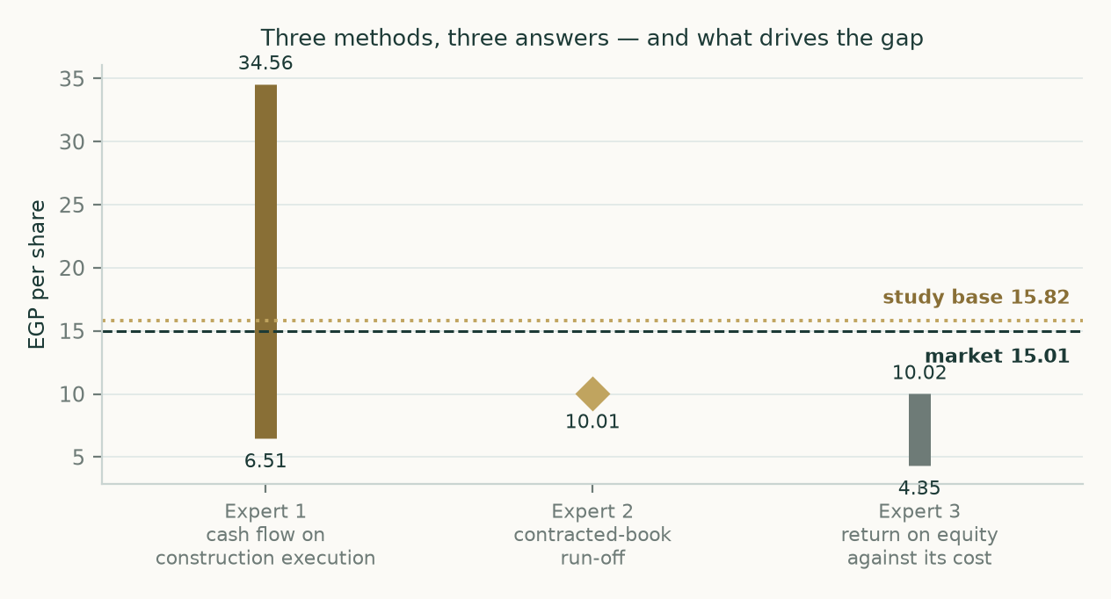
Figure 8. The three methods against the market price and the study's base case.
About this series
Every instrument analysed in this series follows the same standing format: a headline, a valuation summary, a company overview, a fundamental section built from the company's own issued statements, a technical section, a probability map, a comparison of the lenses, a catalyst calendar, a probability-zone reading, caveats, statement appendices, a peer and research appendix, and an expert panel. Fundamental value and the probability map run on separate clocks and each carries its own date stamp, so a reader can always see which half of a document has been refreshed. Forecasts are graded publicly when they resolve.
Disclosure and disclaimer — read in full
Nature of this document. This study is an educational valuation exercise and an expression of the preparer's personal analytical opinion, based exclusively on publicly available information and on assumptions stated in the text and the accompanying model. It is published free of charge, on a standing periodic schedule, to demonstrate methodology and to invite scrutiny and critique of that methodology.
No advice, no recommendation, no solicitation. Nothing in this document constitutes investment advice, financial consultancy, securities analysis services, a research recommendation, a rating, a price target, an offer, or a solicitation or invitation to buy, sell, hold, subscribe for or otherwise deal in any security or financial instrument. No statement herein is directed at, or calibrated to, the investment objectives, financial situation, risk tolerance or particular needs of any person.
No licensed activity. The preparer is not licensed or registered with the Egyptian Financial Regulatory Authority or any other securities regulator; does not carry on financial consultancy, securities evaluation or analysis services, portfolio management, brokerage, promotion or any other regulated activity; does not manage money; does not accept clients, fees, subscriptions or funds of any kind; and does not provide personalised advice to anyone.
Estimates and uncertainty. All valuations, scenarios, probabilities and levels are model outputs resting on explicit, subjective assumptions; they are illustrative, highly uncertain, and likely to prove wrong in material respects. They are deliberately presented as ranges and distributions because no single number should be relied on. Public and vendor-sourced data are believed reliable but are not guaranteed; vendor-derived figures are flagged as such where used.
No liability. To the maximum extent permitted by applicable law, the preparer accepts no liability or responsibility whatsoever for any decision made or action taken or not taken, or for any loss or damage of any kind incurred, by any person in reliance on, or in connection with, any part of this document or the accompanying model.
Reader's responsibility. Any person considering an investment decision should conduct their own independent assessment and consult a financial advisor licensed in their jurisdiction. If the publication of material of this kind is restricted where you are reading it, do not rely on it.

