Testahil · Independent Valuation Study — Educational Analysis Not investment advice

Arabian Cement Company S.A.E.
Egyptian Exchange · ARCC · Egyptian pounds · valuation as of 30 June 2026, the date of the latest disclosed balance sheet; issued 9 September 2026
One of Egypt's largest cement plants, at the top of the best year the industry has had in more than a decade — audited profit up 210% in a single year on a 42.6% revenue step — and facing 12.6 million tonnes of dormant national capacity queuing to restart inside the forecast window.
What this is. An independent valuation of Arabian Cement Company, an educational analysis and not investment advice. It carries no rating and no price target — fair-value ranges and distributions only.
The company in one line. Two production lines in Suez governorate, about 5.0 million tonnes of cement a year and roughly 6.6% of Egypt's nominal capacity, listed on the Egyptian Exchange since May 2014, with cash of EGP 1,971mn against interest-bearing debt of EGP 1,283mn at 30 June 2026. Every figure in this study is read from the company's own audited and reviewed accounts.
Where the value lands. The cash-flow lens — the value this study publishes — reads EGP 69.22, and the cross-checks around it span EGP 45.65 to EGP 65.57, against a market price of EGP 77.00 — -10.1%.

Headline
PRICE DATE 3 September 2026 — the latest known close, the price this valuation is measured against. ISSUE DATE 9 September 2026 — the day this edition was issued. A recalibration issues a new document carrying its own issue date; the two dates are stated separately because they are not the same fact.
Arabian Cement is worth EGP 69.22 a share on the cash-flow lens this study publishes, against a market price of EGP 77.00 on 3 September 2026 — -10.1%. The other reads span EGP 45.65 to EGP 65.57 and are published beside it rather than averaged into it, because they disagree for reasons a reader should see.
The shape of the range matters more than its width, and it is not symmetric. On the primary lens the bear corner is EGP 27.30 and the bull corner EGP 69.77 — barely above the central. Both corners move one business driver across the span this company's own audited accounts have printed, the EBITDA margin from 22.00% in FY2023 to 39.25% in FY2025, with the macro path held completely still. Essentially the whole range is downside: if the margin reverts to what this company earned in FY2023 the value is EGP 27.30. An earlier edition published a symmetric band of two margin points around the forecast and concealed that completely.
The disagreement with the market is not about the business, and the forecast itself is the evidence. It opens at an EBITDA margin of 39.03% against 39.25% in FY2025, audited — the best year this company has ever filed — and rises to 40.40% by the end of the window. There is essentially no operating upside left in it: a reader looking for the cautious assumption that produces this discount will not find one on the margin line. Section 1.11 sets out what a buyer at EGP 77.00 has to believe instead, and section 1.4 is where that belief has to live.
Three things about the company matter more than anything else in the model. It is one plant — about 5.0 million tonnes of cement a year in Suez governorate, one product, one country, and no diversification anywhere to absorb a shock. It holds more cash than debt: EGP 1,971mn against EGP 1,283mn of interest-bearing borrowings at 30 June 2026, which is why the enterprise-to-equity bridge adds rather than subtracts. And it has just filed the best year the Egyptian industry has had in more than a decade — audited profit up 210% on a 42.6% revenue step — with 12.6 million tonnes of dormant national capacity queuing to restart inside the forecast window.
What would change the answer is stated in section 7 and not buried: a cost of capital that normalises faster than the central bank's published path would raise this value materially, and beta is the input it would arrive through — worth +12.4% of value and published both ways rather than averaged. The study's LARGEST contested judgement is a different one — terminal useful life, worth +20.8% — and it is set out with the rest in section 1.9.
Valuation summary — every read at a glance
Lens | Value per share (EGP) | Role | Versus spot | Terminal value % of EV
DCF (cash flow) | 69.22 | the central | -10.1% | 55.4%
Relative multiples | 45.65 | cross-check | -40.7% | —
Asset / replacement cost | 65.57 | cross-check | -14.8% | —
Normalised earnings | 49.64 | diagnostic only | -35.5% | —
Range across the reads | 45.65 – 65.57 | — | -40.7% to -14.8% | —
Market price, latest known close (3 September 2026) | 77.00 | — | — | —

The cash-flow lens IS the value this study publishes. The others are cross-checks, shown at the same size so a reader can see where they disagree with it rather than an average that hides the disagreement. A previous edition blended all four at fixed weights of 50, 20, 22 and 8 per cent and published EGP 59.91; those weights were chosen rather than tested, and averaging four methods makes a fifth one nobody has checked. Normalised earnings is shown as a diagnostic and is not a valuation of this company: it capitalises a mid-cycle margin at a nominal rate, and section 1.7 shows growth destroying value here.
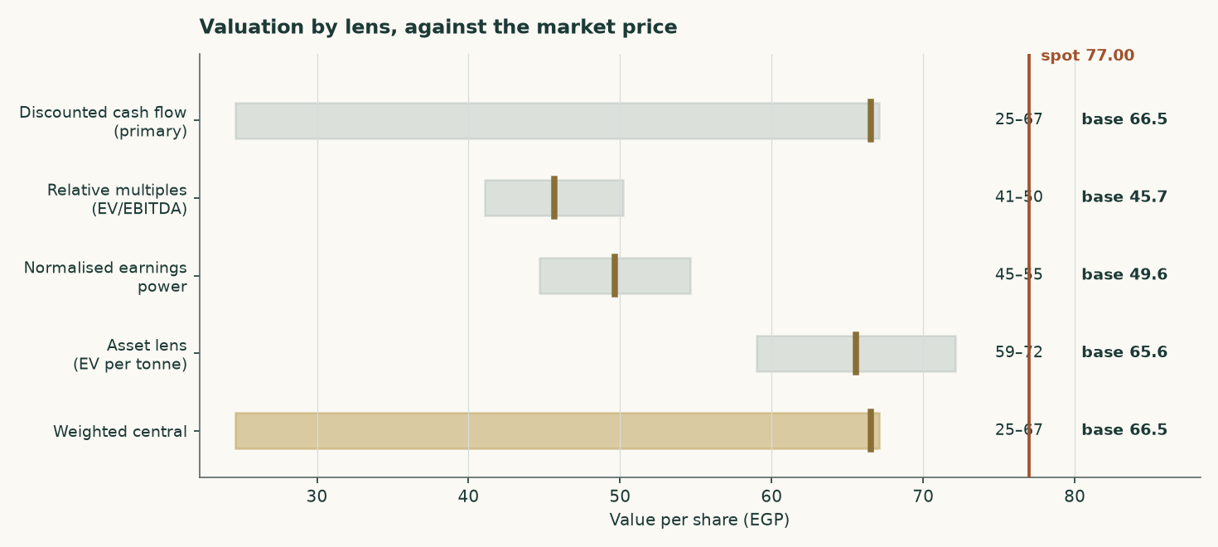
Figure 1 — Each lens as a range, with its base case marked, against the market price.
Company overview
Arabian Cement Company S.A.E. runs two production lines at a single site in Suez governorate with a nameplate capacity of about 5.0 million tonnes of grey cement a year, roughly 6.6% of Egypt's nominal capacity. It has been listed on the Egyptian Exchange since May 2014. Every figure about the company in this study is read from its own audited and reviewed accounts; nothing about its reported history comes from a data vendor or a broker.
What it sells is close to a commodity, and that is the first fact the lens follows from. Essentially all revenue is cement and clinker out of one plant, so there are no parts to sum: this is valued as a single operating company. Of the 4.9 million tonnes it sold in FY2025, 26.8% left as raw clinker for export — the lowest-value and highest-carbon thing it ships — and the rest as cement into a domestic market it cannot differentiate itself within.
The balance sheet is the unusual part and it works in the shareholder's favour. At 30 June 2026 the company held EGP 1,971mn of cash against EGP 1,283mn of interest-bearing debt, so it is net cash. Section 1.7 sets out how that reaches equity value, and section 1.4 why a debt book that changed currency inside the period is measured against its facility notes rather than against a trailing effective rate the accounts cannot produce.
The sector context is what earlier editions of this forecast turned on, and the measure they turned on was wrong. Egypt sold 65.1 million tonnes of CEMENT — 54.0 domestic and 11.1 exported — against roughly 76 million tonnes of cement nameplate. That is 86%, with about 10.9 million tonnes of grinding capacity idle. The 72.6Mt figure earlier editions used adds 7.6Mt of exported CLINKER, which leaves at the kiln and never enters a cement mill, and printed 96%.
SO THE MARKET IS NEITHER OF THE TWO THINGS THIS STUDY HAS CALLED IT. It is not the structurally slack market the first editions described, and it is not the 96% market the last one described. It is running with roughly a sixth of its cement capacity unused, and the 12.6 million tonne restart programme would take that to about 23.5Mt — a third of nameplate — before a tonne of new demand appears. A production quota suspended in May 2025 rather than repealed sits on top of that.
WHAT THIS DOES AND DOES NOT DO TO THE FORECAST, because a corrected premise that quietly leaves its conclusion standing is the same defect one step along. The price path in this study does NOT rest on the sector being tight. Its FY2026 step is taken from a filed number — the company's own fourth-quarter 2025 realised price, which is 7.2% above its full-year average — and every year after it grows at zero real against the house inflation path. That argument is unaffected by which utilisation figure is right. What IS affected is the comfort around it: at 86% with a restart programme pending, a price path that merely holds real is a stronger assumption than it looked at 96%, and the margin sensitivity in section 7 is where a reader should go to disagree with it.
1 Fundamental valuation
Arabian Cement is valued as a single operating company, not as a sum of parts, and the reason is worth stating before any number appears. Essentially all of its revenue is grey cement and clinker from one industrial site. There is no property portfolio, no lending book, no concession and no collection of consolidated operating subsidiaries that would need valuing on their own terms. A sum-of-the-parts here would be a sum of one part, and the discipline it is meant to impose — never blending legs that need different methods — has nothing to bite on.
Four lenses are read and ONE of them is the answer. A discounted cash-flow model built up from tonnes and costs is the primary for this class, and the figure this study publishes is that lens and nothing else: EGP 69.22. Relative multiples, normalised earnings power and replacement cost are CROSS-CHECKS, published in the same table so a reader can see where they disagree — they span EGP 45.65 to EGP 65.57 — and none of them is averaged into the answer. There are no weights in this model to report. An earlier edition blended the four at 50/20/22/8 and would have read EGP 59.91; those weights had never cleared any out-of-sample test, and a number produced by averaging several methods is not more robust than the best of them — it is a new method with free parameters nobody tested, importing every weakness of the weakest lens at whatever weight somebody typed. Where several methods disagree the honest thing is to publish the disagreement and say which one the answer is.
1.1 The business, and why the lens follows from it
The plant runs two lines in Suez governorate producing on average about 5.0 million tonnes of clinker and cement a year. That is roughly 6.6% of Egypt's nominal capacity. Larger single sites exist — National Cement Beni Suef and Lafarge Ain Sokhna are both materially bigger — so the earlier edition's claim that this is the country's second-largest plant is withdrawn. The balance sheet is what that description implies: property-dominated, with working capital in inventory and receivables, no investment property, no equity-accounted portfolio of any size, and no financing arm.
The FY2025 accounts show revenue of EGP 12,447mn and attributable profit of EGP 3,600mn, against EGP 8,730mn and EGP 1,160mn a year earlier — revenue up 42.6% and profit up 210%. That is not a business changing shape. It is a price event, and the whole of this valuation turns on how much of it lasts.
 | FY2023 | FY2024 | FY2025
Revenue (EGP mn) | 6,043 | 8,730 | 12,447
Gross profit (EGP mn) | 1,283 | 2,087 | 5,058
Operating profit (EGP mn) | 1,079 | 1,764 | 4,596
EBITDA (EGP mn) | 1,330 | 2,021 | 4,886
EBITDA margin | 22.0% | 23.1% | 39.3%
Attributable profit (EGP mn) | 697 | 1,160 | 3,600
Earnings per share (EGP) | 1.81 | 3.02 | 9.49
Effective tax rate | 25.0% | 23.0% | 23.8%
Capital expenditure (EGP mn) | 59 | 912 | 796

Table 1 — Three audited years. Every line is a disclosed figure or a formula over disclosed figures: operating profit is gross profit less administrative expenses, provisions and credit losses, and EBITDA adds back the depreciation and amortisation reported in the cash flow statement.
Two things stand out. The revenue note splits local from export: local sales rose 71% while export sales were -0.8% — the abolition of Egypt's cement production quota in May 2025 was a DOMESTIC event, and exports sat against a statutory 30% cap throughout. And the margin moved from 23.1% to 39.3% in a single year, because almost the entire price increase fell to the bottom line on a cost base that is largely fixed.
1.2 The unit economics — where EBITDA actually comes from
The operating model starts at the PLANT, and the tonnes are now DISCLOSED rather than reconstructed. The company publishes sales volumes and production indicators in its FY2025 investor presentation — clinker production, cement production, local sales, cement exports and clinker exports — and this build reproduces every one of them to within 0.02%. Three earlier editions of this study rebuilt those tonnes from an assumed price because that document had not been read, and were 28% low on the total.
It is worth being plain about what those editions did, because the failure was structural rather than arithmetic. They assumed a cement price, divided the audited revenue by it to get tonnes, and presented the utilisation that fell out as an independent corroboration. It was neither independent nor a corroboration: it was the same assumption written twice, and the FY2025 check it produced was an accounting identity that reproduces the audited revenue for ANY price, because volume moves by exactly the reciprocal. The drivers here are physical — kiln utilisation, the clinker factor and the two export shares — and the tonnes, the mill utilisation and all three realised prices come out of them. The prices are therefore outputs that can be held against the market and disagree with it.
It also carries three products where the previous edition carried one. This company sells local cement, export cement and export CLINKER, and clinker is the unground intermediate, worth a fraction of the cement it could have become. Pricing every tonne at a cement price made the plant look far smaller than it is.
 | Value
Kiln clinker capacity (audited note 1) | 4.20Mt
Kiln utilisation (DRIVER) | 91.7%
Clinker produced | 3.851Mt
Sold as clinker (DRIVER) | 33.8%
Clinker exported | 1.301Mt
Clinker factor (DRIVER) | 0.733
Cement produced | 3.480Mt
Mill utilisation | 69.6%
Plus draw from finished-goods stock | 0.072Mt
Cement sold | 3.553Mt
Cement exported (DRIVER) | 17.7%
Exported as cement | 0.630Mt
Local cement | 2.923Mt
Exported as clinker (from above) | 1.301Mt
TOTAL DESPATCHES | 4.854Mt
Local cement price — DERIVED | EGP 2,856/t
Export cement price — DERIVED | USD 46.2/t
Export clinker price — DERIVED | USD 30.0/t

Table 2 — The plant in tonnes, and the prices that fall out of it. Every FY2025 physical figure is the company's own disclosure. The four drivers are physical; everything below them is derived. Cement exports of 17.7% of cement made sit inside the 30% statutory cap — the previous edition's single-product build put exports at 31.5% of volume and breached the cap its own text called binding.
The three derived prices are the test, and it is a test this study does not pass cleanly. Local cement at EGP 2,856 a tonne is credible against Egyptian ex-works commentary. Export cement at USD 46.2 and export clinker at USD 30.0 sit roughly a third BELOW the USD 44-48 the trade press quotes for Egyptian clinker free on board. Either the physical volumes behind this build are too high, or realisations run well under the published indices. The gap is published rather than tuned away, and it is the reason the volume base carries its own sensitivity rather than being presented as settled.
The cost stack is the printed one. Cost of sales of EGP 7,389mn splits into materials and fuel of EGP 5,698mn — the note confirms this is the cost of inventories charged to cost of sales, so it carries fuel, packing and spares as well as raw meal — transportation of EGP 764mn, overheads of EGP 641mn, and depreciation and amortisation of EGP 285mn. Adding cash administrative expenses, provisions and credit losses gives a total cash cost of EGP 7,484mn, or EGP 1,542 a tonne.
The cost stack and the margin it produces | FY2025A | FY2026E | FY2030E
Materials and fuel (EGP mn) | 5,698 | 6,130 | 8,393
Transportation (EGP mn) | 764 | 824 | 1,186
Overheads and administration (EGP mn) | 1,021 | 1,101 | 1,585
Provisions and credit losses (EGP mn) | 78 | 84 | 119
Total cash cost (EGP per tonne of cement) | 1,542 | 1,676 | 2,265
Blended realised price (EGP per tonne of cement) | 2,565 | 2,777 | 3,842
Volume (Mt) | 4.854 | 4.807 | 4.929
EBITDA (EGP mn) | 4,886 | 5,210 | 7,650
EBITDA margin | 39.3% | 39.0% | 40.4%

Table 3 — The cost stack and the margin it produces. EBITDA is an OUTPUT of this build, not an input to it, and the table foots: revenue less the four cost lines IS the EBITDA printed at the foot. THE FOUR COST LINES ARE TOTALS IN EGP MILLIONS, NOT per-tonne rates — materials and fuel are driven by CLINKER produced, because the kiln burns the fuel, while transportation and overheads are driven by cement despatched, so no single per-tonne figure describes them all. Provisions and credit losses are an operating charge above operating profit in the audited statements, so they belong in this bridge, but they are not a cost of making a tonne and are therefore excluded from the per-tonne cash cost above.
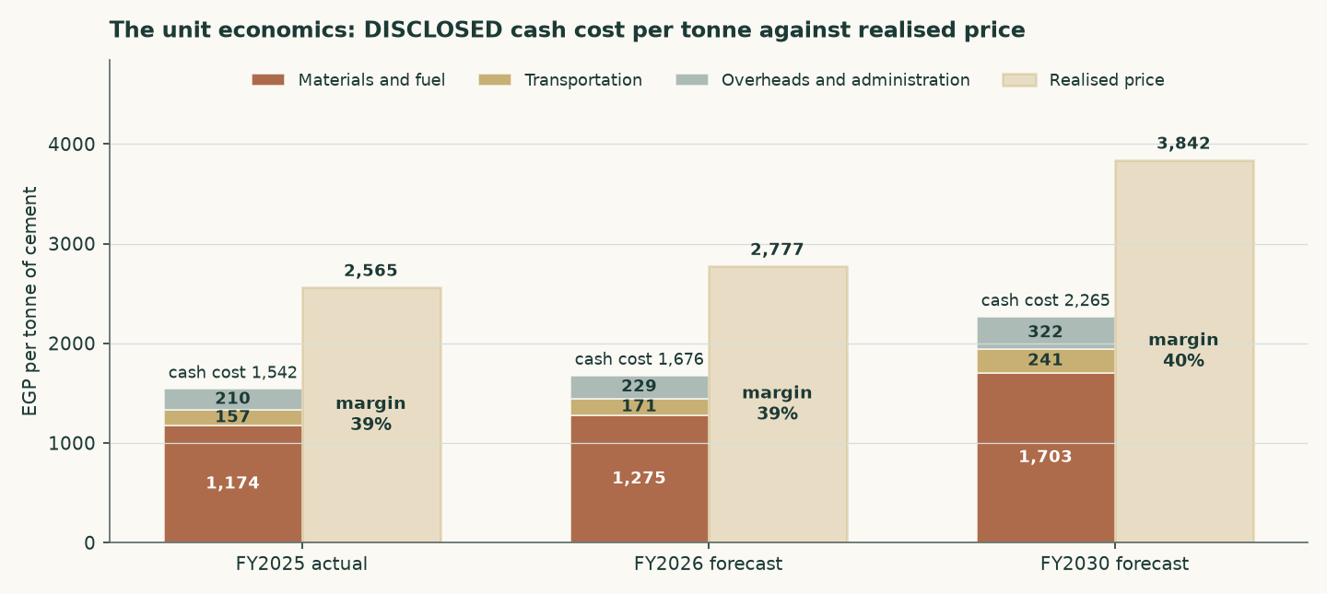
Figure 2 — Cash cost per tonne against realised price per tonne. The margin is the gap, and the gap narrows across the forecast.
The reconstruction ties to audited FY2025 revenue at +0.000% and to audited FY2025 EBITDA at +0.000%. THAT IS A TIE AND NOT A TEST, and it is worth being plain about which: prices here are derived as revenue over volume, so revenue rebuilt as volume times price reconstructs by construction and would foot on any volume whatever. It is checked because a tie that failed to foot would mean an arithmetic error, not because footing corroborates the volume.
The test that CAN fail is the three derived prices, because they can be held against a market: local cement at EGP 2,856 a tonne, export cement at USD 46.2 and export clinker at USD 30.0. Two of the three are credible against Egyptian commentary. The third is not comfortable — export clinker sits roughly a third below the USD 44-48 the trade press quotes for Egyptian FOB cargoes — and that gap is a live disagreement between the physical disclosure and the price indices. It is published rather than tuned away, and it is the reason the volume base carries a sensitivity.
One physical constraint is worth checking, because the volume forecast is built off CEMENT capacity while the kiln is what could bind first. At a clinker factor of 0.73 — observed from the audited capacity pair of 4.2Mt of clinker against 5.0Mt of cement — the FY2030 volume needs 3.612Mt of clinker against 4.2Mt of kiln capacity, or 86.0% of it. The forecast fits the plant, with 0.588Mt of headroom, and more blending would widen that.
The company-specific lever is fuel, and it is now visible in the accounts rather than assumed. Assets under construction of EGP 392mn include EGP 240mn of alternative-fuel capacity for production line 2 and EGP 146mn of a new cement silo for line 1, and a EUR 25mn European Bank for Reconstruction and Development facility is drawn against exactly that programme — tranche one for alternative-fuel capacity and hydrogen injection on kiln 1, tranche two for hydrogen injection on kiln 2. The model carries a saving on the materials-and-fuel line rising to 5.5% by FY2030 as a result. That is a funded and part-built programme, not an intention.
1.3 Depreciation, capital spending, and what the book hides
Depreciation and amortisation is disclosed in the cash flow statement: EGP 290mn in FY2025, EGP 257mn in FY2024 and EGP 250mn in FY2023 — property depreciation, licence amortisation and right-of-use amortisation. That is 2.33% of FY2025 revenue, and it is small for a cement plant.
It is small for a reason that matters to the valuation. The plant dates from around 2010 and the accounts are prepared on a historical-cost basis; the pound has devalued several times since. Net property, plant and equipment is EGP 2,522mn and assets under construction a further EGP 392mn; the EGP 2,914mn together, on 5.0Mt of capacity, is about USD 12 per annual tonne — against a replacement cost of USD 130. The book is carrying the plant at 8.9% of what one would cost to build.
EGP mn | FY2023 | FY2024 | FY2025
Depreciation and amortisation | 250 | 257 | 290
Capital expenditure | 59 | 912 | 796
Capex as a share of EBITDA | 4.4% | 45.1% | 16.3%
Net reinvestment (capex less depreciation) | -192 | 655 | 507
Reinvestment rate (net reinvestment / NOPAT) | -23.7% | 48.2% | 14.5%
Return on BOOK invested capital | 43.9% | 44.3% | 60.6%
Character | stable | stable | stable

Table 4 — The reinvestment record, buildable because capital expenditure is disclosed for all three years. FY2023 spent less than it depreciated; FY2024 and FY2025 carried the alternative-fuel and silo programmes on top of maintenance.
That has a direct consequence for the forecast, and it is treated as one. Capital expenditure is NOT set at book depreciation. It is set at the economic maintenance level of USD 3.23 per tonne of installed capacity — about EGP 890mn in FY2026 against a book charge of EGP 344mn. Setting capex equal to book depreciation would flatter free cash flow by construction; the cost of refusing to do so is computed in section 1.9 and is worth +5.9% of the cash-flow lens. The audited FY2024 and FY2025 outturns of EGP 912mn and EGP 796mn — USD 4.1 and USD 3.2 a tonne — bracket the assumption, and both of those years carried growth projects as well as maintenance.
1.4 The cost of capital, and a debt book that changed currency
The discount rate is a schedule, not a number. Egypt is in monetary transition: the central bank held its main operation rate at 19.50% through the first half of 2026 while headline inflation eased to 14.3%, and its own published medium-term target is 7%. A single flat rate applied to both the explicit years and a perpetuity would assert that Egypt's cost of capital never normalises.
The cost of DEBT is the line the audited accounts changed most. During 2025 the company refinanced out of pound working-capital facilities and into euro term debt: a EUR 25mn facility from the European Bank for Reconstruction and Development at three-month Euribor plus 4.35%, drawn to EUR 18.5mn to fund alternative-fuel capacity and hydrogen injection, and a EUR 3.09mn National Bank of Egypt facility under a KfW industrial-pollution programme at six-month Euribor plus 3%. 91.1% of the interest-bearing book is now euro-denominated.
Facility | Balance (EGP mn) | Currency | Contractual rate | Pound-equivalent cost
CIB credit facilities | 100 | EGP | corridor + 0.6% = 20.60% | 20.60%
National Bank of Egypt / KfW | 146 | EUR | Euribor + 3.00% = 5.49% | 11.49%
European Bank for Reconstruction and Development | 888 | EUR | Euribor + 4.35% = 6.84% | 12.84%
Lease liabilities | 1.2 | EGP | marginal pound rate = 20.60% | 20.60%
Weighted average | 1,135 | 91% EUR | 7.89% | 13.36%

Table 5 — The debt book, facility by facility, from the audited borrowings note, and the rate ADOPTED is the last column. A euro loan is not a cheap loan to a company that earns pounds: the contractual coupon has to carry the expected 6% annual pound depreciation against the euro before it can be compared with a pound rate or applied to pound cash flows. Both columns weight to the figures shown, from these four lines and nothing pasted; the contractual weighted average is published beside the adopted one so the reader can see the whole of the difference.
Three checks are published rather than asserted, because a contractual rate is not the same thing as a rate paid. Interest expense over average interest-bearing debt gives 20.85% in FY2024, 5.03% in FY2025 and 3.73% annualising the first quarter of 2026. The adopted 13.36% sits ABOVE all three, and the gap is not a reconciling item to be smoothed: the book re-based mid-year, so the trailing average balance is not what carried the interest, and the borrowing that funds an asset still under construction has its interest capitalised into that asset rather than expensed. A marginal forward-looking rate is the right one for a discount rate, and the gap is disclosed so the reader can disagree.
One caution belongs next to that number, and it runs the other way from the one a reader might expect. The alternative here is the CONTRACTED euro rate — the coupon as written, 7.89% blended — and adopting it would mean the euro debt is NOT compensated for pound depreciation beyond what this study's own currency path already assumes. This study does not adopt it. Loading the euro legs with 6% annual pound depreciation under interest parity, which is what a company earning pounds actually bears on a euro loan, is what produces the adopted 13.36% — 1.7 times the contracted figure. The cheaper alternative is computed as a VALUE and not merely described: it is worth +0.2% of the cash-flow lens, because debt is only 3.8% of the capital structure. A large swing in a small weight is still a small effect, and saying so is not the same as dismissing it. The adopted rate is the MORE conservative of the two.
 | Explicit window | Terminal
Risk-free rate | 22.95% | 12.50%
Less sovereign default spread | (3.40%) | —
Normalised risk-free rate | 19.55% | 12.50%
Beta (terminal is the explicit beta unlevered and relevered — see below) | 0.928 | 1.074
Equity risk premium | 9.41% | 7.00%
Cost of equity | 28.28% | 20.02%
Cost of debt after tax | 10.35% | 11.62%
Debt weight | 3.78% | 20.0%
Blended cost of capital | 27.60% | 18.34%

Table 6 — The two anchors. The sovereign default spread is netted OUT of the local risk-free rate before a country equity premium is added, so Egypt's default risk is charged once rather than twice; leaving it in would have put the cost of equity at 31.68% instead of 28.28%.
Year | FY2026E | FY2027E | FY2028E | FY2029E | FY2030E
Glide fraction | 0.000 | 0.379 | 0.682 | 0.864 | 1.000
Forward cost of capital | 27.60% | 24.09% | 21.29% | 19.60% | 18.34%
Cumulative discount factor | 0.9409 | 0.7947 | 0.6478 | 0.5378 | 0.4521

Table 7 — The schedule. The glide fractions are the cumulative progress of the POUND cost-of-debt path: the discount rate is a pound rate applied to pound cash flows, so the Egyptian easing calendar sets its slope while the euro debt book sets the level of the cost of debt. The terminal value is capitalised at the terminal rate and brought home on the END-OF-WINDOW factor of 0.4156 at 4.50 years — it is the value at the end of the window of everything after it, so it arrives half a year later than year five's own cash flow at 0.4521 and is worth less. One date, one price of time, and the terminal's date is not year five's.
ONE CHOICE IN THAT TABLE IS NOT THE ONLY PUBLISHED ANSWER, and a reader should be told which. The equity risk premium of 9.41% is the CDS-based figure from the country risk file this study cites. The same row of the same file also publishes a RATING-based construction — Egypt at Caa1, a default spread of 6.37% and a total premium of 13.94% — and these are two answers rather than an answer and a footnote.
APPLIED CONSISTENTLY, the rating basis nets its own spread out of the risk-free rate and puts its own premium back on: a normalised risk-free of 16.58%, a cost of equity of 29.51% and an explicit cost of capital of 28.78% against the 27.60% adopted here — 118 basis points dearer. Half a basis is not a basis: mixing a CDS-netted risk-free rate with a rating premium would charge Egypt's default risk once at one price and once at another, so the comparison moves both legs together.
WHY THE CDS BASIS IS ADOPTED, and the honest form of the answer includes which way it cuts. A CDS spread is a price at which sovereign risk actually changed hands; a rating spread is a lookup from a letter grade to a table, and Egypt's letter grade moves in steps while its traded spread moves continuously. For a sovereign whose CDS trades in size, the traded price is the better estimate of what the market charges for that risk today. IT IS ALSO THE CHEAPER OF THE TWO, and therefore the one that flatters this valuation. A reader who prefers the rating basis should read 28.78% wherever this study prints 27.60%, and the terminal shifts with it.
1.5 Beta, and why it is a peer estimate rather than a regression
This edition changes the beta, and the change is worth setting out plainly because it is the single largest driver of the difference between this valuation and the previous one.
The only market index against which an Egyptian Exchange listing can properly be measured is the EGX30. Measured against it, over 4.89 years of weekly returns to 2026-07-16, Arabian Cement returns a beta of 0.698 on 253 observations — with an R-squared of 4.7% and a standard error of 0.228. An R-squared of 4.7% means the index explains under a twentieth of this share's movement. That is below the threshold at which a regression is treated as usable, so the regression is NOT adopted, and its diagnostics are printed here rather than tucked away.
Earlier editions of this study reported a beta of 0.628 with a materially better R-squared. That figure was measured against a basket assembled from the other Egyptian companies this house follows, rather than against the market. A basket of covered names will always appear to explain a covered name better than the market does, because it is partly made of companies like it; the better statistic was the artefact, not the evidence. It is withdrawn.
What replaces it is the ordinary fallback when a company's own history cannot carry the estimate: the betas of comparable Egyptian companies. The peer set was named before any of it was measured — Lecico, Egypt Aluminium, Orascom Construction and Egyptian Chemical Industries, the country's building-materials and construction complex — and their betas against the EGX30 are 0.815, 0.919, 0.936, 1.030. The median, 0.928, is adopted. Sinai Cement is the closest business match of all and is deliberately NOT used: its own regression is weaker still, and a second unusable number does not make a usable one. It is reported here as evidence about how thinly this sector trades rather than as an input.
One step could not be completed and it is flagged rather than passed over. The proper construction strips each peer's own borrowing out of its beta and then adds back the borrowing of the company being valued. That needs each peer's balance sheet, which this study has not sourced, so the peers' betas are used as published. The direction of the omission is not in doubt: Arabian Cement holds more cash than debt while its peers carry borrowings, so completing the step could only LOWER the beta, lower the discount rate and RAISE the value. The figure adopted here is therefore the cautious end of the range, and the valuation is shown across the whole peer spread rather than at a point.
The consequence is large and is published as a value rather than described: on the withdrawn basket figure the cash-flow lens would read 77.79 against 69.22 on the adopted one, a difference of +12.4%.
Beta | 0.60 | 0.80 | 1.00 | 1.15 | 1.30
Fair value per share (EGP) | 82.73 | 73.30 | 65.95 | 61.43 | 57.54

Table 8 — Fair value across the fixed comparability anchors. These are round numbers held constant so studies can be compared, and they therefore do NOT track any one regression's confidence interval — on this name the withdrawn own-stock estimate carries a 95% interval of 0.25 to 1.15, whose LOWER end sits below the lowest anchor here and would put the cash-flow lens at EGP 107.82. That end is the value-RAISING one, and it is stated rather than left off the table: a wider interval than the anchors show is a fact about how little this regression establishes, not a reason to print a narrower one.
ONE MORE BETA, AND IT IS NOT THE ONE ABOVE. Everything in this section concerns the beta the EXPLICIT window runs on. The terminal block runs on a different one — 1.074 against 0.928 — and the difference is not a second estimate but the same estimate at a different capital structure. The company today carries debt at 3.78% of its capital and holds more cash than debt; the terminal assumes it has settled at 20.0%, which is the structure a mature cement producer in this market would be expected to hold. A beta is a levered quantity, so it cannot be carried across that change unaltered: it is unlevered at the observed structure to an asset beta of 0.900 and relevered at the terminal one.
The tax rate in that step is the STATUTORY 22.50%, and it is deliberately not the effective 23.82% that every profit line in this model carries. The two answer different questions: what a pound of debt saves in tax is worth the statutory rate, while what the company actually pays on its profit is the effective one. Both are stated here because a reader who found two tax rates in one model and no explanation would be right to suspect one of them of being a mistake.
WHAT THE STEP IS WORTH, because a construction disclosed without its price is only half-disclosed. Relevering raises the terminal beta and therefore the terminal discount rate: carrying the explicit 0.928 straight through instead would lower the terminal cost of capital and RAISE the value. This study takes the more expensive of the two, and it does so because the terminal capital structure it assumes is a real assumption with a real consequence, not because the answer is preferred.
1.6 The cash-flow waterfall
EGP mn | FY2026E | FY2027E | FY2028E | FY2029E | FY2030E
Revenue | 13,349 | 14,985 | 16,440 | 17,688 | 18,934
EBITDA | 5,210 | 5,918 | 6,574 | 7,111 | 7,650
EBITDA margin | 39.0% | 39.5% | 40.0% | 40.2% | 40.4%
Depreciation and amortisation | 344 | 417 | 491 | 565 | 643
Plus other operating income | 50 | 54 | 57 | 60 | 62
EBIT | 4,916 | 5,556 | 6,140 | 6,606 | 7,069
Tax rate (effective, 23.8%) | 23.8% | 23.8% | 23.8% | 23.8% | 23.8%
NOPAT (EBIT × (1 − t)) | 3,745 | 4,232 | 4,677 | 5,032 | 5,385
Plus depreciation | 344 | 417 | 491 | 565 | 643
Less capital expenditure | (890) | (973) | (1,034) | (1,085) | (1,132)
Less change in working capital | (111) | (201) | (179) | (153) | (153)
Remaining fraction of the year | 0.50 | 1.00 | 1.00 | 1.00 | 1.00
Free cash flow to the firm | 1,544 | 3,476 | 3,955 | 4,359 | 4,743
Discount factor | 0.9409 | 0.7947 | 0.6478 | 0.5378 | 0.4521
Present value of FCFF | 1,453 | 2,762 | 2,562 | 2,344 | 2,144

Table 9 — The full build from revenue to present value, and every line of it is printed so the arithmetic closes on the page: EBITDA less depreciation PLUS other operating income is the EBIT shown. That last line is the export subsidy at the rate the company disclosed on its FY2025 export revenue, plus the non-subsidy remainder escalated; it is a real disclosed income and leaving it out of the printed build would have left a reader unable to reconcile the two rows either side of it. FY2026 carries only the 6 months not yet earned at the valuation date; the 6 already earned are rolled into the opening cash balance instead, so the period is counted exactly once rather than twice or not at all.
The effective tax rate of 23.8% is DISCLOSED, not inferred: income tax of EGP 1,125mn against pre-tax profit of EGP 4,725mn. The company separately states an average effective rate of 23.33% for 2025 and 22.96% for 2024, and the first quarter of 2026 ran at 25.9%. It sits close to the statutory 22.5% because the deferred-tax movement is small.
The margin path is the central judgement in this forecast, and it deserves stating as one number rather than left inside a table — including where that number runs against the story. Local prices are assumed to grow 51.7% in total across the five years while the INPUT-PRICE index grows 56.6%, so on the published ladders cost outruns price by 3.2%. That is not the cost this model charges. Netting the alternative-fuel saving off the materials line — a funded programme with an asset under construction behind it, not a trend — the cash cost per tonne charged grows 46.9%, which is 3.1% SLOWER than price rather than faster.
SO THE MARGIN DOES NOT GIVE BACK, AND EARLIER EDITIONS OF THIS PARAGRAPH SAID IT DID. The EBITDA margin dips once, to 39.0% in FY2026 from the audited 39.3%, and then rises in every year after it to 40.4% by FY2030 — above the best year this company has ever filed, against 23.1% in FY2024 and 22.0% in FY2023. A forecast that ends above a company's best filed year is a claim that needs its mechanism named rather than a sentence saying the opposite, and the mechanism is the alternative-fuel substitution: it is the whole of the gap between the input-price ladder and the cost charged. Strip it out and cost grows 56.6% against price at 51.7%, the wedge turns the other way, and the margin declines instead of rising.
THAT IS THE ASSUMPTION IN THIS SECTION MOST WORTH DISAGREEING WITH. It rests on a substitution rate reaching 5.5% of the materials and fuel line by FY2030, on capacity that is funded and being built rather than running. A reader who thinks the programme underdelivers, or that the industry passes cost through faster than assumed, should read the margin sensitivity in section 7: two points of margin is worth about EGP 4.92 a share.
The presentation also settles a question three earlier editions argued about without evidence. It reports local revenue and local volume for both years, so the realised local price can be COMPUTED: EGP 1,810 a tonne in FY2024 against EGP 2,909 in FY2025, a rise of 60.7% on volume up only 11.7%. The FY2025 margin step was price, not volume. More useful for a forecast is the exit rate: the fourth quarter of 2025 realised EGP 3,118 a tonne, 7.2% ABOVE the full-year average, so holding that exit flat through 2026 would by itself produce a full-year average 7.2% higher. THE STEP THIS FORECAST ACTUALLY CARRIES IS 16.5%, not the 8.0% growth index alone: the model calibrates its FY2026 channel prices to the reviewed half before growing them, and the calibration and the index both sit in that number. It is 9.3% above the flat-exit path rather than under a point above it, and the earlier editions of this paragraph quoted the index and left the calibration out — which understated the step by about half while claiming the forecast was conservative on exactly that ground. The honest statement is narrower: the price path grows BELOW cost inflation in every forecast year, which is where the margin discipline in this study actually sits, and the first-year level is set by a filed half rather than by a view.
The audited record still frames it. In FY2024 revenue grew 44.5% against total cash cost of 41.8%; in FY2025 revenue grew 42.6% against cash cost of 12.5%, which is why the gross margin moved 21.2% to 23.9% to 40.6%. In every period the accounts cover, price outran cost. But the first quarter of 2026 is the sharper evidence and it cuts the other way: revenue grew 17.3% while the gross margin EXPANDED to 42.9% from 40.6%. A margin that widens on a 17% revenue step is the signature of VOLUME spread over fixed cost, not of price. This study does not hold the quarterly volume and price split, so it cannot settle which it was — and that is stated here rather than resolved by assertion, because the answer changes the forecast materially.
One reconciliation belongs here too, because it is the sharpest challenge to the forecast. The first quarter of 2026 — reviewed, not audited, but signed off in May — earned attributable profit of EGP 943mn on revenue of EGP 2,996mn, a gross margin of 42.9% against 40.6% for FY2025 as a whole. Four times that quarter is EGP 3,772mn. This model forecasts EGP 3,842mn for FY2026, +1.8% above the simple annualisation — a direction that is COMPUTED here rather than typed, because the earlier editions of this sentence said "below" beside a positive sign. The margin turn is visible in the two rates rather than in that one: revenue is forecast +11.4% against four times the quarter while profit is forecast +1.8%, so the model has revenue running well ahead of earnings. Margins were still EXPANDING in the first quarter; the forecast assumes they turn. That is the assumption to attack.
1.7 The enterprise-to-equity bridge
 | EGP mn | Per share (EGP)
Present value of explicit free cash flow | 11,266 | 30.05
Present value of terminal value | 13,996 | 37.34
Enterprise value | 25,262 | 67.39
Plus net cash at the valuation date | 687 | 1.83
Less non-controlling interests | -0 | -0.00
Equity value | 25,949 | 69.22
Terminal value as % of enterprise value | 55.4% | —
Market price, latest known close (3 September 2026) | — | 77.00
Upside / (downside) to this lens | — | -10.1%

Table 10 — The bridge. Terminal value as a share of enterprise value is stated here and again in the summary table on page 1.
Cash is added at face and is not in the discount rate. The valuation date is 30 June 2026 and the bridge stands on the balance sheet OF THAT DATE rather than on a roll-forward: cash of EGP 1,971mn less interest-bearing debt of EGP 1,283mn is net cash of EGP 687mn, or EGP 1.83 a share. The previous edition had no balance sheet for its own valuation date and had to build one — FY2025 cash, plus the cash the business would generate to that date, less the declared dividend — which came out EGP 1,252mn too generous, EGP 3.34 a share, because a projection cannot see six months of stock-building, receivables and capital spending that had in fact happened. A disclosed balance sheet beats a projection of one.
Minority interests are deducted, and the audited figure is the reason this line is now immaterial: EGP 216,054 at 30 June 2026, or 0.0008% of equity value. The subsidiaries are 99% to 99.99% owned.
At 55.4% of enterprise value, the terminal value carries less of this valuation than the two-thirds to four-fifths a long-horizon discounted cash-flow model usually ends up with, and that is a consequence of the 27.6% explicit-window discount rate rather than a design choice — at that rate the fifth forecast year is already discounted to 45% of its face value. The answer therefore depends more on the next five years and less on a perpetuity assumption than is usual, which for a business whose next five years are forecastable from tonnes and disclosed costs is the right place for the weight to sit. It is worth naming the direction of travel honestly: the prior revision put the terminal share at 45.5%, and correcting the price path lifted it because a higher terminal margin loads more value into the perpetuity than into a heavily discounted explicit window. More of the answer rests on the far end than it did.
1.8 Terminal value, and what growth costs
Terminal growth is held at 7%, against a terminal risk-free rate that already embeds disinflation — so approximately zero in real terms. It is not derived from recent performance, and the reason is arithmetic rather than a matter of judgement.
Attributable profit compounded 127% a year across the two audited steps from FY2023 to FY2025. Compounded against nominal economic growth of about 18%, a company at 0.069% of Egyptian output today would equal the entire Egyptian economy in roughly 11 years. That is not a forecast anyone would defend; it is the reason recent growth belongs in the explicit window, describing a specific dated event — the removal of the production quota — and not in the perpetuity.
Growth in the terminal state has to be paid for, and the choice of what capital it is paid on is the single most consequential judgement in this model. On the audited BOOK, return on invested capital was 60.6% in FY2025 — well above any plausible cost of capital, which would make terminal growth free. But that book carries a plant built around 2010 at historical cost through several devaluations: net property and construction of EGP 2,914mn is about USD 12 per annual tonne against a replacement cost of USD 130. A return computed on that base measures the devaluation, not the economics of adding a tonne.
The terminal block is therefore struck on REPLACEMENT-COST invested capital — EGP 45,911mn, being 5.0Mt at USD 130 a tonne, converted at EGP 50.30 to the dollar and carried forward at the model's own cost inflation to the last forecast year — 5.0 x 130 x 50.30 x 1.566. THE ESCALATION IS NOT AN ADJUSTMENT AND IT IS THE OPERAND MOST EASILY MISSED: the terminal is struck in that year's money, so a replacement cost quoted in today's pounds against a profit five years out would compare two different currencies of the same name. In today's pounds the same capacity is EGP 32,695mn. On that basis the return on capital is 11.73% — the last forecast year's operating profit after tax against that capital, both measured at the same date. A figure of 12.6% appears in the earlier editions of this section and is NOT used here: it divides a profit already grown by one year of terminal growth by a capital base that has not grown, which flatters the return by 82 basis points for no reason other than the mismatch. The lower figure is the one this study tests growth against.
WHAT THE TERMINAL CHARGES, AND WHY IT CHANGED IN THIS EDITION. Earlier revisions derived the terminal reinvestment from that return — growth divided by return on capital, which came to 55.8% of terminal profit. Substituting the definitions, that construction collapses to a fixed charge of growth multiplied by invested capital: EGP 3,214mn a year, for ever. Read as a programme for replacing the plant it implies doing so every 14.3 years — which is one divided by the growth rate, and so a fact about the inflation path rather than about the kiln. The reinvestment identity is a statement about REAL growth, and this model’s terminal real growth is zero, so the charge was buying no capacity at all.
This edition charges what holding the plant actually costs: capital maintenance over the useful life ARCC’s own audited accounts disclose — 20 years for machinery and equipment and for other installations — which is EGP 2,296mn a year against replacement cost, plus the working capital that inflation requires, less the book depreciation already inside terminal profit. That is the same definition of free cash flow the explicit window uses; the earlier terminal used a different one, and a model should not carry two. Three implied asset lives previously sat inside this one and disagreed by a factor of 2.8: the terminal’s 14.3 years, the explicit window’s own capital spending at 40.2 years, and the disclosed 20. The sourced figure sits between the model’s own two conventions. The explicit window and the terminal may still differ, and here they do for an economic reason: kiln 2 sits in assets under construction, so a young plant genuinely spends less than replacement depreciation for a while, while the terminal is perpetuity, where every asset must be replaced at current cost.
Growth in the terminal is charged at what growth costs — the capital a REAL increase in capacity requires, at the replacement cost of that capacity — and this model takes no real growth, so it charges none for it. Whether it should is the ordinary question: does a new tonne earn more than it costs? Terminal profit over invested capital is 11.73% against a terminal rate of 18.3% — 661 basis points BELOW it. Growth therefore DESTROYS value: the cash-flow lens is EGP 71.23 at 3% terminal growth and EGP 69.22 at 7%, so four extra points of perpetual growth take the value DOWN by 2.8%. The practical conclusion is the one that matters: on a replacement-cost denominator this plant roughly breaks even on new tonnes, in a market carrying 76Mt of capacity against 54Mt of consumption, so nothing in this valuation is bought with an assumption about perpetual growth. A reader who prefers the book basis should know it lifts the valuation substantially, and should say why a plant carried at a tenth of replacement cost is the right denominator.
Explicit-window rate | 3% | 4% | 5% | 6% | 7%
24.60% | 73.61 | 73.30 | 72.87 | 72.29 | 71.52
26.10% | 72.40 | 72.10 | 71.68 | 71.11 | 70.36
27.60% | 71.23 | 70.93 | 70.52 | 69.96 | 69.22
29.10% | 70.08 | 69.79 | 69.39 | 68.84 | 68.12
30.60% | 68.97 | 68.68 | 68.29 | 67.75 | 67.04

Table 11 — Fair value per share across the explicit-window cost of capital and terminal growth. Growth is the WEAKER of the two levers here and it points DOWN: across a row the value moves EGP 2.09, against EGP 4.64 down a column. The paragraphs above set out why the growth axis is nearly flat — on a replacement-cost denominator this plant sits within -661 basis points of breaking even on new tonnes, so perpetual growth neither creates nor destroys much of anything.
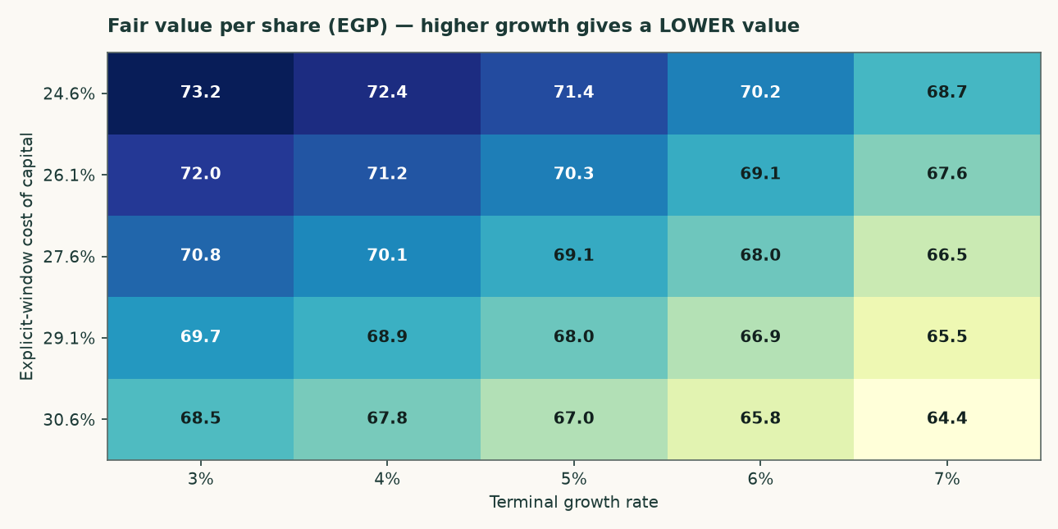
Figure 3 — The same surface. The growth axis is almost flat and the discount-rate axis is not; that is the model being consistent with its own terminal algebra rather than a sign error.
Explicit-window rate | 16.3% | 17.3% | 18.3% | 19.3% | 20.3%
24.60% | 82.72 | 76.59 | 71.52 | 67.27 | 63.64
26.10% | 81.34 | 75.32 | 70.36 | 66.19 | 62.63
27.60% | 79.99 | 74.09 | 69.22 | 65.13 | 61.65
29.10% | 78.67 | 72.89 | 68.12 | 64.11 | 60.69
30.60% | 77.39 | 71.72 | 67.04 | 63.11 | 59.75

Table 12 — The two anchors varied INDEPENDENTLY: the explicit-window rate down the side, the terminal rate across the top. This shows what the valuation needs the economy to do, not merely what growth rate the model needs.
1.9 The other three lenses, and the choices that were contested
The relative lens applies 4.5 times to normalised EBITDA of EGP 3,651mn — the FY2025 revenue base cut 6% and a mid-cycle margin of 31.2% applied to it — and adds net cash at face. The multiple is disclosed as weakly anchored: the listed Egyptian peer set is thin, and its published multiples do not reconcile against the market capitalisations printed beside them. That weakness is why this lens is published as a CROSS-CHECK beside the answer and is not the answer: a multiple anchored on a peer set this thin cannot carry a valuation, and averaging it into one would import that weakness at whatever weight somebody chose.
The normalised-earnings lens capitalises the same mid-cycle operating profit after tax — EGP 2,560mn — at 7.0 times, and again adds cash at FACE rather than capitalising it at the operating multiple. Cash is worth cash; capitalising a pound of treasury at seven times would value it at a discount to itself.
The asset lens values the capacity: 5.0Mt at a justified USD 95 per annual tonne, marked down 27% from a replacement cost of USD 130. Against that, the market is paying USD 112.0 per annual tonne. This lens is a CROSS-CHECK and not the answer, and the reason is in the same paragraph as the number: restarting a mothballed line costs a fraction of building one, and 12.6Mt of restart capacity is queuing. Replacement cost is a ceiling here, not a floor.
Choice | Adopted | Alternative | Effect on the cash-flow lens
Cost of debt: the POUND-EQUIVALENT cost of a euro debt book (adopted) vs the contracted euro rate | 13.36% | 7.89% | 69.34 (+0.2%)
Beta: same-country peer median (adopted, tier 2) vs the own-stock regression against the EGX30 that is too weak to use: its R-squared of 0.047 leaves the slope indistinguishable from noise | 0.928 | 0.698 | 77.79 (+12.4%)
Capex: economic maintenance in dollars per tonne (adopted) vs book depreciation | USD 3.23/t | book depreciation | 73.32 (+5.9%)
Terminal useful life: the disclosed 20 years of machinery and equipment, the class the replacement-cost base actually represents (adopted), vs the longest life disclosed in the same accounting-policies note, 50 years | 20 years | 50 years | 83.63 (+20.8%)

Table 13 — Every contested choice computed as a value rather than argued in prose. None of these alternatives is hidden; each is a full re-run of the model.
1.10 A published sell-side target, reconciled item by item
On 6 August 2026 EFG Hermes published a Buy rating on ARCC with a target price of EGP 69.75, against a spot of EGP 77.00. Both models reproduce FY2025 revenue, cost of sales, gross profit, D&A, capex and net cash to the pound, so the whole EGP 0.53 gap between the two targets is forward-looking. What follows replaces one driver of theirs with one of ours at a time and records the change, so the bars sum to the gap by construction rather than by a plug.
Step | EGP/sh | What moved
START — EFG Hermes target | 69.75 | 6 Aug 2026, Buy, DCF
EFG's own date mismatch | -2.12 | flows dated 1-Jan, cash dated August
Maintenance capex | -6.69 | 5-yr 1,533 → 5,592 theirs below D&A
Operating build | +9.74 | our volume up, our margin down
Terminal block | +14.82 | capital maintained over its disclosed life
Discount rate | -6.48 | their flat 20.06% vs our 27.60%->18.34%
Valuation date 1 Jan -> 30 Jun | -4.09 | -5.46 out of window, +1.37 back as cash
Dividend paid, debt refreshed | -5.67 | EGP 5.34 ex 12 Apr (−2,002mn)
Share count, reconciliation | -0.04 | 374.867 vs 375.0, and the full re-run
END — this study's central | 69.22 | the cash-flow lens, published alone

Table 14 — The reconciliation bridge. Bars sum to the gap exactly (-0.53 vs -0.53). Reproduced independently as a check before publication.
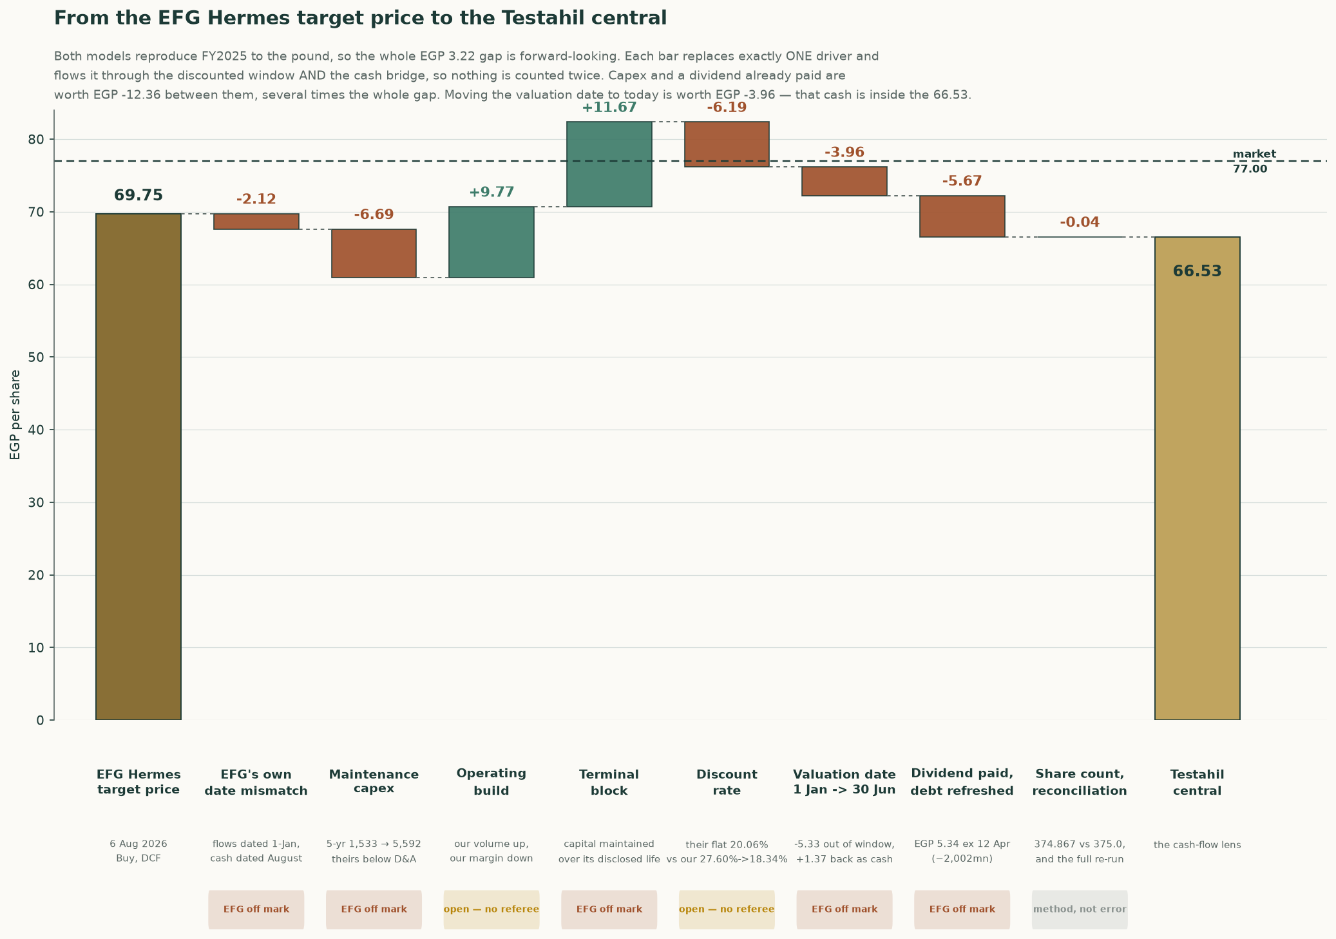
Figure 4 — The same bridge, drawn. Every bar substitutes exactly one driver and carries it through both the discounted window and the cash bridge, so nothing is counted twice.
Sorting the eight steps by who the evidence favours: the items where EFG’s own construction is inconsistent with itself sum to -3.75 — an internal date mismatch between their discount factors and their cash balance, a capex path that sits below their own depreciation in every tabulated year, a terminal value grown without a reinvestment charge, and a dividend of EGP 5.34/share, ex 12 April 2026, that their own front page discloses and their balance sheet does not appear to reflect. Two items are genuinely open — the operating build, where our volumes are higher and our margin path is lower, and the discount-rate convention, where their rate is below the sovereign risk-free rate early and harsher than ours late, worth a combined +3.25. The remaining -0.04 is a lens-weighting difference, not an error on either side.
EFG's own date mismatch (-2.12, EFG off mark). Their factors are 1/(1.2006)^(t-1), so FY2026 is undiscounted and the flows sit at 1-Jan-2026. Their net cash of 3,119 is ABOVE the audited 31-Dec-2025 net cash of 2,324. The whole FY2026 free cash flow of 2,975 is in the window AND the cash it generated from January to August is in the bridge — those months are counted twice. On their own consistent basis their target is 67.64, not 69.75.
Maintenance capex (-6.69, EFG off mark). EFG's capex sits below their OWN D&A in all three years they tabulate: 308 vs 318, 300 vs 347, 248 vs 378 — net disinvestment. ARCC actually spent 912 (FY2024) and 799 (FY2025). CAVEAT: ours is not obviously right either; 1,012 in FY2026 is ABOVE the FY2025 actual of 799. The magnitude is arguable, the direction is not.
Operating build (+9.74, open — no referee). Two errors pointing opposite ways and no referee. Our FY2028 revenue is 15,350 against their 13,792 (+11.3%) because we build tonnes from kiln utilisation 91.7%->93.5%; they have volume FALLING 3%. But our EBITDA margin glides 39.3%->34.3% while Q1-2026 gross margin was 42.9% and widening, which is their side of it.
Terminal block (+14.82, EFG off mark). They grow FY2030 free cash flow at 2.5% for ever with no charge for keeping the plant standing. A perpetuity has to maintain its own capital: on replacement-cost capital of EGP 45,911 and the 20-year machinery life ARCC's own audited accounting-policies note discloses, that maintenance is EGP 2,296 a year, against book depreciation of EGP 643 already inside terminal profit. CAVEAT: the USD 130 per annual tonne behind that capital base is this model's least-verified single input.
Discount rate (-6.48, open — no referee). Their flat 20.06% is applied to FY2026 while the Egyptian 1-year T-bill yields 22.95% -- below the risk-free rate, which is hard to defend. Late in the window it runs the other way. On THEIR calendar, which is the only way to compare a rate against a rate, their year-five factor is 0.4813 against ours of 0.4353, so ours discounts the far end harder. The two work against each other and what is LEFT is this bar, -6.48 a share, which is the number to argue with rather than either convention.
Valuation date 1 Jan -> 30 Jun (-4.09, EFG off mark). A price is what you pay today. Only the remainder of the current fiscal year sits inside the discounted window, so the rest of that year's free cash flow leaves it -- and arrives in the bridge as cash already earned. This step REMOVES value on net. The +1.37 of accumulated cash is INSIDE the answer; it is not owed on top.
Dividend paid, debt refreshed (-5.67, EFG off mark). EFG's own front page prints 'Last Div. / Ex. Date EGP5.34 / 12 Apr 2026'. A buyer on 6 August does not receive it. Their net cash of 3,119 is 1,193 ABOVE our post-dividend 1,926 and cannot be a post-dividend August figure. INFERRED, not proved: they do not print the date.
Share count, reconciliation (-0.04, method, not error). Not an error on either side, and not a lens weighting: this study's central IS the cash-flow lens, published alongside the other reads rather than averaged with them. Two things sit in this step. The share count (374.867mn against their 375.0mn), and the residual between walking one driver at a time down this bridge and running the whole model at once, which is what the published central is. A previous edition weighted four lenses 50/20/22/8 and this step carried those weights; the weights are retired and so is the description.
Year | Testahil | EFG published | EFG on our definition | Gap
FY2025a | 39.3% | 40.3% | 39.3% | audited
FY2026e | 39.0% | 39.0% | 38.0% | -1.04pt
FY2027e | 39.5% | 40.5% | 39.5% | -0.01pt
FY2028e | 40.0% | 40.7% | 39.7% | -0.29pt
FY2029e | 40.2% | 40.7% | 39.7% | -0.51pt
FY2030e | 40.4% | 40.7% | 39.7% | -0.71pt

Table 15 — EBITDA margin, year by year. EFG’s FY2025a margin restates to 39.3% once the 1.1% definitional wedge — provisions, expected credit losses and other operating income, which the two models classify oppositely — is removed, reproducing our own audited figure exactly. The disagreement from FY2026 on is real, not definitional, and it widens rather than staying flat.
Scenario | Cash-flow lens | vs spot
Testahil base — our margin, our volumes | 69.22 | -10.1%
Half way between the two margin paths | 68.47 | -11.1%
EFG margin, OUR volumes | 67.73 | -12.0%
EFG margin, EFG volumes — their view whole | 47.78 | -37.9%
EFG margin, our volumes, mid-cycle lifted too | 67.73 | -12.0%

Table 16 — What EFG’s margin view is worth, held against both volume assumptions. Their margin on OUR volumes reaches EGP 67.73, -12.0% against the latest close; their margin AND their volumes together reach EGP 47.78, -37.9%. NEITHER clears the price, and the volume assumption is worth 19.94 a share between them — several times what the margin disagreement is worth, which is why the volume base carries its own sensitivity in section 1.2.
1.11 What a buyer at EGP 77.00 must believe
Strip out the items resolved above and the honest disagreement left is one thing: how fast does the FY2025 margin peak fade. Everything else in the bridge is either a construction error on the published target (the date mismatch, the sub-depreciation capex path, the unfunded terminal growth, the still-outstanding dividend) or a lens-weighting convention that is not a factual dispute at all. A market price of EGP 77.00 sits between this study’s central of EGP 69.22 and EFG’s corrected-for-its-own-errors figure, closer to ours — but a buyer paying spot is not implicitly endorsing either model whole. Splitting the one open question down the middle — EFG’s margin path and this study’s volume path, averaged rather than either side’s optimism taken alone — prices at EGP 68.47, -11.1% against spot. That, not either published figure, is the number this study would defend if forced to name one.
2 Price structure
The price closed 59.00 above a rising 20-day (56.27), a rising 50-day (56.25) and a rising 200-day (51.73). Momentum is firm: RSI(14) is ~65 and the daily ATR near 1.28 (~2.2%) points to a normal tape. MACD (12·26·9) is positive and rising (+0.46 / +0.25 / +0.20). Over the last year it has ranged 35.01–60.40; the last close sits 2% below that high and 69% above that low.
 | Level (EGP) | Distance from the 59.00 close of 2026-08-06
Resistance 1 | 60.34 | +2.3%
Resistance 2 | 62.00 | +5.1%
Resistance 3 | 63.00 | +6.8%
Support 1 | 54.25 | -8.1%
Support 2 | 52.99 | -10.2%
Support 3 | 48.10 | -18.5%
52-week high | 60.40 | +2.4%
52-week low | 35.01 | -40.7%

Table 17 — Levels are computed from swing structure with a recency weight; moving averages, the 52-week extremes and round numbers are admitted as candidates but score below real swing points. Resistance 1 and support 1 always mean nearest to the close. THE DATES DIFFER AND THAT MATTERS HERE: this read is built on price history ending 2026-08-06 at EGP 59.00, while the latest known market price used everywhere else in this study is EGP 77.00 on 2026-09-03, +30.5% higher. Every distance above is measured from the read's own close, because a level drawn on one day's history says nothing about a price on another. The whole ladder — the 52-week high included — sits BELOW the current price, so on this evidence the tape has moved clear of every level this structure identified and the read should be treated as describing a market the price has since left.
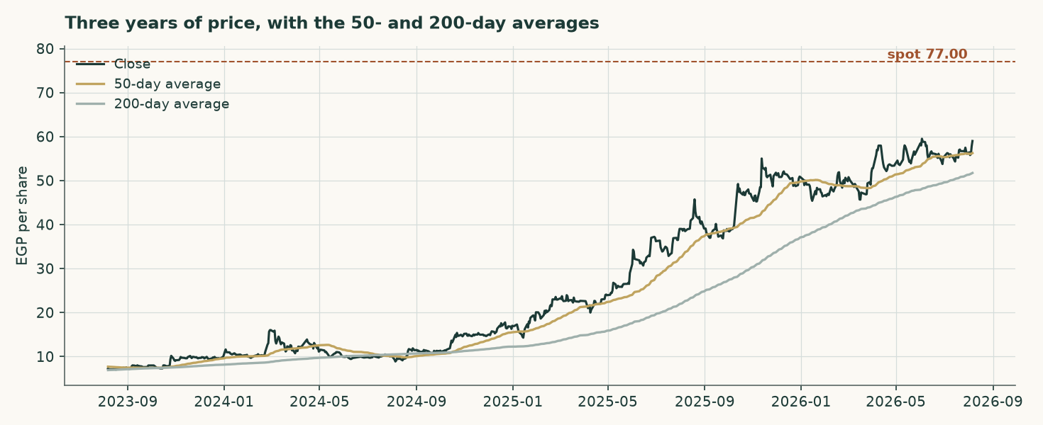
Figure 5 — Three years of price with the 50- and 200-day averages.
On the upside: A daily close back above 60.34 would clear the nearest resistance and open the 63.00 zone.
On the downside: A close below 54.25 would break the nearest support and open the 48.10 zone.
This section describes the tape and makes no claim about value. The two are compared in section 4.
3 A probabilistic price map
The following is NOT a valuation. It is a distribution of where the share price could sit at two horizons, drawn from the price history alone and from nothing in the preceding sections. It is included because a single fair-value number tells a reader nothing about dispersion. Over 44 resolved three-month forecasts this name's price finished inside the 90% band 93.2% of the time, against a 90% target — a record long enough to read, and one on which nothing further is claimed either way. Its bands run 1.45 times the width of a naive carry-anchored random walk's, which is disclosed rather than judged: on this exchange that is the ordinary figure and a wider band is not automatically a worse one.
 | One month | Three months
5th percentile | 50.44 | 43.92
25th percentile | 55.93 | 53.71
Median | 59.45 | 60.46
75th percentile | 63.21 | 67.97
95th percentile | 70.09 | 83.17
Probability of finishing above the EGP 59.00 anchor | 53.4% | 55.6%
Probability of touching +10% of the anchor at any point | 27.8% | 58.0%
Probability of touching −10% of the anchor at any point | 19.8% | 45.5%

Table 18 — Percentiles in EGP per share, from a 50,000-path simulation anchored on the 2026-08-06 close of EGP 59.00 — the last session in the price history this map was simulated from, which is EARLIER than the 3 September 2026 close of EGP 77.00 the valuation is struck against. Those are two clocks and they are supposed to be: a fresh price moves the valuation without re-running the simulation. Read every percentile below against EGP 59.00. The drift is the carry — the risk-free rate less the dividend yield — and nothing else.
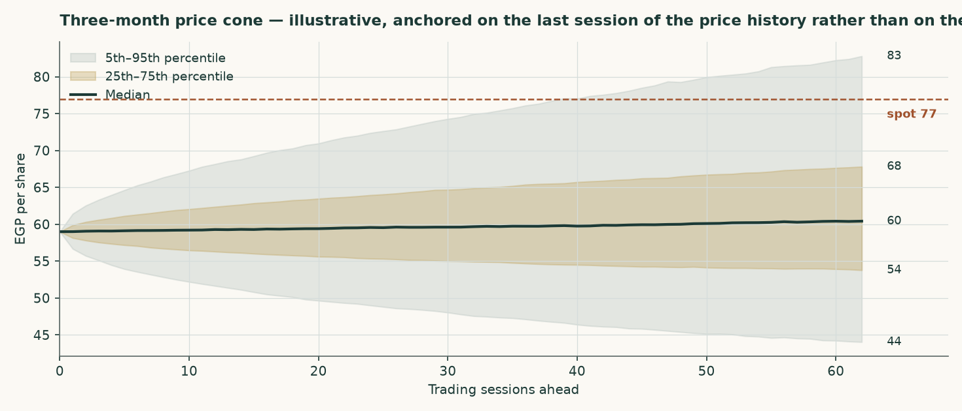
Figure 6 — The three-month cone.
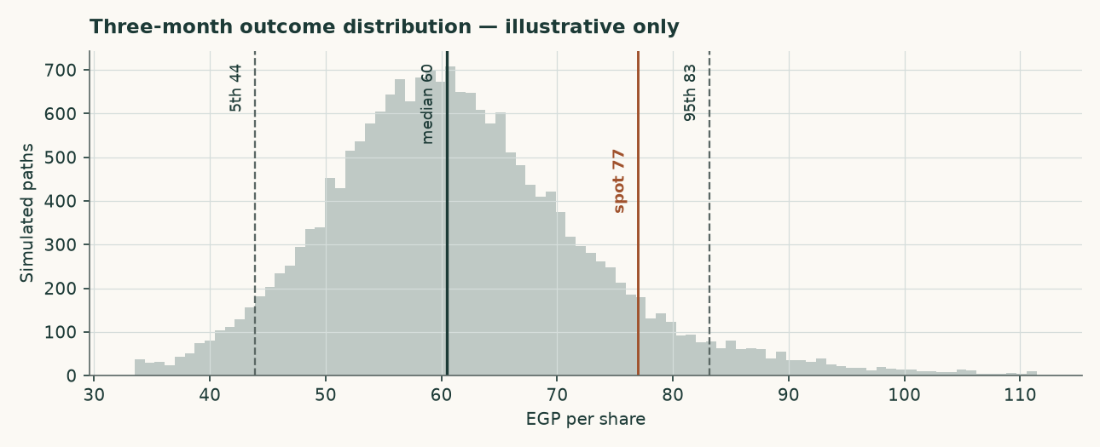
Figure 7 — The three-month outcome distribution.
How well calibrated is it? Over 44 resolved three-month forecasts on this share the price finished inside the ninety-per-cent band 93% of the time, and inside the fifty-per-cent band 59% of the time. The count is printed beside the percentage because a percentage without its count is the number that misleads. No flag is earned on a two-sided test at the five-per-cent level: the bands held about as often as they promised, and nothing further is claimed for them. No valuation conclusion in this study rests on the map.
4 Comparison of the lenses
Lens | Bear (EGP) | Base (EGP) | Bull (EGP) | Role | Versus spot
DCF (cash flow) | 27.30 | 69.22 | 69.77 | the central | -10.1%
Relative multiples | 41.09 | 45.65 | 50.22 | cross-check | -40.7%
Asset / replacement cost | 59.01 | 65.57 | 72.13 | cross-check | -14.8%
Normalised earnings | 44.68 | 49.64 | 54.60 | diagnostic only | -35.5%

Table 19 — Each lens as a range. The disagreement between them is information, not noise. THE CASH-FLOW RANGE IS ALMOST ENTIRELY DOWNSIDE, AND THAT IS A CLAIM RATHER THAN AN ACCIDENT: the forecast opens at 39.03% against a latest audited 39.25% — within 0.22 of a point of the best year this company has ever filed — and rises from there to 40.40%. There is almost nothing above it left to reach for, which is why the bull corner sits only +0.8% above the base while the bear corner, struck on this company's own FY2023 margin, sits -60.6% below it. A forecast sitting at the top of a filed record is a claim a reader is owed plainly, not one to be inferred from the shape of a range.
The lenses do not agree, and the pattern of their disagreement is the most useful thing in this study. EVERY lens sits BELOW the market price: Relative multiples, Asset / replacement cost and DCF (cash flow), at EGP 45.65 and EGP 65.57 and EGP 69.22. Not one read in this study reaches what the shares trade at, which is a stronger statement than any single lens makes and is the thing to weigh first. The split is not assets against earnings. It runs between what the plant can be expected to EARN or COST from here, which both land above the market, and what the market is currently willing to PAY for a pound of Egyptian cement earnings, which is what the two multiple-based lenses measure and which lands below. A cement peer group trading at 6.2 times earnings in a country whose policy rate has a two in front of it is not obviously mispricing anything; it is discounting the same restart programme this study discounts, only harder and sooner.
This edition does not resolve that by weighting. A previous one blended the four readings at 50%/20%/22%/8% and published the average, EGP 59.91; but those weights were chosen rather than tested, and an average of four methods is a fifth method nobody has checked, carrying every weakness of the weakest at whatever weight somebody typed. The value published here is the cash-flow lens alone, EGP 69.22 against EGP 77.00 — -10.1% — and the other readings are printed beside it so the disagreement is visible rather than averaged away. A reader who believes replacement cost is a floor rather than a ceiling can read EGP 65.57 off the same table and reach the opposite conclusion; the case against doing so is the 12.6Mt restart programme, and it is a testable one.
Against the technical picture, the two readings are in tension, and the tension is entirely one-sided. On the price history the read was built from, the share was above its whole moving-average stack on a rising 200-day and at 98% of its 52-week intraday high of EGP 60.40. The latest close of EGP 77.00 is +27.5% beyond even that high, so the tape has run past every level the structure identified. Against it, every one of this study's 3 valuation lenses sits BELOW the market, the nearest at -10.1% — there is no reading here that supports the price, which is a stronger and less comfortable statement than any single lens makes. Momentum is with the market and value is not, and this study takes no view on which resolves first.
5 Catalysts to watch
- The restart programme. Seven to nine dormant Egyptian lines are under study for revival, potentially adding 12.6Mt from the second half of 2026 — about 23% of domestic consumption. Whether those lines actually restart, and how fast, is the single largest swing factor in the price path this model assumes.
- The realised price, quarter by quarter. The model assumes a domestic price of EGP 3,328 a tonne in FY2026 and growth below cost inflation thereafter. Two consecutive quarters of realised prices above EGP 4,200 would break that assumption upward; a return toward EGP 3,000 would break it down.
- The alternative-fuel programme. The substitution rate is assumed to rise from a cumulative 5.5% saving on the materials and fuel line by FY2030, against a EUR 25mn facility already drawn and EGP 240mn of capacity already under construction. Progress on it is reported in the company's own sustainability disclosure and is directly visible in the fuel cost per tonne. A stall would cost roughly the difference between the blended and fossil-only fuel bills.
- Energy tariffs. Phased subsidy reform continues to raise the domestic industrial energy bill independently of the global fuel price. The model inflates the pound cost lines by 11.5% in FY2026, easing to 7.0% by FY2030; a faster reform schedule would compress the margin faster than assumed.
- The export cap and the carbon border mechanism. Exports are capped at 30% of production, and the EU carbon border mechanism raises the landed cost of Egyptian cement in Europe. A low-clinker, high-alternative-fuel producer suffers less from the second than a conventional peer, and the export price path assumes exactly that.
- Distribution policy. The company declared EGP 2,002mn for FY2025, about 56% of attributable profit, on top of EGP 1,102mn for FY2024. A change in that policy changes the cash roll-forward and, through it, the balance sheet the bridge relies on.
6 Reading the probability zones
The distribution in section 3 is easier to use as zones than as percentiles. The following divides the three-month outcome space into four bands and states what each would mean, without predicting which occurs.
Zone | Three-month range (EGP) | Probability | What it would mean
Lower tail | below 43.92 | 5% | A break of the 48.10 support zone, most plausibly on a faster-than-assumed capacity restart
Below the 59.00 anchor | 43.92 – 59.00 | 39% | The market converging toward the earnings-based lenses in this study
Above the 59.00 anchor | 59.00 – 83.17 | 51% | Momentum and the 2026 pricing environment continuing to lead the earnings case
Upper tail | above 83.17 | 5% | A re-rating toward the asset lens, which would require the restart programme to be abandoned or delayed materially

Table 20 — Zones, not forecasts. The four are exclusive and sum to 100%: each tail is carved OUT of the band beside it rather than counted twice. EVERY BOUNDARY AND EVERY PROBABILITY HERE IS MEASURED FROM THE EGP 59.00 ANCHOR THE SIMULATION WAS RUN ON, not from the EGP 77.00 latest close — the two are +30.5% apart on this edition. Splitting the bands at the latest close while keeping probabilities computed from the anchor would state the chance of finishing above one number using the distribution of another, which is worse than saying nothing. The latest close sits above this cone's 67.97 seventy-fifth percentile, and what a reader should take from that is that the price has moved well beyond the window this simulation was struck in, not that any zone below has become more likely.
7 Caveats and what would change our mind
- The accounts are audited, and this study is built on them. An earlier edition of this work was written without access to a source document and reconstructed the history by closing disclosed profit against modelled assumptions. That edition is superseded. Every historical figure here is read from the consolidated financial statements signed by Deloitte on 25 February 2026, or from the reviewed interim accounts of 25 May 2026. Four things it got materially wrong are worth naming, because they show where reconstruction fails: minority interests were deducted at EGP 150mn against an audited EGP 158,005 — one hundred and fifty-eight THOUSAND pounds rather than million, a figure 949 times smaller; the effective tax rate was inferred at 29.4% against a disclosed 23.8%; the cost of debt was assumed at 21.5% against a euro-denominated book paying about 7.5%; and kiln capacity was assumed 14% too low.
- The model was rebuilt bottom up, and the answer moved a long way. Four reviewers tested the previous edition. Between them they showed that its volume came from an assumed price rather than from the plant, that its FY2025 validation was an identity that could not fail, that its terminal capital was measured in valuation-date pounds against a terminal-year cash flow, that its terminal cost of debt sat 250 basis points below its own terminal risk-free rate, that its terminal risk-free rate used the central bank's near-dated inflation target rather than its medium-term one, that its discount factors applied each year's rate one period late, that its beta was levered twice, and that ten rows of its income statement were labelled one row above their contents. All of that is corrected here. The central fair value moves from EGP 61.30 to EGP 69.22, and the conclusion moves from a premium over the market of that day to a discount of -10.1% against the latest close — large enough that this edition carries the gap review its own standing threshold requires, rather than being waved through as a small difference.
- The expert panel is the model at three parameter values, not three independent valuations. A reviewer pointed out that Expert 1's central IS the asset lens to the pound and Expert 2's IS the normalised-earnings lens. That is correct, and the workbook now builds all nine panel figures as FORMULAS off the same drivers rather than typing them, so the point is demonstrated rather than argued: Expert 1 marks replacement cost at USD 80/95/110 a tonne, Expert 2 capitalises the normalised base at 6/7/8 times, Expert 3 discounts mid-cycle free cash flow at a 20.0%/17.5%/15.0% required return. Read the panel as a sensitivity with reasoning attached, not as corroboration.
- Volume is now physical, and it is the largest open question in the study. The build runs on kiln utilisation, the clinker factor and two export shares, and the three realised prices are derived from the audited revenue note. That makes the prices testable, and they do not fully pass: export clinker derives to USD 30.0 a tonne against a trade-press range of USD 44-48. Either the physical assumptions are too generous or realisations run below the published indices. The company discloses despatch volumes in its investor material, which would settle it; that material could not be reached from here, and the audited statements are image-only scans that carry no volume table.
- The cost of debt is marginal and pound-equivalent, not the coupon as written. The adopted 13.36% carries the euro legs at the pound cost a company earning pounds actually bears, against a contracted blend of 7.89%. It sits above the 5.03% that FY2025 interest over average debt gives and the 3.73% the first quarter of 2026 annualises to, because the book re-based mid-year and interest on assets still under construction is capitalised. Adopting the contracted rate instead would leave the euro debt uncompensated for pound depreciation beyond the currency path assumed here, and is worth +0.2%.
- Half a year has been turned into a whole one, and that is the largest assumption here. The forecast starts from the reviewed six months to 30 June 2026 — revenue of EGP 6,081mn at a 40.5% gross margin — grossed up to a full year. HOW MUCH OF A YEAR ARCC'S FIRST HALF IS varies: it was 44.2%, 45.5% and 52.7% of the year in the three years that can be measured. The median is used, which puts FY2026 revenue at EGP 13,349mn; on the least favourable of the three it would be EGP 11,540mn and on the most favourable EGP 13,761mn. Simply doubling the half gives EGP 12,161mn.
- And no interim tonnage is published, so the uplift cannot be split between price and volume. Local sales of goods rose 18.5% against the same half of 2025 while export sales of goods fell -3.8%. The company publishes no tonnage with its half-year accounts, so this study cannot tell how much of the local rise was a higher price and how much was more tonnes. It is taken entirely as price and carried through every forecast year as a level shift of 1.079 times. THAT IS THE ASSUMPTION IN THIS STUDY MOST CAPABLE OF BEING WRONG: if the rise was volume rather than price, and volume is capped by the plant, the later years are overstated. TWO FURTHER FACTORS COME OUT OF THE SAME HALF AND ARE STATED HERE RATHER THAN LEFT TO THE MODEL: the export price is scaled 0.871 times, because export sales of goods FELL over the same half, and the whole cash-cost stack is scaled 0.976 times, because the half's own cost of sales and administrative expenses gross up to EGP 8,056mn against what the uncalibrated model would have charged. The cost factor is not an adjustment to the answer and it is the one that keeps the margin honest: calibrating price to a filed half WITHOUT calibrating cost to the same half would manufacture a margin out of the calibration itself, which is precisely what this study forbids elsewhere. The three move in different directions because that is what the half reports — local price up, export price down, cost down — and all three come from one document.
- A large collection of export subsidy is treated as one-off. The half-year accounts record EGP 468mn of export subsidy collected in the second quarter, against EGP 32.6mn for the whole of FY2025. It is excluded from forward operating profit and left in the cash balance, on the reading that it settles accumulated claims. If a comparable amount arrives again with no accumulated-claims explanation, it is recurring and this study understates value.
- The terminal denominator is a choice. Return on capital is 60.6% on the audited book and 11.73% on replacement cost. The terminal block uses replacement cost, which leaves the plant roughly breaking even on new tonnes — 11.73% against a hurdle of 18.34%, so four points of terminal growth are worth -2.8% of value and the answer does not rest on the rate. On the book basis growth would be close to free and the valuation materially higher. The case for replacement cost is that the book carries a 2010-vintage plant at a tenth of what one would cost to build today, but a reader is entitled to disagree.
- The beta is not this company's own. Measured against the market index, Arabian Cement's own share history explains too little to be usable — an R-squared of 4.7% — so the discount rate rests on the betas of four comparable Egyptian companies instead. That is the ordinary fallback and it is disclosed, but it means the risk measure in this valuation is a sector estimate rather than a measurement of this share. The valuation is shown across the whole peer spread for exactly that reason.
- The price map is a separate lens and carries no valuation weight. Over 44 resolved three-month forecasts the price finished inside the ninety-per-cent band 93% of the time. It is carried as illustrative only, and nothing in the valuation depends on it.
- A minority position under a 60% shareholder. Aridos Jativa of Spain owns 60% of the capital. No control premium or discount is applied anywhere in this valuation, in either direction. The company also holds 1% of its own capital in treasury, acquired during 2025, which is excluded from the share count throughout.
- Currency, on both sides now. Revenue is 69% local and 31% export; costs are largely in pounds but fuel and spares are not; and the debt is 91% euro. A weaker pound raises export revenue in pounds and raises the pound cost of servicing the euro debt. The model carries one currency path acting on all three legs.
Net cash at the valuation date (EGP mn) | -813 | -63 | 687 | 1,437 | 2,187
Fair value per share (EGP) | 65.22 | 67.22 | 69.22 | 71.22 | 73.22

Table 21 — The clean net-cash sensitivity, with the tax rate held.
Shift in the EBITDA margin, every forecast year | -4% | -2% | +0% | +2% | +4%
Fair value per share (EGP) | 59.37 | 64.30 | 69.22 | 74.15 | 79.07

Table 22 — And the margin sensitivity, which is the largest single swing factor in the model.

Appendix A Financial statements
A.1 Income statement — three years reported and five forecast
EGP mn | FY2023 | FY2024 | FY2025 | FY2026E | FY2027E | FY2028E | FY2029E | FY2030E
Revenue | 6,043 | 8,730 | 12,447 | 13,349 | 14,985 | 16,440 | 17,688 | 18,934
Cost of sales | (4,760) | (6,643) | (7,389) | — | — | — | — | —
Gross profit | 1,283 | 2,087 | 5,058 | — | — | — | — | —
Operating profit | 1,079 | 1,764 | 4,596 | 4,916 | 5,556 | 6,140 | 6,606 | 7,069
Depreciation and amortisation | 250 | 257 | 290 | 344 | 417 | 491 | 565 | 643
EBITDA | 1,330 | 2,021 | 4,886 | 5,210 | 5,918 | 6,574 | 7,111 | 7,650
EBITDA margin | 22.0% | 23.1% | 39.3% | 39.0% | 39.5% | 40.0% | 40.2% | 40.4%
Plus other operating income | — | — | — | 50 | 54 | 57 | 60 | 62
Net finance and other income | -149 | -258 | 129 | 127 | 237 | 358 | 495 | 662
Profit before tax | 930 | 1,506 | 4,725 | 5,043 | 5,793 | 6,498 | 7,101 | 7,731
Income tax | (233) | (346) | (1,125) | (1,201) | (1,380) | (1,548) | (1,691) | (1,841)
Attributable profit | 697 | 1,160 | 3,600 | 3,842 | 4,413 | 4,950 | 5,409 | 5,889
Earnings per share (EGP) | 1.81 | 3.02 | 9.49 | 10.25 | 11.77 | 13.21 | 14.43 | 15.71

Table A1 — Three AUDITED years and five forecast. FY2023-FY2025 revenue, cost of sales, administrative expenses, provisions, pre-tax profit, tax, attributable profit, earnings per share and depreciation are disclosed figures; operating profit, EBITDA and the margins are formulas over them. TWO ROWS CHANGE BASIS BETWEEN THE AUDITED AND FORECAST HALVES AND BOTH ARE STATED RATHER THAN LEFT FOR A READER TO DISCOVER. Operating profit is EBITDA less depreciation in the audited years and EBITDA less depreciation PLUS other operating income in the forecast years, which is why that line is printed. And the audited earnings per share is the PUBLISHED figure, struck on distributable profit after the statutory employees' and directors' share — EGP 9.49 in FY2025 against EGP 9.60 on profit over the share count — while the forecast years are profit over the share count, since this model does not forecast that statutory appropriation. The step at the boundary is a change of basis, not a change in the business.
A.2 Balance sheet — as reported
EGP mn | FY2023 | FY2024 | FY2025 | FY2026E | FY2027E | FY2028E | FY2029E | FY2030E
Total assets | 3,888 | 5,849 | 8,784 | 8,487 | 10,446 | 12,644 | 15,046 | 17,661
Cash and bank balances | 561 | 1,687 | 3,459 | 2,506 | 3,709 | 5,185 | 6,913 | 8,886
Interest-bearing debt | 90 | 761 | 1,135 | 1,135 | 1,135 | 1,135 | 1,135 | 1,135
Net (cash) / debt | -471 | -926 | -2,324 | -1,371 | -2,574 | -4,050 | -5,778 | -7,751
Equity attributable to owners | 1,754 | 2,303 | 4,643 | 4,347 | 6,306 | 8,504 | 10,906 | 13,520
Book value per share (EGP) | 4.68 | 6.14 | 12.38 | 11.60 | 16.82 | 22.68 | 29.09 | 36.07
Return on equity | 39.8% | 50.4% | 77.5% | 88.4% | 70.0% | 58.2% | 49.6% | 43.6%

Table A2 — All three historical years are AUDITED. The FY2025 balance sheet closes exactly: total assets of EGP 8,784mn less total liabilities of EGP 4,141mn equals equity of EGP 4,643mn.
A.3 Forecast cash flow and the working-capital markers
EGP mn | FY2026E | FY2027E | FY2028E | FY2029E | FY2030E
Attributable profit | 3,842 | 4,413 | 4,950 | 5,409 | 5,889
Add back depreciation | 344 | 417 | 491 | 565 | 643
Less change in working capital | -111 | -201 | -179 | -153 | -153
Capital expenditure | -890 | -973 | -1,034 | -1,085 | -1,132
Dividends paid | -2,136 | -2,454 | -2,752 | -3,008 | -3,274
Closing cash | 2,506 | 3,709 | 5,185 | 6,913 | 8,886
Memo: free cash flow to the firm | 1,544 | 3,476 | 3,955 | 4,359 | 4,743

Table A3 — Free cash flow to the FIRM excludes treasury income, which is handled in the equity bridge; free cash flow to equity includes it through profit.
A.4 Years three to five as ranges — this company's own tested error, applied
 | FY2028E | FY2029E | FY2030E
Revenue — point (EGP mn) | 16,440 | 17,688 | 18,934
Revenue — low of the range | 8,062 | 14,344 | 17,168
Revenue — high of the range | 49,203 | 71,149 | 71,453
Cement and clinker sold — point (mn t) | 4.89 | 4.91 | 4.93
Volume — low of the range | 3.35 | 4.44 | 4.45
Volume — high of the range | 7.41 | 7.06 | 5.45
Profit before tax — point (EGP mn) | 6,498 | 7,101 | 7,731
Profit before tax — low of the range | 345 | 2,641 | 3,925
Profit before tax — high of the range | 42,128 | 268,271 | 360,783
Tested cases behind each band | 5 | 4 | 3

Table A4 — the multipliers come from rebuilding this company's forecast as it would have stood at each of 8 past year-ends, projecting one to five years ahead under the same rules, and scoring every projection against what was later reported: 25 tested cases over FY2014-FY2025. The bands are the spread of those misses at three, four and five years out, applied to this forecast's own path.
THE TONNES WERE FORECAST FAR BETTER THAN THE MONEY, and that is the most useful thing this test says about the forecast above. Three years out, the volume band runs 0.68 to 1.52 times the point, while revenue runs 0.49 to 2.99 times and profit before tax 0.05 to 6.48 times. The physical business — kilns, mills, tonnes sold — was largely knowable in advance. What was not knowable was the price those tonnes fetched and the cost of making them, in a currency that was devalued twice inside the tested window. The width on profit is a measurement of Egyptian inflation and the exchange rate, not of this plant.
The band is wide because the record is short and the period was violent, and it narrows on volume for the same reason it widens on profit. It is published rather than smoothed: a far year of any projection of this company supports a range and never a point, and the reader is entitled to the width the method actually earned rather than to a single figure carried to the decimal. The counts in the last row fall from 5 to 3 across the three years, because a five-year-ahead test needs five more years of history than a one-year-ahead test, and those are the cases the record actually holds.
One correction was adopted out of 12 candidates — manufacturing depreciation, at a factor of 1.0298 — and 11 others were recorded as watch flags and acted on by nobody. A correction is adopted only where the bias holds its sign across the record and the model is otherwise right; where the model itself is wrong, a multiplier would hide it rather than fix it.

Appendix B Peer set, sector structure and risks
B.1 Peers and the sector frame
 | Revenue (EGP mn) | Profit (EGP mn) | Market cap (EGP mn) | Price / earnings | Net margin
Arabian Cement (ARCC) | 12,447 | 3,600 | 28,865 | 8.02x | 28.9%
Sinai Cement (SCEM) | 9,090 | 2,290 | 20,604 | 9.00x | 25.2%
Misr Beni Suef Cement (MBSC) | 5,700 | 3,946 | 13,730 | 3.48x | 69.2%

Table B1 — Every multiple here is RECOMPUTED from revenue, profit and market capitalisation rather than quoted, because the published multiples for this peer set do not reconcile against the market capitalisations printed beside them.
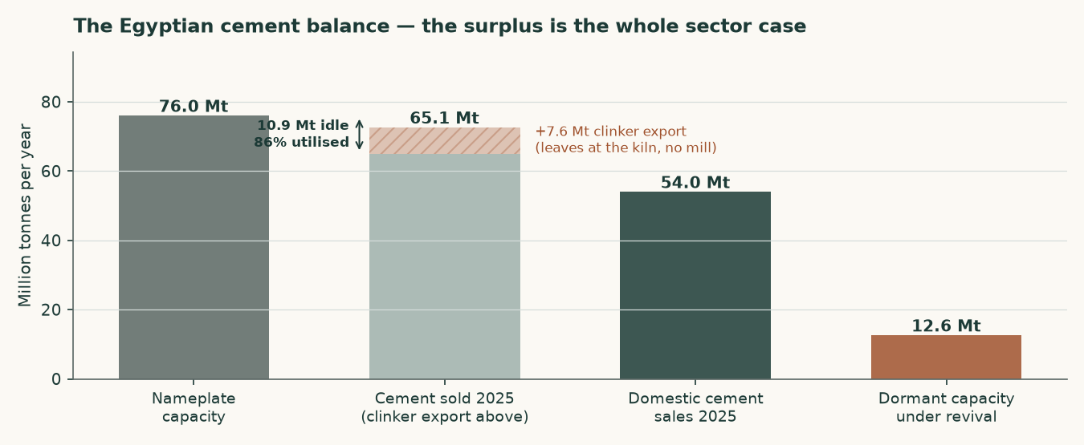
Figure B1 — The Egyptian cement balance. The surplus is the whole sector case.
B.2 The sector balance, and what it is not
Egypt carries about 76Mt of cement nameplate capacity. The company's own market page splits FY2025 sales three ways, and the split is what this balance turns on: domestic cement 54.0Mt, exported cement 11.1Mt, exported clinker 7.6Mt, total 72.6Mt. The three add to the disclosed total exactly, and the export line adds to the disclosed export total exactly, which is what makes either ratio below safe to publish.
TWO RATIOS COME OUT OF THAT PAGE AND ONLY ONE OF THEM MEANS ANYTHING. Cement sold — domestic plus export, 65.1Mt — against cement nameplate is 85.6%. All product sold, 72.6Mt, against the same cement nameplate is 95.6%. The second is the one earlier editions of this study printed, and it is not a measure of anything: clinker leaves at the kiln and never enters a cement mill, so a tonne exported as clinker consumes no grinding capacity and does not belong in the numerator. That is the SAME mismatch this study identified in the editions before it — a cement-plus-clinker figure against a cement-only one — committed again in the other direction, and the 65.1Mt discarded then as a failed balance was the correct cement-basis number all along.
ON THE MEASURE THAT MEANS SOMETHING, the market is running with about 10.9Mt of cement capacity idle — roughly a sixth of nameplate. That is neither the structurally slack market the first editions of this study described nor the tight one the last edition described. The 12.6Mt restart programme would take idle capacity to about 23.5Mt before any new demand appears, and the production quota abolished in May 2025 removed the mechanism that had been supporting price into a surplus. The forecast price path does not depend on which of these two numbers is right — its first-year step is a filed quarterly realisation and every later year holds flat in real terms — but the comfort around it does, and this is where a reader who wants to press on the price path should press.
B.3 Risk register
One entry per risk that could move this valuation by more than a few per cent, each stated as a mechanism rather than a worry, and each with the disclosure it rests on.
- Price risk. This is the dominant risk and it is LARGER than the edition before this one said, because that edition measured the market wrongly. On matched denominators Egypt sold 65.1Mt of cement against roughly 76Mt of cement nameplate — 86%, about 10.9Mt idle — where the previous edition printed 96% by counting exported clinker against grinding capacity it never touched. So the surplus is CURRENT as well as prospective. On top of it sit two further legs: the 12.6Mt restart programme, and a production quota SUSPENDED rather than repealed, which could return without legislation. Against that, this company realised a 60.7% rise in its local price in FY2025 and exited the year 7.2% above its own annual average, which is the evidence the first forecast year rests on — a filed number rather than a view about how tight the market is. Every year after it holds flat in real terms.
- Energy and currency. Fuel is dollar-priced and electricity tariffs are on a reform path. Both raise cost independently of what happens to price.
- Concentration. One site, one product, one country. There is no diversification anywhere in this business to absorb a shock to Egyptian construction demand.
- Carbon. The EU carbon border mechanism raises the landed cost of exports into Europe. At a clinker factor of 0.733 — a PRODUCTION ratio, not the ratio of two nameplate capacities the earlier edition mistook for one — this producer is better placed than most Egyptian peers, but better placed is not unaffected. It also ships 26.8% of its tonnes as raw clinker, which carries the highest embedded carbon of anything it sells.
- Disclosure. The depth of published financial detail is thin by the standards of the other markets covered, which is why so much of this study is a triangulation shown rather than a figure asserted.

Appendix C The expert valuation panel
Three independent valuations of the same company, each built by a different method and each stated with the specific evidence that would prove it wrong. They are not averaged: the disagreement between them is the point.
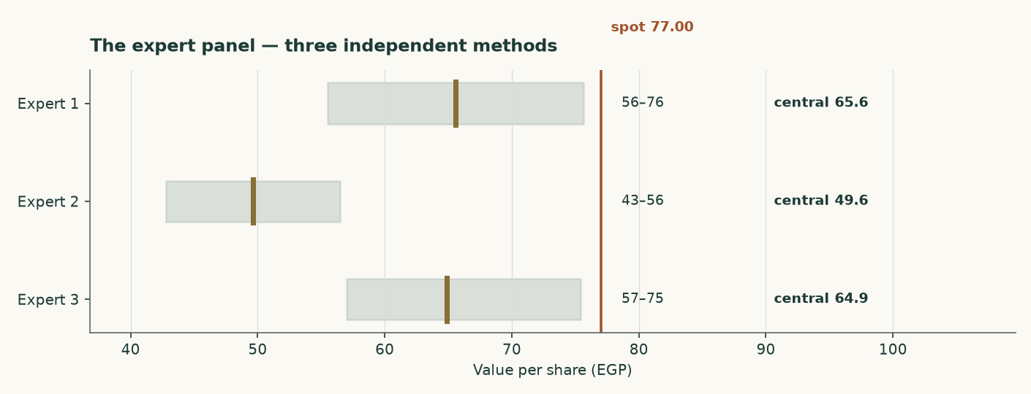
Figure C1 — The three panel valuations against the market price.
C.1 Expert 1 — Replacement-cost industrialist
Valuation: EGP 55.51 to EGP 75.63, central EGP 65.57 (-14.8% against the market price of EGP 77.00).
Values the plant, not the earnings stream. The audited accounts put net property, plant and equipment at EGP 2,522mn and assets under construction at a further EGP 392mn, on a book carried at pre-devaluation historic cost. Five million tonnes of grey cement capacity costs about USD 130 per annual tonne to build; nobody pays that in a market carrying 76Mt of capacity against 54Mt of consumption, so the justified figure is marked to USD 95. Against that the market is paying USD 112 per annual tonne.
What would prove this wrong: Find an Egyptian line built, bought or restarted below USD 95 per annual tonne. The 12.6Mt revival programme is the live test and it runs against this lens: restarting a mothballed kiln costs a fraction of building one, which is why this valuation is a CEILING and is published as a cross-check rather than as the answer.
C.2 Expert 2 — Mid-cycle earnings-power analyst
Valuation: EGP 42.81 to EGP 56.47, central EGP 49.64 (-35.5% against the market price of EGP 77.00).
Refuses to capitalise a peak, and refuses it on both legs. The audited EBITDA margin went 22.0% to 23.1% to 39.3% across FY2023 to FY2025 — the last of those is the best of the three audited years this study holds, by a wide margin. (An earlier edition called it the best year the Egyptian INDUSTRY had had in over a decade, which is a claim about the industry that nothing in this study measures.) The margin is normalised to 31.2%, the midpoint of the two most recent audited years, the revenue base is cut 6%, and what is left is capitalised at 7 times with cash added back at face.
What would prove this wrong: Two consecutive years of realised prices above EGP 4,200 a tonne WITH the revival proceeding would prove the mid-cycle base too low. Equally, the first quarter of 2026 already ran a 42.9% gross margin against 40.6% for FY2025 as a whole — if that holds for the year, this lens is too cautious.
C.3 Expert 3 — Cash-return and distribution investor
Valuation: EGP 56.96 to EGP 75.34, central EGP 64.84 (-15.8% against the market price of EGP 77.00).
Ignores the terminal value and asks what the cash stream is worth to someone who has to be paid in cash. Average free cash flow to the firm across FY2027-FY2030 is EGP 4133mn; required at a 17.5% cash return that is a business worth EGP 23619mn before net cash of EGP 687mn is added back. This is not hypothetical: the company declared EGP 2002mn for FY2025 on EGP 3600mn of attributable profit, a 56% payout, and the audited cash flow shows EGP 1702mn actually paid out during 2025.
What would prove this wrong: A required cash return above 20% takes this valuation to EGP 56.96. So would maintenance capital spending materially above the USD 3.23 per tonne assumed here — the audited FY2024 and FY2025 capex of EGP 912mn and EGP 796mn is the number to watch, and both years carried the alternative-fuel and silo programmes on top of maintenance.
 | Low (EGP) | Central (EGP) | High (EGP) | Versus spot
Expert 1 — Replacement-cost industrialist | 55.51 | 65.57 | 75.63 | -14.8%
Expert 2 — Mid-cycle earnings-power analyst | 42.81 | 49.64 | 56.47 | -35.5%
Expert 3 — Cash-return and distribution investor | 56.96 | 64.84 | 75.34 | -15.8%
Panel median | — | 64.84 | — | -15.8%

Table C1 — The panel. The median of the three, EGP 64.84, sits -6.3% from this study's own central of EGP 69.22 and -15.8% from the market price. It is NOT a confirmation of anything: two of the three panel methods are anchored on the same forecast the central uses, and the one that is not — replacement cost — is the highest read in the study. An earlier edition compared this median to a weighted average of four lenses; those weights are retired, and the comparison is now against the published central.
C.4 Cross-examination
Each expert is put the strongest objection the other two can make, and each objection is either conceded or rejected with the arithmetic that settles it. Every figure below comes from the three valuations above or from the study's own committed record.
Objection | Raised by | Answered | The arithmetic
Replacement-cost industrialist values a plant nobody is building. The 12.6Mt restart programme is the live test and restarting a mothballed kiln costs a fraction of new build. | Experts 2 and 3 | CONCEDED | This is Expert 1's own stated falsifier, and it is the reason the lens is marked to USD 95 an annual tonne rather than the USD 130 a new line costs. At USD 95 it reads EGP 65.57; the market is paying USD 112.0 an annual tonne at the traded price.
A replacement-cost read says nothing about whether the plant earns its cost of capital. | Expert 3 | REJECTED | That is what it is for. It is the one read in this study anchored on something other than a forecast, and it is the strongest argument against the central — which is why it is published beside it at EGP 65.57 rather than averaged away.
The forecast that drives the earnings reads opens at 39.03% against a filed peak of 39.25%, so it has no headroom. | Expert 1 | CONCEDED — AND STATED IN THE STUDY | It is the point of the range: the bull corner is EGP 65.57, barely above the central of EGP 69.22, while the bear corner is EGP 45.65 on the FY2023 margin this company actually filed. Essentially the whole range is downside, and a symmetric band would have concealed that.
The beta is a peer median, not this company's own regression, so the discount rate is borrowed. | Experts 1 and 2 | CONCEDED — AND PUBLISHED BOTH WAYS | The own-stock regression against the EGX30 returns 0.698 on an R-squared of 4.7%, below the usability floor, so tier 1 is not available. On the regression the lens would read EGP 77.79 against EGP 69.22 — +12.4%. The study's largest is terminal useful life at +20.8%.
Peer betas are used as published, without unlevering and re-levering. | Expert 3 | CONCEDED — WITH THE DIRECTION NAMED | The peers carry borrowings and this company holds net cash, so completing the step could only LOWER the beta, lower the rate and RAISE the value. The adopted figure is therefore the cautious end of tier 2, and the omission is flagged rather than passed over.
Growth is worth having, so a terminal that punishes it is wrong. | Expert 2 | REJECTED | Measured on this company's own returns. The return on replacement-cost capital is 11.73% against a terminal cost of capital of 18.34% — short of it by 661 basis points — so moving terminal growth from 3% to 7% takes the value from EGP 71.23 DOWN to EGP 69.22, -2.8%, about 0.50 a share for each point of growth, and the WRONG way. Growth funded at a return below the cost of capital destroys value, and section 1.8 shows the arithmetic.

Table C2 — Cross-examination. Four of the six objections are conceded, which is the honest count for a study whose forecast sits at its subject's best filed year and whose discount rate rests on a borrowed beta. The two rejections each rest on a number rather than a preference.
C.5 The three in one room
Put in one room the three methods land between EGP 49.64 and EGP 65.57, a spread of 32.1% of the lower number, with a median of EGP 64.84 against a market price of EGP 77.00 — -15.8%. All three sit below the price, and so does the study's own central of EGP 69.22.
What they agree on is not built in, and that is what makes it worth reading. None of the three sets a macro path of its own — all of them stand on the house inflation, currency and policy path for Egypt, so their disagreement is entirely about how a tonne of cement should be capitalised and never about what the economy is doing. All three also agree that this company is worth less than EGP 77.00, by methods that share no arithmetic: one values the steel and concrete, one the earnings stream, one the cash returned against what the capital costs.
Where they part company is what they are anchored ON. Expert 1 — replacement-cost industrialist — is the highest at EGP 65.57 because it is the only read not anchored on a forecast at all; it asks what the plant would cost to build and marks that down for a market with dormant capacity. The other two are anchored on the same forecast the central uses, and that forecast already sits at this company's best filed margin. So the panel's spread is largely the difference between valuing an asset and valuing a stream, which is exactly the disagreement a cyclical single-plant producer should produce — and it is why the study publishes the replacement-cost read beside its central rather than inside it.
C.6 Reading the divergence
One row per pair, naming the single assumption that accounts for most of the gap between them, and what is left of the gap once that assumption is removed.
Pair | Gap (EGP) | Gap % | What drives it | What is left
Expert 1 vs Expert 3 | 0.73 | 1.1% | the anchor itself — one values the plant, the other the stream. There is no single parameter to remove, because the two do not share one. | not decomposed
Expert 1 vs Expert 2 | 15.93 | 32.1% | the same thing, at its widest: an asset value against the most forecast-dependent read in the panel. | not decomposed
Expert 3 vs Expert 2 | 15.20 | 30.6% | both are anchored on the same forecast, so what separates them is how much of the value is allowed to sit beyond the explicit window. | not decomposed
Panel median vs the central | -4.38 | 6.3% | nothing structural — the central is a cash-flow read and so is one of the three | not decomposed

Table C3 — The divergence. Not one of these gaps reduces to a parameter, and that is the finding rather than a gap in the analysis: the panel was cast by METHOD, so two members of it do not share an input to vary. Where a pair does share its arithmetic — the median against the central — the difference is small and structural. A divergence table that decomposed these into parameters would be inventing a common model the panel deliberately does not have.

About this series
WHAT THIS IS. An independent, educational valuation study. It is NOT investment advice and it issues no buy, sell or hold recommendation. It publishes a fair-value range, a probability distribution for the price, and the model behind both, and it grades its own forecasts publicly when they resolve.
WHAT IT RESTS ON. The company's own audited and reviewed financial statements, read from the filings rather than from any vendor's summary. Every input carries a value, a source, a date and a research layer in the companion source register, and every figure in this document is computed by the model rather than typed into the document.
THE COMPANION FILES. A workbook that recalculates this study live, and a standalone bibliography listing every registered input with its source, the judgements with what would overturn each one, and the negative results — the things looked for and not found.
WHAT IT DOES NOT DO. It never states a rating or a price target. Where a figure has two legitimate framings, both are published. Where a judgement is contested and worth more than a few per cent of the answer, the study computes it both ways and shows the pair instead of averaging them into one number nobody can check.

Disclosure & Disclaimer
Testahil · Independent valuation research · Educational analysis, not investment advice. No rating and no price target is expressed or implied.
This document is published for education and discussion. It is not a recommendation, an offer, or a solicitation to buy or sell any security, and it takes no account of any reader's circumstances, objectives or constraints. Nothing in it should be relied on as the basis for an investment decision.
The valuation is a range produced by a stated model from stated inputs, and it will be wrong in ways the model cannot see. Section 7 sets out what would change it. Forecasts about a single-plant producer in one country are uncertain in ways no range fully captures, and past performance — the company's or this method's — does not predict future results.
The price quoted throughout is the latest known close, EGP 77.00 on 3 September 2026. It moves; the valuation does not move with it. No position is held in this security by the author of this study, and no compensation of any kind has been received from the company, from any holder of its shares, or from anyone with an interest in its price.

