Testahil · Independent Valuation Study — Educational Analysis Not investment advice

Sinai Cement Company S.A.E.
Egyptian Exchange · SCEM · Egyptian pounds · issued 7 September 2026, struck on the closing price of 2 September 2026
A single-plant cement producer, sitting on net cash worth 25% of its market capitalisation, at the top of the best year the Egyptian cement industry has had since 2008 — and with 12.6 million tonnes of dormant capacity queuing to restart inside the forecast window.
What this is. An independent valuation of Sinai Cement, an educational analysis and not investment advice. It carries no rating and no price target — fair-value ranges and distributions only.
The company in one line. Two cement lines at El Hassana in North Sinai, about 3.8 million tonnes a year of capacity, 77.6% owned by the French Vicat group, with a 22.4% free float and essentially no debt.
Where the value lands. The cash-flow lens is the answer: EGP 122.67 a share against a market price of EGP 100.50, +22.1%. Flexing the operating margin down to 8.7% takes it to EGP 22.29 — and that is not the lowest margin the company has filed but the lowest at which this remains a GOING CONCERN, because below it the terminal consumes cash for ever and would have to be valued as a liquidation rather than at a smaller number. The forecast opens above the best year the company has filed, so essentially the whole of that range is downside. The other lenses are published beside it rather than averaged into it: replacement cost EGP 94.23, an enterprise multiple EGP 62.11, and a disclosed book floor of EGP 27.12.

Summary valuation table
Lens | Value per share (EGP) | Role | Versus spot | Terminal value % of EV
DCF (cash flow) | 122.67 | PRIMARY — this is the central | +22.1% | 68.2%
Relative multiples | 62.11 | cross-check | -38.2% | —
Asset / replacement cost | 94.23 | cross-check | -6.2% | —
Book value (disclosed floor) | 27.12 | disclosed floor, never weighted | -73.0% | —
Central fair value | 122.67 | the primary lens, not a blend | +22.1% | —
Range on the primary lens | 22.29 – 122.67 | the operating margin across its own filed span | -77.8% to +22.1% | —
Market price, 2 September 2026 | 100.50 | — | — | —
Vicat tender offer, July 2025 (reference only) | 41.00 | — | -59.2% | —

The central IS the cash-flow lens. The other reads are cross-checks published beside it and are not averaged into it: where several methods disagree the disagreement is the output, and a weighted blend of them is a new method with weights nobody has tested. Terminal value as a percentage of enterprise value is shown beside the cash-flow lens, and again in the bridge in section 1.1.
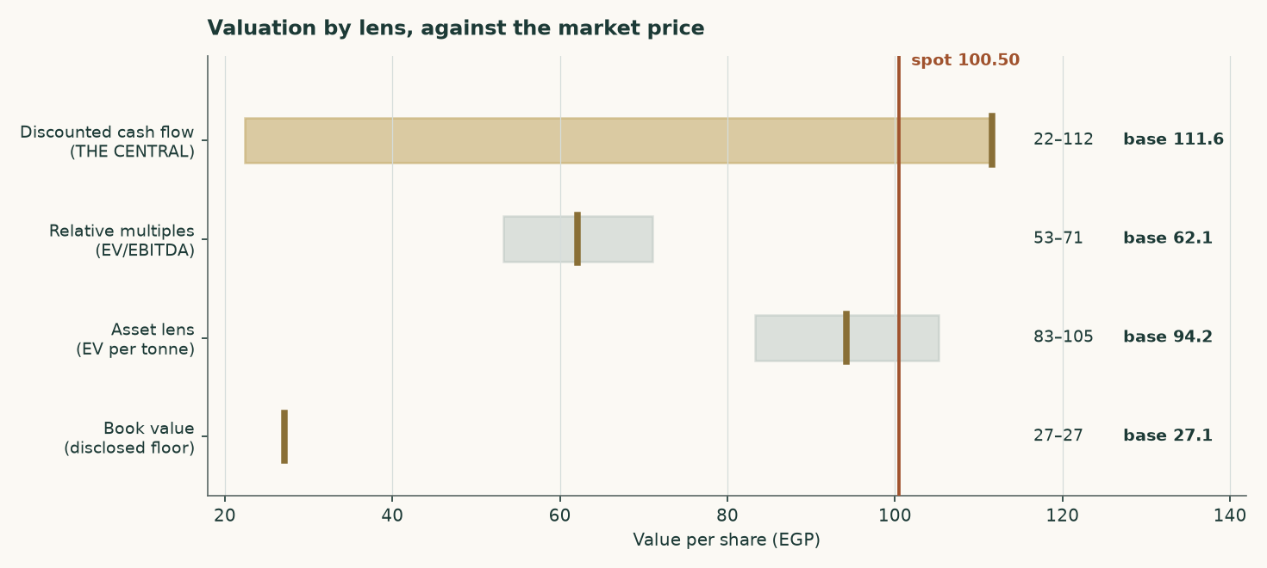
Figure 1 — Each lens as a range, with its base case marked, against the market price.
1 Fundamental valuation
PRICE DATE 2 September 2026 — the latest known close, the price this valuation is measured against. ISSUE DATE 10 September 2026 — the day this edition was issued. A recalibration issues a new document carrying its own issue date; the two dates are stated separately because they are not the same fact.
Sinai Cement is valued as a single operating company, not as a sum of parts, and the reason is worth stating before any number. Essentially all of its revenue is grey cement and clinker from one asset base. Its subsidiaries are a service arm and a trading arm feeding that same cement rather than separable businesses. Its balance sheet carries EGP 36.8 million of total debt against roughly EGP 5.2 billion of equity, which makes it net cash rather than leveraged. There is no lending book, no captive finance arm and no third-party asset management.
The one thing that could have made this a two-legged valuation has already been sold. Sinai Cement held 25.40% of Sinai White Portland Cement and disposed of it to Aalborg Portland, part of the Cementir group, for EUR 30 million, completing on 13 August 2024. There is no second leg left to value, so a single lens is not a simplification here — it is the accurate description.
One thing to fix in your head before reading the history. Profit after tax of EGP 3,072 million in FY2024 on revenue of EGP 6,428 million is a 48% net margin. No cement plant earns that from making cement. That year contains the Sinai White disposal gain of roughly EGP 1,517 million and treasury income of EGP 30 million. THE UNDERLYING FIGURE IS NOT THE REPORTED PROFIT LESS THE GAIN: it is operating profit of EGP 1,495 million plus that treasury income, taxed at the effective 32.0%, which is EGP 1,016 million — so FY2025 profit +125% rather than -26% as the headline comparison suggests.

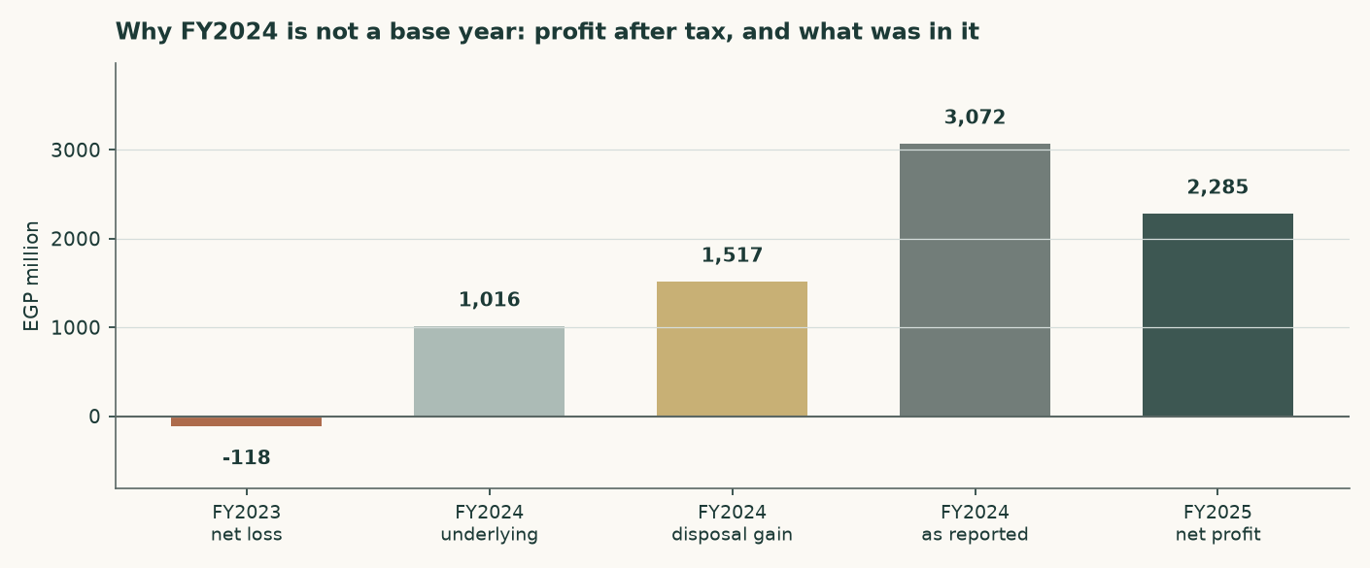
Figure 2 — Profit after tax across three years, and what FY2024 actually contained.
1.1 The cash-flow model — the primary lens, with the full waterfall
The discounted cash-flow model is the primary lens, and for this company it IS the answer rather than a share of one. It runs on a volume-and-price build off one plant, discounts each year at that year's own cost of capital, and capitalises a terminal value at a separately built terminal rate. An earlier edition averaged it with three other reads at weights that were typed rather than tested — and two of those three value a cement plant off reported accounting earnings and historical-cost book, which for an asset commissioned in 1997 and carried through a five-fold devaluation measures the accounting rather than the plant.
EGP million | FY2026E | FY2027E | FY2028E | FY2029E | FY2030E
Revenue | 10,550 | 12,015 | 13,316 | 14,560 | 15,848
EBITDA | 4,076 | 4,677 | 5,225 | 5,754 | 6,313
EBITDA margin | 38.6% | 38.9% | 39.2% | 39.5% | 39.8%
Depreciation & amortisation | 135 | 162 | 204 | 263 | 341
EBIT | 3,941 | 4,515 | 5,021 | 5,491 | 5,971
NOPAT (EBIT × (1 − t)) | 3,054 | 3,499 | 3,891 | 4,256 | 4,628
Depreciation and amortisation added back | 135 | 162 | 204 | 263 | 341
Capital expenditure | (352) | (699) | (1,094) | (1,533) | (2,022)
Change in working capital | (117) | (117) | (104) | (100) | (103)
Free cash flow to the firm | 1,134 | 2,846 | 2,898 | 2,887 | 2,844
Discount factor | 0.9484 | 0.8050 | 0.6536 | 0.5434 | 0.4597
Present value of free cash flow | 1,076 | 2,291 | 1,894 | 1,569 | 1,308

Table 1 — From revenue to the present value of free cash flow to the firm. Free cash flow is NOPAT plus book depreciation, less the capital actually spent and the working capital the growth absorbs — the SAME waterfall the terminal uses, so the two windows cannot mean different things by the same words. The first year is scaled to the 41.7% of FY2026E still unearned at the valuation date — that is the only line a reader cannot add up from the two above it. Every line is a live formula in the companion model.
Capital expenditure is the company's own run rate from its cash-flow statements — EGP 121 million in FY2023, 526 million in FY2024 and 262 million in FY2025 — escalated with domestic costs, and depreciation is the rate its own accounting-policies note discloses applied to the asset base that capital spending builds. An earlier edition charged depreciation at 4.6% of revenue falling to 4.2%, against a company that filed 1.35%.
The discount rate is not one number. Egypt's cost of capital today reflects a policy rate of 19.00% and a ten-year government yield of 23.00%, neither of which the central bank itself expects to persist — its own published target is 7%. Applying today's rate to a perpetuity would assert that Egypt never normalises. Each forecast year is therefore discounted at its own forward rate, sliding from the explicit-window cost of capital to the terminal one, and the terminal value is discounted using the identical cumulative factor as the year-five cash flow. One date, one price of time.
 | Year 1 | Year 2 | Year 3 | Year 4 | Year 5
Forward cost of capital | 28.96% | 24.83% | 21.52% | 19.04% | 17.38%
Cumulative discount factor | 0.9484 | 0.8050 | 0.6536 | 0.5434 | 0.4597

Table 2 — The discount schedule. The shape of the slide is inherited from the assumed borrowing-cost path rather than invented separately.
The enterprise-to-equity bridge
 | EGP million | Per share (EGP)
Present value of the explicit five years | 8,137 | 31.20
Present value of the terminal value | 17,421 | 66.80
Enterprise value | 25,558 | 98.00
Terminal value as a percentage of enterprise value | 68.2% | —
Plus net cash | 6,555 | 25.13
Less non-controlling interests in the subsidiaries | (120) | (0.46)
Equity value | 31,993 | 122.67
Market price | — | 100.50

Table 3 — The bridge. Net cash is ADDED, because this company holds more cash than debt, and the minority is deducted from EQUITY value rather than from enterprise value, on the share of profit the subsidiaries actually earn. A reviewer proposed EGP 2,008 million instead, 8% of enterprise value; on that reading the shares are worth EGP 115.43 rather than EGP 122.67, and the reasoning behind the adopted figure is in the input register. Terminal value is 68% of enterprise value.
The terminal value, and the judgement that decides it
The single most consequential judgement here is what return the company earns on capital in perpetuity, because that sets how much of its growth must be paid for. Measured on the books the answer is meaningless: the El Hassana plant was commissioned from 1997 and is carried at historic cost in pre-devaluation pounds, so dividing today's profit by that asset base returns a return no cement plant has ever earned.
The terminal return is therefore struck on REPLACEMENT cost. Building 3.80 million tonnes of grinding capacity costs about USD 130 per annual tonne, or EGP 24,824 million at today's exchange rate. On that basis the terminal return on capital is 19.9% and the reinvestment rate is 25.1% of profit. Growth is only real if someone pays today's price for the capacity that delivers it — and the same rule now governs the explicit forecast years, so both windows price growth identically.
And this is why growth does not help. Terminal return on capital of 19.9% sits BELOW the terminal cost of capital of 17.4%. Every extra point of perpetual growth must be bought with reinvestment that earns less than it costs, so raising terminal growth from 3% to 7% LOWERS fair value, from EGP 102.66 to EGP 122.67. That is not a modelling artefact; it is the correct reading of a mature plant in an oversupplied market. This company creates value by harvesting and distributing, not by growing.

1.2 The asset lens — enterprise value per tonne against replacement cost
For cement, the sector's own yardstick is enterprise value per annual tonne of capacity, and it is used here in place of a book-value lens. That substitution is deliberate: a plant commissioned in 1997 and carried through a five-fold devaluation has a book value that measures the accounting rather than the asset, so a price-to-book ratio on this company says almost nothing.
 | Value
Enterprise value at the market price (EGP mn) | 19,657
Capacity (million tonnes a year) | 3.8
Enterprise value per tonne, at market (USD/t) | 102.9
Replacement cost of new capacity (USD/t) | 130
Discount to replacement cost | -20.8%
Justified enterprise value per tonne (USD/t) | 95
Implied enterprise value at EGP 50.2 to the dollar (EGP mn) | 18,140
Plus net cash (EGP mn) | 6,555
Less non-controlling interests (EGP mn) | (120)
Divided by shares in issue (260.8 million)
Implied value per share (EGP) | 94.23

Table 5 — The asset lens. The justified figure sits below replacement cost because nobody pays build cost for capacity in a market with a structural surplus.
This is the most generous of the four lenses, and the reason is instructive rather than convenient: the market is paying roughly USD 81 per annual tonne for an operating, profitable, cash-generative plant, against USD 130 to build one. That gap is real. What it does not tell you is whether the plant will earn its cost of capital, which is what the cash-flow lens answers and answers less generously. The disagreement between these two lenses is the central question about this company, and section 1.5 does not average it away.
1.3 Relative multiples
The named Egyptian comparator is Misr Beni Suef Cement, which posted the same 2025 step-change: attributable profit up 373.7% to EGP 3.946 billion on sales of EGP 5.700 billion, trading at 6.44 times trailing earnings and 5.03 times EBITDA. Arabian Cement reported roughly EGP 3.6 billion of consolidated profit on the same industry conditions. The uniformity across the peer group is itself the finding: this was a sector event, not a company event, which is why the multiple here is applied to normalised rather than trailing earnings.
 | Value
FY2025 revenue (EGP mn) | 9,089
Haircut to a mid-cycle revenue base | -8.0%
Mid-cycle revenue base (EGP mn) | 8,362
Mid-cycle EBITDA margin | 27.8%
Normalised EBITDA (EGP mn) | 2,325
Justified EV/EBITDA | 4.2x
Implied enterprise value (EGP mn) | 9,763
Plus net cash (EGP mn) | 6,555
Less non-controlling interests (EGP mn) | (120)
Divided by shares in issue (260.8 million)
Implied value per share (EGP) | 62.11

Table 6 — The relative lens, struck at the peer's own EBITDA multiple with no premium for net cash, which the bridge adds separately.
1.4 Normalised earnings power — where this sits in the cycle
2025 was the first year since 2008 that Egypt's cement supply and demand balanced. Domestic consumption rose 13.4% to 54 million tonnes, production rose 18% to about 65 million tonnes, operating utilisation reached 98%, and prices roughly doubled after the competition authority permanently lifted production quotas in July 2025. Every one of those is a cyclical high, not a plateau.
 | Value
Normalised EBITDA (EGP mn) | 2,325
Less depreciation & amortisation (EGP mn) | (123)
Less tax at the statutory 22.5% (EGP mn) | (495)
Normalised NOPAT — the earnings capitalised (EGP mn) | 1,707
Treasury income on the cash pile, DELIBERATELY EXCLUDED | nil
Justified price/earnings | 7.0x
Capitalised earnings (EGP mn) | 11,946
Plus net cash (EGP mn) | 6,555
Less non-controlling interests (EGP mn) | (120)
Divided by shares in issue (260.8 million)
Implied value per share (EGP) | 70.48

Table 7 — Normalised earnings power. THIS READ IS RETIRED AS A LENS FOR THIS company and is shown for the record rather than carried into the answer: on a single-asset plant whose margin is an output of how hard the kilns run against a fixed cost stack, there is no mid-cycle earnings level the cash-flow lens does not already carry. It rests on a mid-cycle margin struck between the FY2024 outturn and the FY2025 peak. The income the cash pile earns is left out of the capitalised figure on purpose: the cash itself is added at face below, and capitalising its income as well would pay for the same asset twice.
1.5 Synthesis — one answer, and the reads that disagree with it
The lenses do not agree, and the disagreement is PUBLISHED rather than smoothed. The cash-flow lens is the answer for this class of company, at EGP 122.67. The replacement-cost read, which asks only what the plant itself is worth, lands at EGP 94.23. The enterprise multiple lands at EGP 62.11 and is the weakest of them, because the Egyptian listed peer set is two names and neither publishes an EBITDA series this study could measure a multiple from. Book value is a disclosed floor at EGP 27.12 and is never weighted into anything. The market price of EGP 100.50 sits between the multiple and the cash-flow answer.
An earlier edition averaged four reads at typed weights and published the average. That blend would read EGP 95.67 here. It is retired: weights that were chosen, written down and inherited are free parameters that have never cleared an out-of-sample test, and a number produced by averaging several methods is not more robust than the best of them — it is a new method, importing every weakness of the weakest lens at whatever weight somebody typed. A normalised-earnings read (EGP 70.48) carried 23% of that blend and is dropped entirely: on a single-asset plant whose margin is an output of how hard the kilns run, there is no mid-cycle earnings level the cash-flow lens does not already carry.
Lens | Bear | Base | Bull | Role | What it is measuring
DCF (cash flow) | 22.29 | 122.67 | 122.67 | PRIMARY — this is the central | What the cash flows are worth, discounted
Relative multiples | 53.20 | 62.11 | 71.02 | cross-check | What an enterprise multiple pays for the same EBITDA
Asset / replacement cost | 83.24 | 94.23 | 105.21 | cross-check | What the plant itself is worth
Book value (disclosed floor) | 27.12 | 27.12 | 27.12 | disclosed floor, never weighted | What the accounts carry the plant at
MEMO — the retired four-lens blend | — | 95.67 | — | retired | What the previous architecture would have printed

Table 8 — The lenses side by side. NOTHING IS WEIGHTED: the cash-flow read is the central and the others are cross-checks. Its bear corner flexes the operating margin down to 8.7% and holds the macro path still. THAT IS NOT THE LOWEST MARGIN THE COMPANY HAS FILED, which is 6.6%: at that margin terminal free cash flow on the disclosed twenty-year machinery life is negative, and a going concern consuming cash for ever is a liquidation rather than a lower valuation — so the bound published is the lowest margin at which the going-concern reading survives, and below it the disclosed book value is the floor. Its bull corner is the base case, because the forecast already opens above the best margin the company has ever filed and this driver has no upside left against its own record.
1.6 The drivers — a bottom-up build from kilns and tonnes
Revenue and EBITDA are not assumed here. They are built from physical units, and the margin is what falls out at the bottom rather than what is typed in at the top.
 | FY2025A | FY2026E | FY2027E | FY2028E | FY2029E | FY2030E
Kiln utilisation | 71.0% | 71.7% | 73.5% | 75.3% | 77.2% | 79.1%
Clinker produced (Mt) | 1.825 | 1.843 | 1.889 | 1.935 | 1.984 | 2.033
Cement produced (Mt) | 2.698 | 2.725 | 2.793 | 2.861 | 2.934 | 3.006
Domestic volume (Mt) | 2.374 | 2.370 | 2.402 | 2.432 | 2.464 | 2.495
Export volume (Mt) | 0.324 | 0.354 | 0.391 | 0.429 | 0.469 | 0.511
Realised price (EGP/t) | 3,372 | 3,872 | 4,302 | 4,654 | 4,963 | 5,272
Revenue (EGP mn) | 9,098 | 10,550 | 12,015 | 13,316 | 14,560 | 15,848

Table 9 — The volume and price chain. The clinker factor of 0.676 tonnes of clinker per tonne of cement is anchored on the plant register, which publishes both capacities — 2.57Mt of kiln clinker against 3.80Mt of grinding — so it is observed rather than assumed.
EGP per tonne of cement | FY2025A | FY2026E | FY2027E | FY2028E | FY2029E | FY2030E
Materials, fuel, power and packing | 1,331 | 1,504 | 1,665 | 1,794 | 1,907 | 2,018
Transport, loading and export costs | 286 | 331 | 371 | 404 | 435 | 465
Total variable cost | 1,617 | 1,835 | 2,036 | 2,199 | 2,342 | 2,484

Table 10 — The cost stack, on the two lines the company itself discloses. The first is note 24 of the audited accounts, "Raw materials, Supplies, fuel, power, packing sacks"; the second is note 25's transport and export costs together with note 24's own loading charge. THE ACCOUNTS DO NOT SPLIT THE FIRST LINE FURTHER, so neither does this model: an earlier edition built it from four industry rules of thumb that came to 29% less than the figure the company filed. The dollar-linked share of that line is estimated at 48% and is the one part of this table the accounts do not evidence; it is sensitised in section 1.9.
EGP million | FY2025A | FY2026E | FY2027E | FY2028E | FY2029E | FY2030E
Revenue | 9,098 | 10,550 | 12,015 | 13,316 | 14,560 | 15,848
Variable cost | 4,363 | 5,000 | 5,687 | 6,291 | 6,871 | 7,465
Fixed cost | 1,271 | 1,474 | 1,651 | 1,800 | 1,935 | 2,070
EBITDA — an OUTPUT | 3,464 | 4,076 | 4,677 | 5,225 | 5,754 | 6,313
EBITDA margin | 38.1% | 38.6% | 38.9% | 39.2% | 39.5% | 39.8%

Table 11 — And the result. The FY2026 margin is not chosen; it emerges from the cost stack meeting the price path.
Does the build reproduce the company? A test that can fail
A driver build is only worth having if it can be wrong. Nothing above was solved to match the accounts — every cost driver is an independent physical or market norm — so the comparison below is a genuine test rather than a restatement.
 | Bottom-up build | The company | Difference
FY2025 revenue (EGP mn) | 9,098 | 9,089 | +0.10%
FY2025 EBITDA (EGP mn) | 3,464 | 3,455 | +0.26%

Table 12 — The validation. The right-hand column is EBITDA implied by closing the disclosed profit at the effective tax rate on the reported cash balance.
It is worth being explicit about why this matters. A build that solved realised price as revenue divided by volume would reproduce revenue exactly — for any volume assumption whatsoever — because price would be the plug. That is an identity, not a check. Here volume comes from capacity and utilisation, price comes from the market, and revenue is the product; if either were wrong the difference above would show it.
The price path deserves scrutiny. Nominal realised prices rise 4.5% to 6.0% a year across the forecast. Against Egyptian inflation running near 14% in 2026 and easing toward the central bank's 7% and then 5% targets, that is a REAL price decline in every single year — which is what a supply glut does to pricing power.
1.7 The crux — the cycle first, the capacity revival second, the cash third
Three things decide this valuation, in this order.
- The structural surplus. Egypt can already make far more cement than it uses. Nameplate capacity is 76 million tonnes a year against domestic consumption of 54 million. Exports of 18.5 million tonnes absorb much of the gap, but they fell about 6% in 2025 even as the domestic market boomed.
- The revival programme. Between seven and nine dormant production lines are under study for revival, potentially adding 12.6 million tonnes from the second half of 2026 — about 23% of domestic consumption, arriving inside the forecast window. Restarting a mothballed line costs a fraction of building a new one, which is precisely why the threat is credible and why the asset lens should not be read as a floor.
- The cash. Net cash of EGP 6,555 million is 37% of the market capitalisation. It is why profit after tax exceeds EBITDA — a cash pile earning Egyptian policy rates throws off more than the plant does in a weak year — and it is why the equity is far less risky than the operating business alone. It is also the lens with the most uncertainty attached, for reasons section 7 sets out.
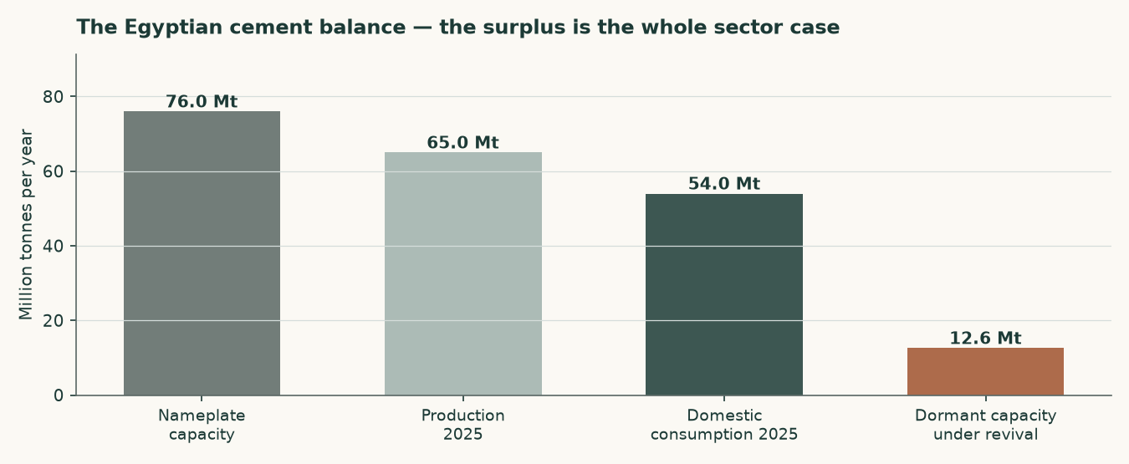
Figure 3 — The Egyptian cement balance. The surplus, and what is queuing to join it.
1.8 Macro and country — rates, the pound, and the sourced cost of capital
The cost of equity starts from the Egyptian ten-year government yield of 23.00%. That yield is high largely because of Egypt's own sovereign default risk, so charging a country equity premium on top of it without adjustment would count that risk twice. The sovereign default spread is therefore netted out of the risk-free rate before the premium is added.
 | Explicit window | Terminal
Risk-free rate | 23.00% | 10.50%
Less sovereign default spread | -3.40% | —
Normalised risk-free rate | 19.60% | 10.50%
Beta | 1.00 | 1.00
Equity risk premium | 9.41% | 7.00%
Cost of equity | 29.01% | 18.82%
Cost of debt after tax | 19.38% | 11.62%
Debt weight | 0.52% | 20.00%
Weighted average cost of capital | 28.96% | 17.38%

Table 10 — The cost of capital, built from its components. The retired construction that leaves the sovereign spread in the risk-free rate would give a cost of equity of 32.41%, some 340 basis points higher.
The terminal rates are house views, and are labelled as such rather than presented as observations. The terminal risk-free rate of 10.5% is the central bank's own stated medium-term inflation target of 5% plus a standard emerging-market real-rate convention of about 5.5 points. The terminal cost of debt of 15% is the midpoint of Egypt's long-run corporate borrowing range. Neither is reverse-engineered from a target price.
The beta, and why it is not the regression's answer
The shares are regressed against raw_indices/EG/EGX30.csv — the published index of the exchange they are listed on, read to 2026-09-08 — on weekly returns struck on that exchange's real trading week (W-THU), over 4.94 years from 2021-09-23 to 2026-09-03. The estimator carries a lead and a lag alongside the contemporaneous term, because a thinly traded share responds to the market late and a same-week-only regression reads that delay as low sensitivity; the beta below is the SUM of the three and not a contemporaneous coefficient with a correction bolted on afterwards.
It returns 0.59 with an R-squared of 0.024 over 255 observations and a standard error of 0.278. THE REGRESSION IS NOT USABLE and its answer is not used: R^2=0.024 < minimum 0.05 — index barely explains the stock's returns. A same-country peer beta cannot be assembled either — the only other Egyptian cement issuer this house holds a price history for is ARCC, and its own conforming regression fails the same test, so a peer beta would be the same unusable number wearing another company's name.
A beta of 1.00 is therefore adopted, and it is corroborated rather than assumed. It sits inside the regression's own 90% interval of 0.13 to 1.05. The Blume adjustment toward the market — the standard correction for the tendency of estimated betas to revert to one — carries the point estimate to 0.73 from the same direction. And a capital-intensive materials producer would normally sit between 1.0 and 1.5; this one sits at the bottom of that band because it carries no financial leverage at all. The point estimate of 0.59 is published beside the adopted figure and is not used.
A PREVIOUS EDITION REGRESSED AGAINST SOMETHING ELSE, and it is named here rather than quietly replaced. It used a 32-name equal-weight composite of the covered EGX library, SCEM excluded from its own index, which returned 0.49 on an R-squared of 0.038 — 0.11 below the conforming answer. A constituent composite is a coverage artefact rather than a market: it changes whenever a stock is posted, it mixes exchanges inside one market code, and it shares constituents with the panel it prices. SIGCM clause 6 calls it a hard fail, not a fallback, and the published index of the exchange the stock is listed on is held in this repository, so there was never a sourcing obstacle — only an inherited pattern.
Beta | 0.60 | 0.80 | 1.00 (adopted) | 1.15 | 1.30
Fair value per share (EGP) | 157.90 | 156.86 | 137.22 | 122.67 | 106.77

Table 11 — Beta sensitivity across the confidence interval and fixed anchors.
1.9 Sensitivity — the discount rate, the growth, the margin and the replacement cost
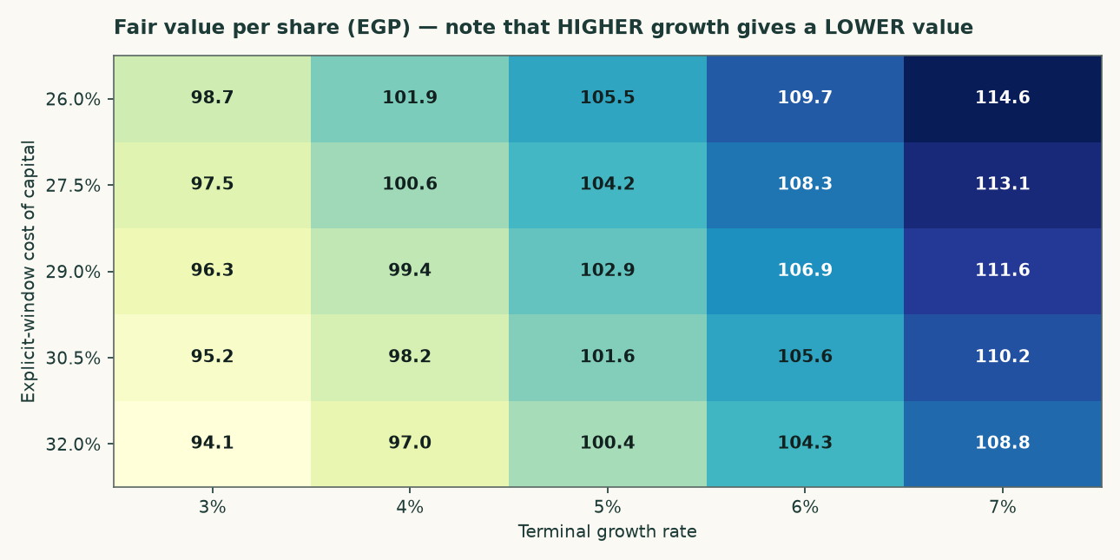
Figure 4 — Fair value across the cost of capital and the terminal growth rate. Reading left to right, higher growth lowers the value.
Explicit cost of capital | g = 3% | g = 4% | g = 5% | g = 6% | g = 7%
25.96% | 105.27 | 109.31 | 113.99 | 119.49 | 126.06
27.46% | 103.95 | 107.91 | 112.50 | 117.90 | 124.34
28.96% | 102.66 | 106.54 | 111.05 | 116.35 | 122.67
30.46% | 101.40 | 105.21 | 109.64 | 114.84 | 121.04
31.96% | 100.17 | 103.91 | 108.26 | 113.36 | 119.45

Table 12 — The same grid in figures.
Net cash (EGP mn) | 5,055 | 5,805 | 6,555 | 7,305 | 8,055
Fair value per share (EGP) | 116.92 | 119.79 | 122.67 | 125.54 | 128.42

Table 13 — Net cash. This is the largest single uncertainty in the valuation and it is now sensitised: the balance is taken from the reported accounts rather than inferred from the income it earns, and the grid shows what a EGP 1.5bn error in either direction is worth.
EBITDA margin shift | -4% | -2% | +0% | +2% | +4%
Fair value per share (EGP) | 109.26 | 115.96 | 122.67 | 129.37 | 136.08

Table 14 — Margin sensitivity. Each two-point change in the EBITDA margin is worth roughly EGP 4.50 a share.
2 Technical and price structure
The shares closed at EGP 100.50 on 2 September 2026. The price history is long and unusually eventful: EGP 3.62 at the 2021 low, still under EGP 10 through 2023, then a run to EGP 45 in 2024, EGP 75 in 2025 and a 2026 high of EGP 87.99. Over the five years to date the shares have risen more than tenfold.
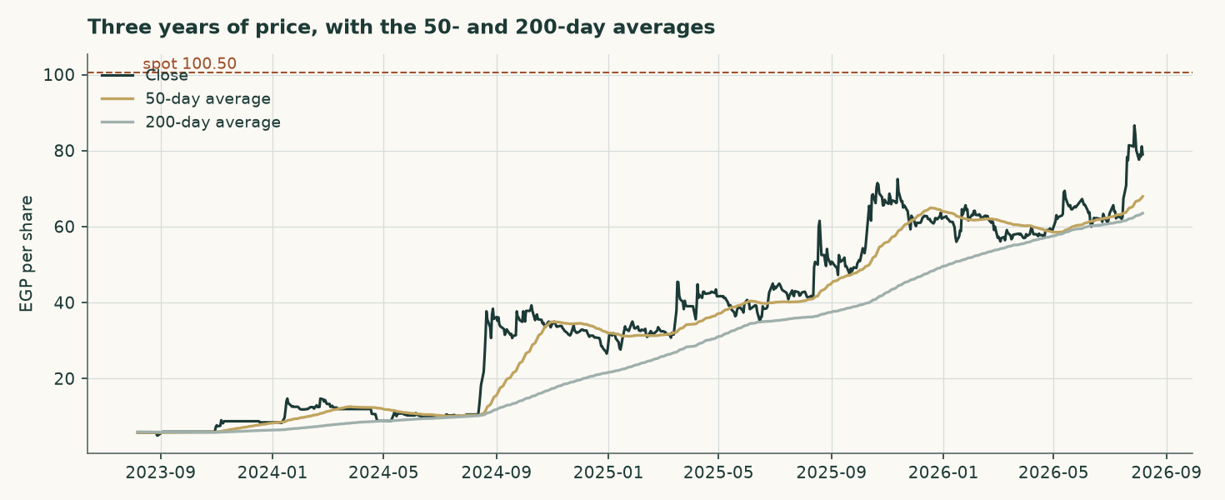
Figure 5 — Three years of closing prices with the 50- and 200-day moving averages.
Two structural features matter more than any level. The first is liquidity: the stock prints an unchanged close on 29.3% of sessions, which is three and a half times the median for covered Egyptian names. Thin trading widens spreads, delays price discovery and makes any statistical read of this security less reliable than the same read on a liquid one. The second is the free float. Vicat holds 77.6%, leaving 22.4% in public hands, and in July 2025 Vicat filed a mandatory offer for that remainder at EGP 41.00 a share. The market price is now roughly double the offer price, so the offer is best read as a floor that the market has long since left behind rather than as a valuation.
3 A probabilistic price map
Read this before the chart. Over 57 resolved three-month forecasts on this security the price finished inside the 90% band 93% of the time, and inside the middle 50% band 70% of the time. The wide band is doing what it promises; the middle band has been catching rather more than half, so the map below is better read as a rough guide to where the price could plausibly be than as a fine probability statement. The band this map draws runs about 1.38 times as wide as a simple carry-anchored benchmark's, which is what real Egyptian tail risk costs and is published rather than tuned away. The cause of the extra width on THIS name is specific: it prints an unchanged close on 29% of sessions, and on a security that does not trade every session a volatility estimate collapses during quiet stretches and the band stays wide enough for the jumps that follow.

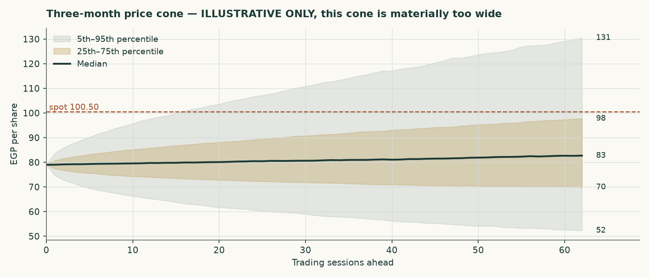
Figure 6 — The three-month cone. Illustrative only.
Horizon | 5th | 25th | Median | 75th | 95th | Above spot
One month | 62.14 | 72.94 | 80.17 | 88.18 | 103.50 | 54%
Three months | 52.13 | 69.75 | 82.78 | 98.07 | 131.35 | 57%

Table 15 — Percentiles of the simulated distribution, in EGP per share.
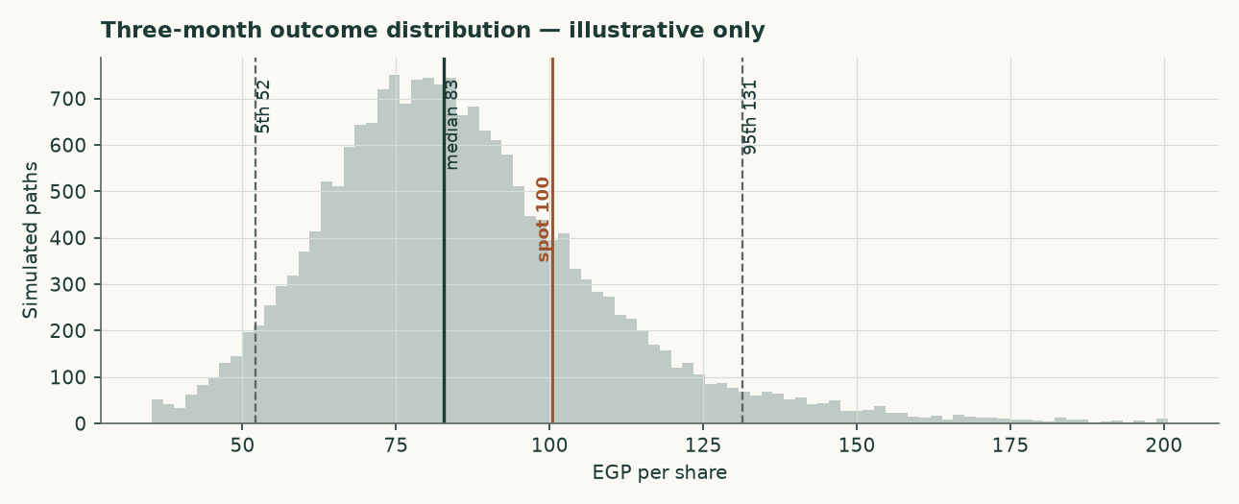
Figure 7 — The three-month outcome distribution.
4 Comparison of the lenses
Set against each other the reads describe a company whose cash flows, on the operating improvement its own filings have already printed, are worth more than either the plant or an enterprise multiple would pay for. Each is stated with the condition that has to hold for it to be the right one, so a reader who rejects a condition can see immediately which answer goes with it.
Lens | Role | Value (EGP) | Versus spot | What would have to be true for it to be right
DCF (cash flow) | PRIMARY — this is the central | 122.67 | +22.1% | Utilisation keeps climbing toward 79% and the real price spread per tonne holds
Relative multiples | cross-check | 62.11 | -38.2% | An enterprise multiple near 4x on a normalised margin is what this asset is worth
Asset / replacement cost | cross-check | 94.23 | -6.2% | Capacity is scarce enough that build cost, not cash flow, anchors value
Book value (disclosed floor) | disclosed floor, never weighted | 27.12 | -73.0% | Nothing — it is a floor, and a 1997 plant carried through a five-fold devaluation is worth more than its historic cost whatever else is true
MEMO — normalised earnings, retired for this class | retired | 70.48 | -29.9% | FY2025 was a cyclical peak rather than a new operating level — a claim the cash-flow lens tests directly through utilisation and price

Table 16 — What each lens is betting on. The cash-flow read is the answer and the others are cross-checks; none of them is weighted into it.
5 Catalysts to watch
- The revival programme. Whether the seven to nine dormant lines actually restart, and how much of the 12.6 million tonnes reaches the market. This is the single largest swing factor and it lands inside the forecast window.
- The first post-quota pricing year. FY2026 realised prices are the first clean read of what an unregulated Egyptian cement market clears at. Published estimates point to EGP 3,600–3,620 a tonne on about 1% demand growth.
- A dividend declaration. The company has no dividend on record and its own statements confirm it twice over, to the pound: equity of EGP 3,735.80 million at 31 December 2024 plus the year's profit of 2,284.54 million is exactly the filed 6,020.34 million, and that plus the reviewed quarter's 1,114.48 million is exactly the filed 7,134.82 million at 31 March 2026. Nothing has been distributed. An earlier edition read a substantial distribution out of balance-sheet arithmetic and called it the largest single uncertainty in the bridge; it was reading a figure it had not taken from the statements. What remains genuinely open is whether the cash is ever returned, and a first declaration would answer it.
- Vicat's intentions for the float. The 2025 mandatory offer at EGP 41.00 lapsed well below the market. Any renewed approach, or a move to delist, changes the minority shareholder's position entirely.
- The central bank's easing path. A faster fall in Egyptian rates lifts the valuation through the discount rate but reduces the treasury income that currently flatters the earnings line. The two effects partly offset.
- Energy costs. Egypt's phased subsidy reform raises the cash cost of clinker independently of the global fuel price, and cement is an energy-conversion business before it is anything else.
6 Reading the probability zones
The distribution in section 3 is too wide to support fine probability statements, and the honest way to use it is as a rough map of where the price could plausibly be, not as a calibrated forecast. Read against the fundamental work, three zones are worth naming.
Zone | Range (EGP) | What it would mean
Below the replacement-cost read | under 94.23 | The plant is valued below what it would cost to build. Where the price sits today, and the condition for it is that the operating improvement the company has already filed does not hold
Between replacement cost and the cash-flow read | 94.23 – 122.67 | The market has come to price the utilisation and margin the filings already show, but not the whole of the forecast path
Above the cash-flow read | over 122.67 | The market is paying for more than this study forecasts — a faster utilisation ramp, a wider real spread per tonne, or a lower cost of capital than the central bank's own easing path implies

Table 17 — Zones read against the fundamental work rather than against the simulated distribution.
7 Caveats and what would change our mind
This edition is built entirely on the company's own audited financial statements, which are published as six PDFs on its own website. Every caveat below is a limit of what those statements disclose, not a limit of what could be obtained.
- This issuer discloses no volume, and that is the largest gap in the build. Not a tonne of clinker, not a tonne of cement, not an installed capacity and not a utilisation rate appears anywhere in any of the six published filings. The cost of sales, selling and administrative notes are broken out line by line and are used here as disclosed, so the cost side is built from the company's own figures; the physical quantities the unit build needs come from the plant register and the trade press and are industry-ring forecast drivers, not the company's own reported numbers. Capacity and the kiln utilisation path are the single largest judgement in this study and are priced both ways in the contested-judgements table.
- The equity roll closes, and the earlier edition's gap was a sourcing error rather than a distribution. Rolling FY2024 equity forward by FY2025 profit with no distribution gives EGP 6,020.34 million against the filed EGP 6,020.34 million — the two agree to the pound. Earlier editions of this study showed a gap here and read it as a distribution the statements do not itemise, because the FY2024 totals they carried came from trade press relaying the filing rather than from the filing itself; on the audited figures there is nothing left to explain. Nothing in the valuation turns on it either way, since the cash the valuation adds back is read off the reviewed balance sheet directly.
- The forecast margin is an output of a disclosed cost stack, and it rises. FY2026 opens at 38.6% against a filed FY2025 of 38.0% and a reviewed first quarter of 2026 that came in ahead of it. The rise is the output of holding the disclosed cost lines flat in real terms against a volume path that grows; it is not an assumed margin, and a reader who disagrees with the volume path should read the utilisation judgement rather than this line.
- The terminal rests on a disclosed 20-year machinery life, and the choice is worth more than five per cent. Note 3/2 discloses depreciation rates rather than lives, and two of its five asset classes are ranges. Machinery is disclosed as a single 5% rate and is 69.5% of the gross cost the replacement-cost base represents, so its 20-year life is adopted without averaging anything. A whole-plant blend across all five classes would be longer and is published beside it in the contested-judgements table. The two ordinary ways of blending disagree by a quarter on the same disclosed table, which is why the scalar is preferred to either.
- At this company's worst filed margin the terminal is a liquidation, not a lower valuation. The bear bound of the range in section 1.9 is not the FY2023 EBITDA margin of 6.6%. At that margin terminal free cash flow on the disclosed maintenance charge is negative, and a going concern that consumes cash for ever is not a business to be discounted at a lower value — it is a liquidation and would have to be valued as one. The bound published is the lowest margin at which the going-concern reading survives, and below it the disclosed book value is the floor.
- The beta is a tier-3 default on a genuine gate failure. The own-stock regression against EGX30 returns an R-squared of 0.038 against the 0.05 floor, and no Egyptian listed cement peer carries a price series in the library, so no peer beta can be re-levered either. A beta of 1.0 is used, disclosed with the diagnostics that triggered it, and it is worth more than five per cent of value — it is in the contested-judgements table for that reason.
- The method has been walk-forward tested on this company's own history, and the run is LIGHT. Five sourceable fiscal years support five origins at horizons of one to three years, nine resolved driver-cells. The method beat both naive benchmarks — holding every line flat, and extrapolating each line's own trailing growth — at every horizon tested. It also forecast BELOW what the company reported on eleven of thirteen drivers, and the far-year ranges in Appendix A carry that finding rather than hiding it. No correction was promoted from the run: nine cells admit no era boundary large enough to test whether any bias is stable, so every bias it measured is recorded and acted on by nobody.
- The price map is wider than the market average, and it says so. Over 57 resolved three-month forecasts the 90% band held 93% of the time and the middle band 70%, so the wide band does what it promises and the middle one has been generous. The band runs about 1.38 times as wide as a simple carry-anchored benchmark, which is what this market's tail risk costs. It carries no weight in the fundamental valuation and is not an input to it.
- Concentration of control. Vicat holds 77.6%. A minority shareholder in an Egyptian company with a float of 22.4% has limited influence over dividend policy, related-party terms or the timing of any exit, and the shares trade thinly as a direct consequence.
- A disclosed finite corporate term. Note 1 states the company's term is twenty-five years, ending on 4 September 2032, while this valuation capitalises a perpetuity. Egyptian company terms are routinely extended and no non-renewal is disclosed, but the disclosure is recorded rather than passed over.
- What would change our mind, upward. A declared dividend confirming the cash is distributable; cancellation or material delay of the capacity-revival programme; realised prices holding above EGP 3,900 a tonne into 2027; or evidence that replacement cost in Egypt is materially above USD 130 per tonne.
- What would change our mind, downward. Restarted capacity reaching the market faster than expected; realised prices falling in nominal terms rather than merely in real terms; a debt-funded expansion into the surplus; or a distribution that takes the cash off the balance sheet the bridge stands on.

Appendix A Financial statements
Three years of history and a five-year forecast. Figures shown in green in the companion model are disclosed; the remainder are derived and are marked here.
The far forecast years, published as a range
The method behind this forecast was tested on this company's own history — five origins, horizons of one to three years, nine resolved driver-cells, every figure from the company's own audited statements. The table below carries what that record actually supports for the third forecast year rather than a single figure. The bounds are the RANGE OF THE OBSERVED OUTCOMES, not percentiles: with two observations at three years a percentile would be a statistic invented for the occasion.
Forecast year | Low | Point | High | Tested on
FY2028E | 12,272 | 13,316 | 14,449 | 2 resolved three-year forecasts
FY2028E EBITDA | 4,815 | 5,225 | 5,670 | the same revenue band, applied to the margin path

Revenue for the third forecast year, in EGP million, with the band this company's own record supports around it. The band is centred on the point projection: over the tested horizons this method came in BELOW what the company reported on eleven of thirteen drivers, and the width here is what that record measured rather than a symmetric allowance.
THE FOURTH AND FIFTH FORECAST YEARS CARRY NO SUCH BAND, and that is stated rather than filled. Five sourceable fiscal years give a longest resolved horizon of three, so nothing in this company's own record speaks to a four- or five-year forecast. Borrowing the three-year band and printing it against FY2030E would be presenting a measurement that was never made.
Income statement (EGP million)
 | FY2023 | FY2024 | FY2025 | FY2026E | FY2027E | FY2028E | FY2029E | FY2030E
Revenue (disclosed) | 4,285 | 6,428 | 9,089 | 10,550 | 12,015 | 13,316 | 14,560 | 15,848
EBITDA (derived) | 284 | 1,585 | 3,455 | 4,076 | 4,677 | 5,225 | 5,754 | 6,313
EBITDA margin | 6.6% | 24.7% | 38.0% | 38.6% | 38.9% | 39.2% | 39.5% | 39.8%
Depreciation & amortisation (derived) | 87 | 91 | 123 | 135 | 162 | 204 | 263 | 341
EBIT (derived) | 196 | 1,495 | 3,333 | 3,941 | 4,515 | 5,021 | 5,491 | 5,971
Treasury income (derived) | 7 | 30 | 172 | 905 | 1,391 | 1,816 | 2,216 | 2,627
Gain on disposal | — | 1,517 | — | — | — | — | — | —
Profit after tax (disclosed / forecast) | -118 | 3,072 | 2,285 | 3,755 | 4,578 | 5,299 | 5,973 | 6,664
Earnings per share (EGP) | -0.45 | 11.78 | 8.76 | 14.40 | 17.55 | 20.32 | 22.90 | 25.55

Table A1 — Income statement. FY2024 contains the disposal gain and is not a base year for normalisation.
Balance sheet (EGP million)
 | FY2023 | FY2024 | FY2025 | FY2026E | FY2027E | FY2028E | FY2029E | FY2030E
Cash and equivalents | 2,348 | 6,708 | 6,708 | 8,184 | 12,108 | 16,413 | 21,017 | 25,897
Gross debt | 137.6 | 137.6 | 137.6 | 137.6 | 137.6 | 137.6 | 137.6 | 137.6
Net cash | 2,210 | 6,570 | 6,555 | 8,046 | 11,970 | 16,275 | 20,879 | 25,760
Shareholders' equity | -614 | 3,736 | 6,020 | 9,776 | 14,353 | 19,652 | 25,625 | 32,288
Book value per share (EGP) | -2.35 | 14.32 | 27.12 | 37.48 | 55.03 | 75.35 | 98.25 | 123.80

Table A2 — Balance sheet. FY2024 is the disclosed column, taken from the audited statements for that year: total assets of EGP 5,695.6 million less total liabilities of EGP 1,959.8 million closes to equity of EGP 3,735.8 million exactly, and that equity is FY2023's EGP -614.0 million plus the year's profit of EGP 3,072.4 million plus the EGP 1,277.5 million paid in under the capital increase. FY2023 equity is negative because losses had exhausted it before that increase.
Cash flow (EGP million)
 | FY2026E | FY2027E | FY2028E | FY2029E | FY2030E
NOPAT | 3,054 | 3,499 | 3,891 | 4,256 | 4,628
Plus depreciation & amortisation | 135 | 162 | 204 | 263 | 341
Less capital expenditure | -352 | -699 | -1,094 | -1,533 | -2,022
Less change in working capital | -117 | -117 | -104 | -100 | -103
Free cash flow to the firm | 1,134 | 2,846 | 2,898 | 2,887 | 2,844
Dividends paid | -0 | -0 | -0 | -0 | -0

Table A3 — Cash flow, linked line for line to the valuation waterfall.

Appendix B Peer set, sector structure, and risks
 | Value
Misr Beni Suef — FY2025 net sales (EGP mn) | 5,700
Misr Beni Suef — FY2025 attributable profit (EGP mn) | 3,946
Misr Beni Suef — earnings per share (EGP) | 61.25
Misr Beni Suef — market capitalisation (EGP mn) | 13,730
Misr Beni Suef — trailing price/earnings | 3.48x
Misr Beni Suef — EV/EBITDA | 5.03x
Arabian Cement — FY2025 consolidated profit (EGP mn) | 3,600

Table B1 — The named Egyptian listed comparators.
 | Million tonnes a year
Egyptian nameplate capacity | 76.0
Production, 2025 | 65.0
Domestic consumption, 2025 | 54.0
Exports, 2025 | 18.5
Dormant capacity under revival from 2H-2026 | 12.6
Sinai Cement capacity | 3.8
Sinai Cement share of Egyptian capacity | 5.0%
Revival capacity as a share of consumption | 23.3%

Table B2 — Sector structure. The surplus between capacity and consumption is the sector case in one number.
Principal risks
- Supply. A structural surplus of capacity over domestic consumption, with a large block of dormant capacity able to restart cheaply.
- Concentration. One plant, one country, one product. There is no diversification anywhere in this business.
- Location. North Sinai carries a security and logistics profile that most Egyptian industrial assets do not, and the plant is distant from the main demand centres.
- Energy. Phased subsidy reform raises the cash cost of production independently of global fuel prices.
- Currency. Revenue and costs are overwhelmingly in Egyptian pounds, but equipment, spares and any future capacity are priced in hard currency.
- Minority position. A 22.4% float under a 77.6% controlling shareholder, in a security that does not trade on nearly a third of sessions.

Appendix C The expert valuation panel
Three independent valuations of the same company, each built by a different method and each stated with the specific evidence that would prove it wrong. They are not averaged: the disagreement between them is the point.
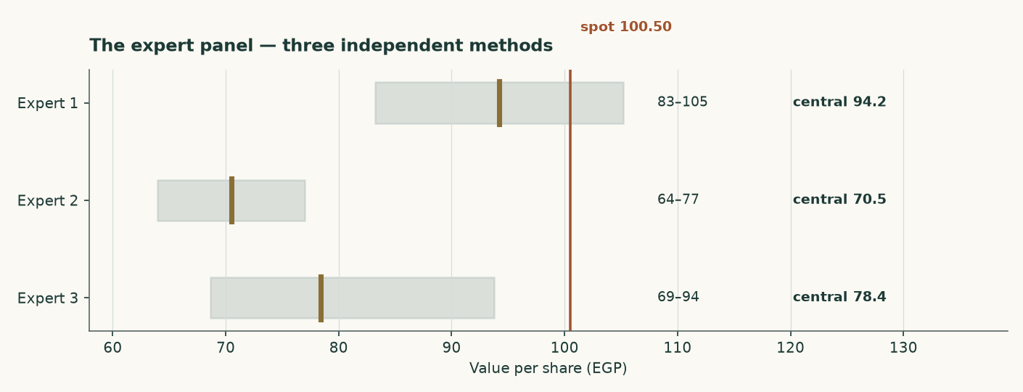
Figure C1 — The three panel valuations against the market price.
Expert 1 — Replacement-cost industrialist
Valuation: EGP 83.24 to EGP 105.21, central EGP 94.23 (-6.2% against the market price of EGP 100.50).
Values the plant, not the earnings stream. A 3.8Mt grey-cement plant costs about USD 130 per annual tonne to build; nobody pays replacement cost for capacity in a market carrying 76Mt against 54Mt of consumption. The market pays USD 103/t.
What would prove this wrong: Find an Egyptian line built, bought or restarted below USD 95 per annual tonne. The 12.6Mt revival programme is the live test: restarting a mothballed line costs a fraction of building one, which is why this lens is a ceiling and not a floor — and why it now carries 8% of the weight rather than 15%.
Expert 2 — Mid-cycle earnings-power analyst
Valuation: EGP 63.93 to EGP 77.02, central EGP 70.48 (-29.9% against the market price of EGP 100.50).
Refuses to capitalise a peak, and now refuses it on BOTH legs: the margin is normalised to 27.8% and the revenue base is cut 8% because FY2025 embeds the post-quota price spike.
What would prove this wrong: Two consecutive years of realised prices above EGP 3,900/t WITH the revival proceeding would prove the mid-cycle base too low.
Expert 3 — Cash-return and distribution investor
Valuation: EGP 68.62 to EGP 93.74, central EGP 78.39 (-22.0% against the market price of EGP 100.50).
Starts from the balance sheet. Net cash of EGP 6.6bn is 25% of the market capitalisation and 20% of fair equity value. Terminal return on capital of 19.9% sits below the 17.4% cost of capital, so growth destroys value and the right policy is to harvest and distribute.
What would prove this wrong: The lens rests on the cash being distributable. Vicat holds 77.6% and a minority cannot force a dividend. If none is declared on FY2026 profits, or the cash funds expansion into a glut, it is worth less than face.
 | Low (EGP) | Central (EGP) | High (EGP) | Versus spot
Expert 1 — Replacement-cost industrialist | 83.24 | 94.23 | 105.21 | -6.2%
Expert 2 — Mid-cycle earnings-power analyst | 63.93 | 70.48 | 77.02 | -29.9%
Expert 3 — Cash-return and distribution investor | 68.62 | 78.39 | 93.74 | -22.0%
Panel median | — | 78.39 | — | -22.0%

Table C1 — The panel. The median sits close to the weighted central of the four principal lenses, which is a coincidence of construction rather than a confirmation — both are looking at the same company through overlapping methods.

Testahil · Independent valuation research · Educational analysis, not investment advice. No rating and no price target is expressed or implied.

