Testahil · Independent Valuation Study — Educational Analysis Edition of 5 September 2026 · Not investment advice

Independent Valuation Study — Educational Analysis
Saudi Telecom Company (Tadawul: 7010)
Fundamental analysis · Technical analysis · Monte Carlo simulation — one integrated read · Edition of 5 September 2026
Anchor: SAR 43.86 (2026-09-03 close) · 4,993.0 mn shares (issued capital over par, less treasury) · market capitalisation SAR 219.0 bn · the Kingdom’s incumbent operator and the largest MENA telecom by market value: stc KSA (consumer, enterprise, wholesale — ~57% mobile share, the national fibre and 5G backbone) plus subsidiaries (solutions by stc 79%, stc bank 85%, stc Kuwait 51.8%, stc Bahrain, center3 data centres, sirar, iot squared) and minority stakes — 43.06% of the PIF-controlled tower company (TAWAL/Digital Infrastructure) and 9.97% of Telefónica · reporting currency SAR (pegged to USD at 3.75) · valued against the latest known close of 2026-09-03, with the price map struck on the last session in the price library, 2026-08-31 · primary lens: going-concern FCFF DCF, cross-checked by the dividend-policy DDM, relative multiples and normalized earnings · the swing factors: capex intensity against the locked SAR 2.20 dividend, and the discount-rate (beta) question.
READ FIRST — what this document is, and is not.
This study is a valuation exercise and an expression of personal analytical opinion, published free of charge for educational purposes: it shows how one analyst applies fundamental, technical and probabilistic methods to a listed company, and invites scrutiny of that methodology. It is NOT investment advice, NOT a recommendation or solicitation to buy, sell or hold any security, and NOT directed at the circumstances of any reader. The preparer is not licensed by any securities regulator in any jurisdiction, holds no brokerage or advisory authorisation, provides no financial consultancy, manages no money, and accepts no fees, funds or clients. See the Disclosure & Disclaimer at the end.
All values are model outputs presented as ranges and distributions because no single number should be relied on. Reported financials are the company’s own disclosure (FY2023–FY2025 IR releases on the restated continuing-operations basis) and the reviewed interim statements for the six months to 30 June 2026 — all from stc.com. Forward-looking inputs — the segment growth and margin paths, capex intensity, the cost of capital, terminal growth and the multiples — are the preparer’s judgments and are flagged throughout. Some balance-sheet detail lines are grouped estimates tying to disclosed totals. Consult a licensed financial advisor before any investment decision.

Headline
The model's read: the central sits below the traded price, and the study is HELD rather than published while it does. At SAR 43.86 — the latest known close, on 2026-09-03 — the shares sit about 18% above the central of SAR 36.06, which is the CASH-FLOW lens and not an average of the reads beside it. Those cross-checks do NOT cluster: the dividend-policy read discounts to 34, the enterprise multiple on this company's own history gives 48, a normalised-earnings read marks 40, and disclosed book value is 17 — a published range of SAR 35.3 to 48.1, and the study publishes that disagreement rather than averaging it away. The terminal carries 70% of the cash-flow value — disclosed, not buried — and is built on the 20.9-year asset life this company's own accounting-policies note discloses, never on the reciprocal of an inflation rate. Over three months the price map places the 5th-to-95th percentile band at roughly SAR 39-52, the median at 45.3, and the middle half at SAR 43-48.
Valuation summary — every read at a glance
One table for the four reads that follow — what the business is worth (fundamental), what the tape is doing (technical), where price could travel over three months (Monte Carlo), and how three independent expert methods land. Every row is developed in the sections and appendices below.
Lens / read | What it measures | Output | Takeaway
FUNDAMENTAL — what the business is worth (the anchor)
FCFF DCF (primary) | Core operations + stake marks − net debt − NCI | SAR 36 | -18% vs spot
Dividend discount (policy lens) | The locked SAR 0.55/quarter, discounted at Ke | SAR 34 | -22%
Relative (EV/EBITDA) | FY26E EBITDA × justified 9.0×, bridged to equity | SAR 48 | +10%
Normalized earnings | Ex-one-off PAT × through-cycle P/E | SAR 40 | -9% · a cross-check, not the floor
THE CENTRAL — the cash-flow lens, not an average | the class primary; the others are cross-checks | SAR 36.06 | -17.8% vs SAR 43.86
Published range | the span of the present-value reads | SAR 35.3-48.1
TECHNICAL — what the tape is doing (timing, not value)
Trend & momentum | Price vs the 20/50/100/200-day averages | Above all four, by 1.8% on the highest | Firm, low energy
Momentum / range | RSI · MACD · 52-week range | RSI 66 · MACD +0.09 · 40.2–45.4 | Firm, not overbought
THE PRICE MAP — where price could go, from the cone anchor
1 month | 50,000 paths, the production engine | p5 42 · p50 44.9 · p95 48 | Median +0.5% on the anchor
3 months | same engine, the longer horizon | p5 39 · p50 45.3 · p95 52 | Median +1.3%; a small upward lean
EXPERT PANEL — three independent methods (Appendix C)
Expert 1 — cash returns / economic profit | ROIC vs WACC with fading excess returns | SAR 36 | the lowest of the three
Expert 2 — normalized earnings power | Mid-cycle EPS × multiple | SAR 40 | nearest the market
Expert 3 — macro-policy scenario tree | Rate path & payout scenarios into a DDM | SAR 37 | between the two
Panel range | Spread = the fade-vs-franchise question | SAR 36–40 | Centres ~SAR 37

Bottom line. The fundamental reads span SAR 35.3 to 48.1 and the central — the cash-flow lens, which is what this class is valued on — is SAR 36.06, 17.8% below the latest known price. THAT GAP IS WHY THIS STUDY IS HELD: a central more than a tenth below the traded price is a high-prior-of-defect region, and an eight-heading review is what stands between the number and a reader. The review did not move the answer toward the price and was not meant to — what it found were defects in the model, each corrected on its own evidence, and the answer moved where the corrections took it. The cross-checks are published beside the central and never averaged into it: two of them are not permitted cross-checks for this class at all, and in the delivered edition they carried 45% of a weighted answer.
Company overview — stc at a glance
Item | Value
Listed entity | Saudi Telecom Company (stc Group), Tadawul: 7010
What it is | The Kingdom’s incumbent telecom operator and MENA’s largest telecom by market value; consumer, enterprise and wholesale connectivity plus a digital-infrastructure and fintech portfolio
Spot / date | SAR 43.86 · 2026-09-03 close, the latest known
Shares · market capitalisation | 4,993.0 mn (issued capital over par, less treasury) · SAR 219.0 bn
FY2025 revenue / EBITDA / net profit | SAR 77,819 mn (+2.5%) · SAR 24,469 mn (31.4% margin) · SAR 14,828 mn (+12.5% adjusted; reported −39.9% vs FY24’s TAWAL-gain year)
Half-year 2026 revenue / gross profit | SAR 40,110 mn (+3.7%) · SAR 19,637 mn (+5.2%, a 49.0% margin) — the reviewed six months to 30 June 2026, which is the period the base year, the bridge and the first forecast year all stand on
Segment split (FY2025) | stc KSA SAR 51,119 mn (consumer 32,826 · enterprise 13,514 · wholesale 4,779) · subsidiaries net ~SAR 26,700 mn
Balance sheet | Net debt SAR 8,375 mn on the reviewed 30 June 2026 sheet the bridge stands on — borrowings 23,537 plus leases 2,259 and the spectrum-licence liability 3,443, against cash and near-cash of 20,863
Dividend | SAR 0.55/quarter locked through Q3-2027 (SAR 2.20/yr ≈ 5.0% yield); FY24 also paid a SAR 2.00 special (cash paid 2025: SAR 4.20/sh ≈ 9.6%)
Key stakes | 43.06% Digital Infrastructure Co (TAWAL + Zain towers; PIF 54%) · 9.97% Telefónica (€2.1 bn cost; ≈€1.96 bn market) · solutions by stc 79% (mkt cap ~SAR 26 bn) · stc bank 85% (8 mn customers)
52-week range | SAR 40.20 (1 Mar 2026) – 45.38 (30 Oct 2025)
Ownership | PIF 62.0% (after the Nov-2024 SAR 3.86 bn accelerated bookbuild) · free float ~38%
Corporate events | $2 bn dual-tranche sukuk (Jan-2026, 4.489%/5.083%) · 26 mn-share ESIP buyback approved 7 May 2026 · center3–HUMAIN AI-data-centre framework (Dec-2025, toward 1 GW) · SilkLink Syria fibre corridor (SAR 3 bn, Feb-2026)

Source: the company’s own audited statements for FY2023 to FY2025, the reviewed interim for the six months to 30 June 2026, and its own earnings presentations — every one from its investor-relations archive; Saudi Exchange disclosures; PIF press releases. Values rounded.
1 Fundamental valuation
We value stc as a going-concern operator. ONE lens is the answer — a free-cash-flow-to-firm DCF — and the others are published beside it as cross-checks rather than averaged into it. The primary lens is that DCF, because a mature, capital-intensive network operator is ultimately worth the cash its infrastructure produces after the capex that keeps it competitive; the tower and Telefónica stakes sit outside the operating engine and are marked separately on the bridge. A dividend-discount read is the natural cross-check for a company whose board has locked a SAR 0.55-per-quarter distribution through 2027. A relative EV/EBITDA read and a normalized-earnings read complete the set. The weights and the football field are in §1.5; the segment engine in §1.6; the crux — dividend cover against the capex cycle, in real units — in §1.7; the cost-of-capital build (every input sourced, both ERP bases published) in §1.8; and the sensitivity grids in §1.9. One lens-selection note, considered and set aside: stc does own a captive-finance arm in stc bank, but at SAR 2.0 bn of revenue — 2.5% of the group — and an early-stage loan book it does not yet warrant the split-legs treatment a bank leg would get; it is carried inside the subsidiaries line and flagged as such, to be revisited once its regulated financials give it a book worth marking separately. Throughout, the cost of equity is published explicitly, and the equity premium is SPLIT because country risk is a charge on being here rather than one that scales with a stock's covariance: the normalised risk-free rate, plus beta times the MATURE premium, plus the country premium charged flat and once — 4.54% + 0.7093 x 4.23% + 1.49% = 9.03%, on the market basis this study names as central, with the alternative basis published beside it in §1.8 rather than chosen silently. The beta behind it is a five-year weekly regression against the published index of the exchange the stock is listed on, not an assumed round number.
1.1 The FCFF DCF — the primary lens
The revenue engine is the §1.6 segment build: stc discloses revenue by segment rather than subscribers and revenue per subscriber, so the forecast grows the disclosed lines on their own drivers rather than manufacturing a bottom-up split it has no data for. Group revenue compounds 2.4% a year across the explicit window, from SAR 80,737 mn to 88,722 mn — consumer growing slowly, enterprise recovering as mega-project phasing normalises, wholesale on hosting and fixed-wireless backhaul, and the subsidiaries fastest of the four. The EBITDA margin runs 32.06% in the first forecast year and 31.77% in the last: essentially flat, and slightly DOWN rather than up. That is deliberate and it is the point of §1.6 — margins here are an OUTPUT of the cost build, not an input, so the model is not permitted to assume the mix improvement that a glide would represent. Capital intensity is 14.96% of revenue, held flat, and it is MEASURED rather than guided: it is the three filed years' own mean of 1.161 times the depreciation of the base being renewed. Management publishes a band and an earlier edition of this study took its path straight from it; a forward target leans the same way an optimistic model does, so guidance is scored against what happens and never consumed as an input. Working capital is projected from the asset-conversion cycle rather than plugged. Zakat and income tax enter at the 8.03% the three filed years imply on operating profit, with the disclosed reversal of a prior year’s provision taken out rather than extrapolated.
SAR mn | FY26E | FY27E | FY28E | FY29E | FY30E
Group revenue | 80,737 | 82,985 | 85,056 | 86,982 | 88,722
EBITDA | 25,882 | 26,537 | 27,138 | 27,694 | 28,190
D&A | (10,407) | (10,697) | (10,964) | (11,212) | (11,437)
EBIT | 15,475 | 15,840 | 16,174 | 16,481 | 16,753
NOPAT = EBIT × (1 − 8.03%) | 14,231 | 14,567 | 14,874 | 15,157 | 15,407
+ D&A | 10,407 | 10,697 | 10,964 | 11,212 | 11,437
− Capex | (12,081) | (12,417) | (12,727) | (13,015) | (13,276)
− Δ working capital | (-0) | (394) | (363) | (338) | (305)
FCFF | 12,558 | 12,453 | 12,748 | 13,016 | 13,263
Discount factor | 0.921 | 0.849 | 0.782 | 0.721 | 0.664
PV of FCFF | 11,571 | 10,572 | 9,972 | 9,381 | 8,808

DCF bridge | SAR mn
Σ PV of explicit FCFF (FY26–30E) | 50,303
Terminal value (perpetuity, g = 2.00%) | 173,537
PV of terminal value | 115,245
Enterprise value — core operations | 165,548
Terminal value as % of enterprise value | 70%
Plus investments in associates and joint ventures, at book | 12,910
Plus the listed equity investment at its disclosed fair value | 8,513
Plus investment funds and unlisted equity investments, at fair value | 5,164
Less net debt | 8,375
Less the minority at its share of equity value | 3,713
Equity value | 180,046
Divided by shares in issue (4,993.0 million) | SAR 36.06 per share

Two honesty notes. First, 70% of the enterprise value sits in the terminal — at a 6.5-point spread between the cost of capital and terminal growth this is a duration bet dressed as a five-year model, which is why §1.9 prices the rate grid and the beta separately rather than hiding either. Second, the model's first-year free cash flow of SAR 12.6 bn runs richer than stc's own reported FY2025 free cash flow of 6.5 bn, because reported operating cash flow absorbs receivables swings, early-retirement cash and zakat timing that a NOPAT-based free cash flow smooths. Appendix A shows both series so the difference is visible rather than averaged away.
1.2 Dividend discount — the policy lens, as the cash-flow cross-check
stc is one of the few large emerging-market payers whose dividend is a stated, board-locked policy rather than a ratio: SAR 0.55 per quarter from the Q4-2024 distribution through the Q3-2027 distribution (announced 25 Aug 2024), with specials assessed quarterly on top — FY24 shareholders also received SAR 2.00. We discount the locked SAR 2.20 through 2027, step the DPS with earnings thereafter (payout ~75–80%), and grow the terminal dividend at 3.0%.
DDM build | FY26E | FY27E | FY28E | FY29E | FY30E
DPS (SAR) | 2.20 | 2.20 | 2.30 | 2.40 | 2.55
PV of DPS @ Ke 7.90% | 2.02 | 1.86 | 1.79 | 1.71 | 1.67

Σ PV of explicit dividends (FY26–30E) | SAR 9.05
Terminal DPS (FY31E) = FY30E × 1.03 | SAR 2.63
Terminal value = TDPS / (Ke − g) | SAR 38.31
PV of terminal value | SAR 25.14
DDM fair value per share | SAR 34.20
Terminal value as % of the total | 74%

DDM base ≈ SAR 34/share — -22% against the market and the LOWEST of the four reads: at a 9.03% cost of equity a locked dividend growing slowly is worth materially less than the market pays, so on this lens alone the market is paying for something the declared distribution does not deliver. Any repeat of a special distribution — the policy explicitly allows a quarterly assessment — is upside this lens does not credit. The cross-check earns its place for a subtler reason: it is the one lens that cannot be flattered by the capex assumptions, because the board has pre-committed the cash.
1.3 Relative multiples
On trailing numbers stc trades at ~14.7× earnings, ~9.5× EV/EBITDA and 2.5× book — the premium name in a GCC cohort spanning 10.7× (Ooredoo) to 17.6× (du) on earnings. The premium tracks the franchise: ~57% mobile share, the only national fixed/fibre footprint, net debt ≈ zero against regional peers at 1–2× EBITDA, and the highest absolute yield commitment. The disciplined relative read is a justified EV/EBITDA on the FY26E build, bridged to equity with the same stake marks as the DCF.
Relative basis | Bear | Base | Bull
FY26E EBITDA (SAR mn) | 25,746 | 25,746 | 25,746
Justified EV/EBITDA | 8.0× | 9.0× | 10.0×
Fair value (SAR/share) | 45.8 | 48.1 | 49.9
P/E cross-check at base (on FY26E EPS 2.82) |  | 17.0×

Relative base ≈ SAR 48 — in line with the DCF, which is itself informative: the market’s multiple for this franchise already embeds roughly the same view of its cash engine as our explicit model.
1.4 Normalized earnings power — where this sits in the cycle
Cycle position first: unlike a developer or a smelter, stc’s P&L has no violent cycle, but FY25 profit is still not a clean base — it carries the reversal of a prior year's zakat provision, SAR 1,325 mn on its own disclosed line, and FY24 before it carried the SAR 12.9 bn TAWAL disposal gain, a SAR 1.5 bn withholding-tax reversal and a SAR 2.6 bn early-retirement charge. Margins sit mid-cycle: the forecast opens at an EBITDA margin of 32.06% against the filed FY2025 year, and it is an output of the cost build rather than a target, enterprise revenue is at the soft point of the government mega-project phasing, and the subsidiary portfolio (stc bank, center3) is still in its investment phase, with several guided to turn contribution-positive from 2026. Normalised attributable profit is therefore SAR 13.2 bn — the filed profit before zakat, charged at the 8.27% the three filed years imply once the disclosed reversal of a prior year’s provision is taken out rather than extrapolated, less the minority’s share — or SAR 2.65 a share, capitalised at 15 times, which is this stock’s own multi-year median area and the middle of its peer set.
Normalized-earnings basis | Bear | Base | Bull
Normalized PAT (SAR mn) | 13,600 | 14,400 | 15,200
Justified P/E | 13.5× | 15.0× | 16.5×
Fair value (SAR/share) | 36.8 | 39.8 | 50.2

Normalized base ≈ SAR 40 — not the floor of the set, which is the disclosed book value of SAR 17.02, but the read that pays nothing for growth beyond today’s earnings power and treats the data-centre build purely as cost.
1.5 Synthesis — the central, and the lenses beside it
One lens is the answer and the others are published beside it. The cash-flow model is the class primary — it is the only one of these that prices the whole capital programme and its recovery — and the dividend, multiple and normalised-earnings reads are cross-checks a reader can hold against it. THEY ARE NOT WEIGHTED AND THERE IS NO BLEND: a number produced by averaging several methods is a new method with parameters nobody tested, and it imports the weakness of the weakest lens at whatever weight somebody typed. An earlier edition of this study did exactly that, at 35 / 25 / 20 / 20.
Lens | Role | Bear | Base | Bull
Cash-flow model | THE CENTRAL | 35.3 | 36.1 | 37.0
Dividend discount | Cross-check | 28.2 | 34.2 | 47.3
Enterprise multiple on own history | Cross-check | 45.8 | 48.1 | 49.9
Normalised earnings power | Cross-check | 36.8 | 39.8 | 50.2
Book value | Disclosed floor |  | 17.02
THE PUBLISHED RANGE — the span of the present-value reads, never an average |  | 35.29 | 36.06 | 48.08

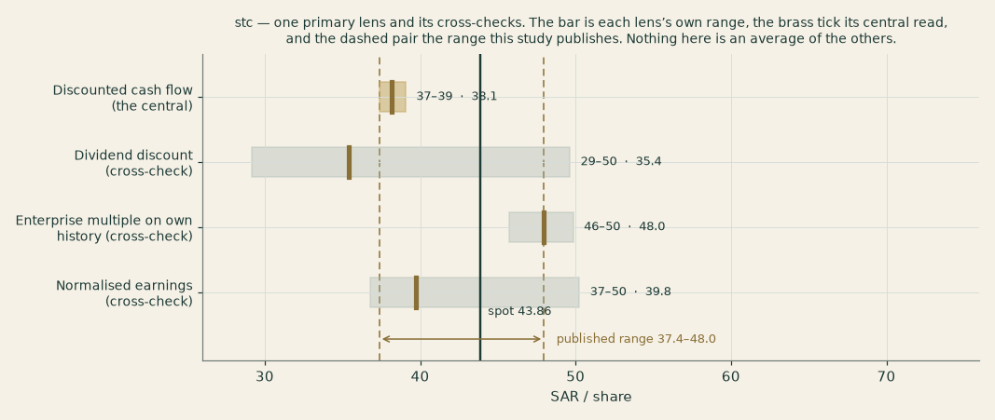
Figure 1 — Valuation football field. Bars span bear–bull per lens; the brass tick is each base case; the gold band is the range the present-value reads span; the ink line is the market price.
Central fair value ≈ SAR 36/share, -18% versus the market. The bear-to-bull span of SAR 35.29 to 48.08 moves exactly ONE driver: capital expenditure as a multiple of the depreciation of the base being renewed, across the range this company's own three filed years ran — 1.054 times at the bull end and 1.252 at the bear. Everything else is held IDENTICAL across all three reads: the cost of capital, the terminal growth, the terminal risk-free rate, the inflation ladder and the margin path. That is deliberate and it is a change from the previous edition, which moved the discount rate and terminal growth inside the scenarios as well — three levers moving together cannot be attributed to any of them, and a bear case that also changes the economy is not a bear case for this company. What the spread is NOT about is revenue: it is a capital-intensity story, and the discount rate has its own grid in §1.9 rather than being folded in here.
1.6 The segments — a deeper look, and the driver table
Segment / leg | FY25 revenue | Trend | Margin role | Swing role
KSA Consumer (CBU) | SAR 32.8 bn (+3.4%) | Mobility +2.8%, fixed +6.6%; 30.3 mn mobile subscribers at the half year, +1.0% on the full-year 2025 count | The cash cow | Competition watch
KSA Enterprise (EBU) | SAR 13.5 bn (+0.4%) | Government phasing; private sector +6%; flat ex-mega-projects | High-margin | Recovery lever
KSA Wholesale & Carrier | SAR 4.8 bn (+10.8%) | Hosting, FWA backhaul, national roaming | Structural | Steady
Subsidiaries (net) | ~SAR 26.7 bn | solutions 12.7 bn · channels ~14.1 bn gross · stc bank 2.0 bn (+11%) · SCCC +62% · sirar +13% · center3 | Dilutive today, guided to turn | The option book
Associates & stakes | off-P&L | 43.06% towers (DIIC) · 9.97% Telefónica · iot squared 50% | Equity-method / marks | Bridge items

The build is per disclosed segment. THE PREVIOUS EDITION GREW FOUR BUSINESS UNITS — consumer, enterprise, wholesale and a subsidiaries residual — which is not how this company reports: note 9 discloses 12 operating segments and each is grown on its own measured real rate. One of them, the Saudi operating business and two thirds of group revenue, is built as volume times price from the subscriber counts the earnings presentations disclose; the others are forecast on their net rate because no unit data is published for them, and that gap is stated rather than filled.
Operating segment (note 9) | FY24 | FY25 | FY26E | FY28E | FY30E
stc | 49,644 | 51,119 | 52,708 | 55,066 | 57,340
Channels | 15,111 | 14,085 | 14,254 | 14,534 | 15,058
Solutions | 12,064 | 12,730 | 13,682 | 15,048 | 15,829
stc Kuwait | 4,105 | 4,180 | 4,324 | 4,532 | 4,721
stc Bahrain | 1,928 | 1,968 | 2,020 | 2,097 | 2,180
Center 3 | 1,912 | 1,962 | 2,057 | 2,192 | 2,291
stc Bank | 1,262 | 1,401 | 1,590 | 1,875 | 2,001
Sirar | 733 | 827 | 963 | 1,174 | 1,262
Specialized | 372 | 355 | 345 | 334 | 343
iot2 | 301 | 322 | 337 | 359 | 376
SCCC | 188 | 304 | 319 | 340 | 355
Other operating segments | 729 | 65 | 68 | 73 | 76
Eliminations / adjustments | (12,455) | (11,499) | (11,930) | (12,568) | (13,110)
Group revenue | 75,893 | 77,819 | 80,737 | 85,056 | 88,722
EBITDA margin |  |  | 32.1% | 31.9% | 31.8%
Capital intensity (% of revenue) |  |  | 15.0% | 15.0% | 15.0%

History: note 9 of the FY2025 audited consolidated statements, on the restated basis, with the earnings presentations for the operating detail no statement carries. Forecast drivers are the house’s own flagged view. These are the company's own internal unit names, used here to describe what drives the business; the MODEL is built on the 12 operating segments note 9 discloses, which is a different and finer cut.
1.7 The crux — dividend cover against the capex cycle, in real units
Three judgments drive this valuation, and all three are observable rather than abstract. First and largest: capex intensity against the locked dividend. The policy dividend costs SAR 10.98 bn a year (2.20 x 4,993.0 mn shares); and the model spans the range this company's OWN three filed years actually ran, 13.6% to 16.1% of revenue, rather than the band management guides to. The cover table below is the whole tension in one place: at the heaviest of those three years the dividend is 1.06x covered by model free cash flow in the first forecast year, and at the lightest 1.24x — so on this company's own history of capital spending the dividend is covered throughout, and the question is whether the data-centre build takes intensity ABOVE anything it has yet run. Second: the discount rate, a 90%-equity-weighted cost of capital on a 0.71 beta from a five-year weekly regression (§1.8) — at a beta of 1.0 the value falls from SAR 36.06 to 31.53, -28% against the price, so §1.9 publishes the whole grid rather than letting one regression settle it. Third: the policy rate path — each 50 basis points off the curve is worth about SAR 2.6 on the value and lowers the funding cost of the build directly. A fourth, slower variable: mobile competition (Mobily’s subscriber growth has outpaced stc’s revenue growth for four quarters) — each 1 pp off consumer growth costs ≈SAR 2 of fair value.
FY26E scenario (real units) | Model FCF (SAR bn) | Dividend bill (SAR bn) | Cover
Capex at 13.6% (the lowest of the three filed years, 1.054x depreciation) | 13.7 | 11.0 | 1.24×
Capex at 15.0% (adopted, the three-year mean of 1.161x depreciation) | 12.6 | 11.0 | 1.14×
Capex at 16.1% (the highest of the three filed years, 1.252x depreciation) | 11.6 | 11.0 | 1.06×

The dividend schedule and its stress test live in Appendix A.3. The dividend is policy-locked through the Q3-2027 distribution; the test is whether free cash flow or the balance sheet pays for it, and the table above answers it at every capital-intensity level this company has actually run.
1.8 Macro and country — SAMA, oil, Vision 2030, and the sourced cost of capital
stc is a defensive claim on the Saudi macro, in three channels. Rates: SAMA shadows the Fed to defend the riyal peg (repo 4.25% / reverse repo 3.75% since 10 Dec 2025; the Fed held 3.50–3.75% on 17 Jun 2026), so the discount rate and the sukuk funding cost are set in Washington as much as Riyadh. Oil and the fiscal impulse: government ICT and giga-project spend (SAR ~32 bn of digital-government spend in 2025) drives the enterprise book — the FY25 softness was phasing, not demand. Vision 2030: the structural bid — data centres (the center3–HUMAIN 1 GW ambition inside a national AI push), 5G/fibre densification, and digital-services adjacencies — is what turns a utility growth profile into a utility-plus-options profile. Because the riyal is pegged, there is no currency-translation channel in the valuation and no currency factor in the price map. Every input in the cost-of-capital build is sourced and named:
Cost-of-capital build | Value | Source
Risk-free rate, as observed | 5.52% | The sovereign yield on the house macro path for Saudi Arabia, carried with its own as-of date
— less this sovereign’s own default spread | 0.98% | Country risk is charged exactly once, and it is charged inside the equity risk premium below — so it is removed here rather than counted twice
Normalised risk-free rate | 4.54% | The two lines above, by subtraction
Equity beta | 0.7093 | A 4.94-year weekly regression of stc against the published index of the exchange it is listed on, the Tadawul All Share Index, read as of 2026-09-08: 254 observations, R² 30.3%, standard error 0.1022. This is the first tier of the house preference order, not a stopgap — but it explains 30% of the variance and no more, which is why §1.9 prices the answer at every beta up to 1.2
Equity risk premium (market basis, adopted) | 5.72% | The premium published for Saudi Arabia specifically, on the basis this study names as central; the alternative basis is published beside it rather than chosen silently
Cost of equity | 9.03% | The normalised risk-free rate plus beta times the premium
Cost of debt, before tax | 4.86% | Built from the company’s own facilities, and above this sovereign’s own yield, as a same-currency corporate borrower must be
Cost of debt, after tax | 3.89% | At the 8.03% effective rate the three filed years imply
Weights (equity / debt) | 90.3% / 9.7% | Market-value equity, never book: the latest known close of SAR 43.86 on 2026-09-03 times 4,993,024 thousand shares outstanding — issued capital of SAR 50,000,000 thousand in shares of SAR 10 each, which divides to the 5,000,000 thousand shares note 17 of the reviewed 30 June 2026 interim itself states, less 6,976 thousand held in treasury. Debt is the borrowings total from the LATEST DISCLOSED balance sheet, 30 June 2026, SAR 23,536,554 thousand, which reproduces from the same interim's own financing cash flows to twelve basis points.
Weighted cost of capital | 8.53% | The explicit-window rate the forecast is discounted at
Terminal cost of capital | 8.53% | Flat against the explicit window, and that is not an oversight: the riyal is pegged, so this economy is already at its terminal cost of capital by construction of the peg and there is no normalisation to glide toward
Terminal growth (nominal) | 2.00% | Terminal inflation of 2.0% plus a stated real growth of 0.0% — derived from the house macro path rather than chosen, and the real component is written down as the number it is

Two honesty notes on this build. First, the sovereign quote behind the risk-free rate is older than the fourteen-day bound this house sets: The Saudi sovereign quote on the house macro path carries an as-of date of 31 July 2026 and this schedule is struck on 5 September 2026, so it is 36 days old against the 14-day bound. It is accepted DELIBERATELY and the age is disclosed here rather than used quietly; refreshing the path is a macro-path task that moves every Saudi study at once, not a lever inside this one. Second, the beta is a proper five-year weekly regression against the exchange’s own published index — the standard, not a stopgap — but its R² of 30% means roughly 70% of what moves this stock is specific to it rather than to the market. A beta is a statement about co-movement, and on this name that statement is weak. The grid in §1.9 prices the answer at every beta up to 1.2 for exactly that reason. Both are recorded with the study’s own inputs.
1.9 Sensitivity — the margin, the capex, the rate spread, and the beta
The first grid re-prices the cash-flow model across the two real-unit operating levers (EBITDA margin and capital intensity); the second across the cost of capital × terminal growth; the third across the beta — which is a proper five-year weekly regression against the exchange’s own index, but explains less than a third of this stock’s variance, so it is the input whose uncertainty is widest even though its construction is sound.
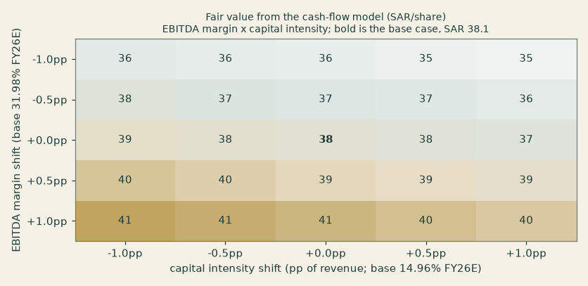
Figure 2 — Fair value from the cash-flow model (SAR/share) across shifts in the EBITDA margin and in capital intensity. The bold cell is the base case. EVERY cell in the grid sits below the market price of SAR 43.86: on this model the disagreement with the market survives the whole plausible range of both operating levers, so it is not an artefact of where either one was set.
WACC \ terminal g | 1.5% | 2.0% | 2.5% | 3.0% | 3.5%
7.53% | 41.3 | 41.7 | 42.1 | 42.7 | 43.3
8.03% | 38.5 | 38.6 | 38.8 | 39.0 | 39.3
8.53% (base) | 36.0 | 36.1 | 36.1 | 36.1 | 36.1
9.03% | 33.9 | 33.8 | 33.7 | 33.6 | 33.4
9.53% | 32.1 | 31.9 | 31.7 | 31.5 | 31.2

Fair value from the cash-flow model (SAR/share) across the cost of capital and terminal growth. The base cell is 8.53% against 2.00%, giving SAR 36.06. The CDS-ERP alternative WACC (7.90%) sits between the third and fourth rows.
Beta | Cost of equity | Cost of capital | Value per share | Note
0.30 | 7.30% | 6.97% | 45.83
0.50 | 8.14% | 7.73% | 40.40
0.71 | 9.03% | 8.53% | 36.06 | the adopted regression
0.85 | 9.63% | 9.07% | 33.69
1.00 | 10.26% | 9.64% | 31.53 | the house fallback, used only where a regression is not usable
1.20 | 11.11% | 10.41% | 29.10

The grid is mandatory disclosure here: the regression is a proper five-year weekly one against the exchange’s own published index, but it explains 30% of this stock’s variance and no more, so the answer is priced across the plausible range rather than at one point. The read survives moderate beta doubt — at 0.85 the value is SAR 33.69 — but not a full reversion to 1.0, where it falls to SAR 31.53, -28% against the market price.
2 Technical and price structure
The tape is firm and the stock is trading above its whole moving-average stack. At SAR 44.72 the price sits above all four of the 20-, 50-, 100- and 200-day averages, which are themselves compressed into a band of SAR 0.61 (43.30 to 43.91) — so the stack is flat while the price has stepped clear of it by 1.8% above the highest of the four. RSI(14) at 66 is firm but short of overbought, and the MACD histogram is positive, with the line above its signal. The 52-week range is narrow for an emerging-market name — 40.20 to 45.38, a span of 13% — and realised volatility over the trailing year (12.9%) is among the lowest on the exchange. Price is up 1.8% over the last twenty sessions and 1.6% over the last sixty. This is a quiet advance rather than a trending breakout: the direction is up, the energy behind it is low.
Indicator | Reading | What it says
Price on 2026-08-31 | SAR 44.72 | 87th percentile of the 52-week range
SMA 20 / 50 | SAR 43.91 / 43.60 | Price above both, by 1.8% and 2.6%
SMA 100 / 200 | SAR 43.51 / 43.30 | Stack compressed into SAR 0.61 — a long flat base
RSI (14) | 65.7 | Firm but short of overbought
MACD (12,26,9) | +0.31 line / +0.21 signal / +0.09 hist | Positive, with the line above its signal
52-week range | SAR 40.20 – 45.38 | A span of 13% — narrow
Change over 20 / 60 sessions | +1.8% / +1.6% | A quiet advance
Realised volatility (252 sessions) | 12.9% | Very low; the forward read used in §3 is 16.5%

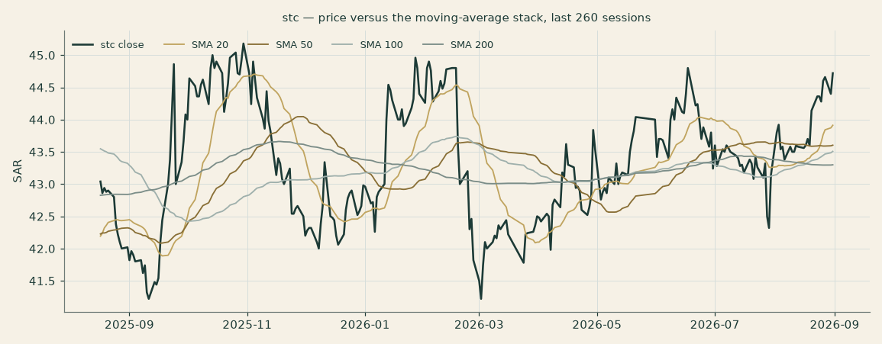
Figure 3 — Price against the moving-average stack, the last 260 sessions.
For the probabilistic work this matters in one way: a low-volatility tape produces a genuinely narrow three-month cone — the 5th-to-95th band in §3 runs -12.1% to +16.7% around the anchor — so even a modest fundamental surprise can carry the price to the edge of the distribution. The technical read neither confirms nor contradicts the fundamental one, and it is not asked to: it is the shortest of the three lenses and speaks only to the weeks ahead.
3 A probabilistic price map
The probability read below opens the section: computed from the same 50,000 paths as everything that follows, it is a summary of the distribution, not an input to it. Both horizons are CALENDAR — one month and three months from the anchor, graded on a stated date rather than after a count of trading sessions.
The probability read (3 months, graded 30 Nov 2026)
Chance the price finishes above the anchor | 56%
Chance of +10% against −10% — the odds | 16% vs 8% · 2.0 : 1
Median level, and its move | SAR 45.30 (+1.3%)
The 50% band (25th–75th) | SAR 42.9 – 47.9 (-4.2% / +7.0% of the anchor)
Chance of touching ±10% at any point | 27% / 16%

How the cone is built. We simulate 50,000 price paths from the anchor (seed 42) with the house engine: the width comes from a cascade of this stock's own recent, medium and longer-run variation, projected forward over the horizon (annualised 16.5% at three months, 15.3% at one), then scaled by the calibration this market's whole panel was fitted to (1.056). The shape of the tails is a Student-t drawn at the same fitted setting. The two numbers trade off against each other, so neither is quoted as precise on its own — the honest object is the cone they jointly produce, and the record of how often it has held follows below.
The centre of the cone is not a view. It is the cost of carry — what money earns while it waits — plus one small lean, described next. The paths deliberately do not know the fundamental fair value of §1: the two lenses are kept apart so that when they agree it is information rather than an echo. §1 says what the business is worth; §3 says where the price could travel from where it is.
The direction call. This market runs a measured momentum lean, and every covered name states the direction its own reading points — including the names where the reading is too weak to move anything. stc reads +0.30, which is past the 0.25 threshold below which no tilt is applied at all, so the call is UP and it carries weight: it shifts the centre of the three-month cone by +0.24% and the one-month cone by +0.13%. Those are small numbers on purpose. The lean is capped at the strength the evidence actually measured; past that point a bigger number is a deliberately worse forecast rather than a braver one.
How often these bands have actually held
Over 58 resolved three-month forecasts, the price finished inside the 90% band 88% of the time, against the 90% that band aims at — and inside the 80% and 50% bands 78% and 47% of the time.
The band is 1.04 times the width of a simple no-forecast rule’s — the price of covering this name honestly. A wider band is not automatically a worse one: covering a name honestly costs width, and the number is published beside the record rather than turned into a pass mark.
No flag is raised, and that is the ordinary case rather than an omission: on a two-sided test at the 5% level, 88% inside a 90% band over 58 forecasts is what a cone that works looks like (p = 0.52). Had the bands run persistently narrow — price escaping more often than a 90% band should allow — or persistently wide, this study would say so here in those words. It says nothing because nothing has been earned either way.
The record is long by this study's own standard: 58 resolved three-month forecasts is enough history to judge this name on its own rather than falling back on the market's, and every one of them is a forecast that was published before its outcome was known and graded on a date fixed in advance.
Percentile map (SAR/share)
Horizon | Graded on | p5 | p25 | p50 | p75 | p95
1 month | 30 Sep 2026 | 41.7 | 43.6 | 44.9 | 46.3 | 48.5
3 months | 30 Nov 2026 | 39.3 | 42.9 | 45.3 | 47.9 | 52.2

Lead with the 50% band, not the tails: three months out, half of all paths finish between roughly SAR 43 and 48 (-4.2% / +7.0%); at one month the band is about SAR 44–46. The 5th-to-95th cone is context rather than a forecast, and on this name it is 33% wide from end to end — the direct consequence of the calm regime the width estimator is reading.
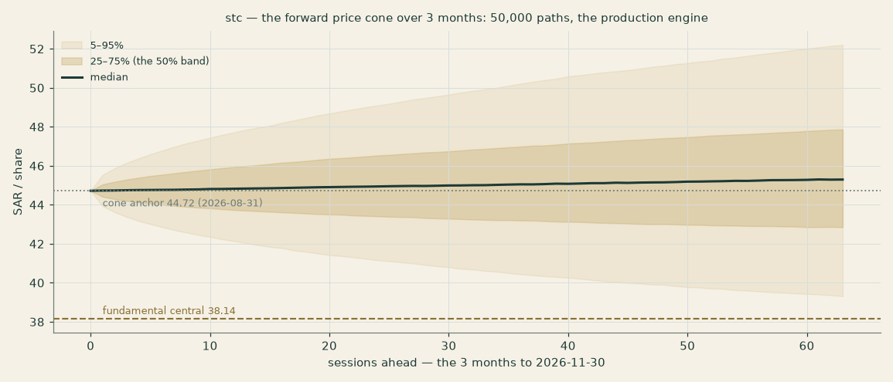
Figure 4 — The forward price cone over 3 months, from the anchor of SAR 44.72. The median carries at the cost of money plus the small momentum lean. The brass dashed line is this study’s fundamental central of SAR 36.06 — below every part of the cone, including its 5th percentile, which never falls under SAR 39.31. The two lenses disagree, and the study shows the disagreement rather than reconciling it.
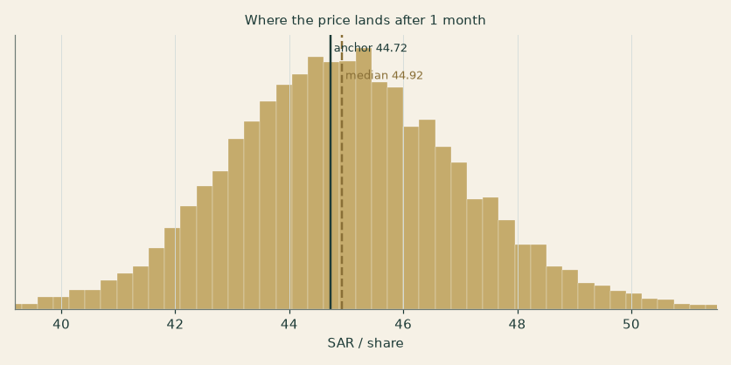
Figure 5 — Where the price lands after 1 month.
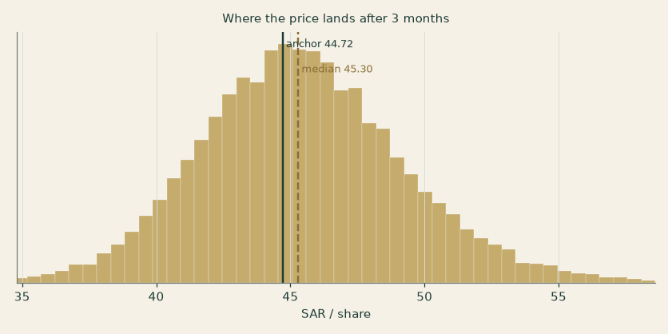
Figure 6 — Where the price lands after 3 months.
Level-touch ladder
The chance that price reaches a level at any point before the horizon, rather than finishing there (a running maximum for levels above, a running minimum for those below):
Level (SAR) | By 1 month | By 3 months | Note
50 | 2% | 20% | Round number; +11.8% on the anchor
48 | 11% | 41% | Above the 52-week high
46 | 48% | 72% | Just past the Oct-25 high zone
44 | 60% | 75% | The anchor itself
42 | 12% | 36% | The March base
40 | 1% | 14% | The 52-week-low shelf
38 | 0% | 4% | Stress zone
36 | 0% | 1% | Crisis zone

4 Comparison of the lenses
Three lenses, read side by side and never averaged. The cash-flow model is the answer this study publishes — SAR 36.06 against a market price of SAR 43.86, -17.8% — and the others sit beside it as cross-checks rather than as weights in a blend. They do not agree, and the disagreement is the most useful thing on this page: the earnings-multiple read on this company's own trading history lands at SAR 48.08, +33% above the cash-flow answer, while the disclosed book value is SAR 17.02 — a floor, not a valuation. The technical picture is a firm tape trading above its whole moving-average stack. The price map says the market is likely to keep the stock within a few riyals of where it is over the quarter (50% band 43–48).
Lens | Role | Reads | Value per share
Discounted cash flow | THE CENTRAL | Below the market | SAR 36.06 (-18%)
Enterprise multiple on own history | Cross-check | Above the market | SAR 48.08 (+10%)
Book value | Disclosed floor | Far below — as a floor should be | SAR 17.02
Dividend discount | Cross-check | Below the market | SAR 34.20 (-22%)
Normalised earnings power | Cross-check | Below the market | SAR 39.75 (-9%)
Technical read | Context | Above the whole moving-average stack | See §2
The price map (three months) | Context | Near-even, a small upward lean | Median 45.3; 5th–95th 39–52

The envelope this study publishes is the RANGE of the present-value reads, not an average of them: SAR 35.29 to 48.08. No weights are applied anywhere, because a number produced by averaging several methods is a new method with parameters nobody tested — it imports the weakness of the weakest lens at whatever weight somebody typed.
What the price is paying for. Read backwards, this model reproduces the market price of SAR 43.86 at an equity beta of about 0.37 — read straight off the grid in §1.9, between its 0.30 and 0.50 rows, so a reader can check it against what is printed there rather than taking it on trust. This stock's own 4.9-year weekly regression against its exchange's published index gives 0.7093 with a standard error of 0.1022, so the market is paying for a beta roughly 3.3 standard errors below the point estimate — inside what the regression cannot rule out, and not what it measures. THE DISAGREEMENT IS ABOUT THE PRICE OF RISK, NOT ABOUT THE BUSINESS, and that is worth stating because §1.7 says otherwise: the crux names capital intensity as the swing driver, and no capital-spending assumption inside this company's own history closes the gap. At two percentage points of revenue BELOW the modelled intensity — lighter than any of the three filed years ran — the model reaches SAR 37.37, still 15% short of the price. A reader who thinks this study too pessimistic should therefore be arguing about the discount rate rather than about the capital programme.
Where the lenses disagree, and what would settle it. The gap between the cash-flow answer and the multiple read is not a modelling artefact — it is one question asked two ways. The multiple lens capitalises what this company earns today at what the market has paid for those earnings over the last three financial year ends; the cash-flow lens charges for the capital the company must keep spending to go on earning them. The whole difference sits in the capital expenditure cycle, and §1.7 prices it in real units: at the lowest capital intensity of the three filed years the cash-flow answer is SAR 35.29, at the highest it is lower still. So the honest statement is that this study reads stc below its market price BECAUSE it charges the company for the investment phase it is currently in, and a reader who believes that phase ends sooner, or earns more than the model credits, should hold the multiple read instead — the study publishes both rather than choosing for them. What would settle it is disclosed economics on the data-centre build and two more years of capital intensity: neither is available today, and neither is invented here.
5 Catalysts to watch
- Third-quarter 2026 results. The reviewed half to 30 June 2026 is already in this model — it sets the base year, the bridge and the first forecast year — so the next disclosure is the first that can move the answer: watch enterprise revenue against mega-project phasing, and capital expenditure against the data-centre build.
- Quarterly dividend declarations. SAR 0.55 is policy through Q3-2027 — the information is in any SPECIAL distribution (the policy explicitly allows quarterly assessment; FY24 paid SAR 2.00). A special would mechanically re-rate the DDM lens; its absence through 2026 keeps the balance sheet funding the build.
- SAMA/Fed decisions (Sep/Oct 2026). Each 25–50 bp off the Saudi curve lowers this study’s discount rate and the marginal cost of the sukuk-funded infrastructure build — the single most mechanical catalyst.
- center3–HUMAIN milestones. The 1 GW AI-data-centre ambition (framework Dec-2025) converts to value only as contracted megawatts and disclosed economics; any capacity/offtake announcement is the option going in-the-money.
- TAWAL/DIIC monetization. stc still owns 43.06% of the region’s largest tower company; an IPO or stake sale would crystallize a mark this study carries at a conservative SAR 4.6 bn book. Speculation only — nothing announced.
- KSA mobile competitive prints. Mobily’s subscriber momentum vs stc’s +5.3%; a price response from any of the three would show first in consumer ARPU-proxy (CBU revenue per sub).
- Telefónica. The 9.97% stake (€2.1 bn cost) trades ≈7% below cost with a halved dividend; further deterioration is a mark-to-market drag, any Spanish-market recovery a small tailwind — the stake is ~3.5% of the DCF equity bridge.
- Index / flow events. PIF sold 2% in Nov-2024 at SAR 38.6 (float now ~38%); any further sell-down is a supply event, any float-driven index-weight uplift a demand event.
6 Reading the probability zones
Translating the three-month distribution into plain zones, anchored on the cone's own origin of SAR 44.72 on 2026-08-31 — which is the last session in the price library and NOT the 2026-09-03 close of SAR 43.86 the valuation is measured against. Two clocks, and the study says which is which:
Zone at 3 months | Range | Probability | What it would mean
Deep downside | < SAR 38 | 2% | A regional shock or a price war; below the 52-week low
Lower band | SAR 38–42 | 16% | Capital spending runs hot and dividend cover stays below 1x; the March base is retested
Around the anchor | SAR 42–46 | 39% | The status quo: the yield carries the return
Upper band | SAR 46–50 | 31% | Cover proven or rate cuts delivered; the 52-week high is pressed
Strong upside | > SAR 50 | 12% | A special dividend, or the data-centre build credited with something

The distribution leans mildly to the upside — the ladder above gives a 27% chance of tagging +10% at some point against 16% for −10% — but the mass is concentrated: 86% of all paths finish between SAR 38 and 50, and half of them inside the much narrower SAR 42.9–47.9. That concentration is what a calm tape produces mechanically; it is not a view about the company, and a shift in the volatility regime would widen the cone at the next re-strike without anybody deciding anything.
7 Caveats and what would change our mind
- The dividend-vs-capex tension is the model. The first forecast year's dividend cover of 1.06–1.24x is an estimate built on the range of capital intensity this company’s own three filed years ran, and on a capital-intensity range and a margin path that is FLAT rather than improving — 32.06% in the first forecast year against 31.77% in the last. Two consecutive quarters of free cash flow below the quarterly dividend bill would push the DDM lens toward its bear case and the balance sheet toward releveraging — watch the quarterly FCF line, not the payout announcements.
- Terminal-value dependency. 70% of the cash-flow model's enterprise value sits beyond the fifth forecast year, at a spread of 6.5 points between the terminal discount rate and the 2.0% terminal growth. §1.9 is the honest statement that this valuation is substantially a judgement about the long-run price of money in Saudi Arabia. The terminal charge for keeping the asset base whole rests on the 21-year average life the company's own accounts imply for its plant, not on a life chosen here — but a network is a bundle of assets with very different lives, and a single average is the coarsest honest way to state it.
- The sovereign quote is older than the house bound. The Saudi sovereign quote on the house macro path carries an as-of date of 31 July 2026 and this schedule is struck on 5 September 2026, so it is 36 days old against the 14-day bound. It is accepted DELIBERATELY and the age is disclosed here rather than used quietly; refreshing the path is a macro-path task that moves every Saudi study at once, not a lever inside this one.
- The method behind these forecasts has not yet been tested on this company’s own history. This house walk-forward tests its forecasting method by rebuilding the driver model as it stood at a past date, projecting forward from there, and scoring each driver against what the company then reported. This company discloses 16 fiscal years reachable from its own archive, back to 2010, which is deep enough for the full test; the test has NOT been run here. Nothing in this study rests on a result from one — there is no bias correction, no calibrated range and no lesson drawn from a test that does not exist — and the practical consequence is that the forecast years three to five carry the uncertainty the sensitivities show and no measured error distribution behind it.
- The beta is a real regression, and it explains less than a third of the variance. The 0.71 beta is a 4.9-year weekly regression of this stock against the published index of the exchange it is listed on (254 observations, standard error 0.10), which is the standard this house requires and not a stopgap. What it does NOT do is explain the stock: the regression accounts for 30% of the variance, so roughly 70% of what moves stc is specific to stc. A beta is a statement about how a stock moves with its market, and on this name that statement is weak. §1.9 shows the valuation at every beta up to 1.2 for exactly that reason.
- Competition is the slow leak. stc’s consumer growth (+3%) already trails Mobily’s subscriber momentum; a price war in Saudi mobile — three players, one regulator, heavy capacity — is the scenario in which the flat margin path reverses and every lens compresses toward the normalized floor.
- The subsidiary portfolio is an investment phase, not yet a return. stc bank (8 mn customers, SAMA-licensed Jan-2025), center3, SCCC and iot squared are guided to turn contribution-positive from 2026; if they stay dilutive through FY27, the 31.77% terminal-year margin this model carries is wrong by construction — and it is worth saying that this forecast assumes NO mix improvement at all, so the risk here is a margin that falls rather than one that fails to rise.
- The stake marks are point-in-time. Telefónica (9.97%) is marked at market (≈SAR 8.6 bn, ~7% below cost) and the tower stake at carrying value (SAR 4.6 bn) — the former moves daily, the latter is conservative against any transaction mark; together they are ~5% of the bridge.
- OCF conversion. Reported FY25 FCF (6.5 bn) ran well below model FCFF on receivables build and one-off cash items; we model an explicit conversion drag, but a government-receivables cycle that widens rather than narrows would make even the 1.06x heaviest-spending cover optimistic.
- Technical reminder. A compressed, low-volatility tape can break either way; the narrow cone in §3 is a regime read, not a promise. The technical section is context, not a trigger.
Appendix A Financial statements
Consolidated figures as disclosed by stc — the audited statements for FY2023 to FY2025 on the restated continuing-operations basis (TAWAL and Digital Infrastructure Co reclassified to discontinued operations) and the reviewed interim for the six months to 30 June 2026 — all from the company’s own investor-relations archive, per the study’s sourcing rule. SAR million. The five-year forecast is the model build (companion Excel, formula-linked to Assumptions).
A.1 Income statement — 3-year historical + 5-year forecast (consolidated, SAR mn)
Line | FY23 | FY24 | FY25 | FY26E | FY27E | FY28E | FY29E | FY30E
Revenue | 71,777 | 75,893 | 77,819 | 80,737 | 82,985 | 85,056 | 86,982 | 88,722
Gross profit | 34,740 | 37,326 | 37,700 | 39,737 | 40,778 | 41,734 | 42,620 | 43,415
EBITDA | 22,445 | 23,951 | 24,469 | 25,882 | 26,537 | 27,138 | 27,694 | 28,190
Depreciation, amortisation and impairment | (9,284) | (9,525) | (10,031) | (10,407) | (10,697) | (10,964) | (11,212) | (11,437)
Operating profit (EBIT) | 13,161 | 14,426 | 14,438 | 15,475 | 15,840 | 16,174 | 16,481 | 16,753
Cost of the early retirement programme | (863) | (2,577) | (824) | (1,421) | (1,451) | (1,480) | (1,510) | (1,540)
Finance income | 1,482 | 1,718 | 1,276 | 952 | 972 | 991 | 1,011 | 1,031
Finance cost | (1,068) | (1,234) | (1,125) | (1,444) | (1,474) | (1,503) | (1,533) | (1,564)
Other income, associates and other gains | 1,275 | -198 | 957 | not forecast | not forecast | not forecast | not forecast | not forecast
Profit before zakat and income tax | 13,987 | 12,134 | 14,723 | 13,562 | 13,887 | 14,181 | 14,449 | 14,680
Zakat and income tax | (1,327) | (1,192) | 466 | (1,121) | (1,148) | (1,172) | (1,194) | (1,214)
Profit from continuing operations | 12,660 | 10,943 | 15,189 | 12,440 | 12,739 | 13,009 | 13,254 | 13,467

The three filed years are note 9's own reconciliation of segment revenue to profit from continuing operations, and they foot to the riyal in every column. THREE LINES ARE NOT FORECAST AND THE TABLE SAYS SO RATHER THAN LEAVING A READER TO NOTICE: net other income, the share of associates and net other gains have no disclosed driver between them and were worth 957 million in FY2025 alone, so the projected profit is BELOW what the same company would report if they recurred. Zakat is the rate the three years imply on profit before zakat, 8.27 per cent, with the reversal of prior years' provision that note 33(a) names put back — carrying that reversal forward would read 5.02 per cent and assume the company keeps finding it has over-provided.
A.2 Balance sheet — the filed years, and why there is no forecast column
Line | FY23 | FY24 | FY25
Total assets | 159,646 | 160,638 | 157,477
Cash and equivalents | 28,138 | 30,755 | 15,080
Borrowings | (21,958) | (15,132) | (15,191)
Equity attributable to the parent | 78,985 | 89,417 | 83,414
Non-controlling interests | 2,530 | 3,069 | 3,482

THERE IS NO FORECAST BALANCE SHEET IN THIS EDITION AND THE REASON IS A DEFECT IN THE FILING RATHER THAN A GAP IN THE MODEL. The latest reviewed balance sheet does not add up in its own current column — four subtotals and both totals — while every prior-year column foots exactly. That was not assumed to be an extraction problem: the file was re-fetched from the company's own site, re-extracted, and re-read by optical character recognition off the page rendered at 300 dots per inch, and both routes return the same figures. A statement is used only if it foots against its own arithmetic, and solving for the six figures that would make it foot would be inventing them. The lines this study's valuation does use are corroborated instead by the same interim's CASH FLOW statement, to the riyal. The previous edition printed a forecast balance sheet whose gaps were filled with grouped estimates chosen to make a balance-check row read zero; a check that cannot fail is not a check, and it is not reprinted here.
A.3 Cash flow, the two free-cash-flow framings, and the dividend schedule
Cash flow (SAR mn) | FY23 | FY24 | FY25 | FY26E | FY28E | FY30E
Operating cash flow (disclosed / model) | 22,418 | 19,885 | 18,283 | 23,647 | 26,155 | 28,441
Capex (disclosed / model) | (9,790) | (11,927) | (11,795) | (13,359) | (14,000) | (14,006)
Free cash flow | 12,628 | 7,959 | 6,488 | 10,287 | 12,156 | 14,435
Dividends paid (attributable) | (8,000) | (18,712) | (10,978) | (10,978) | (11,477) | (12,724)

FY23–FY25 disclosed (stc IR); FY24 dividends-paid include the FY24 quarterly schedule; calendar-2025 cash dividends ≈ SAR 20.9 bn including the SAR 2.00/share special. Model OCF is a NOPAT-based construct and runs richer than the disclosed series — the conversion gap (receivables, ERP cash, zakat timing) is modelled as an explicit drag and discussed in §1.1; both framings shown per house rule.
Dividend schedule | FY25A | FY26E | FY27E | FY28E | FY29E | FY30E
DPS declared (SAR) | 2.20 | 2.20 | 2.20 | 2.30 | 2.40 | 2.55
Dividend bill (SAR bn) | 11.0 | 11.0 | 11.0 | 11.5 | 12.0 | 12.7
Payout of attributable NP | 74% | 78% | 75% | 75% | 74% | 74%
Yield at spot (declared) | 5.0% | 5.0% | 5.0% | 5.3% | 5.5% | 5.9%

Stress check: at the heaviest capital spending of the three filed years the dividend is 1.06x covered by model free cash flow in the first forecast year, and at the lightest 1.24x — covered throughout the range this company has actually operated in. What the cover table asks is whether the data-centre build takes intensity ABOVE anything it has yet run; the core cash pile funds a shortfall for years before leverage becomes a constraint.
Two yield framings (house rule): declared-regular 2.20/sh = 5.0%; cash paid during calendar-2025 incl. the FY24 special = 4.20/sh = 9.6%. A forecast-versus-actual scorecard and a new-versus-old reconciliation: not applicable on an initiation; both become standing sections from the first 3-month update.
Appendix B Peer frame, risk register, and the research register
B.1 The peer frame and the sector
stc is the premium name in a three-player Saudi market inside a GCC cohort where telecom equity is increasingly a yield-plus-digital-infrastructure asset class.
Name | P/E (t) | Div yield | One-line profile
stc (7010) | ~14.7× | 5.0% (9.6% incl. special) | Incumbent; ~57% mobile share; net debt ~0; AI-DC and fintech options
Mobily (7020) | ~13.5× | 4.5% | No.2; e& anchor (~28%); fastest subscriber momentum
Zain KSA (7030) | ~12.8× | 4.9% | No.3; tower-light; balance-sheet repair done
e& (UAE) | ~13.2× | 5.1% | UAE incumbent + Vodafone/PPF international portfolio
Ooredoo (Qatar) | ~10.7× | 5.7% | Multi-market; MENA data-centre pivot
du (UAE) | ~17.6× | 5.5% | No.2 UAE; hyperscale data-centre momentum — the multiple stc’s DC build aspires to
Omantel / Beyon / Telecom Egypt | 11.5× / 11.1× / 8.8× | 3.9% / 7.1% / 1.5% | Regional context

Multiples approximate, mixed as-of dates (May–Jul 2026), secondary aggregators — context only, never model inputs.
Sector structure. Saudi mobile is a disciplined three-player market (~57/27/16 stc/Mobily/Zain) under CST regulation, with spectrum freshly allocated (Nov-2024 auction: stc took 600 MHz + 3.8 GHz), 5G at 63% populated coverage for stc and FWA adoption among the highest globally — FWA is both an opportunity (4.1 mn of stc’s 6.0 mn fixed lines) and the competitive vector through which mobile capacity attacks fixed pricing. Fibre stays an stc moat (3.75 mn FTTH, 258k km). The Kingdom’s AI push (HUMAIN, sovereign compute, the center3 1 GW ambition) is turning telecom capex into a national-strategy line item. Principal risks: a mobile price war; capex overshoot on the AI build; government-receivables cycles; subsidiary execution (stc bank credit costs as it scales); the Telefónica mark; regional geopolitics; and the rate path staying higher for longer.
B.2 Risk register
Risk | How it would show up first | What it is worth
A price war in Saudi mobile | Consumer revenue per subscriber, before it reaches the margin | The single largest downside: this model assumes NO margin improvement, so a price war breaks it downward from a path that has nothing built in to give back
Capital expenditure overshoot on the data-centre build | Capital intensity against the three filed years (1.05x to 1.25x depreciation) | The bear-to-bull span of the central: SAR 35.29 to the cash-flow bull
Government receivables cycles | Operating cash conversion, not the income statement | A cash-flow timing risk rather than a value risk, unless it persists
Subsidiary execution as the portfolio scales | Contribution turning positive on the guided schedule, or not | The flat margin carried to the terminal depends on it
The rate path staying higher for longer | The discount rate directly | 70% of enterprise value sits beyond year five
The overseas listed stake | A mark that moves daily and is carried at market | A few per cent of the bridge; disclosed, not modelled

B.3 The research register — what was searched, and what came back empty
Before any forecast driver was set, the research ran at four levels — the world, the country, the industry and the company — and every finding was recorded with its source and that source’s own date. The table below is that register in summary; the standalone bibliography carries every line of it, together with the full register of the 176 inputs this study consumes, each with its value, its source and its date.
Level | Findings | Of which searches that came back empty | The sources they rest on
Global | 4 | 1 | company ir, company official, regulator official, search
Country | 3 | 1 | company official, regulator official, search
Industry | 5 | 2 | company ir, search
Company | 7 | 0 | company ir, company official
All four | 19 | 4 | sweep dated 2026-09-05

A NEGATIVE RESULT IS A RESULT, and this study records four of them. They are printed here rather than left out, because a question asked and answered with nothing is evidence, while a question never asked looks identical to one that found nothing:
- Global — trade / sanctions / supply chains. Searched the FY2025 audited statements and the FY2025 and H1-2026 earnings presentations for sanctions, export controls, supply-chain disruption or tariffs. Two hits in the statements, neither a risk disclosure: one lists 'supply chain and other related services' among a subsidiary's permitted activities, and one records a 2017 Kuwaiti court ruling on a regulatory tariff decree. No supply-chain or sanctions exposure is disclosed anywhere in the three documents.
- Country — fiscal / political events with sector read-through. Searched the FY2025 audited statements and both 2026 interim sets for any fiscal or political event with a stated effect on this company — a change in the zakat or income-tax basis, a subsidy, a state directive. The tax note records ordinary zakat and income tax and a FY2025 CREDIT of SAR 466,436 thousand against a FY2024 charge of 1,191,564, a swing of 1.66bn that the statements do not attribute to a policy change. Nothing else is disclosed.
- Industry — new entrants (named-competitor level). Searched the FY2025 audited statements and the FY2025 and H1-2026 earnings presentations for any named competitor, market-share figure or new entrant. ZERO hits across all three documents for 'competitor', 'market share', 'Mobily' or 'Zain'. This company does not disclose its competitive position in any document this study holds, and no peer multiple or share figure is therefore used anywhere in the model.
- Industry — competitor capacity / price moves (named). The same search as the new-entrants category and with the same result: no named competitor appears in any of the three documents, so no competitor capacity or price move can be cited. Recorded as an evidenced absence rather than closed by moving a finding about this company's own operations into a row about its competitors.
The company’s own investor-relations channel was attempted first, before any aggregator, and the attempt is logged whether or not it succeeded. It was reached on 2026-09-05 — and the route matters: four direct address guesses each returned the site’s own error page under a success code, which reads as a working page to anything that only checks the status. The sitemap found it. Every historical figure in this study comes from the company’s own audited statements or its own investor material, and none from a data vendor, a broker or a press report.
Appendix C The expert valuation panel
Every Testahil study closes with a panel of standing expert personas — drawn from the house Expert Persona Library, not invented for the occasion, so each accumulates a track record across studies and a quarterly update is a re-run, not a re-training. For stc we cast the telecom trio from the library’s coverage map — cash-returns (DCF + returns on capital against WACC), earnings-power (normalized through-cycle earnings + multiples), and macro-policy (scenario-weighted policy options) — labelled Expert 1 / 2 / 3. Each runs a genuinely different method, derives its fair value from shown workings, and states a falsification condition.
C.1 Expert 1 — cash returns: ROIC against the cost of capital
Worldview and tradition. A business is worth the cash it returns over its life, and it creates value only when each riyal of capital earns above its cost. He looks past accounting earnings to free cash flow and to the economic-profit spread — and he is temperamentally suspicious of capex programs described with the word “vision.”
When it works / fails. Best for capital-intensive businesses where returns on capital are the crux — precisely a telecom. Fails where reinvestment economics are genuinely improving (past ROIC misleads a new-moat story) — his risk here if the AI-data-centre build earns structurally above telecom returns.
Expert 1’s economic-profit test | Value
Invested capital (parent equity 85.0 bn plus net debt 8.4 bn) | SAR 93.4 bn
FY26E operating profit after tax, over that capital | SAR 14.2 bn → 15.2%
Cost of capital (he accepts the §1.8 build) | 8.53%
Economic profit = (return − cost) × capital | SAR 6.3 bn/yr
Fade: excess returns decay 2.5%/yr toward the cost of capital | Multiple on economic profit 11.1x
Core enterprise value = capital + present value of the fading economic profit | SAR 163 bn
+ stakes less net debt less the minority, divided by 4,993.0 mn shares | → SAR 35.5 per share

Sensitivity, and the swing really is the fade rate alone — the cost of capital has its own grid in §1.9 and is held here: at 1% a year, a durable moat, his value rises to SAR 38.22; at 4%, where competition and technology churn eat the spread, it falls to SAR 33.57. Cross-examination: he tells Expert 2 that a 15× multiple on normalized earnings quietly capitalizes today’s ROIC forever without charging for the capital that sustains it — his fade does explicitly what the multiple hides. He tells Expert 3 that scenario trees on the policy rate are fine, but the bigger lever is inside the company: each percentage point of capex intensity is SAR 0.8 bn of cash that either earns the spread or doesn’t.
Verdict, falsification, market-implied. Fair SAR 35.5 (range 34–38) — the panel’s conservative anchor, below spot: on his arithmetic the market already pays for the excess returns to persist a decade-plus. Falsified by disclosed data-centre economics showing contracted returns above telecom ROIC (the fade would then be too harsh), or by return on capital holding above 15% through FY2028 while capital intensity normalises. What the price implies: at SAR 43.86 the market discounts a gentler fade than his 2.5% a year, i.e. it believes in the moat slightly more than he does.
C.2 Expert 2 — normalized earnings power
Worldview and tradition. An operating company is worth a fair multiple of its sustainable, mid-cycle earnings power; peaks, troughs and one-off gains are noise to be stripped before anything is capitalized.
When it works / fails. Best for stable operating businesses with a track record — a fit for stc, whose underlying earnings have grown 12–13% (adjusted) for two straight years. Fails at structural breaks: if the subsidiary portfolio re-rates the growth profile, his through-cycle multiple is too low; if a price war breaks the margin, too high.
Expert 2’s normalisation | SAR mn
FY2025 profit before zakat, as filed | 14,723
less zakat at the rate the three filed years imply | (1,217)
less the minority interest | (273)
Normalised profit attributable | 13,233
Divided by shares in issue (4,993.0 million) | SAR 2.65 per share
Justified through-cycle price-to-earnings | 15.0x
Fair value | SAR 39.8 per share

Sensitivity (the swing is the multiple): every turn of the price-to-earnings ratio is worth exactly his normalised earnings per share, SAR 2.65 — so at 13.5x he reads SAR 35.8 and at 16.5x SAR 43.7. His published range of SAR 36.8 to 50.2 spans 13.9x to 19.0x. Cross-examination: he tells Expert 1 that a fade model is a multiple wearing a lab coat — the honest disagreement is the number. He tells Expert 3 that the dividend lens undervalues whatever the board chooses not to distribute.
Verdict, falsification, market-implied. Fair SAR 39.8 (range 37–50), -9% against the market. On clean current earnings the stock is priced above his read: the market pays 16.5x his normalised earnings against the 15.0x he will justify, and the difference is growth not yet printed. Falsified by two consecutive years of double-digit adjusted earnings growth, which would make his base stale, or by the flat margin path turning down.
C.3 Expert 3 — macro-policy: the scenario tree
Worldview and tradition. In a policy-driven market, policy outranks fundamentals: the Fed/SAMA rate path, the oil-funded fiscal impulse, and sovereign strategic priorities (Vision 2030, the AI build, PIF’s portfolio choices) move this stock more than management execution does. He prices the equity as a probability-weighted set of policy worlds, expressed through the dividend stream — the one cash flow a policy-anchored shareholder actually receives.
When it works / fails. Best where binary policy catalysts dominate — rate cuts, sovereign flows, national-champion capex mandates. Fails through false precision: the probabilities are judgments, and the tree can miss the branch that grows (his own flag: a KSA price war appears in nobody’s policy scenario, yet would dominate all of them).
Scenario (through 2027) | Prob. | World | DDM value
Easing + special dividends | 30% | Fed/SAMA cut 75–100 bp; cover proven; a special repeats | SAR 48
Base: policy held, dividend locked | 45% | Gradual cuts; capex mid-band; SAR 2.20 through 2027 then +3% | SAR 34
Higher-for-longer + capex overrun | 25% | No cuts to mid-2027; capex at 17.5%; no specials | SAR 27
His answer across the three policy worlds |  |  | SAR 36.6

Sensitivity (swing = the scenario weights): shifting 10 points from base to bear moves him ≈SAR 1.5; his answer is more stable than either colleague’s because the dividend floor does most of the work in every branch. Cross-examination: he tells Expert 1 that a fade rate is unknowable to the decimal while the policy calendar is published — model what is scheduled. He tells Expert 2 that a through-cycle multiple assumes a cycle; Saudi rates are pegged to a foreign central bank, so the local 'cycle' is imported and can stay dislocated from local fundamentals for years.
Verdict, falsification, market-implied. Fair SAR 36.6 — the dividend model with its eyes open, and between his two colleagues, with Expert 2 the nearer to the market. Falsified by the board breaking the policy (either direction: a cut dividend or a step-change up), or by a Fed path outside his tree (no cuts through 2027, or emergency easing). What the price implies: the market is pricing roughly his base case with a small weight on the bear — i.e. the locked dividend at a ~5% yield, and near-zero credit for specials or the AI build.
C.4 Cross-examination — each challenge conceded or rejected
Each expert puts a challenge to each colleague above. A challenge is worth nothing until somebody says whether it lands, so each is answered here, and two of the four are conceded.
Challenge | From → to | Answer
A fade model is a multiple wearing a lab coat — the honest disagreement is the number, not the machinery. | 2 → 1 | CONCEDED, partly. Both capitalise the same earnings; the fade makes the capital charge explicit and the multiple buries it. That is a real difference in what is visible, not in what is assumed — and it means Expert 1 owns his fade rate where Expert 2 does not own his multiple.
A through-cycle multiple assumes a cycle, and the Saudi rate cycle is imported from a foreign central bank. | 3 → 2 | CONCEDED. The riyal is pegged, so the local discount rate is set abroad and can stay dislocated from local fundamentals for years. Expert 2’s multiple is a claim about the average of a cycle whose length he does not control.
Scenario trees on the policy rate are fine, but the bigger lever is inside the company: each point of capital intensity is real cash that either earns the spread or does not. | 1 → 3 | REJECTED, on this company’s own numbers. The three filed years span a capital intensity of 1.05 to 1.25 times the depreciation of the base being renewed, and that whole span is worth less to the answer than the discount rate is. The policy lever is the larger one here; it is simply the one nobody controls.
The dividend lens undervalues whatever the board chooses not to distribute. | 2 → 3 | REJECTED, with a caveat. Retained cash shows up as future dividends in the same model, so it is not lost — but only if it earns its cost of capital on the way. That is Expert 1’s question, not Expert 2’s, and it is the one the data-centre build actually turns on.

Two conceded, two rejected. Nothing here changes any expert’s number: a concession about what a method makes visible is not a concession about what it computes, and the panel is published with its disagreement intact rather than talked into a consensus.
C.5 The three in one room
Put the three in a room and the argument is about one thing: what happens to stc’s return on capital as the Kingdom’s AI-infrastructure build runs through its income statement.
Expert 1: “15 per cent returns on 93 billion of capital, fading as every telecom’s returns have always faded. The data centres are capital expenditure with a press release until somebody shows me contracted economics. I pay SAR 36.”
Expert 3: “Your fade rate is a guess dressed as physics. What is not a guess: the board has signed a cheque for SAR 2.20 a year through 2027, the central bank’s next moves are the Federal Reserve’s, and the sovereign has made this company its digital-infrastructure champion. Price the policy, not the physics — SAR 37.”
Expert 2: “You are both reaching. Clean earnings are SAR 2.65 a share; the market pays 15 times that across the Gulf. Everything else — fades, scenario trees, gigawatts — is a story about the next turn of the multiple. SAR 40, and note that the market is paying 16.5 times, which is 10 per cent more than I will justify — so I am not agreeing with the price, I am naming the gap.”
C.6 Reading the divergence
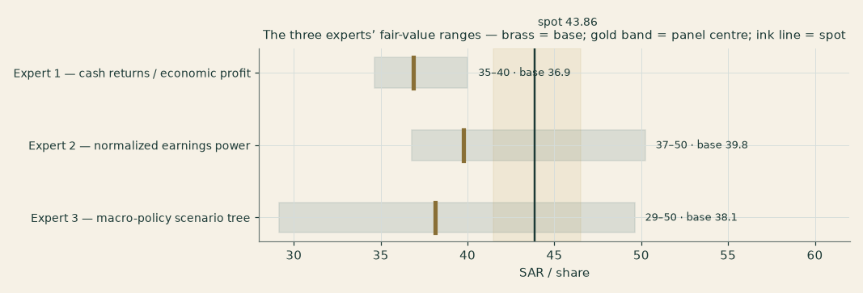
Figure C-1 — The three experts’ fair-value ranges. Brass ticks are base cases; the gold band is the panel centre; the ink line is spot. The spread is the return-fade question.
Expert | Method | Single swing assumption | Base fair value
Expert 1 | Cash returns / economic profit | The fade rate on excess returns (2.5%/yr) | SAR 35.5
Expert 2 | Normalized earnings power | The through-cycle multiple (15x) | SAR 39.8
Expert 3 | Macro-policy scenario tree | The scenario weights on the rate/payout path | SAR 36.6

The spread — SAR 35.5 to 39.8, 12% of the low — is narrow by this series’ standards, and it measures one thing cleanly: how much of stc’s current 15% return on capital survives the next decade of competition, technology churn and nation-scale capital spending. On that question the three barely disagree, and all three land below the market price: Expert 1 charges for the erosion explicitly, Expert 2 freezes today’s clean earnings at a multiple he will defend, and Expert 3 prices the policy floor — three different routes to the same neighbourhood. The study’s own central of SAR 36.06 sits inside that band, SAR 1.24 below the panel’s own average, which is worth saying plainly: the cash-flow model and three independently-constructed methods arrive within a riyal or two of each other, and all of them below the price. An investor’s position on this stock reduces to a position on one axis: if the data-centre build earns telecom-plus returns, the cash-flow model understates it; if it earns telecom-minus, Expert 1 is right and today’s price already flatters it.
Each expert’s point fair value, and its range where the method produces one, is recorded with the price it was struck against: SAR 43.86 on 2026-09-03.
About this series
Testahil publishes independent, educational valuation studies. Each is an attempt to reason transparently about what a security is worth, with every assumption shown and a companion model so readers can disagree productively. The house style is distributions, not tips: we describe ranges and probabilities, not targets, and we do not tell anyone what to do. Studies are framed as educational analysis, the preparer is not licensed by any securities regulator, and holdings are disclosed.
Disclosure & Disclaimer
Not investment advice. This document is educational and informational only. It is not, and must not be relied upon as, investment, financial, legal, accounting or tax advice, nor an offer, solicitation or recommendation to buy, sell or hold any security. It contains no price target and no rating.
No licence; no advisory relationship. The preparer is not registered or licensed with any securities or financial regulator in any jurisdiction — including the Saudi Capital Market Authority (CMA) — holds no brokerage or investment-advisory authorisation, and is not acting as your adviser or fiduciary. Nothing here is personalised to your circumstances.
Holdings disclosure. The preparer may hold, and may in the future take or dispose of, a position in the security discussed in this report, and may transact at any time without notice. This is a potential conflict of interest you should weigh.
Sources & accuracy. Reported financial and operating figures are drawn from the company’s public disclosure (stc.com IR releases and interim financial statements) and other public sources believed reliable but not independently verified; they may contain errors or be superseded. Forward-looking inputs — the segment growth and margin paths, capex intensity, the derived risk-free rate and regressed beta, terminal growth, the multiples, the stake marks and the Monte-Carlo factor probabilities — are the preparer’s own judgments and are inherently uncertain. Some balance-sheet detail lines are grouped estimates tying to disclosed totals.
Forward-looking statements. Any statements about the future are estimates subject to risks and uncertainties; actual results may differ materially. The Monte Carlo models price, not value, and encodes subjective probabilities for events that have not occurred.
No reliance; your responsibility. Do your own research and consult a licensed professional before making any decision. You are solely responsible for your investment decisions and their outcomes. To the maximum extent permitted by law, the preparer accepts no liability for any loss arising from use of this document.
Currency & figures. Figures are in Saudi riyals (SAR), millions unless stated; bn denotes billion. The riyal is pegged to the US dollar at 3.75. Rounding may cause totals to differ slightly. The market price this study is measured against is the close of 2026-09-03; the price map is struck on 2026-08-31, the last session in the price library, and both change continuously.
TESTAHIL · Independent Valuation Study · Educational Analysis · Saudi Telecom Company (Tadawul: 7010) · edition 05-09-2026 · reporting currency SAR

