Testahil · Independent Valuation Study — Educational Analysis Not investment advice

ADNOC Drilling Company P.J.S.C.
Abu Dhabi Securities Exchange · ADNOCDRILL · reports in US dollars, trades in dirhams
Valuation study — 9 August 2026
READ FIRST
What this is. An independent valuation of ADNOC Drilling built from the company's own audited and reviewed financial statements. It produces a fair-value RANGE and a distribution of possible prices. It contains no rating and no price target, and it is not investment advice.
Where the history comes from. The three years of income statement, balance sheet and cash flow are read from the signed consolidated financial statements for 2023, 2024 and 2025 and the reviewed interim statements for the first quarter and first half of 2026, each downloaded from the company's own investor-relations site. Operating units — rig counts, wells drilled, integrated-services rig counts and unconventional revenue — come from the company's own quarterly management commentary, the only published source that carries them. No data vendor, broker note or press report is a source for any figure about ADNOC Drilling itself.
Two currencies. The company's functional and presentation currency is the US dollar; its shares trade in dirhams. The valuation runs in dollars and converts to dirhams at the peg of 3.6725 dirhams to the dollar.
One judgement, computed both ways. The most consequential question in this study — what happens to drilling demand once Abu Dhabi's production-capacity target is met — has two defensible answers. Both are computed in full and published side by side, and both appear in the summary table as separate lines. They are NOT collapsed into a single cash-flow answer before the reader sees them. They do, however, both enter the weighted central figure, at a quarter of the weight each — so that figure is a blend of the two, and a reader who holds a view on which future arrives should read the case that matches it rather than the blend.

Headline
ADNOC Drilling trades at AED 5.94. Five lenses put fair value between AED 3.46 and AED 6.21, with a weighted central of AED 4.92 — 17.2% below the market. The market price sits above four of the five lenses and below one. The company is priced for the continuation of a programme that its own customer has not yet extended beyond 2027, and for a cost of capital at the defensive end of what its own trading record supports.
Three things carry the analysis.
- It is a very good business. The business is an exceptional operator on almost any measure. Revenue compounded from USD 3.06bn in 2023 to USD 4.90bn in 2025, EBITDA margins have run between 44.8% and 49.9% across the three audited years, and the return on capital employed was 24.4% in 2025 and broadly unchanged in the first half of 2026. Very few listed drillers anywhere earn that on that scale.
- It has one customer. Every rig works for one customer group. Revenue is billed to ADNOC Onshore, ADNOC Offshore and their affiliates; the controlling shareholder is the same group. That is why the contracted book is so stable, why the receivable is so large — days sales outstanding stood at 113 days at the end of 2025 — and why the terminal question is the only question that matters.
- The growth rate has already turned. First-half 2026 revenue grew 4% against 22% for full-year 2025. The company has reaffirmed roughly USD 5 billion of revenue for 2026 and has explicitly declined to guide 2027 until rig and services phasing is fixed. The market is paying 12.9 times its own last-twelve-month EBITDA against a segment-weighted peer median of 8.7 times struck the same way. That gap is the whole argument.
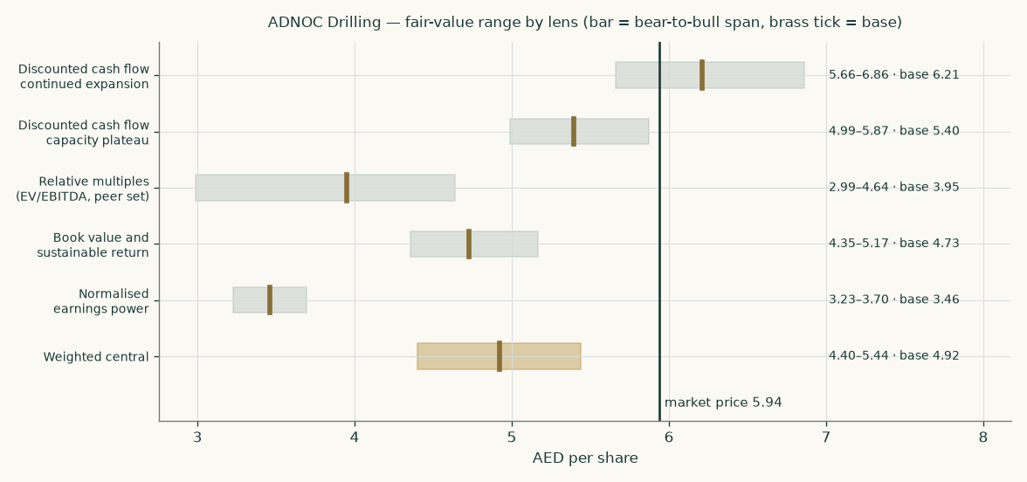
Fair value by lens. Each bar is the same lens re-run on a stated stress — the discounted-cash-flow bands move the cost of capital 50 basis points either way, the relative band is the peer set's own interquartile range, the book band moves the cost of equity 50 basis points, the normalised band moves the margin two points.
Valuation summary
Lens | AED/share | Weight | Bear | Bull | Terminal value share
Discounted cash flow — continued expansion | 6.21 | 25% | 5.66 | 6.86 | 76.0%
Discounted cash flow — capacity plateau | 5.40 | 25% | 4.99 | 5.87 | 72.3%
Relative multiples | 3.95 | 20% | 2.99 | 4.64 | —
Book value and sustainable return | 4.73 | 15% | 4.35 | 5.17 | —
Normalised earnings power | 3.46 | 15% | 3.23 | 3.70 | —
Weighted central fair value | 4.92 | 100% | 4.40 | 5.44
Market price, 7 August 2026 | 5.94
Central against the market price | -17.2%

The terminal-value share is shown beside each discounted-cash-flow lens because it is the honest measure of how much of that answer rests on a period beyond the forecast. Both cases carry more than seven-tenths of their value there.
Why the two discounted-cash-flow cases carry equal weight and half the total: they are the same model on two different answers to one question, and the study does not claim to know which is right. They are published as separate lines above and are never collapsed into one cash-flow number. They do both feed the weighted central, at a quarter of the weight each, so that single figure of AED 4.92 is a blend — which is precisely why the two cases are shown beside it, at AED 6.21 and AED 5.40. A reader who holds a view on which future arrives should read the case, not the blend.
Company overview
ADNOC Drilling Company P.J.S.C. was incorporated in 1972 by a resolution of the Council of Ministers of the Government of Abu Dhabi and listed on the Abu Dhabi Securities Exchange in October 2021. It provides start-to-finish drilling and construction services across conventional and unconventional reservoirs and hires out onshore and offshore rigs. Its parent is Abu Dhabi National Oil Company, which is wholly owned by the Government of Abu Dhabi; during 2025 the shareholding was transferred to XRG P.J.S.C., an international energy investment company itself wholly owned by ADNOC, with no change in ultimate control.
The group reports three segments and states in its own accounts that there were no inter-segment sales in either of the last two years.
Segment | FY2025 revenue (USD mn) | Share | FY2025 EBITDA (USD mn) | EBITDA margin | What it is
Onshore | 2,037 | 41.5% | 994 | 48.8% | Land rigs, water wells and workover rigs, deployed mainly across ADNOC Onshore concessions
Offshore | 1,404 | 28.6% | 953 | 67.8% | Owned jack-ups and island rigs meeting ADNOC Offshore drilling needs; the jack-up and island segments were merged into one from the first quarter of 2025
Oilfield Services | 1,462 | 29.8% | 251 | 17.2% | Integrated and discrete well services, built out of the partnership with Baker Hughes formed in late 2018
Group | 4,903 | 100.0% | 2,198 | 44.8%

The balance sheet is what an asset-heavy driller's should look like. Property and equipment of USD 5.48bn is two-thirds of USD 8.10bn of total assets. There is no lending book, no investment property and no development inventory. The only equity-accounted holdings are two service joint ventures — Enersol and Turnwell — carried at USD 437 million and contributing USD 29 million of profit. That balance-sheet shape, together with the revenue mix above, is the evidence for treating this as an operating company and valuing it on the cash its fleet generates rather than on a sum of holdings or a book of loans.
The fleet, in the company's own numbers:
 | FY2023 | FY2024 | FY2025 | 30 June 2026
Abu Dhabi onshore rigs | 84 | 95 | 92 | 92
Jack-up rigs | 35 | 37 | 36 | 36
Island rigs | 10 | 10 | 12 | 13
Regional rigs outside the UAE | — | — | — | 30
Total rigs | 129 | 142 | 140 | 171
Integrated-services rigs | 48 | 57 | 60 | 61
Wells drilled | 613 | 676 | 836 | —

The 2025 total of 140 excludes 29 regional rigs the company reported on a pro-forma basis at the year end; 8 of those closed in January 2026 through the joint venture with SLB and the remainder through the acquisition of a stake in MBPS, which is why they appear in the June 2026 column.

1. Fundamental valuation
1.1 Cash-flow model
The primary lens is a discounted free cash flow to the firm over five explicit years, with a terminal value built on the return the business earns on the capital it reinvests. The waterfall below is the continued-expansion case in full; every line is a formula in the delivered workbook.
USD million | FY2026E | FY2027E | FY2028E | FY2029E | FY2030E
Revenue | 5,000 | 5,207 | 5,497 | 5,774 | 5,962
EBITDA | 2,158 | 2,330 | 2,509 | 2,641 | 2,709
EBITDA margin | 43.2% | 44.7% | 45.6% | 45.7% | 45.4%
less depreciation and amortisation | (556) | (570) | (573) | (568) | (554)
EBIT | 1,601 | 1,760 | 1,936 | 2,074 | 2,156
Tax rate | 9% | 9% | 9% | 9% | 9%
NOPAT = EBIT x (1 - tax rate) | 1,457 | 1,602 | 1,762 | 1,887 | 1,962
add back depreciation and amortisation | 556 | 570 | 573 | 568 | 554
less capital expenditure | (700) | (600) | (520) | (420) | (380)
less increase in working capital | (146) | (19) | (26) | (25) | (17)
Free cash flow to the firm | 1,167 | 1,553 | 1,789 | 2,010 | 2,118
Discount factor | 0.926 | 0.857 | 0.794 | 0.735 | 0.680
Present value of free cash flow to the firm | 1,081 | 1,331 | 1,420 | 1,477 | 1,441

The bridge from enterprise value to equity, struck on the capital structure at 30 June 2026 rather than a year-old one:
USD million | Continued expansion | Capacity plateau | Note
Present value of the explicit five years | 6,749 | 6,860
Present value of the terminal value | 21,382 | 17,900
Enterprise value | 28,570 | 25,067
Terminal value as a share of enterprise value | 76.0% | 72.3% | More than seven-tenths of the answer sits beyond 2030 in both cases
carried forward half a year at the cost of capital | 1,105 | 972 | Discounting 2026 by a full year dates the figure above at 31 December 2025; the balance sheet beneath it is dated 30 June 2026. The gap is closed rather than ignored
less the free cash flow actually generated over that half year | (666) | (666) | Reported, not forecast. Cash the enterprise has already handed out is no longer inside it
Enterprise value at 30 June 2026 | 28,570 | 25,067 | On the same date as every line below
add investment in joint ventures | 462 | 462 | Enersol and Turnwell at carrying value; their earnings are outside the discounted cash flow, so the stake is added here
add cash and cash equivalents | 355 | 355
less borrowings | (2,469) | (2,469)
less lease liabilities | (45) | (45)
less the financial liability over the acquired minorities | (63) | (63) | The present value of the price at which the parent may be required to buy the 30% of the Sea and Land holding and the 20% of the MBPS holding it does not own. The minority interests reported at 30 June 2026 are NOT deducted as well: that is the same claim under a second name, and the company has already charged a matching reserve against owners equity for it
Equity value at 30 June 2026 | 26,811 | 23,307
accreted 38 days to the price anchor at the cost of equity | 224 | 195 | The remaining days between the balance-sheet date and the share price this value is compared against
Equity value | 27,035 | 23,502
Shares outstanding (million) | 15,993 | 15,993 | Issued shares less the shares the appointed market maker holds
Value per share (AED) | 6.21 | 5.40 | Converted at the peg

1.2 Book value and sustainable return
A business earning a return on equity of 30.6% against a cost of equity of 8.33% and growing at 2.5% justifies a price-to-book of 4.82 times. Applied to book equity attributable to owners of USD 4.23bn — book value per share of AED 0.97 — that is AED 4.73 a share. The shares currently trade at 6.11 times book.
Read this lens with care. The justified multiple is a ratio whose denominator is the cost of equity less the growth rate, which here is only 5.83%. A 50-basis-point move in the cost of equity moves the implied value from AED 4.35 to AED 5.17. The lens carries a 15% weight for that reason and no more.

1.3 Relative multiples
The listed comparator universe splits into four groups that price differently, so each of this company's segments is read against the group that actually does that job, weighted by that segment's share of segment EBITDA.
Group | Median EV/EBITDA | Applied to | Segment weight | Contribution
MENA national-oil-company drillers | 9.49x
Global land drillers | 6.15x
Global offshore drillers | 8.55x
Diversified oilfield services | 10.62x
Onshore multiple (average of the first two) | 7.82x | Onshore | 45.2% | 3.54x
Offshore multiple (average of the first and third) | 9.02x | Offshore | 43.3% | 3.91x
Oilfield-services multiple | 10.62x | Oilfield Services | 11.4% | 1.21x
Segment-weighted multiple | 8.66x |  | 100.0%
ADNOC Drilling's own multiple at AED 5.94 | 12.90x

The multiple and the earnings it is applied to are put on the same footing, on two counts that both cut the same way. Every multiple in the table above is an enterprise value struck today over that company's LAST TWELVE MONTHS of EBITDA, so this company's earnings are measured the same way — audited 2025 plus the first half of 2026 less the first half of 2025, or USD 2.20bn — rather than on the guided 2026 figure of USD 2.25bn, which would credit this company with a year of growth no peer in the denominator is credited with. And the share of joint-venture results inside that number, USD 31 million, is taken out, because the carrying value of those joint ventures is added back on the bridge — capitalising the earnings and adding back the asset that produces them would count them twice.
Applying 8.66 times to USD 2.17bn on that basis gives an enterprise value of USD 18.82bn and, through the same bridge, AED 3.95 a share. This is the lens that sits furthest below the market price, and the reason is a single observable fact: the shares are valued at 12.9 times the same trailing EBITDA when the closest regional comparators — two drillers serving national oil companies on multi-year contracts — trade at 9.5 times and the global land drillers at 6.2 times. A premium is defensible; the size of it is the question.
1.4 Normalised earnings power
This lens asks what the fleet the company had ALREADY TAKEN DELIVERY OF at 30 June 2026 earns at the margin management itself guides to, with no growth credited at all, and capitalises it in perpetuity. It is the floor of the set, and three things about it are worth stating before the table, because an earlier edition of this study got all three wrong in the same direction.
- No growth in the denominator. It is capitalised at the cost of capital itself, with nothing subtracted from the denominator for growth. A denominator of cost-of-capital-less-growth IS a growth credit; there is no other reason for a growth rate to appear in it, and a lens that says it credits none may not have one.
- Delivered, not targeted. The counts below are the ones the company reported at 30 June 2026 — including 13 island rigs and 61 integrated-services rigs — not the 70 integrated rigs the company TARGETS for the end of 2026. A target is growth.
- The depreciation this fleet carries. The charge is the first-half 2026 depreciation annualised, which is what the fleet being priced actually carries. The 2030 charge this study forecasts, USD 554 million, belongs to a larger fleet and is not available to this lens; the maintenance capital expenditure of USD 250 million is a spending floor, not a depreciation charge.
 | Units | Revenue per rig-year (USD mn) | Revenue (USD mn)
Abu Dhabi onshore rigs | 92 | 20.1 | 1,849
Regional onshore rigs | 30 | 8.0 | 240
Jack-up rigs | 36 | 30.5 | 1,099
Island rigs | 13 | 26.3 | 342
Rigs served by oilfield services | 114 | 7.9 | 897
Normalised revenue |  |  | 4,427
Normalised EBITDA at the guided margin of 45.0% |  |  | 1,992
less normalised depreciation and amortisation |  |  | (521)
Normalised EBIT |  |  | 1,471
Normalised NOPAT after tax at 9% |  |  | 1,339
Capitalised at the cost of capital of 8.01%, with no growth deducted from it |  |  | 16,714
Value per share (AED) |  |  | 3.46

1.5 Synthesis — four lenses, one field
Four methods, five readings: the cash-flow method is run on two different futures and each is reported as its own line, which is why the heading says four and the table below says five.
The five readings span AED 3.46 to AED 6.21, and the width is informative rather than embarrassing: the multiple lens sits well below the rest because it reads the company as one of a class of drillers, while the cash-flow and franchise lenses read it as a business earning an exceptional return on a modest asset base. What has changed since the cost of capital was rebuilt on the published index is where the market price sits relative to that field. At a cost of capital of 8.01% the market price of AED 5.94 sits above four of the five lenses and below one, and above the weighted central. The conclusion rests heavily on one input — so the beta table in section 1.8 and the beta row of the sensitivity in section 1.9 should be read before it is.
1.6 Drivers
Revenue is built from the bottom up: rigs in service times revenue per rig-year, by class, with margins falling out as an OUTPUT of a cost stack rather than being assumed. The rates below are derived from the company's own disclosed segment revenue and its own disclosed rig counts — they are arithmetic, not estimates.
Revenue per rig-year (USD million) | FY2023 | FY2024 | FY2025
Abu Dhabi onshore, conventional | 18.9 | 20.9 | 20.1
Offshore, blended | 23.5 | 28.9 | 29.6
Integrated services, conventional | 12.6 | 13.7 | 15.9
Wells drilled per drilling rig | 5.0 | 5.0 | 5.9

The onshore rate rose from 2023 to 2024 and then fell back in 2025; it is not a trend, so the forecast escalates it at 1.5%, the domestic inflation rate, rather than extrapolating the 2024 step. The offshore rate rose steadily as jack-ups and island rigs came into service.
Oilfield services needs two volume drivers, not one.
The company discloses TWO rig populations that this segment serves, and they are different populations. One is the integrated-drilling-services fleet, which it reports at 57 rigs at the end of 2024 and 60 at the end of 2025. The other is the rigs given at least one discrete service, reported separately at 48 and 58 over the same two year ends. An earlier edition of this study built the segment on the first population alone. That is not a simplification, it is a build the company's own numbers refute: solve for one constant revenue rate on each population across the two disclosed years and the integrated rate comes out at MINUS USD 6.8 million a rig. A negative price is not a rounding problem; it says the one-driver model cannot be made to fit.
Oilfield services | FY2024 | FY2025
Integrated-services rigs at year end | 57 | 60
Rigs given at least one discrete service | 48 | 58
Rigs served, total | 105 | 118
Segment revenue excluding the unconventional programme (USD mn) | 718 | 928
Revenue per rig served (USD mn) | 6.84 | 7.86
Realised growth in revenue per rig served |  | 15.0%

The forecast carries both populations and lets the revenue per rig served grow at the rate the company actually achieved between the two disclosed years, 15.0%, fading linearly to the contract escalator of 1.5% by the end of the window. It fades because a gain of that size in revenue per rig served is a mix and efficiency effect — more services sold onto the same rig — and mix effects do not compound indefinitely. This is the cleanest growth story in the business and the least contracted.
The two 2026 acquisitions are consolidated, on both sides of the balance sheet.
An earlier edition of this study consolidated the REVENUE of the two regional businesses acquired in the first half of 2026 while leaving their asset base, the borrowings assumed with them and the minority interests recognised out of the roll-forward entirely. They are now entered as the single transaction the acquisition note supports, line by line. Nothing in it is a plug: the entry closes to zero against owners equity, which is the test a business combination has to pass — buying a business cannot, by itself, make the parent's shareholders richer or poorer.
The 2026 business combinations, as entered | USD mn
Property, equipment, right-of-use assets and goodwill acquired | 309
Working capital acquired | 41
Cash acquired | 43
Borrowings and lease liabilities assumed | (180)
Deferred tax, income tax and end-of-service benefits assumed | (15)
Contingent consideration outstanding | (20)
Minority interests recognised | (50)
The 2025 advance, released against consideration | (91)
Cash consideration paid in 2026, net of the amount received back | (38)
Net effect on equity attributable to owners | 0

Two independent checks tie the entry to the face of the accounts: the goodwill it recognises equals the goodwill line on the 30 June 2026 balance sheet, which was nil six months earlier, and the minority interests it recognises equal the corresponding line in the statement of changes in equity.
Working capital is set on the only balance sheet that includes what was bought.
An earlier edition projected working capital at the average of the three audited years, 5.91% of revenue, and applied it to a revenue line that consolidates two businesses none of those three year ends contained. The ratio now comes off the 30 June 2026 balance sheet, the only one that consolidates them: working capital of USD 443 million on annualised first-half revenue, or 9.01%. Of that, USD 41 million came with the acquisitions, leaving 8.17% organic — so the acquisitions explain part of the increase and the business explains the rest.
The obvious objection is that a mid-year balance sheet flatters or punishes the ratio seasonally. The company's own cash-flow statement answers it, and answers it against this study: over the first half of 2025 working capital RELEASED USD 154 million of cash, so this company runs BELOW its year end at mid-year rather than above it. Over the first half of 2026 it ABSORBED USD 173 million. The build is real, it is not seasonal, and raising the ratio to meet it lowers this valuation rather than raising it.
What the unit build decides, and what the guidance decides.
The company guides all three segments for 2026, and this study reconciles the unit build to all three rather than to the group total. That reconciliation is a real correction and its size is published here rather than absorbed silently, because it says how much of the FY2026 figure is the bottom-up build and how much is the company's own guidance.
FY2026, conventional revenue only | Unit build before reconciliation (USD mn) | Guided, less the contracted unconventional programme (USD mn) | Correction
Onshore | 2,120 | 1,909 | -10.0%
Offshore | 1,463 | 1,500 | +2.5%
Oilfield Services | 1,103 | 1,191 | +8.0%
Group | 4,686 | 4,600 | +1.9%

The unconventional programme is contracted revenue on its own schedule and is not scaled by a unit-rate correction, so it is taken out of both columns above; the reconciliation is solved on the part of each segment the unit rates actually build.
The group total is close, and an earlier edition stopped there. The segments are not: the onshore build runs above the guidance and the oilfield-services build below it, and those two errors were cancelling. The correction is applied as a persistent level shift on each segment's unit rate rather than as a one-year plug, so it carries through every forecast year. The consequence for a reader is worth stating plainly: THE UNIT RATES SET THE GROWTH PATH, AND THE COMPANY'S GUIDANCE SETS THE FY2026 LEVEL. A change to any FY2025 unit rate moves 2027 onwards and leaves 2026 where the guidance put it.
The margin is NOT reconciled, and that is deliberate. The build produces an FY2026 EBITDA margin of 43.74% against guidance of 44.0% to 46.0% — below the guided range, by roughly USD 63 million of EBITDA. Scaling the cost stack to close that gap would move the weighted central figure by about six fils. It is not done, because the margin here is an OUTPUT of a cost stack built line by line from the company's own cost note, each line on its own volume driver and its own escalator. A margin that has been scaled to meet a guided margin is no longer evidence about anything. The gap is reported instead, and it is a reason to read the cost table below closely.
Costs are escalated one class at a time. A single blended inflation rate applied across physically different cost lines is the fastest way to manufacture a margin trend that is not there, so each line gets the escalator that belongs to it.
Cost line | FY2025 conventional base (USD mn) | Volume driver | Escalator | Rate
Repairs and maintenance | 681 | rig years | Oilfield-services cost index | 1.5%
Staff costs | 604 | rig years | Domestic wage inflation | 2.0%
Hire of equipment | 228 | conv revenue | Oilfield-services cost index | 1.5%
Chemicals | 192 | wells | Oilfield-services cost index | 1.5%
Fuel and lubricants | 128 | rig years | Own commodity path | 0.0% flat nominal
Major maintenance | 40 | offshore rig years | Oilfield-services cost index | 1.5%
Other direct cost | 93 | conv revenue | Domestic inflation | 1.5%

Fuel is the line that most often gets this wrong. It is a globally traded input, so it is escalated on its own commodity path and not on a domestic price index: Brent closed at USD 88.90 on 3 August 2026 against a three-year average of USD 79.48, roughly 12% above the mean, so a flat nominal path already embeds real mean reversion. It also matters less than it looks: the company's onshore contracts carry an explicit fuel-escalation pass-through, and its own first-half commentary attributes part of the onshore revenue increase to exactly that mechanism, so the line is close to margin-neutral in either direction.
1.7 The crux
One question dominates this valuation, and it is not a financial one. Abu Dhabi has a stated objective of five million barrels a day of production capacity by 2027. ADNOC Drilling exists to deliver it. The fleet has grown from 115 rigs at the end of 2022 to 171 at the middle of 2026, the company has six more island rigs on order for delivery between 2026 and 2028, and it has bought its way into Oman, Kuwait and Bahrain. What happens after the target is met?
 | Continued expansion | Capacity plateau
The premise | Regional expansion, integrated services and automation keep the fleet and the services book growing after 2027; unconventional Phase 1 is followed by more work | The domestic fleet stops growing once the capacity target is met; the ordered island rigs still arrive because they are paid for, but nothing follows them
Abu Dhabi onshore rigs by 2030 | 100 | 92
Regional rigs by 2030 | 38 | 30
Integrated-services rigs by 2030 | 82 | 72
Unconventional revenue in 2030 (USD mn) | 200 | 0
FY2030 revenue (USD mn) | 5,962 | 5,371
Terminal growth rate | 2.5% | 1.5%
Enterprise value (USD mn) | 28,570 | 25,067
Value per share (AED) | 6.21 | 5.40

The two cases are AED 0.81 apart — 13.7% of the current price. They are published side by side and are not averaged into one number. A reader who believes the programme continues should read the first column; a reader who thinks 2027 is the peak should read the second. The market price sits between them, closer to the first.
One finding materially narrows this. The unconventional programme looks like the obvious thing to worry about — USD 692 million of 2025 revenue on a contract with roughly USD 0.86 billion left at the year end and no announced successor. It is not, because it barely earns anything. Applying the company's own disclosed conventional EBITDA margin of 51% to conventional revenue leaves about 7.3% of margin on the unconventional book; the year-on-year incremental bridge gives 5.8%. Both methods are shown in the workbook and averaged there to 6.6%. So the runoff of a USD 692 million revenue line removes roughly USD 45 million of EBITDA, not USD 350 million. The crux is the conventional fleet, not the shale contract.

1.8 Macro and country — the cost of capital, built
The cash flows are in US dollars, so the discount rate is built in dollars. Country risk enters ONCE, through the Abu Dhabi country risk premium already inside the equity risk premium; the risk-free rate is therefore the US Treasury yield normalised by the United States' own default spread rather than a local yield that would carry sovereign risk a second time.
 | Rating basis | CDS basis | Source
US 10-year Treasury yield, 6 August 2026 | 4.69% | 4.69% | Federal Reserve H.15
less the US adjusted default spread | (0.23%) | (0.23%) | Damodaran country file, 5 January 2026
Normalised risk-free rate | 4.46% | 4.46%
Equity beta | 0.795 | 0.795 | Own-stock five-year weekly regression
Equity risk premium (Abu Dhabi, rated Aa2) | 4.87% | 4.93% | Damodaran country file
Cost of equity | 8.33% | 8.38%
Marginal cost of debt, pre-tax | 5.15% | 5.15%
Cost of debt after tax at 9% | 4.69% | 4.69%
Weight of equity | 91.1% | 91.1% | Market capitalisation over market capitalisation plus net debt
Weighted average cost of capital | 8.01% | 8.05%

Both bases are published because both are defensible and they differ by only 4 basis points; the rating basis is used, and nothing in the conclusions turns on the choice.
Cost of debt: three methods, one test
The cost of debt is marginal and forward-looking, not an accounting average. Three candidates were computed and one test applied — a same-currency corporate cannot borrow below its own sovereign.
Method | Construction | Rate | Clears the sovereign floor?
Term-matched to the latest facility | US 5-year Treasury yield plus the 0.75% margin on the USD 2.0 billion facility signed 16 October 2025 with a five-year initial maturity | 5.15% | Yes — adopted
Spot floating all-in cost | Overnight financing rate plus the same margin | 4.40% | No — it is a short rate, and it prices below the sovereign
Trailing effective rate | FY2025 interest on loans over average gross debt | 4.77% | No — and it is backward-looking in any case
Sovereign floor | US 5-year Treasury yield plus the Abu Dhabi sovereign credit-default-swap spread | 4.86%

Beta
The beta is the company's own, measured against the index it actually trades in: a five-year weekly regression of its returns against the FTSE ADX General Index, giving 0.795 on 247 weekly observations with an R-squared of 0.128, a standard error of 0.133 and a 90% interval of 0.58 to 1.01. Because the listing dates from October 2021 a full five-year window exists, so no peer beta is needed.
Five robustness runs are published rather than hidden, and they do not all agree:
Regression | Beta | R-squared | Weeks | Standard error
Five-year weekly against the index (adopted) | 0.795 | 0.128 | 247 | 0.133
Four-year weekly against the index | 0.836 | 0.111 | 205 | 0.166
Three-year weekly against the index | 1.025 | 0.142 | 153 | 0.205
Two-year weekly against the index | 0.890 | 0.109 | 102 | 0.255
Five-year monthly against the index | 0.471 | 0.059 | 57 | 0.255
Five-year weekly against an equal-weight composite of the market | 0.664 | 0.160 | 249 | 0.097
Five-year weekly against a turnover-weighted composite | 0.500 | 0.117 | 249 | 0.087

Three things in that table matter. First, the published index is the regressor, not a composite: an equal-weight average of the market's constituents under-weights the large-capitalisation names the index is concentrated in, and here that difference is worth +0.132 of beta — about 64 basis points on the cost of equity. The two series are far from interchangeable despite a weekly return correlation of 0.84.
Second, the estimate is not stable across windows. The three-year window gives 1.025 — above one — and the monthly regression gives 0.471. The five-year weekly run is adopted because it has the most observations and the tightest standard error, not because it is the middle of the range. A reader who prefers the three-year window should read the beta row of the sensitivity table in section 1.9 and take the answer there.
Third, one is no longer outside the confidence interval. The 90% interval reaches 1.01. A contracted revenue stream from a state counterparty ought to be defensive, and on the five-year weekly measure it is, but the evidence for that is weaker than a point estimate suggests. The sensitivity to beta is published in section 1.9 for exactly that reason, and it is the largest single sensitivity in this study.
One disclosure on timing: the index series runs to 2026-07-24 while the price series runs to 2026-08-07, so the regression's overlap ends 14 days before the valuation anchor. That costs two of roughly 250 weekly observations and does not move the estimate, but it is stated rather than passed over.
1.9 Sensitivity
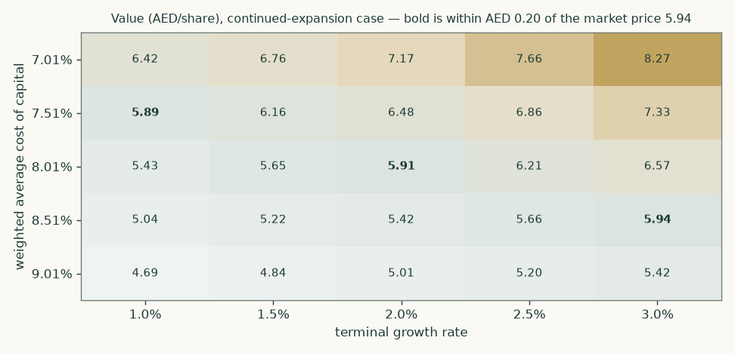
Discounted-cash-flow value per share against the cost of capital and the terminal growth rate, continued-expansion case. Bold cells lie within AED 0.20 of the market price.
Driver | Move | Value per share (AED) | Change against the base
Equity beta | 0.500 | 8.25 | 32.8%
Equity beta | 0.664 | 6.98 | 12.4%
Equity beta | 0.795 | 6.21 | base case
Equity beta | 0.900 | 5.70 | -8.2%
Equity beta | 1.010 | 5.24 | -15.6%
EBITDA margin | -4 points | 5.45 | -12.2%
EBITDA margin | -2 points | 5.83 | -6.1%
EBITDA margin | +0 points | 6.21 | base case
EBITDA margin | +2 points | 6.59 | 6.1%
EBITDA margin | +4 points | 6.97 | 12.2%

The single most powerful driver is the beta, and it is the one input in the whole model that is estimated from market data rather than read from a filing. Across the range the regressions in section 1.8 actually produced — from 0.50 on a turnover-weighted composite to 1.01 at the top of the adopted regression's own confidence interval — the continued-expansion case runs from AED 8.25 down to AED 5.24. That is a spread of AED 3.01, wider than the gap between the two terminal cases and wider than the gap between the central and the market price. It is stated here rather than buried in a footnote because it is the quickest way to overturn this study — in either direction.

2. Technical and price structure
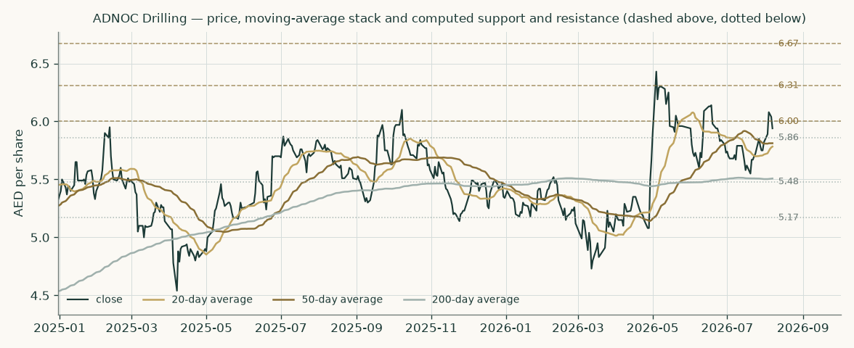
Price against the 20-, 50- and 200-day moving averages, with the computed support and resistance ladder.
The price closed 5.94 above a rising 20-day (5.78), a falling 50-day (5.81) and a flat 200-day (5.51). Momentum is neutral: RSI(14) is ~57 and the daily ATR near 0.12 (~2.0%) points to a normal tape. MACD (12·26·9) is positive and rising (+0.06 / +0.02 / +0.04). Over the last year it has ranged 4.51–6.67; the last close sits 11% below that high and 32% above that low.
The trend reading is: trading above the whole moving-average stack, on a flat 200-day.
 | Level (AED) | Distance from the close
Resistance 1 | 6.00 | 1.0%
Resistance 2 | 6.31 | 6.2%
Resistance 3 | 6.67 | 12.3%
Support 1 | 5.86 | -1.3%
Support 2 | 5.48 | -7.7%
Support 3 | 5.17 | -13.0%
Last close | 5.94
52-week range | 4.51 – 6.67 | 10.9% off the high

Upside trigger: A daily close back above 6.00 would clear the nearest resistance and open the 6.67 zone. Downside trigger: A close below 5.86 would break the nearest support and open the 5.17 zone.
Every level and every clause above is computed from the same cleaned price series the probability map runs on; nothing here is a chart opinion. Levels one and above are the nearest to the close in each direction.
3. Probability map
Alongside the fundamental work the study carries a probability map: a simulation of where the price could be at two fixed future dates, given how this share has actually behaved. It is a different question from fair value and it is answered differently — 50,000 simulated price paths anchored on the close of 7 August 2026, with the drift set by the risk-free rate less the dividend yield the company has itself guided to (4.06% on the reaffirmed USD 1.05 billion floor), so no part of the answer comes from assuming the shares go up.
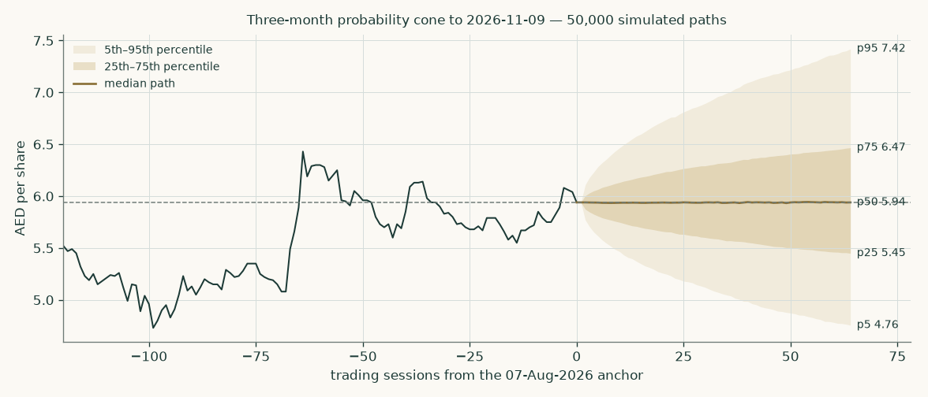
Three-month cone to 2026-11-09, with the preceding 120 sessions of realised price for scale.
 | One month — 2026-09-07 | Three months — 2026-11-09
5th percentile (AED) | 5.26 | 4.74
25th percentile (AED) | 5.67 | 5.45
50th percentile (AED) | 5.94 | 5.94
75th percentile (AED) | 6.22 | 6.47
95th percentile (AED) | 6.69 | 7.44
Probability of finishing above AED 5.94 | 49.8% | 50.0%
Probability of finishing 10% or more above | 8.8% | 22.7%
Probability of finishing 10% or more below | 7.3% | 20.6%

Touching a level at any point during the window is a different and higher probability than finishing beyond it, and both are given.
Level | AED | Touched within one month | Touched within three months
+5% | 6.24 | 40.6% | 65.0%
+10% | 6.53 | 14.6% | 41.8%
+15% | 6.83 | 4.7% | 25.5%
+20% | 7.13 | 1.5% | 15.3%
-5% | 5.64 | 39.2% | 63.7%
-10% | 5.35 | 11.8% | 37.6%
-15% | 5.05 | 2.7% | 19.4%
-20% | 4.75 | 0.5% | 8.9%

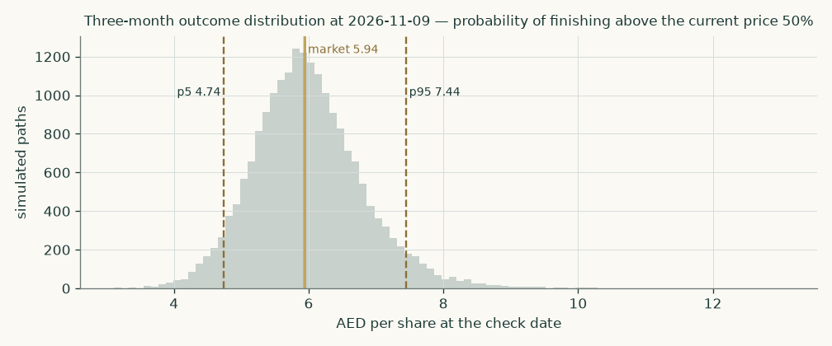
The three-month distribution of outcomes. The gold line is the current price.
How well has this map worked?
A probability map that has never been scored is decoration, so the record is stated plainly. Run backwards across every non-overlapping three-month window that the price history used here can score — the first of them opens on 2022-10-17 and the last on 2026-04-20, which is not the whole listed history: the earliest windows are held back to fit the model that predicts them — 15 independent, non-overlapping windows — the map scored 1.65% WORSE than a simple no-information benchmark that assumes the price simply drifts with the risk-free rate less the dividend. That shortfall held under three different resampling schemes, so it is a real result and not a sampling artifact.
The reason is specific and worth stating, because it is not the reason most readers would assume. The map is not pointing the wrong way. Its centring is close to perfect: the median of the realised outcomes sat at the 55th percentile of the predicted distribution, against 50 for a perfectly centred forecast. The problem is that it is TOO WIDE. Every single realised outcome fell inside the predicted 80% band and inside the 90% band — 100% and 100% coverage against targets of 80% and 90% — and the band itself was 1.10 times the benchmark's. A band that wide is never wrong and is not very useful, and a scoring rule that rewards sharpness penalises it accordingly.
The cause is mechanical. The bands are calibrated across a panel of Abu Dhabi and Dubai listed companies, and this share's own realised volatility — measured as the annualised standard deviation of its daily returns over the whole price history used here — of 25.2% sits at the 28th percentile of that panel, below the panel median of 27.1% on the same measure. (Two other volatility figures appear in this study and are not the same quantity: the shorter-window figure quoted in the technical section, which is measured over the recent trading range only, and the forward volatility embedded in the probability map, which is what the panel calibration produces.) A band sized for the average name is too wide for a below-average-volatility one. Narrowing it to 80% of the panel width would have turned the score positive, and that is reported as a diagnosis rather than applied, because a width chosen after seeing the outcomes it is scored on is not evidence of anything.
The one-month map is a different matter: over 44 windows it scored -0.06% against the same benchmark — statistically indistinguishable from it — with outcomes spread across the predicted distribution rather than bunched in the middle. Read the three-month percentiles above as an outer bound on plausible movement rather than as a calibrated probability, and read the one-month figures as neither better nor worse than assuming no information.

4. Comparison of the lenses
Lens | AED/share | What it assumes | When it is the right lens | When it misleads
Discounted cash flow — continued expansion | 6.21 | The fleet and the services book keep growing after the capacity target is met | When a customer has a published multi-decade investment programme | When the programme is a project with an end date rather than a policy
Discounted cash flow — capacity plateau | 5.40 | Domestic growth stops in 2027 and only the ordered rigs arrive | When the demand driver is an explicit capacity target | When it ignores regional expansion that is already contracted
Relative multiples | 3.95 | That this company should be valued like other listed drillers | When the peer set genuinely does the same job | When the peers are exposed to a spot market and this company is not
Book value and sustainable return | 4.73 | That a return on equity above the cost of equity is durable | When a franchise has demonstrated the return through a cycle | When the cost of equity is close to the growth rate, as it is here
Normalised earnings power | 3.46 | Only the fleet already installed, at the guided margin, forever | As a floor that credits no growth at all | When the installed fleet is genuinely still being built out

The lenses disagree in a structured way rather than randomly, and the disagreement is about one thing: whether the return this business earns on its capital is durable. Four of the five sit at or below the market price — the capacity-plateau cash-flow case, the peer-multiple lens, the book-value lens and the normalised-earnings lens — and one sits above it, the continued-expansion cash-flow case. That is the same disagreement the expert panel in Appendix C reaches from three different starting points, and it is the disagreement a reader has to resolve for themselves.
5. Catalysts
What | When | Why it matters | Which way
2027 guidance | The company has said it will publish it once rig and oilfield-services phasing is fixed | This is the single observation that separates the two discounted-cash-flow cases | Either
Third-quarter 2026 results | Expected late October 2026 | The first read on whether the first-half deceleration to 4% revenue growth is phasing or trend | Either
Completion of the MBPS acquisition | Announced November 2025, subject to regulatory approval | 22 of the 30 regional rigs already in the June 2026 fleet count come through it | Down if it fails
Delivery of the remaining ordered island rigs | Gradually to 2028 | 5 of the six ordered rigs are still to arrive — one entered the fleet in the second quarter of 2026, ahead of schedule; they are the most visible contracted growth in the model | Up
An unconventional Phase 2 award | Not announced | Would extend a revenue line that is large but, on the evidence in section 1.7, barely profitable | Up, but less than it looks
Integrated-services rig count reaching the stated 70 target | End of 2026 | The fastest-growing and highest-incremental-margin part of the business | Up
A change in the dividend policy | Board discretion | The guided floor of USD 1.05bn is 76.4% of forecast 2026 profit; the model accumulates cash rather than assuming a rise | Up if raised

6. Reading the probability zones
The percentile map in section 3 is not a forecast of where the price will go. It is a statement about how far it could plausibly travel in a given window, given how it has travelled before. Three cautions apply to reading it.
- Percentiles are not bounds. A 5th percentile is not a floor. One outcome in twenty is expected to fall below it, and the events that produce those outcomes — a contract loss, a sovereign shock, a sharp move in oil — are exactly the ones a volatility model does not see coming.
- Touching is not finishing. The probability of touching a level at some point in a window is materially higher than the probability of finishing beyond it. Both are tabulated because confusing them is the most common error in reading a cone.
- This particular band is wide. On this share's own record the three-month band has been too wide, as section 3 sets out in full. Treat the outer percentiles as generous rather than tight.
The map and the valuation answer different questions and are not reconciled with each other. The valuation says what the business is worth; the map says how far the price might wander in the next quarter regardless.
7. Caveats, and what would change our mind
Caveat | What it does to the answer | What would settle it
The terminal value is more than seven-tenths of enterprise value in both cases | Most of this valuation is a claim about a period nobody has contracted for | Published 2027 and medium-term guidance
The beta of 0.80 does more work than any other input, and it is not stable across estimation windows | The regressions actually run span 0.47 to 1.02, and across the sensitivity grid the continued-expansion case runs from AED 8.25 to AED 5.24 — a wider spread than the gap between the two terminal cases | A longer trading record, or a stress episode that tests the correlation. The index series is also two weeks behind the price anchor and should be refreshed alongside it
One customer group, which is also the controlling shareholder | Contract terms are set inside a group, not in a market; the model reads realised rates and cannot see the negotiation behind them | Disclosure of contract tenor and repricing mechanics
Regional expansion is bought, not built | Two acquisitions supply 30 of the 171 rigs; the revenue per regional rig is derived from one half-year of consolidation | A full year of reported regional segment data
The dividend floor is a policy, not an obligation | The distribution lens in Appendix C rests on it entirely | A declared distribution below the floor, or a capital raise
The forecast holds debt flat and pays only the guided floor | Cash accumulates to USD 2.79bn by 2030 and net debt turns negative; enterprise value is unaffected, but the balance sheet in Appendix A is a floor case, not a prediction | Any capital-allocation announcement
First-half 2026 revenue grew 4%, against 22% for 2025 | The forecast reconciles to guidance for 2026 and grows from there; if the deceleration is trend rather than phasing, the continued-expansion case is wrong | Third-quarter and full-year 2026 results

Appendix A — financial statements
A.1 Income statement — three audited years and five forecast years
USD million | FY2023 | FY2024 | FY2025 | FY2026E | FY2027E | FY2028E | FY2029E | FY2030E
Revenue | 3,057 | 4,034 | 4,903 | 5,000 | 5,207 | 5,497 | 5,774 | 5,962
Direct cost | -1,849 | -2,337 | -3,106 | -3,262 | -3,296 | -3,394 | -3,521 | -3,618
Gross profit | 1,208 | 1,697 | 1,797 | 1,738 | 1,911 | 2,102 | 2,253 | 2,345
General and administrative expenses | -126 | -155 | -167 | -164 | -179 | -195 | -208 | -218
Other income | 10 | 6 | 27 | 27 | 28 | 28 | 29 | 29
Share of joint-venture results | 0 | 8 | 29 | 29 | 30 | 30 | 31 | 31
EBITDA | 1,483 | 2,015 | 2,198 | 2,187 | 2,360 | 2,539 | 2,672 | 2,741
EBITDA margin | 48.5% | 49.9% | 44.8% | 43.7% | 45.3% | 46.2% | 46.3% | 46.0%
Depreciation and amortisation | -391 | -458 | -512 | -556 | -570 | -573 | -568 | -554
EBIT | 1,092 | 1,556 | 1,686 | 1,631 | 1,790 | 1,966 | 2,104 | 2,187
Finance cost | -75 | -136 | -109 | -129 | -129 | -129 | -129 | -129
Finance income | 16 | 12 | 12 | 9 | 10 | 24 | 45 | 72
Profit before tax | 1,033 | 1,432 | 1,588 | 1,511 | 1,671 | 1,862 | 2,020 | 2,130
Income tax | 0 | -129 | -139 | -136 | -150 | -168 | -182 | -192
Profit after tax | 1,033 | 1,304 | 1,449 | 1,375 | 1,521 | 1,694 | 1,839 | 1,939
Net margin | 33.8% | 32.3% | 29.5% | 27.5% | 29.2% | 30.8% | 31.8% | 32.5%

The three historical years are the audited figures. FY2023 carries no income tax because the Abu Dhabi fiscal arrangement took effect on 1 January 2024.
A.2 Balance sheet
USD million | FY2023 | FY2024 | FY2025 | FY2026E | FY2027E | FY2028E | FY2029E | FY2030E
Fixed assets | 5,027 | 5,381 | 5,534 | 5,987 | 6,017 | 5,964 | 5,816 | 5,642
Other non-current assets | 2 | 4 | 100 | 10 | 10 | 10 | 10 | 10
Investment in joint ventures | 0 | 275 | 437 | 437 | 437 | 437 | 437 | 437
Inventories | 206 | 223 | 279 | 477 | 497 | 525 | 551 | 569
Trade and other receivables | 154 | 186 | 150 | 257 | 268 | 283 | 297 | 307
Due from related parties | 987 | 1,361 | 1,365 | 2,335 | 2,432 | 2,567 | 2,696 | 2,784
Cash and cash equivalents | 365 | 336 | 236 | 279 | 653 | 1,221 | 1,971 | 2,794
Total assets | 6,740 | 7,766 | 8,101 | 9,781 | 10,313 | 11,005 | 11,778 | 12,543
Borrowings and lease liabilities | 2,181 | 2,320 | 2,317 | 2,496 | 2,496 | 2,496 | 2,496 | 2,496
Trade and other payables | 930 | 1,241 | 1,115 | 1,907 | 1,986 | 2,096 | 2,202 | 2,274
Due to related parties | 250 | 251 | 416 | 712 | 741 | 782 | 822 | 849
Employees' end of service benefits | 114 | 130 | 144 | 149 | 152 | 155 | 158 | 162
Income tax payable | 0 | 15 | 11 | 11 | 12 | 13 | 14 | 15
Total liabilities | 3,476 | 3,956 | 4,002 | 5,307 | 5,420 | 5,576 | 5,725 | 5,828
Total equity | 3,264 | 3,810 | 4,099 | 4,424 | 4,843 | 5,379 | 6,002 | 6,665
Net debt | 1,827 | 1,990 | 2,081 | 2,217 | 1,843 | 1,276 | 526 | -297
Net debt / EBITDA | 1.23x | 0.99x | 0.95x | 1.01x | 0.78x | 0.50x | 0.20x | -0.11x

The forecast balance sheet holds gross debt flat at the audited 2025 level and pays only the guided dividend floor, so surplus cash accumulates. It balances in every year, and the residual equity agrees with the independently rolled-forward equity to the dollar.
A.3 Cash flow and the working-capital cycle
USD million | FY2023 | FY2024 | FY2025 | FY2026E | FY2027E | FY2028E | FY2029E | FY2030E
Net cash from operating activities | 1,355 | 1,654 | 2,226 | 1,788 | 2,076 | 2,245 | 2,386 | 2,479
Capital expenditure | (1,062) | (762) | (815) | (700) | (600) | (520) | (420) | (380)
Dividends paid | (700) | (752) | (1,144) | (1,050) | (1,102) | (1,158) | (1,216) | (1,276)
Free cash flow to the firm | — | — | — | 1,167 | 1,553 | 1,789 | 2,010 | 2,118
Closing cash | 354 | 330 | 236 | 279 | 653 | 1,221 | 1,971 | 2,794

The asset-conversion cycle, read from the statements and used to project the balance sheet rather than plugged:
Days | FY2023 | FY2024 | FY2025 | What it is
Days sales outstanding | 136 | 140 | 113 | Trade receivables plus amounts due from related parties, over revenue. The size reflects unbilled contract assets on work performed for group companies
Days inventory outstanding | 41 | 35 | 33 | Inventories over direct cost
Days payables outstanding | 233 | 233 | 180 | Trade and other payables plus amounts due to related parties, over direct cost
Working capital as a share of revenue | 5.5% | 6.9% | 5.4% | Averaged to 9.0% and used to drive the forecast

Appendix B — peers, risks and research register
B.1 The peer set
Company | Group | Enterprise value (USD mn) | Last 12 months EBITDA (USD mn) | EV/EBITDA
ADES Holding | MENA NOC-contracted driller | 9,981 | 976 | 10.23x
Arabian Drilling | MENA NOC-contracted driller | 2,587 | 296 | 8.75x
Helmerich & Payne | Global land driller | 5,365 | 794 | 6.75x
Nabors Industries | Global land driller | 2,826 | 1,308 | 2.16x
Patterson-UTI | Global land driller | 4,849 | 873 | 5.56x
Precision Drilling | Global land driller | 1,604 | 229 | 7.02x
Valaris | Global offshore driller | 6,080 | 606 | 10.03x
Noble Corporation | Global offshore driller | 7,941 | 929 | 8.55x
Borr Drilling | Global offshore driller | 3,247 | 452 | 7.18x
SLB | Diversified oilfield services | 85,049 | 6,663 | 12.76x
Halliburton | Diversified oilfield services | 32,747 | 3,592 | 9.12x
Baker Hughes | Diversified oilfield services | 61,604 | 5,080 | 12.13x
Weatherford Intl | Diversified oilfield services | 6,756 | 848 | 7.97x
ADNOC Drilling at AED 5.94 | Subject | 28,025 | 2,173 | 12.90x

Peer prices are at the close on 7 August 2026; earnings and balance-sheet figures are each company's own latest reported period. Nothing on this table is a source for any ADNOC Drilling figure — it is used for cross-check and for the relative lens only.
B.2 Risk register
Risk | How it would show up | Severity | Already visible?
Customer concentration | A change in contract terms at renewal, invisible until realised revenue per rig moves | High | No — terms are not disclosed
Capacity target achieved and drilling demand plateaus | Flat or falling rig count from 2028 | High | Partly — 2027 guidance is deliberately withheld
Receivable concentration | Four counterparties represented 99.9% of related-party receivables at the end of 2025 | Medium | Yes — disclosed in the accounts
Current liabilities exceed current assets | The company disclosed a USD 477.7 million shortfall at the end of 2025 and states it has assessed liquidity under several scenarios | Low | Yes — disclosed, with USD 1.5 billion of undrawn revolving capacity behind it
Regional integration risk | Two acquisitions consolidated within six months; margin dilution already visible in the first-half onshore numbers | Medium | Yes — onshore EBITDA margin fell from 50% to 45% year on year in the first half
Oil price | Indirect: it moves the customer's investment programme rather than this company's day rates | Medium | No
Floating-rate debt | All borrowings are priced over the overnight financing rate | Low | Yes — the rate structure is disclosed in the borrowings note

B.3 Research register — what was looked for, and what was found
Question | Where it was looked for | Outcome
Audited statements for three complete years | The company's investor-relations site | Found: signed consolidated statements for 2023, 2024 and 2025, plus reviewed interims for the first quarter and first half of 2026
Rig counts, wells drilled and utilisation | Quarterly management commentary and earnings presentations | Found for every year from 2022 to the second quarter of 2026
Contract tenor and day-rate mechanics | All filings and presentations | NOT FOUND. The company does not disclose contract tenor or repricing terms. Realised revenue per rig is used instead, and the gap is flagged
Backlog | All filings | NOT FOUND in the form other drillers report. The accounts disclose only USD 19.4 million of unsatisfied performance obligations, which is a revenue-recognition measure and not a backlog
2027 and beyond guidance | Results releases | NOT AVAILABLE. The company states it will publish it once rig and oilfield-services phasing is finalised. This absence is the reason the study carries two cases rather than one
Exchange disclosure portal | adx.ae | Returned an access error from this environment. Not required — the filings were obtained from the company itself
Local-currency government bond curve | Central bank of the UAE and market data sources | NOT OBTAINED. Not required: the cash flows are in US dollars and the discount rate is built in dollars. A dirham-basis cross-check would need this curve and is therefore not published

Appendix C — the expert panel
Three analysts value the same company by three genuinely different methods. Each shows the workings, each names the sensitivity that matters most to their answer, and each states in advance what would prove them wrong.
C.1 Expert 1 — the asset valuer
Worldview: a rig is a machine with a replacement cost. Anything a buyer pays above the cost of rebuilding the fleet is a payment for a contract, and contracts end. This lens is therefore not a fair value at all; it is a floor, and its usefulness is the size of the gap between it and the market.
When it works: in a downturn, when contracts lapse and the steel is what is left. When it fails: in a company like this one, where the contract is the asset.
USD million |  | Source or construction
Property and equipment at cost | 10,379 | FY2025 property and equipment note
less accumulated depreciation | (4,902) | Same note
Net book value | 5,477
Replacement uplift on net book at 15% | 822 | The fleet was bought over many years; rebuilding it costs more than it cost
Fully depreciated assets still in use, at cost | 1,539 | Disclosed in the FY2025 note: assets still in use with nil carrying value
valued at 25% of cost | 385
Depreciated replacement cost of the fleet | 6,684
add right-of-use assets and intangibles | 56
add net working capital | 263 | FY2025 balance sheet
add other non-current assets | 10
Asset enterprise value | 7,013
Equity value after the bridge | 5,200 | Same bridge as the main study
Value per share (AED) | 1.19

Named sensitivity: the replacement uplift is the only judgement in the table.
Replacement uplift on net book | 0% | 15% | 30% | 50%
Value per share (AED) | 1.01 | 1.19 | 1.38 | 1.63

Falsifier, stated in advance: A rig sale, or an impairment, at a price materially away from depreciated book. The company sold one rig for $36.0 million in 2025 against a carrying value that produced a $21.6 million disposal gain — that single observation supports the uplift. A future disposal at or below carrying value would falsify it.
C.2 Expert 2 — the contracted-cash-flow analyst
Worldview: this is not an equity, it is a bond with an equity tail. The near years are contracted to a state counterparty and should be discounted at something close to a corporate borrowing rate; the years beyond the window are not contracted at all and deserve a penalty on top of the ordinary cost of capital.
When it works: on infrastructure and long-contract assets where the counterparty is better credit than the company. When it fails: when the "contracted" book turns out to be cancellable, or when splitting the rate is used to make a number bigger rather than more honest.
USD million | FY2026E | FY2027E | FY2028E | FY2029E | FY2030E
Free cash flow to the firm | 1,167 | 1,553 | 1,789 | 2,010 | 2,118
Discount factor at 5.15% | 0.951 | 0.904 | 0.860 | 0.818 | 0.778
Present value | 1,110 | 1,404 | 1,538 | 1,644 | 1,648

 | USD million | Construction
Present value of the contracted years | 7,345
Terminal-year NOPAT | 1,991 | FY2030 NOPAT grown at 1.5%
Reinvestment rate | 8.3% | Growth over the terminal return on capital
Tail discount rate | 9.51% | The cost of capital plus a 150-basis-point renewal premium
Terminal value | 22,789
Present value of the terminal value | 14,470
Enterprise value | 21,816
of which terminal | 66.3%
Equity value after the bridge | 20,003
Value per share (AED) | 4.59

Renewal premium over the cost of capital | 0.5% | 1.0% | 1.5% | 2.5% | 3.5%
Value per share (AED) | 5.25 | 4.90 | 4.59 | 4.09 | 3.70

Falsifier, stated in advance: The 2027 guidance the company has said it will publish once rig and oilfield-services phasing is fixed. If the guided 2027 revenue lands below this model's $5.16 billion, the contracted book is thinner than assumed and the near-year discount rate is too generous.
C.3 Expert 3 — the distribution investor
Worldview: a minority shareholder in a state-controlled company owns the distribution, not the enterprise. Value what actually leaves the company, discounted at the cost of equity — not at a cost of capital that blends in debt the shareholder does not own.
When it works: on mature, high-payout, majority-controlled companies. When it fails: when the payout is a policy that can be withdrawn, and whenever retained cash is genuinely being reinvested at a high return — as some of it is here.
 | FY2026E | FY2027E | FY2028E | FY2029E | FY2030E
Dividend (USD million) | 1,050 | 1,102 | 1,158 | 1,216 | 1,276
Discount factor at 8.33% | 0.923 | 0.852 | 0.787 | 0.726 | 0.670
Present value | 969 | 939 | 911 | 883 | 855

 | USD million | Construction
Present value of the five guided years | 4,557
Terminal dividend | 1,308 | FY2030 dividend grown at 2.5%
Terminal value | 22,433
Present value of the terminal value | 15,035
Equity value | 19,592
Value per share (AED) | 4.50
Payout as a share of forecast profit, 2026 | 76.4% | The floor is covered by earnings with room to spare
Payout as a share of forecast profit, 2030 | 65.8%

Terminal growth of the distribution | 1.0% | 1.5% | 2.0% | 2.5% | 3.0%
Value per share (AED) | 3.75 | 3.96 | 4.21 | 4.50 | 4.84

Falsifier, stated in advance: Any distribution below the guided floor, or a capital raise. Either would break the premise that the payout is the residual the shareholder actually receives.
C.4 Cross-examination
Expert 1 to Expert 3: the dividend floor is a board policy, not a contract. In the year the six island rigs and a regional acquisition land together, the floor is the first thing to go.
Conceded in part. The guided floor is 76% of the profit this model forecasts for 2026 and 66% by 2030, so it is covered by earnings with room to spare, and the company funded a 52% increase in dividends paid in 2025 out of operating cash flow while capital expenditure ran at $815 million on the audited cash-flow statement. But the challenge stands where it matters: the floor is uncontracted, and the valuation of a promise is not the valuation of an obligation. Expert 3 is the widest of the three for exactly that reason.
Verdict: Partly conceded.
Expert 3 to Expert 1: replacement cost values a rig at what it costs, not at what it earns. This fleet earns a 23% return on capital employed. Valuing it at book plus a fifteen-point uplift prices it as scrap.
Rejected as a criticism, accepted as a description. Expert 1 is not claiming to be the fair value; it is claiming to be the floor. The gap between the replacement-cost answer of AED 1.19 and the market price of AED 5.94 is the market's price for the contract, and putting a number on that gap is the point of running the lens at all.
Verdict: Rejected.
Expert 2 to Expert 3: discounting dividends at the cost of equity while the company runs net cash by 2030 double-counts the balance sheet. The undistributed cash is not risky.
Conceded. Under the model's flat-debt, floor-dividend policy the company accumulates roughly $2.5 billion of cash by 2030 and net debt turns negative. Expert 3 does not credit that cash, so its answer is conservative by construction — the correction would raise it, not lower it. The reason it is left uncorrected is that a board holding that much idle cash would in practice have raised the distribution, which is the same thing seen from the other end.
Verdict: Conceded.
Expert 1 to Expert 2: a 150-basis-point premium on the tail is a number chosen to look prudent. The tail is 70% of your answer.
Conceded on the arbitrariness, and the sensitivity is published rather than buried: moving the premium from 50 to 350 basis points moves the answer from AED 5.25 to AED 3.70. That spread is wider than the gap between any two of the three experts, which is the honest summary of how much of this valuation is a judgement about a period nobody has contracted for.
Verdict: Conceded.
C.5 The three in one room
Put in one room, the three do not disagree about the company — they agree on the fleet, on the customer, and on the 2026 numbers, because all three read the same filings. They disagree about what a single-customer contract is worth. Expert 1 will not pay for it at all and lands at AED 1.19. Expert 2 pays for the part that is written down and charges a premium for the part that is not, landing at AED 4.59. Expert 3 pays for the part that reaches the bank account and lands at AED 4.50. The spread between them, AED 3.40, is not measurement error. It is the price of the question none of them can answer from the filings: what happens to a rig fleet whose only customer is also its controlling shareholder, once that shareholder's capacity target is met.
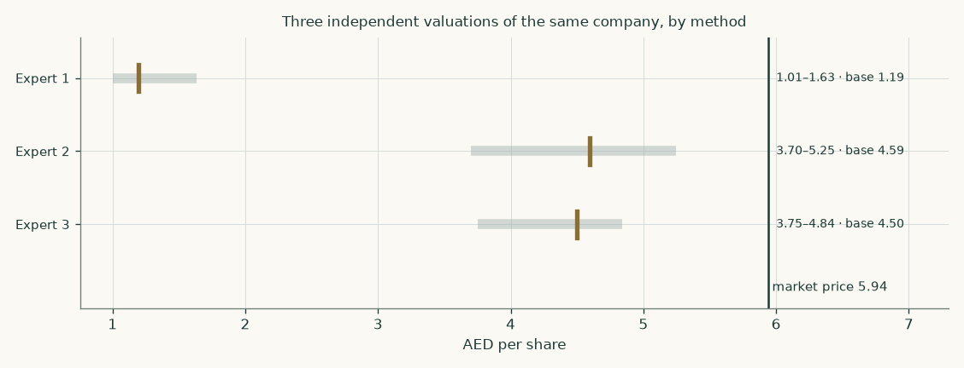
The three valuations against the market price. The bar is each expert's own published sensitivity range; the brass tick is the base case.
C.6 Divergence — which assumption drives which gap
Assumption | Expert 1 | Expert 2 | Expert 3 | What it drives
What is being valued | The steel. The fleet at what it would cost to rebuild, and nothing else. | The cash the contracted book throws off, plus a discounted tail. | The cash that actually reaches the shareholder. | Expert 1 is structurally the lowest because it refuses to pay for the contract that makes the steel earn 23% on capital.
Discount rate | None. An asset value is not discounted. | 5.15% on the contracted years, 9.51% on the tail. | 8.33% throughout — the cost of equity, not of capital. | Expert 2 discounts the near years more cheaply than the study does and the far years more dearly; the two effects partly cancel, which is why its answer lands close to the study despite a very different construction.
Treatment of growth | Ignored entirely. | 1.5% in the tail, with the fleet build inside the explicit years. | 5% for five guided years, then 2.5%. | The dividend step is the single largest source of Expert 3's premium over Expert 1: five years of guided 5% growth compounds before the fade begins.
Where the risk sits | In whether the rigs can be redeployed if the customer walks. | In the renewal of the uncontracted tail, priced as an explicit premium. | In whether the dividend floor survives a capital-expenditure cycle. | All three risks are the same risk seen from three sides: the durability of one customer relationship.

About this study
Testahil publishes independent valuation studies and calibrated probability maps, with a public record of how they turned out. Every study is built from the subject company's own issued financial statements, read from an official source. The delivered workbook calculates: change a driver and the valuation moves. Every formula in it has been checked against the model that produced it, and every input has been perturbed to prove the chain from driver to answer is live.
This study values ADNOC Drilling Company P.J.S.C. as an operating company, using a discounted cash flow as the primary lens with relative multiples, normalised earnings power and a book-and-return lens alongside it. Its most consequential judgement is computed both ways and published both ways.
Disclosure
This document is educational analysis. It is not investment advice, not a recommendation, and not an offer or solicitation to buy or sell any security. It contains no rating and no price target. Fair-value ranges and probability distributions are estimates that depend on assumptions stated throughout the document, and reasonable people applying the same evidence will reach different numbers.
The historical financial information is taken from ADNOC Drilling Company P.J.S.C.'s own published financial statements and disclosures. Third-party market data is used only for peer comparison and is identified as such wherever it appears. Prices and market data are as at 7 August 2026 and go stale immediately.
Past performance and past accuracy are not guarantees of future results. Readers should form their own view and, where appropriate, take professional advice.
© 2026 Testahil. All rights reserved.

