TESTAHIL — STANDING RESEARCH SERIES
GB Corp (Ghabbour) — Valuation Study
GBCO.CA on the Egyptian Exchange · fundamental refresh of 19 August 2026 · re-issues the study of 8 July 2026 (amended 9 July) on the first-half 2026 accounts
READ FIRST
- This is a re-build of the July 2026 study on new primary evidence: the reviewed consolidated interim financial statements of 30 June 2026 and the 2Q/1H26 results release, both published by the company on 13 August 2026.
- The single question that moves this valuation most is what a 42.93% stake in MNT-Halan is worth. The June-2026 funding round says USD 1.4bn for the whole company (EGP 35.22 per GB Corp share on our sum of the parts); the company's own balance sheet carries the stake at EGP 15.7bn (EGP 22.99 per share) — and the reviewer states it could not verify that figure. We compute the whole study BOTH ways, side by side, and never average the two.
- Fair-value range: EGP 19.4 / EGP 34.2 / EGP 47.4 (bear / central / bull) against a last exchange close of EGP 31.31 on 22 July 2026 — the latest close in our price library. The company's own investor page quoted EGP 29.70 on 19 August 2026.
- The probability map and the technical read in this document are reproduced from our published page unchanged, with their own dates shown. They were built on price data of 22 July 2026 and were NOT re-struck for this refresh; only the fundamental range moved. A fresh price feed updates them on their own schedule.
- No rating and no price target. Fair-value ranges and probabilities only.
The headline
EGP 34.2 central fair value — or EGP 29.26 if you take the company's own book at its word
The first half of 2026 settled the operating question and sharpened the valuation one. Operationally, GB Corp beat the July study's pace almost everywhere that matters: automotive revenue ran about 10% ahead of the forecast's seasonal path, commercial vehicles nearly doubled, and the working-capital discipline the model hoped for actually printed (net debt fell to EGP 14.5bn, 2.14x EBITDA). What fell short sits below the operating line: net finance cost rose 42% and the effective tax rate reached 41.0% because regional losses in Iraq and Jordan earn no tax relief — group profit fell 24.5% on a 35% revenue gain.
The valuation question is now officially two-sided. In June, Egypt's largest bank led a funding round valuing MNT-Halan at USD 1.4bn; GB Corp's stake, translated at today's 50.71 pound, is worth EGP 30.5bn on that mark. The company's balance sheet carries the same stake at EGP 15.7bn — and the auditor's review report says it was not given MNT-Halan's accounts and could not verify the number, for the second period running. That disagreement is worth EGP 12.23 per share. We show every result in both framings rather than blending them.
Valuation summary — every read at a glance
Lens | Bear | Base | Bull | Weight
Sum of the parts — stake at the round mark | 17.40 | 35.22 | 54.72 | 40%
Sum of the parts — stake at the balance-sheet mark | 8.97 | 22.99 | 40.45 | (same weight, alternate framing)
Book value & sustainable return | 24.66 | 30.82 | 44.41 | 15%
Relative multiples | 22.57 | 26.80 | 31.04 | 20%
Normalised earnings power | 30.26 | 40.34 | 50.50 | 25%
Weighted central — round mark | 19.36 | 34.16 | 47.38 | 100%
Weighted central — balance-sheet mark | — | 29.26 | — | 100%
Published range (this refresh) | 19.4 | 34.2 | 47.4
July 2026 study, for comparison | 23.3 | 35.7 | 51.0

EGP per share. The bear of the published range lives in the balance-sheet-mark world with operating setbacks; the bull lives in the round-mark world with the operating tailwinds. Last close EGP 31.31 (22 July 2026).
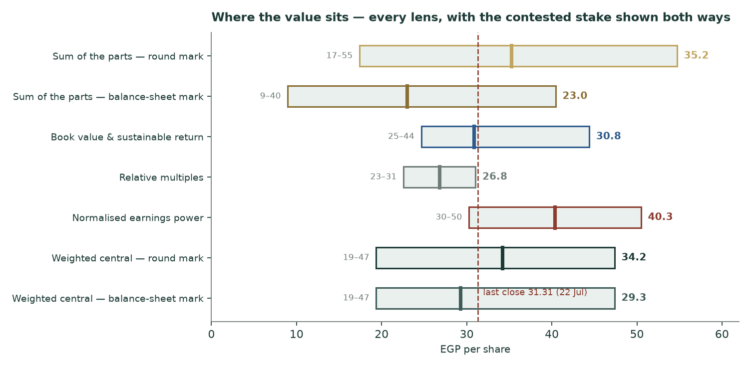
Every lens, with the contested stake computed both ways — the two darkest bars are the same synthesis under the two marks.
Company overview
GB Corp is Egypt's largest automotive assembler and distributor and, through GB Capital, one of its largest non-bank lenders. The automotive side spans passenger cars (Hyundai, Chery, Changan, Haval, Deepal, MG, Mazda, Genesis and others, assembled and imported), commercial vehicles and construction equipment (Volvo, Fuso, Marcopolo bus building, exports), two- and three-wheelers (Bajaj), tires and parts. The Sadat assembly plant became fully operational in the half, with a locally assembled Changan SUV already the best-seller in its class; a further Hyundai model arrives in September 2026 and a third Changan model late in the year. The financing side (GB Lease & factoring, Drive consumer finance and its Forsa instalment arm, fleet and bus rental, SME lending, securitisation) carried a net loan book of EGP 24.0bn at June 2026, up 33.6% in a year, with non-performing loans at 2.8%.
Alongside the consolidated businesses sits a 42.93% associate stake in MNT-Halan, the Egyptian-origin fintech whose lending book now reaches roughly USD 1.95bn across Egypt, Turkey and Pakistan. The Ghabbour family controls 63.38% of GB Corp; Olayan of Saudi Arabia holds 3.61% and the Miri Strategic Emerging Markets Fund 7.37%. 1,085.5mn shares are outstanding; the free float is 36.6%.
H1-2026, EGP mn | Group | Automotive | GB Capital
Revenue | 48,474.4 | 40,021.5 | 9,088.2
Gross profit | 7,421.9 | 5,722.1 | 1,762.2
Operating profit | 3,661.3 | 3,127.0 | 574.4
Net profit (attributable) | 1,262.0 | 607.9 | 649.6
Net debt / book | 32,269.8 | 14,493.6 | 23,984.6

From the reviewed interim statements and the results release of 13 August 2026. GB Capital's last row is its net loan portfolio; the group's is net debt.
1 Fundamental valuation
1.1 The cash-flow model — automotive leg, full waterfall
The automotive business is valued on its free cash flow to the firm, discounted at the group's own cost of capital of 22.72% (built from scratch in section 1.8), with terminal growth of 11.5% in nominal pounds. The valuation is dated 30 June 2026: the realized first half is already in the opening net debt, so the model discounts the second half and four further years, each at mid-period.
EGP mn | FY26E | FY27E | FY28E | FY29E | FY30E
Revenue | 87,056 | 102,662 | 118,513 | 133,419 | 148,579
Gross profit | 11,862 | 13,455 | 15,523 | 17,473 | 19,452
Operating profit | 6,221 | 6,853 | 7,962 | 9,068 | 10,195
Effective tax rate | 38.0% | 30.0% | 26.0% | 24.0% | 22.5%
After-tax operating profit | 3,857 | 4,797 | 5,892 | 6,892 | 7,901
Depreciation & amortisation | 871 | 1,047 | 1,233 | 1,388 | 1,545
Capital expenditure | 2,800 | 2,600 | 2,500 | 2,500 | 2,600
Working-capital build | 1,106 | 3,076 | 2,974 | 2,612 | 2,516
Free cash flow to the firm | 822 | 168 | 1,650 | 3,167 | 4,330

Discounting (valuation date 30-Jun-2026) | Cash flow | Period (yrs) | Present value
H2-26E | -1,871 | 0.5 | -1,689
FY27E | 168 | 1.5 | 124
FY28E | 1,650 | 2.5 | 989
FY29E | 3,167 | 3.5 | 1,547
FY30E | 4,330 | 4.5 | 1,723
Terminal value (on FY30E) | 43,032 | 4.5 | 17,127
Enterprise value |  |  | 19,821
less net debt (30-Jun-26) |  |  | -14,494
less non-controlling interests |  |  | -591
Automotive equity value |  |  | 4,737
Per share |  |  | 4.36

Two honest features of this table. First, the second half of 2026 is cash-negative: the first half released EGP 1.8bn of working capital (inventories fell hard), and the year-end always rebuilds stock ahead of the selling season — the full-year build nets to roughly EGP 1,106mn. Second, 86% of the enterprise value sits in the terminal value, because near-term cash flow is consumed by a business growing revenue in the high teens with four months of inventory on the floor. At a 22.7% discount rate that is the honest arithmetic of growth in this currency, and it is why the cash-flow lens values the automotive leg (EGP 4.36) well below its accounting capital employed — the business currently earns roughly its cost of capital, no more.
1.2 Book value and sustainable return
Restated book value is EGP 30.82 per share (parent equity EGP 33.5bn over 1,085.5mn shares). The prior-year accounts were restated upward by EGP 2.88bn, mostly a write-up of the MNT-Halan carrying value. Forecast return on that equity runs 8.5% in FY26E, recovering toward 13.9% by FY30E as regional losses fade and the tax rate normalises — below the 27.9% cost of equity throughout, which is why we anchor this lens at plain book (price-to-book of one) rather than a premium. Marking the MNT-Halan stake to the funding round would lift book to EGP 44.41 — that is the lens's bull case, and the bear (EGP 24.66) is 0.8x book, the discount the market applies to sub-hurdle returns.
1.3 Relative multiples
On the statement-forecast for the full year 2026 the group earns EGP 2.82 per share. Egypt's closest listed financing peer, Contact Financial, trades at 9.4x trailing earnings; AutoNation, the mature-market auto retailer, at 9.1x; Dogus Otomotiv, Turkey's closest analogue to the distribution business, at 12.6x; Bajaj Auto, the two-wheeler partner, at 27.6x in a far richer market. A 8–11x band with 9.5x at the centre prices GBCO at EGP 22.57 / EGP 26.80 / EGP 31.04. This lens is deliberately stake-blind: earnings capture only MNT-Halan's equity pickup, not its mark — which is exactly why it sits at the cautious end of the field.
1.4 Normalised earnings power
Normalisation walk (mid-cycle) | EGP mn
FY27E automotive operating profit | 6,853
Financing cost at an eased 17% on today's net debt | -2,464
Tax at the statutory 22.5% (no loss-stranding) | -988
GB Capital net profit, FY27E (incl. associates) | 1,750
Normalised group profit | 5,152
Per share x 8.5 | 40.34

What normalisation removes: the 41.0% effective tax rate (statutory is 22.5% — the excess is Iraqi and Jordanian losses that shield nothing), and a funding bill still priced off a 19% policy corridor that the central bank has begun easing. At 8.5x — between the Egyptian financing peer and the mature-market retailers — normalised power is worth EGP 40.34 (bear EGP 30.26, bull EGP 50.50). This lens leans furthest into the recovery; its weight reflects that.
1.5 Synthesis — four lenses, one field
Weights: sum of the parts 40%, book 15%, relative 20%, normalised 25%. Under the round mark the weighted central is EGP 34.16; under the company's balance-sheet mark it is EGP 29.26. We publish the round-mark central as the base — the round is real third-party money, led by the country's largest bank — and we let the balance-sheet framing define the bear side of the published range, because the auditor's inability to verify the carrying value is not a technicality. The two numbers are EGP 4.89 apart; nothing in this study averages them.
1.6 The drivers — every line on its own volumes and prices
Before re-setting a single driver, the July forecast was scored against the half that actually printed:
Line | July study, FY26E | H1-26 actual | Full-year pace vs forecast | Verdict
PC volumes (units) | 63,334 | 29,554 | +2% | on track
PC revenue | 62,717 | 30,596 | +7% | escalate
CV&CE revenue | 7,818 | 4,749 | +37% | escalate
Light-Mobility revenue | 3,008 | 1,435 | +13% | escalate
Trading revenue | 5,007 | 2,572 | -11% | escalate
Auto revenue | 78,550 | 40,022 | +10% | escalate
Auto EBITDA | 6,677 | 3,485 | +8% | escalate
Group net profit | 3,300 | 1,262 | -34% | escalate

'Full-year pace' compares the half against the forecast using last year's seasonal split, so a strong second half is not mistaken for a miss. Anything beyond five percent is treated as a forecast error to be explained, not smoothed over.
Three real errors surfaced. Commercial vehicles were under-forecast by a third — the bus and truck replacement cycle plus exports ran far ahead of the modelled recovery. Tires were over-forecast — last year's base carried a one-off dealer stock transfer the old model treated as run-rate. And group profit was over-forecast for a reason that had nothing to do with operations: the old model taxed everything at a flat 28% and carried no financing-cost line; the real half printed a 41% effective rate and 42% higher finance costs. All three mechanisms are now modelled explicitly.
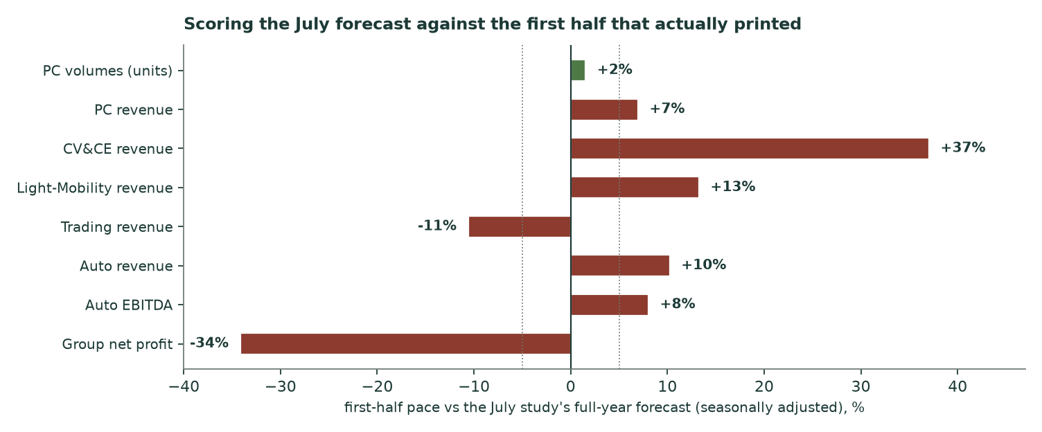
The scorecard behind the driver re-set.
The re-built stack, line by line (volumes x prices, with unit costs escalated on their own physical classes — imported content on the currency path, domestic content on the inflation path; margins are outputs, never inputs):
Line of business | H1-26 actual | FY26E | FY27E | FY30E | How it is built
Passenger cars — units | 29,554 | 64,300 | 70,087 | 84,247 | H1 actual + the launch calendar; market print +18%
Passenger cars — price (EGP mn) | 1.035 | 1.049 | 1.133 | 1.362 | realized +10.8%; capped below cost inflation ahead
Commercial vehicles & equipment | 4,749 | 10,100 | 12,320 | 18,476 | units and prices separately; replacement cycle + exports
Two-, three- & four-wheelers | 1,435 | 3,350 | 4,119 | 6,519 | supply constraint (India) resolves; strong two-wheeler demand
Tires & parts trading | 2,572 | 4,800 | 5,328 | 6,899 | one-off margin benefit resets next year
Automotive total | 40,022 | 87,056 | 102,662 | 148,579

The margin mechanics: gross margin printed 14.3% in the half against 15.5% a year earlier — one measured year of compression, driven by supply normalising and the pound. The model carries exactly one more year of that differential (to 13.1% in FY27E) and then holds the cost-to-price relationship flat: the compression is evidenced, a compounding forever-version of it is not, and the offsetting force — three more locally assembled models — is real but equally unquantified in the filings. Second-half margins are set off last year's measured seasonal gap (1.2% below the first half), not assumed.
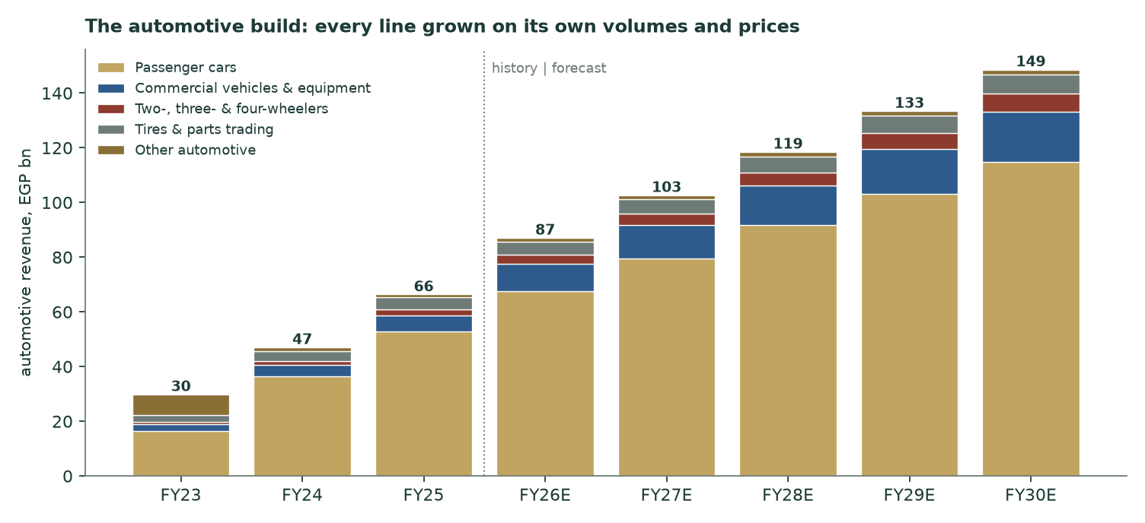
History and forecast, stacked by line of business.
Working capital is projected on its measured cycle — 122 days of inventory, 27 of receivables, 82 of payables at June 2026 (a 67-day cash cycle) — expressed as 23.0% of revenue gliding to 21.0%, anchored on five disclosed quarterly snapshots rather than the year-end peak. Capital spending follows the company's own half (1,376 spent, EGP 1,021mn contractually committed). The effective tax rate glides from 38% to the statutory 22.5% as the regional drag fades — management itself guides the Jordanian rationalisation to largely end this year.
1.7 The crux — one stake, two official answers
Strip everything else away and this valuation is a view on one number. GB Corp's 42.93% of MNT-Halan is worth EGP 30.5bn if the June funding round (USD 1.4bn, led by Al Ahly Capital of the National Bank of Egypt, first close, a second pending) is the truth. It is worth EGP 15.7bn if the company's own accounts are — a figure produced by the equity method, written up 2.46bn in a restatement, and explicitly not verified by the reviewing auditor, who was not provided MNT-Halan's financial statements for the second period in a row. The gap is EGP 12.23 per GB Corp share — roughly 39% of the current price. For perspective, the round mark alone equals 95% of GB Corp's entire market value at the August quote: the market has already answered which framing it believes, and it is not the round. What would settle it: MNT-Halan's audited numbers reaching the reviewer, the second close completing at or above USD 1.4bn, or any arm's-length secondary sale of stock. Until one of those happens, both answers are published everywhere in this study.
1.8 Macro & country — the cost of capital, built from scratch
Egypt's 10-year local bond yielded 22.92% on 19 August 2026. That yield already contains the sovereign's own default risk, so charging an emerging-market equity premium on top of the raw yield would count the same risk twice — the error that inflated the July study's discount rate and is corrected here. We strip the sovereign's default spread and add it back once, inside the equity premium, on two published bases:
Cost of equity | CDS basis | Rating basis
Observed 10Y local yield (19-Aug-26) | 22.92% | 22.92%
less sovereign default spread | 3.41% | 6.37%
risk-free, normalised | 19.51% | 16.55%
equity risk premium (Egypt, Jan-26 tables) | 9.41% | 13.94%
beta (own shares vs the EGX 30, weekly, five years) | 0.893 | 0.893
Cost of equity | 27.91% | 28.99%

The beta is this study's own regression of GBCO's weekly returns on the exchange's published index over five years: 0.893 with a standard error of 0.202 across 255 weeks, explaining 24% of the variance — a usable, conservative estimate that replaces the July study's assumption of exactly 1.0 (its earlier attempt, five annual observations, was rightly discarded as meaningless).
Cost of debt — the evidence | Rate | Dated
Company's own average on current EGP borrowings (H1-26 statements) | 20.82% | 13-Aug-26
Company's own average on USD borrowings | 7.78% | 13-Aug-26
Consumer-finance bond programme, 2022 vintage (fixed) | 13.5–14.0% | 2022
Central-bank overnight deposit corridor (held, July meeting) | 19.0% | 11-Jul-26

Essentially the whole EGP 43.5bn borrowing book floats, so the current average IS the marginal rate — it reprices as the central bank moves. The blended pre-tax cost is 20.71% (90% local at 20.82%, the dollar tranche carried at its coupon plus expected depreciation, 19.68% in pound terms — the currency split of the debt itself is not disclosed and is bounded at no more than 17% dollar from the statements' currency-exposure table; we carry 10% and flag it). One deliberate tension is disclosed rather than hidden: the borrowing average sits below the 10-year sovereign yield. That is tenor, not magic — the company borrows short against a policy corridor of 19% while the long end carries the fiscal premium; a corporate cannot out-borrow its sovereign at matched maturity, and at matched maturity it does not.
Weights use the market's own equity value (EGP 29.70 on the company's investor page, 19 August, times 1,085.5mn shares) against the automotive segment's gross debt including leasing notes — the lending platform's funding belongs to its loan book, not to the automotive capital structure, and is valued inside that leg instead. Result: equity 56% / debt 44%, and a weighted average cost of capital of 22.72% on the CDS basis (23.33% on the rating basis — both are used and shown, the CDS basis as primary, continuing the July study's choice). Every contested construction above is priced in section 1.9 rather than just named.
1.9 Sensitivity
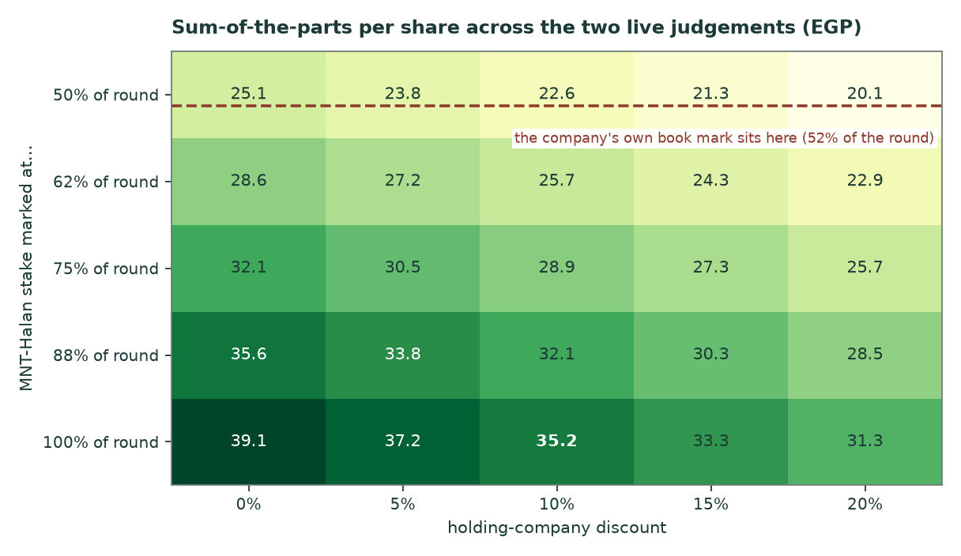
The two live judgements, priced: what the stake is really worth, and how much conglomerate discount the structure deserves.
The grid spans the whole disagreement: at the company's own book mark (52% of the round) with a 10% holding discount the sum of the parts is worth about EGP 22.99; at the full round mark, EGP 35.22. Beyond the grid: one point of automotive gross margin is worth about EGP 6.49 per share on the cash-flow leg; one point of discount rate about EGP 1.94 on the sum of the parts; the difference between the two equity-premium bases is 0.61% of discount rate. The published bear-to-bull range is wide because the honest range IS wide: it contains a real, unresolved factual question, not just parameter noise.
2 Technical & price structure — as published, unchanged
This section reproduces our live page's technical read exactly as it stands. Its own stamps: computed 2026-08-17 on price data through 2026-07-22. This refresh did not touch it — a technical read moves only when the price library moves.
Trend: Consolidating below the near-term moving averages, above a rising 200-day.
The price closed 31.31 above a rising 50-day (29.25) and a rising 200-day (27.25), but below a rising 20-day (31.67). Momentum is neutral: RSI(14) is ~53 and the daily ATR near 1.23 (~3.9%) points to a lively tape. MACD (12·26·9) is above zero but rolling over (+0.81 / +0.95 / −0.14). Over the last year it has ranged 19.10–34.20; the last close sits 8% below that high and 64% above that low.
Resistance | Support
31.70 | 29.96
32.30 | 28.20
33.40 | 26.73

- Bull trigger: A daily close back above 31.61 would clear the nearest resistance and open the 34.20 zone.
- Bear trigger: A close below 28.64 would break the nearest support and open the 23.99 zone.
3 A probabilistic price map — as published, with its dates
The published probability cone was struck on the closing library of 2026-07-22 and computed on 2026-07-28. It is reproduced here unchanged and is now four weeks old against this refresh: its one-month window resolves on 2026-08-23, days away. Treat the levels below as the record of what was published, not as a fresh forecast — a new price data-set re-strikes the map on its own schedule, independently of this fundamental refresh.
Horizon | 5th | 25th | median | 75th | 95th | resolves
1 month | 25.55 | 29.31 | 31.78 | 34.47 | 39.54 | 2026-08-23
3 months | 22.08 | 28.34 | 32.80 | 37.86 | 48.54 | 2026-10-22

EGP per share, from a 50,000-path simulation anchored at the EGP 31.31 close of 2026-07-22.
Price level | Touch within 1 month | Touch within 3 months
40.00 | 7% | 30%
38.00 | 13% | 40%
36.00 | 25% | 54%
34.00 | 46% | 71%
32.00 | 78% | 89%
30.00 | 59% | 73%
28.00 | 27% | 48%
26.00 | 11% | 30%

Probability of trading at the level at any point inside the window, not of finishing there.
When that map was built, the engine behind it had beaten its no-skill benchmark on this stock's own five-year record — its probability scores were 3.2% better than the benchmark on strictly non-overlapping three-month windows and 9.6% better sampled monthly, with 94% of outcomes inside its 90% bands (17 windows). Those statistics travel with the July strike; they are not re-measured here.
4 Comparison of the lenses
Lens | What it sees | What it is blind to | Where it lands
Sum of the parts | each business on its own economics; the stake at a real mark | which mark is true — so it is computed twice | 23.0 or 35.2
Book & return | the restated accounting floor | franchise value above book; the unbooked round gain | 30.8
Relative multiples | what buyers pay today for comparable earnings | the stake entirely; the tax normalisation | 26.8
Normalised power | the business with the two distortions removed | how long the distortions actually last | 40.3

The pattern is the tell: the two stake-blind lenses sit at 27–40, the stake-aware framings at 29–34. The market's August quote of 29.7 prices GB Corp as if the operating businesses were nearly the whole story and MNT-Halan's round were mostly noise. That is a coherent position — it is the balance-sheet framing — but it leaves the round-mark upside as a free option on a documented, bank-led transaction.
5 Catalysts to watch
- The stake: MNT-Halan's second closing — size and price either validate the USD 1.4bn mark or re-price the crux directly.
- Rates: The central bank's next meetings against 14.9% July inflation: each cut reprices the floating funding book downward and extends car affordability.
- Launches: September's additional Hyundai model, the third locally assembled Changan in the fourth quarter, and the new mainstream electric brand launched in August.
- Funding plumbing: The new bank-participation rules in securitisation: management expects delayed issuance and dearer funding in the second half, normalising thereafter.
- Regional: Iraq and Jordan: management guides the drag to largely end from the fourth quarter — the single biggest swing to the tax rate and to reported profit.
- The next print: Full-year 2026 results: the first print against this refresh's forecast — revenue near EGP 104bn and earnings near EGP 2.8 per share are the marks to beat.
6 Reading the probability zones
The published three-month map (struck 2026-07-22) put the middle half of outcomes between 28.34 and 37.86, with a median of 32.80. Overlaying this refresh's fair-value range: the balance-sheet-mark central (29.3) sits inside the map's middle band — the market can reach the conservative framing on ordinary volatility. The round-mark central (34.2) sits near the map's upper quartile: reaching it inside a quarter historically required either the stake question resolving or an earnings surprise. The map is the July strike; the overlay is today's fundamentals — read the four-week gap between their dates accordingly.
7 Caveats — what would change our mind
- The reviewer could not verify the MNT-Halan carrying value (second consecutive period) and the associate contributed EGP 410mn of the period's profit. If audited numbers eventually disappoint, both framings fall, not just one.
- 86% of the automotive enterprise value is terminal. A one-point widening of the spread between discount rate and terminal growth removes roughly a tenth of that leg.
- The margin path assumes exactly one more year of the measured compression, then stability. If supply keeps improving faster than localisation offsets it, the flat-after-FY27 assumption is the study's soft spot.
- The tax-rate glide to 22.5% depends on the regional losses actually ending. Each year they persist costs roughly EGP 0.4–0.5 of earnings per share against our path.
- The pound: the round mark is a dollar number. The same round is worth 6.8% more in pounds than at the July study purely from depreciation — and the mechanism runs both ways.
- Working capital is modelled on the measured cycle; the five disclosed quarters span 16.7–18.9bn but the year-end build is real. A repeat of the 2025 year-end peak (28.5% of revenue) would push the FY26E cash flow negative.
- The price-side of this document (the probability map and technical levels) is dated 2026-07-22 and is stale by four weeks at issue. It is reproduced for completeness, not re-struck.
Appendix A — Financial statements
A.1 Income statement — three disclosed years and the five-year model
EGP mn | FY23 | FY24 | FY25 | FY26E | FY27E | FY28E | FY29E | FY30E
Automotive revenue | 23,854 | 47,065 | 66,358 | 87,056 | 102,662 | 118,513 | 133,419 | 148,579
GB Capital revenue | 4,951 | 7,384 | 14,743 | 18,700 | 22,440 | 26,255 | 30,193 | 33,816
Group revenue | 28,317 | 53,970 | 80,230 | 104,381 | 123,475 | 142,886 | 161,485 | 180,024
Automotive operating profit | 3,461 | 5,565 | 5,831 | 6,221 | 6,853 | 7,962 | 9,068 | 10,195
Financing cost (automotive) | — | — | — | -3,620 | -2,842 | -3,033 | -2,991 | -2,809
Group net profit (attributable) | 1,891 | 2,928 | 2,880 | 3,063 | 4,558 | 5,697 | 6,968 | 8,374
Earnings per share (EGP) | 1.74 | 2.70 | 2.65 | 2.82 | 4.20 | 5.25 | 6.42 | 7.71

History from the company's issued statements (2026 comparatives restated where the company restated them). The half-year already delivered: revenue 48,474mn, attributable profit 1,262mn, earnings per share 1.163.
A.2 Balance sheet — the disclosed position
EGP mn | FY23 | FY24 | FY25 (restated) | 30-Jun-26
Inventories | 6,366 | 21,134 | 24,650 | 22,998
Receivables & debtors (current) | 2,783 | 6,651 | 19,976 | 21,840
Investments in associates | 10,732 | 11,744 | 15,732 | 16,230
Cash & equivalents | 4,504 | 7,421 | 9,524 | 10,952
Total assets | 42,586 | 62,725 | 94,288 | 100,921
Borrowings & overdrafts | 12,518 | 22,609 | 37,921 | 42,476
Parent equity | 19,839 | 25,438 | 31,671 | 33,454
Group net debt | 8,014 | 15,188 | 29,299 | 32,270
Book value per share (EGP) | 18.28 | 23.43 | 29.18 | 30.82

FY25 as restated in the June-2026 statements (associates +2,460mn, receivables reclass, equity +2,883mn). The receivables line for FY23-24 groups automotive receivables and advances; from FY25 the group figures are shown.
A.3 Forecast balance-sheet and cash-flow markers
Marker | FY26E | FY27E | FY28E | FY29E | FY30E
Automotive working capital | 20,023 | 23,099 | 26,073 | 28,685 | 31,202
Automotive net debt (cash-sweep) | 16,239 | 18,383 | 19,300 | 18,730 | 16,900
Associates carrying (equity-method roll) | 17,080 | 18,145 | 19,475 | 21,075 | 22,945
Parent equity (profit less the held dividend) | 36,137 | 40,315 | 45,633 | 52,221 | 60,215
Book value per share (EGP) | 33.29 | 37.14 | 42.04 | 48.11 | 55.47
Return on equity | 8.5% | 11.3% | 12.5% | 13.3% | 13.9%
Free cash flow to the firm (automotive) | 822 | 168 | 1,650 | 3,167 | 4,330

Appendix B — Peer frame, risk register and the research base
B.1 Peers (context only)
Peer | Trailing P/E | Note
Contact Financial (Egypt, consumer finance) | 9.41 | the direct local financing peer
Dogus Otomotiv (Turkey, distribution) | 12.55 | P/B 0.62 on inflation-restated book
AutoNation (US, auto retail) | 9.11 | forward 8.35
Bajaj Auto (India, two-wheelers) | 27.56 | partner brand, far richer market
GB Corp at the July close / FY26E | 11.1 | on this study's forecast

B.2 Risk register
Risk | Where it bites | Mitigant / marker
MNT-Halan opacity: reviewer not provided its accounts (twice) | the crux — both framings | audited numbers; the second close
Regional losses persist (Iraq geopolitics, Jordan demand) | tax rate, reported profit | management guides the drag ending from Q4
Securitisation rule change raises funding cost | GB Capital's second half | normalisation expected as banks adapt
Pound step-devaluation | costs, the dollar debt, sentiment | pricing power demonstrated; stake mark rises in pounds
Family control (63.4%) | governance discount | long listed record; institutional register
Algeria arbitration (claim at least USD 24mn) | one-off recovery, not modelled | carried at zero in this study
Year-end working-capital peak repeats | FY26 cash flow | five quarterly snapshots anchor the path

B.3 The research base
Built on four layers of evidence, from the inside out: the company's own issued statements and releases (the only source for its reported numbers), its investor materials, official market and country data (exchange prices, the published index, central-bank and statistics-office prints, the January-2026 country-risk tables), and finally market aggregators for peer multiples only. Every input in the model carries its value, source, date and layer in the companion bibliography document, which also lists the judgement calls and what would overturn each, the searches that returned nothing, and one material discrepancy found between aggregators. 174 registered inputs across the model.
Appendix C — Three experts, one company
C.1 Expert 1 — the sum-of-the-parts practitioner
Worldview: conglomerates are collections of separable claims; value each at its own economics and let the structure discount tell you about governance, not about the assets. Works best when the parts have observable marks; fails when the biggest mark is itself the question — which this expert answers by taking the most recent arm's-length transaction as primary evidence.
Worked valuation | EGP mn
Automotive equity (cash-flow model) | 4,737
GB Capital operating equity | 6,267
MNT-Halan at the round (42.93% x USD 1.4bn x 50.71) | 30,478
Other associates and holdings | 996
Sum | 42,478
Structure discount at 8% (thinner than the house 10%: a bank-led round IS the evidence) | -3,398
Equity / per share | 39,080 / 36.00

Named sensitivity: every 10% shaved off the round mark costs EGP 2.58 per share. Falsifier, stated in advance: the second closing completes below USD 1.4bn, or the next audited accounts carry the stake below its current book — either overturns the primary-evidence claim and this valuation with it.
C.2 Expert 2 — the normalised-earnings conservative
Worldview: pay for demonstrated earning power, normalised for distortions you can name and date; never pay for marks you cannot audit. Works best when distortions are genuinely temporary; fails when 'temporary' becomes structural — Egypt has taught that lesson before.
Worked valuation | Value
Normalised group profit (walk in section 1.4) | 5,152 mn
Per share | 4.75
Multiple (between the local financing peer and mature retail) | 8.5x
Value / range | 40.34 / 30.3–50.5

Named sensitivity: if normalised funding costs land at 20% instead of 17%, the walk loses EGP 337mn of profit — about EGP 2.64 of value at the same multiple. Falsifier: the regional losses are still distorting the tax line in the FY27 accounts, or the easing cycle stalls with inflation re-accelerating past 20%.
C.3 Expert 3 — the returns-on-capital sceptic
Worldview: a business is worth its capital employed scaled by the ratio of what it earns to what that capital costs; growth without spread is a treadmill. Works best at cycle mid-points; fails at inflection points, which it systematically undervalues — this expert accepts that bias knowingly.
Worked valuation | EGP mn
Automotive capital employed (June-26) | 28,185
Trailing return on it | 22.9%
Cost of capital | 22.72%
Implied automotive enterprise value (capital x return/cost) | 28,408
less net debt and minorities | -15,084
GB Capital at 0.9x operating book | 5,641
Associates at 0.85x the balance-sheet carrying (no round credit) | 14,212
Equity / per share | — / 30.56

Named sensitivity: two points of return on capital either way move this reading by about EGP 2.29. Falsifier: returns on capital recover above 26% with the working-capital cycle holding — the treadmill claim dies and the sceptic concedes the growth is funded.
C.4 Cross-examination
- Expert 2 to Expert 1: 'Your primary evidence is one round the auditor never saw close.' — Partially conceded: the first close is documented and bank-led; the second is pending. The 8% discount stands, but Expert 1 accepts the bear leg must live in the book-mark world.
- Expert 1 to Expert 3: 'You value a franchise gaining share in an 18%-growth market at its trailing return.' — Rejected by Expert 3: trailing is what is proven; the model's own forward returns barely clear the hurdle.
- Expert 3 to Expert 2: 'Your normalisation assumes the easing cycle completes on schedule.' — Conceded in part: the walk uses 17%, not the corridor's eventual floor; the bear case (0.85x profit, 7.5x) absorbs a stall.
C.5 The three in one room
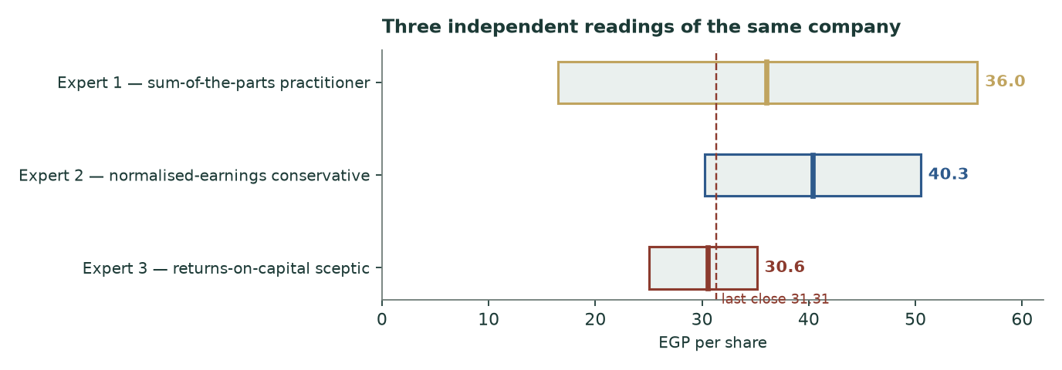
Three methods, one company.
The room agrees on more than the spread suggests: all three would own the operating businesses near 31; the entire quarrel is the stake and the speed of normalisation. The panel's span — 30.6 to 40.3 at the centres — brackets the published central from both sides.
C.6 Reading the divergence
Assumption | Who differs | Worth per share
MNT-Halan: round mark vs balance-sheet carrying | Expert 1 vs Expert 3 | 12.23
Normalisation completes vs trailing persists | Expert 2 vs Expert 3 | 9.78
Structure discount 8% vs the house 10% | Expert 1 vs the house | 0.78
Equity-premium basis (CDS vs rating) | inside the house model | 1.18

About this series
Standing research on Egyptian and regional listed companies: full fundamental studies, probability-calibrated price maps graded in public, and refreshes like this one whenever the company's own disclosures move the evidence. Every forecast this series publishes is dated, resolved on its date, and scored against what happened; the record — hits and misses alike — stays on the site.
Disclosure & disclaimer
This document is research, not investment advice, and contains no rating and no price target. Fair values are ranges with stated assumptions; probabilities are model outputs with stated calibration records. The authors hold no position in the securities discussed. Figures derive from the company's own published statements and releases and from sourced public market data, each dated in the companion bibliography; errors are ours alone. Prices can and do leave any range. Do your own work.

