Testahil · Independent Valuation Study — Educational AnalysisNot investment advice

Independent Valuation Study — Educational Analysis
Tesla, Inc. (NASDAQ: TSLA)
Fundamental analysis · Technical analysis · Monte Carlo simulation — one integrated read
Anchor: USD 420.60 (30 Jun 2026 close) · ~3.23bn shares · mkt cap ~USD 1.36tn · the world's most valuable automaker, an EV + energy-storage + AI/robotics company · value concentrated in an operating auto+energy business plus a large, unproven autonomy/AI optionality (FSD, Robotaxi, Optimus) · prices & probabilities computed 30 Jun 2026 from the attached daily price history · primary lens: going-concern discounted-cash-flow on the operating business, cross-checked by a segment sum-of-the-parts that isolates the optionality · the autonomy premium is the swing factor.
READ FIRST — what this document is, and is not. This study is a valuation exercise and an expression of personal analytical opinion, published free of charge for educational purposes: it shows how one analyst applies fundamental, technical and probabilistic methods to a listed company, and invites scrutiny of that methodology. It is NOT investment advice, NOT a recommendation or solicitation to buy, sell or hold any security, and NOT directed at the circumstances of any reader. The preparer is not licensed by any securities regulator in any jurisdiction, holds no U.S. or other brokerage authorisation, provides no financial consultancy, manages no money, and accepts no fees, funds or clients. See the Disclosure & Disclaimer at the end. All values are model outputs presented as ranges and distributions because no single number should be relied on. Reported financials are Tesla's own disclosure; forward-looking inputs — the value of the autonomy/AI optionality, the segment marks, the operating margins, the multiples, the DCF and the Monte-Carlo factor probabilities — are the preparer's judgments and are flagged throughout. Consult a licensed financial advisor before any investment decision.

Headline
The model's read: richly valued on the operating businesses, with the entire premium to fair value resting on the autonomy/AI optionality. At USD 420.60 the shares sit well above our weighted central estimate of USD 174 — an unusually wide gap that says less about the operating businesses, which are genuinely valuable, than about the option stacked on top of them. Tesla is the world's most valuable automaker, a profitable EV maker and a fast-growing energy-storage business, wrapped around an autonomy-and-robotics ambition (FSD, Robotaxi, Optimus) whose cash flows do not yet exist. FY2025 was the first annual revenue decline in Tesla's history (revenue −3% to USD 94.8bn) and GAAP net income fell to USD 3.79bn, leaving the stock on roughly 360× trailing earnings. The question is not whether Tesla owns a valuable operating business — it plainly does — but whether the ~USD 1.1tn of market value above that business will be earned by the autonomy bet.
Four fundamental lenses land between USD 90 and USD 230 — a spot-anchored sum-of-the-parts (USD 230), a consolidated DCF (USD 90), a relative-multiple read (USD 175) and a normalized-earnings read (USD 150) — for a weighted central of USD 174, about 59% below spot; only the case in which the autonomy option is credited at full scale (USD 560) exceeds the price. The dispersion is driven almost entirely by one input, the value assigned to the autonomy option: on the operating businesses alone the stock is expensive, while a world in which Robotaxi and Optimus scale supports a price well above it. The width of that range — USD 90 to USD 560 — is the honest measure of how much the answer depends on an outcome that has not happened.
This is a statement about valuation, not direction. Tesla's tape is the mirror image of the fundamentals — the shares have recovered to sit just above a compressed 20/50/200-day moving-average stack, roughly 14% below the 52-week high, with a neutral RSI near 58 and a MACD histogram that has turned up while still below zero — and a single 16-factor Monte Carlo (auto margins, delivery volumes, FSD/Robotaxi monetization, Nasdaq beta, real rates, plus nine discrete events including a Robotaxi milestone, a China price-war shock and EV-credit/tariff policy; 50,000 paths, seed 42) puts both the T+20 and T+60 medians essentially at spot (~USD 420) inside a very wide cone — Tesla's realized volatility is ~48%. A richly-priced growth stock can stay richly priced for a long time, and it can also re-rate violently in either direction. What a buyer at this level underwrites is not a margin of safety on cash flows — there is none on our numbers — but the proposition that unsupervised autonomy arrives, that Robotaxi and Optimus become large, high-margin businesses, and that the operating auto and energy businesses fund the wait. The downside tail belongs to autonomy slipping, auto margins compressing under Chinese competition, and multiple de-rating; the upside to a genuine Robotaxi ramp, Optimus commercialisation, and the energy business compounding.

Valuation summary — every read at a glance
One table for the four reads that follow — what the operating businesses are worth (fundamental), what the tape is doing (technical), where price could travel over three months (Monte Carlo), and how three independent expert methods land. Every row is developed in the sections and appendices below.
Lens / read | What it measures | Output | Takeaway
FUNDAMENTAL — what the operating businesses are worth (the anchor)
Sum-of-the-parts (primary) | Marked segments + risk-weighted option | USD 230 | −45% vs spot
Consolidated DCF (cross-check) | Discounted 5-yr operating cash flows | USD 90 | −79% · the floor
Relative multiples | Premium EV/Sales, EV/EBITDA, P/E | USD 175 | −58%
Normalized earnings | Mid-cycle earnings × multiple | USD 150 | −64%
Weighted central | Blend 40 / 20 / 15 / 25 | USD 174 | −59% vs USD 420.60
TECHNICAL — what the tape is doing (timing, not value)
Trend | Price vs the 20/50/200-day averages | Above all three | Constructive, recovering
Momentum / range | RSI · MACD · 52-week range | RSI 58 · MACD hist +1.1 | Neutral, turning up
MONTE CARLO — where price could go in 3 months (paths from spot)
T+20 sessions | 50,000 paths · 16 factors | p50 420 | p5 325 · p95 541 · median ≈ spot
T+60 sessions | same engine, longer horizon | p50 419 | p5 270 · p95 647 · wide, right-skew
EXPERT PANEL — three independent methods (Appendix D)
Expert 1 — SOTP + option | Risk-weighted option on marked segments | USD 230 | The anchor
Expert 2 — normalized earnings | Mid-cycle earnings × multiple | USD 175 | The middle
Expert 3 — cash returns (DCF+ROIC) | Return on capital vs ~10% WACC | USD 105 | Most conservative
Panel range | Spread = the autonomy question | USD 105–230 | Centres ~USD 170
Bottom line. Every fundamental read points the same way — the operating businesses are worth far less than the price — and the reads disagree only on how much to pay for the autonomy option on top. The four lenses cluster at USD 90–230 for a central near USD 174, ~59% below the USD 420.60 spot; the three experts span USD 105–230 at base, and each turns on a single question: how likely, how large and how soon Robotaxi, unsupervised FSD and Optimus become real, high-margin businesses. Only the autonomy-at-scale case (~USD 560) exceeds spot. The technical tape is the lone dissenter to the caution, constructive and turning up, which is why the three-month distribution centres near spot with a wide band rather than already at fundamental value.

Company overview — Tesla at a glance
Tesla, Inc. (NASDAQ: TSLA) designs, manufactures and sells electric vehicles and energy generation and storage systems, and is developing autonomous-driving software (FSD), a ride-hailing Robotaxi service, and a humanoid robot (Optimus). Its profit engine remains the automotive business — Models 3/Y/S/X and Cybertruck — which still generates the large majority of revenue, though at operating margins that have fallen sharply from their 2022 peak as average selling prices dropped and incentives rose. Around it sit a fast-growing Energy Generation & Storage segment (Megapack and Powerwall; 46.7 GWh deployed in 2025, +27% revenue) and a Services & Other segment (supercharging, used-car, insurance, parts). The defining feature for valuation is structural: the operating businesses, however profitable, cannot on any conventional cash-flow basis justify a ~USD 1.36tn market capitalisation — so the stock is best read as an operating company plus a large embedded option on autonomy and robotics, not as a multiple on today's income statement. Two developments frame 2025-26: Tesla launched a Robotaxi ride-hailing service in Austin (June 2025) and expanded it, and it guided 2026 capital expenditure above USD 25bn — a step-up from USD 8.6bn in 2025 — to fund AI compute, factory capacity and the Robotaxi programme.
Item | Value (as disclosed / derived)
Listing / sector | NASDAQ: TSLA · automobiles & light trucks / clean energy & AI
Leadership | Founder-CEO Elon Musk; key-person and attention risk is material
Share price (30 Jun 2026 close) | USD 420.60
Shares outstanding | ~3.23bn
Market capitalisation | ~USD 1.36tn
FY2025 revenue / GAAP op inc / net | USD 94.8bn / ~4.3bn / 3.79bn (first-ever revenue decline)
FY2025 segment mix | Auto ~USD 69.5bn · Energy ~12.8bn · Services ~12.5bn
FY2025 R&D | USD 6.41bn (+41% YoY, AI/autonomy build)
Energy storage deployed (2025) | 46.7 GWh (+27% revenue YoY)
Vehicle deliveries (2025) | ~1.64m (approx.; first annual decline)
Cash & investments (Q1 2026) | ~USD 44.7bn; minimal debt (strong net cash)
2025a GAAP EPS / P·E | ~USD 1.17 / ~360× (trailing)
2026 capex guidance | > USD 25bn (up from USD 8.6bn in 2025)
Autonomy angle | FSD (supervised) · Robotaxi (Austin, expanding) · Optimus
52-week range (close) | USD 293.94 – 489.88 (spot upper-middle)
Company-level figures are sourced from Tesla's public disclosure (Q4/FY2025 Update and FY2025 Form 10-K, filed Jan 2026; Q1 2026 Update, Apr 2026) via SEC EDGAR and ir.tesla.com; forward-looking inputs — the autonomy/AI optionality value, the segment marks, the 2026e-2030e projections, the multiples, the DCF and the Monte-Carlo factor probabilities — are the preparer's derived estimates, not company disclosure, and are flagged throughout.

1 Fundamental valuation
We value Tesla as an operating company that houses three quite different businesses — a large, profitable but maturing automaker, a fast-growing energy-storage business, and a small services arm — sitting beneath one very large option on autonomy and robotics, and we triangulate four lenses. The primary lens is a segment sum-of-the-parts (SOTP), because the pieces trade on different economics and — crucially — because it is the only frame that cleanly separates the operating businesses, which can be valued with reasonable confidence, from the autonomy option, which can only be probability-weighted. A consolidated DCF on the operating business, a relative-multiple cross-check and a normalized-earnings read complete the set. Reported financials are Tesla's disclosure; the operating projections, the option mark and the discount rate are our judgments, shown explicitly so you can disagree. The weights and the football field are in §1.5; the swing factor — the autonomy option — is dissected in §1.7 and the sensitivity grid in §1.9.

1.1 Segment sum-of-the-parts — the primary lens
Value the operating pieces at fair segment multiples, then price the autonomy option on its own. Broken into parts, the operating businesses are worth on the order of USD 95-130 per share: the automotive business on a generous ~15× normalized EBIT, the energy business on a growth multiple reflecting its 27% revenue growth and improving margins, and services at a modest multiple. To that we add a separately-identified autonomy/AI bucket — Robotaxi, unsupervised FSD and Optimus — which is where the entire gap to spot lives. Our base case applies a ~24% probability weight to that bucket reaching scale, which lands a base sum-of-the-parts of USD 230 per share, still ~45% below spot. The bull case, in which the option is credited close to full value, reaches USD 560; the bear case, in which autonomy does not monetize and the bucket goes to roughly zero, leaves only the operating pieces at ~USD 95. That range — USD 95 to USD 560 — is the honest measure of how much of Tesla's price is a probability-weighted bet the market observes only through the share price.
SOTP component (base case) | Basis | Value (USD/sh)
Automotive (Models 3/Y/S/X, Cybertruck) | ~15× normalized EBIT | ~70
Energy generation & storage | growth multiple on scaling segment | ~35
Services & other | modest multiple | ~10
(+) Net cash & investments | balance sheet | ~12
Operating businesses subtotal |  | ~127
Autonomy/AI optionality (risk-weighted) | ~24% × scale value | ~103
Value / share (base SOTP) |  | USD 230
Per-share segment marks are illustrative allocations of the operating value implied by the same projections that drive the DCF; the autonomy bucket is a probability-weighted judgment, not a market observable. The Excel companion lets you change the segment multiples, the scale value of the option and the probability weight, and every figure repriced.

1.2 Consolidated DCF — the cash-flow cross-check
The cash-flow cross-check lands far below the asset sum — by construction. We model revenue reaccelerating from ~USD 95bn to ~USD 215bn by 2030e — a demanding ~18% compound rate that already folds in a strong volume recovery, the energy business scaling, and a growing software/services contribution — with the GAAP operating margin recovering from ~4.5% in 2025 to ~15.5% by 2030e as ASPs stabilise, cost per vehicle falls and the higher-margin energy and software mix grows. Even on those generous inputs, the unlevered free-cash-flow stream is negative in 2026e-2027e (2026 capex alone is guided above USD 25bn) and only reaches ~USD 21bn by 2030e. Discounting at a 10.0% WACC with a 4.5% terminal growth rate, and adding ~USD 40bn of net cash, the DCF lands at USD 90 per share — about 79% below spot. The point is not the precise figure; it is that a standard cash-flow model, fed deliberately optimistic operating assumptions, cannot get within hailing distance of the price. To justify USD 420 on cash flows alone, terminal free cash flow would have to be several times our base — which is precisely the autonomy bet, and which the operating business does not contain.
FCFF build (USD bn) | 2026e | 2027e | 2028e | 2029e | 2030e
Revenue | 108 | 130 | 154 | 182 | 215
EBIT margin | 6.5% | 9.0% | 11.5% | 13.5% | 15.5%
EBIT | 7.0 | 11.7 | 17.7 | 24.6 | 33.3
NOPAT (@15% tax) | 6.0 | 9.9 | 15.1 | 20.9 | 28.3
(+) D&A | 6.5 | 7.5 | 8.5 | 9.5 | 11.0
(−) Capex | (25.0) | (22.0) | (20.0) | (18.0) | (17.0)
(−) Δ working capital | (1.0) | (1.5) | (1.5) | (1.5) | (1.5)
Unlevered FCFF | (13.5) | (6.1) | 2.1 | 10.9 | 20.8

DCF bridge to value | USD bn | per share
PV of explicit FCFF (2026e-2030e) | 4.6
PV of terminal value (g 4.5%, WACC 10.0%) | 245.4
Enterprise value | 250.0
(+) Net cash & investments | 40.0
Equity value | 290.0
DCF value / share |  | USD 90
Why the DCF lands so far below the price. Two forces compress it. First, the near-term free-cash-flow drought: the 2026 capital-expenditure step-up above USD 25bn — for AI compute, new capacity and Robotaxi — turns free cash flow negative just as the model begins, so almost all the value sits in the terminal year. Second, the discount rate: Tesla is a high-beta name (realized volatility ~48%), and even a relatively forgiving 10% WACC leaves a terminal free-cash stream of ~USD 21bn worth only a few hundred billion in present value against a ~USD 1.36tn market capitalisation. A bull will object that a DCF cannot capture optionality — correct, and exactly why we treat the DCF as the anchor for the operating business and value the option separately in 1.1. But it makes the central point unambiguous: Tesla is an option story bolted onto a cash-flow business, and any thesis must rest on the option. Across a plausible WACC and terminal-growth range the DCF spans ~USD 67–143 (Excel Sensitivity sheet) — wide, and everywhere below the asset sum.

1.3 Relative multiples
On any peer multiple Tesla screens expensive; the comparison depends entirely on the peer set. At USD 420.60 the shares trade at ~360× trailing earnings, ~14× trailing sales and a very high EV/EBITDA — figures that are extreme against traditional automakers (Toyota, GM and even fast-growing BYD trade at low-single-digit to low-double-digit earnings multiples) and rich even against mega-cap technology (which trades at ~25-40× earnings). Applied to auto peers the relative lens implies a value near the operating floor; applied to premium software/AI multiples on Tesla's still-small high-margin revenue it implies more. Blending EV/Sales (~5× on ~USD 108bn revenue, a large premium to autos), EV/EBITDA (~30×) and P/E (~45× on normalised earnings) gives USD 175 (−58%). The honest reading: the relative lens is the least informative here, because no clean peer set exists — Tesla is priced as neither an automaker nor a software company but as an autonomy option, and multiples cannot capture that.
Relative lens | Metric | Multiple | Implied / sh
EV / Sales | ~USD 108bn revenue | ~5.0× | ~180
EV / EBITDA | ~USD 17bn norm. EBITDA | ~30× | ~170
P / E | ~USD 12bn norm. earnings | ~45× | ~167
Blended relative value |  |  | USD 175

1.4 Normalized earnings power
Strip out the peak-cycle distortions and the credit-driven tail, and ask what Tesla earns in a normal year. Normalising the automotive margin to a mid-cycle level, adding the growing energy and services contribution and a modest amount of high-margin software, a defensible through-cycle net profit is on the order of USD 14bn — well above the USD 3.79bn reported in the trough year of 2025 but a fraction of what the market capitalisation implies. At a ~35× multiple — a quality-growth premium, but applied to earnings that exclude the unproven autonomy businesses — that is USD 150 (−64%). Like the relative lens, this measures only the operating earnings and so excludes the option that dominates the price; it is included as a discipline, not as the primary anchor.

1.5 Synthesis — four lenses
The four methods and weights are below. We anchor on the segment SOTP (the only lens that separates the operating businesses from the option), carry the consolidated DCF as a cash-flow cross-check, and split the balance across the relative and normalized reads. The autonomy-at-scale case is not a separate weighted lens — it is the upper end of the SOTP range, shown on the football field so its weight is visible rather than buried.
Method | USD / sh | vs spot | Weight
SOTP — segments + option (primary) | 230 | −45% | 40%
Consolidated DCF (cross-check) | 90 | −79% | 20%
Relative multiples (blended) | 175 | −58% | 15%
Normalized earnings power | 150 | −64% | 25%
WEIGHTED CENTRAL | 174 | −59% | 100%
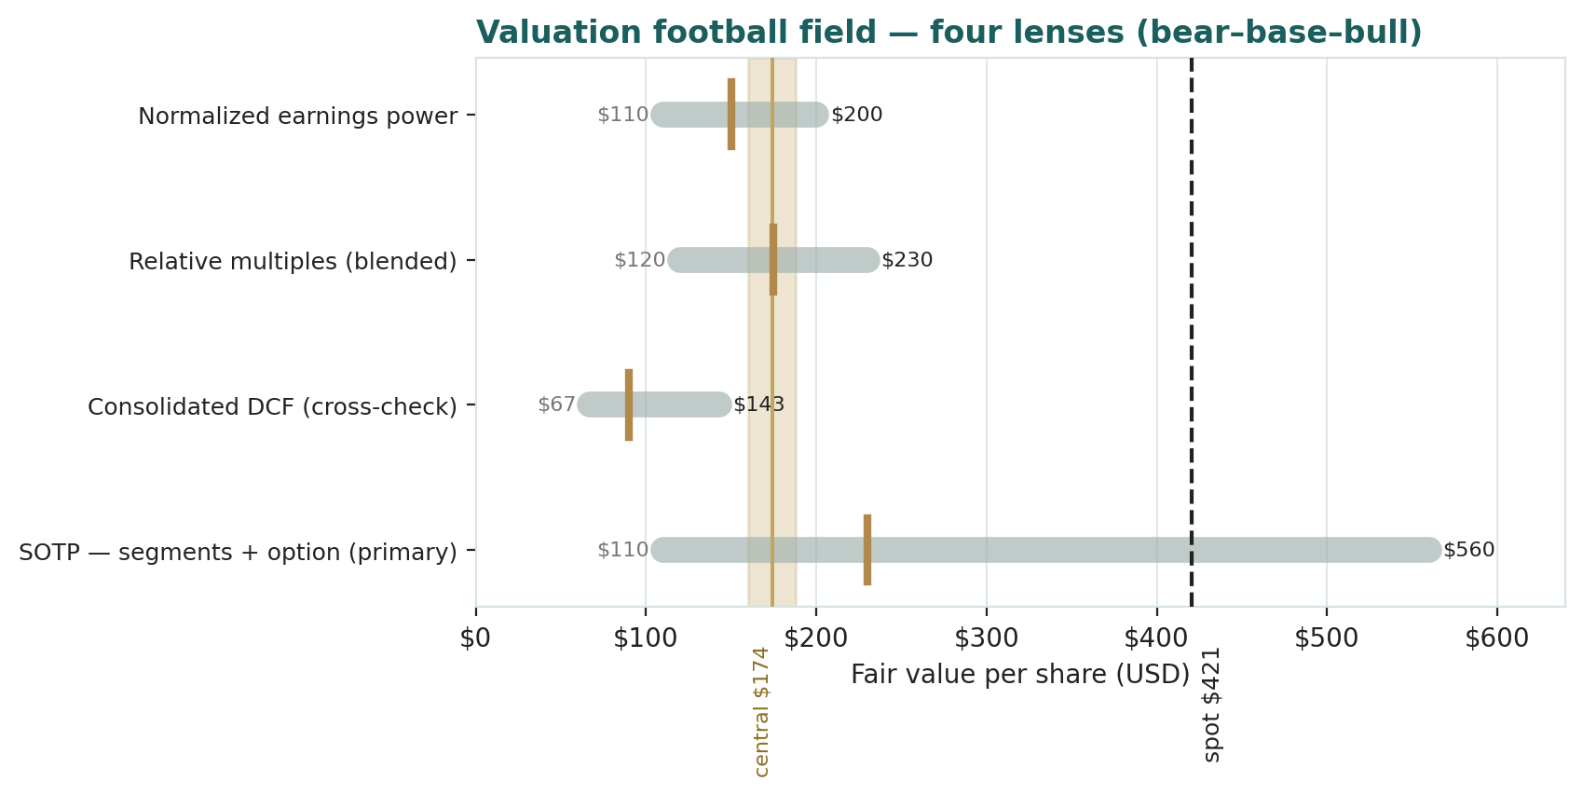
Figure 1 · Valuation football field — four lenses, each shown bear–base–bull; the brass tick is the base case, the gold band the weighted central, the dark line spot. Only the top of the SOTP range (the autonomy-at-scale case, ~USD 560) reaches spot.
How to read this. The four lenses cluster below spot and the central sits ~59% under the price — but the honest signal is the width of the SOTP bar, not the point estimates: the operating businesses are worth ~USD 90–175 on cash flows and earnings, while the autonomy option carries the value from there to spot and beyond. The dispersion — USD 90 to USD 560 — is driven almost entirely by one input, the value of the autonomy option: on operating fundamentals the stock is expensive; on a full autonomy outcome it is cheap. None of this forecasts direction — the next sections describe a constructive, high-volatility price process — it states that, on the fundamentals, the debate is not about the operating business but about whether the autonomy bet pays off.

1.6 The operating segments and the optionality — a deeper look
The valuation rests on segment-level judgments and one large option. For each piece we set out what it is, where it stands competitively, and how we mark it. One fact recurs: the operating segments can be marked with reasonable confidence, so the genuine judgment call is the autonomy bucket — the option the market prices in full and we can only probability-weight.
Segment / asset | Share of value | Mark basis | Key tension
Automotive | operating core | normalized EBIT multiple | margin compression vs volume recovery
Energy generation & storage | rising | growth multiple | fastest-growing, improving margin; scale
Services & other | modest | low multiple | supercharging/insurance optionality
FSD / Robotaxi / Optimus | the swing | risk-weighted option | binary: scale, or roughly zero
Automotive — the profitable core under pressure. Still the large majority of revenue, the auto business generates real operating profit, but its margin has fallen from the 2022 peak as ASPs dropped, incentives rose and Chinese competition (led by BYD) intensified. The recovery in Q1 2026 — revenue +16% YoY, gross margin back to 21.1% — is the bull's evidence that the trough is past; the bear's is that the first-ever annual revenue decline in 2025 shows a maturing, contested franchise.
Energy generation & storage — the quiet compounder. Megapack and Powerwall deployments drove 27% revenue growth and 46.7 GWh deployed in 2025, at improving margins. This is the segment most likely to be under-appreciated in a simple auto-multiple framing, and it carries a growth multiple in our SOTP.
Services & other — small, with embedded options. Supercharging (now opened to other manufacturers), used-vehicle sales, insurance and parts. Modest today, with optionality in the charging network and insurance.
FSD / Robotaxi / Optimus — the entire debate. The autonomy and robotics ambition is where the market's ~USD 1.1tn premium to the operating business sits. Robotaxi launched in Austin in June 2025 and is expanding; unsupervised FSD remains unapproved at scale; Optimus is pre-revenue. This bucket is binary at the margin — either it becomes a large, high-margin business and the bull case is right, or it does not and the price has no fundamental support. We probability-weight it rather than assert it.

1.7 The autonomy premium — the crux of the valuation
Why the market pays for the option. Investors credit Tesla with a lead in real-world autonomy data, a vertically-integrated hardware/software/manufacturing stack, and a founder willing to spend heavily against a very large prize — a Robotaxi network and a general-purpose humanoid robot, each with a total addressable market measured in trillions if it works. Priced as a real option, a low-probability, very-high-payoff outcome can carry a large expected value, which is how a stock can trade far above its cash-flow value without being irrational.
Why it might not pay. Unsupervised autonomy has been 'a year or two away' for a decade; regulatory approval for driverless operation at scale is uncertain and jurisdiction-by-jurisdiction; competitors (Waymo in robotaxi, numerous firms in humanoids) are credible; and the auto business that funds the wait is itself under margin pressure. If autonomy slips or disappoints, there is no cash-flow floor near the current price — the fall is to the operating value.
What the price implies. At USD 420.60 the market prices the autonomy option at roughly full value — our bull case, in which it monetizes at scale, lands at USD 560, only ~33% above spot, so the market is already crediting perhaps two-thirds to three-quarters of the full autonomy outcome. Our base case applies a ~24% probability weight and lands at USD 230; to reach spot you must weight the full autonomy outcome at ~70%+. That is the debate, stated plainly: not what Tesla's factories earn, but how likely, how large and how soon the autonomy businesses become — an outcome the market observes only through the price.

1.8 The macro and policy backdrop — rates, tariffs, credits, and the founder
Rates and the discount on long-duration growth. Tesla is among the longest-duration equities in the market — most of its value is in terminal-year cash flows and an option that pays off years out — so it is unusually sensitive to the real-rate and risk-appetite regime. A higher-for-longer rate path lowers the present value of that distant value and compresses the multiple; an easing cycle does the reverse. This enters the Monte Carlo as a continuous factor.
Policy — EV credits, tariffs and autonomy regulation. Three policy levers matter. The phase-down or removal of U.S. EV purchase and production credits (the §45W/consumer-credit regime) directly affects demand and reported profit; tariffs on vehicles and on battery inputs affect cost and pricing; and the regulatory path for driverless operation gates the entire Robotaxi thesis. Each is a discrete event in the Monte Carlo.
The founder is a first-order factor. Elon Musk's vision drives the autonomy ambition and much of the equity premium, but his divided attention across multiple ventures, his compensation arrangements, and his public and political profile are a genuine source of both upside narrative and downside risk. Unlike a currency or a rate, this is idiosyncratic and two-sided, and it enters the Monte Carlo as a discrete key-person event.

1.9 SOTP sensitivity — how much the autonomy swing moves the value
The primary lens turns on two inputs: the full-scale value assigned to the autonomy option and the probability weight placed on it. The grid below shows the base SOTP value per share — the operating businesses at ~USD 127 plus the risk-weighted option — across both. The base cell, a ~24% weight on a ~USD 433 full-scale option, is highlighted; the point is how fast the value moves with the weight, which no one observes directly.
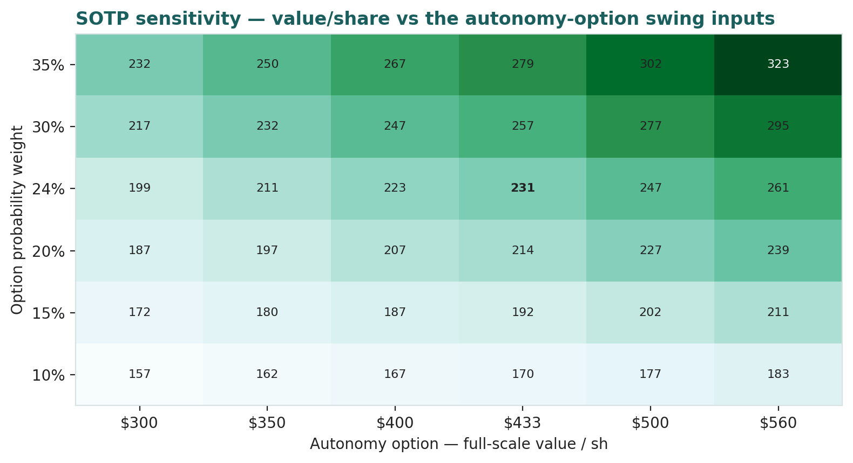
Figure 2 · SOTP sensitivity to the autonomy-option swing inputs (USD/share). Rows are the probability weight; columns the full-scale option value; each cell is operating value plus the risk-weighted option.
Reading the grid. Even a generous 35% weight on a USD 560 full-scale option reaches only ~USD 323 — still below spot. To reach USD 420 the market must weight roughly the full autonomy outcome; the operating businesses plus a modest option cannot get there. The DCF's own WACC×g sensitivity (spanning ~USD 67–143) is on the Excel Sensitivity sheet.

2 Technical and price structure
Technicals describe the price, not the value. They matter here for one reason: a high-volatility stock that has recovered to sit above a compressed moving-average stack is as capable of a sharp continuation as of a sharp reversal. The structure is constructive but extended — the mirror image of the beaten-down names elsewhere in our coverage.
Indicator | Reading | Interpretation
Spot vs 52-week range | 420.60 / 293.94 – 489.88 | upper-middle of the range
Off the 52-week high | 420.60 vs 489.88 | −14% from the high
SMA 20 / 50 / 200 | 400.6 / 405.6 / 418.5 | compressed stack; price above all (constructive)
RSI (14) | ~58 | neutral, mild positive momentum
ATR (14) | 17.5 (4.2%) | elevated daily range
Realized vol 60d / 252d | ~46% / ~45% | high (full-sample ~59%)
MACD (12/26/9) | −3.3 line / −4.4 signal / +1.1 hist | below zero but histogram turned up (improving)
Skew / excess kurtosis (252d) | −0.10 / +0.14 | near-normal recently
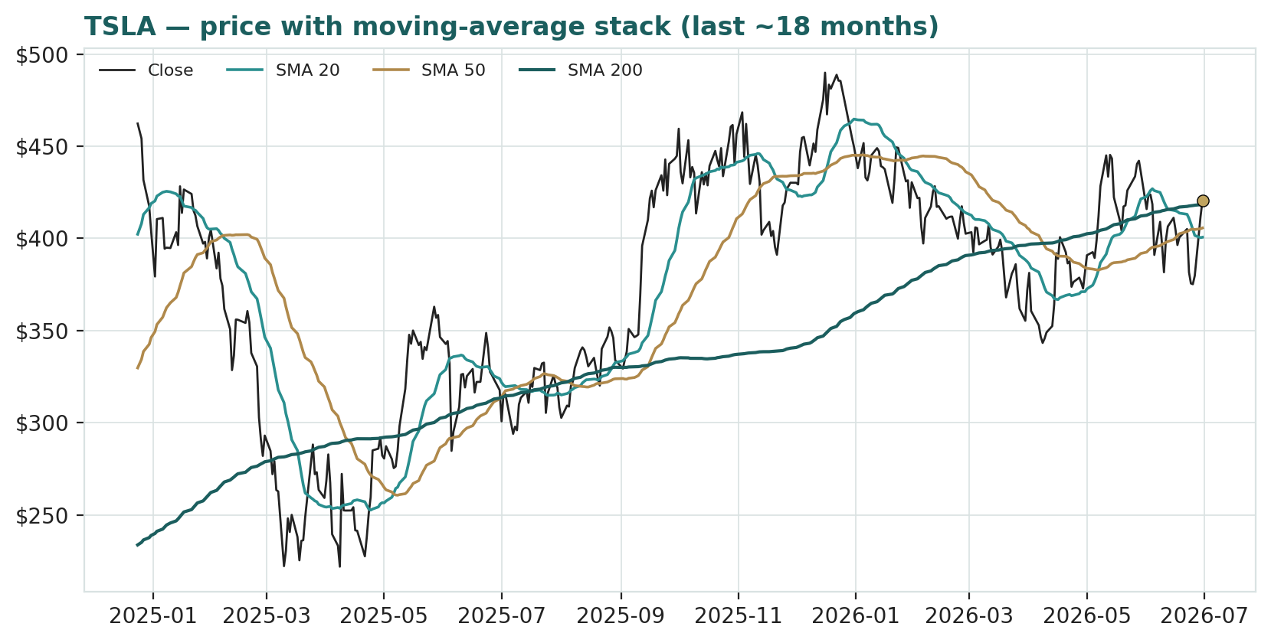
Figure 3 · Price with moving-average stack — a compressed 20/50/200 structure with spot just above all three; a constructive, high-volatility tape.
The honest technical read. The trend has turned constructive: price has recovered above all three moving averages, which are compressed and no longer falling, RSI near 58 is neutral, and the MACD — still below zero — has produced a positive histogram (a bullish crossover forming). Realized volatility around 46% and elevated ATR mean moves in either direction can be violent. Nearest support is the moving-average cluster around USD 400-405, then the range lows near USD 294; nearest resistance is the 52-week high near USD 490. The technical and fundamental pictures are, unusually, in tension: the tape is constructive while the fundamentals say the price is rich — which is exactly what a momentum-driven, option-heavy stock looks like.

3 Monte Carlo — a probabilistic price map
This models the price over the next three months, not value. We simulate 50,000 paths (seed 42) from a 16-factor structure — seven continuous drivers and nine discrete event risks — calibrated to Tesla's own realized volatility. It answers “where could the price plausibly be, and with what probability”, not “what is Tesla worth”. The paths diffuse from spot as a near-term price process and deliberately do not embed the fundamental value gap — the ~59% gap of Section 1 is kept out of the drift, so the fundamental and probabilistic lenses stay independent.
The 16 factors. Continuous (7): auto ASP / gross-margin trajectory (ex-credits), delivery-volume trajectory (US/China/Europe), Nasdaq / high-beta growth flows, US real-rate / discount-rate path, FSD / Robotaxi monetization ramp, energy-storage & services growth, and input-cost / FX. Discrete events (9): a Robotaxi / unsupervised-FSD milestone (p~0.35, +8%), a two-sided quarterly delivery print (p~0.45, ±), a two-sided quarterly earnings/margin print (p~0.50, ±), Optimus / new-product progress (p~0.30, +6%), a China demand / price-war shock (p~0.30, −7%), an EV-credit / tariff / FSD-probe policy event (p~0.35, −6%), a key-person / governance / attention event (p~0.30, two-sided), a broad Nasdaq risk-off drawdown (p~0.25, −6%), and an energy megadeal / margin inflection (p~0.30, +4%).
Net three-month drift is modestly positive (~+3%), total three-month volatility ~28% (~55% annualised, a touch above realized as the discrete events add spread), and the distribution is mildly right-skewed — the positive catalyst set (Robotaxi, Optimus, energy) slightly outweighs the negative in expectation, while the downside events are sharper per event. The drift is built from these forward factors rather than from trailing momentum: on a literal extrapolation of the past year's advance the median would sit higher, but we do not assume the run simply continues, and carry realized momentum only as one editable factor among sixteen.
Horizon | 5% | 25% | Median | 75% | 95%
T + 20 sessions (~1m) | 325 | 379 | 420 | 466 | 541
T + 60 sessions (~3m) | 270 | 350 | 419 | 501 | 647
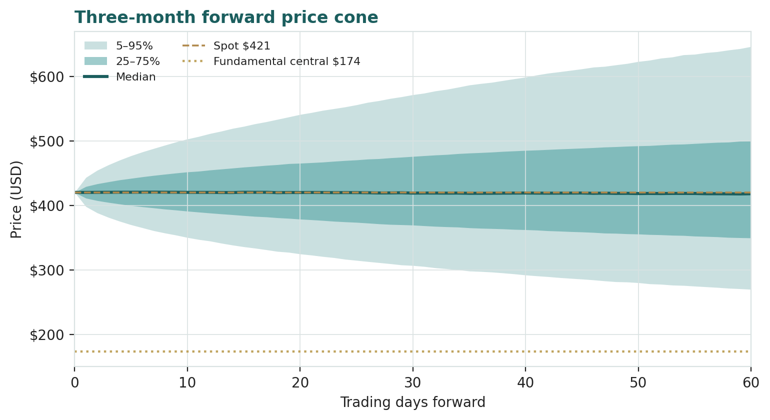
Figure 4 · Three-month forward price cone — median tracks spot; the gold dotted line marks the USD 174 fundamental central, deliberately below the cone.
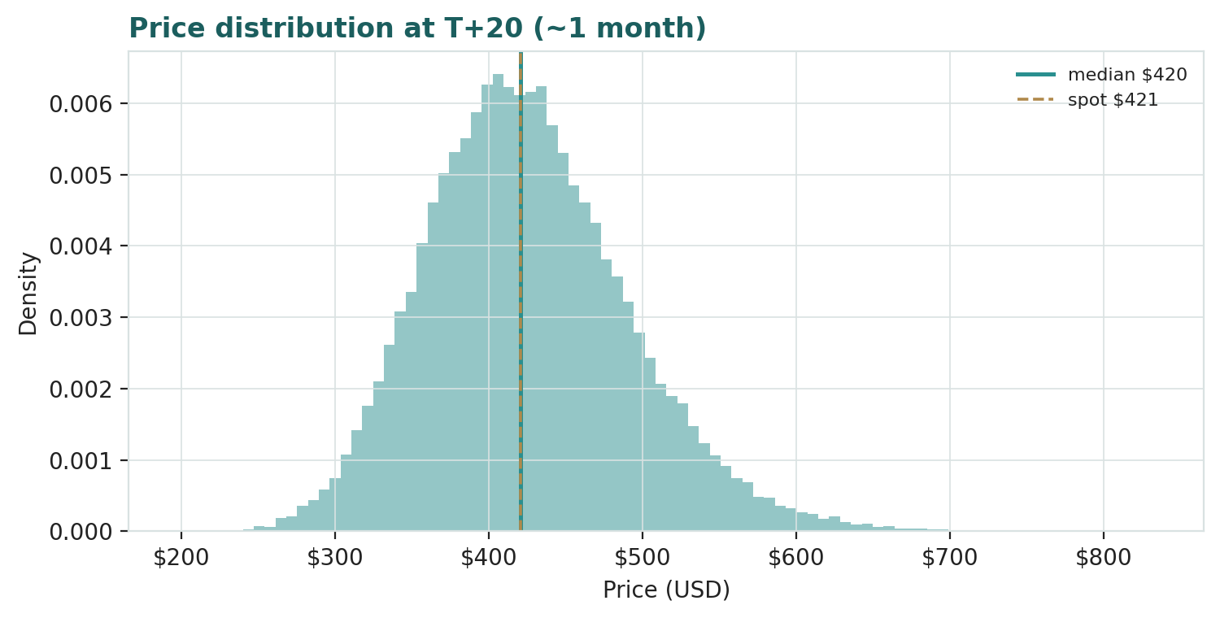
Figure 5 · Price distribution at T+20 (~1 month) — roughly two-sided around spot.
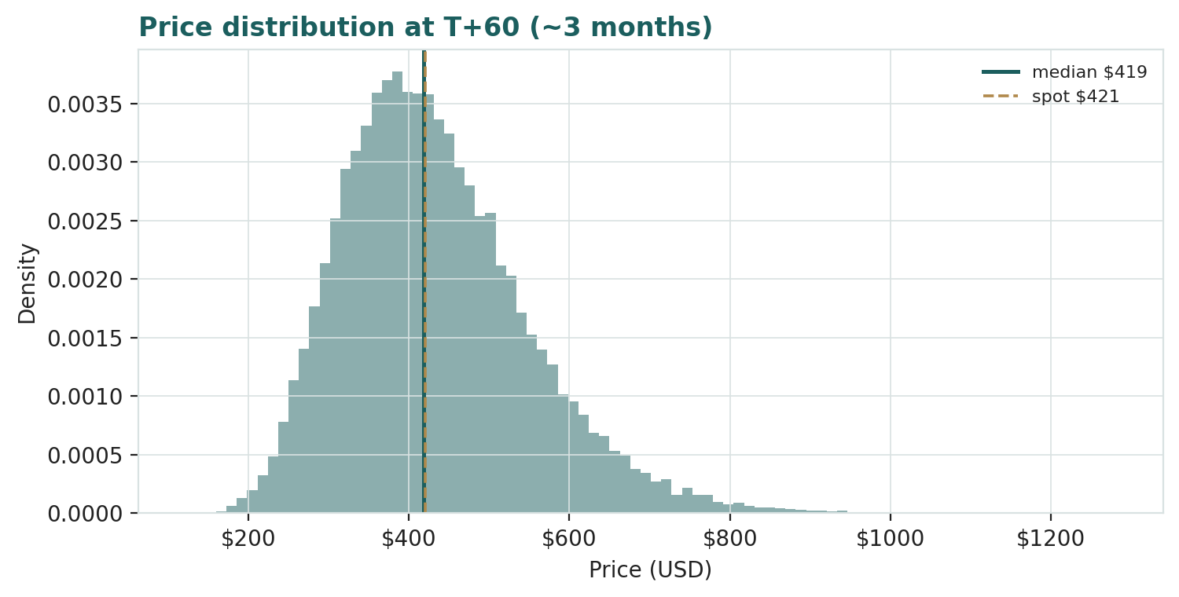
Figure 6 · Price distribution at T+60 (~3 months) — wider, with a mild right skew and fat tails.
Touch probabilities — chance the price reaches a level at any point in the window
Level | by T+20 | by T+60 | Note
USD 460 | 47% | 68% | toward recent highs
USD 485 | 29% | 54% | toward the 52-week high
USD 500 | 21% | 46% | above the 52-week high
USD 540 | 8% | 30% | new-high extension
USD 380 | 42% | 65% | first support test (MA cluster)
USD 360 | 25% | 51% | below the moving averages
USD 320 | 6% | 28% | deeper pullback
USD 290 | 1% | 15% | toward the range low / SOTP zone
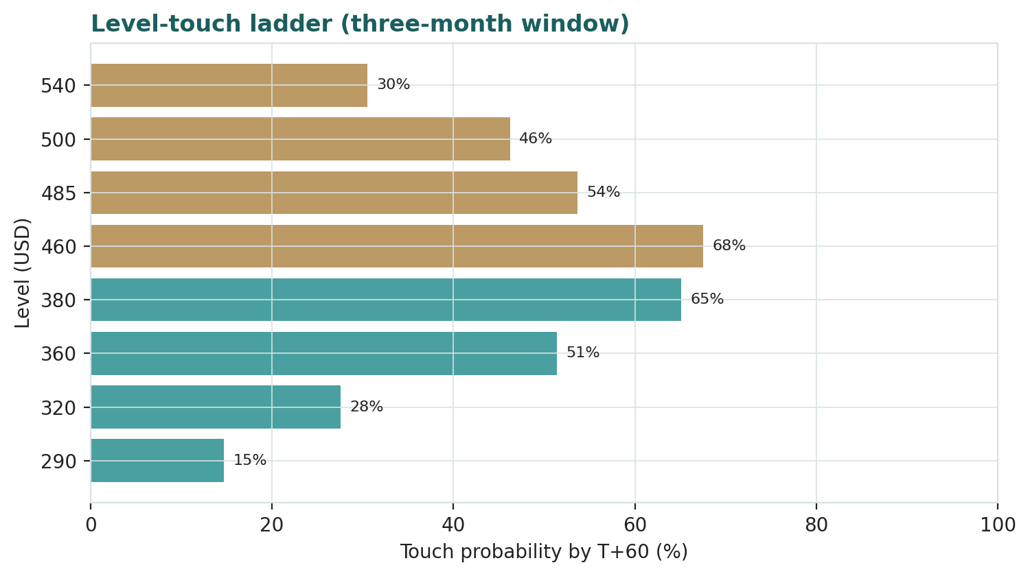
Figure 7 · Upside and downside touch ladders over the three-month window.
What the map says. Over three months a move up toward recent highs around USD 460 is more likely than not (~68%), while a push above the 52-week high toward USD 500 is a lower-probability ~46%. On the downside, a test of the moving-average support near USD 380 is likely (~65%) and a deeper slide toward USD 320 is a non-trivial ~28%. Crucially, this near-term map and the fundamental finding are not in conflict: the price can wander within a wide band over three months while value sits well below price. The Monte Carlo describes the former; Section 1 describes the latter.

4 Comparison of the lenses, and a verdict
Lens | What it measures | Output | vs spot
SOTP — segments + option (primary) | operating + risk-weighted option | USD 230 | −45%
Consolidated DCF (cross-check) | operating cash flow only | USD 90 | −79%
Relative multiples | vs auto / tech peers | USD 175 | −58%
Normalized earnings | through-cycle profit | USD 150 | −64%
Weighted central | triangulated estimate | USD 174 | −59%
Autonomy-at-scale (SOTP bull) | option credited in full | USD 560 | +33%
Monte Carlo T+60 median | likely 3-month price | USD 419 | −0%
Verdict — richly valued on fundamentals; the whole case is an autonomy-and-AI bet. The fundamental lenses agree that USD 420.60 is well above the value of the operating businesses: the central estimate is USD 174 (−59%), and every operating lens sits below spot. The SOTP anchor, which separates the operating pieces from the option, values the businesses at ~USD 127 and credits a risk-weighted option to reach USD 230; the cash-flow cross-check, which ignores the option entirely, is the most conservative at USD 90. The technical trend is constructive — the shares have recovered above their moving averages — and the three-month price map is wide and roughly centred on spot. A buyer at this level is not buying a discount to value, but is underwriting one proposition: that unsupervised autonomy arrives, that Robotaxi and Optimus become large, high-margin businesses, and that the operating businesses fund the wait. If the option monetizes, the autonomy-at-scale case at USD 560 is reachable; if it slips or disappoints, there is no cash-flow floor near the price and the downside to the operating value is large. This study expresses a valuation, not a trade, and certainly not advice.

5 Catalysts to watch
Robotaxi scale-up (↑, high impact). Expansion of the Austin Robotaxi service to new cities, a shift to genuinely unsupervised operation, and evidence of unit economics are the single most powerful levers on the autonomy premium and thus on the price.
Unsupervised-FSD approval (↑). Regulatory clearance for driverless operation at scale in major jurisdictions would convert the option from possibility toward reality and re-rate the entire thesis.
Optimus commercialisation (↑). Any credible path to volume production and external sales of the humanoid robot would add a second large optionality leg the market is only beginning to price.
Quarterly deliveries and auto margin (↑/↓). The direction of vehicle volumes and automotive gross margin is the clearest read on whether the operating business that funds the wait is strengthening or eroding.
Energy-storage growth (↑). Continued 25%+ growth and margin improvement in Megapack/Powerwall strengthens the operating floor and the least-appreciated part of the story.
Policy / rates (↓). EV-credit removal, tariffs on vehicles or battery inputs, an adverse FSD safety investigation, or a higher-for-longer rate path are the principal near-term downside catalysts for a long-duration, policy-exposed name.

6 Reading the probability zones
Combining the fundamental anchors with the three-month price map gives a set of zones — descriptive, not directive.
Zone | Range (USD) | What it would mean
Autonomy re-rating | 500 – 560+ | option credited toward full value; Robotaxi scaling
Momentum / new highs | 460 – 500 | tape extends above the 52-week high
Central / range | 400 – 460 | where spot and the moving averages sit
Reality check | 320 – 400 | auto-margin or policy disappointment; multiple de-rates
Operating-value zone | < 300 | autonomy discounted out; SOTP / DCF territory

7 Caveats and what would change our mind
The autonomy option is a judgment, and it dominates. The ~USD 1.1tn premium to the operating business rests on a probability-weighted bet on Robotaxi, unsupervised FSD and Optimus. A genuine ramp could justify the price and more; a stall could remove the floor. This is by far the single biggest source of error in the valuation, in either direction.
Our operating projections are generous, and may be wrong. The DCF already assumes ~18% revenue growth and a margin recovery to ~15.5%. If Chinese competition compresses auto margins further, fair value migrates toward the bear case; if the energy and software mix lifts margins faster, toward the base. Reasonable analysts will choose differently; the Excel companion lets you change every input.
The discount rate is a large lever. For a stock whose value is almost all terminal, the WACC and terminal-growth pairing swings the DCF materially (Excel Sensitivity sheet). We use a forgiving 10%; a rate consistent with the stock's beta would be higher and the DCF lower.
The Monte Carlo is a price model, not a forecast. It encodes our probability estimates for events that have not happened. The factor probabilities are inputs, not facts, and the model says nothing about value.
Momentum reminder. The tape is constructive and the stock can extend well above fundamental value for a long time — richly-valued momentum names often do. Do not mistake a strong tape for a margin of safety; on our numbers there is none near the current price. Equally, do not mistake our fundamental caution for a directional call — this is a valuation, not a trade.

Appendix A Financial statements (USD bn)
Actuals (FY2023-FY2025) are Tesla's consolidated disclosure under US GAAP (per the Q4/FY2025 Update and FY2025 Form 10-K). FY2023 GAAP net income of ~USD 15.0bn included a one-time ~USD 5.9bn deferred-tax benefit and so overstates through-cycle earnings; FY2025 — at USD 94.8bn revenue and USD 3.79bn net income — was the first annual revenue decline in Tesla's history. Forecast columns (2026e-2030e) are the preparer's illustrative operating build that ties to the Excel companion and to the DCF in 1.1; they assume a strong volume and margin recovery and are deliberately optimistic on the operating business so as not to understate fair value. Sub-lines of the balance sheet are approximate allocations to the reported totals. The autonomy/AI optionality sits outside these consolidated operating lines.
A.1 Consolidated income statement (USD bn)
Income statement | 2023a | 2024a | 2025a | 2026e | 2027e | 2028e | 2029e | 2030e
Automotive revenue | 82.4 | 77.1 | 69.5 | 78.0 | 94.0 | 112.0 | 134.0 | 161.0
Energy gen. & storage | 6.0 | 10.1 | 12.8 | 16.0 | 20.0 | 24.0 | 28.0 | 32.0
Services & other | 8.3 | 10.5 | 12.5 | 14.0 | 16.0 | 18.0 | 20.0 | 22.0
Total revenue | 96.8 | 97.7 | 94.8 | 108.0 | 130.0 | 154.0 | 182.0 | 215.0
growth YoY | — | +1% | −3% | +14% | +20% | +18% | +18% | +18%
(Cost & opex) | (87.9) | (90.6) | (90.5) | (101.0) | (118.3) | (136.3) | (157.4) | (181.7)
Operating profit | 8.9 | 7.1 | 4.3 | 7.0 | 11.7 | 17.7 | 24.6 | 33.3
OP margin | 9.2% | 7.3% | 4.5% | 6.5% | 9.0% | 11.5% | 13.5% | 15.5%
Net interest & other | 1.0 | 1.6 | 1.6 | 1.5 | 1.6 | 1.7 | 1.8 | 1.9
Pre-tax profit | 9.9 | 8.7 | 5.9 | 8.5 | 13.3 | 19.4 | 26.4 | 35.2
Tax & minorities | 5.1 | (1.6) | (2.1) | (2.0) | (2.8) | (3.6) | (4.6) | (5.7)
Net profit attributable | 15.0 | 7.1 | 3.79 | 6.5 | 10.5 | 15.8 | 21.8 | 29.5
EPS (USD) | 4.30 | 2.04 | 1.17 | 2.01 | 3.25 | 4.89 | 6.75 | 9.13
Note. Automotive is still the large majority of revenue but its margin has fallen from the 2022 peak; energy and services are growing faster. FY2023 net income is flattered by a one-time deferred-tax benefit; FY2025 is a trough. Reported earnings capture none of the autonomy optionality, which is why the DCF-plus-SOTP framing — not the income statement — is the primary lens.
A.2 Consolidated balance sheet (USD bn)
Balance sheet | 2023a | 2024a | 2025a | 2026e | 2027e | 2028e | 2029e | 2030e
Cash & equivalents | 16.4 | 16.1 | 16.5 | 14.0 | 16.0 | 20.0 | 26.0 | 34.0
Short/long-term investments | 12.7 | 20.4 | 28.2 | 28.0 | 28.0 | 28.0 | 28.0 | 28.0
Accounts receivable & other | 3.5 | 4.4 | 4.5 | 5.0 | 6.0 | 7.0 | 8.0 | 9.0
Inventory | 13.6 | 12.0 | 12.5 | 14.0 | 16.0 | 18.0 | 20.0 | 22.0
Total current assets | 46.2 | 52.9 | 61.7 | 61.0 | 66.0 | 73.0 | 82.0 | 93.0
Property, plant & equipment | 29.7 | 35.8 | 40.0 | 52.0 | 62.0 | 70.0 | 76.0 | 80.0
Other non-current assets | 30.9 | 33.5 | 33.3 | 34.0 | 35.0 | 36.0 | 37.0 | 38.0
Total assets | 106.6 | 122.1 | 135.0 | 147.0 | 163.0 | 179.0 | 195.0 | 211.0
Accounts payable & accrued | 23.8 | 26.6 | 28.0 | 30.0 | 33.0 | 36.0 | 39.0 | 42.0
Debt & finance leases | 9.6 | 7.3 | 6.5 | 6.5 | 6.5 | 6.5 | 6.5 | 6.5
Other liabilities | 10.5 | 13.6 | 14.5 | 15.0 | 15.5 | 16.0 | 16.5 | 17.0
Total liabilities | 43.0 | 48.4 | 49.0 | 51.5 | 55.0 | 58.5 | 62.0 | 65.5
Total equity | 62.6 | 72.9 | 85.0 | 94.5 | 107.0 | 119.5 | 132.0 | 144.5
Total liab. & equity | 106.6 | 122.1 | 135.0 | 147.0 | 163.0 | 179.0 | 195.0 | 211.0
Net cash (cash+inv − debt) | 19.5 | 29.2 | 38.2 | 35.5 | 37.5 | 41.5 | 47.5 | 55.5
Note. Totals are anchored to Tesla's reported balance sheet (total assets ~USD 122bn end-2024, ~135bn end-2025; cash & investments ~USD 41-44bn; debt & leases ~USD 6-7bn); sub-lines are approximate allocations. Net cash of ~USD 38bn is a real asset in the SOTP. Book value understates fair value only if the autonomy option has value — which is the whole debate.
A.3 Consolidated cash flow (simplified)
Cash flow | 2023a | 2024a | 2025a | 2026e | 2027e | 2028e | 2029e | 2030e
Operating cash flow | 13.3 | 14.9 | 16.8 | 11.5 | 15.9 | 22.1 | 28.9 | 37.8
Capex (investing) | (8.9) | (11.3) | (8.6) | (25.0) | (22.0) | (20.0) | (18.0) | (17.0)
Free cash flow | 4.4 | 3.6 | 8.2 | (13.5) | (6.1) | 2.1 | 10.9 | 20.8
The point of A.3 for the valuation. Tesla generated strong free cash flow in 2025, but the 2026 capex step-up above USD 25bn — for AI compute, capacity and Robotaxi — turns free cash flow sharply negative in 2026e-2027e before it recovers. That front-loaded investment, together with a high discount rate on distant cash flows, is why the DCF in 1.1 lands far below the price.

Appendix B Step 0 — calibration backtest
Before publishing any probabilistic price map we test the engine against Tesla's own five-year history: does a lognormal three-month price model, fed with realized volatility, produce calibrated intervals?
Result. Using non-overlapping three-month windows over the five-year history (19 windows) and a volatility uplift of 1.20x on the trailing realized volatility, the probability-integral-transform (PIT) mean is ~0.58, the 50/80/90% bands cover at roughly 47/68/89%, and the Kolmogorov-Smirnov test does not reject calibration (p ≈ 0.47). The window count is small, so the coverage figures are noisy, but the engine is not materially mis-calibrated: the 90% band covers close to nominal and the 50% band is on target, with the 80% band a touch light. The PIT mean above 0.5 reflects a mild upward bias — over 2021-2026 Tesla's price rose on balance, so a random-walk model centred on spot sat slightly below the realized close on average. Consistent with the house rule, we do not extrapolate that trailing drift into the live model: we build the Monte-Carlo drift from forward factors and carry realized momentum only as one editable factor among sixteen.
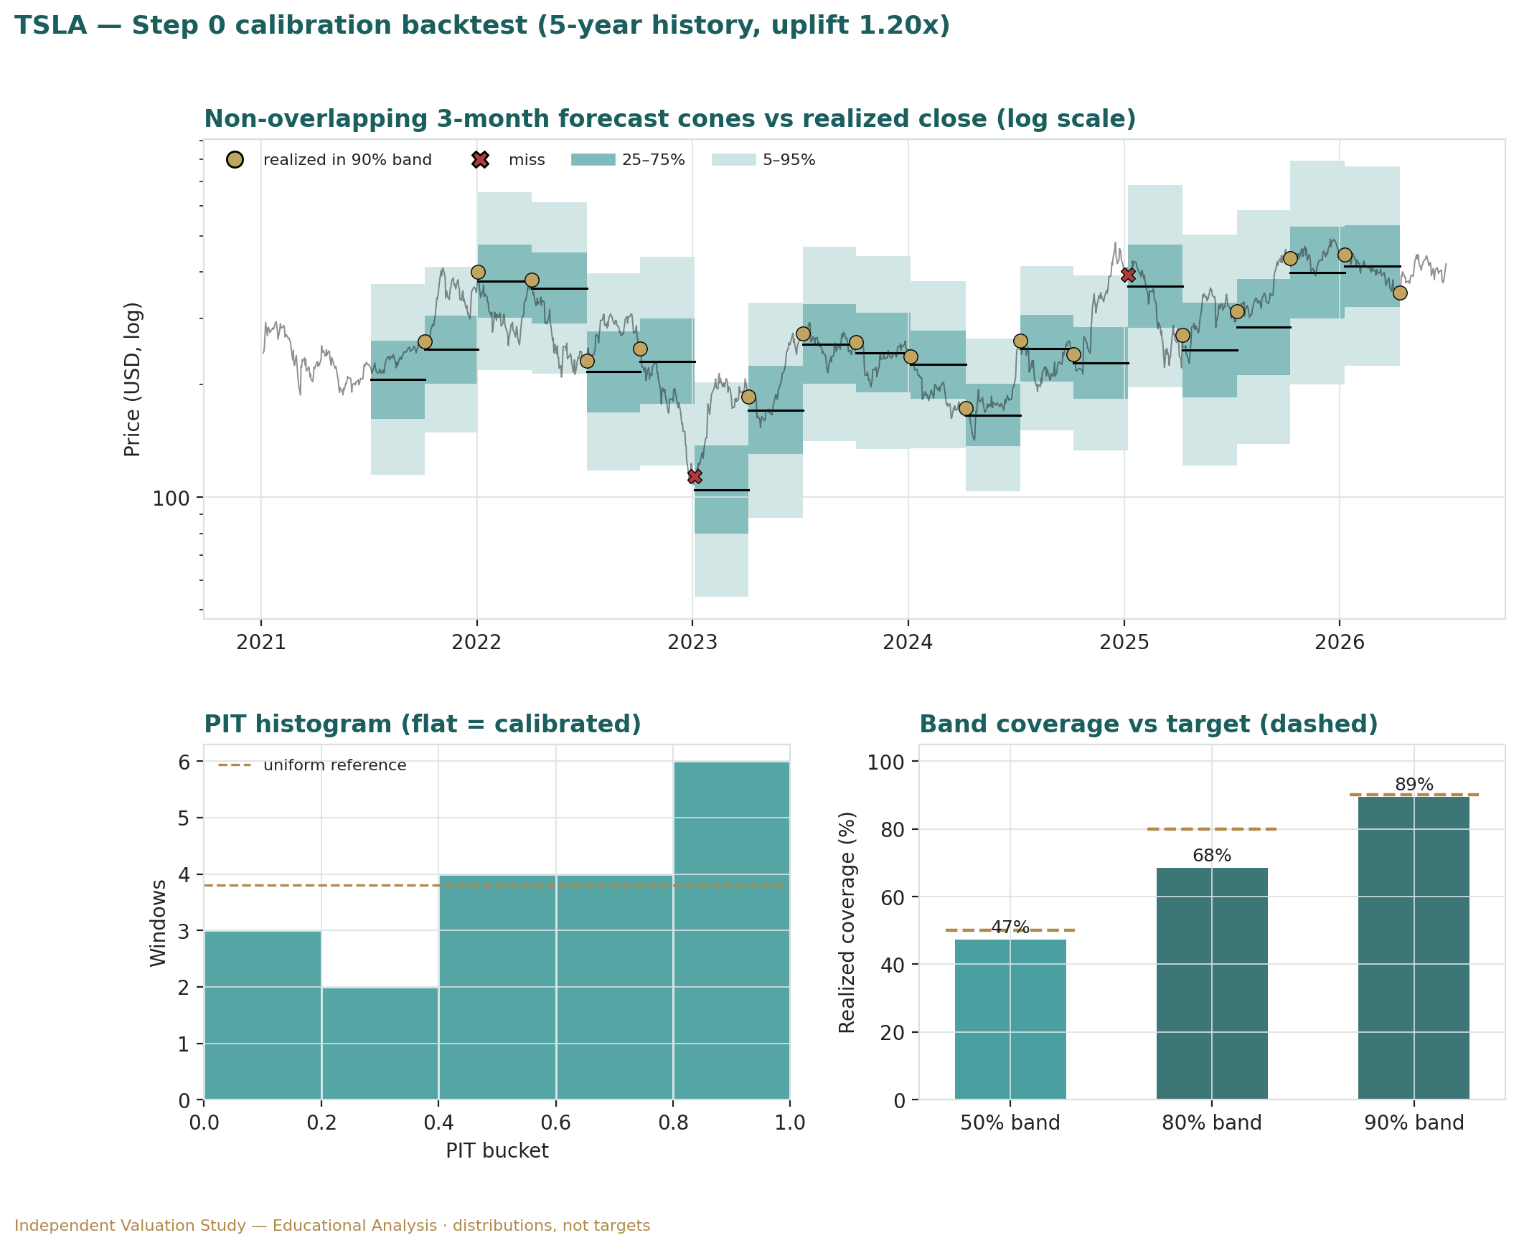
Figure B1 · Non-overlapping 3-month forecast cones vs realized close (top, log scale; gold = realized inside the 90% band, red = miss); PIT histogram (lower-left; flat = calibrated); and interval coverage vs the 50/80/90% targets (lower-right).

Appendix C Peer set, sector structure, and risks
C.1 The competitive map
Arena | Leaders | Tesla | Note
EV manufacturing | BYD / Tesla / legacy OEMs | co-leader | BYD leads on volume/price; Tesla on brand/software
Energy storage | Tesla / CATL / Fluence | top tier | Megapack scaling fast
Robotaxi / autonomy | Waymo / Tesla | challenger | Waymo live in more cities; Tesla data-led bet
Humanoid robotics | Tesla / Figure / others | early | Optimus pre-revenue; crowded field
FSD / ADAS software | Tesla / Mobileye / others | leader (data) | real-world fleet data advantage; unproven at L4
Charging network | Tesla (NACS) / others | #1 | Supercharger opened to other OEMs
C.2 Principal risks
Autonomy optionality — the dominant factor; a stall in Robotaxi/FSD/Optimus removes the fundamental support for most of the price, while a genuine ramp could justify it and more.
Auto-margin compression — Chinese competition (BYD) and price/incentive pressure can erode the operating business that funds the autonomy wait.
Policy and rates — EV-credit removal, tariffs on vehicles/inputs, an adverse FSD safety investigation, or a higher-for-longer rate regime all pressure a long-duration, policy-exposed name.
Valuation / multiple — at ~360× trailing earnings the multiple itself is a risk; a de-rating toward peer multiples is a large downside independent of operations.
Key-person / governance — dependence on the founder's vision and attention is both an upside narrative and a concentrated, two-sided risk.
Competition in every arena — Waymo in robotaxi, BYD in EVs, multiple firms in humanoids and storage; Tesla leads in none uncontested except brand and charging.

Appendix D The expert valuation panel
Every Testahil study closes with a panel of standing expert personas — drawn from the house Expert Persona Library, not invented for the occasion, so that each accumulates a track record across studies and a quarterly update is a re-run, not a re-training. For Tesla — a capital-heavy operating company carrying a very large technology option — we cast the three whose methods both fit an operating-company-plus-option and genuinely disagree: Expert 1 (segment sum-of-the-parts and the autonomy option), Expert 2 (normalized earnings power and relative multiples), and Expert 3 (cash returns — DCF and return on capital versus its cost). Each runs a different method, derives its fair value from shown workings, and states a falsification condition. The macro-policy lens — autonomy regulation, EV-credits and tariffs, rates and China — runs through the body (§1.8, §5) rather than as a separate persona.

D.1 Expert 1 — sum-of-the-parts and the autonomy option
Worldview. An operating company that houses distinct businesses plus a large option is worth the sum of its parts at realizable value, with the option priced separately and explicitly. Expert 1 marks each operating segment to what it would fetch on its own economics, then adds a probability-weighted value for the autonomy bucket rather than folding it into a multiple. When it works / when it fails. Best where the pieces trade on genuinely different economics and one piece is an unrealized option — Tesla exactly — and it is the only frame that keeps the operating value and the option value from contaminating each other. It fails if the segment marks are wrong, or if the single number chosen for the option's probability is treated as fact rather than judgment.
Standard workings. (1) mark each operating segment (auto on a normalized EBIT multiple, energy on a growth multiple, services on a modest multiple); (2) add net cash; (3) estimate the autonomy option's full-scale value; (4) apply a probability weight; (5) sum, and carry bull/bear as the weight moves.
Expert 1 — worked example | Value / sh
Automotive (~15× normalized EBIT) | ~USD 70
Energy generation & storage (growth multiple) | ~USD 35
Services & other (modest multiple) | ~USD 10
(+) Net cash & investments | ~USD 12
Operating businesses subtotal | ~USD 127
Autonomy option — full-scale value | ~USD 433
Probability weight (base) | ~24%
Autonomy option (risk-weighted) | ~USD 103
Expert 1 fair value | USD ~230
Sensitivity (swing = the option probability weight). At a 10% weight he is ~USD 170; at 24%, ~USD 230; at 35%, ~USD 279; crediting the option in full takes him to ~USD 560. The operating businesses are fixed at ~USD 127; his entire range above that is a statement about one probability no one can observe.
Cross-examination. He tells Expert 2 that a normalized P/E on today's earnings simply omits the option that is the whole point — 'you are valuing the wrapper and ignoring the prize.' He tells Expert 3 that a single group DCF blurs an auto business, an energy business and an option that deserve different discount rates and cannot be one cash-flow stream. Verdict, falsification, market-implied. Fair ~USD 230 (range USD 110–560) — the anchor and the most generous of the three at base. Falsified if a segment mark proves illusory, or above all if the autonomy option cannot be monetized near the value assumed. The market price implies a ~70% weight on the full autonomy outcome, far above his 24%.

D.2 Expert 2 — normalized earnings power and relative multiples
Worldview. An operating business is worth a fair multiple of its sustainable, mid-cycle earnings; peaks and troughs are noise to be stripped out, and the market's own multiples on comparable businesses are the discipline. When it works / when it fails. Best for operating businesses with a record and in relative-value contexts; it fails at structural breaks and where value rests on assets or options outside current earnings — which is precisely Tesla's difficulty, so he prices only the operating engine and is explicit that he excludes the option.
Standard workings. (1) normalize revenue and margins to mid-cycle; (2) derive sustainable earnings and EPS; (3) apply a justified P/E against history and peers; (4) cross-check with EV/EBITDA and EV/Sales; (5) blend.
Expert 2 — worked example | Value
Normalized revenue | ~USD 108bn
Normalized net margin | ~13%
Sustainable net earnings | ~USD 14bn
Sustainable EPS | ~USD 4.33
P/E read (~35×, ex-option) | ~USD 150
Relative cross-check (EV/EBITDA ~30×; EV/Sales ~5×) | ~USD 180–195
Expert 2 fair value (blend) | USD ~175
Sensitivity (swing = the justified multiple). At ~28× on normalized earnings he is near USD 120; at ~40×, USD 175; at ~50×, USD 220. Even a rich multiple on ex-option earnings stays well below spot — the multiple cannot bridge the gap, because the earnings exclude the autonomy businesses.
Cross-examination. He tells Expert 1 that a probability-weighted option is 'a multiple in disguise with the discipline removed,' and that a number you cannot observe is not a valuation input. He tells Expert 3 that a DCF whose value is almost all terminal is fragile and that his own multiple, struck against real peers, is the steadier instrument. Verdict, falsification, market-implied. Fair ~USD 175 (range USD 120–220) — the middle of the three. Falsified by a durable structural margin re-rating up (auto plus high-margin software lifting through-cycle earnings well beyond USD 14bn). The market implies a through-cycle multiple near 60× — sensible only if the earnings base is about to multiply, i.e., if autonomy monetizes.

D.3 Expert 3 — cash returns: DCF and ROIC versus the cost of capital
Worldview. A business creates value only when each unit of capital earns above its cost. Cash, not booked profit, is the test; he looks past the income statement to free cash flow and to the economic-profit spread of ROIC over WACC. When it works / when it fails. Best for capital-intensive businesses where returns on capital are the crux — Tesla's gigafactories and the USD 25bn+ capex programme make him essential — but a DCF is fragile for asset-light, optionality-driven value, so he brackets the option out and prices only the operating engine, which is his deliberate limitation.
Standard workings. (1) build free cash flow (NOPAT + D&A − capex − ΔNWC); (2) compute ROIC against WACC; (3) discount the explicit stream plus a terminal value with returns fading toward the cost of capital; (4) sensitivity on WACC and the ROIC-fade.
Expert 3 — worked example | Value
Invested capital (approx.) | ~USD 75bn
Trough ROIC (2025) | ~5% (below WACC)
Recovering ROIC by 2030e | ~13%
WACC | 10.0%
Terminal FCFF (2030e) | ~USD 21bn
Terminal growth | 4.5%
Expert 3 fair value (operating only) | USD ~105
Sensitivity (swing = WACC / ROIC-fade). At an 8.5% WACC he reaches ~USD 145; at 10.0%, ~USD 105; at 11.5% — a rate truer to the stock's beta — ~USD 75. The single most important number is the discount rate applied to a value that is almost entirely terminal.
Cross-examination. He agrees with Expert 2 that the operating business is worth little near spot, but insists the right tool is cash and ROIC, not a P/E. He tells Expert 1 that until the option produces cash it earns no return on the capital being poured into it, and that the capex programme is destroying near-term economic profit. Verdict, falsification, market-implied. Fair ~USD 105 (range USD 75–150) — the most cautious of the three: no margin of safety, operating business only. Falsified by a durable step-up in ROIC above WACC — a genuine autonomy-software moat at high incremental margin. The market price implies terminal free cash flow several times his estimate.

D.4 The three in one room — the autonomy option
Put the three in a room and one disagreement dwarfs the rest: what the autonomy option is worth today. Expert 3: “It is consuming roughly USD 25bn of capital a year at a return of zero. Until it earns above its cost of capital it destroys economic profit — I credit it nothing.” Expert 2: “Agreed on the cash, and on the earnings. The multiple only makes sense if the earnings base is about to multiply, and I will not pay sixty times for a hope. On today's business it is worth about USD 175.” Expert 1: “You are both pricing the wrapper and ignoring the prize. Mark the parts — auto, energy, services, the net cash — at about USD 127, then decide what a one-in-four chance of a Robotaxi-and-Optimus world is worth. That risk-weighted option is another hundred dollars a share. The argument is the probability, not the parts.” The exchange is the whole study: two anchor the operating value with discipline, one prices the option with humility about the odds, and none of the three reaches spot.

D.5 Reading the divergence
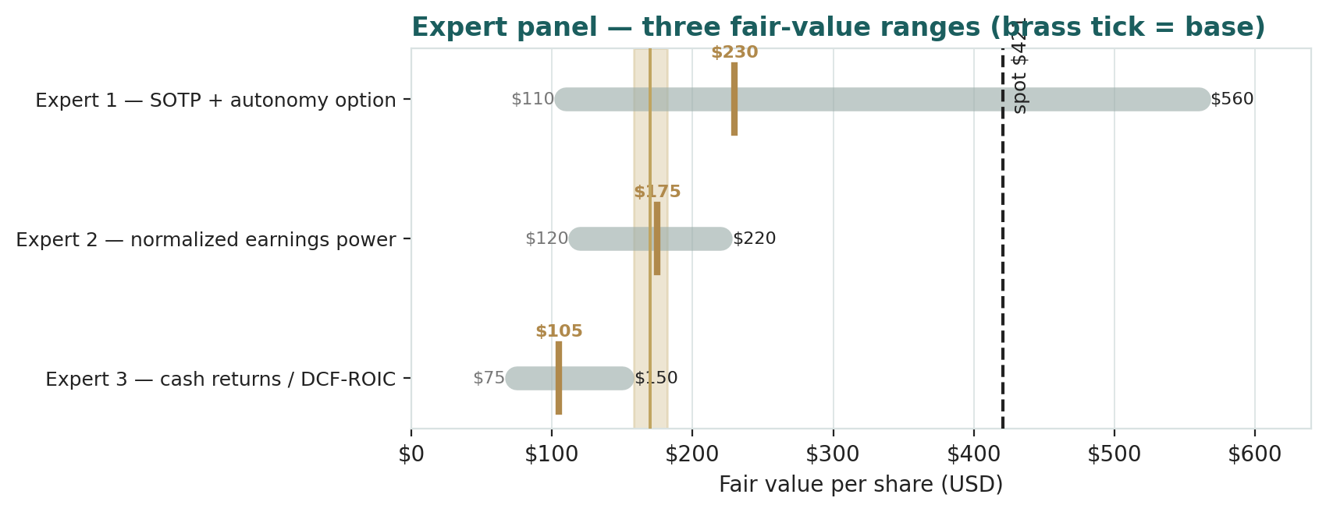
Figure D-1 · The three experts' fair-value ranges. Brass ticks are base cases; the gold band is the panel centre; the dark line is spot. The spread is almost entirely an autonomy-option disagreement.
Expert | Method | Single swing assumption | Base fair value | vs spot
Expert 1 | Sum-of-the-parts + option | autonomy option probability weight | USD 230 | −45%
Expert 2 | Normalized earnings × multiple | the justified multiple | USD 175 | −58%
Expert 3 | Cash returns / DCF-ROIC | WACC & ROIC-fade | USD 105 | −75%
What the spread measures. The USD 105-to-USD 230 spread across the three is not disagreement about Tesla's factories, its cash, or its energy business — on those they broadly concur at ~USD 127 of operating value. It is disagreement about one thing only: how much to pay today for an unproven, high-payoff future. Expert 3 and Expert 2, each in their discipline, refuse to pay much for what has not yet produced cash; Expert 1 prices the option but is honest that its value rests on a probability. The panel centres near USD 170, essentially on top of the USD 174 fundamental central of §1.5 — reassuring, since the panel and the body share almost no arithmetic. And that every one of the three — including the most generous — lands far below the USD 420.60 spot is the panel's central message: the market is paying more for the autonomy option than even the analyst most willing to price it. This is a valuation, not a recommendation, and not advice.
Per-expert point fair values are logged with the study date (30 Jun 2026) and spot (USD 420.60) as an internal per-expert calibration layer, kept separate from the core Calibration Ledger. A future 3-month update re-runs the same three personas on fresh data; it does not re-train them.

About this series
Testahil publishes independent, educational valuation studies. Each is an attempt to reason transparently about what a security is worth, with every assumption shown and a companion model so readers can disagree productively. The house style is distributions, not tips: we describe ranges and probabilities, not targets, and we do not tell anyone what to do. Studies are framed as educational analysis, the preparer is not licensed by any securities regulator, and holdings are disclosed.

Disclosure & Disclaimer
Not investment advice. This document is educational and informational only. It is not, and must not be relied upon as, investment, financial, legal, accounting or tax advice, nor an offer, solicitation or recommendation to buy, sell or hold any security. It contains no price target and no rating.
No licence; no advisory relationship. The preparer is not registered or licensed with any securities or financial regulator in any jurisdiction, holds no brokerage or investment-advisory authorisation, and is not acting as your adviser or fiduciary. Nothing here is personalised to your circumstances.
Holdings disclosure. The preparer may hold, and may in the future take or dispose of, a position in the security discussed in this report, and may transact at any time without notice. This is a potential conflict of interest you should weigh.
Sources & accuracy. Reported financial and operating figures are drawn from Tesla's public disclosure (SEC filings, ir.tesla.com) and other public sources believed reliable but not independently verified; they may contain errors or be superseded. Forward-looking inputs — the autonomy optionality value, the segment marks, projections, multiples, the DCF and Monte-Carlo factor probabilities — are the preparer's own judgments and are inherently uncertain.
Forward-looking statements. Any statements about the future are estimates subject to risks and uncertainties; actual results may differ materially. The Monte Carlo models price, not value, and encodes subjective probabilities for events that have not occurred.
No reliance; your responsibility. Do your own research and consult a licensed professional before making any decision. You are solely responsible for your investment decisions and their outcomes. To the maximum extent permitted by law, the preparer accepts no liability for any loss arising from use of this document.
Currency & figures. All figures are in U.S. dollars (USD) unless stated; bn denotes billion, tn trillion. Rounding may cause totals to differ slightly. Spot price and market data are as of 30 June 2026 and change continuously.

TESTAHIL · Independent Valuation Study · Educational Analysis · Tesla, Inc. (NASDAQ: TSLA) · edition 30-06-2026 · reporting currency USD

