Testahil · Independent Valuation Study — Educational Analysis Not investment advice

Independent Valuation Study — Educational Analysis
GB Corp S.A.E. (EGX: GBCO)
Fundamental analysis · Technical analysis · Monte Carlo simulation — one integrated read
Anchor: EGP 31.25 (7 Jul 2026 close) · 1,085.5 mn shares · mkt cap ~EGP 33.9 bn · the continuing listed entity of the former GB Auto (Ghabbour), renamed GB Corp in 2023, housing GB Auto (passenger cars, commercial vehicles & construction equipment, tires & trading, light mobility; Egypt · Iraq · Jordan), GB Capital (leasing, factoring, consumer finance, SME lending) and associate stakes led by MNT-Halan · prices and probabilities computed 7 Jul 2026 from the attached daily history · primary lens: split-the-legs sum-of-the-parts (operating company + captive lender, §3.5-F5) · Auto cash conversion and the Egyptian nominal-rate path are the swing factors.
READ FIRST — what this document is, and is not.
This study is a valuation exercise and an expression of personal analytical opinion, published free of charge for educational purposes: it shows how one analyst applies fundamental, technical and probabilistic methods to a listed company, and invites scrutiny of that methodology. It is NOT investment advice, NOT a recommendation or solicitation to buy, sell or hold any security, and NOT directed at the circumstances of any reader. The preparer is not licensed by any securities regulator in any jurisdiction, holds no Egyptian (FRA) or other brokerage or advisory authorisation, provides no financial consultancy, manages no money, and accepts no fees, funds or clients. See the Disclosure & Disclaimer at the end.
All values are model outputs presented as ranges and distributions because no single number should be relied on. Reported financials are the company’s own disclosure (FY23–FY25 earnings releases; 1Q26 release, 14 May 2026); forward-looking inputs — the marks on GB Capital and the MNT-Halan stake, the complexity discount, the multiples, the DCF and the Monte-Carlo factor probabilities — are the preparer’s judgments and are flagged throughout. A note on identity: GB Corp S.A.E. is the renamed GB Auto S.A.E. (Ghabbour Auto); the EGX ticker is GBCO (price history continues the former AUTO listing). Consult a licensed financial advisor before any investment decision.

Headline
The model's read: roughly fairly valued — the price already pays for the recovery; what it does not yet pay for is the cash. At EGP 31.25 the shares sit about 3% above our weighted central estimate of EGP 30.2. The four lenses cluster tightly: the split-the-legs sum-of-the-parts lands at 28.7 after a 10% complexity discount (pre-discount 31.9), a conservative relative read at 28.9, and a normalized mid-cycle read at 32.9 marks the ceiling. One structural fact belongs up front: the ~20% MNT-Halan stake alone is ≈EGP 11/share of that SOTP — about a third of the market price — marked to June’s USD 1.4 bn first close. The whole answer turns on the Auto leg's cash conversion: FY25 revenue grew 49% but working capital swallowed EGP 8.1 bn and Auto net debt rose to EGP 15.2 bn, so the DCF value of a business earning a 21% ROCE depends almost entirely on working-capital intensity gliding from 28.5% of revenue back toward its FY23–24 range — and on how fast Egyptian nominal rates (the 22% WACC against 11.5% terminal growth) come down. Technically the stock is the mirror image of a cheap chart: above all four moving averages, RSI in the low-60s, five months into a new all-time-high zone. Over three months the Monte Carlo — whose secular drift is the configuration that passed the Step 0 calibration gate — places the 5th–95th percentile band at roughly EGP 24–51 with a median near 35.
Valuation summary — every read at a glance
One table for the four reads that follow — what the business is worth (fundamental), what the tape is doing (technical), where price could travel over three months (Monte Carlo), and how three independent expert methods land. Every row is developed in the sections and appendices below.
Lens / read | What it measures | Output | Takeaway
FUNDAMENTAL — what the business is worth (the anchor)
Split-legs SOTP (primary) | Auto DCF + lender book + associate marks, less discount | EGP 28.7 | −8% vs spot
Pre-discount NAV | The same legs, no complexity discount | EGP 31.9 | +2%
Relative multiples | FY26E EPS × justified P/E | EGP 28.9 | −8% · the floor
Normalized earnings | Mid-cycle PAT × through-cycle P/E | EGP 32.9 | +5% · the ceiling
Weighted central | Blend 40 / 15 / 20 / 25 | EGP 30.2 | −3% vs EGP 31.25
TECHNICAL — what the tape is doing (timing, not value)
Trend & momentum | Price vs the 20/50/100/200-day averages | Above all four | Strong uptrend
Momentum / range | RSI · MACD · 52-week range | RSI 63 · MACD +0.04 · 19.1–33.4 | Extended, not euphoric
MONTE CARLO — where price could go in 3 months (paths from spot)
T+20 sessions | 50,000 paths · 16 factors | p5 26 · p50 32.5 · p95 40 | Median above spot
T+60 sessions | same engine, longer horizon | p5 24 · p50 35 · p95 51 | Wide, right-skewed
EXPERT PANEL — three independent methods (Appendix D)
Expert 1 — split-legs NAV | Marks each leg; fair discount | EGP 29.3 | The anchor
Expert 2 — normalized earnings power | Mid-cycle PAT × multiple | EGP 32.9 | Most bullish
Expert 3 — cash returns (ROCE vs WACC) | Economic profit on capital employed | EGP 27.5 | Most conservative
Panel range | Spread = the cash-conversion question | EGP 27.5–32.9 | Centres ~EGP 30

Bottom line. Every read lands within a few pounds of the price, and each disagreement is the same disagreement: how much of GB Auto’s reported growth converts into distributable cash. The fundamental central sits near EGP 30 — about 3% below the EGP 31.25 spot — the three experts span 27.5–32.9, and the tape, unusually, is more bullish than the value work: price has led. The three-month distribution centres above spot only because the engine’s secular drift survived the calibration gate; Appendix B shows exactly how thin that margin is.
Company overview — GB Corp at a glance
Item | Value
Listed entity | GB Corp S.A.E. (EGX: GBCO; formerly GB Auto / Ghabbour Auto, AUTO)
What it owns | GB Auto (PC assembly & distribution, CV&CE, tires & trading, light mobility) · GB Capital (Drive Finance, GB Lease & Factoring, rentals, Kredit) · associates: MNT-Halan, Bedaya, Kaf
Spot / date | EGP 31.25 · 7 Jul 2026 close
Shares · market cap | 1,085.5 mn · ~EGP 33.9 bn
FY25 revenue / net profit | EGP 80,229.8 mn (+48.7% YoY) · EGP 2,880.0 mn (3.6% margin)
1Q26 revenue / net profit | EGP 21,570.8 mn (+28.7%) · EGP 435.8 mn (−30.4%, regional drag + finance cost)
Segment split (FY25, pre-elim.) | GB Auto EGP 66.4 bn (83%) · GB Capital EGP 14.7 bn (17%); Capital = ~47% of segment net profit
Auto net debt / group equity | EGP 15.2 bn (2.39× Auto EBITDA; 2.14× at 1Q26) · attributable equity EGP 28.8 bn (BVPS 26.5)
52-week range | EGP 19.10 – 33.40 (all-time high 3 Feb 2026)
Ownership · leadership | Ghabbour family ~63.4% · free float ~36.6% · Group CEO Nader Ghabbour
Corporate events | MNT-Halan first-close capital increase at USD 1.4 bn valuation (Jun 2026) · Sadat CKD facility inaugurated Jun 2026 · 2Q26 results due 11 Aug 2026

Source: company 4Q23/4Q24/4Q25 and 1Q26 earnings releases, EGX data, MNT-Halan transaction press release (Jun 2026). Values rounded.
1 Fundamental valuation
We value GB Corp as an operating company with a captive finance arm and split the legs (§3.5-F5): blending an auto assembler-distributor, a leveraged lender and an unlisted fintech associate into one multiple would blur three different economics. The primary lens is therefore a split-legs sum-of-the-parts: the Auto operating leg on a free-cash-flow DCF; GB Capital on its adjusted operating book times a return-justified multiple; the MNT-Halan-led associate stakes at balance-sheet carrying value, cross-checked against the June-2026 funding round. A relative-multiple read and a normalized mid-cycle read complete the set. The weights and the football field are in §1.5; the swing factor — Auto cash conversion — is dissected in §1.7 and the sensitivity grids in §1.9.
1.1 Split-the-legs sum-of-the-parts — the primary lens
Each leg is marked on the basis that fits it. The Auto leg takes the §1.2 DCF value; GB Capital is marked on the company’s own adjusted-ROAE equity base (the disclosure that strips the MNT-Halan revaluation out of the equity denominator: NP EGP 1,366 mn / 15.1% adjusted ROAE ⇒ ~EGP 9.5 bn of operating book) at 1.0× — the return-justified multiple for a mid-teens-ROE lender whose margin is a beneficiary of the easing cycle; and the associates are held at their EGP 13.7 bn carrying value, which the June-2026 round independently corroborates (USD 1.4 bn × an estimated ~20% stake × EGP/USD ≈ 47.5 ⇒ ~EGP 13.3 bn — the stake percentage is not separately published and is flagged as an estimate). Within the associates line, MNT-Halan is essentially the whole story: ~EGP 13.3 bn of the EGP 13.7 bn carrying value (≈97%), with Bedaya and Kaf the ~EGP 0.4 bn residual — so the line is split below rather than lumped. From the sum we deduct a 10% complexity discount for the wrapper: an auto operator, an NBFI and an unlisted fintech in one listing will not trade at the clean sum of its parts.
Leg (base case) | Basis | Value (EGP mn)
GB Auto operating leg | FCFF DCF (§1.2): EV 27,398 − net debt 15,210 − NCI 800 | 11,388
GB Capital lending leg | Adjusted operating book 9,500 × 1.0× | 9,500
Associate — MNT-Halan (~20% est.) | USD 1.4 bn Jun-26 round × ~20% stake × 47.5 EGP/USD | 13,300
Other associates (Bedaya, Kaf) | Residual carrying value | 390
Σ Equity value (pre-discount) | = EGP 31.9 / share | 34,577
less: complexity / conglomerate discount | 10% | (3,458)
SOTP equity value | = EGP 28.7 / share | 31,120

SOTP base ≈ EGP 28.7/share, with a bear–bull span of 13–50 driven mainly by the Auto margin and working-capital path, the discount, and the two financial marks (§1.9). The market-implied read is instructive: market cap less the lender and the associates leaves ~EGP 10.7 bn for the Auto leg — almost exactly our DCF’s 11.4 bn, or ~4.0× FY26E Auto EBITDA. The market is not mispricing the parts; it is pricing the wrapper at roughly our discount.
What the MNT-Halan stake is worth inside this valuation
Because a single unlisted mark this large deserves its own arithmetic, here is MNT-Halan’s exact footprint — every figure derived from the SOTP above:
MNT-Halan in the GBCO valuation | Value
Implied value at the June-2026 round | USD 1.4 bn × ~20% est. stake × 47.5 = EGP 13,300 mn
Per share, pre-discount | EGP 12.25 — 38% of the EGP 31.9 pre-discount NAV
Per share, after the 10% discount | EGP 11.03 — 38% of the EGP 28.7 SOTP
As a share of the market price (EGP 31.25) | ≈35% — roughly a third of GB Corp’s market value
Sensitivity to the mark | each ±0.2× on the mark = ∓EGP 2.2/share (0.8× → SOTP 26.6; 1.2× → 31.0)
If the second closing prices at USD 2.0 bn | +EGP 4.7/share → SOTP ≈ 33.5

In plain terms: roughly a third of GB Corp’s market value is a ~20% stake in an unlisted fintech, marked to a first-close price at which cash actually changed hands — the most objective mark available, but a private one. That is why the second closing is a top-three catalyst (§5), why the bear case carries the stake at 0.8× (§7), and why the stake percentage itself — estimated, not separately published — is flagged wherever it appears.
1.2 The Auto-leg DCF — the cash-flow engine of the SOTP
The Auto leg is built bottom-up on disclosed units × ASP per line of business (the data-discipline gate is cleared: volumes and revenue are published per LoB, so ASP is arithmetic, not guesswork — the driver table is in §1.6 and Appendix A). Gross margin glides from 13.8% (FY26E, absorbing the regional drag visible in 1Q26’s 12.4%) back to 14.5% — below FY24’s FX-windfall 19.2% by design; GS&A holds ~7%; capex follows the EGP 3 bn 2026 guidance then normalizes; and the crux — net working capital — glides from 28.5% of revenue (FY25) to 21.5% by FY30E as the payables re-extension completes and the Sadat stock-build unwinds. WACC is built per the house rule (§1.8 table): Ke = 19% rf + 0.95 β × 7% ERP = 25.7%, blended with after-tax debt to 22.0%; terminal growth 11.5% nominal EGP.
EGP mn | FY26E | FY27E | FY28E | FY29E | FY30E
Auto revenue | 78,550 | 95,736 | 112,459 | 128,714 | 144,761
EBITDA | 6,677 | 8,616 | 10,571 | 12,228 | 13,752
D&A | (864) | (1,053) | (1,237) | (1,416) | (1,592)
EBIT | 5,813 | 7,563 | 9,334 | 10,812 | 12,160
NOPAT = EBIT × (1 − 28%) | 4,185 | 5,445 | 6,721 | 7,785 | 8,755
+ D&A | 864 | 1,053 | 1,237 | 1,416 | 1,592
− Capex | (3,000) | (2,400) | (2,500) | (2,600) | (2,800)
− Δ working capital | (1,899) | (3,118) | (2,494) | (2,533) | (2,163)
FCFF | 151 | 980 | 2,964 | 4,068 | 5,384
Discount factor | 0.820 | 0.672 | 0.551 | 0.451 | 0.370
PV of FCFF | 123 | 659 | 1,632 | 1,836 | 1,992

DCF bridge | EGP mn
Σ PV of explicit FCFF (FY26–30E) | 6,243
Terminal value (Gordon, g = 11.5%) | 57,178
PV of terminal value | 21,156
Enterprise value — Auto leg | 27,398
Terminal value as % of EV (device A-7) | 77%
less: Auto net debt · Auto NCI | (15,210) · (800)
Auto equity value | 11,388

Two honesty notes. First, 77% of the EV sits in the terminal value — this is a growth-and-rates bet dressed as a five-year model, which is why §1.9 sensitizes the WACC × terminal-g grid rather than hiding it. Second, the explicit-period FCFF is thin (EGP 0.2 bn in FY26E) precisely because growth consumes working capital; the value is in the steady state, not the ramp. Both are disclosed rather than blended away (device A-8).
1.3 Relative multiples
On FY25 earnings GB Corp trades at ~11.8× P/E and ~1.18× book. On the FY26E build (~EGP 3.3 bn attributable, EPS ~3.04) the forward P/E is ~10.3×. A justified multiple for the blend — an EM auto distributor (typically 8–12×) plus a mid-teens-ROE NBFI (6–10×) with an unlisted fintech kicker — sits around 8–11×. We mark the lens on the FY26E EPS.
Relative basis | Bear | Base | Bull
FY26E net profit (EGP mn) | 3,300 | 3,300 | 3,300
Justified P/E | 8.0× | 9.5× | 11.0×
Fair value (EGP/share) | 24.3 | 28.9 | 33.4

Relative base ≈ EGP 28.9 — the most conservative lens and probably where a sceptic anchors: it pays for this year’s earnings and gives nothing for the working-capital release or the associate optionality.
1.4 Normalized earnings power — where this sits in the cycle
Cycle position first (device A-6): GB’s FY25 passenger-car volume of 56.5k units is roughly double the 2023 trough (27.0k) but still well short of the company’s mid-2010s run-rate, and the Egyptian market’s 210k registrations in 2025 — +40% y/y — remain below the pre-2016-devaluation peak; the recovery is mid-cycle, not late-cycle. Margins are past their peak, though: FY24’s 19.2% Auto gross margin carried an FX-scarcity windfall that is normalizing (14.8% FY25, 12.4% in 1Q26). Mid-cycle earnings power therefore blends recovering volumes with normalized margins: ~EGP 4.2 bn of group PAT (Auto ~2.2 bn at 14.5% GPM on FY27-scale revenue + Capital ~1.7 bn + associates), against FY25’s reported 2.9 bn.
Normalized-earnings basis | Bear | Base | Bull
Mid-cycle PAT (EGP mn) | 3,600 | 4,200 | 4,800
Justified P/E | 7.5× | 8.5× | 9.5×
Fair value (EGP/share) | 24.9 | 32.9 | 42.0

Normalized base ≈ EGP 32.9 — the ceiling of the central case: in effect the bet that the volume recovery completes while margins hold the post-windfall floor.
1.5 Synthesis — four lenses
We weight the SOTP most heavily because it respects the differing economics of the legs; the pre-discount NAV carries the discount-narrowing case; the relative lens anchors the floor; normalized earnings carries the recovery thesis.
Lens | Weight | Bear | Base | Bull
Split-legs SOTP | 40% | 13 | 28.7 | 50
Pre-discount NAV | 15% | 16 | 31.9 | 52
Relative multiples | 20% | 24 | 28.9 | 33
Normalized earnings | 25% | 25 | 32.9 | 42
Weighted central |  | 18.8 | 30.2 | 45.1

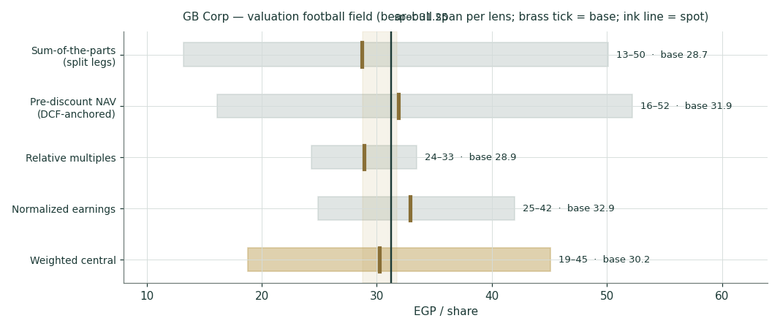
Figure 1 — Valuation football field. Bars span bear–bull per lens; the brass tick is each base case; the gold band is the blended central range; the light line is spot.
Central fair value ≈ EGP 30.2/share, about 3% below spot. The tightness of the bases (28.7 to 32.9) is itself the message: this is not a deep-value or a clearly-expensive name, but a fairly-priced operator whose next leg of value depends on cash conversion and the rate cycle rather than on the market discovering the story.
1.6 The legs — a deeper look, and the units × ASP driver table
Leg | Cyclicality | Margin / return trend | Capital intensity | Swing role
GB Auto — PC (80% of Auto rev) | High (rates, FX, imports) | GPM normalizing 14.8% → ~14% | Very high (working capital) | Dominant
GB Auto — CV&CE, trading, mobility | Moderate | Bus exports scaling | Moderate | Diversifier
GB Capital | Credit-cycle | Adj. ROAE 15.1%; NIM 5.0%; NPL 2.1–2.5% | Leverage 0.86× D/E | Compounder
Associates (MNT-Halan et al.) | Venture-like | Revenue +50% (1Q26); loan book > USD 1.7 bn | Off balance sheet | Optionality

The bottom-up build (§3.5-B/C — gate cleared: every driver below is disclosed or arithmetic on disclosed figures):
Driver (disclosed) | FY23 | FY24 | FY25 | FY26E | FY30E
PC volume (units) | 26,994 | 42,043 | 56,548 | 63,334 | 90,921
PC ASP (EGP mn/unit) | 0.61 | 0.87 | 0.93 | 0.99 | 1.27
PC revenue (EGP mn) | 16,544 | 36,533 | 52,827 | 62,717 | 115,821
CV&CE revenue | 2,323 | 3,985 | 5,957 | 7,818 | 14,921
Light-Mobility revenue | 854 | 1,378 | 2,204 | 3,008 | 6,217
Trading (tires + parts) | 2,507 | 3,816 | 4,243 | 5,007 | 7,803
GB Auto total revenue | 23,854 | 47,065 | 66,358 | 78,550 | 144,761

FY25 PC mix: 31,349 CKD / 25,199 CBU; Egypt 80.5% of PC revenue, Iraq/Jordan 19.5%. Sources: 4Q23/4Q24/4Q25 releases, Tables 2–7. Forecast drivers are the house’s own flagged view.
1.7 Cash conversion and the rate path — the crux
Two judgments drive the valuation more than any other. First, where working-capital intensity settles (the observable, disclosed unit: net Auto working capital as % of Auto revenue — device A-1). It ran 18.7% in FY23, 22.9% in FY24 and 28.5% in FY25 as import-restriction payables normalized and inventory was pre-built for Sadat; we glide it to 21.5% by FY30E. Each percentage point of steady-state intensity is worth roughly EGP 4–5/share of SOTP value — a bigger lever than a half-turn of the P/E. Second, the Egyptian nominal-rate path: the 22.0% WACC against 11.5% terminal growth is a 10.5-pt real spread struck off a 19% blended risk-free; every 100 bp the CBE easing cycle takes out of that spread adds ~EGP 3/share (§1.9 grid). A third, binary-style exposure (§3.5-E device 6, applied cross-class): roughly a fifth of PC revenue is Iraq/Jordan, where the regional conflict cut 1Q26 volumes — a full-year regional freeze would take ~EGP 1.5–2 bn off Auto gross profit, worth ~EGP 2–3/share.
1.8 Macro and country — rates, the pound, imports and the region
GB Corp is a leveraged play on Egyptian nominal normalization. The CBE has cut 825 bp since April 2025 and held its deposit rate at 19.00% through the April and May 2026 meetings with inflation ~14.6%; every cut lowers GB Capital’s funding cost on a fixed-rate-lending book, lowers the Auto customer’s instalment, and compresses the discount rate this study applies. The EGP (~47–48/USD, firmer y/y) sets CKD input costs and the EGP value of the MNT-Halan mark — a step-devaluation is the single nastiest macro scenario for both margin and multiple. Import policy and Chinese entrants (BYD’s Egypt entry; grey imports into Iraq) set the competitive ceiling on ASPs; localization (Sadat, 46%+ local content on core CKD lines) is the structural answer. The cost-of-equity build these translate into (house rule §3.5-G):
Cost-of-capital build | Value
Risk-free rate (blended 5-yr EGP view) | 19.0%
Equity beta (band 0.8–1.3) | 0.95
Equity risk premium (Egypt) | 7.0%
Cost of equity Ke = rf + β × ERP | 25.7%
After-tax cost of debt (21% pre-tax, 28% tax) | 15.1%
WACC (65% equity / 35% debt) | 22.0%
Terminal growth (nominal EGP) | 11.5%

1.9 Sensitivity — the margin, the discount, and the rate spread
Holding the lender and associate marks at base, the first grid re-prices the SOTP across the Auto gross-margin path and the complexity discount; the second across the WACC × terminal-growth spread (the rate-cycle bet made explicit, device A-7).
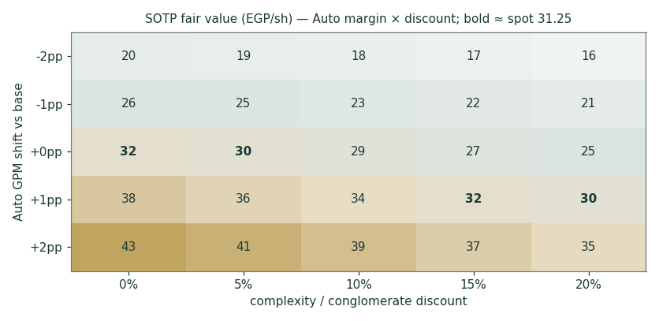
Figure 2 — SOTP fair value (EGP/share) across the Auto GPM shift and the complexity discount. Bold cells sit nearest spot (EGP 31.25).
WACC \ terminal g | 9.5% | 10.5% | 11.5% | 12.5% | 13.5%
20% | 30.2 | 32.3 | 35.0 | 38.4 | 42.8
21% | 27.7 | 29.4 | 31.5 | 34.1 | 37.3
22% | 25.6 | 27.0 | 28.7 | 30.7 | 33.2
23% | 23.8 | 25.0 | 26.3 | 28.0 | 29.9
24% | 22.3 | 23.3 | 24.4 | 25.7 | 27.3

SOTP fair value (EGP/share, post-discount) across WACC × terminal growth. Base cell 22% × 11.5% = 28.7. Read it as the bet you are taking: spot is consistent with roughly a 9.5–10-pt nominal spread — i.e. two-to-three more CBE cutting cycles already partly in the price.
2 Technical and price structure
The tape is strong and extended. GBCO trades above all four major moving averages, the MACD histogram has just re-crossed positive, and RSI sits in the low-60s — firm, not yet euphoric. The structure is a stair-step advance: a February spike to the EGP 33.40 all-time high, a two-month consolidation into the April low near 24, and a renewed leg that has carried price back within ~6% of the high. The 52-week low at 19.10 is the deep floor; the 20-day average near 30 is the trend’s first support.
Indicator | Reading | Signal
Spot | EGP 31.25 | —
SMA 20 / 50 | EGP 30.0 / 28.2 | Above both — short-term up
SMA 100 / 200 | EGP 27.8 / 26.7 | Above both — trend up
RSI (14) | 62.8 | Firm; below overbought
MACD (12,26,9) | +1.15 line / +1.11 signal / +0.04 hist | Bullish, momentum re-building
52-week range | EGP 19.10 – 33.40 | Upper tenth of range
Realized vol (252d) | 35.6% | Elevated but off crisis highs

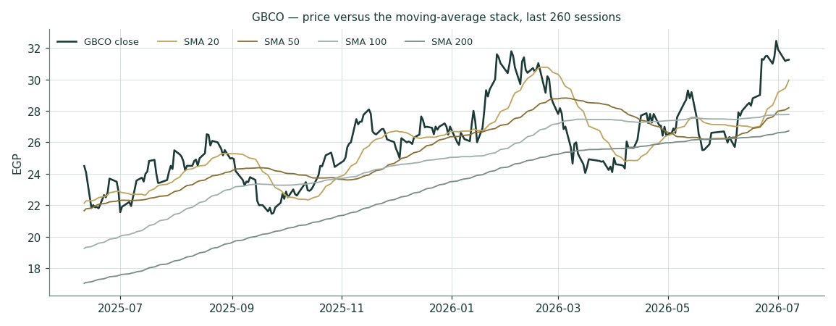
Figure 3 — Price versus the moving-average stack, last 260 sessions.
For the probabilistic work this matters in one way: an above-trend, momentum-positive tape thickens the near-term upside tail even where the fundamental work says value has been reached. The technical and fundamental pictures genuinely disagree here — unusually, with the tape the more bullish — and §6 reads the resulting probability zones without forcing a reconciliation.
3 Monte Carlo — a probabilistic price map
The probability read below opens the section, per house presentation: computed from the same 50,000 paths as everything that follows, it is a summary of the distribution, not an input to it.
The probability read (T+60)
P(price above spot) | 71%
P(+10%) vs P(−10%) — the odds | 54% vs 15% · 3.6 : 1
Median level, and its move | EGP 34.98 (+11.9%)
The 50% band (25th–75th) | EGP 30.6 – 40.1 (-2% / +28% of spot)
Touch(+10%) / touch(−10%) at any point | 76% / 38%

We simulate 50,000 three-month price paths (seed 42) with the house YZ-HAR v2 engine: width from a pooled log-HAR cascade (variance lags 1/5/22) on a gap-aware Yang-Zhang variance proxy, projecting the average daily variance over the next 60 sessions (annualized ≈ 49.6% at this origin — regime-conditional by construction, with no calibration multiplier: the retired KVOL floor is replaced by the HAR width itself); shape from unit-variance Student-t(5) innovations via a per-path chi-square mixture (tighter interquartile body, honest tails); and drift that is asset-class-conditional — here the secular expanding-window drift (+9.8% per quarter), because that is the configuration that passed the Step 0 gate on this name while zero drift failed it (Appendix B). A sixteen-factor stack layers on top: seven continuous macro/operating drivers contributing a small net forward drift and nine discrete events that each fire with a probability and an impact, together adding a modest +1.5% over the quarter.
By design the paths diffuse from spot as near-term price and deliberately do not embed the fundamental NAV — the value gap of §1 is kept out of the drift. The fundamental gap lives in §1, not here; §3 maps where price could go from today, not where value sits. The upward median you see is the stock’s own measured secular behaviour surviving a calibration test — never a target, and never the §1 value gap smuggled in.
Continuous factor (7) | Dir. | Discrete event (9) | Prob. | Mean impact
Egypt PC demand / rate-cut cycle | + | 2Q26 results (11 Aug 2026) | 90% | +0.5%
EGP/USD drift (CKD import content) | ± | MNT-Halan second closing ≥ $1.4 bn | 45% | +1.5%
CBE easing (affordability + Capital NIM) | + | CBE cut ≥ 100 bp (Aug/Oct MPC) | 50% | +1.0%
Iraq / Jordan regional-conflict drag | − | Regional escalation spillover | 25% | −2.5%
Chinese grey-import competition | − | BYD Egypt entry / price shock | 35% | −1.0%
Localization / CKD mix & Sadat ramp | + | Sadat ramp / new CKD model | 55% | +0.6%
Funding-cost & provisioning cycle | − | Dividend / capital-return surprise | 15% | +0.8%
 |  | EGP step-devaluation | 12% | −2.0%
 |  | EGX flows / index event | 25% | +0.8%

Percentile map (EGP/share)
Horizon | p5 | p25 | p50 | p75 | p95
T+20 sessions | 26.1 | 30.0 | 32.5 | 35.1 | 40.5
T+60 sessions | 24.0 | 30.6 | 35.0 | 40.1 | 51.1

Lead with the 50% band, not the tails: a quarter ahead, half of all paths finish between roughly EGP 31 and 40; at one month the band is ~EGP 30–35 (width ≈ ÷√3). The 5–95% cone is context, not a forecast.
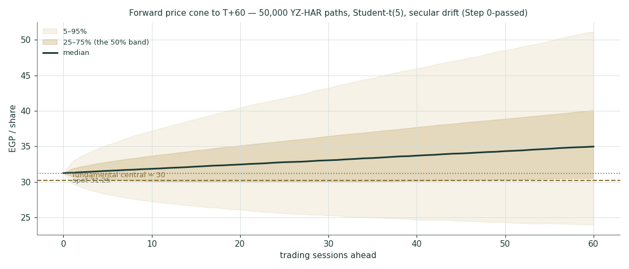
Figure 4 — Forward price cone to T+60. The median drifts up with the calibrated secular term; the gold dashed line marks the EGP 30 fundamental central, deliberately below the median path.
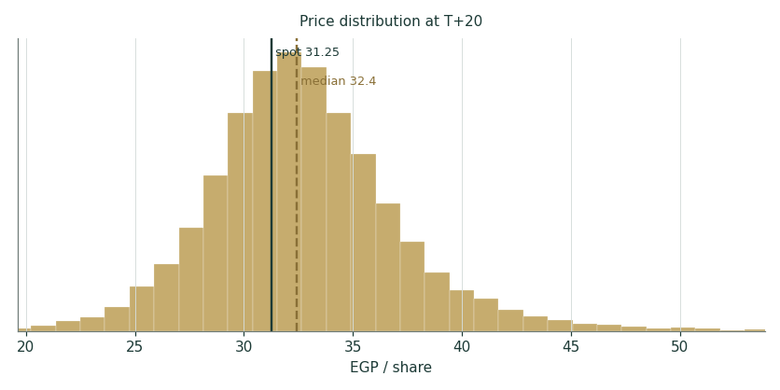
Figure 5 — Price distribution at T+20.
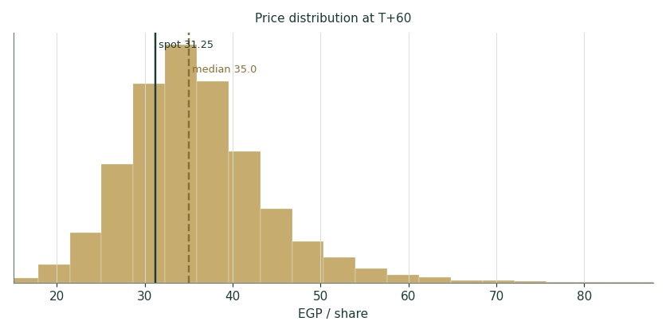
Figure 6 — Price distribution at T+60.
Level-touch ladder
The probability that price touches a level at any point by the horizon (running max for upside, running min for downside):
Level (EGP) | T+20 touch | T+60 touch | Note
40 | 8% | 37% | Blue-sky; +28%
38 | 15% | 50% | Upper zone gateway
36 | 29% | 64% | Above the Feb high zone
34 | 51% | 79% | New-high territory
32 | 82% | 93% | Just above spot
30 | 53% | 64% | The 20-day / round number
28 | 22% | 37% | The 50/100-day shelf
26 | 9% | 20% | April-low zone

4 Comparison of the lenses, and a verdict
Three readings sit side by side. The fundamental lenses cluster at 29–33 with a central 30.2 — a shade below spot, contingent on cash conversion. The technical picture is, unusually, the most bullish of the three: above every average, momentum positive, six percent from an all-time high. The probabilistic map splits the difference in an unfamiliar way: its median (35) sits above both spot and fair value, because the engine’s calibrated secular drift — the EGX repricing that has carried this stock thirteen-fold in five years — has not yet statistically died. That is a description of measured price behaviour, not a claim about value.
Lens | Reads | Central / implication
Fundamental (4-lens) | Fairly valued | EGP 30.2 (~−3%)
Technical | Strong / extended | Support 30.0 / 28.2 (20d/50d); resistance 33.4 (ATH)
Monte Carlo (3-month) | Drift-up, right-skewed | Median 35; p5–p95 24–51

Verdict (a fair-value read, not a recommendation). GBCO looks fairly valued on fundamentals with the recovery priced but the cash-conversion proof still pending: working capital, not demand, is now the income statement’s judge. The strong tape and the drift-up distribution argue the market is willing to pay ahead of that proof; the fundamental work argues the next EGP 5/share of value must be earned in the balance sheet (WC release, CBE cuts, an MNT-Halan second closing) rather than re-rated into existence. The honest summary is a value at price, a distribution centred modestly above it, and a bear–bull span (EGP 19–45) wide enough to demand humility. Readers should weigh the lenses themselves; we publish the distribution, not a target.
5 Catalysts to watch
- 2Q26 results (11 Aug 2026). First read on whether the 1Q26 margin dip (12.4% Auto GPM) was the regional-drag trough; watch Egypt PC volumes vs the +42% 1Q pace and the finance-cost line as CBE cuts feed through.
- CBE MPC meetings (Aug / Oct 2026). Each 100 bp cut lowers GB Capital funding costs, customer instalments and this study’s discount rate — the single most mechanical catalyst.
- MNT-Halan second closing. The June first close priced USD 1.4 bn; a completed round at or above it hardens ~40% of the SOTP’s financial-asset value; a re-price below would cut it directly.
- Sadat ramp and new CKD models. The June-2026 inauguration adds capacity and local content; model announcements and the inventory unwind are the visible working-capital catalysts.
- BYD entry pricing. The clearest competitive threat to PC ASPs and share in the recovering Egyptian market.
- Iraq / Jordan normalization. ~19.5% of PC revenue; any de-escalation restores the fastest-margin sales in the mix.
- The pound. A step-devaluation is the compound risk (CKD costs, rates, the EGP value of every mark); continued stability is the quiet tailwind.
- Dividend decision. FY25 paid ~EGP 0.35/share (~13% payout); with Auto deleveraging to 2.14× ND/EBITDA, a payout step-up would mark the cash-conversion inflection this study is waiting for (device A-2 schedule in Appendix A).
6 Reading the probability zones
Translating the three-month distribution into plain zones, anchored on spot EGP 31.25 and the fair-value cluster:
Zone (T+60) | Range | Approx. probability | What it would mean
Deep downside | < EGP 26 | ~9% | Regional escalation / devaluation; tests the April shelf
Lower band | EGP 26–30 | ~14% | Margin proof delayed; relative-multiple lens dominates
Around spot | EGP 30–34 | ~22% | Status quo; fair value and price coexist
Upper band | EGP 34–38 | ~22% | Cuts + WC release credited; new-high extension
Strong upside | > EGP 38 | ~34% | Secular repricing continues; discount narrows toward NAV

The distribution is right-skewed by construction — the calibrated secular drift plus fat-tailed innovations put roughly a third of terminal mass above EGP 38, more than any other single zone. Read that with Appendix B open: the drift term passed its test, but on 17 non-overlapping windows with a thin margin. It is the spread of outcomes consistent with the stock’s own measured behaviour and the factor stack; it is not a forecast.
7 Caveats and what would change our mind
- Working capital is the model. The DCF’s value lives in the glide from 28.5% to 21.5% WC intensity; if 26–28% is the new structural cost of holding share (import finance, CKD stock), the Auto leg is worth EGP 4–8/share less and the central drops toward the relative lens.
- Terminal-value dependency. 77% of the Auto EV is terminal value at a 10.5-pt WACC−g spread; the §1.9 grid is the honest statement that this is partly a bet on Egyptian nominal normalization.
- The drift is empirical, and thin. Secular drift passed Step 0 (CRPS skill +3.2% non-overlapping, +9.6% monthly) where zero drift failed — but the bootstrap CI spans zero (P(skill>0) ≈ 0.62 on 17 windows). A regime turn — the exact failure mode that killed trend drift on Samsung and Tata — would flip the median read; we will re-test every quarter and cut the drift the moment it fails.
- The associate mark is private. MNT-Halan’s USD 1.4 bn is a first-close price, the GB stake percentage is an estimate, and private marks are sticky on the way down; the bear case carries it at 0.8×.
- The lender is a credit cycle. GB Capital’s 15% adjusted ROAE and 2.1–2.5% NPLs are cycle-friendly numbers struck in an easing cycle; a funding-market seizure or NPL spike would break the 1.0× book mark.
- Consolidation approximations. The consolidated forecast maps eliminations, minority interests and the grouped balance-sheet layout with stated simplifications (flagged in the model); segment disclosure, not audited consolidation schedules, is the source.
- Technical reminder. An extended tape above every average mean-reverts routinely; the strong chart says nothing about value and can unwind 10% without touching the thesis. The technical read is context, not a trigger.
Appendix A Financial statements
Selected consolidated figures, as reported (4Q23 / 4Q24 / 4Q25 earnings releases; 1Q26 release 14 May 2026). EGP million. FY23 operating profit is shown after provisions for cross-year consistency with the FY25 layout. The five-year forecast is the model build (companion Excel, Income Statement sheet, formula-linked to Assumptions).
A.1 Income statement (consolidated, EGP mn)
Line | FY23 | FY24 | FY25 | FY26E | FY27E | FY28E | FY29E | FY30E
GB Auto revenue | 23,854 | 47,065 | 66,358 | 78,550 | 95,736 | 112,459 | 128,714 | 144,761
GB Capital revenue | 4,951 | 7,384 | 14,743 | 21,377 | 27,790 | 34,738 | 41,686 | 49,189
Eliminations | (488) | (479) | (872) | (1,099) | (1,359) | (1,619) | (1,874) | (2,133)
Total revenue | 28,317 | 53,970 | 80,230 | 98,828 | 122,168 | 145,578 | 168,525 | 191,817
Gross profit | 6,884 | 10,515 | 12,431 | 14,633 | 18,600 | 22,760 | 26,551 | 30,417
S&M and administration | (3,431) | (4,844) | (6,547) | (7,906) | (9,651) | (11,355) | (13,061) | (14,770)
Other income · provisions | 250 | 150 | 747 | 791 | 977 | 1,165 | 1,348 | 1,535
Operating profit | 3,703 | 5,821 | 6,631 | 7,518 | 9,926 | 12,570 | 14,838 | 17,182
Associates | 1,066 | 868 | 975 | 1,250 | 1,430 | 1,630 | 1,830 | 2,030
EBIT | 4,770 | 6,689 | 7,606 | 8,768 | 11,356 | 14,200 | 16,668 | 19,212
FX gains (losses) | (1,499) | (292) | (37) | — | — | — | — | —
Net finance cost | (966) | (2,398) | (3,702) | (4,100) | (3,800) | (3,500) | (3,300) | (3,100)
Earnings before tax | 2,304 | 3,999 | 3,867 | 4,668 | 7,556 | 10,700 | 13,368 | 16,112
Income taxes | (493) | (939) | (1,086) | (1,307) | (2,116) | (2,996) | (3,743) | (4,511)
NP before minority interest | 1,811 | 3,060 | 2,780 | 3,361 | 5,441 | 7,704 | 9,625 | 11,601
Minority interest | 80 | (132) | 100 | (67) | (109) | (154) | (193) | (232)
Net profit (attributable) | 1,891 | 2,928 | 2,880 | 3,294 | 5,332 | 7,550 | 9,433 | 11,369

Forecast columns are the live model build (rounded); the Excel is the source of truth and reprices from Assumptions.
A.2 Balance sheet (consolidated, EGP mn) — grouped house layout
Line | FY23 | FY24 | FY25 | FY26E | FY28E | FY30E
PP&E, intangibles, ROU & inv. property | 6,937 | 10,361 | 13,389 | 15,665 | 19,821 | 23,414
Investments in associates | 10,732 | 11,744 | 13,690 | 14,940 | 18,000 | 21,860
GB Capital loan book (on BS) | 7,681 | 11,483 | 17,518 | 23,650 | 37,542 | 53,158
Inventories | 6,366 | 21,134 | 24,650 | 28,278 | 35,987 | 42,849
Trade receivables — Auto | 1,744 | 3,709 | 5,317 | 6,284 | 8,997 | 11,581
Advances, debtors & other current | 1,039 | 2,942 | 4,671 | 5,498 | 7,591 | 9,337
Cash & cash equivalents | 4,504 | 7,421 | 9,524 | 6,371 | 2,744 | 4,779
Other assets | 3,581 | 3,932 | 2,601 | 2,602 | 2,602 | 2,602
TOTAL ASSETS | 42,585 | 72,725 | 91,359 | 103,287 | 133,283 | 169,579
Equity attributable | 19,839 | 25,439 | 28,789 | 31,625 | 43,463 | 61,568
Non-controlling interests | 1,363 | 1,978 | 1,801 | 1,869 | 2,090 | 2,515
Borrowings | 12,518 | 22,609 | 38,041 | 43,541 | 54,341 | 66,241
Trade & notes payables | 7,399 | 19,718 | 18,437 | 21,961 | 28,864 | 35,360
Leases · provisions · other · DT | 1,467 | 2,982 | 4,291 | 4,291 | 4,291 | 4,291
Balance check (assets − L&E) | 0 | 0 | 0 | 0 | 0 | 0

Historic columns are grouped from the disclosed segment balance sheets (release Tables 12–13); a small reallocation between “advances & debtors” and “other assets” aligns the grouped layout to the disclosed Auto working-capital figures — flagged in the model. Forecast rolls forward on the clean-surplus construction; the check row is zero.
A.3 GB Auto segment and cash-flow markers · the DPS schedule (device A-2)
GB Auto segment | FY23 | FY24 | FY25
Revenue | 23,854 | 47,065 | 66,358
Gross margin | 24.4% | 19.2% | 14.8%
EBITDA · margin | 3,795 · 15.9% | 5,881 · 12.5% | 6,363 · 9.6%
Net working capital · % of revenue | 4,466 · 18.7% | 10,784 · 22.9% | 18,917 · 28.5%
Net debt · ND/EBITDA | 2,922 · 0.77× | 5,292 · 0.90× | 15,210 · 2.39×
Capital employed · ROCE | 10,231 · 35.9% | 18,731 · 31.5% | 28,513 · 21.3%
Capex | ~1,100 | 2,642 | 2,695

Dividend schedule | FY25A | FY26E | FY27E | FY28E | FY29E | FY30E
Payout of attributable NP | ~13% | 14% | 15% | 16% | 18% | 20%
DPS (EGP) | 0.35 | 0.42 | 0.74 | 1.11 | 1.56 | 2.09
Yield at spot | 1.1% | 1.4% | 2.4% | 3.6% | 5.0% | 6.7%
Stress check | Bear-case FY27E NP ~3.6 bn still covers a 15% payout 6.7×; the constraint is the lending book’s equity appetite, not earnings.

Forecast-vs-actual scorecard (device A-3) and new-vs-old reconciliation (A-4): not applicable on an initiation; both tables become standing sections from the first 3-month update, scoring these FY26E lines against the print.
Appendix B Step 0 — calibration backtest
Before any forecast we test the Monte Carlo lens on GBCO’s own five years of history: at seventeen non-overlapping origins (h = 60 trading days), using only data available at each origin, the YZ-HAR engine generates the three-month-ahead distribution and the realized close is scored against it. The grade is skill versus a naïve benchmark — a zero-drift random-walk lognormal cone on trailing realized vol — measured by CRPS skill (must be > 0) and the Winkler interval score; the PIT histogram and coverage table are diagnostics only, since band-containment rewards width.
Configuration / scheme | n | CRPS skill | Interval skill | 50 / 80 / 90% coverage | PIT mean
Zero drift — non-overlapping | 17 | −1.6% | −0.4% | 47 / 82 / 88% | 0.62 (right-skewed)
Secular drift — non-overlapping | 17 | +3.2% | −6.0% | 59 / 76 / 94% | 0.53
Secular drift — monthly origins | 49 | +9.6% | −8.4% | 53 / 86 / 92% | 0.57

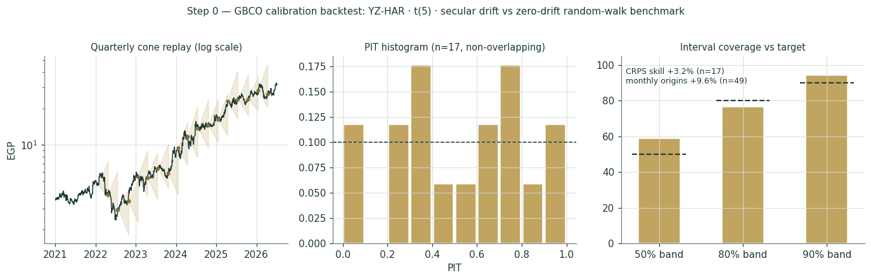
Figure B-1 — Calibration backtest: quarterly cone replay (log scale), PIT histogram, and interval coverage versus target, secular-drift configuration.
Zero drift fails the gate on this name: negative CRPS skill and a PIT pushed into the upper deciles — the classic signature of a distribution that keeps under-calling a secular uptrend (GBCO is a thirteen-bagger over the sample, the same EGP-repricing dynamic as the EGX developers). Re-running with the asset-class secular drift switched on — the prescribed recalibration path — flips the result: CRPS skill +3.2% on non-overlapping windows and +9.6% on monthly origins, with the PIT mean back near 0.5 and no material U-shape. The interval score gives some of that back (the t(5) tails price protection the benchmark doesn’t carry), and a block bootstrap on the 17 windows puts the 90% CI on CRPS skill at roughly [−0.17, +0.18] — P(skill > 0) ≈ 0.62. The lens is accepted with that thinness stated: seventeen windows is decent validation, not robust proof, and the drift term is re-tested every quarter with a hard kill rule. Flag for the record: GBCO is the first EGX non-developer to carry the secular drift — adopted empirically here, exactly as the protocol requires, not by asset-class default.
Appendix C Peer set, sector structure, and risks
GB Corp has no clean single comparable — an auto assembler-distributor, an NBFI and a fintech associate in one wrapper. The peer set is therefore split by leg.
Leg | Closest peers | Typical valuation
Auto assembly & distribution | Saudi/GCC auto distributors, Türk Traktör, EGX consumer durables | EV/EBITDA ~4–6×; P/E ~8–12×
NBFI / consumer & SME finance | Contact Financial (CNFN), EFG finance arm, Raya finance leg | P/B ~1.0–1.8× on mid-teens ROE
Fintech associate | Fawry (FWRY), e-Finance (EFIH); MNT-Halan private rounds | Private marks; last round USD 1.4 bn

Sector structure. Egypt’s PC market is in a policy-assisted recovery (~210k registrations in 2025, +40% y/y) with the CBE easing cycle restoring affordability, localization incentives reshaping the CKD/CBU mix, and Chinese entrants (BYD) resetting price points. Consumer and SME finance is growing faster than banking credit off a low base, with securitization deepening as a funding market. Principal risks: a structurally higher working-capital intensity; a renewed EGP devaluation; regional conflict freezing Iraq/Jordan; BYD-led price competition; credit-cycle deterioration in the lending book; a private-market re-price of MNT-Halan; and execution on Sadat.
Appendix D The expert valuation panel
Every Testahil study closes with a panel of standing expert personas — drawn from the house Expert Persona Library, not invented for the occasion, so that each accumulates a track record across studies and a quarterly update is a re-run, not a re-training. For GBCO we cast the industrial trio, adding the cash-returns lens because the name is capital-heavy: Expert 1 (the accountant — split-legs NAV and the marks), Expert 2 (earnings power — normalized mid-cycle earnings and multiples), Expert 3 (cash returns — return on capital against its cost). Each runs a different method, derives its fair value from shown workings, and states a falsification condition. The macro-policy lens — rates, the pound, the region — runs through the body (§1.8, §5) rather than as a separate persona.
D.1 Expert 1 — the split-legs NAV and the marks
Worldview. A group is worth the sum of its parts at realizable value, less a discount for the wrapper. Mark each leg to what it would fetch on its own; then argue only about the discount.
When it works / fails. Best where the legs are separable and independently markable (they are here: a DCF-able operator, a bookable lender, a just-priced associate); fails when a private mark is stale or the legs share a balance sheet more than the accounts admit.
Expert 1’s marks (EGP mn) | Value
Auto leg (accepts the §1.2 DCF) | 11,388
GB Capital at 1.0× adjusted book | 9,500
Associates: MNT-Halan 13,300 (~20% est. × USD 1.4 bn) + other 390 | 13,690
Σ = EGP 31.9/share pre-discount | 34,577
Fair wrapper discount 8% (operator, not a passive holdco) | → EGP 29.3/share

Sensitivity (swing = the discount): at 0% EGP 31.9; at 15%, 27.1; at 20%, 25.5. Cross-examination: he tells Expert 2 that capitalizing mid-cycle earnings double-counts assets he has already marked at full value; he tells Expert 3 that punishing the Auto leg for working capital while crediting the lender book at 1× is applying two different standards to the same balance sheet.
Verdict, falsification, market-implied. Fair EGP 29.3 (range ~24–37). Falsified if a mark proves illusory — above all if the MNT-Halan second closing re-prices below USD 1.4 bn, or the lender’s NPLs breach ~5%. The market price implies a ~2% discount to his NAV — tighter than his 8%; on his method the stock is a shade rich.
D.2 Expert 2 — normalized earnings power
Worldview. An operating business is worth a fair multiple of its sustainable mid-cycle earnings; peaks (FY24’s FX windfall) and troughs (FY23) are noise to be stripped out.
When it works / fails. Best with a through-cycle record (three disclosed years spanning trough, windfall and normalization is workable); fails at structural breaks — if BYD resets Egyptian ASPs permanently, his normalization is simply wrong.
Expert 2’s normalization | Value
Mid-cycle group PAT (EGP mn) | 4,200
Shares (mn) → normalized EPS | 1,085.5 → EGP 3.87
Justified through-cycle P/E (EM auto + NBFI blend) | 8.5×
Fair value | → EGP 32.9/share

Sensitivity (swing = the multiple / the margin): at 7.5× EGP 29.0; at 9.5×, 36.8; a 1-pt miss on mid-cycle Auto GPM costs ~EGP 2.5. Cross-examination: he tells Expert 1 that an NAV struck off a trough-margin DCF understates a business whose volumes are still mid-cycle; he tells Expert 3 that cash-conversion pessimism ignores that working capital is a stock, not a perpetual flow — it releases exactly when growth normalizes.
Verdict, falsification, market-implied. Fair EGP 32.9 (range 25–42) — the most bullish. Falsified by Auto gross margin stuck below ~13% through FY27, or the Egyptian PC market rolling over. The market implies normalized earnings ~5% below his: it mostly believes him.
D.3 Expert 3 — cash returns: ROCE against the cost of capital
Worldview. A business creates value only when each pound of capital earns above its cost, in cash. He looks past the income statement to the economic-profit spread — and past reported returns to returns ex one-offs.
When it works / fails. Best for capital-intensive compounders where the reinvestment spread is the story; fails where the capital base is temporarily inflated by a one-off build (his own caveat here: FY25’s WC bulge may be exactly that).
Expert 3’s economic-profit test | Value
Auto capital employed (FY25) | 28,513
Auto ROCE — FY25 vs FY23/24 | 21.3% vs 35.9% / 31.5%
WACC (his hurdle) | ~22%
Spread ≈ nil ⇒ Auto EV ≈ 0.9× CE | 25,662 → equity 9,652
Lender at 0.9× book · associate at 0.85× (private-mark haircut) | 8,550 · 11,636
GB Capital ROAE, headline vs adjusted (one-off stripped) | 7.9% vs 15.1%
Fair value | → EGP 27.5/share

Sensitivity (swing = the ROCE fade): if ROCE re-approaches 30% as WC releases, his Auto mark rises to ~1.1× CE and his fair value to ~EGP 31; if 21% is the new normal against a 22% hurdle, he stands. Cross-examination: he tells Expert 2 that mid-cycle earnings without the capital cost to hold them is a half-truth — FY25 grew profit 49% in revenue terms and consumed EGP 8 bn doing it; he tells Expert 1 that a discount debate is premature until the parts prove they earn their keep.
Verdict, falsification, market-implied. Fair EGP 27.5 (range ~22–33) — the most cautious: fairly valued with no margin of safety. Falsified by a durable ROCE recovery above ~28–30% with working capital normalizing — the FY23–24 configuration re-established. The market price sits ~14% above his number: on a cash-returns basis, the market is paying ahead of the proof.
D.5 The three in one room
The single thing they most disagree on is the Auto leg’s working capital — whether the EGP 18.9 bn tied up at year-end is a temporary stock or a permanent cost of doing business.
Expert 2: “FY25 was a company doubling its volumes into a supply-constrained market. Of course the balance sheet bulged. Normalize the margin, let the volumes stand, and the group earns EGP 4.2 bn — the market pays eight times that.”
Expert 3: “And to earn it, the Auto business absorbed eight billion pounds of cash and tripled its net debt. Capitalize the earnings if you like — I subtract the capital that produces them. At a 21% return against a 22% hurdle, growth adds nothing until the working capital comes back out.”
Expert 1: “You are both arguing about one leg. Mark all three — the operator, the lender, the associate the market just priced at USD 1.4 bn — and the bundle is worth EGP 31.9 a share. The market pays 31.25. The argument left is the wrapper, and two points of discount is not much of an argument.”
D.6 Reading the divergence
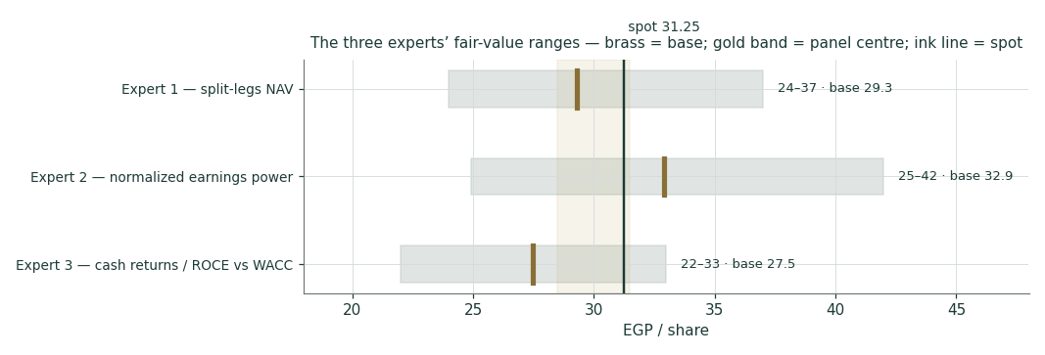
Figure D-1 — The three experts’ fair-value ranges. Brass ticks are base cases; the gold band is the panel centre; the light line is spot. The spread is almost entirely a cash-conversion disagreement.
Expert | Method | Single swing assumption | Base fair value
Expert 1 | Split-legs NAV | Fair wrapper discount (8%) | EGP 29.3
Expert 2 | Normalized earnings power | Mid-cycle PAT 4.2 bn × 8.5× | EGP 32.9
Expert 3 | Cash returns / ROCE vs WACC | ROCE fade to ~0.9× capital | EGP 27.5

The spread — EGP 27.5 to 32.9 at base — is narrow for an EM cyclical, and it is almost entirely one disagreement: none of the three contests the volumes, the lender’s profitability, or the existence of the associate stake. What separates them is whether growth here converts to cash or consumes it. Expert 2 says the working capital releases (operating leverage); Expert 3 says prove it (the capital cost is the story); Expert 1 says the marks already settle it and only the wrapper is left to argue. The EGP 5.4 spread is therefore a clean measure of one uncertainty — the steady-state working-capital intensity of selling cars in Egypt. Resolve that, and the three converge.
Each expert’s point fair value (and bull/base/bear) is logged with the study date (8 Jul 2026) and spot (EGP 31.25) as an internal per-expert track record, kept separate from the core Calibration Ledger.
About this series
Testahil publishes independent, educational valuation studies. Each is an attempt to reason transparently about what a security is worth, with every assumption shown and a companion model so readers can disagree productively. The house style is distributions, not tips: we describe ranges and probabilities, not targets, and we do not tell anyone what to do. Studies are framed as educational analysis, the preparer is not licensed by any securities regulator, and holdings are disclosed.
Disclosure & Disclaimer
Not investment advice. This document is educational and informational only. It is not, and must not be relied upon as, investment, financial, legal, accounting or tax advice, nor an offer, solicitation or recommendation to buy, sell or hold any security. It contains no price target and no rating.
No licence; no advisory relationship. The preparer is not registered or licensed with any securities or financial regulator in any jurisdiction — including Egypt’s Financial Regulatory Authority (FRA) — holds no brokerage or investment-advisory authorisation, and is not acting as your adviser or fiduciary. Nothing here is personalised to your circumstances.
Holdings disclosure. The preparer may hold, and may in the future take or dispose of, a position in the security discussed in this report, and may transact at any time without notice. This is a potential conflict of interest you should weigh.
Sources & accuracy. Reported financial and operating figures are drawn from the company’s public disclosure and other public sources believed reliable but not independently verified; they may contain errors or be superseded. Forward-looking inputs — the leg marks, the MNT-Halan stake estimate, the complexity discount, projections, multiples, the DCF and Monte-Carlo factor probabilities — are the preparer’s own judgments and are inherently uncertain.
Forward-looking statements. Any statements about the future are estimates subject to risks and uncertainties; actual results may differ materially. The Monte Carlo models price, not value, and encodes subjective probabilities for events that have not occurred.
No reliance; your responsibility. Do your own research and consult a licensed professional before making any decision. You are solely responsible for your investment decisions and their outcomes. To the maximum extent permitted by law, the preparer accepts no liability for any loss arising from use of this document.
Currency & figures. Figures are in Egyptian pounds (EGP), millions unless stated; bn denotes billion. FX at study date: USD/EGP ≈ 47.5 (flagged estimate). Rounding may cause totals to differ slightly. Spot price and market data are as of 7 July 2026 and change continuously.
TESTAHIL · Independent Valuation Study · Educational Analysis · GB Corp S.A.E. (EGX: GBCO) · edition 08-07-2026 · reporting currency EGP

