Testahil · Independent Valuation Study — Educational Analysis Not investment advice

EGYPTIAN CHEMICAL INDUSTRIES (KIMA)
Egyptian Exchange: EGCH · Aswan · Nitrogen fertilizers and industrial chemicals
Valuation study — 8 August 2026 · Reporting and valuation currency: Egyptian pounds · Anchor price EGP 13.98 at the close of 2026-08-06
Read first
What this is. An independent valuation of a single-site Egyptian nitrogen-fertilizer producer, built from the company's own audited statements and reviewed interim accounts, and read through four separate lenses rather than one.
What it is not. Not a rating, and not a price target. It reports a range of fair values, the reasoning behind each, and the probability map around today's price.
The one judgement that decides the answer. This company is building a nitric-acid and ammonium-nitrate complex whose bank-approved cost is about three quarters of its own stock-market value, and which was 12.9% built against a 37% plan at the last reported date. Whether that programme is carried through or stopped is worth more than three pounds a share. Both answers are computed and both are published side by side throughout this document. Neither is averaged into the other, because the average would be true in neither world.
How to read the numbers. Four lenses give a field, not a point. Where they disagree, the disagreement is the information — section 4 isolates which assumption drives which gap.

Headline
Four lenses put this company between EGP 0.00 and EGP 15.47 a share. It trades at EGP 13.98. The gap is not a rounding difference between the lenses: it is the whole disagreement. The multiple lens, on the range Egyptian fertilizer producers actually trade at, centres at EGP 15.47 — above the traded price — and it reaches that answer only by never asking what the capital programme does to cash. Every lens that does ask lands below EGP 3.78.
Three things push in the same direction. An EGP 20.3 billion capital programme is running two years behind its own plan. The debt book is 99.7% dollar-denominated against an earnings stream that must service it in pounds — a single quarter's translation swing this year was larger than the whole nine-month profit. And any cost of capital anchored to Egypt's sovereign risk lands in the mid-twenties, which is brutal for a business whose cash arrives late.
Read the other way round: the traded price is reproduced by this model only at a flat nominal discount rate of about 7.9%, against a sovereign ten-year yield of 23.0% on the same day. That is the disagreement stated precisely rather than argued.
Valuation summary — every read at a glance
Read | Basis | Range (EGP/share) | Central | vs spot
Cash flow — programme carried through | Five-year free cash flow to the firm on a cost of capital gliding from 24.4% to 19.8%, terminal growth 5.0% | -2.45 to 1.78 | -0.67 | -105%
Cash flow — programme stopped | The same model with the capital programme wound down in the first forecast year and the plant run as it stands | 1.45 to 3.40 | 3.34 | -76%
Relative multiples | Forward operating profit before depreciation at 6.0x to 9.9x, the Egyptian industrial range, with 8.0x central | 10.88 to 20.07 | 15.47 | +11%
Normalised earnings power | Mid-cycle profit after tax of EGP 1,400m at 8x to 12x, 10x central | 2.37 to 5.19 | 3.78 | -73%
Book value and sustainable return | Book equity of EGP 8.16 a share at the multiple a 6.9% sustainable return on equity justifies against a 31.3% cost of equity | — | 0.58 | -96%
THE FIELD, all four lenses | Low to high across every read above. The two cash-flow readings are the contested judgement and are never averaged into one another | 0.00 to 15.47 | — | —
Market price | Closing price on the anchor date | — | 13.98 | —
ALTERNATIVE READINGS — each a full re-run of the model with ONE component moved, and none of them inside the field above
Country risk priced off the sovereign's credit rating | Priced off the sovereign's traded default swap instead, which is the narrower of the two spreads | — | -0.02 | -100%
A cost of capital that glides from its spot build to a terminal rate made from its own long-run components | One flat spot rate applied to every explicit year and to the perpetuity | — | -1.17 | -108%
Terminal growth at the central bank's medium-term inflation target | Two percentage points below it, which is negative real maintenance growth | — | -0.67 | -105%
Beta from the five-year weekly regression of the share against its own local index | The Dimson sum-beta from the same regression, which corrects for co-movement booked late because the share does not trade every session | — | -0.20 | -101%
Gas at the realised price the company's own loss disclosure implies | The contract formula price in the operating agreement, which is higher | — | -2.55 | -118%
The new complex earning at half its derived nameplate in the terminal year | Seventy per cent, which is what a well-run nitrate line achieves | — | -0.45 | -103%
Maintenance capital expenditure at the company's own observed pre-project rate of 1.12% of revenue | Replacement-rate maintenance: gross fixed assets at the disclosed 3.95% machinery depreciation rate, or 6.11% of revenue | — | -1.48 | -111%
Terminal reinvestment of 38.9% of operating profit after tax, from growth over an 18% return on capital | 23.3%, from a 30% return on capital — the rate a newly completed plant earns on incremental capital while it is still filling | — | -0.41 | -103%
Project spending anchored on the observed run rate: the nine-month actual extended to a full year | The faster profile the first issue of this study used, opening at EGP 3,000m | — | -0.90 | -106%

Table 1. Egyptian pounds a share against a traded price of EGP 13.98. Every alternative reading is a complete re-run of the model through the same case machinery, not an adjustment applied to the answer; each is argued for and against in section 1.8.
Terminal value as a share of enterprise value | Programme carried through | Programme stopped
Discounted cash-flow lens | 65.3% | 31.2%

Table 2. Reported beside the cash-flow lens because on this company it is the number that decides the answer. Above one hundred per cent means the five explicit years contribute negative present value: the capital programme absorbs more cash than the plant generates, so the terminal block carries the whole enterprise value and then some.
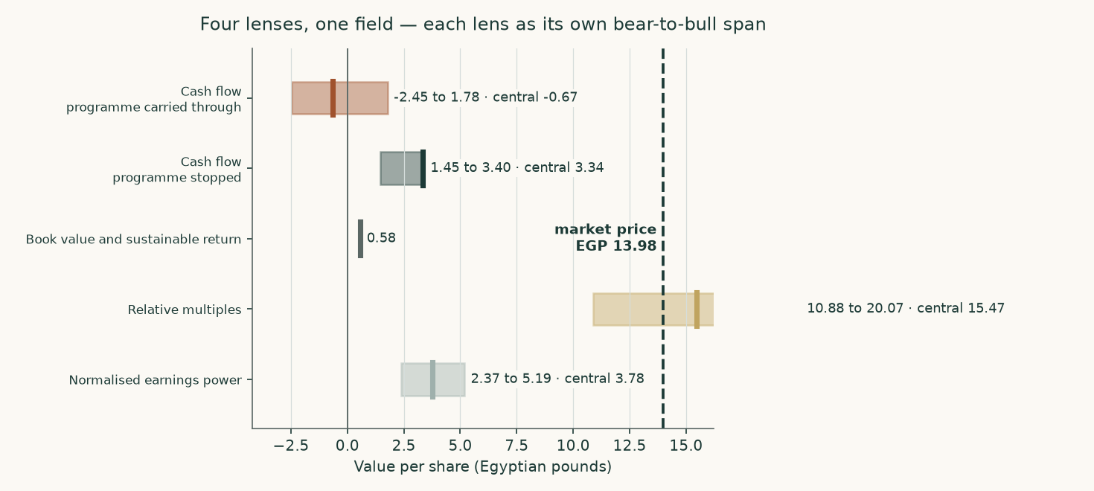
Figure 1. Each lens as its own bear-to-bull span, with the central marked, against the traded price.
The alternative readings are shown so that each genuinely contested choice in the construction can be priced rather than argued. The widest of them is the gas price: moving from the price the company's own loss disclosure implies to the contract formula price in its operating agreement is worth EGP 1.89 a share. The narrowest is terminal growth, worth EGP 0.00. Not one of them, alone or together, reaches the traded price — which is the finding this study reports, and the reason the headline states the discount rate the market itself implies rather than asserting that the market is wrong.
Company overview
Egyptian Chemical Industries, universally called KIMA, has made nitrogen fertilizer at Aswan since 1956. It is 69.8% owned by the state-controlled Chemical Industries Holding Company, with public-sector insurance funds and a state bank holding most of the rest; the free float is about 6.2%. Its accounts are audited by Egypt's Central Auditing Organization, jointly with a private firm in some years.
The audited revenue note for the year to 30 June 2025 splits EGP 8,603 million into EGP 6,609 million of exports and EGP 1,994 million of local sales. There is no lending book, no rental business of any size and no fee stream; the balance sheet is EGP 13,058 million of net plant and EGP 5,654 million of construction in progress. This is an operating company that converts natural gas into nitrogen products and sells them by the tonne, which is why it is valued on cash flow to the firm with a driver tree of volumes and prices rather than on a sum of parts or a dividend stream — it has paid no dividend in either of the last two years.
Product | FY2024/25 output (tonnes) | Unit cost (EGP/t) | Role
Urea, 46.5% nitrogen | 513,385 | 7,509 | The business: sold subsidised, on the local free market and for export
Liquid ammonia | 318,242 | 9,114 | Feedstock for urea; a small merchant volume is exported
Granulated 33.5% nitrate | 17,887 | 4,076 | Small nitrate leg
Low-density ammonium nitrate | 8,171 | 8,154 | Small nitrate leg
Nitric acid | 35,590 | 610 | Intermediate
Ferrosilicon | nil | n/a | Furnace idle since 2019 and leased to a tenant from May 2025, so it is now rent

Table 3. Production and unit costs as disclosed in the auditor's own cost table. Ammonia is consumed by urea rather than sold, which is why the surplus over urea's draw is what the new complex is built to use.
1 Fundamental valuation
1.1 The cash-flow model — the primary lens, with the full waterfall
Revenue is tonnes multiplied by price, channel by channel. Cost is physical consumption multiplied by a unit price. Free cash flow to the firm is then built line by line and discounted on a cost of capital that glides to a terminal rate assembled from its own components.
EGP million | FY2026/27 | FY2027/28 | FY2028/29 | FY2029/30 | FY2030/31
Revenue | 11,310 | 11,539 | 11,626 | 11,863 | 12,303
EBITDA | 4,684 | 4,436 | 4,074 | 3,849 | 3,797
Depreciation and amortisation | 891 | 1,009 | 1,147 | 1,292 | 1,434
EBIT | 3,793 | 3,427 | 2,928 | 2,556 | 2,363
NOPAT — EBIT after tax | 2,940 | 2,656 | 2,269 | 1,981 | 1,831
Add back depreciation | 891 | 1,009 | 1,147 | 1,292 | 1,434
Less capital expenditure | -2,725 | -3,229 | -3,430 | -3,332 | -2,627
Less change in working capital | 858 | -134 | -121 | -134 | -154
FREE CASH FLOW TO THE FIRM | 1,963 | 302 | -135 | -193 | 485
Discount rate from the glide | 24.39% | 23.47% | 22.55% | 21.63% | 20.71%
Discount factor | 0.8039 | 0.6511 | 0.5313 | 0.4368 | 0.3619
PRESENT VALUE OF FREE CASH FLOW | 1,578 | 197 | -72 | -84 | 176

Table 4. The full waterfall, programme carried through. Every line is a live formula in the accompanying workbook.
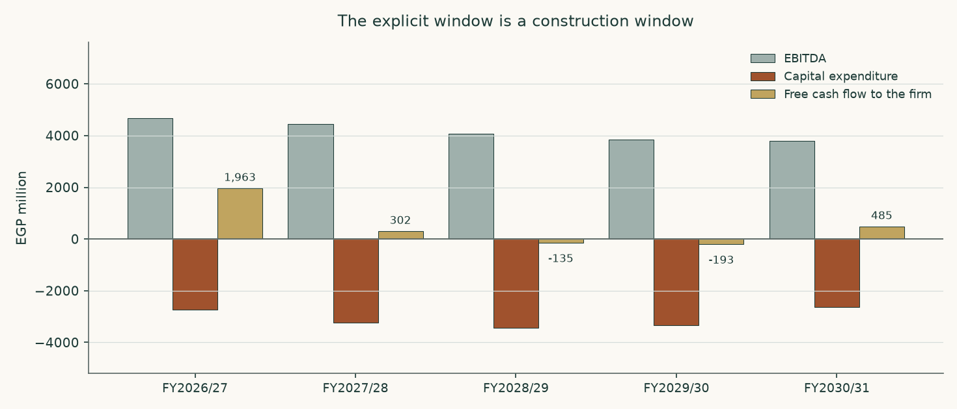
Figure 2. Operating profit is healthy throughout and free cash flow is not, because the capital programme absorbs it. This is the study in one picture.
The bridge from enterprise value to the equity — both sides of the judgement
Component | Carried through (EGP m) | Stopped (EGP m)
Present value of the explicit window | 1,794 | 9,034
Present value of the terminal value | 3,375 | 4,090
Enterprise value | 5,169 | 13,124
Terminal value as a share of enterprise value | 65.3% | 31.2%
Less net debt | -10,032 | -10,032
Plus listed equity stakes at market | 1,383 | 1,383
Plus investment property | 2,155 | 2,155
EQUITY VALUE | -1,325 | 6,629
VALUE PER SHARE (EGP) | -0.67 | 3.34

Table 5. Net debt is larger than the enterprise value the cash flows support in the carried-through column. That is why the equity value there is negative, and it is stated rather than clipped to zero.
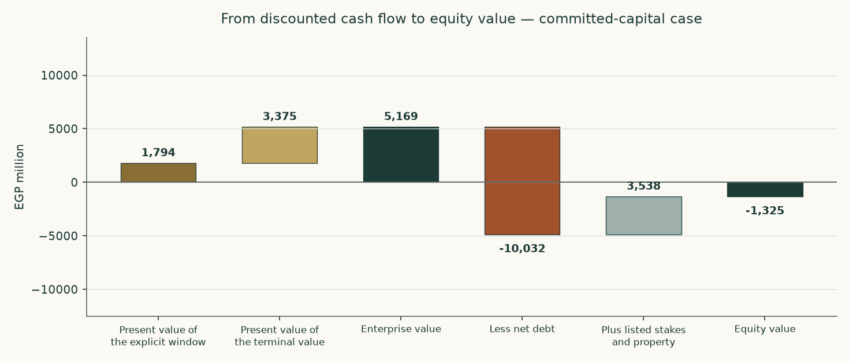
Figure 3. The bridge, carried-through case.
Why the answer is negative, and what would change its sign
The same bridge in pounds a share makes the mechanism plain, and it is not the capital programme.
Carried-through case, per share | EGP
Enterprise value the cash flows support | 2.60
Less net debt | -5.05
Plus listed stakes and investment property | 1.78
EQUITY | -0.67
Traded price | 13.98

Table 6. The operating business is carried at less than half the debt standing against it. Free cash flow is positive in three of the five forecast years — the construction is no longer what makes the answer negative. The debt is.
So the question is not whether the plant earns. It is whether EGP 5,169 million is the right enterprise value for a business generating around EGP 4,684 million of operating profit before depreciation, and that is entirely a question about the rate at which Egyptian pounds are capitalised. Holding every operating assumption exactly as built and moving only the discount rate:
A flat cost of capital of | Value per share (EGP) | What it would mean
25.0% | -1.24 | roughly the rate this study builds from the sovereign's own yield
20.0% | -0.47 | below the sovereign's ten-year yield of 23.0%
18.0% | 0.03 | the sign changes here
16.0% | 0.72
14.0% | 1.75
12.0% | 3.39
7.9% | 13.98 | the rate the traded price itself implies

Table 7. Every row is a full re-run. The sign of the answer turns at about eighteen per cent — five points below what Egypt's own government pays to borrow for ten years. Reaching the traded price needs about 7.9%, which is 15.1% below the sovereign. That, and not the capital programme, is the disagreement between this study and the market.
1.2 Book value and sustainable return — the asset lens
Book equity stood at EGP 16,206 million at 31 March 2026, or EGP 8.16 a share. What that book is worth depends on what it earns. On underlying profit — the FY2023/24 result stripped of its one-off revaluation gain — the return on opening equity was 6.9% and then 6.8%, a sustainable 6.9%.
Line | Value
Book equity, 31 March 2026 (EGP m) | 16,206
Book value per share (EGP) | 8.16
Underlying profit FY2023/24 (EGP m) | 503
Underlying profit FY2024/25 (EGP m) | 987
Return on equity FY2023/24 | 6.9%
Return on equity FY2024/25 | 6.8%
Sustainable return on equity | 6.9%
Cost of equity | 31.30%
Terminal growth | 5.0%
Justified price-to-book before flooring | 0.071x
Justified price-to-book | 0.07x
Value per share on this lens (EGP) | 0.58
Price-to-book the market pays | 1.71x

Table 8. The justified multiple of book is negative before flooring, and that is the finding rather than a rounding artefact: a sustainable return of 6.9% does not cover even nominal maintenance growth of 5.0%, let alone a 31.30% cost of equity. On this lens the book is worth nothing beyond what the assets would fetch, and the market pays 1.71 times it.
1.3 Relative multiples
Egyptian industrial businesses have generally changed hands between 6.0 and 9.9 times operating profit before depreciation. On forward EBITDA of EGP 4,684 million the mid-point implies an enterprise value of EGP 37,236 million and, after the debt and the non-operating stack, EGP 15.47 a share — a range of EGP 10.88 to EGP 20.07 across the band.
The two numbers worth putting side by side are these: at the traded price the shares change hands at 8.1 times that same forward EBITDA, while the cash-flow lens values them at 1.1 times. One is above the Egyptian industrial band and the other below it. That is the whole disagreement in a single number, and it is reported rather than resolved.
This lens gives the highest of the four answers, and the reason matters. A multiple of forward operating profit never asks what the capital programme does to cash: it values the plant as though the money being spent on the new complex were not being spent. That is precisely the question the cash-flow lens exists to answer, which is why this one is a cross-check rather than the primary read.
1.4 Normalised earnings power
Strip out the construction, the translation noise and the price cycle. Take urea output at the three-year average of audited production, 540,542 tonnes, and a mid-cycle export price of US$400 a tonne — above the 2015-2020 average of roughly US$250 and well below the US$545 at which the contract settled in August 2026.
Line | EGP million
Mid-cycle revenue | 9,404
Natural gas | -3,877
Other materials | -1,276
Wages and purchased services | -303
Inland freight | -662
Other selling and administration | -590
MID-CYCLE EBITDA | 2,697
Depreciation and amortisation | -891
MID-CYCLE OPERATING PROFIT AFTER TAX | 1,400
At ten times — enterprise value | 13,996
Value per share at ten times (EGP) | 3.78
At eight times (EGP) | 2.37
At twelve times (EGP) | 5.19

Table 9. A mature single-asset industrial in a high-inflation economy does not deserve more than ten times, and the band either side is shown.
1.5 Synthesis — four lenses, one field
The field runs from EGP 0.00 to EGP 15.47 a share. It is a wide field, and the width is honest: the lenses disagree because they ask different questions of a company whose asset base is changing underneath its earnings. One of them now reaches the traded price: on the observable Egyptian listed range the multiple lens centres at EGP 15.47 against EGP 13.98. That is a change from the first issue of this study, which used a lower multiple band it could not source, and it is reported rather than resisted.
The ordering is itself informative. The asset-backed and multiple-based lenses sit highest because they value what has been built without asking what it earns. The cash-flow lens sits lowest because it asks exactly that, and gets an uncomfortable answer. The book lens sits at zero because a 6.9% sustainable return on equity does not clear a 31.30% cost of equity — a company earning below its cost of capital destroys value by growing, which is the same finding the capital programme produces from a different direction.
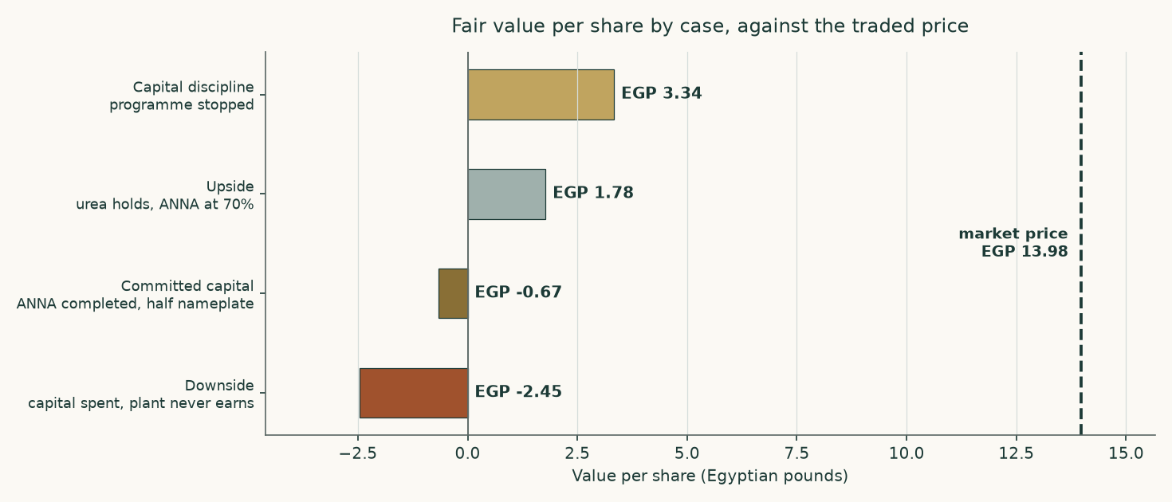
Figure 4. The same cash-flow model run in four states of the world. The spread between the top and the bottom bar is what the capital programme is worth, in either direction.
1.6 The drivers — each leg grown on its own driver, margins as outputs
The company reports one operating segment, so the build goes below it to the product and the channel, which is the finest level the statements source. Nothing in the model sets a margin: every margin falls out of tonnes, prices and physical consumption.
The channels, historically
Channel | FY2022/23 | FY2023/24 | FY2024/25 | What sets it
Urea produced (tonnes) | 586,373 | 521,868 | 513,385 | Gas availability against a 574,875-tonne design plate
Export tonnes | — | — | 350,318 | Output less the subsidised and free-market legs
Subsidised tonnes | — | — | 126,000 | An administered quota the company has been unable to meet in full
Free-market tonnes | — | — | 37,085 | The residual of the local revenue note
Realised export price (US$/t) | — | — | 385 | The auditor's own disclosed average
Revenue (EGP m) | 6,612 | 6,532 | 8,603 | Tonnes times price, in five legs
Gross margin | 45.9% | 32.7% | 38.4% | An output, never an input
Operating margin before depreciation | 46.8% | 31.4% | 35.5% | An output

Table 10. The channel split is disclosed only for the most recent year, in the revenue note; the two earlier years disclose production and revenue but not the split between the three domestic and export channels. That gap is stated here rather than filled with an assumption.
How the forecast is driven
Driver | Basis | FY2026/27 | FY2030/31
Urea output (tonnes) | Design plate with utilisation banded by gas availability | 524,861 | 544,982
Export tonnes | Output less the subsidised and free-market legs | 329,861 | 325,982
Export price (US$/t) | US$385 realised FY2024/25; US$545 spot; mean reversion | 530 | 440
Exchange rate (EGP/US$) | Spot, depreciating 4.5% a year | 53.49 | 64.96
Subsidised price (EGP/t) | Cooperative supply price on an administered path | 7,526 | 10,915
Gas (EGP per m3) | Realised dollar price through the exchange rate | 8.84 | 10.73
Egyptian inflation | Converging on the central bank's target | 10.0% | 7.0%
Gross margin — OUTPUT | Falls out of the above | 45.7% | 33.0%
EBITDA margin — OUTPUT | Falls out of the above | 41.4% | 30.9%

Table 11. Each cost class escalates on its own driver and never on one blended index: gas is a globally traded input and escalates on its dollar price through the exchange rate, while wages, inland haulage and administration escalate on Egyptian consumer prices and the subsidised price follows its own administered path.
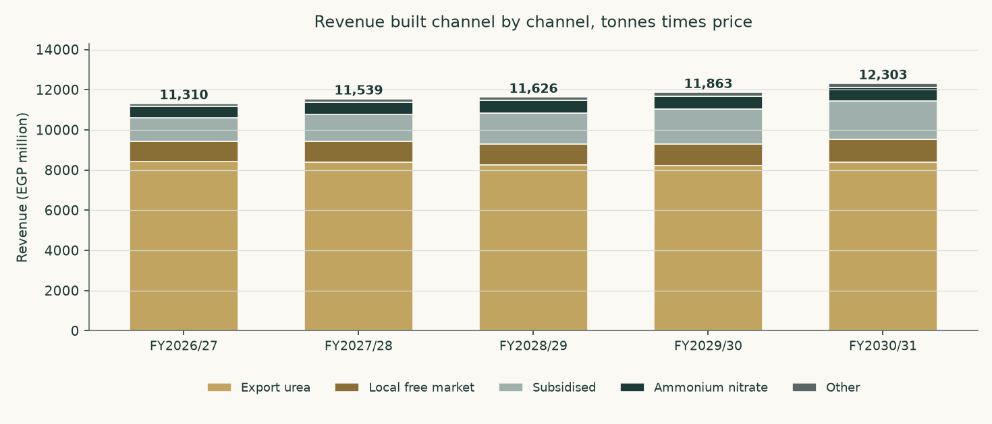
Figure 5. Revenue built channel by channel.
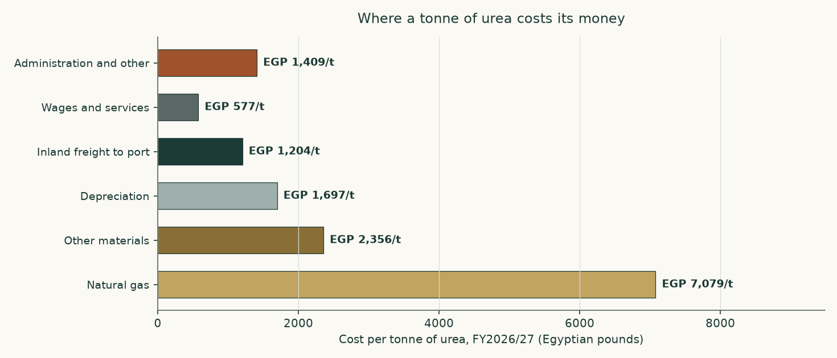
Figure 6. Where a tonne of urea costs its money. Gas dominates, which is why the gas price and the consumption rate are treated as crux variables.
What the build produces — margins as outputs
EGP million | FY2026/27 | FY2027/28 | FY2028/29 | FY2029/30 | FY2030/31
Revenue | 11,310 | 11,539 | 11,626 | 11,863 | 12,303
Cost of sales | 6,146 | 6,668 | 7,179 | 7,699 | 8,239
Gross profit | 5,165 | 4,871 | 4,448 | 4,163 | 4,064
Gross margin | 45.7% | 42.2% | 38.3% | 35.1% | 33.0%
Operating profit before depreciation | 4,684 | 4,436 | 4,074 | 3,849 | 3,797
Margin before depreciation | 41.4% | 38.4% | 35.0% | 32.4% | 30.9%
Operating profit | 3,793 | 3,427 | 2,928 | 2,556 | 2,363
Operating margin | 33.5% | 29.7% | 25.2% | 21.5% | 19.2%

Table 12. Not one margin in this table is set. Each is revenue less a cost stack that was built from physical consumption times a unit price, so the margin path is a consequence of the tonnes, the prices and the escalators above it. The margin falls across the window because the export price mean-reverts faster than the domestic cost base disinflates — which is a statement about two sourced paths, not a view about management.
The revenue mix, the first forecast year against the last
Channel | FY2026/27 revenue (EGP m) | Share | FY2030/31 revenue (EGP m) | Share
Export urea | 8,416 | 74.4% | 8,385 | 68.2%
Subsidised urea | 1,167 | 10.3% | 1,910 | 15.5%
Free-market urea | 1,021 | 9.0% | 1,132 | 9.2%
Nitrates | 568 | 5.0% | 689 | 5.6%
Other | 140 | 1.2% | 186 | 1.5%
Total | 11,310 | 100.0% | 12,303 | 100.0%

Table 13. The export leg shrinks as a share of the total, not because the company sells less abroad but because the administered domestic price rises faster than the export price falls. A reader who expects the opposite is disagreeing with one of those two paths, and section 1.9 prices both.
One allocation is the model's rather than the company's, and it is the largest in the study. The audited statements give a single materials line and do not split gas from everything else. Gas is set at three quarters of that line, which implies 1,292 cubic metres per tonne of ammonia — inside the auditor's own disclosed range of 1,025 to 1,771. A reader who prefers a different split should move the gas driver and watch the model reprice.
1.7 The crux — the capital programme first, the price second
One judgement dominates. The new complex has a bank-approved cost of EGP 6,422 million plus US$278.4 million — about EGP 20.3 billion at today's rate, against a stock-market value of EGP 27.8 billion. EGP 5,654 million sat in construction at 31 March 2026 and the auditor put physical progress at 12.9% against a 37.0% plan.
Carried through, the programme is worth EGP -0.67 a share. Stopped, EGP 3.34. The difference, EGP 4.00 a share or EGP 7,954 million of equity, is the cost of the programme to shareholders on this model's assumptions. What decides it is whether the plant, once built, earns a return above the capital sunk into it. On the disclosed cost and the derived nameplate it does not.
The capital programme | Value | Where it comes from
Bank-approved cost | EGP 6,422m plus US$278.4m | The facility signed on 25 June 2025
Approved cost, one currency | EGP 20,342m | At the rate prevailing when it was approved
As a share of the whole company's market value | 73.2% | Against a market value of EGP 27,772m
Spent by 31 March 2026 | EGP 5,654m | Construction in progress on the reviewed balance sheet
Money spent, as a share of the approved cost | 27.8% | Derived
Physical progress reported | 12.9% | The auditor's own figure at September 2025
Physical progress planned by the same date | 37.0% | The auditor's own figure
Still to spend | EGP 14,688m | Derived
Derived nameplate | 264,000 tonnes a year | FLAGGED as derived: no filing states it
Capital per annual tonne | EGP 77,052 | Approved cost over derived nameplate
What it earns after tax in the terminal year, at half nameplate | EGP -12m | The model's own terminal year
Return on the approved cost | -0.1% | Derived
Against a terminal cost of capital of | 19.8% | Section 1.8

Table 14. The two lines that matter are the fifth and the sixth. More than a quarter of the money has been spent against an eighth of the plant, and the whole of it earns a return an order of magnitude below what the capital costs. Neither number is a forecast: both are the company's own disclosures set against the model's own terminal year.
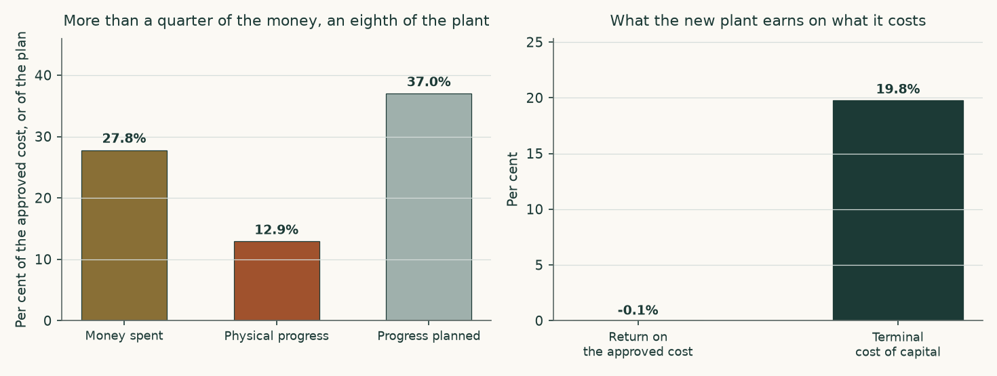
Figure 7. On the left, what has been spent against what has been built. On the right, what the finished plant earns against what the capital costs.
What the company actually spends — the capital-expenditure record
Before any of the above can be read, one question has to be answered from the statements rather than assumed: is this a one-off build, or is it what this company spends? The cash-flow statements answer it directly. The investing section carries a single line — payments to acquire fixed assets, projects under construction — and it has two clean years before the programme started.
Year | Capital expenditure paid (EGP m) | Revenue (EGP m) | Of revenue | What it was
FY2021/22 | 80.8 | 4,441 | 1.8% | Before the project
FY2022/23 | 42.5 | 6,612 | 0.6% | Before the project
FY2023/24 | 2,396.6 | 6,532 | 36.7% | The build begins
FY2024/25 | 1,545.1 | 8,603 | 18.0% | Building
9M FY2025/26 | 1,949.1 | 7,315 | 26.6% | Nine months actual; a full year at this rate is EGP 2,599m

Table 15. The two shaded years are the answer. With nothing being built, this plant cost EGP 80.8m and then EGP 42.5m a year to keep running — pooled, 1.1% of revenue. Everything above that is the new complex.
Three things follow, and the first two correct this study rather than confirm it. First, the capital expenditure in the forecast IS a one-off bulk: EGP 14,688 million across five years against EGP 14,688 million still to spend on the approved cost, after which it stops. Second, it does not repeat inside any horizon this study can see — the disclosed depreciation rate on the plant's machinery is 3.95% a year, an asset life of about 25 years, so the replacement cycle sits far beyond the terminal year. Third, and this is the correction: maintenance capital expenditure is now set at the 1.1% of revenue the company has actually paid, not at a three per cent mature-plant standard. That standard was an assertion, it was almost three times anything this company has ever spent to keep this plant running, and no disclosure supported it.
The project path is anchored the same way. The company spent EGP 1,545.1m in the last audited year and EGP 1,949.1m in nine months of this one — a full year at that rate is EGP 2,599m, and that is where the forecast now opens. The remaining years complete the approved cost inside the window, because the terminal year only earns if the plant is finished.
The honest counter-argument is that the two pre-project years flatter the plant: it was newly built, and new plant does not need much. The upper framing of the same driver is replacement-rate maintenance — gross fixed assets at that same 3.95% machinery rate, or 6.1% of revenue. Both are published: the observed rate is the central and the replacement rate is the downside, and they are worth EGP 0.81 a share between them. They are not averaged.
The asset-conversion cycle — disclosed, then projected from it
Working capital is not a percentage of revenue in this model. It is three day counts taken from the audited statements and applied to the forecast revenue and cost of sales, so that every pound of it traces to a receivable, an inventory or a payable rather than to a plug.
Days | FY2022/23 | FY2023/24 | FY2024/25 | Carried forward
Receivable days | 44.1 | 48.0 | 26.8 | 26.8
Inventory days | 142.1 | 134.1 | 165.2 | 165.2
Payable days | 139.7 | 131.8 | 83.2 | 83.2
Cash-conversion cycle | 46.5 | 50.3 | 108.9 | 108.9
Working capital (EGP m) | 823 | 887 | 1,823 | 2,212
As a share of revenue | 12.4% | 13.6% | 21.2% | 19.6%

Table 16. Inventory is the whole story: 165.2 days of cost of sales sat in stock at the last audited date, against 26.8 days of receivables. A plant a thousand kilometres from its export port carries its working capital in warehouses, and the auditor's inability to satisfy itself on the slow-moving provision is a caveat about exactly this line.
The second-order crux is the long-run export price, and the third is the rate at which a perpetuity of Egyptian pounds is capitalised. Both are observable — one prints daily on a listed futures contract, the other can be read against the sovereign's own borrowing cost — which is why section 1.9 sensitises them in those units rather than in percentage-point abstractions.
1.8 Macro and country — rates, the pound, and the sourced cost of capital
Sovereign risk enters exactly once. The local government bond yield is reduced by Egypt's own default spread before a country-loaded equity premium is added back, because charging the same risk in both places would count it twice. Both premium bases the underlying data supports are published, and neither is mixed with the other's risk-free rate.
Component | Rating basis | CDS basis | Source
Local ten-year government yield | 23.00% | 23.00% | Market quote, 6 August 2026, corroborated by a treasury bond listed at a 23.10% coupon
Less sovereign default spread | 6.37% | 3.55% | Country-premium workbook, Egypt row
Normalised risk-free rate | 16.63% | 19.45% | Built, not quoted
Equity risk premium | 13.94% | 9.42% | Mature-market 4.23% plus the Egypt country premium
Beta | 1.053 | 1.053 | Own-stock weekly regression, 257 observations, R-squared 0.283, standard error 0.105
Cost of equity | 31.30% | 29.37%
Cost of debt after tax | 12.97% | 12.97% | 99.7% dollar, carried at local-equivalent cost
Weights, equity and debt | 65.5% / 34.5% | 65.5% / 34.5% | Market-value equity, never book
Cost of capital, year one | 24.39% | 23.71% | The rating basis is carried into the valuation as the more conservative

Table 17. The cost of capital, built rather than assumed, on both premium bases.
The cost of debt — three pieces of evidence, not an assumption
Evidence | What it shows | Rate
The holding-company facility | EGP 500 million drawn in FY2024/25 carried EGP 96.9 million of interest — the company's own latest local-currency borrowing | 19.40%
The project loan | EGP 1,338.0 million of interest on a mean dollar balance of about US$233 million | 11.70% in dollars
The new facility | US$82.9 million plus EGP 5,931 million, signed 25 June 2025 and amortising to 2035 and 2036 — the same dual-currency structure forward | same structure

The pound tranche of the project loan was repaid in June 2024, so 99.7% of the book is dollar-denominated. A dollar coupon cannot be dropped into a cost of capital denominated in pounds: the company earns pounds and must buy dollars to service it. The dollar cost of 11.7% is therefore grossed up by a 2.5% expected depreciation to a local-equivalent 16.73% — and the same wedge drives the currency path in the revenue build, so the two cannot quietly disagree.
Where this construction is contested, and what the alternative is worth
A spot cost of capital embeds today's 14.3% inflation in every future year, while the terminal value grows at the central bank's 7.0% target. Capitalising one at the other is a units mismatch, and on a company whose value sits in its terminal year it would be the largest error in the study. The rate therefore glides to a terminal rate built from its own components: 7.0% inflation compounded with a 3.5% real rate gives a normalised risk-free rate of 10.75%, and the terminal cost of capital is 19.79%. Discount factors compound the glide year by year rather than raising one rate to a power.
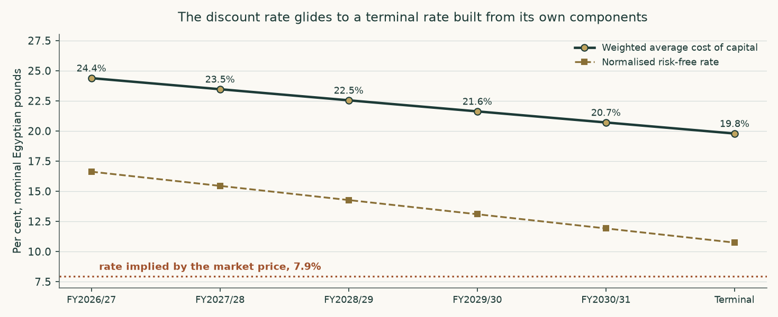
Figure 8. The rate glides from its spot build to a terminal rate made from its own parts. The dotted line is the rate the traded price implies.
Seven choices in the construction above are legitimately arguable, and every one of them has been priced rather than defended in prose. Each row below is a complete re-run of the model with that single component moved and everything else held, so the figure in the third column is what this study would have published had it made the other choice.
Choice made | The alternative | On the alternative | Against EGP -0.67 | Why we keep ours
Country risk priced off the sovereign's credit rating | Priced off the sovereign's traded default swap instead, which is the narrower of the two spreads | -0.02 | +0.65 | The rating basis is the wider spread and therefore the more conservative equity premium. Both are published in full in section 1.8 and neither is ever mixed with the other's risk-free rate.
A cost of capital that glides from its spot build to a terminal rate made from its own long-run components | One flat spot rate applied to every explicit year and to the perpetuity | -1.17 | -0.50 | A spot rate carries today's inflation print into a perpetuity growing at the central bank's target. That is a units mismatch, and on a company whose value sits in its terminal year it would be the largest single error in the study.
Terminal growth at the central bank's medium-term inflation target | Two percentage points below it, which is negative real maintenance growth | -0.67 | +0.00 | Nominal maintenance growth with no real growth is the neutral assumption for a single plant at steady state. Below inflation implies the asset shrinks in real terms every year forever, which the maintenance capital expenditure in the model is sized to prevent.
Beta from the five-year weekly regression of the share against its own local index | The Dimson sum-beta from the same regression, which corrects for co-movement booked late because the share does not trade every session | -0.20 | +0.47 | The regression passes all three conditions of the usability test and the sum-beta sits inside its confidence interval, so the direct estimate is adopted and the correction is disclosed rather than substituted.
Gas at the realised price the company's own loss disclosure implies | The contract formula price in the operating agreement, which is higher | -2.55 | -1.89 | The realised price is what the company actually paid on its own numbers. The contract price is carried as the downside case rather than as the central assumption, because a company that has been paying less than its contract for three years is evidence, not an exception.
The new complex earning at half its derived nameplate in the terminal year | Seventy per cent, which is what a well-run nitrate line achieves | -0.45 | +0.22 | Half is the observed record of the existing plant against its own plate under the same gas constraint. Assuming the new line does better than the old one on the same feedstock would need evidence no filing provides.
Maintenance capital expenditure at the company's own observed pre-project rate of 1.12% of revenue | Replacement-rate maintenance: gross fixed assets at the disclosed 3.95% machinery depreciation rate, or 6.11% of revenue | -1.48 | -0.81 | The observed rate is what this company has actually paid to keep this plant running in the two years when it was not building anything. The replacement-rate framing is the honest upper bound — a plant cannot spend a fifth of its depreciation forever — and it is carried as the downside case rather than averaged into the central.
Terminal reinvestment of 38.9% of operating profit after tax, from growth over an 18% return on capital | 23.3%, from a 30% return on capital — the rate a newly completed plant earns on incremental capital while it is still filling | -0.41 | +0.26 | Eighteen per cent is the conservative reading and is kept, but it is an assumption rather than a disclosure, and on a plant that has just been rebuilt it charges a heavy ongoing reinvestment against a terminal year that needs no further building. It is the single largest unsourced input left in the model and is flagged as such.
Project spending anchored on the observed run rate: the nine-month actual extended to a full year | The faster profile the first issue of this study used, opening at EGP 3,000m | -0.90 | -0.23 | The company has never spent EGP 3,000m in a year on this project. The observed rate is a disclosed, dated figure and the total still completes the approved cost inside the forecast window.

Table 18. The premium basis and the gas price are the two that move the answer most, in opposite directions, and both are published on both readings elsewhere in this study. None of the seven, and no combination of them, closes the gap to the traded price.
1.9 Sensitivity
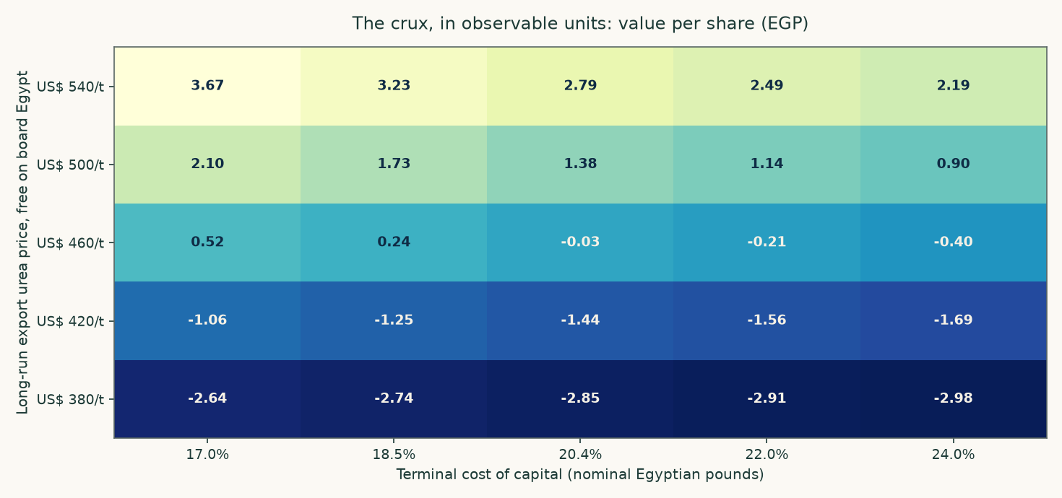
Figure 9. Value per share across the two observable inputs that decide it. Every cell is a complete revaluation, not an interpolation.
The same grid in numbers. Each column is a long-run export price in dollars a tonne, each row a terminal cost of capital, and each cell a full re-run of the model — the segment build, the waterfall, the terminal year and the bridge — not a multiplier applied to the central answer.
Terminal cost of capital | US$380/t | US$420/t | US$460/t | US$500/t | US$540/t
17.0% | -2.64 | -1.06 | 0.52 | 2.10 | 3.67
18.5% | -2.74 | -1.25 | 0.24 | 1.73 | 3.23
20.4% | -2.85 | -1.44 | -0.03 | 1.38 | 2.79
22.0% | -2.91 | -1.56 | -0.21 | 1.14 | 2.49
24.0% | -2.98 | -1.69 | -0.40 | 0.90 | 2.19

Table 19. The highest cell in the grid is EGP 3.67, at a long-run export price above today's spot and a terminal rate below the sovereign's own short-term yield. Reaching EGP 13.98 requires leaving the grid altogether, which is what the reverse calculation in the headline does explicitly.
Each anchor below is varied independently around its own base, so the swings do not add. Every one is the difference between two complete re-runs of the model.
What moves | Range tested | Fair value span (EGP/share) | Swing
Long-run export price | US$380 to US$540 a tonne | -2.85 to 2.79 | 5.63
The capital programme | Carried through against stopped | -0.67 to 3.34 | 4.00
Gas price | The realised price against the contract formula price | -2.55 to -0.67 | 1.89
Terminal cost of capital | 17.0% to 24.0% | -0.40 to 0.52 | 0.91
Maintenance capital expenditure | 1.1% of revenue against 0.7% | -1.48 to -0.67 | 0.81
Country-risk basis | Rating spread against traded default swap | -0.67 to -0.02 | 0.65
Beta | 1.053 against the Dimson sum-beta of 0.828 | -0.67 to -0.20 | 0.47
Project utilisation in the terminal year | 50.0% against 70.0% | -0.67 to -0.45 | 0.22
Terminal growth | 5.0% against 5.0% | -0.67 to -0.67 | 0.00

Table 20. Ranked by the size of the swing. The capital programme dominates everything else on this company, which is why it and not the discount rate is the study's contested judgement, and why it is published both ways rather than averaged.
The beta deserves a note of its own, because it is the one input in the cost of capital that comes from a statistical estimate rather than from a quote or a disclosure. It is 1.053, from 257 weekly observations over 5 years against an equal-weight index of 35 Egyptian names with the subject itself excluded — leaving a share inside its own index injects a self-covariance term, and doing so here would have returned 1.126 instead. The regression explains 28.3% of the variation with a standard error of 0.105, so all three conditions of the usability test are met and the estimate is adopted rather than defaulted. It was cross-checked two ways. The Dimson sum-beta over one lead and two lags — the correction for co-movement booked late because the share does not trade every session — is 0.828, and the adopted figure sits inside its interval; the share closes unchanged on 5.0% of sessions against 8.7% for the Egyptian library, so it is not unusually thin. And the simple prior for a cyclical, capital-intensive materials business is 1.0 to 1.5. The alternative is priced with the other contested constructions in section 1.8 rather than argued: on the sum-beta the answer is EGP -0.20 instead of EGP -0.67.
2 Technical and price structure
The shares closed at EGP 13.98 on 2026-08-06, 9.0% below their fifty-two-week high of EGP 15.37 and 47.2% above the low of EGP 9.50. The relative strength index reads 60.6 and the average true range is EGP 0.44, or 3.1% of the price a session — a stock that moves about three per cent on an ordinary day.
Level | Price (EGP) | Distance from the close
Resistance 1 | 14.98 | 7.2%
Resistance 2 | 15.37 | 9.9%
Resistance 3 | 16.00 | 14.4%
Support 1 | 12.49 | -10.7%
Support 2 | 11.13 | -20.4%
Support 3 | 9.83 | -29.7%

Table 21. Levels are computed from recency-weighted pivot clusters in the same cleaned price history the rest of the study uses; the first of each is the nearest to the close. Nothing here is fitted and nothing is hand-drawn.
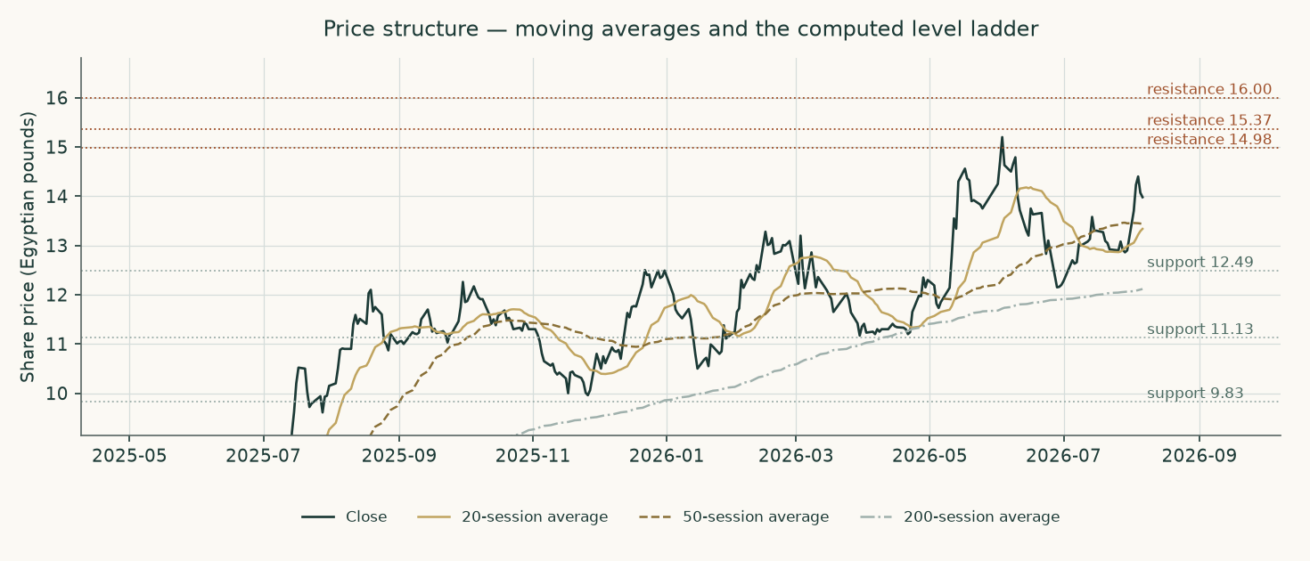
Figure 10. Price structure — moving averages and the computed level ladder.
A technical read cannot speak to whether a business is worth owning, and this one makes no fundamental claim. What it does say is that the price sits in the upper part of its own year, with the nearest resistance about seven per cent above and the nearest support about eleven per cent below — an asymmetry worth knowing when reading the probability map that follows.
3 A probabilistic price map
This is a map of where the traded price may go, not of what the business is worth. It comes from fifty thousand simulated paths anchored on the 2026-08-06 close of EGP 13.98, drifting at the carry the market itself sets — the local risk-free rate less the dividend yield, which is zero here because nothing was distributed in either of the last two years.
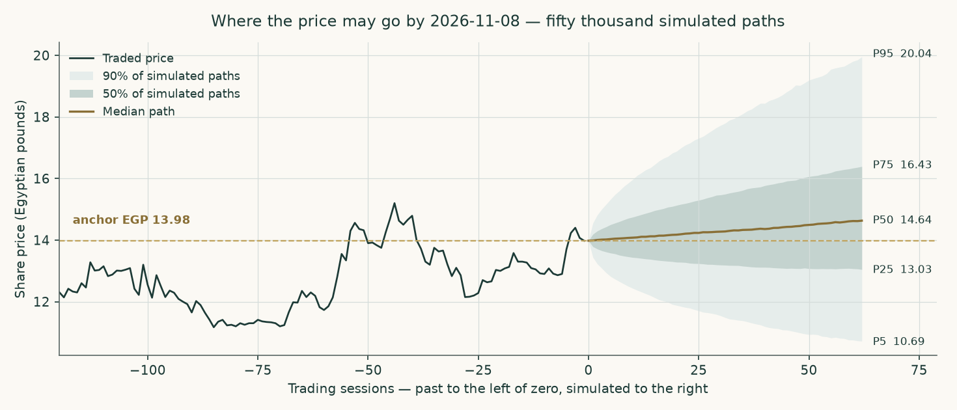
Figure 11. The middle of the simulated distribution over time, to 2026-11-08. The shaded bands hold half and ninety per cent of the paths.
Percentile map (Egyptian pounds a share)
Percentile | One month, to 2026-09-06 | Three months, to 2026-11-08
Percentile 5 | 12.04 | 10.69
Percentile 25 | 13.35 | 13.03
Percentile 50 | 14.19 | 14.64
Percentile 75 | 15.09 | 16.43
Percentile 95 | 16.73 | 20.04
Probability the price ends above today's | 56.7% | 60.7%

Table 22. The map says where the price may end. It is not a forecast of where it will end, and the probability in the last row is the share of paths finishing above the anchor, not a claim about direction.
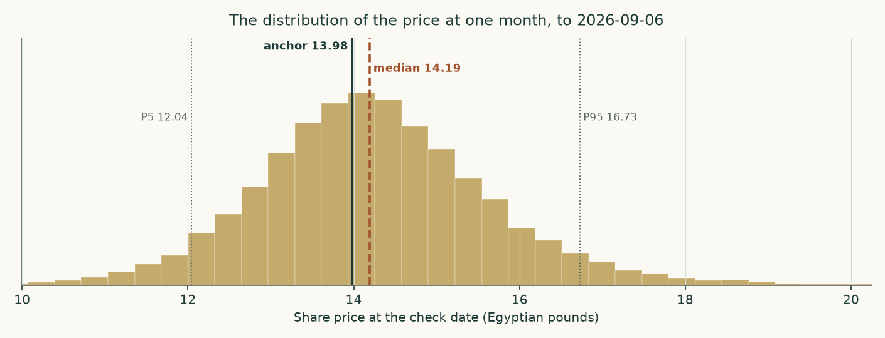
Figure 12. The shape of the distribution at one month, to 2026-09-06.
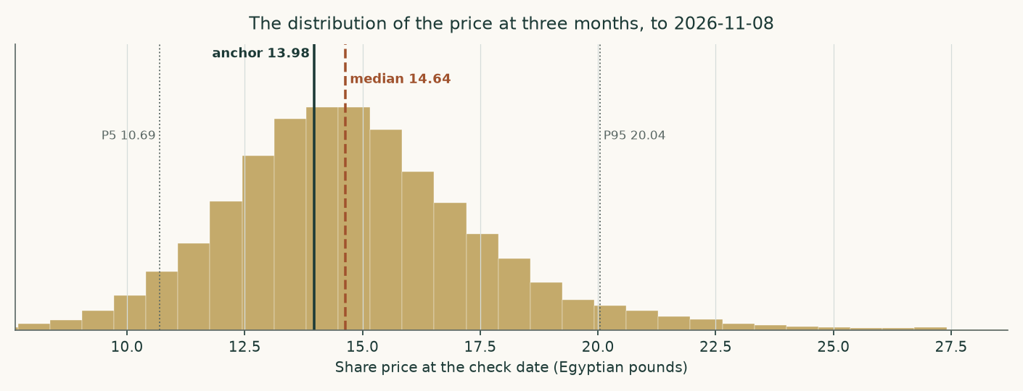
Figure 13. And at three months, to 2026-11-08. The right tail is longer than the left because the price cannot fall below zero and can rise without a bound — which is why the median sits below the mean and why the ladder below, not the median, is the more useful line.
Level-touch ladder
The percentile map says where the price may END. This ladder says how likely it is to TRADE THROUGH a level at any point before the check date, which is a different and usually larger number.
Level | One month | Three months
Up 5% | 56.1% | 78.7%
Up 10% | 30.1% | 61.7%
Up 15% | 14.8% | 47.1%
Up 20% | 7.3% | 34.7%
Down 5% | 43.6% | 63.4%
Down 10% | 18.3% | 40.8%
Down 15% | 6.9% | 24.9%
Down 20% | 2.6% | 14.5%

Table 23. Probability of touching each level at any point before the check date.
How this was tested, in plain terms. The same method was run backwards over the company's own price history in non-overlapping three-month windows and scored against a random walk that carries the same interest-rate drift. Over the 17 windows since the market's last structural break it beat that benchmark by 2.64 per cent on a proper scoring rule, and the advantage held across every resampling block size tested, so it is not an artefact of how the windows were cut. Outcomes fell inside the fifty, eighty and ninety per cent bands 64.7%, 88.2% and 94.1% of the time against the fifty, eighty and ninety they promise. A uniformity test on where each outcome landed within its predicted distribution returns a p-value of 0.625, which is to say the bands are neither too wide nor too narrow to a degree the data can detect. Over the last five years of windows the advantage was 2.04 per cent.
Two honest limits. The bands are wide because this share is volatile — an annualised 46.8% at the anchor date — and a wide band that is right is worth more than a narrow one that is wrong. And the map says nothing about value: a price can stay far above what a business is worth for a very long time, and on a stock with a six per cent free float it can do so on modest volume.
4 Comparison of the lenses
Lens | EGP/share | What it assumes that the others do not | Which assumption drives its gap to the cash-flow lens
Cash flow — carried through | -0.67 | That the capital programme is completed and earns at half its derived nameplate | —
Cash flow — stopped | 3.34 | That the board stops after one further year and runs the plant it owns | The programme alone: EGP 4.00
Book value and sustainable return | 0.58 | That the historic return on equity persists | Nothing — it agrees, from the other direction, that the business does not earn its cost of capital
Relative multiples | 15.47 | That a peer multiple on forward operating profit captures the whole business | It ignores capital expenditure entirely; that is the whole gap
Normalised earnings power | 3.78 | That an average year is the right year, and the balance sheet is stable | Mid-cycle pricing plus the same blindness to the capital programme

Table 24. The divergence is structured, not random. Every lens that lands above the cash-flow reading does so by not asking what the capital programme costs.
The reading we take from this is not that four lenses agree — they do not, and a study that made them agree would have hidden the thing worth knowing. It is that they disagree in one direction and for one reason. The three lenses that land above the cash-flow reading all reach their answer by declining to charge the capital programme against the years in which it is actually spent: the multiple lens capitalises a forward operating profit that is struck before capital expenditure, the normalised lens values a steady state the company is not in, and the book lens values what has already been paid for. Each is a legitimate question. None of them is the question that decides this company.
Our own reading therefore sits at the conservative end of the field, and the field's upper bound of EGP 15.47 should be read as what the shares would be worth if the programme were free — which it is not. The multiple lens does reach EGP 13.98, and that is the whole point of it: at the multiple Egyptian fertilizer producers actually trade at, a reader who ignores the capital programme gets the market's answer. The cash-flow lens, which does not ignore it, does not. The gap is reported as the flat discount rate that would close it, about 7.9% against a sovereign ten-year yield of 23.0%, so that a reader who disagrees can see precisely what they are disagreeing with rather than being asked to accept a conclusion.
No rating and no price target is expressed here or anywhere else in this document. What is published is a field of fair values, the reasoning behind each, and the probability map around today's price.
5 Catalysts
Catalyst | Why it matters | What to watch
A dated capacity disclosure for the new complex | The nameplate used in this study is derived from the ammonia design plate because no filing states it, and it is the input the terminal value is most sensitive to after the discount rate. | The annual report's note on the project, or any prospectus for the facility drawn to build it
Physical progress moving back toward plan | Progress ran 12.9% against a 37.0% plan while more than a quarter of the money had been spent. Closing that gap shortens the construction window and brings the terminal contribution forward. | The percentage-of-completion figure the auditor discloses each year, against construction in progress on the balance sheet
A structural fix to industrial gas supply | Every tonne not made is fixed cost with no revenue against it. The stoppage cost was EGP 164.5m in the last audited year and EGP 152.7m the year before. | The disclosed stoppage cost, and the summer curtailment months in the quarterly production numbers
A price regime the market treats as permanent | The study assumes mean reversion from a war-tightened level toward the cash cost of the marginal gas-based producer. A decade above today's spot is a different company. | The Egyptian free-on-board quote against the model's path, and any change in the export duty that sits between the two
The debt moving into the currency the company earns | 99.7% of the book is dollar-denominated against a revenue stream that is largely priced in dollars but settled in pounds. A single quarter's translation swing this year was larger than the whole nine-month profit. | Any refinancing announcement, and the currency split in the borrowings note
The first dividend | Nothing was distributed in either of the last two years. A distribution would say the board considers the capital programme funded. | The appropriation statement in the annual accounts
The next disclosed quarter against this study's own forecast | This study forecasts the year to June 2026 from nine reviewed months. The fourth quarter is a direct test of that construction. | Revenue against EGP 10,379m and gross margin against 43.9% for the full year

Table 25. Each of these is observable from a disclosure the company already makes. None of them requires an estimate to detect.
6 Reading the probability zones
Three zones, and what each would mean. The boundaries are the quartiles of the three-month distribution in section 3, not levels chosen for the purpose.
Zone | Three-month range (EGP) | How to read it
Below the lower quartile | under 13.03 | The price would be moving toward the upper end of what the four lenses support, and the gap this study reports would be closing from the price side rather than from the value side.
The ordinary range | 13.03 to 16.43 | Half the simulated paths end here. Nothing inside it would tell a reader anything about value, in either direction.
Above the upper quartile | 16.43 to 20.04 | The market would be paying more for a business whose sustainable return on equity is 6.9% against a cost of equity of 31.3%, with the capital programme still unfinished.
Above the ninety-fifth percentile | over 20.04 | One path in twenty. On a free float of about six per cent this can happen on modest volume, which is a fact about the register rather than about the business.
What none of the zones says | — | Where the price will go. The distribution is a map of dispersion around today's price and carries no view of value; the value work is sections 1 and 4.

Table 26. Zones, not targets.
The single most useful line in section 3 is the ladder rather than the map: there is a 14.5% chance of touching twenty per cent below today's price at some point in three months, against 34.7% of touching twenty per cent above. A reader who cares about the path, not just the destination, should read that pair together — and should note that the two are close to each other even though the median path drifts up, which is what a wide, right-skewed distribution looks like from the inside.
7 Caveats and what would change our mind
The auditor's reports carry a formal basis for qualification in every year examined. They are not boilerplate and they are part of the evidence: fixed assets whose useful lives and residual values have not been reassessed as the standard requires; inventory whose slow-moving provision the auditor could not satisfy itself was sufficient; a shortfall of 1,648 tonnes of urea between warehouse records and the physical count at Damietta; supplier and customer balances unconfirmed; and, on the capital programme, a holding-company committee finding of severe deficiencies in the award process. A reader who discounts this study should discount the statements underneath it first.
The largest modelled allocation is the gas share of the cost stack. The statements give one materials line of EGP 4,399m and do not split gas from the rest. Gas is set at 75.0% of it, which implies 1,292 cubic metres a tonne of ammonia — inside the auditor's own disclosed 1,025 to 1,771 range, but a choice nonetheless. The alternative gas price is priced in section 1.8 and is worth EGP 1.89 a share.
Maintenance capital expenditure is the driver this study got wrong on its first issue and has since re-anchored. It was set at three per cent of revenue on the assertion that the company's own observed spending was abnormally low; the cash-flow statements show two pre-project years at 1.1% of revenue, and that is now the central. The correction is worth EGP 0.31 a share on its own. The replacement-rate framing at 6.1% is published beside it as the downside rather than averaged in.
The terminal reinvestment rate is now the largest unsourced input left in the model. It is set by terminal growth over an assumed 18.0% return on invested capital, which charges 27.8% of terminal operating profit after tax back into the business every year for ever — on a plant that has just been rebuilt and needs no further building. A thirty per cent return on capital, which is what a newly completed line earns while it is still filling, is worth EGP 0.26 a share. The conservative reading is kept and the alternative is priced.
The new plant's capacity is derived, not disclosed. No filing states it. It is built from the ammonia design plate less the draw of urea at its own plate, converted at the nitrate route's ammonia ratio. Every figure that depends on it is flagged as derived wherever it appears, and the utilisation applied to it is sensitised in both directions.
Terminal value is 65.3% of enterprise value on the carried-through case and 31.2% on the stopped case. Above one hundred per cent is unusual and is explained rather than smoothed: the explicit window is a construction window with negative free cash flow, so the terminal block carries the whole enterprise value and then some. It is a real characteristic of an asset being rebuilt, not a modelling artefact — but it does mean the answer rests more heavily on one year than most studies do.
The forecast for the year to June 2026 rests on nine reviewed months and one run-rated quarter. The fourth quarter is run-rated on the third quarter's revenue with a 3.0% haircut for the summer gas curtailment, and the translation line is set to zero because a currency swing is not forecastable. That last choice matters: the nine-month translation loss was larger than the nine-month profit.
The currency of discounting is unresolved and is the largest single judgement after the capital programme. This is a company that sells most of its output in dollars, borrows almost entirely in dollars, and reports in pounds. The study discounts pound cash flows at a pound rate throughout and carries the dollar debt at local-equivalent cost using the same depreciation wedge that drives the revenue path, so the two cannot quietly disagree. A dollar valuation would be a different study, not a different number.
The concentration risks are plain and are not diversifiable inside this company: one product, one site, one feedstock, one regulator setting both the domestic price and the export duty, and a single offtake arrangement covering roughly two thirds of production. The state and its related institutions hold about 69.8% of the shares and the free float is about 6.2%, so the traded price is set in a thin market. That is worth remembering when comparing it with any valuation, including this one.
The subsidised quota is a legal obligation the company has not been able to meet. It delivered 147,000 tonnes of a 322,000-tonne requirement over fourteen months. The forecast does not assume that gap closes, but it also does not price a penalty for it, because none is disclosed.
The share count is taken from the capital note rather than from the exchange, whose page is behind an automated challenge. Two third-party sources carry figures inconsistent with the note and with each other; both are recorded in the bibliography as documented discrepancies and neither is used anywhere in the build.
What would change our mind, specifically. Upward: a disclosed capacity for the new complex that earns above the cost of capital on the approved cost; the programme completing near that cost rather than above it; a sustained export price regime above the top of the tested grid; a refinancing that moves the debt into pounds; or evidence that Egyptian equity risk is genuinely priced below its own sovereign — which would revalue every Egyptian equity, not only this one. Downward: the contract gas price replacing the realised price; a further slip in physical progress against money spent; or a translation loss on the scale of this year's repeating.
Appendix A Financial statements
A.1 Income statement — three years historical and five years forecast (EGP million)
EGP million | FY2022/23 | FY2023/24 | FY2024/25 | FY2025/26E | FY2026/27 | FY2027/28 | FY2028/29 | FY2029/30 | FY2030/31
Revenue | 6,612 | 6,532 | 8,603 | 10,379 | 11,310 | 11,539 | 11,626 | 11,863 | 12,303
Cost of sales | 3,574 | 4,396 | 5,300 | 5,825 | 6,146 | 6,668 | 7,179 | 7,699 | 8,239
Gross profit | 3,038 | 2,136 | 3,302 | 4,554 | 5,165 | 4,871 | 4,448 | 4,163 | 4,064
Selling and distribution | 474 | 563 | 786 | 980 | 826 | 894 | 958 | 1,023 | 1,093
Administrative | 189 | 298 | 360 | 365 | 396 | 429 | 461 | 494 | 528
EBIT before other items | 2,375 | 1,276 | 2,156 | 3,209 | 3,793 | 3,427 | 2,928 | 2,556 | 2,363
Depreciation and amortisation | 719 | 773 | 896 | 891 | 891 | 1,009 | 1,147 | 1,292 | 1,434
EBITDA | 3,094 | 2,049 | 3,052 | 4,099 | 4,684 | 4,436 | 4,074 | 3,849 | 3,797
Gross margin | 45.9% | 32.7% | 38.4% | 43.9% | 45.7% | 42.2% | 38.3% | 35.1% | 33.0%
EBITDA margin | 46.8% | 31.4% | 35.5% | 39.5% | 41.4% | 38.4% | 35.0% | 32.4% | 30.9%
Net profit as reported | 1,151 | 2,538 | 987 | 531

Table 27. The EBIT line is struck before provisions, currency translation and other income and expense, so it measures trading rather than the statements' own operating result which mixes all three. The FY2023/24 reported profit includes EGP 2,035 million of one-off investment-property revaluation gain; the underlying figure is about EGP 503 million, and every margin and return in this study uses the underlying number. Depreciation for FY2024/25 is the disclosed charge plus disclosed amortisation; for the two earlier years only the depreciation inside cost of sales is separately disclosed, so the amortisation element there is a modelled estimate and is flagged rather than presented as reported. FY2025/26 is nine months reviewed plus a fourth quarter run-rated on the third quarter, with the translation line set to zero.
A.2 Balance sheet (EGP million)
EGP million | 30 Jun 2023 | 30 Jun 2024 | 30 Jun 2025 | 31 Mar 2026
Net fixed assets | 11,300 | 14,144 | 13,587 | 13,058
Construction in progress | 56 | 2,535 | 3,790 | 5,654
Investment property | 0 | 2,035 | 2,161 | 2,155
Investments at fair value | 1,855 | 2,491 | 2,163 | 1,383
Intangible assets | 1,909 | 2,376 | 2,257 | 2,170
Inventory | 1,392 | 1,615 | 2,400 | 3,378
Receivables | 799 | 858 | 631 | 1,230
Cash and equivalents | 1,416 | 3,103 | 3,057 | 4,607
Total assets | 18,728 | 29,158 | 30,046 | 33,634
Paid-in capital | 5,933 | 9,933 | 9,933 | 9,933
Reserves and retained earnings | 1,317 | 4,627 | 5,430 | 6,273
Long-term bank loans | 8,425 | 11,226 | 11,183 | 14,386
Holding-company loans | 50 | 0 | 597 | 46
Deferred tax liability | 1,469 | 1,001 | 991 | 961
Provisions | 144 | 432 | 309 | 292
Payables and other | 1,368 | 1,587 | 1,208 | 1,539
Current portion of long-term debt | 21 | 354 | 397 | 207
Gross interest-bearing debt | 8,497 | 11,580 | 12,178 | 14,639
Net debt | 7,080 | 8,477 | 9,120 | 10,032

A.3 Forecast balance sheet and cash-flow markers (EGP million)
EGP million | FY2026/27 | FY2027/28 | FY2028/29 | FY2029/30 | FY2030/31
Capital expenditure | 2,725 | 3,229 | 3,430 | 3,332 | 2,627
Depreciation and amortisation | 891 | 1,009 | 1,147 | 1,292 | 1,434
Receivables | 830 | 846 | 853 | 870 | 902
Inventory | 2,782 | 3,019 | 3,250 | 3,486 | 3,730
Payables | 1,400 | 1,519 | 1,636 | 1,754 | 1,877
Net working capital | 2,212 | 2,346 | 2,467 | 2,601 | 2,755
Change in net working capital | -858 | 134 | 121 | 134 | 154
Free cash flow to the firm | 1,963 | 302 | -135 | -193 | 485

Table 28. Working capital is projected from the day counts the audited statements themselves imply — 26.8 days of receivables, 165.2 of inventory and 83.2 of payables — rather than plugged.
Appendix B Peer frame, risk register and the research register
B.1 Peers and the sector frame
Company | Market | Urea capacity (kt/yr) | Why it matters here
Egyptian Chemical Industries | EGX | 575 | The subject. The only Egyptian nitrogen producer off the coast, which is why freight to port is its own disclosed cost line.
Abu Qir Fertilizers | EGX | 2,000 | The listed comparator, and the marketer of the subject's ammonia exports for a fee of 12% of the export price. The subject held 2.7% of it and began selling down.
MOPCO | Unlisted | 1,800 | Curtailed alongside the rest of the industry in the 2026 gas squeeze; the subject's own urea is warehoused at Damietta for export.
Helwan Fertilizers and NCIC | Unlisted | 1,300 | Completes the supply picture against which the export share is allocated.

B.2 Risk register
Risk | How it shows up in the numbers | Where it is carried
Gas curtailment | EGP 164.5 million of stoppage cost in FY2024/25 and about EGP 781 million of abnormal gas loss cumulatively since July 2022 | Utilisation path and a standing stoppage line
Currency | A EGP 1,072 million translation loss in nine months on an almost entirely dollar debt book | The cost of debt and the currency path
The capital programme | Approved cost about three quarters of market value, 12.9% built against a 37% plan | The contested judgement, computed both ways
Administered pricing | An export levy of EGP 438 million charged on the quota shortfall in one year | Channel mix and the duty
Governance | A holding-company committee finding severe deficiencies in the project award process | The haircut in the asset-based expert's range
Concentration | One product, one site, one feedstock, one offtake counterparty for about two thirds of production | Not diversifiable — stated, not modelled
Liquidity | A free float of 6.2% | Stated; no model adjustment

B.3 The research register — layers, dated, negative results included
Layer | What it covers | Inputs
L1 | Primary filing — the company's own statements | 187
L2 | Primary market data | 14
L3 | Official external (regulator, central bank, government) | 10
L4 | Industry and sector context | 21
L5 | Constructed in this study | 62
Total | Every input carries a value, a source, a date and a layer | 294

Table 29. The full register — every input with its value, date and source-and-construction — is printed in the separate bibliography document, together with the judgements table, the negative results and the notes on where a widely quoted third-party figure disagreed with the filings.
Appendix C The expert valuation panel
Three practitioners were put the same question by genuinely different methods. Each states a worldview, when the method works and when it fails, shows every intermediate line of the arithmetic, names the sensitivity that moves the answer, and commits in advance to what would prove them wrong.
C.1 Expert 1 — Replacement cost and asset backing
Worldview. A plant is worth what it would cost to build again, less what is owed against it. Cash flows are a claim on the asset; the asset is the thing.
When it works. When an asset is scarce, hard to permit and expensive to replicate — which a gas-connected nitrogen complex in Egypt certainly is.
When it fails. When the asset cannot earn its keep. Replacement cost sets a ceiling on what a rational buyer pays and says nothing about what an owner receives.
Line | Value | Basis
Gross fixed assets at cost | 17,022 | note 6
Less accumulated depreciation | -3,435 | note 6
Net book value of the operating plant | 13,587 | as reported
Urea plate (tonnes a year) | 574,875 | 1,575 t/day contractual plate
Build cost, low (US$ per annual tonne) | 550.00 | industry range
Build cost, high (US$ per annual tonne) | 700.00 | industry range
Replacement cost at the low end (EGP m) | 15,743 | plate x cost x the rate
Replacement cost at the high end (EGP m) | 20,036
Replacement cost, mid-point (EGP m) | 17,889
Construction in progress at cost (EGP m) | 5,654 | 31 March 2026
Haircut for delay and the governance findings | -2,261 | 40%
Construction in progress, valued (EGP m) | 3,392
Listed equity stakes at market (EGP m) | 1,383
Investment property (EGP m) | 2,155
Gross asset value (EGP m) | 24,819
Less net debt (EGP m) | -10,032 | 31 March 2026
Equity before any control discount (EGP m) | 14,787
Per share before the discount (EGP) | 7.44
Control discount on a state-held listed industrial | -40.0% | observed
Equity after the discount (EGP m) | 8,872
PER SHARE (EGP) | 4.47

Table 30. Expert 1's workings in full — every intermediate line, not a summary of them.
Range: EGP 4.47 to EGP 7.44 a share.
Reading it. This is the highest of the three readings and it should be read as a ceiling rather than a centre. It values the plant at what a buyer would pay to avoid building one, and on a plate of 574,875 tonnes at the mid-point of the industry build range that is EGP 17,889m before anything is owed against it. What the method cannot see is that the plant has been running at about ninety per cent of that plate on rationed gas, and that the asset under construction — carried here at 60% of what has been spent on it — is exactly the asset whose return the cash-flow lens finds inadequate. The gap between this expert and the panel's lowest is not a disagreement about the plant. It is a disagreement about whether an asset that cannot earn its cost of capital is worth its replacement cost.
Named sensitivity. The build cost is the swing factor. At US$550 per annual tonne the range starts at EGP 3.82; at US$700 it reaches EGP 5.11. The control discount moves it by about a third either way.
Falsifier, stated in advance. A comparable Egyptian nitrogen asset transacting above US$700 per annual tonne, or a state-held listed subsidiary changing hands without a control discount. Either would show this method is set too low and the cash-flow lens should govern.
C.2 Expert 2 — Normalised earnings power
Worldview. Strip out the construction, the translation noise and the price cycle, and ask what this plant earns in an ordinary year. Value that.
When it works. For a mature single-asset producer whose economics are stable once the cycle is averaged out.
When it fails. When the capital structure or the asset base is changing underneath the earnings — which is exactly what is happening here, and why this expert's answer sits above the cash-flow lens.
Line | Value | Basis
Mid-cycle urea output (tonnes) | 540,542 | three-year average of audited output
Less subsidised deliveries (tonnes) | -155,000 | obligation path
Less local free-market (tonnes) | -40,000
Export tonnes | 345,542
Mid-cycle export price (US$/t) | 400.00 | above the 2015-2020 average, below spot
Exchange rate | 54
Export revenue (EGP m) | 6,742 | net of the 10% duty
Subsidised revenue (EGP m) | 1,167
Local free-market revenue (EGP m) | 780
Nitrate revenue (EGP m) | 575
Other revenue (EGP m) | 140
MID-CYCLE REVENUE (EGP m) | 9,404
Natural gas (EGP m) | -3,877 | consumption x price x the rate
Other materials (EGP m) | -1,276
Wages (EGP m) | -234
Purchased services (EGP m) | -69
Inland freight (EGP m) | -662
Other selling (EGP m) | -194
Administration (EGP m) | -396
MID-CYCLE EBITDA (EGP m) | 2,697
Depreciation and amortisation (EGP m) | -891
Tax at the statutory rate | -406
MID-CYCLE OPERATING PROFIT AFTER TAX (EGP m) | 1,400
At ten times — enterprise value (EGP m) | 13,996
Less net debt (EGP m) | -10,032
Plus non-operating assets (EGP m) | 3,538
PER SHARE (EGP) | 3.78

Table 31. Expert 2's workings in full — every intermediate line, not a summary of them.
Range: EGP 2.37 to EGP 5.19 a share.
Reading it. The middle reading, and the one closest to a conventional analyst's answer. It credits an ordinary year — EGP 9,404m of revenue and EGP 2,697m of operating profit before depreciation — and capitalises the after-tax result at ten times. Its blind spot is stated in its own worldview: a normalised year is a steady state, and this company is not in one. The capital programme sits entirely outside this table. Read strictly, this expert is valuing the plant that exists, and the reader who wants the whole company should subtract the programme's cost separately — which is what the cash-flow lens does inside a single model.
Named sensitivity. The multiple is the swing factor: eight times gives EGP 2.37, twelve times EGP 5.19. The mid-cycle price matters almost as much — every US$50 a tonne is worth roughly a pound a share.
Falsifier, stated in advance. Two consecutive years of EBITDA above EGP 4 billion with the capital programme funded out of operating cash flow. That would show the normalisation is too harsh and the multiple too low.
C.3 Expert 3 — The equity as a contingent claim
Worldview. When the value of the firm sits below the face value of its debt, the equity is not a claim on cash flows. It is an option on the assets, and a discounted-cash-flow model understates it because it ignores the shareholder's right to walk away.
When it works. For a leveraged, volatile business whose enterprise value is near or below its debt — precisely this situation.
When it fails. When the option holder cannot choose when to exercise, when further capital calls dilute the position, or when the enterprise comfortably covers its debt.
Line | Value | Basis
Enterprise value including non-operating assets (EGP m) | 8,707 | the underlying
Gross debt — the strike (EGP m) | 14,639 | 31 March 2026
Time to the last dollar maturity (years) | 5.00 | discounted from 2035
Enterprise volatility a year | 45.0% | the export price alone moved between US$380 and US$730 inside eighteen months
Risk-free rate in pounds | 20.0%
Call value on those parameters (EGP m) | 4,647
At 35% volatility (EGP m) | 4,170
At 55% volatility (EGP m) | 5,123
Adjustment for forced timing and dilution | -25.0%
Adjusted call value (EGP m) | 3,485
PER SHARE (EGP) | 1.75

Table 32. Expert 3's workings in full — every intermediate line, not a summary of them.
Range: EGP 0.00 to EGP 1.93 a share.
Reading it. The lowest and the widest of the three, and the only one that takes the debt seriously as a structural fact rather than as a subtraction. Enterprise value including the non-operating assets is EGP 8,707m against gross debt of EGP 14,639m, so the equity is out of the money on the model's own central case and its value is entirely time value. That is why the answer rises with volatility and with time, and why the grid below matters more than the point: at 30% volatility over three years the claim is worth EGP 0.78 a share, and at 60% over seven years EGP 2.44. A reader who finds it perverse that a worse business is worth more here has understood the method correctly: limited liability truncates the downside, so dispersion accrues to the holder. What the method cannot do is tell that holder when the option expires.
Time to maturity | 30% volatility | 35% volatility | 45% volatility | 55% volatility | 60% volatility
3 years | 0.78 | 0.89 | 1.09 | 1.29 | 1.38
5 years | 1.49 | 1.57 | 1.75 | 1.93 | 2.02
7 years | 2.03 | 2.09 | 2.23 | 2.37 | 2.44

Table 33. The claim in Egyptian pounds a share across the two parameters that decide it. The published figure is the five-year, forty-five per cent cell; every other cell is a full revaluation of the same option.
Named sensitivity. Volatility is the swing factor: at 35% the claim is worth EGP 1.57 a share, at 55% EGP 1.93. Time to maturity matters almost as much, because it is time for the enterprise to recover above the debt.
Falsifier, stated in advance. Enterprise value rising above the face value of the debt — which needs roughly a US$120 a tonne sustained improvement in the export price, or the capital programme being stopped. Either would retire the option framing and hand the question back to the cash-flow lens.
C.4 Cross-examination
Challenge | From | To | Conceded or rejected
Replacement cost values a plant nobody would build today at these gas terms and this utilisation. You are pricing an asset by what it cost, not by what it does. | Expert 2 | Expert 1 | CONCEDED in part. Expert 1 accepts the method sets a ceiling on what a rational buyer pays rather than a floor under what an owner receives, and that is why the control discount is applied rather than argued away. The range stands as the upper bound of the panel, not its centre.
Your mid-cycle year quietly assumes the new complex never absorbs another pound. That is the same blindness you accuse the multiple lens of. | Expert 3 | Expert 2 | CONCEDED. Expert 2 accepts that the normalised year is a steady-state construct and that the capital programme sits outside it entirely. The answer should be read as the value of the existing plant, with the programme's cost subtracted separately — which is what the cash-flow lens does.
An option framing rewards volatility, so the worse the business gets the more you say the equity is worth. That cannot be right. | Expert 1 | Expert 3 | REJECTED, with the mechanism given. The option value rises with volatility because a limited-liability holder cannot lose more than the shares cost; the downside is already truncated by the debt. What is conceded is that the holder cannot choose the exercise date and can be diluted by a rights issue, which is why a quarter is taken off the raw call value.
You are all discounting at rates the market plainly does not use. If none of you can reach the traded price, perhaps the rate is wrong rather than the price. | The reader | The panel | REJECTED as to method, CONCEDED as to consequence. The rate is built from the sovereign's own yield less its own default spread, which is the only construction that charges Egypt's risk once. But the panel accepts the practical point: the gap is reported as an implied discount rate precisely so a reader who disagrees can see exactly what they are disagreeing with.

C.5 The three in one room
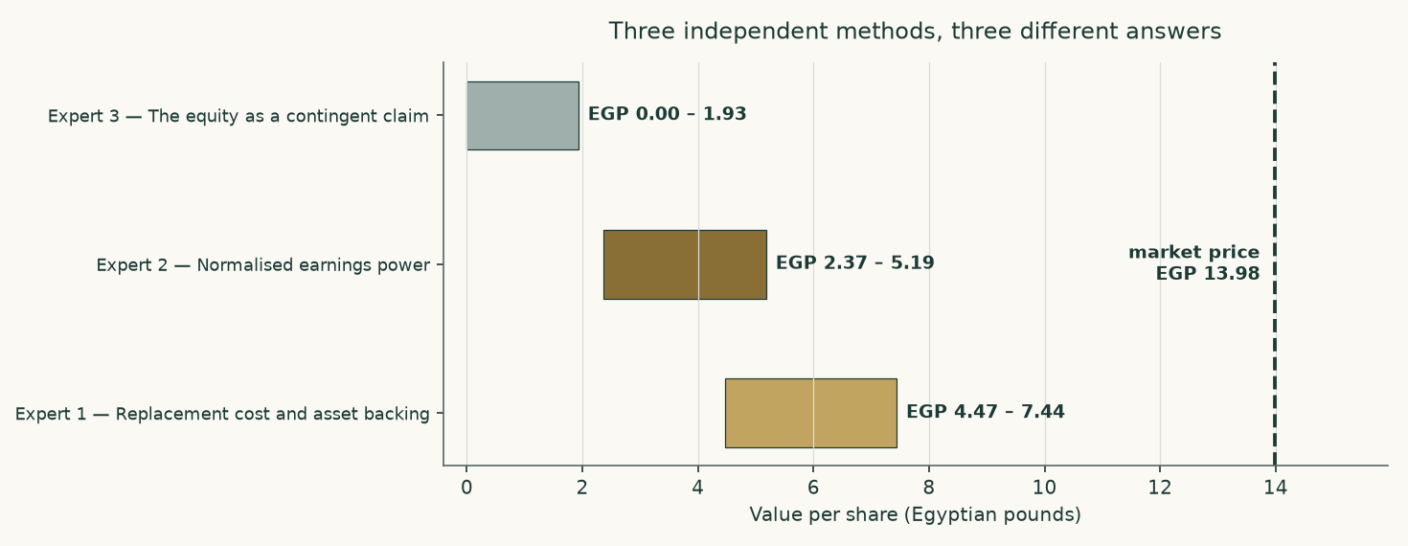
Figure 14. Three methods, three ranges, and none of them reaches the traded price.
Put together, the panel spans EGP 0.00 to EGP 7.44. They agree on more than the spread suggests: all three price the same plant, the same debt and the same programme, and all three land below the traded price. Where they part is on what to do about a business whose asset base is being rebuilt while its earnings stand still.
The most useful thing the panel produces is not a number but an ordering. The asset lens is highest because it credits what has been built without asking what it earns. The earnings lens sits in the middle because it credits a normal year but not the new plant. The option lens is lowest and widest because it takes the leverage seriously. Each is right about the thing it looks at and blind to the thing it does not.
C.6 Reading the divergence
Pair | Gap (EGP/share) | The single assumption that drives it
Expert 1 against Expert 2 | 2.10 | Whether an asset is worth what it would cost to rebuild or what it earns in an ordinary year. On a plant running below plate on rationed gas, those are different numbers.
Expert 2 against Expert 3 | 0.43 | Whether the debt is a subtraction or a strike price. Above the debt it is a subtraction; below it, the equity is an option and the two methods stop agreeing.
Expert 1 against Expert 3 | 2.53 | Both of the above at once, which is why this is the widest pair.
The panel against the cash-flow lens | 0.67 | The capital programme. Every expert method treats it more kindly than a year-by-year cash-flow model does, because none of them charges the full expenditure against the years in which it is actually spent.
The whole study against the market | 1.49 | The discount rate, and only the discount rate. At about 7.9% the market's price is reproduced; at any rate anchored to Egypt's sovereign it is not.

Table 34. Each gap isolated to the one assumption that creates it.
About
This study is one of a series of independent valuation studies produced to a fixed method: the historical statements are taken only from the company's own issued documents; the forecast is built from the ground up in physical units; the cost of capital is constructed from the sovereign's own data rather than assumed; and the workbook that accompanies the document calculates rather than stores, so that a reader who disagrees with an assumption can change it and watch the answer move.
Every input behind this study — 294 of them — carries a value, a source, a date and a research layer, and all of them are printed in the separate bibliography document. Where a number is constructed rather than reported, the construction is stated. Where a needed number could not be obtained, that is stated too.
Disclosure
Educational analysis. This document is an independent educational analysis. It is not investment advice, not a recommendation, and not an offer or solicitation.
No rating, no target. It contains no rating and no price target. It reports a range of fair values and the reasoning behind them.
Point in time. It reflects information available on 8 August 2026 and the closing price of 2026-08-06. It will age, and it is not updated.
Sources and their limits. Historical figures come from the company's own audited and reviewed statements. Those statements carry qualifications, set out in section 7; a reader should weigh them.
Model risk. The forecast depends on judgements that are stated and sensitised. Reasonable people will choose different inputs and reach different answers, which is why the contested judgement is published both ways rather than averaged.
No position. The author holds no position in the subject and receives no compensation from it or from any party with an interest in it.

