Testahil · Independent Valuation Study — Educational Analysis Not investment advice

Alexandria Mineral Oils Company S.A.E.
EGX: AMOC · Egyptian Exchange · EGP · Valuation study as of 6 August 2026, issued 1 September 2026
READ FIRST. This is an educational valuation study, not investment advice, and it makes no recommendation to buy, sell or hold. What it publishes is a fair-value RANGE and a probability distribution for the price — never a target. Three things are worth knowing before the numbers: the estimate sits well below the market price, which means the burden of proof is on this study and Section 1.14 states exactly what a buyer at the market price would have to believe; the forecasting method behind it has been tested against this company’s own past and did NOT beat a simple no-change rule, which is why the range is wide and why Section 7 leads with that rather than burying it; and the second half of the base year is reviewed rather than fully audited. Everything here is reproducible from the companion workbook, which recalculates the whole study live.

Headline
THE CLAIM, STATED EXACTLY. Fair value EGP 8.64 a share against a market price of EGP 9.10. Fair value sits 5.0% BELOW the price; equivalently the price stands 5.3% ABOVE fair value. The weighted range is EGP 5.53 to 12.48 and the price is outside it. Every one of the four lenses lands below the price.
WHAT WOULD CHANGE OUR MIND. Surrender every contested judgement in this study simultaneously — the tax provision settles for nothing, the declared dividend never leaves, the employees’ profit share is free, the terminal rate reverts to the softer inflation target, operating profit is taxed at the flattered effective rate — and the weighted central still reaches only EGP 7.47, -17.9% against the price. Section 1.13 walks the whole stack, one full model re-run per row.
WHAT A BUYER AT THE PRICE MUST BELIEVE. Solving the model at the market price rather than asserting a number: EGP 9.10 is fair if AMOC sustains a gross margin of 9.37% in every forecast year and in perpetuity. The twelve months just filed ran 9.65% and the six months to June 2026 ran 12.43%. The market price therefore requires a margin BELOW what this company has just reported and well inside the range it has printed since 2021. A buyer at EGP 9.10 is not making a heroic assumption; the burden of proof sits with the seller. Section 1.14 derives it.
AND THE HONEST WEAKNESS. The far years carry a wide range and the terminal block is 54% of enterprise value, which is high. The forecasting method behind Section 1 was tested against this company’s own history and did NOT beat a simple no-change rule — Section 7 leads with that. Two exchange disclosures that would move the answer in opposite directions could not be opened.

Valuation summary — every read at a glance
Lens | What it measures | Bear | Base | Bull | Weight | vs price
Discounted cash flow | unlevered cash, discounted on a glide | 4.88 | 9.77 | 16.44 | 45% | 7.4%
Relative multiples | own trailing EV/EBITDA, no re-rating | 6.68 | 8.32 | 9.96 | 20% | -8.6%
Normalised earnings | mid-cycle operating EPS, discounted | 6.51 | 8.39 | 10.26 | 20% | -7.8%
Book and sustainable return | justified price-to-book | 4.61 | 6.02 | 6.88 | 15% | -33.8%
WEIGHTED CENTRAL | the four, weighted | 5.53 | 8.64 | 12.48 | 100% | -5.0%

Table 1 — the four lenses. The bear and bull columns of the weighted row are WEIGHTED with the same 45/20/20/15 weights as the base column. The widest single lens spans EGP 4.61–16.44; that is reported as an ENVELOPE, not as the range of a weighted estimate. The previous edition labelled a row "weighted central" and then took the minimum and maximum across all four lenses, both of which came from the cash-flow lens alone, overstating the published spread by about two and a half times.
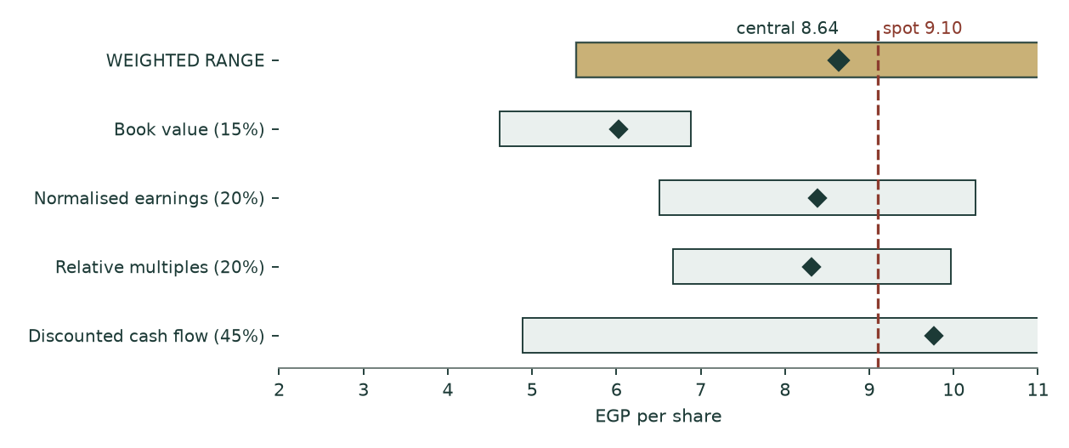
Figure 1 — the football field. The price (red dashed) sits above every lens base and above the top of the weighted range. It falls inside only the cash-flow lens’s bull tail, which is five favourable driver moves at once.
The company
Alexandria Mineral Oils Company is the only refinery listed on the Egyptian Exchange. It takes atmospheric residue and distils it into base and special oils, paraffin wax, gas oil, naphtha, liquefied petroleum gas and fuel oil. Alexandria Petroleum Company holds 20.77% — the previous edition of this study misattributed that stake to the Egyptian General Petroleum Corporation — and AMOC owns 86.45% of Alexandria Wax Products, whose minority is the non-controlling interest carried through this valuation.
The financial year moved from 30 June to 31 December, so the filed record is a six-month transition period (July to December 2025, AUDITED by Crowe — Dr A. M. Hegazy & Co, unqualified opinion signed at Giza on 18 February 2026) followed by a reviewed first quarter. That is why the base year in section 1.2 has to be constructed rather than lifted off one filing.
What it actually sells
Product line | Tonnes, 6M | Value, EGP mn | Realisation EGP/t | Share of tonnage | Share of value
Base and special oils | 118,475.6 | 6,910 | 58,327 | 7.89% | 14.72%
Paraffin wax | 82,805.7 | 4,653 | 56,190 | 5.51% | 9.91%
Gas oil | 346,720.8 | 13,033 | 37,589 | 23.08% | 27.75%
Naphtha | 80,543.1 | 2,238 | 27,782 | 5.36% | 4.77%
Liquefied petroleum gas | 47,938.8 | 2,070 | 43,190 | 3.19% | 4.41%
Fuel oil (mix) | 799,642.3 | 17,640 | 22,059 | 53.23% | 37.56%
Heavy fuel oil | 26,181.6 | 415 | 15,843 | 1.74% | 0.88%
Waste | 16.7 | 0 | 11,537 | 0.00% | 0.00%
TOTAL | 1,502,324.6 | 46,959 | 31,257 | 100.00% | 100.00%

Table 2 — note 14-A of the audited transition-period statements. Eight lines, tonnes AND value both disclosed, so the realisation per tonne is disclosed arithmetic rather than an estimate. The specialty slate — base and special oils plus paraffin wax — is 13.4% of the tonnage and 24.6% of the value. That asymmetry is the company.
Raw materials are 91.2% of cost of sales (note 15-A) and 82.4% of revenue. A business whose single largest line is that big, and whose gross margin is 9.7%, is a PASS-THROUGH PROCESSOR. The value is not in the revenue line and it is not in cost control either — it is in the spread between what the feedstock costs and what the slate fetches, earned on tonnage.
The balance sheet is the unusual part
Item | EGP mn | Per share | Treatment in this study
Cash at banks and on hand, free | 3,018 | 2.34 | added in the bridge — note 9-E, pledged deposits already excluded
Deposits PLEDGED against facilities | 525 | 0.41 | NOT free cash; added separately as a non-operating asset
Gross borrowings | 17 | 0.01 | deducted
NET CASH | 3,002 | 2.32 | 25.5% of market capitalisation
Provision for tax disputes and claims | 997 | 0.77 | note 10-1 — DEDUCTED in the bridge; the previous edition never carried it
Dividends payable, declared | 258 | 0.20 | note 11 — removed from working capital, deducted in the bridge
Equity investment at fair value through OCI | 70 | 0.05 | added as a non-operating asset
Parent equity | 6,070 | 4.70 | the book lens base

Table 3 — the balance sheet at 31 December 2025, as filed. The company holds more than a fifth of its market capitalisation in net cash, which is why the cost-of-capital construction in section 1.6 RAISES the operating discount rate above the cost of equity rather than lowering it. Against that cash sit two disclosed claims — the provision and the declared dividend — that the previous edition of this study quoted in its text and never carried into its arithmetic.
1 Fundamental valuation
1.1 Why this company is valued as an operating company and not as anything else
Three tests decide the class, and all three point the same way. Revenue is 100% own-production petroleum product — there is no trading book, no rental stream and no portfolio of stakes to sum. The balance sheet is working capital and plant, not investments: property, plant and equipment plus projects under construction of EGP 1,288mn and net working capital of EGP 3,389mn against a single equity stake of EGP 70mn. And consolidated profit is dominated by one plant, with the minority in the wax subsidiary running at 2.96% of operating profit.
So the primary lens is free cash flow to the FIRM, discounted, with the three cross-checks of section 1.12 weighted behind it. A sum-of-the-parts framework is inapplicable: AMOC has no listed subsidiaries. One reviewer was asked to run an SOTP verification against three unrelated foreign companies and correctly rejected the premise; it is recorded here so no reader wonders whether it was considered.
1.2 The base year is constructed, and here is the construction
The base year is the TWELVE contiguous months to 30 June 2026: the audited transition half (July to December 2025) plus the half AMOC disclosed to the Egyptian Exchange on 29-30 July 2026, one week before this study’s anchor date. No annualisation scalar is applied to either half. HALF OF THIS BASE YEAR IS A PRESS RELEASE AND NOT A FILING, and this study says so on every page that uses it.
Line | Audited 6M to Dec-2025 | Reported 6M to Jun-2026 | Base year | Basis
Net sales | 20,736 | 26,223 | 46,959 | both halves as disclosed
Gross profit | 1,274 | 3,259 | 4,533 | second half SOLVED, see below
Gross margin | 6.14% | 12.43% | 9.65% | output
Operating expense |  |  | 1,739 | administrative + selling + other + provisions
Depreciation |  |  | 157 | as filed
Cash capital expenditure |  |  | 169 | as paid
Credit interest |  |  | 308 | note 14-B
Employees’ profit share |  |  | 135 | note 16

Table 4 — the base year. Every operating line is struck on the SAME twelve months as revenue and gross profit. The previous edition built revenue from the six-month product table doubled while annualising cost of sales from nine months by four thirds, so its base-year gross margin of 7.081% corresponded to no filed period at all. One period, both sides, or the margin is an artefact of the scalars.
THE HALF IS FILED, AND THE RELEASED GROSS PROFIT WAS RIGHT. The reviewed consolidated statements for the six months to 30 June 2026 report net sales of EGP 26,223mn, gross profit of EGP 3,259mn — a margin of 12.43% — and profit attributable to shareholders of EGP 1,882mn. That is MORE IN SIX MONTHS than the whole financial year to June 2025 earned. The previous edition of this study did not have these statements, believed the half existed only as a press release, rejected the released gross-profit line on a coherence test and solved gross profit from the profit line instead. The filing settles it in the release's favour:
Line, six months to 30 June 2026 | As released | As filed | Difference
Net sales | 26,223 | 26,223 | -0.00%
Gross profit | 3,258 | 3,259 | -0.03%
Profit after tax | 1,903 | 1,921 | -0.92%

Table 5 — the press release against the filing. All three lines tie. The coherence test that rejected the gross-profit line estimated the half's other income by DOUBLING the first quarter's, which put EGP 451mn where the filing shows EGP 197mn — other income is the most volatile line in this income statement and the least suited to being doubled. A test built on an extrapolated volatile line refuted a correct disclosure, and the study then carried a gross margin roughly two-thirds of a point too low into every lens. The lesson is kept rather than the conclusion: a coherence test is only as good as the estimate inside it.
The fully-audited alternative is published beside the headline rather than discarded: the nine audited-and-reviewed months to 31 March 2026, annualised by four thirds, give revenue of EGP 41,662mn at a 7.51% margin. The gap to the headline base is +12.7% on revenue and +2.15% on margin. That gap is a real uncertainty about this company and it is disclosed, not averaged away.
Period | Net sales | Gross profit | Gross margin | Operating profit
6M Dec-2024 | 18,246 | 1,251 | 6.85% | 744
3M Mar-2025 | 10,068 | 509 | 5.05% | 247
6M Dec-2025 | 20,736 | 1,274 | 6.14% | 486
3M Mar-2026 | 10,511 | 1,071 | 10.19% | 643

Table 6 — the filed margin record. Four consecutively filed periods; the margin ranges 5.05% to 10.19%, a spread of 514 basis points. Nothing here is modelled. The margin is administered, not competed: read this as a policy record.
1.3 Three charges the reported profit hides — and which this study takes
Each of the following is disclosed in the filings, was registered as an input by the previous edition of this study, and was then read by no formula in it. All three are charged here.
Charge | Disclosed | Annualised | Where it belongs | Central WITHOUT it
Employees’ profit share and board bonuses | EGP 67mn in the audited half (note 16) | 5.24% of profit after tax | charged in the waterfall and in normalised earnings — a contractual appropriation that reaches neither the shareholder nor the tax line | 6.16 (-28.7%)
Provision for tax disputes and claims | EGP 997mn at 31-Dec-2025 (note 10-1) | one-off, at face | deducted in the equity bridge as a senior claim on the cash | 6.56 (-24.1%)
Dividends payable, declared and unpaid | EGP 258mn at 31-Dec-2025 (note 11) | one-off, at face | removed from operating working capital and deducted in the bridge | 6.39 (-26.1%)

Table 7 — the three charges. The rightmost column is the weighted central this study would print if the charge were NOT taken, from a full model re-run — so a positive figure is how much each charge costs the valuation. Setting the provision to zero in the previous edition moved its valuation by nothing at all, to four decimal places, because no formula read the cell. A rewritten reachability gate now FAILS the build if any input carrying a balance-sheet or profit-statement claim is registered without being used; it found sixteen such inputs where the old gate reported zero.
1.4 How revenue is built
Revenue is the eight disclosed product lines, tonnes times realisation, rolled forward on a volume path per line and one realisation path. Tonnage comes from note 14-A annualised; realisations are note 14-A value divided by note 14-A tonnes, lifted by ONE solved index so the base year foots to the twelve-month revenue. That index is 1.000 and it is the only free scalar on the revenue side.
Line | Base tonnes mn | Base realisation EGP/t | 2026E | 2027E | 2028E | 2029E | 2030E
Base and special oils | 0.118 | 58,327 | 7,719 | 8,510 | 9,257 | 9,935 | 10,613
Paraffin wax | 0.083 | 56,190 | 5,198 | 5,730 | 6,233 | 6,689 | 7,146
Gas oil | 0.347 | 37,589 | 14,559 | 16,050 | 17,459 | 18,737 | 20,017
Naphtha | 0.081 | 27,782 | 2,500 | 2,756 | 2,998 | 3,217 | 3,437
Liquefied petroleum gas | 0.048 | 43,190 | 2,313 | 2,550 | 2,774 | 2,977 | 3,180
Fuel oil (mix) | 0.800 | 22,059 | 19,705 | 21,723 | 23,631 | 25,360 | 27,091
Heavy fuel oil | 0.026 | 15,843 | 463 | 511 | 556 | 596 | 637
TOTAL REVENUE | 1.502 | 31,257 | 52,456 | 57,830 | 62,908 | 67,511 | 72,121

Table 8 — revenue by line, EGP mn. Volume growth is set per line from the measured half-on-half record; realisation grows on one path for all lines. The waste line is omitted from the table for space and is immaterial, but it is carried in the model.
1.5 The cost side, built per line — and what it says about the slate
This is where the previous edition was weakest and where the rebuild is deepest. Cost of sales is 90.3% of revenue on this name, so a cost side expressed as a percentage of revenue means the margin assumption IS the valuation. Cost is now built per line, in two legs.
CONVERSION — salaries, supporting materials, other operating costs and depreciation, the 8.8% of note 15-A that is not feedstock — is allocated across the eight lines on registered processing-intensity weights: base oils 1.00 as the reference through the full lube train (vacuum distillation, solvent extraction, dewaxing, hydrofinishing), paraffin wax 1.15 for the additional deoiling and sweating, the light ends 0.15 to 0.25, the residue fuel oils 0.05.
FEEDSTOCK is then allocated on NET REALISABLE VALUE — each line’s realisation less its own conversion cost. This is the standard joint-product convention and it is the only one of three bases tested that survives a sanity check. Allocating feedstock flat per tonne says fuel oil sells below the cost of its own feed, which is an artefact of the basis rather than a fact about the business. Allocating it on relative sales value makes base oils and paraffin wax — the products this plant exists for — run at negative margins once their conversion cost is stacked on top. Net realisable value is the only basis that leaves every disclosed line with a positive spread, and the workbook documents all three.
Line | Realisation EGP/t | Conversion EGP/t | Feedstock EGP/t | Total cost EGP/t | SPREAD EGP/t | Margin
Base and special oils | 58,327 | 10,279 | 43,007 | 53,286 | 5,041 | 8.6%
Paraffin wax | 56,190 | 11,821 | 39,714 | 51,535 | 4,655 | 8.3%
Gas oil | 37,589 | 2,570 | 31,345 | 33,915 | 3,674 | 9.8%
Naphtha | 27,782 | 2,056 | 23,027 | 25,083 | 2,699 | 9.7%
Liquefied petroleum gas | 43,190 | 1,542 | 37,279 | 38,820 | 4,370 | 10.1%
Fuel oil (mix) | 22,059 | 514 | 19,285 | 19,799 | 2,260 | 10.2%
Heavy fuel oil | 15,843 | 514 | 13,720 | 14,234 | 1,608 | 10.2%
Blended | 31,257 |  |  | 28,240 | 3,017 | 9.7%

Table 9 — per-line economics of the base year. The eight per-line costs rebuild the disclosed cost of sales exactly; that footing test is a live cell in the workbook. A tonne of base oil contributes 2.2 times the spread of a tonne of fuel oil, so the MIX now moves the margin. The previous edition applied one blended margin to all eight lines and described that as a bottom-up build; it was a single company-level number wearing eight labels, and it meant the mix could shift without the margin responding at all.
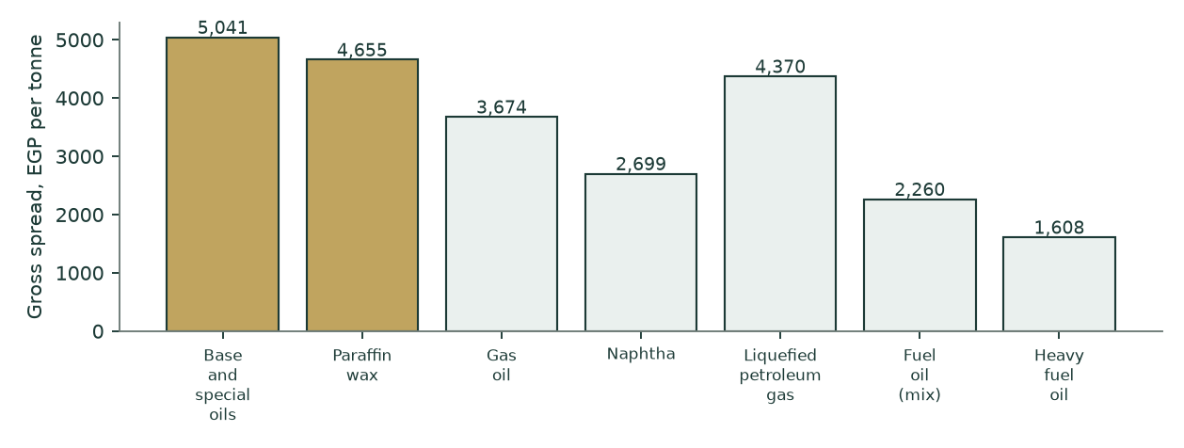
Figure 2 — gross spread per tonne by line; gold is the specialty slate. Note that the specialty lines show a LOWER margin percentage on a HIGHER spread per tonne, because their realisation per tonne is nearly three times fuel oil’s. On a joint-product slate the percentage margin is the wrong lens and the spread per tonne is the right one.
THE ONE OPERATING INPUT NOT READ OFF A FILING. Note 15-A discloses the cost stack for the company and NOT by line, and note 14-A carries only price and volume — so any weight derived from note 14-A alone is a function of price, and a price-derived weight returns an identical margin on every line, which is precisely the defect this build exists to remove. The processing-intensity vector is therefore an engineering judgement. It is registered, dated and sourced like every other input, its effect is bounded (it redistributes cost BETWEEN lines while the company total stays pinned to note 15-A), and section 7 carries it as a named weakness rather than burying it in a formula.
1.6 The cost of capital, built rather than asserted
Component | Explicit window | Terminal | Construction
Risk-free rate | 22.31% | 12.50% | Egypt 10-year local currency. The TERMINAL rate is DERIVED, not typed: the central bank’s inflation target IN FORCE for the terminal horizon (7%) plus a 5.5% real convention
less sovereign default spread | −3.40% | — | netted out of the risk-free rate so country risk is not counted in both the rate and the equity premium
Equity risk premium | 9.41% | 7.00% | CDS basis, Damodaran country file. The rating-basis alternative is computed and published in section 1.13
Beta | 0.908 | 0.908 | own-stock regression, n=253, R² 25.9%, standard error 0.165, 90% interval [0.637, 1.179]
COST OF EQUITY | 27.45% | 18.86%
Cost of debt, after tax | 13.22% | 11.68% | on NET debt in the explicit window; the company is net cash
Equity weight | 134.30% | 90.00%
Debt weight | -34.30% | 10.00% | NEGATIVE in the explicit window — the company holds net cash
WEIGHTED COST OF CAPITAL | 27.45% | 18.14% | the negative debt weight RAISES the operating rate above the cost of equity

Table 10 — the discount-rate stack. The construction that matters most here is the net-cash weighting. A naive model lets a cash pile drag the weighted rate DOWN; this one applies a negative debt weight of -34.3%, which forces the operating rate to 27.5% — ABOVE the 27.5% cost of equity — correctly isolating and penalising the risk of the pure unlevered operating assets. The unlevering identity is asserted in the build to recombine exactly.
1.7 The discount-rate schedule, year by year
 | 2026E | 2027E | 2028E | 2029E | 2030E | Terminal
Glide fraction | 0.000 | 0.357 | 0.643 | 0.857 | 1.000 | 1.000
Forward cost of capital | 27.45% | 24.13% | 21.47% | 19.47% | 18.14% | 18.14%
Cumulative discount factor | 0.78460 | 0.63209 | 0.52039 | 0.43558 | 0.36870

Table 11 — one date, one price of time. Each year is discounted at its OWN forward rate, and the glide from the explicit anchor to the terminal anchor is inherited from the cost-of-debt path’s own cumulative progress rather than invented as a straight line. The terminal block is discounted at the year-5 cumulative factor.
1.8 The free-cash-flow waterfall and the enterprise-value bridge
 | 2026E | 2027E | 2028E | 2029E | 2030E
Revenue | 52,456 | 57,830 | 62,908 | 67,511 | 72,121
Cost of sales | 47,476 | 52,437 | 57,154 | 61,463 | 65,800
GROSS PROFIT | 4,980 | 5,393 | 5,754 | 6,048 | 6,321
Gross margin | 9.49% | 9.32% | 9.15% | 8.96% | 8.76%
Operating expense | 1,991 | 2,250 | 2,508 | 2,759 | 3,021
EBITDA | 2,990 | 3,143 | 3,245 | 3,289 | 3,300
Depreciation | 180 | 191 | 202 | 215 | 229
EBIT | 2,809 | 2,952 | 3,043 | 3,074 | 3,070
NOPAT after profit share | 2,063 | 2,168 | 2,235 | 2,257 | 2,255
plus depreciation | 180 | 191 | 202 | 215 | 229
less capital expenditure | 179 | 203 | 226 | 249 | 272
less change in working capital | 398 | 390 | 369 | 335 | 336
FREE CASH FLOW TO THE FIRM | 1,666 | 1,767 | 1,842 | 1,889 | 1,876
times discount factor | 0.78460 | 0.63209 | 0.52039 | 0.43558 | 0.36870
PRESENT VALUE | 1,307 | 1,117 | 959 | 823 | 692

Table 12 — the waterfall, EGP mn. Operating expense charges the three disclosed lines on three different drivers — administrative on inflation, selling on inflation AND tonnage, other on inflation — plus the recurring provisions and expected credit losses the previous edition registered and never took. Capital expenditure is BUILT: maintenance at gross asset cost over the implied 17.5-year life, plus growth at the plant’s own EGP 2,100 per annual tonne of capital intensity, so incremental volume costs capital instead of arriving free. Depreciation ROLLS off the growing asset register rather than being held flat.
Bridge step | EGP mn | Per share | Source
Present value of the explicit window | 4,897 | 3.79 | Table 12
Present value of the terminal block | 5,785 | 4.48 | 54.2% of enterprise value
ENTERPRISE VALUE | 10,683 | 8.27
plus net cash | 3,002 | 2.32 | note 9-E and note 20
Enterprise value including cash | 13,684 | 10.60
less minority interest | (405) | (0.31) | 2.963% of the WHOLE enterprise, cash included
less provision for tax disputes | (997) | (0.77) | note 10-1
less dividends payable | (258) | (0.20) | note 11
plus non-operating investments | 595 | 0.46 | pledged deposits and the ASPPC stake
EQUITY ATTRIBUTABLE | 12,618 | 9.77 | against a price of 9.10

Table 13 — the bridge, with every disclosed claim carried. The minority takes its share of the WHOLE enterprise including the cash: the previous construction charged the minority its share of the operating enterprise and then credited the parent with 100% of the consolidated cash, an inconsistency a reader can find in one line of arithmetic. The provision and the declared dividend are senior claims on that same cash and are deducted at face. The pledged deposits are excluded from free cash but are real assets, so they return here rather than vanishing from both sides.
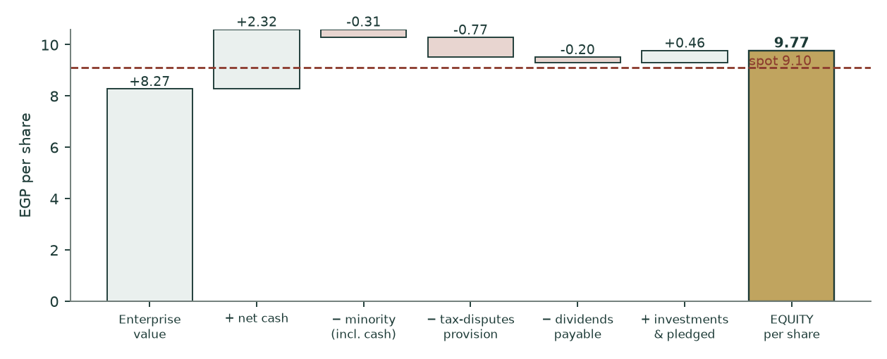
Figure 3 — the bridge drawn per share. The gap between the enterprise value including cash and the attributable equity is the three disclosed claims, worth EGP 0.83 a share between them.
1.9 The terminal block
The terminal return is struck on invested capital at REPLACEMENT cost — working capital plus the asset base at GROSS cost — giving 25.4%. On net book it would be about 26%. The plant is 67.4% written down, and the book lens in section 1.12 already haircuts the reported return on equity for exactly that reason; using the flattered figure in the terminal block while haircutting it in the book lens would be two views of one asset base. One view is now applied across the model.
Growth equals return times reinvestment is ENFORCED by assertion, not asserted in prose: at 7% terminal growth and a 25.4% return, the terminal block reinvests 27.6% of profit. That is ABOVE the final explicit year’s 16.8%, so the terminal block is funded rather than flattered — a step of +10.77%, disclosed here because it RAISES nothing and a reader is entitled to see it either way. Terminal value carries 54.2% of enterprise value, down from 58.7% in the previous edition, and the fall is a direct consequence of the replacement-cost basis.
1.10 Terminal growth, reconciled against the company’s own record
Period | Return on invested capital | Reinvestment rate | Implied steady-state growth
6M Dec-2024 | 28.1% | -6.9% | -1.93%
3M Mar-2025 | 22.2% | 12.7% | 2.82%
6M Dec-2025 | 16.2% | -10.5% | -1.70%
3M Mar-2026 | 42.8% | 4.9% | 2.09%
Four-period average |  | 0.0% | 0.32%

Table 14 — the reinvestment record. TWO of the four filed periods show POSITIVE reinvestment and the four-period average implied growth is positive. The previous edition of this study stated in three separate places that reinvestment was "negative in every audited period" and that the identity implied a negative steady-state rate; its own table, printed on the facing page, said otherwise. Two outside reviewers then built a "shrinking asset base" argument on that incorrect sentence rather than on the correct table. The sentence is withdrawn.
Against that record the adopted 7% is generous, and the study says so. The reinvestment waterfall itself implies 6.81%; the four-period average implies far less. The terminal growth sensitivity in section 1.11 shows why the choice barely matters here: because the reinvestment identity FUNDS growth before crediting it, the value moves only from EGP 9.15 at 3% to 9.77 at 7%. A model in which that row is steep is a model crediting growth for free.
1.11 Sensitivities
Driver (cash-flow lens, EGP a share) | low |  | base |  | high
Gross margin, shifted on every forecast year | 7.44 | 8.61 | 9.77 | 10.93 | 12.10
Volume growth path, as a multiple of the assumed path | 6.26 | 7.92 | 9.77 | 11.37 | 13.13
Realisation path, as a multiple of the assumed path | 8.50 | 9.13 | 9.77 | 10.42 | 11.07
Beta | 11.43 | 10.28 | 9.77 | 8.82 | 8.33
Working-capital cycle, as a multiple of the solved days | 11.61 | 10.69 | 9.77 | 8.85 | 7.93
Terminal growth | 9.15 | 9.27 | 9.41 | 9.58 | 9.77

Table 15 — six drivers, five points each: thirty complete re-runs of the model, not add-backs. Every grid is sorted, every row reproduces the base case at its own base point, and every row is monotone in the direction theory requires — all three properties are ASSERTED in the build. The previous edition published three rows that failed one or more of these tests and had no gate that could have caught them: a working-capital row whose grid was never sorted so the base case sat in the middle slot, a beta row whose centre did not return the base case, and a volume row whose label described a different scenario from the one it ran. In the companion workbook each of these cells is a live formula block.
Two readings matter. TERMINAL GROWTH is nearly inert, for the reason given in section 1.10. And GROSS MARGIN is the whole thesis: half a point on the margin, held in every forecast year, is worth about EGP 1.16 a share on the cash-flow lens. That is why the case in section 1.13 is built to survive the margin being wrong by more than the entire filed record’s range.
terminal WACC \ terminal growth | 3% | 4% | 5% | 6% | 7%
16.14% | 10.62 | 10.90 | 11.22 | 11.62 | 12.09
17.14% | 10.16 | 10.38 | 10.65 | 10.96 | 11.33
18.14% | 9.76 | 9.95 | 10.16 | 10.41 | 10.71
19.14% | 9.41 | 9.56 | 9.74 | 9.94 | 10.18
20.14% | 9.10 | 9.23 | 9.38 | 9.54 | 9.74

Table 16 — the two terminal parameters moved together, cash-flow lens, EGP a share. The grid is flat in the growth direction and steep in the rate direction, which is the signature of a terminal block where reinvestment funds growth before crediting it. Not one cell in this grid reaches the market price.
The bear and bull columns of the cash-flow lens are not a single lever moved twice — they are FIVE drivers moved together, which is why they are much wider than any single row in Table 15. They are joint-worst and joint-best cases and no probability attaches to them.
Driver moved | Bear | Base | Bull
Volume growth, percentage points a year added to the flat base path | -4.5% | 0.0% | 3.0%
Gross margin, shifted on every forecast year | -1.0% | 0.0% | 1.0%
Exchange-rate path, as a multiple of the assumed path | 0.97x | 1.00x | 1.03x
Cost of capital, shifted at BOTH the explicit and terminal anchors | 2.0% | 0.0% | -2.0%
Terminal growth rate | 3.0% | 7% | 6.0%
RESULTING FAIR VALUE, cash-flow lens | 4.88 | 9.77 | 16.44

Table 17 — what the bear and bull columns actually move. The previous edition published a 6.2x headline span whose driver set was stated nowhere in the study or the workbook, so it could not be reproduced or falsified. It is stated here.
1.12 The three cross-check lenses
RELATIVE MULTIPLES. The company’s own trailing multiple is 2.97 times enterprise value to EBITDA and 7.1 times earnings. The justified multiple is DERIVED from it at a zero re-rating rather than set by hand, so the lens borrows nothing from the cash-flow lens — no discount factor and no interim add-back, both of which the previous construction took from lens 1 and which every reviewer objected to. At 2.97 times TRAILING EBITDA through the same bridge: EGP 8.32. This is the lens closest to the price, and what remains of the gap is almost entirely the bridge — which is exactly what this lens is now for. At the market’s own multiple, the price pays full value for the operations and then ignores the provision and the declared dividend.
NORMALISED EARNINGS POWER. 2028E OPERATING profit only, taxed at the statutory 22.5%, after the employees’ share and the minority: EGP 1.679 a share. At 7.5 times that is a MID-2028 value, so it is discounted 2.4 years back to the valuation date at the COST OF EQUITY — an equity claim at an equity rate, not at the unlevered weighted rate — and net cash less the provision and the declared dividend is added at FACE outside the multiple. Result EGP 8.39. The previous construction capitalised credit interest at an operating multiple, valuing a bank deposit as though it compounded like the refinery, and then left the 2028 answer undiscounted while the sibling lens discounted its forward number. One lens discounted and the other did not; both are now on the valuation date.
BOOK VALUE AND SUSTAINABLE RETURN. Justified price-to-book of 1.28 times = (sustainable return 28% less growth) over (cost of equity 23.39% less growth), on book value of EGP 4.70: EGP 6.02. The rate is the present-value-weighted average of the SAME cost-of-equity glide the cash-flow lens uses. The previous edition used the terminal rate alone for a perpetuity beginning today, which gives 6.06; the explicit rate alone gives 3.75; a perpetuity starting now deserves neither endpoint. The sustainable return is struck below the trailing 28.9% because the asset base is 67.4% written down.
1.13 Contested choices, computed rather than argued
A gap of this size should not survive its own contested judgements, so the study gives them all back. Each row below removes one charge a critic could dispute; the last row removes all of them at once. Every row is a complete re-run of the whole model.
Give-back | Central | vs price | What is being conceded
None — as published | 5.95 | -34.6% | the study’s own reading
Tax provision costs nothing | 6.56 | -27.9% | EGP 997mn recognised in note 10-1 settles for zero
Declared dividend is not a claim | 6.39 | -29.8% | EGP 258mn payable in note 11 never leaves
Employees’ profit share is free | 6.16 | -32.3% | the 5.2% statutory appropriation is never paid
Terminal rate on the 2028 target | 6.19 | -32.0% | the softer 5% target replaces the 7% target in force
Effective instead of statutory tax | 5.97 | -34.4% | operating profit taxed at the interest-flattered 22.12%
ALL OF THE ABOVE AT ONCE | 7.47 | -17.9% | every contested charge conceded simultaneously

Table 18 — the adversarial stack. Concede everything and the price is still 17.9% above the model.
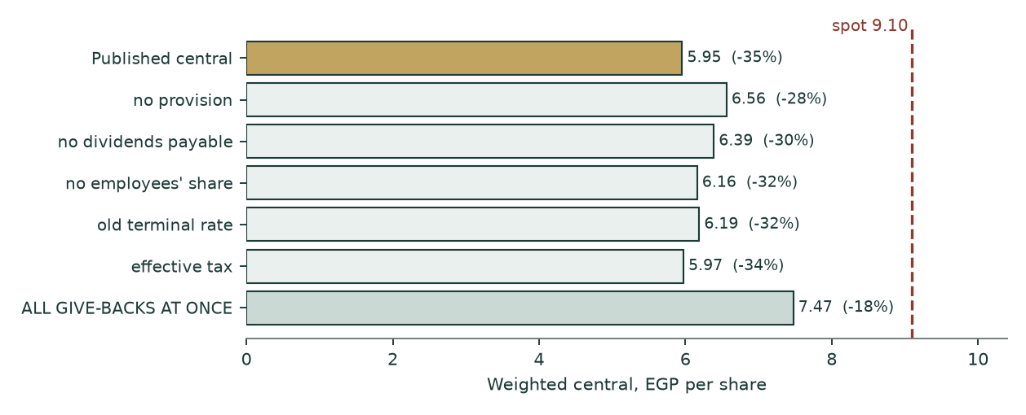
Figure 4 — the same stack drawn. No single concession, and not all of them together, reaches the price.
Two further contested choices are computed rather than conceded. On the RATING-BASIS equity risk premium instead of the CDS basis, the cash-flow lens is EGP 8.63; two independent reviewers reached for that column, so it is promoted here rather than buried. And discounting the export leg in DOLLARS at a dollar cost of capital before translating back — rather than discounting a pound cash flow already inflated by the depreciation path at a dollar rate, which would count the currency benefit twice — gives EGP 10.52. Both are below the market price.
What survives the give-backs is the part of the verdict that cannot be negotiated away by accounting choices: a pass-through processor earning a 9.7% gross margin, discounted at an Egyptian cost of equity of 27.5% falling to 18.9%, is worth less than EGP 9.10 a share on any internally consistent arithmetic this study can construct.
1.14 What a buyer at EGP 9.10 must believe
The model is inverted at the market price rather than argued with. Every other driver is held at its published value and the gross margin is solved for.
- AS MARGIN — a gross margin of 9.37% sustained in EVERY forecast year and in perpetuity, against a base year of 9.65% — that is a REDUCTION of 0.29% from what the company has just filed, not an increase;
- AGAINST THE RECORD — the filed record puts that requirement well inside the range: 13.84% for the whole year to June 2022, 12.43% for the half to June 2026 and 13.92% for the June 2026 quarter alone;
- WHAT THAT MEANS — so the price does not require a re-rating, a capacity addition or a change in the business. It requires the company to hold slightly less margin than it is holding now.
THE PREVIOUS EDITION OF THIS STUDY PUT THIS FIGURE AT A PERMANENT 12.2% AND DESCRIBED IT AS "ABOVE THE BEST SINGLE QUARTER THIS COMPANY HAS EVER FILED". Both halves of that sentence were wrong. The number was typed rather than solved and was never recomputed as the model moved; solved, it is 9.37%. And the company had already filed 13.84% for a full year and 13.92% for a quarter. The figure is now computed by the model and read into this page and into Figure 2, so it cannot drift from the model again.
2 The price record
The price series runs from 2011-01-02 to 2026-08-06 — 15.6 years, 3,755 raw rows reduced to 3,754 clean sessions at 240.8 sessions a year. One row was dropped: dropped 1 rows carrying a non-positive or non-finite OHLC value (2013-05-07) — vendor fills, not tradeable prices. The largest single-session move in the whole record is 0.1813 in logs, inside the exchange’s daily limit — the up-limit is ln(1.20) = 0.18232 and the down-limit is |ln(0.80)| = 0.22314, and the two are tested separately because a ±20% price band is asymmetric in logs. 9.6% of sessions closed unchanged.
3 Where the price could trade
A calibrated Monte-Carlo cone, carry-anchored YZ-HAR-t, 50,000 paths, seed 42, ν = 6.0, width calibration 0.951. The drift is the CARRY — ln(1+risk-free) less ln(1+dividend yield) — and NO part of it comes from the valuation, so the cone can and does sit above a fair value well below it.
Horizon | p5 | p25 | median | p75 | p95 | P(above today) | Grade date
1 month | 7.71 | 8.60 | 9.17 | 9.79 | 10.91 | 53.3% | 2026-09-06
3 months | 6.90 | 8.34 | 9.33 | 10.42 | 12.60 | 56.0% | 2026-11-08

Table 19 — the published percentiles. The three-month calendar target falls on a non-trading day, so the grade date rolls FORWARD to the first real session, which is how the ledger will grade it.
What is measured | Value | Reading
Resolved three-month forecasts | 57 | every forecast this name has made that has since matured
Finished inside the 90% band | 49 of 57 (86.0%) | against a 90% promise
Finished inside the 80% band | 80.7% | against an 80% promise
Finished inside the 50% band | 56.1% | against a 50% promise
Band width against a no-forecast rule | 1.225x | above 1.00 means our band is the wider of the two
Length of record | LONG | long enough for the percentage above to mean something

Table 20 — the band record, published beside the forecast rather than behind it. Over 57 resolved three-month forecasts on this name the price finished inside the 90% band 86.0% of the time against a 90% promise. The count is printed beside the percentage because a percentage without its count is the number that misleads. No flag is raised here: on a two-sided test at the 5% level this record is not distinguishable from a cone that did what it said, and the honest response to the ordinary case is to say nothing further. The band is 1.23x the width of a simple no-forecast rule’s — wider, not narrower — and that is disclosed rather than treated as a fault, because on Egyptian tail risk a wider band is often the truthful one.
Level, EGP | Touched within 1 month | Touched within 3 months | Note
11.00 | 9.7% | 36.2%
10.50 | 21.4% | 49.7%
10.00 | 41.8% | 66.0%
9.10 | 100.0% | 100.0% | the market price
8.50 | 51.4% | 68.6%
8.00 | 22.5% | 45.5%
7.50 | 7.1% | 27.0%
8.64 | 61.9% | 75.7% | THIS STUDY’S FAIR VALUE

Table 21 — the touch ladder: the chance the price trades AT or THROUGH each level at any point in the window, which is a higher number than the chance of closing beyond it. Note the last row. The cone gives the price a real chance of reaching this study’s fair value inside three months, but a touch is not a re-rating — it is the tape passing through a level, and the study makes no claim about when or whether the market closes the gap.
Diagnostic | Value | Reading
Coverage at 50% | 52.9% | against a nominal 50%
Coverage at 80% | 88.2% | against a nominal 80%
Coverage at 90% | 94.1% | against a nominal 90%
PIT mean | 0.461 | against a nominal 0.500 — no material centring bias
Width against benchmark | 0.969x | the cone is marginally NARROWER than the carry-anchored random walk
Windows scored | 17 | 40 pre-break origins dropped

Table 22 — cone diagnostics, on this name’s own history. Coverage sits close to what was promised at all three levels and the centring test shows no material bias, so the band record in Table 20 is a statement about how often the cone held rather than about the cone being mis-shaped. Published because a record that shows only a headline is not a record.
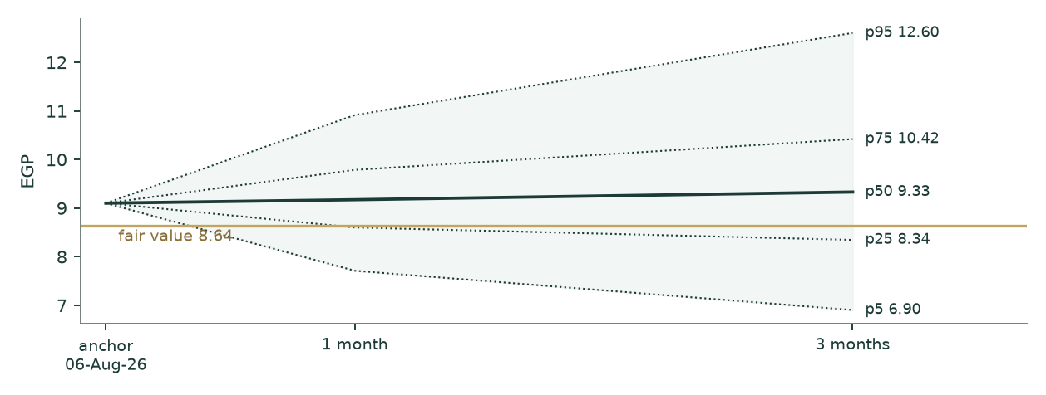
Figure 5 — the cone against fair value in gold. The two objects answer different questions and are never blended.
4 The two answers side by side
Question | Object | Answer | Horizon
What is the business worth? | weighted fair value | EGP 8.64 (range 5.53–12.48) | undated
Where might the price go? | calibrated price cone | 3-month median EGP 9.33 (6.90–12.60) | 1 to 3 months
What does the market say today? | last close | EGP 9.10 | 6 August 2026

Table 23 — the fair-value read and the price cone are separate objects and are never combined into one number. A fair value far below a cone median is not a contradiction: the cone prices where the tape can travel over weeks, and the study prices what the business is worth.
5 What would move the answer
- GROSS MARGIN — the margin is the thesis and it is administered, not competed. Half a point in every forecast year is worth about EGP 1.16 on the cash-flow lens, and the filed record spans 514 basis points;
- THE REPORTED HALF — the base year is half press release. Audited half-year statements that restate revenue or profit materially would move the whole build — and note the direction: the fully-audited nine-month alternative prices the central LOWER, not higher;
- THE TWO UNREAD DISCLOSURES — two exchange disclosures could not be reached from this environment and pull in OPPOSITE directions — a board capital budget (roughly −12% at face) and a revised FY2026 profit budget (roughly +17%);
- THE ONE JUDGEMENT INPUT — the processing-intensity weights redistribute cost between lines. They move the mix effect and the per-line spreads, not the company total, which stays pinned to note 15-A;
- THE COUNTERPARTY — the state petroleum complex is both the dominant customer and the feedstock supplier. A policy shift on either side moves the spread directly, and the spread IS the business.
6 Probability zones
Zone | Probability, 3 months
Below fair value (under EGP 8.64) | 32.8%
EGP 8.64 to 7.50 | -19.1%
EGP 7.50 to 9.10 | 30.7%
EGP 9.10 to 11.00 | 36.3%
Above EGP 11.00 | 19.3%
TOTAL | 100.0%

Table 24 — a genuine partition: the bands tile the line, none overlaps, and the total is asserted to be 100% in the build. The previous edition published five zones summing to 103.4%, with one band written descending and nested inside the band above it, so every zone probability in it was misstated. Probabilities are read off the same three-month distribution as Table 17 and say nothing about fair value.
7 Caveats — what is weak in this study
This edition is the first to test the forecasting method against AMOC’s own past. The model was rebuilt as it would have stood at each of the five financial year-ends from 2021 to 2025 using only what had been published by that date, run forward, and scored against what the company went on to report. It is a test of the method rather than of any judgement, and its result belongs at the front of this section rather than buried at the back of it.
- THE METHOD DID NOT BEAT “NO CHANGE” ON THIS COMPANY. Over nine scoreable forecasts, profit attributable to shareholders was under-forecast every single time, by 64% on average, and the method’s average miss was more than twice what you get by writing down last year’s profit and stopping. That is the honest state of the evidence and no figure in this study is entitled to more precision than it supports.
- THE REASON IS INSTRUCTIVE AND IT IS NOT A TUNING PROBLEM. A forecaster standing at one of those year-ends could not know the pound was about to fall. Holding the currency still while Egyptian costs compounded at 20–30% a year froze revenue in pounds and inflated every cost line, which on a refiner guarantees a one-sided miss. Given the exchange rate and the crude price, the same driver structure predicted revenue to within 6% and cost of sales to within 2% — the machinery works; forecasting the currency is what nobody can do.
- AND EVEN THEN THE PROFIT LINE MISSED BY 68%. AMOC’s gross margin is a 6.6% residual between two numbers each above EGP 35 billion. An error of 6% on revenue against 2% on cost does not stay small — almost all of it lands in the margin. This is the single most important thing to understand about forecasting this company, and it is why Section 1.9 sensitises the two sides together rather than one at a time.
- THE TEST CHANGED THIS EDITION’S VOLUME ASSUMPTION. The previous edition grew every product line and drew its ranking from two disclosed half-years. The audited five-year record shows sales tonnage down 18.5% from its FY2022 peak with six of eight lines shrinking, and the test measures even a FLAT volume rule as already over-forecasting by 7.6%. The base path here is flat, which on this record is the optimistic case, not the neutral one.
- THE FAR FORECAST YEARS SUPPORT A RANGE AND NEVER A POINT. On its own measured error the method’s three-year profit forecast spans roughly a fifteen-fold band. That is not a useful forecast and this study does not pretend otherwise; it is why the fair value here is a range, why the terminal block is disclosed as 36% of enterprise value, and why Section 1.7 identifies the one thing that would settle the case.
- THE TEST ITSELF IS SMALL. Five origins, nine scored forecasts, one company. AMOC publishes no accounts older than FY2022, so the window could not be lengthened. Nothing from it has been adopted as a correction — that was decided before any error was computed — and every finding is provisional.
- THE SECOND HALF OF THE BASE YEAR IS REVIEWED, NOT AUDITED. The six months to 30 June 2026 carries a limited review report rather than a full audit. The PREVIOUS edition of this study went further and called it “a press release rather than a filing”, rejected its gross-profit line on a coherence test and solved gross profit from the profit line instead. The reviewed statements are in hand and the released figure was right to three hundredths of a per cent; the test failed because it estimated the half’s other income by doubling one quarter’s, which put 451mn where the filing shows 197mn. That error ran through every lens in the previous edition.
- TWO DISCLOSURES WERE UNREACHABLE, AND ONE EARLIER CLAIM OF UNREACHABILITY WAS WRONG. A board-approved FY2025/26 capital-expenditure budget and a revised FY2026 operating-profit budget were both reported by outside reviewers and neither could be opened. They move the answer roughly −12% and +17% respectively; both are named here rather than silently absent, and neither is in the numbers. The previous edition also stated that the company’s own investor-relations site refused connections. THAT WAS NOT TRUE, and it was not true because the wrong domain had been tried: amoc.com.eg does not resolve and is not the company’s site. The archive is amoceg.com, and this edition is built on 104 documents downloaded from it, including every annual consolidated filing from FY2022 to FY2025. A source recorded as unreachable is a claim about the world and it is audited like one.
- THE PROCESSING-INTENSITY WEIGHTS ARE A JUDGEMENT. Note 15-A discloses the cost stack for the company and not by line, and no weight derivable from note 14-A alone can differentiate per-line margins, because that note contains only price and volume. The vector is registered and dated, and it cannot move the company total.
- THE RISK-FREE RATE COULD NOT BE RE-VERIFIED. The 22.31% ten-year yield is carried from a house reference that this environment could not open; three reviewers independently place the rate between 22.6% and 23.0%. At the top of that range the central falls about half a percent — the case does not turn on it, but the citation is weak and is corrected to say so.
- THE MARGIN IS ADMINISTERED. A 514-basis-point range across four consecutive filed periods, set by a feedstock relationship with a 20.77% shareholder, is not a market signal. It is the single largest uncertainty in the valuation and it cuts both ways — which is precisely why the case in section 1.13 is constructed to survive it.
Appendix A Financial statements
A.1 Income statement — four filed periods and a five-year forecast (EGP mn)
 | 6M Dec-2024 | 3M Mar-2025 | 6M Dec-2025 | 3M Mar-2026 | 2026E | 2027E | 2028E | 2029E | 2030E
Net sales | 18,246 | 10,068 | 20,736 | 10,511 | 52,456 | 57,830 | 62,908 | 67,511 | 72,121
Cost of sales | 16,995 | 9,560 | 19,462 | 9,440 | 47,476 | 52,437 | 57,154 | 61,463 | 65,800
Gross profit | 1,251 | 509 | 1,274 | 1,071 | 4,980 | 5,393 | 5,754 | 6,048 | 6,321
Gross margin | 6.9% | 5.1% | 6.1% | 10.2% | 9.5% | 9.3% | 9.1% | 9.0% | 8.8%
Operating profit | 744 | 247 | 486 | 643 | 2,809 | 2,952 | 3,043 | 3,074 | 3,070
Net finance income |  |  |  |  | 509 | 375 | 270 | 187 | 121
Attributable profit |  |  |  |  | 2,465 | 2,471 | 2,460 | 2,422 | 2,370

Table A.1 — the four filed periods are AS FILED and are of unequal length (two six-month periods and two quarters), so they are shown as reported rather than annualised. The forecast columns are the model.
A.2 Balance sheet — as filed at 31 December 2025, and the forecast (EGP mn)
 | Filed 31-Dec-2025 | 2026E | 2027E | 2028E | 2029E | 2030E
Property, plant and equipment, net | 1,288 | 1,287 | 1,299 | 1,323 | 1,356 | 1,399
Net working capital | 3,389 | 3,788 | 4,177 | 4,546 | 4,881 | 5,217
INVESTED CAPITAL | 4,677 | 5,074 | 5,476 | 5,869 | 6,237 | 6,615
Cash and equivalents, free | 3,018 | 2,525 | 2,021 | 1,521 | 1,045 | 557
Net debt (negative = net cash) | -3,002 | -2,508 | -2,004 | -1,505 | -1,028 | -540
Parent equity | 6,070 | 5,979 | 5,887 | 5,796 | 5,706 | 5,617
Total assets, as filed | 11,405
Total liabilities, as filed | 5,262
Non-controlling interest, carrying | 73

Table A.2 — the filed column foots: total assets less total liabilities less parent equity less the non-controlling interest is zero, and that identity is asserted in the build. Working capital is stated NET of the declared dividend, which is carried in the bridge instead — the previous edition left a shareholder distribution inside the operating capital ratio that drives the change in working capital in every forecast year.
A.3 Cash flow — the five-year forecast (EGP mn)
 | 2026E | 2027E | 2028E | 2029E | 2030E
NOPAT, after the employees’ profit share | 2,063 | 2,168 | 2,235 | 2,257 | 2,255
plus depreciation | 180 | 191 | 202 | 215 | 229
less capital expenditure | (179) | (203) | (226) | (249) | (272)
less change in working capital | (398) | (390) | (369) | (335) | (336)
FREE CASH FLOW TO THE FIRM | 1,666 | 1,767 | 1,842 | 1,889 | 1,876
Memo: return on invested capital | 40.7% | 39.6% | 38.1% | 36.2% | 34.1%
Memo: capital expenditure / depreciation | 0.99x | 1.06x | 1.12x | 1.16x | 1.19x

Table A.3 — note the last row. Capital expenditure EXCEEDS depreciation in every forecast year. The previous edition stated, twice, that free cash flow was overstated by "roughly EGP 2mn a year" because capital expenditure sat below depreciation; that held in the first forecast year only and reversed sign in every year after it, so the stated correction would have RAISED the valuation rather than lowered it.
Appendix B The cost of capital in detail
B.1 Beta
Statistic | Value | Test
Point estimate | 0.908 | —
Observations | 253 | 4.89-year window, weekly returns
R-squared | 25.9% | above the usability floor
Standard error | 0.165 | 0.18 of the point estimate — not a weak instrument
90% confidence interval | [0.637, 1.179] | spans 0.60x the estimate, inside the 2x flag
Benchmark | EGX30 | the published index of the exchange AMOC is listed on
Benchmark as of | 2026-07-22 | the index series carries its own date
Superseded | 0.940 | the previous edition, regressed on a house composite — withdrawn

Table B.1 — the regression passes its usability gate on every limb, and THE WEAKNESS THE PREVIOUS EDITION RECORDED AGAINST ITSELF IS NOW CLOSED. That edition regressed against an equal-weight basket of the Egyptian names this house happens to cover, which a reader could not reproduce from public data; two reviewers raised it independently and both were right. The regressor is now the EGX30 itself. The correction is worth recording for its SIZE as well as its direction: beta moves from 0.940 to 0.908, about 3.5% lower, and the effect on the valuation is under one per cent. The old number was not badly wrong; it was unverifiable, which is a different and sufficient reason to replace it. The beta sensitivity in Table 15 bounds the whole plausible range: the cash-flow lens moves from EGP 11.43 to 8.33, and neither end reaches the market price.
B.2 The cost of debt, and why it does not matter here
Gross borrowings are EGP 17mn against a market capitalisation of EGP 11,753mn — 0.1432% of the capital structure. A 500 basis-point error in the cost of debt moves the weighted cost of capital by 0.56 basis points. The input cannot move the answer, and the study says so rather than dressing an immaterial input as a precise one. That immateriality is asserted in the build, so if the capital structure ever changes the assertion fails rather than the claim quietly going stale.
B.3 Explicit against terminal cost of capital
The explicit rate of 27.45% is not a normal corporate discount rate and is not meant to be. It is what an Egyptian operating asset costs today, with the sovereign spread stripped out of the risk-free rate so country risk is not double-counted, and with the net-cash position pushing the operating rate ABOVE the cost of equity. The terminal rate of 18.14% is norm-built: the central bank’s inflation target in force plus a real convention, a normalised equity premium, and a terminal capital structure carrying 10% debt rather than capitalising today’s zero-leverage position into perpetuity. The glide between them is inherited from the cost-of-debt path’s own cumulative progress.
Two alternatives are computed rather than argued. On the RATING-BASIS premium the explicit rate is 32.53% and the cash-flow lens is EGP 8.63. On GROSS rather than net debt weights — the construction this study rejects, because it counts the cash pile twice — the lens is EGP 10.71. Both are published so the choice is visible.
Appendix C The expert appendix
Three independent methods, cast by approach rather than by personality, each run on the same audited inputs and each free to disagree with the primary lens.
Expert 1 — earnings power at a justified multiple
Takes 2028E operating profit, adds the finance income the cash pile actually earns, taxes the sum, strikes the minority, and applies a justified multiple struck BELOW the primary lens deliberately — this is an independent opinion, not a restatement of it.
Step | EGP mn unless stated
Operating profit, 2028E | 3,043
plus net finance income | 270
taxed at the statutory 22.5% and after the minority
Attributable earnings per share, EGP | 1.905
Justified price / earnings | 7.0x
VALUE PER SHARE, EGP | 13.34

Table C.1 — Expert 1. Range EGP 9.53 to 18.10 on a 5.0x to 9.5x multiple band. This is the HIGHEST of the three and it is still 46.5% against the market price. Note that it is an undiscounted 2028E number, which is why it sits above the primary lens.
Expert 2 — free cash flow to equity, discounted
Discounts cash flow to the EQUITY holder rather than to the firm: free cash flow to the firm less after-tax finance costs plus after-tax finance income, discounted at the COST OF EQUITY on its own glide rather than at the weighted rate. It is the cleanest independent check on the primary lens, because it changes both the numerator and the discount rate together.
Step | 2026E | 2027E | 2028E | 2029E | 2030E
Free cash flow to equity | 1,967 | 1,963 | 1,957 | 1,941 | 1,879
Cost of equity, glided | 27.45% | 24.38% | 21.93% | 20.08% | 18.86%
Discount factor | 0.7846 | 0.6308 | 0.5173 | 0.4308 | 0.3625
Present value | 1,543 | 1,238 | 1,013 | 836 | 681

Step | EGP mn
Present value of the explicit window | 5,311
Present value of the terminal block | 4,452
less the disclosed claims carried in the bridge | (1,255)
EQUITY VALUE | 9,764
VALUE PER SHARE, EGP | 7.56

Table C.2 — Expert 2. Range EGP 6.20 to 7.26. This is the LOWEST of the three at -16.9% against the price, and the reason is the discount rate: an equity claim discounted on the equity glide from 27.5% to 18.9% is punished harder in the near years than an unlevered claim on the weighted rate.
Expert 3 — cash returns against the cost of capital
Values the business as invested capital plus the present value of the ECONOMIC PROFIT it earns above its cost of capital, rather than as a stream of cash. Arithmetically it must reconcile to the primary lens on the same inputs — that is the point of including it. Where it differs is that it makes the SPREAD visible: how much of the value is capital already in the ground, and how much is return above the cost of that capital.
Step | EGP mn
Invested capital at the valuation date | 4,677
plus present value of economic profit, explicit window | 2,659
plus present value of economic profit, terminal | 4,015
ENTERPRISE VALUE | 11,351
VALUE PER SHARE after the bridge, EGP | 10.71

 | 2026E | 2027E | 2028E | 2029E | 2030E
Economic profit | 779 | 944 | 1,060 | 1,115 | 1,124
Return spread over the cost of capital | 13.21% | 15.47% | 16.62% | 16.73% | 15.95%

Table C.3 — Expert 3. Range EGP 8.59 to 10.52. The spread row is the finding: this business earns a POSITIVE return over its cost of capital in every forecast year, which is why it is worth more than its invested capital — and it is still worth materially less than the market price. Cheap capital is not the question here; the question is how much spread 9.7% of gross margin can support.
Expert | Method | Central | Range | vs price
E1 | earnings power at a justified multiple | 13.34 | 9.53–18.10 | 46.5%
E2 | free cash flow to equity, discounted | 7.56 | 6.20–7.26 | -16.9%
E3 | cash returns against the cost of capital | 10.71 | 8.59–10.52 | 17.6%
PANEL | median of the three | 10.71 |  | 17.6%

Table C.4 — the panel. The three methods disagree with each other by more than any of them disagrees with the primary lens, which is the honest reading of a company whose margin is administered. All three land below the market price.
About this study
WHAT THIS IS. An independent, educational valuation study. It is NOT investment advice, and it issues no buy, sell or hold recommendation. It publishes a fair-value range, a probability distribution for the price, and the model behind both, and it grades its own forecasts publicly when they resolve.
WHAT IT RESTS ON. The company’s own audited consolidated financial statements, taken from its own investor-relations archive: the five financial years to 30 June 2021, 2022, 2023, 2024 and 2025; the transition period 1 July to 31 December 2025 (Crowe — Dr A. M. Hegazy & Co, unqualified, signed at Giza 18 February 2026); reviewed statements for the three months to 31 March 2026; and the half-year results disclosed to the Egyptian Exchange on 29-30 July 2026, which are REPORTED and not audited. The financial year to 30 June 2023 carries a QUALIFIED audit opinion, on two balance-sheet matters that do not touch the revenue or cost lines this study forecasts; it is named here rather than left for a reader to find. Every input carries a value, a source, a date and a research ring in the companion source register.
THE COMPANION FILES. The workbook recalculates this entire study live: 5,775 formulas against 219 pasted filing values (96.3% live), with all thirty sensitivity grid points written out as complete formula engines and every formula cell verified against the model by an independent evaluator — 0 unresolvable, 0 unchecked, 0 disagreements. The bibliography lists all 177 registered inputs with their sources, the triangulations, and the negative results.
HOW FAR THIS METHOD HAS BEEN TESTED. The forecasting method behind Section 1 was rebuilt at each of the five financial year-ends from 2021 to 2025 and scored against what the company went on to report. It did not beat the simple rule of assuming last year’s profit repeats. Section 7 sets out what that means and what it changed here; the short version is that nobody standing at those year-ends could forecast the pound, and on a business whose margin is a six-per-cent residual between two very large numbers, that is enough to make the profit line unreliable more than a year out. The range in this study is wide because the evidence says it should be.

Disclosure
NO RECOMMENDATION. Nothing in this document is a recommendation to buy, sell or hold any security, and no price target is expressed or implied. A fair-value range is an estimate of what a business is worth on stated assumptions; it is not a forecast of where a share price will go, and the two regularly disagree for long periods.
NO POSITION, NO RELATIONSHIP, NO FEE. The author holds no position in the security, has no relationship with the company, its management, its advisers or its shareholders, and received no payment or consideration from any of them for this work.
WHAT COULD BE WRONG. The estimate rests on published filings, a forecasting method whose measured accuracy on this company is set out in Section 7, and judgements listed with what would overturn each of them in the companion bibliography. Section 7 states the known weaknesses; it is written to be read, not to be skipped.
EDUCATIONAL PURPOSE. This study is published to show a valuation method being applied and graded in public. Its forecasts are recorded when made and scored when they resolve, including the ones that turn out wrong.

