Testahil · Independent Valuation Study — Educational Analysis Not investment advice
Independent Valuation Study — Educational Analysis
Two Point Zero Group PJSC (ADX: 2POINTZERO)
Fundamental analysis · Technical analysis · Monte Carlo simulation — one integrated read
Anchor: AED 2.16 (3 July 2026 close) · 34,564 mn shares · market capitalisation AED 74.7 bn (~US$20.3 bn) · Abu Dhabi's IHC-controlled investment holding company, created by the November-2025 reverse merger in which Multiply Group absorbed 2PointZero Holding and Ghitha and took the 2PointZero name · it owns operating businesses in food, fashion retail, mining and media, and a AED 58.7 bn portfolio of financial investments · reporting currency AED, pegged to the US dollar at 3.6725 · every price and probability here is computed from daily history to 3 July 2026 · the swing factor: what a portfolio nobody outside the company can price is actually worth (§1.6).
READ FIRST — what this document is, and is not. This is a valuation exercise and a statement of personal analytical opinion, published free of charge for educational purposes. It is NOT investment advice, NOT a recommendation to buy, sell or hold any security, and NOT directed at any reader's circumstances. The preparer holds no licence from any securities regulator, manages no money and accepts no fees or clients. Every value here is a model output shown as a range, because no single number deserves to be relied on. The financial figures are the company's own: the audited 2025 accounts (Deloitte, unmodified opinion, 5 February 2026), the audited 2024 and 2023 accounts of the pre-merger Multiply Group, and the first-quarter 2026 results release.
THE MERGER — READ THIS TWICE. The November-2025 reverse merger means the year-on-year figures below are a change of perimeter, not growth. The 2025 revenue of AED 7.0 bn consolidates the acquired businesses for perhaps one to two months. The first quarter of 2026 — revenue AED 9.9 bn — is the first clean quarter of the merged company, and it is the base for everything forecast here. Comparing 2025 to 2024 measures the arrival of new subsidiaries, not the performance of old ones.
WHAT WE GOT WRONG THE FIRST TIME. An earlier draft of this study applied a single 25% margin to group revenue. That was wrong, and the company's own disclosure shows why: 59% of first-quarter profit came from the Investments vertical, which produces essentially no revenue at all. A margin applied to a sales line cannot see the majority of this company's earnings. This version values the operating businesses and the investment portfolio separately — which is the only honest way to value a holding company. The earlier draft also modelled a phased rise in the tax rate; there is no such phase-in, and the correction is applied here.
TIMING. The price history ends 3 July 2026. On 7–8 July the US–Iran ceasefire collapsed: Iran struck three commercial vessels in the Strait of Hormuz, the United States hit more than eighty targets in reply, and the President declared the ceasefire over. Brent rose above $78. Nothing in the prices, percentiles or probabilities below embeds that. It is carried throughout as an explicit, unpriced downside risk. Consult a licensed financial advisor before any investment decision.
The company
Two Point Zero Group is what Abu Dhabi's International Holding Company built when it decided its listed investment vehicle should stop being a collection of consumer businesses and start being a diversified capital platform. In November 2025 the listed Multiply Group absorbed 2PointZero Holding and the food group Ghitha from IHC entities, renamed itself, and emerged with roughly 34.6 billion shares and a balance sheet three times its former size. It now makes money two quite different ways. It owns and operates businesses — Ghitha in food, Tendam in fashion retail across 1,800 stores, International Resources Holding in copper and tin, a media arm, a driving school — which together turned AED 9.9 billion of first-quarter revenue into AED 3.0 billion of gross profit. And it holds a AED 58.7 billion portfolio of financial investments, which produces no revenue whatsoever and yet accounted for 59% of the group's first-quarter profit. Its advantage is positional rather than operational: proximity to the IHC ecosystem's deal flow, first call on state-linked capital, and the ability to have assets moved into it at prices minority shareholders do not set. The tension this study prices is easy to state and hard to settle: the audited book says each share is backed by AED 2.43 of equity, the market pays AED 2.16, and almost nothing about how that book was assembled can be checked against a screen.
2PointZero at a glance
Item | Value
Listed entity | Two Point Zero Group PJSC, ADX: 2POINTZERO (ISIN AEM001001019). Formerly Multiply Group; renamed after the November-2025 reverse merger
What it owns | Operating businesses (Ghitha 83.9%, Tendam 67.91%, International Resources Holding, Emirates Driving Company, Multiply Media, ISEM 60.8%) plus a AED 58.7 bn financial-investment portfolio (Lunate, Beltone, WHOOP, Getty, Kalyon and others)
Spot / date | AED 2.16 · 3 July 2026 close
Shares · market capitalisation | 34,564 mn · AED 74.7 bn (~US$20.3 bn)
Q1-2026 (the first clean merged quarter) | Revenue AED 9.9 bn · gross profit AED 3.0 bn (30% margin) · administrative costs AED 1.8 bn · investment and other income AED 1.2 bn · reported net profit AED 2.3 bn, of which AED 1.1 bn is unrealised revaluation gains · EPS AED 0.056
Where the profit comes from | By the company's own split: Investments 59% · Mining 22% · Energy 12% · Consumer 8%. By revenue: Consumer 52% · Mining 37% · Energy 12% · Investments ~0%
FY2025 (audited) | Revenue AED 7.004 bn · net profit AED 3.628 bn (attributable 3.440; EPS 0.246) · but it includes a +AED 2.73 bn disposal gain and a −AED 0.85 bn impairment, and the merger sits inside it for ~2 months only
Balance sheet | Assets AED 133.7 bn · owners' equity 83.9 bn · minorities 10.8 bn · cash 9.5 bn · book value per share AED 2.427
Investment portfolio | AED 58.7 bn carrying value against AED 48.0 bn invested. See §1.2 — this single line is the study
The June disposal | Sold its entire 7.29% of TAQA (9,095,702,934 shares) to Abu Dhabi Power, completed 11 June 2026. At TAQA's AED 2.37 close that is roughly AED 21.6 bn — against the AED 10 bn Multiply paid in 2022
Ownership | IHC-affiliated 60.57% · free float 39.05% (ADX disclosure, April 2026)
Dividend | None declared. Management states a policy intent from 2027
52-week range | AED 1.65 – 3.26 · one-year return -8.1%
Headline
The model's read: fully valued. And the reason sits in one line of the company's own disclosure. At AED 2.16 the shares trade about 13% above our weighted central estimate of AED 1.91, and 11% below the audited book value of AED 2.427 a share. The market, in other words, already applies a discount to this holding company's book. Our case is that the discount should be wider, and the evidence is the company's. The investment portfolio is carried at AED 58.7 bn against AED 48.0 bn invested — a AED 10.7 bn gain on paper. But in June the company sold its entire stake in TAQA, a listed Abu Dhabi utility, for roughly AED 21.6 bn, against the AED 10 bn it had paid. Strip that one holding out and the rest of the portfolio — every dirham of it now unlisted — is carried AED 0.9 bn BELOW what was paid for it. The entire mark-up was one listed stake, and it has been sold, with the proceeds redeployed into private midstream pipelines, private mines and private packaging. That is why this study values the parts separately and applies a wide discount to the part that cannot be priced. On a sum-of-the-parts basis, marking the operating businesses on their real earnings and discounting the portfolio for what it is, we get AED 1.95 a share. Capitalising the underlying earnings — everything except the marks — gives AED 1.39. A cash-flow model of the operating businesses, with the portfolio added back at its mark, gives AED 2.39, and it is treated as a ceiling because 81% of it is a terminal assumption. The technical picture is unresolved: price above the short averages but 11% below the 200-day, momentum just rolled over. Over three months the simulation puts the 5th-to-95th band at AED 1.59–3.00 with the median at 2.18 — and the July war re-escalation sits outside that map, not inside it.
Valuation summary — every read at a glance
Lens / read | What it measures | Output | Takeaway
FUNDAMENTAL — what the company is worth
Sum-of-the-parts (primary) | Operating businesses on their earnings; portfolio at mark, discounted; cash at par | AED 1.60–2.33 (base 1.95) | -10% vs spot
Cash-flow model + portfolio | Discounted cash flow on the operating legs, portfolio added at mark | AED 2.39 | +11% · the ceiling
Relative — reported earnings | 2026E attributable EPS with a normalised mark contribution, × 8–11× | AED 1.85 | -14%
Underlying earnings | The same earnings with every mark and one-off stripped out | AED 1.39 | -36% · the floor
Weighted central | Blend 45 / 15 / 25 / 15 | AED 1.91 (1.55–2.27) | spot is +13% above it
TECHNICAL — what the tape is doing (timing, not value)
Trend | Price against the 20/50/100/200-day averages | Above 20/50/100-day; 11% below the 200-day | Unresolved
Momentum | RSI · MACD · 52-week range | RSI 37 · MACD histogram -0.015 | Neutral, drifting
MONTE CARLO — where price could go in three months
T+20 sessions | 50,000 paths, no equity drift assumed | p5 1.80 · p50 2.17 · p95 2.59 | Median ≈ spot
T+60 sessions | Same engine, longer horizon | p5 1.59 · p50 2.18 · p95 3.00 | P(above spot) 52%
EXPERT PANEL — three independent methods (Appendix C)
Expert 1 — sum-of-the-parts | Mark the parts; discount what can't be priced | AED 1.95 | The anchor
Expert 2 — underlying earnings | No marks at all. Only what the businesses earn | AED 1.39 | The floor
Expert 3 — regime tree | Are the marks believed, ignored, or doubted? | AED 1.97 | Probability-weighted
1 Fundamental valuation
We value 2PointZero as what it is: a holding company that owns two very different things. It owns operating businesses, which turn revenue into profit and can be valued on their earnings or their cash flows. And it owns a portfolio of financial investments, which produces no revenue at all and yet supplied the majority of last quarter's profit. These must be valued apart. A single margin applied to the revenue line — the approach an earlier draft of this study took — cannot see the second thing, and therefore cannot value this company. What follows is a sum of the parts (§1.1), the portfolio question that decides everything (§1.2), a cash-flow model of the operating legs (§1.3), two earnings reads that bracket the answer (§1.4 and §1.5), the synthesis (§1.6), the crux in real money (§1.7), the cost of capital (§1.8) and the sensitivities (§1.9).
1.1 The sum of the parts — the primary lens
The starting point is the one number that has been audited: owners' equity of AED 83.9 bn. That figure is not a guess — and, importantly, it already carries the investment portfolio at fair value, cash at par and debt at par. Only the operating businesses sit inside it at book. So a sum-of-the-parts has exactly three honest jobs: re-mark the operating businesses to what they are worth, discount the portfolio for the fact that nobody outside the company can price it, and discount the wrapper itself. Everything else is already in the audited number. Here is the reconciliation, and it ties exactly:
What the owners' book contains | AED bn
Total assets (audited) | 133.67
less the investment portfolio (at fair value) | −64.10
less cash | −9.18
= operating assets | 60.39
less total liabilities | −39.02
Operating businesses, net book (whole group) | 21.36
less the minorities' share | −10.77
Operating businesses, net book (owners') | 10.59
add the investment portfolio | 64.10
add cash | 9.18
= Owners' equity | 83.876 (audited: 83.876)
The reconciliation must close on the audited figure, and it does, to the third decimal. That is what separates a valuation from an assertion — and it tells us that 87% of the owners' book is portfolio and cash, and only 13% is the operating businesses at book.
Now the three adjustments. First, the operating businesses. They earned AED 4.7 bn of operating profit in the first quarter, annualised (gross profit less administrative costs, both disclosed). After financing costs and a 15% tax, and taking only the owners' share, that is roughly AED 1.9 bn of earnings a year. At 8 to 12 times — a mid-quality diversified group, neither a compounder nor distressed — they are worth AED 15.5–23.2 bn against a book of AED 10.6 bn. Second, the portfolio: AED 58.7 bn at management's own mark, and §1.2 explains at length why we take 25% off it. Third, the wrapper: a further 7.5% for the agency risk of a company whose controlling shareholder owns 60.6% and moves assets in and out at prices minorities do not set.
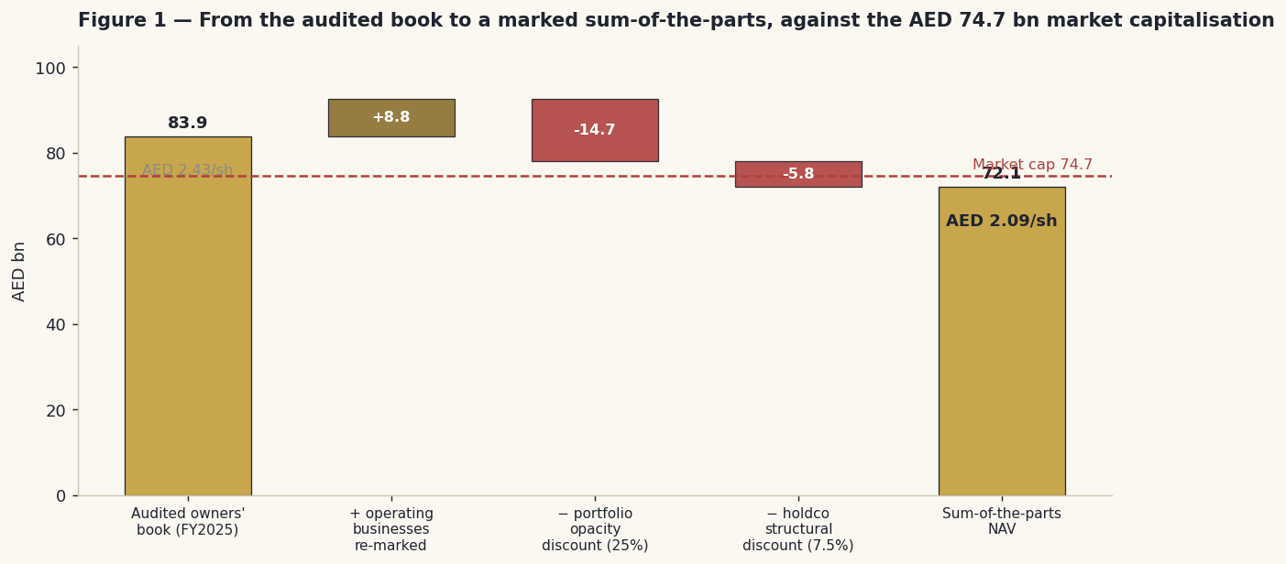
Figure 1 — From the audited book to a marked sum-of-the-parts. The operating businesses are worth more than book; the portfolio is worth less than its mark.
Sum-of-the-parts (owners' basis) | Low | Base | High
Operating businesses, marked (8× / 10× / 12×) | 15.5 | 19.4 | 23.2
Investment portfolio, after discount (35% / 25% / 15%) | 38.2 | 44.0 | 49.9
Cash | 9.5 | 9.5 | 9.5
Holdco structural discount (12.5% / 7.5% / 2.5%) | −12.5% | −7.5% | −2.5%
Fair value per share (AED) | 1.60 | 1.95 | 2.33
Base case AED 1.95 — 10% below the AED 2.16 price. Note what has happened: giving the operating businesses full credit for being worth more than their book still does not close the gap, because the portfolio is 71% of the book and we do not believe its mark.
1.2 The portfolio — and the single fact that decides this valuation
Everything above turns on one discount, so it deserves the evidence rather than an assertion. The company tells us the portfolio is carried at AED 58.7 bn against AED 48.0 bn invested. On the face of it, that is a AED 10.7 bn gain — a manager who buys well. Now decompose it.
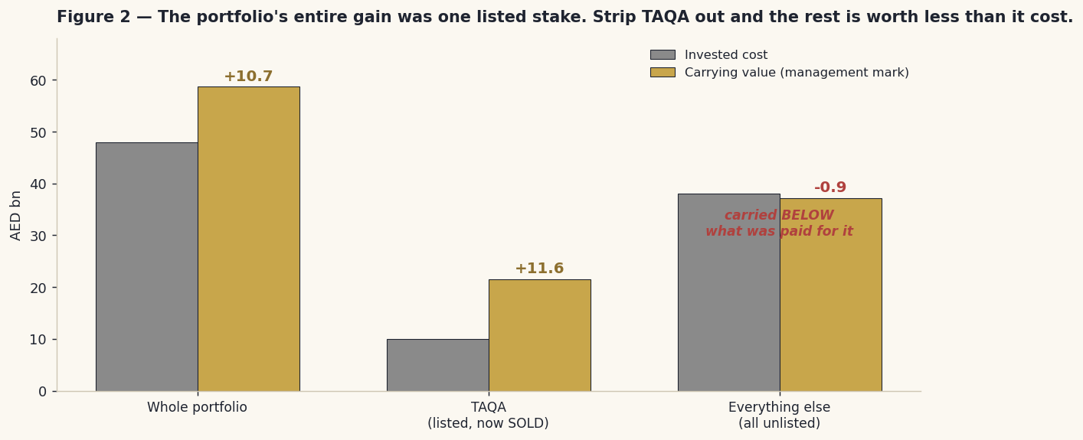
Figure 2 — The portfolio's entire gain was one listed stake. Strip TAQA out, and what remains is carried below what was paid for it.
 | Invested cost | Carrying value | The mark-up
The whole portfolio | 48.0 | 58.7 | +10.7
TAQA — a listed stake, SOLD in June | 10.0 | 21.6 | +11.6
Everything else — all of it unlisted | 38.0 | 37.1 | -0.9
Read the last row. Every dirham of the portfolio's AED 10.7 bn gain came from a single holding: 7.29% of TAQA, the listed Abu Dhabi utility, bought for AED 10 bn in 2022 and worth roughly AED 21.6 bn when it was sold on 11 June 2026. Take it out, and the AED 38.0 bn the company put into everything else is carried at AED 37.1 bn — AED 0.9 bn less than it paid. The one asset that was actually appreciating was the one with a daily price on a screen. Everything management marks itself has, in aggregate, lost money.
And it gets sharper. The TAQA proceeds have not been banked. In the same half-year the company announced roughly AED 14.4 bn of purchases: Traverse Midstream in the United States for $2.25 bn, Mopani in Zambia for about $1.1 bn, Alphamin for about $367 mn, ISEM for AED 704 mn. Every one of them is unlisted. Its own guidance after the transaction is net debt to equity of 0.17× — a strong balance sheet, but emphatically not the pile of cash a AED 21.6 bn windfall might suggest. So the portfolio has not merely lost its only proven asset; it has been made less observable, not more. That is the case for the discount, and it is built entirely from the company's own numbers.
Two honest qualifications, because the argument should be tested rather than sold. First, carrying assets at roughly cost is conservative accounting, not aggressive: the company is not marking things up to flatter itself, and it took a AED 0.85 bn impairment on Kalyon and a AED 0.4 bn write-down on digital assets when it had to. Second, some of the portfolio does have external reference points — Alphamin is listed in Toronto, Getty Images in New York, and WHOOP's recent financing round was priced by third parties. A 25% discount is a judgment, not a calculation, and §1.9 shows what 15% or 35% would do instead.
1.3 The operating businesses — a cash-flow model of what revenue actually produces
This is where the first draft of this study went wrong, and it is worth being explicit about it. That draft applied a 25% margin to group revenue. The 25% came from the company's adjusted EBITDA of AED 2.5 bn on AED 9.9 bn of quarterly revenue — but that AED 2.5 bn has AED 1.2 bn of investment income inside it, income which comes from the portfolio and has nothing to do with selling anything. The operating businesses' real economics are disclosed and are far more modest: gross profit of AED 3.0 bn on AED 9.9 bn of revenue (a 30% margin), administrative costs of AED 1.8 bn (18% of revenue), leaving an operating margin near 12%, or 14% before depreciation. Growing revenue and applying 25% to it grows the portfolio's dividends as though they were retail sales. The correction cuts the operating value roughly in half.
AED bn | 2026E | 2027E | 2028E | 2029E | 2030E
Revenue | 39.6 | 43.6 | 47.0 | 50.3 | 53.4
Gross profit (30%) | 11.9 | 13.1 | 14.1 | 15.1 | 16.0
less administrative costs (18%) | −7.2 | −7.9 | −8.6 | −9.2 | −9.7
Operating profit | 4.7 | 5.1 | 5.6 | 5.9 | 6.3
less tax at 15% | −0.7 | −0.8 | −0.8 | −0.9 | −0.9
add back depreciation | 0.8 | 0.9 | 0.9 | 1.0 | 1.1
less capital expenditure | −1.2 | −1.3 | −1.3 | −1.3 | −1.3
less working capital | −0.9 | −0.8 | −0.5 | −0.4 | −0.3
Free cash flow | [object Object] | [object Object] | [object Object] | [object Object] | [object Object]
Discount factor | 0.922 | 0.850 | 0.784 | 0.723 | 0.666
Present value | [object Object] | [object Object] | [object Object] | [object Object] | [object Object]
Bridge | AED bn
Sum of present values, 2026–30 | 14.5
Terminal value (growth 3.0%, discount rate 8.47%) | 90.3
Present value of the terminal value | 60.1
Enterprise value — the operating businesses | 74.6
Terminal value as a share of it | 81%
add the investment portfolio (at management's mark) | 58.7
add cash | 9.5
less net debt (the company's own 0.17× guidance) | −16.1
less the minorities' share of the operating legs | −39% of the operating equity
less the same portfolio and structural discounts as §1.1 | −25% / −7.5%
Per share (AED) | 2.39
AED 2.39 — +11% against spot, and the highest of the four fundamental reads. It is treated as a ceiling and weighted at 15%, for one blunt reason: 81% of the operating enterprise value is a terminal assumption. That is a bet on the discount rate and the growth rate dressed up as a five-year cash-flow model, and we disclose it rather than bury it.
1.4 Relative value — and the two earnings you can choose from
There are two defensible answers to the question 'what did this company earn?', and the difference between them is larger than the company's entire operating profit. Both are stated wherever the figure appears.
Framing | 2026E group net profit | Attributable EPS | × 9.5 | Comment
Underlying — no marks, no one-offs | 6.0 | 0.146 | 1.39 | What the businesses and the portfolio's income actually produce
Reported, marks normalised (base case) | 8.0 | 0.195 | 1.85 | Adds AED 2.0 bn of marks — well below Q1's run-rate
Reported, Q1's marks annualised | 10.4 | 0.253 | 2.41 | What annualising one quarter would give. We do not use it
The attributable share is not a guess: the company published earnings per share of AED 0.056 for the first quarter, which fixes attributable profit at AED 1.94 bn against a reported AED 2.3 bn — 84.2%. (The 2025 ratio was 94.8%, but 2025 barely consolidated the minority-heavy subsidiaries; the first quarter of 2026 is the right one.) The base case adds a normalised AED 2.0 bn of fair-value gains rather than the AED 4.4 bn that annualising the first quarter would give — because, as §1.2 showed, the asset that was generating the gains has been sold. On the base case the shares are worth AED 1.85 at 9.5×, with a range of AED 1.56–2.14 across 8–11×.
1.5 Underlying earnings — the floor
The fourth lens asks the hardest question: what if the marks stop entirely? There is no dividend lens to build here — none has ever been paid — so this stands in its place. Take the first quarter's AED 2.3 bn of reported profit; remove the AED 1.1 bn of unrealised revaluation gains; remove the AED 0.1 bn one-off gain on an associate disposal; add back the AED 0.4 bn write-down of digital assets. What remains is AED 1.5 bn a quarter, or AED 6.0 bn a year — and note that this figure still includes the portfolio's real cash income of roughly AED 4.8 bn, because dividends received are earnings even if revaluations are not. The owners' share is AED 5.05 bn, or EPS of AED 0.146. At 7.5–10.5× that is AED 1.10 to AED 1.53, base AED 1.39 — 36% below the market price. The point of this lens is not that the company is worth AED 1.39. It is the size of the dependency: on these numbers, roughly a third of what the market pays rests on revaluations continuing, on a portfolio that has never in aggregate revalued upwards once you take out the stake it just sold. And a revaluation, unlike a dividend, never becomes cash that leaves the building. Weight: 15%, as a floor rather than a forecast.
1.6 Synthesis
Lens | Low | Base | High | Weight | Why this weight
Sum-of-the-parts | 1.60 | 1.95 | 2.33 | 45% | It ties to the audited book; only the discounts are opinion
Cash flow + portfolio | 1.87 | 2.39 | 3.02 | 15% | 81% terminal value — a ceiling, not an anchor
Relative — reported earnings | 1.56 | 1.85 | 2.14 | 25% | Uses the published EPS; the mark dependence is disclosed
Underlying earnings | 1.10 | 1.39 | 1.53 | 15% | Prices only what is real — a floor
Weighted central | 1.55 | 1.91 | 2.27 | 100% | Spot AED 2.16 sits +13% above it
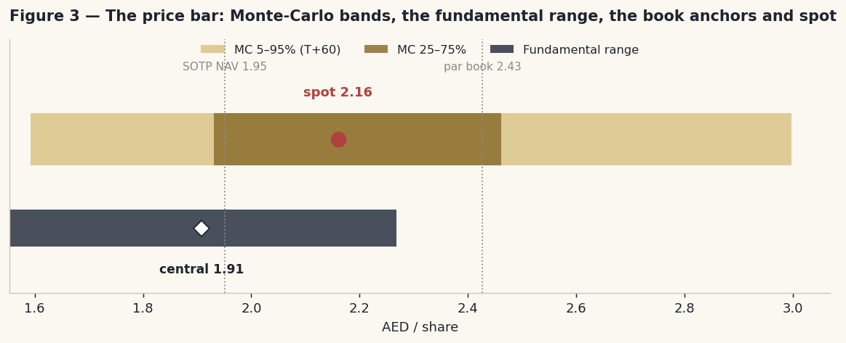
Figure 3 — The price bar: Monte-Carlo bands, the fundamental range, the book anchors and spot.
Every one of the four fundamental lenses lands below the market price. That was not true of the earlier draft, and the difference is not a change of opinion — it is the correction of two errors and the addition of one fact the company published and we had missed.
1.7 The crux — in real money
Strip the study to one number a reader can check. The audited book is AED 2.427 a share. The market pays AED 2.16 — a discount of 11.0%. Our sum-of-the-parts says AED 1.95. The whole disagreement is about how much of that book you can believe, and it comes down to the AED 58.7 bn portfolio, which is 71% of it.
If the portfolio is worth… | 0% off (par) | 15% off | 25% off (base) | 35% off | The market implies
Value per share (AED) | 2.34 | 2.11 | 1.95 | 1.79 | 2.16
What that assumes | Every mark is right | A modest haircut | The unlisted book is worth 3/4 of its mark | A deep haircut | Roughly a 15% haircut
Each 10 points of portfolio discount is worth roughly AED 0.157 a share, or AED 5.9 bn across the company. The market is applying something like 15%. We apply 25%. That nine- or ten-point gap is the entire argument, and here is what sits on each side of it.
For a narrow discount: the portfolio is real and large; Lunate genuinely manages around US$110 bn; the IHC ecosystem does produce deal flow a minority investor could not get near; the company has twice crystallised value at good prices (PAL Cooling in 2025 for a AED 2.7 bn gain, TAQA in 2026 for a AED 11.6 bn gain); and it marks conservatively — it took the Kalyon impairment and the digital-asset write-down when it had to. For a wide discount: every remaining asset in that portfolio is unlisted, and in aggregate they are carried below cost; the one holding that was genuinely appreciating has been sold, and the proceeds put into private pipelines and private mines; the controlling shareholder owns 60.6% and moves assets in and out at prices minorities do not set; and no stake-by-stake valuation of the portfolio has ever been published, so no outsider can check any of it. On the evidence, 25% is where we land. A reader who disagrees can read their own number straight off §1.9.
1.8 Macro, the war, and the cost of capital
The macro frame is unusually binary. The dirham's peg to the dollar imports Fed policy directly — the target was 3.50–3.75% in June, with the central bank's base rate at 3.65% from 17 June — and Abu Dhabi's federal bonds trade within about 16 basis points of US Treasuries. The war matters to this company through three channels it cannot hedge: the risk premium on the whole Abu Dhabi market (the March low of AED 1.65 is the proof); the value of a financial portfolio whose worth moves with regional risk appetite; and the oil-linked fiscal pulse behind the state-adjacent deal flow that is, in the end, this company's business model. The March trough and the April relief rally are both in the price history. The 7–8 July collapse is not — it happened after the data ends — and it is carried as an explicit unpriced risk rather than a modelled input. On tax, one thing is knowable and it has been corrected in this version: the UAE's minimum top-up tax sets a 15% floor on the effective rate for large multinational groups, for financial years starting on or after 1 January 2025. It is a floor, not a phase-in. An earlier draft modelled a gradual climb from 9% to 15% over five years. No such phase-in exists, and the 15% rate is applied from 2026 throughout.
Cost-of-capital input | Value | Source
Risk-free rate (AED, long) | 4.75% | UAE federal dirham bond, ~16 bp over the 4.58% US 10-year. We do not shortcut to the dollar rate
Equity risk premium — rating basis | 4.87% | Damodaran (NYU Stern), January 2026 — UAE, Aa2
Equity risk premium — CDS basis | 4.93% | Damodaran, January 2026 — Abu Dhabi credit-default-swap basis. Both are published
Beta | 1.00 (band 0.8–1.3) | A regression was attempted and failed the usability test — no usable index series. 1.0 is assumed and sensitised in §1.9
Cost of equity | 9.62% / 9.68% | Risk-free + beta × premium, on both bases
Cost of debt | 6.00% | Interbank rate plus roughly 210 bp. A judgment, and flagged as one
Net debt | AED 16.1 bn | The company's own post-TAQA guidance: net debt to equity of 0.17×. We use their number, not our derivation
Discount rate | 8.47% / 8.51% | Weighted at market values, taxed at the 15% minimum rate
1.9 Sensitivity — read your own number off these grids
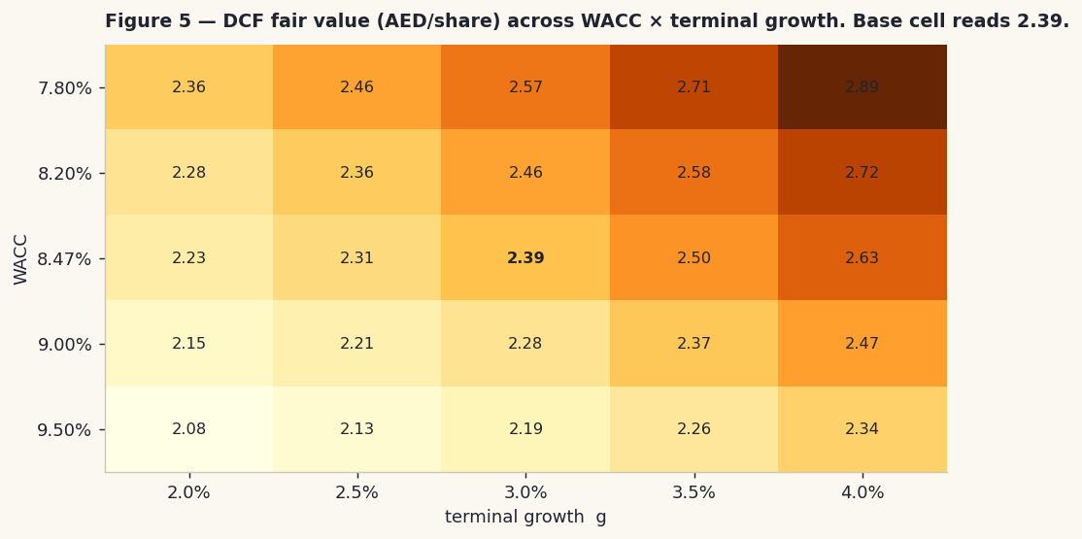
Figure 5 — Fair value per share across the discount rate and terminal growth. The base cell reads AED 2.39.
Discount rate ↓ × growth → | 2.0% | 2.5% | 3.0% | 3.5% | 4.0%
7.80% | 2.36 | 2.46 | 2.57 | 2.71 | 2.89
8.20% | 2.28 | 2.36 | 2.46 | 2.58 | 2.72
8.47% | 2.23 | 2.31 | 2.39 | 2.50 | 2.63
9.00% | 2.15 | 2.21 | 2.28 | 2.37 | 2.47
9.50% | 2.08 | 2.13 | 2.19 | 2.26 | 2.34
The two grids that actually matter.
Operating margin (the driver the first draft got wrong) | 10.0% | 12.0% | 13.8% | 16.0% | 18.0%
Fair value (AED/share) | 1.94 | 2.18 | 2.39 | 2.65 | 2.89
Portfolio discount ↓ × structural discount → | 2.5% | 7.5% | 12.5%
15% off the portfolio | 2.22 | 2.11 | 1.99
25% off (base) | 2.06 | 1.95 | 1.84
35% off | 1.89 | 1.79 | 1.70
The margin grid is the one to stare at. The disclosed operating margin is 13.8%; the earlier draft used 25%, and that single error was worth more than a dirham a share. The portfolio grid is the crux made mechanical: it takes a discount of about 15% — roughly where the market already is — to justify today's price on this lens alone. Beta is assumed rather than regressed, so it too is sensitised in the model: across 0.8 to 1.3 the discount rate moves from about 7.7% to 9.6%, and fair value by roughly AED 0.3 a share. Together these grids bracket every fundamental read in this study between roughly AED 1.10 and AED 3.00.
2 Technical and price structure
The five-year chart is a listing bubble, a long de-rating, and a war. As Multiply, the shares ran from AED 2.1 at the December-2021 listing to AED 5.00 in December 2022, then de-rated for two years to AED 1.50 by April 2025. The merger announcement in September 2025 produced a sharp rally to AED 3.26; completion in November, and the dilution it brought, began a slide that the February–April 2026 war finished at AED 1.65 on 16 March. Since then, a grinding recovery. As of 3 July the tape reads: price above the 20-day (2.19), the 50-day (2.12) and the 100-day (2.07), but 11% below the 200-day (2.42) — a recovery inside a downtrend, not a new uptrend. RSI at 37.0 is neutral. The MACD has just rolled over. One-year return: -8.1%. This is timing, not value — but nothing in the tape argues against the fundamental read.
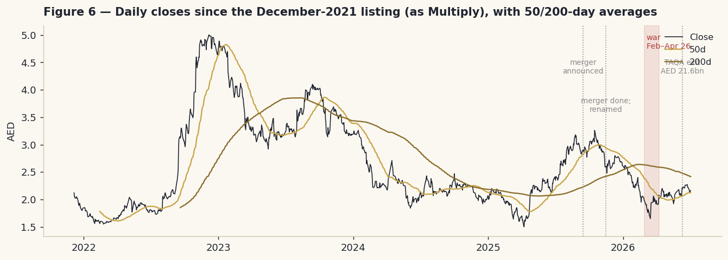
Figure 6 — Daily closes since the December-2021 listing, with the 50- and 200-day averages. The shaded band is the February–April 2026 war.
Indicator | Reading (3 July 2026) | Interpretation
Price vs moving averages | above 20d 2.19 · above 50d 2.12 · above 100d 2.07 · below 200d 2.42 | Recovery inside a downtrend
RSI (14) | 37.0 | Neutral
MACD (12,26,9) | line 0.0139 · signal 0.0289 · histogram -0.0151 | Just rolled negative
52-week range | 1.65 – 3.26 | Spot in the lower third
Annualised volatility | 38.9% | High — the cone in §3 is wide for a reason
3 Monte Carlo — a probabilistic price map
This section opens with the five numbers most readers actually want, before any machinery.
Question (T+60 sessions ≈ 3 months) | Answer
Will the price be above AED 2.16? | 52%
Gain of 10%+ versus loss of 10%+ (odds) | 32% vs 26% — 1.21 : 1
The median level, and its move | AED 2.18 (+0.9%)
The 50% band (25th–75th percentile) | AED 1.93 – 2.46 (-11% to +14% of spot)
Touch +10% / touch −10% at any point | 57% / 50%
Where the median comes from, stated so that a committed number is an explained number: the T+60 median of AED 2.18 is +0.9% from spot, and essentially all of it is the carry — the 3.65% central-bank rate scaled to sixty sessions, which is 0.85%. There is no equity drift in this simulation at all: no view about direction is fed into it. And because 2PointZero pays no dividend, none of that carry leaves as cash, so all of it shows up in the price. The tilt is arithmetic, not opinion.
One rule worth stating plainly: the fundamental gap of §1 is never fed into this simulation. The 13% distance between price and our central estimate lives in §1 and nowhere else. If it also leaked into the drift here, the same opinion would be counted twice and the two sections would stop being independent checks on one another.
The engine: 50,000 paths, a volatility estimate built from the full daily range rather than closes alone, with the recent past weighted more heavily, and fat-tailed innovations. The shape and the cone width are fitted on a fourteen-name panel of UAE-listed companies rather than assumed — and one caveat is owed to the reader: the tail parameter is only weakly identified. Every value from moderately fat to Gaussian sits inside the statistical confidence interval, and it trades off against the width of the cone. The pair is fitted together; neither number alone is precise. Testing this configuration against the last fourteen non-overlapping three-month windows, it beat a random-walk benchmark by 0.18% on the standard scoring rule — a margin whose confidence interval straddles zero. Coverage came in at 50/79/93% against 50/80/90 targets, which is close to ideal. The honest verdict is therefore: the distribution is well calibrated, and no forecasting edge is demonstrated. We publish that rather than dress it up. Annualised volatility: 38.3%. And the shape was fitted through 3 July — before the ceasefire collapsed. Read the downside percentiles as floors on risk, not ceilings.
Percentile map (AED per share)
Horizon | p5 | p10 | p25 | p50 | p75 | p90 | p95
T+20 (~1 month) | 1.80 | 1.89 | 2.02 | 2.17 | 2.33 | 2.48 | 2.59
T+60 (~3 months) | [object Object] | [object Object] | [object Object] | [object Object] | [object Object] | [object Object] | [object Object]
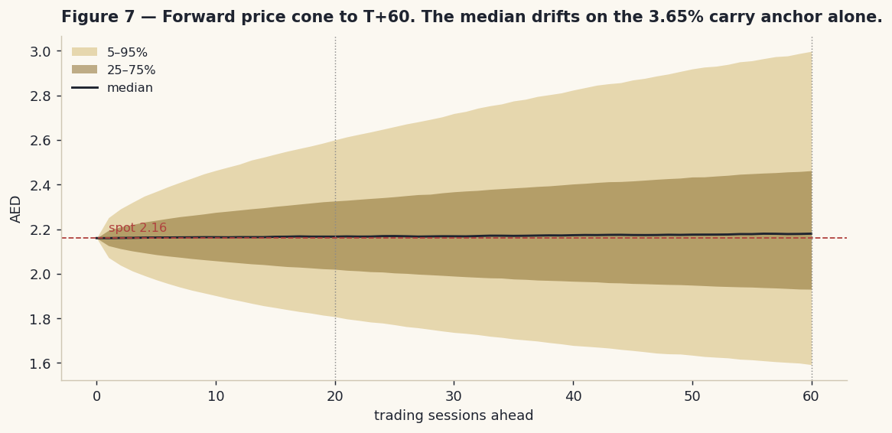
Figure 7 — The forward price cone to T+60. The median drifts only on the carry.
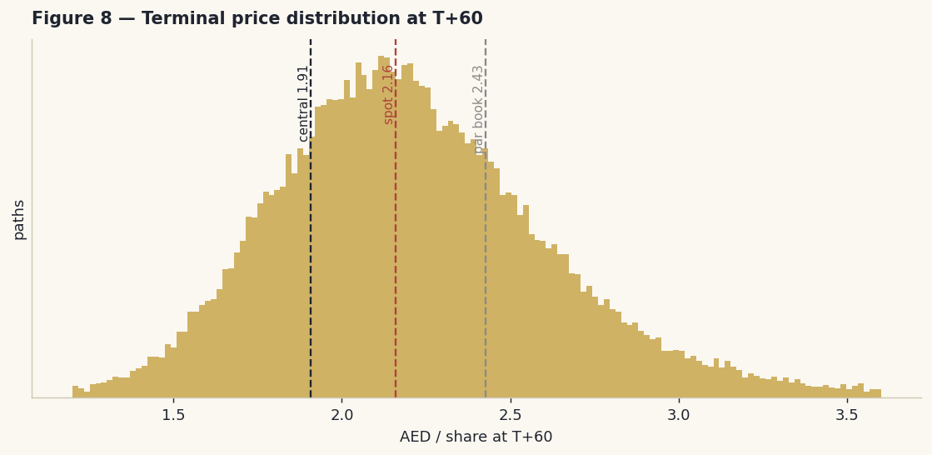
Figure 8 — The distribution of possible prices in three months, with the fundamental central estimate and the par book both marked.
Hold the two horizons together. At one month the distribution is tight — a month rarely resolves anything. At three months the 50% band runs AED 1.93–2.46, and note what sits inside it: our weighted central (1.91), the sum-of-the-parts (1.95), and — at its very top — the 200-day average (2.42). The simulation is saying the market can travel to any of this study's reference points within a quarter without doing anything statistically remarkable.
The level ladder
Level (AED) | 1.80 | 1.90 | 2.00 | 2.20 | 2.40 | 2.60 | 2.80
P(finish above) | 85% | 78% | 69% | 48% | 30% | 17% | 9%
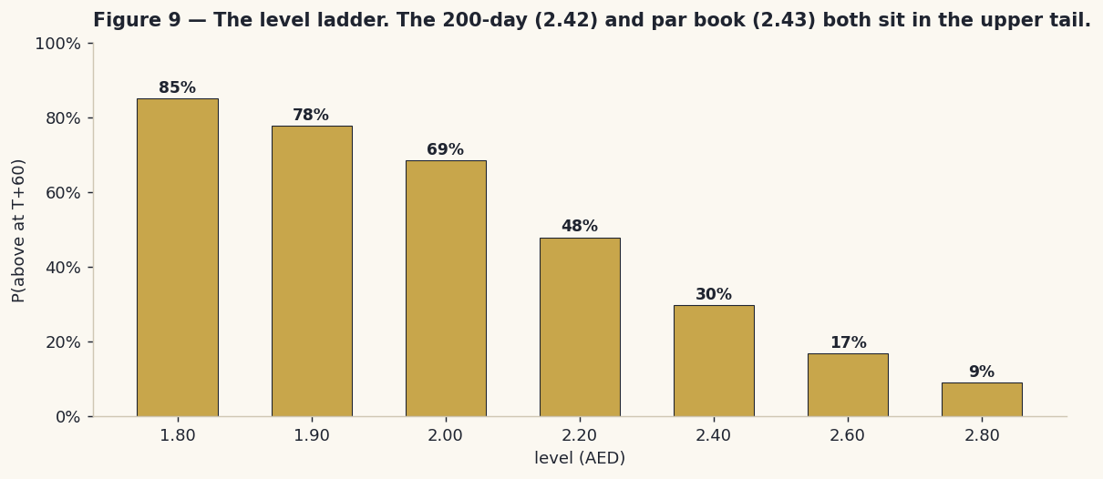
Figure 9 — The level ladder: the probability of finishing above each price in three months.
4 Comparing the reads — and a verdict
Lens | The question it answers | The answer | Standing
Fundamental (§1) | What is the company worth? | AED 1.55–2.27, central 1.91 | Spot is +13% above it — fully valued
Technical (§2) | What is the tape doing? | A stalled recovery below the 200-day | No edge either way
Monte Carlo (§3) | Where can the price go in three months? | 5–95%: 1.59–3.00 | Near a coin-flip; the fundamental anchors sit inside the core
Expert panel (App. C) | What do three other methods say? | AED 1.39 / 1.95 / 1.97 | All three below spot
The verdict. All four fundamental lenses now land below the AED 2.16 price, and the weighted central of AED 1.91 sits 13% beneath it. That is a change from an earlier draft of this study, and it is worth being clear that the change came from evidence, not from a change of mind: we had used a margin that quietly included the portfolio's investment income, we had modelled a tax phase-in that does not exist in law, and we had failed to price a AED 21.6 bn disposal that the company had announced in June and that turns out to explain the entire mark-up on its portfolio. Correct those three things and the picture changes. The spread between the lenses — AED 1.39 if you refuse to capitalise the marks, AED 2.39 if you believe the cash-flow model — is not model noise. It is a single, identifiable disagreement about one thing: whether unrealised gains on a portfolio nobody outside the company can price are earnings. If they are, the shares are reasonably priced. If they are not, a third of the market value rests on nothing that has ever been proven. Fair value AED 1.55–2.27, central 1.91. No rating, no target — a distribution and its reasons.
5 What to watch
When | Event | Why it moves the read
Live | The war | The dominant risk in both directions. Market risk premia, the portfolio's marks and regional deal flow all move together
~August 2026 | First-half results | The first real test of the merged company — and the first chance to see whether the operating margin holds at 12%
Every quarter | The revaluation line | The crux made observable. If the marks fade and operating profit does not fill the hole, §1.5's floor becomes the read
Any time | A disposal of an UNLISTED portfolio asset at or above carrying value | The single cleanest way for management to prove the book — and it would collapse our discount
Any time | An impairment in the portfolio | The mirror image. It would vindicate the wide discount and pull every lens down together
Rolling | Where the TAQA money goes next | Roughly AED 14.4 bn has been committed to private assets. Each one makes the book harder to check
Rolling | New transactions inside the IHC group | Assets moved in or out at prices minorities do not set re-price a book minorities cannot mark
2027 | The first dividend | Management states an intent. A real distribution would turn some of the marks into cash that actually leaves
6 Reading the probability zones
Zone (three months) | Range (AED) | Probability | What being there would mean
Deep stress | below 1.59 | ~5% | War-tail territory — the regime a fitted distribution understates by construction
Lower band | 1.59 – 1.93 | ~20% | The move toward the earnings floor: the market deciding the marks are not earnings
The core | 1.93 – 2.46 | ~50% | Our central (1.91) and the sum-of-the-parts (1.95) both live here
Upper band | 2.46 – 3.00 | ~20% | Through the 200-day (2.42) and toward par book (2.43) — the market taking the marks at face value
Right tail | above 3.00 | ~5% | A premium to audited book, on a proven disposal or an ecosystem event
7 Caveats — and what would change our mind
This study was wrong once already. An earlier draft put fair value near AED 2.03 and called the shares fairly valued. It used a 25% operating margin that had the portfolio's investment income buried inside it; it modelled a five-year phase-in of a tax that is a statutory floor; and it recorded the TAQA disposal as an event whose value could not be determined, when in fact the stake was 9,095,702,934 listed shares whose price anyone could look up. All three are corrected here. We say so plainly because a research process that hides its corrections is not a research process.
One quarter is a thin base. Every forecast here rests on the first quarter of 2026 — the only clean observation of the merged company that exists. If that quarter was flattered by integration accounting, by seasonality, or by contributions we cannot see, the base is wrong and everything downstream inherits it. This is the strongest argument for weighting the audited book at 45% and the cash-flow model at 15%.
The discount is a judgment. 25% off the portfolio and 7.5% off the wrapper are arguments, not calculations. §1.9 shows what other numbers would give, and a reader who thinks the marks deserve more faith can read a higher value straight off the grid. What is not a judgment is the fact underneath: strip TAQA out and the rest of the portfolio has never, in aggregate, been worth more than what was paid for it.
The attributable share moves. We use 84.2%, derived from the published first-quarter EPS. The 2025 figure was 94.8%, because 2025 barely consolidated the minority-heavy subsidiaries. If the minorities' share settles higher than the first quarter suggests, both earnings lenses are too generous.
Calibration humility. The simulation in §3 is honestly calibrated — its coverage is close to ideal — but it demonstrates no forecasting edge over a random walk. Nothing there should be read as a directional call, and the forecast is logged and will be graded either way.
What would change our mind. Upward: a disposal of an unlisted portfolio asset at or above carrying value — the cleanest possible proof of the book; two quarters in which underlying operating profit compounds and the floor rises to meet the price; a genuine dividend; a published, stake-by-stake valuation of the portfolio. Downward: an impairment in the investment book; a related-party purchase at rich marks; the revaluation line reversing while operating profit stays flat; or a war escalation that closes the region's capital markets for a quarter.

Appendix A Financial statements
Three years of history and five of forecast. The 2023 and 2024 columns are Multiply Group standalone — a different, much smaller company — and are shown because the legal entity is continuous and because the 2023 column carries a lesson (see the note below). All figures in AED bn unless marked.
A.1 Income statement — the operating businesses, separated from the portfolio
Line | FY2023 | FY2024 | FY2025 | 2026E | 2027E | 2028E | 2029E | 2030E
OPERATING BUSINESSES
Revenue | 1.3 | 1.7 | 7.0 | 39.6 | 43.6 | 47.0 | 50.3 | 53.4
Gross profit | 0.7 | n/d | n/d | 11.9 | 13.1 | 14.1 | 15.1 | 16.0
less administrative costs | n/d | n/d | n/d | −7.2 | −7.9 | −8.6 | −9.2 | −9.7
Operating profit | n/d | n/d | n/d | [object Object] | [object Object] | [object Object] | [object Object] | [object Object]
PORTFOLIO & CORPORATE
Investment and other income | n/d | n/d | n/d | 4.8 | 4.8 | 4.8 | 4.8 | 4.8
Share of joint-venture result | n/d | n/d | n/d | -0.4 | -0.4 | -0.4 | -0.4 | -0.4
Unrealised revaluation of investments | −0.5 | n/d | n/d | 2.0 | 2.0 | 2.0 | 2.0 | 2.0
One-off items | n/d | n/d | 1.9 | 0.0 | 0.0 | 0.0 | 0.0 | 0.0
GROUP
less net financing costs | n/d | n/d | 0.7 | −1.0 | −1.0 | −1.0 | −1.0 | −1.0
less tax (15% minimum rate) | n/d | n/d | n/d | −1.5 | −1.6 | −1.6 | −1.7 | −1.8
Net profit — reported | 0.6 | 0.2 | 3.6 | 8.6 | 9.0 | 9.3 | 9.7 | 10.0
Net profit — attributable to owners | n/d | -0.01 | 3.4 | [object Object] | [object Object] | [object Object] | [object Object] | [object Object]
Earnings per share (AED) | 0.030 | n/d | 0.246 | 0.209 | 0.219 | 0.228 | 0.236 | 0.243
MEMO — underlying profit (no marks, no one-offs) | 1.1 | n/d | n/d | [object Object] | [object Object] | [object Object] | [object Object] | [object Object]
Read the 2023 column, then the memo line beneath it. In 2023 Multiply Group reported AED 0.55 bn of net profit — but its profit EXCLUDING fair-value changes was AED 1.1 bn. The revaluation line was NEGATIVE that year, and it cost the company half its earnings. That is the same line that added AED 1.1 bn in the first quarter of 2026. Anyone valuing this company off a quarter in which the marks were kind should look at the year in which they were not. The 2026–30 forecast therefore carries a normalised AED 2.0 bn of marks — half what annualising the first quarter would give — and the memo line shows what happens if they go to zero.
A.2 Balance sheet
Line | FY2023 | FY2024 | FY2025
Total assets | n/d | 43.0 | 133.7
of which the investment portfolio | n/d | n/d | 64.1
of which cash | n/d | n/d | 9.2
of which operating assets | n/d | n/d | 60.4
Total liabilities | n/d | n/d | 39.0
Owners' equity | n/d | 28.9 | 83.9
Non-controlling interests | n/d | n/d | 10.8
Total equity | 30.2 | n/d | 94.6
Book value per share (AED) | n/d | n/d | 2.427
The balance sheet nearly tripled in one year, and almost none of it is retained profit — it is the merger. Note the composition: of the AED 83.9 bn of owners' equity, AED 64.1 bn is the investment portfolio and AED 9.2 bn is cash, leaving only AED 10.6 bn of operating businesses at book. This company IS its portfolio, which is why §1.2 does the work it does.
A.3 Cash, and where the TAQA money went
Item | AED bn
Net cash generated from operations, Q1-2026 | 2.6
Dividends paid to shareholders, ever | 0.0
TAQA disposal proceeds (June 2026) | +21.6
redeployed: Traverse Midstream (US pipelines, 100%) | −8.3
redeployed: Mopani (Zambian copper, via IRH) | −4.0
redeployed: Alphamin (tin, via IRH) | −1.3
redeployed: ISEM (packaging, 60.8%) | −0.7
Announced redeployment, total — every asset unlisted | −14.4
Company's stated position after the transaction | Net debt / equity 0.17× · net debt / EBITDA ~2.0×
This is the table that answers the question 'surely a AED 21.6 bn cash inflow makes the company safer?' It does improve the balance sheet — the company's own guidance of 0.17× net debt to equity is a strong position. But the cash has not been banked; it has been recycled into four unlisted assets. The portfolio's most observable holding has been exchanged for four of its least observable, and that is a fact about the quality of the book, not just its size.
A.4 Per-share and ratio dashboard
Metric | FY2025 actual | FY2026E | Note
Per share (AED)
EPS — reported basis | 0.246 | 0.195 | Includes a normalised AED 2.0 bn of marks
EPS — underlying (no marks, no one-offs) | n/d | 0.146 | What the businesses and portfolio income actually produce
Dividend per share | 0.000 | 0.000 | None ever paid
Book value per share | 2.427 | 2.427 | The anchor
Valuation at spot AED 2.16
Price / earnings — reported | 8.8× | 11.1× | Looks cheap — because the marks are in the E
Price / earnings — underlying | n/d | 14.8× | The same price, the other framing
Price / book | 0.89× | 0.89× | A 11% discount to audited book
Dividend yield | 0.0% | 0.0% | Nothing leaves the building
Returns and structure
Operating margin (the businesses only) | n/m | 11.8% | Gross 30% less administrative costs 18%
Return on equity — reported | n/m | 8.0% | On opening owners' equity
Return on equity — underlying | n/m | 6.0% | What the company earns without revaluations
Net debt / equity | n/m | 0.17× | The company's own post-TAQA guidance
Effective tax rate | 4.8% | 15.0% | The minimum top-up tax is a floor, from 2025
Where in the cycle these earnings sit. There is no cycle here yet — the company in its current form is eight months old and has printed one clean quarter. But something narrower can be said. The reported earnings are flattered, knowably: 59% of first-quarter profit came from the Investments vertical, which sells nothing. The underlying figure — around AED 6.0 bn a year — is the closest thing to a mid-cycle number on offer, and it is what every earnings lens here normalises to. Two ratios in the table above make the point without commentary: a reported price/earnings of 11.1× and an underlying one of 14.8× are the same price, the same year and the same company.

Appendix B Peers, risks — and the research register
B.1 The comparable set, and why it is thin
2PointZero has no clean peer. The obvious comparison is its own parent: IHC, which has traded at a large and persistent PREMIUM to conventional net asset value for years, and Alpha Dhabi, the group's other listed holding company, which traded at a premium until a sharp de-rating brought it back toward its marked value. 2PointZero trades at a DISCOUNT to book — unlike either. That either means the market has learned something about the group's mid-layer vehicles, or that this one is differently constructed. Both readings are live. The wider set of Gulf and emerging-market controlled holding companies trades across a very wide range, and the dispersion is explained almost entirely by two things: how observable the assets are, and how far minority shareholders can trust the capital allocation. On the first, 2PointZero now scores poorly — and got worse in June. On the second, the record is too short to score at all.
B.2 Risk register
Risk | How it reaches the shareholder | Sensitivity of the read
The marks themselves | A AED 58.7 bn portfolio valued by management, with no external reference for the great majority of it | This is the whole valuation. A 10% write-down is roughly AED 0.16 a share of book
Dependence on revaluations | 59% of first-quarter profit came from a vertical with no revenue | If it stops, §1.5's floor (AED 1.39) becomes the read
The June exchange | The one listed portfolio asset was sold; the proceeds went into four unlisted ones | It made the book harder to verify, not easier. It is the direct justification for a wider discount
Related-party capital allocation | IHC-affiliated ownership of 60.57%; assets moved in and out at prices minorities do not set | The structural discount
One quarter of data | Every operating driver rests on Q1-2026 | The 30% gross margin and the 18% cost ratio are each a single observation
The war | Market risk premia, the portfolio's marks and regional deal flow all move together | The only risk that hits every line at once — and it re-escalated after our data ends
Thin float | 39.05% free float | Price discovery is weak in both directions. A discount can persist, or vanish, quickly
Disclosure | No guidance; no segment income statement; no stake-by-stake portfolio breakdown | It forces every operating driver to be top-down — and is itself an argument for the discount
B.3 Research register — every source, including the searches that found nothing
What a company does not disclose is evidence too. Four of the rows below are dated searches that came back empty, and they are the direct justification for the discount applied in §1.2. Class: B = changes the base for the forecast · S = a structural driver · D = unlocks a driver we could not otherwise build · C = context · NEG = a dated search that found nothing.
Area | Topic | Class | Finding | Source | Date
Global | Rates and the peg | S | US policy rate 3.50–3.75% (June); UAE central-bank base rate 3.65%, held 17 June. The peg imports it directly. | Central bank; market data | 6 Jul 26
Global | Equity risk premium | S | UAE (Aa2) 4.87%; Abu Dhabi on a credit-default-swap basis 4.93%. Both published in §1.8. | Damodaran, NYU Stern | 5 Jan 26
Global | Oil | S | Brent above $78 after the July escalation. | Press | 9 Jul 26
Country | The war | S | War from 28 February; ceasefire 8 April; memorandum 17 June; CEASEFIRE COLLAPSED 7–8 July — Iran struck three vessels in Hormuz, the US hit 80+ targets, the President declared it over. This POST-DATES the price data. | Al Jazeera; CNN; Britannica; Reuters | 9 Jul 26
Country | Tax | S | The UAE's minimum top-up tax sets a 15% effective-rate FLOOR for large multinational groups, for years starting on or after 1 January 2025. There is no phase-in. Cabinet Decision 142 of 2024. | UAE Ministry of Finance; PwC; EY; KPMG | 11 Jul 26
Industry | The IHC group | S | IHC trades at a large premium to conventional net asset value; Alpha Dhabi de-rated toward its marked value. 2PointZero trades at a discount to book — unlike either. | Company filings; market data | 11 Jul 26
Industry | The platforms | C | Lunate manages around US$110 bn; Beltone bought Baobab for €197.6 mn. | Company releases | H1 2026
Company | FY2023 (Multiply) | B | Revenue AED 1.3 bn (+15%); REPORTED net profit AED 552 mn; profit EXCLUDING fair-value changes AED 1.1 bn. The marks were NEGATIVE that year and cost half the earnings. | Multiply Group FY2023 results | 7 Feb 24
Company | FY2024 (Multiply) | B | Revenue 1.703; net profit 0.189; attributable −0.006; assets 43.0; owners' equity 28.9. | Audited FY2024 accounts | Feb 25
Company | FY2025 (audited) | B | Revenue 7.004; net profit 3.628 (attributable 3.440; EPS 0.246); assets 133.669; owners' equity 83.876; minorities 10.769; cash 9.184. Deloitte, unmodified opinion. | Audited FY2025 consolidated accounts | 5 Feb 26
Company | FY2025 one-offs | B | PAL Cooling disposal gain +2.725; Kalyon impairment −0.845. Neither recurs. | Audited FY2025 accounts | 5 Feb 26
Company | Q1-2026 | B | Revenue 9.9; gross profit 3.0 (30%); administrative costs (1.8); investment and other income 1.2; one-offs +0.1 and (0.4); adjusted EBITDA 2.5; reported net profit 2.3 INCLUDING 1.1 of unrealised revaluations; cash 9.5; debt/equity 0.31; portfolio 58.7 against 48.0 invested. | Q1-2026 results release (ADX) | 4 May 26
Company | Q1-2026 EPS | D | AED 0.056 — PUBLISHED. It fixes attributable profit at AED 1.94 bn, or 84.2% of reported. This replaces the balance-sheet proxy an earlier draft used. | ADX interim disclosure | May 26
Company | Profit by vertical | D | Revenue: Consumer 52%, Mining 37%, Energy 12%, Investments ~0%. PROFIT: Investments 59%, Mining 22%, Energy 12%, Consumer 8%. The single most important disclosure in this study. | Q1-2026 results release | 4 May 26
Company | TAQA disposal | B | The entire 7.29% stake — 9,095,702,934 shares — sold to Abu Dhabi Power (L'IMAD), completed 11 June. TAQA closed at AED 2.37, so the stake was worth roughly AED 21.5 bn. Multiply had paid AED 10 bn for it in 2022. | ADX filings; The National | 11 Jun 26
Company | The balance sheet after it | D | The company's OWN guidance: net debt to equity 0.17×, net debt to EBITDA about 2.0×. So the proceeds did not create a net-cash pile. | Company release | 11 Jun 26
Company | Where the money went | B | Traverse Midstream ($2.25 bn), Mopani (~$1.1 bn), Alphamin (~$367 mn), ISEM (AED 704 mn) — roughly AED 14.4 bn, every asset unlisted. | Company releases | H1 2026
Company | The reverse merger | B | November 2025: Multiply absorbed 2PointZero Holding (100%) and Ghitha (83.9%); renamed; 34,563.6 mn shares in issue. | Merger circular; ADX | Nov 25
Company | Ownership | C | IHC-affiliated 60.57%; free float 39.05%. | ADX disclosure | 14 Apr 26
Company | Dividend | C | None ever declared. Management states a policy intent from 2027. | Company release | 5 Feb 26
Company | Guidance | NEG | NOT FOUND. No numeric revenue, margin or capital-expenditure guidance is published anywhere. Every operating driver in this study is therefore top-down. | Searched investor relations; results calls | 11 Jul 26
Company | Portfolio breakdown | NEG | NOT FOUND. No stake-by-stake valuation of the AED 58.7 bn portfolio has ever been published. This is the entire basis of the opacity discount. | Searched investor relations; annual report | 11 Jul 26
Company | Segment income statement | NEG | NOT FOUND. No full profit-and-loss by segment for the merged group. Only the percentage splits above exist. | Searched investor relations | 11 Jul 26
Company | Borrowings note | NEG | NOT machine-extractable from the 2025 accounts. Net debt is therefore taken from the company's own 0.17× guidance rather than derived by us. | Searched FY2025 accounts | 11 Jul 26
A full bibliography, with the web address and access date of every source above, is published as a separate companion document alongside this study.

Appendix C The expert panel
Three genuinely different methods, each with its workings shown, its weakest assumption named, and a condition that would prove it wrong. They share no inputs beyond the audited accounts, so their agreement — or their disagreement — means something. On this company they disagree sharply, and the disagreement has a single axis.
C.1 Expert 1 — the sum-of-the-parts
Method. For a holding company, everything except the parts and their discounts is decoration. The audited owners' equity of AED 83.9 bn is accepted as the starting point — Deloitte signed an unmodified opinion, and this expert does not second-guess an auditor on whether assets exist. What an auditor's signature does NOT certify is that a management-determined fair value is what a third party would pay. So the discount is built in components, each scored against the evidence:
Component | Assessment | Contribution
Can the assets be priced from outside? | After the June TAQA sale, essentially no. Every remaining portfolio holding of size is unlisted, and in aggregate they are carried BELOW cost. This is the worst score this expert has assigned in the coverage universe. | +14 pts on the portfolio
Related-party density | IHC-affiliated 60.57%. The company's own creation was a related-party transaction. The TAQA buyer was a sovereign vehicle. | +7 pts
Free float and price discovery | 39.05% — thin, but not extreme by Abu Dhabi standards. | +3 pts
Capital-allocation record | Genuinely mixed. PAL Cooling sold at a AED 2.7 bn gain; TAQA at a AED 11.6 bn gain — both good. But Kalyon impaired, digital assets written down, and the rest of the book has gone nowhere. | +1 pt
Asset quality | Lunate, Traverse and the IRH mining assets are real, institutional-grade holdings. This is not paper. | −5 pts
Composite | Rounded into the published band | 25% on the portfolio, 7.5% on the wrapper
Value: AED 1.95, range AED 1.60–2.33. Where this expert parts company with the house: no credit at all for the cash-flow model, on the grounds that future compounding is already inside the marks — the portfolio's fair value embeds the portfolio's prospects, so adding a growth lens on top counts it twice. Falsification: two consecutive disposals of UNLISTED portfolio assets at or above carrying value. That would prove the marks conservative, collapse the observability score, and push this expert to AED 2.3–2.5.
C.2 Expert 2 — underlying owner earnings
Method. Ignore the balance sheet entirely. A book that cannot be independently priced is not evidence; it is an assertion. Ask instead what the company actually earned, and what that stream is worth.
Build | AED bn | Note
Q1-2026 reported net profit | 2.3 | The headline, and where most coverage stops
less unrealised revaluations | −1.1 | Not cash, not distributable, and in 2023 this line was negative
less the one-off gain on an associate disposal | −0.1 | Does not recur
add back the digital-asset write-down | +0.4 | Also does not recur — cutting both ways honestly
Underlying quarterly profit | 1.5 | Includes the portfolio's real cash income — dividends ARE earnings
Annualised | 6.0 | No seasonality adjustment is possible with one quarter
Attributable (84.2%, from the published EPS) | 5.05 | Not a proxy — derived from the AED 0.056 the company published
Underlying EPS (AED) | 0.146 | Against the 0.195 used in §1.4
Scenario | EPS | Multiple | Value (AED)
De-rated | 0.146 | 7.5× | 1.10
Through the cycle | 0.146 | 9.5× | 1.39
Quality re-rating | 0.146 | 10.5× | 1.53
Integration disappoints (−15%) | 0.124 | 9.5× | 1.18
Value: AED 1.39 — 36% below the market price, and by a distance the panel's outlier. This expert's position, stated plainly: the market pays AED 2.16 for a business whose operations and real investment income, on their only clean quarter of evidence, support about AED 1.39. Everything above that is a bet on revaluations — of a portfolio that, stripped of the stake it just sold, has never revalued upwards at all. Falsification, and this expert is explicit that it is the most falsifiable position on the panel: two quarters of underlying attributable profit compounding above roughly 15% would lift the base toward AED 1.7–1.8. A single large disposal of an unlisted asset at carrying value concedes the argument to Expert 1 outright.
C.3 Expert 3 — the regime tree
Method. This share is not priced quarter to quarter by cash flows; it is priced by whether the market accepts the IHC group's own valuation of itself. The 2026 price series says so directly: a 49% peak-to-trough fall and a partial recovery inside four months, with no change in the underlying assets. So model the regimes, not the spreadsheet.
State | Prob. | What happens | The logic | Value | Contribution
A — the marks are accepted | 25% | De-escalation holds; a disposal of an unlisted asset validates the book; the IHC deal flow continues | The discount narrows toward the market's: spot × 1.10 | AED 2.38 | 0.59
B — gravity | 45% | No crisis, but the revaluation line fades and nothing proves the book. The market drifts toward a fair discount | Our sum-of-the-parts, plus a small premium | AED 2.05 | 0.92
C — the marks are doubted | 30% | The war re-escalates, or an impairment lands, or an asset is bought from a related party at a rich price | A stressed sum-of-the-parts, less a further 5% | AED 1.52 | 0.46
Probability-weighted |  |  |  | AED 1.97 | = sum
Two things about this tree deserve emphasis. The states are not symmetric around the price: even the friendly one yields only +10%, because in this expert's read the merger has not been re-rated by anyone — the stock is below where it traded when the deal was announced, and de-escalation removes a tail without proving a book. And the tree's centre of gravity is the boring state: the most likely world is one in which nothing breaks, nothing is proven, and the price grinds toward a fair discount on a book nobody can check. The weight on state C was raised from an earlier draft, for the reason §1.2 gives.
Weights (A / B / C) | Value (AED) | Reading
40 / 40 / 20 — a durable ceasefire and a disposal at book | 2.07 | The falsification case
25 / 45 / 30 — as published | 1.97 | The base case
15 / 45 / 40 — the war regime entrenched | 1.89 | Roughly where the July news pushes it
10 / 40 / 50 — the marks actively doubted | 1.82 | Still above Expert 2 — the tree prices regimes, not accounting
C.4 The three in one room
Expert | Method | Base (AED) | Range | Position in one line
Expert 1 | Sum-of-the-parts | 1.95 | 1.60–2.33 | Mark the parts; discount hard what cannot be priced
Expert 2 | Underlying earnings | 1.39 | 1.10–1.53 | The book is an assertion. Price only what was earned
Expert 3 | Regime tree | 1.97 | 1.82–2.07 | Price whether the market believes the group's own valuation
Panel |  | 1.95 (median) | 1.39–1.97 | All three below the market price
Cross-examination, recorded so the reader can weigh it rather than take the panel's harmony on trust. Expert 1 to Expert 2: you are discarding the only audited number in the building because you dislike how it was measured — a fair-value hierarchy is imperfect, not fictional, and an unmodified audit opinion is evidence even if it is not a price. To Expert 3: your states are all anchored to my book, so your tree is partly derivative of my method rather than independent of it. Expert 2 to Expert 1: your discount is built from governance scores, which is intuition with decimals; my number comes from a profit-and-loss account. To Expert 3: assigning a 25% probability to 'the marks are accepted' is not analysis, it is a shrug with a spreadsheet. Expert 3 to both: your numbers were equally confident in October at AED 3.26 and in March at AED 1.65, and the assets did not change in between — a valuation that cannot say which regime it assumes is not wrong, it is incomplete. The disclosed rebuttals: Expert 1's component table at least makes the discount arguable line by line; Expert 2's build is the most falsifiable position here and will be settled by two prints; Expert 3's weight table is exactly the honesty the objection demands.
C.5 Reading the divergence
The panel spans AED 1.39 to AED 1.97 — a spread of AED 0.58, or 30% of its own median. Experts 1 and 3 both anchor to the book and land within AED 0.02 of each other. Expert 2 refuses the book entirely and lands 29% lower. This is not three opinions about value. It is two opinions about one question — is a management-marked, wholly unlisted investment portfolio an asset you can underwrite? — and the answer is worth roughly AED 0.58 a share, or AED 20 bn across the company.
What would break the deadlock, and in which direction. One disposal of an unlisted asset at or above carrying value moves Experts 1 and 3 up and forces Expert 2 to concede the book is real — all three converge upward. A portfolio impairment moves all three down together and vindicates Expert 2's refusal. Two quarters of compounding underlying profit lifts Expert 2 alone, closing the panel from below. Nothing else resolves it — which is why the watch-list in §5 is dominated by exactly those three events, and why the audited book is weighted at 45% rather than 100%. It is the best evidence available. It is not conclusive.
About this series
Testahil publishes independent, educational valuation studies as fair-value ranges and probability distributions — never ratings, price targets or buy/sell calls. Every probabilistic forecast is logged, dated and graded after the fact in a public, append-only calibration ledger, whether it was right or wrong. Studies follow a fixed house format so that the methods, and not the presentation, carry the differences between companies.
Disclosure & Disclaimer
1. No advice. This document is educational analysis and personal opinion. It is not investment advice, not research within the meaning of any regulation, not an offer or a solicitation, and not directed at the circumstances of any person.
2. No licence. The preparer is not licensed or registered with any securities regulator in any jurisdiction, is not an investment adviser, portfolio manager or broker, manages no client assets and accepts no fees, funds or clients.
3. No warranty. Information is drawn from sources believed reliable — audited financial statements, company releases and exchange data, all listed in the accompanying bibliography — but is not guaranteed complete or accurate. Models simplify; the outputs are ranges, not facts. Two items are flagged in the text: the borrowings note could not be extracted from the 2025 accounts, and no stake-by-stake valuation of the investment portfolio has ever been published.
4. Risk. Equity investments can lose most or all of their value. Emerging-market, thin-float and geopolitically exposed securities — this one is all three, and its principal asset is a portfolio marked by its own management — can move far beyond modelled percentiles, and a live regional war makes that concrete rather than theoretical.
5. Positions. The preparer may hold, and may in future take or dispose of, a position in the security discussed. No compensation from any issuer relates to this study.
6. Verification. The forecasts here are logged with their dates and horizons and will be graded on maturity regardless of outcome. Readers should verify every figure against the primary sources cited and consult a licensed financial adviser before any investment decision.
© 2026 Testahil · testahil.com · Published free of charge for educational purposes.

