Testahil · Independent Valuation Study — Educational Analysis | Not investment advice

Independent Valuation Study — Educational Analysis
Apple Inc. (NASDAQ: AAPL)
Fundamental analysis · Technical analysis · Monte Carlo simulation — one integrated read
Anchor: $313.09 (Mon 06 Jul 2026 close) · 14.776 bn shares · market cap ≈ $4.63 tn ($4,626 bn) · the world's largest hardware-and-services franchise: iPhone, Mac, iPad and Wearables around a $123 bn-and-growing high-margin Services layer · prices and probabilities computed 06 Jul 2026 from the attached daily history · primary lens: consolidated discounted cash flow, triangulated against a segment sum-of-the-parts, forward multiples and normalized earnings · the Services attach-rate, the gross-margin trajectory and the AI-driven upgrade cycle are the swing factors.
READ FIRST — what this document is, and is not. This study is a valuation exercise and an expression of personal analytical opinion, published free of charge for educational purposes: it shows how one analyst applies fundamental, technical and probabilistic methods to a listed company, and invites scrutiny of that methodology. It is NOT investment advice, NOT a recommendation or solicitation to buy, sell or hold any security, and NOT directed at the circumstances of any reader. The preparer is not licensed by any securities regulator in any jurisdiction, holds no brokerage authorisation, provides no financial consultancy, manages no money, and accepts no fees, funds or clients. See the Disclosure & Disclaimer at the end. All values are model outputs presented as ranges and distributions because no single number should be relied on. Reported financials are the company's own disclosure (Form 10-K, fiscal years ended September 2023, 2024 and 2025); forward-looking inputs — the revenue and margin forecasts, the multiples, the DCF and the Monte-Carlo factor probabilities — are the preparer's judgments and are flagged throughout. Consult a licensed financial advisor before any investment decision.

Headline
The model's read: richly valued on every fundamental lens; the market is paying for an AI-led upgrade cycle, Services compounding and a durability premium that sits beyond the cash flows we can model.
At $313.09 the shares trade about 51% above our weighted central estimate of $208. The four lenses do not agree — and that disagreement is the story. A consolidated DCF on explicit five-year cash flows lands at $152; a segment sum-of-the-parts at $184; forward multiples at $249; and a normalized through-cycle earnings read at $253. The gap between the cash-flow lenses (low-$150s to mid-$180s) and the market-multiple lenses (high-$240s to low-$250s) is roughly a $90 spread, and it is not noise: it is the premium the market assigns to Apple's installed base, switching costs and Services annuity — durability the explicit DCF window does not capitalise. We therefore present the spread and the distribution, never a single point or a rating. Technically the stock is the opposite of a value screen — above a rising moving-average stack, momentum firm — so price and our fundamental read pull in opposite directions. Over three months the Monte Carlo places the 5th–95th percentile band at roughly $237–$386, with the median a shade below spot at $303 — a distribution that is near-even on direction with a mild downside tilt from event skew, not from any embedded view that the shares are expensive.
Valuation summary — every read at a glance
One table for the four reads that follow — what the business is worth (fundamental), what the tape is doing (technical), where price could travel over three months (Monte Carlo), and how three independent expert methods land (the panel in Appendix C).
Read | What it measures | Central figure | In one line
Fundamental — weighted central | Blended fair value across four lenses | $208 | Bear $182 · bull $244
Consolidated DCF (primary) | PV of explicit FCFF + terminal value | $152 | TV 77% of EV; WACC 9.5%
Segment sum-of-the-parts | Services & Products on separate multiples | $184 | Services carries the premium
Relative multiples | Forward P/E on FY26E EPS | $249 | 30× $8.29 EPS
Normalized earnings | Through-cycle EPS × multiple | $253 | 32× $7.90
Technical | Trend / momentum posture | Uptrend | Above the 50/100/200-day stack
Monte Carlo (3-month) | Distribution of price paths | $303 median | 50% band $276–$333
Spot | Market price today | $313.09 | 51% above central

EXPERT PANEL — three independent methods (Appendix C)
Expert | Method | Fair value | Stance
Expert 1 — cash returns (DCF + ROIC) | Economic profit vs a ~9.5% WACC | $152 | The conservative anchor
Expert 2 — earnings power & multiples | Through-cycle EPS × justified multiple | $253 | Most constructive
Expert 3 — demand & installed base | Units × ASP + Services attach | $184 | The bridge between them

Company overview — Apple at a glance
Apple Inc. is the largest company on the NASDAQ by market capitalisation and among the most profitable enterprises in the world. Its fiscal year ends in late September; FY2025 (ended 27 September 2025) produced revenue of $416 bn, operating income of $133 bn (a 32.0% operating margin) and net income of $112 bn on 15.00 bn diluted shares, or $7.47 of diluted EPS. The business is two engines: a hardware franchise — iPhone (roughly half of revenue), Mac, iPad and Wearables — and a $109 bn Services layer (App Store, licensing, iCloud, advertising, AppleCare, payments) that grew double digits again in FY2025 and carries far higher gross margin than hardware. Apple runs a net-cash balance sheet — roughly $34 bn of cash and marketable securities net of debt at FY2025 — and returns almost all of its free cash flow to shareholders through buybacks and a growing dividend.
Item | Value
Exchange / ticker | NASDAQ: AAPL
Fiscal year-end | Late September
Spot price (06 Jul 2026) | $313.09
Shares outstanding | 14.776 bn
Market capitalisation | $4,626 bn
FY2025 revenue | $416 bn
FY2025 operating margin | 32.0%
FY2025 diluted EPS | $7.47
Services revenue (FY2025) | $109 bn
Net cash (FY2025) | +$34 bn
Cost of equity (Ke = rf + β·ERP) | 4.5% + 1.10×5.0% = 10.0%
Primary valuation lens | Consolidated DCF

1 Fundamental valuation
We anchor on a consolidated discounted-cash-flow model and triangulate it against three independent lenses — a segment sum-of-the-parts, forward multiples and normalized earnings power. For a business whose value rests heavily on durability, no single lens is authoritative; the spread between them is informative in itself, and §1.5 shows it as a football field rather than collapsing it into false precision.
1.1 Consolidated DCF — the primary lens
We forecast five explicit years (FY2026E–FY2030E), taking group revenue from $442 bn to $540 bn as Services compounds low-double-digits and hardware grows low-single-digits, and lifting the operating margin from 32.5% toward 34.5% on Services mix. Free cash flow to the firm rises from $119 bn to $155 bn. We discount at a 9.5% WACC — built on a cost of equity of 10.0% (4.5% risk-free + 1.10 beta × 5.0% equity-risk premium) — and apply a 3.5% terminal growth rate. The result is an enterprise value of $2,219 bn, of which the terminal value is 77% — a dependency we disclose openly and sensitize in §1.9 — plus net cash of $34 bn, giving equity value of $2,253 bn and a fair value of $152.50 per share. That the DCF sits well below spot is the central tension of this study: on explicit modelled cash flows discounted at an equity-appropriate rate, the shares are dear.
USD bn | FY26E | FY27E | FY28E | FY29E | FY30E
Revenue | $442 | $466 | $491 | $515 | $540
EBITDA | $156 | $167 | $178 | $190 | $201
Depreciation & amortization | $12 | $13 | $14 | $15 | $15
EBIT | $144 | $154 | $165 | $175 | $186
NOPAT = EBIT × (1 − t) | $121 | $129 | $138 | $147 | $156
+ Depreciation & amortization | $12 | $13 | $14 | $15 | $15
− Capex | ($12) | ($13) | ($14) | ($14) | ($14)
− Δ working capital | ($2) | ($2) | ($2) | ($2) | ($2)
Free cash flow to firm (FCFF) | $119 | $127 | $137 | $146 | $155
Discount factor @ WACC | 0.913 | 0.834 | 0.762 | 0.696 | 0.635
PV of FCFF | $108 | $106 | $104 | $101 | $99

Sum of PV of explicit FCFF $518 bn · terminal value $2,677 bn · PV of terminal value $1,701 bn · enterprise value $2,219 bn · terminal value 77% of EV · + net cash $34 bn · equity value $2,253 bn · $152.50 per share. Bear $143.10 · bull $199.80.
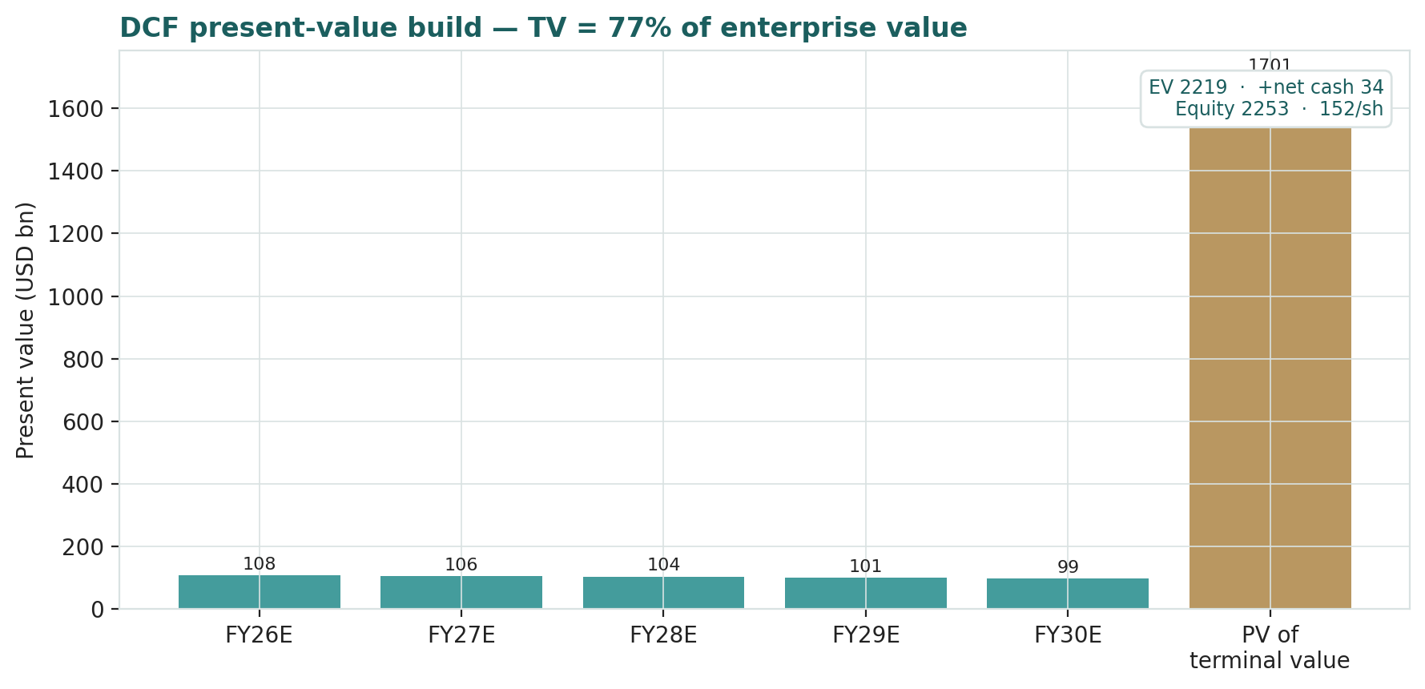
DCF present-value build — the terminal value is the majority of enterprise value, disclosed and sensitized in §1.9.
1.2 Segment sum-of-the-parts — the cross-check
Because Apple's two engines earn very different margins and would command very different multiples as standalone businesses, we value them separately. On FY2026E revenue we credit Services roughly $123 bn of revenue at a ~42% EBIT margin and a 26× EV/EBIT multiple — annuity-like economics — and the Products stack at a ~30% EBIT margin and a 14× multiple, closer to a premium-hardware peer. Adding net cash of $34 bn gives an equity value of $2,719 bn, or $184.00 per share (bear $157.00, bull $210.90). The exercise makes explicit what the market is really buying: on our marks, Services is worth roughly as much as the entire hardware franchise, and the multiple the market pays for the whole is only justified if Services keeps compounding and keeps its take-rate.
Segment sum-of-the-parts (FY26E, base) | USD bn
Services revenue | $123
Services EBIT (≈42% margin) | $52
Services value (26× EV/EBIT) | $1,347
Products revenue | $318
Products EBIT (≈30% margin) | $95
Products value (14× EV/EBIT) | $1,337
+ Net cash | $34
Equity value | $2,719
Fair value per share | $184.00

1.3 Relative multiples
On our FY2026E EPS of $8.29, the shares trade near 38× forward earnings. Anchoring a base multiple of 30× — a premium to the mega-cap median but defensible for the highest-quality name in the group — gives $248.70; a 26× bear gives $215.50 and a 34× bull gives $281.90. Multiples say the shares are closer to fair than the DCF does — because a multiple silently capitalises the same durability the explicit DCF window truncates. That is precisely why we refuse to blend the two into one point (device A-8).
Forward-multiple read | Bear | Base | Bull
FY26E EPS (USD) | $8.29 | $8.29 | $8.29
Forward P/E (×) | 26× | 30× | 34×
Fair value (USD) | $215.50 | $248.70 | $281.90

1.4 Normalized earnings power
Apple's current earnings are neither depressed nor obviously peak: FY2025 EPS of $7.47 was a record, helped by a low effective tax rate, but Services mix is still climbing. We take a through-cycle normalized EPS of $7.90 — a shade below the FY2026E figure, to strip any cyclical flattery — and apply a 32× multiple, giving $252.80 (bear $213.30 at 27×, bull $284.40 at 36×). This lens is the most constructive because it rewards the margin trajectory directly.
Normalized-earnings read | Bear | Base | Bull
Normalized EPS (USD) | $7.90 | $7.90 | $7.90
Normalized P/E (×) | 27× | 32× | 36×
Fair value (USD) | $213.30 | $252.80 | $284.40

1.5 Synthesis — four lenses
We weight the consolidated DCF and the relative read at 30% each, and the normalized and segment-SOTP reads at 20% each, giving a weighted central fair value of $207.70 (bear $181.60, bull $243.60). At $313.09 the market sits about 51% above that central estimate — above the top of our base-case range. The football field below shows why we do not average into a point: the cash-flow lenses and the multiple lenses genuinely disagree, and the disagreement is a clean read on how much of the price is durability the explicit model cannot see.
Lens | Bear | Base | Bull | Weight
Consolidated DCF (primary) | $143 | $152 | $200 | 30%
Relative multiples | $216 | $249 | $282 | 30%
Normalized earnings | $213 | $253 | $284 | 20%
Segment sum-of-the-parts | $157 | $184 | $211 | 20%
Weighted central | $182 | $208 | $244 | 100%

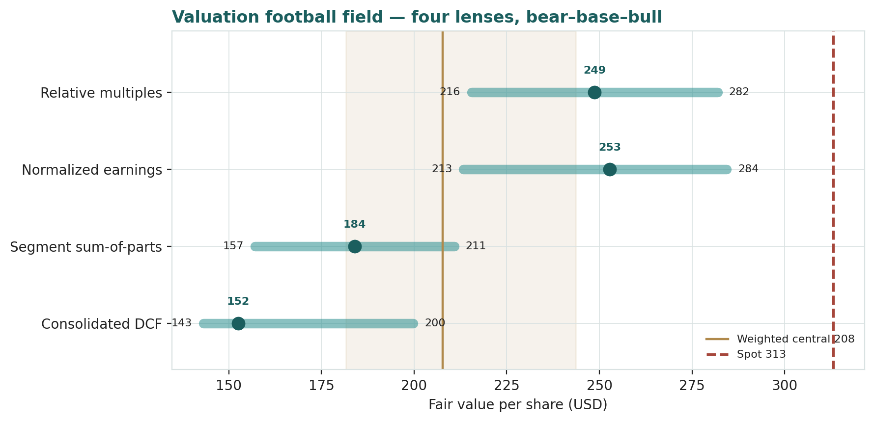
Valuation football field — four lenses, bear–base–bull, with the weighted-central band and spot. Spot sits above the base-case range.
1.6 The segments — a deeper look, with scorecard
The value question is really a Services question layered on a stable hardware base. The scorecard frames where each engine sits and what it contributes to the forecast.
Segment | FY25 revenue | 5-yr growth (CAGR) | Role in the thesis | Cycle read
iPhone | $210 bn | low-single | The volume anchor and Services funnel | Mid-cycle; AI upgrade optionality
Mac | $34 bn | mid-single | Silicon-led share gains | Stable
iPad | $28 bn | low-single | Mature, cash-generative | Mature
Wearables | $36 bn | low-single | Ecosystem lock-in | Soft, awaiting a new category
Services | $109 bn | low-double | The margin and multiple driver | Secular growth; regulatory watch

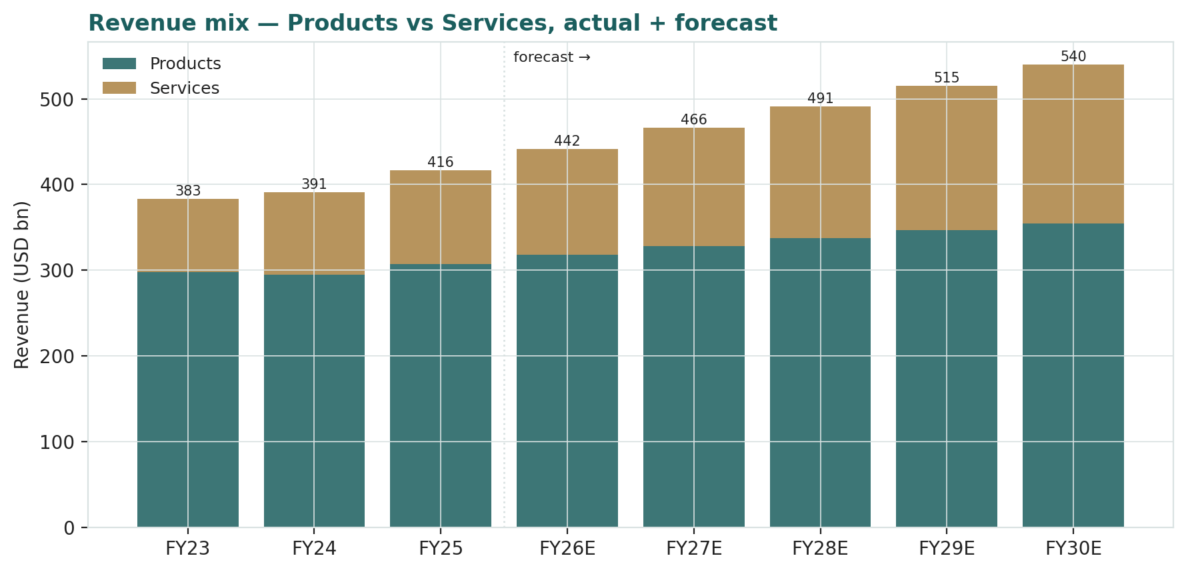
Revenue mix — Products vs Services, actual and forecast. Services is the margin-and-multiple engine.
1.7 The crux — Services attach, gross margin and the AI cycle
Three observable drivers move this valuation more than any abstract margin assumption, so we sensitize on them directly, in their own units. First, Services revenue growth: at our base path Services compounds low-double-digits; a sustained deceleration to high-single-digits removes a meaningful share of the SOTP premium, while a re-acceleration on advertising and payments does the reverse. Second, group gross margin, which we carry from roughly 47% toward 48% on mix — each point of gross margin is worth several dollars of DCF value. Third, the iPhone replacement cycle: an AI-driven upgrade wave shortens the cycle and lifts near-term units and Services attach; a cycle that fails to materialise leaves the hardware base flat. The table sensitizes fair value on the two most quantifiable of these in real units.
Crux driver (real units) | Bear | Base | Bull | Approx. value swing
Services 5-yr growth | ~8% | ~11% | ~13% | ± $15–20/sh via SOTP & DCF
Group gross margin (terminal) | ~46% | ~48% | ~49% | ± $6–8/sh per point
iPhone unit trajectory | flat | low-single | AI supercycle | cycle-timing optionality

1.8 Macro and country — China, tariffs, regulation, FX and rates
Apple is a US-domiciled global franchise, so the macro that matters is external. China is both a large market and the manufacturing spine; share loss to domestic handset makers and any escalation in US–China trade friction are the primary geopolitical risks. Tariff policy can raise landed hardware costs; the company has been diversifying assembly toward India and Vietnam to blunt it. Regulation is a genuine swing on the Services annuity — antitrust action on App Store economics and the multi-billion-dollar Google traffic-acquisition payment are the two most material items, and both feed the event stack in §3. Finally, a stronger dollar is a mild headwind to reported revenue, and the level of long-term rates feeds directly into the discount rate we sensitize in §1.9.
Macro factor | Channel | Direction
China demand & supply chain | Units, gross margin, continuity | Two-sided, tail-risk
US tariffs | Landed hardware cost | Headwind, mitigated by India/Vietnam
App Store / antitrust | Services take-rate | Downside to the annuity
Google TAC ruling | Services revenue line | Discrete downside
US dollar (DXY) | Reported revenue translation | Mild headwind when strong
Long-term rates | Discount rate / WACC | Higher rates → lower DCF

1.9 DCF sensitivity — WACC × terminal growth
Because the terminal value is 77% of enterprise value, the DCF is ultimately a bet on the spread between the discount rate and the terminal growth rate. The grid shows fair value per share across a WACC range of 8.5%–10.5% and a terminal-g range of 2.5%–4.5%. The base case (9.5% WACC, 3.5% g) is shaded. Even at the most generous corner of the grid the DCF does not reach spot — which is the honest way to say that the market's price embeds durability beyond what a five-year explicit model plus a perpetuity can capture.
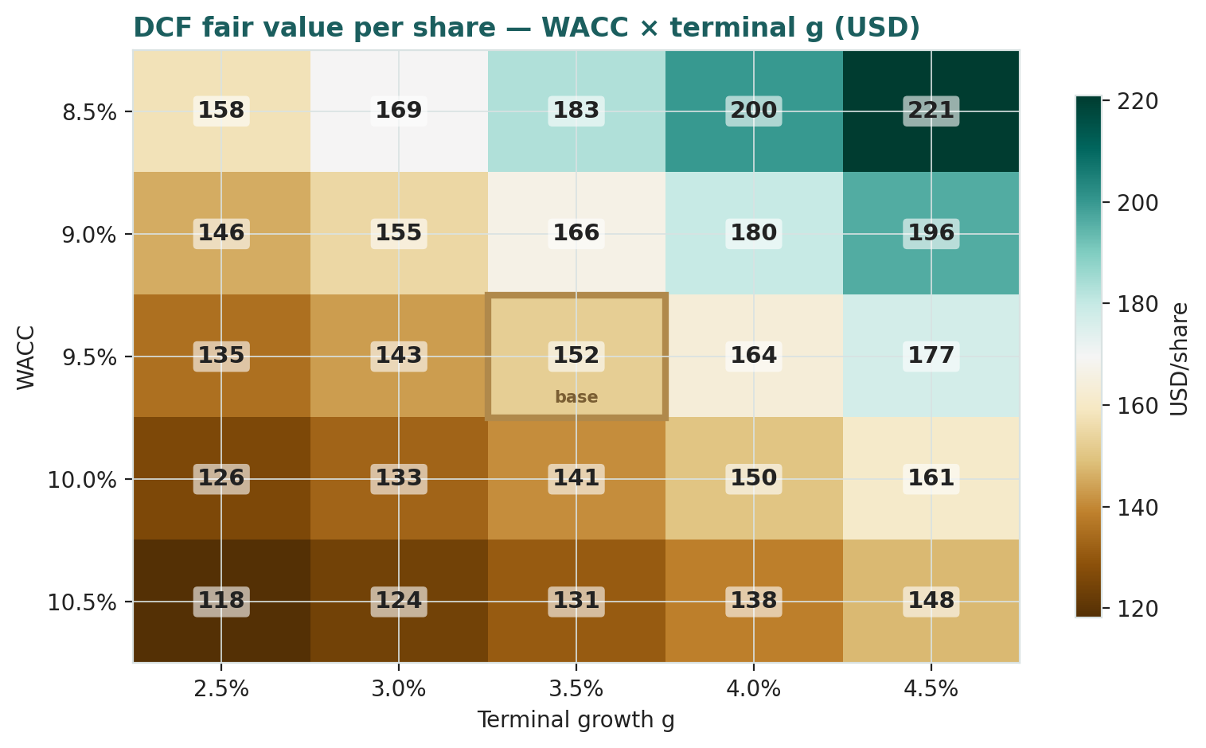
DCF fair value per share across WACC × terminal g. Base case shaded; Ke = rf + β·ERP = 10.0%.
2 Technical and price structure
Where the fundamentals say expensive, the tape says trending. The stock trades above its rising 50-, 100- and 200-day moving averages, the classic posture of an established uptrend, and momentum has stayed firm. For a probabilistic study the technical read matters mainly as context for the Monte Carlo: a name in a strong uptrend with contained realized volatility produces a forward cone centred near spot with moderate width, which is what §3 shows. We read the moving-average stack as support beneath the current price rather than as a signal.
Indicator | Reading | Interpretation
Price vs 50-day MA | Above | Short-term uptrend intact
Price vs 200-day MA | Above | Primary uptrend intact
MA stack (50 / 100 / 200) | Rising and stacked | Trend-supportive
Trailing realized volatility | ≈ 28% annualized | Moderate; sets the cone width
Posture | Constructive | Price and fundamental value diverge

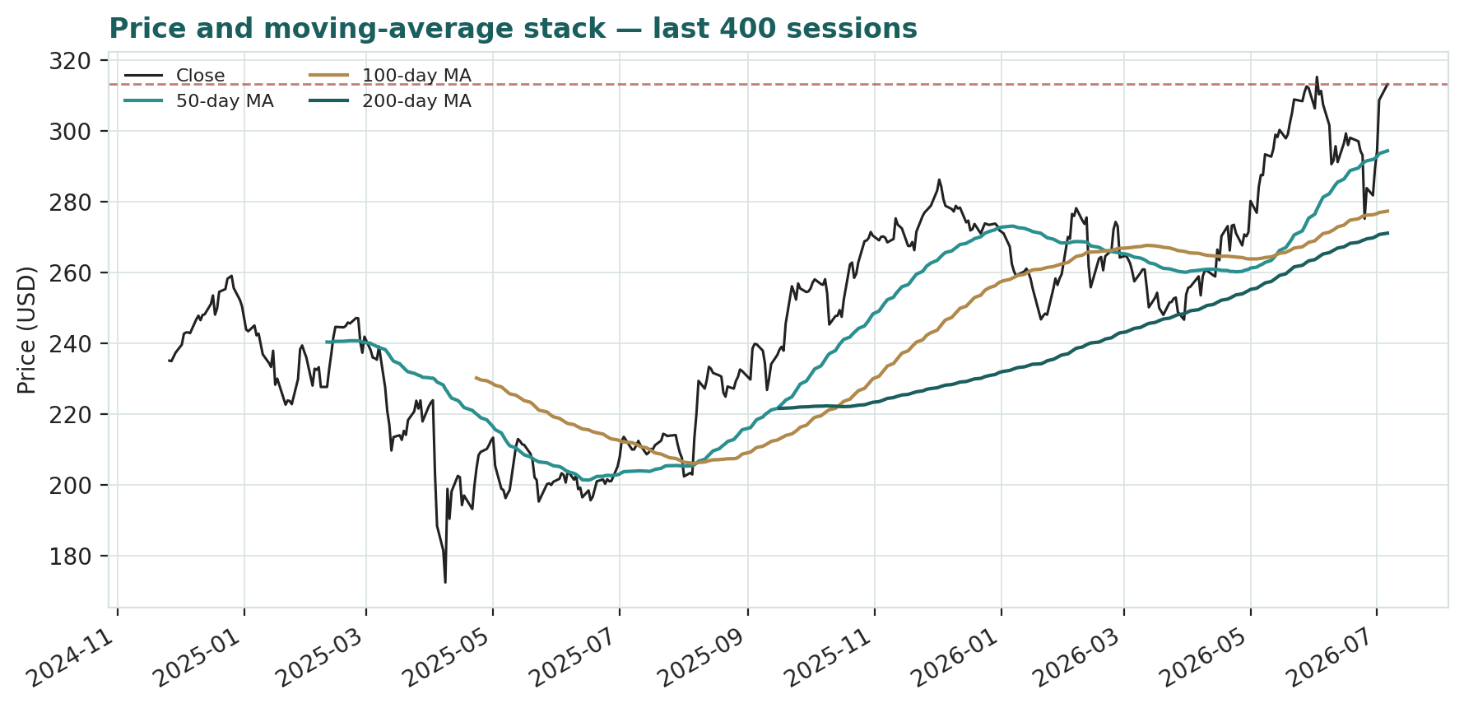
Price and moving-average stack, last 400 sessions. Price sits above a rising 50/100/200-day stack.
3 Monte Carlo — a probabilistic price map
We simulate 50,000 three-month price paths (seed 42) with the house YZ-HAR engine: width is set by a pooled log-HAR variance cascade on a gap-aware Yang-Zhang volatility proxy, innovations are unit-variance Student-t(5) for honest tails, and a sixteen-factor stack — seven continuous drivers and nine discrete events — layers on top.
By design the paths diffuse from spot, and the §1 value gap is kept out of the drift — the fundamental NAV gap lives in §1, not here; §3 maps where price could go from today, not where value sits.
Apple is an international name, so the engine runs with zero secular drift; the mild downside tilt in the read below comes from the event skew (regulatory, China-share and Google-TAC events carry more downside than the AI/Services events carry upside), not from any embedded view on valuation. Diffusion volatility is the YZ-HAR estimate, annualized ≈ 28%.
The probability read (T+60)
The probability read — T+60 | Value
P(price above spot) | 40.2%
P(+10%) vs P(−10%) | 18% vs 30% (odds 0.59)
Median level / % move | $303 (-3.4%)
50% band (25th–75th) | $276 – $333 (-12.0%, 6%)
Touch(+10%) / Touch(−10%) | 37% / 50%

Read it plainly: over three months the distribution is close to a coin-flip on direction, with a mild downside lean — the median sits a few percent below spot and a 10% fall is somewhat more likely to be touched than a 10% rise. That skew is the event stack, not a valuation view.
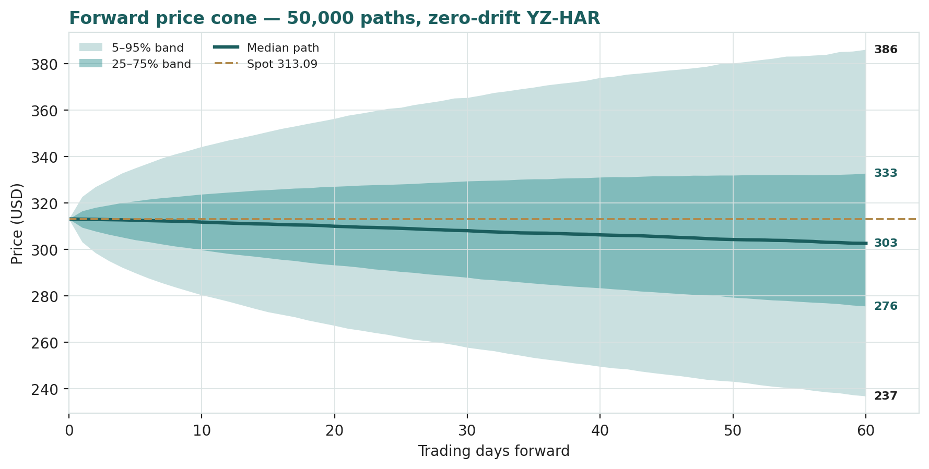
Forward price cone — 50,000 paths, zero drift. Lead with the 25–75% interquartile band; the 5–95% band is the tail.
Percentile (USD) | 5th | 25th | 50th | 75th | 95th
T+20 | $267 | $293 | $310 | $327 | $356
T+60 | $237 | $276 | $303 | $333 | $386

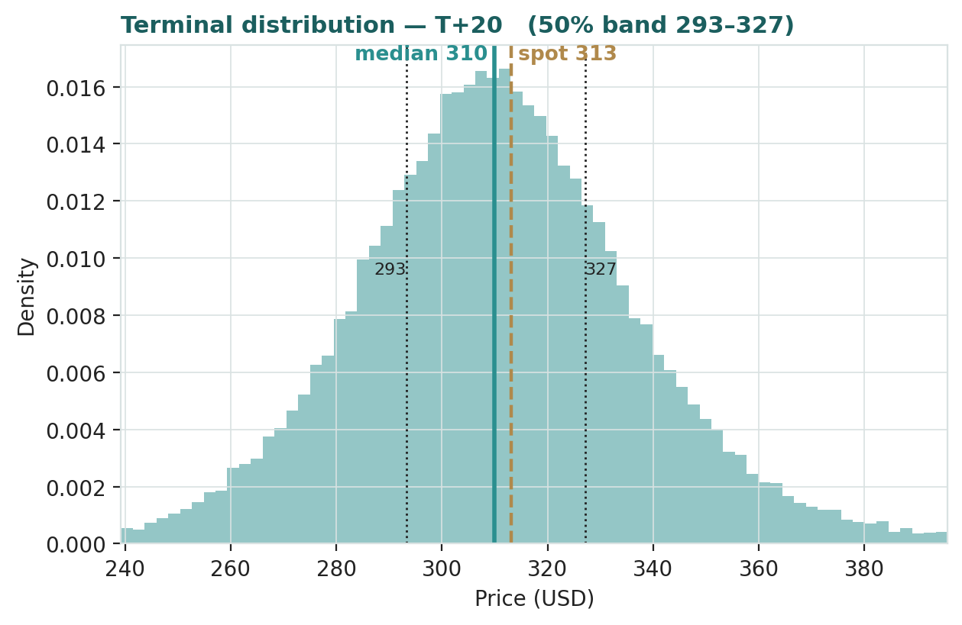  T+20 terminal distribution | 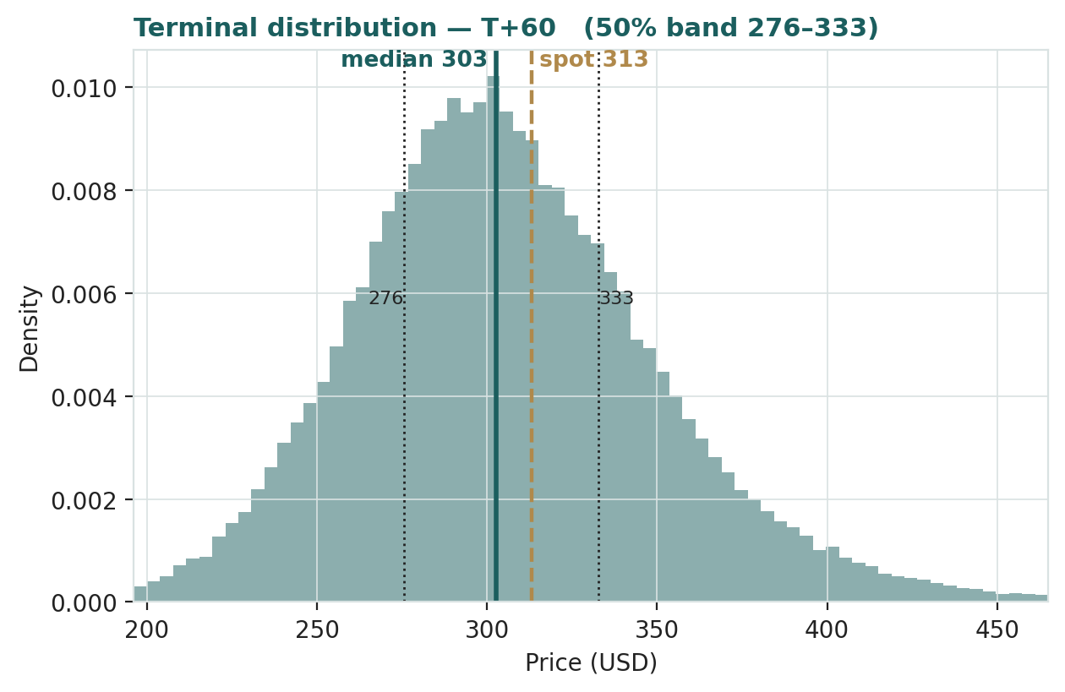  T+60 terminal distribution

Touch-probability ladders
Level (USD) | Touch by T+20 | Touch by T+60
250 | 2% | 15%
266 | 7% | 29%
282 | 21% | 50%
297 | 47% | 72%
329 | 41% | 60%
344 | 18% | 38%
360 | 7% | 23%
376 | 3% | 13%

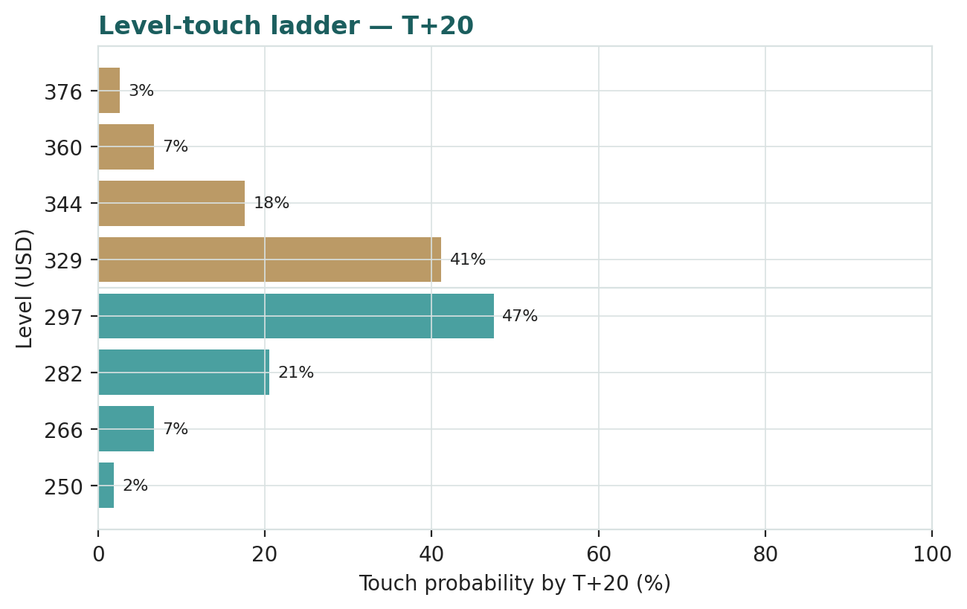 | 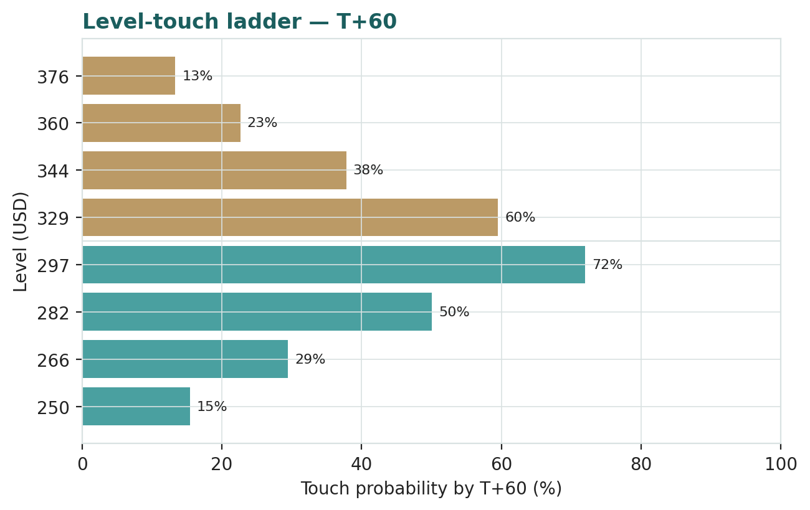

4 Comparison of the lenses, and a verdict
Four fundamental lenses, one technical read and a three-month distribution point in a consistent direction: on modelled fundamentals Apple is richly valued, while the tape is in an uptrend and the near-term distribution is close to even. The consolidated DCF ($152) and the segment SOTP ($184) — the two cash-and-asset lenses — bracket the low end; the multiple and normalized lenses ($249–$253) bracket the high end; the weighted central is $208, and spot is 51% above it. Our verdict is not a rating — it is a description: the market is capitalising a durability and an AI-and-Services optionality that our explicit five-year models deliberately do not, and the $90-odd spread between the lens families is the price of that optionality. A reader who believes Services keeps compounding and the moat holds will lean on the multiple lenses; a reader who discounts strictly on modelled cash flows will lean on the DCF. We show both, and the distribution, and let the reader weigh them.
Lens / read | Figure | What it privileges
Consolidated DCF | $152 | Explicit modelled cash flows
Segment sum-of-the-parts | $184 | Standalone segment economics
Relative multiples | $249 | Market pricing of quality
Normalized earnings | $253 | Through-cycle margin
Weighted central | $208 | Blend of the four
Monte Carlo median (3-mo) | $303 | Where price may sit near-term
Spot | $313.09 | The market's answer today

5 Catalysts to watch
Catalyst | Why it matters | Skew
Quarterly Services growth print | Sustains or challenges the SOTP premium | Two-sided
iPhone AI upgrade-cycle evidence | Drives near-term units and Services attach | Upside if it lands
Gross-margin trajectory | Each point is several $/sh of DCF value | Two-sided
App Store / antitrust rulings | Directly hits the Services take-rate | Downside
Google TAC / search deal outcome | A discrete Services revenue line | Downside
China share & trade policy | Units, margin and supply continuity | Tail-risk, two-sided
Capital-return refresh | Buyback pace shrinks the share count | Modest upside

6 Reading the probability zones
The cone is not a forecast of one path; it is a map of where price could travel and with what likelihood. The interquartile (25th–75th) band — $276 to $333 at T+60 — is where half the paths end, and is the band to reason with; the 5th–95th band ($237–$386) is the tail region, not the expectation. At T+20 the same bands are roughly $293–$327 (interquartile) and $267–$356 (5–95%) — narrower, because width scales with the square root of time.
Zone (T+60) | Range (USD) | Meaning
Interquartile (25th–75th) | $276 – $333 | Half of paths end here — the working band
Median | $303 | -3.4% vs spot
5th–95th | $237 – $386 | Tail region, not the expectation
Above spot | ≥ $313 | 40.2% of paths

7 Caveats and what would change our mind
This is a model, and every model is a set of assumptions. The DCF is dominated by its terminal value, so it is ultimately a bet on the WACC-minus-g spread; a materially lower cost of capital or higher durable growth would lift it toward the multiple lenses. The SOTP depends on the Services margin and multiple we assign; if Services is more annuity-like than we credit, the segment value — and the justified price — rises. The relative and normalized lenses assume the mega-cap quality premium persists; a regime in which that premium compresses would pull them toward the DCF. On the Monte Carlo, the engine models price, not value, and encodes subjective event probabilities; the mild downside skew would flip if the AI-cycle evidence arrived faster than the regulatory overhang resolved. What would change our mind on the central tension: durable evidence that Services can hold a mid-teens growth rate and its take-rate through the regulatory cycle would justify the market's premium; evidence that the take-rate is capped and hardware is ex-growth would vindicate the DCF. We hold both possibilities open, which is why the output is a range and a distribution rather than a number.
Appendix A Financial statements
A.1 Income statement (consolidated, USD bn) — 3 years actual + 5-year forecast
USD bn | FY23 | FY24 | FY25 | FY26E | FY27E | FY28E | FY29E | FY30E
Revenue | $383 | $391 | $416 | $442 | $466 | $491 | $515 | $540
Gross profit | $169 | $181 | $195 | $207 | $220 | $233 | $246 | $259
Operating income (EBIT) | $114 | $123 | $133 | $144 | $154 | $165 | $175 | $186
EBIT margin | 29.8% | 31.5% | 32.0% | 32.5% | 33.0% | 33.5% | 34.0% | 34.5%
D&A | $12 | $11 | $12 | $12 | $13 | $14 | $15 | $15
EBITDA | $126 | $135 | $145 | $156 | $167 | $178 | $190 | $201
Pre-tax income | $114 | $123 | $133 | $144 | $154 | $165 | $175 | $186
Income tax | $17 | $30 | $21 | $23 | $25 | $26 | $28 | $30
Net income | $97 | $94 | $112 | $121 | $129 | $138 | $147 | $156
Diluted shares (bn) | 15.81 | 15.41 | 15.00 | 14.55 | 14.15 | 13.80 | 13.50 | 13.25
Diluted EPS (USD) | $6.13 | $6.08 | $7.47 | $8.29 | $9.13 | $10.01 | $10.90 | $11.80

A.2 Balance sheet (consolidated, USD bn) — 3 years actual + 5-year forecast
USD bn | FY23 | FY24 | FY25 | FY26E | FY27E | FY28E | FY29E | FY30E
Cash & securities | $166 | $141 | $132 | $132 | $132 | $132 | $132 | $132
Other assets | $187 | $224 | $213 | $217 | $221 | $226 | $230 | $235
Total assets | $353 | $365 | $345 | $349 | $354 | $358 | $363 | $367
Total debt | $111 | $107 | $98 | $98 | $98 | $98 | $98 | $98
Other liabilities | $179 | $201 | $186 | $186 | $186 | $186 | $186 | $186
Shareholders' equity | $62 | $57 | $61 | $67 | $73 | $80 | $88 | $96

Apple returns close to all of its free cash flow to shareholders, so book equity stays roughly flat as buybacks offset retained earnings; the forecast retains a nominal 5% of net income and holds cash and debt near FY2025 levels, consistent with the company's stated capital-return posture. Balance-sheet detail is illustrative and secondary to the cash-flow and valuation build.
A.3 Cash flow (consolidated, USD bn) — 5-year forecast
USD bn | FY26E | FY27E | FY28E | FY29E | FY30E
Net income | $121 | $129 | $138 | $147 | $156
+ D&A | $12 | $13 | $14 | $15 | $15
− Δ working capital | ($2) | ($2) | ($2) | ($2) | ($2)
Operating cash flow | $131 | $140 | $150 | $160 | $170
− Capex | ($12) | ($13) | ($14) | ($14) | ($14)
Free cash flow | $119 | $127 | $137 | $146 | $155
Capital returned | ($113) | ($121) | ($130) | ($138) | ($147)

Appendix B Peer set, sector structure, and risks
Apple sits within the US mega-cap technology cohort, which trades at a premium to the broad market on the strength of durable franchises, high returns on capital and secular growth. Within the cohort Apple is the highest-quality cash machine but among the slower growers, which is why its forward multiple sits above the median but below the AI-capex-levered names. The peer table is context for the relative lens, not a recommendation.
Company | Fwd P/E (×) | EV/EBITDA (×) | Revenue growth | Note
Apple (AAPL) | 38× | 27× | low-single | Subject; quality anchor
Microsoft (MSFT) | 32× | 22× | low-double | Cloud & AI
Alphabet (GOOGL) | 22× | 15× | low-double | Search & cloud
Amazon (AMZN) | 34× | 16× | low-double | Retail & AWS
Nvidia (NVDA) | 34× | 30× | high | AI compute
Meta (META) | 24× | 14× | mid-double | Ads & AI
Mega-cap median (ex-AAPL) | 31× | 18× | low-double | Cohort context

Principal risks, restated: regulatory compression of the Services take-rate (App Store, Google TAC); China demand and supply-chain concentration; a failure of the AI-driven upgrade cycle to materialise; gross-margin give-back; and the discount-rate sensitivity of a terminal-value-heavy DCF. Each is reflected either in the lens spread (§1.5), the crux sensitivity (§1.7) or the Monte-Carlo event stack (§3).
Appendix C The expert valuation panel
Every Testahil study closes with a panel of standing expert personas — drawn from the house Expert Persona Library, not invented for the occasion, so that each accumulates a track record across studies and a quarterly update is a re-run, not a re-training. For Apple we cast the three whose methods both fit a high-quality, capital-returning, installed-base franchise and genuinely disagree: Expert 1 (cash returns — a DCF and return-on-capital view), Expert 2 (earnings power — normalized EPS and justified multiples), and Expert 3 (demand and installed base — units, ASP and the Services attach). Each runs a different method, derives its fair value from shown workings, and states a falsification condition. The macro-policy lens — China, tariffs, regulation, FX — runs through the body (§1.8, §5) rather than as a separate persona.
C.1 Expert 1 — cash returns: DCF and return on capital versus the cost of capital
Worldview. Cash is the only thing a shareholder can ultimately spend, and a business creates value only when it earns more on the capital it employs than that capital costs. Expert 1 trusts a disciplined DCF discounted at an equity-appropriate rate and cross-checks it against economic profit (ROIC minus WACC). The method works best for mature, cash-generative franchises and fails when almost all the value sits in a terminal value that is really a growth-versus-discount-rate bet — which Expert 1 addresses by disclosing that dependency rather than hiding it.
Expert 1's workings | Value
FY26E–FY30E FCFF (USD bn) | $119, $127, $137, $146, $155
WACC (Ke = rf + β·ERP) | 9.5% (Ke 10.0%)
Terminal growth g | 3.5%
Sum PV of explicit FCFF | $518 bn
PV of terminal value | $1,701 bn (77% of EV)
Enterprise value | $2,219 bn
+ Net cash | $34 bn
Equity value | $2,253 bn
Fair value per share | $152.50

Worked example & sensitivity (swing = WACC and terminal g). At the base 9.5%/3.5% the model yields $152.50. Flexing the discount rate and growth: at 9.0%/4.0% fair value rises to $180; at 10.5%/2.5% it falls to $118. Even the generous corner does not reach spot.
WACC / g | g = 3.0% | g = 3.5% | g = 4.0%
8.5% | $169 | $183 | $200
9.5% (base) | $143 | $152 | $164
10.5% | $124 | $131 | $138

Cross-examination. Expert 1 tells Expert 2 that a multiple silently capitalises a durability the explicit cash flows have to earn, and that peak-multiple earnings without the capital cost to sustain them is a half-truth. He tells Expert 3 that a full installed base is only worth its cash generation, discounted — a large user count that does not convert to free cash at a rate above the cost of capital is not value. Verdict & falsification. Fair value near $152; at spot the market implies either a WACC well below 9% or durable growth well above 4%. Falsified if Apple sustains ROIC-minus-WACC wide enough that a higher terminal growth is defensible.
C.2 Expert 2 — earnings power: normalized EPS and justified multiples
Worldview. What does the business earn through the cycle, and what is that stream worth? Expert 2 normalizes earnings to strip cyclical flattery, then applies a multiple justified by growth, returns and durability. The method is powerful for franchises with pricing power and a widening high-margin mix, and fails when it is used to rationalise any multiple after the fact — which Expert 2 guards against by tying the multiple to the mega-cap quality cohort rather than to the stock's own recent range.
Expert 2's normalization | Value
FY26E EPS (USD) | $8.29
Normalized EPS (through-cycle) | $7.90
Justified multiple (base) | 32×
Normalized fair value | $252.80
Relative cross-check (30× FY26E) | $248.70
Range (bear–bull) | $213 – $284

Worked example & sensitivity (swing = normalized margin / multiple). At 27× the normalized read is $213; at 36× it is $284. The lens is the most constructive because a rising Services mix lifts both the normalized margin and the multiple the market will pay.
Normalized P/E | 24× | 32× (base) | 36×
Fair value (USD) | $190 | $253 | $284

Cross-examination. Expert 2 tells Expert 1 that a strict DCF on a five-year window understates a franchise whose competitive position lets it compound well beyond it, and that discounting Apple like an average company ignores the moat. He tells Expert 3 that a large installed base only matters because it monetises — the earnings are the point, the units are the mechanism. Verdict & falsification. Fair value near $253; at spot the market is paying roughly 38× forward earnings, a premium that is defensible only if Services growth and margin hold. Falsified if normalized EPS growth stalls or the quality premium compresses.
C.3 Expert 3 — demand and installed base: units, ASP and the Services attach
Worldview. Value begins with demand: how many devices are in use, how often they are replaced, at what price, and how much high-margin Services each active device pulls through. Expert 3 builds from the installed base and the attach rate, valuing the hardware on its through-cycle economics and the Services annuity on a richer multiple — a demand-anchored sum-of-the-parts. The method is strong when an ecosystem has genuine switching costs and weak when it double-counts assets already reflected in earnings, which Expert 3 avoids by valuing the two engines separately.
Expert 3's build (FY26E) | Value
Services revenue | $123 bn
Services value (≈42% EBIT × 26×) | $1,347 bn
Products revenue | $318 bn
Products value (≈30% EBIT × 14×) | $1,337 bn
+ Net cash | $34 bn
Equity value | $2,719 bn
Fair value per share | $184.00

Worked example & sensitivity (swing = Services attach / multiple). Crediting Services a 30× multiple on the same margin lifts the segment value and the per-share figure toward the bull case ($211); a 22× multiple pulls it to the bear ($157). The whole disagreement with the DCF is how annuity-like Services really is.
Services EV/EBIT | 22× (bear) | 26× (base) | 30× (bull)
Fair value per share (USD) | $157 | $184 | $211

Cross-examination. Expert 3 tells Expert 1 that a pure cash-flow discount misses the option value of an installed base that keeps finding new ways to monetise — the base is an asset the DCF window undercounts. He tells Expert 2 that a single blended P/E hides the fact that a dollar of Services earnings is worth far more than a dollar of hardware earnings, which is exactly what the sum-of-the-parts exposes. Verdict & falsification. Fair value near $184, between the cash-flow floor and the multiple ceiling. Falsified if the Services take-rate is capped by regulation or the attach rate stops rising.
C.5 The three in one room
Expert 2: “FY26 earnings power is real and growing. Normalize it, put a quality multiple on it, and the shares are close to fair — the market is paying for a franchise that compounds. Discounting Apple like an average company is the error.”
Expert 1: “And to earn it, Apple must keep out-returning its cost of capital for decades — that is what your multiple assumes. My explicit cash flows, discounted at an equity rate, land near $150. The gap to spot is not earnings; it is a bet on durability I will not pay for in full.”
Expert 3: “You are both arguing about the engine. Count the base. Two billion active devices, a Services layer that attaches to every one of them and grows double digits — value the annuity apart from the hardware and you land near $184, between you. The argument is the Services multiple, not the earnings.”
C.6 Reading the divergence
Expert | Method | The one assumption that drives it | Fair value
Expert 1 | Cash returns (DCF + ROIC) | WACC vs terminal growth | $152
Expert 2 | Earnings power & multiples | Justified quality multiple | $253
Expert 3 | Demand & installed base | Services attach & multiple | $184

The spread — $152 to $253 at base — is wide, and it is almost entirely one disagreement: how much of Apple's value is a durable, high-margin Services annuity beyond the explicit cash-flow window. Expert 2 says the market is right to capitalise it (quality compounds); Expert 1 says pay only for the modelled cash (durability must be earned); Expert 3 says value the annuity apart from the hardware and you land in between. The $100 spread is therefore a clean measure of a single uncertainty — the durability and monetisation of the Services layer. Resolve that, and the three converge. Spot, at $313.09, sits above all three base cases, which is the market's own answer: it is paying, today, for the most optimistic reading of that annuity.
About this series
Testahil publishes independent, educational valuation studies. Each is an attempt to reason transparently about what a security is worth, with every assumption shown and a companion model so readers can disagree productively. The house style is distributions, not tips: we describe ranges and probabilities, not targets, and we do not tell anyone what to do. Studies are framed as educational analysis, the preparer is not licensed by any securities regulator, and holdings are disclosed.
Disclosure & Disclaimer
Not investment advice. This document is educational and informational only. It is not, and must not be relied upon as, investment, financial, legal, accounting or tax advice, nor an offer, solicitation or recommendation to buy, sell or hold any security. It contains no price target and no rating.
No licence; no advisory relationship. The preparer is not registered or licensed with any securities or financial regulator in any jurisdiction, holds no brokerage or investment-advisory authorisation, and is not acting as your adviser or fiduciary. Nothing here is personalised to your circumstances.
Holdings disclosure. The preparer may hold, and may in the future take or dispose of, a position in the security discussed in this report, and may transact at any time without notice. This is a potential conflict of interest you should weigh.
Sources & accuracy. Reported financial and operating figures are drawn from the company's public disclosure (Form 10-K, FY2023–FY2025) and other public sources believed reliable but not independently verified; they may contain errors or be superseded. Forward-looking inputs — the revenue and margin forecasts, the segment marks, the multiples, the DCF and Monte-Carlo factor probabilities — are the preparer's own judgments and are inherently uncertain.
Forward-looking statements. Any statements about the future are estimates subject to risks and uncertainties; actual results may differ materially. The Monte Carlo models price, not value, and encodes subjective probabilities for events that have not occurred.
No reliance; your responsibility. Do your own research and consult a licensed professional before making any decision. You are solely responsible for your investment decisions and their outcomes. To the maximum extent permitted by law, the preparer accepts no liability for any loss arising from use of this document.
Currency & figures. Figures are in US dollars ($); bn denotes billion and tn trillion. Apple's fiscal year ends in late September. Rounding may cause totals to differ slightly. Spot price and market data are as of 06 July 2026 and change continuously.
TESTAHIL · Independent Valuation Study · Educational Analysis · Apple Inc. (NASDAQ: AAPL) · edition 06-07-2026 · reporting currency USD

