Testahil · Independent Valuation Study - Educational Analysis Not investment advice
Independent Valuation Study - Educational Analysis
Abu Qir Fertilizers and Chemical Industries (S.A.E.) (EGX: ABUK)
Fundamental analysis · Technical analysis · Monte Carlo simulation - one integrated read
Anchor: EGP 67.97 (1 Jul 2026 close) · ~1,262.5 mn shares · mkt cap ~EGP 85.8 bn · Egypt's largest nitrogen-fertilizer producer, effectively debt-free with ~EGP 16 bn net cash and a sizeable investment/associate portfolio · prices and probabilities computed 1 Jul 2026 from the attached daily history · primary lens: operating FCFF plus a sum-of-the-parts for investments and net cash · swing factors: the gas-feedstock cost (subsidised vs export-parity) and the EGP.
READ FIRST - what this document is, and is not. This study is a valuation exercise and an expression of personal analytical opinion, published free of charge for educational purposes. It is NOT investment advice, NOT a recommendation or solicitation to buy, sell or hold any security, and NOT directed at the circumstances of any reader. The preparer is not licensed by any securities regulator, manages no money, and accepts no fees, funds or clients. All values are model outputs presented as ranges and distributions because no single number should be relied on. Reported financials are the company's own disclosure (FY2024/25 audited, reported Jul-Sep 2025); forward-looking inputs - the mid-cycle margin, the marks on investments and net cash, the multiples, the DCF and the Monte-Carlo factor probabilities - are the preparer's judgments and are flagged throughout. Core earnings shown here deliberately exclude the lumpy one-off associate revaluations that inflate reported net income in some years. See the Disclosure & Disclaimer at the end.
Headline
At EGP 68 the stock sits modestly above a fundamental cluster of roughly EGP 57-62. The operating fertilizer business, valued on a mid-cycle margin, is worth ~EGP 54 bn; add ~EGP 16 bn of net cash and ~EGP 6 bn of investments and equity is ~EGP 72-76 bn, or EGP 57-60 a share. The argument is not really the numbers - it is whether subsidised gas holds (bull) or resets to export parity (bear), and how much to discount a cash pile the company has not distributed. The three-month probability map is near-symmetric around spot: a 25-75% band of about EGP 56-81, with a fatter upside tail from the fertilizer-price and FX event factors.
Valuation summary - every read at a glance
One table for the four reads that follow - what the business is worth (fundamental), what the tape is doing (technical), where price could travel over three months (Monte Carlo), and how three independent expert methods land. Every row is developed in the sections and appendices below.
Lens / read | What it measures | Output | Takeaway
FUNDAMENTAL - what the business is worth (the anchor)
Sum-of-the-parts (primary) | Operating DCF + investments + net cash | EGP 60 | -11% vs spot
Consolidated DCF | Discounted 5-yr operating cash flows | EGP 60 | -11%
Mid-cycle EBITDA x 5.5x | Operating multiple, ex one-offs | EGP 57 | the floor
Relative P/E | Peer-multiple on core earnings | EGP 72 | +6% · the ceiling
Weighted central | Blend 40 / 20 / 15 / 25 | EGP 60 | -11% vs 68
TECHNICAL - what the tape is doing (timing, not value)
Trend & momentum | Price vs 20/50/100/200-day | Below 20/50/100, above 200 | Oversold pullback
MONTE CARLO - where price could travel (3 months)
T+60 distribution | 16-factor, 50k paths, seed 42 | P25-P75 EGP 56-81 | Near-symmetric to spot
EXPERT PANEL - three independent methods
Expert 1 / 2 / 3 | Earnings-power · NAV · Gas/FX regime | EGP 57 / 58 / 62 | Cluster below spot

Company overview - Abu Qir Fertilizers and Chemical Industries at a glance
Item | Value
Exchange / ticker | EGX: ABUK
Sector | Nitrogen fertilizers & chemicals
Fiscal year-end | 30 June
Shares outstanding | ~1,262.5 mn
Spot / market cap | EGP 67.97 / ~EGP 85.8 bn
Net cash | ~EGP 16 bn (D/E ~0.05%)
FY25 revenue / core NI | EGP 22.9 bn / ~EGP 8.8 bn
Dividend | ~EGP 6-7/share (~9-10% yield)
Export footprint | ~40 markets; urea, ammonium nitrate, NPK, ammonia
52-week range | EGP 45.4 - 94.0

Source: company FY2024/25 audited results and EGX disclosure; Investing.com/Mubasher/Arab Finance releases; prices from the attached daily history.
1 Fundamental valuation
1.1 Operating FCFF + sum-of-the-parts - the primary lens
The operating fertilizer business is valued on a five-year FCFF: NOPAT on a normalizing EBIT margin (38%->40%), plus D&A, less maintenance capex and working-capital investment, discounted at a 24% nominal EGP WACC with 11% terminal growth. That yields an operating enterprise value of ~EGP 54 bn.
Because roughly a third of ABUK's reported profit is investment and associate income earned on its cash and portfolio - not the fertilizer plants - the operating DCF is combined with a sum-of-the-parts: operating EV + investments (~EGP 6 bn) + net cash (~EGP 16 bn) = equity of ~EGP 76 bn, or EGP 60.3/share. Valuing the plants and the treasury separately is what keeps the gas question from contaminating the cash, and vice versa.
The 24% WACC is built bottom-up for an EGP investor: a ~20-21% local risk-free anchor, a modest equity premium for a debt-free exporter, and no size or liquidity add-on given ABUK's index weight. Terminal growth at 11% is deliberately below long-run nominal GDP so the terminal year never smuggles in real expansion the plants have not committed capex to.
1.2 Reverse-DCF cross-check
Reverse-engineering the price: at EGP 68 with ~EGP 22 bn of cash and investments, the market implies an operating EV of ~EGP 64 bn - about EGP 10 bn more than the base DCF. The table translates that gap into the assumption you must hold to pay spot.
Neither implied assumption is unreasonable if gas stays subsidised; both are aggressive if it does not - which is why the study treats the price as a regime bet rather than a mispricing.
What spot implies | Implied level | Base case
Operating EV backed out of EGP 67.97 | ~EGP 64 bn | EGP 54 bn
Mid-cycle EBITDA margin | ~44% | 40%
or nominal WACC | ~21-22% | 24%
What would change the implication: a gas-pricing announcement would collapse the implied margin question overnight in either direction, while a CBE easing cycle would validate the lower implied WACC without touching operations - the two implied levels in the table are therefore watchable, not abstract.

1.3 Relative multiples
For completeness the peer frame: Gulf producers with contracted cheap gas trade 6.5-8x EV/EBITDA, diversified globals 6-7x, and Egyptian industrials with policy-priced inputs 4-6x - ABUK's clean balance sheet argues for the top of the local band, which is precisely where the mid-cycle lens (5.5x) puts it.
On a mid-cycle EBITDA of ~EGP 9.2 bn the operating business trades around 5-5.5x EV/EBITDA once net cash is stripped out - a discount to global nitrogen peers (Nutrien, CF, Yara at 6-8x through-cycle), appropriate for EGP and country risk but not extreme. On core (ex-one-off) earnings the trailing P/E is ~8x and the dividend yield ~9-10%.
The yield is the quiet argument for the stock: at these payout levels an owner is paid to wait out the gas question, provided the distribution policy holds. Against Gulf producers (which enjoy contracted cheap gas) ABUK's discount narrows to a turn or less once the cash is stripped - the market already charges for the policy risk, the question is whether it charges enough.
1.4 Normalized earnings power
Normalized earnings power: through-cycle EBIT margin ~38-40% on ~EGP 23 bn revenue is ~EGP 8.8-9.2 bn; taxed and capitalised at the cost of equity, with the cash and investments added, supports ~EGP 63-66/share - above the conservative DCF because it implicitly credits a full mid-cycle rather than the current pullback in urea and ammonia prices.
The gap between this lens (65) and the DCF (60) is a clean measure of how much the explicit forecast years cost at a 24% discount rate: about EGP 5/share of pure discounting drag, no disagreement about the business at all.
Two refinements keep this lens honest: the capitalization rate is the full cost of equity (no growth credit beyond the mid-cycle itself), and the investment income is normalized to a sustainable treasury yield rather than the FY24 spike - both choices push the answer down, which is the correct direction for a lens whose job is a ceiling-check on the DCF, not a second bull case.
1.5 Synthesis - five lenses
Five lenses - operating DCF, SOTP NAV, mid-cycle multiple, relative P/E, normalized earnings - cluster the operating-plus-cash value at roughly EGP 57-66, with the relative-multiple lens the most generous. Weighting the two most instrument-appropriate (operating DCF and SOTP NAV) most heavily centres fair value near EGP 58-60, modestly below spot.
Reading the field: the tightness of the cluster is itself information - four independent methods land within EGP 9 of each other, so the residual between fair value and price is not model risk, it is the regime question, quantified in section 1.7 and priced by Expert 3.
Lens | Fair value (EGP) | Weight
Sum-of-the-parts (primary) | 60 | 40%
Consolidated DCF | 60 | 20%
Mid-cycle EBITDA x multiple | 57 | 15%
Normalized earnings | 65 | 25%
Weighted central | ~60 | 100%

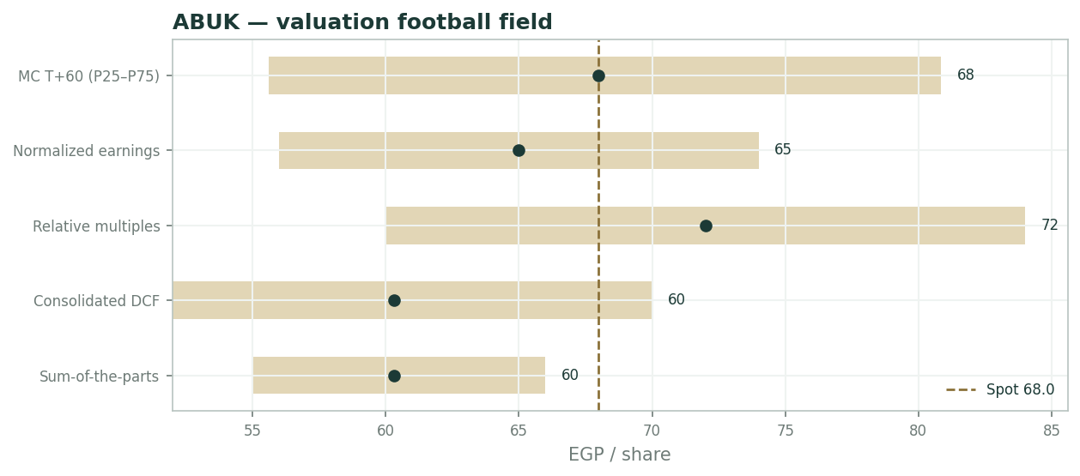
The weights are declared, not optimized: the two parts-based lenses carry 60% because they are the instrument-appropriate pair for a cash-heavy producer; the multiple lenses carry the rest as market context.
Valuation football field - lens ranges vs spot
1.6 The three parts - operating, investments, net cash
Three parts drive the whole, and they answer to different masters: the operating fertilizer business answers to gas and urea; the investment portfolio to equity-method accounting; the net cash to treasury yields and the payout decision. The scorecard separates them so each risk can be priced where it lives.
The market's premium, if any, sits on the second and third - capital the company holds but has not fully distributed - which is precisely where Expert 2's haircut operates.
Part | Value (EGP bn) | Exposure | Read
Operating business (DCF) | 54.2 | Gas cost, urea/ammonia, EGP | The only cyclical part
Investments & associates | 6.0 | Equity-method income | Carrying value - confirm in notes
Net cash | 16.0 | Treasury yields, payout policy | The floor under the price
Gross equity value | 76.2 |  | EGP 60.3 per share

1.7 Gas feedstock and the EGP - the crux
The crux is gas. ABUK's margin is a spread between USD-linked fertilizer prices and a largely state-set gas-feedstock cost; a weak EGP widens it (exports priced in USD), a move of gas toward export parity collapses it. FX and gas are therefore not independent risks - they are the same swing, and they dominate the value far more than any modelling choice.
History frames the stakes: the 2014 and 2022 feedstock episodes each compressed margins for four to six quarters before pricing and the currency restored them, and the FY25 accounts already carry an adjustment from a gas-supply shutdown. The bull case is continuity; the bear case is a fiscal decision taken in one meeting.
Quantifying the crux: each ~5-point move in the EBITDA margin is worth roughly EGP 8/share through the capitalized lenses, and each 10% EGP move roughly EGP 5-7 - so the plausible policy space alone spans about EGP 25 of value per share, dwarfing every modelling choice in this report.
1.8 Macro and country
Macro/country: Egypt's periodic gas shortages have forced temporary fertilizer-plant shutdowns, and the FY25 accounts carry adjustments tied to one such closure. The medium-term risk is a policy shift on feedstock pricing under fiscal pressure; the medium-term support is a weak EGP and ABUK's export franchise across ~40 markets.
On the demand side, Egypt's domestic allocation quota (fertilizer sold locally at regulated prices in exchange for the gas arrangement) caps a slice of revenue but stabilises volumes; the export tranche is where both the upside and the policy risk concentrate.
Globally, nitrogen prices are off their 2022 peaks but stabilising, and food-security demand keeps volumes defensive - the cycle here is a price cycle, not a volume cycle, which is what makes a mid-cycle margin estimable at all.
1.9 WACC x mid-cycle-margin grid
Sensitivity (per-share) is dominated by two inputs - WACC and the mid-cycle EBITDA margin. Holding the parts fixed, WACC 22/24/26% moves fair value by roughly +/-EGP 6, and margin 35/40/45% by roughly +/-EGP 8; the interaction, not either alone, defines the EGP 50-75 fundamental envelope. The grid below is illustrative and consistent with the live two-way table in the companion Excel.
WACC \ margin | 35% | 40% | 45%
22% | 58 | 66 | 74
24% | 52 | 60 | 68
26% | 46 | 54 | 62

2 Technical and price structure
Price EGP 68.0 sits below the 20-day (73.4), 50-day (81.3) and 100-day (79.1) averages but above a rising 200-day (64.8) - a sharp correction inside a longer uptrend. RSI(14) at ~19 is deeply oversold; the 52-week range is EGP 45.4-94.0, so the stock has round-tripped from its high and is nearer the middle.
The MA stack is bearish short-term with support toward the 200-day (~EGP 65) and the recent low (~EGP 60); oversold readings this deep have historically marked exhaustion zones in ABUK's tape rather than trend starts, but the signal is timing, not value.
Indicator | Reading
Spot | EGP 67.97
SMA 20 / 50 / 100 / 200 | 73.4 / 81.3 / 79.1 / 64.8
RSI(14) | ~19 (deeply oversold)
52-week range | EGP 45.4 - 94.0
Structure | Below short/medium MAs, above rising 200-day

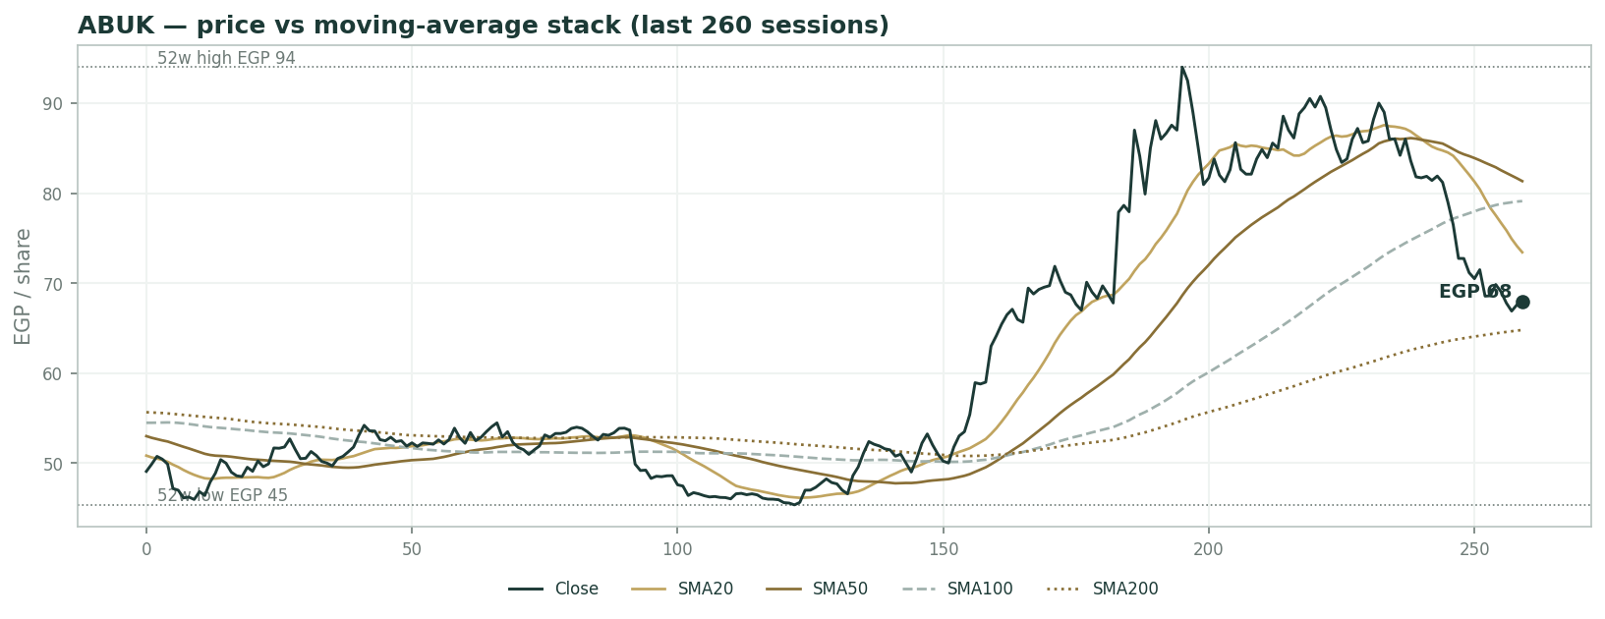
Price vs moving-average stack (last 260 sessions)
3 Monte Carlo - a probabilistic price map
Paths diffuse from spot; the §1 value gap is kept out of the drift, so the three lenses stay independent. 16-factor model - 7 continuous + 9 discrete - 50,000 paths, seed 42.
Horizon | P5 | P25 | P50 | P75 | P95
T+20 | 52 | 61 | 68 | 76 | 88
T+60 | 42 | 56 | 67 | 81 | 106

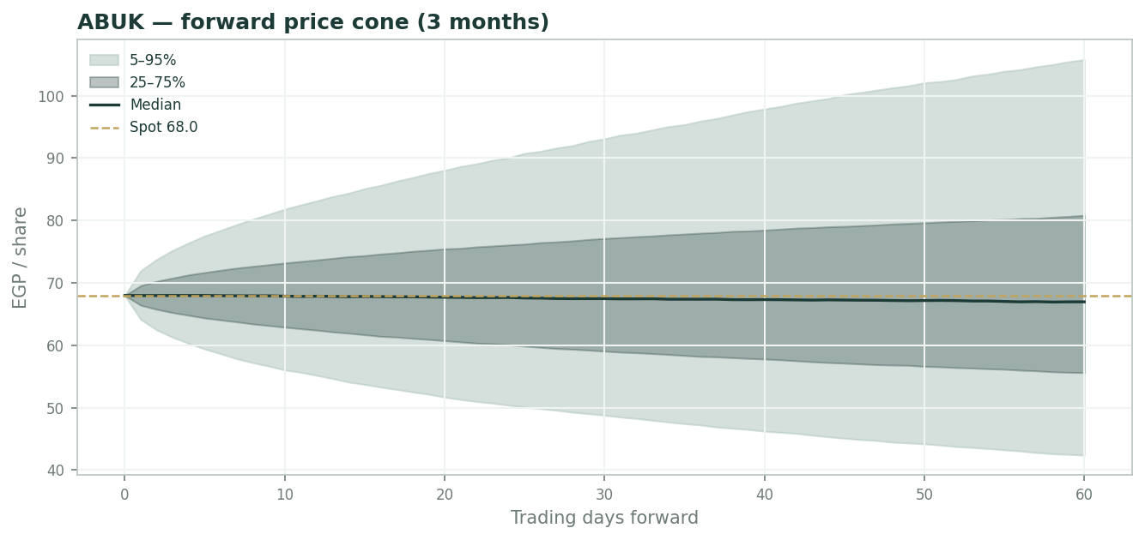
Forward price cone (3 months)
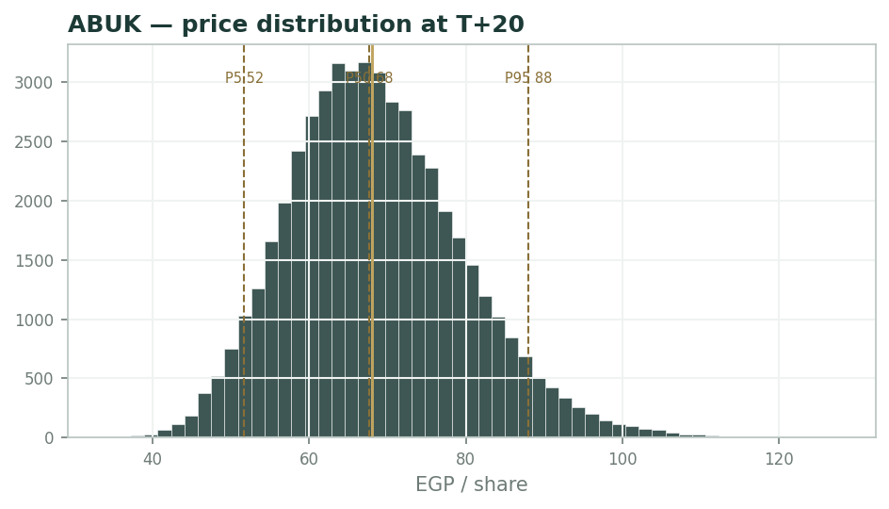
Price distribution at T+20
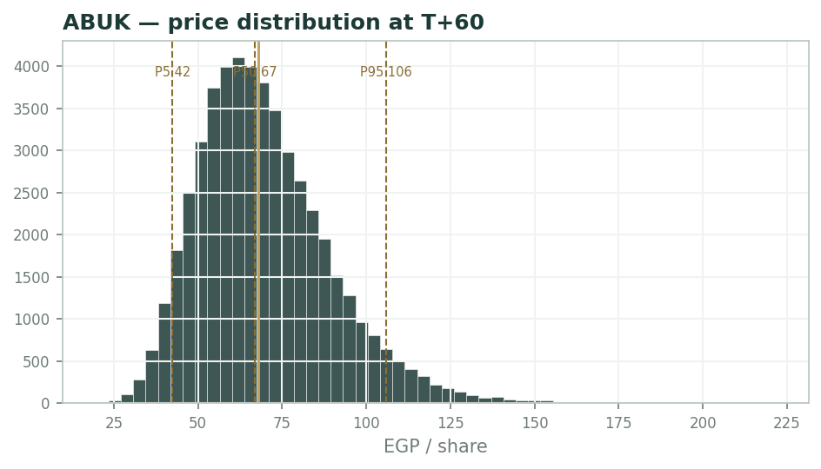
Price distribution at T+60
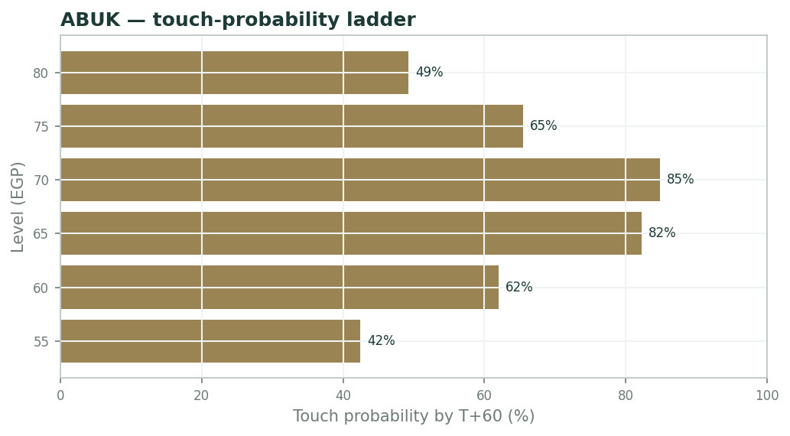
Touch-probability ladder by T+60
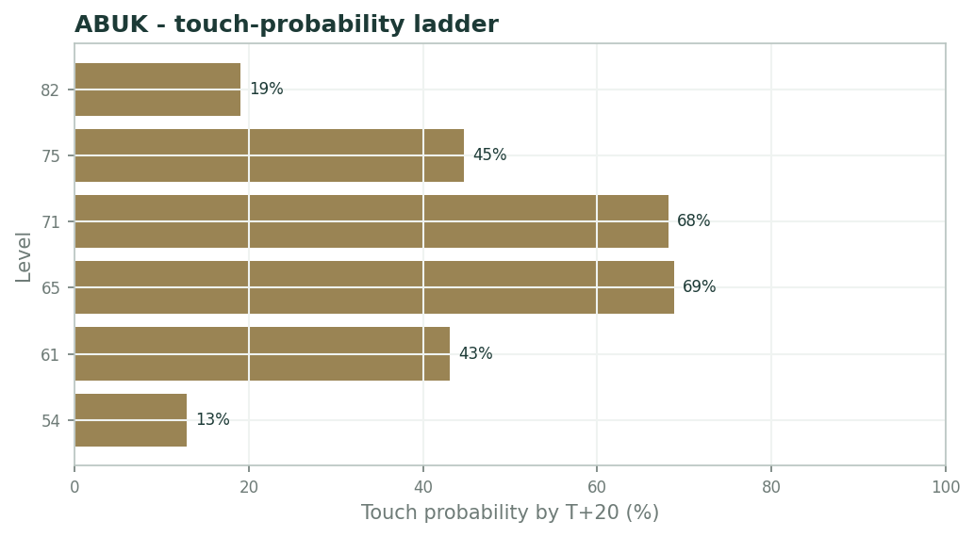
Touch-probability ladder by T+20
The 16-factor model diffuses from spot with a near-flat median. At T+20 the interquartile band is EGP 61-76; by T+60 it widens to EGP 56-81 around a 67 median, with P5-P95 of 42-106. The distribution is right-skewed - the upside tail is fatter than the downside - reflecting the fertilizer-price and FX event factors.
Touch probabilities: by T+60, EGP 60 ~66%, EGP 75 ~65%, EGP 80 ~44%; by T+20 the same levels run ~43%, ~45% and ~19% - the one-month map is the three-month map compressed, not reshaped.
4 Comparison of the lenses, and a verdict
The lenses agree more than they appear to: the operating-plus-cash value sits at EGP 57-60 across DCF, NAV and mid-cycle multiple, with the price-multiple lens the outlier on the high side. Spot EGP 68 is ~10-15% above that fundamental centre, a gap that is really a bet on gas staying subsidised and the cash carrying no discount.
Verdict: fairly-to-fully valued on base assumptions, with the risk skewed to the gas-policy question rather than to the model - and the ~9-10% dividend yield the compensation for holding through it.
5 Catalysts to watch
- FY2025/26 full-year results (early Aug 2026) - margin and the investment-income line.
- Any announcement on fertilizer-sector gas-feedstock pricing - the single largest swing.
- EGP moves and the USD urea/ammonia price - the same spread from both ends.
- Dividend declaration and any special distribution of the cash pile - Expert 2's falsification event.
- Gas-supply interruptions forcing plant shutdowns, as already booked in FY25.
6 Reading the probability zones
Below ~EGP 55 the stock is cheap on every lens including a conservative NAV - the P5-P25 zone. EGP 57-66 is the fundamental fair band where the lenses cluster. EGP 68-80 (spot to P75) requires the bull gas/FX case. Above ~EGP 88 (P95) prices in a full mid-cycle plus no discount on the cash - a demanding combination.
Zone | Range (EGP) | What it means
Cheap on all lenses | < 55 | P5-P25; below conservative NAV
Fundamental fair band | 57 - 66 | DCF, NAV, mid-cycle and normalized interleave
Bull gas/FX priced | 68 - 80 | Spot to P75; needs subsidised gas + weak EGP
Full mid-cycle + no discount | > 88 | P95; demanding combination

7 Caveats and what would change our mind
Core earnings exclude lumpy one-off associate revaluations, which have materially inflated reported net income in some years; investments/associates and net cash are carried at estimated values pending the FY25 balance-sheet notes; FY23-24 balance-sheet lines and D&A are estimates; the EGP WACC and terminal growth are large judgment calls; and the whole valuation is hostage to gas-feedstock policy, which is outside the model.
Appendix A Financial statements
A.1 Income statement - 3 years historical + 5-year forecast
Line | FY23 | FY24 | FY25 | FY26E | FY27E | FY28E | FY29E | FY30E
Revenue | 21,657 | 18,528 | 22,916 | 25,208 | 27,728 | 30,501 | 33,551 | 36,906
EBIT (operating) | 11,179 | 6,526 | 8,185 | 9,579 | 10,537 | 11,895 | 13,085 | 14,763
D&A | 1,080 | 1,100 | 1,150 | 1,260 | 1,386 | 1,525 | 1,678 | 1,845
EBITDA | 12,259 | 7,626 | 9,335 | 10,839 | 11,923 | 13,421 | 14,763 | 16,608
Investment & interest income | 2,870 | 4,036 | 3,229 | 3,400 | 3,700 | 4,000 | 4,300 | 4,600
Pre-tax profit (core) | 14,049 | 10,562 | 11,414 | 12,979 | 14,237 | 15,895 | 17,385 | 19,363
Tax | 3,161 | 2,376 | 2,568 | 2,920 | 3,203 | 3,576 | 3,912 | 4,357
Net income (core) | 10,888 | 8,186 | 8,846 | 10,059 | 11,034 | 12,319 | 13,473 | 15,006
Reported net income (incl. one-offs) — memo | 14,020 | 13,477 | 9,353

A.2 Balance sheet
Line | FY23 | FY24 | FY25 | FY26E | FY27E | FY28E | FY29E | FY30E
Cash & cash equivalents | 11,000 | 13,500 | 17,073 | 26,243 | 36,685 | 48,413 | 61,306 | 75,754
Investments & associates | 6,000 | 6,000 | 6,000 | 6,000 | 6,000 | 6,000 | 6,000 | 6,000
PP&E (net) | 3,200 | 3,300 | 3,400 | 3,640 | 3,853 | 4,028 | 4,151 | 4,205
Net working capital | 2,600 | 2,900 | 3,132 | 3,781 | 4,159 | 4,575 | 5,033 | 5,536
Total equity (≈ net assets) | 19,000 | 21,500 | 24,002 | 34,061 | 45,094 | 57,413 | 70,887 | 85,893

A.3 Cash flow
Line | FY23 | FY24 | FY25 | FY26E | FY27E | FY28E | FY29E | FY30E
Net income (core) | 10,888 | 8,186 | 8,846 | 10,059 | 11,034 | 12,319 | 13,473 | 15,006
+ D&A | 1,080 | 1,100 | 1,150 | 1,260 | 1,386 | 1,525 | 1,678 | 1,845
− Increase in NWC | 0 | -300 | -232 | -649 | -378 | -416 | -458 | -503
Cash from operations | 11,968 | 8,986 | 9,764 | 10,670 | 12,042 | 13,428 | 14,693 | 16,348
− Capex | -1,200 | -1,300 | -1,400 | -1,500 | -1,600 | -1,700 | -1,800 | -1,900
Cash from investing | -1,200 | -1,300 | -1,400 | -1,500 | -1,600 | -1,700 | -1,800 | -1,900
Net change in cash | 10,768 | 7,686 | 8,364 | 9,170 | 10,442 | 11,728 | 12,893 | 14,448

A.4 Discounted cash flow (5-year forecast)
Line | FY26E | FY27E | FY28E | FY29E | FY30E
EBIT | 9,579 | 10,537 | 11,895 | 13,085 | 14,763
NOPAT = EBIT×(1−tax) | 7,424 | 8,166 | 9,219 | 10,141 | 11,441
+ D&A | 1,260 | 1,386 | 1,525 | 1,678 | 1,845
− Capex | -1,500 | -1,600 | -1,700 | -1,800 | -1,900
− Increase in net WC | -649 | -378 | -416 | -458 | -503
FCFF | 6,535 | 7,574 | 8,628 | 9,561 | 10,883
Discount factor | 0.806 | 0.650 | 0.524 | 0.423 | 0.341
PV of FCFF | 5,270 | 4,926 | 4,525 | 4,044 | 3,712

DCF build | Value
Σ PV of explicit FCFF | 22,478
Terminal value (Gordon) | 92,925
PV of terminal value | 31,697
Operating enterprise value | 54,175
+ Investments & associates | 6,000
+ Net cash | 16,000
Equity value | 76,175
Fair value per share | 60.34

Appendix B Step 0 - calibration backtest
Step 0 replayed non-overlapping quarterly 3-month forecasts across the full five years. After tuning the volatility multiplier to 1.45, the 50/80/90% bands covered 59 / 82 / 88% of realized outcomes and the PIT histogram is approximately uniform - calibration passes (n = 17 quarterly windows).
Band | Target | Realized
50% | 50% | 59%
80% | 80% | 82%
90% | 90% | 88%

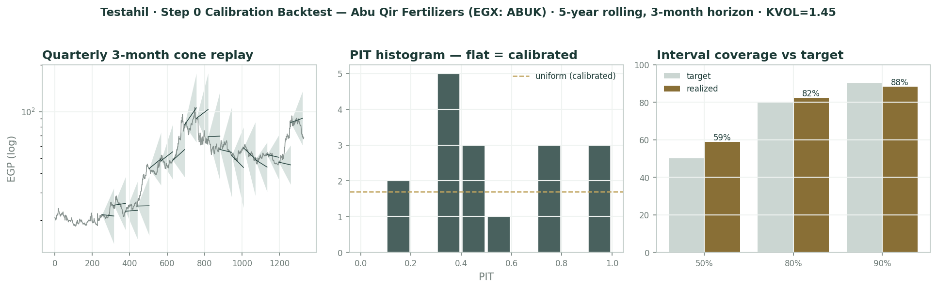
Calibration backtest - cone replay, PIT histogram, interval coverage
Appendix C Peer set, sector structure, and risks
Peers: global nitrogen producers (Nutrien, CF Industries, Yara) and regional Gulf/Egypt producers; ABUK trades at a discount on EV/EBITDA appropriate for EGP and country risk. Sector structure: gas-feedstock cost and export-parity pricing dominate margins; demand is defensive (food security) but prices are cyclical.
Principal risks: gas-feedstock repricing, gas-supply interruptions, EGP and global fertilizer-price swings, governance around the undistributed cash, and the concentration of value in a single feedstock decision the company does not control.
Appendix D The expert valuation panel
D.1 Expert 1 - normalized mid-cycle earnings power (operating fertilizer business)
Worldview and tradition. A cash-generating industrial is worth its through-the-cycle earnings capitalized, not the last printed year. Fertilizer is cyclical - urea and ammonia prices and the gas cost swing wildly - so any single year, high or low, is noise around a mid-cycle.
The tradition is Graham-and-Dodd earning-power value applied to commodity processors: estimate the margin the asset earns across a full price cycle, put a conservative multiple on it, and treat everything the market adds above that as payment for a forecast nobody can make. It refuses both the euphoria of a peak year and the despair of a trough one.
Applied here, the discipline reduces to one question: across a full urea-ammonia cycle, what EBITDA does a debt-free, gas-fed, export-capable plant complex of this scale reliably produce - and what is a pound of that worth to an EGP investor who can earn 20%+ risk-free? Every other page of this report is detail around that question.
When it works / when it fails. Works for stable-demand commodity producers with a definable mid-cycle margin - fertilizer demand is food security, so volumes barely flinch even when prices halve. Fails when the cost or price regime structurally breaks: if subsidised gas moves permanently to export parity, the historical 'mid-cycle' is the wrong anchor, and the method quietly capitalizes a regime that no longer exists.
It also fails on timing - it says what the business is worth, never when the market will agree - and it deliberately ignores the balance-sheet optionality Expert 2 prices.
The honest weakness in this specific case is the anchor's provenance: ABUK's history is a subsidised-gas history, so 'mid-cycle' partly assumes the subsidy. I mitigate by using 40% rather than the ~44% five-year average, but the residual regime risk is real - it is priced by Expert 3, not by me.
Standard workings. Take mid-cycle revenue, apply the mid-cycle EBITDA margin, capitalize at a conservative operating multiple, then add the non-operating assets at face. Every step below lives in the companion Excel's Assumptions layer (blue cells), so any single input can be red-penned and the whole answer reprices.
Each input is deliberately conservative: revenue at the FY25 level rather than trend, the margin below the five-year average, the multiple below global peers. The stack builds enterprise value first, then adds the two non-operating layers at face - no synergy, no growth premium, no credit for the export franchise's option value.
Step | Value
Mid-cycle revenue (~FY25 level) | EGP 22,900 mn
x mid-cycle EBITDA margin | 40%
Mid-cycle EBITDA | EGP 9,160 mn
x EV/EBITDA | 5.5x
Operating EV | EGP 50,380 mn
+ Net cash | EGP 16,000 mn
+ Investments & associates | EGP 6,000 mn
Equity value | EGP 72,380 mn
/ shares (mn) | 1,262.5
Fair value per share | EGP 57.4

Worked example. FY25 revenue EGP 22.9 bn x 40% = EGP 9.16 bn EBITDA; at 5.5x that is EGP 50.4 bn operating EV; add EGP 22 bn of cash and investments for EGP 72.4 bn equity, or EGP 57.4/share.
As a cross-check, the same EBITDA at the FY25 realized margin (35.7%) and a global-peer 6x gives EGP 55.0/share - the answer is stable across reasonable inputs, which is the point of the method.
Run the arithmetic at the bear inputs (35% margin, 5.0x) and it still yields ~EGP 50 - which is why the floor of my range, not its base, is the number I would defend in a hostile room.
Sensitivity on the swing input. The two dials are the margin and the multiple; the table shows how far each moves the answer, and note the symmetry - neither dial alone can carry the value to spot.
Swing input | Fair value (EGP/sh)
EBITDA margin 35 / 40 / 45% | 50 / 57 / 65
EV/EBITDA 5.0 / 5.5 / 6.0x | 54 / 57 / 61
Revenue +/-10% | +/- ~4.5

Cross-examination. To Expert 2: carrying value understates the operating franchise's earning power - a plant that mints EGP 9 bn of EBITDA is worth more than its depreciated book, and your haircut on the cash is a governance opinion, not a valuation. History sides with me: the payout record shows the cash does reach shareholders, just slowly - a timing discount at most, not a value one.
To Expert 3: you cannot discount the whole business to the gas worst-case; these plants ran through the 2014 and 2022 gas shocks and the margin recovered both times, because food-security politics protects the feedstock more than the fiscal ledger suggests. Your tree is honest about uncertainty, but it treats the state as indifferent to its largest fertilizer asset - two decades of revealed preference say it is not.
Verdict, falsification, and what the price implies. Operating-plus-cash value ~EGP 57 (range 50-65). At EGP 68 the market is paying for a mid-cycle margin nearer 45% or a discount rate below 20% - a full price for the franchise, defensible only if the gas regime holds.
What the price implies: buyers at spot are underwriting the top half of my range. That is not irrational - it is a view on gas - but it should be held knowingly, because at 68 my method offers no margin of safety at all. Falsification: two consecutive years of sub-30% EBITDA margin with no recovery would break the mid-cycle anchor.
D.2 Expert 2 - sum-of-the-parts net asset value with a discount for undistributed capital
Worldview and tradition. Mark each part to a defensible value and refuse to pay for hope. ABUK is an operating fertilizer business wrapped around a large cash-and-investment pile; the market rightly discounts capital it cannot get its hands on.
The tradition is the conglomerate/holdco NAV school: assets are worth what a rational owner could realize for them, less a charge for the wrapper - here, the risk that EGP 22 bn of shareholder money sits earning treasury yields instead of being distributed, at a company where the state's stake shapes payout policy.
In practice the method is bookkeeping with teeth: list what the company owns, mark each item at what a willing buyer pays today, and charge for every layer standing between the shareholder and the asset. The EGP 22 bn stack is the test case - real money, really earned, and really not yet in your pocket.
When it works / when it fails. Works when the parts are separable and markable - operating business, investment portfolio, net cash - and ABUK's are, because the cash is audited and the plants have a clean earnings history. Fails when the 'discount' on trapped capital is really a governance judgment that swings the answer more than the marks do, and it says nothing about when the discount closes.
It is also blind to cyclical upside by design: a NAV never pays for next year's urea price.
Its blind spot in this case is asymmetry of revision: my operating mark is a conservative DCF, so if urea rips or the EGP breaks, I will be late to raise it. I accept that lag as the price of never paying for a forecast.
Standard workings. Mark the operating business at the conservative DCF, add investments and cash at face, then haircut the non-operating stack for being undistributed.
The 15% haircut is calibrated to observed EGX behaviour rather than theory: cash-rich industrials with state-linked registers persistently trade 10-20% below transparent NAV until a distribution event closes the gap; I take the middle of that band.
Component | EGP mn
Operating business (conservative DCF) | 54,000
Investments & associates (carrying) | 6,000
Net cash | 16,000
Gross NAV | 76,000
- 15% haircut on undistributed EGP 22 bn stack | (3,300)
Equity value | 72,700
/ shares (mn) | 1,262.5
NAV per share | EGP 57.6

Worked example. Gross NAV EGP 76.0 bn is EGP 60.3/share; haircut the EGP 22 bn non-operating stack 15% for being undistributed and you reach EGP 72.7 bn, or EGP 57.6/share.
Note how close this lands to Expert 1's EGP 57.4 by a wholly different route - the operating mark and the earnings capitalization agree, so the whole argument between us collapses into the haircut.
Run the haircut at zero and the NAV is exactly the operating-DCF answer of 60.3 - proof that the entire disagreement between the market and this lens is the wrapper, never the plants.
Sensitivity on the swing input. The haircut is the swing; the operating mark is second; the investment carrying value barely matters.
Swing input | Fair value (EGP/sh)
Non-operating haircut 0 / 15 / 30% | 60.3 / 57.6 / 54.9
Operating DCF +/-10% | +/- ~4.3
Investments mark +/-50% | +/- ~2.4

Cross-examination. To Expert 1: a 5.5x multiple on a mid-cycle margin double-counts the cash - the investment income you capitalise is earned by the very cash I hold separately, so pick one home for it. And notice that at your own multiple the implied operating earnings yield is ~18%, below the EGP risk-free rate: the multiple is doing quiet heavy lifting your prose does not admit.
To Expert 3: the net cash is real whatever gas does; it is the floor under the price, and your scenario C forgets that EGP 17.4 of value per share sits outside the plants entirely. Scenario analysis that ignores the balance sheet is theatre with better lighting.
Verdict, falsification, and what the price implies. NAV ~EGP 58 (range 55-62). At EGP 68 the market applies zero discount to the non-operating stack and a full operating mark simultaneously - both generosities at once.
Price-implied: the market is running my model with a zero haircut and Expert 1's multiple at the same time. One of those two assumptions usually gets repriced first, and the dividend calendar decides which. Falsification: a large special dividend distributing the cash would collapse the discount and prove the haircut wrong - value up.
D.3 Expert 3 - gas-feedstock and FX regime - value as a policy variable
Worldview and tradition. For an Egyptian gas-fed exporter the entire operating margin is a policy setting: the gas price the state charges and the level of the EGP. Model those two and you have modelled the value; everything else is second order.
The tradition is regime/scenario analysis from sovereign-linked commodity equities: when one ministry decision can move the margin ten points, point estimates are theatre, and the honest output is a probability-weighted tree whose width is the message.
The discipline is to name the offices that actually set the margin - the petroleum ministry (the gas price), the central bank (the pound), the trade file (export access) - and to refuse any 'fundamental' number that pretends those desks do not exist.
When it works / when it fails. Works when policy is the dominant swing - and here it is: ABUK's feedstock is state-priced gas, its revenue is USD-linked urea and ammonia, and the FY25 accounts already carry a shutdown adjustment from a gas-supply interruption. Fails as a standalone lens because it says little about the value of the non-operating cash and investments, and its probabilities are judgments dressed as numbers.
I anchor those probabilities on things that can be checked: the subsidy's fiscal cost, IMF-program optics, and the political price of idle plants - and I publish them so they can be argued with rather than merely believed.
It is, in the end, the lens that tells you what you are actually betting on when you pay EGP 68.
Standard workings. Three regimes on the gas/FX pair, each valued as margin -> equity per share, probability-weighted.
Each scenario is a full re-solve of Expert 1's model at that regime's margin, not a haircut: scenario A also re-prices the EGP 15% weaker; scenario C moves gas to parity while holding the currency - the combinations are chosen because the two levers historically move together.
Scenario | Margin / EGP per share / prob.
A - gas subsidised, EGP weak | ~45% / ~75 / 30%
B - base: partial pass-through | ~40% / ~62 / 45%
C - gas to export parity | ~30% / ~48 / 25%
Probability-weighted | ~EGP 62

Worked example. Weighting EGP 75 / 62 / 48 by 30 / 45 / 25% gives ~EGP 62/share, with a wide EGP 48-78 span that is the honest measure of policy uncertainty.
Each step from subsidised toward export-parity gas compresses the EBITDA margin by roughly 5-8 points and moves the value ~EGP 10-13/share; the cheapest hedge against my own scenario C is the EGP itself - a 15% devaluation roughly restores it.
The width matters more than the mean: a 48-78 span against a 68 price says the position is a policy trade with an income statement attached.
Sensitivity on the swing input. Gas is the swing; FX is the counterweight; the fertilizer price is the amplifier.
Swing input | Fair value (EGP/sh)
Gas step toward parity (per ~5 margin pts) | - ~10-13
EGP -15% (devaluation) | + ~8-10
Urea +/-USD 50/t | +/- ~5

Cross-examination. To Expert 1: your 'mid-cycle margin' is not a constant of nature, it is a policy dial the state reset in 2014 and 2022 - and 'recovered both times' is the survivorship of a fiscal era now under IMF review. The past subsidy is data, not destiny.
To Expert 2: your carrying values do not move, but the operating value halves if gas is repriced - and your floor is not even static: in scenario C the market discounts trapped cash harder, not softer, because capital locked inside a shrinking franchise is worth less, not the same.
Verdict, falsification, and what the price implies. Base ~EGP 62 (range 48-78, the widest). At EGP 68 the market assigns a low probability to near-term gas repricing - which is a view, not a fact.
Price-implied: spot weights my scenarios roughly 40/45/15 - fatter on A and thinner on C than I can justify from the fiscal arithmetic. The market, in one sentence, is long the subsidy. Falsification: an announced move of fertilizer-sector gas to export-parity pricing confirms the bear; continued subsidy with a weak EGP confirms the bull.
D.5 The three in one room
Put in one room, the three argue about the operating fertilizer business - the only part they truly value differently. Expert 1 opens: forty percent through the cycle, EGP 50 bn of operating value, and the history to prove it. Expert 2 slides the balance sheet across the table: mark the plants conservatively and remember the cash is the floor, not the looms of your imagination - EGP 17.4 a share needs no gas view at all. Expert 3 cuts in: the margin you both cite is a policy number - 45% if gas stays subsidised, 30% if it goes to parity - so your 'mid-cycle' is a coin the state is holding, and it has flipped it twice in a decade. The room falls quiet at the one point of agreement: whoever is right about the gas file is right about the stock, and none of them sets gas policy.
D.6 Reading the divergence
The football field shows base fair values of ~EGP 57 / 58 / 62 against spot 68, but the ranges tell the real story - EGP 50-65, 55-62, and 48-78. The spread does not measure disagreement about ABUK's numbers - all three accept the accounts - it measures uncertainty about Egyptian gas policy and how to value a cash pile the company holds but has not handed back.
What closes it is also visible: the two falsification events (a gas-pricing announcement, a special dividend) are the same two catalysts heading section 5 - the divergence is not academic, it has a calendar.
Expert | Method | Fair value (EGP) | Swing assumption
Expert 1 | Earnings-power | 57 (50-65) | Mid-cycle EBITDA margin
Expert 2 | NAV / SOTP | 58 (55-62) | Discount on undistributed capital
Expert 3 | Gas/FX regime | 62 (48-78) | The gas-price regime


Expert fair values vs spot
About this series
Testahil publishes independent, educational valuation studies. The house style is distributions, not tips: we describe ranges and probabilities, not targets. Studies are framed as educational analysis, the preparer is not licensed by any securities regulator, and holdings are disclosed.
Disclosure & Disclaimer
Not investment advice. This document is educational and informational only. It is not, and must not be relied upon as, investment, financial, legal, accounting or tax advice, nor an offer, solicitation or recommendation to buy, sell or hold any security. It contains no price target and no rating.
No licence; no advisory relationship. The preparer is not registered or licensed with any securities or financial regulator in any jurisdiction, holds no brokerage or investment-advisory authorisation, and is not acting as your adviser or fiduciary. Nothing here is personalised to your circumstances.
Holdings disclosure. The preparer may hold, and may in the future take or dispose of, a position in the security discussed in this report, and may transact at any time without notice. This is a potential conflict of interest you should weigh.
Sources & accuracy. Reported financial and operating figures are drawn from the company's public disclosure and other public sources believed reliable but not independently verified; they may contain errors or be superseded. Forward-looking inputs are the preparer's own judgments and are inherently uncertain.
Forward-looking statements. Any statements about the future are estimates subject to risks and uncertainties; actual results may differ materially. The Monte Carlo models price, not value, and encodes subjective probabilities for events that have not occurred.
No reliance; your responsibility. Do your own research and consult a licensed professional before making any decision. You are solely responsible for your investment decisions and their outcomes. To the maximum extent permitted by law, the preparer accepts no liability for any loss arising from use of this document.
Currency & figures. Group figures are in EGP. Rounding may cause totals to differ slightly. Spot price and market data are as of the study date and change continuously.
TESTAHIL · Independent Valuation Study · Educational Analysis · Abu Qir Fertilizers and Chemical Industries (S.A.E.) (EGX: ABUK) · edition 01-07-2026 · reporting currency EGP

