Testahil · Independent Valuation Study — Educational Analysis Not investment advice

Independent Valuation Study — Educational Analysis
ACWA Power Company (Tadawul: 2082)
Fundamental analysis · Technical analysis · Monte Carlo simulation — one integrated read
Anchor: SAR 193.90 (05 Jul 2026 close) · 766.5m shares · mkt cap ~SAR 148.6bn · ACWA Power is a Develop–Invest–Operate–Optimize infrastructure platform — the world's largest private water-desalination company and a Vision-2030 renewables champion — holding equity in a 108-project, ~SAR 437bn portfolio (93 GW power, 9.2m m³/day water) on 20–30-year offtake contracts. Prices and probabilities computed 05 Jul 2026 from the attached daily history. Primary lens: sum-of-the-parts / NAV of the project portfolio, development pipeline and services, less holdco net debt. The swing factors are whether Vision-2030 growth capital earns above its cost and the multiple the market pays for the development platform.
READ FIRST — what this document is, and is not. This study is a valuation exercise and an expression of personal analytical opinion, published free of charge for educational purposes: it shows how one analyst applies fundamental, technical and probabilistic methods to a listed company, and invites scrutiny of that methodology. It is NOT investment advice, NOT a recommendation or solicitation to buy, sell or hold any security, and NOT directed at the circumstances of any reader. The preparer is not licensed by any securities regulator in any jurisdiction, holds no brokerage or investment-advisory authorisation, provides no financial consultancy, manages no money, and accepts no fees, funds or clients. See the Disclosure & Disclaimer at the end. All values are model outputs presented as ranges and distributions because no single number should be relied on. Reported financials are the company's own disclosure (FY2025 results, KPMG-audited); forward-looking inputs — the portfolio marks, the pipeline value, the holdco treatment, the multiples, the DCF and the Monte-Carlo factor probabilities — are the preparer's judgments and are flagged throughout. Consult a licensed financial advisor before any investment decision.

Headline
The model's read: fairly valued, with the upside resting on Vision-2030 execution and the multiple on the development platform. At SAR 194 the shares sit almost exactly on our weighted central estimate of SAR 195. The four lenses disagree by magnitude, not direction: a sum-of-the-parts NAV of the contracted portfolio (SAR 215) sits above spot; a normalized-attributable DCF (SAR 184) and a relative-multiple read (SAR 158) sit below; and a pipeline-maturation earnings read (SAR 197) lands near spot. The whole answer turns on one economic question — whether the enormous capital ACWA is deploying to triple its assets under management to US$250bn by 2030 will earn above its cost. Today's reported returns say not yet (ROIC ~2.6%, below an ~8–10% cost of capital) because much of that capital sits in projects still under construction; the bull case is that as the SAR 100bn-plus under-construction book reaches commercial operation, earnings and returns ramp. Technically the tape is neutral: the stock has bounced off its SAR 157 low to sit on its 200-day average, with RSI near 50 and momentum cooling — neither the oversold spring nor the overbought stretch. Over three months the Monte Carlo places the 5th–95th band at roughly SAR 137–268 with the median on spot, and the honest quarter-ahead read is the 50% band, SAR 171–220.
Valuation summary — every read at a glance
One table for the four reads that follow — what the business is worth (fundamental), what the tape is doing (technical), where price could travel over three months (Monte Carlo), and how three independent expert methods land. Every row is developed in the sections and appendices below.
Lens / read | What it measures | Output | Takeaway
FUNDAMENTAL — what the business is worth (the anchor)
Sum-of-the-parts / NAV (primary) | Marked portfolio + pipeline + services − holdco net debt | SAR 215 | +11% vs spot
Consolidated DCF | Normalized attributable FCFF, 5-yr + terminal | SAR 184 | −5%
Relative multiples | P/E, P/B, EV/EBITDA blend | SAR 158 | −19% · the floor
Pipeline-maturation earnings | 2030 run-rate NP × P/E, discounted | SAR 197 | +2% · the ceiling
Weighted central | Blend 40 / 25 / 15 / 20 | SAR 195 | +0.7% vs SAR 194
TECHNICAL — what the tape is doing (timing, not value)
Trend & momentum | Price vs the 20/50/100/200-day averages | On the 200-day | Neutral, consolidating
Momentum / range | RSI · MACD · 52-week range | RSI 51 · MACD −1.3 hist · 157–266 | Balanced
MONTE CARLO — where price could go in 3 months (paths from spot)
T+20 sessions | 50,000 paths · 16 factors | p5 159 · p50 194 · p95 235 | Median ≈ spot
T+60 sessions | same engine, longer horizon | p5 137 · p50 194 · p95 268 | Wide, mild right tail
EXPERT PANEL — three independent methods (Appendix D)
Expert 1 — sum-of-the-parts NAV | Holdco/structure discount on marked parts | SAR 212 | The anchor
Expert 2 — cash returns (DCF + ROIC) | Return on Vision-2030 capital vs WACC | SAR 175 | Most conservative
Expert 3 — macro-policy scenarios | Vision 2030 / PIF / rate-path options | SAR 200 | Policy-weighted
Panel range | Spread = the returns-on-growth question | SAR 175–212 | Centres ~SAR 196
Bottom line. Every read agrees the stock is close to fair value and disagrees only on how much Vision-2030 growth is worth. The fundamental central sits at SAR 195 — essentially spot — the three experts span SAR 175–212, and each turns on a single question: whether ACWA's growth capital earns its keep. The technical tape is neutral rather than a dissenter, which is why the three-month distribution centres on spot with a wide, slightly right-skewed spread rather than pointing anywhere.
Company overview — ACWA Power at a glance
Item | Value
Listed entity | ACWA Power Company (Tadawul: 2082); listed Oct 2021
What it owns | Equity stakes in 108+ power & water projects (thermal, solar PV, CSP, wind, BESS, green hydrogen) + NOMAC (O&M) + a development platform
Business model | Develop–Invest–Operate–Optimize: 20–30-year offtake contracts (PPAs/WPAs), mostly hard-currency-indexed, with investment-grade / sovereign offtakers
Spot / date | SAR 193.90 · 05 Jul 2026 close
Shares · market cap | 766.5m · ~SAR 148.6bn
Holdco / corporate net debt | ~SAR 25bn (project debt is non-recourse, ring-fenced at the SPV level)
FY2025 revenue / operating income | SAR 7,410m (+18%) · SAR 3,600m before impairment (+20%)
FY2025 net profit / EPS | SAR 1,852m (+5.4%) · SAR 2.47 (adjusted net profit SAR 2.2bn, +60%)
Portfolio (YE2025 / latest) | 108 → 111 projects · 93 → 98 GW power (52.3 GW renewable) · 9.2 → 9.7m m³/day water · SAR 437 → 466bn AUM
Operating portfolio | 43 GW power · 6.3m m³/day water · 3,000 t/yr green hydrogen · power availability 91%, water 99%
52-week range | SAR 156.6 – 266.0 (all-time high SAR 496.8, Sep-2024)
Ownership | PIF 44.16% · Vision International Investment 22.75% · free float / others
Chairman · CEO | Mohammad Abunayyan · Dr. Samir J. Serhan (from 1 Mar 2026, succeeding Marco Arcelli)
Strategy 2.0 | Triple AUM to US$250bn by 2030; 70% renewable mix by 2030; ~US$2.5bn/yr equity commitments
Source: ACWA Power FY2025 results (KPMG-audited), investor reports, Saudi Exchange disclosures. Values rounded; SAR/USD peg 3.75.
1 Fundamental valuation
We value ACWA Power as an infrastructure investment platform that holds equity in a large portfolio of contracted power and water projects, develops new ones, and services them through NOMAC. The parts trade on different economics — a mature fleet of operating assets throwing off contracted, hard-currency-indexed cash; a large book of projects still under construction; a pipeline of development options; and a fee-earning services arm — so the primary lens is a sum-of-the-parts / NAV, and a single group multiple would blur them. A normalized-attributable DCF, a relative-multiple cross-check and a pipeline-maturation earnings read complete the set. The weights and the football field are in §1.5; the crux — whether Vision-2030 growth capital earns its cost — is dissected in §1.7 and the sensitivity grid in §1.9. Two features of the structure shape every number below. First, ACWA consolidates the projects it controls but equity-accounts the many it does not, so consolidated revenue (SAR 7.4bn) badly understates the economic scale of a SAR 437bn portfolio, and reported returns understate steady-state economics while the pipeline is mid-build. Second, the vast majority of the group's debt is non-recourse project debt ring-fenced inside each SPV; only ~SAR 25bn of holdco / corporate net debt is a claim on the parent, and that is the only debt we deduct in the SOTP.
1.1 Sum-of-the-parts / NAV — the primary lens
Each leg is marked on the basis that best fits it, on an attributable-equity basis (project debt already netted within each leg). The operating portfolio is marked on the capitalized value of the distributions it pays up to ACWA — a contracted, availability-based stream on 20–30-year offtake contracts — cross-checked against an EV-per-MW on attributable operating capacity. The under-construction book is marked at invested equity plus a modest development uplift, recognising that a de-risked, financed, under-construction asset is worth more than cost but less than a fully operating one. The advanced-development pipeline is a risk-weighted option value. NOMAC and the development platform are marked on a DCF of their fee stream — super-senior, visible and stable, and involved at every stage of the asset life. From the summed attributable equity we deduct holdco net debt; we apply no blanket conglomerate discount (per the disciplined-holdco rule, holdco leverage is an explicit line, not a hand-waved haircut).
Part (base case) | Basis | Value (SAR bn)
Operating power & water portfolio | Capitalized attributable distributions / EV-per-MW | 115
Under-construction portfolio | Invested equity + development uplift (to COD) | 42
Advanced development pipeline | Risk-weighted optionality | 10
NOMAC + development / services | Fee-stream DCF (super-senior, stable) | 23
Σ Gross asset value (attributable equity) |  | 190
less: holdco / corporate net debt |  | (25)
SOTP equity value | = SAR 215 / share | 165
Implied gross NAV (pre-net-debt) | = SAR 248 / share | 190
SOTP base ≈ SAR 215/share, with a bear–bull span of roughly SAR 140–320 driven mainly by the operating-portfolio mark and the credit given to the pipeline (see §1.9). The pre-net-debt gross NAV of SAR 248 says the market is paying SAR 194 for SAR 248 of marked assets — a ~22% implied discount to gross NAV, wider than we would strike on a platform with this contract quality, which is the crux of the constructive case.
1.2 Consolidated DCF — the cash-flow cross-check
A discounted-cash-flow model is the natural check on the asset sum, but for ACWA it must be built with care: a naïve consolidated free-cash-flow model captures neither the cash ACWA receives from equity-accounted associates nor the development and services fees, and it is swamped by gross project construction funded by non-recourse debt. We therefore build the DCF on a normalized attributable free cash flow to the firm — the cash the whole portfolio generates for ACWA's account, net of maintenance and attributable growth equity — and let it ramp as the under-construction book reaches commercial operation. We fade the growth into a 3.5% terminal and discount at an 8.75% WACC. The cost of equity is published explicitly: Ke = risk-free 4.75% + beta 0.85 × ERP 6.0% = 9.85% (§1.9 and Appendix D sensitize it).
The full five-year build (SAR m, normalized attributable FCFF):
Line (SAR m) | FY2026E | FY2027E | FY2028E | FY2029E | FY2030E
EBITDA | 8,300 | 9,650 | 11,100 | 12,650 | 14,500
less: D&A | (1,300) | (1,450) | (1,600) | (1,750) | (1,900)
EBIT | 7,000 | 8,200 | 9,500 | 10,900 | 12,600
NOPAT = EBIT × (1 − 10%) | 6,300 | 7,380 | 8,550 | 9,810 | 11,340
plus: D&A | 1,300 | 1,450 | 1,600 | 1,750 | 1,900
less: Capex | (2,000) | (2,100) | (2,200) | (2,300) | (2,400)
less: Δ working capital | (300) | (300) | (300) | (300) | (300)
Free cash flow to firm (FCFF) | 5,300 | 6,430 | 7,650 | 8,960 | 10,540
Discount factor @ 8.75% | 0.920 | 0.846 | 0.778 | 0.715 | 0.657
PV of FCFF | 4,874 | 5,437 | 5,948 | 6,406 | 6,929
DCF to equity value | SAR m
Σ PV of explicit FCFF (FY2026–30) | 29,594
Terminal value (Gordon, g 3.5%) | 207,789
PV of terminal value | 136,608
Enterprise value | 166,202
less: holdco / corporate net debt | (25,000)
Equity value | 141,202
Fair value per share (÷ 766.5m) → SAR 184 | 141,202
Terminal value as % of EV | 82.2%
Memo: WACC 8.75% · Ke = 4.75% + 0.85 × 6.0% = 9.85% · terminal g 3.5%
Free cash flow to the firm, five-year explicit forecast. Every input links to the model's Assumptions sheet. Normalized attributable EBIT sits above consolidated EBIT because it includes ACWA's share of equity-accounted project cash and development fees.
Sensitivity across WACC and terminal growth:
DCF input | Bear | Base | Bull
Normalized attributable FCFF, FY2030 (SAR bn) | 8.0 | 10.5 | 13.0
WACC | 10.0% | 8.75% | 7.5%
Terminal growth | 2.5% | 3.5% | 4.5%
Terminal value as % of EV | ~78% | ~82% | ~86%
Fair value (SAR/share) | 120 | 184 | 285
The DCF base of SAR 184 sits a touch below the SOTP — a healthy tension, since the two share almost no inputs. Its width is a fair warning: this is a terminal-heavy model (~82% of enterprise value is the terminal value, appropriate for 20–30-year contracted assets but a terminal-g-versus-WACC bet nonetheless), and a single point of WACC or a half-turn of normalized FCFF moves the answer materially. We disclose that terminal dependency rather than bury it, and sensitize it in §1.9 and Appendix D.
1.3 Relative multiples
On its own reported numbers ACWA screens expensive and cheap at once: a trailing P/E near 78× (forward ~55×) looks extreme, but that P/E capitalizes a portfolio whose earnings are mostly still under construction, so the multiple describes the pipeline, not the steady state. We mark the relative lens on a blend that respects the structure — a growth-justified P/E on near-term EPS, a price-to-book on the equity base, and an EV/EBITDA on normalized EBITDA — and read the blend as a floor rather than an anchor.
Relative basis | Workings | SAR/share
P/E on FY2026E EPS | SAR 2.70 × 55× | 149
P/B on book value | SAR 37 × 4.5× | 167
EV/EBITDA | SAR 4.9bn × 30× − holdco net debt, /sh | 159
Relative blend (average of the three) |  | 158
Relative base ≈ SAR 158 — the most conservative lens, and probably the closest to where a sceptic anchors. It treats ACWA as an expensive-but-growing utility rather than a compounding development franchise, and assigns no separate option value to the Vision-2030 pipeline or the green-hydrogen first-mover position.
1.4 Pipeline-maturation earnings power
For a growth developer, a normalized-earnings-power lens has to be reframed. ACWA's earnings are not at a cyclical peak or trough to be smoothed — they are structurally understated because the portfolio is mid-build. The relevant question is what the group earns once the current under-construction book and near pipeline reach commercial operation. This is the developer analogue of the software version-cycle framing: capitalize the run-rate the pipeline delivers, then discount it back to today. We estimate a FY2030 run-rate net profit of ~SAR 5.5bn as operating capacity roughly doubles toward the 2030 targets, apply a justified through-growth P/E of 40× (below today's optical multiple, acknowledging the capital intensity), and discount at the 9.85% cost of equity.
Pipeline-maturation basis | Bear | Base | Bull
FY2030 run-rate net profit (SAR bn) | 4.2 | 5.5 | 7.0
Justified P/E | 33× | 40× | 46×
Implied 2030 value/share (undiscounted) | 181 | 287 | 420
Fair value today (discounted at Ke) | 130 | 197 | 300
Pipeline-maturation base ≈ SAR 197 — the recovery-and-growth lens, and effectively the bet that the Vision-2030 build is delivered at accretive returns. It is, in effect, the wager that today's depressed reported returns are a construction-phase artifact, not the new normal.
1.5 Synthesis — four lenses
We weight the SOTP most heavily because it respects the differing economics of the parts and the contract quality that underpins them; the DCF and pipeline-maturation lenses carry the growth thesis; the relative lens anchors the floor.
Lens | Weight | Bear | Base | Bull
Sum-of-the-parts / NAV | 40% | 140 | 215 | 320
Consolidated DCF | 25% | 120 | 184 | 285
Relative multiples | 15% | 115 | 158 | 235
Pipeline-maturation earnings | 20% | 130 | 197 | 300
Weighted central |  | 129 | 195 | 299
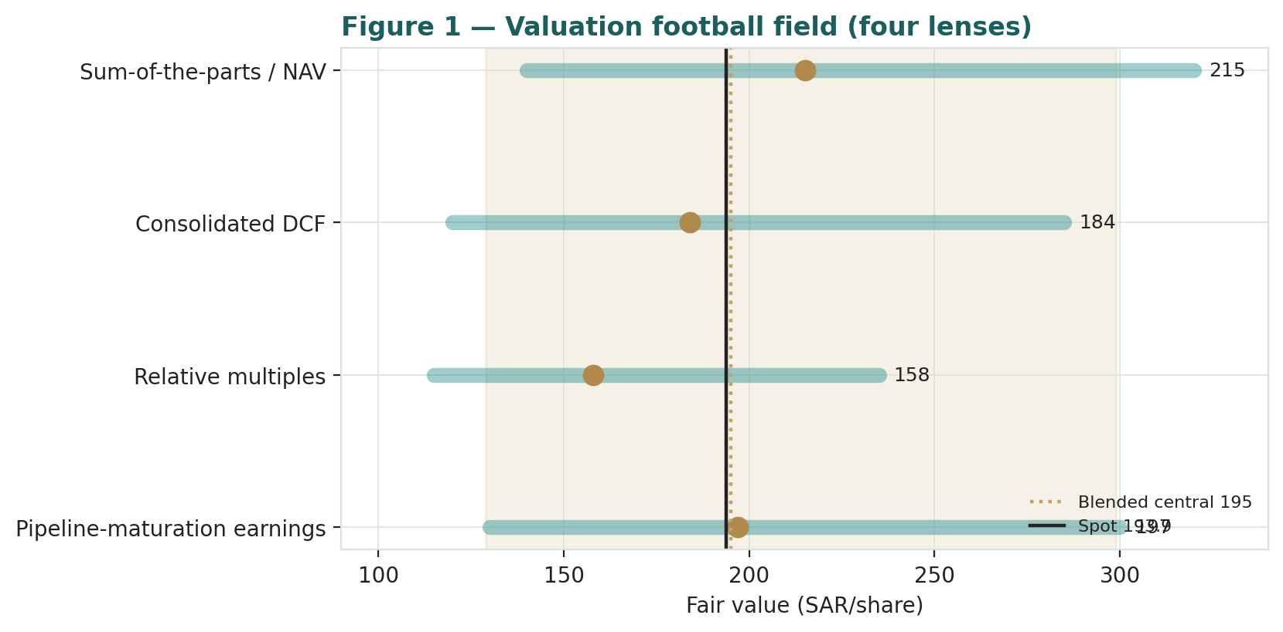
Figure 1 — Valuation football field. Bars span bear–bull per lens; the brass tick is each base case; the gold band is the blended central range; the dark line is spot.
Central fair value ≈ SAR 195/share, essentially on spot. The spread of the lenses (SAR 158 to SAR 215 at base) is itself the message: this is not a deep-value or a clearly-expensive name, but a fairly-valued platform whose re-rating depends on a single operating outcome — the return earned on the Vision-2030 capital programme.
1.6 The portfolio assets — a deeper look
The operating fleet (43 GW of power, 6.3m m³/day of water, 91% power / 99% water availability in 2025) is the value anchor: contracted, availability-based, largely hard-currency-indexed, with investment-grade or sovereign offtakers. The under-construction book — over SAR 100bn at cost, the largest in ACWA's history — is the growth engine and the risk, because its value depends on execution and on the returns locked in at financial close. The services arm (NOMAC) and the development platform earn fees across the whole life-cycle, a super-senior, stable stream. The table scores each part on the axes that matter.
Part | Cash quality | Growth role | Capital intensity | Swing role
Operating portfolio | Contracted, indexed | Cash anchor | Sunk (financed) | Base value
Under-construction book | Locked at close, not yet earning | Dominant | Very high | Dominant
Advanced pipeline | Optional | Optionality | High (future) | Upside
NOMAC + services | Fee, super-senior | Scales with fleet | Low | Steady
1.7 Returns on the Vision-2030 capital — the crux
One judgment drives the valuation more than any other: whether the capital ACWA is deploying to triple its assets under management earns above its cost. This is the single-point dependency, and it is best read in observable units rather than an abstract margin. Today the group's return on invested capital is ~2.6% and its return on equity ~6.5% — both below an ~8–10% cost of capital — because a large share of invested capital sits in projects still under construction and not yet generating. The constructive case is arithmetic and time: as the SAR 100bn-plus under-construction book reaches commercial operation over 2026–2029, contracted cash begins to flow and blended returns rise toward the mid-teens equity returns ACWA underwrites at financial close. The bear case is that the growth is value-dilutive — that competition for Vision-2030 and international tenders, rising financing costs, or execution slippage push realized project equity returns below the cost of capital, in which case the market is right to de-rate the platform toward its earnings and book support. We frame the crux on the realized project equity IRR versus the cost of equity, and sensitize the DCF and SOTP on it in §1.9.
Realized project equity IRR (blended) | vs Ke 9.85% | Read
~13–15% (underwritten level, delivered) | Above | Growth is accretive; SOTP/pipeline lenses dominate → SAR 215–300
~10–11% (partial delivery / cost creep) | ≈ At | Growth roughly value-neutral; central ~SAR 180–200
~7–8% (execution / financing shortfall) | Below | Growth is dilutive; relative/DCF floor → SAR 130–160
Read it as the bet you are taking: at SAR 194 the market is pricing something close to full delivery of the underwritten returns on the operating book but crediting only a partial success on the growth pipeline — a fair, not an extreme, position either way.
1.8 Macro and country — Saudi Arabia, rates, oil and the peg
ACWA is a Saudi champion with an increasingly international footprint, so its value is set by a handful of macro-policy levers. Vision 2030 is the structural tailwind — PIF has allocated ~70% of the Kingdom's renewables pipeline to ACWA under a Strategic Framework Agreement, a near-monopoly on the domestic build. Saudi and global rates matter mechanically: long-life contracted cash flows are long-duration assets, so a higher-for-longer rate path lifts the discount rate and compresses value, while the SAR/USD peg (3.75) means US rate policy transmits directly to ACWA's cost of capital and to its largely USD-indexed project debt. Oil and the Saudi fiscal position set the pace of the domestic programme and PIF's capacity to fund it. Internationally, the energy transition and rising power and water demand across the Gulf, Central Asia, Africa and Southeast Asia widen the opportunity set, while country and offtaker risk on non-Saudi projects (as the terminated Africa PPA and the Uzbekistan and Bulgaria episodes show) is the recurring downside. These levers are the swing factors behind the bear and bull cases in §1.5 and the catalysts in §5.
1.9 SOTP sensitivity — how much the swing moves the value
Holding the pipeline and services at base, the table re-prices the SOTP across the operating-portfolio mark and the credit given to the development pipeline and services. The cells near spot (SAR 194) are shaded toward the centre; the value runs from roughly SAR 130 to over SAR 300.
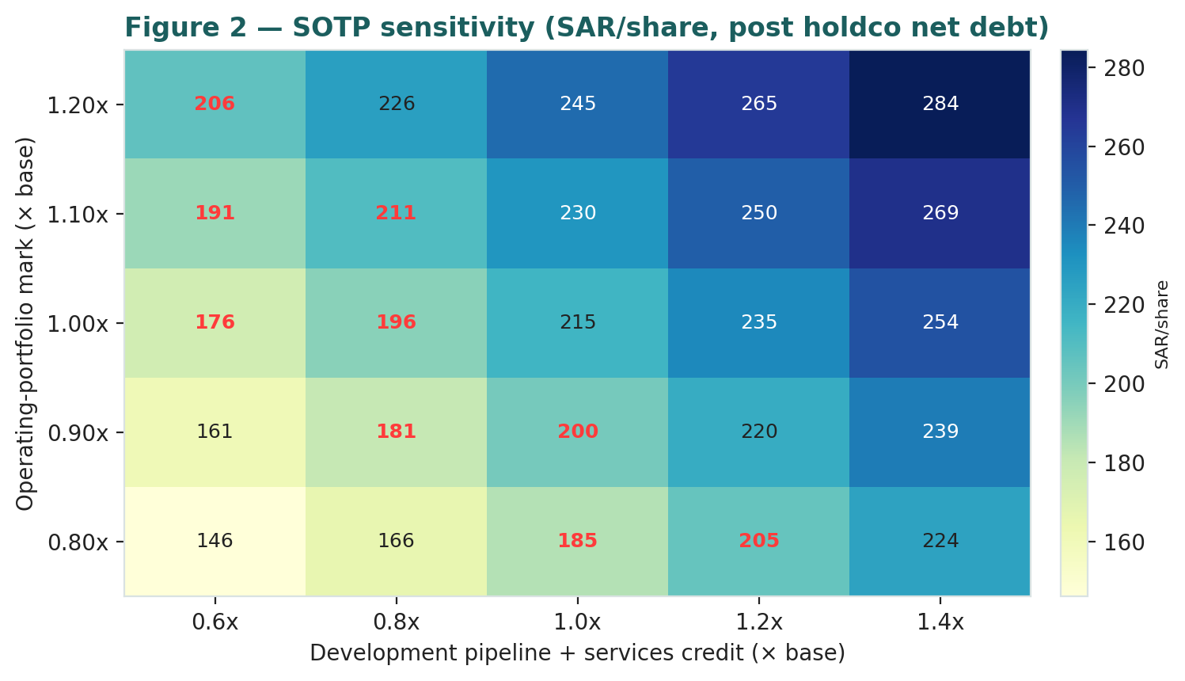
Figure 2 — SOTP sensitivity to the operating-portfolio mark × pipeline/services credit (SAR/share, post holdco net debt). Cells near spot are highlighted.
The reading is the same as the crux: the market price is consistent with a roughly base operating mark and only partial credit for the growth pipeline — a partial, not a full, delivery of Vision-2030 already in the price.
2 Technical and price structure
The tape is neutral and consolidating. ACWA trades right on its 200-day average, above the 50- and 100-day and just below the 20-day, with RSI near the midline and momentum cooling after a bounce. The structure is a base-building recovery: a stock that fell from the SAR 497 all-time high of September 2024 to a SAR 157 low, then bounced to the low-190s and has been ranging near the 200-day. Neither the oversold spring nor the overbought stretch — a genuinely balanced technical picture.
Indicator | Reading | Signal
Spot | SAR 193.9 | —
SMA 20 / 50 | SAR 197 / 186 | Straddling — short-term flat
SMA 100 / 200 | SAR 179 / 191 | Above both — base recovering
RSI (14) | 51.2 | Neutral (midline)
MACD (12,26,9) | 2.15 line / 3.46 signal / −1.31 hist | Momentum cooling after bounce
52-week range | SAR 156.6 – 266.0 | Lower-middle of range
Realized vol (252d) | 36.9% | Moderate (YZ-HAR forward 41.2%)
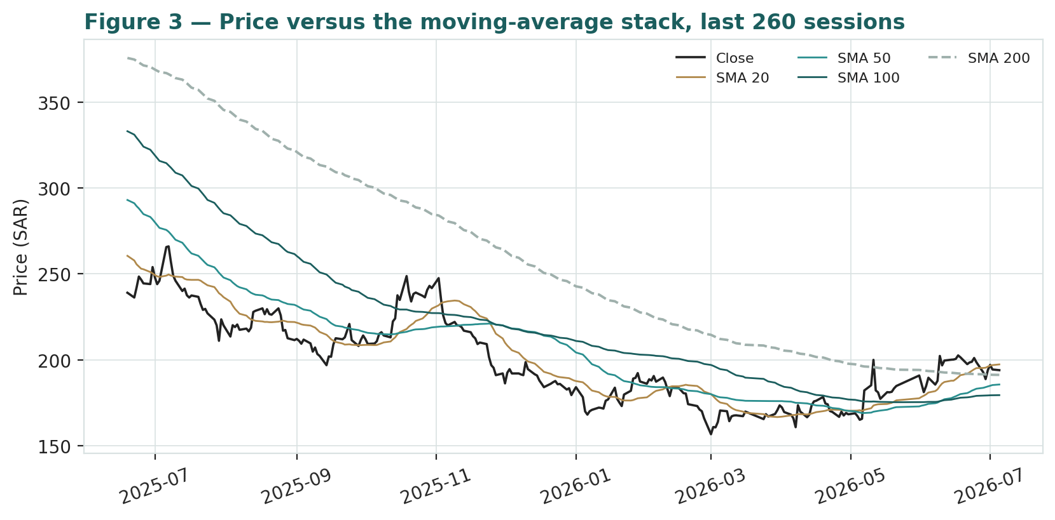
Figure 3 — Price versus the moving-average stack, last 260 sessions.
For the probabilistic work this matters in one way: a neutral, mid-range tape neither adds a directional tilt nor stretches a near-term tail. The technical and fundamental pictures broadly agree that the stock is near fair value, and §6 reads the resulting probability zones without forcing a directional call.
3 Monte Carlo — a probabilistic price map
We simulate 50,000 three-month price paths (seed 42) using a sixteen-factor stack: seven continuous macro/operating drivers contributing a small net forward drift, and nine discrete events that each fire with a probability and an impact. By design the paths diffuse from spot, and the §1 value gap is kept out of the drift — the fundamental NAV gap lives in §1, not here; §3 maps where price could go from today, not where value sits. Diffusion volatility is sized by the YZ-HAR engine (a gap-aware Yang-Zhang variance proxy fed to a pooled log-HAR cascade), which projects an annualized ~41.2% over the quarter — above the trailing 252-day close-to-close vol (36.9%) because the recent tape is more active, and regime-conditional by construction. Innovations are unit-variance Student-t(5), giving a tighter interquartile body with honest tails. As an international name, ACWA carries no secular drift; the net external drift from the factor stack is a modest +1.9% over the quarter, so the median tracks spot.
Continuous factor (7) | Dir. | Discrete event (9) | Prob. | Mean impact
Vision 2030 / PIF renewables pipeline | + | Q2-2026 results (early Aug) | 85% | +0.3%
Saudi / global real-rate path | − | New financial close / PPA-WPA award | 50% | +2.2%
Oil price / Saudi fiscal capacity | + | Project COD milestone (capacity online) | 45% | +2.0%
SAR/USD peg + USD rate path | ± | NEOM green-hydrogen progress/setback | 30% | +1.0%
Global power & water demand / transition | + | Fed / rate-path surprise | 32% | −3.5%
TASI & foreign flows (index beta) | + | Capital action / dividend-initiation signal | 25% | +1.5%
Project capex / construction input cost | − | Impairment / project delay / offtaker dispute | 32% | −5.0%
 |  | Divestment / capital-recycling gain | 28% | +2.2%
 |  | Index / flow rebalancing (MSCI/TASI) | 25% | +1.0%
Percentile map (SAR/share):
Horizon | p5 | p25 | p50 | p75 | p95
T+20 sessions | 159 | 180 | 194 | 209 | 235
T+60 sessions | 137 | 171 | 194 | 220 | 268
Leading with the honest quarter-ahead read: the 50% interquartile band is SAR 171–220 at T+60 (about −12% / +13% around spot) and SAR 180–209 at T+20. That residual width is the instrument's genuine uncertainty, not padding; the 90% tail (SAR 137–268) is the outer envelope, not the base case.
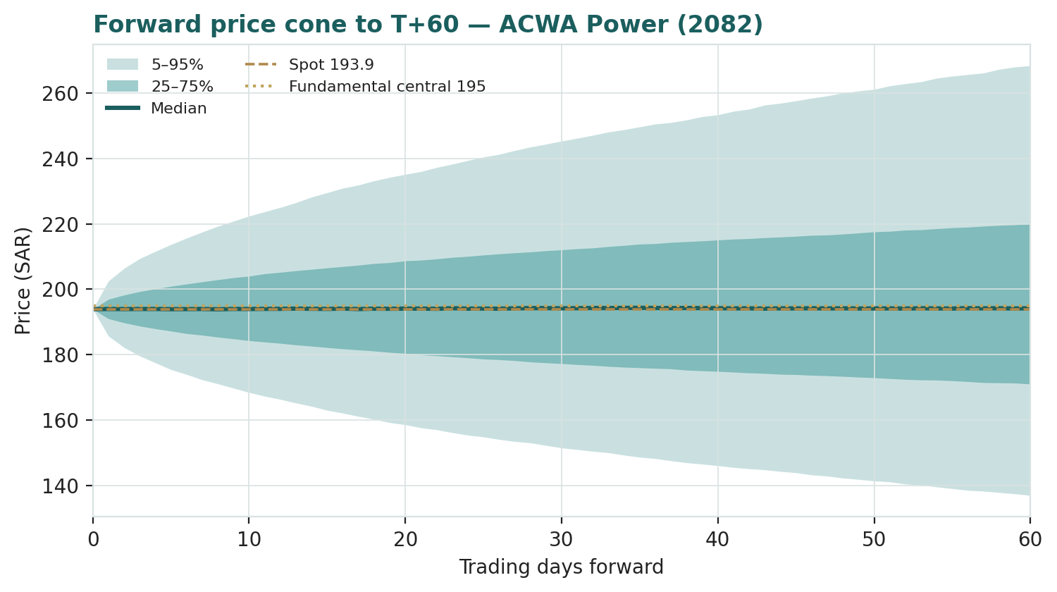
Figure 4 — Forward price cone to T+60. Median tracks spot; the gold dotted line marks the SAR 195 fundamental central value.
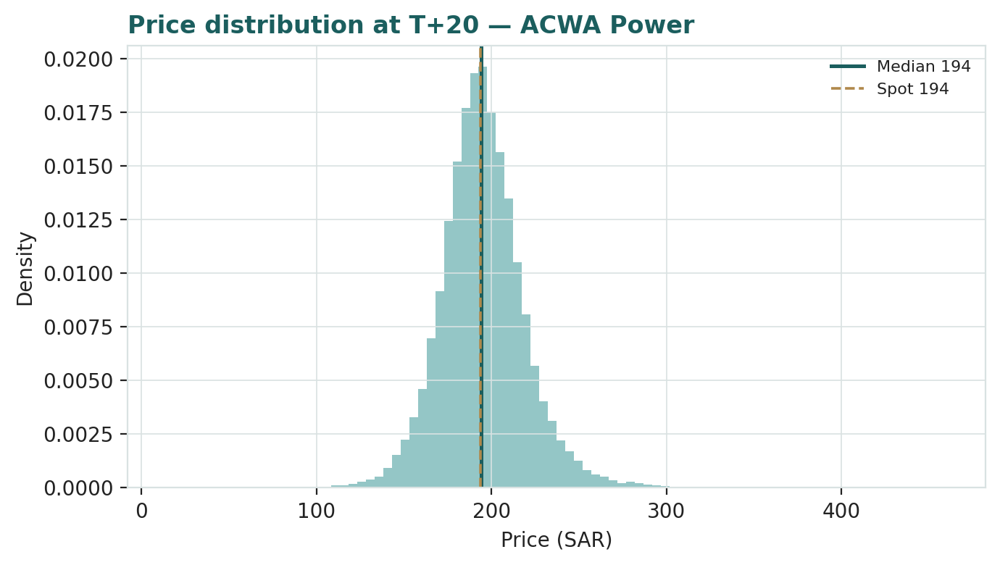
Figure 5 — Price distribution at T+20.
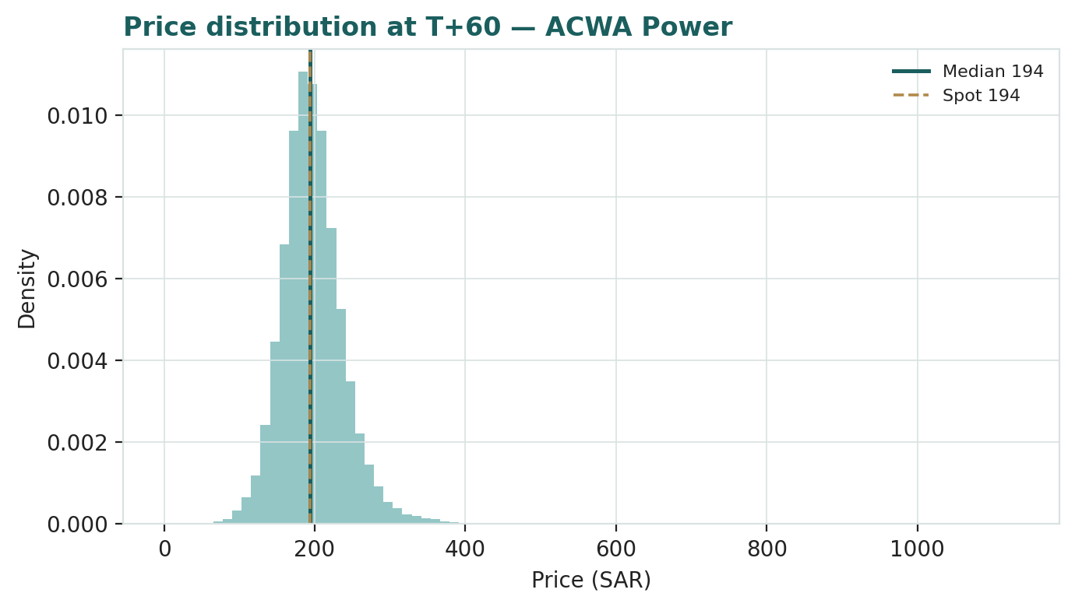
Figure 6 — Price distribution at T+60.
Level-touch ladder — the probability that price touches a level at any point by the horizon (running max for upside, running min for downside):
Level | T+20 touch | T+60 touch | Note
SAR 250 | 5% | 19% | Toward the upper range
SAR 230 | 13% | 34% | Near the bull lens
SAR 210 | 30% | 52% | Above spot / near SOTP
SAR 195 | 49% | 66% | Near central fair value / spot
SAR 180 | 63% | 74% | Just below spot
SAR 165 | 32% | 52% | Toward the relative-lens floor
SAR 150 | 14% | 35% | Toward the 52-week low zone
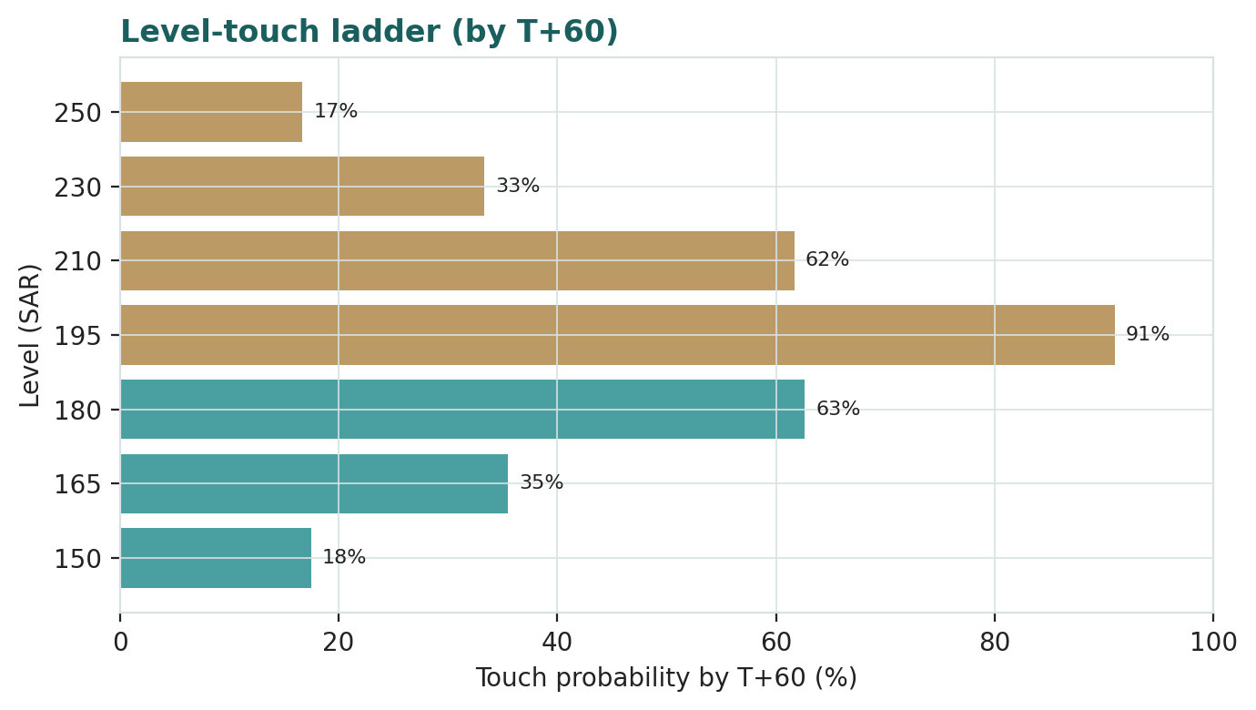
Figure 7 — Level-touch ladder (by T+60).
4 Comparison of the lenses, and a verdict
Three readings sit side by side. The fundamental lenses cluster at SAR 158–215 with a central SAR 195 — essentially spot, contingent on the returns earned on Vision-2030 capital. The technical picture is neutral: base-building on the 200-day, RSI at the midline, no directional tilt. The probabilistic map says that over three months price is roughly symmetric around spot with a wide, mildly right-skewed band — the median is SAR 194, not a fair-value target, because the simulation does not assume any value gap closes inside the quarter.
Lens | Reads | Central / implication
Fundamental (4-lens) | Fairly valued | SAR 195 (~+1%)
Technical | Neutral / consolidating | Base ~SAR 179–191; range floor SAR 157
Monte Carlo (3-month) | Symmetric, wide | Median SAR 194; p5–p95 SAR 137–268
Verdict (a fair-value read, not a recommendation). ACWA looks fairly valued on fundamentals, with an unusually concentrated swing factor: the return its Vision-2030 capital programme earns. The neutral technical tape and the symmetric three-month distribution argue that any re-rating is a question of operating and returns proof over several years, not of an imminent move. The honest summary is a value on top of price, a near-term distribution centred on price, and an outcome that hinges on one thing — whether the growth build is delivered at accretive returns — which is why the bear–bull span (SAR 129–299) is wide. Readers should weigh the lenses themselves; we publish the distribution, not a target.
5 Catalysts to watch
• Q2-2026 results (early Aug 2026). First clean read on whether operating income growth continues and whether newly-operational capacity is converting to earnings.
• Financial closes & new awards. Each PPA/WPA signed or project financially closed adds contracted cash and validates the pipeline; 2025 was a record 15 closes at SAR 70bn.
• Commercial operation dates (CODs). Progress converting the SAR 100bn-plus under-construction book to operating, earning assets — the core of the returns thesis.
• NEOM green hydrogen. Ramp and offtake milestones on the world's largest green-hydrogen project (with Air Products) — the option value in the platform.
• Saudi / global rate path. A higher-for-longer path lifts the discount on long-duration contracted cash; a pivot re-rates the complex. The peg transmits US policy directly.
• Capital & dividend policy. ACWA suspended meaningful dividends to fund growth; any dividend-initiation signal, or a further capital raise, moves the capital-trajectory thesis.
• Execution / country risk. Impairment, project delay or offtaker dispute (as in the terminated Africa PPA) is the recurring downside on the international book.
• Index & flow events. MSCI / TASI rebalancing and foreign-flow shifts move a large, index-heavy Saudi name independent of fundamentals.
6 Reading the probability zones
Translating the three-month distribution into plain zones, anchored on spot SAR 194 and the fair-value cluster:
Zone (T+60) | Range | Approx. probability | What it would mean
Deep downside | < SAR 160 | ~15% | Growth doubts / risk-off; tests the 52-wk low
Lower band | SAR 160–180 | ~22% | Relative-multiple lens dominates; partial-delivery fears
Around spot | SAR 180–200 | ~26% | Status quo; value near price
Upper band | SAR 200–225 | ~21% | Pipeline credited; toward SOTP/NAV
Strong upside | > SAR 225 | ~16% | Returns-on-growth proven; re-rating toward the bull
The distribution is close to symmetric, with a slightly heavier upper tail from the discrete upside events (project awards, CODs, capital-recycling gains). It is not a forecast; it is the spread of outcomes consistent with the stock's own volatility and the factor stack.
7 Caveats and what would change our mind
• The returns question is the model. Almost the entire valuation rests on whether Vision-2030 capital earns above its cost; our base assumes broadly on-plan delivery. A structurally lower realized project IRR would pull the central value toward — or below — the relative-lens floor.
• Consolidated accounts understate the economics. Much of the group's cash arrives via equity-accounted associates and fees; both the SOTP marks and the normalized-attributable DCF rely on the preparer's reconstruction of attributable cash, not a clean consolidated line.
• Terminal-heavy DCF. At ~82% of enterprise value in the terminal, the DCF is a terminal-g-versus-WACC bet dressed as a five-year model; we disclose and sensitize it rather than lean on the point estimate.
• Rate and duration risk. Long-life contracted cash is long-duration; a higher-for-longer rate path is a direct, mechanical downgrade not fully captured in the operating story, transmitted via the SAR/USD peg.
• Pipeline marks are judgemental. The under-construction and advanced-pipeline legs are marked on invested equity plus uplift and risk-weighted optionality — the single lines with the widest bear–bull range.
• Country & offtaker risk. The international book carries execution, currency and sovereign-offtaker risk (the terminated Africa PPA and the Uzbekistan / Bulgaria episodes are live reminders).
• Technical / RSI reminder. A mid-range tape with RSI near 50 gives no edge in either direction; the technical read is context, not a trigger.
Appendix A Financial statements
Selected consolidated figures, as reported (FY2023–FY2025 results, KPMG-audited). Revenue, operating income and net profit are company disclosure; intermediate lines (D&A, finance cost, minority) and some balance-sheet items are estimated to tie to disclosed totals and are flagged. Recall that ACWA equity-accounts many projects, so consolidated revenue understates portfolio scale, and non-recourse project debt sits within the borrowings line but is ring-fenced at the SPV level. SAR million.
A.1 Income statement (consolidated, SAR m) — 3 years actual + 5-year forecast
Line (SAR m) | 2023 | 2024 | 2025 | 2026E | 2027E | 2028E | 2029E | 2030E
Consolidated revenue | 6,080 | 6,280 | 7,410 | 8,522 | 10,055 | 11,664 | 13,297 | 14,893
EBITDA | 4,034 | 4,133 | 4,900 | 5,539 | 6,637 | 7,757 | 8,909 | 10,053
less: D&A (memo; estimated) | 1,050 | 1,150 | 1,300 | 1,278 | 1,508 | 1,750 | 1,995 | 2,234
EBIT (operating income, pre-impair.) | 2,984 | 2,983 | 3,600 | 4,261 | 5,128 | 6,007 | 6,915 | 7,819
Net finance cost | 1,050 | 1,000 | 1,400 | 1,600 | 1,750 | 1,850 | 1,950 | 2,050
PBT | 1,934 | 1,983 | 2,200 | 2,661 | 3,378 | 4,157 | 4,965 | 5,769
Zakat & tax | 130 | 100 | 231 | 266 | 338 | 416 | 496 | 577
Minority interest | 142 | 126 | 117 | 130 | 150 | 170 | 190 | 210
Net profit (attributable) | 1,662 | 1,757 | 1,852 | 2,265 | 2,890 | 3,571 | 4,278 | 4,982
FY2026E–FY2030E are formula-driven forecasts (every cell links to the model's Assumptions sheet). EBIT margins are elevated because operating income includes equity-accounted associate and development-fee income not in consolidated revenue.
A.2 Balance sheet (consolidated, SAR m) — 3 years actual + 5-year forecast
Line (SAR m) | 2023 | 2024 | 2025 | 2026E | 2027E | 2028E | 2029E | 2030E
PP&E + project assets | 78,000 | 86,000 | 95,000 | 101,722 | 108,613 | 115,664 | 122,869 | 130,235
Equity-accounted invts | 9,000 | 10,500 | 12,500 | 13,500 | 14,580 | 15,746 | 17,006 | 18,367
Receivables & contract assets | 1,702 | 1,758 | 2,075 | 2,386 | 2,816 | 3,266 | 3,723 | 4,170
Cash & equivalents | 5,000 | 5,600 | 7,830 | 10,403 | 13,812 | 17,723 | 22,165 | 27,131
Other assets | 12,000 | 13,000 | 14,000 | 14,000 | 14,000 | 14,000 | 14,000 | 14,000
Total assets | 105,702 | 116,858 | 131,405 | 142,011 | 153,821 | 166,399 | 179,764 | 193,903
Equity (attrib. to parent) | 22,000 | 24,000 | 28,000 | 30,265 | 33,155 | 36,326 | 39,805 | 43,586
Non-controlling interests | 13,000 | 14,500 | 16,500 | 16,630 | 16,780 | 16,950 | 17,140 | 17,350
Borrowings (corp + non-recourse) | 28,800 | 32,500 | 37,200 | 43,200 | 49,500 | 56,100 | 63,000 | 70,200
Payables & other liab. (bal.) | 41,902 | 45,858 | 49,705 | 51,916 | 54,386 | 57,022 | 59,819 | 62,767
Total equity & liabilities | 105,702 | 116,858 | 131,405 | 142,011 | 153,821 | 166,399 | 179,764 | 193,903
Historical anchored to disclosed equity, borrowings and cash; other lines estimated to balance and the balance sheet ties (payables & other is the balancing line). Only holdco/corporate net debt (~SAR 25bn) is deducted in the SOTP; non-recourse project debt sits inside each project's equity value.
A.3 Cash flow (consolidated, SAR m) — 5-year forecast
Line (SAR m) | 2026E | 2027E | 2028E | 2029E | 2030E
Net profit (attributable) | 2,265 | 2,890 | 3,571 | 4,278 | 4,982
plus: Minority interest | 130 | 150 | 170 | 190 | 210
plus: D&A | 1,278 | 1,508 | 1,750 | 1,995 | 2,234
less: Δ working capital | (300) | (300) | (300) | (300) | (300)
Operating cash flow | 3,373 | 4,249 | 5,191 | 6,163 | 7,126
less: Growth capex (attributable) | (2,000) | (2,100) | (2,200) | (2,300) | (2,400)
less: Dividend | 0 | 0 | (400) | (800) | (1,200)
plus: Net new borrowing (est.) | 1,200 | 1,260 | 1,320 | 1,380 | 1,440
Net change in cash | 2,573 | 3,409 | 3,911 | 4,443 | 4,966
Closing cash (ties to balance sheet) | 10,403 | 13,812 | 17,723 | 22,165 | 27,131
Derived from the income statement and balance sheet; closing cash ties to the balance sheet. Attributable growth capex is the normalized parent-equity figure (gross consolidated project capex is funded by non-recourse debt). Note markers: FY2025 included a SAR 7,125m rights issue; equity commitments are guided at ~US$2.5bn/yr to 2030.
Appendix B Step 0 — calibration backtest
Before any forecast we test the Monte Carlo lens on ACWA's own history — all available since the October-2021 IPO (~4.7 years, so a full-history rather than a full-5-year replay): generate three-month-ahead distributions across the sample, score the realized close against each, and grade skill versus a naïve benchmark. The grade is CRPS skill (1 − CRPS/CRPS_benchmark, must be > 0) against a zero-drift random-walk lognormal cone (spot, trailing realized vol), plus the Winkler interval score. PIT uniformity and band coverage are diagnostics only, never the pass criterion. The engine is the YZ-HAR width plus unit-variance Student-t(5) with zero secular drift (an international name).
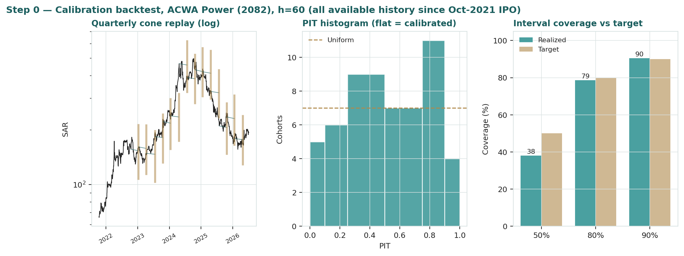
Figure B-1 — Calibration backtest: quarterly cone replay (log scale), PIT histogram, and interval coverage versus target.
Window scheme | n | CRPS skill | Winkler skill | 50% cov | 80% cov | 90% cov | PIT mean
Non-overlapping (step 63d) | 14 | +0.001 | +0.031 | 36% | 64% | 86% | 0.51
Monthly origins (step 21d) | 42 | +0.003 | +0.044 | 38% | 79% | 91% | 0.53
Fortnightly (step 10d) | 87 | +0.002 | +0.073 | 45% | 76% | 91% | 0.54
Target | — | > 0 | > 0 | 50% | 80% | 90% | 0.50
The engine beats the random-walk benchmark on CRPS skill on every window scheme — modestly, because a large, near-random-walk, near-Gaussian utility like ACWA is a hard name for any lens to beat a naïve cone on — and beats it more clearly on the Winkler interval score, precisely because the YZ-HAR forecast is a mean-reverting vol estimate that avoids the benchmark's habit of over-widening right after a volatility spike (in this history, high trailing vol anti-predicts the forward 60-day move). The PIT histogram is close to flat and the 90% band coverage lands on target; the tighter 50% coverage is the honest Student-t(5) body, held as a diagnostic, not the grade. The lens is accepted; this engine carries into the §3 forward run.
Appendix C Peer set, sector structure, and risks
ACWA has no clean single comparable — it is a renewables IPP, a water-desalination leader, a green-hydrogen first-mover and a development platform in one wrapper. The peer set is therefore split by lens.
Part | Closest peers | Typical valuation
Renewables IPP | NextEra, Iberdrola, EDPR, Ørsted | EV/EBITDA ~9–13×; growth-quality premium
Gulf / MENA utilities | SEC, TAQA, regional developers | EV/EBITDA ~7–11×; contracted
Water desalination | Veolia, developer peers | Scarce; ACWA ~25% of global capacity
Development platform | Project developers | EV/GW; pipeline optionality
Sector structure. Global power is mid-energy-transition — renewables and storage compress margins before they lift them, while contracted, availability-based models like ACWA's insulate cash from merchant price risk. Water desalination is scarce and structurally growing, and ACWA controls about a quarter of global private capacity. Green hydrogen is optionality: large potential, uncertain timing.
Principal risks: a structurally lower realized return on the Vision-2030 capital programme; a higher-for-longer rate path lifting the discount on long-duration cash; execution and country/offtaker risk on the international book; the pipeline marks proving optimistic; a further dilutive capital raise; and the equity-method structure making the true economics harder to verify than a clean consolidated line.
Analyst context (not model inputs). Al Rajhi Capital (Feb-2024) set a SAR 257 target (Neutral), with a DCF of SAR 241 (7.37% WACC, 5% terminal g) and an EV/GW read of SAR 272; consensus has since fallen with the stock into a SAR ~100–205 range. Shown for context only — Testahil publishes distributions, not targets.
Appendix D The expert valuation panel
Every Testahil study closes with a panel of standing expert personas — drawn from the house Expert Persona Library, not invented for the occasion, so that each accumulates a track record across studies and a quarterly update is a re-run, not a re-training. ACWA is a contracted-infrastructure developer-owner-operator — economically a holding company of project stakes with a heavy, capital-intensive growth programme — so we cast the three whose methods both fit that shape and genuinely disagree: Expert 1 (sum-of-the-parts NAV and the structure discount), Expert 2 (cash returns — DCF and return on invested capital versus its cost), and Expert 3 (scenario-weighted macro-policy real-options). Each runs a different method, derives its fair value from shown workings, and states a falsification condition. The macro lens runs as a full persona here rather than only through the body, because for a Vision-2030 / PIF champion policy genuinely sets value.
D.1 Expert 1 — sum-of-the-parts NAV and the structure discount
Worldview. A holding of infrastructure stakes is worth the sum of its parts at realizable value, less a discount for the wrapper. He marks each asset — the operating fleet, the under-construction book, the pipeline, the services arm — to what it would fetch on its own, deducts holdco net debt as an explicit line, and asks what the market pays for the bundle versus the pieces.
When it works / fails. Best where the parts are separable and markable and a structure discount is observable; it fails when the marks on unbuilt or contracted assets prove illusory, or when a genuine platform synergy (ACWA's development engine winning tenders others cannot) is worth more than the sum.
Standard workings & worked example. Mark the operating portfolio on capitalized attributable distributions, the under-construction book at invested equity plus uplift, the pipeline as risk-weighted optionality, and NOMAC on a fee-stream DCF; deduct holdco net debt; apply a fair structure discount.
His tradition is the Graham-Dodd realization school, ported to infrastructure: a business is worth what its assets would realize net of every claim, and the balance sheet is a fact while the future is a guess. For ACWA the realization is unusually clean on the operating leg — an availability-based, hard-currency-indexed distribution stream on 20-30-year contracts with sovereign or investment-grade offtakers is close to a bond, and he capitalizes it at a yield that reflects that quality, then haircuts the associate marks for the cash-conversion lag that the equity method disguises. The under-construction book he treats conservatively: financed and de-risked, yes, but not yet paying, so it earns invested equity plus a modest uplift rather than a full operating multiple. He is explicit that his one act of faith is the pipeline line — an option, not an asset — and he keeps it small precisely because it is the least realizable mark on the page.
Expert 1's marks (SAR bn) | Value
Operating power & water portfolio | 118
Under-construction portfolio | 44
Advanced development pipeline | 11
NOMAC + services | 23
Σ attributable equity − holdco net debt (SAR 25bn) | 171
Fair structure discount 5% (offset by platform premium) → SAR 212/sh | → 163
Sensitivity (swing = the marks and the discount). At a base operating mark and 0% net discount, SAR 224; at a 10% structure discount, SAR 195; at a bearish operating mark, SAR 165. Cross-examination. He tells Expert 2 that a consolidated DCF blurs parts that deserve different discount rates and misses the associate cash entirely; he tells Expert 3 that policy scenarios are already priced into the marks he strikes.
Verdict, falsification, market-implied. Fair SAR 212 (range SAR 150–315). Falsified if a leg's realizable mark proves illusory — above all if the under-construction book cannot be delivered near its underwritten equity value — or if the structure discount widens durably. The market price implies a ~22% discount to his gross NAV, wider than he judges fair for this contract quality.
D.2 Expert 2 — cash returns: DCF and ROIC versus the cost of capital
Worldview. A business creates value only when each unit of capital earns above its cost. Cash, not booked profit or a mark, is the test; he looks past the NAV to free cash flow and to return on invested capital — does each riyal of Vision-2030 capital earn its keep, or quietly destroy value?
When it works / fails. Best for capital-intensive businesses where returns on capital are the crux — precisely ACWA's situation. It fails where reinvestment economics are about to change sharply, which is the very risk here: today's depressed ROIC may be a construction-phase artifact, or the new normal.
Standard workings & worked example. Build normalized attributable FCFF, compute ROIC against WACC — the economic-profit spread — and discount the explicit cash stream plus a terminal value consistent with returns fading toward the cost of capital. Publish Ke explicitly.
His discipline is economic profit: invested capital earns its keep only when its return clears the cost of the capital tied up in it, and a growing company that reinvests below that hurdle destroys value the faster it grows. ACWA is the textbook stress test of the idea. It is deploying roughly nine billion riyals of equity a year to triple its assets under management, yet its reported return on invested capital is under three percent and its return on equity around six-and-a-half — both beneath a cost of capital he pins at nearly nine. He accepts the constructive rejoinder that this is a construction-phase artifact — capital sunk into projects that have not yet reached commercial operation cannot be earning — and models the ROIC ramping into the low-teens as the under-construction book comes online. But he insists the burden of proof sits with the cash: he will pay for returns he can see accruing, not for an underwriting assumption, and he strips every one-off capital-recycling gain from the return the multiple is applied to, because a divestment gain is not a recurring spread.
Expert 2's economic-profit test | Value
Normalized attributable FCFF, FY2030 (SAR bn) | 10.5
Cost of equity Ke = 4.75% + 0.85 × 6.0% | 9.85%
Current ROIC vs WACC (~2.6% vs ~8.75%) | Negative spread today
Terminal value as % of EV | ~82%
Fair value → SAR 175/sh | → 134 equity (SAR bn)
Sensitivity (swing = WACC / ROIC fade). At a 7.5% WACC, SAR 285; at 10%, SAR 120; hold the returns below cost and the value sits near the relative floor. Cross-examination. He tells Expert 1 that marking parts at realizable value ignores whether the capital in them earns its cost — a de-risked under-construction asset can still be a value-destroying one; he tells Expert 3 that policy optionality without the cash to fund accretive returns is a half-truth.
Verdict, falsification, market-implied. Fair SAR 175 (range SAR 120–285) — the most cautious of the three: fairly-to-slightly-richly valued, no margin of safety. Falsified by a durable ROIC lift above WACC as the pipeline matures (the constructive base case) or a structural decline in project returns. On a cash-returns basis the market price is a little above his number — it credits some, not all, of the returns recovery.
D.3 Expert 3 — scenario-weighted macro-policy real-options
Worldview. In a Vision-2030 economy, policy outranks fundamentals — the PIF allocation, the Saudi rate and oil path, the peg, and sovereign programme design move value more than management does. He prices ACWA as a set of options on which policy world arrives, and probability-weights them.
When it works / fails. Best in policy-driven markets with binary catalysts and a state sponsor — ACWA's near-monopoly on the domestic renewables build is exactly this. It fails through false precision: the scenario probabilities are judgements, and a tree can miss the branch that grows.
Standard workings & worked example. Identify the policy levers, define bull/base/bear as configurations of them, re-run the base valuation under each so the scenario values are derived, then probability-weight and stress the weights.
He does not pick a side; he weights the odds, and he absorbs the other two experts as sub-cases of his tree. The levers he watches are specific: PIF's Strategic Framework Agreement allocation (today ~70% of the Kingdom's renewables build), the Saudi rate and oil path that sets both the discount rate and the fiscal room to fund the programme, the dollar peg that transmits US policy straight into ACWA's cost of capital, and the design of the offtake contracts themselves. Crucially, his scenario values are re-derived, not asserted: the bull case is Expert 1's marks struck at a narrower discount and Expert 2's ROIC clearing the hurdle because rates eased and the pipeline delivered; the bear case is the same two experts' models run with a programme wobble and financing costs biting. That is why he can put a probability on each and hand the other two their own numbers back as branches of his tree — and why his honest weakness is that a fourth, unmodelled policy shock, or a mis-specified weight, can dominate the whole exercise.
Expert 3's scenario tree | Value/sh | Prob.
Bull — Vision-2030 delivered, rates ease, PIF pipeline accelerates | 300 | 30%
Base — programme broadly on-plan, rates higher-for-longer | 195 | 45%
Bear — execution slips / financing costs bite / global risk-off | 135 | 25%
Probability-weighted fair value → SAR 200/sh | 200
Sensitivity (swing = the scenario weights). Shift 15 points from base to bull and the value is SAR 216; shift them to bear and it is SAR 184. Cross-examination. He tells Expert 1 that the structure discount is really a policy variable — it narrows when Vision-2030 delivers and widens on a programme wobble; he tells Expert 2 that his single WACC cannot capture a regime in which the sovereign both funds and de-risks the growth.
Verdict, falsification, market-implied. Fair SAR 200 (range SAR 135–300). Falsified by a fourth, unmodelled policy shock dominating — a change in PIF's allocation to ACWA, a Saudi fiscal retrenchment, or a peg-stress scenario. The market price sits just below his weighted value, consistent with the base scenario carrying the day.
D.5 The three in one room
The single question they most disagree on is whether the capital ACWA is pouring into the Vision-2030 build will earn its keep — and how much of that is a policy call versus a returns call.
Expert 1: “Mark the parts. The operating fleet is contracted and indexed, the under-construction book is financed and de-risked, the services arm is a fee annuity. The bundle is worth about SAR 248 a share gross and the market discounts it a fifth. The argument is the discount, not the cash.”
Expert 2: “And to build that bundle ACWA spends roughly nine billion riyals of equity a year at returns I cannot yet see in the numbers — ROIC under three percent against a nine-plus cost of capital. Mark the parts all you like; until the capital earns its cost, you are capitalizing a promise.”
Expert 3: “You are both arguing about a spreadsheet. PIF handed ACWA seventy percent of the Kingdom's renewables pipeline. If Vision 2030 is delivered and rates ease, the returns and the discount both fix themselves; if the programme wobbles, neither does. Price the policy world, then the parts.”
D.6 Reading the divergence
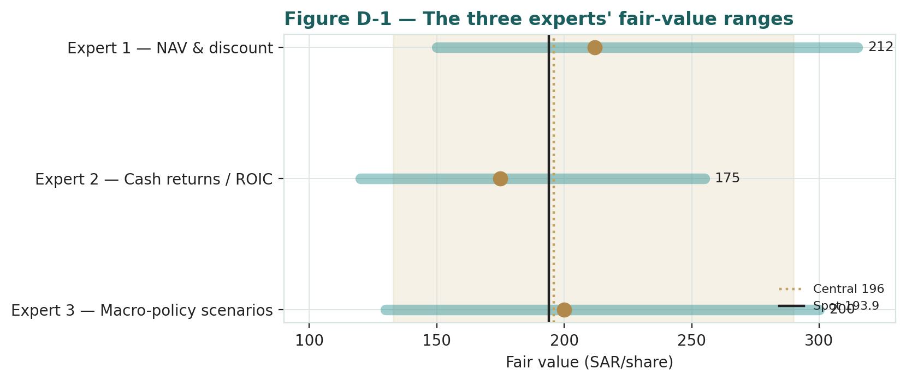
Figure D-1 — The three experts' fair-value ranges. Brass ticks are base cases; the gold band is the central, the dark line is spot. The spread is almost entirely a returns-on-growth disagreement.
Expert | Method | Single swing assumption | Base fair value
Expert 1 | Sum-of-the-parts NAV | Fair structure discount (5%) | SAR 212
Expert 2 | Cash returns / ROIC | ROIC versus a ~8.75% WACC | SAR 175
Expert 3 | Macro-policy scenarios | Vision-2030 scenario weights | SAR 200
The spread — SAR 175 to SAR 212 at base — is narrow for a growth infrastructure name, and it is almost entirely a returns-on-growth disagreement: none of the three contests the operating fleet, the contract quality, or the balance sheet. What separates them is whether the capital ACWA is now spending will earn above its cost. Expert 1 says the parts are worth it and the discount is the question; Expert 2 says the cash returns must prove it first; Expert 3 says the answer is set in Riyadh, not in the model. The SAR 37 spread is therefore a clean measure of one uncertainty — the return on the Vision-2030 build. Resolve that, and the three converge.
A note on how the three would update. Because each persona is a standing method rather than an opinion invented for this study, a quarterly re-run feeds them fresh disclosure and re-runs the same workings: the NAV expert re-marks the legs off the new portfolio schedule, the cash-returns expert re-computes the ROIC spread off the latest attributable cash, and the policy expert re-weights the scenario tree off the newest PIF and rate signals. Nothing is re-trained; the personalities and disciplines carry forward verbatim, and each accumulates a scoreable, per-market track record against realized prices that a one-off bespoke expert could never build. That continuity is the point of casting from a fixed library rather than assembling a fresh panel each time, and it is what lets a reader hold each method accountable over successive quarters rather than judging a single snapshot in isolation.
What the spread measures is worth stating plainly: it is the market’s uncertainty about a single number — the return ACWA will earn on the capital it is spending now and cannot un-spend. If that return lands at the underwritten mid-teens, Expert 1 is right that the discount is the only question and the stock is worth north of SAR 210; if it lands below the cost of capital, Expert 2 is right that the parts are a promise and the value sits near the relative floor around SAR 160; and Expert 3’s wager is that which of those worlds arrives is decided less by ACWA’s execution than by Riyadh’s policy and the global rate path. None of the three is arguing about the operating fleet, the contract quality, or the balance sheet — the disagreement is entirely forward, entirely about returns on growth, and therefore entirely resolvable with time and disclosure. That is the cleanest possible statement of the ACWA question, and it is why a single fair-value number would mislead where a distribution does not.
Each expert's point fair value (and bull/base/bear) is logged with the study date (05 Jul 2026) and spot (SAR 193.90) as an internal per-expert track record, kept separate from the core Calibration Ledger.
About this series
Testahil publishes independent, educational valuation studies. Each is an attempt to reason transparently about what a security is worth, with every assumption shown and a companion model so readers can disagree productively. The house style is distributions, not tips: we describe ranges and probabilities, not targets, and we do not tell anyone what to do. Studies are framed as educational analysis, the preparer is not licensed by any securities regulator, and holdings are disclosed.
Disclosure & Disclaimer
Not investment advice. This document is educational and informational only. It is not, and must not be relied upon as, investment, financial, legal, accounting or tax advice, nor an offer, solicitation or recommendation to buy, sell or hold any security. It contains no price target and no rating.
No licence; no advisory relationship. The preparer is not registered or licensed with any securities or financial regulator in any jurisdiction, holds no brokerage or investment-advisory authorisation, and is not acting as your adviser or fiduciary. Nothing here is personalised to your circumstances.
Holdings disclosure. The preparer may hold, and may in the future take or dispose of, a position in the security discussed in this report, and may transact at any time without notice. This is a potential conflict of interest you should weigh.
Sources & accuracy. Reported financial and operating figures are drawn from the company's public disclosure and other public sources believed reliable but not independently verified; they may contain errors or be superseded. Forward-looking inputs — the SOTP marks, the pipeline value, the holdco treatment, projections, multiples, the DCF and Monte-Carlo factor probabilities — are the preparer's own judgments and are inherently uncertain.
Forward-looking statements. Any statements about the future are estimates subject to risks and uncertainties; actual results may differ materially. The Monte Carlo models price, not value, and encodes subjective probabilities for events that have not occurred.
No reliance; your responsibility. Do your own research and consult a licensed professional before making any decision. You are solely responsible for your investment decisions and their outcomes. To the maximum extent permitted by law, the preparer accepts no liability for any loss arising from use of this document.
Currency & figures. Figures are in Saudi riyals (SAR) unless stated; the SAR is pegged to the US dollar at 3.75. Rounding may cause totals to differ slightly. Spot price and market data are as of 05 July 2026 and change continuously.

TESTAHIL · Independent Valuation Study · Educational Analysis · ACWA Power Company (Tadawul: 2082) · edition 05-07-2026 · reporting currency SAR

