Testahil · Independent Valuation Study — Educational Analysis Not investment advice

Abu Dhabi Commercial Bank PJSC (ADX: ADCB)
Independent valuation study · 10 July 2026 · spot AED 15.10 (03-Jul close) · 7,912.2mn shares · market cap ~AED 119.5bn (~US$32.5bn) · third-largest UAE bank · newest name in Testahil’s UAE coverage
READ FIRST. This is an independent, educational valuation study published under the Testahil brand. It is not investment advice, not a recommendation, and contains no rating and no price target. It presents fair-value ranges and probability distributions — distributions, not tips.
Who we are not. The preparer is not licensed by the FRA, the SCA, or any securities regulator, holds no CFA charter, and this document has not been reviewed by any authority.
What the numbers are. Model outputs under stated assumptions — every input is disclosed, every unsourced driver is logged in a public ledger, and every published forecast is graded after the fact on the public Calibration Ledger.
The two clocks. The weighted central (AED 19.7) is a risk-adjusted ~12-month anchor. The strategy-delivered value (AED 23.0 at a peace-time Ke) is a multi-year ceiling. The only genuinely 3-month figures in this study are the Monte Carlo percentiles in §3. Never read one clock as another.
Calibration tier. Backtest verdict for ADCB: PASS — under the fitted UAE market model, ADCB’s own five-year backtest beats the naive benchmark with the margin holding across every resampling scheme. The §3 distribution is calibrated and carries a modest demonstrated edge — still read it as a base rate, not a promise.
Provenance flag. ADCB’s own PDF filings were not machine-accessible during this work; financial-statement figures were taken from ADCB’s results releases as reproduced word-for-word on financial news wires and on the bank’s own news pages, and must be re-verified against the filed statements before any reliance. Figures we derived rather than took directly are flagged inline.

The company
Abu Dhabi Commercial Bank is the UAE’s third-largest bank, with AED 809bn in assets at March 2026, formed in its current shape by the 2019 three-way merger of ADCB, Union National Bank and Al Hilal Bank. It makes money the way a classic universal bank does: it gathers AED 523bn of deposits (46.9% of them low-cost CASA), lends AED 426bn — roughly two-thirds of it in Abu Dhabi and Dubai — and earns the spread, layering fee income from cards, trade finance, capital markets and its growing international franchise (28% of loans, including a US$3.5bn Türkiye sovereign bond mandate won this year) on top. Its moat is structural rather than clever: majority ownership by Mubadala (60.69%) anchors it in Abu Dhabi’s government-related ecosystem, its funding base is granular and cheap, and its post-merger cost discipline shows in a cost-to-income ratio that fell to 25.6% in Q1-2026. Scale now compounds: nineteen consecutive quarters of rising profit before tax, an ROE above 16%, and a five-year plan targeting AED 20bn of annual net profit by 2030. A completed AED 6.1bn rights issue in December 2025 — the base-changer running through every per-share figure here — pre-funds that growth and lifts CET1 to 13.8%.
At a glance
 | Value |  | Value
Spot (03-Jul-2026) | AED 15.10 | Weighted central | AED 19.7 (+31%)
Shares out (post-rights) | 7,912.2mn | Range across lenses | AED 14.3 – 23.3
Market cap | AED 119.5bn (~US$32.5bn) | Ke (war-adjusted central) | 10.57% (rf 4.70% + β 1.00 × ERP 4.87% + 1.0pt)
FY25 net profit | AED 11,445mn (+22%) | Trailing P/E · P/B | 10.4x · 1.52x
Q1-26 RoAE / RoTE | 16.3% / 18.1% | FY25 DPS · yield | AED 0.63 · 4.2%
CET1 / CAR (Mar-26) | 13.82% / 16.95% | Backtest verdict | PASS (skill +0.023, 14 windows)
NPL / coverage | 1.76% / 151.8% | MC T+60 median | AED 15.09 (-0.1%)

Sources: ADCB FY25 and Q1-2026 results releases and MD&A; Testahil model. Per-share figures on the post-rights 7,912.2mn count throughout.
Headline
Five independent lenses put fair value between AED 14.3 (a conservative through-cycle value) and AED 23.3 (an equity DCF that credits the strategy), with a weighted central of AED 19.7 — +31% above the 03-July close of AED 15.10, even after charging a full percentage point of war-risk premium to the cost of equity. The market is pricing ADCB at roughly 1.5× book and ~10× trailing earnings, a multiple set during a regional war and a rights-issue digestion, for a bank compounding profit at 20%+ with a 16% ROE and a 4%+ dividend yield. The gap has one honest counter-argument — that the relative lens (AED 15.9) says the whole UAE bank complex is priced this way, so ADCB is cheap only if the sector re-rates or the strategy delivers. That tension is the study’s crux (§1.8).
Valuation summary
The whole answer in one view. Five independent methods value ADCB; the table below shows what each is worth, the weighted central that combines them, and how that sits against today’s price and against the two longer-dated reference points.
The bottom line
Fair-value range across the five lenses | AED 14.3 – 23.3
Weighted central (risk-adjusted, ~12-month anchor) | AED 19.7
Current price (03-Jul-2026 close) | AED 15.10
Implied gap to central | +31%
Upper reference — strategy delivered, peace-time cost of equity | AED 23.0
Lower reference — conservative through-cycle value | AED 14.3
Three-month view — probability price is above today’s | 50%
Three-month view — median outcome | AED 15.09 (-0.1%)

Lens | Value (AED) | What it prices
Equity DCF (FCFE) | 23.3 | Cash the bank could distribute after funding its own growth
Residual income | 22.7 | Today’s book value plus the value of returns above the cost of equity
Dividend discount model | 21.2 | The board’s explicit, progressive dividend policy
Relative multiples | 15.9 | What comparable UAE banks trade at right now
Normalized value (through-cycle) | 14.3 | Mid-cycle earnings valued at the multiple their return on equity warrants

The two cash-flow methods and residual income cluster at AED 21–23; the market-anchored lens says AED 15.9, essentially today’s price. The weighted central of AED 19.7 sits between them and leans toward delivery — it is a probability-weighted judgement that the strategy-and-de-escalation outcome is more likely than the priced-in one, not a claim that the answer lies neatly in the middle. The three-month figures are a separate matter entirely and come only from the distribution in §3; they describe near-term noise around the current price, not this fair-value anchor. The remainder of this section builds each lens in full.
§1 Fundamental valuation
1.1 Dividend discount model — the primary lens
For a bank, deposits are an operating input, not a financing choice, so enterprise-value arithmetic is meaningless: everything discounts at the cost of equity. The DDM is primary because ADCB’s board has made distribution policy explicit — a progressive dividend, c.AED 25bn cumulative over the five-year plan — and because dividends are the one cash flow a minority shareholder actually receives. The schedule below runs the driver build of §1.7: payout glides from 38% to 33% as growth consumes capital, yet DPS still rises every year because earnings rise faster.
AED / share | FY26E | FY27E | FY28E | FY29E | FY30E
EPS | 1.74 | 1.89 | 2.12 | 2.37 | 2.61
Payout | 38% | 37% | 36% | 34% | 33%
DPS | 0.66 | 0.70 | 0.76 | 0.80 | 0.86
Discount factor @ Ke 10.57% | 0.904 | 0.818 | 0.740 | 0.669 | 0.605
PV of dividend | 0.60 | 0.57 | 0.56 | 0.54 | 0.52

Terminal block | Value
Terminal payout = 1 − g/ROE_t = 1 − 4.0/15.0 | 73%
Terminal DPS (FY31) | AED 1.99
Terminal value at (Ke − g) | AED 30.3
PV of terminal value | AED 18.4
Σ PV explicit dividends (FY26–30) | AED 2.8
DDM fair value | AED 21.2
Terminal value as % of total (dependency disclosure) | 87%

Terminal-value dependency: 87% of the DDM sits in the terminal block — normal for a growing bank at a 38%→33% payout, but it means the number is a claim about ADCB’s steady state (15% ROE, 4% growth), not about the next five dividends. §1.10 sensitizes exactly that claim.
1.2 Equity DCF (FCFE) — the full build, from revenue to cash
The equity DCF asks not what the board chooses to pay, but what the business could pay after funding its own growth. It is built from the top line down. For a bank the top line — total revenue — is operating income: net interest income (the spread earned on loans funded by deposits) plus non-interest income (fees, cards, trade, treasury). From there the waterfall runs through costs, loan-loss provisions and tax to net profit, and then subtracts the one item a bank cannot avoid: the fresh equity it must retain each year to keep its capital ratio intact as its balance sheet grows. What remains is free cash flow to equity — genuinely distributable, whether or not it is actually paid out. Every line below is driven off the build in §1.7.
AED mn | FY26E | FY27E | FY28E | FY29E | FY30E
Net interest income | 16,132 | 18,047 | 20,199 | 22,308 | 24,409
Non-interest income | 8,319 | 9,068 | 9,884 | 10,774 | 11,744
Operating income (total revenue) | 24,452 | 27,115 | 30,084 | 33,081 | 36,153
Operating expenses | -6,602 | -7,050 | -7,671 | -8,270 | -8,857
Pre-provision operating profit | 17,850 | 20,065 | 22,412 | 24,811 | 27,295
Impairment charge | -2,411 | -2,496 | -2,658 | -2,789 | -2,960
Profit before tax | 15,438 | 17,570 | 19,754 | 22,022 | 24,336
Tax | -1,698 | -2,635 | -2,963 | -3,303 | -3,650
Net profit after tax | 13,740 | 14,934 | 16,791 | 18,719 | 20,685
less: equity retained for RWA growth | -7,740 | -7,198 | -6,610 | -6,215 | -5,262
Free cash flow to equity (FCFE) | 6,000 | 7,736 | 10,181 | 12,504 | 15,423
Discount factor at Ke 10.57% | 0.904 | 0.818 | 0.740 | 0.669 | 0.605
PV of FCFE | 5,426 | 6,328 | 7,531 | 8,366 | 9,332

Terminal value & bridge to per-share | AED mn
Sum of PV of explicit FCFE (FY26–30) | 36,983
Terminal FCFE (FY31) = FY30 FCFE × (1 + g) | 16,040
Terminal value = terminal FCFE ÷ (Ke − g) | 244,142
PV of terminal value | 147,726
Equity value = Σ PV explicit + PV terminal | 184,709
÷ shares outstanding (mn) | 7,912
FCFE value per share | AED 23.3
Memo: terminal value as % of equity value | 80%

The equity DCF lands at AED 23.3 — above the dividend model — for a specific reason: in FY26–27 the bank retains more capital than its declared dividend requires, because the December rights issue left it with surplus buffer. That surplus is distributable value the dividend model only collects years later in its terminal payout, whereas the equity DCF counts it as it is generated. The terminal block is 80% of the total, so this number is as much a claim about ADCB’s steady state (a mid-teens return on equity growing at 4%) as about the next five years — which is exactly what the sensitivity grid in §1.10 stresses.
1.3 Residual income — book value plus the value of excess returns
Residual income starts from what shareholders already own (common book value, AED 78.5bn at Dec-2025, post-rights, after deducting an estimated AED 6.0bn of Tier-1 capital notes — a split we derived rather than one the bank disclosed, and flagged as such) and adds only the present value of returns above the cost of equity. It is the lens least dependent on terminal assumptions and the natural cross-check on both DCFs.
AED mn | FY26E | FY27E | FY28E | FY29E | FY30E
Opening common equity | 78,500 | 87,019 | 96,427 | 107,174 | 119,528
Equity charge (Ke × opening) | -8,297 | -9,198 | -10,192 | -11,328 | -12,634
Net profit | 13,740 | 14,934 | 16,791 | 18,719 | 20,685
Residual income | 5,443 | 5,736 | 6,599 | 7,391 | 8,051

Book AED 78.5bn + PV of explicit RI AED 24.3bn + PV of terminal RI AED 77.1bn = AED 179.9bn, or AED 22.7 per share — an implied 2.29× on current common book. Because ADCB earns ~15–16% against a ~10.6% Ke, more than half the RI value is already on the balance sheet today; the lens lands near the FCFE precisely because both are counting the same excess-return engine two different ways.
1.4 Relative multiples — what the sector will pay today
The disciplining lens. UAE large-cap banks trade around 1.55× book and ~9.5× forward earnings after the war-year de-rating. Applying those sector marks to ADCB’s own post-rights book (1.55× × BVPS 9.92 = AED 15.4) and FY26E EPS (9.5× × 1.74 = AED 16.5) blends to AED 15.9 — essentially the current price. The message is clean: ADCB is not mispriced against its peers; the entire complex is priced for a 10.5%+ cost of equity and no strategy delivery. The relative lens can only converge on the DCF family if the sector re-rates (de-escalation, rate cuts) or ADCB’s ROE visibly decouples.
1.5 Normalized-earnings value — the conservative, through-cycle case
This lens sets aside the current profitability surge and asks what ADCB is worth on mid-cycle earnings — but, crucially, values those earnings at the multiple they actually warrant rather than an arbitrarily low one. Through-cycle return on equity of 13.5% (the FY22–24 average, below the 15–16% run-rate) on post-rights book gives normalized earnings per share of AED 1.34. A bank that sustainably earns 13.5% and grows at 4% is worth a price-to-book of (13.5 − 4) ÷ (10.57 − 4) = 1.45×, which on book value per share of AED 9.92 is AED 14.3 — an implied 10.7× on those normalized earnings, and about 5% below today’s price. Valuing the earnings at the price-to-book their return justifies keeps this lens internally consistent with the others, which all discount at the same cost of equity. The reading is deliberately sober: even cutting the current run-rate back to mid-cycle and pricing it fairly, ADCB is close to fairly valued — so the upside to the cash-flow lenses rests specifically on the run-rate return on equity holding above the through-cycle 13.5%, not on any multiple re-rating. This value sits around the lower quartile of the three-month distribution in §3 (25th percentile AED 13.95), a reminder that the conservative case is a modestly-lower fair value, not a crash.
1.6 Synthesis — weights and the football field
Weights reflect how much each lens can be trusted for a bank of this kind: the dividend model leads because ADCB’s distribution policy is explicit and board-committed; residual income and the equity DCF share the fundamental weight because they value the same excess-return engine two ways; the relative lens earns real weight because it is the only one anchored to prices the market is setting today; and the normalized through-cycle value keeps the whole set honest against a cyclical-earnings reading.
Lens | Value (AED) | Weight | Contribution
DDM (primary) | 21.2 | 30% | 6.36
Residual income | 22.7 | 20% | 4.54
FCFE (equity DCF) | 23.3 | 15% | 3.50
Relative multiples | 15.9 | 20% | 3.18
Normalized value (through-cycle) | 14.3 | 15% | 2.15
Weighted central |  |  | 19.7

The DCF family (21–23) and the market family (11–16) do not overlap — so they are not blended into a single point estimate dressed up as precision. The weighted central of AED 19.7 is a probability-weighted statement across regimes: it says the strategy-delivery world is more likely than the priced-in world, not that the truth lies politely in between.
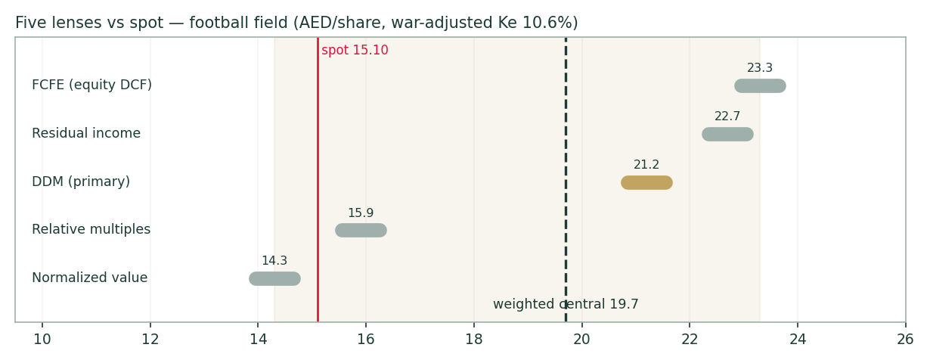
Figure 9 — Five lenses versus spot. The gold span marks the full lens range; the dashed line is the weighted central (AED 19.7); spot in red. The relative lens sitting on top of spot is the market saying "prove it."
1.7 The driver build — how each assumption was set, then the machinery
Every forecast driver below is tagged by how it was derived. Where the bank discloses the underlying components, the driver is built up from them; where it does not, the driver is set top-down from the outcomes the bank does report and the guidance it has given. All eight of ADCB’s drivers are top-down, because the bank reports blended results — net interest margin, cost-to-income, cost of risk — rather than the deposit-repricing betas, fee volumes or product unit-economics a bottom-up build would need. Each row names the evidence it rests on; the full source list is in Appendix B.
Driver | How derived | Justification and supporting evidence
Loan growth (FY26-30 glide 16%->8%) | Top-down | no unit-level pipeline disclosure; anchored to Q1'26 +18% YoY momentum, guidance 'above 16%', CBUAE 2026 macro cut (evidence: F05,F08,F13,F21)
NIM path (2.30 trough 2.26 -> 2.32) | Top-down | rate-path-driven NIM bridge off disclosed quarterly NIM/asset-yield/CoF and Fed/CBUAE path; per-book repricing betas undisclosed (evidence: F01,F09,F22)
Non-interest income (+11% then +9%/yr) | Top-down | fee/trading split disclosed quarterly (Q1'26: fees 938, trading 959, other 299) but no volume drivers; war-vol trading gain haircut applied (evidence: F14,F19,F23)
Cost-to-income (27.0% -> 24.5%) | Top-down | management AI-efficiency program direction disclosed, unit economics not; glide inside record 25.6% Q1 print (evidence: F11,F13,F24)
Cost of risk (55bp -> 45bp) | Top-down | guide <60bp; Q1'26 41bp incl 596mn overlays; NPL 1.76% coverage 152%; war-risk premium retained FY26 (evidence: F02,F13,F18,F21)
Tax rate (11% -> 15%) | Top-down | DMTT 15% statutory with IAE initial-phase 9% currently applied (note 3, Q1'26 FS); lapse timing undisclosed -> conservative step-up, sensitized (evidence: F06,F25)
Dividend payout (38% -> 33%) | Top-down | c.AED 25bn 5yr distribution guide + 'progressive' language + CET1>12% floor; capital equation binds (see FCFE leg) (evidence: F13,F16,F27)
RWA path & CET1 glide (13.8% -> 12.75%) | Top-down | RWA level not disclosed in captured releases -> derived from CET1 ratio (FLAGGED, ledger row); density and glide sensitized (evidence: F19,F16,F26)

The build itself (fully live in the companion Excel’s Driver Build sheet):
- NIM path — anchors on Q1-26 exit NIM of 2.32% and CBUAE’s two anticipated 2026 cuts (management’s own rate call): 2.30% FY26, trough 2.26% FY27, then a slow recovery to 2.32% as deposits reprice down and CASA (46.9%) cushions the fall;
- Loan growth — 16% in FY26 (management: "above 16%"), fading to 8% by FY30 as the base compounds; average interest-earning assets held at 1.60× net loans (Dec-25 ratio);
- Cost-to-income — 27.0% → 24.5% — slower than the Q1-26 print suggests, deliberately conservative on AI-led saves that gate top-down (n4);
- Cost of risk — 55bp FY26 (Q1 ran 41bp plus AED 596mn of geopolitical overlays — the war is provisioned, not just priced), gliding to 45bp; NPL 1.76% with 151.8% coverage gives room;
- Tax — 9% while the Initial-Phase International Activity Exclusion holds, stepping to 15% DMTT from FY27 — the lapse date is undisclosed (n5), so the step is placed early and §1.10 sensitizes it;
- Capital — RWA growing ~1–2pt below loans (mix drift), CET1 gliding 13.6% → 12.75% against the >12% floor; payout 38% → 33%. This is the machinery that decides how much profit is distributable versus retained.
Driver Build (AED mn) | FY26E | FY27E | FY28E | FY29E | FY30E
Net loans | 470,922 | 527,432 | 580,176 | 632,391 | 682,983
Net interest income | 16,132 | 18,047 | 20,199 | 22,308 | 24,409
Non-interest income | 8,319 | 9,068 | 9,884 | 10,774 | 11,744
Operating income | 24,452 | 27,115 | 30,084 | 33,081 | 36,153
Operating expenses | -6,602 | -7,050 | -7,671 | -8,270 | -8,857
Impairment charge | -2,411 | -2,496 | -2,658 | -2,789 | -2,960
Profit before tax | 15,438 | 17,570 | 19,754 | 22,022 | 24,336
Net profit after tax | 13,740 | 14,934 | 16,791 | 18,719 | 20,685
ROE % | 16.6% | 16.3% | 16.5% | 16.5% | 16.4%

Fig. 6–8 below chart the same build: the income stack and NIM path, the profit trajectory against the AED 20bn 2030 target, and the CET1 walk.
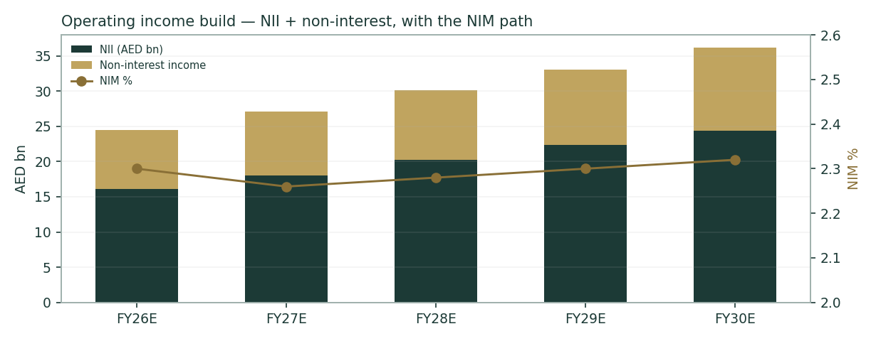
Figure 6 — Operating income build: NII plus non-interest income, with the NIM path (right axis). The FY27 NIM trough is the single most consequential assumption in the model.
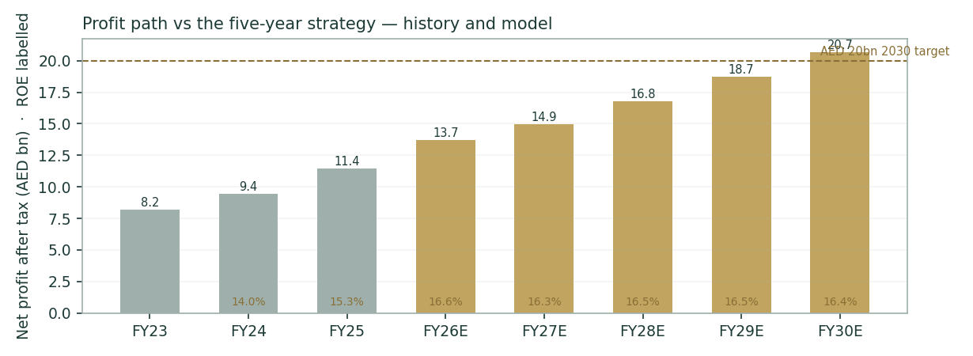
Figure 7 — Net profit, history and model, against the strategy’s AED 20bn 2030 target. The model lands at AED 20.7bn without ever assuming the verbatim "c.20%/yr" — compounding does the work.
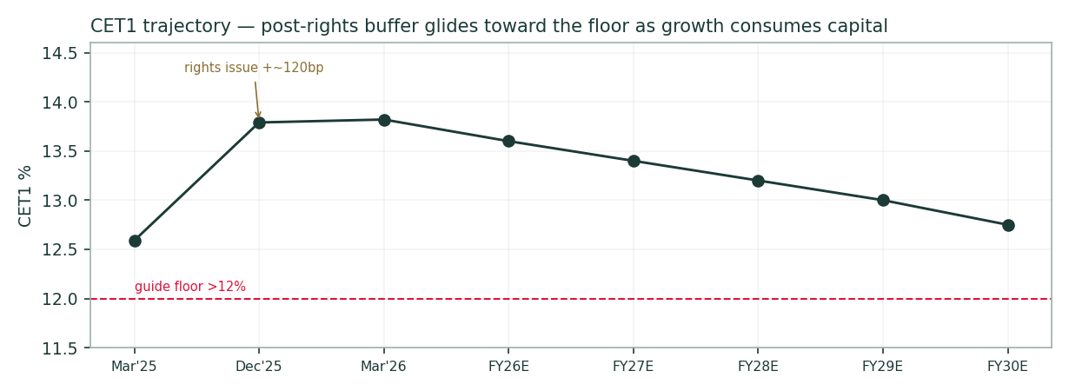
Figure 8 — CET1 walk: the rights issue buys ~120bp of buffer; growth then consumes it toward the >12% floor. This glide is what makes 16% growth, a rising dividend and the capital floor simultaneously affordable — barely.
The bank also runs four disclosed lines plus two subsidiaries: Corporate & Investment Banking, Retail, Treasury & Investments and Private Banking split Q1’26 operating income roughly 36/33/25/6%; Al Hilal Bank (Islamic banking) is folded into these on a product basis, not broken out separately, and ADCB Egypt contributed a Q1’26 net profit of EGP 1.1bn (RoE 24%) — about 1% of group profit, immaterial to the AED model but growing faster than the core. Full segment detail is in the companion Excel’s Segments sheet.
DuPont — the anatomy of the 16%–ROE reads: margin and efficiency, not leverage
The protocol calls for a DuPont decomposition on every bank study so a reader can see whether a projected ROE comes from genuine operating quality or from balance-sheet leverage. Decomposed to average assets, ADCB’s FY26E return on average assets of 1.65% comes almost entirely from the operating income line (NII 1.93% plus fees 1.00% of assets) net of a lean cost base (opex 0.79% of assets) and a modest credit charge (0.29% of assets) — not from a rising equity multiplier. The leverage line (avg assets ÷ avg common equity, ~10.1× in FY26E, easing to ~9.9× by FY30E) is held essentially flat by the CET1 floor across the whole forecast, so when ROE glides from 16.6% toward 16.4% it is doing so on RoAA holding almost exactly flat (1.65% both years) while the mix shifts slightly toward fee income, not on the bank taking on more balance-sheet risk per dollar of equity. That is the answer to the question a DuPont table exists to ask.
DuPont — RoAA decomposition | FY26E | FY30E
Net interest income / avg assets | 1.93% | 1.95%
+ Non-interest income / avg assets | 1.00% | 0.94%
− Operating expense / avg assets | (0.79%) | (0.71%)
− Impairment charge / avg assets | (0.29%) | (0.24%)
− Tax / avg assets | (0.20%) | (0.29%)
= Return on average assets (RoAA) | 1.65% | 1.65%
× Equity multiplier (avg assets / avg common equity) | 10.09× | 9.91×
= Return on average equity (ROE) | 16.6% | 16.4%

Full year-by-year DuPont build (FY26E–FY30E) is live in the companion Excel’s Driver Build sheet.
1.8 The crux — the capital equation cannot maximize everything
Every bank study has one load-bearing tension. ADCB’s is arithmetic: management has promised, simultaneously, loan growth "above 16%", CET1 "above 12%", and "c.AED 25bn" of dividends over five years — on top of a war it does not control. Retained earnings must fund RWA growth; the same dirham cannot also be a dividend; the rights issue bought slack, not immunity. In real units:
- 16% loan growth in FY26 alone adds ~AED 65bn of loans and ~AED 60bn of RWA, consuming ~AED 8bn of CET1 at the 13.6% target — versus ~AED 12.9bn of profit. Distribution capacity in the high-growth years is real but thin: the model’s FY26 FCFE is AED 6.0bn against a declared dividend of ~AED 5.2bn.
- If growth runs at the top of guidance for longer, either the payout glide steepens (DDM value falls toward AED 19) or CET1 approaches the floor faster (FCFE value falls); if growth disappoints, dividends are safer but the AED 20bn target slips past 2030. The promises are jointly affordable only on the narrow path §1.7 draws — which is exactly why the model draws it.
- The war premium is the second crux: strip the 1.0pt conflict adder and the central rises to AED 23.0; harden it to 2.5pt (renewed Hormuz closure) and the central falls to ~AED 16.3. About AED 3 of value per share — a fifth of the price — is a pure geopolitics bet neither management nor this model controls.
1.9 Macro & regime
The operating backdrop is a peculiar mix of strong micro and bruised macro. The UAE grew 6.2% in 2025; the central bank now forecasts 1.7% for 2026 — the war’s bill. Oil traded to war highs and back; the Strait of Hormuz was effectively closed for parts of March–May (the largest supply disruption on record) before the April ceasefire; Jebel Ali took physical debris. Yet system credit demand stayed robust, UAE bank assets reached AED 4.97tn by mid-2025, and ADCB itself booked the disruption as AED 596mn of precautionary overlays rather than actual losses. The rate cycle matters more for the model: the CBUAE base rate (3.65%, pegged to the Fed corridor) is expected by ADCB’s own management to fall twice in 2026 — the source of the FY27 NIM trough. S&P’s upgrade of ADCB to A+ (2025) and the Aa2 sovereign keep funding costs anchored; the constructed AED 10-year risk-free of 4.70% (UST 4.58% + ~12bp AED T-bond spread, from the Ministry of Finance’s May-2026 auctions) is itself an estimate, flagged as such, until a longer AED government curve is available.
1.10 Sensitivity — Ke × terminal growth, and the crux in real units
Weighted central (AED) | g 3.0% | g 3.5% | g 4.0% | g 4.5%
Ke 9.6% | 21.2 | 22.0 | 22.9 | 24.0
Ke 10.1% | 19.8 | 20.4 | 21.2 | 22.0
Ke 10.6% | 18.6 | 19.1 | 19.7 | 20.3
Ke 11.1% | 17.5 | 17.9 | 18.4 | 18.9
Ke 11.6% | 16.5 | 16.9 | 17.3 | 17.7
Ke 12.1% | 15.7 | 16.0 | 16.3 | 16.6

DDM alone (AED) | g 3.0% | g 3.5% | g 4.0% | g 4.5%
Ke 9.6% | 23.5 | 24.4 | 25.4 | 26.6
Ke 10.1% | 21.6 | 22.3 | 23.0 | 23.9
Ke 10.6% | 19.9 | 20.4 | 21.0 | 21.7
Ke 11.1% | 18.5 | 18.9 | 19.3 | 19.9
Ke 11.6% | 17.2 | 17.5 | 17.9 | 18.3
Ke 12.1% | 16.1 | 16.3 | 16.6 | 16.9

Crux swing (real units) | Effect on central
NIM ±10bp across the path (≈ AED 0.9bn NPAT/yr by FY28) | ≈ ±AED 1.0/share
Cost of risk ±10bp (≈ AED 0.55bn pre-tax/yr mid-path) | ≈ ∓AED 0.5/share
Tax: IAE 9% persists through FY28 (vs 15% step in FY27) | +AED 1.3–1.5/share
Conflict adder 0pt ↔ 2.5pt on Ke | AED 23.0 ↔ ~AED 16.3
Loan growth −4pt across the path | ≈ −AED 1.5/share (NII/FCFE, partly offset by lower retention)

Both ERP bases are carried: rating-based Ke 9.57% and CDS-based 9.63% pre-adder; the published central uses the rating basis + 1.0pt conflict adder = 10.57%. The full grids are live in the companion Excel.
§2 Technical and price structure
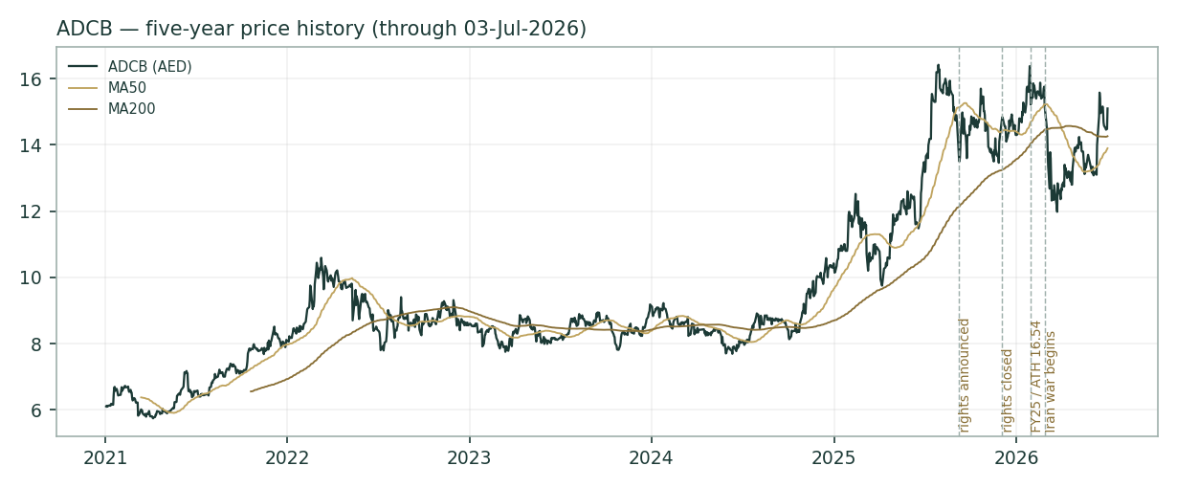
Figure 1 — Five years of ADCB: the 2024–25 re-rating, the rights-issue digestion, the FY25-results all-time high (AED 16.54), the war drawdown to ~12, and the recovery — including the +4.3% de-escalation session of 03-July that set the study’s spot.
Price sits above every major moving average (MA20 14.40, MA50 13.90, MA100 13.92, MA200 14.26) — a fully repaired trend just 9% below the all-time high. RSI-14 at 65 is warm but not stretched; MACD (12,26,9) reads 0.287 / 0.304 / -0.018 — the line is above zero (bullish regime) with the histogram marginally negative, i.e. momentum is pausing after the July pop rather than reversing. The 52-week range is 11.98–16.42; YTD +5.6%, one-year +12.0%. Positioning context: the December rights added 592mn shares at AED 10.30 — everyone who took up rights is sitting on ~+47%, and the stock reclaimed the pre-war shelf in seven weeks. The technical read and the §1 value gap point the same way, which is precisely when the discipline of §3 matters most.
Indicator | Level | Read
MA20 / MA50 / MA200 | 14.40 / 13.90 / 14.26 | Price above all; MA50 curling up through MA200
RSI-14 | 65 | Warm; room before the 70 line
MACD 12 26 9 | 0.287 / 0.304 / -0.018 | Positive regime, momentum pausing
52-week range | 11.98 – 16.42 | Spot 70% up the range
All-time high | 16.54 (2026-01-29) | -8.7% below

§3 Monte Carlo
The probability read comes first; the machinery follows. These five rows are the only genuinely 3-month statements in this study.
Probability read (T+60 trading days ≈ 3 months)
P(price above spot AED 15.10) | 50%
P(+10% or better) vs P(−10% or worse) | 21% vs 19% (odds 1.10×)
Median path | AED 15.09 (-0.1%)
Central 50% of outcomes (25th–75th) | AED 13.95 – 16.32
Touch probability: ±10% at any point within the horizon | 38% up · 34% down

Lens independence note: the Monte Carlo drift never sees §1. Its anchor is pure carry — ln(1+rf 3.65%) − ln(1+dividend yield 4.17%) ≈ -0.12% over 60 days. For this dividend-payer, carry is a hair negative in price terms: the expected total return ≈ the risk-free rate, delivered as dividend rather than drift. The §1 value gap lives in §1 only; if it closes, it closes as a surprise to this distribution, not inside it.
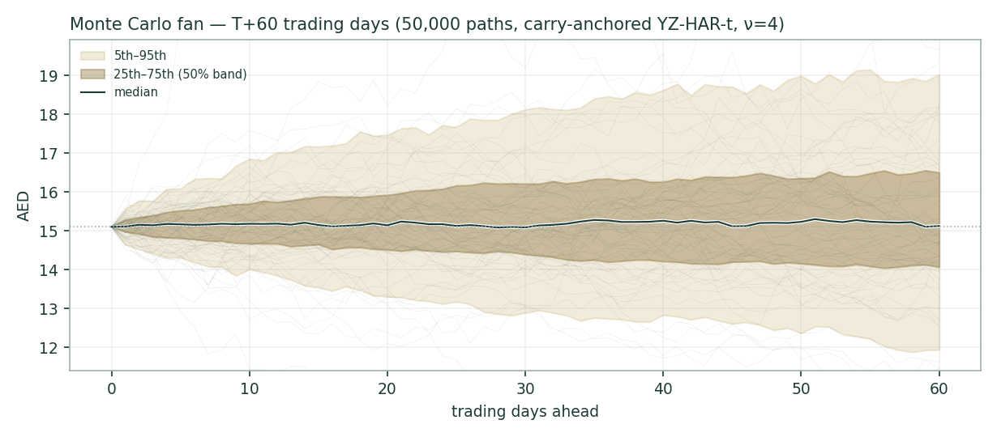
Figure 2 — T+60 fan: 50,000 simulated price paths. Gold band spans the 5th to 95th percentile, brass the 25th to 75th, the white line the median.
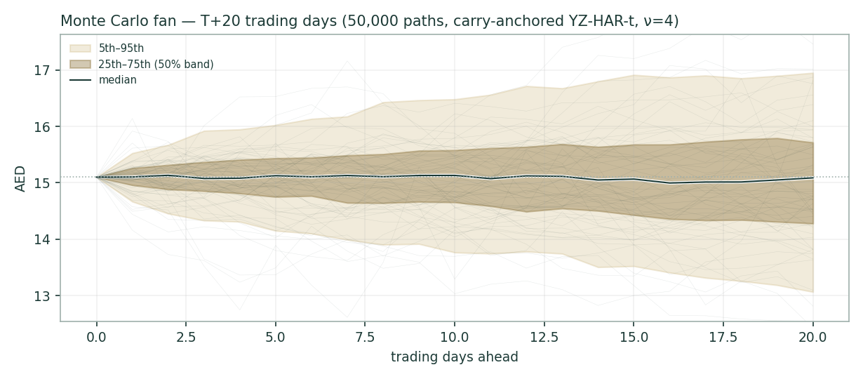
Figure 3 — T+20 fan (≈ one month): the near-term cohort the Calibration Ledger will grade first, on 05-Aug-2026.
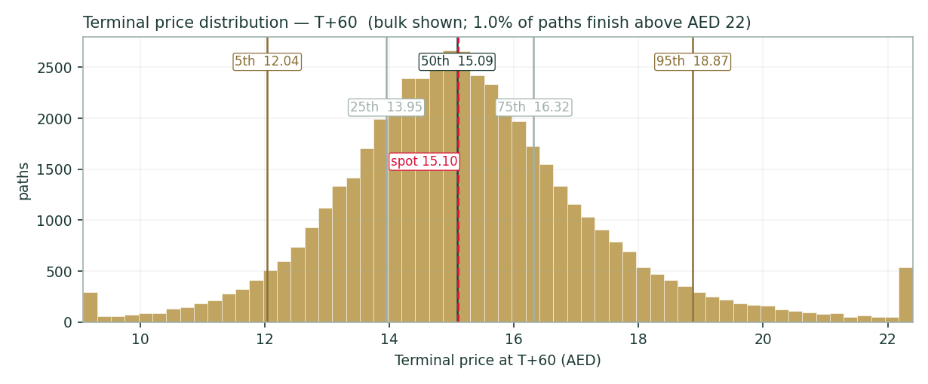
Figure 4 — Terminal T+60 price distribution with percentile markers; spot dashed red. The right tail is fatter than the left in AED terms — the arithmetic of lognormality, not a view.
Percentile | T+20 (AED) | T+60 (AED)
5th | 13.28 | 12.04
25th | 14.43 | 13.95
50th | 15.09 | 15.09
75th | 15.79 | 16.32
95th | 17.20 | 18.87

3.1 Engine & calibration — the backtest in the open
The engine models daily volatility with a gap-aware Yang-Zhang estimator and a heterogeneous-autoregressive forecast, draws shocks from a fat-tailed Student-t distribution to respect crash risk, and centres the paths on carry alone — no momentum or trend signal is used, because none tested reliably for this market. The tail heaviness and cone width are fitted to a panel of nine UAE names (this bank together with its ADX and DFM peers), so the calibration reflects the market as a whole rather than any single stock; interestingly the UAE panel is genuinely fat-tailed, unlike its thinner-tailed Gulf neighbours. The history used starts in January 2022, after the UAE moved its trading week to Monday–Friday, so the volatility estimate rests on a consistent calendar.
Five-year backtest — walk-forward, 60-day horizon, non-overlapping
Windows | 14 (post-2022 break)
CRPS skill vs zero-drift random walk | +0.0232
Pinball-0.50 skill / Winkler-90 skill | +0.0019 / +0.0780
Coverage 50 / 80 / 90 | 0.64 / 0.86 / 0.86
PIT mean | 0.54
Bootstrap CI, block 2 / 3 / 4 | [0.004, 0.035] · [0.002, 0.04] · [0.003, 0.032]
Robust verdict (all blocks agree) | PASS

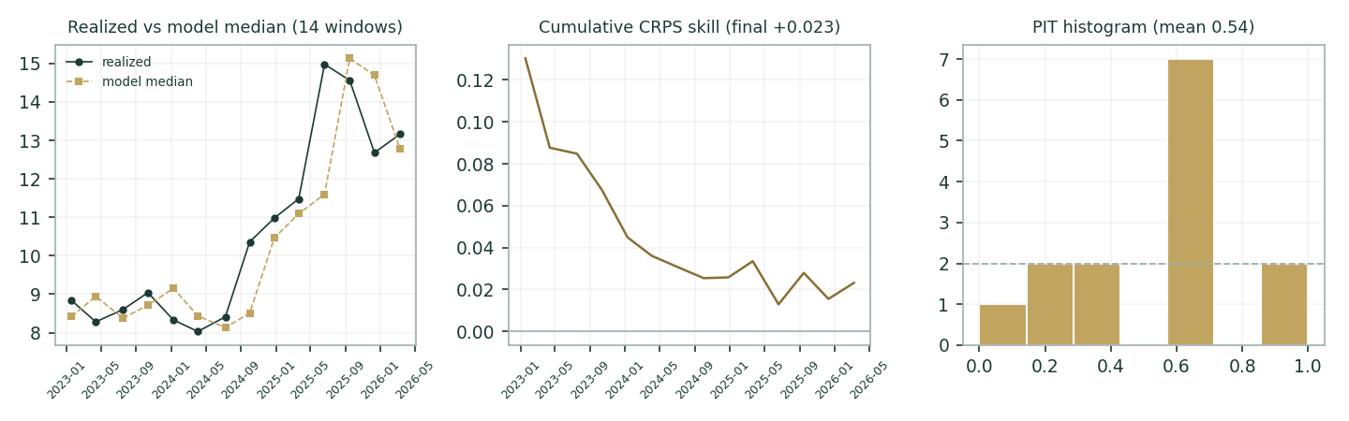
Figure 5 — Calibration three-panel: realized vs model median per window; cumulative CRPS skill; PIT histogram. The two 90%-band misses are the Oct-24 (+23%) and Jun-25 (+30%) rallies — the model under-called upside, never downside.
A PASS means two things at once: the distribution is honest (coverage near nominal, PIT centred) AND it beats the naive benchmark, with the CRPS-skill margin (+0.023) staying above zero across every block-resampling scheme tested — a demonstrated, if modest, edge on this name rather than mere calibration. The published T+20/T+60 cohorts (grading 05-Aug and 02-Oct-2026) now carry that record into live, out-of-sample territory, where it can be confirmed or corrected.
4. What would change our mind
- Falsifier 1 — Q2-2026 results (due 16-July — six days after this study) printing NIM below 2.25% or CoR above 70bp: the FY27 trough assumption is too kind; central falls ~AED 1–1.5.
- Falsifier 2 — CET1 printing below 13.3% by year-end without a corresponding RWA surge: the dividend-growth-capital triangle is tighter than modeled; the payout glide steepens.
- Falsifier 3 — The IAE tax exclusion formally lapsing for FY26: −AED 0.5–0.7 versus the base path (the model already steps to 15% in FY27).
- Falsifier 4 — Renewed Hormuz closure or direct UAE escalation: the 1.0pt adder is a ceasefire-holding assumption; the sensitivity row (§1.10) is the honest map, not a tail footnote.
- Falsifier 5 — Sector P/B re-rating above ~1.8× while ADCB merely tracks: the relative lens converges upward on the DCFs and the thesis resolves without ADCB doing anything — the pleasant failure mode.
5. How to use this study
Read the central as a probability-weighted anchor, not a target. If you need a 3-month view, use §3 and nothing else. If you disagree with an input, the companion Excel reprices the whole study from one blue cell — that is the point of it. Grade us: every forecast in this document is on the public Calibration Ledger with a maturity date, and the graded record — not the prose — is the product.
6. Coverage & ledger integration
ADCB joins Testahil’s UAE coverage alongside its ADX and DFM peers. Two forecast cohorts are registered today — one maturing 05 August 2026, one 02 October 2026 — each recorded with its full set of percentiles so it can be graded after the fact. When a cohort matures it is scored against the same naive benchmark used in the backtest, its result is added to the UAE sample the market calibration is estimated on, and a fresh forecast is issued in its place. The graded record, published openly, is the point of the exercise.
7. The one-paragraph version
ADCB is a 16%-ROE bank compounding profit at 20%+, pre-funded by a rights issue, guided by an explicit five-year plan, priced at ~1.5× book and ~9× forward earnings because it lives in a war zone and just asked shareholders for AED 6.1bn. Five lenses say AED 14.3–23.3 with a weighted central of AED 19.7 (+31%); the honest counter is that the whole UAE sector is priced this way and ADCB must out-deliver it. The 3-month distribution is essentially balanced (P(above spot) 50%, median -0.1%); the value gap, if it closes, closes on delivery and de-escalation — the two things the next four quarters will grade.

Appendix A — Financials (3-year history + 5-year model)
AED mn unless noted. History from ADCB’s results releases; FY24 opex/impairment and FY23 balance-sheet lines derived to disclosed totals (flagged); forecast lines follow the driver build in §1.7. FY23 is shown both ways — as reported (including the AED 490mn gain on the 80% sale of ADCP, and before UAE corporate tax) and excluding that one-off — so the underlying trend is not distorted by a single transaction.
Income statement | FY23 | FY24 | FY25 | FY26E | FY27E | FY28E | FY29E | FY30E
Net interest income | 12,370 | 13,232 | 14,688 | 16,132 | 18,047 | 20,199 | 22,308 | 24,409
Non-interest income | 4,490 | 6,227 | 7,495 | 8,319 | 9,068 | 9,884 | 10,774 | 11,744
Operating income | 16,860 | 19,459 | 22,183 | 24,452 | 27,115 | 30,084 | 33,081 | 36,153
Operating expenses | -5,176 | -6,032 | -6,256 | -6,602 | -7,050 | -7,671 | -8,270 | -8,857
Impairment charge | -3,477 | -2,842 | -3,084 | -2,411 | -2,496 | -2,658 | -2,789 | -2,960
Profit before tax | 8,207 | 10,585 | 12,843 | 15,438 | 17,570 | 19,754 | 22,022 | 24,336
Tax | 0 | -1,166 | -1,398 | -1,698 | -2,635 | -2,963 | -3,303 | -3,650
Net profit after tax | 8,207 | 9,419 | 11,445 | 13,740 | 14,934 | 16,791 | 18,719 | 20,685
EPS (AED) | 1.12 | 1.29 | 1.45 | 1.74 | 1.89 | 2.12 | 2.37 | 2.61
DPS (AED) | 0.56 | 0.59 | 0.63 | 0.66 | 0.70 | 0.76 | 0.80 | 0.86

FY23 as reported AED 8,207mn (pre-CIT); ex the ADCP gain AED 7,717mn. FY23/24 EPS on the pre-rights 7,319.9mn count; FY26E onward on 7,912.2mn.
Balance sheet & capital | FY23 | FY24 | FY25 | FY26E | FY27E | FY28E | FY29E | FY30E
Total assets | 567,000 | 650,130 | 773,654 | 896,994 | 1,004,633 | 1,105,096 | 1,204,555 | 1,300,919
Net loans | 301,700 | 349,972 | 405,967 | 470,922 | 527,432 | 580,176 | 632,391 | 682,983
Customer deposits | 363,000 | 421,000 | 499,775 | 579,953 | 649,547 | 714,502 | 778,807 | 841,112
Common equity (close) | — | — | 78,500 | 87,019 | 96,427 | 107,174 | 119,528 | 133,387
CET1 % | 12.9 | 12.6 | 13.79 | 13.60 | 13.40 | 13.20 | 13.00 | 12.75
NIM % | 2.83 | 2.58 | 2.45 | 2.30 | 2.26 | 2.28 | 2.30 | 2.32
Cost-to-income % | 30.7 | 31.0 | 28.2 | 27.0 | 26.0 | 25.5 | 25.0 | 24.5
NPL % | 3.73 | 3.04 | 1.83 | — | — | — | — | —

FY23 total assets and FY24 deposits derived from disclosed YoY growth; FY26E+ assets/deposits held at the Dec-25 loans-mix (52.5%) and LDR (81.2%) — presentation scaffolding, not drivers. Q1-2026 anchors: assets 808,857 · loans 425,720 · deposits 523,095 · CET1 13.82% · LCR 124.2%.
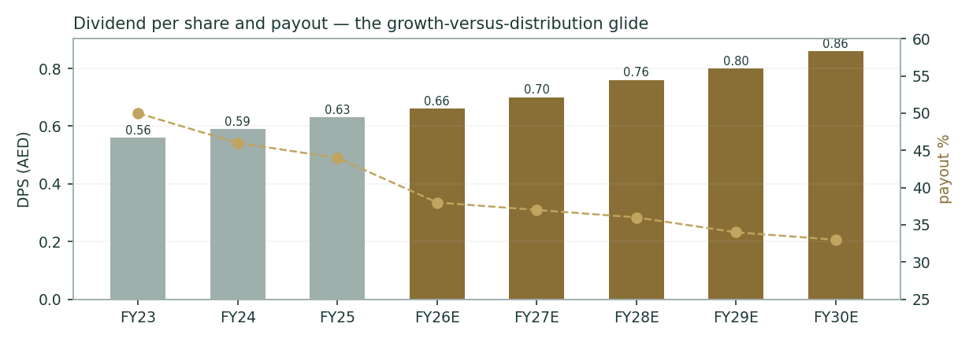
Figure 10 — DPS and payout: the distribution glide that reconciles a rising dividend with 13%+ RWA growth. Cumulative FY26–30 model dividends ≈ AED 24bn against guidance of "c.AED 25bn" — stated both ways: the guide is a round gross number; the model is the net arithmetic of the payout path.

Appendix B — Peers, sector, risks, and the research register
B.1 Peer set
Bank | Latest sourced print | Read vs ADCB
First Abu Dhabi Bank | Q1-26 net income AED 4.75bn, EPS 0.43 (beat) | Sector ceiling; ADCB narrows the ROE gap
Emirates NBD | Not re-sourced this session (DFM) | Dubai flagship; refresh at publish
Dubai Islamic Bank | Not re-sourced this session | Largest Islamic peer
Abu Dhabi Islamic Bank | FY24 NPAT AED 6.1bn (+16%); DPS 0.83 | Premium-ROE Islamic AD peer
ADCB (this study) | Q1-26 NPAT AED 3.361bn; RoAE 16.3% | 19 consecutive quarters of PBT growth

Sector: UAE bank assets AED 4.97tn (Jun-25); credit demand robust through the war; deposit competition keeps CASA valuable as rates fall. The 1.55× sector P/B input is the large-cap band mark used in §1.4.
B.2 Risk table
Risk | Channel | Model treatment
Regional conflict re-escalation | Ke, CoR overlays, sentiment | 1.0pt Ke adder; §1.10 maps 0↔2.5pt; AED 596mn overlays already booked
Rate cuts deeper than two | NIM compression | FY27 trough 2.26%; ±10bp ≈ ±AED 1.0/sh
DMTT/IAE tax step | Net profit −6–7% | Stepped to 15% in FY27; upside if 9% persists
Capital triangle (growth·CET1·dividends) | Payout or growth gives | Explicit CET1 glide; crux §1.8
Credit cycle turn | CoR, NPL | CoR 55→45bp vs Q1 print 41bp; coverage 151.8% buffer
Concentration: Abu Dhabi GREs | Single-obligor / sovereign nexus | Qualitative; Mubadala anchor cuts both ways
Execution on AED 20bn plan | Multiple de-rating on a miss | Model lands 20.7bn on drivers, never assumes the slogan

B.3 Research register — what was checked before the forecast was set
This table is a transparency device. Before setting a single forecast assumption, we work outward from the world to the company — the global rate and oil backdrop, the UAE macro and regulatory picture, the competitive landscape, and finally ADCB’s own disclosures — and record what we found. Crucially, it also records the searches that came back empty: a line marked as a negative finding means we looked for something (a hidden one-off, a tax-rule change, an undisclosed capital action) and confirmed it was not there. The purpose is to let a reader audit the inputs, not just the outputs: you can see the full set of factors considered, judge whether anything material was missed, and see exactly which public source each fact came from. One caveat carries through every row: ADCB’s own PDF filings were not machine-accessible during this work, so company figures were taken from ADCB’s results releases as reproduced word-for-word on financial news wires, and should be checked against the filed statements before being relied upon.
# | Area checked | Type | What we found (with date and source)
F01 | Global — rate cycle & USD/FX regime | Structural | Fed 3.50-3.75% held Jan/Mar/Jun-2026; CBUAE Base Rate 3.65% via AED-USD peg (confirmed again 17-Jun-2026, post-Fed hold); market prices further cuts; three benchmark cuts since Sep-2025 already in NIM — CBUAE press release 17-Jun-2026 (latest; supersedes the 18-Mar-2026 release also on file) + Fed schedule, 2026-07-10
F02 | Global — commodity complex (input/output) | Structural | 2026 Iran war: Strait of Hormuz effectively closed Mar-May-2026 (IEA: largest oil supply disruption on record); UAE re-routed ~1.8mbd via Habshan-Fujairah; Brent back near pre-war levels by Jul on ceasefire/deal hopes — IEA Oil Market Report 17-Jun-2026; Reuters/Zawya Jul-2026, 2026-06-17
F03 | Global — global sector demand | Context | Global growth 3.1% 2026f (IMF, -0.2pt revision); global bank NIMs compressing as easing cycles mature — CBUAE QER June-2026 (citing IMF), 2026-06-30
F04 | Global — trade / sanctions / supply chains | Context | Hormuz closure froze Gulf container traffic Mar-May (Jebel Ali disruption); carrier surcharges from 02-Mar-2026; normalisation underway post-ceasefire but IEA flags slow recovery — IEA topic note Jun-2026; Maersk/carrier notices via trade press, 2026-06-17
F05 | Country — sovereign macro (inflation, policy rate, FX/deval risk) | Structural | UAE 2025 GDP +6.2% (non-oil +6.8%); 2026f cut to 1.7% on the war; inflation 1.3% 2025, 2.3% 2026f; AED peg unquestioned; DONIA ~Base+5bp — CBUAE Quarterly Economic Review June-2026, 2026-06-30
F06 | Country — regulatory environment (regulator, caps, tariffs, tax/subsidy) | Structural | D-SIB designation raised ADCB capital buffers (disclosed rationale for rights issue); DMTT 15% from 01-Jan-2025, but ADCB qualifies for Initial-Phase International Activity Exclusion -> 9% statutory in FY25/Q1'26 (effective ~11%); CBUAE 'Proactive Financial Institution Resilience Package' live (ADCB: unused) — ADCB rights-issue prospectus page + Q1'26 results note 3 (IR release), 2026-04-23
F07 | Country — fiscal / political events with sector read-through | Structural | 2026 Iran war reached UAE directly (airspace closures, strikes near bases, Jebel Ali debris fire); ceasefire holding since ~April; World Bank cut GCC 2026 growth to 1.3%; UAE fiscal buffers deployed (Dubai AED 2.5bn package) — CBUAE QER June-2026; IEA; press synthesis, 2026-06-30
F08 | Industry — demand drivers & capacity/supply balance | Context | UAE system credit demand robust into the war: ADCB Q1'26 loans +18% YoY with AED 10bn to GREs; M2 +17.7% YoY; banks' asset base AED 4.97tn (Jun-2025) — CBUAE QER + ADCB Q1'26 release, 2026-06-30
F09 | Industry — pricing | Structural | Deposit competition keeping funding costs sticky as rates fall; ADCB asset yield 6.03%->5.30% YoY vs CoF improvement via CASA (46.9%); sector NIMs compressing — ADCB Q1'26 investor presentation (IR), 2026-04-23
F10 | Industry — new entrants (named-competitor level) | Context | No new licensed full-service bank entrant found 2025-26; digital challengers (Wio, Zand, ADCB's own Al Hilal) scale within incumbent/backed structures — sector press review, 2026-07-10
F11 | Industry — technology substitution | Context | AI adoption is the sector battleground: ADCB 150+ use-case AI program (2025); UAE ranked #1 globally in AI adoption (Microsoft, Jul-2026); risk is cost-curve differentiation, not disintermediation yet — ADCB FY25 release; Zawya/Microsoft, 2026-07-08
F12 | Industry — competitor capacity / price moves (named) | Context | FAB (largest peer) Q1'26 net income AED 4.75bn, EPS 0.43 beat; ADIB FY24 NPAT AED 6.1bn (DPS 0.83); ADCB won first-of-kind GCC mandate (USD 3.5bn Türkiye sovereign bond) — capital-markets share gain — TradingView earnings page (FAB); WAM/ADIB release; ADCB Q1'26 release, 2026-04-23
F13 | Company — strategic plans & guidance | Structural | Five-year strategy (launched Q1-2025): double net profit to AED 20bn by 2030 (c.20%/yr framing), RoE >15%, CET1 >12%, CoR <60bp, c.AED 25bn dividends over the period; FY26 guidance reiterated Apr-2026 — ADCB Q1'26 results release, guidance table (IR), 2026-04-23
F14 | Company — regular disclosures | Context | FY25: PBT 12.843bn (+21%), NPAT 11.445bn (+22%), OpInc 22.183bn (+14%), NIM 2.45%, CIR 28.2%, DPS 0.63 (payout 44%); Q1'26 MD&A table captured in full — ADCB FY25 + Q1'26 earnings releases (IR; reproduced on news wires — ADCB filed PDF not machine-accessible — re-verify against filing), 2026-04-23
F15 | Company — IR communications (calls, presentations, releases) | Context | Q4'25 call: two rate cuts anticipated in 2026; loan growth 'above 16%'; AI transformation program at scale; Q2'26 results due 16-Jul-2026 — ADCB Q4'25 earnings call (transcript via Investing.com); TradingView calendar, 2026-01-29
F16 | Company — one-off base-resetting transactions | Base change | AED 6.1bn rights issue COMPLETED Dec-2025: 592.2mn new shares at AED 10.30 (1-for-12.36, record 07-Nov), capital 7,319.9mn -> 7,912.2mn shares; largest ADX primary rights issue; CET1/CAR +~120bp; Q4'23 ADCP 80% stake sale gain AED 490mn is the prior-period one-off — ADCB rights-issue completion release 10-Dec-2025 + prospectus terms (IR), 2025-12-10
F17 | Company — ownership / stake changes (named-transaction rule) | Context | Mubadala Investment Company 60.69% — unchanged through the rights issue (subscribed in full, per completion release); subsidiaries: Al Hilal Bank (100%), ADCB Egypt, ADCB Securities, ADCE; ADCP 20% retained interest since Q4'23 divestment — ADCB rights-issue page + completion release (IR), 2025-12-10
F18 | Company — management & capital actions | Structural | S&P upgraded ADCB to A+/Stable (2025); Fitch A+/Stable; FY25 DPS 0.63 recommended (AED 4.985bn, 44%); rights proceeds deployed into +16% loan growth; Q1'26 overlays AED 596mn for geopolitical risk — ADCB FY25 + Q1'26 releases (IR), 2026-04-23
F19 | Company — official financial statements | Context | Q1'26 balance sheet: assets 808,857; net loans 425,720; deposits 523,095; NIEA 679,794; total SH equity 86,000; CET1 13.82%; NPL 1.76%, coverage 151.8%; investment securities AED 160bn (99.4% bonds) — ADCB Q1'26 results release MD&A tables (IR; reproduced on news wires — re-verify vs adcb.com/ADX PDF at publish), 2026-04-23
F20 | Company — regular disclosures | Context | 03-Jul-2026 +4.28% single-day move: no ADCB-specific disclosure found; coincides with market-wide de-escalation rally (Brent near pre-war levels, US-Iran deal hopes); treated as market beta — price series + Reuters/Zawya headline scan, 2026-07-03
F21 | Company — regular disclosures | Checked — none found | Negative search — nothing found (per-segment loan pipeline / booking volumes beyond 'AED 10bn to GREs' — not disclosed in FY25/Q1'26 releases or slides) — negative search, 2026-07-10
F22 | Company — regular disclosures | Checked — none found | Negative search — nothing found (asset/liability repricing betas per book (needed for bottom-up NIM) — not disclosed; only blended NIM/asset-yield/CoF) — negative search, 2026-07-10
F23 | Company — regular disclosures | Checked — none found | Negative search — nothing found (fee volume drivers (cards/trade/AUM unit economics) — quarterly fee lines disclosed, volumes not) — negative search, 2026-07-10
F24 | Company — strategic plans & guidance | Checked — none found | Negative search — nothing found (AI program unit economics / cost-save AED quantification — direction disclosed, numbers not) — negative search, 2026-07-10
F25 | Country — regulatory environment (regulator, caps, tariffs, tax/subsidy) | Checked — none found | Negative search — nothing found (IAE initial-phase lapse date for DMTT 15% step-up — not disclosed in note 3 as captured) — negative search, 2026-07-10
F26 | Company — official financial statements | Checked — none found | Negative search — nothing found (RWA level and density path — CET1/CAR ratios disclosed, RWA absolute not in captured releases) — negative search, 2026-07-10
F27 | Company — management & capital actions | Checked — none found | Negative search — nothing found (year-by-year dividend schedule beyond 'progressive, c.AED 25bn over five years' — not disclosed) — negative search, 2026-07-10

Coverage: all four layers were reviewed before any forecast assumption was set. Of the items logged, one is a base-changing event (the rights issue), several are structural factors that shaped a driver, most are context, and seven are searches that came back empty — each recorded so the reader can see what was checked and found absent.

Appendix C — Expert panel (three independent workings)
Every Testahil study closes with a panel of standing expert personas, cast from the house Expert Persona Library rather than invented for the occasion, so each accumulates a track record across studies and a quarterly update is a re-run, not a re-training. For a bank we cast the bank trio the library specifies — Capital-&-returns, Credit-cycle and Macro-Policy — labelled Expert 1 / 2 / 3, each using a genuinely different valuation method, each showing its working step by step, and each stating the single fact that would prove it wrong. Where they disagree is not a flaw; it maps precisely onto the study’s central tension — how much of ADCB’s five-year plan a buyer should pay for before it has been delivered, and how much of its recent asset quality survives a real credit cycle.
Expert 1 — the dividend purist
The argument. A minority shareholder in a bank ultimately owns a stream of dividends, nothing more. So value the dividend policy directly and ignore the rest of the forecast — if the policy is credible, it already embeds the earnings that fund it. ADCB has committed to a progressive dividend and a mid-teens return on equity, and its board controls the payout; that is enough to price the equity without forecasting a single loan.
The working, in four steps. (1) A bank that sustainably earns a return on equity of ROE and grows its book at g is worth a multiple of book value equal to (ROE − g) ÷ (Ke − g). (2) Putting in a through-the-cycle ROE of 15.0%, long-run growth of 4.0%, and the war-adjusted cost of equity of 10.57%: (15.0 − 4.0) ÷ (10.57 − 4.0) = 11.0 ÷ 6.57 = 1.67× book. (3) Post-rights book value per share is AED 9.92, so fair value = 1.67 × 9.92 = AED 16.6. (4) Cross-check the other way: next year’s dividend of about AED 0.66, capitalised at (Ke − g) = 6.57%, is worth roughly AED 10 on its own — the remaining AED 6-plus is the value of dividend growth, which is why the rising payout, not the current yield, is what carries the case.
Expert 1 — inputs and result
Sustainable return on equity | 15.0%
Long-run growth | 4.0%
Cost of equity (war-adjusted) | 10.57%
Justified price-to-book = (ROE − g)/(Ke − g) | 1.67×
Book value per share (post-rights) | AED 9.92
Fair value | AED 16.6

Verdict: AED ~16.6 — the most conservative fundamental number of the three, because it credits none of the near-term earnings surge, only the steady state. What would prove it wrong: if ADCB cut or merely froze its dividend in FY26 despite rising earnings, the premise that the payout policy is credible would collapse, and this expert would fall back to the lower through-cycle value of AED 14.3.
Expert 2 — the credit-cycle skeptic
The argument. Reported book value, and every lens built on it, is only as real as the loan book behind it. ADCB’s asset quality today — NPL 1.76%, coverage 151.8%, cost of risk running at 41bp against a <60bp guide — is genuinely strong, but it is a peacetime-adjacent, low-rate-cycle reading, not a through-cycle one. A credit-cycle analyst does not price the bank on the credit costs it is booking now; she prices it on what it would book in a real downturn, then asks what is left.
The working. Take the FY26E–30E loan book from the driver build and reprice the impairment line at a genuinely stressed, through-cycle cost of risk — 110bp on average loans, roughly the UAE system’s own 2020 downturn experience, versus the model’s base-case glide of 51bp down to 43bp. Holding loan growth, the NIM path and the payout ratio unchanged, that stress cuts net profit by AED 2.4–4.1bn a year — an average of 19% of NPAT across FY26–30 — because the extra provisioning flows straight through pre-tax income with only a partial tax shield. Repricing the two cash-flow lenses off that stressed earnings stream (holding Ke and the capital schedule fixed) pulls the DDM to about AED 17.2 and the equity DCF to about AED 19.0.
Expert 2 — the through-cycle stress test
Base-case cost of risk (FY26E → FY30E) | 51bp → 43bp on avg loans
Stressed through-cycle cost of risk | 110bp (~2020 UAE-system downturn)
Average NPAT cut under the stress | 19% per year
DDM under stressed earnings | AED ~17.2
Equity DCF (FCFE) under stressed earnings | AED ~19.0

Verdict: AED ~18.1 (the mid-point of the two stressed cash-flow reads) — asset quality is genuinely strong today, and none of this is a call that a downturn is imminent, but a valuation that only survives on the current benign credit cycle is not fully priced for the cycle it will eventually face. What would prove it wrong: cost of risk staying inside the 41–55bp guided range through a full rate cycle, including whatever the war ultimately costs the loan book — in which case the stress was too harsh and the cash-flow lenses at their base-case values are the better guide.
Expert 3 — the regime skeptic
The argument. Trust prices, distrust stories. The entire UAE banking sector trades around 1.5× book because the marginal buyer is charging a wartime cost of equity, and ADCB at 1.52× book is sitting exactly on that line — there is no idiosyncratic mispricing to capture. Any value above the sector is a bet that the regional risk premium falls, which is a macro trade dressed up as a stock pick.
The working. Start from where comparable UAE banks actually clear — about 1.5× book — and ask only what premium ADCB specifically deserves. For its superior return-on-equity trajectory and the stability of majority ownership by Mubadala, a 10–15% premium to the sector is fair: 1.70× to 1.78× book. On post-rights book value per share of AED 9.92, that is AED 16.9 to AED 17.7, with a mid-point of about AED 17.3. Everything above that line requires the war premium to compress — which may well happen, but is not something to underwrite in a valuation.
Expert 3 — sector-relative pricing
UAE sector price-to-book | ~1.5×
Justified ADCB premium (ROE, ownership) | +10–15%
Applied multiple range | 1.70× – 1.78×
Fair-value range | AED 16.9 – 17.7
Central | AED ~17.3

Verdict: AED ~17.3. What would prove it wrong: two consecutive quarters of the whole sector re-rating above 1.8× book would show the wartime premium is lifting, at which point the cash-flow methods — which price the business through the cycle rather than at today’s risk premium — become the better guide.
Expert | Method in one line | Value (AED) | What would prove it wrong
Expert 1 | Price the dividend policy directly (justified P/B) | ~16.6 | FY26 dividend cut or frozen despite higher earnings
Expert 2 | Reprice earnings at a through-cycle cost of risk | ~18.1 | Cost of risk stays inside the 41–55bp guide through a full cycle
Expert 3 | Price off the sector at today’s war premium | ~17.3 | Sector re-rates above 1.8× book for two straight quarters

The three land at AED 16.6, 17.3 and 18.1, all below the study’s weighted central of AED 19.7. Their disagreement is not noise — it is the single question this whole study turns on: how much of ADCB’s current run-rate should a buyer trust, before a real credit cycle or the war’s endgame has tested it. Expert 1 prices the dividend and ignores the growth story; Expert 2 prices earnings through a credit downturn the current numbers have not yet faced; Expert 3 prices the sector’s own wartime discount. All three sit below the weighted central, which gives more credit than any single expert to the five-year plan actually being delivered — precisely the bet §1.8 names as the crux.

Disclaimer
1. This document is published by Testahil for educational purposes only. It is not investment advice, an offer, a solicitation, a recommendation, a rating, or a price target of any kind.
2. The preparer is not licensed or supervised by the Financial Regulatory Authority (Egypt), the Securities and Commodities Authority (UAE), or any other securities regulator, and holds no professional investment designation.
3. All figures are model outputs under stated assumptions and may be wrong. Financial-statement data was captured from company results releases as republished on public wire services because the issuer’s PDF filings were inaccessible this session; figures must be re-verified against the filed statements before any reliance.
4. Forecasts are probability distributions, not predictions; they are published to be graded, and the graded record on the public Calibration Ledger — including failures — is part of this document’s meaning.
5. Nothing here considers any person’s objectives or circumstances. Anyone considering an investment should consult a licensed advisor and the issuer’s official filings.
6. The preparer may hold, or may in the future hold, a position in the security discussed. Testahil accepts no liability for any loss arising from the use of this document.
Testahil · testahil.com · study date 10 July 2026 · all forecasts in this study are logged, with maturity dates, to the public Calibration Ledger and graded after the fact.

