Testahil · Independent Valuation Study — Educational Analysis Not investment advice

Abu Dhabi Islamic Bank PJSC (ADX: ADIB)
Fundamental analysis · Technical analysis · Monte Carlo simulation — one integrated read
Independent valuation study · 11 July 2026 · spot AED 21.76 (03-Jul close) · 3,632.0mn shares · market cap ~AED 79.0bn (~US$21.5bn) · the UAE's largest listed Islamic bank by returns, not by size · newest name in Testahil's UAE coverage
READ FIRST. This is an independent, educational valuation study published under the Testahil brand. It is not investment advice, not a recommendation, and contains no rating and no price target. It presents fair-value ranges and probability distributions — distributions, not tips.
Who we are not. The preparer is not licensed by the FRA, the SCA, or any securities regulator, holds no CFA charter, and this document has not been reviewed by any authority.
What the numbers are. Model outputs under stated assumptions — every input is disclosed, every unsourced driver is logged in a public ledger, and every published forecast is graded after the fact on the public Calibration Ledger.
The two clocks. The weighted central (AED 21.23) is a risk-adjusted ~12-month anchor. The only genuinely 3-month figures in this study are the Monte Carlo percentiles in §3. Never read one clock as the other.
Calibration tier. Backtest verdict for ADIB: PARITY, on a CRPS skill of +0.0093 against a carry-anchored random walk across 14 walk-forward windows. The shape and width parameters are not chosen by us — they are read live from the engine registry, where they are fitted to a 14-name UAE panel. The distribution is honestly calibrated and validated on that panel, but on ADIB's own 14 windows the confidence interval spans zero, so no single-name forecasting edge has been demonstrated. Read §3 as a base rate, not a promise.
Provenance. Every historical figure here comes from ADIB's own filings — the FY2023, FY2024 and FY2025 Management Discussion & Analysis, the FY2025 earnings presentation, and the Q1-2026 MD&A, all machine-read from adib.ae. No aggregator was used for any financial-statement line. Market prices, yields and sector multiples are market data and are sourced as such.
One timing flag. The spot price is the 03-July close. Between that date and this publication the regional ceasefire frayed — strikes resumed on 4–6 July, Brent rose from $70.82 to ~$76, and on 10 July the US President described the ceasefire as "effectively over". The spot was set on de-escalation optimism. §1.10 maps what a harder conflict premium does.

The company
Abu Dhabi Islamic Bank is the UAE's largest listed Islamic bank and, on the only measure that matters to a shareholder, the most profitable bank in the country: it earned a 28.8% return on equity in 2025 against a sector that managed 18.3%. It makes money the way any bank does, but with a Shari'a-compliant wrapper — it gathers AED 229bn of deposits, two-thirds of them in current and savings accounts that cost almost nothing, deploys AED 186bn into customer financing that is still 55% retail, and keeps the spread. That funding mix is the whole story: it is why ADIB's net profit margin of 4.11% sits 163 basis points above the sector's net interest margin, and why a 100bp cut in the benchmark rate cost it only 24bp of margin last year. The bank has just finished a five-year plan in which it doubled — assets from AED 128bn to AED 281bn, profit from AED 1.6bn to AED 7.1bn, return on equity from 10% to 29% — while cleaning up a legacy bad-loan problem that had left 8.9% of the book non-performing in 2021 and now leaves 2.6%. Roughly half its revenue comes from retail banking — a book whose deposits are 91% current-and-savings, which is the cheapest funding in the market and the single fact behind everything else here — with wholesale at 16%, treasury at 7%, and the rest from associates and a fast-growing Egyptian subsidiary. It is now starting another five-year plan, under a 2035 vision, aiming to be 1.7–1.9 times bigger by 2030 at a still-remarkable 25% return on equity. The market knows all of this, which is precisely the problem this study has to solve.
At a glance
 | Value |  | Value
Spot (03-Jul-2026) | AED 21.76 | Weighted central | AED 21.23 (-2.4%)
Shares outstanding | 3,632.0mn | Range across lenses | AED 17.9 – 23.5
Market cap | AED 79.0bn (~US$21.5bn) | Ke (conflict-adjusted) | 10.57% (rf 4.70% + β 1.00 × ERP 4.87% + 1.0pt)
FY25 net profit | AED 7,070mn (+16%) | Trailing P/E · P/B | 12.5x · 3.31x
FY25 ROAE / net profit margin | 28.8% / 4.11% | FY25 DPS · yield | AED 0.9705 · 4.5%
Q1-26 ROAE / CET1 | 27.1% / 12.0% | Backtest verdict | PARITY (skill +0.009, 14 windows)
NPA / coverage (incl. collateral) | 2.6% / 178.3% | MC T+60 median | AED 21.73 (-0.1%)

Sources: ADIB FY2025 and Q1-2026 Management Discussion & Analysis and the FY2025 earnings presentation; Testahil model. P/B is on the latest reported (Q1-26) book of AED 6.571 per share; on the last audited FY book (Dec-25, AED 7.177) it is 3.03x. Both framings carry through.
Headline
Five independent lenses put ADIB's fair value between AED 17.9 — what the sector will pay today for a bank earning what ADIB earns — and AED 23.5, an equity DCF that credits the plan. The weighted central is AED 21.23, which is 2.4% below the 03-July close of AED 21.76. That is the finding, and it is deliberately undramatic: ADIB is a superb bank at a full price. The three cash-flow lenses — the dividend model, the equity DCF and residual income — cluster at AED 22.5–23.5 and say the stock is worth a few percent more than it costs. The two market-anchored lenses say AED 17.9–19.0 and say it is worth rather less. Both are right about something, and the tension between them is the whole study.
Here is that tension in one number. ADIB trades at 3.31 times book. The UAE bank sector trades at about 1.55 times. ADIB's 28.8% return on equity genuinely earns most of that premium — on the arithmetic that governs bank multiples, a bank earning 28.8% against a sector earning 18.3% deserves 1.73 times the sector multiple, or 2.69x. But it trades at 3.31x. The market is paying a further 23% on top of what the return already justifies. Put the other way round: at our cost of equity, today's price implies ADIB earns 25.8% on equity forever — better than management's own 2030 target of about 25%, and ten points better than any peer. That is the bet. Everything else in this document is detail.
Valuation summary
The whole answer in one view. Five independent methods value the bank; the table below shows what each is worth, the weighted central that combines them, and how that sits against today's price.
The bottom line
Market-anchored family — relative and normalized | AED 17.94 – 19.00
Cash-flow family — DDM, residual income, FCFE | AED 22.54 – 23.48
Weighted central — a probability-weighted summary, NOT a target | AED 21.23
Current price (03-Jul-2026 close) | AED 21.76
Implied gap to central | -2.4%
Upper reference — the plan delivered, at a peace-time cost of equity | AED 24.63
Lower reference — a renewed Hormuz closure (2.5pt conflict adder) | AED 17.73
Three-month view — probability the price is above today's | 50%
Three-month view — median outcome | AED 21.73 (-0.1%)

Lens | Value (AED) | What it prices
Equity DCF (FCFE) | 23.48 | The cash the bank could distribute after funding its own growth
Dividend discount model | 22.54 | A payout policy that has not moved in five years
Residual income | 22.54 | Today's book plus the value of returns above the cost of equity
Normalized (through-cycle) | 19.00 | Mid-cycle earnings at the multiple their return warrants
Relative multiples (ROE-adjusted) | 17.94 | What the UAE sector pays today for a bank earning what ADIB earns

Read the two families, not the single number. They do not overlap, and that non-overlap is the finding. The cash-flow family (AED 22.5–23.5) prices a bank that keeps out-earning its cost of equity for a very long time. The market-anchored family (AED 17.9–19.0) prices what a buyer will actually pay for that today. The weighted central of AED 21.23 is a probability-weighted summary ACROSS those two regimes. It is not a claim that the truth sits politely in the middle, it is not a price we expect the stock to trade at, and it is emphatically not a target — this document contains no rating and no price target, and the range above, together with the distribution in §3, is what we are actually publishing. The three-month figures come from §3 and nowhere else. The remainder of §1 builds each lens in full.
1. Valuation
1.1 Dividend discount model — the primary lens
For a bank, deposits are an operating input rather than a financing choice, so enterprise-value arithmetic is meaningless: everything discounts at the cost of equity. The dividend model is primary here for a reason that is unusually strong. ADIB's payout ratio over the last five declared years was 48.5%, 49.2%, 49.4%, 49.7% and 49.9%. That is not a coincidence and it is not a range — it is a policy, executed to within 140 basis points across a period in which profit tripled. A board that has held its payout that steady while its earnings ran away from it is telling you what it intends to do with the next five years of cash. The dividend per share rose from 31.1 fils to 97.05 over those five years; the payout barely moved.
AED / share | FY26E | FY27E | FY28E | FY29E | FY30E
EPS | 1.836 | 1.949 | 2.161 | 2.384 | 2.623
Payout | 50% | 50% | 51% | 52% | 53%
DPS | 0.918 | 0.975 | 1.102 | 1.240 | 1.390
Discount factor @ Ke 10.57% | 0.904 | 0.818 | 0.740 | 0.669 | 0.605
PV of dividend | 0.830 | 0.797 | 0.815 | 0.829 | 0.841

Terminal block | Value
Closing common equity FY30 (AED mn) | 45,422
Terminal ROE (the crux — see §1.8) | 20%
Terminal payout = 1 − g / ROE = 1 − 4%/20% | 80%
Terminal earnings (FY31) = terminal ROE × FY30 book | AED 2.50 / share
Terminal dividend (FY31) | AED 2.00 / share
Terminal value at (Ke − g) | AED 30.46
PV of terminal value | AED 18.43
Σ PV of explicit dividends (FY26–30) | AED 4.11
DDM fair value | AED 22.54
Terminal value as % of total (dependency disclosure) | 82%

Terminal-value dependency, stated plainly: 82% of this number sits in the terminal block. That is normal for a bank growing financing at 13% on a 50% payout — the explicit dividends are small precisely because the bank is reinvesting — but it means the DDM is a claim about ADIB's steady state, not about the next five dividends. The steady state in question is a 20% return on equity, forever. §1.8 is about nothing else, and §1.10 stresses exactly that claim.
1.2 Equity DCF (FCFE) — the full build, from revenue to cash
The equity DCF asks not what the board chooses to pay but what the business could pay after funding its own growth. It is built from the top line down. For an Islamic bank the top line is total operating income: funded income (the return on financing assets, net of what is distributed to depositors) plus non-funded income (fees, FX, investment income). From there the waterfall runs through costs, impairments and tax to profit — and then subtracts the one item a bank cannot avoid: the fresh equity it must retain each year to keep its capital ratio intact as its balance sheet grows. What is left is genuinely distributable, whether or not it is actually paid.
AED mn | FY26E | FY27E | FY28E | FY29E | FY30E
Funded income | 8,441 | 9,302 | 10,206 | 11,155 | 12,147
Non-funded income | 4,941 | 5,336 | 5,763 | 6,224 | 6,722
Total operating income | 13,382 | 14,638 | 15,970 | 17,380 | 18,869
Operating expenses | -3,934 | -4,245 | -4,551 | -4,866 | -5,189
Pre-provision operating profit | 9,448 | 10,393 | 11,418 | 12,513 | 13,680
Impairment charge | -909 | -1,023 | -1,090 | -1,177 | -1,259
Profit before tax | 8,538 | 9,371 | 10,328 | 11,336 | 12,421
Tax | -1,110 | -1,499 | -1,652 | -1,814 | -1,987
Profit after tax | 7,428 | 7,871 | 8,675 | 9,522 | 10,434
less: AT1 sukuk coupon | -353 | -353 | -353 | -353 | -353
less: non-controlling interests | -406 | -439 | -474 | -512 | -552
Attributable to ordinary shareholders | 6,669 | 7,080 | 7,849 | 8,658 | 9,528
less: equity retained for RWA growth | -2,726 | -2,881 | -2,965 | -3,004 | -2,990
Free cash flow to equity (FCFE) | 3,943 | 4,199 | 4,884 | 5,654 | 6,538
Discount factor at Ke 10.57% | 0.904 | 0.818 | 0.740 | 0.669 | 0.605
PV of FCFE | 3,566 | 3,435 | 3,613 | 3,783 | 3,956

Terminal value & the bridge to per-share | AED mn
Σ PV of explicit FCFE (FY26–30) | 18,353
Terminal FCFE (FY31) = steady-state payout × terminal earnings | 7,267
Terminal value = terminal FCFE ÷ (Ke − g) | 110,616
PV of terminal value | 66,931
Equity value = Σ PV explicit + PV terminal | 85,284
÷ shares outstanding (mn) | 3,632
FCFE value per share | AED 23.48
Memo: terminal value as % of equity value | 78%

The equity DCF lands at AED 23.48, AED 0.94 above the dividend model — and the reason is precise rather than decorative. The two lenses share one terminal steady state, so they can differ only inside the explicit window. Inside that window, ADIB generates more capital than a 50% payout distributes: as financing growth glides from 13% to 9%, the retained half of a rising profit stream starts to exceed what risk-weighted-asset growth consumes. The surplus runs from AED 608mn in FY26 to AED 1,488mn in FY30, and its present value is exactly AED 0.94 per share. That is the whole of the gap between the two numbers — not a modelling artefact, but the value of cash the board has not yet promised.
1.3 Residual income — book value plus the value of excess returns
Residual income starts from what shareholders already own — AED 26,067mn of common equity at December 2025, after separating out the AED 4,754mn of Tier-1 sukuk and AED 1,548mn of minority interests, both of which ADIB discloses on the face of its balance sheet — and adds only the present value of returns earned above the cost of equity. It is the lens least dependent on a terminal assumption, and under clean-surplus accounting it must reconcile exactly to the dividend model. It does: both give AED 22.54. That agreement is not a coincidence to be admired; it is an arithmetic identity, and its purpose is to prove the model has no leak in it.
AED mn | FY26E | FY27E | FY28E | FY29E | FY30E
Opening common equity | 26,067 | 29,402 | 32,942 | 36,787 | 40,943
Equity charge (Ke 10.57% × opening) | -2,755 | -3,108 | -3,482 | -3,888 | -4,328
Attributable profit | 6,669 | 7,080 | 7,849 | 8,658 | 9,528
Residual income | 3,914 | 3,972 | 4,367 | 4,769 | 5,201

Book AED 26,067mn + PV of explicit residual income AED 16,357mn + PV of terminal residual income AED 39,448mn = AED 81,872mn, or AED 22.54 per share — an implied 3.14× on current common book. Because ADIB earns 22–24% against a 10.6% cost of equity across the forecast, the excess-return engine is doing almost all the work: the starting book is only 32% of the answer. That is the honest reading of a bank trading above three times book — you are not buying assets, you are buying a spread.
1.4 Relative multiples — what the sector pays for a bank that earns this much
This is the disciplining lens, and it needs to be built carefully, because the naive version of it is wrong. Applying the sector's 1.55× price-to-book to ADIB's book would value a bank earning 28.8% as though it earned 18.3%, which is not a valuation but a category error. The arithmetic that governs bank multiples says a justified price-to-book is linear in (ROE − g), not proportional to ROE. So the sector's own mark tells us what one point of return on equity is worth in this market today — and ADIB's premium has to be earned on that scale.
The ROE-justified line | Value
UAE bank sector P/B (large-cap band) | 1.55x
UAE bank sector ROE | 18.3%
ADIB ROE (FY25 reported — like-for-like with the sector mark) | 28.8%
ROE-justified premium = (28.8% − 4%) / (18.3% − 4%) | 1.73x
Justified P/B = sector P/B × premium | 2.69x
× BVPS (latest reported, Q1-26) | AED 6.571
Value on the P/B route | AED 17.66
Value on the P/E route (justified fwd P/E 9.9x × FY26E EPS) | AED 18.21
RELATIVE FAIR VALUE (average of the two routes) | AED 17.94
Dual frame — the same lens on A&M's 1.64x P/TBV mark instead | 2.84x → AED 18.45
— where ADIB actually trades | 3.31x = AED 21.76
— premium over its own ROE-justified value | +23% (on the 1.64x mark: +16%)

Which sector mark, and why it barely matters. Two legitimate marks exist and both are carried here to a value rather than to a footnote. The 1.55x price-to-book is the UAE large-cap band as at 10 July 2026 — measured at CURRENT prices, after the war de-rating, and therefore apples-to-apples with ADIB's own current price. Alvarez & Marsal's 1.64x price-to-tangible-book is the FY2025 pulse, measured at FY2025 prices. Since ADIB carries negligible intangibles, the gap between the two is a PRICE-DATE difference, not a tangibility one. We use 1.55x as primary because it is the more current — but the choice hardly signifies: the relative lens moves from AED 17.94 to AED 18.45, and the weighted central from AED 21.23 to AED 21.33. About ten fils. Anyone who suspects the sector mark was chosen to engineer an answer can check that in one line.
One observation the dual frame surfaces. ADIB's own annual report puts its FY2025 price-to-book at 2.9x against a sector at 1.64x — a 1.77x premium at December prices. At today's price and today's 1.55x sector mark, that premium has widened to 1.96x. The stock has re-rated UP while its own sector de-rated. That is not an argument against ADIB; it is a precise statement of what has to keep going right.
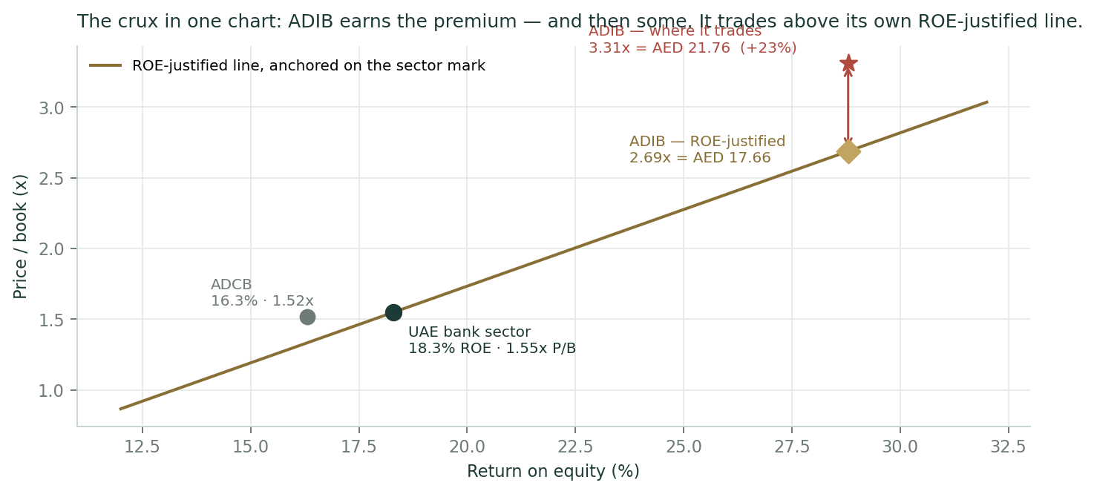
Figure 1 — The relative lens in one chart. The line is what the UAE sector pays for a point of return on equity. ADCB, the conventional Abu Dhabi comparator, sits almost exactly on it. ADIB's 28.8% ROE justifies 2.69× book — a large premium, honestly earned. It trades at 3.31×. The red arrow is the 23% the market is paying on top of what the return justifies, and it is the single most important gap in this document.
The message is clean and it is not the one a promotional note would write. ADIB is not cheap against its peers; it is expensive against them, even after giving it full credit for a return on equity ten points above the sector. The relative lens can only converge upward on the cash-flow lenses if one of two things happens: the whole UAE complex re-rates (de-escalation, a lower risk premium), or ADIB's ROE proves durable enough that a 25%-plus perpetual return stops looking heroic. Neither is impossible. Neither should be assumed.
1.5 Normalized-earnings value — the conservative, through-cycle case
This lens sets aside the current profitability surge and asks what ADIB is worth on mid-cycle earnings — but values those earnings at the multiple they actually warrant, rather than at an arbitrarily low one. A through-cycle return on equity of 23% is our normalized figure: below management's 25% 2030 target, and set against a five-year average of 23.8% that is itself depressed by the 2021–22 prints, when 8.9% of the book was non-performing and the cost of risk was 99 basis points. That legacy problem has been fixed; a flat five-year average would therefore understate the bank ADIB is now. A bank that sustainably earns 23% and grows at 4% is worth a price-to-book of (23% − 4%) ÷ (10.57% − 4%) = 2.89×, which on a book of AED 6.571 is AED 19.00 — an implied 12.6× on normalized earnings of AED 1.511, and about 13% below today's price. Valuing the earnings at the price-to-book their return justifies keeps this lens internally consistent with the other four, which all discount at the same cost of equity. The reading is deliberately sober: cut the run-rate back to mid-cycle and price it fairly, and ADIB is worth about a fifth less than it costs. This value sits close to the lower quartile of the three-month distribution in §3 (25th percentile AED 19.81) — a reminder that the conservative case is a modestly lower fair value, not a crash.
1.6 The driver build — how each assumption was set, then the machinery
Every forward driver below is tagged by how it was derived. Where ADIB discloses the underlying components, the driver is built up from them; where it does not, it is set top-down from the outcomes the bank does report and the guidance it has given. All of ADIB's drivers are top-down, for a specific and checkable reason: the bank reports blended results — net profit margin, cost-to-income, cost of risk — rather than the deposit-repricing betas, fee volumes or product unit economics a bottom-up build would need. We looked for each of those and recorded the searches that came back empty; they are in the register in Appendix B. Every row below names the evidence it rests on.
Driver | Mode | Justification, and the evidence it rests on
Gross financing growth  13% → 9% | Top-down | Portfolio mix disclosed (retail 55%, GRE 26%, corporate 14%) but no unit-level pipeline. Anchored to FY26 guidance of 12–14% and the 1.7–1.9× 2030 asset target; our path lands at 1.68× — at or below the bottom of management's own range. (F16, F21, F17)
Net profit margin  3.90% → 3.70% | Top-down | FY26 guidance 3.8–4.0%; Q1-26 printed 3.91%. Per-book repricing betas are not disclosed (negative search, F22). The grind down is MIX — retail 56→55%, GRE 24→26% — not a rate call; the Fed is now expected to hold or hike, which is a margin tailwind. (F16, F14, F21, F22, F01)
Non-funded income  +4%, then +8%/yr | Top-down | Fee, FX and investment lines disclosed; their volume drivers are not (F23). Q1-26 grew only +4% year-on-year on management's own "softer transaction activity", so FY26 holds that run-rate rather than assuming the +17% of FY25 repeats. (F15, F14, F23)
Cost-to-income  29.4% → 27.5% | Top-down | Guidance "<30%" for FY26 and 26–28% by 2030. Q1-26 printed 29.6%. The AI and digital cost programme is described but never quantified (negative search, F24), so the glide is deliberately slow and lands at the TOP of the 2030 target band. (F16, F14, F11, F24)
Cost of risk  46bp → 42bp (our basis) | Top-down | Guidance 40–60bp; FY25 printed 44bp on ADIB's stated basis, Q1-26 48bp. DUAL-FRAMED: our impairment is cost of risk × average GROSS financing, on which FY25 was 41bp; our path maps to roughly 50/50/48/46/45bp on ADIB's own basis — mid-guidance, and ABOVE the FY25 print, because relief programmes defer losses rather than delete them. (F16, F14, F19)
Effective tax rate  13% → 16% | Top-down — CRUX | The most contested line — and no longer a bare judgement. ADIB's effective rate: 4.0% (FY23) → 11.2% (FY24) → 12.7% (FY25) → 12.9% (Q1-26): two reporting periods under the UAE's 15% minimum tax with no step-up, and no Pillar Two disclosure anywhere we could find (F25). Two things nevertheless PLACE the step. First, the mechanism has a date: Pillar Two's transitional safe harbour needs a simplified tax rate clearing 15% / 16% / 17% for FY24 / FY25 / FY26, and it is available only for years beginning on or before 31 December 2026 — so the full computation applies from FY2027 (F28). Second, the peer is already paying: Dubai Islamic Bank told its FY25 call its tax rate went from 9% to 15% (F29). ADIB is the outlier, not the rule. (F06, F28, F29, F14, F25)
Dividend payout  50% → 53% | Top-down — but barely | The most sourced driver here. Payout: 48.5 / 49.2 / 49.4 / 49.7 / 49.9% across FY21–25. That is a policy. It drifts up only because growth slows and the capital equation frees cash. (F13)
Terminal ROE 20% | House judgement  — LEDGER ROW | THE crux. Management targets ~25% by 2030; FY25 actual was 28.8%; the sector earns 18.3%. We fade to 20% — still 170bp above the sector, in perpetuity. This is less a forecast than a statement about how long a moat lasts. (F16, F09, F17)
Beta 1.00 | Assumed  — LEDGER ROW | A regression against the FTSE ADX General Index was genuinely attempted. The only daily series obtainable was a single stale 21-observation window; the index download endpoints returned 404 or were script-walled. n = 21 fails the usability gate (n ≥ 24), so the house fallback applies. Never a foreign sector-peer beta. Sensitized 0.8–1.3 in §1.10.

The build itself — every line of it live in the companion Excel's Driver Build sheet:
Financing and the balance sheet — gross financing grows 13% in FY26 (guidance: 12–14%), fading to 9% by FY30 as the base compounds. Average earning assets are held at 1.12× average net financing — one notch below the 1.134× ADIB disclosed for FY25, continuing a visible three-year trend (1.221 → 1.172 → 1.134) in which financing outgrows the rest of the earning-asset base.
The margin — 3.90% in FY26, easing to 3.70% by FY30. This is a mix statement, not a rate call. ADIB's financing book has swung toward government-related entities (24% → 26% in a single quarter) and away from retail (56% → 55%), and GRE assets simply yield less. Working the other way is the fact that explains ADIB: its retail deposits are 91% current-and-savings, and group CASA is 65% of all deposits, rising to 67% by Q1-26. That is why a 100bp benchmark cut cost ADIB only 24bp of margin in 2025 — and it is why the comparison with Dubai Islamic Bank, whose margin is 151bp lower on the identical metric, is a comparison of funding structures rather than of lending skill.
Costs — cost-to-income from 29.4% to 27.5%, slower than management's trajectory implies, because the AI-led saves that would justify a faster glide are described but never quantified.
Credit — cost of risk set at mid-guidance and ABOVE the FY25 print. The non-performing ratio is at a record low (2.6%) and coverage at a record high (178% including collateral) — but Q1-26 impairments were already up 50% year-on-year, and the CBUAE relief measures and ADIB's own "Sanadna" support scheme defer credit losses rather than remove them.
Capital — CET1 held at the 12.0% level management has actually run for four straight years. Risk-weighted assets are built as credit RWA (88% of gross financing, the FY25 disclosed density) plus market and operational RWA — a construction that reproduces FY25's reported AED 183,637mn to within 0.06%. This is the machinery that decides how much profit is distributable rather than retained.
Driver build (AED mn) | FY26E | FY27E | FY28E | FY29E | FY30E
Gross customer financing | 209,728 | 234,895 | 260,734 | 286,807 | 312,620
Total operating income | 13,382 | 14,638 | 15,970 | 17,380 | 18,869
Profit before tax | 8,538 | 9,371 | 10,328 | 11,336 | 12,421
Profit after tax | 7,428 | 7,871 | 8,675 | 9,522 | 10,434
Attributable to ordinary shareholders | 6,669 | 7,080 | 7,849 | 8,658 | 9,528
Risk-weighted assets | 206,355 | 230,361 | 255,068 | 280,098 | 305,017
ROE % | 24.0% | 22.7% | 22.5% | 22.3% | 22.1%
CET1 % | 12.33% | 12.58% | 12.87% | 13.20% | 13.59%

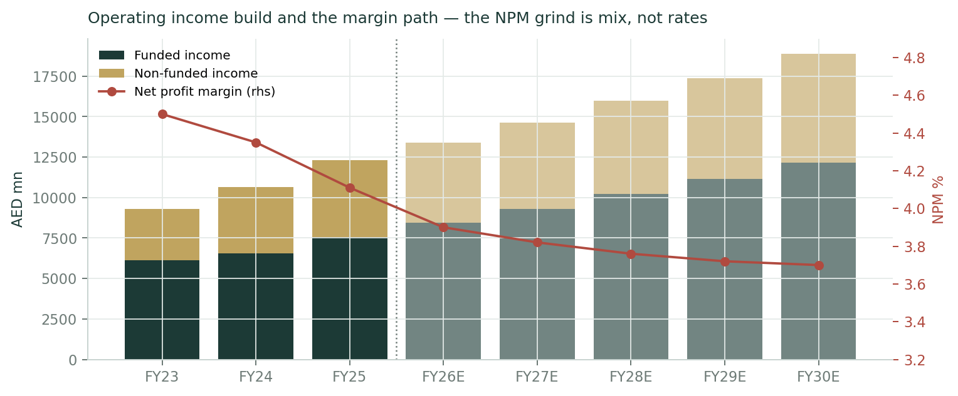
Figure 2 — The operating income build and the margin path. The net profit margin (right axis) grinds from 4.11% to 3.70% — but the driver is the mix shift toward government-related lending, not the rate cycle. The Fed is now expected to hold or hike, which cuts the other way.
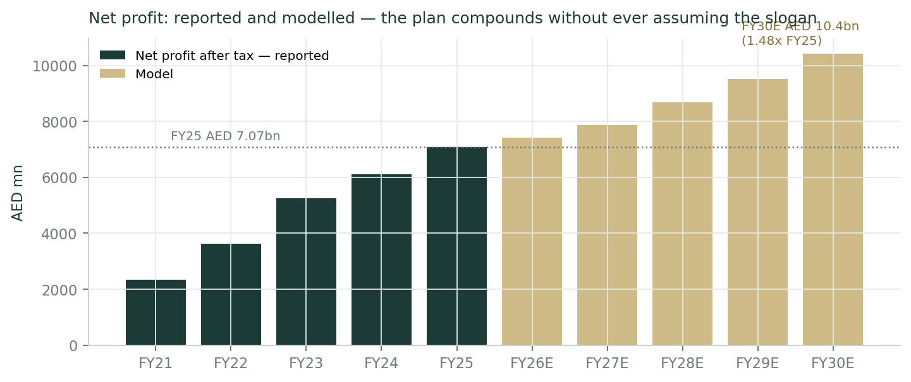
Figure 3 — Net profit, reported and modelled. ADIB reaches AED 10.4bn by FY30 — 1.48× the FY25 print — without the model ever assuming management's slogan. Compounding does the work.
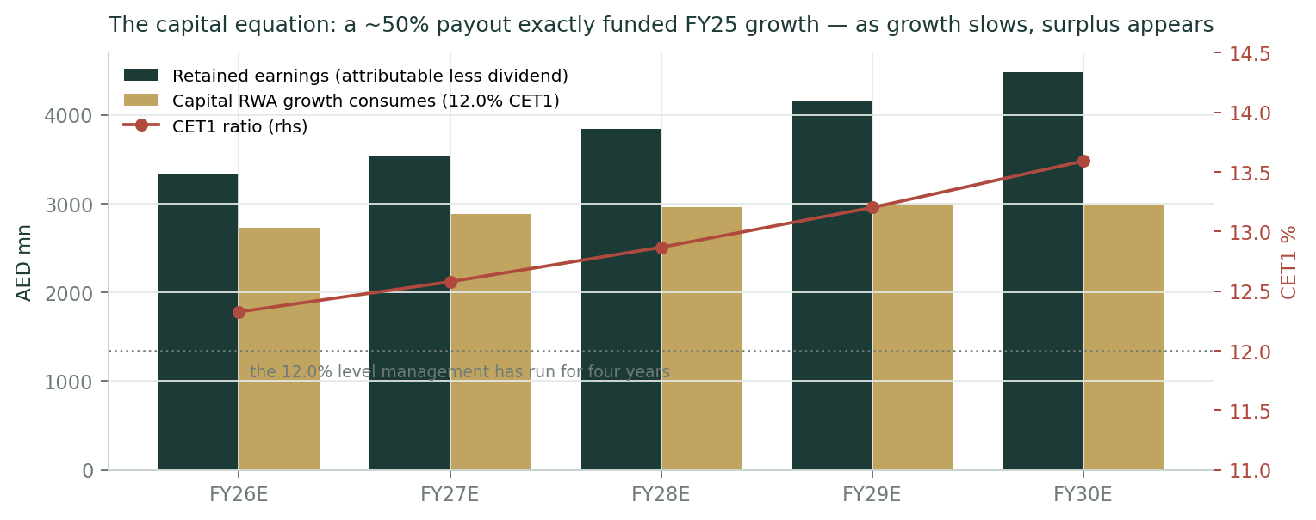
Figure 4 — The capital equation. In FY25 a ~50% payout EXACTLY funded 15% risk-weighted-asset growth at a flat 12% CET1: AED 2,816mn retained against AED 2,838mn consumed. As financing growth glides down, that equality breaks in the shareholder's favour and surplus capital appears — which is precisely why the equity DCF is worth more than the dividend model.
1.7 Synthesis — weights and the football field
Weights reflect how far each lens can be trusted for a bank of this kind. The dividend model leads because ADIB's payout is not a forecast but an observed five-year policy. Residual income earns real weight because it is the least terminal-dependent construction and reconciles to the DDM as an identity. The equity DCF is weighted lower not because it is wrong but because its extra value comes from surplus capital the board has not yet promised to distribute. The relative lens earns a full fifth because it is the only one anchored to prices the market is actually setting. And the normalized value keeps the whole set honest against a cyclical-earnings reading of a bank that has just had five extraordinary years.
Lens | Value (AED) | Weight | Contribution
Dividend discount model (primary) | 22.54 | 30% | 6.76
Residual income | 22.54 | 20% | 4.51
FCFE (equity DCF) | 23.48 | 15% | 3.52
Relative multiples (ROE-adjusted) | 17.94 | 20% | 3.59
Normalized (through-cycle) | 19.00 | 15% | 2.85
Weighted central |  |  | 21.23
Spot (03-Jul-2026) |  |  | 21.76

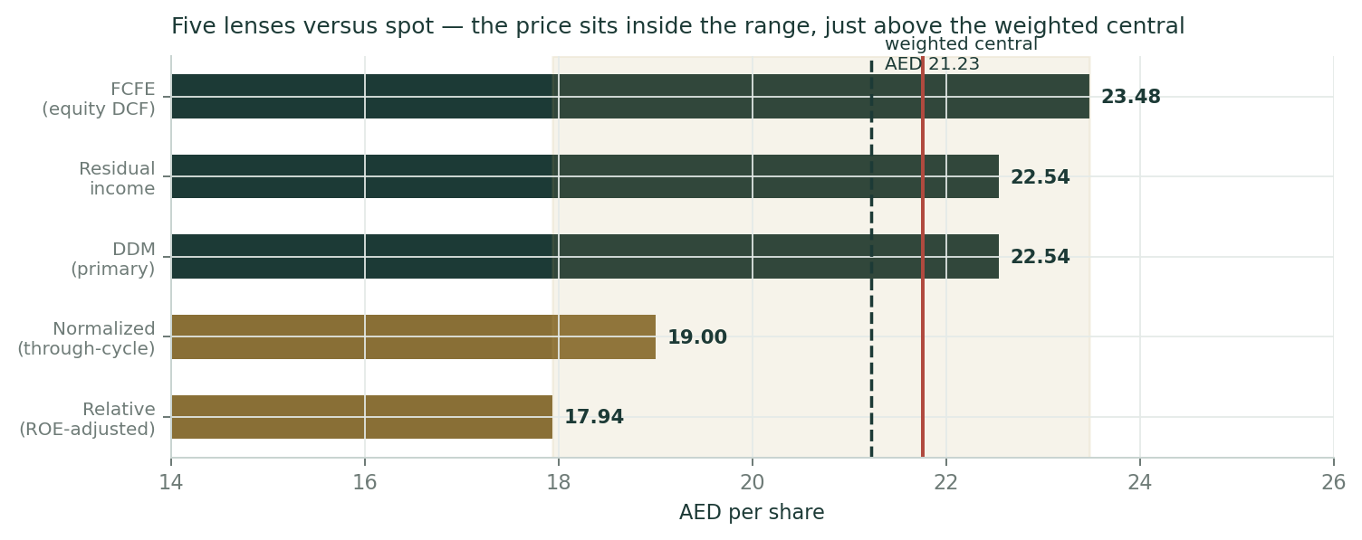
Figure 5 — Five lenses versus spot. The gold span is the full lens range; the dashed line is the weighted central (AED 21.23); the red line is the price. The price sits inside the range and just above the central — a bank that is neither mispriced nor a bargain.
A word about what the central is and is not, because it is the easiest number in this document to misuse. The two families do not overlap. The cash-flow family (AED 22.5–23.5) prices a bank that keeps earning a large spread over its cost of equity for a very long time. The market family (AED 17.9–19.0) prices what a buyer will actually pay for that spread today. Those are two different views of the world, not two estimates of one quantity, and averaging them does not produce a truth that sits between them. The RANGE is therefore the primary object of this section, and the football field above is how it should be read.
The weighted central of AED 21.23 is a probability-weighted summary across those regimes — a way of saying that both worlds are live and roughly how much weight each deserves. It is not a price target, it is not a rating, and it is not a price at which we expect ADIB to trade; this house publishes neither. Its only real job here is to be compared with the market price, and the comparison is deliberately undramatic: the central lands within 2.4% of spot, which is itself the finding. Two sanity checks on how little it depends on our choices. Swap the sector price-to-book mark for Alvarez & Marsal's 1.64× and the central moves to AED 21.33 — ten fils. And the three independent experts in Appendix C, running three different methods, land at AED 20.00, 18.03 and 20.71 — all of them BELOW it. If the central is engineering anything, it is engineering against itself.
1.8 The crux — how long does a 25% return on equity last?
Every bank study has one load-bearing tension. ADIB's is not credit, not capital and not the margin. It is durability. This is a bank earning 28.8% on equity in a market where the average is 18.3%, and the entire question is whether that gap is a moat or a moment.
The case that it is a moat is real and it is structural, not clever. Two-thirds of ADIB's deposits sit in current and savings accounts, which is the cheapest funding a bank can have and the hardest to replicate; that is why a 100bp benchmark cut cost it only 24bp of margin. Its book is still 55% retail, which is higher-yielding and stickier than wholesale. Its cost-to-income ratio has fallen from 40.7% to 28.6% in four years. And its legacy asset-quality problem — 8.9% non-performing in 2021 — is genuinely fixed, at 2.6% with 178% coverage.
The case that it is a moment is equally real. Return on equity is a ratio, and its denominator is compounding. ADIB retains half its earnings every year; on a 25%-plus return, that equity base grows at 12–13% a year, and the return must fall unless the bank can keep deploying at the same spread — which is exactly what the mix shift toward government-related lending suggests it cannot. Management's own 2030 target is about 25%, four points below where it is now. They are telling you the fade is coming.
Here is what the market is paying for it. The table below is the study in miniature.
What the price implies | Value
P/B on the latest reported book (Q1-26, AED 6.571) | 3.31x
P/B on the last audited FY book (Dec-25, AED 7.177) | 3.03x
Perpetual ROE the price implies at our Ke of 10.57% | 25.8%
Terminal ROE at which the DDM alone equals spot | 19.3%
Terminal ROE at which the five-lens central equals spot | 20.7%
ADIB FY25 actual ROE | 28.8%
ADIB management 2030 target | ~25%
UAE bank sector ROE | 18.3%

Read that carefully, because the two framings say different things and both are honest. On the simple steady-state arithmetic — the one-line justified price-to-book applied to today's book — the price implies ADIB earns 25.8% on equity forever, which is above management's own target and above anything any UAE peer earns. On the full two-stage model, which gives ADIB credit for the 22–24% it earns during the transition before fading, the price is matched at a terminal return of 19.3%. The difference between those two numbers — 25.8% versus 19.3% — is the value of the fade path, and it is worth several dirhams a share. Anyone who tells you a bank's value is "just" its justified P/B has not priced the transition.
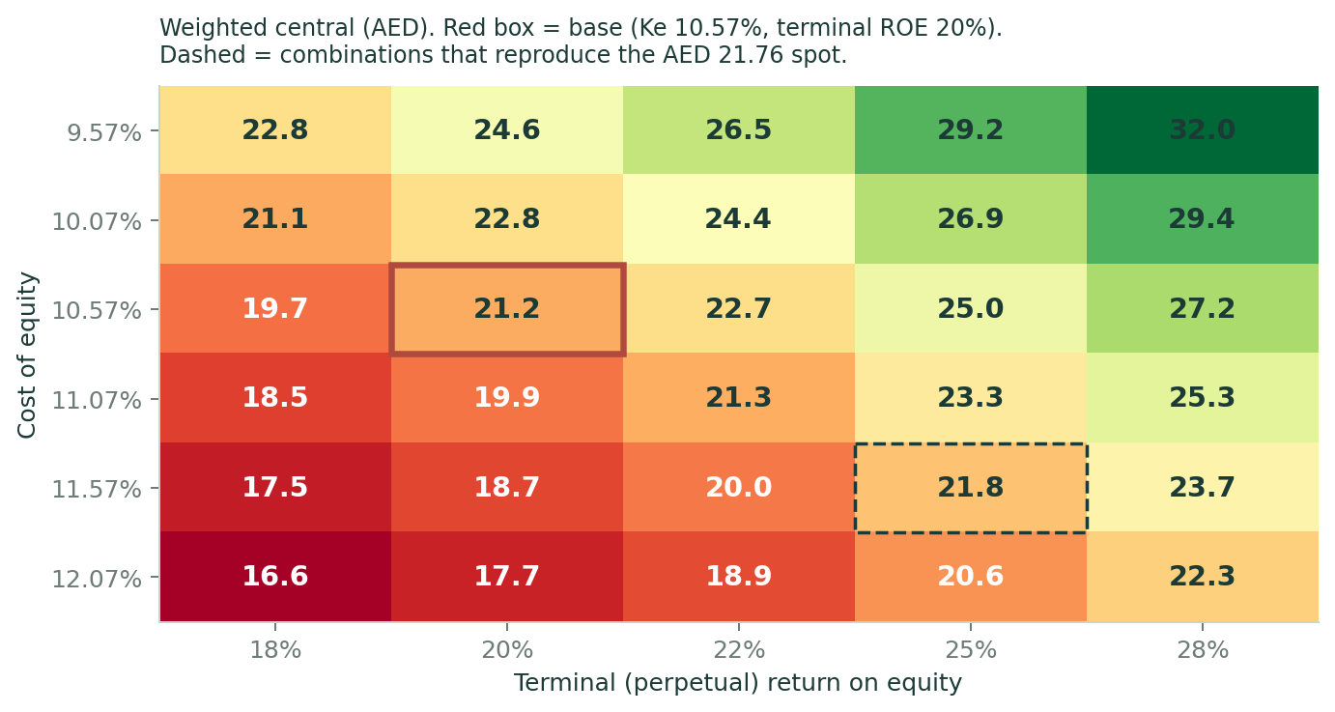
Figure 6 — The crux, mapped. The weighted central across cost of equity (rows) and terminal return on equity (columns). The red box is the base case. The dashed cells are the combinations that reproduce today's AED 21.76 price — and note how many of them there are. This is a stock whose price is consistent with a wide range of honest views, which is exactly why the distribution in §3 matters more than the point estimate here.
The second crux is the war premium, and it is worth almost as much. Strip the 1.0-point conflict adder from the cost of equity and the central rises to AED 24.63; harden it to 2.5 points — a renewed Hormuz closure — and it falls to AED 17.73. About AED 7 of value per share, a third of the price, is a pure geopolitics bet that neither management nor this model controls. And as §1.9 sets out, that bet moved against the holder in the week between the spot date and this publication.
1.9 Macro and regime — a strong economy inside a bad neighbourhood
The operating backdrop is a peculiar combination of excellent micro and dangerous macro. On ADIB's own numbers, the UAE grew 4.9% in real terms in 2025 and is expected to grow 5.3% in 2026, with inflation at 1.5–1.8% and government spending steady at about 26.5% of GDP. The central bank puts system credit growth at 17.9% and total banking assets at AED 5.34tn. Nothing in the domestic economy is broken; ADIB's 26% financing growth in 2025 was not an act of aggression, it was the market growing.
The neighbourhood is another matter. The 2026 Iran conflict closed the Strait of Hormuz for most of March to June — the largest oil supply disruption on record — and Brent traded above $126 at the end of April. A US–Iran memorandum of understanding on 17 June reopened the strait; Brent fell to $70.82 by 2 July. ADIB's own Q1 commentary is unusually candid about it: management describes "a more volatile backdrop", credits the central bank's "timely relief measures", and launched a support programme called Sanadna for front-line businesses. Impairments rose 50% year-on-year in that quarter.
And then, in the week between this study's spot date and its publication, the ceasefire frayed. Strikes resumed around 4–6 July; Brent has moved back to roughly $76; on 10 July the US President described the ceasefire as "effectively over", while saying negotiations remain open. The 60-day window under the June memorandum closes on 21 August. This matters for a specific, unglamorous reason: the AED 21.76 spot that anchors this entire study was set on 3 July, at the very bottom of the oil market's de-escalation optimism. The price may already have moved. We do not adjust the spot — the study is anchored where the data is anchored — but the reader should know that the 1.0-point conflict adder in our cost of equity is the low end of a live range, and that the 2.5-point row in §1.10 is a scenario, not a footnote.
The rate cycle cuts the other way, and in ADIB's favour. The Federal Reserve held at 3.50–3.75% for a fourth consecutive meeting in June, and its own projections now show nine of nineteen officials expecting at least one HIKE in 2026 — the cutting cycle that compressed UAE bank margins through 2025 appears to be over. Because the dirham is pegged, the CBUAE follows: the base rate is 3.65% and three-month EIBOR is around 3.90%. A bank with 67% of its deposits in current and savings accounts is the single biggest beneficiary of rates that stop falling. This is why the margin compression in our model is attributed to the financing mix and not to rates — and it is a genuine, if modest, upside risk to the FY27–30 path.
Finally, the sovereign. Abu Dhabi is rated Aa2 by Moody's with a 46bp credit-default swap spread — one of the strongest sovereigns in the world. That is what sets the equity risk premium at 4.87% on the rating basis and 4.93% on the CDS basis (both published; the central uses the rating basis). The risk-free rate of 4.70% is a constructed AED ten-year, built as the US Treasury yield plus the dirham-bond spread from the Ministry of Finance's May-2026 auctions, and it is flagged as an estimate: no live AED long curve is quotable. The house rule that a currency peg does NOT make the local and dollar curves equivalent is observed here, even though observing it costs us precision.
1.10 Sensitivity — the crux in the units that actually move it
Weighted central (AED) | g 3.0% | g 3.5% | g 4.0% | g 4.5%
Ke 9.57% | 22.70 | 23.59 | 24.63 | 25.87
Ke 10.07% | 21.23 | 21.95 | 22.79 | 23.77
Ke 10.57% | 19.95 | 20.55 | 21.23 | 22.02
Ke 11.07% | 18.84 | 19.33 | 19.90 | 20.54
Ke 11.57% | 17.86 | 18.27 | 18.74 | 19.27
Ke 12.07% | 16.98 | 17.33 | 17.73 | 18.17

Weighted central (AED) | Terminal ROE 18% | Terminal ROE 20% | Terminal ROE 22% | Terminal ROE 25% | Terminal ROE 28%
Ke 9.57% | 22.78 | 24.63 | 26.48 | 29.25 | 32.02
Ke 10.07% | 21.13 | 22.79 | 24.45 | 26.93 | 29.42
Ke 10.57% | 19.73 | 21.23 | 22.73 | 24.97 | 27.22
Ke 11.07% | 18.54 | 19.90 | 21.26 | 23.30 | 25.34
Ke 11.57% | 17.50 | 18.74 | 19.98 | 21.84 | 23.71
Ke 12.07% | 16.59 | 17.73 | 18.87 | 20.58 | 22.29

The second grid is the one that matters. Read across the Ke = 10.57% row: the answer moves from AED 19.73 to AED 27.22 purely on how long the return on equity lasts. No operating driver in this model has a tenth of that leverage.
The crux, in real units | Effect on the central
Terminal ROE 18% (the sector level, forever) | -1.50 → AED 19.73
Terminal ROE 25% (management's own 2030 target) | +3.74 → AED 24.97
Conflict adder 0pt — a signed peace (Ke 9.57%) | +3.40 → AED 24.63
Conflict adder 2.5pt — Hormuz re-closes (Ke 12.07%) | -3.50 → AED 17.73
Net profit margin ±10bp across the whole path | +0.21 / -0.21
Tax: no DMTT step at all (13% held) | +0.27
Tax: the full 15% UAE top-up lands (17.3% effective) | -0.12
Cost of risk +10bp across the path | -0.27
Financing growth −3pt across the path | -0.26
Cost-to-income held flat at the Q1-26 print of 29.6% | -0.17

Read that table and nothing else if you are short of time. Every operating driver — the margin, the cost of risk, the growth rate, even the tax step that Appendix B spends most of its space on — moves the answer by a few tens of fils. The terminal return on equity and the conflict premium move it by three to four dirhams each. ADIB's price is not a bet on next year's margin. It is a bet on how long a 25% return on equity lasts, and on whether the region calms down. Anyone who tells you otherwise is selling you a spreadsheet.
Beta sensitivity (beta was assumed, not regressed) | Ke | Weighted central (AED)
Beta 0.8 | 9.60% | 24.52
Beta 0.9 | 10.08% | 22.74
Beta 1.0 | 10.57% | 21.23
Beta 1.1 | 11.06% | 19.93
Beta 1.2 | 11.54% | 18.80
Beta 1.3 | 12.03% | 17.80

Both equity-risk-premium bases are carried: the rating basis gives a pre-adder Ke of 9.57% and the CDS basis 9.63%; the published central uses the rating basis plus the 1.0-point conflict adder = 10.57%. The full grids are live in the companion Excel and reprice from a single blue cell.
2. Technical and price structure
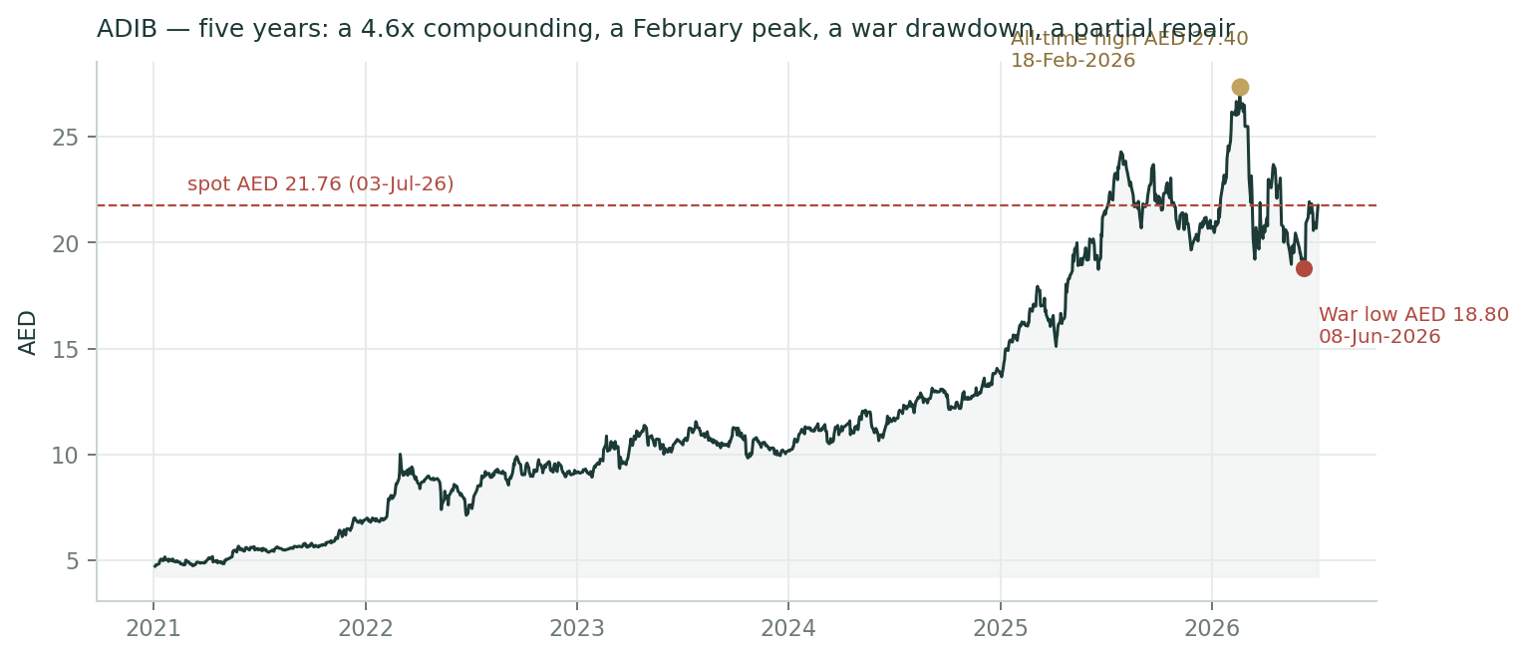
Figure 7 — Five years of ADIB. A 4.6× compounding, an all-time high of AED 27.40 on 18 February 2026, a war drawdown to AED 18.80 in mid-June, and a partial repair. The 03-July close of AED 21.76 — which anchors this entire study — was set on the de-escalation rally, three weeks off the low and still a fifth below the high.
The technical picture is one of a stock in repair, not a stock in a trend — and it is a notably different picture from the one the fundamentals paint. Price at AED 21.76 sits above the 20-day and 50-day moving averages (AED 20.71 and AED 20.75) but BELOW the 100-day and 200-day (AED 22.10 and AED 21.88). That is the signature of a stock that has bounced hard off a low but has not yet reclaimed its longer trend. It is 20.6% below its February all-time high and only 34% of the way up its 52-week range of AED 18.80–27.40.
RSI-14 at 59 is neutral — warm, with room. MACD (12, 26, 9) reads 0.263 / 0.179 / +0.084: the line is above zero and the histogram is positive, so momentum is building rather than fading. The one-year return is a flat +1.2% and the year-to-date is +4.8%; the five-year return is +363%. In other words, ADIB has spent the last twelve months going precisely nowhere after a spectacular four years — the profit kept compounding and the multiple did the work in reverse. That is what a de-rating looks like from the inside.
Indicator | Level | Read
MA20 / MA50 | 20.71 / 20.75 | Price above both — the near-term repair is real
MA100 / MA200 | 22.10 / 21.88 | Price BELOW both — the longer trend is not reclaimed
RSI-14 | 59 | Neutral-warm; room before the 70 line
MACD 12 26 9 | 0.263 / 0.179 / +0.084 | Above zero with a positive histogram — momentum building
52-week range | 18.80 – 27.40 | Spot 34% up the range
All-time high | 27.40 (18-Feb-2026) | -20.6% below
2026 low | 18.80 (war low, mid-June) | +15.7% off it

The technical read and the §1 valuation point in the same direction here — neither is shouting. A fundamental central within a few percent of spot and a chart in the middle of its range are a consistent pair. This is precisely the situation in which the discipline of §3 matters most: when the point estimate has nothing interesting to say, the distribution does.
3. Monte Carlo — the three-month distribution
The probability read comes first; the machinery follows. These five rows are the only genuinely three-month statements in this study.
The probability read (T+60 trading days ≈ 3 months)
P(price above spot AED 21.76) | 50%
P(+10% or better) vs P(−10% or worse) | 24% vs 23% (odds 1.07×)
Median path | AED 21.73 (-0.1%)
Central 50% of outcomes (25th–75th) | AED 19.81 – 23.84 (19% of spot)
Touch probability: ±10% at any point within the horizon | 44% up · 41% down

Lens independence, and an explained flat. The Monte Carlo drift never sees §1. Its centre is pure carry: ln(1 + rf 3.90%) − ln(1 + dividend yield 4.46%), which over sixty trading days is -0.20%. For this dividend-payer the carry is a hair NEGATIVE in price terms, and that is not a bug — it is the arithmetic of a bank whose dividend yield exceeds the risk-free rate. The expected total return is approximately the risk-free rate, delivered as dividend rather than as price drift; the price median is therefore approximately flat, ± the band. That is an explained flat, not an unexplained one. No momentum or trend signal is used, because none tested reliably on the UAE panel. And the AED 0.53 value gap from §1 lives in §1 only — if it closes, it closes as a surprise to this distribution, not from inside it.
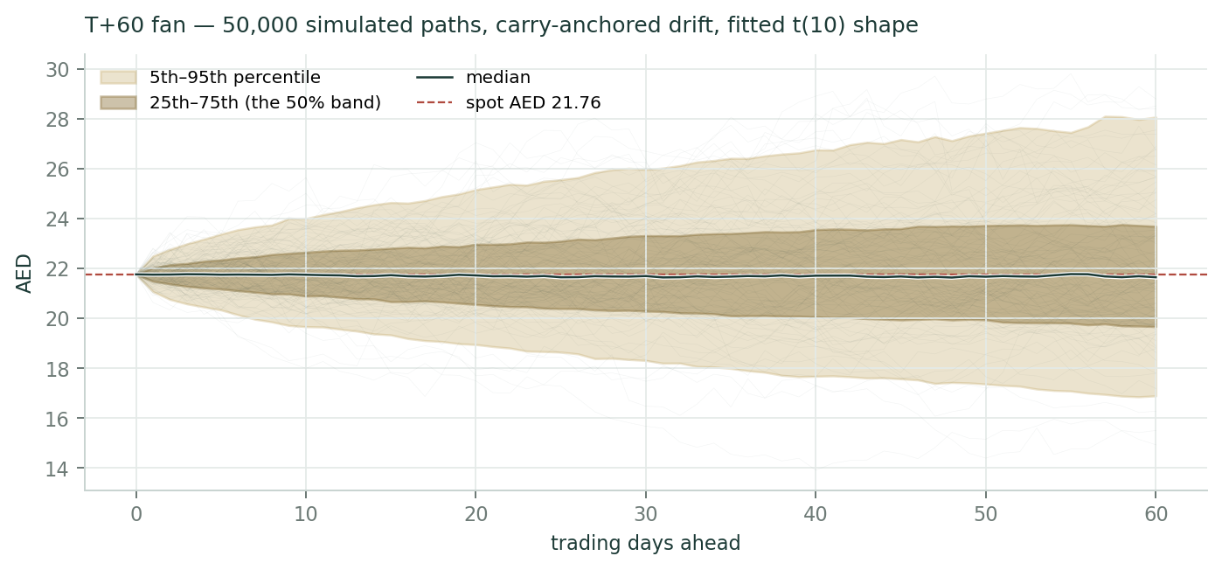
Figure 8 — T+60 fan: 50,000 simulated price paths. The gold band spans the 5th to 95th percentile, the brass the 25th to 75th, and the white line is the median. Lead with the brass band, not the gold one: the 50% band (AED 19.81–23.84) is the honest quarter-ahead statement, and the tails are the tails.
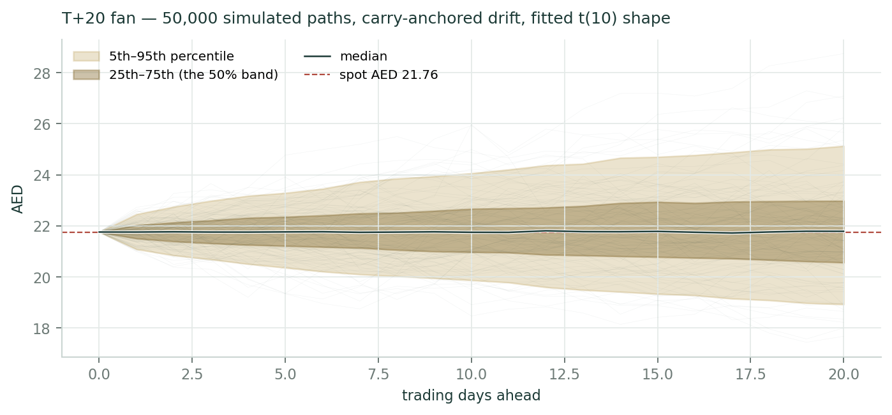
Figure 9 — T+20 fan (≈ one month): the near-term cohort the Calibration Ledger will grade first, on 3 August 2026. Width divides by roughly √3 against the T+60.
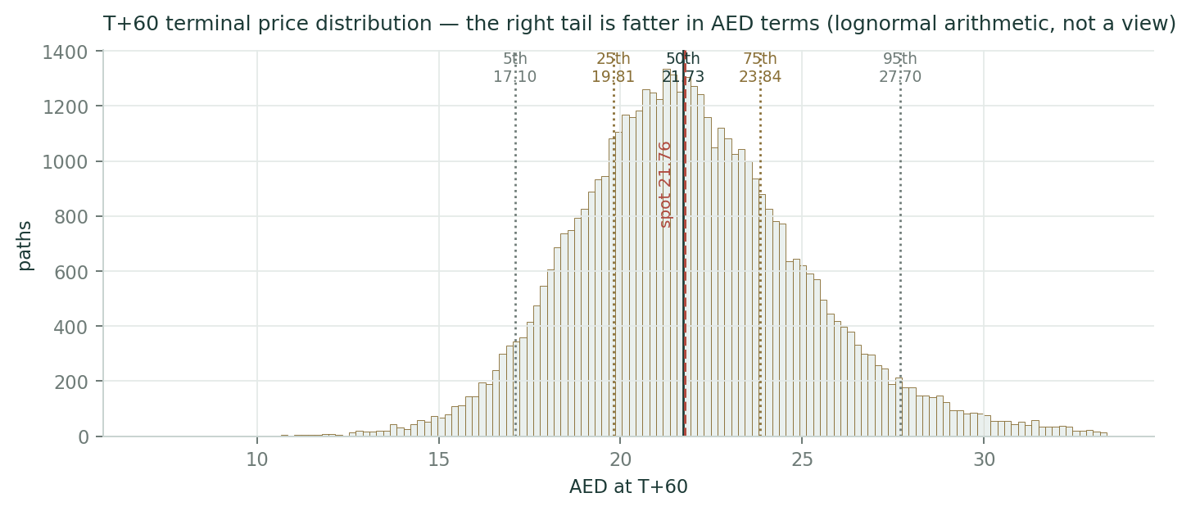
Figure 10 — The T+60 terminal distribution with percentile markers; spot dashed in red. The right tail is fatter in dirham terms than the left — that is the arithmetic of lognormality, not a directional view.
Percentile | T+20 (AED) | T+60 (AED)
5th | 18.91 | 17.10
25th | 20.61 | 19.81
50th (median) | 21.74 | 21.73
75th | 22.95 | 23.84
95th | 24.95 | 27.70
Touch +10% / −10% within the horizon | 20% / 16% | 44% / 41%

3.1 Engine and calibration — the backtest in the open
The engine models daily volatility with a gap-aware Yang-Zhang estimator fed into a heterogeneous-autoregressive forecast, draws its shocks from a fat-tailed Student-t distribution so that crash risk is respected rather than assumed away, and centres the paths on carry alone. 50,000 paths, seed 42. Two things about that sentence deserve emphasis, because they are what makes the number below worth anything.
First, we do not choose the shape or the width. The tail parameter (ν = 10) and the width calibration (1.049) are FITTED — by maximum likelihood, on a pooled panel of fourteen UAE names and 237 windows, with leave-one-name-out cross-fitting — and they are read live from the engine registry at build time rather than typed in from memory. That registry was itself re-fitted on the morning of this study, which is exactly the point of holding it in one place: a stock added to the library re-fits its whole market, and no study can quietly run on a stale cone. The anchor volatility that comes out for ADIB is 30.7% annualized.
Second, the price series is cleaned before it is trusted. A mandatory data-quality gate runs first. Its threshold is not a guess: the ADX daily price limit is ±15%, so a single session cannot move further than that by trading — anything beyond can only be a corporate action or a data error. ADIB's series came back clean of corporate-action artefacts (largest one-day move 10.5%, well inside the limit) at 248 rows a year against an ADX calendar of about 250, so no phantom rows. The gate did remove two stale no-trade rows — sessions with an identical open, high, low and close and no volume — which would otherwise have flattened the intraday range and biased the volatility estimate DOWN. Small, but it is the kind of thing that is only small when you check.
Then we test it — on ADIB's own history, walking forward, using only data available at each origin, and scoring the realized close against the distribution the model would have produced. The benchmark is a carry-anchored random walk on trailing volatility: the same centre on both sides, so the score measures the shape and the width and can never harvest the time value of money. The score is scale-normalized (CRPS divided by that window's spot) because CRPS is denominated in price — pooling it raw would weight a stock that quadrupled by its late windows, and weight a panel by share price rather than by information.
Five-year backtest — walk-forward, 60-day horizon, non-overlapping
Windows (post-2022 break) | 14
CRPS skill vs the carry-anchored random walk (the gate) | +0.0093
Pinball-0.50 skill (median placement) | +0.0024
Winkler-90 interval skill | -0.1093
Coverage 50 / 80 / 90 (nominal: 0.50 / 0.80 / 0.90) | 0.43 / 0.79 / 1.00
PIT mean (nominal: 0.50) | 0.618
Bootstrap CI — window-block 2 / 3 / 4 | [-0.014, +0.030] · [-0.017, +0.032] · [-0.017, +0.032]
Robust name-level verdict (all block sizes agree) | PARITY
THE STANDING GATE — 14-name UAE market panel | PARITY · skill +0.0049 · CI [-0.004, +0.015]

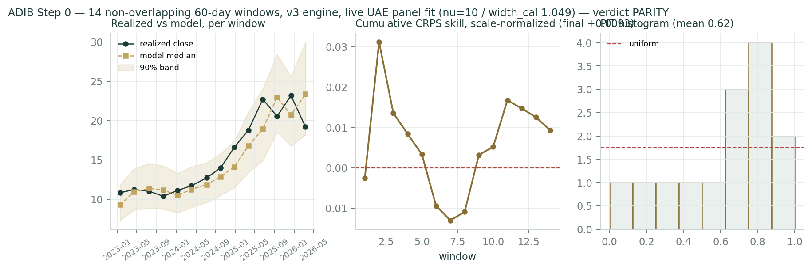
Figure 11 — Calibration, three panels: realized close versus model median at each window; cumulative CRPS skill; and the PIT histogram. Note where the PIT mass sits — in the upper deciles.
PARITY means exactly what it says, and it is worth being precise, because it would be easy to dress this up as either better or worse than it is. The distribution is honestly calibrated. The CRPS skill is POSITIVE at +0.0093; coverage at the 80% band is 0.79 against a 0.80 target, which is as close as fourteen observations can get; every realized close fell inside the 90% band. But the confidence interval spans zero at every block-resampling scheme we tried — with fourteen windows it was always going to — so no single-name forecasting EDGE has been demonstrated. The distribution is validated on the fourteen-name UAE panel, which is the standing gate, and that panel is itself PARITY (+0.0049, CI [-0.004, +0.015]). ADIB publishes under the honest tier.
Two diagnostics point the other way and we are not going to hide them. The Winkler interval score is -0.109 — WORSE than the naive benchmark. That is not a contradiction of the positive CRPS; it is a specific, known thing. CRPS scores the whole distribution, while Winkler scores only the 90% interval and penalises width. Our cone is fitted to a fourteen-name market, and ADIB's own volatility sits below that panel's average — its own leave-one-out fit would be ν = 12 with a width of 1.035 against the market's 10 and 1.049. So the band it inherits is slightly too wide for it, which CRPS forgives and Winkler punishes. The fix — a name-level width calibration shrunk toward the market fit — is the single largest open item on this engine's own list, and it is not in production because it has not yet survived the same out-of-sample test the forecasts have to survive. Until it does, the honest thing is to publish the wider band and say why.
The second diagnostic is the PIT mean of 0.62. Above 0.5 means realized prices kept landing in the upper part of the predicted distribution — the model consistently UNDER-called ADIB's rise and never over-called it. That is exactly what a carry-anchored engine should do to a stock that quadrupled: it refuses to extrapolate a secular trend, and it pays for that refusal in a rising market. We keep the refusal. The alternative — a drift term fitted to a stock's own past — sits on this house's do-not-revive list precisely because it feels clever right up until the trend ends. The T+20 and T+60 cohorts registered today (grading 3 August and 30 September 2026) now carry that record into live, out-of-sample territory, where it can be confirmed or corrected in public.
4. What would change our mind
- Falsifier 1 — ADIB's H1-2026 results, due in the second half of July — within a fortnight of this study — printing a net profit margin below 3.80% or a cost of risk above 60bp. That breaks the FY26 driver set immediately; the central falls by roughly AED 0.5–1.0.
- Falsifier 2 — ADIB disclosing its Pillar Two position — and it holding indefinitely. Two things now argue the tax step is coming: the transitional safe harbour expires for years beginning after 31 December 2026, and Dubai Islamic Bank is ALREADY paying the 15% floor (its rate went from 9% to 15% in FY2025). If ADIB nonetheless holds at 13%, the central rises by about AED 0.27; if the full top-up lands with no substance relief, it falls by about AED 0.12. Either way the largest single unknown in the model closes, and the FY2025 audited tax note is where to look.
- Falsifier 3 — A renewed Hormuz closure or a direct strike on UAE territory. The 1.0-point conflict adder is a ceasefire-holding assumption, and the ceasefire is already fraying. At 2.5 points the central falls to AED 17.73 — the §1.10 row is the honest map, not a tail footnote.
- Falsifier 4 — Two consecutive quarters of return on equity printing below 25%, without a matching balance-sheet surge to explain it. That is the fade arriving early, and the terminal-ROE assumption — the load-bearing beam of the whole valuation — would have to come down. At an 18% terminal the central is AED 19.73.
- Falsifier 5 — A UAE credit-cycle turn: the non-performing ratio rising for two straight quarters off its 2.6% low, or Stage-2 exposures building. The book grew 28% year-on-year and is therefore unseasoned; Expert 2 in Appendix C prices exactly this, and gets a materially lower number.
- Falsifier 6 — The pleasant failure mode: the UAE sector re-rating above 1.8× book while ADIB merely tracks it. The relative lens converges upward on the cash-flow lenses, the value gap closes, and ADIB has done nothing at all to earn it.
5. How to use this study
Read the central as a probability-weighted anchor, not a target. If you need a three-month view, use §3 and nothing else. If you disagree with an input — and on the terminal return on equity you very reasonably might — the companion Excel reprices the entire study from one blue cell. That is the point of it. And grade us: every forecast in this document is registered on the public Calibration Ledger with a maturity date, and the graded record, including the failures, is the product.
6. Coverage and ledger integration
ADIB joins Testahil's UAE coverage alongside its ADX and DFM peers. Two forecast cohorts are registered today — one maturing on 3 August 2026, one on 30 September 2026 — each recorded with its full set of percentiles, its anchor volatility, the carry inputs used, and the fitted shape and width the cone was built on, so that it can be graded after the fact against exactly the benchmark it was scored against here. Grade dates are computed in trading sessions on the ADX calendar, not in calendar days. When a cohort matures it is scored, its windows are appended to the UAE panel on which the market calibration is estimated, and a fresh forecast is issued in its place. The graded record, published openly, is the exercise.
The same discipline has to apply to the fundamentals, and on an initiation it is easy for it not to. Our house rule requires a forecast-versus-actual scorecard on every quarterly update — but on a first study there is no prior forecast to score, and that is precisely how an accountability mechanism quietly dies. So the FY26 estimates are FROZEN below, with the dates on which they become testable. The first test is a fortnight away.
FY2026E — frozen at publication | Our estimate | First testable print
Net profit margin | 3.90% | H1-2026 results, late July 2026
Cost-to-income ratio | 29.4% | H1-2026 results, late July 2026
Cost of risk (ADIB's stated basis) | ~0.50% | H1-2026 results, late July 2026
Effective tax rate | 13.0% | H1-2026 results, late July 2026
Gross financing growth | 13% | FY2026 results, January 2027
EPS (AED) | 1.836 | FY2026 results, January 2027
DPS (AED) | 0.918 | FY2026 board proposal, January 2027
Return on equity | 24.0% | FY2026 results, January 2027
Profit after tax (AED mn) | 7,428 | FY2026 results, January 2027

This is the fundamental analogue of the Calibration Ledger. The next update on ADIB opens by scoring this table — including, and especially, the rows we got wrong.
7. The one-paragraph version
ADIB is the most profitable bank in the UAE — a 28.8% return on equity against a sector at 18.3%, built on deposits that are two-thirds free and a book that is still half retail — and it has just doubled in five years while fixing a legacy bad-loan problem. It is also priced for all of that: 3.31 times book against a sector at 1.55, a premium that its return justifies to 2.69× and no further. Five lenses put fair value at AED 17.9–23.5 with a weighted central of AED 21.23, which is 2.4% below the 3 July close. At our cost of equity the price implies a 25.8% return on equity in perpetuity — better than management's own 2030 target. The three-month distribution is essentially balanced (P(above spot) 50%, median -0.1%), and the two things that would move this stock materially — how long the 25% return lasts, and whether the Strait of Hormuz stays open — are neither of them on ADIB's balance sheet.

Appendix A — Financials (3 years reported + 5 years modelled)
AED mn unless noted. FY2023, FY2024 and FY2025 are taken verbatim from ADIB's own Management Discussion & Analysis for those years; the Q1-2026 column is the latest reported actual. No aggregator was used for any line. The forecast columns follow the driver build in §1.6 and are formulas, not estimates typed over the top.
A.1 Income statement
Income statement | FY23 | FY24 | FY25 | FY26E | FY27E | FY28E | FY29E | FY30E
Funded income | 6,122 | 6,566 | 7,553 | 8,441 | 9,302 | 10,206 | 11,155 | 12,147
Non-funded income | 3,172 | 4,066 | 4,751 | 4,941 | 5,336 | 5,763 | 6,224 | 6,722
Total operating income | 9,294 | 10,632 | 12,304 | 13,382 | 14,638 | 15,970 | 17,380 | 18,869
Operating expenses | -3,061 | -3,145 | -3,525 | -3,934 | -4,245 | -4,551 | -4,866 | -5,189
Impairment charge | -760 | -620 | -678 | -909 | -1,023 | -1,090 | -1,177 | -1,259
Profit before tax | 5,472 | 6,868 | 8,101 | 8,538 | 9,371 | 10,328 | 11,336 | 12,421
Tax | -221 | -766 | -1,031 | -1,110 | -1,499 | -1,652 | -1,814 | -1,987
Profit after tax | 5,251 | 6,101 | 7,070 | 7,428 | 7,871 | 8,675 | 9,522 | 10,434
EPS (AED) | 1.284 | 1.490 | 1.746 | 1.836 | 1.949 | 2.161 | 2.384 | 2.623
DPS (AED) | 0.715 | 0.834 | 0.971 | 0.918 | 0.975 | 1.102 | 1.240 | 1.390

FY23 is stated before zakat and tax of AED 221mn (the UAE corporate tax regime had not yet applied to ADIB's domestic profits); the tax line steps to AED 766mn in FY24 and AED 1,031mn in FY25 as the 9% regime phases in. EPS is on 3,632.0mn shares throughout — ADIB has not issued a share since FY22, so history and forecast are directly comparable.
A.2 Balance sheet and capital
Balance sheet & capital | FY23 | FY24 | FY25 | Q1-26 | FY26E | FY28E | FY30E
Total assets | 192,827 | 225,910 | 280,753 | 287,065 | 317,497 | 394,712 | 473,260
Gross customer financing | 120,169 | 147,100 | 185,600 | 198,000 | 209,728 | 260,734 | 312,620
Customer deposits | 157,067 | 182,675 | 229,096 | 239,335 | 259,079 | 322,088 | 386,183
Common equity (ordinary) | 20,374 | 22,591 | 26,067 | 23,865 | 29,402 | 36,787 | 45,422
Tier 1 sukuk (AT1) | 4,754 | 4,754 | 4,754 | 4,754 | 4,754 | 4,754 | 4,754
Risk-weighted assets | 138,211 | 159,983 | 183,637 | 193,748 | 206,355 | 255,068 | 305,017
CET1 % | 12.23 | 12.07 | 12.02 | 12.0 | 12.33 | 12.87 | 13.59
Capital adequacy ratio % | 16.80 | 16.21 | 15.71 | 15.5 | — | — | —
NPA ratio % | 6.1 | 4.0 | 2.8 | 2.6 | — | — | —
NPA coverage incl. collateral % | 139.5 | 157.4 | 172.5 | 178.3 | — | — | —
BVPS (AED) | 5.610 | 6.220 | 7.177 | 6.571 | 8.10 | 10.13 | 12.51

Forecast total assets and deposits are held at their FY25 ratios to net financing — presentation scaffolding, not drivers. Nothing in the valuation depends on them. The lines that DO drive value — financing, risk-weighted assets, common equity and CET1 — are all built from the assumptions in §1.6. Note the December-25 common equity of AED 26,067mn still contains the AED 3,525mn dividend proposed then and paid after the 4 March 2026 AGM; the Q1-26 figure of AED 23,865mn is after that payment. Both P/B framings are carried throughout this study.
A.3 Cash flow to the ordinary shareholder
AED mn | FY26E | FY27E | FY28E | FY29E | FY30E
Profit after tax | 7,428 | 7,871 | 8,675 | 9,522 | 10,434
less: AT1 sukuk coupon | -353 | -353 | -353 | -353 | -353
less: non-controlling interests | -406 | -439 | -474 | -512 | -552
Attributable to ordinary shareholders | 6,669 | 7,080 | 7,849 | 8,658 | 9,528
less: equity retained for RWA growth | -2,726 | -2,881 | -2,965 | -3,004 | -2,990
Free cash flow to equity | 3,943 | 4,199 | 4,884 | 5,654 | 6,538
Dividend declared | -3,335 | -3,540 | -4,003 | -4,502 | -5,050
Surplus capital generated | 608 | 659 | 881 | 1,152 | 1,488

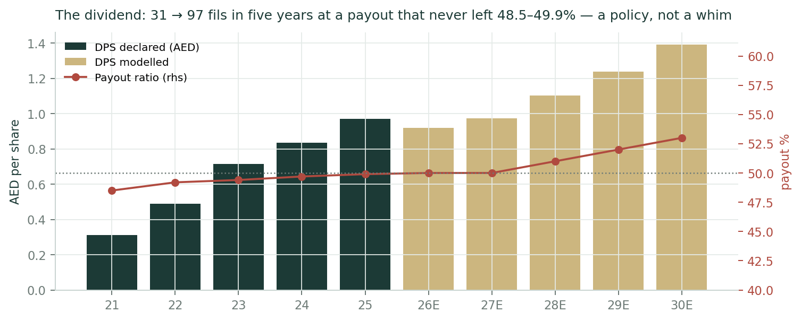
Figure 12 — The dividend. From 31.1 fils to 97.05 in five years, at a payout that never left the 48.5–49.9% band. The forecast lets it drift to 53% by FY30 — not because the board has said so, but because the capital equation frees the cash as growth slows. Cumulative FY26–30 modelled dividends are AED 20.9bn.

Appendix B — Peers, sector, risks, and the research register
B.1 Peer set
Bank | Latest sourced print | Read against ADIB
Dubai Islamic Bank (DFM: DIB) | FY25 revenue AED 13.3bn (+3%), pre-tax AED 9.0bn (+20%), assets AED 416bn (+21%); EPS 0.98; DPS 0.35. Net profit margin 2.6% ACTUAL in FY25, guided down to 2.3% for 2026 by the Group CEO on the FY25 results call — a guide that explicitly assumes three more Fed cuts. Also guided: financing +10%, cost of risk ~50bp. Effective tax rate went from 9% (2024) to 15% (2025). No fixed dividend policy. | The only true like-for-like. ADIB's 4.11% margin is 151bp above DIB's 2.6% on the identical metric — both banks define it as net financing income over average profit-bearing assets. And DIB's 2.3% guide rests on rate cuts the June-2026 dot plot no longer supports, which makes ADIB's CASA defence look MORE structural, not less. DIB is also already paying the 15% minimum tax — the single strongest piece of evidence that ADIB's own step is coming.
Abu Dhabi Commercial Bank (ADX: ADCB) | FY25 net profit AED 11.4bn (+22%); Q1-26 RoAE 16.3%; CET1 13.82%; DPS 0.63 (44% payout). Testahil study of 10-Jul-2026: trading at 1.52× book. | The conventional Abu Dhabi comparator. Bigger, cheaper, and earns twelve points less on equity. It sits almost exactly ON the ROE-justified line in Figure 1. ADIB sits above it.
First Abu Dhabi Bank (ADX: FAB) | The largest UAE bank. Q1-26 net income AED 4.75bn, EPS 0.43 (a beat). FY25 payout ~43%. | The sector ceiling on scale — but not on returns.
Emirates NBD (DFM: ENBD) | Dubai flagship. Q1-26 net interest margin 3.37%, down 19bp quarter-on-quarter. | The most rate-sensitive of the large peers. ADIB's 67% CASA is the structural defence ENBD does not have.
UAE bank sector (top-10 listed) | FY25: NIM 2.48% (−19bp), RoE 18.3% (−63bp), RoA 2.0%, NPL 2.4%, cost of risk 0.47%; 8.8× P/E and 1.64× P/TBV. Q1-26 sector NIM 2.37%. | ADIB's 4.11% net profit margin is 163bp above the sector's NIM, and its 28.8% return on equity is 10.5 points above. That gap is the entire investment case — and the entire risk.

Company figures from each bank's own results releases and earnings calls. Sector aggregates from the Alvarez & Marsal UAE Banking Pulse, built from the same public filings. Prices and multiples are market data. On the two sector marks: §1.4 uses 1.55× price-to-book (the large-cap band as at 10 July 2026, i.e. at current post-war prices) as primary and carries A&M's 1.64× price-to-tangible-book (an FY2025 mark, at FY2025 prices) all the way through to a second value rather than a footnote. The two answers differ by about ten fils on the central. ADIB has negligible intangibles, so the gap between the marks is a price-DATE difference, not a tangibility one.
B.2 Risk table
Risk | Channel | How the model treats it
The ROE fades faster than modelled | Terminal ROE; the entire multiple | THE crux. Terminal 20% vs 28.8% actual and ~25% target. §1.10 maps 18%→28%: AED 19.73 to AED 24.97.
Regional conflict re-escalation | Cost of equity; impairment overlays; sentiment | 1.0pt Ke adder. §1.10 maps 0↔2.5pt: AED 24.63 to AED 17.73. The ceasefire frayed on ~10 July.
The DMTT top-up lands | Net profit −4–5% | Stepped to 16% from FY27 — now EVIDENCED, not merely cautious: the transitional safe harbour expires for years beginning after 31-Dec-2026, and DIB is already paying 15%. Sensitized 13%↔17.3%. ADIB still has not disclosed its position.
Margin compression beyond the mix | Net profit margin | FY30 at 3.70% vs 4.11% actual. ±10bp ≈ ±AED 0.21. The Fed's hold-or-hike turn is an upside risk here, not a downside one.
Credit-cycle turn on an unseasoned book | Cost of risk; book value | Cost of risk modelled ABOVE the FY25 print. The book grew 28% year-on-year — Expert 2 in Appendix C prices exactly this and gets AED 18.03.
Concentration in Abu Dhabi GREs | Single-obligor and sovereign nexus | Qualitative. GRE financing went from 24% to 26% of the book in one quarter — it is the margin drag AND the credit comfort, and it cuts both ways.
Execution on the 2030 plan | Multiple de-rating on a miss | The model lands assets at 1.68× FY25 by 2030 — below management's own 1.7–1.9× target. We take the machinery, not the optimism.

B.3 Research register — what was checked before a single forecast was set
This table is a transparency device. Before setting any forecast assumption we work outward from the world to the company — the global rate and oil backdrop, the UAE macro and regulatory picture, the competitive landscape, and finally ADIB's own disclosures — and record what we found. Crucially, it also records the searches that came back empty. A line marked as a negative finding means we looked for something — a hidden one-off, a tax note, an undisclosed capital action — and confirmed it was not there. The purpose is to let a reader audit the inputs, not just the outputs: you can see the full set of factors considered, judge whether anything material was missed, and see exactly which source each fact came from. Coverage is measured by categories closed, never by the number of searches run — and silence closes nothing.
# | Ring / category | Class | What we found (with source and date)
F01 | Global — rate cycle & USD/FX regime | S | FOMC held 3.50–3.75% for a fourth meeting on 17-Jun-2026; the June dot plot REMOVED prior cut expectations and 9 of 19 officials now project at least one HIKE in 2026 (median year-end ~3.8%). The AED is pegged, so CBUAE tracks the Fed: Base Rate 3.65%, 3M EIBOR ~3.90%. [Federal Reserve; CBUAE fixings (official), 2026-07-08]
F02 | Global — commodity complex | S | 2026 Iran war: Hormuz effectively closed from 28-Feb; Brent peaked above $126 on 30-Apr; a 17-Jun US–Iran MoU reopened the strait; Brent fell to $70.82 on 2-Jul. But the ceasefire FRAYED — renewed strikes around 4–6 Jul, Brent back to ~$76 by 10-Jul, and the US President described the ceasefire as "effectively over". The 60-day negotiation window runs to 21-Aug-2026. [EIA; Trading Economics; wire reports, 2026-07-10]
F03 | Global — global sector demand | C | Global bank NIMs compressing as easing cycles mature; Basel III fully implemented in the UAE via CBUAE; capital conservation buffer held at 2.5% for 2026 with a NEW 0.5% countercyclical buffer on UAE private-sector credit from 2026. [CBUAE; ADIB Pillar III Q1-2026 (official), 2026-06-30]
F04 | Global — trade / sanctions / supply chains | C | Hormuz traffic recovering but still well below the ~130 daily pre-war crossings; UAE exports back to ~85% of pre-war volumes and UAE crude production at a record high. [IEA; Kpler via wire reports, 2026-07-07]
F05 | Country — sovereign macro | S | ADIB's own macro deck: UAE real GDP +3.9% (2024), +4.9% (2025), +5.3% (2026e); inflation 1.7 / 1.5 / 1.8%; Brent $81 / $68 / $66; government spending 26.6 / 26.7 / 26.5% of GDP. CBUAE separately puts 2025 real GDP at 5.6% and system credit growth at +17.9%. [ADIB FY25 earnings presentation, Outlook (official); CBUAE, 2026-01-22]
F06 | Country — regulatory environment | S | UAE corporate tax 9%; the Domestic Minimum Top-up Tax (15% floor, Cabinet Decision 142/2024) has applied to in-scope MNE groups for financial years starting on/after 1-Jan-2025. ADIB is in scope (revenue AED 12.3bn; subsidiaries in Egypt, UK, Qatar, Iraq). Yet ADIB's ETR was 12.7% in FY25 and 12.9% in Q1-26 — i.e. NO observable top-up in two DMTT-period prints. [UAE Ministry of Finance (official); ADIB FY25 + Q1-26 MD&A (official), 2026-04-29]
F28 | Country — regulatory environment | S | THE MECHANISM — AND IT HAS A DATE. Pillar Two's transitional CbCR safe harbour lets a group skip the full GloBE computation only if its simplified jurisdictional effective tax rate clears a threshold that RISES every year: 15% for FY2024, 16% for FY2025, 17% for FY2026. And the safe harbour is available only for fiscal years COMMENCING ON OR BEFORE 31-Dec-2026 — so for a calendar-year filer the last sheltered year is FY2026, and the full computation applies from FY2027. [OECD Pillar Two administrative guidance; PwC and KPMG IAS 12 technical notes, 2026-07-11]
F29 | Industry — competitive structure (named) | S | PEER EVIDENCE THAT THE REGIME BITES. Dubai Islamic Bank — the closest comparable UAE Islamic bank — told its FY2025 results call that its effective tax rate rose from 9% (2024) to 15% (2025), "affecting net profit comparisons", printing at 14.1-15%, and that it is working to bring it back toward 9% during 2026. [DIB FY2025 earnings call, Group CEO (Feb-2026), 2026-02-19]
F07 | Country — fiscal / political events | S | CBUAE deployed relief measures during the conflict; ADIB launched "Sanadna", a support programme for front-liners and SMEs, and management flagged a "more volatile backdrop". Abu Dhabi is rated Aa2 (Moody's) / AA (S&P) / AA (Fitch), all stable; sovereign CDS 0.46%. [ADIB Q1-2026 MD&A (official); Damodaran ctryprem.html, 5-Jan-2026, 2026-04-29]
F08 | Industry — demand & capacity | C | UAE banking system assets AED 5.34tn end-2025 (+17.1%); loans +17.9%; deposits +16.2%; system CAR 17.1%; net NPL 1.6%. Islamic banks hold ~18% of sector assets, with a national strategy to more than double Islamic assets by 2031. [CBUAE (official), 2026-03-31]
F09 | Industry — pricing | S | UAE top-10 listed banks FY25: NIM 2.48% (−19bp YoY), RoE 18.3% (−63bp), RoA 2.0%, NPL 2.4%, CoR 0.47%; trading at 8.8x P/E and 1.64x P/TBV. Q1-26 sector NIM fell further to 2.37%. [Alvarez & Marsal UAE Banking Pulse (built from public filings), 2026-03-23]
F10 | Industry — competitive structure (named) | S | Dubai Islamic Bank (the only true like-for-like): FY25 revenue AED 13.3bn (+3%), pre-tax AED 9.0bn (+20%), assets AED 416bn (+21%), EPS 0.98, DPS 0.35. NET PROFIT MARGIN: 2.6% ACTUAL in FY25, guided DOWN to 2.3% for 2026 by the Group CEO on the FY25 results call — and that 2.3% explicitly assumes THREE more Fed cuts in 2026. Also guided for 2026: financing +10%, cost of risk ~50bp normalized. DIB states it has NO fixed dividend policy. ADCB (Testahil study, 10-Jul-2026): P/B 1.52x on 16.3% RoAE. FAB Q1-26 net income AED 4.75bn. [DIB FY2025 earnings call, Group CEO + results release (official); ADCB results (official); Testahil ADCB study, 2026-02-19]
F11 | Industry — technology substitution | C | ADIB is the first UAE bank licensed as an Open Finance Provider under the AlTareq initiative; 79% of new customers acquired digitally; 61% of personal-finance origination digital. Sector AI adoption is the cost-curve battleground, not a disintermediation threat yet. [ADIB Q1-2026 MD&A (official), 2026-04-29]
F12 | Company — official financial statements | D | FY2025 (audited, MD&A): funded income 7,553; non-funded 4,751; operating income 12,304; opex (3,525); impairment (678); PBT 8,101; tax (1,031); PAT 7,070; EPS 1.746; NPM 4.11%; CIR 28.6%; CoR 0.44%; ROAE 28.8%. Balance sheet: assets 280,753; gross financing 185,600; net financing 181,376; deposits 229,096; common equity 26,067; AT1 4,754; NCI 1,548; RWA 183,637; CET1 12.02%; CAR 15.71%; NPA 2.8%. [ADIB FY2025 MD&A + ADIB Annual Integrated Report 2025 (official, audited), 2026-01-21]
F13 | Company — management & capital actions | D | Dividend history, official: FY21 31.1 fils (48.5% payout) → FY22 49.0 (49.2%) → FY23 71.5 (49.4%) → FY24 83.4 (49.7%) → FY25 97.05 (49.9%, AED 3,525mn, AGM-approved 04-Mar-2026). [ADIB FY2025 earnings presentation p.8 (official), 2026-01-22]
F14 | Company — regular disclosures | D | Q1-2026 (official): funded 2,041; non-funded 1,162; operating income 3,203; opex (949); impairment (158); PBT 2,096; tax (271); PAT 1,825; EPS 0.44; NPM 3.91%; CIR 29.6%; CoR 0.48%; ROAE 27.1%. Balance sheet: assets 287,065; gross financing 198,000; deposits 239,335; common equity 23,865; RWA 193,748; CET1 12.0%; NPA 2.6% (record low); coverage 178.3%. CASA 67% of deposits. [ADIB Q1-2026 Management Discussion & Analysis (official), 2026-04-29]
F15 | Company — IR communications | S | Q1-2026: non-funded income grew only +4% YoY, management citing "softer transaction activity across some fee-generating products". Wealth-management revenue nevertheless +27% YoY. [ADIB Q1-2026 MD&A (official), 2026-04-29]
F16 | Company — strategic plans & guidance | S | FY2026 guidance (official): gross financing growth 12–14%; net profit margin 3.8–4.0%; cost-to-income <30%; cost of risk 0.40–0.60%; ROE >25%. 2030 targets under ADIB Vision 2035: total assets 1.7–1.9x FY25; CIR 26–28%; CoR 40–60bp; ROE ~25%. [ADIB FY2025 earnings presentation, "Outlook and Guidance" (official), 2026-01-22]
F17 | Company — strategic plans & guidance | B | ADIB completed its 2020–2025 five-year strategic cycle with every target met or exceeded (profit CAGR 18%, balance-sheet CAGR 17%, ROE to 29%) and has now STARTED a new five-year plan under Vision 2035. Total assets 127.8 → 280.8bn and net profit 1.6 → 7.1bn over the cycle. [ADIB FY2025 MD&A + earnings presentation (official), 2026-01-21]
F18 | Company — one-off base-resetting transactions | C | NEGATIVE-ADJACENT: no rights issue, no capital raise, no acquisition, no disposal and no share split in FY25 or 1H26. Share capital unchanged at AED 3,632mn since FY23. AT1 unchanged at AED 4,754mn since 2022. Price-series scan confirms no split artefact (max daily move +11.1%, May-2022). [ADIB FY23/FY24/FY25/Q1-26 MD&A (official) + OHLC scan, 2026-07-11]
F19 | Company — management & capital actions | S | ADIB launched "Sanadna" — a relief programme for front-liners and SMEs — in coordination with CBUAE support measures during the conflict. Impairments rose 50% YoY in Q1-26 to AED 158mn (CoR 48bp) even as the NPA ratio hit a record-low 2.6% and coverage a record-high 178.3%. [ADIB Q1-2026 MD&A (official), 2026-04-29]
F20 | Company — ownership / stake changes | C | RESOLVED (it was an unresolved conflict at first pass). ADIB's Annual Integrated Report 2025 states the ownership structure outright: Emirates International Investment Company 46%, other UAE nationals 32%, foreign ownership 22%. No stake transaction in FY25 or 1H26; share capital unchanged since FY22. [ADIB Annual Integrated Report 2025 (official, audited), 2026-07-11]
F21 | Company — regular disclosures | S | Financing MIX shift, disclosed: retail 56% -> 55%, GRE 24% -> 26%, large corporate 15% -> 14% between FY25 and Q1-26. Group CASA rose to 65% of deposits at FY25 (AED 148bn, +14% YoY) and 67% by Q1-26; RETAIL CASA is 91% (Annual Integrated Report). [ADIB FY25 + Q1-26 MD&A + Annual Integrated Report 2025 (official), 2026-04-29]
F22 | Company — regular disclosures | C | NEGATIVE SEARCH — nothing found. Per-book asset/liability repricing betas (needed for a bottom-up margin bridge) are not disclosed; only the blended net profit margin, gross margin and cost of funds. [negative search, 2026-07-11]
F23 | Company — regular disclosures | C | NEGATIVE SEARCH — nothing found. Fee/FX/investment-income VOLUME drivers (cards, trade, AUM unit economics) are not disclosed; only the revenue lines themselves. [negative search, 2026-07-11]
F24 | Company — strategic plans & guidance | C | NEGATIVE SEARCH — nothing found. The AI / digital cost programme's quantified savings. Direction is disclosed ("Gen AI across the value chain"); AED amounts are not. [negative search, 2026-07-11]
F25 | Country — regulatory environment | C | NEGATIVE SEARCH — nothing found. ADIB's Pillar Two / DMTT disclosure note. Neither the FY25 MD&A, the FY25 earnings presentation nor the Q1-26 MD&A states whether ADIB is applying the Initial-Phase International Activity Exclusion, a transitional safe harbour, or a substance-based carve-out. [negative search, 2026-07-11]
F26 | Company — official financial statements | D | CORRECTED FINDING — A FIRST-PASS NEGATIVE SEARCH HERE WAS WRONG. Segment detail IS disclosed: not in the MD&A nor the earnings presentation, but in the Annual Integrated Report. FY2025: Retail Banking 49% of group revenue (revenue AED 6.0bn +10%, net income AED 3.0bn, financing AED 95bn +27%, deposits AED 114bn, RETAIL CASA 91%); Wholesale 16% (financing AED 71bn +27%, revenue +20%, non-funded +34%, GRE 24% of the book); Treasury 7% (revenue AED 815mn); Others incl. associates and ADIB Egypt 28%. Group CASA AED 148bn = 65% of deposits. [ADIB Annual Integrated Report 2025 (official, audited), 2026-07-11]
F27 | Company — IR communications | S | ADIB's next scheduled disclosure is the Q2/H1-2026 results, expected late July 2026 — roughly two weeks after this study. [ADIB IR calendar, 2026-07-11]

Register verdict: PASS. 29 findings across all four mandatory rings, of which 1 is a base-changer, 14 are structural drivers, 4 are driver-unlocks and 10 are context — and 5 are searches that came back empty, each recorded so the reader can see what was checked and found absent. Every financial-statement figure in this study carries a company-official source; every B, S and D finding names the model line it changed.

Appendix C — Expert panel (three independent workings)
To stress the conclusion from three directions, we set out three independent analyses of the same bank. Each uses a genuinely different valuation method — not one model with three sets of inputs, which would be cosmetic. Each shows its working step by step. Each states the single fact that would prove it wrong. They are labelled Expert 1, 2 and 3. Where they disagree is not a flaw; it maps precisely onto the question this whole study turns on — how long ADIB's extraordinary return on equity lasts, and what a buyer should pay for it before it has been proven.
Expert 1 — the capital-and-returns analyst
The argument. A bank is worth its book value plus the present value of the returns it earns above its cost of equity — nothing else. Forget the forecast; the forecast is a story. Two facts settle a bank: what return it sustainably earns on its equity, and whether it can grow without asking shareholders for more. Establish those and the multiple follows as arithmetic.
The working, in four steps. (1) Capital first. ADIB's CET1 ratio is 12.02% and its total capital ratio 15.71%. In FY2025 it retained AED 2,816mn of attributable earnings while risk-weighted-asset growth consumed AED 2,838mn of capital at a 12% ratio. The difference is AED -22mn — which is to say, zero. There is no excess capital to return and no deficit to fund; the bank is exactly self-financing on a 50% payout, which is precisely why the payout has not moved in five years. (2) The sustainable return. Reported: 27.1%, 27.9%, 28.8% across FY23–25. Management targets about 25% by 2030. But the equity base compounds at 12–13% a year on a 50% payout, so the return must drift down mechanically even if the bank does nothing wrong. She takes 24% — one point below management's own target, still 570bp above the sector. (3) The multiple. A bank sustainably earning ROE and growing at g is worth a price-to-book of (ROE − g) ÷ (Ke − g): (24% − 4.0%) ÷ (10.57% − 4.0%) = 3.04×. (4) On a book value of AED 6.571, that is AED 20.00.
Expert 1 — inputs and result
FY25 retained attributable earnings | AED 2,816mn
FY25 capital consumed by RWA growth at a 12% CET1 | AED 2,838mn
Excess / (deficit) capital | AED -22mn — i.e. none
Sustainable return on equity | 24.0%
Long-run growth | 4.0%
Cost of equity (conflict-adjusted) | 10.57%
Justified price-to-book = (ROE − g)/(Ke − g) | 3.04×
Book value per share (latest reported) | AED 6.571
Fair value | AED 20.00

A worked cross-check, and a confession. Next year's dividend of AED 0.918, capitalised at (Ke − g) = 6.57%, is worth AED 13.97 on its own. The remaining AED 6.03 IS the value of dividend growth — which is why the rising payout, not today's 4.5% yield, carries her case. But notice what she does not do: she gives no credit whatsoever for the 22–24% ADIB earns on the way to its steady state. That transition is worth real money, and the gap between her AED 20.00 and the study's two-stage dividend model at AED 22.54 is exactly what it is worth. She would say that is the point: a transition you have to model is a transition you are guessing at.
Sensitivity — her swing input (sustainable ROE) | 20% | 22% | 24% | 26% | 28%
Fair value (AED) | 16.00 | 18.00 | 20.00 | 22.00 | 24.00

Verdict: AED 20.00 — about 8% below the price. What the market price implies on her own method: a sustainable return of 25.8%, which is better than anything ADIB has committed to. What would prove her wrong: two consecutive years of ROE printing above 27% with the equity base still compounding — that would mean the deployment spread is not decaying, and her mechanical fade is wrong.
How she cross-examines the others. To Expert 2: "You are stressing a book with 178% coverage and a 2.6% non-performing ratio. If you cannot find the losses in the coverage ratio, you are inventing them." To Expert 3: "You are forecasting geopolitics and calling it valuation. My number does not move with the headlines, which is the only argument in its favour that matters."
Expert 2 — the credit-cycle analyst
The argument. A bank's value is dominated by the credit it underwrites, and through-cycle losses — not peak-cycle profits — set the floor. Reported book value is only as real as the loan book behind it. Everyone is looking at ADIB's record-low non-performing ratio and record-high coverage and concluding the credit risk has gone away. Look at how that ratio got there.
The working. Step one, read the asset quality properly. The non-performing ratio fell from 4.0% to 2.8% in FY25 and to 2.6% in Q1-26. But gross financing grew 26% in FY25 and 28% year-on-year in Q1-26, while non-performing financing fell only 11%, from AED 5.9bn to 5.3bn. A ratio improves when the numerator shrinks OR when the denominator explodes — and here it is mostly the denominator. That book is unseasoned: loans written in 2025 have not had time to go bad. The tell is already in the numbers — Q1-26 impairments were up 50% year-on-year. Step two, the through-cycle cost of risk. ADIB's own prints across FY21–25 were 0.99%, 0.58%, 0.49%, 0.53% and 0.44%, a mean of 0.61%. He takes 0.65% — above the mean — because the book has swung wholesale (government-related lending went from 24% to 26% of it in a single quarter), because the central bank's relief measures and ADIB's own Sanadna scheme defer credit losses rather than delete them, and because Q1-26 already printed 48bp.
Step three, rebuild the earnings on that cost of risk — from the pre-provision line, which is the only part of a bank's P&L that credit cannot touch.
Expert 2 — stressed FY26 earnings (AED mn)
Pre-provision operating profit (credit-independent) | 9,448
less: through-cycle impairment at 0.65% | (1,186)
Profit before tax | 8,262
less: tax at 16% (he takes the DMTT step, not the 13% print) | (1,322)
Profit after tax | 6,940
less: AT1 coupon and minority interests | (759)
Attributable to ordinary shareholders | 6,181
Stressed EPS (AED) | 1.702 (the study's base: 1.836)
Stressed return on equity | 22.4% (base: 24.0%)
Justified P/B on the stressed return | 2.80×
Value on the through-cycle case | AED 18.39

Step four — and this is the move the other two do not make — write down the BOOK, not just the earnings. In a downturn (a UAE property-cycle turn plus re-escalation) cost of risk goes to 1.2% for two years. ADIB printed 0.99% in 2021 on a book a third of today's size. The excess provisions above through-cycle are (1.20% − 0.65%) × AED 197,664mn × 2 years = AED 2,174mn pre-tax, or AED 1,826mn after tax — AED 0.50 straight off the book, per share. A downturn book of AED 6.068 at 2.80× gives AED 16.98. Weighting 75% through-cycle and 25% downturn: 0.75 × 18.39 + 0.25 × 16.98 = AED 18.03.
Sensitivity — his swing input (through-cycle cost of risk) | 50bp | 65bp | 80bp | 100bp
Fair value (AED) | 19.17 | 18.39 | 17.60 | 16.54

Verdict: AED 18.03 — the lowest of the three, and 17% below the price. What would prove him wrong: the FY26 and FY27 cost of risk printing inside the 40–60bp guidance while the book keeps growing double-digit. Two clean years on an unseasoned book at that pace would mean the underwriting is genuinely better, not just younger, and he would have to concede the seasoning argument.
How he cross-examines the others. To Expert 1: "Your 24% sustainable return was earned on a 44 basis-point cost of risk in a year when the book grew 26%. That is a peak-cycle number wearing a steady-state costume. Show me that return after one bad vintage." To Expert 3: "Your bear case stresses the discount rate. Mine stresses the assets. A higher cost of equity is a preference; an impaired loan is a fact."
Expert 3 — the macro-policy strategist
The argument. In this market, policy outranks management. The three things that will actually determine what a holder of ADIB earns over the next two years are whether the Strait of Hormuz stays open, whether the UAE's new minimum tax bites, and what the Federal Reserve does — and ADIB's board controls precisely none of them. So price the stock as a set of options on which policy world arrives, and be honest that the weights, not the models, are where the judgement lives.
The working. Define the levers, configure them into three worlds, and re-run the base valuation under each — so the scenario values are derived, never asserted.
Lever | Bull | Base | Bear
The regional conflict → Ke adder | 0pt (peace signed) | 1.0pt (ceasefire limps) | 2.5pt (Hormuz re-closes)
The UAE minimum top-up tax → effective rate | 13% (exclusion holds) | 16% (steps in FY27) | 17.3% (full top-up)
The Fed / CBUAE path → net profit margin | Stable ~3.9% | Glides to 3.70% | Glides to 3.70%
UAE credit growth → financing | Guidance +1pt | Guidance | Guidance −3pt; CoR 75bp
Cost of equity | 9.57% | 10.57% | 12.07%
Derived value | AED 25.34 | AED 21.23 | AED 16.77

The weights, and where they come from. He sets them from the news, not from hope. On 17 June a US–Iran memorandum reopened the strait and Brent fell to $70.82 by 2 July — the day before this study's spot price was set. Then strikes resumed on 4–6 July, Brent went back to roughly $76, and on 10 July the US President described the ceasefire as "effectively over" while saying talks remain open. The 60-day negotiating window closes on 21 August. A signed peace is therefore LESS likely than it looked on the very day the market set the price this study is anchored to. He takes 20% bull, 50% base, 30% bear: 0.20 × 25.34 + 0.50 × 21.23 + 0.30 × 16.77 = AED 20.71.
Sensitivity — his real swing input: the WEIGHTS, not the scenario values | Fair value (AED)
35/50/15 peace holds | 22.00
25/50/25 neutral | 21.14
20/50/30 his call | 20.71
10/40/50 the deal collapses | 19.41

Verdict: AED 20.71. What the market price implies on his method: weights of roughly 30/50/20 — i.e. the market is pricing a materially higher chance of a signed peace than the 10 July news supports. What would prove him wrong: a formal agreement signed inside the 21 August window, at which point his bear branch collapses and his own bull value of AED 25.34 becomes the reference — a 16% move on a piece of paper, which is exactly his point about this market.
How he cross-examines the others. To Expert 1: "Your 'sustainable' return assumes a tax rate. The UAE has just introduced a 15% floor and ADIB has not told anyone whether it applies to them. That is not a rounding error — it is three points of return on equity." To Expert 2: "Your through-cycle cost of risk is a UAE-domestic number. A fifth of ADIB's pre-tax profit and most of its tax bill come from Egypt. You are stressing the wrong balance sheet."
The three in one room
Put them in a room and the argument narrows to one thing within about ninety seconds. It is not credit, and it is not the war. It is whether a 28.8% return on equity is a moat or a moment.
Expert 1 says the fade is mechanical and modest: the equity base compounds, the return drifts to 24%, and at that level the bank is worth AED 20 and the price is 9% too high. Expert 2 says her 24% has never been tested — it was earned on a 44 basis-point cost of risk against a book that grew a quarter in twelve months, and one bad vintage takes it to 22% and the value to AED 18. Expert 3 tells them both that they are arguing about the third decimal place of a number that a single headline out of the Strait of Hormuz moves by four dirhams, and that the only intellectually honest position is to hold all three worlds at once and weight them.
The interesting thing is what they agree on. All three land below the market price. They disagree about how much, not about the direction — and none of them is a bear. Each of them, in their own frame, is describing an excellent bank that is fully paid for.
Reading the divergence
Expert | Method in one line | Value (AED) | The one assumption driving it
Expert 1 | Steady-state justified P/B — no credit for the transition | 20.00 | Sustainable ROE of 24%
Expert 2 | Stressed earnings on a written-down book | 18.03 | Through-cycle cost of risk of 65bp
Expert 3 | Policy levers priced as options, probability-weighted | 20.71 | Scenario weights of 20 / 50 / 30
— study weighted central | Five lenses, weighted | 21.23 | Terminal ROE of 20%
— spot | 03-Jul-2026 close | 21.76

The three land at AED 20.00, 18.03 and 20.71 — a spread of AED 2.68, or 12% of the price. That spread is not noise. It measures the distance between three legitimate ways of pricing durability: as arithmetic (Expert 1), as credit risk (Expert 2), and as geopolitics (Expert 3). What is worth noticing is that all three sit BELOW the study's own weighted central of AED 21.23, and all three sit below the price. The reason they sit below the study is instructive: the study's cash-flow lenses give ADIB credit for the 22–24% return it earns during the five-year transition before fading to 20%, and none of the three experts does. That transition credit is worth roughly AED 2 a share. Whether you believe it is the difference between thinking this stock is fairly valued and thinking it is 10% expensive — which is, in the end, a fair summary of the entire disagreement about ADIB.

About this series
Testahil publishes independent, educational valuation studies on EGX equities, GCC and international equities, and metals. Every study integrates three reads of the same instrument — a fundamental valuation, a technical read, and a Monte Carlo distribution — and every published distribution is registered on a public Calibration Ledger with a maturity date and graded after the fact against a naive benchmark, win or lose. Every forecasting driver that is not sourced from a disclosure or a market quote is logged, openly, as a gut check. We publish fair-value ranges and probability distributions. We do not publish ratings, price targets, or opinions about what you should do.
Disclosure & Disclaimer
1. This document is published by Testahil for educational purposes only. It is not investment advice, an offer, a solicitation, a recommendation, a rating, or a price target of any kind.
2. The preparer is not licensed or supervised by the Financial Regulatory Authority (Egypt), the Securities and Commodities Authority (UAE), or any other securities regulator, and holds no professional investment designation.
3. All figures are model outputs under stated assumptions and may be wrong. Financial-statement data was taken from ADIB's own published Management Discussion & Analysis documents and earnings presentation, machine-read from adib.ae; market data (prices, yields, index levels, sector multiples) is sourced from market data providers and is identified as such.
4. Forecasts are probability distributions, not predictions; they are published in order to be graded, and the graded record on the public Calibration Ledger — including the failures — is part of this document's meaning.
5. Nothing here considers any person's objectives or circumstances. Anyone considering an investment should consult a licensed advisor and read the issuer's official filings.
6. The preparer may hold, and may in the future take or dispose of, a position in the security discussed in this report. Testahil accepts no liability for any loss arising from the use of this document.
Testahil · testahil.com · study date 11 July 2026 · spot AED 21.76 (03-Jul-2026 close) · all forecasts in this study are logged, with maturity dates, to the public Calibration Ledger and graded after the fact.

