Testahil · Independent Valuation Study — Educational Analysis Not investment advice
Independent Valuation Study — Educational Analysis
Abu Dhabi Islamic Bank – Egypt (EGX: ADIB)
*Fundamental analysis · Technical analysis · Monte Carlo simulation — one integrated read*
Anchor: EGP 46.64 (01 Jul 2026 close) · 1,200mn shares issued; 1,500mn pro-forma the approved EGP 12→15bn cash increase — all per-share figures in this study are pro-forma · mkt cap ≈ EGP 56bn issued, ≈ EGP 70bn pro-forma (~US$1.1–1.4bn) · Egypt's leading listed Islamic bank — FY25 attributable profit EGP 12.6bn (+40%), ROE 44%, assets EGP 347bn (+33%), financing +53% · prices and probabilities computed 01 Jul 2026 from the attached daily history · primary lens: multi-stage dividend discount on distributable earnings, adapted to a zero-payout compounder, cross-checked with an explicit free-cash-flow-to-equity DCF · the swing factors are how much of a 44% ROE survives the CBE easing cycle, the through-cycle cost of risk after a year of 53% financing growth, and an EGP cost of equity near 23%.
READ FIRST — what this document is, and is not. This study is a valuation exercise and an expression of personal analytical opinion, published free of charge for educational purposes: it shows how one analyst applies fundamental, technical and probabilistic methods to a listed company, and invites scrutiny of that methodology. It is NOT investment advice, NOT a recommendation or solicitation to buy, sell or hold any security, and NOT directed at the circumstances of any reader. The preparer is not licensed by any securities regulator in any jurisdiction, holds no Egyptian (FRA) or other brokerage authorisation, provides no financial consultancy, manages no money, and accepts no fees, funds or clients. See the Disclosure & Disclaimer at the end. All values are model outputs presented as ranges and distributions because no single number should be relied on. Reported financials are the company's own disclosure (FY2025 financial statements, Feb 2026; Q1-2026 condensed consolidated statements, May 2026; FY2023 results, Mar 2024); forward-looking inputs — the sustainable ROE, the EGP cost of equity, the growth, payout and margin paths, the multiples and the Monte-Carlo factor probabilities — are the preparer's judgments and are flagged throughout. A note on identity: ADIB-Egypt (EGX: ADIB), the subject of this study, is the Cairo-listed subsidiary; “ADIB Group” (ADX: ADIB) is its Abu Dhabi-listed parent and controlling shareholder — a different security on a different exchange. Consult a licensed financial advisor before any investment decision.

Headline
The model's read: modestly undervalued — a 44%-ROE compounder priced at five and a half times earnings, with the whole argument about how long the compounding lasts. At EGP 46.64 the shares sit about 16% below our weighted central estimate of EGP 54.3, and the four lenses agree to a degree we rarely see — the dividend-discount model lands at 53.8, an explicit free-cash-flow-to-equity DCF at 54.4, a normalized mid-cycle read at 54.0, and even the relative-multiple lens against Egypt's own bank complex reaches 56.3. The operating story behind them is extreme by any market's standard: FY25 attributable profit of EGP 12.6bn, up 40% with no one-offs, a 44% return on equity, a 17.2% cost-to-income ratio, financing up 53% in a single year, and a 19.4% capital ratio with a further EGP 3bn cash increase approved and pending. The question is durability, not quality: that ROE is partly a rate-cycle artifact — a large sovereign-securities book earning 25%+ yields and a balance sheet repricing after two devaluations — and the CBE's easing cycle, already three hundred-plus basis points into its cuts, will compress it toward a still-excellent high-20s. The bank also pays no cash dividend, so the value case rests on retained book compounding at returns far above a ~23% EGP cost of equity. Technically the tape agrees with the fundamentals for once: price sits above all four major moving averages after a twelve-month double, consolidating just under the 49.6 high. Over three months the Monte Carlo — whose drift is the stock's own calibrated trend, not our value view — places the 5th–95th percentile band at roughly EGP 35–74 with a median near 51.5.

Valuation summary — every read at a glance
One table for the four reads that follow — what the business is worth (fundamental), what the tape is doing (technical), where price could travel over three months (Monte Carlo), and how three independent expert methods land. Every row is developed in the sections and appendices below.
Lens / read | What it measures | Output | Takeaway
**FUNDAMENTAL — what the business is worth (the anchor)**
Dividend discount (primary) | PV of distributable earnings + justified-P/B terminal | EGP 53.8 | +15% vs spot
Equity DCF (FCFE) | PV of 5-yr free cash flow to equity + terminal | EGP 54.4 | +17%
Relative multiples | P/B & P/E vs the EGX bank complex | EGP 56.3 | +21%
Normalized earnings | Mid-cycle EPS × justified P/E | EGP 54.0 | +16%
Weighted central | Blend 40 / 20 / 15 / 25 | EGP 54.3 | +16% vs EGP 46.64
**TECHNICAL — what the tape is doing (timing, not value)**
Trend & momentum | Price vs the 20/50/100/200-day averages | Above all four | Strong, extended uptrend
Momentum / range | RSI · MACD · 52-week range | RSI 51 · MACD +0.01 · EGP 20.1–49.6 | Top decile of range
**MONTE CARLO — where price could go in 3 months (paths from spot)**
T+20 sessions | 50,000 paths · 16 factors | p5 38.5 · p50 48.2 · p95 59.7 | Median ≈ spot + trend
T+60 sessions | same engine, longer horizon | p5 35.3 · p50 51.5 · p95 74.4 | Wide, right-skewed
**EXPERT PANEL — three independent methods (Appendix D)**
Expert 1 — capital & returns | Justified P/B on sustainable ROE | EGP 48.0 | Near spot
Expert 2 — credit cycle | Value off stressed, through-cycle earnings | EGP 38.0 | The floor; most cautious
Expert 3 — macro-policy | Scenario-weighted policy worlds | EGP 54.0 | Probability tree
Panel range | Spread = how durable the 44% ROE is | EGP 38.0–54.0 | Centres ~EGP 47 ≈ spot

Bottom line. For once the lenses, the tape and the tree lean the same way. Fundamentals put fair value in the low-to-mid EGP 50s against a EGP 46.64 spot; the expert panel spans 38–54 and centres almost exactly on the market price — meaning the market is already paying Expert-consensus, and the study's ~16% gap is precisely the difference between capitalizing a stressed credit cycle (Expert 2's 38) and a merely normalized one. The technical uptrend is intact and the trend-conditioned three-month distribution centres modestly above spot. The honest tension is not between price and value but between today's extraordinary economics and the disinflation cycle that will normalize them — which is why §1.7 and Appendix D spend their time on the durability of the 44%, not on the gap.

Company overview — ADIB-Egypt at a glance
Item | Value
Listed entity | Abu Dhabi Islamic Bank – Egypt S.A.E. (EGX: ADIB) · the former National Development Bank, renamed on acquisition in 2013; HQ Garden City, Cairo
What it does | Full Shariah-compliant corporate, retail, investment & custody banking; subsidiaries in leasing, investment banking (ADI Capital), consumer & micro finance
Ownership | ADIB Group (ADX: ADIB) is the controlling shareholder (incl. ~US$195mn of subordinated Wakala financing to the bank); National Investment Bank a minority holder; free float on EGX
Spot / date | EGP 46.64 · 01 Jul 2026 close
Shares · market cap | 1,200mn issued (paid-in EGP 12bn, par 10; authorized EGP 20bn — Q1-26 statements) ≈ EGP 56bn (~US$1.1bn) · 1,500mn / ≈ EGP 70bn pro-forma the approved increase
FY25 revenue / profit | EGP 23.6bn (+31%) · attributable EGP 12.6bn (+40%, no one-offs) · reported weighted EPS 11.25
Profitability & efficiency | ROE 44% · cost-to-income 17.2% (best-in-class) · net income from funds EGP 20.2bn (+32%)
Balance sheet (FY25) | Assets EGP 347bn (+33%) · financing EGP 159bn (+52.8%; +15.6% more in Q1-26 alone) · deposits EGP 278bn (+39%)
Capital | CAR 19.44% · EGP 12bn→15bn cash increase approved Aug-25, pending execution — the third rise in four years
Dividend | No cash dividend to date — earnings retained to fund growth
52-week range | EGP 20.09 – 49.60
CEO & Managing Director | Mohamed Aly
Footprint · recognition | 79 branches, 2,779 employees (Q1-26) · Best Islamic Bank in Egypt (Global Finance), 8th consecutive year

Source: FY2025 financial statements & results (Feb 2026), Q1-2026 condensed consolidated statements (May 2026), FY2023 results (Mar 2024), EGX data. Values rounded. Per-share figures are pro-forma the approved capital increase (1,500mn shares) unless marked issued.

1 Fundamental valuation
We value ADIB-Egypt the way banks have to be valued — off distributable earnings and book, not off free cash flow to firm, which is meaningless for a deposit-funded balance sheet. The primary lens is a multi-stage dividend discount model (DDM), adapted honestly to what this bank actually is: a zero-payout compounder. It pays no cash dividend today, so near-term “dividends” in the model are the small stream we expect policy to initiate from FY27, and the bulk of the value sits in a justified price-to-book terminal on the retained, compounding book. An explicit free-cash-flow-to-equity DCF (the capital-need-based cash-flow cross-check), a relative-multiple read against Egypt's own bank complex, and a normalized mid-cycle earnings-power read complete the set. The weights and the football field are in §1.5; the swing factor — how much of a 44% ROE survives the easing cycle, and at what EGP cost of equity — is dissected in §1.7, and the sensitivity grid in §1.9.

1.1 Multi-stage dividend discount — the primary lens
We project attributable earnings from the driver-built income statement in the companion model: revenue growth fading from FY25's +31% to +13.5% by FY30 as the CBE easing cycle compresses the sovereign-carry and financing margins, cost-to-income drifting up from an exceptional 17.2% toward a still-excellent 20%, financing growth fading from +53% to +15%, and the cost of risk normalizing around 1.0–1.1% of the book. That yields EPS (on the pro-forma 1,500mn shares) of EGP 10.53 in FY26 rising to EGP 18.82 by FY30. Cash dividends are assumed to begin at a 10% payout in FY27 and reach 25% by FY30 as balance-sheet growth normalizes; the terminal value is a justified price-to-book of (ROE − g)/(COE − g) on FY30 book, at a 28% sustainable ROE, 11% nominal terminal growth and a 23% EGP cost of equity (≈ a 19–20% CBE corridor / long-bond base plus an equity premium — a currency-consistent discount rate).
Year | Attrib. EPS (EGP) | Payout | DPS (EGP) | BVPS, yr-end | PV of DPS
FY26E | 10.53 | 0% | 0.00 | 35.39 | 0.00
FY27E | 12.37 | 10% | 1.24 | 46.53 | 0.91
FY28E | 14.48 | 15% | 2.17 | 58.84 | 1.29
FY29E | 16.57 | 20% | 3.31 | 72.09 | 1.60
FY30E | 18.82 | 25% | 4.71 | 86.21 | 1.86
Sum, PV of dividends FY26–30 |  |  |  |  | 5.66
Terminal P/B =(28% − 11%)/(23% − 11%) |  |  |  |  | 1.42×
Terminal value on FY30 book of 86.21 |  |  |  |  | 122.13
PV of terminal value |  |  |  |  | 48.11
DDM fair value (EGP/share) |  |  |  |  | 53.8

DDM base ≈ EGP 53.8/share, with a bear–bull span of EGP 26.4–113.4 — a very wide fan, because a 23% discount rate makes every terminal assumption violent (§1.9). Note the model's honesty about the payout: with no cash dividend, 94% of the base value sits in the terminal — this is a bet on the book compounding at returns above a 23% hurdle, which is exactly what a 44%-ROE bank retaining everything is.

1.2 Equity DCF — five years of free cash flow to equity
Free cash flow to firm is meaningless for a deposit-funded balance sheet, so the bank-appropriate DCF works on the equity claim directly: FCFE = attributable profit minus the equity the bank must retain to fund its own growth at a constant capital intensity (attributable equity held at 10.7% of assets, the FY25 pro-forma level). Retention is the tax that ~28% asset growth levies on shareholders — of FY26E's EGP 15.8bn of attributable profit, EGP 11.1bn must stay in the bank just to hold capital intensity flat, leaving EGP 4.7bn (EGP 3.14/share) genuinely free. Each year's FCFE is discounted at the 23% cost of equity — the WACC of an all-equity claim — and the terminal is the same justified P/B as §1.1, applied to the DCF's own (lower) book path, since the build assumes FCFE is actually distributed.
Line | FY26E | FY27E | FY28E | FY29E | FY30E
Attributable net profit (EGP mn) | 15,789 | 18,558 | 21,721 | 24,853 | 28,233
less: equity retained for growth (10.7% × ΔTA) | (11,072) | (11,848) | (12,077) | (13,046) | (13,059)
Free cash flow to equity (EGP mn) | 4,717 | 6,710 | 9,644 | 11,808 | 15,175
FCFE per share (EGP) | 3.14 | 4.47 | 6.43 | 7.87 | 10.12
Discount factor @ 23% COE | 0.902 | 0.733 | 0.596 | 0.485 | 0.394
PV of FCFE (EGP/share) | 2.84 | 3.28 | 3.83 | 3.81 | 3.99

DCF valuation bridge | Bear | Base | Bull
Cost of equity (discount rate) | 26.0% | 23.0% | 20.0%
Sum, PV of FCFE FY26–30 | — | 17.75 | —
Terminal value (justified P/B × FY30 book) | — | 92.93 | —
PV of terminal value | — | 36.61 | —
DCF fair value (EGP/share) | 31.3 | 54.4 | 97.4

The equity-DCF base of EGP 54.4 lands on top of the DDM — reassuring, since one prices the policy dividend stream and the other the residual cash after self-funded growth. The build also names the trade the growth story hides: as long as assets grow near 28%, two-thirds of every pound of profit is spoken for before shareholders see it — which is why this bank has kept raising capital rather than paying a dividend.

1.3 Relative multiples
Against its own market ADIB-Egypt screens cheap on quality-adjusted terms. Egypt's listed banks trade around 5–7× trailing earnings and 1.5–2.5× book on 30–40% nominal ROEs — the whole complex is optically cheap because the denominator is an EGP earnings stream discounted at EGP rates. Within it, CIB — the private-sector benchmark — commands ~2.3× book on a ~38% ROE. ADIB-Egypt earns a higher ROE (44%) with a better cost base (17.2% C/I) and faster growth, on a thinner free float and no dividend; we grant 2.2× book and 5.5× forward earnings — inside the complex's range, below what the quality maths would justify.
Relative basis | Bear | Base | Bull
P/B multiple × pro-forma book of 24.87 | 1.7× → 42.3 | 2.2× → 54.7 | 2.8× → 69.6
Forward P/E × FY26E EPS of 10.53 | 4.0× → 42.1 | 5.5× → 57.9 | 7.0× → 73.7
Fair value (blend, EGP/share) | 42.2 | 56.3 | 71.7

Relative base ≈ EGP 56.3. The check runs the other way here: at spot the market pays about 1.6× the issued book (1.9× pro-forma the increase) and ~5.6× trailing pro-forma earnings — 4.4× on issued shares, 4.1× on the reported weighted EPS of 11.25 — for the highest-ROE, lowest-cost bank in the market: a discount to CIB's ~2.3× for a superior return profile, explained mostly by the free float, the absent dividend and the pending dilution.

1.4 Normalized earnings power
If the cycle normalizes — CBE policy rates settling in the low teens by 2028, the sovereign-carry trade fading, deposit costs catching up and the cost of risk mean-reverting after a 53% growth year — mid-cycle returns settle near 30% on equity. On the FY26 book that is a normalized EPS of roughly EGP 9.0, which we capitalize at a justified 6.0× — the top of the sector's earned range, in recognition of the cost base and the Islamic franchise.
Normalized-earnings basis | Bear | Base | Bull
Mid-cycle EPS (EGP) | 7.50 | 9.00 | 10.50
Justified P/E | 4.5× | 6.0× | 7.5×
Fair value (EGP/share) | 33.8 | 54.0 | 78.8

Normalized base ≈ EGP 54.0 — the reminder cuts both ways: FY25 was a peak-conditions year (peak rates on a repricing book, post-devaluation nominal growth), but even the normalized bank clears its cost of equity by a wide margin, which is why this lens lands with the others rather than below them.

1.5 Synthesis — four lenses
We weight the dividend discount most heavily because it is the instrument-appropriate lens for a bank, adapted to the retention reality; the equity DCF prices the residual cash after self-funded growth; the normalized lens prices the cycle honestly; the relative lens anchors the read to what the local market actually pays for banks.
Lens | Weight | Bear | Base | Bull
Dividend discount (primary) | 40% | 26.4 | 53.8 | 113.4
Equity DCF (FCFE) | 20% | 31.3 | 54.4 | 97.4
Relative multiples | 15% | 42.2 | 56.3 | 71.7
Normalized earnings | 25% | 33.8 | 54.0 | 78.8
Weighted central |  | 31.6 | 54.3 | 95.3

Figure 1 — Valuation football field. Bars span bear–bull per lens; the brass tick is each base case; the gold band is the blended central range; the dark line is spot.
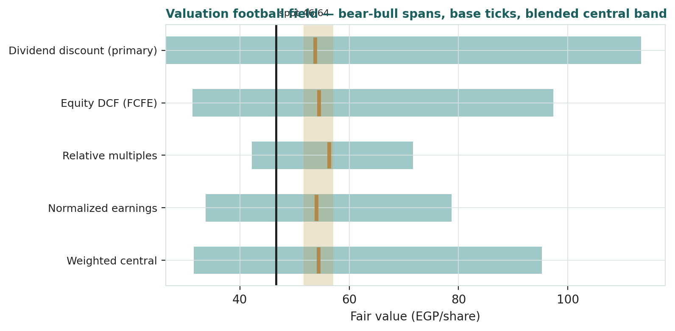
Central fair value ≈ EGP 54.3/share, about 16% above spot. Two features stand out. First, the base-case cluster is remarkably tight (53.8–56.3) — four genuinely different methods land within five percent of each other, so the +16% is not an artifact of lens choice. Second, the fan is enormous (31.6–95.3), because at a 23% discount rate the terminal assumptions dominate: this is a market where being roughly right about the cycle matters far more than being precise about the model.

1.6 The franchise — a deeper look
What makes ADIB-Egypt unusual is the combination: the country's dominant Islamic-banking franchise (Best Islamic Bank in Egypt for eight straight years) built on the bones of the old National Development Bank, run at a 17.2% cost-to-income ratio nobody in the market matches, with a corporate-led financing book that grew 52.8% in 2025 — and another 15.6% in Q1-26 alone — as Egypt's crowding-out cycle finally unwound, a 79-branch retail deposit machine funding it at Islamic (profit-share) cost, and a large sovereign-securities operation that turned the 2023–25 rate spike into extraordinary carry (including a Shariah-engineered restricted-Wakala/Murabaha structure with a local bank of roughly EGP 133bn, netted on the balance sheet, through which the bank runs government-paper economics in compliant form). A cluster of subsidiaries — ADI Capital (investment banking), leasing, consumer and micro finance — adds fee optionality. Each part sits differently in the cycle; the table scores them on the axes that matter.
Part | Cyclicality | Margin / trend | Capital intensity | Swing role
Corporate & syndications (~55% e) | High — tracks the private-capex revival | Repricing up post-devaluation; +53% growth | High — drives the capital raises | Growth engine; seasoning risk
Retail & branches (~30% e) | Moderate | Low-cost profit-share deposits; 79 branches | Moderate | The funding moat
Sovereign securities & treasury | Rate-cycle — the 25%+ carry is fading | Exceptional now; compresses with CBE cuts | Low RWA, high earnings share | The §1.7 crux
SME & micro (~10% e) | High | Priced widest; CBE-mandated growth | Moderate | Optionality + risk
Subsidiaries (ADI Capital, leasing, CF) | Market-linked | Fee-rich, capital-light | Low | Fee diversifier

1.7 How much of a 44% ROE survives — the crux
Two judgments drive this valuation more than any other, and both live in the terminal. First, decompose the 44%: it is the product of a once-a-decade configuration — a sovereign-securities and financing book repricing at 25%+ post-devaluation rates while profit-share deposit costs lag; nominal balance-sheet growth of 33% compounding a 17.2% cost base; and a cost of risk still benign because the boom is young. As the CBE cuts from the 27.25% peak — the corridor already sits at 19–20% after the February 2026 move — the carry compresses, deposit competition catches up, and the C/I drifts toward 20%: our glide takes the ROE from 44% to the high-20s by FY30, and the terminal is set at 28% — still a return on equity most banking systems never see, sustainable here only because nominal EGP growth and the Islamic funding franchise are real. Second, the cost of equity: 23% is an EGP discount rate (a ~19–20% policy/long-bond base plus an equity premium), which is why every fair value in this study is an EGP number — it neither needs nor makes a currency forecast. Now invert the question and ask what the market price implies. At EGP 46.64 and ~1.9× pro-forma book, the justified-P/B identity (ROE − g)/(COE − g) = 1.9 requires a perpetual ROE of ~34% at our 23% cost of equity — more than we grant, less than the bank currently earns (on the issued book the same arithmetic reads ~30%). The whole debate is therefore a corridor: the market prices roughly six points more terminal ROE than our base, and each point of terminal ROE is worth about EGP 4/share in the DDM (§1.9). Price and value are arguing about the same number — how fast the golden configuration fades.

1.8 Macro and country — rates, the pound, the program
ADIB-Egypt is a leveraged expression of one macro configuration. The CBE easing cycle is the master variable: policy rates peaked at 27.25%, and by the 12 February 2026 meeting the MPC had cut the corridor to 19.0/20.0% (main operation 19.5%) while releasing reserves — the required-reserve ratio fell from 18% to 16% — before holding on 2 April 2026. Every cut compresses the sovereign carry and financing yields that produced the 44% ROE, with a lag through the repricing book. The pound is the second lever: the March-2024 float and the devaluations before it are what inflated the nominal balance sheet, the FX gains and the repricing margin; the EGP has since traded around 49 per dollar, and a further step move would cut USD value even as it lifts EGP earnings again. The IMF program and the crowding-out unwind are the growth engine: as the sovereign's borrowing appetite normalizes — S&P affirmed Egypt at B/B with a stable outlook on 10 April 2026 — banks are rotating from T-bills into private credit; that rotation is the +53% financing growth, and it is also where unseasoned risk now sits. The sovereign nexus cuts both ways: a large government-securities book (and the EGP 133bn Wakala structure of §1.6) ties the bank's fortunes to Egypt's fiscal path, ratings and external position. These levers are the raw material of the bear and bull cases in §1.5, the catalysts in §5, and Expert 3's scenario tree in Appendix D.

1.9 DDM sensitivity — pricing the terminal pair
Holding the five-year earnings and payout path at base, the grid re-prices the DDM across the EGP cost of equity and the terminal (sustainable) ROE. The value runs from roughly EGP 26 (32% COE / 22% ROE) to EGP 123 (20% / 34%).
Figure 2 — DDM fair value across the cost of equity and the terminal ROE (EGP/share). Spot 46.64 sits inside the grid.
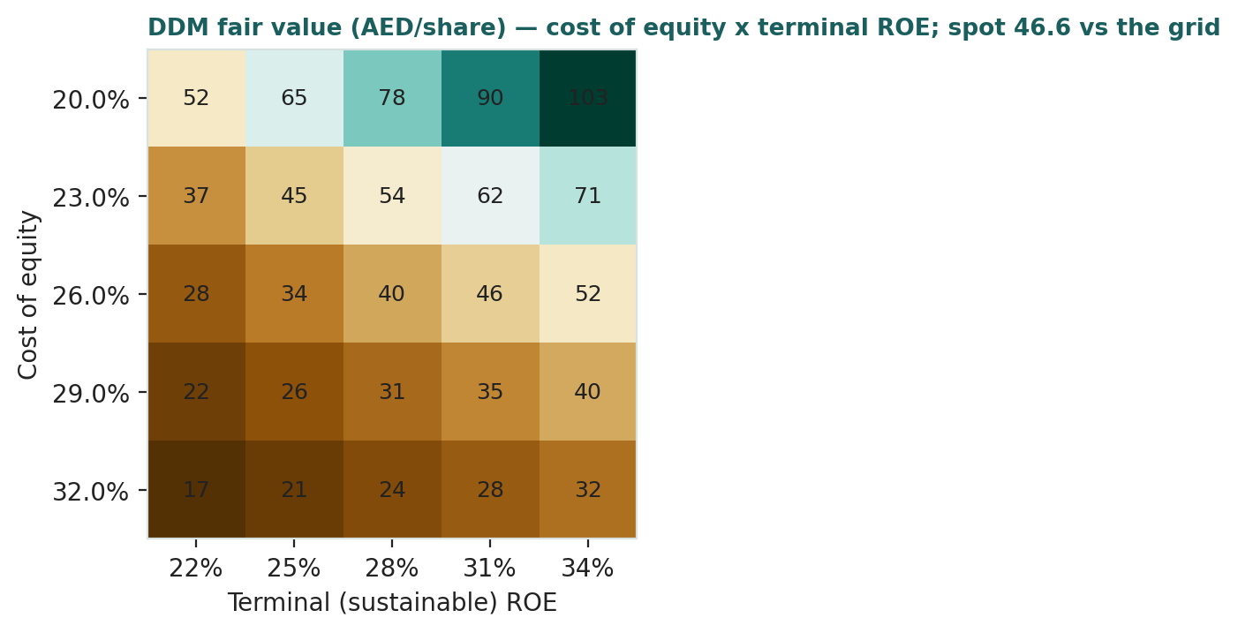
Read it as a map of the debate rather than a verdict: spot corresponds to roughly a 26% cost of equity on our 28% terminal ROE, or our 23% discount rate on a ~25% terminal — both entirely respectable opinions. The base case (23% / 28%) prints 53.8. Unlike a developed-market grid, no corner is absurd here; the grid is wide because Egypt's discount rate is, and that width is the honest message.

2 Technical and price structure
The tape and the fundamentals agree for once: a powerful, intact, twelve-month uptrend that has roughly doubled the share price, now pausing just under its high — beneath a fair value that sits higher still. ADIB trades above all four major moving averages — the 20- and 50-day have converged flat at ~46.3 beneath price, the 100-day rises at 43.0, and the 200-day trails far below at 34.6, a textbook bull stack. Momentum has cooled rather than cracked: RSI sits at a neutral 51.5 after June's consolidation, and the MACD is fractionally positive following a violent final week of the quarter (+6.9% on 30 June to a 49.60 high print, −3.8% on 1 July). Realized volatility of 40% is high for a bank anywhere — the tape of a crowded, contested EGX leader.
Indicator | Reading | Signal
Spot | EGP 46.64 | —
SMA 20 / 50 | EGP 46.3 / 46.3 | Above both — short-term trend intact, flattening
SMA 100 / 200 | EGP 43.0 / 34.6 | Above both — primary uptrend
RSI (14) | 51.5 | Neutral; overbought worked off by consolidation
MACD (12,26,9) | +0.05 line / +0.04 signal / +0.01 hist | Marginally positive after the late-June whipsaw
52-week range | EGP 20.09 – 49.60 | Top decile of the range
Realized vol (252d) | 40.4% | Elevated; HAR projects 43% ahead

Figure 3 — Price versus the moving-average stack, last 260 sessions.
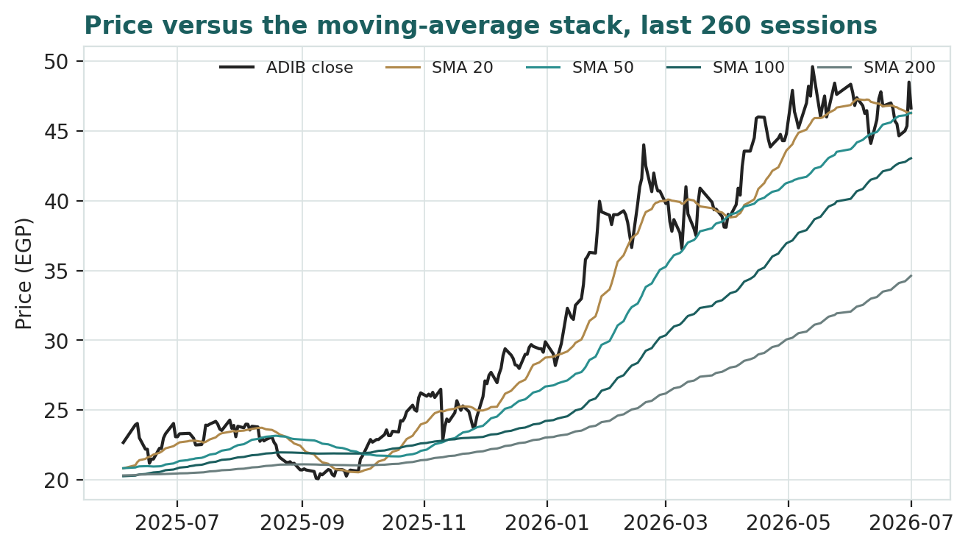
For the probabilistic work this matters in two ways: an intact uptrend with elevated volatility widens both tails, and under the calibrated drift (Appendix B) it pulls the median above spot — here, toward rather than away from the fundamental value. §6 reads the resulting probability zones.

3 Monte Carlo — a probabilistic price map
We simulate 50,000 three-month price paths (seed 42) using a sixteen-factor stack: seven continuous macro/operating drivers contributing a modest net forward drift, and nine discrete events that each fire with a probability and an impact. By design the paths diffuse from spot, and the §1 value gap is kept out of the drift — the fundamental gap lives in §1, not here; §3 maps where price could go from today, not where value sits. Diffusion width is the YZ-HAR engine of Appendix B: a log-HAR variance cascade on a gap-aware Yang-Zhang proxy projects an annualized 43.2% over the next sixty sessions, with unit-variance Student-t(5) innovations for honest tails (simulated path vol prints 49.3% once events layer on). Per the Step-0 calibration, the secular drift is ON — the expanding-window mean of the stock's own daily log-returns, +10.9% over sixty sessions — the same configuration as the EGX-developer class, and for the same underlying reason: a devaluation-driven nominal repricing that made the zero-drift cone fail its PIT test. The continuous factors net to +3.5% and the discrete events to an expected −1.8%, so the judgment layer trims rather than compounds the trend the engine carries. One flag: the 16-factor set is the house egx_bank class — the structure comes from the factor library, but the magnitudes below are starting judgments (calibrated=False) pending sign-off.
Continuous factor (7) | Dir. | Discrete event (9) | Prob. | Mean impact
CBE policy-rate path | + | Geopolitical / regional security shock | 30% | -10.0%
EGP/USD rate | + | Asset-quality / NPL-cycle shift | 30% | -6.0%
Inflation (CPI) | + | Sovereign rating / T-bill yield regime | 30% | +2.0%
EGX30 & foreign flows | + | EGP step-devaluation | 25% | +3.0%
Private-sector credit growth | + | Capital / dividend-policy change | 25% | +2.0%
Easing-cycle NIM compression | - | Earnings surprise (NIM / ECL / fees) | 50% | +2.0%
Positioning / valuation drag after the run | - | M&A / capital action | 30% | +3.0%
 |  | Rights issue / dilution overhang | 25% | -3.0%
 |  | Non-recurring ECL release / one-off | 30% | +0.0%

Percentile map (EGP/share):
Horizon | p5 | p25 | p50 | p75 | p95
T+20 sessions | 38.5 | 44.5 | 48.2 | 52.2 | 59.7
T+60 sessions | 35.3 | 44.7 | 51.5 | 59.3 | 74.4

Figure 4 — Forward price cone to T+60. The median follows the calibrated drift; the gold dotted line marks the EGP 54.3 fundamental central value — inside the cone's upper half.
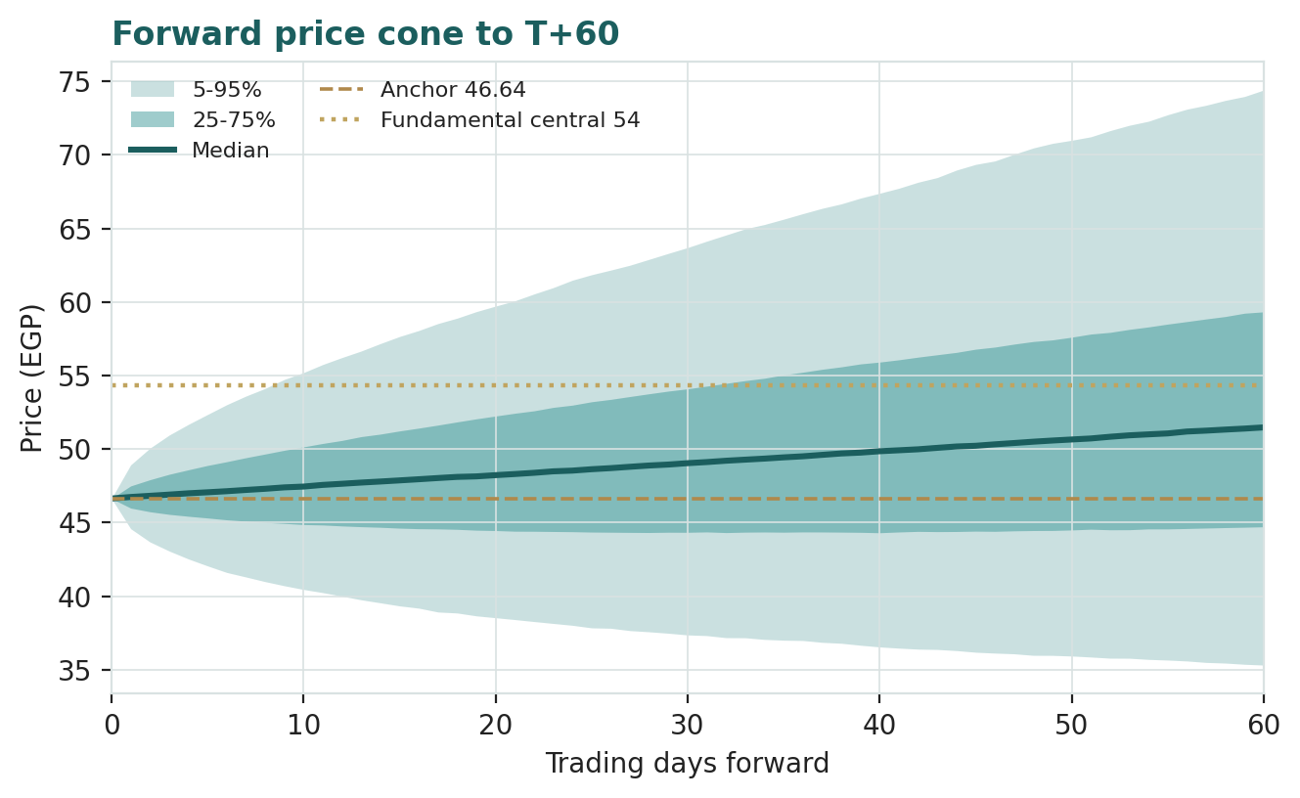
Figure 5 — Price distribution at T+20.
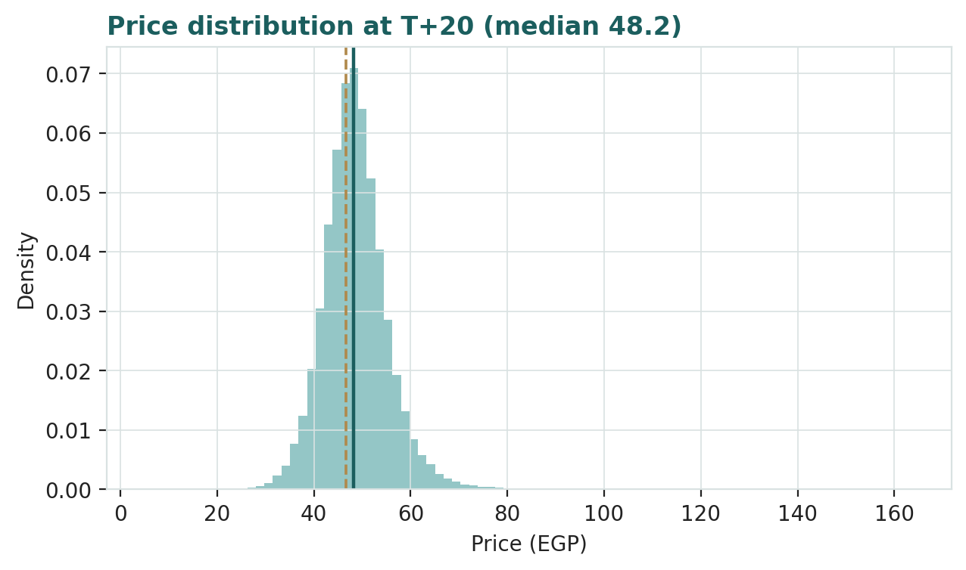
Figure 6 — Price distribution at T+60.
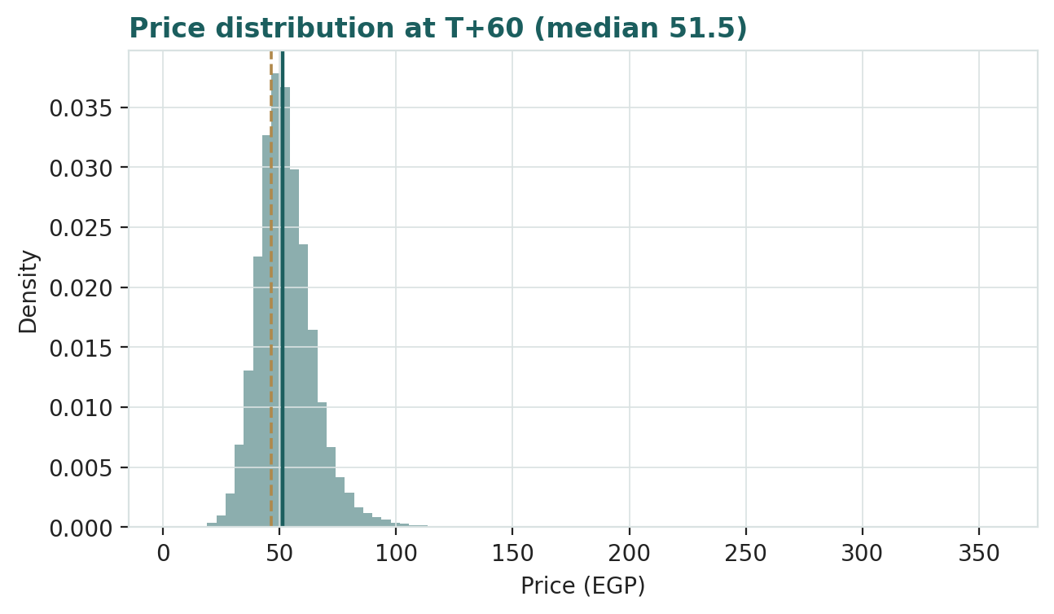
Level-touch ladder — the probability that price touches a level at any point by the horizon (running max for upside, running min for downside):
Level | T+20 touch | T+60 touch | Note
EGP 55 | 21% | 55% | Above the 52-wk high; past our central value
EGP 52 | 39% | 70% | Approaching the EGP 54.3 fair-value zone
EGP 50 | 57% | 81% | The round-number battleground at the high (49.60)
EGP 48 | 78% | 91% | Just above spot
EGP 45 | 56% | 68% | Just below spot; the 20/50-day shelf
EGP 42 | 25% | 42% | Below the 100-day average
EGP 40 | 14% | 29% | Round-number support
EGP 38 | 7% | 19% | Deep pullback; Expert 2's fair-value zone

4 Comparison of the lenses, and a verdict
Three readings sit side by side, and for once they rhyme. The fundamental lenses cluster at EGP 53.8–56.3 with a central 54.3 — about 16% above the market price, with unusual agreement between methods. The technical picture is a strong, intact primary uptrend above the full moving-average stack, consolidating in the top decile of its range. The probabilistic map, whose drift is the stock's own calibrated trend rather than our value view, centres near 51.5 at T+60 with a heavy right tail — between spot and fair value.
Lens | Reads | Central / implication
Fundamental (4-lens) | Modestly undervalued | EGP 54.3 (~+16% vs spot)
Technical | Strong uptrend, consolidating | Support at the 20/50-day shelf ~46.3, then 43.0; resistance 49.6
Monte Carlo (3-month) | Trend-conditioned, wide | Median 51.5; p5–p95 EGP 35.3–74.4

Verdict (a fair-value read, not a recommendation). ADIB-Egypt is, on our numbers, an exceptional bank at a reasonable price — the rarer combination. The market is not asleep: at ~1.9× pro-forma book it already pays for a ~34% perpetual ROE, well above our 28% terminal; the ~16% gap to our central value is the difference between pricing the stressed credit cycle Expert 2 capitalizes and the merely normalized one we do. What the price does not yet embed is the base case continuing to compound: EPS nearly doubling by FY30 while the payout finally begins. The risks are equally real and named — the CBE easing cycle attacks the carry that built the 44% ROE, a 53% growth year must season, the sovereign nexus is inescapable, and dilution has been management's habitual funding tool, with the next EGP 3bn already approved. The honest summary is a value in the low-to-mid 50s, a tape and a three-month distribution that lean the same way, and a resolution that will come from the pace of disinflation and the first credit-cost prints, not from any single quarter. Readers should weigh the lenses themselves; we publish the distribution, not a target.

5 Catalysts to watch
- CBE Monetary Policy Committee meetings. After the February cut to a 19–20% corridor and the April hold, the pace of further easing sets the glide of the sovereign carry and the NIM — the single most important repricing variable in the model.
- Q2-26 results (≈ Aug 2026). First read on whether financing growth (+15.6% in Q1 alone), the 17.2% cost base and the benign cost of risk survive a full quarter of lower rates.
- Execution of the EGP 12→15bn capital increase. Approved Aug-25, pending at 31-Mar-26: roughly 300mn new shares (+25%). Terms and timing settle how the per-share story dilutes or is protected — our figures are pro-forma.
- The first cash dividend. Any board move from full retention to a payout would re-rate the DDM mechanically and signal that growth is normalizing on management's own numbers.
- The pound and the IMF reviews. Program milestones, external financing and the EGP's stability near 49; S&P's B/B stable affirmation (Apr-26) is the current mark. A step-devaluation is a mixed event (EGP earnings up, USD value down) the factor stack prices at 25%.
- Asset-quality seasoning. After +53% financing growth, Stage-2 migration and the first uptick in cost of risk are the tell — Expert 2's whole case rests here.
- EGX flows and index events. Foreign appetite for EGP risk, EM/frontier index treatment and local liquidity after a twelve-month double.
- Group-level strategy. ADIB Group's capital plans for Egypt — its fastest-growing subsidiary, already carrying ~US$195mn of the parent's subordinated financing — including any stake, sukuk or expansion announcements.

6 Reading the probability zones
Translating the three-month distribution into plain zones, anchored on spot EGP 46.64, the technical shelf and the EGP 54.3 central value:
Zone (T+60) | Range | Approx. probability | What it would mean
Deep downside | < EGP 38 | ~8% | Macro shock / credit turn; Expert 2's territory
Lower band | EGP 38–44 | ~14% | Trend break; 100-day gives way
Around spot | EGP 44–50 | ~22% | Consolidation under the high; stalemate
Upper band | EGP 50–56 | ~21% | Breakout above 49.6 into the fair-value zone
Strong upside | > EGP 56 | ~34% | Melt-up through fair value; drift and right tail compound

The distribution is right-skewed — the calibrated drift plus fat-tailed innovations put a third of the mass above 56 and only ~8% below 38 — and, unusually, the skew points toward rather than away from the fundamental value. Hold the two reads in their proper lanes all the same: this is the spread of outcomes consistent with the stock's own volatility, trend and factor stack. It is not a forecast, and it is emphatically not a fair-value statement.

7 Caveats and what would change our mind
- The drift is a regime bet. Step 0 selected secular drift ON because five years of devaluation-driven uptrend made zero drift fail the PIT test — but trend drifts break precisely at regime turns (our Samsung and Tata backtests reversed in-sample). If disinflation succeeds and the nominal regime ends, the cone's centre is wrong first. The falsification is visible in the ledger within one or two cohorts.
- The terminal ROE is a judgment. We grant 28% forever — extraordinary by global standards, defensible only in nominal EGP. If the true through-cycle number is 24%, fair value drops toward EGP 42; at 32% it exceeds 66 (§1.9).
- The credit cycle is at its most flattering point. A benign cost of risk after +53% financing growth — and +15.6% more in one quarter — is a boom-cycle reading. Our 1.0–1.1% normalization could be optimistic (Egypt's own history has episodes well above 2%) or pessimistic if the private-capex revival is durable.
- The pound is outside the model. Every figure here is EGP. A step-devaluation would lift EGP earnings and book while cutting their dollar value; readers who think in USD must overlay their own FX view.
- Dilution mechanics. All per-share figures are pro-forma the approved EGP 12→15bn increase (1,500mn shares); the terms of execution, and any *further* increase beyond it, would move the per-share numbers — a fourth raise of 20% at spot would cut fair value per share by roughly a tenth unless deployed at today's returns.
- The factor set is new. The 16-factor egx_bank structure is house-standard but its magnitudes are uncalibrated starting judgments, flagged calibrated=False pending sign-off.
- Estimates. FY23 detail and several balance-sheet lines are derived to disclosed totals (flagged 'e' in the model); reported segmentals could shift line items without changing the value story.

Appendix A Financial statements — three years reported, five years forecast
Consolidated statements: FY23–FY25 as reported (FY2025 financial statements & results, Feb 2026; Q1-2026 condensed consolidated statements, May 2026; FY2023 results, Mar 2024) and the FY26E–FY30E forecast generated by the driver build in the companion model — every forecast cell below is a live formula there, linked to the Assumptions sheet. EGP millions. Lines marked e are derived or estimated to balance to disclosed totals. FY25 balance sheet is shown pro-forma the approved EGP 3bn capital increase, consistent with the per-share basis of the study.

A.1 Income statement (consolidated, EGP mn) — history and forecast
Line | FY23 | FY24 | FY25 | FY26E | FY27E | FY28E | FY29E | FY30E
Net income from funds | 8,900 | 15,252 | 20,152 | 24,888 | 29,741 | 34,945 | 40,362 | 45,811
Fees & other operating income | 2,000 | 2,758 | 3,448 | 4,258 | 5,089 | 5,979 | 6,906 | 7,838
Total operating income | 10,900 | 18,010 | 23,600 | 29,146 | 34,829 | 40,925 | 47,268 | 53,649
Operating expenses | (2,830) | (3,420) | (4,060) | (5,246) | (6,443) | (7,776) | (9,217) | (10,730)
Provision for impairment (ECL) | (1,470) | (2,180) | (1,940) | (2,011) | (2,558) | (2,842) | (3,380) | (3,540)
Profit before tax | 6,600 | 12,410 | 17,600 | 21,888 | 25,828 | 30,307 | 34,671 | 39,380
Taxation | (1,810) | (3,290) | (4,880) | (6,019) | (7,180) | (8,486) | (9,708) | (11,026)
Profit after tax | 4,790 | 9,120 | 12,720 | 15,869 | 18,648 | 21,821 | 24,963 | 28,353
Non-controlling interests | (90) | (112) | (132) | (80) | (90) | (100) | (110) | (120)
Attributable net profit | 4,700 | 9,008 | 12,588 | 15,789 | 18,558 | 21,721 | 24,853 | 28,233
EPS (pro-forma 1,500mn shares, EGP) | 3.13 | 6.01 | 8.39 | 10.53 | 12.37 | 14.48 | 16.57 | 18.82
memo: cost-to-income | 26.0% | 19.0% | 17.2% | 18.0% | 18.5% | 19.0% | 19.5% | 20.0%
memo: effective tax rate | 27.4% | 26.5% | 27.7% | 27.5% | 27.8% | 28.0% | 28.0% | 28.0%

Reported weighted EPS: FY24 14.02, FY25 11.25 (rising share count). Forecast drivers: revenue growth 23.5→13.5%, C/I 18→20%, cost of risk 1.1→0.9%, tax ~28% — all live in the Assumptions sheet.

A.2 Balance sheet (consolidated, EGP mn) — history and forecast
Line | FY23 | FY24 | FY25 | FY26E | FY27E | FY28E | FY29E | FY30E
Cash & due from banks | 22,300 | 32,100 | 41,000 | 56,991 | 72,385 | 88,377 | 108,319 | 127,713
Treasury & investment securities | 65,000 | 115,000 | 140,000 | 179,200 | 222,208 | 266,650 | 311,980 | 358,777
Customer financing, net | 67,000 | 104,400 | 159,000 | 206,700 | 258,375 | 310,050 | 365,859 | 420,738
Fixed & other assets | 8,000 | 9,000 | 10,000 | 11,000 | 12,100 | 13,310 | 14,641 | 16,105
Total assets | 162,300 | 260,500 | 350,000 | 453,891 | 565,068 | 678,387 | 800,799 | 923,333
Depositors' accounts | 127,000 | 200,000 | 278,000 | 362,632 | 453,289 | 543,947 | 641,858 | 738,137
Due to banks, subordinated & other liab. | 20,100 | 37,100 | 34,200 | 37,620 | 41,382 | 45,520 | 50,072 | 55,079
Total liabilities | 147,100 | 237,100 | 312,200 | 400,252 | 494,671 | 589,468 | 691,930 | 793,216
Paid-in capital (FY25 pro-forma) | 6,000 | 12,000 | 15,000 | 15,000 | 15,000 | 15,000 | 15,000 | 15,000
Retained earnings & reserves | 8,900 | 11,000 | 22,300 | 38,089 | 54,791 | 73,254 | 93,137 | 114,312
Equity attributable to shareholders | 14,900 | 23,000 | 37,300 | 53,089 | 69,791 | 88,254 | 108,137 | 129,312
Non-controlling interests | 300 | 400 | 500 | 550 | 605 | 666 | 732 | 805
Total equity | 15,200 | 23,400 | 37,800 | 53,639 | 70,396 | 88,919 | 108,869 | 130,117

Issued paid-in capital per the Q1-2026 statements: EGP 12bn (1,200mn shares, par 10) at 31-Dec-25 and 31-Mar-26; authorized EGP 20bn; the 12→15bn increase is approved and pending — FY25 onward shown pro-forma (paid-in 15,000, cash +3,000). Subordinated financing of ~US$195mn (parent Wakala tranches + IFC Murabaha) sits within other liabilities. Balance check (assets − liabilities − equity) = 0 in every year of the model.

A.3 Cash flow (bank presentation, EGP mn) — history and forecast
Line | FY24 | FY25 | FY26E | FY27E | FY28E | FY29E | FY30E
Profit after tax | 9,120 | 12,720 | 15,869 | 18,648 | 21,821 | 24,963 | 28,353
Impairment charge (non-cash) | 2,180 | 1,940 | 2,011 | 2,558 | 2,842 | 3,380 | 3,540
Δ Customer financing (gross) | (39,580) | (56,540) | (49,711) | (54,233) | (54,517) | (59,189) | (58,419)
Δ Depositors' accounts | 73,000 | 78,000 | 84,632 | 90,658 | 90,658 | 97,911 | 96,279
Δ Due to banks & other liabilities | 17,000 | (2,900) | 3,420 | 3,762 | 4,138 | 4,552 | 5,007
Δ Fixed & other assets | (1,000) | (1,000) | (1,000) | (1,100) | (1,210) | (1,331) | (1,464)
Net cash from operating activities | 60,720 | 32,220 | 55,221 | 60,293 | 63,732 | 70,286 | 73,296
Δ Treasury & securities (investing) | (50,000) | (25,000) | (39,200) | (43,008) | (44,442) | (45,330) | (46,797)
Dividends paid | 0 | 0 | 0 | (1,856) | (3,258) | (4,971) | (7,058)
Capital increase / equity movements | (920) | 1,680 | (30) | (35) | (39) | (43) | (47)
Net change in cash & due from banks | 9,800 | 8,900 | 15,991 | 15,394 | 15,993 | 19,941 | 19,394

FY25 equity movement includes the EGP 3bn increase (pro-forma). Forecast dividends follow the §1.1 payout path (0% → 25%); closing cash ties to the balance sheet in every year (check = 0).

A.4 Equity DCF — the complete five-year build
The full free-cash-flow build behind §1.2, reproduced line by line from the model's DCF sheet: attributable profit for each of the five forecast years, the equity that must be retained to fund balance-sheet growth at constant capital intensity, the resulting free cash flow to equity, the year-by-year discounting at the cost of equity (the WACC of an all-equity claim), the terminal value, and the present value of every piece — all the way to the valuation.
DCF build | FY26E | FY27E | FY28E | FY29E | FY30E
Attributable net profit (EGP mn) | 15,789 | 18,558 | 21,721 | 24,853 | 28,233
Total assets, year-end (EGP mn) | 453,891 | 565,068 | 678,387 | 800,799 | 923,333
Δ Total assets (EGP mn) | 103,891 | 111,177 | 113,319 | 122,412 | 122,534
Equity retained = 10.66% × ΔTA (EGP mn) | (11,072) | (11,848) | (12,077) | (13,046) | (13,059)
Free cash flow to equity (EGP mn) | 4,717 | 6,710 | 9,644 | 11,808 | 15,175
FCFE per share (EGP) | 3.14 | 4.47 | 6.43 | 7.87 | 10.12
Discount factor @ 23.0% COE (mid-year) | 0.902 | 0.733 | 0.596 | 0.485 | 0.394
PV of FCFE (EGP/share) | 2.84 | 3.28 | 3.83 | 3.81 | 3.99

Valuation bridge (EGP/share unless noted) | Value
Sum, PV of FCFE FY26–FY30 | 17.75
Terminal value at end-FY30 = justified P/B 1.42× × FY30 book 65.60 | 92.93
PV of terminal value (× FY30 discount factor 0.394) | 36.61
Discount rate: cost of equity (EGP) — the WACC of the equity claim | 23.0%
Equity DCF fair value | 54.4

Terminal P/B = (28% terminal ROE − 11% g)/(23% COE − 11% g) = 1.42×, applied to the DCF's own book path (which assumes FCFE is distributed). 94% of the DDM's value and ~88% of the DCF's sits beyond FY30 — the honest shape of a zero-payout compounder discounted at Egyptian rates.

Appendix B Step 0 — calibration backtest
Before any forecast we test the Monte-Carlo lens on ADIB's own five and a half years of history: seventeen non-overlapping 60-session windows (Jan 2022 → Jun 2026), each forecast built only from data available at its origin, scored against the realized close. The grade is skill versus a naïve zero-drift random-walk lognormal cone (spot, trailing 252-day vol): CRPS skill must exceed zero, with the Winkler interval score alongside; PIT and band coverage are diagnostics only. The engine's default for a first-pass name — zero drift — failed the PIT diagnostic: CRPS skill was marginally positive (+0.03) but the PIT mean of 0.68 rejected uniformity (KS p = 0.018), the signature of scoring a five-year, eleven-fold uptrend with a driftless cone. Per protocol we recalibrated the asset-class drift and re-ran: with the expanding-window secular drift ON — the EGX-class configuration, and this is an EGX name whose uptrend has the same devaluation-driven nominal engine as the developers' — the lens beats the benchmark decisively and the PIT flattens. That configuration carries into §3, with its regime-turn fragility flagged in §7.
Configuration | n | CRPS skill | Winkler-90 skill | Winkler-50 skill | Coverage 50/80/90 | PIT mean | PIT KS p
Zero drift (engine default) | 17 | +0.03 | +0.18 | +0.02 | 53 / 76 / 88% | 0.68 | 0.018 — reject
Secular drift ON (adopted) | 17 | +0.19 | +0.22 | +0.21 | 59 / 88 / 94% | 0.56 | 0.64 — pass
Target / benchmark | — | > 0 | > 0 | > 0 | 50 / 80 / 90% | 0.50 | uniform

Figure B-1 — Calibration backtest, adopted configuration: quarterly cone replay (log scale), PIT histogram, and interval coverage versus target.
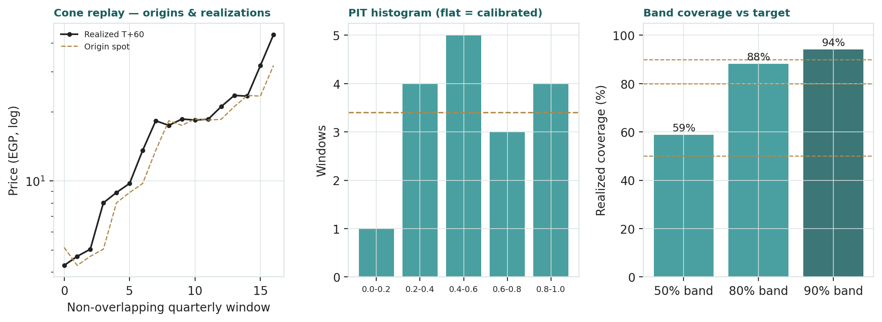
Coverage sits near target at all three bands, the PIT histogram is close to flat, and the adopted configuration beats the benchmark in 12 of 17 windows. The lens is accepted. The honest caveat travels with it: a drift-on cone assumes the nominal regime persists, and the one materially negative window in the set is exactly a drawdown quarter — the falsification condition of §7, scored forward in the Calibration Ledger.

Appendix C Peer set, sector structure, and risks
ADIB-Egypt's cleanest comparison is its own market — the EGX-listed bank complex — with CIB as the quality benchmark and Faisal Islamic as the direct Shariah incumbent.
Metric | EGX banks (typical) | ADIB-Egypt | Read
P/E (trailing) | 5–7× | ≈ 4.4× issued / 5.6× pro-forma | Cheap end, for the best growth
P/B | 1.5–2.5× | ≈ 1.6× issued / 1.9× pro-forma | Below CIB's ~2.3× on a higher ROE
ROE | 30–40% | 44% (FY25) | Best-in-class
Cost-to-income | ~25–30% | 17.2% | The structural edge
Capital (CAR) | ~18–20% | 19.44% | Further EGP 3bn approved
Financing growth (FY25) | ~25–35% | +52.8% | Fastest of the majors

Peers. Commercial International Bank (the private-sector benchmark: ~2.3× book on a ~38% ROE — the multiple ceiling the market grants Egyptian bank quality), QNB Alahli (foreign-owned scale peer with the same T-bill-carry economics), Faisal Islamic Bank of Egypt (the listed Islamic incumbent — cheaper, slower, the direct franchise comparison), and Banque du Caire / Al Baraka (state and Islamic mid-tier context; Banque du Caire's FY25 profit grew ~30%). Sector structure. Egyptian banking is a concentrated, highly profitable oligopoly living off three engines — a huge sovereign-securities carry, post-devaluation nominal repricing, and now a private-credit revival as crowding-out unwinds; the whole complex trades at single-digit earnings multiples because those earnings are EGP streams discounted at EGP rates. Principal risks: disinflation and CBE easing compressing the carry (the very thing the base case models); credit seasoning after a +53% growth year; the sovereign nexus (securities book, the Wakala structure, ratings, IMF milestones); EGP regime risk; dilution via the approved and any further capital increases; and free-float, liquidity and majority-control considerations for minority shareholders.

Appendix D The expert valuation panel
Every Testahil study closes with a panel of standing expert personas — drawn from the house Expert Persona Library, not invented for the occasion, so that each accumulates a track record across studies and a quarterly update is a re-run, not a re-training. For a bank we cast the bank trio — the three whose methods both fit a deposit-funded lender and genuinely disagree: Expert 1 (capital and returns — the justified price-to-book on a sustainable ROE, cross-checked against the distribution stream), Expert 2 (the credit cycle — through-cycle cost of risk and stressed earnings), and Expert 3 (macro-policy — scenario-weighted valuation across the policy worlds an EGP-denominated bank actually lives in). Each runs a genuinely different method, derives its fair value from shown workings, and states a falsification condition. Their point fair values are logged with the study date and spot as an internal per-expert track record, kept separate from the core Calibration Ledger.

D.1 Expert 1 — capital and returns: the justified price of a franchise
Worldview. A bank is worth its book value plus the present value of the returns it earns above its cost of equity — nothing more mystical than that. Value flows from three things: a sustainable ROE, the capital required to hold the balance sheet, and the ability to grow without dilution. Franchises differ in how long they defend an excess spread, not in the arithmetic that prices it.
When it works / when it fails. The method is at its best on well-capitalized banks with observable returns — and it is stress-tested here, because ADIB-Egypt's returns are observable but extreme. It fails through credit shocks, when book value stops being real (there she defers to Expert 2), and it can mislead at cycle extremes, when the observed ROE is a phase of the cycle masquerading as a property of the franchise. A 44% print at the top of a rate cycle is precisely the case she treats with suspicion.
Standard workings. (1) Establish the capital position: CAR 19.44% is comfortable, but the CBE measures capital against risk-weighted assets, and a financing book growing 53% consumes RWA capacity faster than even a 44% ROE replaces it — which is exactly why the bank has raised capital three times in four years and pays no dividend. (2) Estimate the sustainable ROE. She triangulates: FY25 reported 44%; the carry decomposition of §1.7 says perhaps a third of that is the rate-cycle configuration; Egyptian quality banks (CIB) have sustained mid-to-high-30s through this cycle and mid-20s through calmer ones. Her judgment: 30% sustainable — above the study's 28%, crediting the 17.2% cost base and the Islamic funding franchise. (3) Price it: justified P/B = (ROE − g)/(COE − g) at a 23% EGP cost of equity and 11% nominal growth, cross-checked against the study's dividend-path machinery re-run at her terminal. (4) Weight the static identity over the path-dependent cross-check 60/40 — the identity assumes less. (5) Sensitivity on the two swing inputs.
Expert 1's workings | Value
Book value per share (FY25, pro-forma the approved increase) | EGP 24.87
Capital check: CAR 19.44%, but RWA growth ≈ +50% p.a. | No surplus — retention + periodic raises fund growth
Sustainable ROE (her judgment) | 30%
Justified P/B = (30% − 11%) / (23% − 11%) | 1.58×
Justified value = 1.58 × 24.87 | EGP 39.4
DDM cross-check (study path re-run at her 30% terminal) | EGP 59.4
Blend (60/40) — fair value | EGP 48.0

Worked example. Take the FY26 year she can almost see: EPS ~EGP 10.53 on opening pro-forma book of 24.87 is a 42% return; her 23% hurdle costs 5.72, leaving EGP 4.81 of genuine economic profit — nineteen percent of book earned above the hurdle in a single year. Compounding that spread while it fades to her 30% terminal is what EGP 48 capitalizes. What the market price capitalizes is nearly the same thing: at ~1.9× pro-forma book, the identity implies a ~34% perpetual ROE — the tape and Expert 1 are separated by four points of terminal ROE, not by a thesis.
The growth-without-dilution test. Her second gate is whether the franchise can fund its own growth. In principle a 44% ROE with zero payout funds 44% balance-sheet growth internally; in practice the CBE's denominator is risk-weighted, the financing mix is shifting toward full-weight corporate risk, and the book grew 53% — so the bank raised EGP 6bn in 2024–25 and has another 3bn approved. The arithmetic is unforgiving: a bank cannot indefinitely grow assets faster than its internal capital generation, hold its ratios, and begin a payout. Something yields — growth slows toward the self-funding rate (her forecast and the study's), the dividend stays at zero, or dilution continues. Each resolution caps the distributable stream; none of them, in her read, supports more than two times book.
Sensitivity (swing = the sustainable ROE). At 26%: 1.25× book → 31.1, blend ≈ EGP 39. At 34%: 1.92× → 47.7, blend ≈ EGP 56. A point of COE moves the blend ~EGP 3. Her stated range is EGP 35–62.
Cross-examination. To Expert 2: “Your stress is honest but you double-count — you cut the earnings for a downturn and then also cut the multiple for the same downturn. Price the through-cycle average once, properly.” To Expert 3: “Your policy worlds are mostly my two numbers wearing costumes — the bull world is a lower cost of equity, the bear world a lower terminal ROE. Name the numbers and we can argue about probabilities honestly.”
Verdict, falsification, market-implied. Fair EGP 48.0 (range 35–62). Falsified by a structural break in the return profile: three consecutive years of ROE held above ~35% through the easing cycle without a further capital raise would push her toward the high case; a capital event, a dividend indefinitely deferred past FY28, or ROE through 24% would pull her to the low one. The market price implies almost exactly her framework with one input moved — on a capital-and-returns basis, ADIB-Egypt is the rare stock where the tape is arguing about the input, not the identity.

D.2 Expert 2 — the credit cycle: what does this book lose in a downturn?
Worldview. A bank's value is dominated by the credit it underwrites — through-cycle losses, not peak-cycle profits, set the floor. Reported book value is only as real as the financing behind it, and the time to ask is precisely when nobody else is asking: at record growth, record profitability, and the top of a nominal boom.
When it works / when it fails. The lens earns its keep at cycle turns and in fast-growth books, where today's underwriting is tomorrow's cost of risk — and 52.8% growth in one year, plus 15.6% more in a single quarter, is the fastest-growing large book he has scored in this market. It fails — systematically undervalues — when a benign environment genuinely persists, and it says little about franchise quality; he is a floor-setter, not a franchise-pricer.
Standard workings. (1) Read the book: net financing EGP 159bn, roughly EGP 55bn of it written in the last twelve months, into a corporate-led revival at post-devaluation collateral values, with SME and micro exposure growing by CBE mandate. (2) Normalize the cost of risk: the bank booked ~147bp of ECL against the average book in FY25 — respectable provisioning — but Egypt's own history (2016 float, 2020, 2022–24) has spent long stretches at or above 200bp. His through-cycle estimate for this mix: 200bp. (3) Normalize the revenue: the 25%+ sovereign carry is a phase, not a property; his mid-cycle revenue line strips roughly a quarter of it. (4) Value off normalized, not reported, earnings, at a cycle-aware multiple, then stress a genuine downturn year to test the floor.
Expert 2's workings | Value
Net financing / 12-month growth | EGP 159bn / ~+53% (≈ EGP 55bn of new vintages)
Booked FY25 cost of risk (ECL / avg financing) | ≈ 147bp
Through-cycle cost of risk (his judgment) | 200bp → extra ~EGP 1.0bn p.a. on the FY26 book
Mid-cycle revenue haircut (carry normalizes) | ≈ −15% vs the FY26 driver build
Normalized attributable EPS | ≈ EGP 7.50
Cycle-aware multiple × normalized EPS | 5.0× → EGP 37.5
Fair value (incl. ~EGP 0.5 franchise premium) | EGP 38.0

Worked example. Reprice one line and watch the tower sway: move the cost of risk from the booked 147bp to his 200bp on the FY26 average book of ~EGP 183bn and the charge rises from ~EGP 2.0bn to ~EGP 3.7bn; after tax, EPS drops about EGP 0.8 — eight percent of the year's earnings from half a point of credit cost. Now run his genuine downturn: a deval-and-recession year with revenue flat and 300bp of cost of risk cuts attributable EPS toward EGP 6.7 and the market would not hold a 5× multiple against a rising-NPL tape — at 4× the stressed stream the price is EGP 27, which is why his floor sits where it does.
The vintage ledger. His deeper worry is composition, not level. A third of today's book has never seen a bad quarter — EGP 55bn written in 2025 and another ~EGP 25bn in Q1-26, and corporate and SME default curves peak in years two to four of a vintage, not year one. Today's benign ratios are quoted against a numerator the new vintages have simply not had time to join. A one-point slippage on the young vintages alone would add ~EGP 0.8bn to Stage 3, and the same quarter would carry the coverage ratio, the cost of risk and the growth narrative into the headlines together — that correlation, not any single number, is what his 5× multiple is pricing.
Sensitivity (swing = the normalized cost of risk). At 160bp: normalized EPS ~8.2, value ≈ EGP 41.5. At 260bp: ~6.6, value ≈ EGP 33.5. Range EGP 28–50.
Cross-examination. To Expert 1: “Your justified P/B assumes the B is real. A third of this book is unseasoned — season it before you capitalize it at 1.6 times.” To Expert 3: “The only policy world that matters to a lender is the credit cycle; your rate and pound branches are inputs to my cost-of-risk line, not a separate valuation.”
Verdict, falsification, market-implied. Fair EGP 38.0 (range 28–50) — the panel floor. Falsified by evidence, not argument: three more years of sub-150bp cost of risk through the easing cycle *and* the seasoning of the 2025–26 vintages would prove this book is structurally better-underwritten than any Egyptian predecessor, and he would move his normalization toward 150bp and his value toward EGP 45. The market at EGP 46.64 is paying almost exactly his no-downturn case — which is his point: there is no multiple of safety in the price against the one thing banks reliably do.

D.3 Expert 3 — macro-policy: pricing the worlds an EGP bank lives in
Worldview. In a managed-currency, program-country economy, policy outranks management: the CBE sets ADIB's carry and margin, the pound sets the nominal size of everything, and the IMF program sets the probability distribution over both. He prices the equity as a probability-weighted set of policy worlds, re-running the study's DDM machinery under each so the scenario values are derived, not asserted.
When it works / when it fails. Strongest exactly here — a bank whose 44% ROE decomposes into a rate level, an FX regime and a fiscal-rotation story is a bank whose valuation is a policy function. It fails when the worlds are drawn lazily (three shades of the base case) or when idiosyncratic execution, not policy, is the real driver — for ADIB-Egypt he judges policy dominant by a wide margin.
Standard workings. (1) Name the levers: the CBE path (corridor 19–20% after the February 2026 cut, from a 27.25% peak); the pound (≈49/USD since the 2024 float); the IMF program and sovereign standing (S&P B/B stable, April 2026); the crowding-out unwind driving private credit; and the sovereign-securities nexus. (2) Define three worlds as configurations of those levers. (3) Re-run the §1 DDM under each — policy lands in a bank valuation through the discount rate and the terminal ROE. (4) Weight, then stress the weights.
World (probability) | Configuration | COE / terminal ROE | Value
Bull — 30% | Disinflation holds; corridor to low-teens by 2028; EGP stable; program completes; flows return | 21% / 30% | EGP 75
Base — 45% | Gradual cuts; EGP drifts, no step move; program muddles through; growth normalizes | 23% / 28% | EGP 53.8
Bear — 25% | Step-devaluation round four; inflation rebounds; corridor back up; risk premium blows out | 27% / 24% | EGP 31
Probability-weighted fair value |  |  | EGP 54.0

Worked example. The bear branch is not exotic — it is 2022–24 replayed: a step move in the pound, a rate spike to defend it, and a de-rating of every EGP asset before the nominal repricing catches up. Marking that world honestly (a 27% discount rate and a 24% terminal as margins and credit are squeezed together) yields EGP 31; the reason his blended value still reaches 54 is that he genuinely weights the benign worlds at 75% — the disinflation data, the February cut and the April hold, and the ratings affirmation are, on his read, the program working.
The transmission map. He prices each lever's mechanical pass-through rather than a mood. A 100bp CBE cut reaches the sovereign-carry and financing yield with a two-to-three-quarter repricing lag, worth very roughly EGP 1.5–2/share of DDM value through the terminal-ROE glide — which is why the corridor path is the master input. A step move in the pound cuts the USD value of every share while inflating the EGP book — a mixed event the study's factor stack prices at 25% for the quarter. An IMF milestone or ratings step moves the equity premium inside his COE. And the crowding-out unwind is the volume engine: every point of sovereign-borrowing normalization is private credit the banks — this one fastest — get to write. His worlds are coherent settings of those four dials, which is why he insists the scenario values are derived, not asserted.
Sensitivity (swing = the weights). Shift ten points from base to bear (25/40/35): EGP 51.6. Shift ten to bull (40/40/20): EGP 57.7. The weights move the answer far less than either colleague's single swing input — his argument for the method. Range EGP 31–75.
Cross-examination. To Expert 1: “Your 'sustainable ROE' is not a property of the bank — it is the intersection of a rate path and an FX regime. I price the distribution of those; you pick its mode.” To Expert 2: “Your downturn is one of my branches with a probability attached. Capitalizing it as the central case confuses prudence with forecasting.”
Verdict, falsification, market-implied. Fair EGP 54.0 (range 31–75). Falsified structurally if either anchor of his framework breaks: an exit from the IMF-anchored disinflation path (his tree re-roots toward the bear world) or a credible move to a genuinely floating, stable pound with single-digit inflation (the whole EGP discount-rate regime — and every number in this study — would need rebuilding at a lower COE). The market price sits between his base and bear worlds: it is paying for disinflation to work, with a haircut for the chance it does not — which he regards as roughly the right shape, a few pounds too cheap.

D.5 The three in one room
The single asset they most disagree on is the 44% return on equity itself — whether it is a franchise, a position in the cycle, or an artifact of policy.
Expert 1: “The cost base is the asset. Seventeen percent cost-to-income and profit-share funding are things competitors cannot copy in a cycle — that is why I grant thirty percent sustainable and 1.6 times book. The carry will fade; the franchise that harvested it stays.”
Expert 2: “And a third of the book that franchise wrote has never seen a bad quarter. You are both capitalizing underwriting you cannot yet observe — benign prints at the top of a 53% growth year are the most expensive data in banking.”
Expert 3: “You are both describing outputs. The 44 percent is a 27% policy rate meeting a repriced pound; the cost base is a nominal boom flattering a fixed-cost bank. Change the policy configuration and both of your 'properties' reprice within four quarters — which is why I hold three worlds open instead of arguing about one.”

D.6 Reading the divergence
Figure D-1 — The three experts' fair-value ranges. Brass ticks are base cases; the gold band is the study's central zone; the dark line is spot. The spread is a credit-cycle-versus-franchise disagreement; the panel's centre lands almost exactly on the market price.
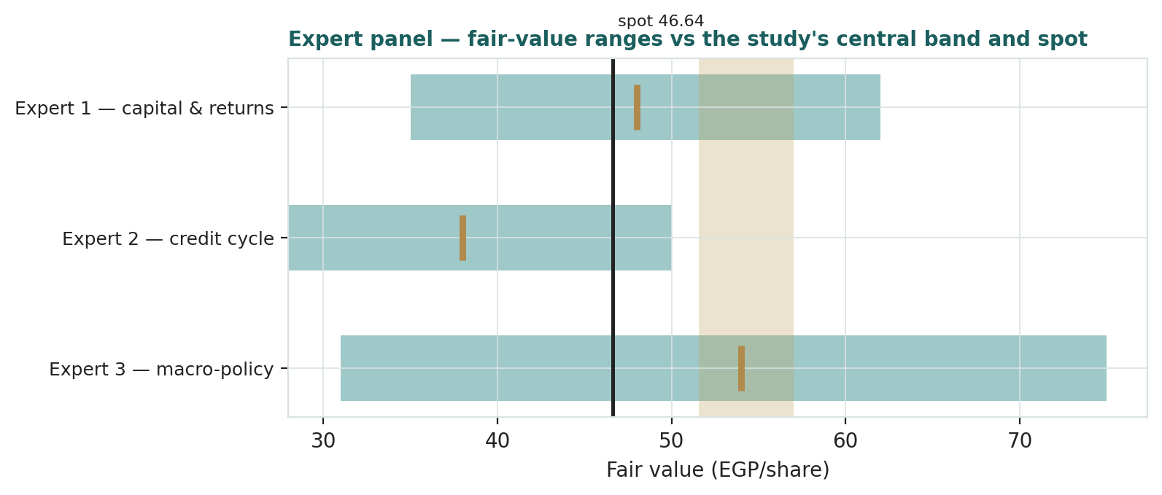
Expert | Method | Single swing assumption | Base fair value
Expert 1 | Justified P/B & excess returns on sustainable ROE | Sustainable ROE (30%) | EGP 48.0
Expert 2 | Through-cycle cost of risk / stressed earnings | Normalized cost of risk (200bp) | EGP 38.0
Expert 3 | Scenario-weighted policy worlds | World weights (30/45/25) | EGP 54.0

The spread — EGP 38 to 54 at base — measures exactly one uncertainty: how much of a once-a-decade configuration belongs in a permanent valuation. Expert 1 capitalizes the cost-and-funding franchise that will survive the cycle; Expert 2 refuses to capitalize underwriting that has not yet been tested; Expert 3 probability-weights the policy worlds that decide between them. Their simple average sits at EGP 46.7 — the market price to within a tenth of a pound — so the tape, on this evidence, is pricing the panel's argument almost perfectly, while the study's EGP 54.3 central takes the base-case side of it. Resolve the seasoning question and the panel converges in the high-40s to mid-50s; fail it, and Expert 2's floor is where the argument reconvenes.
*Each expert's point fair value (and bull/base/bear) is logged with the study date (03 Jul 2026) and spot (EGP 46.64) as an internal per-expert track record, kept separate from the core Calibration Ledger.*

About this series
Testahil publishes independent, educational valuation studies. Each is an attempt to reason transparently about what a security is worth, with every assumption shown and a companion model so readers can disagree productively. The house style is distributions, not tips: we describe ranges and probabilities, not targets, and we do not tell anyone what to do. Studies are framed as educational analysis, the preparer is not licensed by any securities regulator, and holdings are disclosed.

Disclosure & Disclaimer
*Not investment advice. *This document is educational and informational only. It is not, and must not be relied upon as, investment, financial, legal, accounting or tax advice, nor an offer, solicitation or recommendation to buy, sell or hold any security. It contains no price target and no rating.
*No licence; no advisory relationship. *The preparer is not registered or licensed with any securities or financial regulator in any jurisdiction — including Egypt's Financial Regulatory Authority (FRA) — holds no brokerage or investment-advisory authorisation, and is not acting as your adviser or fiduciary. Nothing here is personalised to your circumstances.
*Holdings disclosure. *The preparer may hold, and may in the future take or dispose of, a position in the security discussed in this report, and may transact at any time without notice. This is a potential conflict of interest you should weigh.
*Sources & accuracy. *Reported financial and operating figures are drawn from the company's public disclosure (FY2025 financial statements, Q1-2026 condensed consolidated statements, FY2023 results) and other public sources believed reliable but not independently verified; they may contain errors or be superseded. Lines marked e are the preparer's estimates made to balance to disclosed totals. Forward-looking inputs — the sustainable ROE, the EGP cost of equity, the growth, payout and margin paths, the multiples and the Monte-Carlo factor probabilities — are the preparer's own judgments and are inherently uncertain.
*Forward-looking statements. *Any statements about the future are estimates subject to risks and uncertainties; actual results may differ materially. The Monte Carlo models price, not value, and encodes subjective probabilities for events that have not occurred.
*No reliance; your responsibility. *Do your own research and consult a licensed professional before making any decision. You are solely responsible for your investment decisions and their outcomes. To the maximum extent permitted by law, the preparer accepts no liability for any loss arising from use of this document.
*Currency & figures. *All figures are in Egyptian pounds (EGP); bn denotes billion and mn million. Per-share figures are pro-forma the approved EGP 12→15bn capital increase (1,500mn shares) unless marked issued. FX reference at the study date: ≈ EGP 49.1 per US dollar. Rounding may cause totals to differ slightly. Spot price and market data are as of 01 July 2026 and change continuously.
*TESTAHIL · Independent Valuation Study · Educational Analysis · Abu Dhabi Islamic Bank – Egypt S.A.E (EGX: ADIB) · edition 03-07-2026 · reporting currency EGP*

