Testahil · Independent Valuation Study — Educational Analysis Not investment advice
Independent Valuation Study — Educational Analysis
ADNOC Gas plc (ADX: ADNOCGAS)
Fundamental analysis · Technical analysis · Monte Carlo simulation — one integrated read
Anchor: AED 3.44 (3 Jul 2026 close) · ~76.74 bn shares · market cap ~AED 264 bn (~$71.9 bn) · net cash ~$4.8 bn · a world-class integrated gas-processing and sales company that supplies ~60% of the UAE's sales-gas needs and exports to 20+ countries; ~86% owned by ADNOC · reporting currency US dollars, share price AED (peg 3.6725) · prices and probabilities computed 3 Jul 2026 from the attached daily history · primary lens: discounted cash flow (FCFF), cross-checked by a dividend-discount model on the board-committed 5%-growth dividend · the swing factors are Brent-linked export pricing and the gap between enterprise cash flow and what the minority actually receives.
READ FIRST — what this document is, and is not. This study is a valuation exercise and an expression of personal analytical opinion, published free of charge for educational purposes: it shows how one analyst applies fundamental, technical and probabilistic methods to a listed company, and invites scrutiny of that methodology. It is NOT investment advice, NOT a recommendation or solicitation to buy, sell or hold any security, and NOT directed at the circumstances of any reader. The preparer is not licensed by any securities regulator in any jurisdiction, holds no brokerage authorisation, provides no financial consultancy, manages no money, and accepts no fees, funds or clients. All values are model outputs presented as ranges and distributions because no single number should be relied on. Reported financials are the company's own disclosure (FY2025 results, 9 February 2026, adjusted/proportionate basis); forward-looking inputs — the DCF and DDM assumptions, the multiples, and the Monte-Carlo factor probabilities — are the preparer's judgments and are flagged throughout. Consult a licensed financial advisor before any investment decision. See the Disclosure & Disclaimer at the end.

Headline
ADNOC Gas — a dividend instrument priced as one, with gated enterprise upside. ADNOC Gas is one of the highest-quality income instruments listed in the Gulf, and the market prices it accordingly. On our central read the shares are fairly valued to modestly cheap: a weighted five-lens fair value of AED 3.79 against a spot of AED 3.44 implies roughly 10% to the midpoint — but that headline conceals the more important finding, which is a wide and instructive spread between the lenses.
The discounted-cash-flow lens, valuing the entire enterprise cash stream at a full equity cost of capital (10.0%), returns AED 4.50 — the company generates free cash flow well above its dividend and is quietly compounding a net-cash pile. The dividend-discount lens, valuing only the board-committed 5%-growth distribution at a lower, sovereign-backed discount rate (8.25%), returns AED 3.41 — almost exactly spot. The market, in other words, is pricing ADNOC Gas as a bond-like dividend claim, and on that basis it is fair. The DCF premium is real but gated: it accrues to a controlling shareholder (ADNOC, ~86%) whose capital-allocation choices determine whether the retained cash is ever distributed. We do not treat that gap as a mispricing to arbitrage; we treat it as the central analytical fact of the name.
The 60-session Monte Carlo — width from the YZ-HAR engine, Student-t(5) shape, drift OFF because this is an international name whose paths should diffuse from spot — puts the T+60 interquartile band at roughly AED 3.22–3.75, with a fat but modest left tail reflecting regional-security risk (a risk that materialised at the Habshan complex in mid-2025). This is a low-volatility instrument: annualised diffusion of ~17%, one of the calmest in our coverage. Our calibration backtest clears the bar — CRPS skill of +0.070 against a random-walk benchmark with a near-uniform PIT — subject to one honest constraint: ADNOC Gas IPO'd only in March 2023, so the backtest spans ~3.3 years of history, not a full five.
Valuation summary — every read at a glance
Lens (AED/share) | Bear | Base | Bull | Weight
DCF (FCFF) | 4.00 | 4.50 | 5.10 | 20%
DDM (dividend stream) | 3.10 | 3.41 | 3.70 | 35%
Relative EV/EBITDA | 3.55 | 3.83 | 4.05 | 15%
Justified P/E | 3.30 | 3.62 | 3.95 | 15%
Dividend yield | 3.60 | 3.83 | 4.00 | 15%
Base values link to the model's lens sheets; bear/bull are judgment ranges. Weights sum to 100%.

Read: Weighted fair value AED 3.79 · spot AED 3.44 · implied 10.0% to the midpoint · reasonable range AED 3.10–5.10 (the width is the DCF-vs-DDM spread, i.e. the distribution-policy discount). No rating, no price target — a range and a distribution.
Company overview — ADNOC Gas at a glance
Item | Value
Listing / ticker | ADX: ADNOCGAS (ISIN AEE01195A234)
Business | Integrated gas processing, fractionation & sales; ~60% of UAE sales-gas; 20+ export countries
Controlling shareholder | ADNOC ~86% (free float raised via 2025 secondary; MSCI EM & FTSE Emerging inclusion)
Spot / close | AED 3.44 · 3 Jul 2026
Shares · market cap | 76.74 bn · ~AED 264 bn (~$71.9 bn)
Net cash · D/E | ~$4.8 bn · ~0.01
FY2025 revenue / EBITDA | $23.47 bn / $8.64 bn (36.8% margin)
FY2025 net income | $5.17 bn (record; +3% YoY despite Brent −14%)
FY2025 dividend | $3.58 bn · 5%/yr policy through 2030 · $24.4 bn cumulative 2025–30 target
EPS / DPS (FY25, AED) | 0.25 / 0.17
Dividend yield / P/E / EV-EBITDA | 5.0% / 13.9x / 7.8x
ROE / ROIC | 22.4% / 17.2%
Strategy | EBITDA +40% by 2029; capex up to $15 bn 2025–29 (incl. Ruwais LNG at cost, H2 2028); RGD +30% capacity
Source: ADNOC Gas FY2025 results (9 Feb 2026) and FY2024 results (6 Feb 2025); market data 3 Jul 2026. Financials on the company's adjusted/proportionate basis.

1 Fundamental valuation
We value ADNOC Gas as an operating company with two very different revenue legs — a large, contracted, take-or-pay domestic gas business (~60% of revenue, underpinned by a 25-year gas supply and purchase agreement with ADNOC) and a smaller, commodity-priced liquids/LNG/condensate export business (~40%, oil-linked). The primary lens is a discounted cash flow on free cash flow to the firm; the decisive cross-check, given an explicit board-committed dividend, is a dividend-discount model; and we triangulate with relative multiples. Because the company reports in US dollars and the dirham is pegged at 3.6725, we build the cash-flow lenses in USD and convert the per-share output to AED.
1.1 Discounted cash flow (FCFF) — the primary lens
We forecast five years of free cash flow to the firm, discount at a WACC equal to the cost of equity (the balance sheet is net cash, so there is effectively no debt weight), add a Gordon terminal value, and add net cash. Cost of equity is published explicitly as rf + β·ERP = 4.5% + 1.00×5.5% = 10.0%; terminal growth 2.5%; effective tax 16.0% (a blend of the 9% UAE corporate rate and the concession/royalty load that lifts the observed all-in rate — a deliberately conservative choice). Revenue is held broadly flat into 2026 on soft Brent, then grows on domestic volumes, the Rich Gas Development ramp and the Ruwais LNG consolidation from H2 2028; EBITDA margin drifts from 37.0% to 38.5% on domestic mix.
USD m | 2026E | 2027E | 2028E | 2029E | 2030E
Revenue | $23,950 | $25,100 | $26,900 | $28,400 | $29,600
EBITDA | $8,862 | $9,412 | $10,168 | $10,849 | $11,396
D&A | $2,000 | $2,250 | $2,550 | $2,750 | $2,900
EBIT | $6,862 | $7,162 | $7,618 | $8,099 | $8,496
NOPAT (EBIT×(1−t)) | $5,764 | $6,016 | $6,399 | $6,803 | $7,137
+ D&A | $2,000 | $2,250 | $2,550 | $2,750 | $2,900
− Capex | ($3,300) | ($3,000) | ($3,400) | ($1,700) | ($2,000)
− Δ working capital | ($150) | ($150) | ($200) | ($150) | ($150)
Free cash flow to firm | $4,314 | $5,116 | $5,349 | $7,703 | $7,887
Discount factor | 0.909 | 0.826 | 0.751 | 0.683 | 0.621
PV of FCFF | $3,922 | $4,228 | $4,019 | $5,261 | $4,897
Free cash flow to the firm, five-year explicit forecast. Every input links to the model's Assumptions sheet.

DCF bridge | Value
Risk-free rate (rf) | 4.5%
Beta (β) | 1.00
Equity risk premium (ERP) | 5.5%
Cost of equity Ke = rf + β·ERP | 10.0%
WACC (net cash → = Ke) | 10.0%
Terminal growth g | 2.5%
Effective tax rate | 16.0%
Sum PV of explicit FCFF (2026–30E) | $22,327
Terminal value (2031) | $107,789
PV of terminal value | $66,928
Enterprise value | $89,256
Terminal value as % of EV | 75.0%
+ Net cash | $4,780
Equity value | $94,036
Value per share (USD) | $1.225
Value per share (AED) | 4.50
Terminal value is 75% of EV — high, as it is for any low-WACC long-life infrastructure DCF. We disclose it (device A-7) and sensitise it in §1.9 rather than presenting the point as precise.

The DCF returns AED 4.50. The single most important disclosure is that the terminal value is 75.0% of enterprise value: this number is a bet on (WACC − g), and it moves materially across a defensible grid (§1.9). It should be read as a soft upper anchor — what the whole enterprise cash stream is worth to an owner who captures all of it — not as a target.
1.2 Dividend discount model — the cash-flow cross-check
For a name whose distribution policy is explicit, board-endorsed and framed as a multi-year commitment ($24.4 bn cumulative 2025–30, growing 5% a year), the dividend-discount model is not a footnote — it is the lens that most closely matches what a minority shareholder actually receives. We apply a split cost of equity: the committed dividend is a lower-risk, sovereign-backed, contractually-supported claim than the volatile total-enterprise cash stream, so it is discounted at 8.2% (a Gulf-USD credit-like rate) rather than the full 10.0% equity WACC used in the DCF. This split-Ke discipline follows the house rule (blend segment costs of capital to the exposure being valued).
Dividend stream | 2026E | 2027E | 2028E | 2029E | 2030E
DPS (USD) | $0.0490 | $0.0515 | $0.0541 | $0.0568 | $0.0596
Discount factor | 0.924 | 0.853 | 0.788 | 0.728 | 0.673
PV of DPS (USD) | $0.0453 | $0.0439 | $0.0426 | $0.0413 | $0.0401

DDM bridge | Value
Sum PV of explicit DPS (USD) | $0.2132
Terminal value, PV (USD) | $0.7148
Value per share (USD) | $0.928
Value per share (AED) | 3.41
— for reference, spot | 3.44
At an 8.25% cost of equity the committed dividend is worth ~AED 3.41 — essentially spot. The market is pricing ADNOC Gas as a dividend bond.

The DDM returns AED 3.41, within a rounding error of spot. Read together, the two cash-flow lenses tell the whole story: the enterprise is worth more than the market pays (DCF AED 4.50), but the shareholder is paid as a bondholder (DDM ≈ spot). The AED ~1.1 gap between them is the value of retained, undistributed cash whose fate rests with the controlling owner — the distribution gate.
1.3 Relative multiples
On FY2026E figures ADNOC Gas trades at ~7.8x trailing EV/EBITDA and ~13.9x trailing earnings, with a ~5.0% dividend yield. Global gas-infrastructure and midstream peers (Cheniere, Williams, ONEOK, Enbridge, Snam) sit at ~9–12x EV/EBITDA and mid-single-digit yields; Gulf/ADX energy peers (ADNOC Drilling, ADNOC Distribution, Saudi Aramco) at ~7–9x. A contracted, utility-like earnings base with a defined growth pipeline justifies the middle of that range; a small free float, single-customer concentration on the parent, and commodity exposure on the export leg justify a discount to the Western midstream cohort.
Multiple lens | AED/share
Relative EV/EBITDA (8.5x FY26 EBITDA) | 3.83
Justified P/E (13.5x FY26 EPS) | 3.62
Dividend yield (4.7% fair yield on FY26 DPS) | 3.83
Three relative reads cluster AED 3.6–3.8, close to spot — corroborating the DDM's 'fairly valued' verdict, not the DCF's.

1.4 Peak / mid-cycle earnings framing
For an energy name, 'normalized earnings power' is better expressed as cycle position, because the export leg's margin is a function of where the oil-and-gas price sits. FY2025 earnings were a record ($5.17 bn) achieved despite an average Brent of $69, down 14% year-on-year — a strong signal that the domestic take-or-pay leg is carrying the group and that current earnings are not a cyclical peak. On the export leg we judge the cycle to be mid-to-low: Brent in the high-$60s is below the 2022–23 average, so liquids/condensate realisations have room to recover but are not depressed. The base case therefore assumes no windfall — flat-to-soft export pricing — and leans on domestic volume growth (UAE industrial demand grew with 4.8% GDP in 2025) and the RGD/Ruwais capacity additions for EBITDA growth. Where current earnings sit in the cycle: domestic, structurally growing; export, mid-cycle.
1.5 Synthesis — five lenses
We weight the five lenses to the confidence each deserves for this instrument. The DDM carries the most weight (0.35) because it matches what the minority is actually paid and because the market is visibly pricing off it. The DCF is down-weighted (0.20) despite its higher value, precisely because it is terminal-value-dominated and captures cash the minority may not receive. The three relative reads share the balance.
Lens | Base (AED) | Weight | Contribution
DCF (FCFF) | 4.50 | 20% | 0.90
DDM (dividend stream) | 3.41 | 35% | 1.19
Relative EV/EBITDA | 3.83 | 15% | 0.57
Justified P/E | 3.62 | 15% | 0.54
Dividend yield | 3.83 | 15% | 0.57
Weighted fair value |  |  | 3.79
Football field below. The spread — not the point — is the message.

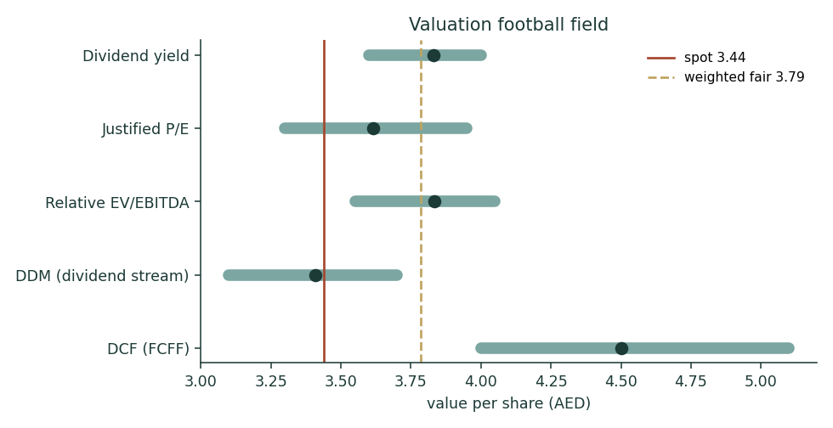
Figure 1. Valuation football field. Bars span bear–bull per lens; dots mark the base. Spot (red) sits between the DDM and the multiples; the DCF (gold dashed weighted-fair line at AED 3.79) is the outlier that pulls the mean up.
1.6 The two revenue legs — a deeper look
ADNOC Gas does not disclose per-segment volume × price in the granularity a full bottom-up build would require, so — per the data-discipline gate — we forecast top-down on disclosed margins and split the revenue illustratively 60/40. What we can anchor in observable units is the crux driver (below): the export leg is oil-linked, so Brent is the market quote we sensitise on, not an abstract margin.
Leg | Character | Sensitivity
Domestic gas (~60%, take-or-pay) | Contracted 25-yr SPA; volume-led; resilient | Low — pricing contractual, volumes grow with UAE industry
Liquids / LNG / condensate (~40%) | Oil-linked realisations; export markets | High — Brent/gas price; the earnings swing sits here
Group EBITDA margin | 36.8% FY25 → ~38.5% by 2030E | Domestic mix expansion the tailwind
Illustrative split; the domestic leg is the ballast, the export leg the variance.

Segment scorecard | 2026E | 2027E | 2028E | 2029E | 2030E
Revenue (USD m) | $23,950 | $25,100 | $26,900 | $28,400 | $29,600
EBITDA (USD m) | $8,862 | $9,412 | $10,168 | $10,849 | $11,396
EBITDA margin | 37.0% | 37.5% | 37.8% | 38.2% | 38.5%
Net income (USD m) | $5,596 | $5,890 | $6,273 | $6,719 | $7,053
Dividend (USD m) | $3,763 | $3,951 | $4,149 | $4,356 | $4,574
The forecast the two legs must jointly deliver. Dividend grows at the committed 5%; EBITDA growth is deliberately below management's '+40% by 2029' (we adopt the machinery, not the optimism).

1.7 The crux — oil-linkage and the distribution gate
Two things swing this valuation, and only one of them is about the business. First, the export leg's oil-linkage. We sensitise it in the observable unit — Brent $/bbl — rather than a margin percentage. A sustained $10/bbl move in Brent flows through the ~40% export leg to roughly ±$0.6–0.9 bn of EBITDA, or about ±AED 0.25–0.35 per share through the DCF; the domestic take-or-pay leg is insulated, which is exactly why the stock's realised volatility is so low. Second, and larger, the distribution gate: the AED 1.1 gap between the DCF (AED 4.50) and the DDM (AED 3.41) is the value of free cash the company generates above its dividend and retains as net cash. Whether that gap ever closes for the minority depends on capital allocation by an ~86% owner — special dividends, buybacks, or value-accretive deployment (Ruwais LNG) versus cash accumulation.
Binary event: A binary-event scenario belongs in the crux for this name because a single class of event can hit it hard: regional security. In June 2025 falling debris from an air-defence interception struck the Habshan complex, killing a contractor; supply was maintained through other facilities, but the episode is a concrete reminder that a Strait-of-Hormuz or facility-strike event is not tail-fiction here. We model this as the dominant left-tail driver in the Monte Carlo (a ~30% one-window probability of a ~−9% security shock), and note that a severe, sustained disruption to a major facility is the scenario that would break the thesis.
1.8 Macro and country — the UAE, the peg, Brent and Middle-East security
ADNOC Gas is a US-dollar business in all but listing currency: the dirham's peg at 3.6725 removes translation risk and lets us discount in USD. The macro variables that matter are (i) Brent and global gas/LNG prices, which set the export leg's realisations; (ii) US real rates, which set the discount rate for what is, functionally, a long-duration bond-proxy; (iii) UAE industrial demand, which drives domestic volumes (self-sufficiency policy, RGD, the Estidama pipeline to the Northern Emirates); and (iv) Middle-East security, the dominant risk premium. The sovereign backdrop is strong — a AA-rated sovereign, a parent (ADNOC) with vast reserves, and a government policy of gas self-sufficiency — which is why the dividend can credibly be discounted at a near-credit rate. Energy transition is a long-dated risk to terminal value rather than a near-term one: Gulf gas has decades of domestic power, industry and desalination demand plus an LNG export runway.
1.9 DCF sensitivity — WACC × terminal growth
Because 75% of the DCF is terminal value, the honest presentation is the grid, not the point. Fair value per share ranges from ~AED 3.66 (WACC 11.0%, g 1.5%) to ~AED 5.94 (WACC 9.0%, g 3.5%). Our base cell (WACC 10.0%, g 2.5%) sits at AED 4.50. The grid makes the dependency explicit and is why the DCF is weighted at only 0.20 in the synthesis.
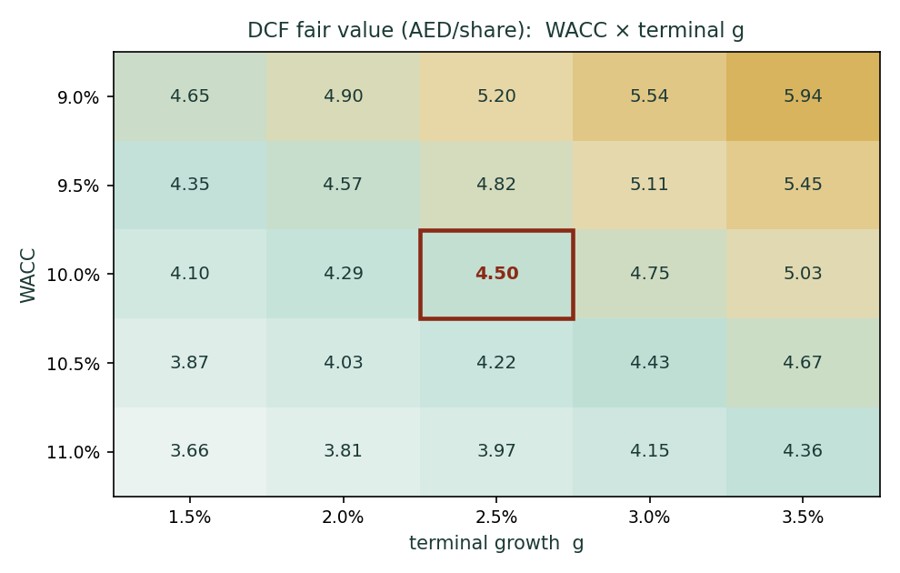
Figure 2. DCF fair value (AED/share), WACC × terminal g. The spread across a defensible grid is wide — the terminal-value dependency device (A-7) in one picture.
2 Technical and price structure
The tape is quiet and range-bound, consistent with a low-beta income name. The close (AED 3.44) sits almost exactly on its 20-day and 200-day moving averages (AED 3.42 and AED 3.42) and just above the 50-day (AED 3.34) — a flat, coiled structure with no trend to speak of. RSI(14) at 56 is neutral; MACD is marginally positive on the line (0.029) but with the histogram just below zero (-0.004), i.e. momentum flat-to-fading. The 52-week range is narrow (AED 3.14–3.72).
Indicator | Reading
Close | 3.44
SMA 20 / 50 / 200 | 3.42 / 3.34 / 3.42
RSI(14) | 56.5 (neutral)
MACD / signal / hist | 0.029 / 0.033 / -0.004
52-week low / high | 3.14 / 3.72
Prices AED. Computed 3 Jul 2026 from the attached history.

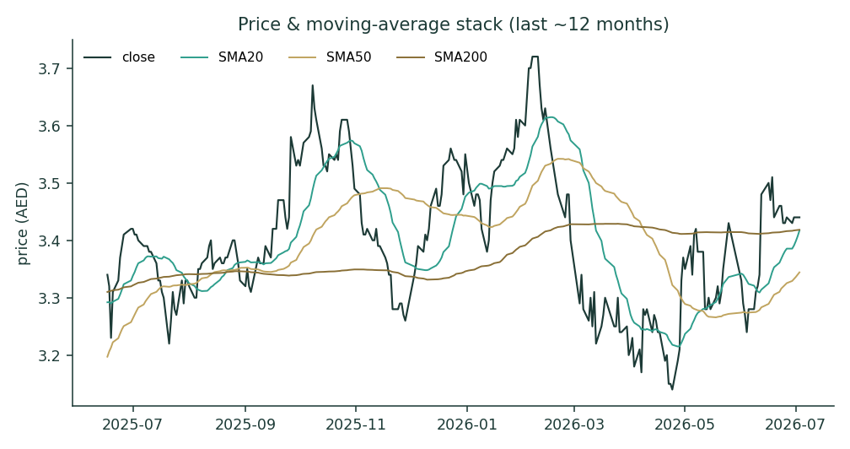
Figure 3. Price and 20/50/200-day moving-average stack (last ~12 months). A flat, mean-reverting structure.
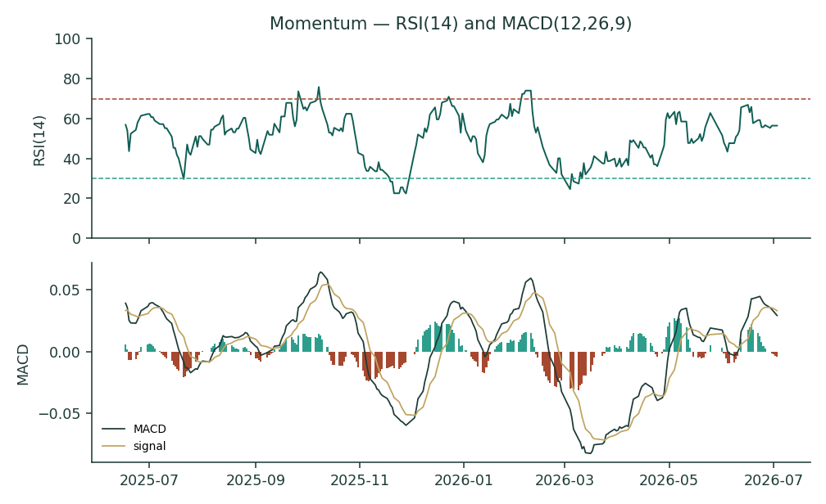
Figure 4. Momentum — RSI(14) and MACD(12,26,9). Neutral RSI; MACD histogram just negative.
The technical read adds no directional signal and, importantly, no drift to the Monte Carlo: for an international name a moving-average or momentum trend is exactly the kind of in-sample crutch that breaks at a regime turn, so drift is set to zero and the paths diffuse from spot.
3 Monte Carlo — a probabilistic price map
Volatility width is sized by the YZ-HAR engine — a pooled log-HAR cascade (variance lags 1/5/22) on a gap-aware Yang-Zhang variance proxy (overnight-return² + Rogers-Satchell), projecting the average daily variance over the next 60 sessions — not trailing close-to-close vol. Innovations are unit-variance Student-t(5), implemented as a per-path chi-square mixture so the 60-day aggregate keeps honest tails without a fat body. Drift is asset-class-conditional and here set OFF (international name). Sixteen factors — seven continuous, nine discrete — layer on top; the §1 value gap is deliberately kept out of the drift, so the fundamental and probabilistic lenses stay independent. 50,000 paths, seed 42.
Read the 50% band first. The engine's annualised width is 17.3% and the net 3-month factor contribution is a near-flat 1.7% — the paths diffuse from spot with a mild positive tilt (structural gas demand, dividend support) and a fat left tail (regional security). Lead with the interquartile band: at T+60 the middle 50% of outcomes spans roughly AED 3.22–3.75; the 5–95% cone spans AED 2.83–4.21.
Horizon (AED) | p5 | p25 | p50 | p75 | p95
T+20 sessions | 3.05 | 3.32 | 3.45 | 3.59 | 3.86
T+60 sessions | 2.83 | 3.22 | 3.48 | 3.75 | 4.21
Percentile map. At T+20 the band width is ≈ the T+60 width ÷ √3.

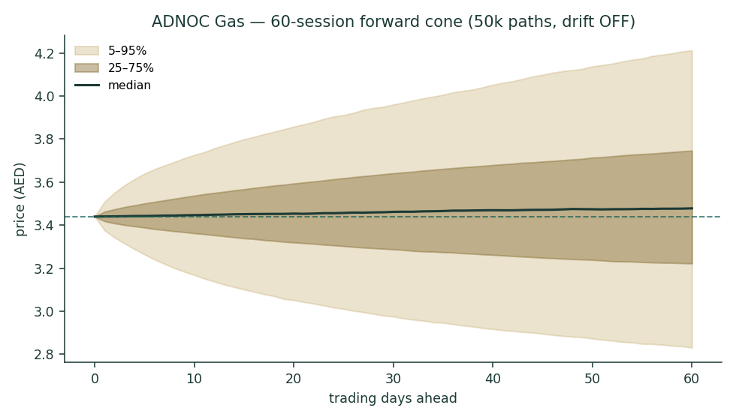
Figure 5. 60-session forward cone (50k paths, drift OFF). Median (dark) barely rises from spot; the fan widens symmetrically with a slightly heavier downside.
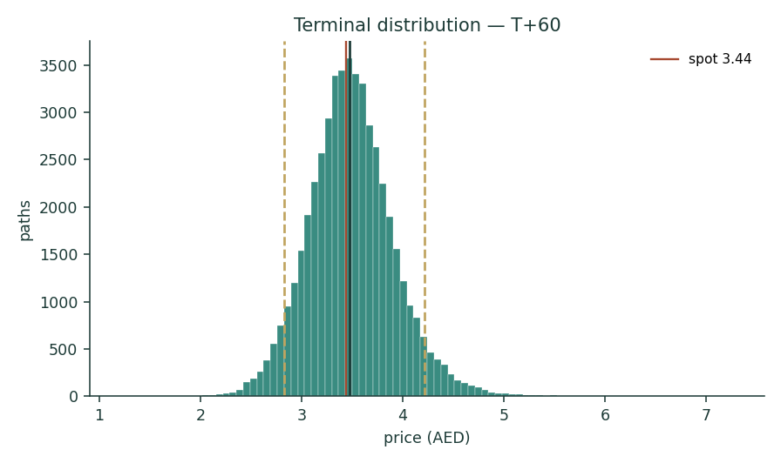
Figure 6. Terminal price distribution at T+60. Student-t(5) tails; median near spot.
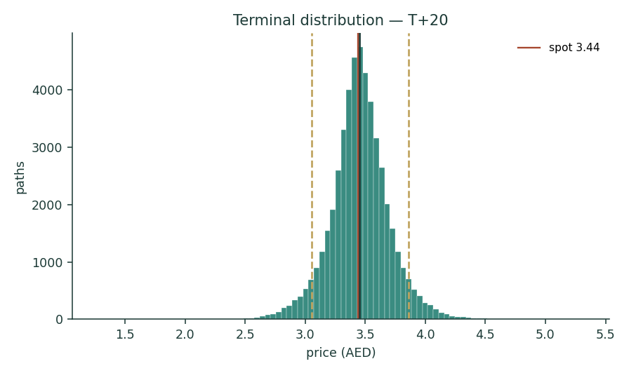
Figure 7. Terminal price distribution at T+20 — a tighter version of the same shape.
T+60 zone (vs spot) | Probability
< -10% | 16.0%
-10..-5% | 12.8%
-5..+5% | 34.8%
+5..+10% | 14.1%
>+10% | 22.2%
The modal outcome is 'within ±5% of spot' — a low-volatility, range-bound instrument.

Level (AED) | Touch by T+20 | Touch by T+60
3.90 | 5.5% | 24.7%
3.75 | 14.4% | 40.4%
3.65 | 27.1% | 54.6%
3.55 | 48.8% | 71.5%
3.35 | 48.5% | 68.2%
3.25 | 24.6% | 48.6%
3.15 | 13.1% | 34.2%
3.05 | 7.1% | 23.3%
Probability the path touches each level at least once within the window (running max for upside, running min for downside).

4 Comparison of the lenses, and a verdict
The three reads do not converge, and that is the finding. The DCF (AED 4.50) says the enterprise is worth ~30% more than spot. The DDM (AED 3.41) and the relative multiples (AED 3.6–3.8) say the shareholder is paid roughly fair. The Monte Carlo, independent of all of them, centres on spot with a modest positive tilt. We resolve this not by averaging to false precision but by naming what the spread measures: the distribution gate. ADNOC Gas is a high-quality, low-volatility, ~5%-yielding income instrument trading at a fair price for the cash it distributes, with additional enterprise value that is real but controlled by ADNOC's capital-allocation choices.
Verdict: Fairly valued to modestly cheap. The weighted fair value (AED 3.79) implies ~10% to the midpoint, but most of that upside is gated behind the payout policy and is terminal-value-dependent. This is a name to own for a defensible, growing 5% yield and optionality on capital returns — not for a re-rating thesis. The 50% band (AED 3.22–3.75 at T+60) frames the near-term risk symmetrically; the left tail is regional security.
5 Catalysts to watch
Catalyst | Sign | Why it matters
RGD phases 2 & 3 FID (targeted Q1 2026) | + | Confirms the +30% capacity / +40% EBITDA-by-2029 pathway
Ruwais LNG consolidation (H2 2028, at cost) | + / mixed | Doubles LNG capacity; accretive but capital-heavy and related-party
Dividend re-affirmation / step-up beyond 5% | + | Would narrow the DCF-vs-DDM gate directly
Brent / global gas price path | mixed | Sets export-leg realisations; the earnings swing
New long-term LNG SPAs (GAIL/JERA-type) | + | Locks export volumes and visibility
Regional security event (Hormuz / facility strike) | − | The dominant left-tail; Habshan 2025 is the precedent
Further ADNOC secondary placement / index weight | mixed | More float and liquidity vs near-term supply overhang
UAE gas-allocation / tax change | − | Domestic pricing or CIT/royalty shifts hit margin

6 Reading the probability zones
The distribution is deliberately centred near spot (drift OFF) with a mild upward tilt from the factor overlay. The probabilities below are the model's, not forecasts of fact: they say the modal 60-session outcome is a move of less than ±5% (34.8%), with the tails roughly balanced but the downside a touch heavier — the signature of a low-vol income name carrying a security-risk premium. Read the interquartile band (AED 3.22–3.75) as the genuine quarter-ahead uncertainty; the 90% cone is context, not the headline.
7 Caveats and what would change our mind
Caveat | Detail
Backtest history is short | Step 0 spans ~3.3 yrs (IPO Mar-2023), not a full 5; calibration is on all available data and passes, but the sample is thin
Terminal-value dependence | 75% of the DCF is terminal value; the point moves widely on (WACC−g) — hence the 0.20 weight and the grid in §1.9
Distribution gate is a governance call | The DCF premium accrues only if ADNOC distributes or deploys the retained cash; a minority cannot force it
Segment split is illustrative | No per-segment volume×price disclosure; we forecast top-down and sensitise Brent in real units rather than manufacture splits
Effective tax is a blend | 16% reconciles the 9% UAE CIT with the observed all-in rate; a lower true rate would raise the DCF, a higher one lower it
Balance-sheet detail is estimated | Anchored to disclosed equity, cash, net cash and debt; line items below those anchors are estimated
Model assumes the stated policy only | No incremental buybacks/specials are modelled, so cash accumulates — conservative for equity value, and the point of the gate discussion

Appendix A Financial statements
Adjusted/proportionate basis, USD m. FY2023–25 anchored to disclosed results; FY2026E–30E from the model (every cell links to the Assumptions sheet). These tables are identical to the companion Excel.
A.1 Income statement
USD m unless noted | 2023 | 2024 | 2025 | 2026E | 2027E | 2028E | 2029E | 2030E
Revenue | $22,830 | $24,428 | $23,473 | $23,950 | $25,100 | $26,900 | $28,400 | $29,600
EBITDA | $7,586 | $8,648 | $8,636 | $8,862 | $9,412 | $10,168 | $10,849 | $11,396
EBITDA margin | 33.2% | 35.4% | 36.8% | 37.0% | 37.5% | 37.8% | 38.2% | 38.5%
D&A | $1,300 | $1,600 | $1,900 | $2,000 | $2,250 | $2,550 | $2,750 | $2,900
EBIT | $6,286 | $7,048 | $6,736 | $6,862 | $7,162 | $7,618 | $8,099 | $8,496
Net finance cost | $1,017 | $1,094 | $586 | $200 | $150 | $150 | $100 | $100
Profit before tax | $5,269 | $5,954 | $6,150 | $6,662 | $7,012 | $7,468 | $7,999 | $8,396
Tax | $843 | $953 | $984 | $1,066 | $1,122 | $1,195 | $1,280 | $1,343
Net income | $4,426 | $5,001 | $5,166 | $5,596 | $5,890 | $6,273 | $6,719 | $7,053
EPS (AED) | 0.21 | 0.24 | 0.25 | 0.27 | 0.28 | 0.30 | 0.32 | 0.34
Dividend | $3,250 | $3,412 | $3,584 | $3,763 | $3,951 | $4,149 | $4,356 | $4,574
DPS (AED) | 0.16 | 0.16 | 0.17 | 0.18 | 0.19 | 0.20 | 0.21 | 0.22
Payout ratio | 73.4% | 68.2% | 69.4% | 67.3% | 67.1% | 66.1% | 64.8% | 64.9%
Source: ADNOC Gas FY2024/FY2025 results; forecast per model.

A.2 Balance sheet
USD m | 2023 | 2024 | 2025 | 2026E | 2027E | 2028E | 2029E | 2030E
Cash & equivalents | $3,500 | $4,200 | $5,060 | $5,442 | $6,482 | $7,556 | $10,819 | $14,047
Trade & other receivables | $2,500 | $2,700 | $2,600 | $2,653 | $2,780 | $2,980 | $3,146 | $3,279
Inventory | $300 | $320 | $300 | $306 | $321 | $344 | $363 | $378
Investments in JV/assoc. | $5,600 | $5,800 | $6,000 | $6,000 | $6,000 | $6,000 | $6,000 | $6,000
PP&E & intangibles | $14,980 | $16,300 | $18,040 | $19,340 | $20,090 | $20,940 | $19,890 | $18,990
Total assets | $26,880 | $29,320 | $32,000 | $33,741 | $35,673 | $37,819 | $40,217 | $42,694
Debt | $320 | $300 | $280 | $280 | $280 | $280 | $280 | $280
Provisions | $3,300 | $3,400 | $3,500 | $3,500 | $3,500 | $3,500 | $3,500 | $3,500
Trade & other payables | $2,980 | $3,150 | $3,170 | $3,234 | $3,390 | $3,633 | $3,835 | $3,997
Other liabilities | $400 | $1,000 | $2,000 | $1,845 | $1,681 | $1,461 | $1,293 | $1,130
Total liabilities | $7,000 | $7,850 | $8,950 | $8,859 | $8,851 | $8,873 | $8,909 | $8,907
Total equity | $19,880 | $21,470 | $23,050 | $24,882 | $26,822 | $28,946 | $31,309 | $33,787
Net cash / (net debt) | $3,180 | $3,900 | $4,780 | $5,162 | $6,202 | $7,276 | $10,539 | $13,767
Balances every year. Anchored to disclosed equity/cash/net cash/debt; line detail estimated.

A.3 Cash flow (forecast)
USD m | 2026E | 2027E | 2028E | 2029E | 2030E
Net income | $5,596 | $5,890 | $6,273 | $6,719 | $7,053
+ D&A | $2,000 | $2,250 | $2,550 | $2,750 | $2,900
− Δ working capital | ($150) | ($150) | ($200) | ($150) | ($150)
Operating cash flow | $7,446 | $7,990 | $8,623 | $9,319 | $9,803
− Capex | ($3,300) | ($3,000) | ($3,400) | ($1,700) | ($2,000)
Free cash flow | $4,146 | $4,990 | $5,223 | $7,619 | $7,803
− Dividends | ($3,763) | ($3,951) | ($4,149) | ($4,356) | ($4,574)
Net change in cash | $382 | $1,039 | $1,074 | $3,263 | $3,228
Closing cash | $5,442 | $6,482 | $7,556 | $10,819 | $14,047
Derived from the income statement and Assumptions drivers; ties to the balance-sheet cash line.

Appendix B Step 0 — calibration backtest
Before valuing the name we test the forecasting engine on the name's own history: a rolling backtest, horizon 60 sessions, scoring each realised close against the distribution the YZ-HAR engine (drift OFF) would have produced using only prior data. The grade is CRPS skill against a zero-drift random-walk cone (spot, trailing realised vol); band coverage and PIT are diagnostics only. Constraint: ADNOC Gas IPO'd in March 2023, so the sample spans 2023-03-14 to 2026-07-03 (~3.3 years, 825 sessions), not a full five — the backtest runs on all available history.
Metric | Result
CRPS skill vs random walk (non-overlapping, n=11) | +0.070 (pass, >0)
CRPS skill (dense origins, n=62) | +0.038 · block-boot 90% CI [+0.012, +0.074]
Mean Winkler score, model vs RW — 50/80/90% | 0.425/0.708/0.942 vs 0.486/0.794/1.018 (model tighter, all bands)
Interval coverage 50/80/90% (diagnostic) | 73% / 91% / 100%
PIT mean / std (diagnostic) | 0.54 / 0.26 (≈ uniform)
Passes: positive CRPS skill with the dense-origin CI entirely above zero, model interval scores beat the benchmark on every band, PIT near-uniform.

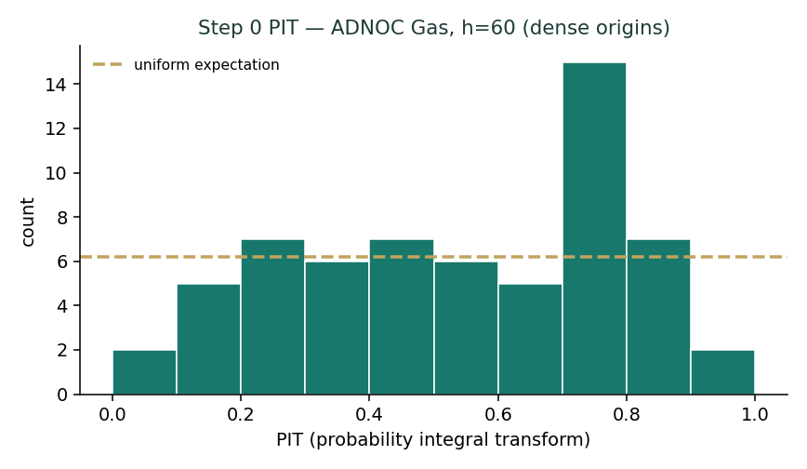
Figure B1. PIT histogram (dense origins). Roughly uniform against the gold expectation line — no material U-shape or skew.
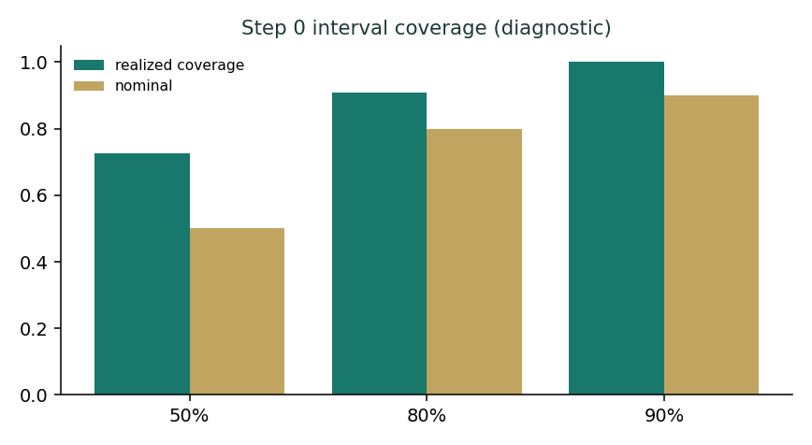
Figure B2. Interval coverage vs nominal (diagnostic only; band-containment is never the grade).
Appendix C Peer set, sector structure, and risks
No perfect comparable exists. ADNOC Gas is a contracted midstream/processing business with a commodity export sleeve and a sovereign parent — a hybrid of a Western midstream utility and a Gulf national-oil-company affiliate. The reference set therefore spans several cohorts.
Cohort | Names | Typical valuation
Global LNG / gas midstream | Cheniere, Williams, ONEOK, Enbridge, Sempra | EV/EBITDA ~9–12x; yield 3–7%
European gas infrastructure | Snam, Enagás, Fluxys | EV/EBITDA ~8–10x; high payout
APAC LNG producers | Woodside, Santos | EV/EBITDA ~5–7x; oil-linked
Gulf / ADX energy | ADNOC Drilling, ADNOC Distribution, Saudi Aramco | EV/EBITDA ~7–9x; 4–6% yield
ADNOC Gas (this study) | — | EV/EBITDA ~7.8x; ~5% yield

Risks: Sector risks, in order of materiality: Brent/oil-linkage on the ~40% export leg; regional security (Strait of Hormuz, facility strikes — Habshan 2025); gas-allocation and tariff policy in the UAE; controlling-shareholder capital allocation (the distribution gate); and energy transition as a long-dated terminal-value risk. The mitigants are structural: a 25-year domestic take-or-pay SPA, a net-cash balance sheet, a sovereign parent, and a government self-sufficiency policy that underwrites domestic volumes.

Appendix D The expert valuation panel
Three analysts, three genuinely different methods, cast by instrument (a capital-heavy, dividend-heavy operating company: earnings-power, cash-returns, and macro-policy). Each works a full valuation, sensitises the swing input, cross-examines the others, and states a falsification condition. They are labelled Expert 1/2/3; their fair values are logged against today's spot as an internal per-expert calibration layer.
How to read this panel. The three experts are not three opinions to be averaged; they are three methods stress-testing one another. Where they agree, the reader can be confident; where they diverge, the divergence itself is information. For ADNOC Gas they agree that the domestic business is a high-quality, contracted annuity and that the dividend is safe — and they disagree, sharply, on how to value the cash the enterprise generates above that dividend. That single disagreement is the whole valuation, and the panel is structured to make it visible rather than to paper over it.
D.1 Expert 1 — enterprise earnings power (DCF / FCFF)
Worldview and tradition. Expert 1 values a company as the present value of the cash the whole enterprise throws off, discounted at the return an equity owner requires. The instrument is a going concern with a defined pipeline; the right lens is a five-year FCFF DCF plus a terminal value. Assets are worth what they earn in cash, not what they distribute.
When it works / fails. It works for a stable, cash-generative operating company with visible volume growth — exactly this. It fails when the terminal value dominates (as here, at 75% of EV), because the answer becomes a bet on (WACC − g); Expert 1 concedes this openly and leans on the sensitivity grid rather than the point.
Standard workings. (1) Forecast revenue on domestic volume growth plus RGD/Ruwais capacity; (2) hold EBITDA margin drifting to ~38.5% on domestic mix; (3) NOPAT at a 16% blended tax; (4) add back D&A, subtract capex (front-loaded, including Ruwais at cost) and working capital; (5) discount at Ke = rf + β·ERP = 4.5%+1.00×5.5% = 10.0%; (6) Gordon terminal at g = 2.5%; (7) add net cash of $4,780.
Expert 1 — DCF | Value
Enterprise value | $89,256
Terminal value (% of EV) | 75.0%
Equity value (+ net cash) | $94,036
Fair value / share | 4.50

Worked example & sensitivity. At WACC 10.0% / g 2.5% the value is AED 4.50. On the grid it runs AED 3.66 (11.0%/1.5%) to AED 5.94 (9.0%/3.5%). A $10/bbl Brent move shifts EBITDA by roughly ±$0.7 bn and the value by ~±AED 0.30.
Cross-examination. To Expert 2: 'You value only the coupon and ignore that the firm earns far more than it pays — you are undervaluing the enterprise.' To Expert 3: 'Your Brent scenarios matter for one year of cash; my terminal value swamps them.'
Verdict, falsification, and what the price implies. Fair value AED 4.50; the enterprise is cheap. Falsified if free cash flow persistently fails to exceed the dividend (i.e. the retained-cash thesis is wrong) or if capex structurally overruns. The market price of AED 3.44 implies the market either applies a higher discount rate than 10% or refuses to credit the undistributed cash.
Method in depth. The unlevered-FCFF tradition — Williams, then Gordon-Shapiro, then the modern two-stage DCF — insists on valuing the firm before the financing, then reconciling to equity by adding net cash. Expert 1's discipline is that every forecast line must be defensible in its own right: revenue is not a growth-rate assumption but a volume-times-realisation build (domestic volumes tied to UAE industrial demand and the RGD capacity step; export realisations tied to the Brent deck); margin is not a wish but the observed 36.8% drifting on a stated domestic-mix shift; capex is not smoothed but front-loaded to reflect the $15 bn 2025-29 programme and the Ruwais LNG acquisition at cost in H2 2028. The terminal value is where honesty is tested, and Expert 1 refuses to hide it: at 75% of enterprise value it is disclosed on the face of the model and stress-tested on the grid, because a reader who cannot see the terminal-value dependency has not been shown the valuation.
The reinvestment check. Expert 1 will not credit growth that is not paid for. ADNOC Gas is spending roughly $3 bn a year to lift EBITDA ~40% by 2029; the implied incremental return on that capital must clear the 10% cost of equity for the growth to create value, and on the disclosed numbers it does — the domestic leg's contracted economics and the Ruwais consolidation are accretive. But Expert 1 flags the one place the DCF can flatter: the net-cash pile. Cash earning a Treasury yield is worth par, not a growth multiple; if ADNOC Gas simply accumulates cash rather than deploying or distributing it, the DCF's implied value is not created for the minority — it is warehoused. That is the bridge to Expert 2's objection, and Expert 1 concedes it is the fair one.
D.2 Expert 2 — cash returns (dividend discount)
Worldview and tradition. Expert 2 values a share as the present value of the cash the shareholder actually receives. For a name with a board-committed, multi-year, growing dividend and a controlling owner, the dividend is the honest object of valuation; enterprise cash the minority cannot claim is not the minority's value.
When it works / fails. It works precisely for high-payout, policy-driven income names with a dominant shareholder — this instrument's defining features. It fails for non-payers or names where distribution policy is about to change discontinuously; Expert 2 mitigates with a sustainability stress test.
Standard workings. (1) Take the committed DPS path growing 5% to 2030; (2) discount at a split cost of equity — the dividend is a sovereign-backed, contractually-supported claim, so 8.2%, below the 10.0% enterprise WACC; (3) Gordon terminal at g = 2.5%; (4) sum. Sustainability check: FY25 free cash flow exceeded the dividend by >$0.5 bn and the balance sheet is net cash, so the 5% path is covered even under a bear Brent.
Expert 2 — DDM | Value
Sum PV of explicit DPS (USD) | $0.2132
PV of terminal value (USD) | $0.7148
Fair value / share (USD) | $0.928
Fair value / share (AED) | 3.41

Worked example & sensitivity. At Ke 8.25% the value is AED 3.41 — essentially spot. At Ke 8.0% it is ~AED 3.57; at 8.75% ~AED 3.13. The valuation is far more sensitive to the discount rate than to one year's Brent, because the dividend is contractually smooth.
Cross-examination. To Expert 1: 'Your AED 4.50 is cash the minority may never see; ADNOC decides, not you. Value what is paid.' To Expert 3: 'Brent moves the coupon at the margin; the policy sets it. The dividend grew 5% in 2025 with Brent down 14%.'
Verdict, falsification, and what the price implies. Fair value AED 3.41; fairly valued as a dividend bond. Falsified if the dividend policy is cut or the growth path abandoned. The market price of AED 3.44 implies a market discount rate of ~8.25% on the dividend — a Gulf-USD credit-like rate, which is exactly how a sovereign-backed coupon should be priced.
Method in depth. Expert 2 stands in the dividend-relevance tradition — the view that, for a minority holder of a controlled company, the only cash flow with a claim is the distribution, and that a growing, policy-anchored dividend is both a valuation object and a signal of the board's confidence. The Gordon growth model is not a toy here: the dividend is contractually smooth (it rose 5% in 2025 while Brent fell 14%), the horizon is explicit (a $24.4 bn cumulative commitment to 2030), and the terminal is a modest 2.5% — so the model's inputs are unusually well-anchored for a DDM. The split cost of equity is the analytical crux: Expert 2 argues that discounting a sovereign-backed, contractually-supported coupon at the same rate as the volatile total-enterprise cash stream is a category error, and that the correct rate is a Gulf-USD credit rate (~8.25%) — which is, not coincidentally, the rate the market itself is applying, since the DDM at 8.25% lands on spot.
The sustainability stress test. A DDM is only as good as the dividend's durability, so Expert 2 runs the bear case explicitly: at Brent $55, export-leg EBITDA falls but the domestic take-or-pay leg (the majority of EBITDA) is insulated by the 25-year SPA, group free cash flow still covers the dividend, and the net-cash balance sheet provides a further buffer — FY2025 free cash flow exceeded the payout by more than $0.5 bn even at Brent $69. The conclusion is that the 5% path survives a materially worse commodity environment; the dividend is not the risk. What Expert 2 will not do is credit the retained cash: 'the day ADNOC declares a special dividend or a buyback, I will value it — not before.'
D.3 Expert 3 — macro-policy (gas price, oil-linkage, sovereign & security)
Worldview and tradition. Expert 3 starts from the top down: the value of an energy affiliate is set by the commodity price deck, the policy and fiscal regime, and the geopolitical risk premium — the equity is a leveraged claim on those macro variables. The method is scenario analysis on the price deck and a security-risk overlay, not a spreadsheet extrapolation.
When it works / fails. It works when a single macro axis dominates the outcome — here, Brent for the export leg and Hormuz for the tail. It fails to price idiosyncratic execution and can be too pessimistic on tail risk; Expert 3 anchors to base rates rather than headlines.
Standard workings. Build three Brent scenarios (bear $55, base $69, bull $85) and map each to export-leg EBITDA and thus to fair value; overlay a security-risk premium calibrated to a ~30% one-window probability of a ~−9% shock (the Habshan base rate); and normalise the domestic leg on the contracted SPA, which is insulated. The output is a distribution, not a point — which is why Expert 3 defers to the Monte Carlo for the near-term map.
Expert 3 — macro scenarios | Fair value
Bear Brent $55 → fair value | ~AED 3.20
Base Brent $69 → fair value | ~AED 3.75
Bull Brent $85 → fair value | ~AED 4.30
Security-risk overlay | −AED ~0.15 expected-value drag

Worked example & sensitivity. The swing input is Brent in $/bbl (not a margin %): each $10/bbl is ~±AED 0.25–0.35. The security overlay is the dominant left-tail; a sustained facility strike is the scenario that dwarfs any price move.
Cross-examination. To Expert 1: 'Your terminal value assumes a benign 2030s for gas; price in transition and Hormuz.' To Expert 2: 'Your smooth coupon is smooth until a facility is offline — the SPA does not deliver gas that isn't processed.'
Verdict, falsification, and what the price implies. Fair value AED ~3.75 base (range AED 3.20–4.30 on Brent), before the security drag. Falsified if the export leg decouples from Brent or if a security event repriced the whole complex. The market price of AED 3.44 implies a Brent deck around the mid-$60s and a contained security premium.
Method in depth. Expert 3 works in the commodity-equity tradition: an energy affiliate is a leveraged claim on a price deck and a policy regime, and the equity value is dominated by a small number of macro axes rather than by line-item extrapolation. The method is deliberately top-down — build the Brent scenarios, map each to the oil-linked export leg, hold the contracted domestic leg roughly constant, and overlay a geopolitical risk premium. Expert 3's insistence is on native units: the crux is expressed as Brent in dollars per barrel, because that is a quoted, tradable price, whereas an 'export-margin assumption' is two guesses multiplied. The domestic leg is treated as a bond — the 25-year SPA insulates its volume and pricing — so the entire earnings variance is pushed onto the ~40% export sleeve, which is where Expert 3 spends the analysis.
The base-rate overlay. On security, Expert 3 refuses both complacency and headline-chasing, and instead reasons from base rates: the Habshan episode of June 2025 is a realised data point that a facility-affecting event has a non-trivial annual probability, and it is modelled as roughly a 30% chance per 60-session window of a ~-9% shock — enough to matter to the tail without dominating the central case. The distinction Expert 3 draws is between price risk, which is symmetric and diversifiable, and disruption risk, which is asymmetric and specific: 'the SPA promises to deliver gas that is processed; it does not deliver gas from a facility that is offline.' This is why Expert 3 defers the near-term price map to the Monte Carlo, whose fat left tail is calibrated to exactly this risk.
D.5 The three in one room
Put on the table the one thing they most disagree on — the AED 1.1 gap between enterprise value and the dividend.
Expert 1: 'The firm earns roughly $5 bn of net income and pays out $3.6 bn. That retained billion-plus a year is real value — capitalise it. The enterprise is worth AED 4.50 and the market pays 3.44.'
Expert 2: 'Value what is paid, not what is earned. ADNOC owns 86% and decides. Until that cash is distributed or deployed accretively for me, it is worth a discount, not par. My AED 3.41 is the honest number, and the market agrees with me, not you.'
Expert 3: 'You are both assuming the cash keeps coming. It comes if Brent holds and the Strait stays open. Size the tail first; the gap between your two numbers is a governance option, and options have a price only if the underlying survives.'
Second round. Expert 1: 'Fine — value the cash as warehoused, at par. Even at par, net cash of nearly $5 bn is AED 0.23 a share the market is not crediting, and the deployment optionality is free.' Expert 2: 'Optionality controlled by someone else is not free to me; it is worth a discount for the wait and the uncertainty.' Expert 3: 'And both of you are pricing a benign Strait. Widen the tail and the discount on the option widens with it — that is the number you are really arguing about.'
D.6 Reading the divergence
Expert / method | Fair value (AED) | The one assumption that drives it
Expert 1 — DCF / FCFF | 4.50 | (WACC−g) and crediting retained cash
Expert 2 — DDM | 3.41 | the discount rate on the committed dividend
Expert 3 — macro scenarios | ~3.75 | the Brent deck and the security premium
Weighted fair value | 3.79 | the blend of the three
Spot | 3.44 | —
The spread (AED 3.41–4.50) is not noise. It is the price of the distribution gate — the value that exists in the enterprise but is controlled by the majority owner. That is what a minority shareholder is really deciding about.

What the spread measures. The AED 3.41-4.50 range across the three experts is not a failure to converge; it is the valuation's most useful output. Its width is the price of a single, nameable thing — the distribution gate. Expert 2's low number is the value of the cash that is contractually promised to flow to the shareholder. Expert 1's high number is the value of all the cash the enterprise generates. The difference between them is the free cash the company retains and the majority owner controls: a governance option whose payoff depends on future capital-allocation decisions and, as Expert 3 insists, on the underlying surviving intact. A reader who understands that the entire spread is this one option has understood the name better than any single point estimate could convey — which is exactly why Testahil publishes the spread and the distribution, and never a single target.

About this series
Testahil publishes independent, educational valuation studies under a single brand — distributions, not tips. Each study applies the same three-part method (fundamental, technical, probabilistic) to a listed company and invites scrutiny of the methodology. We publish fair-value ranges and probability distributions, never a rating, price target, or recommendation. Forecasts are graded after the fact against a random-walk benchmark on a public calibration ledger.
Disclosure & Disclaimer
Not investment advice. This document is a valuation exercise and an expression of personal analytical opinion, published free of charge for educational purposes. It is not investment advice, and not a recommendation or solicitation to buy, sell or hold any security.
Not directed at you. Nothing here is tailored to the financial circumstances, objectives or risk tolerance of any reader. Consult a licensed financial advisor before any investment decision.
No licence, no clients. The preparer is not licensed or authorised by any securities regulator in any jurisdiction, holds no brokerage authorisation, provides no financial consultancy, manages no money, and accepts no fees, funds or clients.
Model outputs, not facts. All values are outputs of models built on assumptions that are disclosed and flagged throughout, and are presented as ranges and distributions because no single number should be relied on. Historical financials are the company's own disclosure; forward-looking inputs are the preparer's judgments.
No warranty. The information is provided 'as is' without warranty of any kind. The preparer accepts no liability for any loss arising from its use.
Position disclosure. The preparer may hold, and may in the future take or dispose of, a position in the security discussed in this report.
Testahil · Independent Valuation Study — Educational Analysis · ADNOC Gas plc (ADX: ADNOCGAS) · edition 4 July 2026

