Testahil · Independent Valuation Study — Educational Analysis Not investment advice

Independent Valuation Study — Educational Analysis
Alpha Dhabi Holding PJSC (ADX: ALPHADHABI)
Fundamental analysis · Technical analysis · Monte Carlo simulation — one integrated read
Anchor: AED 8.22 (3 Jul 2026 close — see the READ FIRST note on the 7–9 Jul war escalation) · 10,000 mn shares · mkt cap AED 82.2 bn (~US$22.4 bn) · Abu Dhabi’s IHC-controlled investment holding across five verticals: listed stakes (Aldar Properties 31.63%, NMDC Group 76.68%, PureHealth 35.06%, NCTH 73.73%), construction (Trojan Construction Holding 51%, co-owned with ADQ), plus industrial, hospitality and services & other portfolios · reporting currency AED (pegged to USD at 3.6725) · prices and probabilities computed from the attached daily history to 3 Jul 2026 · primary lens: mark-to-market sum-of-the-parts NAV, cross-checked by a consolidated FCFF DCF, look-through relative multiples and the stated dividend policy · the swing factor: the premium the market pays above marked NAV (§1.7), against a live Gulf-war tail.
READ FIRST — what this document is, and is not.
This study is a valuation exercise and an expression of personal analytical opinion, published free of charge for educational purposes: it shows how one analyst applies fundamental, technical and probabilistic methods to a listed company, and invites scrutiny of that methodology. It is NOT investment advice, NOT a recommendation or solicitation to buy, sell or hold any security, and NOT directed at the circumstances of any reader. The preparer is not licensed by any securities regulator in any jurisdiction, holds no brokerage or advisory authorisation, provides no financial consultancy, manages no money, and accepts no fees, funds or clients. See the Disclosure & Disclaimer at the end.
All values are model outputs presented as ranges and distributions because no single number should be relied on. Reported financials are the company’s own disclosure: the audited FY2025 consolidated financial statements (Deloitte, released 10 Feb 2026), the FY2024 audited statements and management discussion & analysis (alphadhabi.com), and the Q1-2026 results release (4 May 2026). One balance-sheet line — FY2025 total borrowings — is a derived figure (FY2024 base plus audited FY2025 financing cash flows) because the borrowings note page was not machine-extractable; it is flagged wherever used, and the derivation is known to omit non-cash additions — lease liabilities recognised at inception (IFRS 16), debt inherited on consolidating NCTH in Jan-2025 (IFRS 3) and FX/accrual effects — so it more likely UNDERstates gross debt than overstates it; the ±AED 5 bn stress columns in §1.9 bound the effect at ±AED 0.5/share, and the exposure is confined to the 15%-weight DCF (the NAV lens builds from book equity and subtracts no debt). Forward-looking inputs — growth, margins, working-capital absorption, the cost of capital, the multiples and the holdco discount — are the preparer’s judgments and are flagged throughout.
TIMING NOTE. The price series ends 3 Jul 2026. On 7–8 Jul 2026 the April Iran–Israel/US ceasefire collapsed (renewed US strikes; Brent ~$77.5 after April’s $126 peak). Every price, percentile and probability in this study is computed as of the 3 Jul close and does not embed that escalation; §3 and §7 treat it explicitly as a live left-tail. Consult a licensed financial advisor before any investment decision.

The company
Alpha Dhabi Holding is Abu Dhabi’s second-largest listed investment holding, assembled since 2021 under International Holding Company (IHC) as a permanent-capital owner of controlling and strategic stakes rather than an operating business in its own right. It makes money three ways: consolidated operating profits from the businesses it controls (Trojan’s construction backlog, NMDC’s marine-dredging and EPC book, NCTH’s hotels, an industrial portfolio), equity-method and dividend income from large minority stakes (31.6% of Aldar, the emirate’s dominant developer; 35.1% of PureHealth, the largest GCC healthcare platform), and fair-value gains on a growing financial-investment book that contributed AED 3.2 bn in FY2025 alone. Its moat is positional rather than operational: proximity to Abu Dhabi’s state-linked project pipeline through IHC and ADQ relationships, first-call access to capital, and board control of assets that themselves hold franchise positions (Aldar in Abu Dhabi real estate, NMDC in Gulf marine works, Trojan as the UAE’s largest contractor). The scale is substantial — FY2025 revenue of AED 78.8 bn, total assets of AED 214 bn, and roughly AED 46 bn of listed-stake value at current marks — which places it among the Gulf’s largest diversified holdings. Positioning is the tension this study prices: a 33% one-year de-rating has brought the shares from a large premium toward, but not yet below, the marked value of what the holding owns.
Alpha Dhabi at a glance
Item | Value
Listed entity | Alpha Dhabi Holding PJSC, ADX: ALPHADHABI · parent: International Holding Company (IHC)
What it is | Investment holding: listed stakes (Aldar, NMDC, PureHealth, NCTH) + Trojan construction + industrial, hospitality, services & other portfolios
Spot / date | AED 8.22 · 3 Jul 2026 close (see READ FIRST timing note)
Shares · market cap | 10,000 mn · AED 82.2 bn (~US$22.4 bn)
FY2025 revenue / adj. EBITDA / net profit | AED 78,775 mn (+24%) · AED ~17.7 bn adjusted · AED 15,032 mn total, of which AED 8,014 mn attributable (EPS 0.79, −10% y/y)
Q1-2026 revenue / net profit | AED 18,790 mn (+8%) · AED 3,800 mn total (+81%, fair-value-gain driven; attributable split not yet published — derived estimate, flagged: AED 2.0–2.5 bn, spanning the FY25 proportional split (53.3%) and an FV-skew-to-parent scenario (65%))
Segment revenue (FY2025) | Industrial AED 28.8 bn · Real estate 27.8 bn · Construction 13.1 bn · Services & other 9.1 bn
Balance sheet (FY2025) | Assets AED 214.4 bn · owners’ equity 60.1 bn · NCI 42.1 bn · hybrids 1.8 bn · cash & bank 40.3 bn · borrowings ≈41.4 bn (derived — flagged) · net debt ≈ AED 1.1 bn
Key stakes (audited FY25) | Aldar 31.63% (consolidated) · NMDC Group 76.68% (up from 66.91%) · PureHealth 35.06% (associate) · NCTH 73.73% (consolidated Jan-25) · Trojan 51% (ADQ 49%)
Dividend | Stated 3-year policy from FY2025: AED 2 bn/yr (20 fils/sh, ~2.4% yield) growing +5%/yr; FY25 distribution paid Q1-2026
52-week range | AED 6.84 (31 Mar 2026, war trough) – 12.58; 1-yr return −33%
Ownership | IHC Capital Holding 75.76% direct; with West Investments SPV 8.36% and Connaissance Investment 6.56%, disclosed anchor holders total ~90.7% (ADX registry via Mubasher profile) — free float ~9%, thinner than the ~87% press figure the first edition carried
Corporate events | NMDC buy-up to 76.68% — the AD Ports 9.77% block (82.5 mn sh) for AED 1.6 bn, 27-Nov-25 · NCTH consolidation (Jan-25) · dividend policy adopted (GA 12 Jan 2026) · buyback running · Q2-26 results due ~Aug 2026

Source: audited FY2025 consolidated FS (Deloitte, 10 Feb 2026); FY2024 audited FS + MD&A (alphadhabi.com); Q1-2026 release (4 May 2026); ADX quotes. Values rounded; the borrowings line is derived and flagged.
Headline
The model’s read: fully valued — after a 33% one-year de-rating the market still pays a premium to what the holding’s parts are worth at today’s marks. At AED 8.22 the shares sit about 15% above our weighted central estimate of AED 7.13, and roughly 10% above the undiscounted mark-to-market NAV of AED 7.44 — before applying any holdco discount at all. The primary lens is the sum-of-the-parts: marking the four listed stakes at exchange prices (AED 20.5 bn Aldar, 14.4 bn NMDC, 8.6 bn PureHealth, 2.4 bn NCTH), Trojan at the price ADQ actually paid for its 49% (AED 5.2 bn for ADH’s 51%), and the rest of the parent’s audited book at carrying value gives AED 74.4 bn, or 7.44/share at par and 6.32 at a 15% holdco discount. A consolidated FCFF DCF lands far higher at 11.72 — but four-fifths of it is terminal value and it credits the owners with cash that today is being swallowed by working capital (FY2025: AED 7.5 bn absorbed, roughly half of every incremental revenue dirham), so it is weighted as a ceiling, not an anchor. Look-through earnings multiples give 8.07; the stated dividend policy discounts to just 4.55, a reminder of how little of the group’s AED 15 bn profit actually leaves the holdco. The crux is concrete (§1.7): the AED 8 bn the market pays above marked NAV is a bet that IHC-ecosystem deal flow and fair-value gains keep compounding book value faster than a standalone owner could — defensible in 2023–24, harder after two straight years of falling attributable earnings. Technically the tape has bounced hard off the March war trough (RSI 64, price above the 20/50/100-day stack but still 7% below the 200-day). Over three months the Monte Carlo — carry-anchored, zero equity drift, the configuration that passed Step-0 calibration at parity — puts the 5th–95th band at AED 6.30–10.93 with the median at 8.29 and the 50% core at 7.42–9.27; the 7–8 Jul war re-escalation is a live left-tail on top of that map, not inside it.
Valuation summary — every read at a glance
One table for the four reads that follow — what the holding is worth (fundamental), what the tape is doing (technical), where price could travel over three months (Monte Carlo), and how three independent expert methods land. Every row is developed in the sections and appendices below.
Lens / read | What it measures | Output | Takeaway
FUNDAMENTAL — what the holding is worth (the anchor)
SOTP / NAV (primary) | Listed stakes at market + Trojan at the ADQ mark + residual audited book, less a 0–25% holdco discount | AED 5.58–7.44 (base 6.32) | -23% vs spot
Consolidated FCFF DCF | Group operating cash engine, owners’ 53.3% share | AED 11.72 | +43% · the ceiling
Relative (look-through P/E) | FY26E attributable EPS × justified 8–11× | AED 8.07 | -2%
Dividend policy (DDM) | AED 2 bn/yr +5% policy, discounted at Ke | AED 4.55 | -45% · cash that leaves
Weighted central | Blend 55 / 15 / 15 / 15 | AED 7.13 (5.95–8.63) | -13% vs AED 8.22
TECHNICAL — what the tape is doing (timing, not value)
Trend & momentum | Price vs the 20/50/100/200-day averages | Above 20/50/100-day; ~7% below the 200-day | War-trough recovery
Momentum / range | RSI · MACD · 52-week range | RSI 64 · MACD hist -0.004 · 6.84–12.58 | Warm, extended
MONTE CARLO — where price could go in 3 months (paths from spot)
T+20 sessions | 50,000 paths · carry-anchored, zero equity drift | p5 7.04 · p50 8.24 · p95 9.67 | Median ≈ spot
T+60 sessions | same engine, longer horizon | p5 6.30 · p50 8.29 · p95 10.93 | P(up) 52%
EXPERT PANEL — three independent methods (Appendix C)
Expert 1 — NAV & the discount | Marked NAV with the empirical holdco-discount band | AED 6.3 | The anchor restated
Expert 2 — look-through earnings | Owners’ share of each asset’s profit × through-cycle multiple | AED 6.78 | The earnings floor
Expert 3 — regime scenario tree | Risk-on / NAV-gravity / war-stress states | AED 7.03 | Probability-weighted
Panel range | Spread = how fast the premium closes | AED 6.3–7.0 | All below spot

Bottom line. Three of the four fundamental lenses — and all three independent experts — land below the AED 8.22 spot; only the consolidated DCF sits above it, and §1.2 explains why that lens flatters a holdco. The weighted central of AED 7.13 is 13% below spot. This is not a broken story — the parts are real, the listed marks are observable, book value has compounded at ~19% a year since 2023 — it is a pricing question: after the de-rating the shares still trade at roughly 1.37× the parent’s audited book and ~10% above marked NAV, levels that assume the FV-gain engine and the IHC deal pipeline keep delivering. The three-month distribution centres at spot with a mild upside tilt from the carry anchor and the post-trough tape — with the July war re-escalation as the explicit, unpriced left-tail.
1 Fundamental valuation
We value Alpha Dhabi as what it is — a holding company — and triangulate four lenses. The primary lens is a mark-to-market sum-of-the-parts NAV, because a holdco is ultimately worth what its assets would fetch, and four of its largest assets are quoted every day on the ADX while a fifth (Trojan) was priced by an arm’s-length transaction with ADQ. A consolidated FCFF DCF is retained as a cross-check on the group’s cash engine but weighted lightly: it consolidates cash that belongs 47% to minorities, and its value is dominated by a terminal assumption. A look-through relative read and the stated dividend policy complete the set. The weights and the range are in §1.5; the segments and the per-driver sourcing gate in §1.6; the crux — the premium over NAV, in real dirhams — in §1.7; the sourced cost of capital (both ERP bases published) in §1.8; the sensitivity grids in §1.9. One lens-selection note: Trojan and NMDC give the group a genuine contractor leg, but the group discloses no contractor-grade orderbook/burn detail at the parent level, so the FCFF+SOTP contractor treatment is applied through the stake marks rather than a bottom-up backlog build — a justified N/A recorded in the driver gate. Throughout, the cost of equity is published explicitly as Ke = rf + β × ERP = 4.75% + 1.0 × 4.87% = 9.62% (rating basis; 9.68% on the CDS basis), with β = 1.0 a disclosed default after the regression failed its usability gate (no usable ADX index series), not an assumption smuggled in.
1.1 Sum-of-the-parts NAV — the primary lens
The construction is deliberately boring: take the parent’s audited FY2025 book equity of AED 60.1 bn, strip out the carrying values of the five assets we can price externally, replace them with their market or transaction marks, and keep everything else at book. Two of the five (Aldar, PureHealth) are liquid ADX large-caps; NMDC and NCTH are quoted but with ADH holding most of the float; Trojan is marked on the buyer-outlay basis of the FY2024 ADQ transaction — ≈ AED 5.0 bn for 49% (AED 4,997 mn on ADH’s audited FY24 cash-flow proceeds line; ~5,043 mn on ADQ’s side per its FY24 statements and GMTN prospectus) — a real price from a sophisticated buyer, aged eighteen months and flagged as such. The transaction has a second legitimate framing, stated per house rule: ADH’s own disposal note records consideration of AED 3,562 mn for the 49%, with AED 1,456 mn credited to non-controlling interests and ~2,105 mn to retained earnings (the IFRS-10 no-loss-of-control mechanics). On that seller-note basis Trojan at 100% is AED 7.3 bn, not 10.2 — the sensitivity below the table carries it.
Asset | Stake | Mark basis | 100% value (AED bn) | ADH share (AED bn) | Carried (est., AED bn)
Aldar Properties | 31.63% | ADX mcap 64.87 bn (Jul-26) | 64.87 | 20.52 | 11.07
NMDC Group | 76.68% | ADX mcap 18.79 bn | 18.79 | 14.41 | 8.82
PureHealth | 35.06% | ADX mcap 24.56 bn | 24.56 | 8.61 | 12.80
NCTH | 73.73% | ADX mcap ~3.27 bn (thin float) | 3.27 | 2.41 | 2.21
Trojan Construction | 51% | ADQ 49% deal, buyer-outlay ≈5.0 bn (FY24) | 10.2 | 5.20 | 1.94
Marked assets subtotal |  |  |  | 51.15 | 36.84
Residual book (everything else, at carrying value) |  | Parent book 60.10 − carried stakes 36.84 |  | 23.26
Mark-to-market NAV |  |  |  | 74.4
NAV per share (10,000 mn sh) |  |  |  | AED 7.44

Stakes from the audited FY2025 subsidiaries/associates notes; marks from ADX quotes (early Jul-26) and the audited FY2024 ADQ transaction. Carried values are the preparer’s allocation of the parent book across the marked assets (recorded in the Fundamental Driver Ledger); the NAV total does not depend on that allocation, only on the parent book total and the external marks.
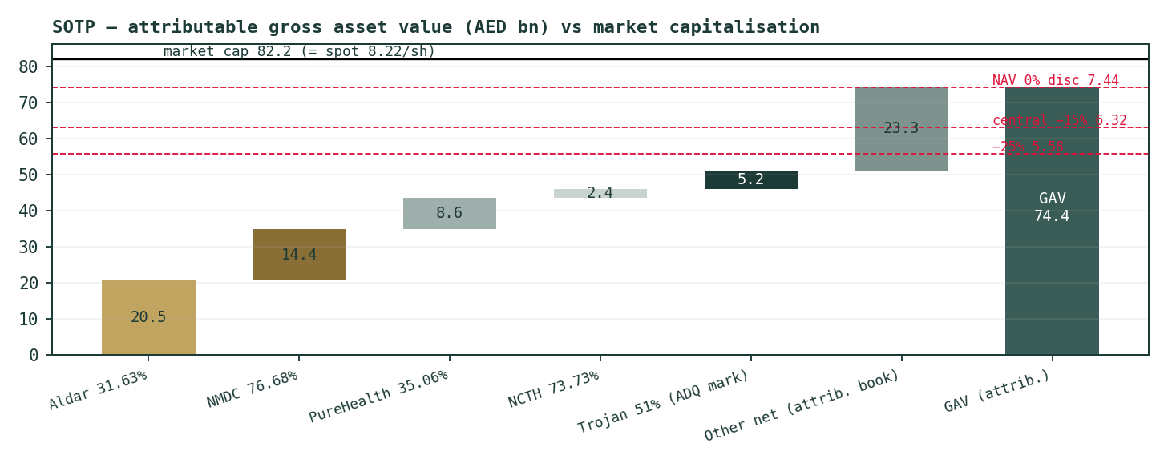
Figure 1 — The SOTP waterfall: from the parent’s audited book to marked NAV, against the AED 82.2 bn market capitalisation. The gap between the last bar and the mcap line is the holdco premium of §1.7.
Trojan-basis sensitivity (dual framing): on the seller-note consideration of AED 3,562 mn the 100% value is AED 7.3 bn and the 51% mark AED 3.71 bn — marked NAV falls to AED 72.9 bn, par NAV to 7.29/share and the 15%-discount central to 6.20. Every verdict in this study survives that framing: spot would then sit ~13% above even par NAV rather than ~10%. The buyer-outlay basis is retained as central because it is the price a sophisticated arm’s-length buyer actually committed; both note extractions are logged as an open Fundamental Driver Ledger row.
Holdcos rarely trade at par: information asymmetry, capital-allocation risk, structural NCI leakage and thin floats justify a discount, and GCC/EM precedent runs roughly 10–25% for diversified holdings. We publish the band rather than pick a point:
Holdco discount | 0% (par) | 10% | 15% (base) | 20% | 25%
NAV per share (AED) | 7.44 | 6.70 | 6.32 | 5.95 | 5.58
vs spot 8.22 | -9% | −18% | -23% | −28% | -32%

Read it plainly: the market is not debating the size of the discount — it is paying a premium. Spot exceeds even the undiscounted NAV by ~10%. That is the number the rest of this study interrogates.
1.2 The consolidated FCFF DCF — the full waterfall, and why it is a ceiling
The DCF is built on the consolidated group because that is what the audited statements describe, then hands the owners their 53.3% (the FY2025 attributable share of profit, used as a proportional NCI proxy — a disclosed simplification). Revenue grows 9% fading to 5% (Q1-26 ran +8%; Aldar’s AED 71.7 bn backlog underwrites the near years), the adjusted EBITDA margin holds at FY2025’s 22.5%, capex fades from 7.1% of revenue toward 5.5%, tax glides from the 10.2% actual ETR to the statutory 15% DMTT, and — the driver that matters — incremental working capital absorbs 45% of each new revenue dirham in 2026, fading to 20% as collections catch up with the construction and development ramp. Every line of the waterfall is shown; a DCF that shows only its output is a hard QC fail under house rules.
AED bn | 2026E | 2027E | 2028E | 2029E | 2030E
Revenue | 85.86 | 92.73 | 99.22 | 105.18 | 110.44
EBITDA | 19.29 | 20.84 | 22.30 | 23.63 | 24.81
less D&A | −3.52 | −3.80 | −4.07 | −4.31 | −4.53
EBIT | 15.77 | 17.03 | 18.23 | 19.32 | 20.29
NOPAT | 13.88 | 14.82 | 15.68 | 16.42 | 17.24
add D&A | 3.52 | 3.80 | 4.07 | 4.31 | 4.53
less Capex | −5.58 | −5.84 | −5.95 | −6.10 | −6.07
less ΔWC | −3.19 | −2.61 | −1.95 | −1.49 | −1.05
FCFF | 8.63 | 10.17 | 11.84 | 13.15 | 14.65
Discount factor | 0.921 | 0.848 | 0.780 | 0.719 | 0.662
PV of FCFF | 7.94 | 8.62 | 9.24 | 9.45 | 9.69

Bridge (AED bn unless noted) | Value
Sum PV of FCFF (2026–30) | 44.9
Terminal value (g = 3.0%, WACC 8.61%) | 268.7
PV of terminal value | 177.7
Enterprise value | 222.7
Terminal value as % of EV — disclosed, not buried | 80%
less Net debt (derived — flagged) | −1.1
less Hybrid perpetual notes | −1.82
Equity value (owners + NCI) | 219.8
Owners’ share (attributable ratio 53.31%) | 117.2
Per share (AED) | 11.72

AED 11.72 is nearly 43% above spot — and it should be read as a multi-year ceiling, for three stated reasons. First, 80% of the value is a terminal assumption about a portfolio whose composition IHC can and does change. Second, the proportional-NCI simplification hands owners 53% of every subsidiary’s cash including businesses (NMDC at 77%, NCTH at 74%) where their true claim differs asset by asset. Third, and decisively for the near term, the group’s realized cash conversion is far below the model’s steady state: FY2025 CFO was AED 9.6 bn against AED 15.0 bn of profit, with AED 7.5 bn absorbed by working capital. The DCF describes what the engine could pay its owners once that absorption normalizes — a fair description of upside, a poor description of the next twelve months. It carries a 15% weight.
1.3 Relative value — the look-through multiple
For a holdco the honest relative question is not “what multiple does the wrapper trade at” but “what are you paying for the earnings you actually own, and what would those earnings cost you directly on the exchange?”
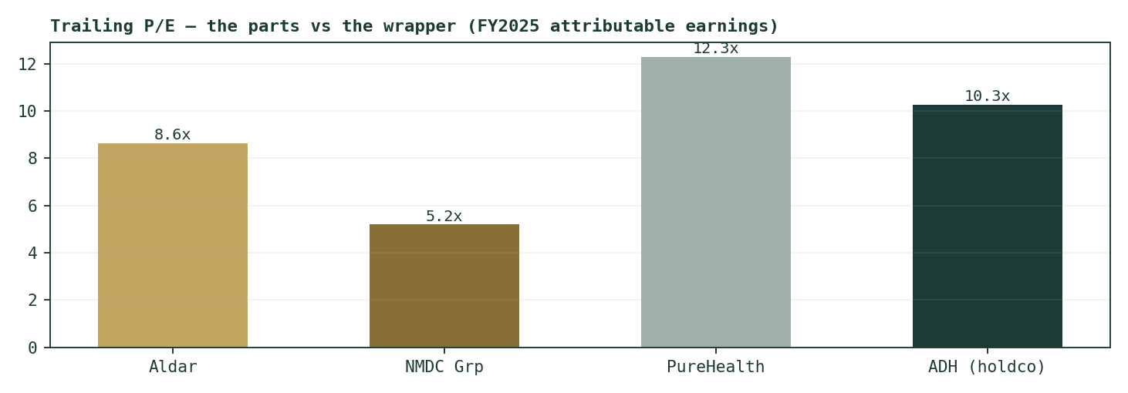
Figure 2 — The look-through P/E: what the wrapper costs versus what its listed parts cost directly on the ADX (Aldar 8.6×, NMDC 5.2×, PureHealth 12.3× trailing).
At AED 82.2 bn against FY2025 attributable profit of AED 8.0 bn, the wrapper trades at 10.3× trailing — while its largest listed part (Aldar, ~AED 20.5 bn of the NAV) costs 8.6× directly and its second (NMDC) costs 5.2×. Paying more at the wrapper than at the window is the multiple-form of the NAV premium. Two EPS framings, both stated per house rule: on the reported basis — the one that includes the fair-value and associate contribution that is structural to this holdco’s P&L (FY2025: +AED 3.2 bn of FVTPL gains) — FY2026E EPS is ~AED 0.85 (FY2025’s 0.79 grown ~7–8%, consistent with the Q1-26 run-rate); on the ex-FV operating build that drives Appendix A’s forecast table, FY2026E attributable EPS is ~AED 0.70. The lens uses the reported basis (this is what holders receive in stated earnings) across a justified 8.0–11.0× band — 9.5× base, set between Aldar’s 8.6× and the wrapper’s own 10.3× — giving AED 6.80 / 8.07 / 9.35. The operating framing at the same multiples would give AED 5.60 / 6.65 / 7.70; the gap between the two rows is the FV-gain dependence, quantified.
1.4 The dividend policy — pricing the cash that actually leaves
In January 2026 the general assembly approved a three-year policy: AED 2 bn a year (20 fils/share) growing 5% annually from FY2025. Discounting that stated stream as a growing perpetuity at Ke = 9.62% gives 0.20 × 1.05 / (0.0962 − 0.05) = AED 4.55 (band 3.50–5.68 across Ke 8.7–10.6% and g 4–6%). The point of this lens is not that ADH is worth 4.55 — a holdco retains earnings by design — it is the observation that only ~13% of FY2025 attributable profit leaves the structure as cash to shareholders, at a ~2.4% yield. Everything above AED 4.55 in the share price is a claim on retained compounding; the market currently pays AED 3.67/share for that claim. Weight: 15%.
1.5 Synthesis — four lenses, one range
Lens | Low | Base | High | Weight | Why this weight
SOTP / NAV | 5.58 | 6.32 | 7.44 | 55% | Observable marks; the honest anchor for a holdco — raised 45%→55% 11-07-2026 (external audit)
FCFF DCF | 8.93 | 11.72 | 15.21 | 15% | 80% terminal; NCI proxy; ΔWC gap — a ceiling
Look-through relative | 6.80 | 8.07 | 9.35 | 15% | Reported-EPS basis; cut 25%→15% 11-07-2026 — flagged double-count risk vs the marks (external audit)
Dividend policy | 3.50 | 4.55 | 5.68 | 15% | Prices only distributed cash — a floor
Weighted central | 5.95 | 7.13 | 8.63 | 100% | Spot 8.22 sits above the base and inside the upper band

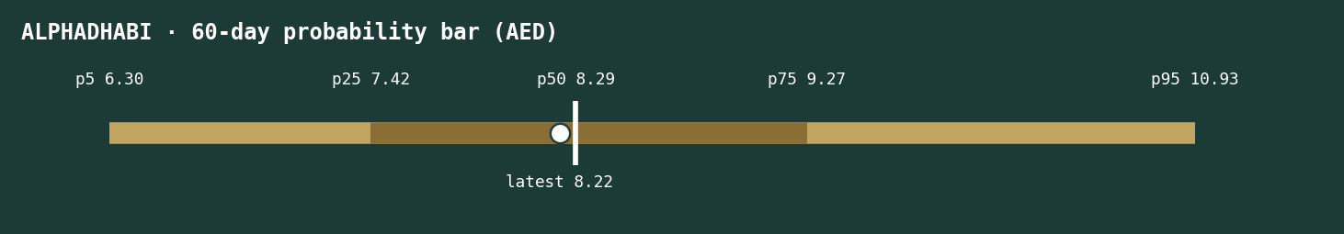
Figure 3 — The house price bar: 5th–95th (gold) and 25th–75th (brass) Monte-Carlo bands with the fundamental central range, the marked NAV, and the AED 8.22 spot dot.
The verdict in one sentence: fully valued — spot sits 13% above the weighted central and above par NAV, and the only lens that flatters it is the one built to describe a normalized future rather than the observable present.
1.6 Segments, the earnings mix — and the per-driver gate
House rule: §1.6 opens with the gate table — every forecast driver, its build (bottom-up only where the Step-2A sweep cleared a disclosed source or observable quote), and the sweep reference behind it.
Driver | Build | Justification | Sweep ref
Revenue growth path | Top-down | No numeric guidance; Q1-26 +8% actual anchors year 1; Aldar’s 71.7 bn backlog the tailwind | R4-01
Adj. EBITDA margin | Top-down | FY25’s 22.5% held flat; mix-shift unmodelled | R4-02
Capex % revenue | Top-down | FY25 7.1% fading to 5.5%; no disclosed capex plan | R4-02
ΔWC % Δrevenue (crux) | Top-down | FY25 absorbed ~48% of Δrev; fade to 20% as collections catch up | R4-03
Tax rate | Bottom-up | Statutory: CT 9% + DMTT 15% from 1-Jan-2025; FY25 actual ETR 10.2% glides to 15% | R2-02
Ownership stakes | Bottom-up | Audited FY25 notes; named transactions (NMDC buy-up; NCTH injection; ADQ/Trojan) | R4-04/05/06
Listed marks | Bottom-up | ADX quotes × audited stakes | R4-07
Trojan mark | Bottom-up | ADQ 49% deal: buyer-outlay ≈AED 5.0 bn (ADH FY24 CF 4,997; ADQ-side ~5,043); seller-note 3,562 + 1,456 NCI — dual-framed in §1.1 | R4-06
rf / carry | Bottom-up | 3M EIBOR 3.93% (carry); AED T-bond ≤16 bp over UST (rf-long 4.75%) | R2-03
ERP | Bottom-up | Damodaran ORIGINAL Jan-26: UAE 4.87% (rating) / 4.93% (CDS) — both published | R1-02
Beta | Top-down | Regression FAILED the usability gate (no usable ADX index series) → 1.0, band 0.8–1.3 | —
Holdco discount | Top-down | GCC/EM precedent 10–25%; spot implies a premium — the crux, not an input | R4-08
Dividend path | Bottom-up | Stated policy AED 2 bn (20 fils) +5%/yr from FY2025, GA-approved 12-Jan-26 | R4-09

Bottom-up is the default wherever the sweep cleared it; every top-down row is a disclosed judgment. The full Sweep Register — including the negative searches — closes Appendix B.
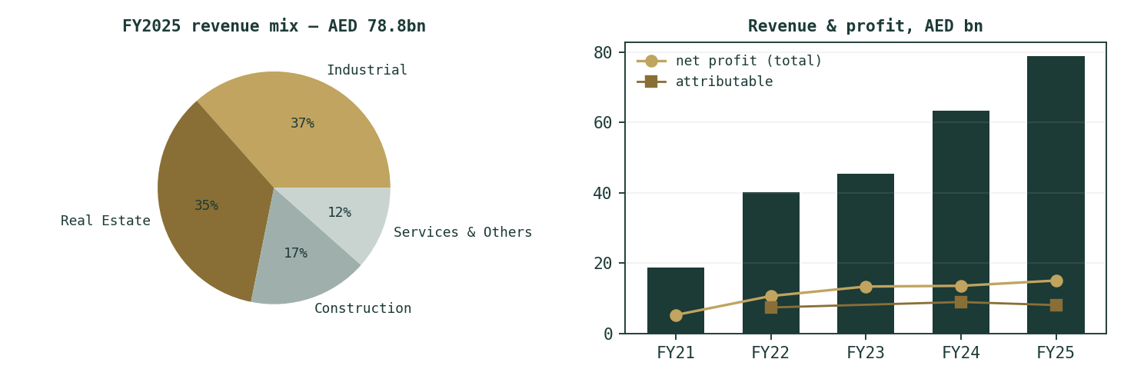
Figure 4 — Segment revenue mix (FY2025) and the group revenue / profit history, FY2021–FY2025.
What the mix says: Industrial (AED 28.8 bn) and Real estate (27.8 bn) now dominate revenue, Construction (13.1 bn) and Services & other (9.1 bn) complete it — but profit tells a different story. On FY2024 segment disclosure, Real estate earned AED 5.2 bn and Services & other AED 4.4 bn of net profit against Construction’s 0.9 bn: the group’s earnings are Aldar plus the investment book, with construction the revenue-heavy, margin-light leg. That is why the SOTP — which prices Aldar and the stakes directly — is the primary lens, and why a consolidated margin model is the wrong primary tool.
1.7 The crux — the holdco premium, in real dirhams
Strip the study to one observable number. Marked NAV is AED 7.44/share; the market pays AED 8.22. The difference — AED 0.78/share, AED 7.8 bn across the company — is the price of believing this holdco creates value above the sum of what it owns. Each 5 points of holdco discount is worth AED 0.37/share; the spot price sits roughly two discount-notches above par. What could justify a premium: the FV-gain engine (AED +3.2 bn in FY2025 alone) persisting; IHC-ecosystem deal access that a minority investor cannot replicate; the buyback shrinking a thin float. What argues against it: attributable earnings fell 10% in FY2025 and EPS has declined two years running; the residual (unlisted) third of the book compounds only if new deals keep landing; and a live war tail sits under every ADX mark simultaneously. The premium is the trade. Everything else in this document is context for it.
If the market applied… | Par (0%) | 10% disc. | 15% disc. | 25% disc. | Spot implies
Share price (AED) | 7.44 | 6.70 | 6.32 | 5.58 | 8.22
Premium/(discount) to NAV | 0% | −10% | −15% | −25% | +10%
Value vs spot (AED bn) | -7.8 | −15.2 | -19.0 | -26.4 | —

1.8 Macro, the war, and the sourced cost of capital
The macro frame is unusually binary this year. The UAE enters the 2026 Iran war as a bystander with exposure: the dirham peg imports Fed policy (mid-2026 target 3.50–3.75%, CBUAE base rate mirroring), the federal AED bond curve trades within ~16 bp of Treasuries, and Abu Dhabi’s Aa2 rating held through the spring escalation. The war matters through three channels ADH cannot hedge: ADX-wide risk premia (all four listed marks fall together in a stress), Gulf logistics and project timelines (NMDC’s marine works, Trojan’s sites), and the oil-linked fiscal pulse behind Abu Dhabi’s project pipeline. The March trough (AED 6.84 intraday, 31 Mar) and the April relief rally are both visible in the price series; the 7–8 Jul ceasefire collapse is not — it post-dates the data, and is carried here as an explicit tail rather than a modelled input. Domestically the DMTT (15% top-up tax from 1 Jan 2025) is a knowable, statutory headwind: the FY2025 ETR of 10.2% glides to 15% in the model, worth roughly −AED 0.4 bn of steady-state NOPAT versus the old regime.
Cost-of-capital input | Value | Source (Step-2A ring)
Risk-free (AED, long) | 4.75% | UAE federal AED T-bond, ≤16 bp over the 4.58% UST 10y — never the USD shortcut
Carry rate (MC anchor) | 3.93% | 3M EIBOR, CBUAE
ERP — rating basis | 4.87% | Damodaran ORIGINAL file, Jan-2026 (UAE Aa2)
ERP — CDS basis | 4.93% | Damodaran ORIGINAL file, Jan-2026 (Abu Dhabi CDS 49 bp)
Beta | 1.00 (band 0.8–1.3) | Regression failed usability gate — no usable ADX index series; ledger row
Ke — rating / CDS basis | 9.62% / 9.68% | rf + β·ERP, both published per house rule
Kd (pre-tax) | 6.0% | EIBOR + ~200 bp holdco spread; AED-denominated book
WACC | 8.61% | D/(D+E) ≈ 25% at market values; tax 15% terminal

1.9 Sensitivity — the rate, the terminal, the discount, and the book
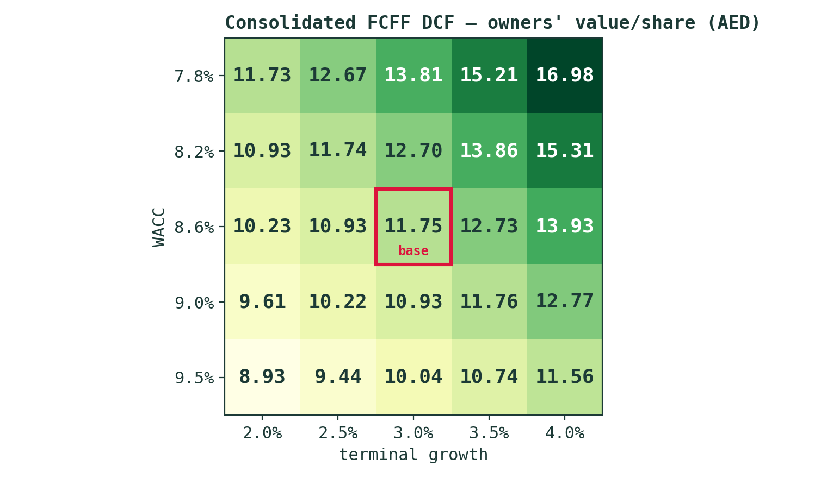
Figure 5 — DCF fair value (AED/share, owners’ 53.3%) across WACC × terminal growth. The base cell (8.6%, 3.0%) reads 11.75.
DCF /sh: WACC ↓ × g → | 2.0% | 2.5% | 3.0% | 3.5% | 4.0%
7.8% | 11.73 | 12.67 | 13.81 | 15.21 | 16.98
8.2% | 10.93 | 11.74 | 12.70 | 13.86 | 15.31
8.6% | 10.23 | 10.93 | 11.75 | 12.73 | 13.93
9.0% | 9.61 | 10.22 | 10.93 | 11.76 | 12.77
9.5% | 8.93 | 9.44 | 10.04 | 10.74 | 11.56

NAV /sh: discount ↓ × residual book → | −AED 5 bn | Base | +AED 5 bn
0% (par) | 6.94 | 7.44 | 7.94
15% (base) | 5.90 | 6.32 | 6.75
25% | 5.21 | 5.58 | 5.96

The NAV grid doubles as the flagged-borrowings stress: because net debt is a derived figure, the ±AED 5 bn residual-book columns bound the effect of a borrowings error at roughly ±AED 0.5/share — material to the decimal, immaterial to the verdict. The two grids together bracket every fundamental read in this study between AED 5.2 and AED 17.0; the weighted central of 7.13 sits in the lower third of that space because the weights sit where the observable marks are — more so since 11-07-2026, when the look-through weight was cut from 25% to 15% (double-count risk vs the marks) and the freed 10 points moved onto the SOTP anchor (45%→55%), following an external audit.
2 Technical and price structure
The five-year chart is a round trip with a violent coda: AED 27–30 through 2022, a two-year controlled de-rating to the AED 9–12 shelf, then the war gap — a slide to the AED 6.84 intraday low on 31 Mar 2026 as Hormuz closed, and a fast partial recovery on the April ceasefire. As of 3 Jul the tape reads: price 8.22 above the 20-day (7.84), 50-day (7.54) and 100-day (7.85), but still 7% below the 200-day (8.84) — the signature of a recovery inside a downtrend, not a new uptrend. RSI at 64 is warm but not overbought; the MACD lines have gone flat (line +0.159 vs signal +0.163, histogram -0.004 — effectively zero), i.e. the post-trough momentum impulse has been spent and price is deciding. The 52-week range (6.84–12.58) frames the levels that matter: the 200-day at ~8.84 is the overhead test, the April–June congestion at 7.4–7.8 the first support shelf, and the war low the line under everything. One-year return: -33%. Timing note, not value: nothing in the tape contradicts the fundamental read — a bounce toward a declining long-term average is exactly what “recovered but still above NAV” looks like.
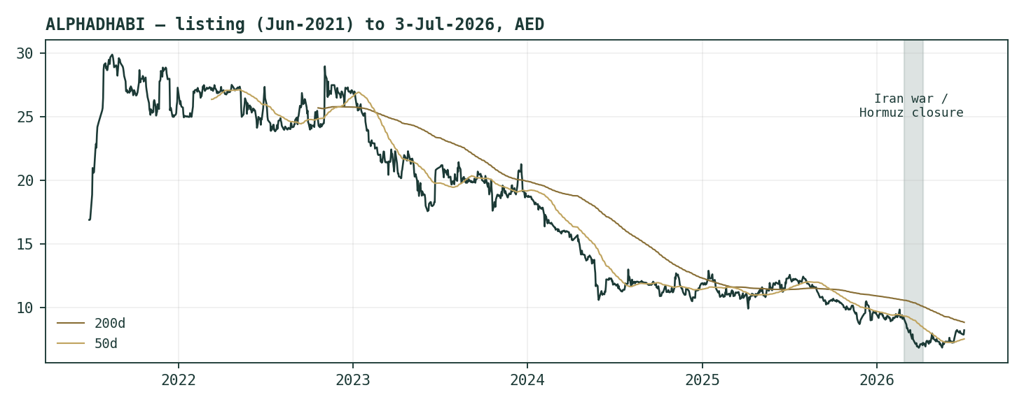
Figure 6 — Five years of daily closes with the 50/200-day averages; the shaded band marks the Feb–Apr 2026 war window (28 Feb outbreak → 8 Apr ceasefire).
Indicator | Reading (3 Jul 2026) | Interpretation
Price vs MAs | > 20d 7.84 · > 50d 7.54 · > 100d 7.85 · < 200d 8.84 | Recovery inside a downtrend
RSI (14) | 64.0 | Warm; room before overbought
MACD (12,26,9) | line +0.159 · signal +0.163 · hist -0.004 | Momentum impulse spent — flat
52-week range | 6.84 – 12.58 | Spot in the lower third
Key levels | 8.84 (200d) overhead · 7.4–7.8 shelf · 6.84 war low | The map for §3’s ladder

3 Monte Carlo — a probabilistic price map
House rule: this section opens with the probability read — the five numbers most people actually want — before any machinery.
The probability read (T+60 sessions ≈ 3 months)
P(price above spot 8.22) | 52%
P(+10%, above 9.04) vs P(−10%, below 7.40) | 30% / 25% — odds 1.2:1 up
Median level and its % move | AED 8.29 (+0.8% — the EIBOR carry, an explained drift)
50% band (25th–75th) | AED 7.42 – 9.27 (90%–113% of spot)
Touch(+10%) / touch(−10%) at any point | 54% / 46%

Two supplementary reads outside the canonical five: P(−20%+, below ~6.58) = 8%, and P(finish within ±10% of spot) = 45%.
Lens-independence note (house rule): the simulation’s drift is the carry anchor only — it does not embed the fundamental NAV gap of §1. The −13% distance to the weighted central lives in §1 and nowhere else; if it also leaked into the drift, the two lenses would double-count one opinion. The MC answers a narrower question: given how this stock has actually moved, where can price be in 20 and 60 sessions?
The engine: 50,000 paths, seed 42, gap-aware Yang–Zhang volatility with HAR dynamics, calibrated on this share’s own post-2022 history (the ADX workweek change is honoured). Step-0 calibration fitted the shape to Gaussian innovations with a width calibration of 1.042 on 14 non-overlapping 60-day windows — the configuration passed at parity (details live in the public Calibration Ledger, never in this document). Drift is the 3M EIBOR carry (3.93%) with no dividend inside the window (the FY25 distribution was paid in Q1; q = 0); annualized anchor volatility 34.1%. One honest caveat stated twice in this study: the Gaussian shape was fitted through 3 Jul — a pre-re-escalation regime. The 7–8 Jul ceasefire collapse is a live left-tail event of exactly the kind a thin-tailed fit understates; read the downside percentiles as floors on risk, not ceilings.
Percentile map (AED/share)
Horizon | p5 | p10 | p25 | p50 | p75 | p90 | p95
T+20 (~1 month) | 7.04 | 7.29 | 7.73 | 8.24 | 8.79 | 9.33 | 9.67
T+60 (~3 months) | 6.30 | 6.70 | 7.42 | 8.29 | 9.27 | 10.28 | 10.93

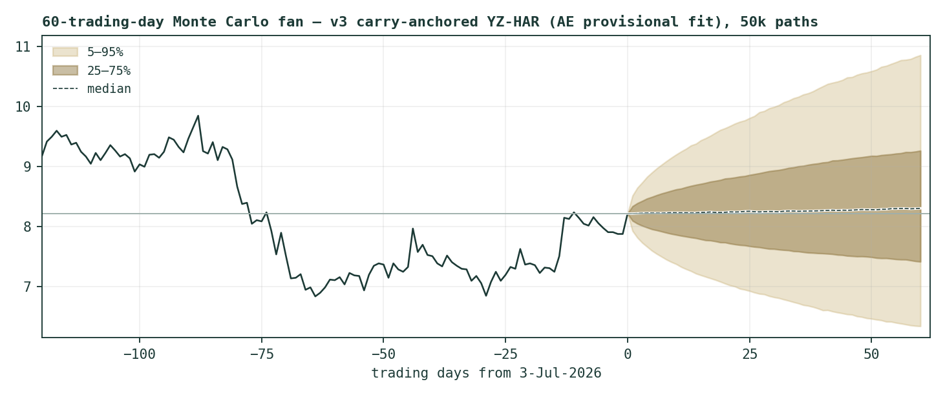
Figure 7 — Forward price cone to T+60. The median drifts gently up on the carry anchor; the gold band is the 5th–95th, the brass band the 25th–75th. Dynamic y-axis per house style.
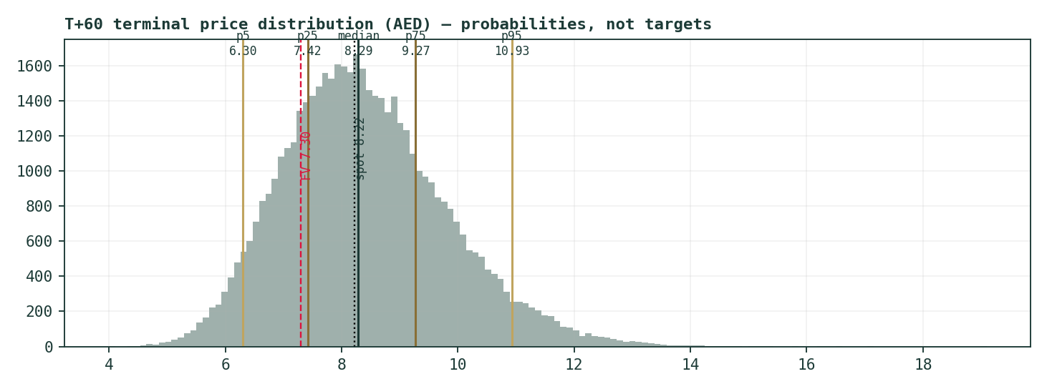
Figure 8 — Terminal price distribution at T+60: right-skewed as lognormal paths are, with the fundamental central (7.13) and marked NAV (7.44) both inside the left half of the 50% core.
How to hold the two horizons together: at T+20 the distribution is tight (p25–p75 = 7.73–8.79) — a month rarely resolves anything. At T+60 the core widens to 7.42–9.27, and note what sits inside it: the weighted central (7.13), par NAV (7.44), and the 200-day average (8.84) sit at or near the 50% band. The simulation is saying the market can travel to any of this study’s reference points within a quarter without doing anything statistically unusual.
Level-touch ladder
Probability that price finishes above each level at T+60 — the §2 map, quantified:
Level (AED) | 7.00 | 7.50 | 8.00 | 8.50 | 9.00 | 9.50 | 10.00
P(finish above) | 85% | 73% | 59% | 44% | 31% | 21% | 13%

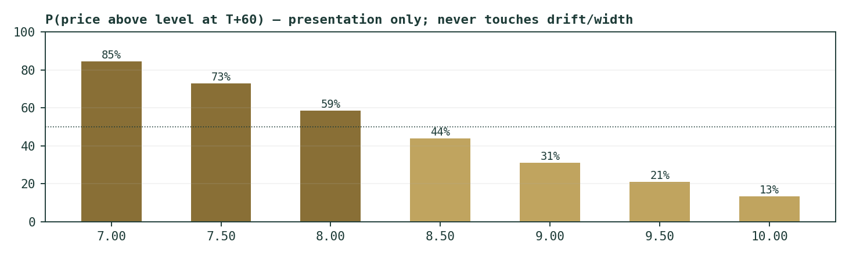
Figure 9 — The level ladder. The 200-day (8.84) carries roughly a one-in-three finish-above probability; the war low (6.84) roughly a one-in-eight finish-below.
4 Comparison of the lenses, and a verdict
Lens | Question it answers | Answer | Standing
Fundamental (§1) | What is the holding worth? | AED 5.95–8.63, central 7.13; par NAV 7.44 | Spot 13% above central — fully valued
Technical (§2) | What is the tape doing? | Post-trough recovery; below the 200-day | Constructive short-term, bearish long-term structure
Monte Carlo (§3) | Where can price go in 3 months? | 5–95%: 6.30–10.93; P(up) 52% | Near coin-flip; both §1 anchors inside the core
Expert panel (App. C) | What do the holdco-trio personas say? | AED 6.3 / 6.8 / 7.03 | Unanimously below spot

Where they agree and where they don’t: all four fundamental-family reads (three lenses plus the panel) put value below the AED 8.22 print — the disagreement is only about how far. The tape disagrees on timing: momentum since the war trough has been buyers’, and the MC accordingly gives a small edge to finishing higher over a quarter. That combination — value below, momentum above — is the classic anatomy of a premium being defended, and it resolves through §1.7’s number: either attributable earnings and deal flow re-accelerate to justify the premium, or the price completes its trip toward the marks. Verdict, in the only form this house publishes: fair value AED 5.95–8.63, central 7.13; the current price sits inside the upper half of that range and above every anchor in it. No rating, no target — a distribution and its reasons.
5 Catalysts to watch
When | Event | Why it moves the read
Ongoing (live) | Iran war re-escalation / de-escalation | The dominant tail both ways: all four ADX marks, Gulf logistics, and the oil-fiscal pulse move together
~Aug 2026 | Q2-2026 results + the missing attributable split | First test of whether Q1’s +81% (FV-driven) profit converts to owners’ EPS; also closes this study’s flagged data gap
H2 2026 | Working-capital trajectory | The DCF crux: if ΔWC absorption fades from 48% of Δrev, cash conversion — and the ceiling lens — become credible
Rolling | Buyback execution & float | A thin-float premium defended with repurchases is a mechanical support; disclosure of pace matters
Rolling | IHC-ecosystem transactions | New injections/disposals re-price the residual book — the third of NAV that has no daily mark
Q1 2027 | FY2026 dividend (policy: 21 fils) | First +5% step of the stated policy; confirmation or breach is a direct DDM input
Any time | Fed / CBUAE path | The peg imports every cut: carry anchor, Kd, and the DCF discount rate all reset together

6 Reading the probability zones
Zone (T+60) | Range (AED) | Probability | What being there would mean
Deep stress | < 6.30 | ~5% | War-tail territory: below the fitted 5th percentile, in the regime the Gaussian understates
Lower band | 6.30 – 7.42 | ~20% | The trip toward NAV-with-a-discount; §1’s central (7.13) sits just below this zone
The core | 7.42 – 9.27 | ~50% | Par NAV (7.44) and spot live here — the premium debate unresolved
Upper band | 9.27 – 10.93 | ~20% | Through the 200-day (8.84): the recovery becomes a trend; premium widening, not closing
Right tail | > 10.93 | ~5% | Re-rating on a deal or de-escalation; back toward the 2025 shelf

The practical use of the map is falsification: a sustained break below ~7.40 with the 200-day still falling says the market has started closing the premium (the fundamental read gaining); a close above ~8.84 that holds says the market is re-underwriting the compounder story (the fundamental read losing, and this study’s next update would have to say why).
7 Caveats and what would change our mind
- Timing. The price series ends 3 Jul 2026; the 7–8 Jul ceasefire collapse post-dates every number here. A war-regime repricing would move spot, all four listed marks, and the MC anchor simultaneously — this study’s next scheduled grade (T+20, early Aug) will land inside that fog.
- The derived line. FY2025 borrowings (≈AED 41.4 bn) are derived, not read off a note; net debt could differ by low single-digit billions. §1.9 bounds the NAV effect at roughly ±AED 0.5/share. A machine-readable FY25 annual report closes this.
- The missing split. Q1-2026 attributable profit was not published in the sources retrieved; the +81% headline is total profit and is FV-gain-driven. If the owners’ share proves weak, the relative lens’s reported-EPS basis (0.85) is too high.
- Allocation. The carried-value allocation of the parent book across the five marked assets is the preparer’s estimate (ledger-logged). The NAV total is insensitive to it, but per-asset premium/discount statements inherit its error.
- The Trojan mark. Trojan’s mark is an eighteen-month-old transaction price. UAE construction has been strong since; the mark is more likely stale-low than stale-high, which would raise NAV modestly.
- Calibration humility. The AE market fit behind Step-0 is single-name and provisional (house rule after the QGTS precedent: no AE name-level FAIL is treated as real until a ≥3-name panel exists). The engine passed at parity here; the fit will be re-estimated as UAE coverage grows.
- Mind-changers. We would revise up on: two quarters of attributable-EPS growth with ΔWC absorption fading; a primary-source IHC float/ownership disclosure plus sustained buyback; disposal of an unlisted asset at or above carrying value (validating the residual book). We would revise down on: a dividend-policy breach; a large related-party injection at rich marks; war escalation that closes Gulf logistics for months.
Appendix A Financial statements
Three years of history from the audited statements (FY2023 from the FY2024 comparatives), five years of forecast on the §1.2 drivers. All AED bn unless noted. The forecast attributable line is the ex-fair-value operating build (NOPAT × 53.3% × 0.95 minority-friction haircut) — deliberately more conservative than the reported basis used in §1.3; both framings are stated there per house rule.
A.1 Income statement — 3-year historical + 5-year forecast (consolidated, AED bn)
Line | FY2023 | FY2024 | FY2025 | 2026E | 2027E | 2028E | 2029E | 2030E
Revenue | 45.4 | 63.4 | 78.8 | 85.9 | 92.7 | 99.2 | 105.2 | 110.4
Gross profit | 9.3 | 13.4 | 18.8 | — | — | — | — | —
EBITDA (reported) | 16.5 | 17.4 | 20.9 | 19.3 | 20.8 | 22.3 | 23.6 | 24.8
EBITDA (adjusted) | 16.5 | 13.6 | 17.7 | — | — | — | — | —
EBIT | — | — | — | 15.8 | 17.0 | 18.2 | 19.3 | 20.3
NOPAT | — | — | — | 13.9 | 14.8 | 15.7 | 16.4 | 17.2
Net profit — total | 13.3 | 13.5 | 15.0 | — | — | — | — | —
Net profit — attributable | — | 8.9 | 8.0 | 7.0 | 7.5 | 7.9 | 8.3 | 8.7
EPS (AED) | — | 0.88 | 0.79 | 0.70 | 0.75 | 0.79 | 0.83 | 0.87

FY2023 attributable profit was not separately restated in the retrieved FY2024 comparatives — shown as “—” rather than invented (Fundamental Driver Ledger row). FY2024–25 from the audited FY2025 statements.
A.2 Balance sheet — condensed house layout (consolidated, AED bn)
Line | FY2023 | FY2024 | FY2025
Total assets | 140.4 | 177.5 | 214.4
Total liabilities | 64.3 | 85.2 | 110.4
— of which borrowings | 24.2 | 30.1 | 41.4 (derived)
Cash & bank balances | 20.2 | 28.8 | 40.3
Net debt | 3.98 | 1.30 | 1.14
Owners’ equity | 42.0 | 52.3 | 60.1
Hybrid perpetual notes | 1.80 | 1.82 | 1.82
Non-controlling interests | 32.1 | 38.2 | 42.1
Total equity | 75.9 | 92.3 | 104.0

What the three columns say: assets up 53% in two years and owners’ equity up 43% (a ~19%/yr book compounding rate) while net debt stayed near zero — the group has funded its expansion with operating cash, NCI capital and asset injections rather than parent leverage. The counterweight: NCI is now 40% of total equity, so consolidated headlines overstate the owners’ economics by design. The FY2025 borrowings figure is the study’s one derived line — FY2024’s disclosed 30.1 plus audited FY2025 financing flows — flagged here and stress-bounded in §1.9.
A.3 Cash flow, the two FCF framings, and the distribution schedule
FY2025 cash flow (AED bn) | Value
Cash from operations (after the ΔWC absorption) | 9.63
— working capital absorbed within it | ≈ −7.5
Capex (PP&E and investment property additions) | −5.57
Free cash flow — cash framing (CFO − capex) | 4.06
Free cash flow — normalized framing (ex-ΔWC) | ≈ 11.5
Net finance costs (P&L) | 0.90
Income tax paid basis (P&L charge) | 1.70

Both FCF framings, per house rule: on the cash framing the group generated AED 4.1 bn of free cash in FY2025 — barely twice the dividend; on the normalized framing (adding back the working-capital build that the model fades over five years) it generated ≈AED 11.5 bn. The distance between those two numbers is the DCF debate of §1.2 in a single row.
Distribution | FY2025 (paid Q1-26) | FY2026E | FY2027E
Policy amount (AED bn) | 2.00 | 2.10 | 2.21
Per share (fils) | 20.0 | 21.0 | 22.1
Yield on AED 8.22 | 2.4% | 2.6% | 2.7%

Appendix B Peer set, structure, risks — and the Sweep Register
B.1 The listed complex
Company | Mcap (AED bn) | Earnings (AED bn) | Trailing P/E | Role in the NAV
Alpha Dhabi (the wrapper) | 82.2 | 8.01 attrib. | 10.3× | —
Aldar Properties (31.63%) | 64.87 | 7.51 | 8.6× | Largest mark: AED 20.5 bn
NMDC Group (76.68%) | 18.79 | 3.62 | 5.2× | AED 14.4 bn; Q1-26 EPS halved — watched
PureHealth (35.06%) | 24.56 | 2.00 | 12.3× | AED 8.6 bn associate
NCTH (73.73%) | 3.27 | 0.30 | ~10.9× | AED 2.4 bn; thin float

The structural read repeats §1.3: the wrapper is dearer than its two largest parts. For context in the regional holdco family, IHC (the parent) has itself traded at a large, persistent premium to conventional NAV — Alpha Dhabi is the ecosystem’s mid-layer, and its premium is smaller but the same species. The risk table below is ordered by what would actually move the NAV, not by boilerplate.
B.2 Risk register
Risk | Channel | NAV/read sensitivity
Gulf war escalation (live) | All four marks + logistics + fiscal pulse | Simultaneous; the only risk that hits every line at once
Concentration in Aldar | 28% of marked NAV in one stock | β to Abu Dhabi property; a 20% Aldar drawdown ≈ −AED 0.41/sh
NMDC normalization | Q1-26 EPS 0.43 vs 0.87 | A 30% NMDC de-rating ≈ −AED 0.43/sh
Related-party capital allocation | IHC-ecosystem injections/disposals | Residual book re-priced by deals minorities don’t set
Thin float / index mechanics | IHC ~87% (press-cited) | Price discovery weak both ways; premium can persist or vanish fast
DMTT to 15% | Statutory from 1-Jan-2025 | ≈ −0.4 bn steady-state NOPAT vs old regime — knowable, modelled
Rate path (peg) | Fed → CBUAE → EIBOR | Cuts lower Ke and carry together; a hawkish turn does the reverse

B.3 The Sweep Register — every ring closed, negatives included
Step-2A house rule: coverage is measured by categories closed, never by query count, and a negative search is a dated finding. Class codes: B base-changer · S structural · D driver-unlock · C color · NEG negative search.
Ring | Category | Cl. | Finding (incl. negatives) | Source | Date
1 Global | Rates / USD | S | Fed 3.50–3.75% post Jun-26; CBUAE mirrors the peg; 3M EIBOR 3.93% = carry anchor | CBUAE / market data | 06-Jul-26
1 Global | ERP | S | UAE Aa2 ERP 4.87% / Abu Dhabi CDS basis 4.93% (Jan-26 update) | Damodaran original (stern.nyu.edu) | 05-Jan-26
1 Global | Commodities / oil | S | Brent ~$77.5 (8-Jul) after the $126 April peak; Hormuz war premium cycling | Press (WaPo/Axios) | 08-Jul-26
2 Country | War / geopolitics | S | 2026 Iran war from 28-Feb; Hormuz closed; ceasefire 8-Apr; MoU 17-Jun; ceasefire COLLAPSED 7–8 Jul — post-dates price data | AP / reference sources | 09-Jul-26
2 Country | Regulatory / tax | S | DMTT 15% top-up from 1-Jan-2025 for large groups; ADH FY25 ETR 10.2% → modelled glide to 15% | MoF; ADH FY25 FS | 10-Feb-26
2 Country | Sovereign funding | C | Federal AED T-bonds ≤16 bp over UST; balanced 2026 budget | MoF / AGBI | Mar-26
3 Industry | Competition (constr.) | C | Trojan the #1 UAE contractor (co. claim); ALEC (DFM-listed) and Orascom active — named-competitor level | ADH MD&A; sweep | FY24/25
3 Industry | RE market | S | Abu Dhabi 9M-25 transactions +43% to AED 94 bn; Aldar record FY25 (attrib. NP 7.51 bn, backlog 71.7 bn) | Aldar Q4-25 / press | 09-Feb-26
3 Industry | Marine / EPC | S | NMDC Q1-26 EPS 0.43 vs 0.87 — normalization plus Gulf operational risk | NMDC / ADH releases | May-26
4 Company | FY2025 audited FS | B | Rev 78.78, NP 15.03 (attrib 8.01, EPS 0.79); assets 214.4; owners 60.1; NCI 42.1; cash 40.3; FVTPL gains +3.15 | Audited FS (Deloitte) | 10-Feb-26
4 Company | Q1-2026 | B | Rev 18.79 (+8%); NP total 3.80 (+81%, FV-gain driven); assets 225.8 | Company release | 04-May-26
4 Company | Stake change — NMDC | B | 66.91% → 76.68%: the AD Ports 9.77% block (82.5 mn sh) for AED 1.6 bn, 27-Nov-25 | ADH + AD Ports releases, 27-Nov-2025 | Nov-25
4 Company | Stake change — NCTH | B | 36.39% associate → 73.73% subsidiary; consolidated from Jan-25 (asset injection) | FY25 FS; FY24 subsequent events | Jan-26/25
4 Company | Trojan / ADQ | B | 49% of Trojan sold to ADQ in FY24 for AED 4,997 mn — the SOTP mark | FY24 audited CF; releases | FY24
4 Company | Dividend / buyback | B | 3-yr policy AED 2 bn (20 fils) +5%/yr from FY25, GA-approved 12-Jan-26; buyback running | Company site / releases | 12-Jan-26
4 Company | PureHealth | S | 35.06% associate; HHG 60% (€800 m) closed; PH FY25 NP 2.0 bn; ADH booked a −863 mn dilution loss | ADH FS; PH releases | FY25
4 Company | Borrowings note | NEG | FY25 borrowings note not machine-extractable; figure DERIVED at ≈41.4 bn from FY24 base + audited financing flows — ledger row | Derivation | 10-Jul-26
4 Company | Q1-26 attributable split | NEG | Interim FS not retrieved; only total NP known — flagged; re-search at Q2 results (SF-risk logged) | Searched IR / press | 10-Jul-26
4 Company | Equity actions | NEG | No split / rights / capital change in ADH shares found 2021–26 (max daily move +14% — no split artefacts) | Price-series scan + sweep | 10-Jul-26
4 Company | IHC parent | C | Parent = IHC per audited FS Note 1; press cites ~87% — precise % not re-sourced from a primary filing (flagged) | FY25 FS Note 1 | FY25

Freshness rule: the company ring re-runs if more than 10 trading days pass between sweep and delivery (swept and delivered 10-Jul-26). A disclosed-but-missed driver discovered later closes as a Sourcing Failure and triggers a named search-pattern fix.
Appendix C The expert valuation panel
Three genuinely different methods, cast for the holdco class, each with shown workings, an explicit sensitivity to its own weakest assumption, and a falsification condition. They are labelled Expert 1/2/3 only, per house rule. The point of the panel is not a second opinion on the house numbers — it is three independent routes to a value that share no inputs with each other beyond the audited statements, so that agreement means something.
C.1 Expert 1 — the NAV-and-discount specialist
Method. For a holdco, this expert argues, everything except the NAV-and-discount question is decoration: the assets have prices, so the only genuine analytical work is (i) auditing the marks and (ii) earning the right to a discount number rather than assuming one. The NAV of §1.1 is accepted as computed (AED 74.4 bn, 7.44/share at par) after two mark audits: the Trojan transaction price is aged eighteen months but was set by ADQ — a sophisticated related-but-distinct buyer — and UAE construction has strengthened since, so if anything it is stale-low; and NCTH’s quote sits on a float thin enough that this expert haircuts confidence in that AED 2.4 bn line, not its value.
The discount build is done in components rather than by precedent-matching alone — each driver scored against the GCC/EM holdco evidence base, where observed discounts run roughly 10–25% and the extremes are explained by governance and float:
Discount driver | Assessment for ADH | Contribution
Observability of marks | 4 of 5 priced assets quoted daily or by transaction — unusually good for the class | −3 pts (reduces discount)
Float / price discovery | IHC ~87% (press-cited); free float thin; index weight mechanical | +6 pts
Related-party density | Injections and disposals set inside the IHC ecosystem; minorities are takers | +6 pts
Capital-allocation record | Book compounded ~19%/yr FY23–25; but attributable EPS fell two years running | +3 pts
Structural NCI leakage | 40% of total equity is NCI; consolidated headlines overstate owners’ economics | +3 pts
Composite discount | Sum, rounded to the band’s midpoint | 15% (band 10–25%)

Discount applied | 0% (par) | 10% | 15% (base) | 20% | 25% | 30% (stress)
Value/share (AED) | 7.44 | 6.70 | 6.32 | 5.95 | 5.58 | 5.21

Base AED 6.3 (74.4 × 0.85 / 10); range 5.2–7.4. Where this expert diverges from the house: no credit at all for the DCF ceiling — in this framework retained-earnings compounding is already inside the marks (Aldar’s price embeds Aldar’s future), so adding a growth lens on top double-counts. And a warning the house table softens: a premium to NAV defended mainly by a buyback in a thin float is the most reversible support in equity markets. Falsification: two consecutive semi-annual disposals of unlisted assets at or above carrying value would prove the residual book conservative, collapse the information-asymmetry component, and push this expert toward par (7.4).
C.2 Expert 2 — the Accountant
Method. The protocol casts an Accountant on every holdco because the instrument IS a set of consolidation choices: this expert refuses every market mark and every scenario until the books themselves have been interrogated, then values the owners’ claim off the cleaned book with a justified price-to-book. The audit comes first, in four exhibits.
Exhibit 1 — does the consolidated P&L reconcile bottom-up? Rebuild attributable earnings asset by asset (stake × each asset’s own reported profit) as a pure audit device:
Asset | Stake | FY25 profit (AED bn) | Owners’ share (AED bn) | Audit note
Aldar Properties | 31.63% | 7.51 | 2.38 | Record year; 71.7 bn backlog underwrites persistence
NMDC Group | 76.68% | 3.62 | 2.78 | The fragile line — Q1-26 EPS halved (0.43 vs 0.87)
PureHealth | 35.06% | 2.00 | 0.70 | Associate; −0.86 bn dilution loss excluded as one-off
NCTH | 73.73% | 0.30 | 0.22 | First full consolidated year (IFRS 3, Jan-25)
Trojan Construction | 51% | ~1.05 | 0.54 | Inferred from FY24 segment NP; margin-light
Other / unlisted book | — | — | ≈1.20 | Residual; closes the reconciliation
Look-through attributable |  |  | 7.81 | vs reported 8.01 — within 2.5%: the P&L is honest

Exhibit 2 — what is the QUALITY of those earnings? FY25 attributable profit of 8.01 bn contains the fair-value-gain engine: +AED 3.15 bn of FVTPL marks. An auditor does not deny those gains; he refuses to capitalize them as recurring. Assuming ~70% sits at parent level (flagged; Driver Ledger), cash-quality attributable earnings ≈ AED 5.81 bn — a cleaned ROAE of 10.3% on the average owners’ book of 56.2 bn, against a 14.3% reported ROAE. Exhibit 3 — the two consolidation findings this audit flags: (i) the FY25 borrowings line is a cash-flow derivation that structurally omits IFRS-16 lease inceptions and the debt inherited when NCTH was consolidated in Jan-25 — gross debt is more likely understated than overstated, which flatters only the DCF leg; (ii) the Trojan mark has two audited framings (buyer-outlay ≈5.0 bn vs seller-note 3,562 + 1,456 NCI transfer) — §1.1 now carries both. Exhibit 4 — the missing Q1-26 attributable split is bridged as a flagged estimate only: AED 2.0–2.5 bn (FY25 proportional split vs an FV-skew-to-parent scenario).
Valuation. With the book audited, the owners’ claim is worth justified-P/B × book: P/B = (ROAE − g)/(Ke − g), Ke 9.62%, on BVPS AED 6.01:
Basis | ROAE | g | Justified P/B | Value/share (AED)
Audit-haircut (cleaned ROAE −50bp for the debt finding; book −5%) | 9.8% | 3.5% | 1.04 | 5.91
Base — cleaned ROAE, cash-quality earnings only | 10.3% | 4.0% | 1.13 | 6.78
Reported ROAE accepted, capped at par-NAV/book | 14.3% | 4.5% | 1.24 | 7.44

Base AED 6.78 (range 5.91–7.44). Where this expert diverges from the house: no credit for the look-through multiple at all — the reconciliation in Exhibit 1 is a truth test, not a lens; capitalizing earnings the marks already price would double-count Aldar’s terminal value. Falsification: two consecutive quarters in which the FV-gain engine converts to cash (disposals at or above the marks) would justify migrating from cleaned to reported ROAE, moving the base toward 7.4; an NCTH-scale restatement or a borrowings note materially above the derived 41.4 bn moves it toward the haircut row.
C.3 Expert 3 — Macro-Policy
Method. The protocol’s third holdco persona prices the policy state, not the spreadsheet: for a dirham-pegged holding whose assets are duration-heavy (a developer, a hospital platform, a hotel platform) and whose pipeline is fiscal (state-linked construction and dredging), four policy channels dominate — the Fed/CBUAE rate path the peg imports, the UAE DMTT 15% corporate-tax glide (FY25 ETR 10.2% → 15%), the oil-fiscal pulse behind Abu Dhabi’s project pipeline, and index/flows mechanics on a ~9% free float. The 2026 tape says the state dominates: a −45% war leg and a +20% ceasefire leg inside four months, with no change in the assets. Three policy states over ~12 months:
State | Prob. | Policy configuration | Valuation logic | Value | Contribution
A — easing + fiscal expansion | 35% | Fed cuts ~100bp through mid-27; the peg imports them; oil holds the fiscal pulse; DMTT drag absorbed by growth | Ke −100bp lifts the duration-heavy marks ~+8% look-through; premium defended | AED 8.20 | 2.87
B — hold / neutral | 40% | Higher-for-longer; DMTT glide bites (~0.4 bn attributable by FY28); no crisis, no catalyst | Discounted-NAV gravity + carry: 6.32 × ~1.09 | AED 6.90 | 2.76
C — war-fiscal stress | 25% | Re-escalation persists; Hormuz premium in every ADX mark; fiscal pipeline pauses | Stressed NAV at a 25% discount | AED 5.60 | 1.40
Probability-weighted value |  |  |  | AED 7.03 | = 2.87+2.76+1.40

Two features deserve emphasis. First, even the friendly state yields only AED 8.20 — easing removes a tail and lifts the marks, but it cannot restore the 2024 growth narrative that two years of falling attributable EPS retired. Second, the DMTT glide is the quiet, certain drag: it is already in the DCF’s tax path and in state B here; it never appears in the bull case because policy certainty is not a catalyst. Sensitivity of the weighted value to the weights:
Weight shift (A / B / C) | Weighted value (AED) | Reading
50 / 35 / 15 — durable ceasefire + Fed cutting | 7.36 | The falsification case: ~15 pts move C→A
35 / 40 / 25 — base | 7.03 | As published
25 / 40 / 35 — war regime entrenched | 6.77 | Roughly where the 7–8 Jul news pushes the tree
15 / 35 / 50 — sustained closure + higher-for-longer | 6.44 | Still above the 25%-discount NAV floor

Note the last row: even a half-weight on the stress state keeps this method above AED 6.4, because the stress state is anchored to marked NAV rather than to panic prices. Falsification: the weights are the opinion — a durable ceasefire with the Fed cutting moves the value to ~7.4; a second Hormuz closure of a month or more, or a UAE decision to accelerate Pillar-Two top-ups, justifies the 6.4 row.
C.4 The three in one room
Expert | Method family | Base (AED) | Range | One-line position
Expert 1 | NAV & discount | 6.3 | 5.2–7.4 | The anchor is the marks; argue only about the discount
Expert 2 | Accountant — cleaned-book justified P/B | 6.78 | 5.91–7.44 | Strip the FV-gain engine; pay P/B the cleaned ROAE earns
Expert 3 | Macro-Policy state tree | 7.03 | 5.60–8.20 (states) | Price the peg, the tax glide and the war state
Panel | — | 6.78 (median) | 6.3–7.03 | Unanimous: below spot

Cross-examination — each expert’s strongest objection to the other two, recorded so the reader can weigh them rather than the panel’s harmony. Expert 1 to Expert 2: a justified P/B is a discount model wearing an eyeshade — your (ROAE−g)/(Ke−g) smuggles in the same growth and cost-of-equity judgments you accuse the market of, and your book is my NAV minus the marks’ information; and to Expert 3: state values anchored to my NAV make the tree partly derivative of my method. Expert 2 to Expert 1: your discount components are vibes with decimals — my two audit findings (the derived borrowings, the dual Trojan framing) are checkable, your governance scores are not; and to Expert 3: 35/40/25 is a confession the method has no edge on the one variable it says matters most. Expert 3 to both: your numbers were equally “right” in February at AED 10 and in March at AED 7 — a valuation that cannot say which policy state it assumes is not wrong, it is incomplete; and the DMTT glide sits in neither of your base cases explicitly. The disclosed rebuttals: Expert 2’s Exhibit-1 reconciliation (within 2.5%) and named findings are exactly the checkability the objection demands; Expert 1’s component table makes the discount arguable line by line; and Expert 3’s weight-sensitivity table is the honesty his own objection requires.
C.5 Reading the convergence
The panel’s striking feature is not divergence but convergence: a balance-sheet mark, a cleaned-book capitalization and a policy state tree — sharing no inputs beyond the audited statements — land within AED 0.7 of each other (6.3 / 6.78 / 7.03), bracketing the house central of 7.13 from below. When methods that share no inputs agree, the residual disagreement with the market price is not model risk; it is the premium of §1.7, isolated. The convergence is also structurally informative: Expert 1 reaches ~6.3 through the marks, Expert 2 reaches ~6.8 through the cleaned book — and the two would only diverge if the marks and the book told different stories; their agreement says the AED 60 bn parent book and its ~10% cash-quality return are consistent descriptions of the same company. What would break the convergence, and in which direction: an unlisted-asset disposal above carrying value splits Expert 1 up from Expert 2 (book proven, cleaned earnings unchanged); FV gains converting to cash splits Expert 2 up (cleaned ROAE migrates toward reported); a policy resolution either way moves Expert 3 alone first — which is why §5’s catalyst list maps one-to-one onto the panel. The panel’s collective falsification condition is therefore the study’s: demonstrated owner-level cash earnings growth plus validated residual-book value would move all three bases up together; nothing else would.
Disclosure & Disclaimer
1. No advice. This document is educational analysis and personal opinion. It is not investment advice, not research within the meaning of any regulation, not an offer or solicitation, and not directed at any person’s circumstances.
2. No licence. The preparer is not licensed or registered with any securities regulator in any jurisdiction, is not an investment advisor, portfolio manager or broker, manages no client assets and accepts no fees, funds or clients.
3. No warranty. Information is drawn from sources believed reliable (audited financial statements, company releases, exchange data) but is not guaranteed complete or accurate; one flagged line (FY2025 borrowings) is a derivation, and one disclosure gap (Q1-2026 attributable split) is open. Models simplify; outputs are ranges, not facts.
4. Risk. Equity investments can lose most or all of their value. Emerging-market, thin-float and geopolitically exposed securities — this one is all three — can gap far beyond modelled percentiles, and a live regional war makes that concrete rather than theoretical.
5. Positions. The preparer may hold or transact in securities mentioned, subject to no restriction; no compensation from any issuer relates to this study.
6. Verification. Forecasts in this document are logged in the public Calibration Ledger with their dates and horizons and will be graded on maturity regardless of outcome. Readers should verify all figures against the primary sources cited and consult a licensed financial advisor before any investment decision.
© 2026 Testahil · testahil.com · Published free of charge for educational purposes.

