Testahil · Independent Valuation Study — Educational Analysis Not investment advice

Alexandria Mineral Oils Company S.A.E.
EGX: AMOC · Egyptian Exchange · EGP · Valuation study as of 6 August 2026, issued 8 August 2026
Headline
THE CLAIM, STATED EXACTLY. Fair value EGP 5.95 a share against a market price of EGP 9.10. Fair value sits 34.6% BELOW the price; equivalently the price stands 52.8% ABOVE fair value. The weighted range is EGP 4.09 to 8.52 and the price is outside it. Every one of the four lenses lands below the price.
WHAT WOULD CHANGE OUR MIND. Surrender every contested judgement in this study simultaneously — the tax provision settles for nothing, the declared dividend never leaves, the employees’ profit share is free, the terminal rate reverts to the softer inflation target, operating profit is taxed at the flattered effective rate — and the weighted central still reaches only EGP 7.47, -17.9% against the price. Section 1.13 walks the whole stack, one full model re-run per row.
WHAT A BUYER AT THE PRICE MUST BELIEVE. For EGP 9.10 to be fair the cash-flow lens must reach EGP 12.49, 127% above this model. On the study’s own live grids that means a PERMANENT gross margin near 12.2% — above the best single quarter this company has ever filed — or volume growth at roughly ten times the assumed path. Section 1.14 derives both.
AND THE HONEST WEAKNESS. Half the base year is a press release rather than a filing, and two exchange disclosures that would move the answer in OPPOSITE directions could not be reached from this environment. Both are named and priced in section 7 rather than left out.

Valuation summary — every read at a glance
Lens | What it measures | Bear | Base | Bull | Weight | vs price
Discounted cash flow | unlevered cash, discounted on a glide | 3.05 | 5.50 | 9.64 | 45% | -39.6%
Relative multiples | own trailing EV/EBITDA, no re-rating | 6.39 | 8.14 | 9.88 | 20% | -10.6%
Normalised earnings | mid-cycle operating EPS, discounted | 4.48 | 5.83 | 7.18 | 20% | -35.9%
Book and sustainable return | justified price-to-book | 3.59 | 4.57 | 5.17 | 15% | -49.8%
WEIGHTED CENTRAL | the four, weighted | 4.09 | 5.95 | 8.52 | 100% | -34.6%

Table 1 — the four lenses. The bear and bull columns of the weighted row are WEIGHTED with the same 45/20/20/15 weights as the base column. The widest single lens spans EGP 3.05–9.88; that is reported as an ENVELOPE, not as the range of a weighted estimate. The previous edition labelled a row "weighted central" and then took the minimum and maximum across all four lenses, both of which came from the cash-flow lens alone, overstating the published spread by about two and a half times.
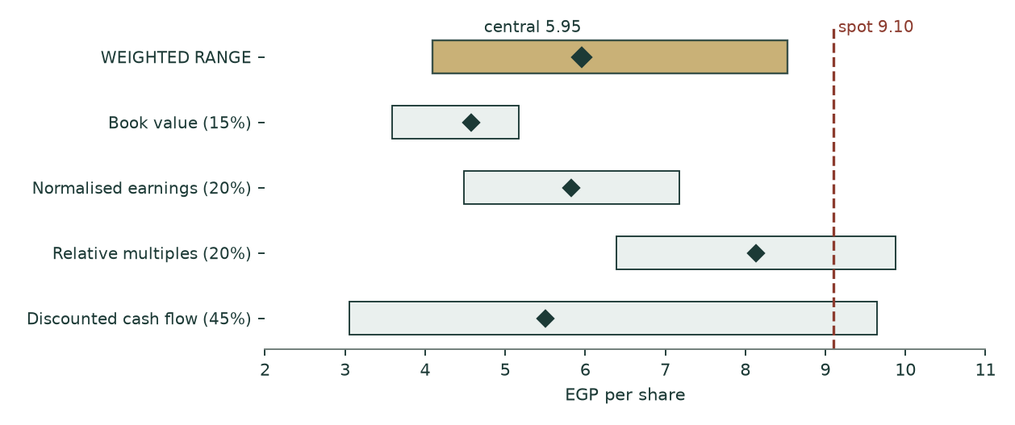
Figure 1 — the football field. The price (red dashed) sits above every lens base and above the top of the weighted range. It falls inside only the cash-flow lens’s bull tail, which is five favourable driver moves at once.
The company
Alexandria Mineral Oils Company is the only refinery listed on the Egyptian Exchange. It takes atmospheric residue and distils it into base and special oils, paraffin wax, gas oil, naphtha, liquefied petroleum gas and fuel oil. Alexandria Petroleum Company holds 20.77% — the previous edition of this study misattributed that stake to the Egyptian General Petroleum Corporation — and AMOC owns 86.45% of Alexandria Wax Products, whose minority is the non-controlling interest carried through this valuation.
The financial year moved from 30 June to 31 December, so the filed record is a six-month transition period (July to December 2025, AUDITED by Crowe — Dr A. M. Hegazy & Co, unqualified opinion signed at Giza on 18 February 2026) followed by a reviewed first quarter. That is why the base year in section 1.2 has to be constructed rather than lifted off one filing.
What it actually sells
Product line | Tonnes, 6M | Value, EGP mn | Realisation EGP/t | Share of tonnage | Share of value
Base and special oils | 54,969.0 | 2,597 | 47,250 | 6.80% | 12.53%
Paraffin wax | 41,774.2 | 2,042 | 48,881 | 5.17% | 9.85%
Gas oil | 171,684.9 | 5,122 | 29,832 | 21.25% | 24.70%
Naphtha | 41,430.9 | 959 | 23,141 | 5.13% | 4.62%
Liquefied petroleum gas | 23,735.8 | 816 | 34,389 | 2.94% | 3.94%
Fuel oil (mix) | 460,153.6 | 8,976 | 19,506 | 56.94% | 43.29%
Heavy fuel oil | 14,327.5 | 224 | 15,642 | 1.77% | 1.08%
Waste | 7.8 | 0 | 11,176 | 0.00% | 0.00%
TOTAL | 808,083.6 | 20,736 | 25,660 | 100.00% | 100.00%

Table 2 — note 14-A of the audited transition-period statements. Eight lines, tonnes AND value both disclosed, so the realisation per tonne is disclosed arithmetic rather than an estimate. The specialty slate — base and special oils plus paraffin wax — is 12.0% of the tonnage and 22.4% of the value. That asymmetry is the company.
Raw materials are 90.7% of cost of sales (note 15-A) and 82.5% of revenue. A business whose single largest line is that big, and whose gross margin is 9.0%, is a PASS-THROUGH PROCESSOR. The value is not in the revenue line and it is not in cost control either — it is in the spread between what the feedstock costs and what the slate fetches, earned on tonnage.
The balance sheet is the unusual part
Item | EGP mn | Per share | Treatment in this study
Cash at banks and on hand, free | 2,464 | 1.91 | added in the bridge — note 9-E, pledged deposits already excluded
Deposits PLEDGED against facilities | 509 | 0.39 | NOT free cash; added separately as a non-operating asset
Gross borrowings | 21 | 0.02 | deducted
NET CASH | 2,443 | 1.89 | 20.8% of market capitalisation
Provision for tax disputes and claims | 921 | 0.71 | note 10-1 — DEDUCTED in the bridge; the previous edition never carried it
Dividends payable, declared | 517 | 0.40 | note 11 — removed from working capital, deducted in the bridge
Equity investment at fair value through OCI | 70 | 0.05 | added as a non-operating asset
Parent equity | 4,791 | 3.71 | the book lens base

Table 3 — the balance sheet at 31 December 2025, as filed. The company holds more than a fifth of its market capitalisation in net cash, which is why the cost-of-capital construction in section 1.6 RAISES the operating discount rate above the cost of equity rather than lowering it. Against that cash sit two disclosed claims — the provision and the declared dividend — that the previous edition of this study quoted in its text and never carried into its arithmetic.
1 Fundamental valuation
1.1 Why this company is valued as an operating company and not as anything else
Three tests decide the class, and all three point the same way. Revenue is 100% own-production petroleum product — there is no trading book, no rental stream and no portfolio of stakes to sum. The balance sheet is working capital and plant, not investments: property, plant and equipment plus projects under construction of EGP 1,300mn and net working capital of EGP 2,251mn against a single equity stake of EGP 70mn. And consolidated profit is dominated by one plant, with the minority in the wax subsidiary running at 3.26% of operating profit.
So the primary lens is free cash flow to the FIRM, discounted, with the three cross-checks of section 1.12 weighted behind it. A sum-of-the-parts framework is inapplicable: AMOC has no listed subsidiaries. One reviewer was asked to run an SOTP verification against three unrelated foreign companies and correctly rejected the premise; it is recorded here so no reader wonders whether it was considered.
1.2 The base year is constructed, and here is the construction
The base year is the TWELVE contiguous months to 30 June 2026: the audited transition half (July to December 2025) plus the half AMOC disclosed to the Egyptian Exchange on 29-30 July 2026, one week before this study’s anchor date. No annualisation scalar is applied to either half. HALF OF THIS BASE YEAR IS A PRESS RELEASE AND NOT A FILING, and this study says so on every page that uses it.
Line | Audited 6M to Dec-2025 | Reported 6M to Jun-2026 | Base year | Basis
Net sales | 20,736 | 26,223 | 46,959 | both halves as disclosed
Gross profit | 1,274 | 2,951 | 4,225 | second half SOLVED, see below
Gross margin | 6.14% | 11.25% | 9.00% | output
Operating expense |  |  | 1,747 | administrative + selling + other + provisions
Depreciation |  |  | 151 | as filed
Cash capital expenditure |  |  | 160 | as paid
Credit interest |  |  | 301 | note 14-B
Employees’ profit share |  |  | 135 | note 16

Table 4 — the base year. Every operating line is struck on the SAME twelve months as revenue and gross profit. The previous edition built revenue from the six-month product table doubled while annualising cost of sales from nine months by four thirds, so its base-year gross margin of 7.081% corresponded to no filed period at all. One period, both sides, or the margin is an artefact of the scalars.
THE RELEASED GROSS PROFIT IS REJECTED. The release states gross profit of EGP 3,258mn for the half. Run through the company’s own first-quarter expense run rates, that figure implies profit after tax of EGP 2,142mn against the EGP 1,903mn the SAME release reports — 12.6% too high. At least one of the two released lines is wrong. Three tests decide which:
Test | What is compared | Result | Verdict
1 — profit | reported majority profit against the "+109%" growth applied to Jan-Jun 2025 majority profit read off the AUDITED statement of changes in equity | agree within 1.2% | CONFIRMS the profit line
2 — revenue | reported revenue triangulated back to a twelve-month figure to Jun-2025 against an independent route through the audited comparatives | agree within 0.2% | CONFIRMS the revenue line
3 — gross profit | released gross profit run down to profit after tax on Q1-2026 expense run rates, against the profit in the same release | disagree by 12.6% | REFUTES the gross-profit line

Table 5 — three coherence tests, run before the figure was used. Two independent tests confirm the profit and revenue lines; the third refutes the gross-profit line. Gross profit is therefore SOLVED from the release’s own profit: EGP 2,951mn, putting the implied Q2-2026 gross margin at 12.0% rather than the 13.9% the released line would require. The whole solve is a live formula block on the Base Year sheet of the companion workbook.
The fully-audited alternative is published beside the headline rather than discarded: the nine audited-and-reviewed months to 31 March 2026, annualised by four thirds, give revenue of EGP 41,662mn at a 7.51% margin. The gap to the headline base is +12.7% on revenue and +1.49% on margin. That gap is a real uncertainty about this company and it is disclosed, not averaged away.
Period | Net sales | Gross profit | Gross margin | Operating profit
6M Dec-2024 | 18,246 | 1,251 | 6.85% | 744
3M Mar-2025 | 10,068 | 509 | 5.05% | 247
6M Dec-2025 | 20,736 | 1,274 | 6.14% | 486
3M Mar-2026 | 10,511 | 1,071 | 10.19% | 643

Table 6 — the filed margin record. Four consecutively filed periods; the margin ranges 5.05% to 10.19%, a spread of 514 basis points. Nothing here is modelled. The margin is administered, not competed: read this as a policy record.
1.3 Three charges the reported profit hides — and which this study takes
Each of the following is disclosed in the filings, was registered as an input by the previous edition of this study, and was then read by no formula in it. All three are charged here.
Charge | Disclosed | Annualised | Where it belongs | Central WITHOUT it
Employees’ profit share and board bonuses | EGP 67mn in the audited half (note 16) | 5.27% of profit after tax | charged in the waterfall and in normalised earnings — a contractual appropriation that reaches neither the shareholder nor the tax line | 6.16 (+3.4%)
Provision for tax disputes and claims | EGP 921mn at 31-Dec-2025 (note 10-1) | one-off, at face | deducted in the equity bridge as a senior claim on the cash | 6.56 (+10.2%)
Dividends payable, declared and unpaid | EGP 517mn at 31-Dec-2025 (note 11) | one-off, at face | removed from operating working capital and deducted in the bridge | 6.39 (+7.3%)

Table 7 — the three charges. The rightmost column is the weighted central this study would print if the charge were NOT taken, from a full model re-run — so a positive figure is how much each charge costs the valuation. Setting the provision to zero in the previous edition moved its valuation by nothing at all, to four decimal places, because no formula read the cell. A rewritten reachability gate now FAILS the build if any input carrying a balance-sheet or profit-statement claim is registered without being used; it found sixteen such inputs where the old gate reported zero.
1.4 How revenue is built
Revenue is the eight disclosed product lines, tonnes times realisation, rolled forward on a volume path per line and one realisation path. Tonnage comes from note 14-A annualised; realisations are note 14-A value divided by note 14-A tonnes, lifted by ONE solved index so the base year foots to the twelve-month revenue. That index is 1.132 and it is the only free scalar on the revenue side.
Line | Base tonnes mn | Base realisation EGP/t | 2026E | 2027E | 2028E | 2029E | 2030E
Base and special oils | 0.110 | 53,502 | 6,700 | 7,490 | 8,256 | 8,997 | 9,730
Paraffin wax | 0.084 | 55,349 | 5,393 | 6,117 | 6,807 | 7,476 | 8,116
Gas oil | 0.343 | 33,779 | 12,895 | 14,140 | 15,330 | 16,479 | 17,596
Naphtha | 0.083 | 26,203 | 2,402 | 2,629 | 2,850 | 3,064 | 3,271
Liquefied petroleum gas | 0.047 | 38,940 | 2,065 | 2,269 | 2,465 | 2,655 | 2,837
Fuel oil (mix) | 0.920 | 22,086 | 22,820 | 25,170 | 27,395 | 29,564 | 31,661
Heavy fuel oil | 0.029 | 17,712 | 564 | 618 | 668 | 718 | 765
TOTAL REVENUE | 1.616 | 29,056 | 52,841 | 58,432 | 63,773 | 68,952 | 73,978

Table 8 — revenue by line, EGP mn. Volume growth is set per line from the measured half-on-half record; realisation grows on one path for all lines. The waste line is omitted from the table for space and is immaterial, but it is carried in the model.
1.5 The cost side, built per line — and what it says about the slate
This is where the previous edition was weakest and where the rebuild is deepest. Cost of sales is 91.0% of revenue on this name, so a cost side expressed as a percentage of revenue means the margin assumption IS the valuation. Cost is now built per line, in two legs.
CONVERSION — salaries, supporting materials, other operating costs and depreciation, the 9.3% of note 15-A that is not feedstock — is allocated across the eight lines on registered processing-intensity weights: base oils 1.00 as the reference through the full lube train (vacuum distillation, solvent extraction, dewaxing, hydrofinishing), paraffin wax 1.15 for the additional deoiling and sweating, the light ends 0.15 to 0.25, the residue fuel oils 0.05.
FEEDSTOCK is then allocated on NET REALISABLE VALUE — each line’s realisation less its own conversion cost. This is the standard joint-product convention and it is the only one of three bases tested that survives a sanity check. Allocating feedstock flat per tonne says fuel oil sells below the cost of its own feed, which is an artefact of the basis rather than a fact about the business. Allocating it on relative sales value makes base oils and paraffin wax — the products this plant exists for — run at negative margins once their conversion cost is stacked on top. Net realisable value is the only basis that leaves every disclosed line with a positive spread, and the workbook documents all three.
Line | Realisation EGP/t | Conversion EGP/t | Feedstock EGP/t | Total cost EGP/t | SPREAD EGP/t | Margin
Base and special oils | 53,502 | 10,957 | 38,362 | 49,320 | 4,182 | 7.8%
Paraffin wax | 55,349 | 12,601 | 38,546 | 51,147 | 4,202 | 7.6%
Gas oil | 33,779 | 2,739 | 27,989 | 30,728 | 3,051 | 9.0%
Naphtha | 26,203 | 2,191 | 21,651 | 23,843 | 2,360 | 9.0%
Liquefied petroleum gas | 38,940 | 1,644 | 33,630 | 35,274 | 3,666 | 9.4%
Fuel oil (mix) | 22,086 | 548 | 19,421 | 19,969 | 2,117 | 9.6%
Heavy fuel oil | 17,712 | 548 | 15,477 | 16,024 | 1,687 | 9.5%
Blended | 29,056 |  |  | 26,441 | 2,614 | 9.0%

Table 9 — per-line economics of the base year. The eight per-line costs rebuild the disclosed cost of sales exactly; that footing test is a live cell in the workbook. A tonne of base oil contributes 2.0 times the spread of a tonne of fuel oil, so the MIX now moves the margin. The previous edition applied one blended margin to all eight lines and described that as a bottom-up build; it was a single company-level number wearing eight labels, and it meant the mix could shift without the margin responding at all.
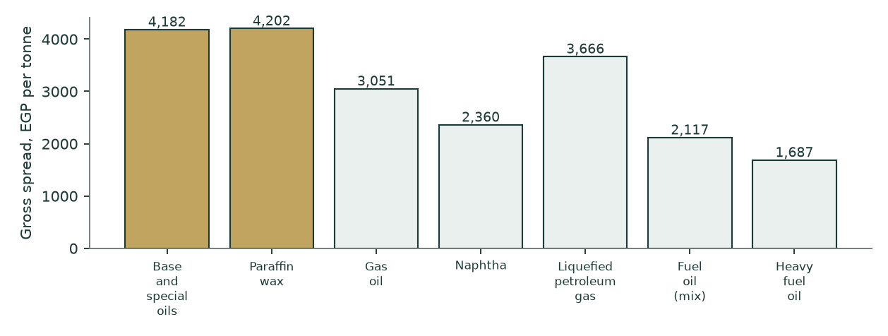
Figure 2 — gross spread per tonne by line; gold is the specialty slate. Note that the specialty lines show a LOWER margin percentage on a HIGHER spread per tonne, because their realisation per tonne is nearly three times fuel oil’s. On a joint-product slate the percentage margin is the wrong lens and the spread per tonne is the right one.
THE ONE OPERATING INPUT NOT READ OFF A FILING. Note 15-A discloses the cost stack for the company and NOT by line, and note 14-A carries only price and volume — so any weight derived from note 14-A alone is a function of price, and a price-derived weight returns an identical margin on every line, which is precisely the defect this build exists to remove. The processing-intensity vector is therefore an engineering judgement. It is registered, dated and sourced like every other input, its effect is bounded (it redistributes cost BETWEEN lines while the company total stays pinned to note 15-A), and section 7 carries it as a named weakness rather than burying it in a formula.
1.6 The cost of capital, built rather than asserted
Component | Explicit window | Terminal | Construction
Risk-free rate | 22.31% | 12.50% | Egypt 10-year local currency. The TERMINAL rate is DERIVED, not typed: the central bank’s inflation target IN FORCE for the terminal horizon (7%) plus a 5.5% real convention
less sovereign default spread | −3.40% | — | netted out of the risk-free rate so country risk is not counted in both the rate and the equity premium
Equity risk premium | 9.41% | 7.00% | CDS basis, Damodaran country file. The rating-basis alternative is computed and published in section 1.13
Beta | 0.940 | 0.940 | own-stock regression, n=257, R² 31.2%, standard error 0.087, 90% interval [0.797, 1.084]
COST OF EQUITY | 27.76% | 19.08%
Cost of debt, after tax | 13.21% | 11.68% | on NET debt in the explicit window; the company is net cash
Equity weight | 126.24% | 90.00%
Debt weight | -26.24% | 10.00% | NEGATIVE in the explicit window — the company holds net cash
WEIGHTED COST OF CAPITAL | 31.58% | 18.34% | the negative debt weight RAISES the operating rate above the cost of equity

Table 10 — the discount-rate stack. The construction that matters most here is the net-cash weighting. A naive model lets a cash pile drag the weighted rate DOWN; this one applies a negative debt weight of -26.2%, which forces the operating rate to 31.6% — ABOVE the 27.8% cost of equity — correctly isolating and penalising the risk of the pure unlevered operating assets. The unlevering identity is asserted in the build to recombine exactly.
1.7 The discount-rate schedule, year by year
 | 2026E | 2027E | 2028E | 2029E | 2030E | Terminal
Glide fraction | 0.000 | 0.357 | 0.643 | 0.857 | 1.000 | 1.000
Forward cost of capital | 31.58% | 26.85% | 23.07% | 20.23% | 18.34% | 18.34%
Cumulative discount factor | 0.76000 | 0.59913 | 0.48682 | 0.40489 | 0.34213

Table 11 — one date, one price of time. Each year is discounted at its OWN forward rate, and the glide from the explicit anchor to the terminal anchor is inherited from the cost-of-debt path’s own cumulative progress rather than invented as a straight line. The terminal block is discounted at the year-5 cumulative factor.
1.8 The free-cash-flow waterfall and the enterprise-value bridge
 | 2026E | 2027E | 2028E | 2029E | 2030E
Revenue | 52,841 | 58,432 | 63,773 | 68,952 | 73,978
Cost of sales | 48,291 | 53,648 | 58,815 | 63,848 | 68,797
GROSS PROFIT | 4,550 | 4,784 | 4,957 | 5,105 | 5,181
Gross margin | 8.61% | 8.19% | 7.77% | 7.40% | 7.00%
Operating expense | 2,008 | 2,276 | 2,546 | 2,808 | 3,082
EBITDA | 2,542 | 2,508 | 2,412 | 2,297 | 2,098
Depreciation | 174 | 189 | 206 | 224 | 244
EBIT | 2,368 | 2,319 | 2,205 | 2,072 | 1,855
NOPAT after profit share | 1,739 | 1,702 | 1,619 | 1,521 | 1,362
plus depreciation | 174 | 189 | 206 | 224 | 244
less capital expenditure | 281 | 307 | 329 | 351 | 375
less change in working capital | 288 | 276 | 265 | 258 | 253
FREE CASH FLOW TO THE FIRM | 1,343 | 1,308 | 1,231 | 1,137 | 978
times discount factor | 0.76000 | 0.59913 | 0.48682 | 0.40489 | 0.34213
PRESENT VALUE | 1,021 | 784 | 599 | 460 | 334

Table 12 — the waterfall, EGP mn. Operating expense charges the three disclosed lines on three different drivers — administrative on inflation, selling on inflation AND tonnage, other on inflation — plus the recurring provisions and expected credit losses the previous edition registered and never took. Capital expenditure is BUILT: maintenance at gross asset cost over the implied 18.1-year life, plus growth at the plant’s own EGP 1,948 per annual tonne of capital intensity, so incremental volume costs capital instead of arriving free. Depreciation ROLLS off the growing asset register rather than being held flat.
Bridge step | EGP mn | Per share | Source
Present value of the explicit window | 3,198 | 2.48 | Table 12
Present value of the terminal block | 2,591 | 2.01 | 44.8% of enterprise value
ENTERPRISE VALUE | 5,789 | 4.48
plus net cash | 2,443 | 1.89 | note 9-E and note 20
Enterprise value including cash | 8,232 | 6.37
less minority interest | (268) | (0.21) | 3.258% of the WHOLE enterprise, cash included
less provision for tax disputes | (921) | (0.71) | note 10-1
less dividends payable | (517) | (0.40) | note 11
plus non-operating investments | 578 | 0.45 | pledged deposits and the ASPPC stake
EQUITY ATTRIBUTABLE | 7,103 | 5.50 | against a price of 9.10

Table 13 — the bridge, with every disclosed claim carried. The minority takes its share of the WHOLE enterprise including the cash: the previous construction charged the minority its share of the operating enterprise and then credited the parent with 100% of the consolidated cash, an inconsistency a reader can find in one line of arithmetic. The provision and the declared dividend are senior claims on that same cash and are deducted at face. The pledged deposits are excluded from free cash but are real assets, so they return here rather than vanishing from both sides.
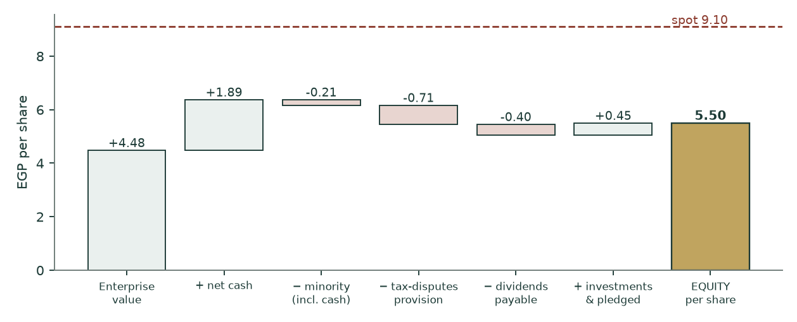
Figure 3 — the bridge drawn per share. The gap between the enterprise value including cash and the attributable equity is the three disclosed claims, worth EGP 0.87 a share between them.
1.9 The terminal block
The terminal return is struck on invested capital at REPLACEMENT cost — working capital plus the asset base at GROSS cost — giving 17.1%. On net book it would be about 26%. The plant is 67.4% written down, and the book lens in section 1.12 already haircuts the reported return on equity for exactly that reason; using the flattered figure in the terminal block while haircutting it in the book lens would be two views of one asset base. One view is now applied across the model.
Growth equals return times reinvestment is ENFORCED by assertion, not asserted in prose: at 5% terminal growth and a 17.1% return, the terminal block reinvests 29.3% of profit. That is ABOVE the final explicit year’s 28.2%, so the terminal block is funded rather than flattered — a step of +1.11%, disclosed here because it RAISES nothing and a reader is entitled to see it either way. Terminal value carries 44.8% of enterprise value, down from 58.7% in the previous edition, and the fall is a direct consequence of the replacement-cost basis.
1.10 Terminal growth, reconciled against the company’s own record
Period | Return on invested capital | Reinvestment rate | Implied steady-state growth
6M Dec-2024 | 28.1% | -6.9% | -1.93%
3M Mar-2025 | 22.2% | 12.7% | 2.82%
6M Dec-2025 | 21.3% | -10.5% | -2.24%
3M Mar-2026 | 56.4% | 4.9% | 2.75%
Four-period average |  | 0.0% | 0.35%

Table 14 — the reinvestment record. TWO of the four filed periods show POSITIVE reinvestment and the four-period average implied growth is positive. The previous edition of this study stated in three separate places that reinvestment was "negative in every audited period" and that the identity implied a negative steady-state rate; its own table, printed on the facing page, said otherwise. Two outside reviewers then built a "shrinking asset base" argument on that incorrect sentence rather than on the correct table. The sentence is withdrawn.
Against that record the adopted 5% is generous, and the study says so. The reinvestment waterfall itself implies 5.88%; the four-period average implies far less. The terminal growth sensitivity in section 1.11 shows why the choice barely matters here: because the reinvestment identity FUNDS growth before crediting it, the value moves only from EGP 5.48 at 3% to 5.52 at 7%. A model in which that row is steep is a model crediting growth for free.
1.11 Sensitivities
Driver (cash-flow lens, EGP a share) | low |  | base |  | high
Gross margin, shifted on every forecast year | 3.53 | 4.51 | 5.50 | 6.49 | 7.47
Volume growth path, as a multiple of the assumed path | 4.83 | 5.16 | 5.50 | 5.85 | 6.22
Realisation path, as a multiple of the assumed path | 4.66 | 5.08 | 5.50 | 5.93 | 6.36
Beta | 6.33 | 5.81 | 5.50 | 5.11 | 4.87
Working-capital cycle, as a multiple of the solved days | 6.58 | 6.04 | 5.50 | 4.96 | 4.42
Terminal growth | 5.48 | 5.49 | 5.50 | 5.51 | 5.52

Table 15 — six drivers, five points each: thirty complete re-runs of the model, not add-backs. Every grid is sorted, every row reproduces the base case at its own base point, and every row is monotone in the direction theory requires — all three properties are ASSERTED in the build. The previous edition published three rows that failed one or more of these tests and had no gate that could have caught them: a working-capital row whose grid was never sorted so the base case sat in the middle slot, a beta row whose centre did not return the base case, and a volume row whose label described a different scenario from the one it ran. In the companion workbook each of these cells is a live formula block.
Two readings matter. TERMINAL GROWTH is nearly inert, for the reason given in section 1.10. And GROSS MARGIN is the whole thesis: half a point on the margin, held in every forecast year, is worth about EGP 0.99 a share on the cash-flow lens. That is why the case in section 1.13 is built to survive the margin being wrong by more than the entire filed record’s range.
terminal WACC \ terminal growth | 3% | 4% | 5% | 6% | 7%
16.34% | 6.74 | 6.85 | 6.98 | 7.14 | 7.33
17.34% | 6.50 | 6.59 | 6.69 | 6.81 | 6.95
18.34% | 6.29 | 6.36 | 6.44 | 6.53 | 6.64
19.34% | 6.10 | 6.16 | 6.22 | 6.30 | 6.38
20.34% | 5.94 | 5.98 | 6.03 | 6.09 | 6.16

Table 16 — the two terminal parameters moved together, cash-flow lens, EGP a share. The grid is flat in the growth direction and steep in the rate direction, which is the signature of a terminal block where reinvestment funds growth before crediting it. Not one cell in this grid reaches the market price.
The bear and bull columns of the cash-flow lens are not a single lever moved twice — they are FIVE drivers moved together, which is why they are much wider than any single row in Table 15. They are joint-worst and joint-best cases and no probability attaches to them.
Driver moved | Bear | Base | Bull
Volume growth path, as a multiple of the assumed path | 0.40x | 1.00x | 1.50x
Gross margin, shifted on every forecast year | -1% | 0.0% | 1%
Exchange-rate path, as a multiple of the assumed path | 0.97x | 1.00x | 1.03x
Cost of capital, shifted at BOTH the explicit and terminal anchors | 2% | 0.0% | -2%
Terminal growth rate | 3% | 5% | 6%
RESULTING FAIR VALUE, cash-flow lens | 3.05 | 5.50 | 9.64

Table 17 — what the bear and bull columns actually move. The previous edition published a 6.2x headline span whose driver set was stated nowhere in the study or the workbook, so it could not be reproduced or falsified. It is stated here.
1.12 The three cross-check lenses
RELATIVE MULTIPLES. The company’s own trailing multiple is 3.54 times enterprise value to EBITDA and 7.1 times earnings. The justified multiple is DERIVED from it at a zero re-rating rather than set by hand, so the lens borrows nothing from the cash-flow lens — no discount factor and no interim add-back, both of which the previous construction took from lens 1 and which every reviewer objected to. At 3.54 times TRAILING EBITDA through the same bridge: EGP 8.14. This is the lens closest to the price, and what remains of the gap is almost entirely the bridge — which is exactly what this lens is now for. At the market’s own multiple, the price pays full value for the operations and then ignores the provision and the declared dividend.
NORMALISED EARNINGS POWER. 2028E OPERATING profit only, taxed at the statutory 22.5%, after the employees’ share and the minority: EGP 1.213 a share. At 7.5 times that is a MID-2028 value, so it is discounted 2.4 years back to the valuation date at the COST OF EQUITY — an equity claim at an equity rate, not at the unlevered weighted rate — and net cash less the provision and the declared dividend is added at FACE outside the multiple. Result EGP 5.83. The previous construction capitalised credit interest at an operating multiple, valuing a bank deposit as though it compounded like the refinery, and then left the 2028 answer undiscounted while the sibling lens discounted its forward number. One lens discounted and the other did not; both are now on the valuation date.
BOOK VALUE AND SUSTAINABLE RETURN. Justified price-to-book of 1.23 times = (sustainable return 28% less growth) over (cost of equity 23.66% less growth), on book value of EGP 3.71: EGP 4.57. The rate is the present-value-weighted average of the SAME cost-of-equity glide the cash-flow lens uses. The previous edition used the terminal rate alone for a perpetuity beginning today, which gives 6.06; the explicit rate alone gives 3.75; a perpetuity starting now deserves neither endpoint. The sustainable return is struck below the trailing 32.6% because the asset base is 67.4% written down.
1.13 Contested choices, computed rather than argued
A gap of this size should not survive its own contested judgements, so the study gives them all back. Each row below removes one charge a critic could dispute; the last row removes all of them at once. Every row is a complete re-run of the whole model.
Give-back | Central | vs price | What is being conceded
None — as published | 5.95 | -34.6% | the study’s own reading
Tax provision costs nothing | 6.56 | -27.9% | EGP 921mn recognised in note 10-1 settles for zero
Declared dividend is not a claim | 6.39 | -29.8% | EGP 517mn payable in note 11 never leaves
Employees’ profit share is free | 6.16 | -32.3% | the 5.3% statutory appropriation is never paid
Terminal rate on the 2028 target | 6.19 | -32.0% | the softer 5% target replaces the 7% target in force
Effective instead of statutory tax | 5.97 | -34.4% | operating profit taxed at the interest-flattered 22.12%
ALL OF THE ABOVE AT ONCE | 7.47 | -17.9% | every contested charge conceded simultaneously

Table 18 — the adversarial stack. Concede everything and the price is still 17.9% above the model.
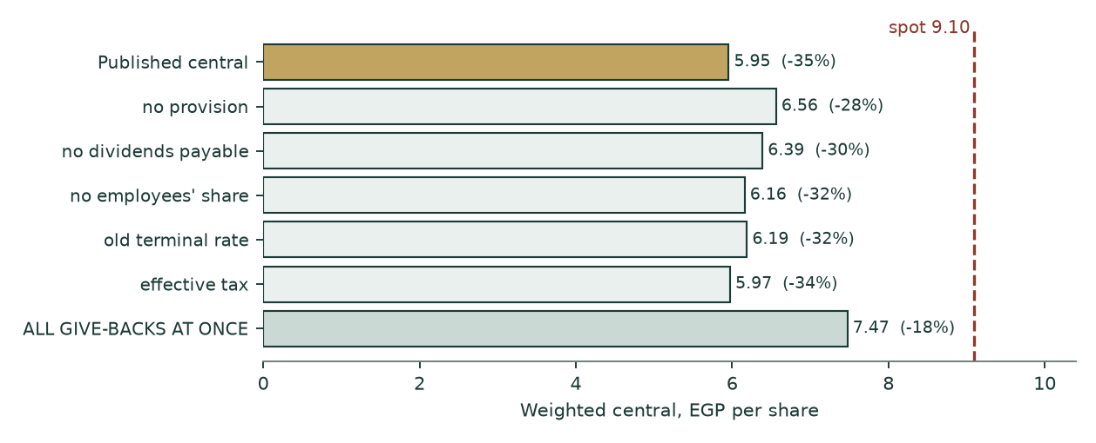
Figure 4 — the same stack drawn. No single concession, and not all of them together, reaches the price.
Two further contested choices are computed rather than conceded. On the RATING-BASIS equity risk premium instead of the CDS basis, the cash-flow lens is EGP 5.72; two independent reviewers reached for that column, so it is promoted here rather than buried. And discounting the export leg in DOLLARS at a dollar cost of capital before translating back — rather than discounting a pound cash flow already inflated by the depreciation path at a dollar rate, which would count the currency benefit twice — gives EGP 6.50. Both are below the market price.
What survives the give-backs is the part of the verdict that cannot be negotiated away by accounting choices: a pass-through processor earning a 9.0% gross margin, discounted at an Egyptian cost of equity of 27.8% falling to 19.1%, is worth less than EGP 9.10 a share on any internally consistent arithmetic this study can construct.
1.14 What a buyer at EGP 9.10 must believe
Inverting the model at the market price, holding everything else at its published value:
- THE REQUIRED LENS — the cash-flow lens must reach EGP 12.49 against this model’s 5.50 — an uplift of 127%;
- AS MARGIN — read off the margin grid, that needs roughly +3.6 percentage points of gross margin on EVERY forecast year and in perpetuity: a permanent ~12.2% against a four-period filed record of 5.05% to 10.19% whose best single quarter is 10.19%;
- AS VOLUME — or, read off the volume grid, roughly ten and a half times the assumed volume-growth path — a plant adding capacity it has not announced, which the built capital line would then have to fund;
- NOT VIA THE RATE — the discount rate cannot get there. Even at a beta of 0.60 the lens reaches only EGP 6.33, and terminal growth cannot do it at any rate the reinvestment identity permits.
The one belief that WOULD close the gap honestly is the released H1-2026 gross-profit line taken at face value — and section 1.2 shows that line contradicts the profit printed in the same release by 12.6%. A buyer at the price is, in effect, trusting the single number in that disclosure which fails its own internal arithmetic.
2 The price record
The price series runs from 2011-01-02 to 2026-08-06 — 15.6 years, 3,755 raw rows reduced to 3,754 clean sessions at 240.8 sessions a year. One row was dropped: dropped 1 rows carrying a non-positive or non-finite OHLC value (2013-05-07) — vendor fills, not tradeable prices. The largest single-session move in the whole record is 0.1813 in logs, inside the exchange’s daily limit — the up-limit is ln(1.20) = 0.18232 and the down-limit is |ln(0.80)| = 0.22314, and the two are tested separately because a ±20% price band is asymmetric in logs. 9.6% of sessions closed unchanged.
3 Where the price could trade
A calibrated Monte-Carlo cone, carry-anchored YZ-HAR-t, 50,000 paths, seed 42, ν = 6.0, width calibration 0.951. The drift is the CARRY — ln(1+risk-free) less ln(1+dividend yield) — and NO part of it comes from the valuation, so the cone can and does sit above a fair value well below it.
Horizon | p5 | p25 | median | p75 | p95 | P(above today) | Grade date
1 month | 7.71 | 8.60 | 9.17 | 9.79 | 10.91 | 53.3% | 2026-09-06
3 months | 6.90 | 8.34 | 9.33 | 10.42 | 12.60 | 56.0% | 2026-11-08

Table 19 — the published percentiles. The three-month calendar target falls on a non-trading day, so the grade date rolls FORWARD to the first real session, which is how the ledger will grade it.
Calibration set | Windows | Scale-normalised skill | Verdict
Name-level, post-break | 17 | +0.68% | PARITY
Five-year | 19 | +0.92% | PARITY
Full cleaned history | 57 | +1.32% | PASS
Egypt market panel | 494 | +1.58% | PASS

Table 20 — the calibration record, published alongside the forecast rather than behind it. The name’s own verdict is PARITY, not skill: the bootstrap interval straddles zero across block sizes 2, 3 and 4. What carries the cone is the market-level gate, the thirty-name Egypt panel, which is the standing gate and PASSES.
Level, EGP | Touched within 1 month | Touched within 3 months | Note
11.00 | 9.7% | 36.2%
10.50 | 21.4% | 49.7%
10.00 | 41.8% | 66.0%
9.10 | 100.0% | 100.0% | the market price
8.50 | 51.4% | 68.6%
8.00 | 22.5% | 45.5%
7.50 | 7.1% | 27.0%
5.95 | 0.0% | 1.9% | THIS STUDY’S FAIR VALUE

Table 21 — the touch ladder: the chance the price trades AT or THROUGH each level at any point in the window, which is a higher number than the chance of closing beyond it. Note the last row. The cone gives the price a real chance of reaching this study’s fair value inside three months, but a touch is not a re-rating — it is the tape passing through a level, and the study makes no claim about when or whether the market closes the gap.
Diagnostic | Value | Reading
Coverage at 50% | 52.9% | against a nominal 50%
Coverage at 80% | 88.2% | against a nominal 80%
Coverage at 90% | 94.1% | against a nominal 90%
PIT mean | 0.461 | against a nominal 0.500 — no material centring bias
Width against benchmark | 0.969x | the cone is marginally NARROWER than the carry-anchored random walk
Windows scored | 17 | 40 pre-break origins dropped

Table 22 — cone diagnostics. Coverage sits close to nominal at all three levels and the width ratio is near one, so the PARITY verdict in Table 20 is a statement about SKILL — the cone is not beating a carry-anchored random walk on this name — rather than about the cone being mis-shaped. Published because a calibration record that shows only the verdict is not a calibration record.
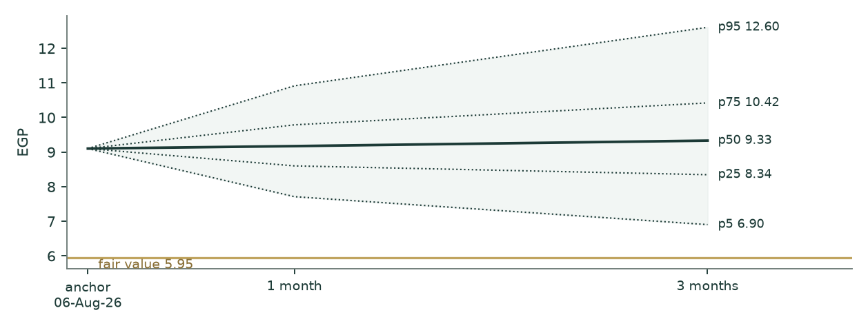
Figure 5 — the cone against fair value in gold. The two objects answer different questions and are never blended.
4 The two answers side by side
Question | Object | Answer | Horizon
What is the business worth? | weighted fair value | EGP 5.95 (range 4.09–8.52) | undated
Where might the price go? | calibrated price cone | 3-month median EGP 9.33 (6.90–12.60) | 1 to 3 months
What does the market say today? | last close | EGP 9.10 | 6 August 2026

Table 23 — the fair-value read and the price cone are separate objects and are never combined into one number. A fair value far below a cone median is not a contradiction: the cone prices where the tape can travel over weeks, and the study prices what the business is worth.
5 What would move the answer
- GROSS MARGIN — the margin is the thesis and it is administered, not competed. Half a point in every forecast year is worth about EGP 0.99 on the cash-flow lens, and the filed record spans 514 basis points;
- THE REPORTED HALF — the base year is half press release. Audited half-year statements that restate revenue or profit materially would move the whole build — and note the direction: the fully-audited nine-month alternative prices the central LOWER, not higher;
- THE TWO UNREAD DISCLOSURES — two exchange disclosures could not be reached from this environment and pull in OPPOSITE directions — a board capital budget (roughly −12% at face) and a revised FY2026 profit budget (roughly +17%);
- THE ONE JUDGEMENT INPUT — the processing-intensity weights redistribute cost between lines. They move the mix effect and the per-line spreads, not the company total, which stays pinned to note 15-A;
- THE COUNTERPARTY — the state petroleum complex is both the dominant customer and the feedstock supplier. A policy shift on either side moves the spread directly, and the spread IS the business.
6 Probability zones
Zone | Probability, 3 months
Below fair value (under EGP 5.95) | 2.1%
EGP 5.95 to 7.50 | 11.7%
EGP 7.50 to 9.10 | 30.7%
EGP 9.10 to 11.00 | 36.3%
Above EGP 11.00 | 19.3%
TOTAL | 100.0%

Table 24 — a genuine partition: the bands tile the line, none overlaps, and the total is asserted to be 100% in the build. The previous edition published five zones summing to 103.4%, with one band written descending and nested inside the band above it, so every zone probability in it was misstated. Probabilities are read off the same three-month distribution as Table 17 and say nothing about fair value.
7 Caveats — what is weak in this study
- HALF THE BASE YEAR IS NOT AUDITED. The six months to 30 June 2026 is an exchange disclosure, not a filing. Its gross-profit line is rejected on a coherence test and solved from its own profit line; its revenue and profit lines pass two independent tests. If the audited half-year statements restate either, the base moves.
- TWO DISCLOSURES WERE UNREACHABLE. A board-approved FY2025/26 capital-expenditure budget and a revised FY2026 operating-profit budget were both reported by outside reviewers and neither could be opened from this environment, where the exchange feed, the company’s investor-relations site and the data vendors all refuse connections under the network policy in force. They move the answer roughly −12% and +17% respectively. Both are named here rather than silently absent, and neither is in the numbers.
- THE PROCESSING-INTENSITY WEIGHTS ARE A JUDGEMENT. Note 15-A discloses the cost stack for the company and not by line, and no weight derivable from note 14-A alone can differentiate per-line margins, because that note contains only price and volume. The vector is registered and dated, and it cannot move the company total.
- THE RISK-FREE RATE COULD NOT BE RE-VERIFIED. The 22.31% ten-year yield is carried from a house reference that this environment could not open; three reviewers independently place the rate between 22.6% and 23.0%. At the top of that range the central falls about half a percent — the case does not turn on it, but the citation is weak and is corrected to say so.
- THE MARGIN IS ADMINISTERED. A 514-basis-point range across four consecutive filed periods, set by a feedstock relationship with a 20.77% shareholder, is not a market signal. It is the single largest uncertainty in the valuation and it cuts both ways — which is precisely why the case in section 1.13 is constructed to survive it.
Appendix A Financial statements
A.1 Income statement — four filed periods and a five-year forecast (EGP mn)
 | 6M Dec-2024 | 3M Mar-2025 | 6M Dec-2025 | 3M Mar-2026 | 2026E | 2027E | 2028E | 2029E | 2030E
Net sales | 18,246 | 10,068 | 20,736 | 10,511 | 52,841 | 58,432 | 63,773 | 68,952 | 73,978
Cost of sales | 16,995 | 9,560 | 19,462 | 9,440 | 48,291 | 53,648 | 58,815 | 63,848 | 68,797
Gross profit | 1,251 | 509 | 1,274 | 1,071 | 4,550 | 4,784 | 4,957 | 5,105 | 5,181
Gross margin | 6.9% | 5.1% | 6.1% | 10.2% | 8.6% | 8.2% | 7.8% | 7.4% | 7.0%
Operating profit | 744 | 247 | 486 | 643 | 2,368 | 2,319 | 2,205 | 2,072 | 1,855
Net finance income |  |  |  |  | 414 | 294 | 200 | 127 | 66
Attributable profit |  |  |  |  | 2,066 | 1,940 | 1,786 | 1,634 | 1,426

Table A.1 — the four filed periods are AS FILED and are of unequal length (two six-month periods and two quarters), so they are shown as reported rather than annualised. The forecast columns are the model.
A.2 Balance sheet — as filed at 31 December 2025, and the forecast (EGP mn)
 | Filed 31-Dec-2025 | 2026E | 2027E | 2028E | 2029E | 2030E
Property, plant and equipment, net | 1,300 | 1,407 | 1,526 | 1,648 | 1,775 | 1,906
Net working capital | 2,251 | 2,540 | 2,816 | 3,081 | 3,340 | 3,592
INVESTED CAPITAL | 3,552 | 3,947 | 4,342 | 4,729 | 5,114 | 5,498
Cash and equivalents, free | 2,464 | 1,986 | 1,511 | 1,045 | 586 | 136
Net debt (negative = net cash) | -2,443 | -1,965 | -1,490 | -1,024 | -565 | -115
Parent equity | 4,791 | 4,714 | 4,642 | 4,575 | 4,515 | 4,462
Total assets, as filed | 8,136
Total liabilities, as filed | 3,312
Non-controlling interest, carrying | 34

Table A.2 — the filed column foots: total assets less total liabilities less parent equity less the non-controlling interest is zero, and that identity is asserted in the build. Working capital is stated NET of the declared dividend, which is carried in the bridge instead — the previous edition left a shareholder distribution inside the operating capital ratio that drives the change in working capital in every forecast year.
A.3 Cash flow — the five-year forecast (EGP mn)
 | 2026E | 2027E | 2028E | 2029E | 2030E
NOPAT, after the employees’ profit share | 1,739 | 1,702 | 1,619 | 1,521 | 1,362
plus depreciation | 174 | 189 | 206 | 224 | 244
less capital expenditure | (281) | (307) | (329) | (351) | (375)
less change in working capital | (288) | (276) | (265) | (258) | (253)
FREE CASH FLOW TO THE FIRM | 1,343 | 1,308 | 1,231 | 1,137 | 978
Memo: return on invested capital | 44.0% | 39.2% | 34.2% | 29.7% | 24.8%
Memo: capital expenditure / depreciation | 1.62x | 1.62x | 1.59x | 1.56x | 1.54x

Table A.3 — note the last row. Capital expenditure EXCEEDS depreciation in every forecast year. The previous edition stated, twice, that free cash flow was overstated by "roughly EGP 2mn a year" because capital expenditure sat below depreciation; that held in the first forecast year only and reversed sign in every year after it, so the stated correction would have RAISED the valuation rather than lowered it.
Appendix B The cost of capital in detail
B.1 Beta
Statistic | Value | Test
Point estimate | 0.940 | —
Observations | 257 | 5-year window, weekly returns
R-squared | 31.2% | above the usability floor
Standard error | 0.087 | 0.09 of the point estimate — not a weak instrument
90% confidence interval | [0.797, 1.084] | spans 0.31x the estimate, inside the 2x flag
Benchmark | 33-name composite | equal-weight Egyptian Exchange basket from the covered library

Table B.1 — the regression passes its usability gate on every limb. ONE WEAKNESS IS RECORDED AGAINST IT: the benchmark is a house composite rather than a published index, so a reader cannot reproduce the regression from public data. Two reviewers raised this independently and both are right. The beta sensitivity in Table 15 bounds what it can cost: across the whole plausible range the cash-flow lens moves from EGP 6.33 to 4.87, and neither end reaches the market price.
B.2 The cost of debt, and why it does not matter here
Gross borrowings are EGP 21mn against a market capitalisation of EGP 11,753mn — 0.1782% of the capital structure. A 500 basis-point error in the cost of debt moves the weighted cost of capital by 0.69 basis points. The input cannot move the answer, and the study says so rather than dressing an immaterial input as a precise one. That immateriality is asserted in the build, so if the capital structure ever changes the assertion fails rather than the claim quietly going stale.
B.3 Explicit against terminal cost of capital
The explicit rate of 31.58% is not a normal corporate discount rate and is not meant to be. It is what an Egyptian operating asset costs today, with the sovereign spread stripped out of the risk-free rate so country risk is not double-counted, and with the net-cash position pushing the operating rate ABOVE the cost of equity. The terminal rate of 18.34% is norm-built: the central bank’s inflation target in force plus a real convention, a normalised equity premium, and a terminal capital structure carrying 10% debt rather than capitalising today’s zero-leverage position into perpetuity. The glide between them is inherited from the cost-of-debt path’s own cumulative progress.
Two alternatives are computed rather than argued. On the RATING-BASIS premium the explicit rate is 32.18% and the cash-flow lens is EGP 5.72. On GROSS rather than net debt weights — the construction this study rejects, because it counts the cash pile twice — the lens is EGP 6.70. Both are published so the choice is visible.
Appendix C The expert appendix
Three independent methods, cast by approach rather than by personality, each run on the same audited inputs and each free to disagree with the primary lens.
Expert 1 — earnings power at a justified multiple
Takes 2028E operating profit, adds the finance income the cash pile actually earns, taxes the sum, strikes the minority, and applies a justified multiple struck BELOW the primary lens deliberately — this is an independent opinion, not a restatement of it.
Step | EGP mn unless stated
Operating profit, 2028E | 2,205
plus net finance income | 200
taxed at the statutory 22.5% and after the minority
Attributable earnings per share, EGP | 1.383
Justified price / earnings | 7.0x
VALUE PER SHARE, EGP | 9.68

Table C.1 — Expert 1. Range EGP 6.92 to 13.14 on a 5.0x to 9.5x multiple band. This is the HIGHEST of the three and it is still 6.4% against the market price. Note that it is an undiscounted 2028E number, which is why it sits above the primary lens.
Expert 2 — free cash flow to equity, discounted
Discounts cash flow to the EQUITY holder rather than to the firm: free cash flow to the firm less after-tax finance costs plus after-tax finance income, discounted at the COST OF EQUITY on its own glide rather than at the weighted rate. It is the cleanest independent check on the primary lens, because it changes both the numerator and the discount rate together.
Step | 2026E | 2027E | 2028E | 2029E | 2030E
Free cash flow to equity | 1,588 | 1,465 | 1,323 | 1,178 | 981
Cost of equity, glided | 27.76% | 24.66% | 22.18% | 20.32% | 19.08%
Discount factor | 0.7827 | 0.6279 | 0.5139 | 0.4271 | 0.3586
Present value | 1,243 | 920 | 680 | 503 | 352

Step | EGP mn
Present value of the explicit window | 3,698
Present value of the terminal block | 1,854
less the disclosed claims carried in the bridge | (1,439)
EQUITY VALUE | 5,552
VALUE PER SHARE, EGP | 4.30

Table C.2 — Expert 2. Range EGP 3.90 to 4.42. This is the LOWEST of the three at -52.8% against the price, and the reason is the discount rate: an equity claim discounted on the equity glide from 27.8% to 19.1% is punished harder in the near years than an unlevered claim on the weighted rate.
Expert 3 — cash returns against the cost of capital
Values the business as invested capital plus the present value of the ECONOMIC PROFIT it earns above its cost of capital, rather than as a stream of cash. Arithmetically it must reconcile to the primary lens on the same inputs — that is the point of including it. Where it differs is that it makes the SPREAD visible: how much of the value is capital already in the ground, and how much is return above the cost of that capital.
Step | EGP mn
Invested capital at the valuation date | 3,552
plus present value of economic profit, explicit window | 1,528
plus present value of economic profit, terminal | 1,080
ENTERPRISE VALUE | 6,159
VALUE PER SHARE after the bridge, EGP | 6.44

 | 2026E | 2027E | 2028E | 2029E | 2030E
Economic profit | 617 | 642 | 617 | 564 | 423
Return spread over the cost of capital | 12.47% | 12.35% | 11.16% | 9.52% | 6.42%

Table C.3 — Expert 3. Range EGP 5.63 to 6.50. The spread row is the finding: this business earns a POSITIVE return over its cost of capital in every forecast year, which is why it is worth more than its invested capital — and it is still worth materially less than the market price. Cheap capital is not the question here; the question is how much spread 9.0% of gross margin can support.
Expert | Method | Central | Range | vs price
E1 | earnings power at a justified multiple | 9.68 | 6.92–13.14 | 6.4%
E2 | free cash flow to equity, discounted | 4.30 | 3.90–4.42 | -52.8%
E3 | cash returns against the cost of capital | 6.44 | 5.63–6.50 | -29.2%
PANEL | median of the three | 6.44 |  | -29.2%

Table C.4 — the panel. The three methods disagree with each other by more than any of them disagrees with the primary lens, which is the honest reading of a company whose margin is administered. All three land below the market price.
About this study
WHAT THIS IS. An independent, educational valuation study. It is NOT investment advice, and it issues no buy, sell or hold recommendation. It publishes a fair-value range, a probability distribution for the price, and the model behind both, and it grades its own forecasts publicly when they resolve.
WHAT IT RESTS ON. Audited consolidated statements for the transition period 1 July to 31 December 2025 (Crowe — Dr A. M. Hegazy & Co, unqualified, signed at Giza 18 February 2026); reviewed statements for the three months to 31 March 2026; and the half-year results disclosed to the Egyptian Exchange on 29-30 July 2026, which are REPORTED and not audited. Every input carries a value, a source, a date and a research ring in the companion source register.
THE COMPANION FILES. The workbook recalculates this entire study live: 5,775 formulas against 198 pasted filing values, with all thirty sensitivity grid points written out as complete formula engines and every formula cell verified against the model by an independent evaluator — 0 unresolvable, 0 unchecked, 0 disagreements. The bibliography lists all 152 registered inputs with their sources, the triangulations, and the negative results.
WHAT CHANGED IN THIS EDITION. The base year moved from nine annualised months to the twelve contiguous months to 30 June 2026; the cost side is now built per product line; capital expenditure, depreciation and working capital are built rather than extrapolated; and the equity bridge now carries three disclosed claims it previously omitted. The fair-value estimate moved from EGP 9.38 (before the filings) to 7.16 (on the audited nine months) to EGP 5.95. Each restatement is part of the record and none is silently overwritten.

