Independent Valuation Study — Educational Analysis
Agthia Group PJSC (ADX: AGTHIA)
Fundamental analysis · Technical analysis · Monte Carlo simulation — one integrated read
Anchor: AED 3.51 (6 Jul 2026 close) · 831.16mn shares · mkt cap ~AED 2.92bn · the ADQ-majority UAE food & beverage platform — Al Ain water, Grand Mills flour and Agrivita feed, Abu Auf / BMB / Al Foah snacking, Nabil and Atyab protein · prices and probabilities computed 6 Jul 2026 from the attached daily history · primary lens: consolidated DCF with a segment sum-of-the-parts cross-check · the Snacking margin reset (green coffee + the Egyptian pound) and the KSA protein ramp are the swing factors. Note: the Monte Carlo lens failed its Step 0 calibration test on this name and is presented as INDICATIVE ONLY; the backtest lives on the public calibration ledger.
READ FIRST — what this document is, and is not. This study is a valuation exercise and an expression of personal analytical opinion, published free of charge for educational purposes: it shows how one analyst applies fundamental, technical and probabilistic methods to a listed company, and invites scrutiny of that methodology. It is NOT investment advice, NOT a recommendation or solicitation to buy, sell or hold any security, and NOT directed at the circumstances of any reader. The preparer is not licensed by any securities regulator in any jurisdiction, holds no UAE or other brokerage authorisation, provides no financial consultancy, manages no money, and accepts no fees, funds or clients. See the Disclosure & Disclaimer at the end. All values are model outputs presented as ranges and distributions because no single number should be relied on. Reported financials are the company’s own disclosure (ADX preliminary FY2025 results, 5 March 2026; Q1 2026 release, 12 May 2026); forward-looking inputs — the segment forecasts, the multiples, the DCF, the sleeve costs of equity and the Monte-Carlo factor probabilities — are the preparer’s judgments and are flagged throughout. A calibration note: every Testahil study runs a Step 0 backtest before publishing a probabilistic forecast; on AGTHIA the Monte Carlo lens does NOT beat the naïve random-walk benchmark (CRPS skill ≤ 0), so §3 carries an INDICATIVE ONLY · FAILED CALIBRATION TEST flag; the full backtest is published on the Testahil calibration ledger (testahil.com/ledger), not reprinted here. The fundamental work in §1 is unaffected. Consult a licensed financial advisor before any investment decision.

Headline
The model’s read: meaningfully undervalued on a reset year the market is treating as structural. At AED 3.51 the shares sit about 25% below our weighted central estimate of AED 4.37. Reported FY2025 optics are dreadful — EPS of 0.103, a 34× trailing P/E, EBITDA down 32% — but AED 143mn of the damage is provisions (an Al Foah commercial counterparty, legacy receivables, a JV exit) that management has ring-fenced and taken to court, not lost operating power: underlying EBITDA held at AED 606.8mn (a 12.5% margin) and the first quarter of 2026 has already turned, with revenue +3.3%, EBITDA +4.1% and net profit +12.5% — printed through the March 2026 regional escalation. The four lenses agree in direction and disagree only on magnitude: the DCF anchors at 4.60, the segment SOTP reads 4.24, a conservative relative-multiple read marks the floor at 3.83, and normalized earnings power lands at 4.51. A 6.3% dividend yield — 22.102 fils, stepped up 10% at the half — pays the reader to wait. The whole answer turns on two operating questions: whether Snacking’s margin rebuilds from a written-down 2025 (green coffee and the Egyptian pound are the levers) and whether the KSA protein facility ramps to absorb its fixed-cost base. Technically the tape is soft — below all four moving averages with a negative MACD — and the three-month Monte Carlo centres on spot with a p5–p95 of 2.85–4.31; but that probabilistic lens failed its own calibration test on this name and is shown as indicative only.

Valuation summary — every read at a glance
One table for the four reads that follow — what the business is worth (fundamental), what the tape is doing (technical), where price could travel over three months (Monte Carlo — indicative only on this name), and how three independent expert methods land. Every row is developed in the sections and appendices below.
Lens / read | What it measures | Output | Takeaway
FUNDAMENTAL — what the business is worth (the anchor)
Consolidated DCF (primary) | 5-yr FCFF at a 10.6% sleeve-built WACC | AED 4.60 | +31% vs spot
Segment SOTP | Four segments at class multiples | AED 4.24 | +21%
Relative multiples | 7.5× FY26E EV/EBITDA | AED 3.83 | +9% · the floor
Normalized earnings | Mid-cycle attributable NP × P/E | AED 4.51 | +29%
Weighted central | Blend 35 / 25 / 15 / 25 | AED 4.37 | +25% vs 3.51
TECHNICAL — what the tape is doing (timing, not value)
Trend & momentum | Price vs the 20/50/100/200-day averages | Below all four | Soft, corrective
Momentum / range | RSI · MACD · 52-week range | RSI 42.9 · MACD hist −0.012 · 3.34–4.37 | Drifting lower
MONTE CARLO — 3-month price paths (INDICATIVE ONLY — failed Step 0)
T+20 sessions | 50,000 paths · 16 factors | p5 3.11 · p50 3.51 · p95 3.95 | Median ≈ spot
T+60 sessions | same engine, longer horizon | p5 2.85 · p50 3.52 · p95 4.31 | Wide, near-even
EXPERT PANEL — three independent methods (Appendix C)
Expert 1 — normalized earnings power | Mid-cycle NP × justified P/E | AED 4.51 | Most constructive
Expert 2 — cash & balance-sheet audit | Capitalized sustainable FCFE | AED 3.62 | Most conservative
Expert 3 — macro-policy sleeves | Two-currency, policy-weighted NAV | AED 4.15 | The bridge
Panel range | Spread = the reset question | 3.62–4.51 | Centres ~4.09

Bottom line. Every read points the same way on value and disagrees only on magnitude. The fundamental central sits near AED 4.37 — about 25% above the AED 3.51 spot — the three experts span 3.62–4.51, and each turns on the same question: whether the FY2025 write-downs were the cost of resetting the portfolio or the first symptom of a lower-quality one. The technical tape is the lone dissenter, soft and below trend, which is why the three-month distribution centres near spot rather than at fair value — and that distribution itself carries a failed-calibration flag on this name.

Company overview — Agthia at a glance
Item | Value
Listed entity | Agthia Group PJSC (ADX: AGTHIA) · est. 2004, Abu Dhabi
What it owns | Water & Food (Al Ain, VOSS UAE, Riviere HOS) · Agri-Business (Grand Mills flour, Agrivita feed) · Snacking (Abu Auf, BMB, Al Foah dates) · Protein & Frozen (Nabil, Atyab, Chicketita + KSA plant)
Spot / date | AED 3.51 · 6 Jul 2026 close
Shares · market cap | 831,155,940 · ~AED 2,917mn
Net debt | AED 1,300mn · 2.9× reported EBITDA (≈ 2.2× underlying)
FY25 revenue / underlying EBITDA margin | AED 4,845.6mn (−1.4% YoY) · 12.5%
Q1 2026 (latest print) | Revenue +3.3% · EBITDA AED 193.3mn (+4.1%) · NP AED 96.9mn (+12.5%)
FY25 dividend | 22.102 fils (interim 10.31 + final 11.792, +10% YoY) ≈ 6.3% yield
Ownership | ADQ (via General Holding / Senaat) — majority shareholder
52-week range | AED 3.34 – 4.37
Chairman · MD & CEO | HE Khalifa Sultan Al Suwaidi · Salmeen Alameri
Footprint | UAE · Egypt · Saudi Arabia · Jordan · Kuwait · Oman · exports across MENA

Source: ADX preliminary FY2025 results (5 Mar 2026), Q1 2026 release (12 May 2026), company disclosure, exchange data. Values rounded.

1 Fundamental valuation
We value Agthia as a consolidated multi-category consumer group and triangulate four lenses. The primary lens is a consolidated DCF, because the group’s cash engine — branded water, regulated flour and feed, and a recovering snacking and protein portfolio — is best captured as one free-cash-flow stream discounted at a cost of capital that honestly reflects its two-currency exposure. A segment sum-of-the-parts, a relative-multiple cross-check and a normalized-earnings-power read complete the set. The weights and the football field are in §1.5; the swing factor — the Snacking reset and the KSA protein ramp — is dissected in §1.7 and the sensitivity grid in §1.9. Per the house data-discipline gate, all segment forecasts are top-down normalized margins on disclosed segment averages: Agthia does not disclose volume/price splits by pack, so no bottom-up packs-×-price build is manufactured (§1.6).

1.1 Consolidated DCF — the primary lens
The cost of capital is built explicitly, per the house rule: Ke = rf + β × ERP with rf 4.2% (the dirham is pegged; UAE sovereign USD curve), ERP 6.0% and β 0.90 (staples; within the 0.8–1.3 band) gives a UAE-sleeve Ke of 9.6%. The Egypt/Jordan sleeve — Abu Auf, Atyab, Nabil, roughly half the group’s risk — carries a flagged-judgment Ke of 17.0% (EGP risk premium). Blended 50/50, Ke is 13.3%; with 69% equity weight and a 4.5% after-tax cost of debt, WACC ≈ 10.6%, terminal growth 2.25%. The five-year FCFF build below runs off the segment forecasts in the companion model (Assumptions sheet); every line links back to one input layer.
AED mn | FY26E | FY27E | FY28E | FY29E | FY30E
Revenue | 5,051 | 5,335 | 5,624 | 5,888 | 6,135
EBITDA | 633 | 708 | 776 | 828 | 870
D&A | 263 | 272 | 287 | 294 | 307
EBIT | 370 | 436 | 489 | 533 | 564
NOPAT = EBIT × (1−tax 20%) | 296 | 349 | 391 | 427 | 451
+ D&A | 263 | 272 | 287 | 294 | 307
− Capex (3.8% of revenue) | -192 | -203 | -214 | -224 | -233
− Δ net working capital | -22 | -24 | -18 | -16 | -15
FCFF | 345 | 394 | 446 | 481 | 510
Discount factor @ 10.6% | 0.904 | 0.818 | 0.740 | 0.669 | 0.605
PV of FCFF | 312 | 323 | 330 | 322 | 308

DCF output | AED mn / per share
Σ PV of explicit FCFF (FY26E–30E) | 1,595
Terminal value (Gordon, g 2.25%) | 6,260
PV of terminal value | 3,788
Enterprise value | 5,383
less: consolidated net debt | (1,300)
less: minorities (est. value) | (260)
Equity value → per share | 3,823 → AED 4.60
Terminal value as % of EV (disclosed & sensitized, §1.9) | 70.4%

DCF input | Bear | Base | Bull
WACC | 11.6% | 10.6% | 9.6%
Terminal growth | 1.5% | 2.25% | 3.0%
Segment EBITDA margins | −100bp | as forecast | +75bp
Capex (% of revenue) | 4.2% | 3.8% | 3.5%
Fair value (AED/share) | 2.76 | 4.60 | 7.07

The DCF base of AED 4.60 rests on a margin path that only recovers to 14.3% by FY30E — below the group’s own FY23–24 14% on a cleaner mix — and on terminal value of 70.4% of EV, disclosed per house device A-7 and stress-tested in §1.9 rather than buried. Its width is a fair warning: a point of WACC moves the answer by roughly AED 0.40.

1.2 Segment sum-of-the-parts — the cross-check
Four businesses with genuinely different economics share one balance sheet: branded UAE water (a compounding consumer franchise), regulated flour and feed (a stable B2B utility with food-security backing), an Egypt-centred snacking portfolio mid-reset, and a protein platform ramping a new Saudi plant. Each is marked at its FY26E EBITDA × a class multiple; no conglomerate discount is applied because the segments share one management, one distribution backbone and one treasury.
Part (base case) | Basis | EV (AED mn)
Water & Food | FY26E EBITDA 208 × 10.5× (branded #1; Riviere D2C) | 2,188
Agri-Business | FY26E EBITDA 227 × 6.0× (regulated flour & feed) | 1,362
Snacking | FY26E EBITDA 122 × 7.5× (Abu Auf growth, reset year) | 917
Protein & Frozen | FY26E EBITDA 95 × 6.5× (Nabil/Atyab + KSA ramp) | 617
Σ Enterprise value |  | 5,085
less: net debt · minorities |  | (1,300) · (260)
SOTP equity → per share |  | 3,525 → AED 4.24

SOTP base ≈ AED 4.24/share (bear–bull 3.09–5.71), landing just under the DCF — reassuring, since the two methods share only the FY26E segment forecasts. The message inside the table: Water & Food alone is worth ~AED 2.2bn, roughly three-quarters of today’s entire market capitalisation, before counting flour, feed, protein or snacking.

1.3 Relative multiples
On reported trailing numbers Agthia screens expensive and cheap at once: a 34× P/E on written-down FY25 EPS, but ~7.0× EV/underlying EBITDA and a 6.3% yield — a valuation the GCC staples complex (Almarai ~9–11× EV/EBITDA, Americana at a premium) does not pay for comparable franchises. We mark the relative lens conservatively at 7.5× FY26E group EBITDA, a discount to the regional set for the Egypt mix and the reset execution risk.
Relative basis | Bear | Base | Bull
FY26E group EBITDA (AED mn) | 633 | 633 | 633
EV/EBITDA multiple | 6.5× | 7.5× | 9.0×
Fair value (AED/share) | 3.07 | 3.83 | 4.97

Relative base ≈ AED 3.83 — the most conservative lens and the sceptic’s anchor: it credits no re-rating, only a clean year at a discount multiple.

1.4 Normalized earnings power
Per house device A-6 we state the cycle position before normalizing: FY2025 was a trough on provisions, coffee costs and the first full Pillar-II tax year; FY2023–24 (underlying group NP AED 342mn / 331mn) were upper-mid-cycle; Q1 2026 marks the turn. Mid-cycle attributable earnings power is set at AED 300mn — below the FY23–24 underlying run-rate, acknowledging the structurally higher ~20% tax rate and a snacking book that must re-earn its margin.
Normalized-earnings basis | Bear | Base | Bull
Mid-cycle attributable NP (AED mn) | 270 | 300 | 330
Justified P/E (GCC staples, below Almarai) | 10.5× | 12.5× | 14.5×
Fair value (AED/share) | 3.41 | 4.51 | 5.76

1.5 Synthesis — four lenses
We weight the DCF most heavily because it is the only lens that prices the recovery path year by year; the SOTP respects the differing economics of the parts; the normalized lens carries the through-cycle thesis; the relative lens anchors the floor. Per house device A-8 the lenses are shown as a field and a distribution — divergent methods are never blended into a false single point beyond this disclosed weighting.
Lens | Weight | Bear | Base | Bull
Consolidated DCF (primary) | 35% | 2.76 | 4.60 | 7.07
Segment SOTP | 25% | 3.09 | 4.24 | 5.71
Relative multiples | 15% | 3.07 | 3.83 | 4.97
Normalized earnings | 25% | 3.41 | 4.51 | 5.76
Weighted central |  | 3.05 | 4.37 | 6.09

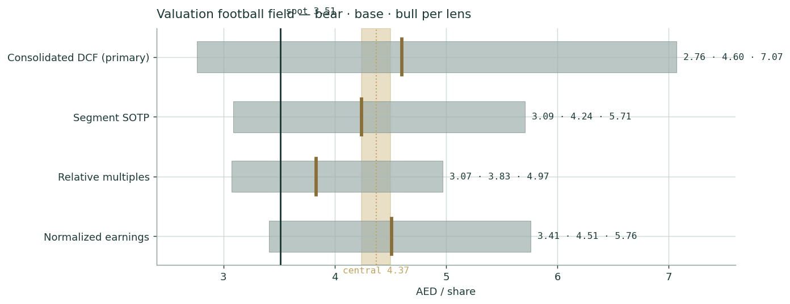
Figure 1 — Valuation football field. Bars span bear–bull per lens; the brass tick is each base case; the gold band is the blended central range; the dark line is spot.
Central fair value ≈ AED 4.37/share, about 25% above spot. The spread of the lenses (3.83 to 4.60 at base) is itself the message: this is not a broken business priced for distress, but a franchise priced as if its reset year were its new normal.

1.6 A deeper look at the four segments
Data-discipline gate applied: Agthia discloses segment revenue and EBITDA but not volume/price splits by pack or SKU, so all forecasts here are top-down normalized margins on the disclosed segment averages; no packs-×-price build is manufactured. The scorecard below states each segment’s FY25 print, our forecast stance, and the single driver that decides it.
Segment | FY25 rev / EBITDA (AED mn) | What happened | Our stance (FY26E–30E) | Decides it
Water & Food | 1,240.3 / 170.9 (13.8%) | Al Ain share gains; VOSS UAE; Riviere home-office-delivery scaling; +14.6% revenue | +12% then mid-single-digit; margin to 15.6% | UAE population & tourism; price ladder discipline
Agri-Business | 1,223.2 / 222.2 (18.2%) | Flour & feed steady; food-security offtake; −8.2% revenue on grain price pass-through | +2–2.5%; margin flat 18.2% | Regulated tariffs; wheat & corn cost pass-through
Snacking | 1,386.5 / 17.0 (1.2%) | The damage: AED 143mn provisions (Al Foah counterparty, receivables); coffee input spike; Abu Auf still growing | −2% then +5–7%; margin rebuilt to 12% by FY29E | Green coffee $/lb; EGP; provision recurrence
Protein & Frozen | 995.6 / 72.7 (7.3%) | Nabil/Atyab solid; new KSA plant in ramp, absorbing fixed costs | +5–7%; margin to 12.5% as KSA fills | KSA plant utilisation; poultry & feed spread

The group’s FY25 margin bridge is stark: three segments earned a blended ~14.9% EBITDA margin; Snacking’s 1.2% — against 12.3% in FY24 — cost the group roughly AED 165mn of EBITDA, of which AED 143mn is the provisions block. The reset thesis is therefore narrow and testable: it does not require heroics anywhere, only that Snacking climbs back toward its own recent history while W&F and Agri keep doing what they already do.

1.7 The crux — the Snacking reset, in real units
Per house device A-1 the swing factor is sensitized on observable market quotes, never an abstract margin%. Two real-unit drivers dominate: green coffee (Abu Auf’s core input; ICE arabica traded ~$4.4/lb at the Feb-2025 peak, ~$3.40 mid-2026) and the EGP/USD rate (~52; roughly a quarter of group revenue is Egypt-linked). The grid below moves only these two quotes through the DCF; the base cell is the §1.1 value.
Coffee $/lb \ EGP/USD | 48 | 52 | 58
2.80 | 4.92 | 4.87 | 4.80
3.40 | 4.65 | 4.60 | 4.53
4.00 | 4.37 | 4.33 | 4.26

The value stays in a 4.26–4.92 band across the grid — the translation math alone cannot break the thesis. What could: a third consecutive year of provisions (the grid assumes zero recurrence), or an EGP step beyond ~65 combined with failure to pass pricing through. Those live in the bear case and in Expert 3’s war-tail scenario, not in this table.
Dividend schedule and stress (device A-2). The payout is the thesis’s coupon while the reset plays out, so it gets its own sustainability test:
(AED mn unless stated) | FY26E | FY27E | FY28E | FY29E | FY30E
DPS (fils) | 24.3 | 26.7 | 29.4 | 32.3 | 35.6
Common dividend | 202 | 222 | 244 | 268 | 296
Free cash flow (model) | 297 | 344 | 397 | 433 | 464
FCF cover | 1.5× | 1.5× | 1.6× | 1.6× | 1.6×
Bear-case FCF (margins −100bp, capex 4.2%) | 221 | 262 | 309 | 341 | 368
Bear cover | 1.1× | 1.2× | 1.3× | 1.3× | 1.2×

Cover holds above 1× even in the bear path — but only just in FY26E, which is why the H1-2026 interim declaration (expected ~Aug) is a live catalyst: a third consecutive step-up would confirm the board’s own read of the reset; a flat or trimmed interim would be the first hard warning.

1.8 Macro & country — the two-currency question
Agthia is a policy asset on one side and an EM consumer play on the other. The UAE side (roughly ~60% of revenue, more of EBITDA in FY25) sits inside Abu Dhabi’s food-security architecture: ADQ is the majority owner, Grand Mills and Agrivita carry strategic-reserve mandates, and the dirham peg (3.6725) makes its cash flows near-USD. Pillar-II corporate tax (15% domestic top-up, blended ~20% group) is now fully in the base. The Egypt/Jordan side (~25–30% of revenue: Abu Auf, Atyab, Nabil) carries EGP translation risk — the pound has held ~50–52 since the 2024 float package, but the March 2026 regional escalation reminds that the tail is fat: Suez-canal receipts, tourism and remittances are the pound’s pillars and all three are geopolitics-sensitive. Rates cut both ways: EIBOR tracking the Fed’s easing path trims the AED 88mn finance-cost line, while Egypt’s still-high local curve keeps the sleeve cost of equity at 17%. Commodities are the operating link — wheat and corn (Agri pass-through), green coffee (Snacking), poultry feed (Protein) — and the group’s hedging is rolling and partial, so the P&L feels the quotes with a two-to-three-quarter lag.

1.9 Sensitivity — WACC × terminal growth
The DCF’s honesty check: terminal value is 70.4% of EV (device A-7), so the discount-rate/growth pair is where the value lives. The grid re-discounts the same FCFF path; the base cell (10.6% / 2.25%) reads AED 4.60; the market’s AED 3.51 is only reproduced near 11.6% WACC with 1.5% terminal growth — pricing the Egypt sleeve’s cost of equity on the whole group, forever.
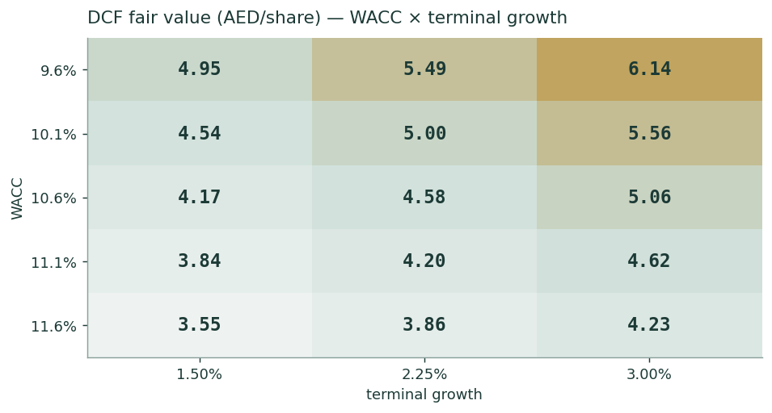
Figure 2 — DCF fair value (AED/share) across WACC × terminal growth. The gold region marks values above spot; the base case sits at 10.6% / 2.25%.

2 Technical & price structure
The tape disagrees with the valuation work, and honestly so: AGTHIA is below all four moving averages, momentum is negative, and the 52-week structure shows a market that sold the FY25 print in March and has not yet paid for the Q1 turn. Technicals here are timing, not value — they say “not yet confirmed”, not “wrong”.
Indicator | Reading | Interpretation
Spot vs SMA-20 | 3.51 vs 3.57 | Below — short-term tape soft
Spot vs SMA-50 | 3.51 vs 3.59 | Below — corrective structure intact
Spot vs SMA-100 | 3.51 vs 3.64 | Below — medium trend not yet repaired
Spot vs SMA-200 | 3.51 vs 3.73 | Below — the long average still falling
RSI (14) | 42.9 | Neutral-weak; no oversold washout
MACD (12,26,9) | -0.0224 / -0.0106 / hist -0.0119 | MACD below signal — bearish, flattening
52-week range | 3.34 – 4.37 | Spot in the lower quartile
Realized vol (252d) | 22.3% | Calm by EM standards; typical staples tape

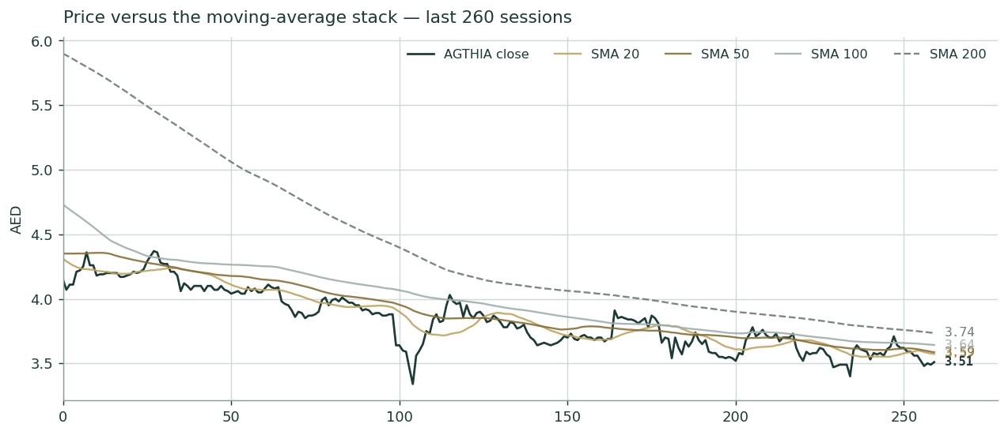
Figure 3 — Price versus the 20/50/100/200-day moving-average stack, last 260 sessions. The stack is bearishly ordered; the March 2026 gap marks the FY25 results.

3 Monte Carlo — 3-month price simulation ⚠ INDICATIVE ONLY · FAILED CALIBRATION TEST
Read this first: the Step 0 backtest of this engine on AGTHIA does not beat the naïve zero-drift random-walk benchmark (CRPS skill ≤0 on every windowing scheme). The full Step 0 result — grade table, PIT and coverage diagnostics — is published on the Testahil calibration ledger with this ticker marked INDICATIVE ONLY · FAILED CALIBRATION TEST; per house rule the backtest mechanics are not reprinted inside the study. House rule: a failed test is flagged, never hidden — the simulation below is presented for completeness and transparency, with the failure disclosed here, in the READ FIRST box, and on the ledger. Treat the widths as roughly honest (coverage and PIT are near-target) and the machinery as adding no measurable skill over the naïve cone on this name.
The probability read — computed from the same 50,000 paths as everything else on this page, presentation-only, never feeding drift or width:
The probability read (T+60) | Value
P(price above spot 3.51) | 50.8%
P(≥ +10%) vs P(≤ −10%) | 20.4% vs 17.9% · odds 1.14×
Median level and move | AED 3.52 (+0.2%)
50% band (25th–75th) | AED 3.26 – 3.79 (-7.2% to +8.0%)
Touch(+10%) / touch(−10%) | 37% / 32%

The read is near-even with a mild upward tilt — exactly what a zero-secular-drift engine plus a slightly positive factor stack should print. The direction is not manufactured: international names carry no secular drift by house rule, so the fundamental value gap of §1 is deliberately kept out of these paths — they diffuse from spot as near-term price, and the §1 value gap is kept out of the drift.
Engine. 50,000 paths, 60 sessions, seed 42. Width from the YZ-HAR cascade (gap-aware Yang-Zhang variance proxy; pooled log-HAR on lags 1/5/22) projecting a forward path volatility of ~26.2% annualized — wider than the trailing 252-day 22.3% because the HAR sees the March-2026 variance cluster. Shape: unit-variance Student-t(5) via a per-path chi-square mixture (tight body, honest tails). Drift: zero secular (international name) plus the 16-factor stack below — 7 continuous factors compounding into a net +0.8% 3-month tilt, and 9 discrete jump factors sampled per path.
Continuous factor (7) | Dir | 3-mo drift | Channel
GCC consumer demand & UAE population/tourism | + | +0.8% | volume growth across Water & Food
Snacking reset execution / Abu Auf momentum | + | +0.6% | margin-recovery evidence
Input-commodity basket (wheat, green coffee, PET) | - | -0.8% | gross-margin squeeze channel
EGP & JOD translation | - | -0.5% | ~1/4 of revenue reports in soft FX
Water category competition & summer season | + | +0.5% | Al Ain share and mix
Rates / ADX liquidity & regional flows | + | +0.3% | yield-name bid as rates ease
Red Sea logistics & freight costs | - | -0.4% | import/export cost drag
Net continuous tilt |  | +0.8%

Discrete factor (9) | P(hit) | Mean impact | σ
Q2 2026 results (early Aug) | 85% | +0.5% | 2.0%
H1-26 interim dividend step-up signal | 45% | +1.0% | 1.0%
Bolt-on M&A / consolidation announcement | 25% | +1.5% | 1.5%
Commodity spike (coffee / wheat) | 25% | -2.0% | 1.5%
EGP devaluation step | 20% | -1.5% | 1.5%
Regional geopolitical / logistics escalation | 20% | -2.5% | 2.0%
KSA protein ramp / food-security contract win | 30% | +1.5% | 1.0%
Snacking reset disappointment (Al Foah / BMB) | 20% | -2.0% | 1.5%
ADQ corporate action / index-flow event | 15% | +2.0% | 2.0%

Horizon | p5 | p25 | p50 | p75 | p95
T+20 sessions | 3.11 | 3.36 | 3.51 | 3.67 | 3.95
T+60 sessions | 2.85 | 3.26 | 3.52 | 3.79 | 4.31

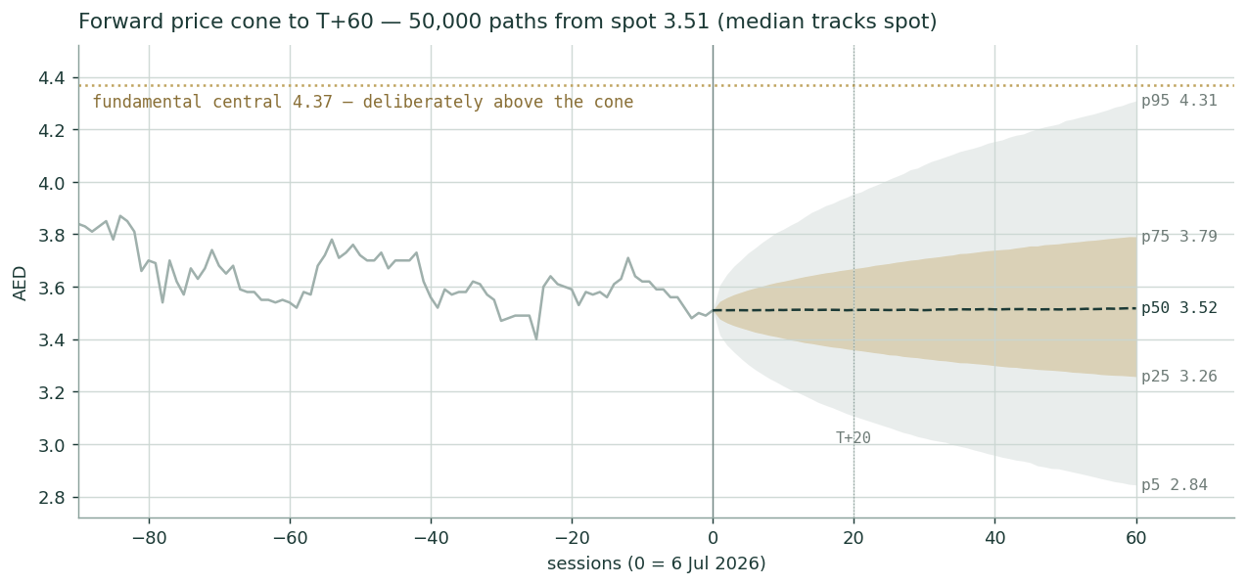
Figure 4 — Forward price cone to T+60 from 50,000 paths. Gold band = 50% interquartile range (lead read); sage = p5–p95; the dotted gold line marks the §1 fundamental central of 4.37, deliberately outside the drift.
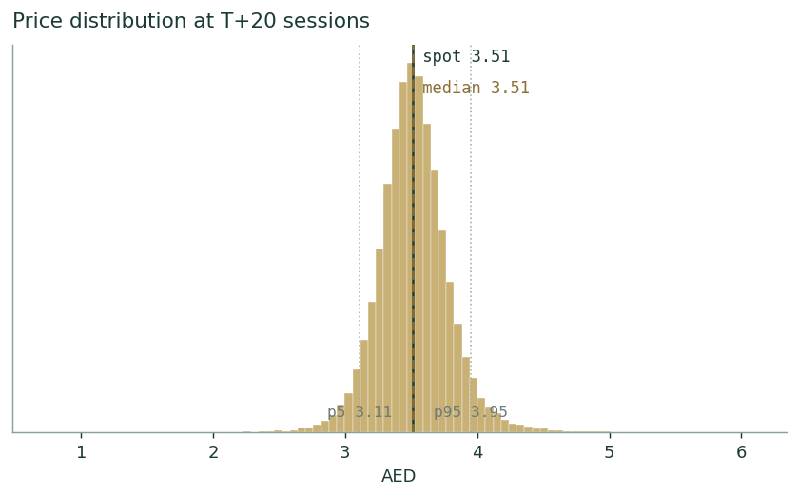
Figure 5 — Simulated price distribution at T+20 sessions. Median hugs spot; the t(5) tails are visibly fatter than a Gaussian.
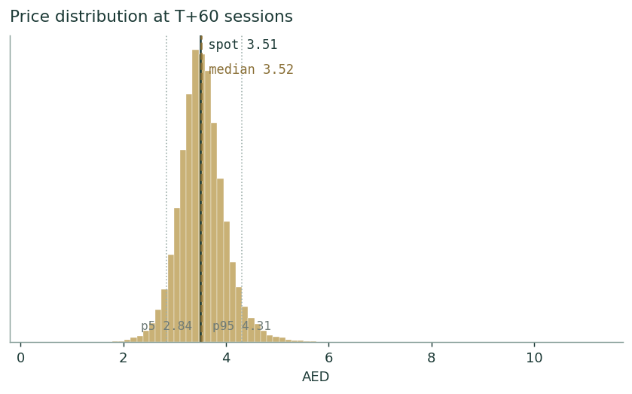
Figure 6 — Simulated price distribution at T+60 sessions. The mild right skew is the factor stack, not a trend assumption.
Touch probabilities — the chance price *trades at* a level at any point inside the horizon (running max/min across paths), always higher than finishing there:
Level (AED) | vs spot | Touch by T+20 | Touch by T+60
4.40 | +25% | 1% | 7%
4.20 | +20% | 2% | 12%
4.00 | +14% | 6% | 24%
3.70 | +5% | 36% | 59%
3.40 | -3% | 54% | 72%
3.20 | -9% | 15% | 38%
3.00 | -15% | 4% | 17%

4 Comparing the lenses — and a verdict
Lens | Answer | What it is good at | What it misses
Fundamental (§1) | AED 4.37 central, 3.05–6.09 | Values the reset path and the franchise | Timing; assumes provisions do not recur
Technical (§2) | Soft; below all MAs | Reads what the market is actually paying | Blind to the underlying-vs-reported gap
Monte Carlo (§3) | p50 ≈ spot; 2.85–4.31 (p5–p95) | Honest width for position sizing | FAILED Step 0 (see ledger) — adds no skill on this name
Expert panel (App. C) | 3.62–4.51, centres ~4.09 | Three genuinely different methods | Each hostage to one worldview

Verdict. The fundamental case is strong and unusually testable: underlying EBITDA held through the worst optical year in the group’s history, Q1-2026 already turned, and the dividend pays 6.3% while the proof accumulates. The market’s counter-case is not stupid — goodwill of roughly AED 2.3bn sits against AED 2.6bn of equity, provisions have now recurred, and Egypt is a live tail — which is why the honest read is a fair-value range of roughly AED 3.8–5.0 centred near 4.37, an attractive asymmetry from 3.51, with the tape yet to confirm and the probabilistic lens explicitly unable to add timing skill here. Testahil publishes distributions, not tips; the distribution says the downside cases cluster near 3.0–3.1 and the upside cases near 5.7–7.1.

5 Catalysts to watch
- Q2 2026 results (early August). The first clean-comp quarter against the provision-hit H2-25 run-rate; consensus-free, so the print sets the narrative alone.
- H1 2026 interim dividend (with Q2). A third consecutive step-up would be the board underwriting the reset; a flat interim is the first warning.
- Snacking reset milestones. Al Foah date-season contracting on the new counterparty terms; BMB relaunch sell-through; Abu Auf Egypt store count and UAE roll-out.
- KSA protein plant utilisation. Phase-II lines commissioning through H2-26; each 10pp of utilisation is roughly 40–50bp of segment margin.
- The commodity tape. Green coffee below ~$3/lb or wheat/corn softness flows to margin with a 2–3 quarter lag; a fresh coffee spike does the reverse.
- The EGP. A step to 58+ (or a credible move the other way) re-marks a quarter of revenue; watch Suez receipts and the IMF review calendar.
- Food-security program awards. New strategic-reserve or offtake mandates to Grand Mills/Agrivita would harden the Agri floor.
- ADQ corporate actions & index events. Bolt-on M&A (the machine that built the group), any stake action, or FTSE/MSCI EM weight changes move the register.

6 Reading the probability zones
The T+60 distribution, cut into the bands a reader actually acts on (indicative only, per the §3 flag):
Zone (AED) | Probability | What it would mean
< 3.00 | 10% | Bear tail — provisions recur or EGP/geopolitics shock; bear fundamentals (≈3.05) in play
3.00 – 3.30 | 19% | Soft drift — reset doubted; yield ≈ 6.7–7.4% does the waiting
3.30 – 3.70 | 39% | The base camp — market waits for Q2/Q3 proof; most likely single zone
3.70 – 4.10 | 23% | Repair — tape reclaims the averages, first re-rating leg toward the relative floor 3.83
> 4.10 | 10% | Re-rating — early move toward the 4.37 central; needs a catalyst from §5

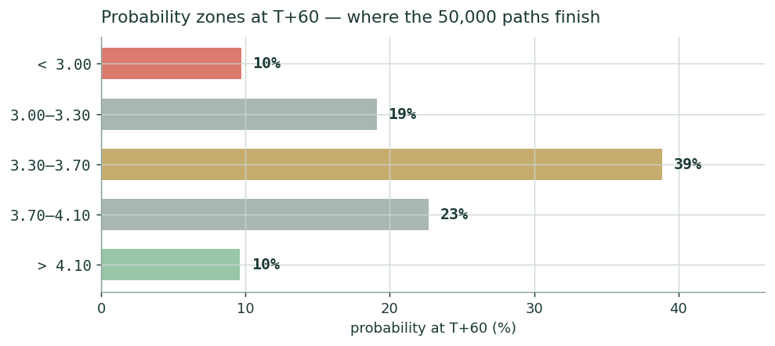
Figure 7 — Probability zones at T+60. The base camp (3.30–3.70) is the single most likely band; the tails carry the bear fundamentals and the first re-rating leg.

7 Caveats — what would change our mind
- Provision recurrence. A third year of receivable/counterparty charges converts “one-off” into “business model” and breaks the normalized-earnings lens; Expert 2’s 3.62 becomes the ceiling, not the floor.
- Goodwill concentration. ~AED 2.3bn of goodwill/intangibles against AED 2.63bn of equity; a Snacking impairment would not touch cash but would crush book value and the P/B optics.
- The Egypt tail. EGP beyond ~65 without pricing pass-through, or a structural regional escalation, invalidates the sleeve math in §1.8 and Expert 3’s weights.
- KSA ramp risk. If the protein plant stalls below breakeven utilisation into FY27, the P&F margin path (to 12.5%) is wrong and ~AED 0.25/share of the DCF with it.
- Calibration failure (§3 / calibration ledger). The Monte Carlo lens has no demonstrated skill on this name; nothing in this study’s probability tables should be treated as calibrated forecasting. This is disclosed, not fixable by assertion — only by the engine some day beating the benchmark here.
- Regulated-margin risk. Flour/feed tariff resets are a policy variable; the Agri 18.2% margin is an administrative outcome as much as a commercial one.

Appendix A — Financial statements
FY2023–FY2025 from company disclosure (ADX preliminary FY2025 results, 5 Mar 2026); FY2026E–FY2030E are the model’s forecasts (companion Excel, Assumptions sheet). Historical D&A, net finance cost, tax and minorities are not separately itemised in the preliminary release and are estimated to balance to the disclosed totals (revenue, EBITDA, net profit, EPS, total assets, equity) — marked †. AED millions.

A.1 Income statement
AED mn | FY23 | FY24 | FY25 | FY26E | FY27E | FY28E | FY29E | FY30E
Revenue | 4,561.2 | 4,914.6 | 4,845.6 | 5,051 | 5,335 | 5,624 | 5,888 | 6,135
Group EBITDA (reported) | 689.3 | 678.8 | 463.4 | 633 | 708 | 776 | 828 | 870
one-off items (memo) | – | (10.0) | 143.4 | – | – | – | – | –
underlying EBITDA (memo) | 689.3 | 688.8 | 606.8 | 633 | 708 | 776 | 828 | 870
D&A † | 240.0 | 245.0 | 250.0 | 263 | 272 | 287 | 294 | 307
EBIT | 449.3 | 433.8 | 213.4 | 370 | 436 | 489 | 533 | 564
Net finance cost † | 110.7 | 62.0 | 88.3 | 60.0 | 56.0 | 52.0 | 47.0 | 42.0
Profit before tax | 338.6 | 371.8 | 125.1 | 310 | 380 | 437 | 486 | 522
Tax † | 39.0 | 50.0 | 24.5 | 62 | 76 | 87 | 97 | 104
Net profit (group) | 299.6 | 321.8 | 100.6 | 248 | 304 | 350 | 389 | 417
Minorities † | 25.3 | 25.9 | 15.0 | 32 | 40 | 46 | 51 | 54
Attributable NP · EPS (AED) | 274.3 · 0.330 | 295.9 · 0.356 | 85.6 · 0.103 | 216 · 0.260 | 265 · 0.319 | 304 · 0.366 | 338 · 0.407 | 363 · 0.437

A.2 Balance sheet
AED mn | FY23 | FY24 | FY25 | FY26E | FY30E
PP&E, goodwill & intangibles | 4,486 | 4,347 | 4,015 | 3,955 | 3,912
Inventory + receivables (modeled) | 1,804 | 1,837 | 1,770 | 1,873 | 2,297
Cash & equivalents † | 350 | 420 | 531 | 609 | 1,364
Total assets | 6,640.3 | 6,603.7 | 6,316.0 | 6,401 | 7,573
Shareholders’ equity | 2,909.8 | 2,824.6 | 2,628.8 | 2,643 | 3,349
Borrowings & leases † | 1,250 | 1,438 | 1,830.7 | 1,831 | 1,831
Net debt | 900 | 1,018 | 1,300 | 1,221 | 467
Net debt / EBITDA | 1.3× | 1.5× | 2.8× | 1.9× | 0.5×

A.3 Cash flow
AED mn | FY24 | FY25 | FY26E | FY27E | FY28E
Operating cash flow | 656.0 | 434.7 | 469 | 516 | 561
Capex | (160.4) | (143.5) | (172) | (172) | (164)
Free cash flow | 495.6 | 317.8 | 297 | 344 | 397
Dividends paid (common) | (167) | (184) | (202) | (222) | (244)
Net change in cash (model) | – | – | 79 | 101 | 131
FCF / dividend cover | 3.0× | 1.7× | 1.5× | 1.5× | 1.6×

FY24–25 OCF, capex and FCF are disclosed; forecast rows link IS + Assumptions in the companion model. FY25’s OCF drop mirrors the provision build and a working-capital normalisation, not a collections failure.

Appendix B — Peer set, sector structure, and risks
Agthia sits in the GCC food & beverage staples complex — a sector of policy-backed champions (food security is sovereign strategy in the UAE and KSA), where multiples reward scale, brand share and dividend reliability, and punish EM-currency exposure. Ranges below are indicative context from public data, not a comp model.
Peer | What it is | Indicative valuation
Almarai (Tadawul: 2280) | GCC dairy & food champion, KSA | EV/EBITDA ~9–11× · P/E ~16–20×
Savola Group (Tadawul: 2050) | KSA food holdco (retail, oils, sugar) | SOTP name; holdco discount
Americana Restaurants (ADX/Tadawul) | MENA QSR platform | P/E ~14–18× · growth premium
Juhayna (EGX: JUFO) | Egypt dairy & juice | EV/EBITDA ~5–7× · EGP discount
NADEC (Tadawul: 6010) | KSA dairy & agriculture | EV/EBITDA ~7–9×
Agthia (ADX: AGTHIA) — at spot | UAE multi-category F&B (this study) | EV/underlying EBITDA ~7.0× · yield ~6.3%

The structural read: Agthia trades at Egypt-adjacent multiples on a balance sheet and ownership that are UAE-sovereign-adjacent. Sector risks: input-commodity cycles (wheat, corn, coffee, resin), EGP/JOD translation, regulated flour & feed tariff resets, water-category price competition, regional geopolitics and logistics (Red Sea/Suez), and the Pillar-II tax floor now embedded across the GCC.

Appendix C — Three experts, three methods, one stock
Per the house protocol, three experts cast from the persona library by method — industrial/general casting: earnings-power, accountant, macro-policy — each runs a genuinely different valuation on the same disclosed numbers, states where the method fails, shows full workings, sensitizes the swing input, cross-examines the other two, and names the condition that would falsify their view. Labels are Expert 1/2/3 per house rule.

C.1 Expert 1 — normalized earnings power
Worldview. A consumer staple is a stream of mid-cycle earnings wearing this year’s costume; the analyst’s job is to price the stream, not the costume. In the Graham-and-Dodd earnings-power tradition, one-offs are removed with a scalpel and the residual is capitalized at a justified multiple. Works when accounting noise is large relative to operating change — precisely FY2025 here. Fails when “one-offs” are secretly recurring, or when a structural break (tax, currency) makes history a bad guide.
Workings | Value
Underlying group NP: FY23 / FY24 / FY25 (AED mn) | 342.2 / 330.9 / 239.8
Cycle read | FY25 = trough (provisions + coffee spike + first full Pillar-II year); FY23–24 = upper-mid
Mid-cycle attributable NP (post-tax-step, post-minorities) | AED 300mn
Normalized EPS | AED 0.361
Justified P/E (GCC staples, discount to Almarai for Egypt mix) | 12.5×
Fair value | AED 4.51 (range 3.40–5.80)

Sensitivity (the multiple is the swing). At 10.5× → 3.79; at 14.5× → 5.23. On the earnings leg, NP of 270–330 spans 4.06–4.96 at the base multiple. Cross-examination. To Expert 2: your capitalized-cash number treats a two-year M&A digestion as the permanent state — cash conversion mean-reverts in staples. To Expert 3: your war tail is real but you double-count it; the 17% Egypt sleeve Ke already prices most of it. Falsification. A third consecutive year of provisions, or Snacking failing to clear a 6% EBITDA margin by FY2027 — either converts my “trough” into “trend” and voids the normalization. Market at 3.51 implies ~9.7× on my mid-cycle EPS — a distressed multiple on an undistressed franchise.

C.2 Expert 2 — the cash & balance-sheet audit
Worldview. Earnings are an opinion; cash and the balance sheet are facts. Value only the free cash flow to equity a company demonstrably generates, and interrogate the balance sheet for where past “earnings” went. Works when reported profits and cash diverge — the exact FY25 pattern. Fails when a genuine step-change (a new plant ramping) makes trailing cash a floor, not a level.
Workings | Value
Operating cash flow FY24 / FY25 (disclosed) | AED 656.0mn / 434.7mn
Normalized OCF (provision build stripped, WC normal) | ~AED 560mn
less: maintenance + growth capex | ~AED 200mn
less: minority leakage | ~AED 35mn
Sustainable FCFE → per share | ~AED 325mn → 0.391
Capitalized at Ke 13.3% − g 2.5% | 0.391 / 0.108
Fair value | AED 3.62 (range 2.90–4.40)

Sensitivity. Ke 12.3% → 3.99; Ke 14.3% → 3.31; FCFE 290–360 spans 3.23–4.01. The audit flags: goodwill and intangibles of roughly AED 2.3bn sit against AED 2.63bn of book equity — the balance sheet is mostly purchased hope; provisions have now hit two vintages of the same M&A book; and FY25 cash conversion (OCF/EBITDA ~94% underlying) is decent but flattered by payables. Cross-examination. To Expert 1: you normalize the P&L but not the acquisition machine that keeps producing the “one-offs”. To Expert 3: policy ownership cuts both ways — ADQ’s balance sheet is a floor under solvency, not under your equity multiple. Falsification. Two consecutive clean years with OCF above AED 550mn and zero new provision lines — then my normalized cash is proven too low and I move to the Expert-1 camp. Market at 3.51 sits 3% below my 3.62: the market is roughly pricing my audit, which is precisely why any good news re-rates.

C.3 Expert 3 — macro-policy sleeves
Worldview. Agthia is not one company; it is a UAE food-security policy asset stapled to an Egyptian consumer business. Value the two sleeves in their own currencies at their own costs of capital, then weight the currency-and-conflict scenarios explicitly — the probability weights ARE the valuation. Works for split-exposure names where averages lie. Fails if the sleeves’ operations are more integrated than the currencies suggest (shared procurement, cross-supply).
Workings | Value
UAE sleeve EV (W&F + Agri + UAE protein; Ke 9.6%) | ~AED 3,650mn
Egypt/Jordan sleeve EV at EGP 48 / 52 / 58 (Ke 17%) | AED 1,900 / 1,750 / 1,520mn
Currency-scenario weights | 25% / 50% / 25%
Weighted EV − net debt 1,300 − minorities 260 | → AED 4.60/share pre-tail
Geopolitical tail: p = 20% regional escalation, −25% value | 0.8 × 4.60 + 0.2 × 2.90
Fair value | AED 4.15 (range 3.10–5.20)

Sensitivity (the tail weight is the swing). Tail p = 10% → 4.43; p = 30% → 3.92; EGP-58 weighted at 50% → 4.36 pre-tail. Cross-examination. To Expert 1: your multiple imports GCC stability into Egyptian cash flows — split them and see what survives. To Expert 2: you capitalize last year’s fear at a blended Ke; my sleeves show the UAE half alone nearly covers the current price. Falsification. EGP through 65 without demonstrated pass-through pricing, or the UAE food-security framework materially de-emphasising Agthia mandates — either breaks the sleeve arithmetic. The market’s 3.51 equals my no-tail UAE sleeve plus Egypt at roughly zero: the tape is pricing the Egyptian business as an option premium, free.

C.4 The three in one room
Expert 1: “FY25 was written down, not earned down. Strip the provisions and this group earned within 3% of its FY23–24 run-rate; the market pays under ten times mid-cycle with a 6% coupon attached.” Expert 2: “Half your ‘one-offs’ are the recurring cost of the M&A machine that built this — the goodwill is nearly the whole book. Show me two clean years of cash and I will capitalize your number, not mine.” Expert 3: “You are both valuing the P&L of a company whose real identity is a two-currency policy asset. Abu Dhabi’s food-security balance sheet stands under one half; the Egyptian pound stands under the other. Price the sleeves and the war tail honestly and the answer lands between you — which is exactly where the market is not.”

C.5 Reading the divergence
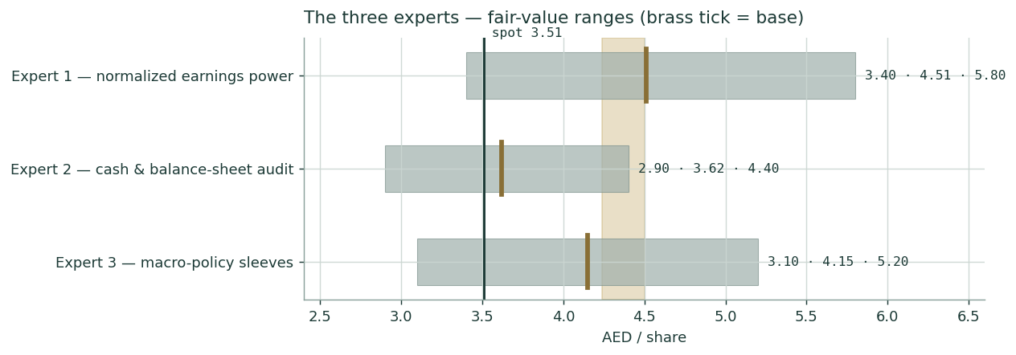
Figure C-1 — The three experts’ fair-value ranges. The gold band is the §1 blended central; the dark line is spot. The spread is the reset question priced three ways.
Expert | Fair value | The one assumption doing the work
Expert 1 — normalized earnings | AED 4.51 | FY25 provisions are non-recurring; mid-cycle NP = 300
Expert 2 — cash & balance-sheet | AED 3.62 | Only demonstrated cash counts; the M&A book keeps taxing it
Expert 3 — macro-policy sleeves | AED 4.15 | Currency scenarios 25/50/25 and a 20% escalation tail

The 3.62–4.51 spread measures exactly one thing: how much of FY2025 was cost, and how much was character. Expert 2’s floor is the market’s current answer; Expert 1’s ceiling is the answer if Q2–Q4 2026 print clean; Expert 3 prices the path between them with the currency and conflict risk stated out loud rather than hidden in a discount rate. Logged for the per-expert calibration layer: study date 6 Jul 2026, spot AED 3.51, E1 4.51 (3.40–5.80), E2 3.62 (2.90–4.40), E3 4.15 (3.10–5.20).

About this series
Testahil publishes independent, educational valuation studies of EGX, GCC and international names under one discipline: distributions, not tips. Every study triangulates fundamental value, technical structure and a Monte-Carlo price simulation; every probabilistic claim is backtested (Step 0) before publication and scored after the fact on a public calibration ledger — including the failures, of which this study’s §3 is one — flagged in the study and carried on the ledger rather than hidden. First edition on AGTHIA: the forecast-vs-actual scorecard and new-vs-old estimate reconciliation (house devices A-3/A-4) begin at the first 3-month update. The standing per-share ratio dashboard (device A-5) lives in the companion Excel. Studies are published under the Testahil brand only; testahil.com carries the full coverage, ledger and methodology.

Disclosure & Disclaimer
- 1. Not investment advice. This study is educational analysis and personal opinion. It is not investment advice, a recommendation, an offer, or a solicitation to buy or sell any security, and it does not consider any reader’s objectives or circumstances.
- 2. No licence. The preparer is not licensed or authorised by the UAE Securities and Commodities Authority, the Egyptian Financial Regulatory Authority, or any other securities regulator, and provides no regulated financial service.
- 3. No client relationship. Publication creates no advisory, fiduciary or client relationship. The preparer manages no money and accepts no fees, funds or mandates from readers.
- 4. Accuracy & sources. Figures are drawn from company disclosure and public sources believed reliable as of 6 July 2026 but not guaranteed; historical lines not separately disclosed are estimated to balance and are marked. Forward-looking statements are judgments that may prove wrong. Currency: AED millions; per-share values in AED; dividends in fils (1/100 AED); USD/AED at the 3.6725 peg; EGP references ~52/USD.
- 5. Risk. All investment involves risk, including loss of principal. Past performance and backtests — including the failed calibration test disclosed in §3 and on the ledger — do not predict future results. Consult a licensed financial advisor before any investment decision.
- 6. Positions. The preparer may hold, and may in the future take or dispose of, a position in the security discussed in this report.
TESTAHIL · Independent Valuation Study · Educational Analysis · Agthia Group PJSC (ADX: AGTHIA) · edition 06-07-2026 · reporting currency AED · testahil.com

