Testahil · Independent Valuation Study — Educational Analysis | Not investment advice

Independent Valuation Study — Educational Analysis
Al Rajhi Bank (Tadawul: 1120)
Fundamental analysis · Technical analysis · Monte Carlo simulation — one integrated read
Anchor: SAR 66.00 (02 Jul 2026 close) · 6,000mn shares (capital SAR 60bn after the 1:2 bonus completed Q1-2026) · market cap ~SAR 396bn (~US$106bn) · the largest Islamic bank in the world and the largest Saudi bank by market value · prices and probabilities computed 02 Jul 2026 from the attached daily history · reporting currency SAR (pegged to USD at 3.75) · primary lens: dividend discount model, cross-checked by residual income, FCFE, relative multiples and normalized earnings · the NIM path through the SAMA easing cycle and the gap between the dividend and excess-return lenses are the swing factors.
READ FIRST — what this document is, and is not. This study is a valuation exercise and an expression of personal analytical opinion, published free of charge for educational purposes: it shows how one analyst applies fundamental, technical and probabilistic methods to a listed company, and invites scrutiny of that methodology. It is NOT investment advice, NOT a recommendation or solicitation to buy, sell or hold any security, and NOT directed at the circumstances of any reader. The preparer is not licensed by any securities regulator in any jurisdiction, holds no brokerage authorisation, provides no financial consultancy, manages no money, and accepts no fees, funds or clients. See the Disclosure & Disclaimer at the end. All values are model outputs presented as ranges and distributions because no single number should be relied on. Reported financials are the bank’s own disclosure (FY2025 results, 27 Jan 2026; Q1-2026, 28 Apr 2026); forward-looking inputs — the NIM and cost-of-risk path, the payout schedule, the cost of equity and terminal growth, the multiples and the Monte-Carlo factor probabilities — are the preparer’s judgments and are flagged throughout. Some balance-sheet lines are estimated to tie to disclosed totals. Consult a licensed financial advisor before any investment decision.

Headline
The model’s read: roughly fairly valued, with modest upside that rests on Al Rajhi’s ability to defend its margin through the rate-cut cycle and keep compounding book value at a ~20% return. At SAR 66 the shares sit about 6% below our weighted central estimate of SAR 70. The five lenses split into two camps, and the spread between them is the whole story. A pure dividend-discount model — the natural primary lens for a bank — is cautious at SAR 58, because at a 9.5% cost of equity a stock that distributes roughly half its earnings looks close to fully priced. But the two excess-return lenses disagree: a residual-income model that credits the value created when Al Rajhi retains capital at a 23% return lands at SAR 77, and a justified price-to-book read (its through-cycle ROE against its cost of equity) lands at SAR 76. A free-cash-flow-to-equity cross-check sits at SAR 80 and a conservative normalized-earnings read marks the floor at SAR 65. In one sentence: on the cash it pays out today the bank is fairly valued; on the value it is quietly building by reinvesting at a high return, it is modestly cheap. Technically the tape is soft rather than washed-out — the price is below all four major moving averages, RSI is in the low-40s and MACD is mildly negative — so price is drifting sideways-to-down while the value case leans gently constructive. Over three months the Monte Carlo places the 5th–95th percentile band at roughly SAR 54–79 with the median at spot, and the honest core — the 50% interquartile band — at about SAR 61–71.

Valuation summary — every read at a glance
One table for the four reads that follow — what the bank is worth (fundamental), what the tape is doing (technical), where price could travel over three months (Monte Carlo), and how three independent expert methods land. Every row is developed in the sections and appendices below.
Lens / read | What it measures | Output | Takeaway
FUNDAMENTAL — what the bank is worth (the anchor)
Dividend discount (primary) | Present value of the dividend stream | SAR 58 | −12% · cautious
Residual income | Book value plus excess return over Ke | SAR 77 | +16%
FCFE (DCF) | Distributable capital, discounted | SAR 80 | +20%
Relative (justified P/B) | Through-cycle ROE vs Ke × book | SAR 76 | +15%
Normalized earnings | Through-cycle EPS × justified P/E | SAR 65 | −1% · the floor
Weighted central | Blend 25 / 25 / 15 / 15 / 20 | SAR 70 | +6% vs SAR 66
TECHNICAL — what the tape is doing (timing, not value)
Trend & momentum | Price vs the 20/50/100/200-day averages | Below all four | Soft, corrective
Momentum / range | RSI · MACD · 52-week range | RSI 41 · MACD −0.38 · 60.7–73.3 | Drifting lower
MONTE CARLO — where price could go in 3 months (paths from spot)
T+20 sessions | 50,000 paths · 16 factors | p5 59 · p50 66 · p95 73 | Median ≈ spot
T+60 sessions | same engine, longer horizon | p5 54 · p50 66 · p95 79 | Wide, mild upside skew
EXPERT PANEL — three independent methods (Appendix D)
Expert 1 — capital & returns | Justified P/B on ROE vs Ke | SAR 76 | The excess-return anchor
Expert 2 — credit cycle | Through-cycle cost of risk & provisioning | SAR 65 | Most conservative
Expert 3 — macro & policy | Rate path, oil, Vision 2030 into DDM | SAR 58 | Cautious on the dividend
Panel range | Spread = the retention question | SAR 58–77 | Centres ~SAR 70

Bottom line. The reads point the same way on direction and disagree only on how much credit to give Al Rajhi’s retained-earnings machine. The fundamental central sits near SAR 70 — about 6% above the SAR 66 spot — the panel spans SAR 58–77, and every one of them turns on a single question: whether a bank earning ~23% on equity should be valued on the cash it hands out (the dividend lens, ~fair) or on the value it creates by reinvesting at that return (the excess-return lenses, modest upside). The technical tape is the lone dissenter, soft and below trend, which is why the three-month distribution centres near spot rather than already at fair value.

Company overview — Al Rajhi Bank at a glance
Item | Value
Listed entity | Al Rajhi Bank (Tadawul: 1120); Islamic (Shariah-compliant) commercial bank
What it is | The world’s largest Islamic bank and Saudi Arabia’s largest bank by market capitalisation; retail-led franchise
Spot / date | SAR 66.00 · 02 Jul 2026 close
Shares · market cap | 6,000mn (capital SAR 60bn post 1:2 bonus, Q1-2026) · ~SAR 396bn (~US$106bn)
FY2025 net income | SAR 24,792mn (+26% YoY) — a record
FY2025 total assets | SAR 1.043 trillion; net financing SAR 752.8bn; customer deposits SAR 667bn
FY2025 profitability | ROAE 23.4% · ROAA 2.4% · NIM 3.16% · cost-to-income 23.3% · cost of risk ~35bps
Capital (FY2025) | CET1 16.6% · Tier-1 20.5% · CAR 21.9% · NPL coverage ~152%
Retail share | Retail ~58% of operating income; the deepest low-cost deposit base in the Kingdom
52-week range | SAR 60.67 – SAR 73.33
Corporate event | 1-for-2 bonus issue completed Q1-2026 (capital raised to SAR 60bn; share count to 6,000mn)
Chairman · CEO | Abdullah bin Sulaiman Al Rajhi (Chairman) · Waleed Al Mogbel (CEO)
Source: Al Rajhi Bank FY2025 results (27 Jan 2026), Q1-2026 results (28 Apr 2026), Tadawul disclosures. Values rounded; some balance-sheet detail estimated to disclosed totals.

1 Fundamental valuation
We value Al Rajhi as a bank, and triangulate five lenses. The primary lens is a dividend discount model (DDM), because a mature, highly profitable, dividend-paying bank is ultimately worth the present value of what it distributes. But a bank that retains half its earnings at a ~23% return creates value the dividend stream alone understates, so we give equal weight to a residual-income (excess-return) model. A free-cash-flow-to-equity model is the cash-flow cross-check the house standard requires; a relative read on justified price-to-book and peer multiples, and a normalized-earnings read, complete the set. The weights and the football field are in §1.5; the crux — the NIM path and the dividend-versus-retention gap — is dissected in §1.7, the driver build in §1.6 and the sensitivity grid in §1.9. Throughout, the cost of equity is published explicitly as Ke = rf + β×ERP = 5.25% + 0.90×4.75% = 9.5%, with a per-name beta inside the house 0.8–1.3 band, and the fair value is sensitised on a Ke×terminal-growth grid.

1.1 Dividend discount model — the primary lens
We forecast the dividend per share five years out — net income from the driver model (§1.6), a payout ratio rising from 45% toward 55% as management has guided (“resuming a 50–60% payout”) — discount each year at Ke, and add a Gordon terminal value growing the FY30 dividend at 5%. The explicit dividends are modest against the price, so the terminal value carries most of the answer; per device A-7 we disclose that dependency rather than bury it.
DDM build | FY26E | FY27E | FY28E | FY29E | FY30E
DPS (SAR) | 2.10 | 2.41 | 2.65 | 2.90 | 3.27
PV of DPS @ Ke | 1.91 | 2.01 | 2.01 | 2.02 | 2.08

Σ PV of explicit dividends (FY26–30) | SAR 10.03
Terminal DPS (FY31) = FY30 × 1.05 | SAR 3.44
Terminal value = TDPS / (Ke − g) | SAR 75.97
PV of terminal value | SAR 48.20
DDM fair value per share | SAR 58.23
Terminal value as % of value | 82.8%
DDM base ≈ SAR 58/share. This is the cautious anchor, and deliberately so: at a 9.5% discount rate, a stock paying a rising-but-modest dividend is close to fully valued on distributions alone. The terminal value is 82.8% of the total — a reminder that the DDM is, at bottom, a bet on the perpetual gap between Ke and g. The next two lenses take the other side of exactly that bet.

1.2 Discounted cash flow (equity DCF / FCFE) — the cash-flow valuation
A full discounted-cash-flow valuation, built in the bank-appropriate form. For a bank the relevant cash flow is free cash flow to equity (FCFE) — net income less the capital that must be retained to support growth in risk-weighted assets — and the discount rate is the cost of equity, Ke. A debt-inclusive WACC is not used for a bank: deposits and funding are operating, not financing, so Ke is the DCF discount rate. We publish it explicitly as rf + β×ERP and sensitise the value on a Ke×g grid below.
Discount rate (WACC for the equity claim = cost of equity Ke).
Risk-free rate (Saudi 10-yr, SAR) | 5.3%
Equity risk premium (ERP) | 4.8%
Beta (levered; house 0.8–1.3 band) | 0.90
Cost of equity Ke = rf + β × ERP (the discount rate used) | 9.5%
Terminal growth g | 5.0%

FCFE build and discounting — every year, in full.
DCF build (SAR mn) | FY26E | FY27E | FY28E | FY29E | FY30E
Net income (SAR mn) | 27,964 | 30,104 | 31,744 | 33,480 | 35,714
Risk-weighted assets (RWA) | 640,906 | 681,299 | 731,189 | 781,781 | 832,663
Required CET1 capital (18.5% × RWA) | 118,568 | 126,040 | 135,270 | 144,629 | 154,043
− Increase in required capital | -5,689 | -7,473 | -9,230 | -9,360 | -9,413
FCFE = Net income − Δ required capital | 22,275 | 22,631 | 22,514 | 24,121 | 26,301
Discount period t (years) | 1 | 2 | 3 | 4 | 5
Discount factor = 1/(1+Ke)^t | 0.913 | 0.834 | 0.761 | 0.695 | 0.635
PV of FCFE @ Ke | 20,338 | 18,866 | 17,136 | 16,763 | 16,688

From cash flows to value.
Σ PV of explicit FCFE (FY26–30E) | SAR 89,791mn
Terminal FCFE (FY31) = FCFE₃₀ × (1+g) | SAR 27,616mn
Terminal value = Terminal FCFE / (Ke − g) | SAR 610,292mn
PV of terminal value = TV / (1+Ke)⁵ | SAR 387,232mn
Equity value = Σ PV(FCFE) + PV(TV) | SAR 477,023mn
Shares outstanding (mn) | 6,000
DCF fair value per share | SAR 79.50
Terminal value as % of equity value | 81.2%

Sensitivity — DCF value per share (Ke × terminal g).
DCF value (SAR) | g 4.0% | g 4.5% | g 5.0% | g 5.5% | g 6.0%
Ke 8.5% | 83 | 92 | 103 | 118 | 139
Ke 9.0% | 74 | 81 | 90 | 101 | 116
Ke 9.5% (base) | 68 | 73 | 80 | 88 | 99
Ke 10.0% | 62 | 66 | 72 | 79 | 87
Ke 10.5% | 57 | 61 | 65 | 71 | 77

The DCF base of SAR 79.50 sits well above the DDM because Al Rajhi over-retains: it earns far more than it needs to fund RWA growth and pays out only ~half, so its “potential” dividend (the FCFE) is much larger than its actual one, and the buffer compounds (CET1 rises from 18.5% toward 23% over the forecast). The gap between this lens (SAR 80) and the DDM (SAR 58) is not a modelling error — it is the value of retained earnings the dividend stream defers. Terminal value is 81.2% of the equity value — appropriately disclosed per device A-7 — which is why we sensitise it on the Ke×g grid above rather than quoting a single point.

1.3 Relative multiples
Al Rajhi trades at ~3.5× book and ~16× forward earnings — roughly a 120% premium to the Saudi banking sector’s ~1.6× book. That premium is not an anomaly to be arbitraged away; it is what a ~23% ROE is worth against a ~15% sector ROE. The disciplined relative lens is therefore a justified price-to-book: (through-cycle ROE − g) / (Ke − g), applied to forward book value. At a 21% through-cycle ROE, 5% growth and a 9.5% Ke, justified P/B is 3.54× — essentially where the stock trades — which on FY26 book of ~SAR 21.3 gives SAR 76. Applying the peer median 1.6× instead would imply ~SAR 34, which is meaningless for this franchise; we show it in the model only to make the ROE-premium visible, not as a fair value.
Relative read | Workings | SAR/share
Justified P/B (Gordon) | (ROE 21% − g 5%) / (Ke 9.5% − g 5%) = 3.54× × fwd BVPS | SAR 76
Own current P/B (~3.5×) | No re-rating, applied to forward book | SAR 75
Peer-median P/B (1.6×) | Sector multiple — ignores the ROE gap (context only) | SAR ~34
Peer-median P/E (10.5×) | Sector multiple × forward EPS (context only) | SAR ~49

1.4 Normalized earnings power
The conservative floor. We take a through-cycle ROE of 21% — below the FY25 peak of 23.4%, acknowledging that record NIM and a benign cost of risk will normalise as rates fall — apply it to current book value of SAR 18.83 to get a normalized EPS of ~SAR 3.95, and capitalise at a justified P/E of 16.5× (itself derived from payout, Ke and g). That yields SAR 65, a shade below spot. Al Rajhi’s earnings sit closer to a cyclical peak than a trough — FY25 NIM of 3.16% and a ~35bps cost of risk both flatter current profit — so a normalized read that strips the cycle back is appropriately the least generous lens, and a useful counterweight to the excess-return models.

1.5 Synthesis — five lenses
The five reads and their weights. We anchor on the two intrinsic lenses that best fit a high-ROE bank — the dividend model and the residual-income model, at 25% each — give the FCFE cross-check and the relative read 15% apiece, and let the conservative normalized lens carry 20% as ballast against the excess-return optimism.
Lens | Fair value | Weight | What it captures
Dividend discount (primary) | SAR 58 | 25% | Cautious — distributions at a 9.5% Ke
Residual income | SAR 77 | 25% | Credits excess return on retained capital
FCFE (DCF) | SAR 80 | 15% | Distributable-capital capacity
Relative (justified P/B) | SAR 76 | 15% | ROE vs Ke, no re-rating assumed
Normalized earnings | SAR 65 | 20% | Through-cycle floor
Weighted central | SAR 70 | 100% | +6% vs SAR 66 spot
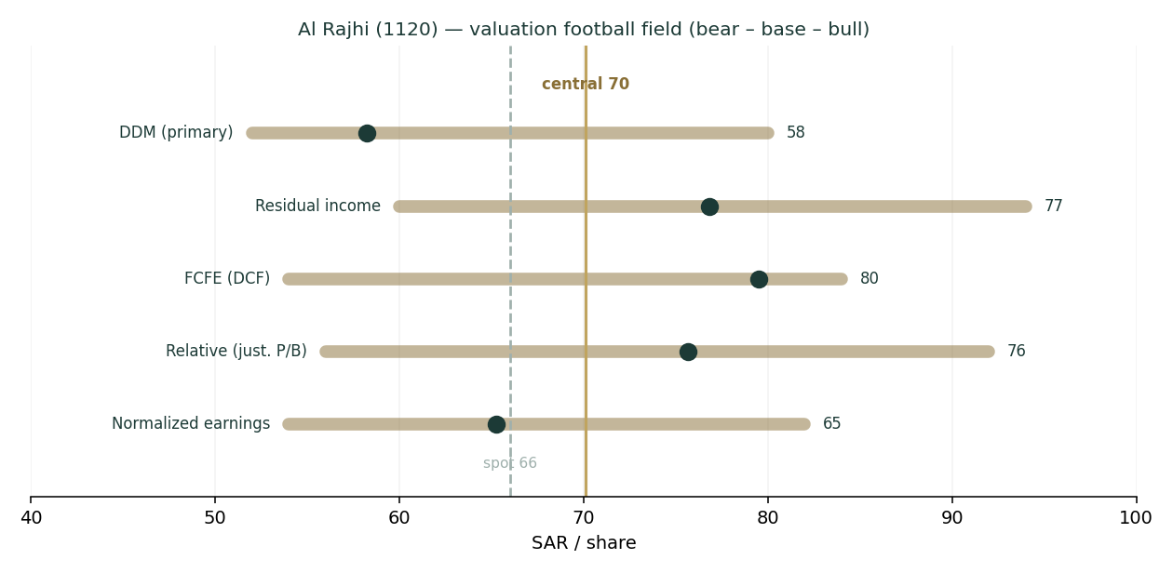
Figure 1 — Valuation football field: the dividend lens marks the low, the excess-return lenses the high; the spread is the retention question.
The football field makes the shape of the disagreement plain. Every lens lands between SAR 58 and SAR 80, spot sits at the low end of that range, and the weighted central of SAR 70 is ~6% above it. This is not a deep-value situation and it is not an obviously expensive one; it is a high-quality compounder trading at fair value on its dividend and at a modest discount on the value of what it reinvests.

1.6 The bank driver build — a deeper look
Behind the lenses is one engine: net income built from a net-interest-margin bridge, a fee line, a cost-to-income ratio and a cost-of-risk charge, feeding a DuPont return decomposition and a capital schedule. Al Rajhi discloses the components — NIM, cost-to-income, cost of risk, RWA density, capital ratios — so this is a legitimate bottom-up build rather than a manufactured one (the data-discipline gate is passed). The sourced driver path comes first.
Driver | FY23 | FY24 | FY25 | FY26E | FY27E | FY28E | FY29E | FY30E
Financing growth | — | — | — | 5.5% | 7.0% | 8.0% | 7.5% | 7.0%
Net interest margin (%) | 3.05 | 3.13 | 3.16 | 3.45 | 3.50 | 3.40 | 3.30 | 3.25
Cost-to-income (%) |  |  | 23.3 | 23.5 | 23.5 | 23.0 | 22.8 | 22.5
Cost of risk (bps) |  |  | ~35 | 35 | 38 | 40 | 40 | 40
Dividend payout (%) |  |  | ~40 | 45 | 48 | 50 | 52 | 55
Blue-cell drivers on the model’s Assumptions sheet; historical NIM/CIR are disclosed, forward path is the house view.
The NIM bridge is the heart of it. FY26 NIM steps up to ~3.45% — Q1-2026 already printed 3.54% as low-cost demand deposits repriced faster than assets — then glides down toward 3.25% by FY30 as SAMA follows the Fed lower and the deposit mix normalises. A retail-led, ~non-profit-bearing deposit base is the structural edge here: it makes Al Rajhi more asset-sensitive on the way up and more defensible on the way down than a corporate-funded peer. The DuPont read shows why the returns are exceptional — a ~2.4% return on assets (sector ~1.5%) driven by a wide margin, a sector-low ~23% cost-to-income, and a benign cost of risk — geared modestly to a ~9.7× assets-to-equity to produce a ~23% ROAE.
DuPont / driver | FY25 | FY26E | FY30E | Comment
Net interest margin | 3.16% | 3.45% | 3.25% | Wide, retail-funded; peaks then glides
Cost-to-income | 23.3% | 23.5% | 22.5% | Best-in-class efficiency (sector ~35%)
Cost of risk | ~35bps | 35bps | 40bps | Benign; normalises modestly
Return on average assets | 2.4% | 2.4% | 2.2% | ~2× the sector
Return on average equity | 23.4% | ~23% | ~19% | Fades as equity compounds & rates fall

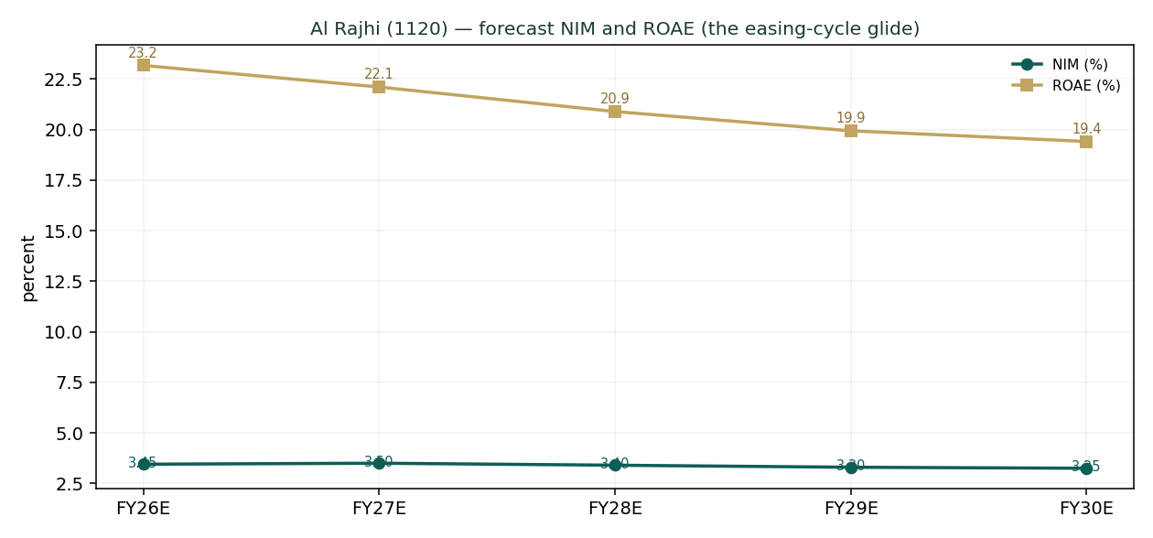
Figure 2 — NIM peaks in FY26–27 then glides; ROAE fades from the low-20s as equity compounds and rates fall.
The capital schedule is the other half of the thesis, and it is what the residual-income and FCFE lenses monetise. Even as the payout rises from 45% to 55%, Al Rajhi keeps building capital — the CET1/common-equity ratio climbs from 18.5% toward 23% — because a 23% ROE on a balance sheet growing ~7% generates far more capital than it consumes. That surplus is real, distributable value; the DDM defers it into the terminal, the FCFE lens brings it forward. For a bank, the capital trajectory is not a footnote — it is the dividend-growth story.
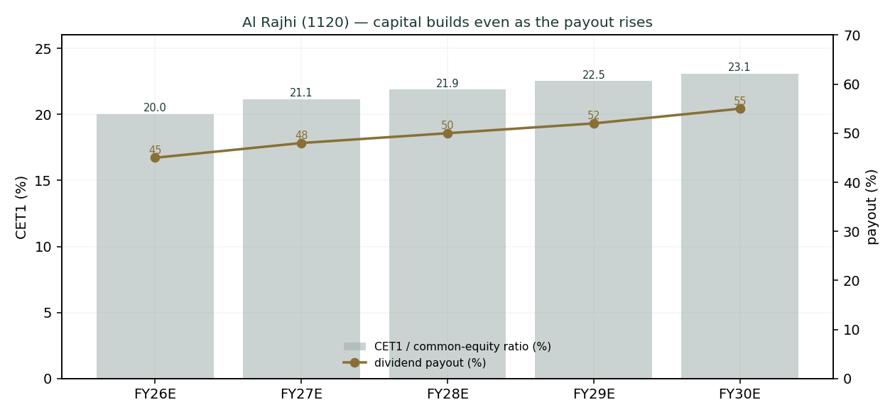
Figure 3 — Capital builds even as the payout rises: the surplus the excess-return lenses value.

1.7 The crux — the NIM path and the dividend-versus-retention gap
Two things swing this valuation, and we sensitise both in their own observable units rather than as an abstract margin.
- The NIM path through the easing cycle (real units: basis points against the SAMA/Fed rate path). Al Rajhi’s asset yields reprice faster than its sticky, low-cost deposits, so the direction of policy rates maps almost linearly onto the margin. Each 25bps of net margin is worth roughly SAR 1.9bn of pre-tax income (~7% of net income) and ~SAR 2–3 of fair value. The base case assumes a measured easing cycle that lets FY26 NIM peak near 3.45% before gliding to 3.25%; a faster, deeper cut cycle that compresses the margin to ~3.0% would take ~SAR 5–6 off the central, while a higher-for-longer path holding NIM near 3.4% would add a similar amount.
- The dividend-versus-retention gap (the SAR 58 to SAR 77 spread). The DDM values distributions; the residual-income and FCFE lenses value retained capital reinvested at a high return. Which is “right” depends on whether you believe Al Rajhi can keep deploying retained earnings at a ~20%+ ROE. If Vision-2030 credit demand (mortgages, SME, giga-project financing) sustains high-return growth, the excess-return lenses are right and the stock is cheap; if growth slows and incremental capital earns closer to the cost of equity, the dividend lens is right and the stock is fair. This is the single judgment that moves the answer most.
Swing (in observable units) | Shift | Central FV | vs spot
NIM to ~3.00% (fast, deep cuts) | −45bps vs base | ~SAR 64 | −9%
NIM base (~3.45%→3.25% glide) | base | SAR 70 | +6%
NIM to ~3.55% (higher-for-longer) | +20bps vs base | ~SAR 74 | +12%
Cost of risk to 60bps (credit stress) | +25bps | ~SAR 66 | ~flat
Retention earns only Ke (growth fades) | — | ~SAR 60 (DDM-weighted) | −9%

1.8 Macro and country — SAMA, oil, and Vision 2030
Al Rajhi is a leveraged play on the Saudi macro, in three channels. Rates: SAMA shadows the Fed to defend the riyal’s USD peg, so the domestic rate path — and thus the NIM — is set in Washington as much as Riyadh; the base case follows the market’s expected gradual easing. Oil and the fiscal impulse: Brent underwrites government spending, deposit growth and system liquidity; a sustained oil slump would tighten funding and slow credit, which is why an oil shock is a live downside factor in §3. Vision 2030: the structural tailwind — mortgage penetration, SME formalisation and giga-project financing — is what lets a bank this size still grow financing at 5–8% and reinvest at a high return, and it is the empirical basis for crediting the excess-return lenses. Because the riyal is pegged, there is no currency translation risk in the valuation — a key simplification versus an EGP- or lira-funded bank, and the reason no FX factor appears in the Monte Carlo.

1.9 DDM sensitivity — Ke × terminal growth
Because the primary lens is terminal-heavy (TV 82.8% of value), the honest disclosure is a grid of the DDM fair value across the cost of equity and terminal growth — the §3.5-G Ke×g sensitivity. The base case (Ke 9.5%, g 5.0%) is the centre cell; the sell-side’s slightly lower 9.0% Ke lifts the dividend value toward the mid-60s, converging with our excess-return lenses.
DDM fair value (SAR) | g 4.0% | g 4.5% | g 5.0% | g 5.5% | g 6.0%
Ke 8.5% | 61 | 67 | 76 | 87 | 103
Ke 9.0% | 54 | 60 | 66 | 74 | 85
Ke 9.5% (base) | 49 | 54 | 59 | 65 | 73
Ke 10.0% | 45 | 49 | 53 | 58 | 64
Ke 10.5% | 42 | 44 | 48 | 52 | 57
The centre cell (Ke 9.5%, g 5.0%) is the DDM base of ~SAR 59; the full valuation blends this with the four other lenses to SAR 70.

2 Technical and price structure
The tape is the mirror of the fundamentals’ mild optimism: soft, but not washed out. Al Rajhi trades below all four major moving averages, RSI sits in the low-40s (neutral, tilted weak), and MACD is modestly negative with the histogram below zero — a gentle downtrend, not a capitulation. The price is at the 42nd percentile of its 52-week range and has drifted down ~7% over the last quarter, consolidating after the post-bonus re-rating. In short, price and value are pulling gently in opposite directions, which is exactly the configuration in which a probabilistic map earns its keep.
Indicator | Reading | Signal
Close | SAR 66.00 | —
SMA 20 / 50 / 100 / 200 | 66.7 / 67.4 / 68.6 / 67.9 | Below all four — soft trend
Price vs SMA200 | −2.8% | Mild downtrend
RSI (14) | 40.8 | Neutral, tilted weak (not oversold)
MACD (12/26/9) | −0.38 / signal −0.34 / hist −0.04 | Mildly bearish, flattening
52-week range | 60.67 – 73.33 | Spot at 42nd percentile
20-day / 60-day change | −1.0% / −7.0% | Consolidating post-bonus

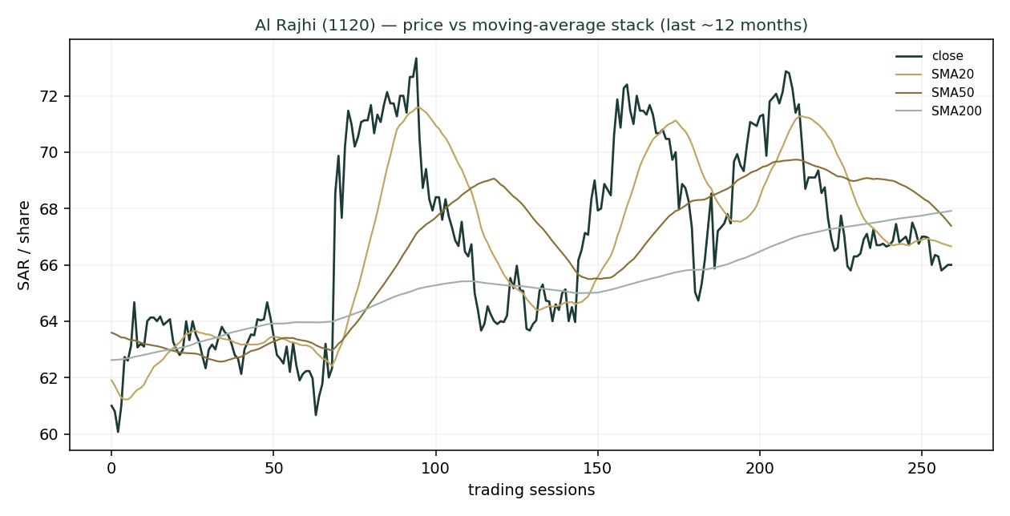
Figure 4 — Price below the 20/50/200-day averages: a soft, corrective tape over the last year.

3 Monte Carlo — a probabilistic price map
We simulate 50,000 three-month price paths from spot. The width is set by the YZ-HAR engine — a log-HAR variance cascade on a gap-aware Yang-Zhang proxy that reads the current volatility regime rather than a flat trailing number — which at the anchor projects ~17.8% annualised, tighter than the 20.4% trailing figure because the recent tape is calm. Innovations are Student-t(5) for honest tails, and the drift is zero (secular): Al Rajhi is an international name, and a confident trend drift breaks at regime turns, so we do not embed one. Sixteen macro factors — seven continuous, nine discrete — then layer on top, widening the realised path volatility to ~24% once event risk is included. Critically, these paths diffuse from spot as a near-term price map and deliberately do not embed the fundamental fair value — the SAR 58–80 value gap of §1 is kept out of the drift, so the fundamental and probabilistic lenses stay independent. The engine is the same one validated in Appendix B, where it beats a random-walk benchmark on CRPS skill with a uniform PIT.
The factor set is Saudi-bank-specific. Note the absence of any FX factor — the riyal’s USD peg removes the currency channel that dominates an EGP- or lira-funded bank — and a rate channel that reflects the SAMA easing cycle (mildly net-positive for the equity: a lower discount rate and credit stimulus against NIM compression). The nine discrete events are deliberately asymmetric: the upside jumps (dividend surprise, index flows, mortgage policy) are smaller and more probable, the downside jumps (oil shock, credit deterioration, geopolitical risk) larger and fatter-tailed.
Continuous factor (7) | Tier | Sign | 3m drift | Channel
SAMA / Fed policy-rate path (easing) | C | mixed | +0.4% | Lower discount rate + credit stimulus vs NIM compression
Oil price / fiscal impulse | C | + | +0.3% | Brent underpins fiscal spend, deposits, credit
Non-oil GDP / Vision 2030 credit demand | C | + | +0.5% | Structural financing-growth tailwind
Mortgage / retail credit cycle | C | + | +0.3% | Al Rajhi is the retail & mortgage leader
TASI beta / foreign & passive flows | C | + | +0.3% | Market beta, MSCI EM weight, liquidity
System liquidity / deposit competition | C | − | −0.4% | SAIBOR & LDR pressure on funding cost
Inflation / real rates | C | mixed | −0.2% | Real-rate level vs asset-sensitivity

Discrete factor (9) | Tier | Prob | Impact (mean) | Spread
Quarterly earnings surprise | E | 50% | +1.0% | 4.0%
Dividend / payout surprise | E | 35% | +2.0% | 3.0%
SAMA / Fed policy surprise | M | 30% | −1.0% | 4.0%
Asset-quality / cost-of-risk shift | M | 25% | −3.0% | 4.0%
Oil-price shock | M | 25% | −4.0% | 5.0%
Geopolitical / regional security | M | 25% | −6.0% | 5.0%
Mortgage-market / regulatory policy | E | 30% | +2.0% | 4.0%
MSCI / index-flow rebalance | E | 30% | +2.0% | 3.0%
Capital action (bonus / AT1 / rights) | E | 20% | +1.0% | 3.0%
All factor numbers are editable judgments (the table is the model); flagged uncalibrated pending red-pen sign-off. Net continuous drift +1.2%, expected event drift −1.0%, combined ~+0.2% — near-zero central drift with fat two-sided tails.
Horizon | p5 | p25 | p50 | p75 | p95
T+20 sessions | 59 | 64 | 66 | 69 | 73
T+60 sessions | 54 | 61 | 66 | 71 | 79
We lead with the 50% interquartile band, not the 90% tail. At T+20 the middle half of paths lies between SAR 64 and SAR 69 (roughly ±4%); at T+60, between SAR 61 and SAR 71 (roughly ±7%). The median sits at spot in both — the honest consequence of zero secular drift and a near-zero factor drift. The wider 5–95% band (SAR 54–79 at T+60) carries a mild upside skew from the positive net factor tilt, offset by the fat downside tail from the oil/credit/geopolitical events.
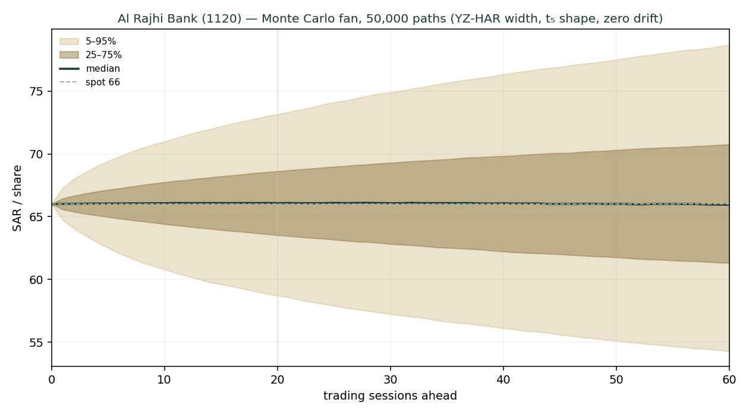
Figure 5 — Monte Carlo fan, 50,000 paths: median at spot, 50% band in brass, 5–95% in gold.
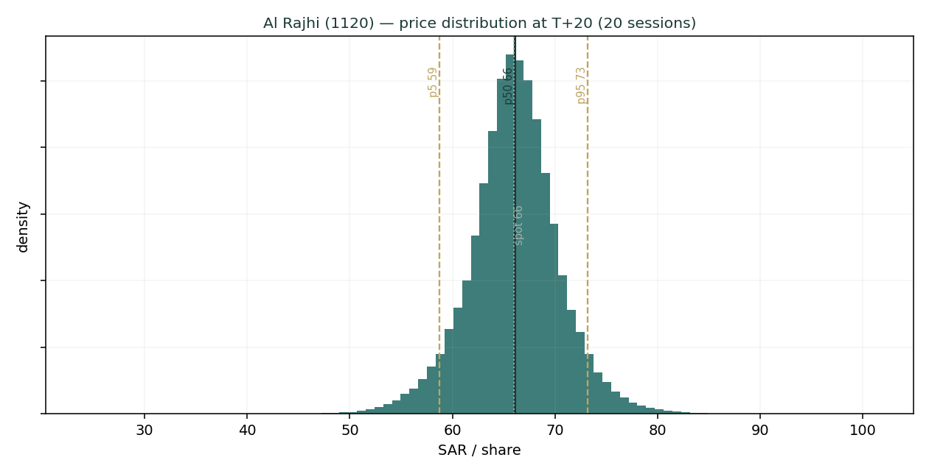
Figure 6 — Price distribution at T+20 (one trading month): tight, near-symmetric core.
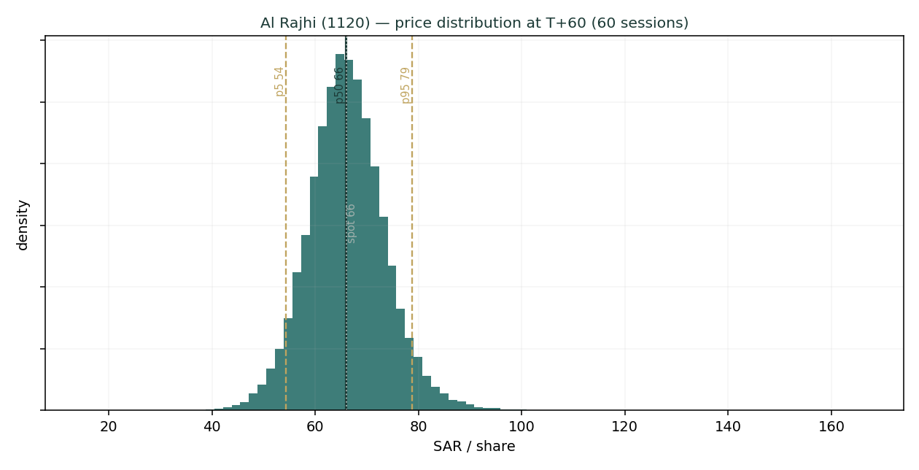
Figure 7 — Price distribution at T+60 (three months): wider, mild right skew, fat left tail.
The touch-probability ladder reads the paths a different way — the chance price touches a level at any point in the window (not where it ends). Over three months there is roughly an even chance of tagging SAR 70 on the upside and SAR 62 on the downside, with the more extreme levels (SAR 74, SAR 60) around a one-in-three chance — a symmetric-with-fat-tails picture consistent with a fairly-valued stock in a calm regime.
Level | Touch by T+20 | Touch by T+60
SAR 74 | 6% | 24%
SAR 72 | 12% | 35%
SAR 70 | 24% | 50%
SAR 68 | 49% | 70%
SAR 66 | 100% | 100%
SAR 64 | 46% | 67%
SAR 62 | 23% | 48%
SAR 60 | 12% | 33%

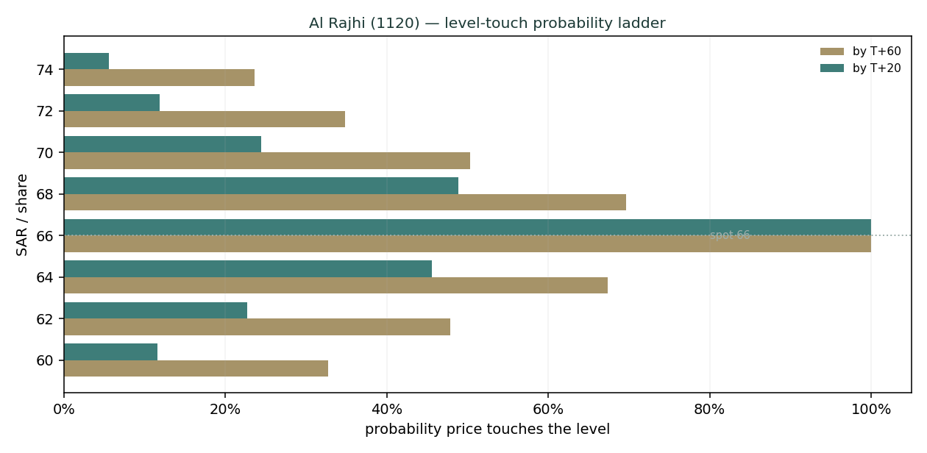
Figure 8 — Level-touch probability ladder: near-symmetric around spot, fat in the tails.

4 Comparison of the lenses, and a verdict
Three lenses, three time horizons, one question. The fundamental read says fair-to-modestly-cheap: SAR 70 central, ~6% above spot, with the answer hinging on whether Al Rajhi’s ~23% return on retained capital deserves to be capitalised (the excess-return lenses) or merely distributed (the dividend lens). The technical read says soft: below trend, mildly negative momentum, drifting lower after the post-bonus consolidation. The probabilistic read reconciles them — with the median at spot and a 50% band of ~SAR 61–71 over three months, the distribution says the market is likely to keep the stock near fair value in the near term, with a mild upside tilt and a fat downside tail tied to oil and credit. The verdict is not a call to act; it is that Al Rajhi is a high-quality compounder trading close to fair value, where the return comes less from a re-rating than from the ~20% ROE grinding book value higher and a rising dividend, and where the main risk is a faster-than-expected margin squeeze if rates fall hard.

5 Catalysts to watch
Catalyst | Weight | Why it matters
SAMA / Fed rate decisions | High | The pace of cuts sets the NIM glide — the single biggest earnings driver
Quarterly NIM prints | High | Q1-2026 was 3.54%; the market watches whether the margin holds as rates fall
Dividend / payout announcements | High | Management guided resuming a 50–60% payout; an interim DPS would confirm the story
Financing growth & mortgage data | Medium | Vision-2030 credit demand is the retention thesis; a slowdown undercuts the excess-return lenses
Cost of risk / asset quality | Medium | A benign ~35bps flatters profit; any normalisation upward is a headwind
Oil price / fiscal stance | Medium | Underwrites deposits, liquidity and credit growth
MSCI / index-weight changes | Low | Passive flows around rebalances move the marginal price

6 Reading the probability zones
Translating the T+60 distribution into plain zones. These are price probabilities over three months, independent of the fundamental fair value.
Zone | ~Probability (T+60) | Interpretation
Below SAR 60 | ~14% | Downside tail — an oil/credit/geopolitical shock territory
SAR 60 – 64 | ~20% | Lower-half drift; a soft-tape continuation
SAR 64 – 68 | ~30% | The modal zone — around spot and fair value
SAR 68 – 73 | ~22% | Upside toward the excess-return fair values
Above SAR 73 | ~14% | Upside tail — a re-rating or positive surprise
Probabilities are approximate, read from the 50,000-path distribution; they sum to ~100% subject to rounding.

7 Caveats and what would change our mind
What would move us more bearish: a faster, deeper SAMA cutting cycle that compresses NIM below ~3.0% and breaks the earnings glide; evidence that incremental capital is being deployed at closer to the cost of equity (which would vindicate the dividend lens and pull fair value toward SAR 60); a cost-of-risk normalisation well above 60bps; or a sustained oil slump that tightens funding and slows Vision-2030 credit.
What would move us more bullish: durable NIM resilience (a higher-for-longer rate path or faster low-cost deposit growth) holding the margin near 3.4%+; confirmation of a 55–60% payout with an interim dividend; and continued high-return financing growth that proves the retention thesis, pushing the blend toward the SAR 76–80 excess-return cluster.
Model caveats. This is an educational model, not a forecast. The DDM and FCFE are terminal-heavy (TV ~81–83% of value), so they are sensitive to the Ke–g spread we have made explicit and sensitised. Some balance-sheet lines (due-to-banks, other liabilities, term-debt/sukuk) are estimated to tie to disclosed totals. The forward NIM, cost-of-risk and payout paths are the preparer’s judgments. The Monte Carlo models price, not value, and its factor probabilities are subjective. Cross-checks against sell-side (a consensus around SAR 78–80, more bullish than our SAR 70; and an intrinsic-value screen near SAR 51, more bearish) place our central sensibly in the middle, appropriately humble.

Appendix A Financial statements

A.1 Income statement — 3-year historical + 5-year forecast (consolidated, SAR mn)
Line | FY23 | FY24 | FY25 | FY26E | FY27E | FY28E | FY29E | FY30E
Net financing & inv. income | 22,600 | 25,400 | 30,500 | 35,046 | 37,575 | 38,994 | 40,540 | 42,603
Fee, FX & other income | 5,300 | 6,650 | 8,594 | 9,797 | 10,973 | 12,180 | 13,398 | 14,738
Total operating income | 27,900 | 32,050 | 39,094 | 44,843 | 48,548 | 51,174 | 53,938 | 57,341
Operating expenses | -7,400 | -7,980 | -9,110 | -10,538 | -11,409 | -11,770 | -12,298 | -12,902
Pre-provision profit | 20,500 | 24,070 | 29,984 | 34,305 | 37,139 | 39,404 | 41,640 | 44,439
Impairment (cost of risk) | -2,500 | -2,120 | -2,320 | -2,707 | -3,124 | -3,535 | -3,809 | -4,085
Net income before zakat | 18,000 | 21,950 | 27,664 | 31,598 | 34,016 | 35,869 | 37,831 | 40,355
Zakat & income tax | -1,380 | -2,230 | -2,872 | -3,634 | -3,912 | -4,125 | -4,351 | -4,641
Net income | 16,620 | 19,720 | 24,792 | 27,964 | 30,104 | 31,744 | 33,480 | 35,714
FY23–FY25 disclosed (net income ties to reported SAR 16,620 / 19,720 / 24,792mn); FY26E–FY30E from the driver model. Source: Al Rajhi results, argaam/IR.

A.2 Balance sheet — 3-year historical + 5-year forecast (consolidated, SAR mn)
Line | FY23 | FY24 | FY25 | FY26E | FY27E | FY28E | FY29E | FY30E
Cash & balances with SAMA | 78,000 | 86,000 | 90,000 | 94,500 | 100,643 | 108,191 | 115,764 | 123,289
Net financing (loans) | 602,000 | 693,400 | 752,800 | 794,204 | 849,798 | 917,782 | 986,616 | 1,055,679
Investments (mostly sukuk) | 140,000 | 164,000 | 174,000 | 179,220 | 184,597 | 191,980 | 199,660 | 207,646
Other assets | 26,000 | 30,600 | 26,200 | 27,641 | 29,576 | 31,942 | 34,338 | 36,741
Total assets | 846,000 | 974,000 | 1,043,000 | 1,095,565 | 1,164,613 | 1,249,895 | 1,336,377 | 1,423,355
Customer deposits | 564,000 | 624,000 | 667,000 | 700,350 | 745,873 | 801,813 | 857,940 | 913,706
Due to banks & other funding | 45,000 | 55,000 | 65,000 | 68,575 | 73,375 | 79,245 | 85,189 | 91,152
Other liabilities | 60,000 | 70,000 | 85,000 | 89,675 | 95,952 | 103,628 | 111,401 | 119,199
Term debt & sukuk incl. AT1 | 89,000 | 126,000 | 113,000 | 108,585 | 105,379 | 105,302 | 105,871 | 107,250
Common equity | 88,000 | 99,000 | 113,000 | 128,380 | 144,034 | 159,906 | 175,977 | 192,048
Total liabilities & equity | 846,000 | 974,000 | 1,043,000 | 1,095,565 | 1,164,613 | 1,249,895 | 1,336,377 | 1,423,355
memo: RWA | 494,910 | 569,790 | 610,155 | 640,906 | 681,299 | 731,189 | 781,781 | 832,663
Historical anchored to disclosed equity / financing / deposits / total assets; term-debt & sukuk is the balancing item. CET1/common-equity ratio rises 18.5% → 22.8%; LDR ~113%.

A.3 Cash flow — sources & uses of equity capital (SAR mn)
Line | FY26E | FY27E | FY28E | FY29E | FY30E
Net income | 27,964 | 30,104 | 31,744 | 33,480 | 35,714
− Increase in required capital | -5,689 | -7,473 | -9,230 | -9,360 | -9,413
Free cash flow to equity | 22,275 | 22,631 | 22,514 | 24,121 | 26,301
− Dividends paid | -12,584 | -14,450 | -15,872 | -17,410 | -19,643
Retained surplus (capital build) | 9,691 | 8,181 | 6,642 | 6,711 | 6,658
For a bank the relevant flow is distributable capital: net income less the capital retained to fund RWA growth. The retained surplus is the buffer the excess-return lenses value.

Appendix B Step 0 — calibration backtest
Before running the forward simulation we validated the engine on Al Rajhi’s own five-year history. At 202 origins, using only data up to each date, we generated the 3-month-ahead distribution with the same YZ-HAR engine and scored the realised price against it. The grade is skill versus a zero-drift random-walk benchmark (spot, trailing realised vol), measured by CRPS skill (must be > 0) and the interval/Winkler score. Band-containment and PIT are diagnostics only — width alone must never be rewarded.
Skill metric (the grade) | Result | Reading
CRPS skill vs random walk (all origins) | 2.4% | > 0 → engine beats the benchmark
CRPS skill (non-overlapping windows) | 3.0% | Overlap-corrected; still positive
Winkler interval skill (80%) | 8.0% | Sharper intervals at equal coverage
Winkler interval skill (90%) | 7.9% | Sharper intervals at equal coverage

Diagnostic (not the grade) | Result | Target | Reading
50% interval coverage | 48.5% | 50% | On target
80% interval coverage | 81.7% | 80% | On target
90% interval coverage | 90.1% | 90% | On target
PIT mean | 0.509 | 0.500 | Centred
PIT chi-square (uniformity) | 12.6 | < 16.92 | Uniform (not rejected)
Engine σ vs trailing σ | 20.2% vs 22.6% | — | Regime-adaptive, tighter

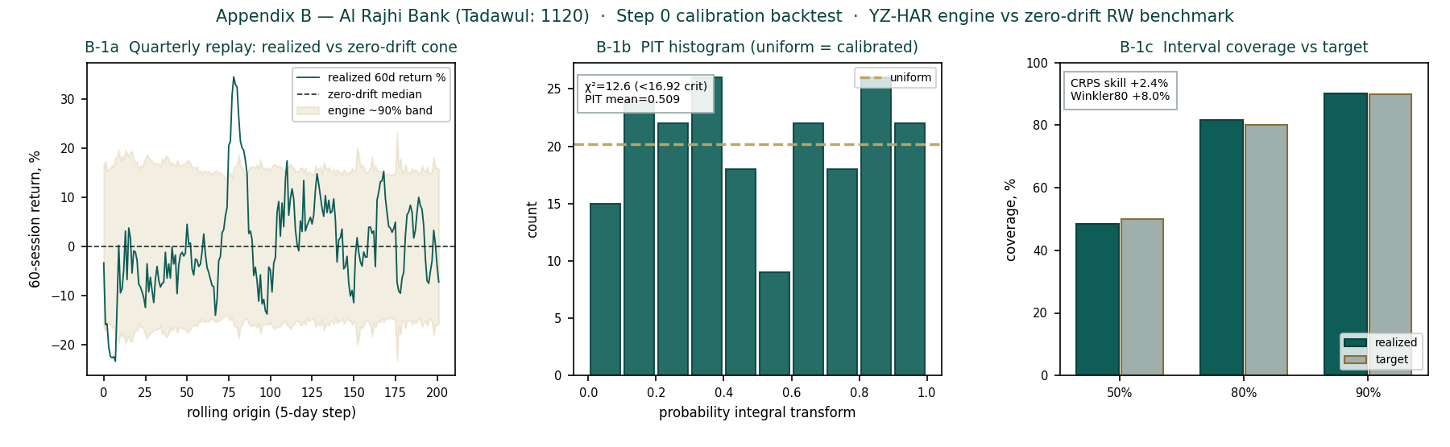
Figure 9 — Step 0 calibration: quarterly replay (left), PIT histogram — roughly uniform (centre), interval coverage vs target (right).
The engine passes: positive CRPS skill on both overlapping and non-overlapping windows, positive Winkler skill, coverage on target across the 50/80/90% intervals, and a PIT that the chi-square test cannot distinguish from uniform. The anchor forward volatility of ~17.8% used in §3 is the engine’s regime-aware read for the current calm tape, tighter than the ~20–23% trailing figure — the source of the interval-skill edge.

Appendix C Peer set, sector structure, and risks
Al Rajhi is the premium name in a concentrated, well-capitalised Saudi banking sector, and screens richly against both Saudi and wider GCC peers — a premium its return on equity earns rather than an anomaly.
Bank | P/B | P/E | ROE | Note
Saudi banks
Al Rajhi Bank (1120) | ~3.5× | ~16.0× | 23.4% | World’s largest Islamic bank; retail-led, premium ROE
Saudi National Bank (1180) | ~1.5× | ~11.5× | 13.5% | Largest by assets; corporate-heavy, lower ROE
Riyad Bank (1010) | ~1.5× | ~10.0× | 15.0% | Corporate & retail; solid, mid-tier
Alinma Bank (1150) | ~1.9× | ~12.0× | 16.5% | Islamic; faster-growing, smaller
Saudi Awwal Bank / SAB (1060) | ~1.3× | ~10.5× | 12.5% | HSBC-linked; corporate franchise
Banque Saudi Fransi (1050) | ~1.2× | ~9.5× | 12.0% | Corporate; value-tier
Wider GCC (context)
QNB (Qatar) | ~1.6× | ~9.5× | 17.0% | Largest MENA bank; regional reach
First Abu Dhabi Bank | ~1.4× | ~9.0× | 16.0% | UAE flagship
Emirates NBD | ~1.2× | ~7.0× | 18.0% | UAE; high ROE, cheaper multiple
Multiples approximate, for context; not independently verified. The ROE–multiple relationship is the point: Al Rajhi’s premium tracks its return.
Sector structure. Saudi banking is an oligopoly of ~10 banks, dominated by Al Rajhi and SNB, operating under a conservative SAMA regime (high capital ratios, the riyal peg, Basel III-plus). Structural drivers are favourable: low credit penetration, a young population, a government-backed mortgage push and Vision-2030 project financing. Key risks: interest-rate/NIM sensitivity in the easing cycle; oil-price dependence of the macro; concentration and real-estate exposure in the loan book; a benign cost of risk that could normalise; and the geopolitical risk premium of the region. For Al Rajhi specifically, the debate is valuation, not quality — whether a world-class franchise at ~3.5× book is worth it, which the excess-return lenses answer in the affirmative and the dividend lens more cautiously.

Appendix D The expert valuation panel
Three independent experts value Al Rajhi by genuinely different methods, cast from the Testahil persona library’s bank coverage map — a capital-and-returns specialist, a credit-cycle specialist, and a macro-policy specialist. They are labelled Expert 1 / 2 / 3. Each shows its workings, states a falsification condition, and reads what the market price implies; they disagree, and the spread is the analysis.

D.1 Expert 1 — capital, returns and the price of book value
Worldview and tradition. Expert 1 comes from the bank-analyst tradition that says a bank is a machine for turning equity capital into a return, and is worth whatever that return justifies relative to its cost. The governing identity is the Gordon-growth justified price-to-book: P/B = (ROE − g) / (Ke − g). A bank earning exactly its cost of equity is worth book; one earning above it is worth a premium that rises with the excess return and with growth. Dividends are almost irrelevant to this expert except as a residual — what matters is the ROE and how long it persists. This method works best for a stable, highly profitable, well-capitalised bank whose ROE is durable, and it works worst for a turnaround or a bank whose returns are about to mean-revert (it will overvalue a peak-ROE cyclical). Expert 1 therefore spends most of the effort defending the through-cycle ROE, not computing the formula.
Standard workings. (1) Estimate a sustainable through-cycle ROE. (2) Publish the cost of equity as rf + β×ERP. (3) Pick a terminal growth rate consistent with nominal GDP and the retention/ROE identity (g = retention × ROE). (4) Compute justified P/B and multiply by forward book value per share.
Input | Value | Basis
Through-cycle ROE | 21.0% | Below the 23.4% FY25 peak; credits durability, not the top of the cycle
Cost of equity (rf + β×ERP) | 9.5% | 5.25% + 0.90 × 4.75%
Terminal growth g | 5.0% | ≈ nominal GDP; consistent with ~45% retention × ~21% ROE (capped)
Justified P/B | 3.54× | (21.0% − 5.0%) / (9.5% − 5.0%)
Forward book value / share | SAR 21.3 | FY26E common equity / 6,000mn shares
Expert 1 fair value | SAR 76 | Justified P/B × forward BVPS
Worked example and sensitivity. At a 21% ROE the machine is worth 3.5× book; the stock trades at ~3.5×, so on Expert 1’s numbers Al Rajhi is fairly-to-attractively priced with the return doing the work. The swing input is the through-cycle ROE. Each one-point change in the sustainable ROE moves justified P/B by ~0.22× and fair value by ~SAR 5: a 19% ROE (a harder rate-cut landing) gives ~3.1× and ~SAR 66; a 23% ROE (peak sustained) gives ~4.0× and ~SAR 85. The Ke matters almost as much — the sell-side’s 9.0% lifts fair value toward SAR 90. Expert 1 flags that the model is most fragile precisely where it is most powerful: it capitalises the current high ROE, and if that ROE is a peak rather than a plateau, the fair value is too high.
When the method works, and when it fails. Expert 1 leans on history to defend the ROE assumption: Al Rajhi has earned above 20% on equity through rate cycles, oil crashes and a pandemic, because its edge is structural rather than cyclical — the widest, cheapest retail deposit base in the Kingdom, a sector-low cost-to-income, and a scale advantage that compounds. That persistence is the whole case; a 21% ROE that lasts a decade is worth vastly more than a 21% ROE that fades in three years. The method fails exactly where persistence fails: it cannot see a competitive erosion or a regulatory change to Islamic-banking economics coming, and it silently assumes the bank can keep finding high-return assets to fund with its retained capital. If financing growth slows to low-single-digits and the surplus capital ends up in low-yielding sovereign sukuk, the realised return on incremental equity falls toward Ke even as the reported group ROE stays high on the legacy book — the trap Expert 1 must watch for, and the reason it cross-checks against a growth-adjusted view rather than a static one.
Cross-examination. Expert 1 tells Expert 3 (macro/DDM) that a dividend model throws away the most valuable thing Al Rajhi does — reinvest at 20%+ — and so structurally understates a compounder; a bank should not be valued like a bond. It tells Expert 2 (credit) that a through-cycle cost of risk is already inside the ROE estimate, so double-counting a credit haircut on top understates value. Verdict: SAR 76, the excess-return anchor. Falsification: if the sustainable ROE proves to be below ~15% (incremental capital earning near Ke), the justified premium collapses toward book and Expert 1 is wrong. What the price implies: at SAR 66 (~3.1× forward book) the market is pricing a through-cycle ROE of ~19% — slightly below what Expert 1 thinks is sustainable, which is the source of the upside.

D.2 Expert 2 — the credit cycle and normalized provisioning
Worldview and tradition. Expert 2 is a credit-cycle sceptic who has seen too many banks report record profits at the top of a benign cycle, only to give it all back in provisions when the cycle turns. The governing idea is that a bank’s reported earnings in a good year overstate its through-cycle earning power, because the cost of risk is temporarily below normal. This expert normalises the P&L to a mid-cycle cost of risk, capitalises the resulting normalized earnings at a sober multiple, and treats everything above that as cyclical froth. The method works best near a cycle peak (it is the natural counterweight to peak-earnings optimism) and worst near a trough (it will undervalue a bank whose provisions are about to fall). For Al Rajhi — FY25 cost of risk ~35bps, historically low, in a still-benign Saudi credit environment — Expert 2 is firmly in “peak-cycle” mode.
Standard workings. (1) Take current pre-provision profit. (2) Replace the reported cost of risk with a through-cycle charge. (3) Tax to a normalized net income and EPS. (4) Apply a through-cycle P/E, deliberately below the market multiple.
Input | Value | Basis
Pre-provision profit (FY26E) | ~SAR 34,300mn | From the driver model
Normalized cost of risk | 55bps | vs ~35bps reported; a mid-cycle charge on gross financing
Normalized impairment | ~SAR (4,300)mn | 55bps × ~SAR 785bn gross financing
Normalized net income (post-zakat) | ~SAR 26,500mn | Below the driver FY26E on the heavier charge
Normalized EPS | ~SAR 4.42 | / 6,000mn shares
Through-cycle P/E | 14.5× | Sober; below the ~16× market multiple
Expert 2 fair value | SAR 65 | Normalized EPS × through-cycle P/E
Worked example and sensitivity. Normalising the cost of risk from 35 to 55bps costs ~SAR 1.5bn of net income and, at 14.5×, ~SAR 4 of fair value; the sober multiple (vs the market’s 16×) costs another few rand. The swing input is the through-cycle cost of risk. At 40bps (only a mild normalisation) fair value rises toward SAR 70; at 80bps (a genuine credit event, e.g. a real-estate or SME stress) normalized EPS falls to ~SAR 4.0 and fair value to ~SAR 58. Expert 2’s whole case is that the market is extrapolating a 35bps world; the fair value is a function of how quickly one thinks that reverts.
When the method works, and when it fails. Expert 2 is at its most valuable near a cycle peak in a petro-economy, where reported provisions understate the risk in a real-estate- and SME-heavy loan book that has never been tested by a genuine downturn under the current rate regime. Saudi banks carry meaningful exposure to contractors, real estate and consumer lending — sectors that move with the oil-funded fiscal cycle — and a benign 35bps charge across a full decade would be historically unusual. The method fails near a trough, or for a bank whose low charge is genuinely structural: if Al Rajhi’s retail-dominated, salary-assigned consumer book and conservative underwriting really do deserve a sub-40bps through-cycle charge, Expert 2’s normalisation is a permanent, unwarranted haircut. The honest position is that no one knows which world we are in until a downturn arrives, and Expert 2’s job is to make sure the valuation does not assume the benign one for free.
Cross-examination. Expert 2 warns Expert 1 that its 21% through-cycle ROE quietly assumes a benign cost of risk forever, and that the ROE and the credit cycle are not independent — the same rate cuts that eventually pressure NIM also tend to accompany the credit softening it ignores. It grants Expert 3’s caution on the dividend but thinks the DDM’s low value is right for the wrong reason (discount rate, not credit). Verdict: SAR 65, the conservative floor and a shade below spot. Falsification: if Al Rajhi’s cost of risk stays below ~40bps through a full rate cycle (proving the low charge is structural, not cyclical), Expert 2 is too bearish. What the price implies: at SAR 66 the market is paying for a ~40bps normalized cost of risk — i.e. it half-agrees with Expert 2 already.

D.3 Expert 3 — macro, policy and the dividend
Worldview and tradition. Expert 3 is a top-down macro strategist who values a bank as a claim on a cash stream whose size is set by forces outside the bank’s control — the policy rate, the oil price, the credit cycle of a petro-economy. The instrument of choice is the dividend discount model, because it is honest about what the shareholder actually receives and because it forces every macro view into two numbers: the discount rate and the growth of the payout. This expert is temperamentally cautious — it discounts a high-ROE bank at a full cost of equity, refuses to capitalise retained earnings it cannot see being distributed, and lets the terminal value carry the optimism transparently. The method works best for a mature, dividend-paying bank in a rate-sensitive economy and worst for a growth compounder that reinvests rather than distributes (it will systematically undervalue retention — which is exactly the debate with Expert 1).
Standard workings. (1) Forecast the dividend from the macro-driven earnings path and a payout schedule. (2) Publish Ke = rf + β×ERP, with the beta and ERP reflecting the macro risk. (3) Discount the explicit dividends and a Gordon terminal. (4) Sensitise on Ke × g, since the answer is terminal-heavy.
Input | Value | Basis
Cost of equity | 9.5% | 5.25% Saudi rf + 0.90 × 4.75% ERP
FY26–30 dividend path (DPS) | SAR ~2.1 → ~3.3 | Payout 45% → 55% on the earnings glide
Terminal growth g | 5.0% | ≈ nominal GDP
PV of explicit dividends | ~SAR 10 | Five years, discounted at Ke
PV of terminal value | ~SAR 48 | Gordon on FY31 dividend; ~83% of value
Expert 3 fair value | SAR 58 | Sum of the discounted dividend stream
Worked example and sensitivity. On the cash Al Rajhi actually pays, the shares are worth ~SAR 58 at a 9.5% Ke — slightly below spot, which is Expert 3’s point: the market is already paying for growth the dividend does not yet deliver. The swing input is the cost of equity. The sell-side’s 9.0% Ke lifts the DDM to ~SAR 66 (spot); an 8.5% Ke — a world of lower Saudi risk premia — pushes it to ~SAR 76, converging with Expert 1. A higher 10.5% Ke drops it to ~SAR 48. The terminal-value share (~83%) is the honest caveat: most of the value is a bet on the perpetual Ke–g gap, which is why Expert 3 leads with the sensitivity grid rather than the point.
When the method works, and when it fails. Expert 3’s DDM is the right tool for a mature bank whose payout is real and rising, and it has the singular virtue of forcing the analyst to state a cost of equity out loud rather than hiding it in a multiple. Its blind spot is the mirror of Expert 1’s strength: by valuing only distributed cash, it structurally penalises a high-return compounder that chooses to retain, and it will look too bearish for as long as reinvestment beats distribution. Expert 3 counters that the beta and equity-risk-premium it uses already encode the things that matter for a Saudi bank — the oil-driven cyclicality of the macro, the concentration of the economy, the geopolitical premium of the region — and that the riyal’s dollar peg, far from removing risk, imports US monetary policy wholesale, so the discount rate is doing real work. The method’s fragility is its terminal dependence: with ~83% of value in the Gordon tail, a quarter-point move in either Ke or g swings the answer by several rand, which is why Expert 3 refuses to quote a point without the grid beside it.
Cross-examination. Expert 3 tells Expert 1 that a justified-P/B model is only as good as its ROE-persistence assumption, and that capitalising a 21% ROE into perpetuity is a heroic macro call dressed as an accounting identity. It tells Expert 2 that normalising credit is sensible but that the bigger risk is the rate path, not the loan book. It concedes that if Al Rajhi truly reinvests at 20%+ for a decade, the DDM will prove too low — but insists that is a forecast, not a fact, and that a cautious shareholder should not pay for it in advance. Verdict: SAR 58, the cautious dividend anchor. Falsification: a sustained cut in the Saudi equity risk premium (Ke toward 8.5%) or a confirmed step-up to a 55–60% payout would both lift the DDM toward the excess-return cluster and prove Expert 3 too conservative. What the price implies: at SAR 66 the market is discounting the dividend stream at ~9.0% — a lower risk premium than Expert 3 is willing to assume.

D.5 The three in one room
Put the three in a room and the argument narrows to one question: what is Al Rajhi’s retained capital worth? Expert 1 says it is worth 3.5× book because it compounds at 20%+; Expert 3 says it is worth only what gets paid out, because the rest is a promise; Expert 2 says whatever it is worth, strip out the cyclically-low provisions first. They agree on the facts — a ~23% ROE, a ~35bps cost of risk, a 45–55% payout, a 9.5% Ke — and disagree only on which of those is durable. Expert 1: “You are both valuing a Toyota like a bond because it hasn’t crashed yet.” Expert 3: “And you are valuing a bank at the top of a rate and credit cycle as if neither turns.” Expert 2: “You are both right about each other.” The useful synthesis is that the truth is a probability-weighted blend — which is precisely why the house central (SAR 70) sits between the excess-return cluster (SAR 76–80) and the dividend/credit floor (SAR 58–65), and why the three-month distribution centres at spot with a mild upside tilt.

D.6 Reading the divergence
The spread — SAR 58 to SAR 76, about 30% — is not noise; it is a clean measurement of a single disagreement. Each expert’s answer is driven by one assumption, and the table isolates it.
Expert | Fair value | The one assumption that drives it | Where it sits and why
Expert 1 — capital & returns | SAR 76 | Sustainable through-cycle ROE (21%) | Highest — capitalises retained-earnings compounding
Expert 2 — credit cycle | SAR 65 | Normalized cost of risk (55bps) | Middle-low — strips cyclical provisioning
Expert 3 — macro & policy | SAR 58 | Cost of equity / risk premium (9.5%) | Lowest — values only distributed cash
Spread | SAR 58–76 | ≈ 30% of the low | Measures: what retained capital is worth
What the spread measures. The distance between Expert 1 and Expert 3 is the value of Al Rajhi’s retention policy — the difference between crediting a 20%+ reinvestment return (Expert 1) and ignoring it until it is paid out (Expert 3). Expert 2 sits between them, reminding both that the returns being argued over rest on a benign credit cycle. An investor’s own view of the stock reduces to a view on that one axis: if you believe the Saudi credit and rate environment lets Al Rajhi keep compounding capital at a high return, you side with Expert 1 and the stock is cheap; if you think you should pay only for cash in hand, you side with Expert 3 and it is fair. The house blend (SAR 70) does not resolve the argument — it prices it.

About this series
Testahil publishes independent, educational valuation studies. Each is an attempt to reason transparently about what a security is worth, with every assumption shown and a companion model so readers can disagree productively. The house style is distributions, not tips: we describe ranges and probabilities, not targets, and we do not tell anyone what to do. Studies are framed as educational analysis, the preparer is not licensed by any securities regulator, and holdings are disclosed.

Disclosure & Disclaimer
Not investment advice. This document is educational and informational only. It is not, and must not be relied upon as, investment, financial, legal, accounting or tax advice, nor an offer, solicitation or recommendation to buy, sell or hold any security. It contains no price target and no rating.
No licence; no advisory relationship. The preparer is not registered or licensed with any securities or financial regulator in any jurisdiction, holds no brokerage or investment-advisory authorisation, and is not acting as your adviser or fiduciary. Nothing here is personalised to your circumstances.
Holdings disclosure. The preparer may hold, and may in the future take or dispose of, a position in the security discussed in this report, and may transact at any time without notice. This is a potential conflict of interest you should weigh.
Sources & accuracy. Reported financial and operating figures are drawn from the bank’s public disclosure and other public sources believed reliable but not independently verified; they may contain errors or be superseded. Forward-looking inputs — the NIM and cost-of-risk path, the payout schedule, the cost of equity and terminal growth, the multiples, the DDM/FCFE and the Monte-Carlo factor probabilities — are the preparer’s own judgments and are inherently uncertain. Some balance-sheet lines are estimated to tie to disclosed totals.
Forward-looking statements. Any statements about the future are estimates subject to risks and uncertainties; actual results may differ materially. The Monte Carlo models price, not value, and encodes subjective probabilities for events that have not occurred.
No reliance; your responsibility. Do your own research and consult a licensed professional before making any decision. You are solely responsible for your investment decisions and their outcomes. To the maximum extent permitted by law, the preparer accepts no liability for any loss arising from use of this document.
Currency & figures. Figures are in Saudi riyals (SAR), which is pegged to the US dollar at 3.75; mn denotes million and bn billion. Rounding may cause totals to differ slightly. Spot price and market data are as of 02 July 2026 and change continuously.

TESTAHIL · Independent Valuation Study · Educational Analysis · Al Rajhi Bank (Tadawul: 1120) · edition 02-07-2026 · reporting currency SAR

