Testahil · Independent Valuation Study — Educational Analysis
Not investment advice
Independent Valuation Study — Educational Analysis
Aldar Properties PJSC (ADX: ALDAR)
Fundamental analysis · Technical analysis · Monte Carlo simulation — one integrated read
Anchor: AED 8.30 (3 Jul 2026 close) · ~7.854bn shares · mkt cap ~AED 65.2bn · net debt ~AED 5.5bn incl. hybrids (~0.5× EBITDA) · a diversified Abu Dhabi developer-plus-landlord: Aldar Development (the region's largest sales franchise, AED 71.7bn backlog) and Aldar Investment (a ~AED 52bn recurring-asset platform) · prices and probabilities computed 3 Jul 2026 from the attached daily history · primary lens: split-the-legs sum-of-the-parts / RNAV (development on a finite going-concern DCF, the recurring platform on a cap-rate GAV) · the swing factors are how much the development franchise is worth beyond current backlog and the recurring-platform cap rate.
READ FIRST — what this document is, and is not. This study is a valuation exercise and an expression of personal analytical opinion, published free of charge for educational purposes: it shows how one analyst applies fundamental, technical and probabilistic methods to a listed company, and invites scrutiny of that methodology. It is NOT investment advice, NOT a recommendation or solicitation to buy, sell or hold any security, and NOT directed at the circumstances of any reader. The preparer is not licensed by any securities regulator in any jurisdiction, holds no brokerage authorisation, provides no financial consultancy, manages no money, and accepts no fees, funds or clients. See the Disclosure & Disclaimer at the end. All values are model outputs presented as ranges and distributions because no single number should be relied on. Reported financials are the company's own disclosure (FY2025 results and Q1 2026, reported 2026); forward-looking inputs — the split-NAV marks, the recurring-platform GAV, the development-franchise DCF, the multiples and the Monte-Carlo factor probabilities — are the preparer's judgments and are flagged throughout. Consult a licensed financial advisor before any investment decision.

Headline
The model's read: modestly undervalued on a split-legs asset value, with the whole question resting on how much the development franchise is worth beyond its current backlog and where the recurring-platform cap rate settles. At AED 8.30 the shares sit about 23% below our weighted central estimate of AED 10.2. The primary lens — a sum-of-the-parts that values Aldar Development on a finite going-concern DCF (AED 4.60/share) and Aldar Investment at its ~AED 52bn recurring-asset GAV (AED 6.62/share), then deducts net debt and minorities — lands at AED 10.14/share (+22%); a whole-company going-concern DCF that strikes its terminal on an exit EV/EBITDA multiple (not a Gordon perpetuity, which would imply AED 13.84) lands close by at AED 9.81 (+18%), and a relative-multiple read centres AED 9.45. That the asset sum and the cash-flow model converge near AED 10 despite sharing almost no inputs is reassuring for a cyclical. Full execution of the development pipeline is worth AED 11.29 (+36%); the defensible floor — the recurring platform at a 10% haircut plus five years of backlog conversion, net of all claims — is ~AED 7.2, just below spot. The split matters: unlike a finite land-monetiser, Aldar Development continuously replenishes its landbank (AED 61bn of gross development value added in Q1 2026 alone), so its leg is valued as a going concern with a modest finite tail rather than as a wasting asset — a deliberate, disclosed deviation from the house split-NAV rule that development legs carry no terminal value. Technically the tape is two-sided and mid-recovery: AED 8.30 sits above the rising short-term averages (SMA20 8.16, SMA50 7.98) but below the 100/150/200-day stack (8.62 / 8.72 / 8.87), which now acts as overhead resistance after the round-trip from the AED 11.80 high to the AED 7.03 low; RSI is neutral at 53.5 and the MACD histogram has just rolled marginally negative. Over three months the Monte Carlo — 50,000 paths, sixteen factors, zero secular drift (an international name) — places the T+60 5th–95th band at roughly AED 6.4–11.3, with the median at AED 8.50, a touch above spot.
Net: the stock trades below the model's split-legs asset value while the tape is balanced in a basing range; the right tail belongs to development-launch execution, recurring re-rating and cap-rate compression, the left tail to a regional-security shock and a stall in launch pace. This study estimates values and probabilities — it does not recommend actions.
Valuation summary — every read at a glance
One table for the four reads that follow — what the business is worth (fundamental), what the tape is doing (technical), where price could travel over three months (Monte Carlo), and how three independent expert methods land. Every row is developed in the sections and appendices below.
Lens / read | What it measures | Output | Takeaway
FUNDAMENTAL — what the business is worth (the anchor)

Sum-of-the-parts / RNAV (primary) | Dev finite-DCF + recurring GAV, less claims | AED 10.14 | +22% vs spot
Consolidated DCF (FCFF) | Recurring-only perpetual terminal | AED 9.81 | +18% · the floor
Relative multiples | P/E · P/B · EV/EBITDA · disc-to-NAV | AED 9.45 | +14%
SOTP — full execution | No execution haircut, recurring +5% | AED 11.29 | +36% · the ceiling
Weighted central | Blend 40 / 25 / 15 / 20 | AED 10.18 | +23% vs AED 8.30
TECHNICAL — what the tape is doing (timing, not value)

Trend & momentum | Price vs the 20/50/100/200-day averages | Above short, below long | Basing, two-sided
Momentum / range | RSI · MACD · 52-week range | RSI 53 · MACD −0.02 · 7.03–11.80 | Neutral
MONTE CARLO — where price could go in 3 months (paths from spot)

T+20 sessions | 50,000 paths · 16 factors | p5 7.02 · p50 8.38 · p95 9.91 | Median ≈ spot
T+60 sessions | same engine, longer horizon | p5 6.36 · p50 8.50 · p95 11.29 | Wide, mild right-skew
EXPERT PANEL — three independent methods (Appendix C)

Expert 1 — Accountant (RNAV / realizable) | Cap-rate GAV + earnings quality | AED 9.2 | The anchor
Expert 2 — Demand (absorption DCF) | Backlog velocity → recognised cash | AED 10.8 | Most bullish
Expert 3 — Macro-Policy (scenario-weighted) | Oil, rates, Hormuz as options | AED 9.3 | Policy-weighted
Panel range | Spread = the franchise question | AED 9.2–10.8 | Centres ~AED 9.8

Bottom line. Every read points the same way on value and disagrees only on magnitude. The fundamental central sits near AED 10.2 — about 23% above the AED 8.30 spot — the three experts span AED 9.2–10.8, and each turns on a single question: how much of Aldar Development's continuously-replenished franchise to credit beyond today's AED 71.7bn backlog, and what cap rate the recurring platform deserves. The technical tape is the lone neutral: mid-recovery, below its long-term averages, which is why the three-month distribution centres near spot with a mild right tail rather than already at fair value.
Company overview — Aldar Properties at a glance
Item | Value
Listed entity | Aldar Properties PJSC (ADX: ALDAR)
What it owns | Aldar Development (UAE master-plans, backlog AED 71.7bn; SODIC Egypt, London Square UK) · Aldar Investment (retail, commercial, residential, logistics, hospitality, education, estates — ~AED 52bn recurring assets)
Spot / date | AED 8.30 · 3 Jul 2026 close
Shares · market cap | ~7.854bn · ~AED 65.2bn
Net debt (incl. hybrids) | ~AED 5.5bn (~0.5× EBITDA); liquidity ~AED 33–38bn
FY2025 revenue / EBITDA | AED 33.8bn (+47% YoY) · AED 11.2bn (33% margin)
FY2025 net profit / EPS | AED 8.8bn group (attributable ~AED 7.6bn) · EPS AED 0.96
Development backlog | AED 71.7bn (Q1 2026: AED 72.1bn) + project-management backlog ~AED 92bn (separate)
Recurring-asset GAV | ~AED 52bn (Q1 2026), 96% occupancy, ~6.2% implied yield
Dividend (FY2025) | AED 0.205/share (+11%), ~AED 1.61bn total
52-week range · all-time | AED 7.03 – 11.80 · AED 3.15 – 11.80
Key holders | Mubadala-linked strategic ownership; free float the listed remainder; Apollo 9.7% of Aldar Investment Properties

Source: company FY2025 results and Q1 2026, ADX disclosures, exchange data. Values rounded.
1 Fundamental valuation
We value Aldar as two quite different businesses under one listing, and triangulate four lenses. The primary lens is a split-the-legs sum-of-the-parts / RNAV because the parts trade on different economics — a high-velocity development franchise whose value is the cash its order book and replenished land will generate, and a stabilised recurring-income platform whose value is its marked asset base at a market cap rate — and a single blended multiple would blur them. A consolidated FCFF DCF, a relative-multiple cross-check and, for a developer, a property-cycle read complete the set. The weights and the football field are in §1.5; the swing factors — the development-franchise value beyond backlog and the recurring cap rate — are dissected in §1.7 and the sensitivity grid in §1.9. Throughout, the cost of equity is published explicitly as Ke = risk-free + equity-risk premium (AD 10-yr 4.8% + ERP 4.4% × beta 1.0 = 9.2%), with a group WACC of 8.0%.
1.1 Split-the-legs sum-of-the-parts / RNAV — the primary lens
Each leg is marked on the basis that fits it. Aldar Investment — the recurring platform (retail, commercial, residential, industrial-and-logistics, hospitality, education and estates) — is carried at its stated recurring-asset gross asset value of AED 52bn, cross-checked by the implied ~6.2% yield on its ~AED 3.2bn adjusted EBITDA and by a ~16× EBITDA multiple appropriate to a 96%-occupied, inflation-linked portfolio. Aldar Development — the sales franchise — is valued on a finite going-concern DCF (§1.7): ten years of development free cash flow from the AED 71.7bn backlog and a normalised, fading launch programme, plus a modest land-replenishment tail, with no perpetual growing terminal (the split-NAV discipline). From the summed gross asset value we deduct net debt (including hybrid instruments, which rank ahead of ordinary equity) and non-controlling interests.
Component (split-legs build) | Basis | AED bn | AED/sh
Aldar Investment (recurring) | Recurring-asset GAV (cap-rate) | 52.0 | 6.62
Aldar Development (finite DCF) | 10-yr FCFF + land tail, no perpetual g | 36.2 | 4.60
Gross asset value (GAV) |  | 88.2 | 11.22
less: net debt (incl. hybrids) | ranks ahead of ordinary equity | (5.5) | (0.70)
less: non-controlling interests | Apollo (AIP) + Mubadala retail JV | (3.0) | (0.38)
SOTP equity value (risk-adjusted) |  | 79.7 | 10.14

SOTP base ≈ AED 10.14/share (+22% vs spot), with a bear–bull span of AED 7.24–11.29 driven mainly by the development-franchise value and the recurring cap rate (see §1.9). The gross asset value of AED 11.22/share says the market is paying AED 8.30 for AED 11.22 of marked assets before any claims — a wider discount to the recurring platform alone than a 96%-occupied portfolio usually carries, which is the crux of the bull case.
Full-execution variant. Setting the development margins a touch higher, extending the land tail, and marking the recurring platform 5% above carrying value lifts the SOTP to AED 11.29/share (+36%). The distance between AED 10.14 and 11.29 is the execution haircut the risk-adjusted case applies — narrower than for a finite land-monetiser because Aldar's franchise is a proven, replenishing machine rather than a one-off land bank.
1.2 Going-concern DCF — cross-check (exit multiple, not a perpetuity)
A discounted-cash-flow cross-check must respect the same finite reality as the sum-of-the-parts. A naïve Gordon-growth perpetuity on a cyclical developer capitalises a stream the market plainly does not treat as permanent — it is precisely why developer-landlords trade on high-single-digit EV/EBITDA, not the mid-teens a perpetuity implies. We therefore strike the terminal as an exit EV/EBITDA multiple anchored to Aldar's own current ~6.6×, held modestly conservative at 6.0×, and disclose (device A-7) that a Gordon perpetuity would instead imply AED 13.84 — a terminal-driven number we do not use. Development land investment is broken out as its own line, because for a developer the landbank replenishment is the cash the market watches. Ke is published transparently as risk-free + equity-risk premium.
AED bn | 2026e | 2027e | 2028e | 2029e | 2030e
Revenue | 37.0 | 41.0 | 45.0 | 48.0 | 50.5
EBITDA | 11.7 | 12.7 | 13.7 | 14.5 | 15.3
D&A | -0.7 | -0.8 | -0.9 | -1.0 | -1.0
EBIT | 10.9 | 11.9 | 12.8 | 13.6 | 14.2
NOPAT = EBIT×(1−t) | 9.6 | 10.5 | 11.3 | 12.0 | 12.5
+ D&A | 0.7 | 0.8 | 0.9 | 1.0 | 1.0
− Capex | -0.9 | -0.9 | -0.9 | -0.9 | -0.9
− Land investment | -3.6 | -3.6 | -3.7 | -3.7 | -3.7
− Δ working capital | -1.5 | -1.2 | -1.0 | -0.9 | -0.8
Free cash flow to firm | 4.35 | 5.58 | 6.59 | 7.41 | 8.14
Discount factor | 0.922 | 0.849 | 0.783 | 0.722 | 0.665
PV of FCFF | 4.00 | 4.74 | 5.16 | 5.35 | 5.41

DCF bridge → fair value | Value
Σ PV of explicit FCFF (2026–30) | 24.7
Terminal value (exit EV/EBITDA 6.0×) | 91.5
PV of terminal value | 60.9
Enterprise value | 85.5
less: net debt (incl. hybrids) | (5.5)
less: non-controlling interests | (3.0)
Equity value | 77.0
Fair value per share (AED) | 9.81
% terminal of EV (device A-7) | 71%
Memo — Gordon-perpetuity FV (disclosed, not used) | 13.84
WACC (≈ Ke, modest net debt) | 8.5%
Ke = rf 4.8% + beta 1.00 × ERP 4.4% | 9.2%

DCF base ≈ AED 9.81, with the terminal at 71% of EV — high, but it reflects Aldar's large permanent recurring platform — struck on a market-anchored exit multiple rather than the even larger figure (implying AED 13.84) that a Gordon perpetuity would carry. The two anchor lenses — RNAV AED 10.14 and DCF AED 9.81 — sit close together despite sharing almost no inputs, which is reassuring for a cyclical.
1.3 Relative multiples and discount-to-NAV
Where the intrinsic methods ask what the assets are worth, relative multiples ask what the market pays for comparable developer-landlords. Each row pairs Aldar's current multiple with a fair range and the implied equity value per share.
Lens | Aldar now | Fair range | Implied AED/sh
P/E (FY25 EPS 0.96) | 8.6x | 9.0–12.0x | 8.6 – 11.5
P/B (BVPS ~5.1) | 1.6x | 1.3–1.8x | 6.6 – 9.2
EV/EBITDA (FY25 11.2) | 6.3x | 7.0–9.0x | 9.3 – 12.1
Discount to NAV | 18% | 5–15% | 8.6 – 9.6
Relative blended midpoint |  |  | ≈ 9.5

The relative lenses cluster around AED 9.5 — below the intrinsic SOTP but above the current price. On near-term earnings Aldar screens roughly in line to modestly cheap (P/E ~8.6×), even as it looks discounted against its asset base. That gap is the structural discount-to-NAV a developer-landlord carries; the families of method answer different questions and are deliberately not blended into one number without judgement (device A-8).
1.4 Property-cycle framing — where Aldar sits in the cycle
For a developer, normalized through-cycle earnings are near-meaningless — each project is finite — so we state cycle position instead. Abu Dhabi and Dubai residential are in the mature-but-extending phase of a multi-year up-cycle that began in 2021: population inflows, a golden-visa-driven demand base, limited prime supply and property as an inflation and safe-haven hedge have driven successive record sales years (Aldar group sales AED 27.9bn → 33.6bn → 40.6bn across FY2023–25). Off-plan penetration is high and payment plans have lengthened, which historically flags mid-to-late cycle. The important structural difference from a pure homebuilder — and from a finite land-monetiser — is that Aldar replenishes its landbank continuously (AED 61bn of gross development value added in Q1 2026 alone across Abu Dhabi and Dubai) and carries a growing recurring-income platform that cushions the development cycle. The bear case is a UAE property cyclical turn — off-plan demand cooling, payment terms extending further, a sales-pace step-down — which the Q1 2026 print already hinted at (group sales −25% YoY on deliberately moderated launches). The recurring platform, at 96% occupancy on long leases, is the ballast that keeps the through-cycle floor well above a pure developer's.
1.5 Synthesis — four lenses
We weight the SOTP most heavily because it respects the differing economics of the two legs; the going-concern DCF, on an exit-multiple terminal, converges with the RNAV; the relative lens is the market-reality check; the full-execution SOTP marks the ceiling.
Lens | Weight | Bear | Base | Bull
SOTP / RNAV | 40% | 7.24 | 10.14 | 11.29
Consolidated DCF | 25% | 8.14 | 9.81 | 11.62
Relative multiples | 15% | 6.62 | 9.45 | 12.13
SOTP — full execution | 20% | 10.14 | 11.29 | 12.64
Weighted central |  | 7.95 | 10.18 | 11.77

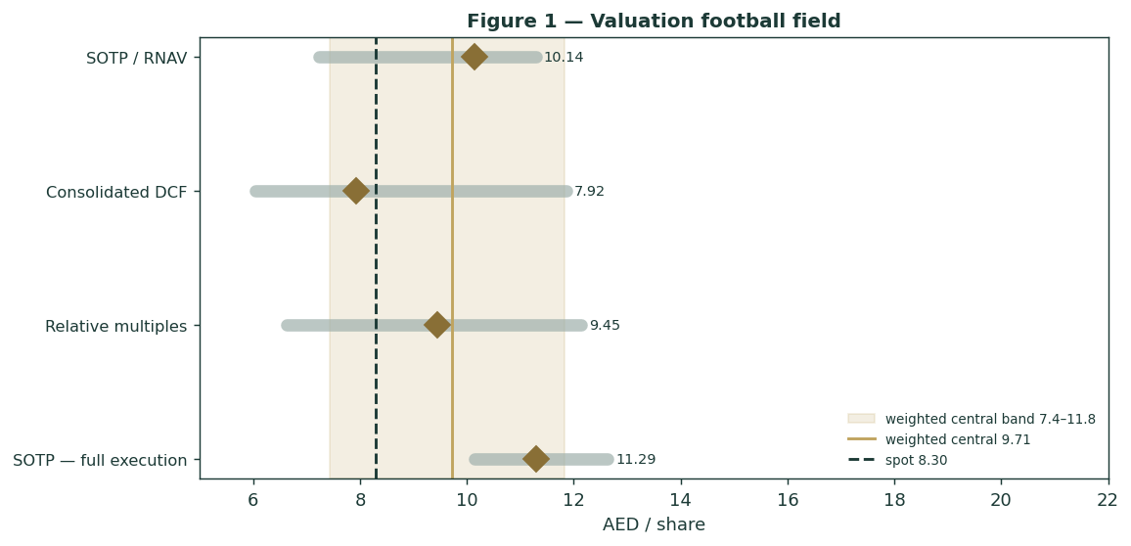
Figure 1 — Valuation football field. Bars span bear–bull per lens; the brass diamond is each base case; the gold band is the blended central range; the dark dashed line is spot.
Central fair value ≈ AED 10.18/share, about 23% above spot. The spread of the lenses (AED 9.81 to 11.29 at base) is itself the message: this is not a deep-value or an expensive name, but a quality developer-landlord trading at a discount to a defensible asset value, whose re-rating depends on the market crediting more of the development franchise and/or a firmer recurring cap rate.
1.6 The two platforms — a deeper look
Aldar Development (FY2025: revenue AED 24.8bn, EBITDA AED 7.2bn, backlog AED 71.7bn) is the region's largest sales franchise — record group sales of AED 40.6bn, a landbank replenished faster than it is consumed, and international optionality through SODIC (Egypt) and London Square (UK). Aldar Investment (FY2025: adjusted EBITDA AED 3.2bn on a ~AED 52bn asset base, 96% occupancy) is the ballast: Investment Properties (commercial, retail, residential, industrial-and-logistics), Hospitality & Leisure, Education and the asset-light Estates fee business. The table scores each leg on the axes that matter.
Leg | Cyclicality | Margin trend | Capital intensity | Swing role
Aldar Development | High (launch timing, off-plan demand) | Peak-ish (~29% EBITDA) | Moderate (land + build) | Dominant swing
Aldar Investment | Low (long leases, 96% occ.) | Improving (rent + occupancy) | High (develop-to-hold) | Ballast / cap-rate re-rate

Sub-segment adjusted EBITDA (Q1 2026 run-rate): Investment Properties AED 632m (Commercial 235, Retail 228, Industrial & Logistics 43), Hospitality & Leisure 98, Education 67, Estates 87 — a diversified, largely contractual recurring base that a pure-developer frame under-credits.
1.7 The crux — development-franchise value and the recurring cap rate
Two judgments drive the valuation more than any other, and we sensitise each in real, observable units rather than an abstract margin. First, the development free-cash stream. It is built bottom-up from the disclosed backlog conversion and a normalised, fading launch programme (the full FCFF waterfall is in §1.2); the swing is the development EBITDA level — a proxy for absorption velocity × realised margin — and the discount rate, dissected in the SOTP grid at §1.9. Second, the recurring cap rate. The AED 52bn platform is marked at an implied ~6.2% gross yield; every 25bp of cap-rate compression or expansion moves the recurring leg by roughly AED 0.25/share. Third, the DCF terminal. Because the going-concern DCF (§1.2) capitalises the terminal on an exit EV/EBITDA multiple, its swing is that multiple against the discount rate — the grid below re-prices the DCF from the low-8s (high WACC, 5.0× exit) to the mid-11s (low WACC, 7.0× exit), with the base at AED 9.81.
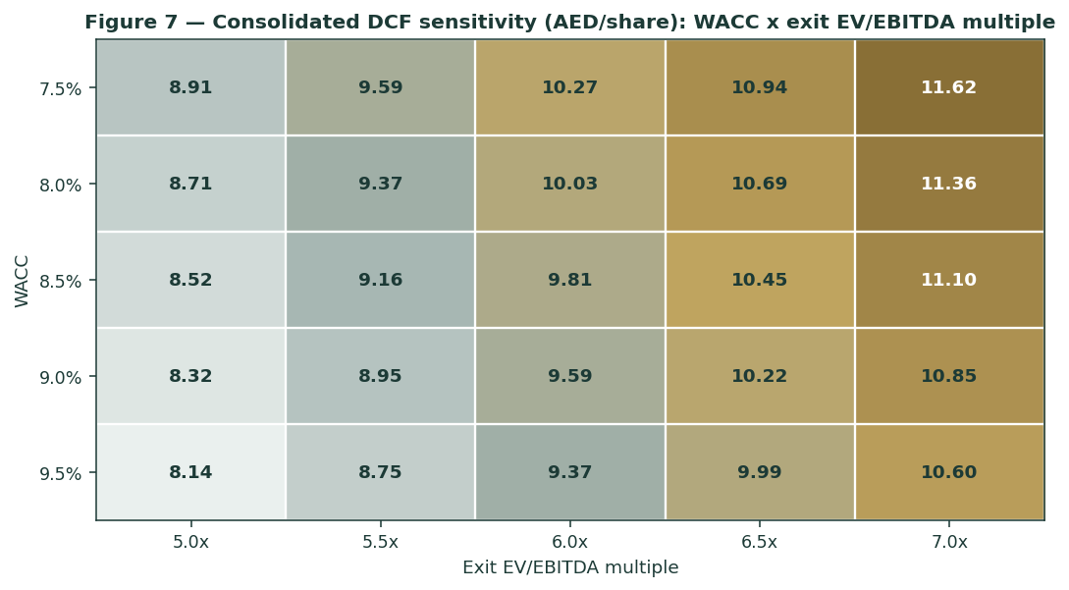
Figure 7 — Consolidated DCF sensitivity (AED/share): WACC × exit EV/EBITDA multiple. Ke is published as rf + ERP (§1.1); the terminal is an exit multiple anchored to Aldar's own current ~6.6×, not a Gordon perpetuity.
1.8 Macro and country — the UAE, oil, rates and regional security
Aldar is an Abu Dhabi cyclical with three external levers. The dirham peg to the US dollar means UAE policy rates track the Fed; a lower-rate path supports both mortgage-driven demand and the recurring platform's cap rate, while the peg mutes the FX translation risk that dominates emerging-market developers. Oil and Abu Dhabi's fiscal position set the liquidity backdrop — sovereign and quasi-sovereign flows, population growth and prime-buyer purchasing power. Regional security is the tail: the stock fell roughly 18% into the low-8s on the mid-2026 Strait-of-Hormuz tensions, a clean illustration of the risk-premium shock that anchors the left tail of the Monte Carlo. These levers are the swing factors behind the bear and bull cases in §1.5 and the catalysts in §5.
1.9 SOTP sensitivity — the development swing
Holding the recurring platform at its marked GAV, the grid re-prices the SOTP across the development discount rate and the development EBITDA level. The value runs from the low-8s (high WACC / lower EBITDA) to the low-12s (low WACC / higher EBITDA).
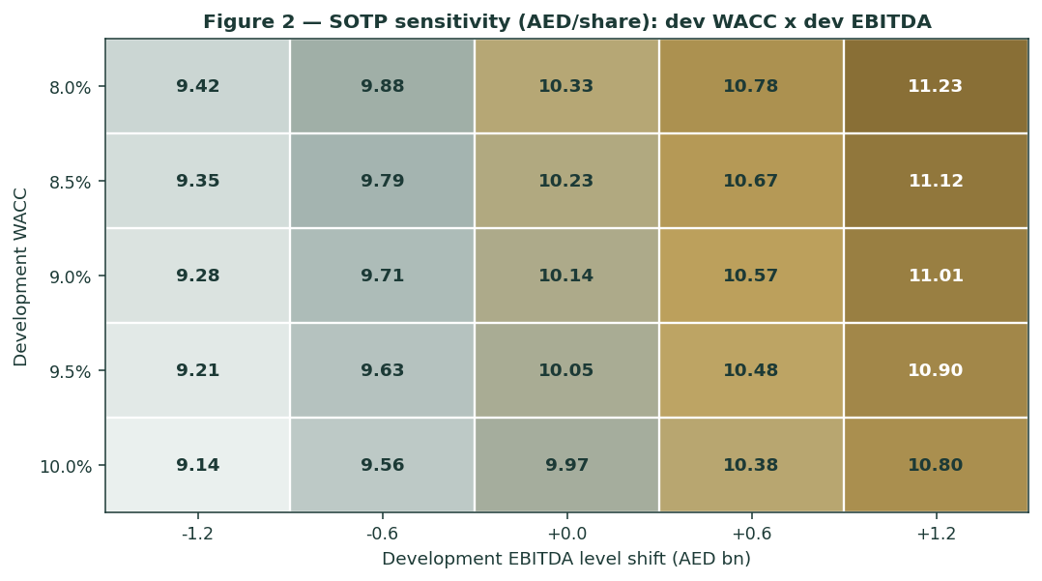
Figure 2 — SOTP sensitivity to the development swing inputs (AED/share, split-legs).
Read it as the bet you are taking: the market price is consistent with a development EBITDA roughly AED 0.6–1.2bn below our base at a ~9–9.5% discount — i.e. the market credits only part of the replenishing franchise, and none of a recurring re-rating.
2 Technical and price structure
The tape is two-sided and mid-recovery. Aldar trades above its rising short-term averages but below the 100/150/200-day stack, which now caps the range after the round-trip from the AED 11.80 high to the AED 7.03 low. RSI is neutral at 53.5 and the MACD histogram has just rolled marginally negative — momentum flattening after a bounce, not a decisive break either way. The structure is a base: a corrective decline that has stabilised and is probing the underside of its longer-term moving-average band.
Indicator | Reading | Signal
Spot | AED 8.30 | —
SMA 20 / 50 | AED 8.16 / 7.98 | Above both — short-term up
SMA 100 / 150 / 200 | AED 8.62 / 8.72 / 8.87 | Below the stack — overhead resistance
RSI (14, Wilder) | 53.5 | Neutral
MACD (12,26,9) | 0.136 line / 0.159 signal / −0.02 hist | Marginally bearish, flattening
52-week range | AED 7.03 – 11.80 | Mid-range
ATR(14) | AED 0.269 (3.2%) | Moderate
Realized vol (252d / 60d) | 34.0% / 40.8% | Elevated near-term

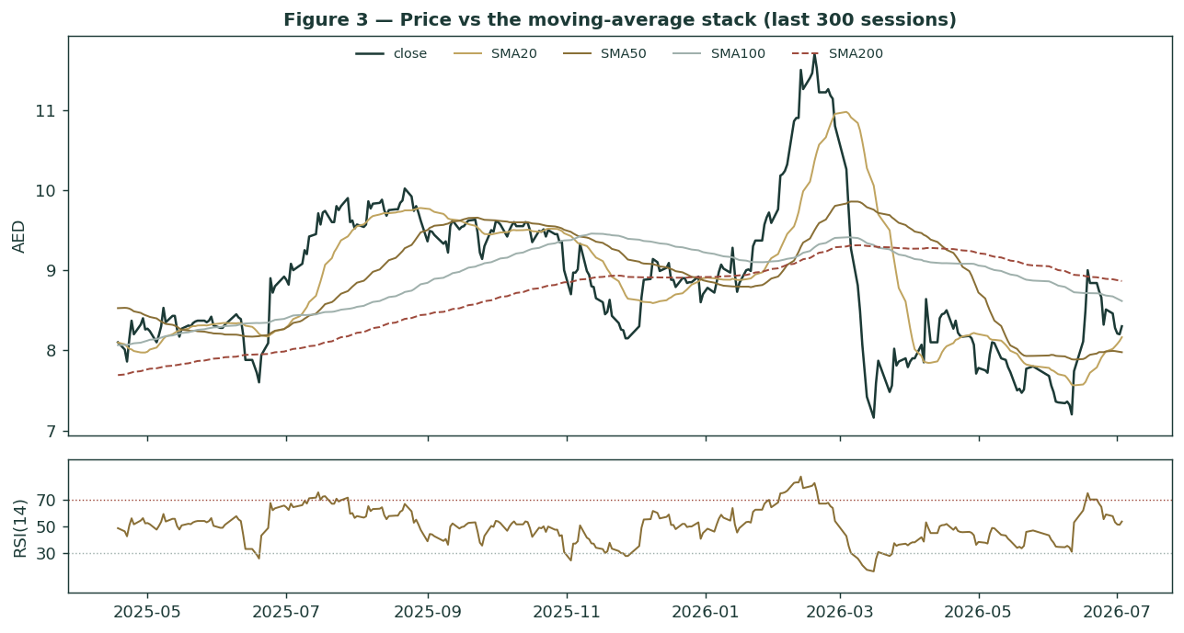
Figure 3 — Price versus the moving-average stack (last 300 sessions), with RSI(14) below.
Levels. Resistance sits at the moving-average band AED 8.6–8.9 (a clean daily close above it opens the AED 9.5–10 zone toward fair value); support is the rising SMA20/50 at AED 8.0–8.2, then the AED 7.03 52-week low. For the probabilistic work this matters in one way: a basing tape below its long-term averages keeps the near-term distribution roughly symmetric around spot, with the fundamentals arguing the upside over quarters, not days. §6 reads the resulting zones without forcing a reconciliation.
3 Monte Carlo — a probabilistic price map
We simulate 50,000 three-month price paths (seed 42) with the house YZ-HAR engine: width from a gap-aware Yang-Zhang variance proxy projected through a HAR cascade (regime-conditional, ~30.3% annualised here), shape from unit-variance Student-t(5) innovations (honest fat tails), and — because Aldar is an international name — zero secular drift, so direction is never manufactured. On top of the diffusion sit sixteen factors: seven continuous macro/operating drivers contributing a small net forward tilt (+1.6% over the quarter) and nine discrete events that each fire with a probability and an impact. By design the paths diffuse from spot, and the §1 value gap is kept out of the drift — the fundamental NAV gap lives in §1, not here; §3 maps where price could go from today, not where value sits. Before use, the engine is calibrated out-of-sample on Aldar's own five-year history and beats a zero-drift random-walk benchmark on probabilistic score (CRPS and interval skill both positive, roughly uniform PIT); the calibration detail is maintained in the Testahil ledger rather than reproduced here.
The probability read — how the distribution leans
Read this first: it summarises the direction and skew already in the 50,000 paths, computed after simulation (it never feeds the drift or width).
Probability read (T+60) | Value | Reading
P(price above spot) at T+60 | 56% | Near-even — a two-sided quarter
P(+10%) vs P(−10%) | 33% vs 22% (odds 1.50×) | Mild upside skew from launch/M&A events
Median level (and move) | AED 8.50 (+2.4%) | Just above spot
50% band (25th–75th) | AED 7.60 – 9.48 (-8% / +14%) | Where most of the mass sits
Touch +10% / −10% | 56% / 42% | Upside more reachable intramonth

The sixteen factors — the table IS the model.
Continuous factor (7) | Dir. | Discrete event (9) | Prob. | Mean impact
US/UAE rate path (AED peg → Fed) | − | Regional geopolitics / Hormuz | 35% | −9.0%
Oil / Abu Dhabi fiscal & liquidity | + | New mega-launch execution | 55% | +6.0%
AD & Dubai residential price cycle | + | Quarterly results (backlog→rev) | 55% | +2.0%
ADX / EM & GCC equity flows | + | Investment-platform M&A / D2H | 40% | +3.0%
USD/AED peg & imported-input inflation | mixed | Recurring re-rating / cap-rate compression | 30% | +3.0%
Global risk appetite / EM spreads | mixed | Dividend / capital-return surprise | 25% | +2.0%
Recurring occupancy & rent trend | + | Fed / UAE rate decision | 40% | 0.0%
 |  | Sales-guidance / launch-pace miss | 35% | −5.0%
 |  | Index / passive-flow rebalancing | 25% | +1.0%

Percentile map (AED/share):
Horizon | p5 | p25 | p50 | p75 | p95
T+20 sessions | 7.02 | 7.86 | 8.37 | 8.92 | 9.91
T+60 sessions | 6.36 | 7.60 | 8.50 | 9.48 | 11.29

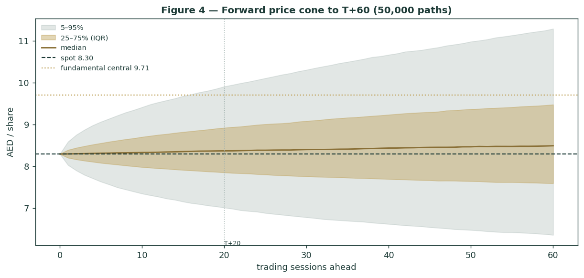
Figure 4 — Forward price cone to T+60. Median tracks just above spot; the gold dotted line marks the AED 10.2 fundamental central, deliberately above the cone.
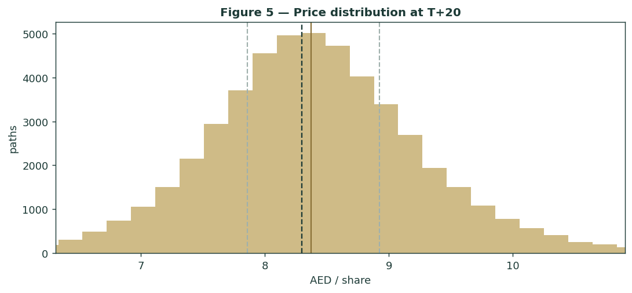
Figure 5 — Price distribution at T+20.
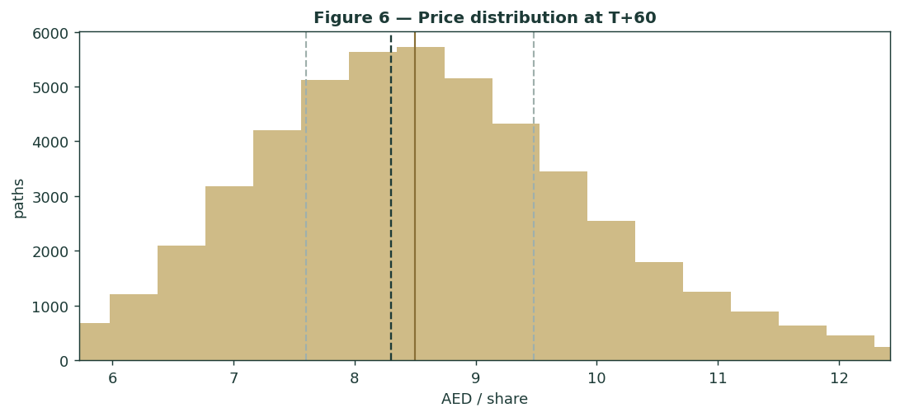
Figure 6 — Price distribution at T+60.
Level-touch ladder — the probability that price touches a level at any point by the horizon (running max for upside, running min for downside):
Level | T+20 touch | T+60 touch | Note
10.50 | 3% | 17% | toward sell-side target zone
10.00 | 7% | 27% | upper fair-value
9.50 | 15% | 42% | fair-value zone
9.00 | 35% | 61% | re-rating zone
8.60 | 61% | 79% | MA-stack resistance
8.00 | 54% | 71% | just below spot
7.60 | 26% | 49% | lower band
7.20 | 12% | 31% | toward 52-wk low
7.00 | 8% | 24% | 52-wk low zone

4 Comparison of the lenses, and a verdict
Three readings sit side by side. The fundamental lenses cluster at AED 9.45–11.29 with a central AED 10.18 — modestly above spot, contingent on how much development-franchise value and recurring re-rating the market credits. The technical picture is neutral: basing below the long-term averages, with support at AED 8.0–8.2 and the AED 7.03 floor. The probabilistic map says that over three months price is roughly symmetric around spot with a mild right tail — the median is AED 8.50, not AED 10.18, because the simulation does not assume the value gap closes inside the quarter.
Lens | Reads | Central / implication
Fundamental (4-lens) | Moderately cheap | AED 10.18 (+23%)
Technical | Basing / neutral | Support 8.0–8.2; resistance 8.6–8.9; floor 7.03
Monte Carlo (3-month) | Two-sided, mild right-skew | Median AED 8.50; p5–p95 6.36–11.29

Verdict (a fair-value read, not a recommendation). Aldar looks modestly-to-moderately cheap on a split-legs asset value, with two clear swing factors: the going-concern worth of the development franchise beyond its backlog, and the recurring-platform cap rate. The neutral technical tape and the near-symmetric three-month distribution argue that any re-rating is a question of operating proof and cap-rate direction over quarters, not of an imminent move. The honest summary is a value modestly above price, a near-term distribution centred on price, and an outcome that hinges on the market crediting more of a proven, replenishing franchise — which is why the bear–bull span (AED 7.4–11.8) is wide. Readers should weigh the lenses themselves; we publish the distribution, not a target.
5 Catalysts to watch
- Q2 2026 results (≈ Aug 2026). First read on whether the moderated launch pace of Q1 is a pause or a trend, and on recurring-EBITDA momentum and occupancy.
- Development launches & sales. New Abu Dhabi and Dubai master-plan releases and absorption — the largest single upside factor in the simulation (launch event p = 55%).
- Landbank replenishment. Further GDV additions (AED 61bn added in Q1 2026) that extend the franchise's going-concern value beyond current backlog.
- Recurring platform & cap rate. Develop-to-hold deliveries, occupancy, and any yield compression that re-rates the ~AED 52bn base — worth ~AED 0.25/share per 25bp.
- UAE / Fed rate path. The peg means a lower-rate path aids both mortgage demand and the recurring cap rate; a higher-for-longer path is the reverse.
- Regional security. Any escalation or de-escalation around the Strait of Hormuz re-prices the risk premium directly (the left-tail event).
- Capital & index events. Hybrid/refinancing actions, dividend policy, Apollo/Mubadala JV developments, and MSCI/FTSE flow rebalancing.
6 Reading the probability zones
Translating the three-month distribution into plain zones, anchored on spot AED 8.30 and the fair-value cluster:
Zone (T+60) | Range | Approx. prob. | What it would mean
Deep downside | < AED 7.20 | ~24% | Regional risk-off / launch stall; tests the 52-wk low
Lower band | AED 7.20–8.00 | ~22% | Basing persists; consolidated-DCF floor dominates
Around spot | AED 8.00–8.90 | ~25% | Status quo; value gap unclosed; MA-stack caps
Upper band | AED 8.90–9.90 | ~18% | Franchise credited; toward central/relative lens
Strong upside | > AED 9.90 | ~11% | Re-rating + cap-rate compression together

The distribution is close to symmetric, with a slightly heavier upper tail from the discrete upside events (launches, M&A, cap-rate compression). It is not a forecast; it is the spread of outcomes consistent with the stock's own volatility and the factor stack.
7 Caveats and what would change our mind
- The development-franchise value is the swing — interrogate it first. Within the SOTP, the development leg (AED 4.60/share) rests on backlog conversion plus a modest replenishment tail; §1.9 shows the value running from the low-8s to the low-12s on the development EBITDA level and discount rate alone. The going-concern DCF converges with the RNAV at ~AED 10 only because its exit multiple is anchored to today's trading level — lift or cut that multiple and it moves as much as the SOTP. If launches slow structurally or margins compress, the value falls toward the bear; if the franchise keeps replenishing at record pace, it rises toward full execution.
- Split-NAV deviation, disclosed. We credit Aldar Development a finite going-concern DCF with a small land-replenishment tail rather than zero terminal value, because — unlike a finite land-monetiser — Aldar demonstrably replenishes its landbank. That is a deliberate, conservative deviation from the house rule; the tail is kept to ~14% of the development leg and the whole leg is stress-tested in §1.9.
- The recurring GAV is a mark. The AED 52bn recurring-asset value is management's stated figure; an independent revaluation, a softer cap rate, or a weaker Abu Dhabi office/retail cycle would reshape the largest single line. Every 25bp of cap rate ≈ AED 0.25/share.
- Hybrids and minorities rank ahead. We deduct net debt including hybrid instruments and non-controlling interests (Apollo in Aldar Investment Properties, Mubadala in the retail JV) as senior claims on the gross asset value; different treatment of the hybrids as equity would lift the per-share NAV.
- Cyclicality can bite. Off-plan penetration is high and payment terms have lengthened; a UAE property cyclical turn would compress development margins and sales pace, as the Q1 2026 −25% sales print hinted.
- Monte Carlo is price, not value. The factors are independent judgments; event timing is uniform-random within the window; the zero-drift choice deliberately declines to extrapolate the five-year uptrend, so the median sits at spot, not at fair value.
Appendix A Financial statements
Selected consolidated figures. FY2023–FY2025 are the company's disclosure (FY2025 results and Q1 2026); the 2026e–2030e forecast is the study's independent operating model, shown over the near-term five-year horizon consistent with developer-valuation practice. Some balance-sheet lines are estimated to balance to disclosed totals and are flagged. Currency AED bn; per-share AED.
A.1 Income statement (consolidated, AED bn)
AED bn | FY23a | FY24a | FY25a | 2026e | 2027e | 2028e | 2029e | 2030e
Revenue | 14.2 | 23.0 | 33.8 | 37.0 | 41.0 | 45.0 | 48.0 | 50.5
EBITDA | 5.1 | 7.7 | 11.2 | 11.7 | 12.7 | 13.7 | 14.5 | 15.3
EBITDA margin | 36% | 34% | 33% | 32% | 31% | 30% | 30% | 30%
D&A | -0.5 | -0.6 | -0.7 | -0.7 | -0.8 | -0.9 | -1.0 | -1.0
EBIT | 4.6 | 7.1 | 10.5 | 10.9 | 11.9 | 12.8 | 13.6 | 14.2
Net finance cost | -0.4 | -0.5 | -0.9 | -0.9 | -0.9 | -0.9 | -0.9 | -0.9
Fair-value / other (actuals) | 0.3 | 0.5 | 0.6 | 0.0 | 0.0 | 0.0 | 0.0 | 0.0
Profit before tax | 4.5 | 7.1 | 10.2 | 10.0 | 11.0 | 11.9 | 12.7 | 13.3
Tax | -0.3 | -0.7 | -1.4 | -1.2 | -1.3 | -1.4 | -1.5 | -1.6
Net profit (group) | 4.2 | 6.4 | 8.8 | 8.8 | 9.7 | 10.5 | 11.2 | 11.7
less: NCI | -0.5 | -0.9 | -1.2 | -1.1 | -1.2 | -1.3 | -1.3 | -1.4
Attributable net profit | 3.7 | 5.5 | 7.6 | 7.8 | 8.5 | 9.2 | 9.8 | 10.3
EPS (AED) | 0.47 | 0.70 | 0.97 | 0.99 | 1.08 | 1.18 | 1.25 | 1.32
DPS (AED) | 0.17 | 0.18 | 0.20 | 0.54 | 0.60 | 0.65 | 0.69 | 0.72

Source: Aldar FY2023–FY2025 results & Q1 2026; forecast is the study's operating build. Actuals carry fair-value revaluation in reported profit; forecast is a clean operating build. Figures rounded.
A.2 Balance sheet (consolidated, AED bn)
AED bn | FY23a | FY24a | FY25a | 2026e | 2027e | 2028e | 2029e | 2030e
Cash & deposits | 11.7 | 15.1 | 21.0 | 22.5 | 24.5 | 27.0 | 30.0 | 33.5
Receivables | 8.0 | 10.0 | 12.0 | 12.0 | 12.0 | 12.0 | 12.0 | 12.0
Development inventory / WIP | 28.0 | 33.0 | 34.0 | 34.0 | 34.0 | 34.0 | 34.0 | 34.0
Investment property (recurring) | 18.0 | 22.0 | 25.0 | 26.0 | 27.0 | 28.0 | 29.0 | 30.0
Other assets (plug) | 9.3 | 8.5 | 16.0 | 17.8 | 19.4 | 21.0 | 22.4 | 23.6
Total assets | 75.0 | 88.6 | 108.0 | 112.3 | 116.9 | 122.0 | 127.4 | 133.1
Debt (incl. hybrids) | 12.1 | 16.4 | 26.5 | 26.5 | 26.5 | 26.5 | 26.5 | 26.5
Customer advances / contract liab. | 15.0 | 18.0 | 20.0 | 20.0 | 20.0 | 20.0 | 20.0 | 20.0
Payables & other liabilities | 14.9 | 16.7 | 18.5 | 18.5 | 18.5 | 18.5 | 18.5 | 18.5
Non-controlling interests | 2.0 | 2.6 | 3.0 | 3.0 | 3.0 | 3.0 | 3.0 | 3.0
Equity (attributable) | 31.0 | 34.9 | 40.0 | 44.3 | 48.9 | 54.0 | 59.4 | 65.1
Total liabilities & equity | 75.0 | 88.6 | 108.0 | 112.3 | 116.9 | 122.0 | 127.4 | 133.1
Memo: net debt | 0.4 | 1.3 | 5.5 | 4.0 | 2.0 | -0.5 | -3.5 | -7.0

Simplified developer balance sheet calibrated to disclosed FY totals; 'Other assets' is a balancing plug and forecast non-core lines are held flat, so it will not tie line-by-line to the reported balance sheet.
A.3 Cash flow (forecast, AED bn)
AED bn | 2026e | 2027e | 2028e | 2029e | 2030e
Attributable net profit | 7.8 | 8.5 | 9.2 | 9.8 | 10.3
+ D&A | 0.7 | 0.8 | 0.9 | 1.0 | 1.0
+ NCI & non-cash | 1.1 | 1.2 | 1.3 | 1.3 | 1.4
− Δ working capital | -1.5 | -1.2 | -1.0 | -0.9 | -0.8
Operating cash flow | 4.6 | 5.5 | 6.2 | 6.8 | 7.3
− Capex | -0.9 | -0.9 | -0.9 | -0.9 | -0.9
Free cash flow | 3.7 | 4.6 | 5.3 | 5.9 | 6.4
− Dividends | -4.3 | -4.7 | -5.1 | -5.4 | -5.7
Net change in cash | -0.6 | -0.1 | 0.3 | 0.5 | 0.7

Appendix B Peer set, sector structure, and risks
B.1 Peer context
Aldar is a developer-plus-landlord: a high-velocity UAE development franchise and a diversified recurring-income platform under one listing. The peer set is split by leg.
Leg | Closest peers | Typical valuation
Development | Emaar Development, DAMAC, Deyaar (DFM) | P/E ~6–9×; discount to NAV; cyclical
Recurring / diversified | Emaar Properties, TECOM, Aldar Investment peers | EV/EBITDA ~7–9×; cap-rate driven
The blend (Aldar) | No clean single comparable | P/E ~8.6×; ~18% discount to split-legs RNAV

Analyst context: sell-side price targets AED 11.0–12.2 (FCFF DCF, WACC ~8%, Ke ~9% = rf 4.8% + ERP 4.4%); a conservative independent DCF marks ~AED 7.2. Aldar at AED 8.30 sits between the two. Indicative; verify live before use.
B.2 Key investment risks
Direction | Risk | Description
Upside | Development-franchise re-rating | Market credits more of the replenishing landbank (AED 61bn GDV added in Q1 2026) beyond current backlog.
Upside | Recurring re-rating / cap-rate compression | The ~AED 52bn platform re-rates as occupancy and rents rise or yields compress (~AED 0.25/share per 25bp).
Upside | Launch execution & record sales | New AD/Dubai master-plans absorb well (event p = 55%), extending the backlog.
Downside | UAE property cyclical turn | Off-plan demand cools, payment terms extend, sales pace steps down (Q1 2026 sales −25% YoY).
Downside | Regional security shock | A Hormuz-type escalation re-prices the risk premium (the left-tail event, p = 35%).
Downside | Rate path / peg | Higher-for-longer US rates (imported via the peg) pressure demand and the recurring cap rate.
Downside | Mark & structure risk | The recurring GAV is a management mark; hybrids and minorities rank ahead of ordinary equity.

Appendix C The expert valuation panel
Every Testahil study closes with a panel of standing expert personas — drawn from the house Expert Persona Library, not invented for the occasion, so that each accumulates a track record across studies and a quarterly update is a re-run, not a re-training. For a mixed real-estate developer we cast the three whose methods both fit a developer-plus-landlord and genuinely disagree: Expert 1 (RNAV at realizable value and earnings quality — the Accountant), Expert 2 (absorption-driven DCF and sales velocity — the Demand analyst), and Expert 3 (scenario-weighted real-options on policy and macro — the Macro-Policy strategist). Each runs a different method, derives its fair value from shown workings, and states a falsification condition.
C.1 Expert 1 — RNAV at realizable value and earnings quality
Worldview. A business is worth what its assets realize net of every claim, and reported profit is trusted only as it converts to cash. He marks the recurring platform conservatively, tests whether development profit is real cash or a booking, and subtracts all senior claims — debt, hybrids and minorities — before he counts a dirham for ordinary holders.
When it works / fails. Best where value rests on markable assets and a wrapper of claims sits between them and the shareholder — exactly Aldar. It fails by systematically undervaluing a genuine compounding franchise, which is why he treats the development leg conservatively and lets Expert 2 argue the franchise.
Standard workings & worked example. Mark the recurring platform at a market cap-rate GAV with a small marketability haircut; value the development leg at a conservative realizable multiple of near-term cash; deduct net debt, hybrids and NCI; apply a cash-conversion overlay.
Expert 1's marks (AED bn) | Value
Recurring platform GAV (5% haircut on AED 52bn) | 49.4
Development leg (realizable, ~4.5× near-term cash) | 33.0
Gross asset value | 82.4
less: net debt (incl. hybrids) | (5.5)
less: non-controlling interests | (3.0)
Equity value → AED 9.2 / share | 73.9

Sensitivity (swing = the recurring haircut and development multiple). At no haircut and ~5× development, AED 10.4; at a 10% haircut and ~4× development, AED 8.0. Cross-examination. He tells Expert 2 that capitalising record sales velocity into perpetuity double-counts land that will have to be re-bought; he tells Expert 3 that scenario trees dignify guesses about policy that the balance sheet already discounts.
Verdict, falsification, market-implied. Fair AED 9.2 (range 7.2–11.3). Falsified if the recurring mark proves soft (an independent revaluation down) or development cash conversion durably disappoints. The market price implies a ~10% discount to his conservative NAV — modestly cheap on the assets alone.
C.2 Expert 2 — absorption-driven DCF and sales velocity
Worldview. A developer is worth the cash its order book will generate, and in a supply-short, high-demand market the franchise is absorption velocity — the rate at which it launches, sells and re-loads land. He sizes the backlog, converts it to recognised cash, and discounts the equity stream on a fading growth path.
When it works / fails. Best where demand is structural — the UAE's population inflows, golden-visa base and prime-supply scarcity. It fails by extrapolating a cyclical peak or waving away a sales-pace turn, which is why the growth path is his crux.
Standard workings & worked example. Backlog AED 71.7bn + a fading run-rate of new sales (AED 40.6bn in FY2025), converted via percentage-of-completion to development earnings, plus the recurring platform's cash, discounted at the group WACC.
Expert 2's absorption build (AED bn) | Value
PV of backlog conversion (AED 71.7bn, ~30% margin) | 21.0
PV of new-launch franchise (fading growth path) | 24.0
Recurring platform (cash-based) | 50.0
Enterprise value | 95.0
less: net debt + NCI | (8.5)
Equity value → AED 11.0 / share (rounds to 10.8 risk-adj) | 86.5

Sensitivity (swing = the sales-velocity / growth path). At a flat (no-growth) launch path, AED 8.4; at a sustained record-sales path, AED 13.5. Cross-examination. He tells Expert 1 that a realizable-value mark struck on near-term cash liquidates a compounding franchise at scrap; he tells Expert 3 that the demand is structural, not a policy coin-flip.
Verdict, falsification, market-implied. Fair AED 10.8 (range 8.4–13.5). Falsified by absorption slowing — affordability breaking or a supply glut, of which the Q1 2026 −25% sales print is the first hint to watch. The market implies a launch path well below his base: it does not yet believe the franchise re-loads at this pace.
C.3 Expert 3 — scenario-weighted real-options on policy and macro
Worldview. In Gulf markets, policy outranks management — the oil-and-fiscal backdrop, the Fed-linked rate path (via the peg) and regional security move value more than a launch schedule does. He prices Aldar as a set of options on which policy world arrives, re-running the base valuation under each and probability-weighting.
When it works / fails. Best in policy-driven markets with binary catalysts and a rate/geopolitical regime in flux — the mid-2026 Hormuz episode is the archetype. It fails through false precision; the probabilities are judgments and a tree can miss the branch that grows.
Standard workings & worked example. Define bull/base/bear as configurations of three levers — oil & AD fiscal liquidity, the Fed/UAE rate path, and regional security — re-run the split-legs valuation under each, then probability-weight.
Policy scenario | Prob. | AED/sh
Bull — firm oil, rate cuts, calm region | 30% | 12.0
Base — steady oil, flat rates, contained risk | 45% | 8.9
Bear — soft oil, higher-for-longer, security shock | 25% | 6.8
Probability-weighted fair value → AED 9.3 | 100% | 9.3

Sensitivity (swing = the scenario probabilities). Shift 15 points from bear to bull and the fair value rises to ~AED 10.1; the reverse cut takes it to ~AED 8.5. Cross-examination. He tells Expert 1 that a static NAV ignores that the same assets are worth materially more or less depending on the rate and security world; he tells Expert 2 that structural demand is itself a policy artefact — visas, mortgages and fiscal spending — that can be dialled down.
Verdict, falsification, market-implied. Fair AED 9.3 (range 6.8–12.0). Falsified by a fourth, unmodelled policy shock dominating, or the scenario set being mis-specified. The market price sits between his base and bear — consistent with the region pricing a live security premium.
C.4 The three in one room
The single thing they most disagree on is how much of Aldar's replenishing development franchise to capitalise beyond today's backlog.
Expert 2: “The order book is AED 72bn and they added AED 61bn of new development value in a single quarter. This is a compounding franchise. Capitalise the velocity — the equity is worth eleven.”
Expert 1: “And every dirham of that velocity consumes land they must buy again. Mark what realizes net of the hybrids and the minorities and you get nine. The argument is the haircut, not the dream.”
Expert 3: “You are both assuming a policy world. Firm oil and rate cuts and I am with Expert 2 at twelve; a security shock and higher-for-longer and Expert 1's nine is generous. The number is a weighted bet on Abu Dhabi's backdrop, and today that backdrop carries a Hormuz premium.”
C.5 Reading the divergence
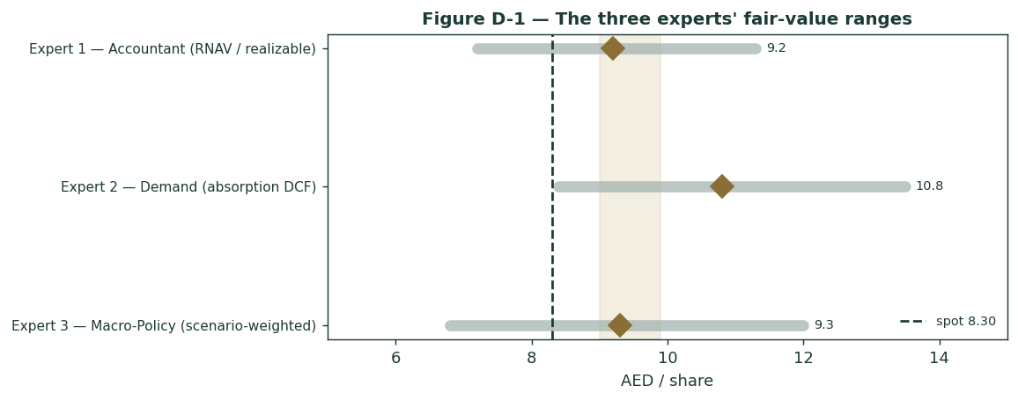
Figure C-1 — The three experts' fair-value ranges. Brass diamonds are base cases; the gold band is the central; the dark dashed line is spot.
Expert | Method | Single swing assumption | Base fair value
Expert 1 | RNAV at realizable value | Recurring haircut / development multiple | AED 9.2
Expert 2 | Absorption-driven DCF | Sales-velocity / growth path | AED 10.8
Expert 3 | Scenario-weighted real-options | Policy-scenario probabilities | AED 9.3

The spread — AED 9.2 to 10.8 at base — is narrow for a developer, and it is almost entirely a franchise-and-policy disagreement: none of the three contests the recurring platform's existence, the backlog, or the balance sheet. What separates them is whether Aldar's replenishing development machine justifies a premium to a conservative asset mark, and which policy world prices it. Expert 2 says the velocity is the value; Expert 1 says mark it net of every claim; Expert 3 says it depends on oil, rates and the region. The AED 1.6 spread is therefore a clean measure of one uncertainty — the going-concern worth of a franchise that re-loads its own land. Resolve that, and the three converge near AED 9.8.
Each expert's point fair value (and bull/base/bear where applicable) is logged with the study date (3 Jul 2026) and spot (AED 8.30) as an internal per-expert track record, kept separate from the core Calibration Ledger.
About this series
Testahil publishes independent, educational valuation studies. Each is an attempt to reason transparently about what a security is worth, with every assumption shown and a companion model so readers can disagree productively. The house style is distributions, not tips: we describe ranges and probabilities, not targets, and we do not tell anyone what to do. Studies are framed as educational analysis, the preparer is not licensed by any securities regulator, and holdings are disclosed.
Disclosure & Disclaimer
Not investment advice. This document is educational and informational only. It is not, and must not be relied upon as, investment, financial, legal, accounting or tax advice, nor an offer, solicitation or recommendation to buy, sell or hold any security. It contains no price target and no rating.
No licence; no advisory relationship. The preparer is not registered or licensed with any securities or financial regulator in any jurisdiction, holds no brokerage or investment-advisory authorisation, and is not acting as your adviser or fiduciary. Nothing here is personalised to your circumstances.
Holdings disclosure. The preparer may hold, and may in the future take or dispose of, a position in the security discussed in this report, and may transact at any time without notice. This is a potential conflict of interest you should weigh.
Sources & accuracy. Reported financial and operating figures are drawn from the company's public disclosure and other public sources believed reliable but not independently verified; they may contain errors or be superseded. Forward-looking inputs — the split-NAV marks, the recurring-platform GAV, the development-franchise DCF, projections, multiples and Monte-Carlo factor probabilities — are the preparer's own judgments and are inherently uncertain.
Forward-looking statements. Any statements about the future are estimates subject to risks and uncertainties; actual results may differ materially. The Monte Carlo models price, not value, and encodes subjective probabilities for events that have not occurred.
No reliance; your responsibility. Do your own research and consult a licensed professional before making any decision. You are solely responsible for your investment decisions and their outcomes. To the maximum extent permitted by law, the preparer accepts no liability for any loss arising from use of this document.
Currency & figures. Figures are in UAE dirhams (AED); bn denotes billion. The dirham is pegged to the US dollar (USD/AED 3.6725). Rounding may cause totals to differ slightly. Spot price and market data are as of 3 July 2026 and change continuously.
TESTAHIL · Independent Valuation Study · Educational Analysis · Aldar Properties PJSC (ADX: ALDAR) · edition 08-07-2026 · reporting currency AED

