Testahil · Independent Valuation Study — Educational Analysis Not investment advice

Alinma Bank (Tadawul: 1150)
Fundamental analysis · Technical analysis · Monte Carlo simulation — one integrated read
Anchor: SAR 24.00 (07 Jul 2026 close) · 3,000mn shares issued (12.8mn treasury; capital SAR 30bn after the Jan-2026 1-for-5 bonus) · market cap ≈ SAR 72bn · per-share figures on the 3,000mn issued basis.
READ FIRST — what this study is, and is not. An educational, independent valuation study. It presents fair-value ranges and probability distributions — never a rating, never a target price, never a recommendation.
Two clocks, never blended. The fundamental fair value (~SAR 27.3) is a ~12-month anchor. Only the Monte Carlo T+20/T+60 percentiles are genuine 3-month figures. The MC drift deliberately excludes the fundamental value gap (lens independence).
The simulation's honesty tier. Step-0 verdict: PARITY under the market-panel gate — a calibrated distribution, market-panel validated; no single-name forecasting edge is claimed.
Flagged inputs. SAR 10Y risk-free is constructed (UST + Saudi Aa3/CDS spread) pending a SAGBI/iBoxx print; beta is a genuine but short-window regression; the Tier-1 sukuk split of equity is assembled from issuance records. All are Fundamental Driver Ledger rows.

Headline
The model's read: modestly undervalued, on the condition that Alinma converts its growth into a durable ~16% through-cycle ROE. Five fundamental lenses put fair value at SAR 19.9–31.2 with a weighted central of ~SAR 27.3 against a SAR 24.00 spot (+14%). The entire gap is a cost-of-equity argument: at our regressed beta the stock is cheap; at beta = 1.0 it is roughly fairly priced.
The bear case, stated fairly. The market is not obviously wrong. A ~2.1× multiple on common book for an 18.7% ROE bank implies a cost of equity near 9.2% — inside our own published Ke band (8.5–10.5%). If NIM compression runs past the guided glide as SAMA follows Fed cuts, if deposit competition keeps repricing the funding side, or if the growth phase demands more retained capital than the ~50% payout allows, the premium to book compresses and today's price needs no correction at all. The upside case requires the ROE glide to hold, not merely the volume growth.
Valuation summary — every read at a glance
One table for the reads that follow — what the bank is worth (fundamental), what the tape is doing (technical), what the next quarter's probabilities look like (Monte Carlo), and what three orthogonal experts conclude. The horizons differ by design and are never blended.
Read | Fair value / signal | vs spot | Horizon
FUNDAMENTAL
Dividend discount (primary) | SAR 31.2 | +30% | ~12m anchor
Residual income | SAR 28.4 | +18% | ~12m anchor
Equity DCF (FCFE) | SAR 23.8 | -1% | ~12m anchor
Relative multiples | SAR 25.7 | +7% | spot-relative
Normalized floor | SAR 19.9 | -17% | through-cycle
TECHNICAL
MA stack / RSI / MACD | Price below MA20/50/100; RSI 11; MACD histogram -0.14 | corrective | weeks
MONTE CARLO
T+60 median (50% band) | SAR 24.00 (22.82–25.24) | -0.0% | 3 months
EXPERT PANEL
Three-lens span (App. C) | SAR ~21.5–29.5 | straddles spot | method-dependent
WEIGHTED CENTRAL | SAR 27.3 | +13.8% | fundamental clock

Bottom line. The fundamental lenses point one way — spot below fair — and disagree only on distance (the Ke crux). The tape is corrective under a falling MA stack, and the three-month simulation is honestly flat: the carry anchor nets to ~zero because Alinma's ~4.2% dividend yield approximately equals the Saudi risk-free, so the expected total return over the quarter arrives as dividend, not price.
Company overview — Alinma Bank at a glance
Item | Detail
Franchise | Fastest-growing large Saudi Islamic bank; founded 2006, retail + corporate + treasury, Alinma Capital subsidiary
Scale (FY25) | Assets SAR 311,067mn · financing SAR 229,747mn · deposits SAR 227,374mn
Profitability (FY25) | Net income SAR 6,397mn (+10%) · ROE 18.7% · ROA 2.18% · NIM ~3.55% · C/I 31.2%
Asset quality | NPL ~1.45% · coverage 150.3% · cost of risk 49bp (from 77bp in 2023)
Capital | CAR 18.0% (Pillar-1 17.7% FY24) · Tier-1 sukuk ~SAR 13.75bn across three issuances (flagged — FS note 11)
Capital action | Jan-2026 1-for-5 bonus: 2,500mn → 3,000mn shares (capital SAR 25bn → 30bn)
Dividend | SAR 0.25/quarter post-bonus (SAR 1.00/yr run-rate) ≈ 4.2% yield · ~47% payout
Strategy | Vision-2030 credit demand, project finance, SME +31% (2023), digital build-out; '2025 strategy' concluded, next phase under way
Listing | Tadawul 1150 · market cap ≈ SAR 71.7bn · among the four largest Saudi banks by market value

1 Fundamental valuation
Instrument class: bank. The lens hierarchy follows the house bank pattern — a dividend discount model as the primary read (banks are valued on distributable earnings under a regulatory capital constraint), a multi-period residual-income build and an equity DCF as genuine cross-checks, relative multiples for the market read, and a normalized floor. Leverage means enterprise-value tools (FCFF, EV/EBITDA) are the wrong instruments here; everything is equity-side.
1.1 Dividend discount model — the primary lens
Five explicit dividend years from the driver build (§1.7), then a terminal value whose payout is forced consistent with terminal growth: payout_t = 1 − g/ROE_t = 1 − 3.0%/16.0% = 81.25%. That consistency matters: Alinma retains ~53% today because it is still compounding at ~18–19% ROE; a terminal value that grows dividends at 3% while silently keeping the 47% payout would throw away the retained half of terminal earnings.
SAR / share | FY26e | FY27e | FY28e | FY29e | FY30e | Terminal
DPS | 1.02 | 1.16 | 1.31 | 1.46 | 1.59
Discount factor @ Ke | 0.914 | 0.835 | 0.763 | 0.697 | 0.636
PV of DPS | 0.93 | 0.97 | 1.00 | 1.02 | 1.01
Terminal payout 1−g/ROE_t |  |  |  |  |  | 81.2%
Terminal DPS = EPS30×(1+g)×payout_t |  |  |  |  |  | 2.67
TV = DPS_t/(Ke−g); PV of TV |  |  |  |  |  | 41.32 → 26.30
DDM fair value |  |  |  |  |  | SAR 31.23

Cost of equity, built bottom-up. rf = 4.8% SAR 10Y — constructed as UST 4.46% plus the Saudi Aa3/CDS spread (0.51–0.98%, Damodaran Jan-2026) because no reliable open SAR sukuk quote was accessible; flagged, replaced by a FTSE SAGBI/iBoxx print at first update. ERP from Damodaran's original file only: 5.0% rating-based (Aa3), 5.7% CDS-based. Beta 0.74 is a genuine regression against TASI (n=40, R²=0.29, SE=0.18) — it passes the usability gate but the window is short, so the grid is mandatory. Ke corners: 8.5% / 9.0% at regressed beta, 9.8% / 10.5% at beta = 1.0; the base Ke 9.5% is the disclosed four-corner mean, and §1.10 prices the whole rectangle.
1.2 Discounted cash flow (equity DCF / FCFE)
The bank form of a free-cash-flow build: what the equity could actually distribute after funding growth. FCFE = attributable net income − capital retained to hold CET1 against RWA growth. Same Ke, same terminal g. Full waterfall — never an output-only line:
SAR mn | FY26e | FY27e | FY28e | FY29e | FY30e
NI to common | 6,531 | 7,228 | 7,999 | 8,780 | 9,565
Δ RWA | 27,296 | 28,144 | 25,987 | 25,493 | 24,496
Capital charge (16% × ΔRWA) | 4,367 | 4,503 | 4,158 | 4,079 | 3,919
FCFE | 2,164 | 2,725 | 3,841 | 4,701 | 5,646
PV of FCFE @ Ke | 1,977 | 2,275 | 2,929 | 3,275 | 3,593
TV = FCFE30×(1+g)/(Ke−g), PV |  |  |  |  | 57,322
Equity value → per share (÷3,000mn) |  |  |  |  | SAR 23.79

FCFE prices lowest of the intrinsic lenses (SAR 23.8) because the growth years consume capital: mid-teens RWA growth at a 16% CET1 target absorbs roughly SAR 3.9–4.4bn a year, leaving near-term distributable cash well below earnings. That is not a flaw — it is the honest price of growth, and it is why the DDM (which credits the retained capital's future ROE explicitly) sits higher.
1.3 Residual income valuation
The EFG-house bank method: value = today's book plus the present value of everything the bank earns above its equity charge. It anchors on the balance sheet, so terminal assumptions do less work than in the DDM — a genuine third method, not a re-arranged second.
SAR / share | FY26e | FY27e | FY28e | FY29e | FY30e
Opening BVPS | 11.50 | 12.65 | 13.90 | 15.26 | 16.73
EPS | 2.18 | 2.41 | 2.67 | 2.93 | 3.19
Equity charge Ke×BV | 1.09 | 1.20 | 1.31 | 1.44 | 1.58
Residual income | 1.09 | 1.21 | 1.35 | 1.48 | 1.61
PV of RI | 1.00 | 1.01 | 1.03 | 1.03 | 1.02
Terminal [justified P/B − 1]×BV30, PV |  |  |  |  | 11.82
RI fair value = BV₀ 11.50 + ΣPV + terminal |  |  |  |  | SAR 28.41

1.4 Relative multiples
Where the Saudi banks price book against returns (Appendix B carries the full peer set). Alinma's ~2.1× / ~18.7% pairing sits ON the sector's P/B–ROE line — the market already pays for the growth. Our read applies the line's slope at Alinma's ROE with a modest growth-quality premium, cross-checked on forward earnings:
Read | Multiple | Applied to | Fair value
Peer P/B–ROE line at 18.7% ROE | 2.30× | BVPS25 11.50 | SAR 26.4
Forward P/E (sector growth cohort) | 11.5× | EPS FY26e 2.18 | SAR 25.0
Blend (equal weight) | — | — | SAR 25.7

1.5 Normalized earnings power — the floor
Strip the growth premium and the regressed beta: at beta = 1.0 on the CDS-based ERP (Ke 10.5%) and a through-cycle 16% ROE, the justified multiple is (16−3)/(10.52−3) = 1.73× book → SAR 19.9. That is the price at which every generous assumption has been surrendered — the anchor for the bear case, ~17% below spot.
1.6 Synthesis — five lenses
Lens | Bear | Base | Bull | Weight
DDM (primary) | 24.5 | 31.2 | 41.5 | 35%
Residual income | 22.4 | 28.4 | 37.6 | 20%
Equity DCF (FCFE) | 18.9 | 23.8 | 31.3 | 15%
Relative multiples | 21.8 | 25.7 | 31.0 | 20%
Normalized floor | 17.9 | 19.9 | 22.9 | 10%
Weighted central | 24.6 | 27.3 | 30.0 | 100%

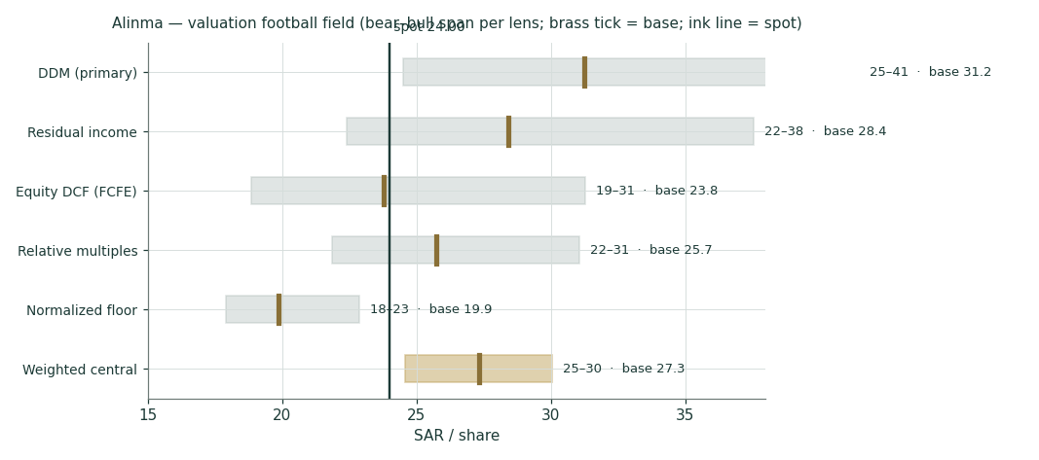
Figure 1 — Valuation football field: bear–bull span per lens; brass tick = base; ink line = spot 24.00.
The bear ends of the intrinsic lenses cluster at SAR 19–22 (Ke = 11%), the bull ends at SAR 29–36 (Ke = 8%). Spot sits in the lower half of the span. Market-implied Ke at 2.1× book and a 16% fade is ≈9.2% — comfortably inside our own uncertainty. This study's claim is therefore deliberately modest: the risk-reward is asymmetric to the upside if the ROE glide holds, and the crux is the discount rate, not the earnings forecast.
1.7 The bank driver build — a deeper look
Where the forecast actually comes from. Three linked schedules: the margin engine (volumes × NIM), the efficiency and risk lines, and the capital that the growth consumes. Every driver is a blue cell in the companion Excel; nothing downstream is hard-coded.
Driver | FY23 | FY24 | FY25 | FY26e | FY27e | FY28e | FY29e | FY30e
Financing growth | — | +15.6% | +13.6% | +13% | +12% | +10% | +9% | +8%
Financing, SAR bn | 175.0 | 202.3 | 229.7 | 259.6 | 290.8 | 319.8 | 348.6 | 376.5
NIM | 3.81% | 3.70% | 3.55% | 3.45% | 3.40% | 3.40% | 3.40% | 3.40%
NII, SAR mn | 7,655 | 8,649 | 9,377 | 10,493 | 11,569 | 12,781 | 13,957 | 15,114
Cost-to-income | 31.3% | 30.9% | 31.2% | 31.5% | 31.2% | 31.0% | 30.8% | 30.5%
Cost of risk | 77bp | 55bp | 49bp | 50bp | 50bp | 50bp | 50bp | 50bp
Payout ratio | ~52% | ~47% | ~47% | 47% | 48% | 49% | 50% | 50%

The NIM story carries the margin engine. FY23's 3.81% was the rate-cycle peak; deposit competition took 10bp in 2024 and ~15bp in 2025 (management flagged elevated funding costs on the Q1-25 call and cut its own NIM guidance). We glide to 3.45% in FY26 as SAMA follows Fed cuts — asset yields reprice down faster than the large CASA base gives relief — then hold 3.40%: Alinma's Islamic retail franchise (~8% CASA growth) is precisely the funding mix that stabilises margins in a down-rate world.
DuPont decomposition | FY23 | FY24 | FY25 | FY26e | FY27e
Net margin (NI/op. income) | 49.8% | 53.3% | 53.7% | 54.8% | 55.4%
Asset turn (op. income/assets) | 4.42% | 4.26% | 4.05% | 3.94% | 3.90%
Leverage (assets/common equity) | 8.6× | 9.0× | 9.4× | 9.3× | 9.2×
= ROE (common) | 17.2% | 18.8% | 18.7% | 18.0% | 18.5%

Capital schedule | FY25 | FY26e | FY27e | FY28e | FY29e | FY30e
Common equity, SAR mn | 34,491 | 37,962 | 41,711 | 45,780 | 50,179 | 54,974
RWA, SAR mn | 233,300 | 260,596 | 288,741 | 314,728 | 340,220 | 364,716
CET1 (common/RWA) | 14.8% | 14.6% | 14.4% | 14.5% | 14.7% | 15.1%
CAR total (reported/est.) | 18.0% | 18.0% | 18.0% | 18.1% | 18.2% | —
Dividends, SAR mn | 3,000 | 3,060 | 3,480 | 3,930 | 4,380 | 4,770
Retained, SAR mn | 2,894 | 3,471 | 3,748 | 4,069 | 4,400 | 4,795

Key earnings drivers, EFG house format — two years back, two forward:
Key earnings drivers | FY24 | FY25 | FY26e | FY27e
Financing growth | 15.6% | 13.6% | 13.0% | 12.0%
Deposit growth | 12.1% | 8.0% | 11.1% | 10.2%
NIM | 3.70% | 3.55% | 3.45% | 3.40%
NII growth | 13.0% | 8.4% | 11.9% | 10.3%
Fee / non-funded growth | 10.6% | 10.3% | 9.0% | 9.0%
Revenue growth | 12.5% | 8.8% | 11.3% | 10.0%
Opex growth | 11.2% | 9.8% | 12.4% | 9.0%
Cost-to-income | 30.9% | 31.2% | 31.5% | 31.2%
Cost of risk | 55bp | 49bp | 50bp | 50bp
Earnings growth | +20.5% | +9.7% | +10.2% | +10.2%
ROAE (common) | 18.8% | 18.7% | 18.0% | 18.1%
ROAA | 2.27% | 2.18% | 2.15% | 2.16%
Net profit, reported (SAR mn) | 5,832 | 6,397 | 7,051 | 7,768
Net profit, attributable (SAR mn) | 5,402 | 5,894 | 6,531 | 7,228

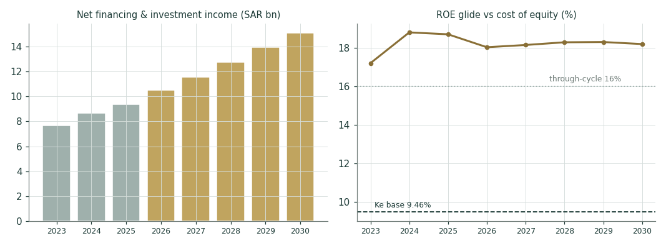
Figure 2 — The margin engine and the return glide: NII history and forecast (left); ROE path against the cost of equity and the 16% through-cycle fade (right).
1.8 The crux — the cost of equity, and the NIM path
Two things swing this valuation, and we sensitise both in their own observable units.
(a) The cost of equity. The regressed beta of 0.74 comes from a short two-month window; a longer sample could easily print closer to 1.0. Each 50bp of Ke moves the DDM roughly SAR 3–4/share:
Ke | 8.49% | 9.01% | 9.46% | 10.17% | 10.52% | 11.0%
DDM fair value | SAR 37.4 | SAR 33.8 | SAR 31.2 | SAR 27.8 | SAR 26.3 | SAR 24.5
vs spot | +56% | +41% | +30% | +16% | +10% | +2%

(b) The NIM path. Each 10bp of through-forecast NIM is worth ~SAR 290mn of annual NII (~SAR 0.09 of EPS) and ~SAR 1.1–1.3/share of DDM value:
Through-forecast NIM | 3.20% | 3.30% | 3.40% (base) | 3.50% | 3.60%
FY27e NII, SAR mn | 9,987 | 10,300 | 10,612 | 10,924 | 11,236
FY27e EPS | 2.28 | 2.37 | 2.46 | 2.55 | 2.64
DDM fair value | SAR 28.7 | SAR 30.0 | SAR 31.2 | SAR 32.5 | SAR 33.7

Read together: the bear case needs BOTH a beta-1.0 discount rate AND a sub-3.3% NIM to push fair value to spot or below; either alone leaves the stock cheap-to-fair. That is what an asymmetric-but-conditional read looks like in real units.
1.9 Macro and country — SAMA, oil, and Vision 2030
Alinma is a leveraged, Sharia-compliant claim on Saudi non-oil growth. The peg outsources monetary policy: SAMA follows the Fed, so US cuts flow directly into SAIBOR and asset yields (management's FY25 guidance assumed −79bp of 3M SAIBOR). Vision-2030 project finance, mortgage expansion and SME formation drive volume; the fiscal breakeven oil price is the tail risk — a sustained oil slump slows government spending, which is the sector's true credit cycle. Damodaran's Jan-2026 file rates Saudi Aa3 (0.98% CDS): low default risk, non-trivial regional political risk.
Macro input | Level / assumption | Channel into the model
SAMA policy (via Fed) | easing bias FY26 | NIM glide 3.55→3.45→3.40%
3M SAIBOR path | ~ −80bp guided FY25→26 | asset repricing beats funding relief
Oil / fiscal stance | supportive at current prices | financing growth 13→8% fade
USD/SAR peg | 3.75 fixed | no FX leg in Ke; rf in SAR terms
Zakat regime | ~10.2% effective | held flat through the forecast

1.10 DDM sensitivity — Ke × terminal growth
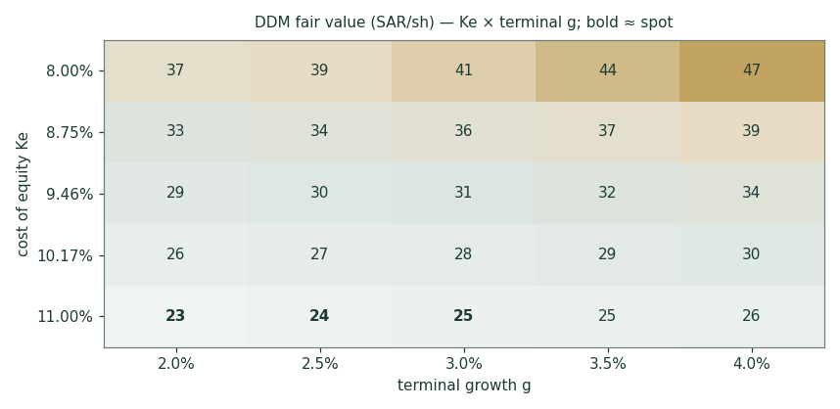
Figure 3 — DDM fair value across the Ke × terminal-g rectangle. Bold cells ≈ spot: the market is pricing roughly Ke 10–10.5% at g 2.5–3.0%.
Ke \ g | 2.0% | 2.5% | 3.0% | 3.5% | 4.0%
8.00% | 37.4 | 39.3 | 41.5 | 44.1 | 47.4
8.75% | 32.7 | 34.0 | 35.5 | 37.3 | 39.4
9.46% | 29.2 | 30.1 | 31.2 | 32.5 | 33.9
10.17% | 26.3 | 27.0 | 27.8 | 28.6 | 29.7
11.00% | 23.5 | 24.0 | 24.5 | 25.1 | 25.8

2 Technical and price structure
The tape is corrective inside a long advance. Price 24.00 sits below the 20/50/100-day averages with only the 200-day (22.72) still underfoot; the 52-week range is 20.05–25.47, so spot is ~-6% off the high after the strong 2025 run. RSI(14) at 11 is neutral-soft, and the MACD histogram (-0.14) is negative but flattening — momentum bleeding out rather than accelerating down.
Indicator | Level | Read
Close (07 Jul 2026) | 24.00 | —
MA20 / MA50 | 24.77 / 24.32 | price below both — corrective
MA100 / MA200 | 24.12 / 22.72 | below MA100, above MA200 — long trend intact
RSI(14) | 11 | neutral-soft
MACD (12,26,9) | -0.07 vs signal 0.07 · hist -0.14 | bearish, decelerating
52-week range | 20.05 – 25.47 | spot at the 73th percentile of the range
Support | 23.30 / 22.10 / 20.40 | prior congestion, MA200, 2025 breakout shelf
Resistance | 25.30 / 26.60 / 27.80 | MA50 cluster, May pivot, 52-week high

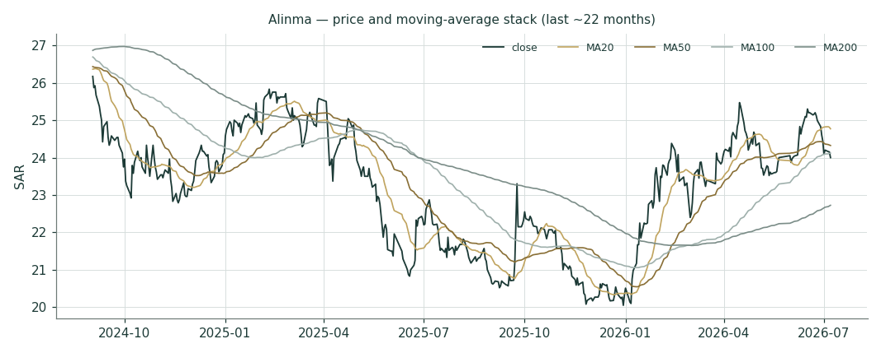
Figure 4 — Price and moving-average stack, last ~22 months: the 2025 advance, the 2026 digestion, and the MA200 as the trend arbiter.
3 Monte Carlo — a probabilistic price map
The probability read — five numbers before anything else:
The probability read (T+60, ~3 months) | Level
Median path | SAR 24.00 (-0.0%)
50% of outcomes inside | SAR 22.82 – 25.24
90% of outcomes inside | SAR 20.76 – 27.70
P(above spot) | 50%
P(+10%) / P(−10%) | 12% / 10%

Why the median is flat — and why that is a statement, not an absence of one. The v3 engine centres each path on the carry anchor ln(1+rf)−ln(1+q): the price of a dividend-payer should drift at the risk-free minus what it pays out. For Alinma, rf ≈ 4.8% and the dividend yield ≈ 4.2% — they cancel almost exactly (-0.04% over the quarter). The expected total return over the next three months is approximately the Saudi risk-free, and it arrives as dividend; the price itself is expected flat, ± the band. An explained flat, never an unexplained one.
Engine and validation. mc_v3 'carry-anchored YZ-HAR-t': gap-aware Yang-Zhang variance with a pooled log-HAR cascade for width (σ₆₀ = 9.7% log), a fitted Student-t(4) aggregate shape, and the carry drift above — the §1 value gap is deliberately NOT in the drift (lens independence). Step-0 verdict under the market-panel gate: PARITY (CRPS skill −0.009, 90% CI [−0.026, +0.018] vs a carry-anchored random-walk) — a calibrated distribution, market-panel validated; no single-name edge is claimed, and none is needed for a probability map. Saudi names run carry-only until the Tadawul panel reaches ~5 names.
The sixteen-factor overlay, cast for a Saudi bank — continuous factors first:
Continuous factor | Direction | Weight in width
SAMA / Fed rate path | cuts → NIM pressure, bond gains | high
Oil price (fiscal stance) | sustained slump → credit cycle | high
Deposit competition (funding beta) | intensifying → margin drag | medium
TASI beta / index flows | risk sentiment pass-through | medium
Financing growth surprise | project-finance drawdowns | medium
Cost of risk drift | normalisation from 49bp | low-medium
SAR liquidity (LDR, NSFR) | tightening → funding cost | low

Discrete event | Window | Sign
Q2-26 earnings (late July) | inside T+20 | ±
Fed decision → SAMA follow | Jul / Sep FOMC | ±
Quarterly dividend (SAR 0.25) | Aug eligibility | mechanical ex-div
MSCI/FTSE EM flows | Aug/Sep reviews | ±
Capital action (T1 refinancing) | opportunistic | neutral-to-+
Vision-2030 project announcements | continuous | + tail
Oil shock (either direction) | continuous | fat tails
Regulatory levy / zakat change | budget cycle | − tail
Digital-bank competitive entry | FY26 | slow burn −

Percentile map at both horizons:
Percentile | T+20 (SAR) | T+60 (SAR)
P5 | 22.10 | 20.76
P10 | 22.61 | 21.63
P25 | 23.31 | 22.82
Median | 24.00 | 24.00
P75 | 24.70 | 25.24
P90 | 25.48 | 26.63
P95 | 26.09 | 27.70
P(above spot) | 50% | 50%

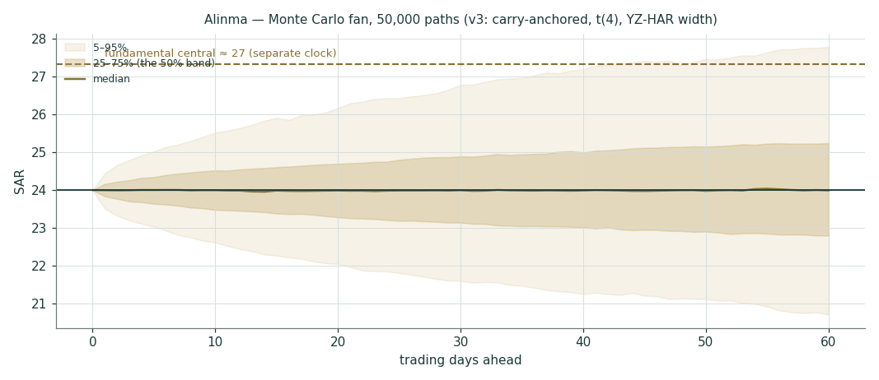
Figure 5 — Monte Carlo fan, 50,000 paths: median ~flat at spot (the carry anchor), 50% band in deep gold, 5–95% in pale gold. The fundamental central is a different clock, drawn only for reference.
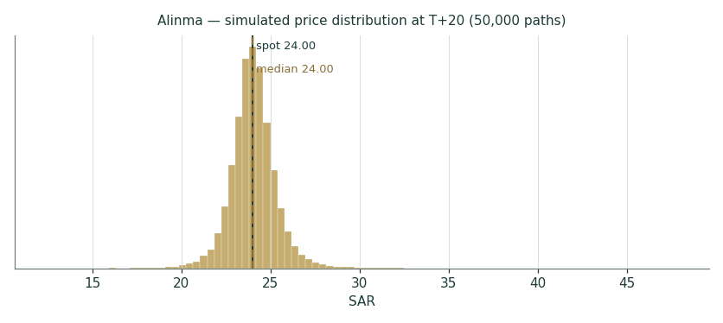
Figure 6 — Simulated price distribution at T+20: width ≈ the T+60 band ÷ √3.
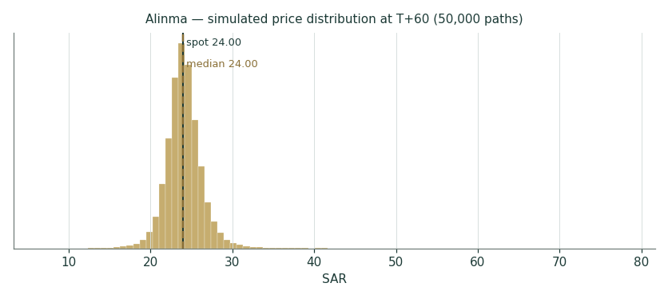
Figure 7 — Simulated price distribution at T+60: fitted t(4) aggregate — fatter tails than a Gaussian at the same variance.
Level-touch probabilities — the chance of trading AT a level at any point inside the horizon (higher than finishing beyond it):
Touch level (up) | T+60 probability
+3% | 63%
+5% | 47%
+8% | 29%
+10% | 21%
+15% | 10%

Touch level (down) | T+60 probability
-3% | 63%
-5% | 45%
-8% | 26%
-10% | 18%
-15% | 7%

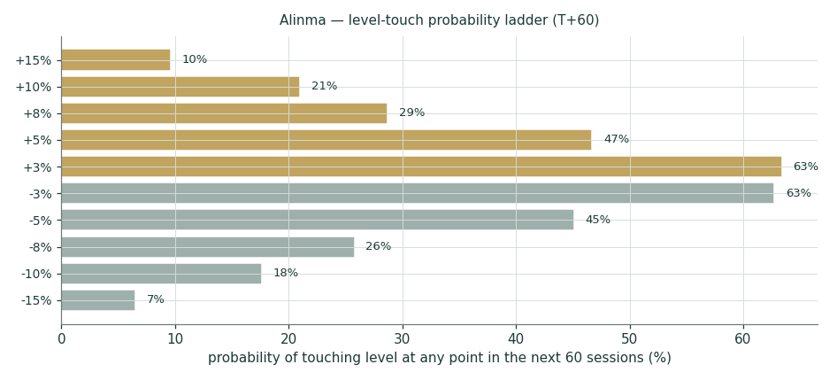
Figure 8 — The touch ladder: near-symmetric around spot, gold up-legs vs sage down-legs, fat in both tails.
4 Comparison of the lenses, and a verdict
Fundamental says SAR ~27.3 conditional on the ROE glide; technical says the tape is digesting under a falling short-MA stack with the long trend intact at MA200; Monte Carlo says the next quarter is a coin flip on price with the return paid as dividend. These are three different clocks and all three can be right at once. The integrated read: a fundamentally cheap-to-fair growth bank in a corrective tape, where patience is literally paid ~1% a quarter to wait. What would make us wrong is not a bad quarter — it is a structural failure of the NIM to stabilise at ~3.4%, or evidence that the market's beta-1.0 discount rate is the correct one (§7).
Clock | Read | Confidence
Fundamental (~12m) | SAR 24.6–30.0 central band; upside +14% | moderate — Ke-conditional
Technical (weeks) | corrective; 23.3 then 22.1 support, 25.3 first resistance | moderate
Monte Carlo (3m) | median 24.00, 50% band 22.82–25.24 | calibrated (parity tier)

5 Catalysts to watch
- Q2-2026 results (expected late July). The first clean read on the FY26 NIM guidance against actual SAMA follow-through; Q1-26 net income was ~SAR 1.68bn (+11%).
- The Fed → SAMA sequence. Each 25bp cut tests the 3.45% NIM glide from both sides — asset repricing versus CASA relief.
- Dividend cadence. SAR 0.25/quarter run-rate; any step-up toward a 50%+ payout is the capital-return signal the DDM already half-prices.
- Index flows. MSCI/FTSE EM reviews in August–September; Alinma is a large, liquid Tadawul constituent.
- Tier-1 refinancing windows. The ~SAR 13.75bn T1 stack reprices opportunistically; cheaper T1 is a direct EPS-to-common tailwind.
6 Reading the probability zones
Zone (T+60) | Probability | What it would likely mean
Above 26.63 (P90) | ~10% | rate-cut euphoria + Q2 beat; premium re-rating toward Al Bilad multiples
25.24–26.63 | ~15% | Q2 beat, NIM holding; drift back toward the May pivot
24.00–25.24 (median→P75) | ~25% | base case: carry accrues, tape stabilises above MA50
22.82–24.00 | ~25% | soft quarter or index outflows; support at 23.3 holds
21.63–22.82 | ~15% | NIM miss; test of 22.1 and the MA200
Below 21.63 (P10) | ~10% | oil-led risk-off or a credit-cost surprise; the 20.4 shelf is the line

7 Caveats and what would change our mind
What would move us more bearish:
- NIM printing below ~3.35% for two consecutive quarters — the glide failing, not pausing.
- Cost of risk re-normalising toward the 2023 77bp without the volume growth to absorb it.
- Deposit competition forcing funded-cost betas above asset repricing through a full cut cycle.
- A longer-window beta regression printing ≥1.0 — validating the market-implied ~9.2–10.5% Ke.
What would move us more bullish:
- Payout stepping to 55–60% with CAR held ≥18% — the excess-capital signal the FCFE lens is waiting for.
- NIM stabilising ≥3.5% through the first two SAMA cuts — the franchise-quality proof.
- SME/mid-corporate mix continuing to shift yield up without credit-cost payback.
Model caveats:
- rf is a constructed SAR 10Y (UST + Aa3/CDS spread), flagged pending a SAGBI/iBoxx print; the beta window is two months; the Tier-1 sukuk split of total equity (~SAR 13.75bn) is assembled from issuance records and must be tied to FS note 11. All three are Fundamental Driver Ledger rows.
- FY23 financing, total assets and total equity are derived from disclosed growth rates, not read off a statement — labelled as such in Appendix A.
- Step 0 is PARITY, not PASS: the simulation is a calibrated map of uncertainty, market-panel validated; it claims no single-name forecasting edge.
Appendix A Financial statements
A.1 Income statement — 3-year historical + 5-year forecast (consolidated, SAR mn)
SAR mn | FY23 | FY24 | FY25 | FY26e | FY27e | FY28e | FY29e | FY30e
Net financing & investment income | 7,655 | 8,649 | 9,377 | 10,493 | 11,569 | 12,781 | 13,957 | 15,114
Non-funded income | 2,071 | 2,292 | 2,529 | 2,756 | 3,004 | 3,245 | 3,504 | 3,749
Total operating income | 9,726 | 10,940 | 11,905 | 13,249 | 14,574 | 16,026 | 17,461 | 18,864
Operating expenses | 3,044 | 3,384 | 3,715 | 4,173 | 4,547 | 4,968 | 5,378 | 5,753
Cost-to-income | 31.3% | 30.9% | 31.2% | 31.5% | 31.2% | 31.0% | 30.8% | 30.5%
Impairment (ECL), net | 1,300 | 1,049 | 1,060 | 1,223 | 1,376 | 1,527 | 1,671 | 1,813
Pre-zakat profit | 5,382 | 6,502 | 7,126 | 7,852 | 8,651 | 9,531 | 10,412 | 11,297
Zakat (~10.2%) | 543 | 670 | 729 | 801 | 882 | 972 | 1,062 | 1,152
Net income (after zakat) | 4,839 | 5,832 | 6,397 | 7,051 | 7,768 | 8,559 | 9,350 | 10,145
Tier-1 sukuk costs | 350 | 430 | 503 | 520 | 540 | 560 | 570 | 580
NI attributable to common | 4,489 | 5,402 | 5,894 | 6,531 | 7,228 | 7,999 | 8,780 | 9,565
EPS, common (÷3,000mn) | 1.50 | 1.80 | 1.96 | 2.18 | 2.41 | 2.67 | 2.93 | 3.19
EPS as reported (pre-bonus wtd.) | 1.81 | 2.22 | 2.37 | — | — | — | — | —

FY23 zakat and attributable lines derived from disclosed totals; FY25/FY24 P&L per the official Tadawul annual announcement.
A.2 Balance sheet — 3-year historical + 5-year forecast (consolidated, SAR mn)
SAR mn | FY23 | FY24 | FY25 | FY26e | FY27e | FY28e | FY29e | FY30e
Financing, net | 175,032 | 202,308 | 229,747 | 259,614 | 290,768 | 319,844 | 348,630 | 376,521
Investments | 43,236 | 48,625 | 56,623 | 62,285 | 67,890 | 73,322 | 79,187 | 84,731
Total assets | 236,600 | 276,828 | 311,067 | 347,462 | 384,988 | 419,637 | 453,627 | 486,288
Customer deposits | 187,901 | 210,545 | 227,374 | 252,499 | 278,254 | 301,905 | 325,001 | 347,101
Total equity (incl. T1 sukuk) | 36,700* | 41,442 | 48,241 | 51,712 | 55,461 | 59,530 | 63,929 | 68,724
Common equity (ex T1 ~13,750) | 27,950* | 32,690* | 34,491 | 37,962 | 41,711 | 45,780 | 50,179 | 54,974
BVPS, common (÷3,000mn) | 9.32 | 10.90 | 11.50 | 12.65 | 13.90 | 15.26 | 16.73 | 18.32
CET1 (common/RWA @75% density) | 15.8% | 15.7% | 14.8% | 14.6% | 14.4% | 14.5% | 14.7% | 15.1%

* Derived, not read off a statement: FY23 financing/assets/equity from disclosed growth rates; the common/T1 split from the three known Tier-1 issuances — flagged to FS note 11. Assets/deposits FY26e+ scale at 0.90×/0.85× of financing growth.
A.3 Cash flow — sources & uses of equity capital (SAR mn)
Equity capital walk | FY23 | FY24 | FY25 | FY26e | FY27e | FY28e | FY29e | FY30e
Opening common equity | 26,210 | 27,950 | 32,690 | 34,491 | 37,962 | 41,711 | 45,780 | 50,179
+ NI attributable | 4,489 | 5,402 | 5,894 | 6,531 | 7,228 | 7,999 | 8,780 | 9,565
− Dividends | 2,500 | 2,750 | 3,000 | 3,060 | 3,480 | 3,930 | 4,380 | 4,770
± OCI / treasury / other | −249 | 2,088 | −1,093 | 0 | 0 | 0 | 0 | 0
Closing common equity | 27,950 | 32,690 | 34,491 | 37,962 | 41,711 | 45,780 | 50,179 | 54,974

Appendix B Peer set, sector structure, and risks
Bank | P/B | P/E | ROE | Note
Al Rajhi | ~3.5× | ~16× | ~23% | Premium Islamic franchise; the sector ceiling
SNB (Saudi National) | ~1.4× | ~10× | ~13% | Largest by assets
Riyad Bank | ~1.2× | ~8× | ~16% | Testahil coverage, 09-Jul-2026 study
Alinma — this study | ~2.1× | ~11× | ~18.7% | Fastest-growing large Islamic bank
Banque Saudi Fransi | ~1.1× | ~9× | ~12% | Corporate-tilted
Arab National Bank | ~1.0× | ~8× | ~12% | Value end of the sector
Al Bilad | ~2.0× | ~14× | ~16% | The closest growth/Islamic comp
Saudi Investment Bank | ~0.9× | ~8× | ~11% | Smallest, deepest discount
GCC — Emirates NBD | ~1.0× | ~6× | ~18% | UAE large-cap context
GCC — QNB | ~1.4× | ~9× | ~18% | Qatar large-cap context

Sector structure. Saudi banking is an oligopoly of ~10 listed names inside a Vision-2030 credit super-cycle: system private-sector credit passed SAR 3.4tn in early 2026, mortgage books built from near-zero in a decade, and the funding constraint (not demand) is the sector's binding limit — hence the deposit war behind everyone's NIM guidance cuts. Alinma's edge is pure-play Islamic positioning with the sector's fastest large-cap growth; its vulnerability is that growth's appetite for funding and capital.
Key risks
- Rate-cycle pass-through compressing NIM below the 3.40% glide.
- ROE fading toward Ke — validating the market discount rather than the intrinsic lenses.
- Credit-quality deterioration if non-oil growth or project-finance discipline slips.
- Funding-cost stickiness: time-deposit mix rising faster than CASA growth offsets.
- Regulatory levy/zakat changes; digital-bank entrants compounding deposit competition.
Appendix C The expert valuation panel
Three orthogonal disciplines from the Testahil persona library, cast for a bank: capital & returns, the credit cycle, and macro-policy-dividend. Labels only — Expert 1/2/3. Each shows workings, sensitises their swing input, cross-examines the other two, and states a falsification condition. Genuinely different methods: agreeing DDMs would be cosmetic.
C.1 Expert 1 — capital, returns and the price of book value
Worldview. A bank is a licence to lever book equity; its worth is book times a multiple set by (ROE−g)/(Ke−g). Works when returns are measurable and capital binds; fails around opaque credit or franchise inflections. The tradition of price-of-book value investing applied through the justified-multiple algebra.
Workings | Value
BVPS, common, FY26e (opening capital compounding through the year) | 12.65
Through-cycle ROE (fade from 18.7%) | 16.0%
Ke — four-corner base | 9.46%
Terminal g | 3.0%
Justified P/B = (16−3)/(9.46−3) | 2.01×
Fair value = 2.01 × 12.66 | SAR 25.4

Swing input: through-cycle ROE | 14% | 15% | 16% (base) | 17% | 18%
Justified P/B | 1.70× | 1.86× | 2.01× | 2.17× | 2.32×
Fair value (SAR) | 21.5 | 23.5 | 25.5 | 27.5 | 29.4

Cross-examination. Against Expert 2: your 70bp normalised cost of risk is inside my 16% ROE — pricing it twice is double-counting. Against Expert 3: your policy-path Ke belongs in the grid, not stacked on top of a fade that already strips 270bp of ROE. Verdict: SAR ~25.5, modestly cheap. Falsification: two consecutive years of ROE below 15% without a payout step-up — then the fade is 14% and spot is fair.
C.2 Expert 2 — the credit cycle and normalized provisioning
Worldview. Bank earnings are a loan book minus a through-cycle loss rate; today's 49bp is a benign print inside a growth phase, and growth-phase books season. Works at cycle turns; fails by being early in long benign stretches. The provisioning-normalisation school.
Workings (FY26e, normalised) | SAR mn / value
Total operating income (as modelled) | 13,249
Operating expenses (as modelled) | 4,173
ECL at a through-cycle 70bp (vs 50bp base) | 1,713
Pre-zakat, normalised | 7,363
NI to common (−10.2% zakat, −T1 520) | 6,092
Normalised EPS | 2.03
× through-cycle bank multiple 10.5× | SAR 21.3

Swing input: through-cycle CoR | 50bp | 60bp | 70bp (base) | 85bp | 100bp
Normalised EPS | 2.28 | 2.19 | 2.10 | 1.97 | 1.83
Fair value @10.5× | 23.9 | 23.0 | 22.1 | 20.7 | 19.2

Cross-examination. Against Expert 1: your 2.0× book capitalises a loss rate we have only observed in a boom — my 70bp is what the licence costs across a cycle. Against Expert 3: dividends are the output of provisioning discipline, not an anchor. Verdict: SAR ~22.1, spot roughly fair. Falsification: NPLs holding ≤1.6% and CoR ≤55bp through a full SAMA cut-and-slowdown cycle — then 49bp was structural and I surrender ~SAR 2.5.
C.3 Expert 3 — macro, policy and the dividend
Worldview. In a pegged economy the bank is a rates-and-fiscal instrument: SAMA imports the Fed, oil sets the fiscal impulse, and the dividend is the only cash fact. Value the payment stream under the policy path. Works when policy dominates; fails at idiosyncratic franchise breaks.
Workings | Value
Ke: rf 4.80% + β 0.85 (policy-blend) × CDS ERP 5.72% | 9.66%
Terminal g under sustained Vision-2030 nominal growth | 3.25%
PV of DPS FY26–30 (SAR 1.02 → 1.59) | 4.90
PV of terminal (payout_t = 1 − 3.25/16 = 79.7%) | 25.80
Fair value | SAR 30.7

Swing input: rf (SAR 10Y) | 4.3% | 4.55% | 4.8% (base) | 5.05% | 5.3%
Ke | 9.16% | 9.41% | 9.66% | 9.91% | 10.16%
Fair value (SAR) | 31.6 | 30.1 | 28.7 | 27.4 | 26.2

Cross-examination. Against Expert 1: your Ke is a two-month beta wearing a suit — mine at least names the policy path it assumes. Against Expert 2: your cycle normalisation ignores that the sovereign IS the cycle here; fiscal capacity at current oil prices funds the soft landing your 70bp fears. Verdict: SAR ~28.7, cheap. Falsification: the constructed rf proving 60bp+ too low when a real SAGBI print lands, or the peg's credibility ever pricing into CDS.
C.5 The three in one room
Expert | Method | Fair value | vs spot
Expert 1 — capital & returns | Justified P/B on faded ROE | SAR 25.4 | +6%
Expert 2 — credit cycle | Normalised provisioning × through-cycle P/E | SAR 22.1 | -8%
Expert 3 — macro-policy-dividend | Policy-path DDM | SAR 30.7 | +28%
Panel span | — | SAR ~22.1–28.7 | straddles spot

C.6 Reading the divergence
The SAR ~6.6 spread between Expert 2 and Expert 3 is not noise — it measures exactly two things: what a through-cycle loss rate costs (each 20bp of CoR ≈ SAR 1.9 of value at the panel's multiples) and who sets the discount rate (each 50bp of Ke ≈ SAR 2.8). The core lenses of §1 sit inside the panel's span, and spot sits between Expert 2 and Expert 1. Translation: the market is currently paying the capital-returns price while reserving judgement on the credit cycle — which is a reasonable thing for a market to do, and why our verdict is 'modestly undervalued, conditionally' rather than anything louder.
About this series
Testahil publishes independent, educational equity valuation studies under the Testahil brand only. Every study presents fair-value ranges and probability distributions — never a rating, never a target price, never a recommendation. Methods, calibration history and the public forecast ledger live at testahil.com; matured Monte Carlo cohorts are scored in public against a random-walk benchmark on CRPS skill, and studies are updated as material facts change.
Disclosure & Disclaimer
1. Educational purpose only. This study is educational analysis and general information. It is not investment advice, not a recommendation, not an offer or solicitation to buy or sell any security, and it does not consider any person's objectives, financial situation or needs.
2. No licence. Testahil and the preparer are not licensed by the Saudi Capital Market Authority, the Egyptian Financial Regulatory Authority, or any other financial regulator, and do not provide regulated investment services.
3. No warranty. Information is drawn from public sources believed reliable as of the study date but is not guaranteed complete or accurate. Figures explicitly labelled as derived, constructed or flagged are estimates pending primary-source confirmation.
4. Forward-looking uncertainty. Fair-value ranges, forecasts and simulated distributions are probabilistic estimates, not predictions. Actual outcomes will differ, possibly materially. Past calibration performance does not guarantee future calibration.
5. Position disclosure. The preparer may hold, and may in the future take or dispose of, a position in the security discussed in this report.
6. No liability. To the maximum extent permitted by law, Testahil and the preparer accept no liability for any loss arising from any use of this study. Readers must do their own research and consult a licensed adviser before any investment decision.
Testahil · testahil.com · Study date 10 July 2026 · Anchor SAR 24.00 (07 Jul 2026 close) · © Testahil 2026

