Testahil · Independent Valuation Study — Educational Analysis Not investment advice
Independent Valuation Study — Educational Analysis
Saudi Aramco (TADAWUL: 2222)
Fundamental analysis · Technical analysis · Monte Carlo simulation — one integrated read
Anchor: SAR 26.24 (1 Jul 2026 close) · ~242bn shares · mkt cap ~SAR 6.35tn (~USD 1.69tn) · the world's largest listed oil company and among its lowest-cost producers (~$3.75/bbl lifting), reserves 247.2bn boe, ~5.2% forward base-dividend yield · prices & probabilities computed 1 Jul 2026 from the attached daily price history · primary lens a going-concern FCFF DCF on an oil-price deck, cross-checked by a dividend-yield support model, relative multiples, a reserves-based NAV/SOTP and through-cycle earnings power · the oil-price path and the dividend's free-cash coverage are the swing factors.
READ FIRST — what this document is, and is not. This study is a valuation exercise and an expression of personal analytical opinion, published free of charge for educational purposes: it shows how one analyst applies fundamental, technical and probabilistic methods to a listed company, and invites scrutiny of that methodology. It is NOT investment advice, NOT a recommendation or solicitation to buy, sell or hold any security, and NOT directed at the circumstances of any reader. The preparer is not licensed by any securities regulator in any jurisdiction, holds no brokerage authorisation, provides no financial consultancy, manages no money, and accepts no fees, funds or clients. See the Disclosure & Disclaimer at the end. All values are model outputs presented as ranges and distributions because no single number should be relied on. Reported financials are Aramco's own disclosure; forward-looking inputs — the oil-price deck, the discount rate, the required dividend yield, the multiples, the reserve marks and the Monte-Carlo factor probabilities — are the preparer's judgments and are flagged throughout. Consult a licensed financial advisor before any investment decision.

Headline
The model's read: roughly fairly valued to modestly rich — priced as a dividend instrument, with the swing resting on the oil-price path and the dividend's cash coverage. At SAR 26.24 the shares trade about 5% above our weighted central estimate of SAR 25.04; spot sits within a few percent of most fundamental lenses. Aramco is the world's largest listed oil company and one of its lowest-cost producers, sitting on a 247.2 billion-boe reserve base — but the market prices it less as a growth barrel and more as a sovereign-backed income instrument: a ~5.2% forward base-dividend yield on a stock whose price has drifted down about 6% over the past year to sit mid-range, roughly 6% below its 52-week high. The question is not whether Aramco generates enormous cash — it plainly does — but whether the market's premium multiple is justified once the dividend is running at the very edge of free cash flow.
Five independent lenses cluster between SAR 21.48 and SAR 29.63; the weighted central estimate is SAR 25.04, about 5% below spot. The dividend-yield support model — the forward base dividend of ~SAR 1.36 capitalised at a ~5.2% required yield — lands almost exactly at spot (SAR 26.09), confirming that the market is pricing Aramco to its yield. An explicit five-year FCFF DCF, built off the integrated statements at ~$70-72 mid-cycle oil and a 6.75% WACC, lands lower at SAR 23.47 (-11%); relative multiples (SAR 21.48, -18%) and through-cycle earnings power (SAR 23.24, -11%) sit below spot, reflecting a premium to the international majors. Only the reserves-based NAV at SAR 29.63 (+13%) — the colossal low-cost reserve base marked after a heavy royalty/tax haircut — reaches above the price. We adopt none of the tails as the base.
This is a statement about valuation, not direction. Aramco's tape is quiet — the shares sit mid-range, just below their 20- and 50-day moving averages but above a rising 200-day line, with an RSI near 31 approaching oversold — and a single 16-factor Monte Carlo (Brent, oil demand and cracks, SAMA/Fed rates via the peg, TASI flows, the base-dividend anchor, plus nine discrete events including an OPEC+ decision, a geopolitical oil shock, a recession, the peg-stability tail and an earnings print; 50,000 paths, seed 42) puts both the T+20 and T+60 medians almost exactly on spot (~SAR 26.2 and ~26.1) inside a moderate cone — Aramco's realized volatility is only ~15%, though we let the event tails widen the simulated path to ~20%. A sovereign-backed mega-cap can sit near fair value for a long time. What a buyer at this level underwrites is that oil holds the mid-$60s-to-$70s, that the base dividend stays covered without persistent re-leveraging, and that the premium the market pays over Western majors is warranted — not a margin of safety on reported earnings or multiples, which look full. The downside tail belongs to a sustained oil slide that forces a dividend rethink; the upside to an oil re-rating, volume growth from the gas build-out, and yield compression.
Valuation summary — every read at a glance
One table for the reads that follow — what the business is worth (fundamental), what the tape is doing (technical), where price could travel over three months (Monte Carlo), and how three independent expert methods land. Every row is developed in the sections and appendices below.
Lens / read | What it measures | Output | Takeaway
FUNDAMENTAL — what the business is worth (the anchor)
DCF (FCFF, 5-yr) — primary | Discounted 5-year cash flows | SAR 23.47 | −11% vs spot
Dividend-yield support | Base dividend / required yield | SAR 26.09 | ≈ spot
Relative multiples | Normalized EV/EBITDA | SAR 21.48 | −18% · the floor
Reserves-NAV / SOTP | Reserve base at realizable value | SAR 29.63 | +13% · the ceiling
Normalized earnings | Mid-cycle net income × P/E | SAR 23.24 | −11%
Weighted central | Blend 30 / 25 / 15 / 20 / 10 | SAR 25.04 | −5% vs SAR 26.24
TECHNICAL — what the tape is doing (timing, not value)
Trend | Price vs 20/50/200-day averages | Below MA20/MA50 | Mild soft
Momentum / range | RSI · 52-week range | RSI 31 · 23.13–27.96 | Approaching oversold
MONTE CARLO — where price could go in 3 months (paths from spot)
T+20 (~1 month) | 50,000 paths · 16 factors | p5 23.80 · p50 26.23 · p95 28.57 | Median ≈ spot
T+60 (~3 months) | same engine, longer horizon | p5 21.99 · p50 26.12 · p95 30.35 | Moderate, right-skew
EXPERT PANEL — three independent methods (Appendix D)
Expert 1 — reserves-NAV | Reserves at realizable value | SAR 27.5 | Most bullish
Expert 2 — normalized earnings | Mid-cycle earnings × multiple | SAR 23.2 | Most conservative
Expert 3 — cash returns (DCF/ROIC) | Return on capital vs ~6.5% WACC | SAR 24.5 | The middle
Panel range | Spread = the reserve-value question | SAR 23.2–27.5 | Straddles spot
Bottom line. The reads do not all point one way — the asset base says cheap, the earnings multiple says dear, and the cash-flow and yield lenses sit in between, netting to a weighted central about 5% below spot. The three experts span SAR 23.2–27.5, and each turns on a single question: how much of Aramco's reserve base accrues to the minority shareholder after the state's take. The technical tape is quiet and the three-month distribution centres on spot, so any move is a question of the oil path over quarters, not an imminent re-rating.
Company overview — Aramco at a glance
Saudi Aramco (TADAWUL: 2222) is the national oil company of Saudi Arabia and the world's largest listed producer of crude oil, an integrated upstream–downstream–chemicals group headquartered in Dhahran. Its profit engine is Upstream: it manages a 247.2 billion-boe hydrocarbon reserve base, holds ~12 mmbd of maximum sustainable crude capacity (producing below that under OPEC+ agreements), and lifts a barrel for roughly $3.75 — among the lowest costs in the world. Around it sit a large Downstream refining, marketing and trading arm and a chemicals business anchored by its SABIC stake, plus a fast-growing gas programme (Jafurah, Tanajib) targeting ~80% higher sales-gas capacity by 2030. The defining feature for valuation is not the asset base — which is vast — but the ownership and payout structure: the Saudi government owns ~81.5% of the shares, the free float is small, and the company distributes the great majority of its free cash flow as a progressive base dividend. So the stock is best read as a sovereign-backed income instrument priced on its dividend yield, over a reserve base whose full value is encumbered by royalties, income tax and the government's priority claim. Two 2025-26 developments matter: the base dividend was raised 3.5% even as the performance-linked dividend was discontinued and oil softened to a $69/bbl realized average; and the dividend now runs at essentially 100% of free cash flow, with gearing edging up to fund the balance.
Item | Value (as disclosed / derived)
Listing / sector | TADAWUL: 2222 · integrated oil & gas (national oil company)
Ultimate context | Government-controlled (~81.5%); small free float; progressive base dividend
Share price (1 Jul 2026 close) | SAR 26.24
Shares outstanding | ~242.0bn
Market capitalisation | ~SAR 6.35tn (~USD 1.69tn)
FY2025 revenue / adj. net / FCF | $445.7bn / $104.7bn / $85.4bn
Net income (reported, 2025) | $93.4bn (SAR 350.2bn); EPS SAR 1.44
Proved reserves | 247.2bn boe (end-2025)
Crude capacity (MSC) / lifting cost | ~12 mmbd / ~$3.75/bbl
Avg. realized oil (2025 / 2024) | $69.2 / $80.2 per bbl
Fwd base dividend / yield | ~SAR 1.36/sh · ~5.2% at spot
Base dividend / free cash flow | ~104% (dividend at the edge of FCF)
Gearing (Dec-25) | 3.8% (2024: 4.5%)
ROACE (2025) | 19.8%
2025a P/E (reported / adj.) | ~18.2x / ~16.2x (premium to majors)
EV/EBITDA (2025a) | ~7.3x
52-week range | SAR 23.13 – 27.96 (spot mid-range)
Company-level figures are from Aramco's public disclosure (Annual Report 2025 / FY2025 results, 10 Mar 2026) and the Saudi Exchange; forward-looking inputs — the oil deck, discount rate, required yield, multiples, reserve marks and Monte-Carlo probabilities — are the preparer's derived estimates, not company disclosure, and are flagged throughout.
1 Fundamental valuation
An integrated national oil company is not valued like a property developer or a bank: there is no land bank to revalue and no loan book to provision, but a stream of oil-linked free cash flow, a progressive dividend that consumes almost all of it, and a colossal reserve base whose equity value is encumbered by the state's royalty, tax and ownership claims. The primary lens is therefore a going-concern discounted-cash-flow (FCFF) on an explicit oil-price deck — what is the owned cash stream worth, discounted at a sovereign-appropriate rate? We then cross-check that figure four ways: a dividend-yield support model (because the stock trades on its yield), relative multiples against the international majors, a reserves-based NAV/SOTP on the asset base, and a through-cycle normalized-earnings calculation. Reported financials are Aramco's disclosure; the deck, the discount rate, the required yield, the marks and the multiples are our judgments, shown explicitly so you can disagree.
1.1 DCF (FCFF) — the primary lens
The crux of the cash-flow lens is the discount rate, not the barrel count. The companion model builds a full, integrated three-statement forecast — three years of disclosed history (FY23–FY25) and five years of projection (FY26E–FY30E) — and takes an explicit five-year free-cash-flow-to-the-firm stream off it: EBIT less tax, plus depreciation, less capex, less the change in working capital. Revenue growth tracks an oil-price deck that grinds from $70 to a $72-74 mid-cycle and back; EBIT margins hold near 44-45%; capex runs at ~$52-54bn. Each year's FCFF is discounted at a 6.75% WACC — low, reflecting minimal leverage and sovereign backing, but not the ~6% the most bullish income buyers would use — and a terminal value at 1.5% growth caps the stream (a high 78% of enterprise value, the mark of a mature, slow-growth cash machine). The result is SAR 23.47 per share, about 11% below spot: at a mid-$60s-to-$70s barrel and a 6.75% discount, the owned-cash-flow value sits well under the price the market pays for the yield, the asset base and the optionality.
Explicit 5-year FCFF DCF (from the model) | Value
Σ PV of explicit FCFF (FY26E–FY30E) | ~$342bn
Terminal value (Gordon, g=1.5%) | ~$1,649bn
PV of terminal value | ~$1,191bn
Enterprise value | ~$1,533bn
Less consolidated net debt | ~$18bn
Equity value | ~$1,514bn (SAR 5.68tn)
WACC / terminal g / % terminal of EV | 6.75% / 1.5% / 78%
Fair value per share | SAR 23.47 (−10.6% vs spot)
Every figure links to the companion model's DCF, Income Statement, Balance Sheet and Assumptions sheets; the WACC and terminal growth are the swing inputs (see §1.9). The full 5-year forecast statements and DCF live in the Excel.
1.2 Dividend-yield support — the income cross-check
Because most of Aramco's free cash flow leaves as a base dividend, the most direct read on the price is the yield. The board's Q4-2025 base dividend of $21.89bn — raised 3.5% year-on-year and reaffirmed for Q1-2026 (paid 9 June 2026) — annualises to ~$87.6bn, or about SAR 1.357 per share. Capitalised at a 5.2% required yield — squarely inside Aramco's own recent trading band of roughly 5.0-5.3% — that dividend is worth SAR 26.09, essentially spot. This lens is not independent evidence that Aramco is cheap; it is confirmation that the market is pricing the stock to its income. The sensitivity is entirely in the required yield: at 5.0% the value is SAR 27.1, at 5.5% it is SAR 24.7, at 6.0% (a de-rating toward the Western majors) it is SAR 22.6. The dividend's durability, in turn, depends on oil — which is why the yield lens and the DCF must be read together, not separately.
1.3 Relative multiples
Against the international majors, Aramco is expensive. It trades at roughly 7.3x EV/EBITDA and 16-18x earnings, versus ~5-6x and ~12-14x for ExxonMobil and Chevron and ~4-5x and ~8-10x for Shell and TotalEnergies. Applying a 'fair' 6.0x EV/EBITDA — a premium to the majors that credits Aramco's lower cost, larger reserves and sovereign backing, but not its full current multiple — to ~$234bn of EBITDA gives an equity value of ~SAR 5.2tn, or SAR 21.48 per share (-18%). The relative lens is the most bearish of the five precisely because it asks the hardest question: why should a barrel of Aramco cash trade at a premium to a barrel of Exxon cash? The bull answer is quality, longevity and a state that will defend the dividend; the bear answer is that a controlled float and index inclusion inflate the multiple. We show the premium; we do not resolve it.
1.4 Through-cycle normalized earnings power
Stripping the cycle, we take a $72 mid-cycle oil price, a normalized ~$100bn of net income, and a justified 15x P/E — a premium to the ~12-14x of the Western majors, a discount to Aramco's own peak multiple. That yields normalized EPS of ~SAR 1.55 and a value of SAR 23.24 (-11%). Like the relative lens, it says the market pays up for quality; unlike a growth stock, Aramco's normalized earnings are not compounding quickly — the barrel count is broadly flat and the price does the work — so the multiple is doing most of the lifting.
1.5 Synthesis — five lenses, and the football field
Weighting the five lenses by our confidence in each for this instrument gives a central estimate of SAR 25.04, about 5% below spot.
Lens | Fair value (SAR) | vs spot | Weight
DCF (FCFF, 5-yr) — primary | 23.47 | −10.6% | 30%
Dividend-yield support | 26.09 | −0.6% | 25%
Relative multiples | 21.48 | −18.1% | 15%
Reserves-NAV / SOTP | 29.63 | +12.9% | 20%
Normalized earnings power | 23.24 | −11.4% | 10%
Weighted central estimate | 25.04 | −4.6% | 100%
The field runs from SAR 21.48 (relative multiples, the bear) to SAR 29.63 (reserves-NAV, the bull), a narrow-to-moderate spread that tells you Aramco is efficiently priced — there is no large, obvious mispricing here, only a debate about how much premium the quality and the sovereign backing deserve. Only the asset-based lens sees material upside; three of the five sit below spot. That is the signature of a fully-valued income instrument, not a discounted one.
1.6 The asset base — reserves-NAV and segments
The reserves-NAV is the one lens above spot, and it is worth being explicit about why we haircut it. Aramco's 247.2bn boe is real and low-cost, but the equity does not own it outright: production is under a concession, subject to royalties that rise with price, a corporate income tax, and — above all — a government that owns ~81.5% and sets the payout. We mark the reserve base at a conservative ~$7/boe net of that take, add ~$200bn for the downstream and chemicals franchise, and deduct net debt, giving SAR 29.63 per share. Push the mark to $9/boe and the NAV clears SAR 35; cut it to $5/boe and it falls below spot. The reserve base is the source of the bull case and the reason the stock will not trade far below its asset value — but it is not a liquidation claim, and marking it generously is the single easiest way to talk yourself into a higher number.
Segment | Character | Read
Upstream | ~9 mmbd crude under OPEC+; MSC ~12 mmbd; ~$3.75 lifting | Cash engine; lowest-cost barrel
Downstream | Refining, marketing, trading; integrated | Scale + integration; margin-cyclical
Chemicals | SABIC-anchored; feedstock advantage | Growth optionality; margin pressure
Gas / new energies | Jafurah, Tanajib; +~80% sales gas by 2030 | Volume-growth leg; long-dated
Reserves | 247.2bn boe hydrocarbon base | Multi-decade; concession-encumbered
1.7 The crux — the dividend at the edge of free cash flow
Every valuation of Aramco eventually reduces to one question: is the base dividend safe? In 2025 the company declared ~$85.5bn of dividends and generated $85.4bn of free cash flow — a payout of essentially 100%. On the forward base run-rate of ~$87.6bn, the ratio is ~104%: Aramco is now distributing slightly more than it earns in free cash, funding the difference by letting gearing drift up (from net cash a few years ago to 3.8% today). At $70-plus oil this is comfortable and self-correcting; at $60 oil the free-cash-flow shortfall widens and the dividend can only be held by further re-leveraging; at $50 oil, sustained, something has to give — capex, the balance sheet, or the payout itself. This is the swing factor the whole study turns on. It is why the DCF (which values the cash, not the payout) sits below the yield model (which capitalises the payout as if permanent), and it is the fault line along which the four experts in the appendix divide.
1.8 Macro and country context
Aramco is a leveraged play on three things it does not control: the oil price, OPEC+ policy, and the Saudi riyal's dollar peg. Brent in the mid-$60s-to-$70s, with OPEC+ gradually unwinding voluntary cuts into soft demand, is the base backdrop — supportive of the dividend but not of a re-rating. The peg (SAR 3.75/USD, in place since 1986) removes translation risk for a dollar-revenue company but concentrates a tail: a peg break, however remote, would reprice everything, which is why it sits in the Monte Carlo as a low-probability, high-impact event. Vision 2030 cuts both ways — it makes Aramco the fiscal engine the state leans on (a reason the dividend is defended) and the source of funds for diversification (a reason secondary share sales and high payouts recur). The country's investment-grade rating (Aa3/A+/A+) and the sovereign's balance sheet backstop the equity in a way no Western major enjoys — the justification, if there is one, for the premium multiple.
1.9 Primary-lens sensitivity — WACC × terminal growth
The 5-year FCFF DCF fair value per share (SAR) across the two inputs the DCF is most sensitive to — the WACC and the terminal growth rate. Spot SAR 26.24 for reference; the base case (6.75% / 1.5%) is SAR 23.47.
WACC ↓ / term g → | 0.5% | 1.0% | 1.5% | 2.0% | 2.5%
6.00% | 23.1 | 25.0 | 27.3 | 30.2 | 33.9
6.50% | 21.2 | 22.7 | 24.6 | 26.9 | 29.7
6.75% | 20.3 | 21.8 | 23.4 | 25.5 | 28.0
7.00% | 19.6 | 20.9 | 22.4 | 24.2 | 26.5
7.50% | 18.2 | 19.3 | 20.6 | 22.1 | 23.9
Holds the explicit-period PV fixed and flexes the terminal value, matching the model's Sensitivity sheet. The value swings far more with the sovereign-appropriate WACC than with any plausible terminal-growth assumption — the discount rate is the real argument, and separately the oil deck enters through the revenue-growth path.
2 Technical and price structure
Aramco's chart is the quietest thing about it. At SAR 26.24 the shares sit just below their 20-day (SAR 26.64) and 50-day (SAR 27.16) moving averages but above a rising 200-day line (SAR 25.74) — a mild near-term drift within a longer-term base, not a breakdown. The 14-day RSI at ~31 is approaching oversold but not there, and the price sits mid-range in a tight 52-week band of SAR 23.13-27.96. For a $1.7tn mega-cap with a controlled float, none of this is surprising: realized volatility is only ~15%, a fraction of a typical single stock. The tape neither confirms nor denies the fundamental read; it simply says the market is not currently excited in either direction.
Indicator | Level | Read
Spot | SAR 26.24 | mid 52-week range
MA20 / MA50 | 26.64 / 27.16 | price just below both (mild soft)
MA200 | 25.74 | rising; price above (base intact)
RSI(14) | 30.9 | approaching oversold
52-week range | 23.13 – 27.96 | spot mid-range
Realized vol (1Y) | ~15.1% | very low for a single stock
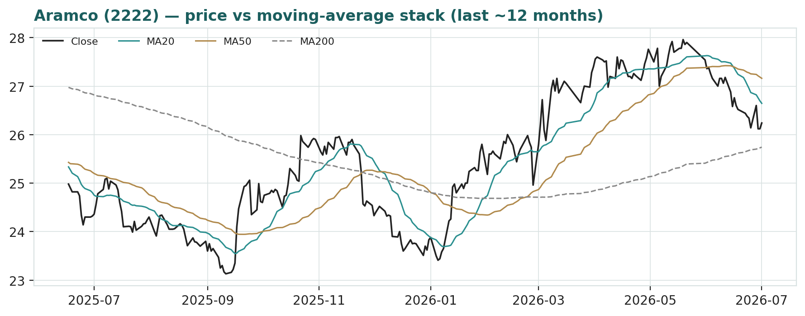
Figure 2 · Price versus the moving-average stack, last ~12 months. Price sits just under a flattening MA20/MA50 and above a rising MA200 — a quiet, range-bound tape.
3 Monte Carlo — the three-month price distribution
This models the price over the next three months, not value. We simulate 50,000 paths (seed 42) from a 16-factor structure — seven continuous drivers and nine discrete event risks — calibrated to Aramco's own realized volatility. It answers 'where could the price plausibly be, and with what probability', not 'what is Aramco worth'. The paths diffuse from spot as a near-term price process and deliberately do not embed the fundamental NAV — the value gap of Section 1 is kept out of the drift, so the fundamental and probabilistic lenses stay independent.
The seven continuous factors (Brent, oil demand and refining/chemicals cracks, SAMA and US-real-rate paths transmitted through the peg, TASI and passive flows, the base-dividend yield anchor, and the oil-vol regime) net to a small +0.6% three-month drift; the nine discrete events (an OPEC+ decision, a geopolitical oil-supply shock, a global recession, the SAR peg-stability tail, a Vision-2030 spending shift, an oil-facility attack, a base-dividend change, the Q2 earnings print, and government action such as a secondary share sale) carry a net negative expected contribution, pulling the expected outcome fractionally below spot and — importantly — fattening the tails. Aramco's day-to-day realized volatility is only ~15%, but its risk is tail-shaped (an oil crash, a facility strike, a peg scare), so we let the events widen the simulated path to ~20% annualized — a deliberate premium over recent calm.
Horizon | P5 | P25 | P50 (median) | P75 | P95
T+20 (~1 month) | 23.80 | 25.33 | 26.23 | 27.13 | 28.57
T+60 (~3 months) | 21.99 | 24.47 | 26.12 | 27.78 | 30.35
All values SAR. Median almost exactly on spot at both horizons; the cone is moderate, widened by the discrete oil/geopolitical/peg tails.
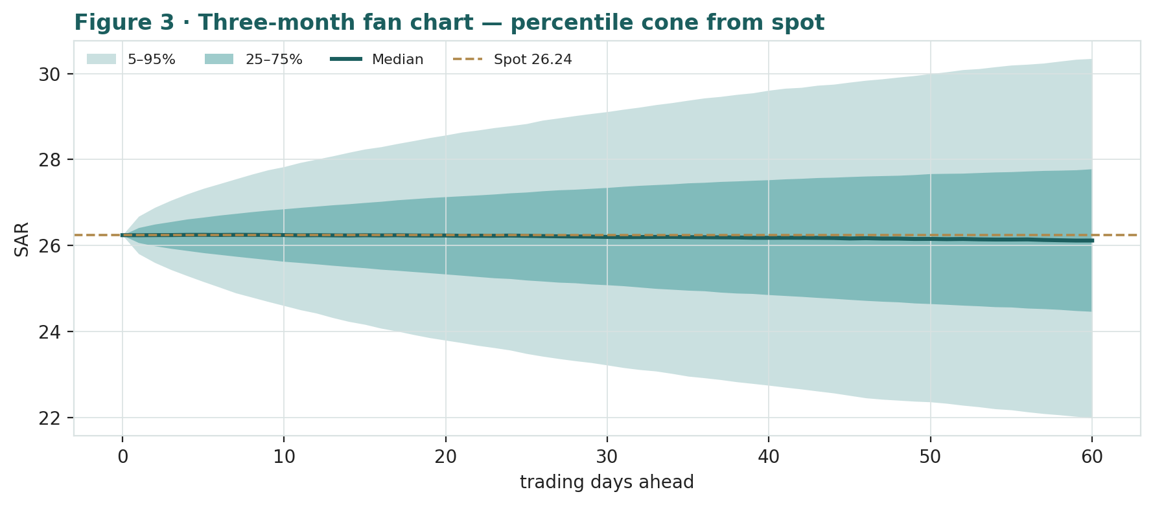
Figure 3 · Three-month fan chart — percentile cone of simulated paths from spot. Median ~flat; a moderate, right-skewed band.
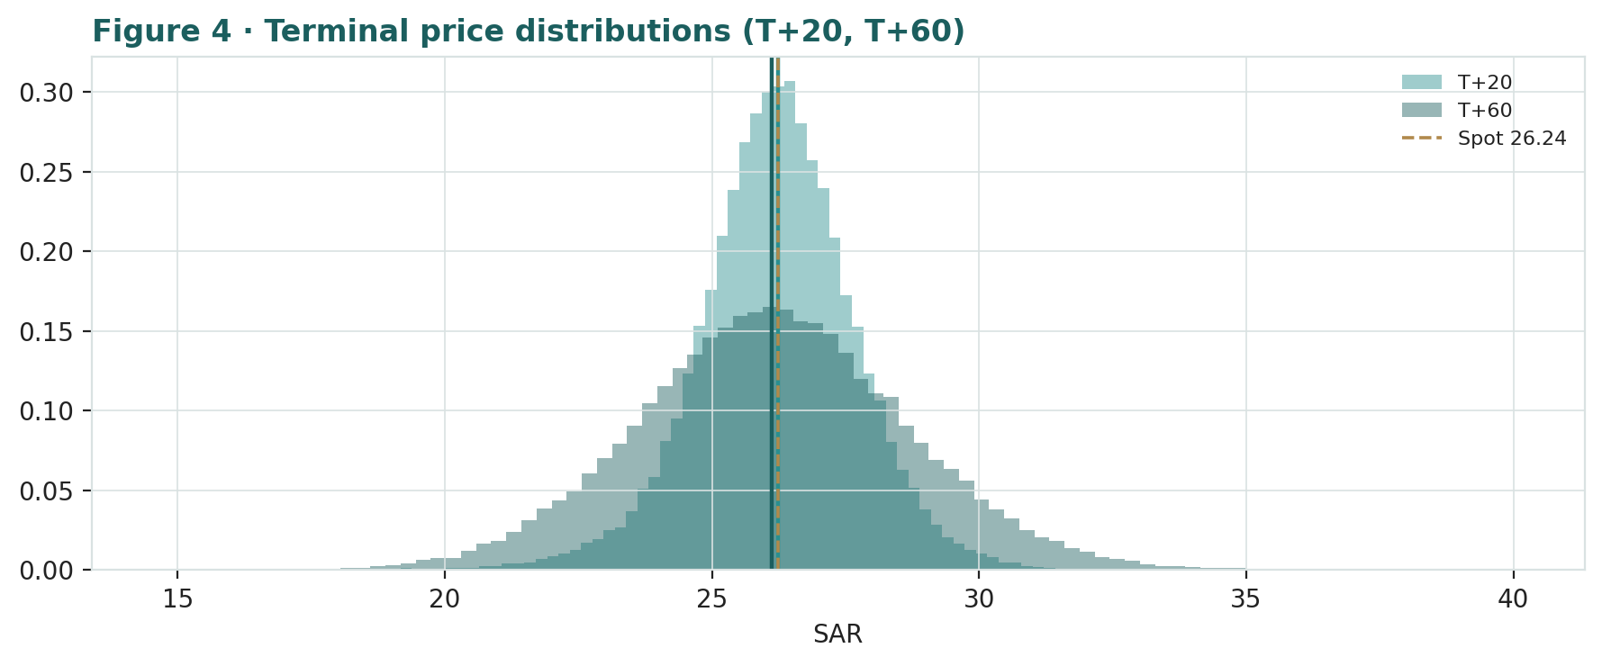
Figure 4 · Terminal price distributions at T+20 and T+60. Both centre on spot; the T+60 right tail is slightly longer (oil-spike optionality).
Level-touch probabilities (probability the price trades at or through a level at any point by T+60):
Level (SAR) | 23 | 24 | 25 | 27 | 28 | 29
P(touch by T+60) | 16% | 31% | 54% | 67% | 40% | 22%
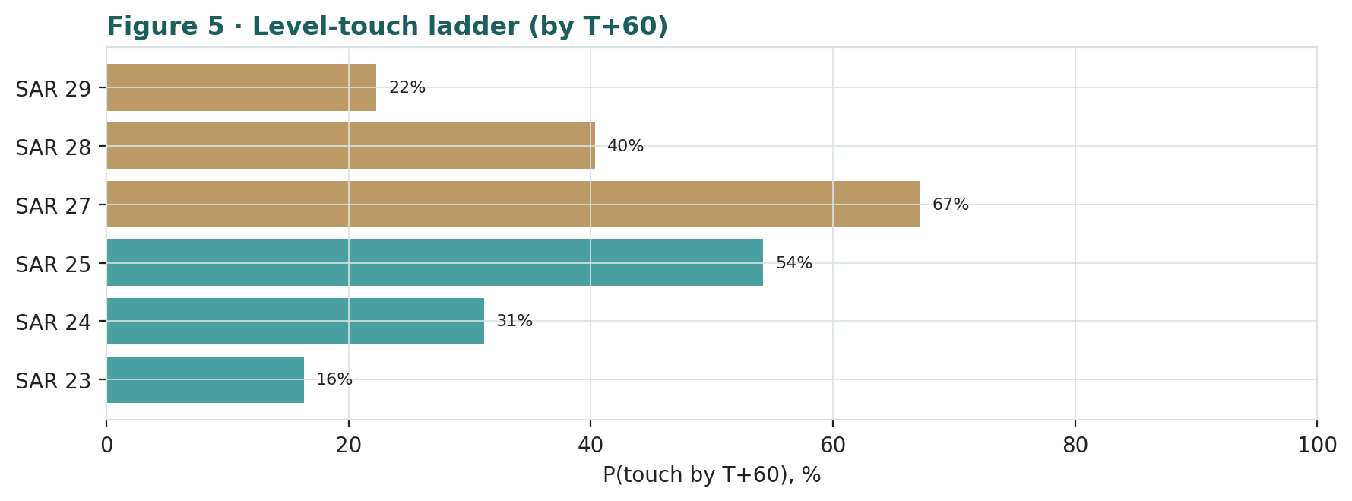
Figure 5 · Level-touch ladder by T+60. Downside levels in teal, upside in brass; SAR 25 is more likely touched (54%) than SAR 28 (40%).
4 Comparison of the lenses, and a verdict
Three readings of the same company, deliberately kept apart. The fundamental lenses average SAR 25.0, ~5% below spot — Aramco is fully valued to modestly rich, priced to its dividend, cheap on none of the earnings-based measures and dear on the multiples. The technical lens is neutral-to-mildly-soft: below the short moving averages, above the long one, RSI near oversold, in a tight range. The probabilistic lens puts the three-month median on spot inside a ~15-20% cone. Where do they agree? All three say the same thing in different languages: there is no obvious edge here in either direction. The value case rests entirely on the dividend holding and the premium being deserved; the price case rests on a quiet tape; the probability case rests on oil not breaking. Our verdict: roughly fairly valued — an income instrument correctly priced for a mid-$60s-to-$70s oil world, with the reserve base as the only source of material upside and the dividend's cash coverage as the principal risk. Not a mispricing; a fair price with two-sided tails.
5 Catalysts to watch
Oil price and OPEC+ policy — The single biggest lever. A sustained move above ~$80 relaxes the dividend-coverage question and supports a re-rating; a slide toward $60 tightens it. OPEC+ decisions on unwinding cuts move both the barrel and Aramco's own volumes.
Base-dividend trajectory — Each quarterly declaration is a referendum on coverage. Continued 3.5%-type increases signal confidence; any pause or trim (however unlikely near-term) would reprice the yield.
Gearing and capex discipline — Watch whether the balance sheet keeps funding the payout gap and whether 2026 capex stays inside the $50-55bn guide; both feed free cash flow and thus dividend cover.
Gas and new-energy ramp — Jafurah/Tanajib volumes and the ~80%-by-2030 sales-gas target are the clearest organic growth leg — evidence of volume offset to a flat oil price.
Government action on the float — Secondary share sales, lock-ups and PIF moves change supply/overhang; index and passive flows amplify them.
Geopolitics — Gulf and Strait-of-Hormuz tension is two-sided — a spike lifts the oil price but raises facility risk; the 2019 Abqaiq precedent is the template.
6 Reading the probability zones
Translating the T+60 distribution into plain zones (these are price probabilities, not valuations, and not advice):
Zone (SAR, by T+60) | Rough probability | Interpretation
Below 24 (downside) | ~25% | oil softens / risk-off; toward the DCF and relative-multiple marks
24 – 28 (fair band) | ~55% | the market's current pricing holds; median outcome
Above 28 (upside) | ~20% | oil re-rates / yield compresses; toward the reserves-NAV mark
The distribution is close to symmetric with a slightly longer right tail — the oil-spike/geopolitical optionality the events inject. That asymmetry is small; the honest summary is that three months from now the price is most likely within a couple of riyals of where it is today, with fatter-than-normal tails on either side driven by oil.
7 Caveats and what would change our mind
The dividend assumption is doing a lot of work — The yield lens capitalises the base dividend as if permanent. If oil stays soft and the payout is trimmed, the SAR 26 support becomes SAR 22-23 quickly. This is the biggest single risk to the 'fairly valued' read.
The reserve mark is a judgment, not a fact — At $7/boe net the NAV is above spot; at $5/boe it is below. The reserves-NAV should be read as a range, not a point, and generosity here flatters the whole synthesis.
The discount rate is the argument — A 7% WACC embeds a sovereign premium-to-Western-majors view. At 8% the DCF is near SAR 20; the entire 'premium multiple justified' case rests on a below-market discount rate.
Low realized vol understates tail risk — We deliberately widened the Monte-Carlo path above realized vol because Aramco's risk is tail-shaped. If anything, the peg and facility tails could justify wider still.
Controlled float and index effects — A small free float and passive inclusion can hold the multiple above where fundamentals alone would place it — a support in calm markets and a risk if flows reverse.
This is price, not permission — Nothing here is a recommendation. The Monte Carlo models price, not value, and encodes subjective probabilities for events that have not occurred.
Technical note: the 14-day RSI stood at ~30.9 at the close, near the conventional oversold threshold of 30 — a mild mean-reversion signal, no more.
Appendix A Financial statements (Aramco disclosure)
Source: Aramco FY2023, FY2024 and FY2025 results press releases and Annual Report 2025. USD millions unless noted; SAR converted at 3.75. Shown for scale; the full three-year-actual plus five-year-forecast income statement, balance sheet and cash flow — and the explicit 5-year FCFF DCF — are built and linked in the companion Excel model.
A.1 Income statement (selected)
($m) | FY2023 | FY2024 | FY2025
Revenue & other income | 440,900 | 480,400 | 445,700
Adjusted EBIT | 230,000 | 210,000 | 199,000
Net income (reported) | 121,300 | 106,246 | 93,400
Adjusted net income | ~130,000 | 110,000 | 104,700
EPS (SAR, reported) | 1.87 | 1.63 | 1.44
Avg. realized oil ($/bbl) | ~82 | 80.2 | 69.2
A.2 Balance sheet (selected)
Item | FY2023 | FY2024 | FY2025
Total equity (SAR m) | ~1,600,000 | ~1,660,000 | 1,721,744
Total equity ($m) | ~426,700 | ~442,700 | 459,132
Net debt ($m) | (25,000) | ~22,000 | 18,100
Gearing | −6.3% (net cash) | 4.5% | 3.8%
Proved reserves (bn boe) | ~256 | ~246 | 247.2
A.3 Cash flow (selected)
($m) | FY2023 | FY2024 | FY2025
Cash flow from operations | 143,400 | ~136,000 | 136,200
Capex | (49,700) | (53,200) | (52,200)
Free cash flow | 101,200 | 85,333 | 85,400
Dividends declared | (97,800) | (124,000) | (85,500)
FCF − dividends (funding gap) | 3,400 | (38,667) | (100)
Net income fell from $121.3bn (2023) to $93.4bn (2025) as oil softened; free cash flow held near $85bn. The funding gap swung with the dividend policy — 2023 comfortably covered, 2024 stretched by the performance dividend, 2025 essentially at parity as the base dividend now consumes almost all free cash flow. Equity/net-debt figures for FY23–FY24 are estimates; FY25 is disclosed.
Appendix B Step 0 — calibration backtest
Before any forecast is published, the Monte-Carlo diffusion model is tested on Aramco's own 5.5-year price history. We roll a three-month-ahead (63-trading-day) forecast distribution across the sample, score the realized price against each, and ask two questions: are the 50/80/90% central bands hitting their stated rates, and is the probability-integral-transform (PIT) roughly uniform (the signature of a calibrated model)? The forecast is median-unbiased — no fundamental view in the drift — so the test isolates the spread, which is what the Monte Carlo depends on. Windows overlap (daily step) for a dense PIT; because overlapping three-month forecasts autocorrelate, we report the effective independent sample (N_eff ≈ 17) and cross-check against a non-overlapping subset.
Central band | Empirical (overlapping) | Non-overlapping | Target | 1σ tolerance
50% | 46.0% | 35.3% | 50% | ±12.2%
80% | 81.7% | 82.4% | 80% | ±9.8%
90% | 90.8% | 94.1% | 90% | ±7.3%
At the model's trailing-volatility calibration with no adjustment (vol multiplier 1.0), all three bands sit within one standard error of their nominal rates, and the PIT has mean 0.44 and standard deviation 0.287 against the ideal 0.289 — the spread is essentially perfect. The only blemish is a mild PIT-mean skew below 0.5: a no-view forecast slightly over-predicted Aramco because the stock drifted gently down over 2021-2026, which is a property of the sample, not a defect in the spread. The gate passes; the diffusion model is well-calibrated on Aramco's own history, and §3 proceeds on that basis.
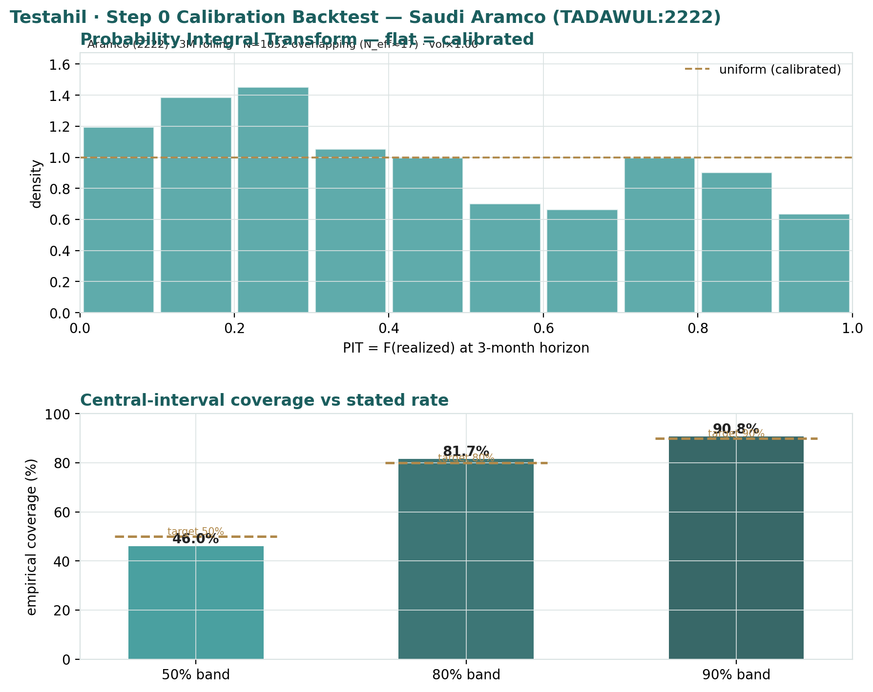
Appendix B · PIT histogram (flat = calibrated) and central-interval coverage versus stated rates. Bands on target; PIT near-uniform with a mild left-of-centre mean from the sample's gentle downtrend.
Appendix C Peer set, sector structure, and risks
C.1 Peer set (international majors and NOC comparators)
Company | EV/EBITDA | P/E | Div yield | Note
Saudi Aramco (2222) | ~7.3x | ~16-18x | ~5.2% | lowest-cost; sovereign; premium multiple
ExxonMobil (XOM) | ~5.5x | ~13x | ~3.5% | integrated major
Chevron (CVX) | ~5.8x | ~13.5x | ~4.5% | integrated major
Shell (SHEL) | ~4.5x | ~9.5x | ~4.0% | integrated + LNG
TotalEnergies (TTE) | ~4.2x | ~8.5x | ~5.5% | integrated + power
PetroChina (857) | ~3.5x | ~8.0x | ~6.0% | NOC comparator
Peer multiples are indicative market levels, not precise as-of figures. Aramco's premium EV/EBITDA and P/E, against a mid-pack yield, is the central relative-value debate.
C.2 Principal risks
Oil price — The dominant factor; sustained weakness pressures free cash flow, the dividend and the multiple together.
Dividend coverage — With the base dividend at ~104% of free cash flow, soft oil forces re-leveraging or a payout rethink.
OPEC+ and volumes — Production policy constrains Aramco's own barrels even when it supports the price.
Peg tail — A remote but catastrophic SAR-depeg would reprice the equity; held as a low-probability event in §3.
Controlled float / flows — A small free float and passive inclusion can hold the multiple up — support in calm, risk in reversal.
Geopolitics / facilities — Regional escalation is two-sided (oil-price up, facility-risk up); Abqaiq 2019 is the precedent.
Appendix D The expert valuation panel
Every Testahil study closes with a panel of standing expert personas — drawn from the house Expert Persona Library, not invented for the occasion, so that each accumulates a track record across studies and a quarterly update is a re-run, not a re-training. For Aramco — a capital-heavy, commodity-driven national oil company — we cast the three whose methods both fit the instrument and genuinely disagree: Expert 1 (reserves-based NAV at realizable value), Expert 2 (normalized earnings power and relative multiples), and Expert 3 (cash returns — DCF and return on capital versus its cost). Each runs a different method, derives its fair value from shown workings, and states a falsification condition. We considered a fourth — the commodities specialist — but her oil supply/demand lens would overlap the macro-policy view; and the macro-policy lens itself — oil, OPEC+, the riyal peg — runs through the body (§1.7, §1.8, §5) rather than as a separate persona, exactly where it belongs for this name.
D.1 Expert 1 — reserves-based NAV at realizable value
Worldview. The Graham-Dodd realization school: a business is worth what its assets realize net of every claim, and reported profit is trusted only as it converts to cash. For Aramco he asks what the reserve base is really worth to a minority holder after the state's royalty, tax and priority claim, and whether the dividend is actually covered by cash.
When it works / fails. Best where the business is capital-intensive and value rests on a vast, markable asset base — Aramco's reserves are exactly that. It fails by undervaluing a genuine compounding franchise, and by marking a concession as if it were owned freehold.
Standard workings & worked example. Mark the reserves at a conservative net value per boe after the government take; add the downstream and chemicals franchise; deduct net debt; then check earnings quality via the free-cash-to-net-income bridge.
Expert 1's realizable-value build | Mark | Value
Proved reserves 247.2bn boe | $6.5/boe net | ~$1,607bn
Downstream & chemicals |  | ~$190bn
Less consolidated net debt |  | -$18bn
Equity NAV |  | ~$1,779bn
Per share (SAR) |  | 27.5
Cash-quality check: FCF / net income | 0.91x | dividend at ~104% of FCF - a flag
Sensitivity (swing = the boe mark). At $5.5/boe he lands near SAR 23; at $7/boe near SAR 29.6; at $9/boe above SAR 35. The reserve mark is the whole argument - and he refuses to credit reserves the state controls at a generous number.
Cross-examination. He tells Expert 2 that a premium multiple on flat earnings double-counts an asset base already worth more than the price; he tells Expert 3 that a single group DCF blurs a reserve base whose value does not depend on next year's oil print.
Verdict, falsification, market-implied. Fair SAR 27.5 (range SAR 23-35) - the asset base is worth more than the market pays, even after a heavy state-take haircut. Falsified if the reserves cannot realize the marked value - a permanently higher government take, or stranded-asset risk. The market price implies a ~$5.5/boe net value he judges too harsh.
D.2 Expert 2 — normalized earnings power and relative multiples
Worldview. An operating business is worth a fair multiple of its sustainable, mid-cycle earnings; the oil cycle's peaks and troughs are noise to be stripped out. He asks what Aramco earns through the cycle and what the market should pay for it - no more.
When it works / fails. Best for cyclical operating businesses with a through-cycle track record and in relative-value contexts. It fails at structural breaks, or where the multiple is doing all the work and earnings are not growing - a live risk here.
Standard workings & worked example. Normalize oil to mid-cycle, derive sustainable net income and EPS, apply a justified multiple against history and peers, and cross-check on EV/EBITDA.
Expert 2's normalization | Value
Mid-cycle oil | $72/bbl
Normalized net income | ~$100bn
Normalized EPS | SAR 1.55
Justified P/E (premium to majors, discount to peak) | 15.0x
Value per share | SAR 23.2
Cross-check: fair EV/EBITDA 6.0x -> SAR | ~21.5
Sensitivity (swing = the multiple). At 13x he lands near SAR 20; at 16x near SAR 25; at 18x (Aramco's own premium) near spot. Almost all of the value is multiple, not compounding - Aramco's earnings are barely growing.
Cross-examination. He tells Expert 1 that a liquidation-style NAV ignores that these barrels throw off real earnings for decades; he tells Expert 3 that ROIC pessimism understates a low-cost producer's staying power. But he concedes the market pays two-to-three turns more than mid-cycle earnings warrant.
Verdict, falsification, market-implied. Fair SAR 23.2 (range SAR 20-26) - the most conservative read: modestly overvalued on through-cycle earnings. Falsified by a structural margin re-rating up (higher-for-longer oil) or a multiple-regime change. The market implies ~17x mid-cycle earnings - a full premium to the majors.
D.3 Expert 3 — cash returns: DCF and ROIC versus the cost of capital
Worldview. A business creates value only when each unit of capital earns above its cost. Cash, not booked profit, is the test; he looks past the income statement to free cash flow and to the economic-profit spread - ROIC versus WACC. For Aramco the spread is emphatically positive today; the question is the fade.
When it works / fails. Best for capital-intensive businesses where returns on capital are the crux - Aramco's home ground. It fails where reinvestment economics are about to change sharply, so past ROIC misleads.
Standard workings & worked example. Build FCFF (NOPAT + D&A - capex - change in working capital), compute ROIC against WACC, and value the explicit five-year stream plus a terminal value with excess returns fading toward the cost of capital.
Expert 3's economic-profit test | Value
FCFF at ~$70-72 mid-cycle oil | ~$82bn
ROIC (2025) | ~20%
WACC | 6.50%
Economic-profit spread | ~13-14 pts (fading)
Terminal growth | 1.75%
Value per share | SAR 24.5
Sensitivity (swing = WACC / fade speed). At a 7.0% WACC he lands near SAR 23; at 6.25% near SAR 26; a faster ROIC fade knocks off a riyal. He is comfortable with a below-major discount rate given the sovereign backstop - which is exactly where he and Expert 1 part ways on the terminal value.
Cross-examination. He tells Expert 2 that mid-cycle earnings without the capital cost to produce them is a half-truth - Aramco's capex and the dividend consume the very cash a P/E capitalizes; he tells Expert 1 that summing marked reserves ignores whether each barrel earns its cost of capital, which it does, but with a fade.
Verdict, falsification, market-implied. Fair SAR 24.5 (range SAR 22-27) - the middle read: fairly valued to a shade rich, the economic profit real but capped by the fade and soft near-term oil. Falsified by a structural change in returns on capital - a new low-cost development, or erosion of the cost advantage. The market implies a ~6.3% WACC or a slower fade than he models.
D.5 The three in one room
Put them together and the argument narrows to one asset and one number: what is Aramco's reserve base worth to a minority shareholder, and what discount rate does a sovereign-controlled oil barrel deserve?
Expert 1: “You are both arguing about this year's barrel. Mark the reserves - 247 billion of them, at the lowest cost in the world - add the downstream, take off the debt. The asset is worth SAR 27.5 a share even after I haircut it for the state's cut. The market pays SAR 26 for a set of assets worth more than that.”
Expert 2: “Assets you cannot sell are worth what they earn, and Aramco earns about $100bn mid-cycle on flat volumes. Fifteen times that is SAR 23. The market pays seventeen times - a premium to Exxon I can't justify on earnings that aren't growing.”
Expert 3: “And to earn it, Aramco spends ~$53bn a year on capex and pays out more than its free cash flow, funding the gap with the balance sheet. The barrels clear their cost of capital - just - so I land in the middle at SAR 24.5. The reserve NAV is real but encumbered; the earnings are real but unpriced-for-growth. The truth is between you.”
D.6 Reading the divergence
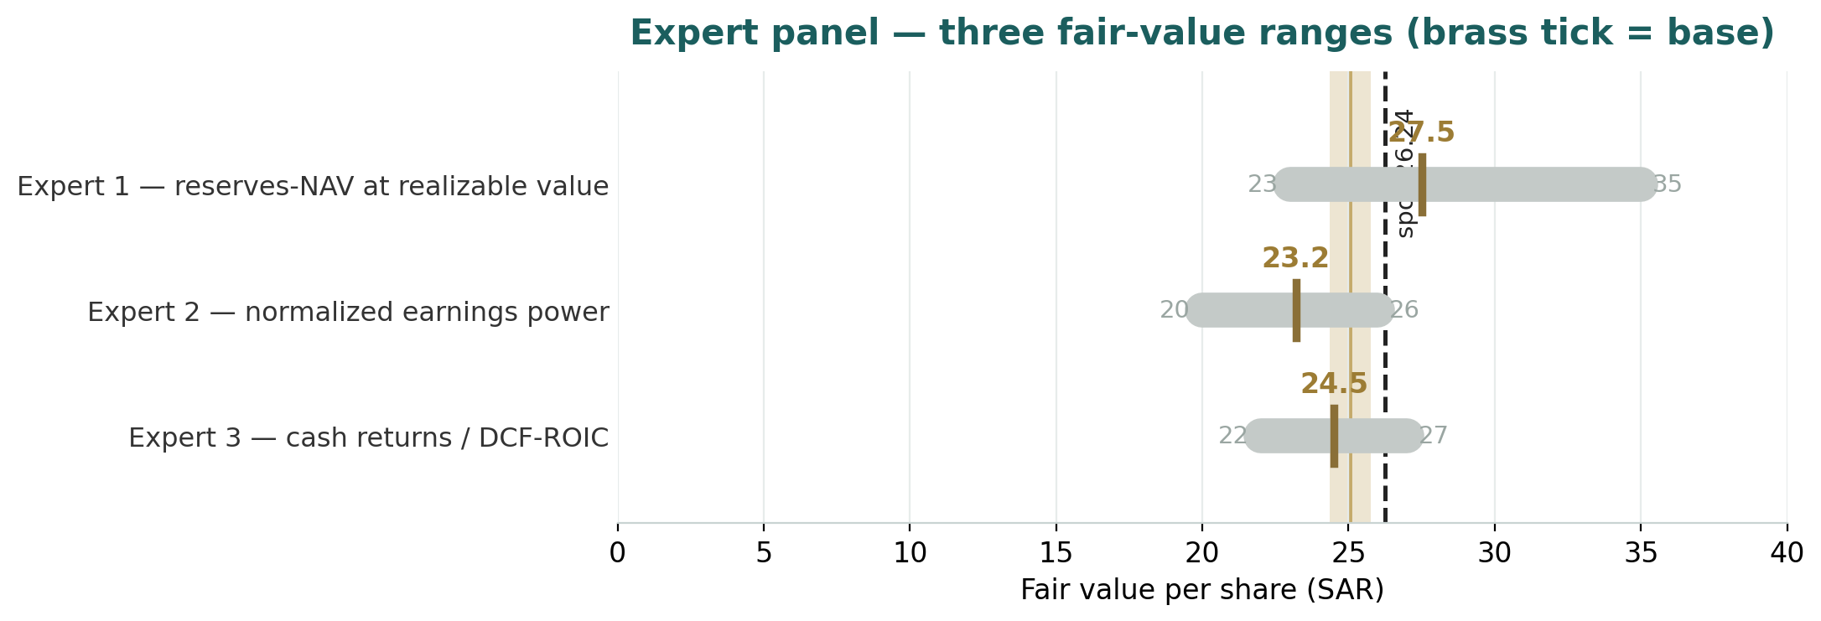
Figure D-1 · The three experts' fair-value ranges. Brass ticks are base cases; the gold band is the panel centre; the dark line is spot. The spread is almost entirely one disagreement: how much of the low-cost reserve base reaches the minority shareholder after the state's royalty, tax and priority claim.
Expert | Method | Single swing assumption | Base fair value (SAR)
Expert 1 | Reserves-NAV at realizable value | reserves at $6.5/boe net (state-take haircut) | 27.5
Expert 2 | Normalized earnings x justified multiple | 15x P/E on flat mid-cycle earnings | 23.2
Expert 3 | FCFF DCF + ROIC vs WACC | 6.5% WACC and a slow ROIC fade | 24.5
The fair values run from SAR 23.2 to SAR 27.5 - a spread of about 18%, and revealingly they straddle spot rather than sitting all above or all below it. Aramco is not a stock the disagreeing experts think is clearly cheap or clearly dear; it is one whose value depends on which lens you privilege - the asset base (bullish) or the earnings multiple (bearish), with the cash-returns view in between. What the spread measures is a single disagreement: how much of Aramco's colossal, low-cost reserve base actually accrues to the minority shareholder once the government has taken its royalty, its tax and its priority claim on the payout - and what discount rate is right for a barrel the state ultimately controls. Resolve that one question and the three numbers collapse toward one.
Per-expert fair values are logged internally with the study date (1 Jul 2026) and spot (SAR 26.24) as a per-expert calibration layer kept separate from the core Calibration Ledger; a future update re-runs these same three personas on fresh data rather than re-training them.
About this series
Testahil publishes independent, educational valuation studies. Each is an attempt to reason transparently about what a security is worth, with every assumption shown and a companion model so readers can disagree productively. The house style is distributions, not tips: we describe ranges and probabilities, not targets, and we do not tell anyone what to do. Studies are framed as educational analysis, the preparer is not licensed by any securities regulator, and holdings are disclosed.
Disclosure & Disclaimer
Not investment advice. This document is educational and informational only. It is not, and must not be relied upon as, investment, financial, legal, accounting or tax advice, nor an offer, solicitation or recommendation to buy, sell or hold any security. It contains no price target and no rating.
No licence; no advisory relationship. The preparer is not registered or licensed with any securities or financial regulator in any jurisdiction, holds no brokerage or investment-advisory authorisation, and is not acting as your adviser or fiduciary. Nothing here is personalised to your circumstances.
Holdings disclosure. The preparer may hold, and may in the future take or dispose of, a position in the security discussed in this report, and may transact at any time without notice. This is a potential conflict of interest you should weigh.
Sources & accuracy. Reported financial and operating figures are drawn from Aramco's public disclosure and other public sources believed reliable but not independently verified; they may contain errors or be superseded. Forward-looking inputs — the oil deck, discount rate, required yield, multiples, reserve marks and Monte-Carlo factor probabilities — are the preparer's own judgments and are inherently uncertain.
Forward-looking statements. Any statements about the future are estimates subject to risks and uncertainties; actual results may differ materially. The Monte Carlo models price, not value, and encodes subjective probabilities for events that have not occurred.
No reliance; your responsibility. Do your own research and consult a licensed professional before making any decision. You are solely responsible for your investment decisions and their outcomes. To the maximum extent permitted by law, the preparer accepts no liability for any loss arising from use of this document.
Currency & figures. Financials are in US dollars (USD) as Aramco reports; the reporting currency for valuation is the Saudi riyal (SAR), converted at the 3.75 peg. bn/tn denote billion/trillion. Rounding may cause totals to differ slightly. Spot price and market data are as of 1 July 2026 and change continuously.
TESTAHIL · Independent Valuation Study · Educational Analysis · Saudi Aramco (TADAWUL: 2222) · edition 01-07-2026 · reporting currency SAR

