Independent Valuation Study — Educational Analysis
Beltone Financial Holding S.A.E. (EGX: BTFH)
Fundamental analysis · Technical analysis · Monte Carlo simulation — one integrated read
Anchor: EGP 2.97 (1 Jul 2026 close) · 10,718.1m shares · mkt cap ~EGP 31.8bn (~USD 640m) · Egypt's fastest-scaling listed financial holding — an Investment Bank platform (brokerage, IB, Egypt's largest non-bank asset manager), an Egypt NBFI lending platform, and, consolidated from Q1 2026, Baobab, a pan-African microfinance banking group bought for €197.6m from the majority shareholder · prices and probabilities computed 1 Jul 2026 from the attached daily history · primary lens: financial-services sum-of-the-parts on justified price-to-book marks · the sustainable-ROE bridge and the related-party Baobab mark are the swing factors.
READ FIRST — what this document is, and is not. This study is a valuation exercise and an expression of personal analytical opinion, published free of charge for educational purposes: it shows how one analyst applies fundamental, technical and probabilistic methods to a listed company, and invites scrutiny of that methodology. It is NOT investment advice, NOT a recommendation or solicitation to buy, sell or hold any security, and NOT directed at the circumstances of any reader. The preparer is not licensed by any securities regulator in any jurisdiction (including Egypt's FRA), holds no brokerage authorisation, provides no financial consultancy, manages no money, and accepts no fees, funds or clients. See the Disclosure & Disclaimer at the end. All values are model outputs presented as ranges and distributions because no single number should be relied on. Reported financials are the company's own disclosure (FY2023–FY2025 earnings releases; Q1-2026 results, 25 May 2026); several income-statement and allocation lines are preparer estimates that reconcile to disclosed anchors and are flagged (est.) where they appear. Forward-looking inputs — the platform price-to-book marks, the Baobab mark, the complexity discount, the ROE path, the multiples, the equity DCF and the Monte-Carlo factor probabilities — are the preparer's judgments and are flagged throughout. A note on identity: the listed entity is Beltone Financial Holding S.A.E.; since 2024 the group brands itself Beltone Holding. Its controlling shareholder is Chimera Investment (Abu Dhabi), which took control via a 2022 mandatory tender offer and anchored both rights issues; the December-2025 Baobab purchase was made from that same shareholder, a related-party fact this study treats as a valuation input, not a footnote. Consult a licensed financial advisor before any investment decision.

Headline
The model's read: fairly valued — the price already pays for most of the ROE bridge. At EGP 2.97 the shares sit about 3% above our weighted central estimate of EGP 2.88. The four lenses fan out exactly along the one question that matters: a sum-of-the-parts on justified price-to-book marks lands at 2.70, an equity DCF that only credits dividends the company can actually pay lands at 2.51, the relative lens reads 2.64 on 2026E earnings, and only the normalized-earnings lens (3.62) — the bet that the enlarged, Baobab-consolidated book earns a sustainable ~18% return on equity — sits meaningfully above the price. The arithmetic of the situation is stark: two record rights issues (EGP 10.0bn in 2023, EGP 10.5bn in 2025 — each the largest cash raise in EGX history at the time) plus the €197.6m Baobab acquisition have multiplied the share count twenty-three-fold since 2022 and lifted attributable book value to ~EGP 2.23 a share, while attributable ROE printed just 7.6% in FY2025 (11% on a recurring basis) against an Egyptian-pound cost of equity we put near 23%. Paying 1.33× book for a book earning below its cost of capital is a growth bet, plainly: revenue has compounded from EGP 1.8bn (FY2023) to a EGP 29bn 2026 run-rate, brokerage share has climbed to 5.6%, AUM to a record EGP 49bn, and the lending book — 236% larger year-on-year at EGP 101bn gross — is now majority pan-African. Technically the tape is soft but unstretched: price below all four moving averages, RSI 43, a year of sideways drift. Over three months the Monte Carlo places the 5th–95th percentile band at roughly EGP 2.04–4.04 with the median a hair under spot.

Valuation summary — every read at a glance
One table for the four reads that follow — what the business is worth (fundamental), what the tape is doing (technical), where price could travel over three months (Monte Carlo), and how three independent expert methods land. Every row is developed in the sections and appendices below.
Lens / read | What it measures | Output | Takeaway
FUNDAMENTAL — what the business is worth (the anchor)
Sum-of-the-parts (primary) | Platform equity × justified P/B, less discount | EGP 2.70 | −9% vs spot
Equity DCF / residual income | PV of payable dividends + terminal | EGP 2.51 | −15% · the cash test
Relative multiples | 10× 2026E EPS; 1.2× book cross-check | EGP 2.64 | −11%
Normalized earnings | Sustainable 18% ROE × 9× P/E | EGP 3.62 | +22% · the ceiling
Weighted central | Blend 40 / 20 / 15 / 25 | EGP 2.88 | Spot ~3% ahead
TECHNICAL — what the tape is doing (timing, not value)
Trend & momentum | Price vs the 20/50/100/200-day averages | Below all four | Soft, drifting
Momentum / range | RSI · MACD · 52-week range | RSI 43 · MACD −0.03 · 2.65–3.79 | Neutral-weak
MONTE CARLO — where price could go in 3 months (paths from spot)
T+20 sessions | 50,000 paths · 16 factors | p5 2.39 · p50 2.95 · p95 3.58 | Median ≈ spot
T+60 sessions | same engine, longer horizon | p5 2.04 · p50 2.89 · p95 4.04 | Wide, right-tailed
EXPERT PANEL — three independent methods (Appendix D)
Expert 1 — residual income / justified P/B | Book + PV of returns above COE | EGP 2.45 | The anchor
Expert 2 — credit cycle / stressed book | Through-cycle cost of risk on EGP 101bn | EGP 2.05 | Most conservative
Expert 3 — macro-policy scenario options | Probability-weighted rate-cut worlds | EGP 3.30 | Most bullish
Panel range | Spread = the ROE-bridge question | EGP 2.05–3.30 | Centres ~2.60
Bottom line. Every fundamental read except the recovery lens sits below the price, and every one of them turns on the same variable: the return the enlarged equity base will sustainably earn. The market is paying ~1% below our pre-discount sum-of-the-parts — in effect assigning this collection of young, related-party-assembled platforms almost no complexity discount at all — and 1.33× a book that does not yet earn its cost of equity. That is not a bubble price; it is a full price for execution that has, so far, actually been delivered. The three-month distribution centres on spot with a fat right tail, because the discrete events (a clean Q2 print, a Baobab integration proof, index flows) skew positive even as the geopolitical and cost-of-risk tails pull left.

Company overview — Beltone at a glance
Item | Value
Listed entity | Beltone Financial Holding S.A.E. (EGX: BTFH.CA); brand: Beltone Holding
What it owns | Investment Bank platform (brokerage · IB advisory · asset management · research) · Egypt NBFI platform (leasing & factoring, consumer finance 'seven', mortgage, microfinance, SMEs) · Beltone Capital / Venture Capital · Baobab Group (pan-African microfinance bank, consolidated Q1-2026)
Spot / date | EGP 2.97 · 1 Jul 2026 close
Shares · market cap | 10,718.1m shares (par EGP 2; issued capital EGP 21,436m) · ~EGP 31.8bn (~USD 640m)
Book value (31 Dec 2025) | Attributable equity EGP 23.25bn · BVPS ~EGP 2.17 · spot P/B ~1.37×
FY2025 revenue / profit | Operating revenue EGP 12.8bn (+73%) · recurring PBT EGP 2.5bn (+33%) · NPAT&MI EGP 1.35bn (−21%, FX loss on a USD long)
Q1-2026 | Operating revenue EGP 6.8bn (+142%) · NPAT&MI EGP 695m (−1%) · Baobab = 53% of revenue
Lending / AUM / brokerage | Gross portfolio EGP 101.1bn (Baobab EGP 60.9bn) · AUM record EGP 49bn · brokerage share 5.6%
52-week range | EGP 2.65 – 3.79
Control · CEO | Chimera Investment, Abu Dhabi (2022 MTO at 55.9%; anchored both rights issues; now grouped under 2PointZero) · Dalia Khorshid, Group CEO & MD
Corporate events | Rights issues: EGP 10.0bn (Jul 2023) and EGP 10.5bn (Apr 2025) · USD 300m shareholder loan (2025) · Baobab via Lumen Aegis SPV from the majority shareholder (Dec 2025, €197.6m)
Source: company earnings releases FY2023–Q1 2026, EGX disclosures, exchange data, press reporting (May–Jun 2026). Values rounded.

1 Fundamental valuation
We value Beltone as a financial holding company — a wrapper around four licensed platforms with quite different economics — and triangulate four lenses. The primary lens is a financial-services sum-of-the-parts: a single group multiple would blur an asset-light brokerage-and-asset-management franchise, a capital-hungry Egyptian consumer/SME lender, a freshly-bought frontier microfinance bank, and a venture book. Free cash flow to the firm is meaningless for a financial, so the cash-flow cross-check is an equity DCF / residual-income model — value equals book plus the present value of returns earned above the cost of equity, and the honest version of that test is unflattering here. A relative-multiple read and a normalized-earnings-power read complete the set. The weights and the football field are in §1.5; the swing factor — the ROE bridge — is dissected in §1.7 and the sensitivity grid in §1.9.

1.1 Financial-services sum-of-the-parts — the primary lens
Attributable book (EGP 23.9bn including the Q1-2026 profit) is allocated across the four platforms — the group does not disclose allocated equity, so the split is a stated judgment that sums exactly to the reported book — and each bucket is marked at a justified price-to-book anchored to what comparable Egyptian and frontier financials command for the return profile involved. The Egypt NBFI platform (a ~EGP 40bn ex-Baobab book across leasing & factoring, 'seven' consumer finance, the market-leading mortgage arm, microfinance and SMEs) earns spread-business returns in a 20%+ rate world and takes a Contact-plus 1.6×. The Investment Bank platform — 5.6% brokerage share, EGP 136bn of FY2025 executions, Egypt's largest non-bank asset manager at EGP 49bn AUM, a scaling advisory book — is asset-light and operationally geared to the rate-cut cycle: 1.9×, a premium to EFG's 1.2× that its growth rate has earned but its track record has not yet proven. Baobab is held at ~1.0× the equity we allocate against it — effectively the €197.6m cost — because a majority stake purchased from one's own controlling shareholder is a mark that must be tested, not trusted. The venture and direct-investment residual takes 0.8×. From the marked sum we deduct a 10% complexity / related-party discount.
Platform (base case) | Allocated equity (EGP m) | Justified P/B | Value (EGP m)
Egypt NBFI lending platform | 8,000 | 1.60× | 12,800
Investment Bank (brokerage · IB · AM) | 4,500 | 1.90× | 8,550
Baobab (pan-Africa, ~cost) | 8,500 | 1.00× | 8,500
Beltone Capital / VC / other | 2,900 | 0.80× | 2,320
Σ marked value (pre-discount) | 23,900 | = EGP 3.00 / share | 32,170
less: complexity / related-party discount | 10% |  | (3,217)
SOTP equity value |  | = EGP 2.70 / share | 28,953
SOTP base ≈ EGP 2.70/share, with a bear–bull span of EGP 1.80–3.68 driven mainly by the Baobab mark and the NBFI multiple (§1.9). The striking line is the pre-discount NAV of EGP 3.00: the market is paying 2.97 for 3.00 of marked platforms — an implied discount of ~1%, versus the 10% we judge fair for a structure this young, this acquisitive, and this related-party-entangled. In the TMPV study the market discounted the parts more harshly than we did; here it is the mirror image, and that inversion is the single cleanest statement of how much execution credit the price already extends.

1.2 Equity DCF / residual income — the cash-flow cross-check
For a lender, the only cash that matters to owners is the cash the balance sheet can release. We therefore discount dividends the model says Beltone can actually pay — nil through 2027 while the book compounds, then a 20% payout — plus a terminal value of 8× 2030E attributable profit, at a 23% Egyptian-pound cost of equity (T-bills ~19–20% and falling, plus an equity premium). The construction is deliberately stingy: it credits nothing for growth the company retains unless that growth survives to the 2030 earnings line.
DCF input | Bear | Base | Bull
2030E NPAT & minority (EGP m) | 7,500 | 8,806 | 10,800
Cost of equity | 26% | 23% | 20.5%
Terminal P/E on 2030E | 6.5× | 8.0× | 9.5×
Fair value (EGP / share) | 1.75 | 2.51 | 3.95
The discount rate is the cost of equity — 23.0%, built as a 17.5% blended five-year risk-free path plus a 1.0 beta on a 5.5% equity risk premium — because for a lender deposits and borrowings are operating liabilities: an FCFF/WACC construction on enterprise value is not meaningful, and the COE is the WACC-equivalent on equity cash flows. Free cash flow to equity is profit less the capital the balance sheet must retain to fund book growth; the full base-case schedule:
Year-by-year schedule (EGP m) | 2026E | 2027E | 2028E | 2029E | 2030E | Terminal
NPAT & minority | 2,833 | 4,110 | 5,572 | 7,116 | 8,806 | —
(−) Retained for book growth | (2,833) | (4,110) | (4,458) | (5,693) | (7,045) | —
Free cash flow to equity (FCFE) | — | — | 1,114 | 1,423 | 1,761 | —
Terminal value (8.0× 2030E NPAT&MI) |  |  |  |  |  | 70,452
Discount factor @ 23% COE | 0.813 | 0.661 | 0.537 | 0.437 | 0.355 | 0.355
PV of FCFE / terminal | — | — | 599 | 622 | 626 | 25,025
Equity value = Σ PV | 26,871 |  |  |  | = EGP 2.51 / share
The base of EGP 2.51 sits below the SOTP, and the residual-income restatement of the same model explains why: on our path, attributable ROE runs 11.5% (2026) → 14.6% → 17.2% → 19.0% → 20.1%, so residual income is negative for the first two to three years — the book destroys value at a 23% hurdle before it creates any. The RI construction, which credits that back-loaded compounding explicitly, lands at 2.74; we take the more conservative payout construction as the lens base. Either way the message is the same: the cash test does not yet support the price, and the model must be paid back in 2028–2030 earnings for the price to be right.

1.3 Relative multiples
On its own trailing numbers Beltone screens expensive against every Egyptian financial: 22× FY2025 earnings and 1.37× book, versus EFG Holding — the closest listed analogue, an investment bank plus NBFI platform — at roughly 10.5× and 1.2× on a proven ~13% ROE. On 2026E earnings the picture normalises fast: our EGP 2,833m NPAT&MI estimate (Q1 annualised with modest second-half seasoning, Baobab full-year) puts the shares at ~11× forward. We mark the lens at 10× 2026E — a small discount to EFG's trailing multiple for float, seasoning and governance — and cross-check at 1.2× book.
Relative basis | Bear | Base | Bull
2026E NPAT & minority (EGP m) | 2,600 | 2,833 | 3,240
Applied P/E | 7.0× | 10.0× | 13.0×
Fair value (EGP / share) | 1.68 | 2.64 | 3.90
P/B cross-check (× BVPS 2.17) | 0.9× → 1.95 | 1.2× → 2.60 | 1.6× → 3.47
Relative base ≈ EGP 2.64 — and the two constructions agree tightly, which is reassuring. The lens treats Beltone as an EFG-class franchise a year early: cheaper than its own tape, richer than its proof.

1.4 Normalized earnings power
If the bridge holds — Baobab integrated, the two raises deployed, the book seasoned — the group's earnings power is far above today's print. We normalize to a sustainable 18% attributable ROE on today's ~EGP 23.9bn book: mid-cycle profit of ~EGP 4.3bn, EPS ~EGP 0.40, and a justified through-cycle P/E of 9× for an EM diversified financial.
Normalized-earnings basis | Bear | Base | Bull
Sustainable attributable ROE | 15% | 18% | 21%
Mid-cycle NPAT & minority (EGP m) | 3,500 | 4,300 | 5,000
Justified P/E | 7.0× | 9.0× | 11.0×
Fair value (EGP / share) | 2.29 | 3.62 | 5.13
Normalized base ≈ EGP 3.62 — the deployment ceiling, and the only lens above the price. It is, in effect, the bet that FY2025's 7.6% reported ROE was the trough of an integration J-curve and not the shape of the franchise.

1.5 Synthesis — four lenses
We weight the SOTP most heavily because it respects the very different economics of the platforms; the equity DCF carries the cash discipline; the normalized lens carries the deployment thesis; the relative lens anchors the market's own pricing of comparable franchises.
Lens | Weight | Bear | Base | Bull
Sum-of-the-parts | 40% | 1.80 | 2.70 | 3.68
Equity DCF / residual income | 20% | 1.75 | 2.51 | 3.95
Relative multiples | 15% | 1.68 | 2.64 | 3.90
Normalized earnings | 25% | 2.29 | 3.62 | 5.13
Weighted central |  | 1.89 | 2.88 | 4.13
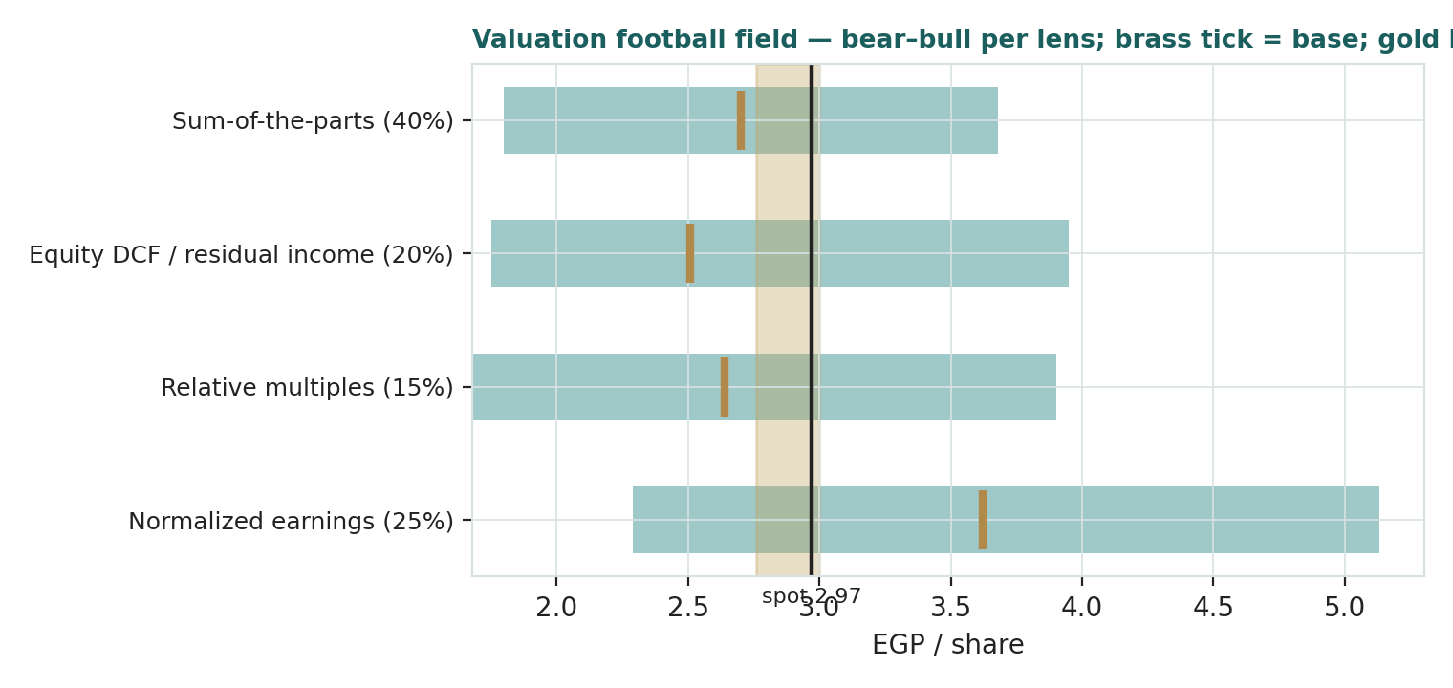
Figure 1 — Valuation football field. Bars span bear–bull per lens; the brass tick is each base case; the gold band is the blended central; the dark line is spot.
Central fair value ≈ EGP 2.88/share, about 3% below spot. The spread of the lenses (2.51 to 3.62 at base) is itself the message: this is not a cheap stock and not an obviously expensive one — it is a fully-priced execution story whose re-rating from here requires the return on the new equity to show up in the accounts, not just in the operating KPIs.

1.6 The holding-company platforms — a deeper look
The Investment Bank platform is the franchise: brokerage market share has climbed from 4.4% (FY2024) to 5.0% (FY2025) to 5.6% (Q1-2026), executions ran EGP 136bn in FY2025, the margin-lending book holds ~13% market share, and Beltone Asset Management is Egypt's largest non-bank manager at a record EGP 49bn AUM (+74% in FY2025 alone) — all operationally geared to the CBE's cutting cycle. The Egypt NBFI platform is the growth engine: the ex-Baobab lending book reached ~EGP 40bn, with 'seven' consumer finance at EGP 6.2bn, the mortgage arm the fastest in the market, and five securitizations worth EGP 6.4bn closed in FY2025 (Sodic Securitization was bought outright in Feb 2025 to internalise that capability). Baobab is the leap: a deposit-taking microfinance banking group across seven-plus African markets (Nigeria, Senegal, Côte d'Ivoire and others) with an EGP 60.9bn book and EGP 3.3bn of Nigerian deposits, contributing 53% of Q1-2026 revenue within one quarter of completion. Beltone Capital and Venture Capital (EGP 2.7bn AUM; four exits including a 75%-IRR partial Bosta sale) round out the wrapper. The table scores each part on the axes that matter.
Platform | Capital intensity | Return profile | Cyclicality | Swing role
Investment Bank (brokerage/IB/AM) | Low | High-ROE, rate-cut geared | High (market turnover) | The franchise
Egypt NBFI lending | High | Spread over rising funding | Credit-cycle | The growth engine
Baobab (pan-Africa) | High (deposit-funded) | Unproven under this owner | Frontier credit + FX | The leap — dominant
Capital / VC / other | Moderate | Lumpy, exit-driven | Venture cycle | Optionality
Platform operating revenue (EGP m) | FY2024 | FY2025 (est. split) | Q1-2026
Investment Bank platform | 1,300 | 2,300 | ~700
Egypt NBFI platform | 5,800 | 9,600 | ~2,300
Baobab (from Q1-2026) | — | — | ~3,600
Beltone Capital / VC / other | 100 | 900 | ~200
Total operating revenue | 7,200 | 12,800 | 6,800
FY2025 platform split estimated from disclosed 1H2025 detail (IB EGP 1.1bn; NBFI EGP 5.0bn) scaled to the disclosed FY total; Q1-2026 from results and press. Flagged (est.).

1.7 The ROE bridge and the Baobab mark — the crux
Two judgments drive this valuation more than any other. First, the ROE bridge. Reported attributable ROE was 7.6% in FY2025 — dragged by a foreign-exchange loss on a USD long position and one-off expenses — and roughly 11% on a recurring basis, against a ~23% cost of equity. A stock at 1.33× book therefore embeds a forecast: that the return on the enlarged equity climbs into the high teens within two to three years. The bridge has real girders — the FX loss reverses rather than repeats; the April-2025 EGP 10.5bn sat undeployed for much of the year and is now inside earning platforms; Baobab converts idle holdco capital into a seasoned, deposit-funded lending book; and the CBE's cutting cycle mechanically lifts brokerage volumes, AUM and NBFI demand. Our path (11.5% → 14.6% → 17.2% → 19.0% → 20.1%) is the base case, and every point of sustainable ROE is worth roughly EGP 0.28/share on the justified-P/B grid of §1.9. Second, the Baobab mark. The €197.6m consideration was paid to the controlling shareholder for an asset the controlling shareholder had pre-positioned in an SPV — the put option was struck in 2024, the SPV changed hands in December 2025. Within one quarter Baobab supplied 53% of group revenue, so the mark now anchors more than half the income statement. We hold it at cost in the base case and cut it to 0.6× in the bear precisely because arm's-length price discovery never occurred; a demonstrated, audited, post-integration return on that EGP ~11bn of consideration is the single fact that would most move this study.
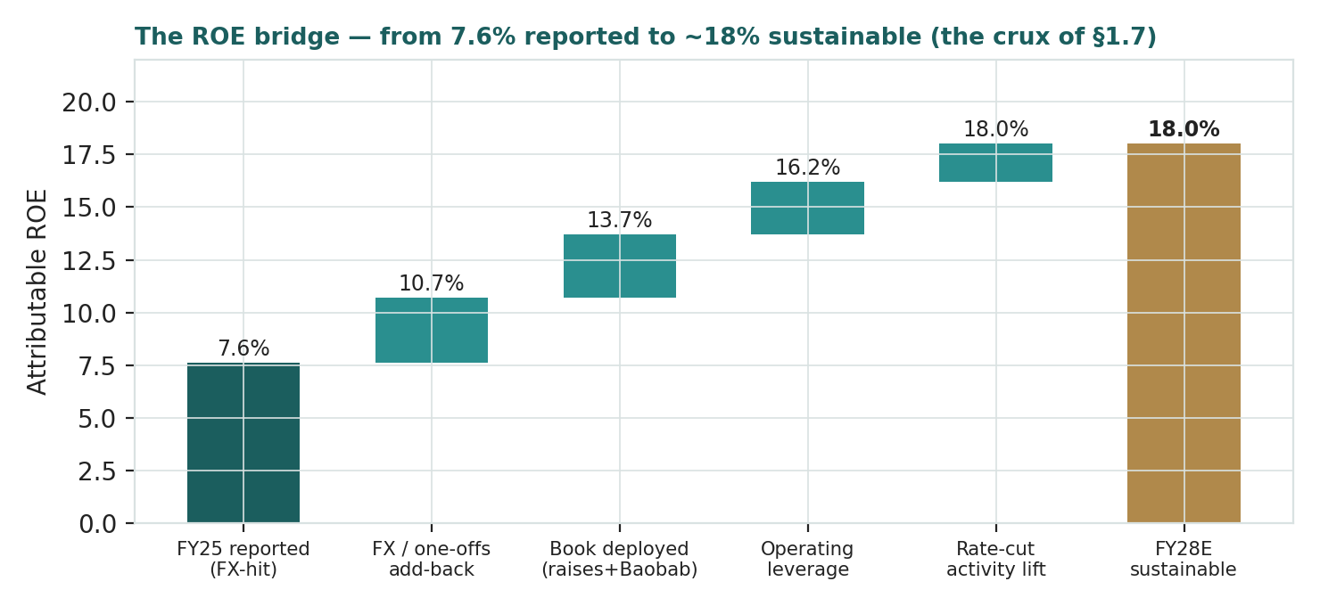
Figure 2 — The ROE bridge: from 7.6% reported (FY2025) to ~18% sustainable, and what carries each step.

1.8 Macro and country — the rate cycle, the pound, and a new African leg
Beltone is a leveraged play on Egyptian financial conditions, now with a frontier-Africa overlay. The CBE cutting cycle is the master variable: from the 27.25% peak the overnight rate has been cut by several hundred basis points and the direction of travel through 2026 remains lower — every cut lifts equity-market turnover (brokerage), fixed-income and money-market AUM economics, consumer and SME credit demand, and compresses the group's own funding cost, while also compressing the treasury yields that flattered FY2024–25. The pound cuts the other way now: the group carries a USD 300m shareholder loan and euro-denominated Baobab consideration, and consolidates naira, CFA-franc and other African-currency earnings — FY2025's headline miss was an FX loss on a USD long, and translation risk has broadened, not narrowed. The sovereign backdrop (T-bill yields ~19–20% and falling, an IMF-anchored program, episodic geopolitical risk premia from the regional conflict map) sets both the cost of equity in this study and the foreign-flow appetite that drives EGX turnover. Africa adds a genuinely different cycle: Nigerian and Francophone-West-African microfinance credit quality, local rate regimes and currency stability now matter to an EGX ticker in a way they did not two quarters ago. These levers are the bear and bull cases of §1.5 and the catalysts of §5.

1.9 Justified-P/B sensitivity — how much the ROE swing moves the value
Holding the allocation fixed, the grid re-prices the whole company on the two inputs that matter: the sustainable attributable ROE and the EGP cost of equity, through the justified multiple (ROE − g)/(COE − g) on a BVPS of 2.23, g = 15% nominal, with a 0.35× book floor. The cells near spot (EGP 2.97) say what you are underwriting at the market price.
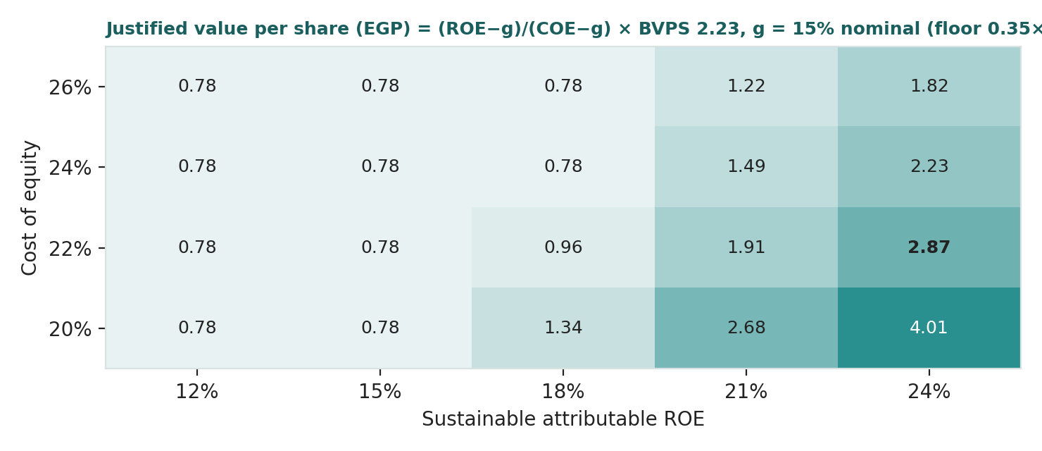
Figure 3 — Justified value per share across sustainable ROE × cost of equity. Spot 2.97 is consistent with roughly a 21% ROE at a 22% COE — most of the bridge, already paid for.
Read it as the bet you are taking: at an 18% ROE and a 22% COE the shares are worth about EGP 2.0; the market price needs either ~21% sustained ROE or a cost of equity falling toward 20% — which is why the rate-cut path and the Baobab proof are the two catalysts that genuinely matter. The SOTP's own grid (Sensitivity sheet, companion model) tells the same story through the discount: at a 0.6× Baobab mark and a 15% discount the SOTP is EGP 2.26; at 1.4× and no discount, EGP 3.32.

2 Technical and price structure
The tape is soft but not stretched. BTFH trades just below all four major moving averages, the MACD histogram is mildly negative, and RSI sits at 43 — the middle of the range, nowhere near oversold. The structure is a year-long consolidation: after the vertical 2022–23 re-rating (the split-adjusted series ran from ~EGP 0.41 to a 4.82 peak in June 2023), price has ground sideways-to-lower, digesting two enormous rights issues; the shares are down ~5% over twelve months against a sharply higher EGX, with the 52-week band a narrow 2.65–3.79. Realized volatility has halved from its 60%+ full-sample average to ~35% — a regime change the HAR width model in §3 respects.
Indicator | Reading | Signal
Spot | EGP 2.97 | —
SMA 20 / 50 | 3.04 / 3.06 | Below both — short-term down
SMA 100 / 200 | 3.02 / 3.08 | Below both — trend down, flat slope
RSI (14) | 43.5 | Neutral, mild downside bias
MACD (12,26,9) | −0.025 line / −0.014 signal / −0.011 hist | Mildly bearish
52-week range | EGP 2.65 – 3.79 | Lower third of range
12-month change | −4.8% | Sideways in an up market
Realized vol (252d) | 34.5% | Elevated vs market, half its own history
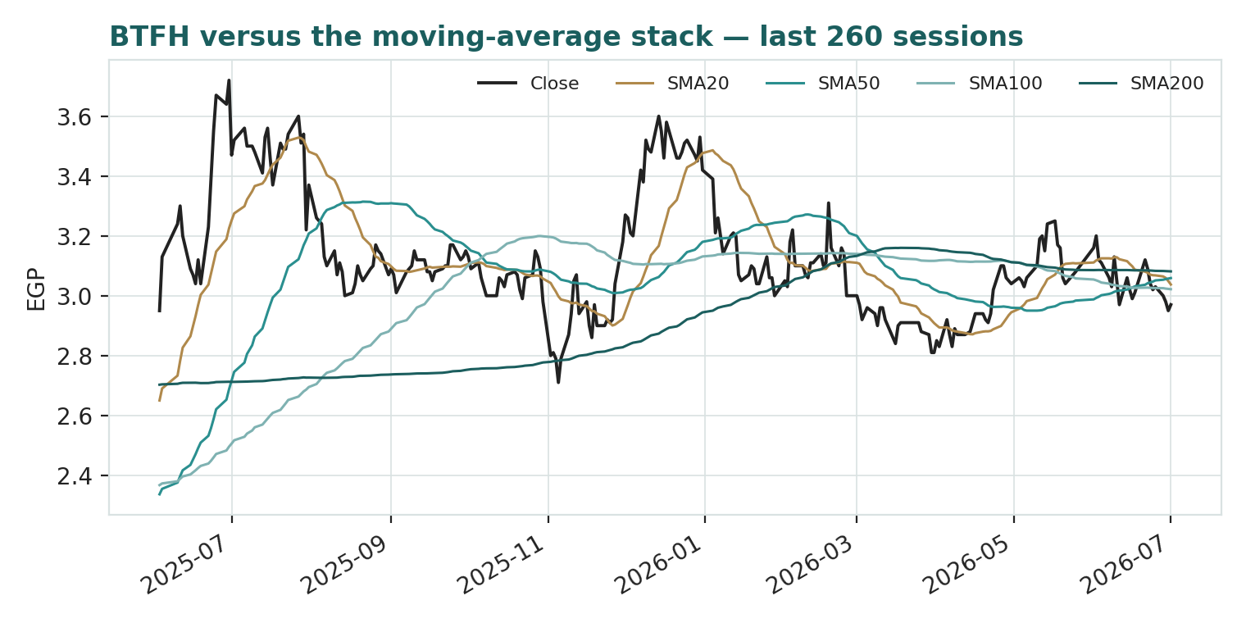
Figure 4 — Price versus the moving-average stack, last 260 sessions.
For the probabilistic work this matters in one way: a flat, post-dilution tape with compressed realized volatility argues for a genuinely two-sided quarter — no trend to lean on in either direction. The technical picture neither confirms nor fights the fundamental read; it simply says the market has been waiting, for a year, for the same proof §1.7 is waiting for.

3 Monte Carlo — a probabilistic price map
We simulate 50,000 three-month price paths (seed 42) using a sixteen-factor stack: seven continuous macro/operating drivers contributing a small net forward drift, and nine discrete events that each fire with a probability and an impact. By design the paths diffuse from spot, and the §1 value gap is kept out of the drift — the fundamental read lives in §1, not here; §3 maps where price could go from today, not where value sits. Diffusion width is sized by the YZ-HAR engine of Appendix B — a log-HAR variance cascade (lags 1/5/22) on a gap-aware Yang-Zhang proxy — which forecasts an annualized ~38.8% (daily σ 2.44%; 60-session horizon σ 18.9%), a touch above the trailing 34.5% because the recent tape carries fresh gap risk. Innovations are unit-variance Student-t(5) via a per-path variance mixture, so the quarter-end aggregate is exactly t5: a tighter interquartile body and honest tails. Drift is OFF — the asset-class rule for EGX non-developers, confirmed by this name's own Step 0 (Appendix B), where a trend drift failed the CRPS gate exactly as it did for Raya. The seven continuous factors net to +2.0% over the quarter; the nine events sum to an expected −2.6%, so the stack is nearly flat with a left-tail geopolitical skew and a cluster of modest positive events. Factor magnitudes for this asset class carry the library's calibrated=False flag — structured judgments pending the standing red-pen sign-off — and are shown in full so they can be argued with.
Continuous factor (7) | Dir. | Discrete event (9) | Prob. | Mean impact
CBE rate-cut path (activity channel) | + | Geopolitical / regional risk shock | 30% | −10.0%
EGP/USD & African FX translation | − | Asset-quality / cost-of-risk shift (incl. Africa) | 30% | −6.0%
Inflation (CPI) / nominal volume | + | Capital action / further raise (dilution overhang) | 25% | −2.0%
EGX30 & foreign flows | + | Sovereign rating / T-bill yield regime | 30% | +2.0%
Private-sector credit & NBFI demand | + | Q2-2026 earnings print (mid-Aug) | 85% | +0.5%
EGX turnover & trading velocity | + | M&A / regional expansion announcement | 35% | +3.0%
Baobab integration cost run-rate | − | Baobab integration milestone / synergy proof | 40% | +3.0%
 |  | Index / flow rebalancing | 25% | +1.5%
 |  | FX-loss recurrence on USD/EUR funding | 30% | −3.0%
Percentile map (EGP/share):
Horizon | p5 | p25 | p50 | p75 | p95
T+20 sessions | 2.39 | 2.74 | 2.95 | 3.17 | 3.58
T+60 sessions | 2.04 | 2.53 | 2.89 | 3.29 | 4.04
Lead with the body, not the tail: the 50% interquartile band at T+60 is EGP 2.53–3.29 (±~13% of spot), and at T+20 roughly 2.74–3.17 — that band, not the 5–95 extremes, is the instrument's genuine quarter-ahead uncertainty.
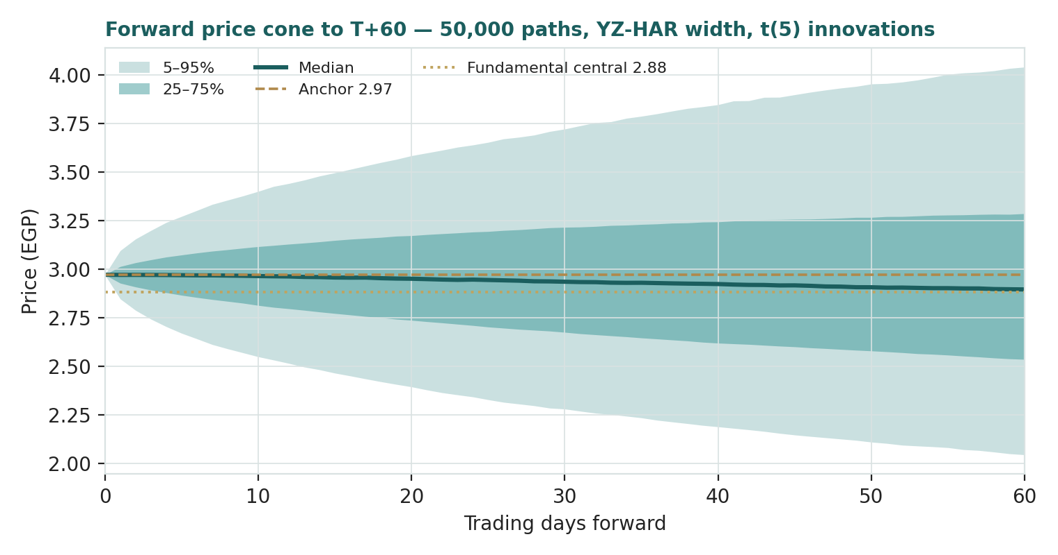
Figure 5 — Forward price cone to T+60. Median tracks a hair under spot; the gold dotted line marks the EGP 2.88 fundamental central, inside the cone's body — value and price are not far apart here.
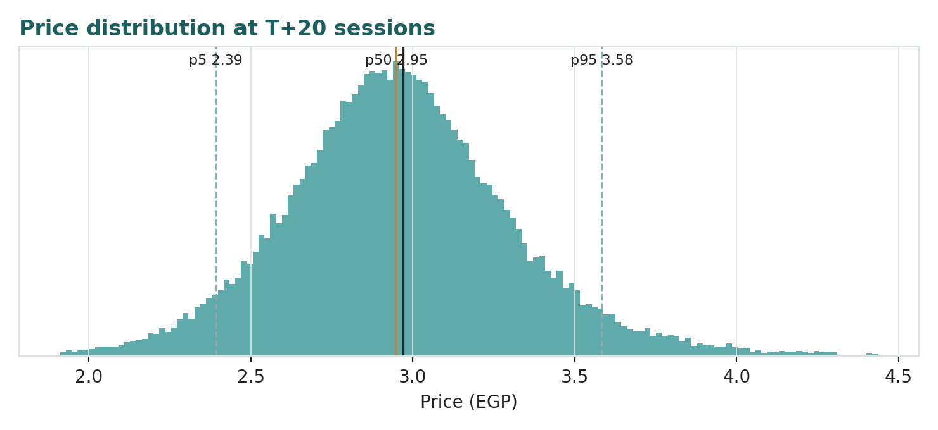
Figure 6 — Price distribution at T+20 sessions.
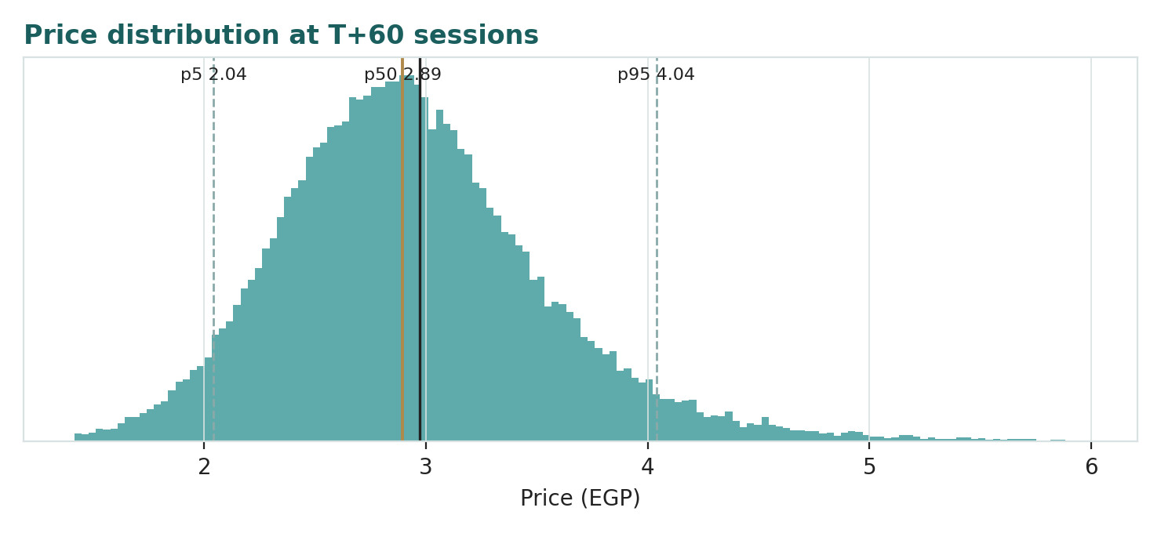
Figure 7 — Price distribution at T+60 sessions.
Level-touch ladder — the probability that price touches a level at any point by the horizon (running max for upside, running min for downside):
Level | T+20 touch | T+60 touch | Note
EGP 3.80 | 3% | 16% | Above the 52-wk high (3.79)
EGP 3.50 | 11% | 31% | Toward the normalized lens
EGP 3.30 | 26% | 48% | Upper band
EGP 3.10 | 57% | 73% | Just above spot
EGP 2.80 | 51% | 73% | Just below spot
EGP 2.60 | 22% | 49% | Around the 52-wk low (2.65)
EGP 2.40 | 8% | 29% | Below the 52-wk low
EGP 2.10 | 1% | 11% | Deep downside / bear-lens zone

4 Comparison of the lenses, and a verdict
Three readings sit side by side. The fundamental lenses cluster at 2.51–3.62 with a central of 2.88 — modestly below spot, contingent on the ROE bridge. The technical picture is a year-long, low-conviction drift below flat moving averages: the market waiting rather than voting. The probabilistic map says that over three months price is roughly symmetric around spot with a ±13% interquartile band and a fatter right tail — the median is 2.89, essentially the fundamental central, not because the simulation assumes the gap closes but because there barely is a gap.
Lens | Reads | Central / implication
Fundamental (4-lens) | Fully priced | EGP 2.88 (~−3% vs spot)
Technical | Soft, unstretched, range-bound | Floor zone 2.65; ceiling at the MA stack 3.02–3.08
Monte Carlo (3-month) | Symmetric, right-tailed | Median 2.89; p5–p95 2.04–4.04; IQR 2.53–3.29
Verdict (a fair-value read, not a recommendation). Beltone looks fairly-to-fully valued: a price fractionally ahead of a central estimate that itself already credits substantial execution. What makes the name unusual is the shape of the wager rather than its size — the market is extending near-zero complexity discount to a three-year-old construction of platforms assembled largely through related-party transactions, on the strength of operating delivery that has, in fairness, been consistently ahead of promise. The honest summary is a full price for a real franchise being built at speed, a near-term distribution centred on that price, and an outcome that hinges on one number: the sustainable return on EGP 24bn of freshly-raised equity. Readers should weigh the lenses themselves; we publish the distribution, not a target.

5 Catalysts to watch
• Q2-2026 results (~mid-Aug 2026). First clean half-year with Baobab fully in: the integration cost line, African cost of risk, and whether group ROE annualises above ~12%.
• Baobab integration milestones. Audited segment disclosure, funding-cost synergies, deposit growth in Nigeria and Francophone West Africa — the proof that the related-party mark was a fair one.
• CBE rate decisions. Each cut lifts brokerage turnover, money-market and equity AUM economics, and NBFI demand — and lowers the cost of equity this study discounts at.
• Deployment of the 2025 raise. New licenses, portfolio growth and any further acquisitions from the EGP 10.5bn; equally, any sign of a third raise (the dilution overhang event in §3).
• FX position and the pound. FY2025's earnings miss was a USD-long FX loss; the USD 300m shareholder loan and African currency translation keep this line live every quarter.
• Brokerage share and AUM prints. The franchise KPIs — 5.6% share and EGP 49bn AUM — are the leading indicators of the Investment Bank platform's earnings power.
• Securitization cadence. Post-Sodic-Securitization issuance (EGP 6.4bn in FY2025) is the release valve that lets the NBFI book grow without consuming equity.
• Governance and disclosure steps. Independent valuation of related-party deals, segment-level ROE disclosure, or a dividend policy — each would directly compress the discount in §1.1.

6 Reading the probability zones
Translating the three-month distribution into plain zones, anchored on spot EGP 2.97 and the fair-value cluster:
Zone (T+60) | Range | Approx. probability | What it would mean
Deep downside | < EGP 2.40 | ~17% | Cost-of-risk or FX shock; the bear lenses (1.7–1.9) take over
Lower band | EGP 2.40 – 2.80 | ~26% | Integration drags; price drifts to the DCF/cash test
Around spot | EGP 2.80 – 3.20 | ~27% | Status quo; the market keeps waiting for the ROE proof
Upper band | EGP 3.20 – 3.60 | ~16% | Clean Q2 + rate cuts; toward the normalized lens
Strong upside | > EGP 3.60 | ~13% | Baobab proof + COE compression re-rate the whole grid
The distribution is close to symmetric with a modestly heavier upper tail from the clustered positive events (earnings, integration milestones, index flows) and a hard left shoulder from the geopolitical and cost-of-risk tails. It is not a forecast; it is the spread of outcomes consistent with the stock's own volatility regime and the factor stack.

7 Caveats and what would change our mind
• The ROE bridge is the model. Our central case pays today for returns that only arrive in 2028–2030. A book stuck at a low-teens ROE makes the justified value EGP ~2.0 or below; a demonstrated 21%+ makes the bull grid real. This single assumption dominates every lens.
• The Baobab mark is related-party. €197.6m was paid to the controlling shareholder for an asset it pre-positioned; no arm's-length price discovery occurred, and Baobab is already 53% of revenue. We hold it at cost, but an audited disappointment there would impair both the SOTP and the earnings path at once.
• Estimated lines are estimates. Beltone's disclosure anchors (operating revenue, recurring PBT, NPAT&MI, portfolios) are firm; several intermediate income-statement lines and the equity allocation are our reconciling estimates, flagged (est.) in Appendix A and the companion model. Fuller statutory disclosure could move the platform marks.
• Frontier credit is a different animal. A lending book that grew 236% year-on-year, majority in African microfinance, has not been through a downturn under this owner. Expert 2's stressed read (Appendix D) is not a tail hobby — it is the base case of every microfinance crisis on record.
• Dilution is a habit here. Two record raises in three years funded the build; a third would reset per-share arithmetic again. We assign it 25% probability inside the quarter's event stack and no probability inside the lens bases — asymmetrically generous.
• FX cuts both ways now. The group is long USD funding costs and long African-currency earnings; FY2025 showed how one position can erase a fifth of the year's profit. Our forecast zeroes the FX line — a neutrality assumption, not a safety one.
• Technical / regime reminder. A 35% realized vol is still double a developed financial's; the HAR width is regime-conditional and would widen fast if the 2022–23 tape returns. The cone is honest today, not guaranteed tomorrow.

Appendix A Financial statements
Selected consolidated figures. Disclosed anchors are the company's earnings releases (FY2023–FY2025; Q1-2026, 25 May 2026); lines marked (est.) are preparer estimates that reconcile between those anchors; forecasts are the model's base case. Full statements with formulas are in the companion Excel.

A.1 Income statement (consolidated, EGP m)
Line | FY2023 | FY2024 | FY2025 | 2026E | 2027E | 2028E | 2029E | 2030E
Operating revenue | 1,800 | 7,200 | 12,800 | 29,000 | 37,120 | 45,286 | 53,438 | 61,454
Net operating profit (est. hist.) | 700 | 2,700 | 4,400 | 5,510 | 7,610 | 9,963 | 12,291 | 14,749
Finance & central costs (est.) | (250) | (800) | (1,900) | (1,595) | (1,930) | (2,264) | (2,458) | (2,581)
Recurring profit before tax | 450 | 1,900 | 2,500 | 3,915 | 5,680 | 7,699 | 9,833 | 12,168
FX & non-recurring (est. hist.) | 50 | 700 | (700) | — | — | — | — | —
Profit before tax | 500 | 2,600 | 1,800 | 3,915 | 5,680 | 7,699 | 9,833 | 12,168
NPAT & minority | 369 | 1,702 | 1,347 | 2,833 | 4,110 | 5,572 | 7,116 | 8,806
Basic EPS (EGP) | 0.07 | 0.31 | 0.146 | 0.264 | 0.384 | 0.520 | 0.664 | 0.822
FY2025 EPS on the ~9.2bn weighted-average share count (the Apr-2025 raise); forecast EPS on the full 10,718m. FY2024 FX line reflects devaluation-year gains; FY2025 the disclosed loss on a USD long.

A.2 Balance sheet (consolidated, EGP m)
Line | FY2023 | FY2024 | FY2025 | 2026E | 2027E | 2028E | 2029E | 2030E
Cash & equivalents | 3,343 | 3,457 | 8,099 | 11,600 | 14,152 | 16,841 | 19,536 | 22,270
Lending portfolio (gross hist. / net fcst) | 12,400 | 26,100 | 38,600 | 105,000 | 130,200 | 156,240 | 182,801 | 210,221
Total assets | 18,285 | 33,747 | 53,024 | 145,000 | 176,900 | 210,511 | 244,193 | 278,380
Customer deposits (Baobab) | — | — | — | 30,000 | 36,000 | 43,200 | 50,976 | 59,132
Borrowings & debt | 6,058 | 12,263 | 15,940 | 71,165 | 88,180 | 105,668 | 121,919 | 137,442
Attributable equity | 10,366 | 12,290 | 23,253 | 26,086 | 30,196 | 34,654 | 40,347 | 47,392
Minority interest | 106 | 183 | 246 | 349 | 498 | 660 | 866 | 1,120
Book value per share (EGP) | 0.97 | 1.15 | 2.17 | 2.43 | 2.82 | 3.23 | 3.76 | 4.42
Historical totals per FY statements (public aggregation, cross-checked to disclosed capital: EGP 10,927m 2023–24, EGP 21,436m from Apr-2025). Baobab consolidates from 2026 — the step-change in assets, deposits and borrowings. Forecast borrowings are the balancing item.

A.3 Cash flow (financial-holding presentation, EGP m)
Line | FY2024 | FY2025 | 2026E | 2027E | 2028E | 2029E | 2030E
Net profit after tax | 1,900 | 1,450 | 2,936 | 4,260 | 5,774 | 7,375 | 9,126
Increase in lending portfolio | (13,700) | (12,500) | (66,400) | (25,200) | (26,040) | (26,561) | (27,420)
Increase in customer deposits | — | — | 30,000 | 6,000 | 7,200 | 7,776 | 8,156
Increase in borrowings & debt | 6,205 | 3,677 | 55,225 | 17,015 | 17,488 | 16,251 | 15,523
Rights issues (paid-in) | — | 10,510 | — | — | — | — | —
Dividends paid | — | — | — | — | (1,114) | (1,423) | (1,761)
Other operating, FX & consolidation (plug) | 5,709 | 1,505 | (18,260) | 477 | (619) | (722) | (890)
Net change in cash | 114 | 4,642 | 3,501 | 2,552 | 2,689 | 2,696 | 2,734
2026 'Other' absorbs Baobab first-time consolidation of non-portfolio assets; 2025 absorbs FX/comprehensive losses. Ties to the balance-sheet cash line by construction.

Appendix B Step 0 — calibration backtest
Before any forecast we test the Monte Carlo lens on BTFH's own five and a half years of history: at 18 non-overlapping origins spaced 60 trading days apart, the engine — fitted only on data available at each origin — generated the three-month-ahead distribution, and the realized close was scored against it. The grade is skill versus a naïve benchmark — a zero-drift random-walk lognormal cone on the trailing 252-day close-to-close vol — measured by CRPS skill (must be > 0) and the Winkler interval score; the PIT histogram and coverage table are diagnostics only, since band-containment rewards width. Two drift configurations were raced. Drift OFF passes: CRPS skill +0.058 and Winkler skill +0.067. Drift ON (expanding-window secular drift) fails at −0.008 CRPS skill — Beltone's history is a staircase of regime turns (the 2022 control change, the 2023 speculative peak, two dilutions), exactly the shape that breaks a trend drift, confirming the asset-class rule set by Samsung, Tata and Raya. The accepted configuration — YZ-HAR width, t(5) innovations, zero drift — carries into §3.
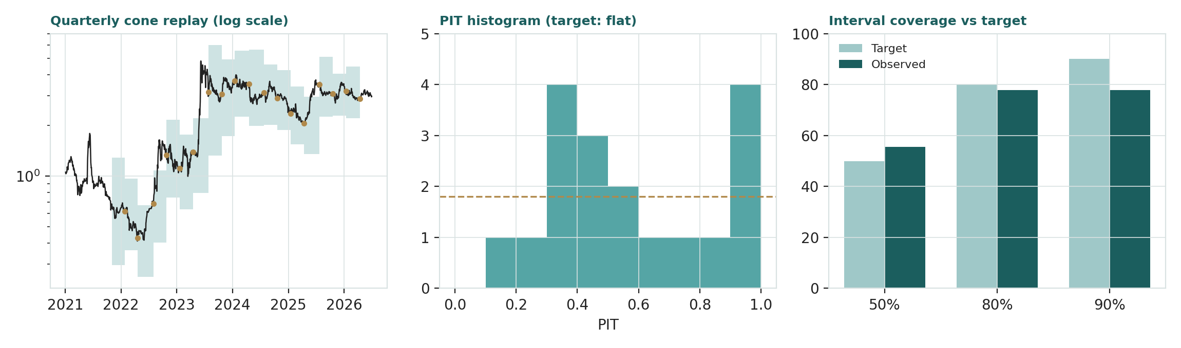
Figure B-1 — Calibration backtest: quarterly cone replay (log scale), PIT histogram, and interval coverage versus target.
Configuration (n = 18, non-overlapping) | CRPS skill | Winkler skill | 50% band | 80% band | 90% band | PIT mean / sd
YZ-HAR · t(5) · drift OFF (accepted) | +0.058 | +0.067 | 56% | 78% | 78% | 0.57 / 0.29
YZ-HAR · t(5) · drift ON (rejected) | −0.008 | +0.040 | 44% | 78% | 78% | 0.52 / 0.31
Target / benchmark | > 0 | > 0 | 50% | 80% | 90% | 0.50 / 0.29
Diagnostics read. The PIT standard deviation (0.29) matches a uniform distribution and the histogram shows no U-shape — the width model is honest. The one visible feature is a cluster of four observations above the 95th percentile: the four explosive upside quarters of 2022–23 and April 2025, when the stock re-rated vertically on the control change and the raise. The 90% band covering 78% (14 of 18) is within two standard errors at this sample size and is precisely the price of refusing to pad the cone — the retired kvol floor would have caught those quarters and failed the CRPS gate doing it. Full origin-by-origin scores ship in files/ with this study.

Appendix C Peer set, sector structure, and risks
Beltone has one close listed comparable and several partial ones — the peer set is therefore split by platform, exactly as the SOTP marks were built.
Peer | What it comps | Approx. P/E | Approx. P/B | ROE
EFG Holding (HRHO) | The whole wrapper: IB + NBFI platform | ~10.5× | ~1.2× | ~13%
Contact Financial (CNFN) | Egypt NBFI consumer/auto lending | ~8.5× | ~1.4× | ~19%
Commercial International Bank (COMI) | The P/B–ROE frontier reference | ~5.5× | ~2.2× | ~38%
Fawry (FWRY) | Growth-multiple reference (not a comp) | ~28× | ~6× | ~24%
Frontier microfinance banks | The Baobab leg | ~5–7× | ~0.8–1.0× | ~15–18%
Beltone (BTFH) — FY2025 / 2026E | — | 22× / ~11× | 1.37× | 7.6% / ~11.5%E
Peer marks approximate, from public data as of Jun–Jul 2026; flagged approximate throughout. The point is positional, not decimal: Beltone trades above every comparable on trailing earnings and book, at a below-peer reported ROE.
Sector structure. Egyptian capital-markets revenue pools — brokerage commissions, asset-management fees, advisory — are in a cyclical upswing as the CBE cuts from the 27.25% peak and foreign flows return to the EGX; the NBFI industry competes on funding cost and distribution, with securitization the capital-relief valve; and pan-African microfinance adds a frontier credit cycle (Nigeria, Francophone West Africa) with its own currency and regulatory weather. Beltone is the most aggressive consolidator in this map, funded by the deepest shareholder pocket on the exchange. Principal risks: cost of risk on a book that grew 236% in a year; FX on USD/EUR funding and African-currency translation; related-party governance around the Chimera/2PointZero ecosystem; execution and talent absorption at this speed; further dilution; concentration of the earnings line in a one-quarter-old acquisition; and the possibility that the rate-cut cycle stalls, freezing both the activity tailwind and the cost-of-equity relief the price depends on.

Appendix D The expert valuation panel
Every Testahil study closes with a panel of standing expert personas — drawn from the house Expert Persona Library, not invented for the occasion, so that each accumulates a track record across studies and a quarterly update is a re-run, not a re-training. For Beltone we cast the bank-and-lender trio, the three whose methods genuinely fit a levered financial and genuinely disagree: Expert 1 (capital and returns — residual income and the justified price-to-book), Expert 2 (the credit cycle — through-cycle cost of risk and the stressed book), and Expert 3 (macro-policy — scenario-weighted real options on the policy worlds that frontier finance actually lives in). Each runs a different method, derives its fair value from shown workings, and states a falsification condition. The asset-and-discount lens travels through the body (§1.1) rather than as a separate persona.

D.1 Expert 1 — capital and returns: residual income and the justified price-to-book
Worldview. A financial institution is worth its book value plus the present value of the returns it earns above its cost of equity — nothing more, however exciting the revenue line. Value flows from a sustainable ROE, capital strength, and the ability to grow without dilution. Her first question to any lender is always the same: show me the sustainable ROE, and show me that the book behind it is real.
When it works / when it fails. The method is at its best on well-capitalized institutions with a stable return history, where book value is a hard number and the ROE fade can be estimated from a cycle of evidence. It fails through credit shocks — book value is fiction if the assets behind it are impaired, which is where she explicitly defers to Expert 2 — and it is systematically late on genuine franchise inflections, because it refuses to pay for returns that have not yet printed.
Standard workings. (1) Assess capital adequacy and identify surplus or deficit capital against the licenses held. (2) Estimate the sustainable attributable ROE — not the best year, not the FX-hit year, the through-cycle number. (3) Value as opening book plus the present value of explicit residual income plus a terminal franchise premium consistent with the fade, cross-checked against the justified price-to-book (ROE − g)/(COE − g). (4) Sensitivity on the two swing inputs: the sustainable ROE and the cost of equity.
Worked example. Her Beltone ledger starts from an attributable book of EGP 23.9bn (BVPS 2.23, Q1-2026 profit included) — real capital, twice raised in cash, and she gives full credit for that. Her sustainable ROE is 17%: below the model's 18% because she weights the fact that the group has never yet printed a clean mid-teens year (7.6% reported, ~11% recurring in FY2025), and she treats the Baobab earnings line as unproven until a full-year audit exists. On a 22% blended cost of equity (23% today fading to 21.5% as the CBE normalizes) and a 15% nominal fade, the explicit residual income of the next three years is negative — the book earns below its hurdle while the bridge is built — and only the 2028–30 years and the terminal franchise premium pull the value above book.
Expert 1's residual-income ledger | EGP / share
Opening attributable book (incl. Q1-26) | 2.23
PV of residual income, 2026–2028 (ROE 11.5–17% vs 22% COE) | (0.18)
PV of residual income, 2029–2030 (ROE 19–20%) | +0.07
PV of terminal franchise premium (1.20× on 2030E book of 4.42) | +0.33
Fair value | 2.45
Sensitivity (swing = the sustainable ROE and the COE). At a 15% sustainable ROE the premium vanishes and her value is EGP 2.10 — essentially book; at 20%, EGP 2.95. Hold ROE at 17% and drop the cost of equity to 20% (a full easing cycle delivered) and she reaches 2.90. Her value crosses the market price only when both swing inputs break favourably at once.
Cross-examination. To Expert 2 she says the stress test is necessary but not a valuation: a franchise gathering 5.6% of a nation's brokerage flow and EGP 49bn of AUM has fee earnings no credit cycle touches, and pricing the whole company off the loan book alone ignores half the platform. To Expert 3 she says scenario trees are how you justify any number you like: the option on the policy world is real, but it must be paid for out of returns above the cost of equity, and today there are none — probability-weighting futures is not a substitute for a book that earns its keep.
Verdict, falsification, market-implied. Fair EGP 2.45 (range 1.90–3.15). Falsified by a structural ROE shift — two consecutive years of clean attributable ROE above 19%, or a capital event (a return of capital, or a fourth raise) that resets the arithmetic. The market price of 2.97 implies a sustainable ROE near 21% on her grid: the market is not paying for the bank Beltone is; it is paying for the bank Beltone says it is becoming, roughly two years early.

D.2 Expert 2 — the credit cycle: through-cycle cost of risk and the stressed book
Worldview. A lender's value is dominated by the credit it underwrites: through-cycle losses, not peak-cycle profits, set the floor, and reported book value is only as real as the loan book behind it. Peak profits, in his phrase, are a loan against the future. He has watched every fast-grown microfinance book in history meet the same downturn, and he prices the meeting in advance.
When it works / when it fails. The method earns its keep late in credit cycles, in rising-rate or stressed environments, and wherever loan books are young, fast-grown or opaque — three boxes Beltone ticks simultaneously. It fails by being too bearish in benign cycles: it will systematically miss franchise value while underwriting discipline is actually holding, which is exactly what it has cost him on Egyptian consumer lenders these past two years, and he knows it.
Standard workings. (1) Map the asset quality: book composition, growth vintage, concentration, coverage. (2) Estimate a normalized through-cycle cost of risk by segment, against what the P&L currently expenses. (3) Stress earnings and capital under a plausible downturn — for microfinance, the recorded crises (Andhra Pradesh 2010, Nicaragua 2009, the West-African delinquency waves) are the reference class, not a hypothetical. (4) Value off stressed-normal earnings at a credit-cyclical multiple, adding back only the fee businesses a credit cycle cannot touch.
Worked example. The book he is asked to bless: EGP 101.1bn gross, up 236% in a year, of which EGP 60.9bn is African microfinance consolidated for precisely one quarter, and ~EGP 40bn is Egyptian NBFI paper — leasing, consumer, mortgage, SME — most of it originated inside 24 months at 30%+ nominal rates. His normalized cost of risk: 2.5% for the Egyptian book (seasoning risk on young consumer vintages), 5.5% for frontier microfinance (the through-cycle number the reference class actually paid), blending to ~4.3% against the roughly 2% he estimates the current P&L expenses. That gap — some EGP 2.3bn pre-tax a year at today's book — is not pessimism; it is the average year arriving.
Expert 2's stressed-normal ledger | Value
Gross lending book (Q1-2026) | EGP 101.1bn
Normalized cost of risk (2.5% Egypt · 5.5% Africa, blended) | ~4.3%
vs currently expensed (est.) | ~2.0%
Pre-tax normalization drag | ~EGP 2.3bn / yr
Mid-cycle NPAT&MI after drag (from 4.3bn) | ~EGP 2.55bn
Stressed-normal EPS × credit-cyclical 7.5× P/E | 0.238 × 7.5 = 1.79
plus fee franchises a credit cycle cannot touch (AM · brokerage) | +0.26
Fair value | EGP 2.05 / share
Sensitivity (swing = the normalized cost of risk). At a 3.0% blended cost of risk his value is EGP 2.45 — nearly Expert 1's number, which tells you the entire disagreement between them is one provisioning assumption. At 6.0% (a genuine African microfinance downturn arriving early) it is EGP 1.65, and in the crisis vintage — a 12% loss emergence on the Baobab book in a single cycle, roughly what the reference class produced — attributable equity absorbs a ~EGP 7bn hit and his floor is the stressed book near 1.55.
Cross-examination. To Expert 1 he says: your book value is my raw material, not my answer — a book that doubled through acquisition from a related party, in asset classes with two recorded crises a decade, is not yet capital; it is exposure wearing capital's clothes. Season it through one downturn and I will capitalize it with you. To Expert 3 he says: your easing scenarios all quietly assume the loans stay good while rates fall — but rate cuts in frontier markets are usually the anaesthetic for the credit pain already in the book, and your best policy world is precisely where lending standards die.
Verdict, falsification, market-implied. Fair EGP 2.05 (range 1.55–2.60) — the most conservative of the three: below the price, no margin of safety. Falsified by a sustained improvement in disclosed asset quality — two years of Baobab NPL and coverage data at or better than its pre-acquisition record, and Egyptian consumer vintages seasoning cleanly. The market price implies a blended cost of risk near 2%, held flat forever, on the youngest large book on the exchange: the market, in his reading, is not pricing credit at all.

D.3 Expert 3 — macro-policy: scenario-weighted real options on the policy world
Worldview. In frontier and emerging markets, policy outranks fundamentals: the rate path, the FX regime, and sovereign action move value more than management does. He prices an asset as a portfolio of options on which policy world arrives — and Beltone, to him, is the purest listed call option on Egyptian financial conditions: brokerage, asset management, margin lending, consumer credit and securitization are all, mechanically, functions of where the CBE takes the price of money.
When it works / when it fails. The method is at its best exactly here — a policy-dominated market mid-easing-cycle, where a single central-bank path swings every line of the income statement the same direction. It fails when idiosyncratic execution dominates (no scenario tree saves a botched integration) and it is vulnerable to the seduction of its own probabilities: the weights are judgments, and he states them so they can be attacked.
Standard workings. (1) Define the policy worlds that matter over the valuation horizon — for Egypt: the speed of the easing cycle, the stability of the pound, and the regional risk premium. (2) Value the company inside each world using the study's own grid (the §1.9 justified-P/B surface), so the scenarios and the fundamentals share one engine. (3) Assign probabilities from the observable policy trajectory — the CBE's cutting cadence from the 27.25% peak, the IMF anchor, the FX regime's behaviour since 2024. (4) Weight, and stress the weights.
Policy world by mid-2027 | Prob. | What it does to Beltone | Value (EGP)
A — Fast easing, stable pound (CBE toward ~14%) | 35% | Turnover and AUM boom; COE toward 20%; the §1.9 grid's upper-right | 4.40
B — Gradual easing (the base path) | 40% | The study's central case grid; ROE bridge on schedule | 3.20
C — Stalled easing / FX wobble | 15% | Activity tailwind freezes; COE stays 24%+; funding-FX losses recur | 2.25
D — Regional shock / risk-off | 10% | Foreign flows exit; brokerage and AUM compress; credit tail opens | 1.70
Probability-weighted fair value |  |  | 3.30
Worked example. The tree above is his whole model, and he is explicit that worlds A and B carry it: three-quarters of his probability mass sits in continued easing, because that is what the CBE has actually been doing and what the disinflation path and the IMF program both reward. Inside each world he does not invent a new company — he reads the study's own justified-P/B surface (§1.9) at that world's ROE and cost of equity, which keeps his optimism honest to the same arithmetic the bears use. The African leg, to him, is a second policy option bought cheaply: if even two of Baobab's markets deliver orthodox rate regimes, the deposit-funded book compounds in currencies the Egyptian cycle never touches.
Sensitivity (swing = the scenario weights). Move ten points of probability from world B to world A and his value is EGP 3.45; move them instead to world C and it is 3.05; give the shock world 20% and he is at 3.10. It takes a genuinely pessimistic tree — A at 15%, C and D at 40% combined — to drag him below the market price: his number is robust to everything except the easing cycle itself reversing.
Cross-examination. To Expert 1 he says: your cost of equity is not a constant, it is the policy variable — you discount the bridge at 22% while the CBE is dismantling the 22%; by the time your residual income turns positive, your own denominator will have surrendered. To Expert 2 he says: your reference-class crises were policy events — caps, moratoria, currency collapses — and pricing them at through-cycle weight in a market entering, not exiting, an orthodox stabilization double-counts the very risk premium that is currently being retired.
Verdict, falsification, market-implied. Fair EGP 3.30 (range 2.20–4.30) — the most bullish of the three. Falsified by the policy trajectory itself: a halt to the easing cycle for two consecutive CBE meetings on inflation re-acceleration, or a disorderly move in the pound, collapses worlds A and B and his tree with them. The market price of 2.97 sits between his worlds B and C — the market is paying for gradual easing with a discount for the wobble, which he regards as the one genuinely cheap thing about the stock.

D.5 The three in one room
The single asset they most disagree on is the EGP 60.9bn Baobab book — specifically, whether a related-party-acquired frontier microfinance portfolio is capital, exposure, or an option.
Expert 1: “Strip the noise and it is arithmetic: EGP 23.9bn of twice-raised, real cash book, earning eleven and climbing toward seventeen. I will pay book plus a franchise premium the moment the returns clear the hurdle — 2.45 pays for the bridge at fair odds.”
Expert 2: “Your book doubled by buying a loan portfolio from your own controlling shareholder, in asset classes that produce a crisis a decade, provisioned at half the through-cycle rate. That is not book value earning eleven; that is un-taken losses earning eleven. Price the average year — 2.05 — and be grateful it isn't the bad one.”
Expert 3: “You are both discounting at a rate the central bank is actively demolishing. Every CBE meeting moves the denominator you two treat as scripture — the turnover, the AUM, the credit demand and the cost of equity all travel together. The question is not the book; it is which policy world arrives, and three of the four that can arrive are worth more than the price.”

D.6 Reading the divergence
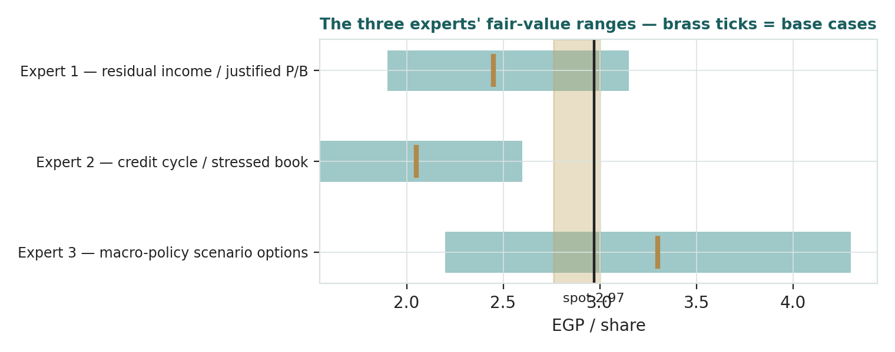
Figure D-1 — The three experts' fair-value ranges. Brass ticks are base cases; the gold band is the study central; the dark line is spot. The spread is a cost-of-risk and cost-of-equity disagreement, not a franchise one.
Expert | Method | Single swing assumption | Base fair value
Expert 1 | Residual income / justified P/B | Sustainable ROE 17% vs a 22% COE | EGP 2.45
Expert 2 | Through-cycle cost of risk | Blended CoR normalizes to ~4.3% | EGP 2.05
Expert 3 | Scenario-weighted policy options | 75% weight on continued CBE easing | EGP 3.30
The spread — EGP 2.05 to 3.30 at base — centres near 2.60, below both the study central (2.88) and the price (2.97), and it decomposes cleanly. None of the three disputes the franchise facts: the 5.6% brokerage share, the EGP 49bn of AUM, the mortgage leadership, the real cash raised. What separates them is two numbers and one date. The two numbers are the through-cycle cost of risk on a 236%-grown book (Expert 2's whole case: each 100bp is roughly EGP 0.28/share of stressed-normal value) and the cost of equity in a dismantling-rate world (Expert 3's whole case: each point off the COE is worth roughly EGP 0.25/share on the §1.9 grid). The one date is when the sustainable ROE prints — Expert 1 will pay the moment it does and not an hour before. The EGP 1.25 spread is therefore a clean measure of a single joint uncertainty: whether the returns arrive before the losses do, in a falling-rate world that accelerates both. Resolve one full Baobab-inclusive fiscal year, and the three converge fast.
Each expert's point fair value (and bull/base/bear) is logged with the study date (1 Jul 2026) and spot (EGP 2.97) as an internal per-expert track record, kept separate from the core Calibration Ledger.

About this series
Testahil publishes independent, educational valuation studies. Each is an attempt to reason transparently about what a security is worth, with every assumption shown and a companion model so readers can disagree productively. The house style is distributions, not tips: we describe ranges and probabilities, not targets, and we do not tell anyone what to do. Studies are framed as educational analysis, the preparer is not licensed by any securities regulator, and holdings are disclosed.

Disclosure & Disclaimer
Not investment advice. This document is educational and informational only. It is not, and must not be relied upon as, investment, financial, legal, accounting or tax advice, nor an offer, solicitation or recommendation to buy, sell or hold any security. It contains no price target and no rating.
No licence; no advisory relationship. The preparer is not registered or licensed with any securities or financial regulator in any jurisdiction — including Egypt's Financial Regulatory Authority (FRA) — holds no brokerage or investment-advisory authorisation, and is not acting as your adviser or fiduciary. Nothing here is personalised to your circumstances.
Holdings disclosure. The preparer may hold, and may in the future take or dispose of, a position in the security discussed in this report, and may transact at any time without notice. This is a potential conflict of interest you should weigh.
Sources & accuracy. Reported financial and operating figures are drawn from the company's public disclosure (earnings releases FY2023–Q1 2026, EGX filings) and other public sources believed reliable but not independently verified; they may contain errors or be superseded. Several intermediate statement lines and the platform equity allocation are preparer estimates flagged (est.). Forward-looking inputs — the platform price-to-book marks, the Baobab mark, the complexity discount, the ROE path, projections, multiples, the equity DCF and Monte-Carlo factor probabilities — are the preparer's own judgments and are inherently uncertain.
Forward-looking statements. Any statements about the future are estimates subject to risks and uncertainties; actual results may differ materially. The Monte Carlo models price, not value, and encodes subjective probabilities for events that have not occurred.
No reliance; your responsibility. Do your own research and consult a licensed professional before making any decision. You are solely responsible for your investment decisions and their outcomes. To the maximum extent permitted by law, the preparer accepts no liability for any loss arising from use of this document.
Currency & figures. Figures are in Egyptian pounds (EGP); m denotes million and bn billion. Approximate FX at study date: USD/EGP ~49.7, EUR/EGP ~57.5. Rounding may cause totals to differ slightly. Spot price and market data are as of 1 July 2026 and change continuously.
TESTAHIL · Independent Valuation Study · Educational Analysis · Beltone Financial Holding S.A.E. (EGX: BTFH) · edition 03-07-2026 · reporting currency EGP

