TESTAHIL
Independent equity research — distributions, not tips · testahil.com
Burjeel Holdings PLC (ADX: BURJEEL)
Valuation Study — 11 July 2026 (rev. 2, reissued 12-Jul-2026) · price anchor: AED 1.11 close, 10-Jul-2026 · fair-value ranges and probability distributions, never ratings or price targets
READ FIRST — what this document is, and is not. This study is a valuation exercise and an expression of personal analytical opinion, published free of charge for educational purposes: it shows how one analyst applies fundamental, technical and probabilistic methods to a listed company, and invites scrutiny of that methodology. It is NOT investment advice, NOT a recommendation or solicitation to buy, sell or hold any security, and NOT directed at the circumstances of any reader. The preparer is not licensed by any securities regulator in any jurisdiction, holds no brokerage or advisory authorisation, provides no financial consultancy, manages no money, and accepts no fees, funds or clients. See the Disclosure & Disclaimer at the end. All values are model outputs presented as ranges and distributions because no single number should be relied on. Reported financials are the company’s own disclosure: the FY2023 results release (6-Mar-2024), the FY2024 results release (5-Mar-2025), the H1-2025 results release (6-Aug-2025), the FY2025 results release and MD&A (4-Mar-2026), the Q1-2026 results release (6-May-2026), and ADX filings — all via burjeelholdings.com and adx.ae. Forward-looking inputs — the growth and margin paths, capex intensity, working-capital normalization, the cost of capital, terminal growth, the DMTT tax scenarios, the multiples, the scenario probabilities and the lens weights — are the preparer’s judgments and are flagged throughout. One open disclosure item is flagged where it bites: the execution status of the 10% buyback announced in March 2025 is not separately reported in the releases reviewed. Revision note (12-Jul-2026, pre-publication): following an external fact-check and internal re-verification, this reissue (i) replaces the flat 15% tax with the Pillar-Two mechanics — a 10→13% effective path reflecting the substance-based carve-outs, with 15% flat retained as the bear rung; (ii) recalibrates the relative multiples to verified, dated peer marks (11.5× EV/EBITDA and 17× P/E bases); and (iii) adds the disclosure items in §1.8 and §7. The Monte Carlo, the calibration verdict and the grading dates are untouched; every correction is folded into the build scripts. Consult a licensed financial advisor before any investment decision.
The company. Burjeel Holdings, founded in 2007 and listed in October 2022 at AED 2.00, is Abu Dhabi’s largest private operator of complex, super-specialty hospital care — the tertiary and quaternary end of medicine: oncology, multi-organ and bone-marrow transplants, fetal medicine, long-term and critical care. Built by founder Dr. Shamsheer Vayalil and majority-owned by his VPS group (~70%) with IHC holding a further ~15%, it runs 19 hospitals plus medical centres, pharmacies and a Saudi physiotherapy network across four reported segments — Hospitals (88–89% of revenue, anchored by the quaternary flagship Burjeel Medical City), Medical Centers, Pharmacies, and Others (the in-house supply-chain, IT and claims machinery, including a revenue-cycle-management arm). Roughly 14,000 employees and 1,776 doctors treated 7.0 million patients in 2025 across 1,784 beds running at 67% occupancy, against the 80–85% its own disclosure calls normalized peak. Nearly all of its AED 5.5 bn revenue is paid by insurers rather than patients — the moat (payer contracts, referral density, scarce specialist licences) and the burden: receivables sit at 135 days of sales and rising. The question the market prices at 1.11 — 45% below the IPO — is not whether Burjeel can grow, but whether a company that earned a 22.4% EBITDA margin in 2023, promised 23.5% and then “high-20s”, and delivered 18–19%, ever converts reported profit into collected cash.
Latest print. Q1-2026 (6-May-2026): revenue AED 1,339 mn, +5.1% reported but +9.7% excluding the UPP change — Abu Dhabi’s unified pharmaceutical procurement moved medicine revenue to a net fee basis in Aug-2025, an optical drag of ~4.6pp that lapses from Q3-2026 — EBITDA AED 201 mn (15.0%, the Ramadan-weighted seasonal trough, exactly rhyming with Q1-25’s 14.2%), net profit AED 57 mn (+44.5%), net leverage 1.7×. It follows a strong exit: Q4-25 EBITDA AED 282 mn at a 20.3% margin with net profit up 160%. The seasonal shape, the one-offs and the dispute effects are laid out quarter by quarter in §1.6.

Headline
The weighted fundamental central sits at AED 1.85 against a 1.11 spot — about +67% above the market — inside a bear–bull span of 1.14–2.35. The telling geometry is the bear leg: the weighted bear case is 1.14 — and spot sits just beneath it. The market is paying slightly less than a scenario in which the margin stays where 2024–25 left it, the full 15% minimum is assessed with no substance relief, receivables never normalize, Saudi stays small, and a management team that guided a 23.5% margin and delivered 18.1% is extended no credit. Everything above spot requires believing some part of guidance — and this study prices that guidance against its own record (§1.6): the margin path modelled here reaches only 22.0%, which is below where the company already operated in 2023, below the withdrawn “high-20s” promise, and at the very bottom of the current “low-20s” guide. The 60-session Monte Carlo is nearly flat (median 1.11, +0.4%) because the engine’s price centre is the money-market carry — the fundamental gap never enters the drift. Two clocks, deliberately: the fundamental read is a ~12-month view; the Monte Carlo is a genuine 3-month distribution.

Valuation summary — every read at a glance
Lens | Bear | Base | Bull | Weight | One-line read
FCFF DCF (primary) | 1.21 | 2.64 | 3.58 | 35% | Five modelled years + 2.5% terminal at the AED-sovereign WACC; TV 83% of EV, disclosed
Relative EV/EBITDA | 1.50 | 1.89 | 2.18 | 25% | 9.5–13.0× FY26E pre-IFRS-16 EBITDA of AED 1,004 mn — discount to the verified peer floor, same net-debt bridge
Normalized earnings | 1.23 | 1.49 | 1.76 | 25% | Clean FY26E EPS 0.088 × 14–20× GCC band (base 17×)
Dividend discount (policy lens) | 0.24 | 0.56 | 0.79 | 15% | What a holder actually receives — FY25 paid below the stated 40–70% policy floor
Weighted central | 1.14 | 1.85 | 2.35 | 100% | Spot sits just under the weighted bear
The DCF and the market lenses are deliberately not blended into one point: the football field in §1.5 carries the divergence, and §4 reads it. All values AED per share.

Company overview
Exchange / ticker | ADX : BURJEEL | Spot / 52-wk range | 1.11 / 1.00–1.57
Market cap | AED 5,783 mn | Shares / employees | 5,210 mn (par 0.10) / ~14,100
FY25 revenue / EBITDA | AED 5,486 / 1,089 mn rep. (1,017 ex-one-offs, 18.5%) | FY25 net profit (owners) | AED 475 mn · EPS 0.09
FY25 DPS / policy | 0.023 (AED 120 mn, 24% payout) vs a stated 40–70% policy | Net debt | 1,637 ex-leases (1.8×) · 2,828 incl (2.6×)
FY26 guidance | low-double-digit revenue CAGR · “low-20s blended” margin · AED 1.0bn growth capex · ND < 2.5× | Ownership / float | VPS ~70% · IHC ~15% · IPO floated 11%; 10% buyback announced Mar-25, execution undisclosed
Network / utilization | 19 hospitals · 1,784 beds · occupancy 67% · 7.0 mn patients · 1,776 doctors | Anchor / grades | 10-Jul-2026 · T+20: 07-Aug · T+60: 02-Oct-2026

1 Fundamental valuation

1.1 The FCFF DCF — the primary lens, with the full waterfall
Five explicit years anchored to guidance that this study refuses to take at face value, then a 2.5% terminal. Revenue steps +11% in FY2026E fading to +8% — the current “low-double-digit” guide, but note the record: “mid-teens” was guided for both FY24 and FY25 and delivered +10.5% and +9.5% (§1.6). The margin is the study’s central judgment: the ex-one-offs margin was 22.4% in FY2023, collapsed to 19.1% in FY2024 under oncology consumable mix, 188 new physicians and pre-operational costs on a wave of openings, and stabilized at 18.5% in FY2025. The modelled glide to 22.0% by FY2030E is therefore a RECOVERY to where this company already operated — not a leap of faith — yet it is held below the withdrawn “high-20s” promise and at the very bottom of the current “low-20s” guide, because the growth mix itself (oncology consumables +40% in FY24, ~38% in H1-25) is structurally lower-margin than the surgical mix that earned 22.4%. Capex is the guided maintenance 2.5% of revenue plus a growth envelope of AED 1.05 bn; working capital consumes 22–24% of every incremental revenue dirham — the DSO-135 reality, only mildly normalized; lease payments are deducted as a separate cash line so the FCFF sits on the same ex-lease basis as the net-debt bridge. Tax follows the Pillar-Two mechanics rather than the headline: the 15% top-up applies only to income above the substance-based carve-outs, so the modelled effective rate glides 10→13% — anchored on the observed FY25 rate of 7.0% and rising as the carve-out percentages step down — with the flat 15% kept as the bear rung. §1.7 prices every one of these choices. The full waterfall, every year, no steps skipped:
AED mn | FY26E | FY27E | FY28E | FY29E | FY30E
Revenue | 6,089 | 6,759 | 7,435 | 8,104 | 8,753
EBITDA (underlying) | 1,175 | 1,365 | 1,561 | 1,751 | 1,926
− D&A | (426) | (466) | (506) | (543) | (578)
EBIT | 749 | 899 | 1,056 | 1,208 | 1,348
− Tax on EBIT (10.0→13.0% path) | (75) | (99) | (127) | (151) | (175)
NOPAT | 674 | 800 | 929 | 1,057 | 1,173
+ D&A | 426 | 466 | 506 | 543 | 578
− Capex | (427) | (419) | (411) | (378) | (344)
− ΔWC | (145) | (157) | (155) | (151) | (143)
− Lease payments | (172) | (182) | (193) | (205) | (217)
FCFF | 357 | 508 | 675 | 867 | 1,047
Discount factor @ 8.16% | 0.925 | 0.855 | 0.790 | 0.731 | 0.676
PV of FCFF | 330 | 434 | 534 | 633 | 707
Sum of PV (FY26–30E) AED 2,639 mn · PV of terminal value AED 12,817 mn · Enterprise value AED 15,456 mn. Terminal value is 83% of EV — a long-duration valuation, disclosed deliberately, and §1.9 stresses exactly that. Bridge: EV 15,456 − net debt ex-leases 1,637 − NCI 68 = equity 13,751 mn → AED 2.64 per share (base). At the peg-parity WACC of 8.80% the same model reads 2.32. Bear (growth 8→6%, margin stuck at 19%, the full 15% flat, WACC 9.30%, terminal 2.0%): 1.21 · bull (growth 13→10%, margin 23.5%, tax 9%, terminal 3.0% — the Saudi-PPP world, decomposed in §1.7): 3.58.
The value-creation test the terminal value must pass. FY2025 return on invested capital — NOPAT of AED 587 mn (ex-one-offs EBIT taxed at the actual ~7%) on invested capital of AED 3,802 mn (equity plus net debt ex-leases) — is 15.4% against a 8.16% WACC: a +7.3pp spread even in a depressed-margin year, and the company’s own ROCE disclosure reads 13.5%. A business earning 7pp over its cost of capital is one whose terminal value legitimately dominates its DCF. The fragility is not the spread; it is the 15% tax step (§1.7) and one modelling honesty worth naming now: with guided capex, D&A exceeds capex in every forecast year — the model quietly assumes the asset base can shrink while revenue compounds. If maintenance capex proves closer to 4% of revenue than the guided 2.5%, the DCF loses roughly AED 0.25 per share; the bear case partly carries this.
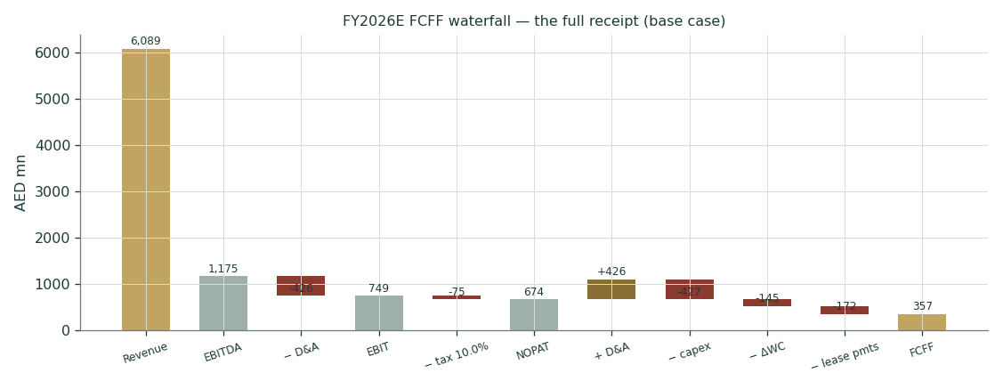
Figure 1 — the FY2026E FCFF waterfall: the full receipt.
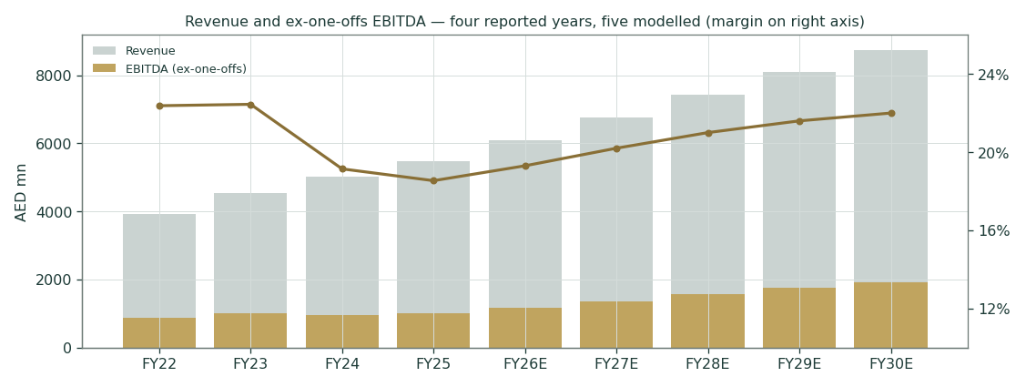
Figure 2 — revenue and ex-one-offs EBITDA: four reported years, five modelled.

1.2 Dividend discount — the policy lens
What a holder actually receives — and here the record earns a table, because the stated policy (a 40–70% payout of net income, per the company’s own FY2024 disclosure) and the paid reality have just diverged:
 | FY2023 | FY2024 | FY2025 | FY26E | FY27E | FY28E | FY29E | FY30E
Dividend (AED mn) | 160 | 170 | 120 | 138 | 158 | 181 | 204 | 231
DPS (AED) | 0.031 | 0.033 | 0.023 | 0.026 | 0.030 | 0.035 | 0.039 | 0.044
Payout of net profit | 30% | 47% | 24% | ~30% | ~27% | ~26% | ~25% | ~25%
FY2025’s AED 120 mn is a 24% payout — below the policy’s own 40% floor, cut in the year the sukuk was being arranged. The DDM takes the paid 2.3 fils and grows it 15% a year — and even that path never re-enters the stated corridor, because modelled earnings compound faster: the base dividend lens deliberately assumes continued underpayment. Discounted at the 8.89% cost of equity with a 3% terminal, the machine is worth AED 0.56 — far below spot, by construction, because Burjeel retains three-quarters of earnings for the build-out and a dividend model refuses to credit reinvestment until it arrives as cash. The gap between 0.56 and the DCF’s 2.64 is the entire growth thesis in one number. Bear (payout frozen at 2.3 fils, Ke +50bp): 0.24 · bull (a genuine return to the 40–70% corridor, terminal 3.5%): 0.79. Weighted 15% — kept in the field precisely because it prices only the cash actually promised, and the promise was just underpaid.

1.3 Relative multiples
Listed GCC hospital operators trade in tiers, and verified, dated marks explain the gap better than adjectives (every row sourced in Appendix B.1): Dr. Sulaiman Al Habib — a ~26% margin and ~33% ROE — is paid ~24–34× EV/EBITDA and ~31–35× earnings; Dallah prints ~22–26× EV/EBITDA; Mouwasat ~18–19×; Al Hammadi ~17.5×; Middle East Healthcare, the cheapest verifiable comp, ~13×. Burjeel earns an 18.5% margin with a 135-day receivables cycle, an ~11% genuine float and a UAE listing outside the Saudi flows, and trades near 8.4× — below every one of them. The base here is 11.5×: a deliberate discount to the FLOOR of the verifiable set, not to its median, because the margin gap, the receivables clock and the float are real — but the prior 10.5×, this reissue accepts, was a discount to nothing observable. Applied to FY26E pre-IFRS-16 EBITDA of AED 1,004 mn — the company’s own leverage basis, through the same net-debt bridge as the DCF — it gives AED 1.89; the 9.5–13.0× band spans 1.50–2.18. The ladder is earned, not assumed: in this peer set roughly every 2pp of delivered margin buys a turn of EV/EBITDA, and Burjeel’s path from 8× toward the floor runs through the margin print, not the story.

1.4 Normalized earnings power
Strip the noise — the AED 72 mn Medeor lease-derecognition gain out of FY2025, the FY23-bonus drag out of FY2024, the UPP optics out of the growth rate — and the clean earning power entering 2026 is about 0.088 per share: EBIT of AED 749 mn less ~210 mn of post-sukuk finance costs, taxed at the FY26E effective ~10% (§1.7), at the FY25 attributable share. Verified GCC healthcare earnings trade ~20–35×; discounting hard for float, margin and market keeps the band at 14–20×, and the base 17× gives AED 1.49, with 1.23–1.76 across the grid. At spot the market pays ~12.6× that clean number for a business guided to grow it double-digit — cheap, unless the earnings are not cash. §1.6 shows exactly why that suspicion exists.

1.5 Synthesis — four lenses, one field
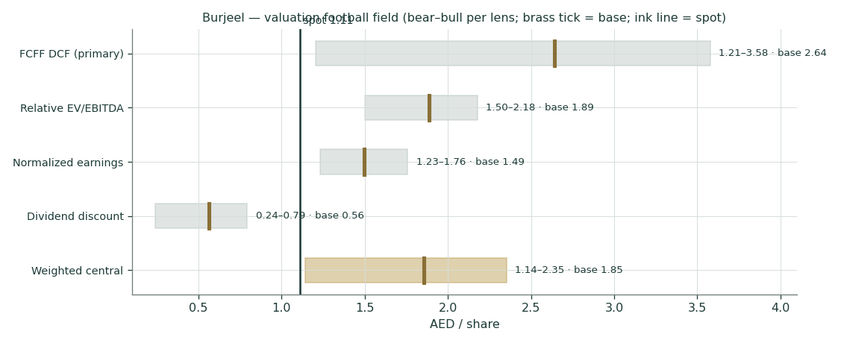
Figure 3 — the football field: bear–bull span per lens; brass tick = base; ink line = spot.
The pattern is unusually clean. The two market lenses sit 20–55% above spot; the DCF sits far above both because it capitalizes a margin recovery — to a level below the company’s own 2023 print — at a pegged-currency cost of capital; and the dividend lens sits far below because the company has just underpaid its own policy. The weighted central of 1.85 is a judgment across them (35/25/25/15 — stated, not derived), and the weighted bear of 1.14 now sits a fraction above spot — the market is paying slightly less than even the bear case. §4 reads what that means.

1.6 The drivers — sourcing gate first, then the machine, quantified
House rule: no forecast driver is set before the pre-study information sweep (Appendix B.4) has run its four rings, and every driver enters through this gate — classed as bottom-up (a disclosed figure or dated market quote) or top-down, flagged. Where a driver leans on guidance, it is marked against the guidance record further below.
Driver | Mode | Justification | Register ref.
FY26E revenue growth +11% | bottom-up (guidance, haircut) | “low-double-digit” guide; Q1-26 +9.7% ex-UPP; mid-teens was guided twice and missed twice | Company/Guidance + Track record
FY27–30E growth +11→+8% | top-down | insured-population tailwind + bed fill; decelerating with base effect | Country/Insurance + Industry/Demand
EBITDA margin 19.3→22.0% | bottom-up (history + guidance floor) | RECOVERY to own FY23 level (22.4%); bottom of “low-20s” guide; oncology mix caps the ceiling | Company/History + Guidance record
Growth capex AED 1,050 mn / 5yr | bottom-up (guidance) | guided AED 1.0bn, 25–30% in 2026; asset-light KSA | Company/Guidance
Maintenance capex 2.5% | bottom-up (guidance) | guided ≤ 2.5% — met every year on record | Company/Guidance
ΔWC 24→22% of Δrevenue | bottom-up (derived) | DSO 135 (from 123); mild normalization only | Company/FS
Tax: 10→13% effective path (bear 15% flat / bull 9%) | bottom-up (regime mechanics + observed ETR) | Pillar-Two top-up applies only to post-SBIE excess profit; FY25 actual ETR 7.0% with a small top-up accrual; carve-outs step down through 2033 (§1.7) | Country/Regulatory + Company/FS
D&A 7.0→6.6% of revenue | bottom-up (derived) | FY25 actual 7.04%; asset-light mix | Company/FS
Lease payments +6%/yr | bottom-up (derived) | FY25 AED 162 mn; grown below revenue | Company/FS
Terminal g 2.5% | top-down | UAE CPI anchor (IMF 2026); sensitized | Country/Sovereign
WACC inputs (rf 3.90 / ERP 4.99 / β 1.0) | bottom-up (sourced) | MoF T-Sukuk; Damodaran original; beta fallback documented in §1.8 | Country/Sovereign + Global/Rates
Multiples 9–12× EV/EBITDA · 14–20× P/E | top-down (flagged) | GCC peer set, aggregator-sourced; float and margin discount held | Industry/Peers
The forecast in driver terms
Driver | FY26E | FY27E | FY28E | FY29E | FY30E
Revenue growth | 11.0% | 11.0% | 10.0% | 9.0% | 8.0%
EBITDA margin (underlying) | 19.3% | 20.2% | 21.0% | 21.6% | 22.0%
D&A % revenue | 7.0% | 6.9% | 6.8% | 6.7% | 6.6%
Capex % revenue (all-in) | 7.0% | 6.2% | 5.5% | 4.7% | 3.9%
ΔWC % of Δrevenue | 24.0% | 23.5% | 23.0% | 22.5% | 22.0%
DPS (AED, modelled) | 0.026 | 0.030 | 0.035 | 0.039 | 0.044
The segment machine — where the guided path actually has to come from
Burjeel reports four segments: Hospitals (88–89% of revenue, quaternary flagship BMC inside it), Medical Centers (the UAE clinics plus the Saudi physiotherapy build — the KSA losses sit here, which is why a segment that earned ~29% margins in 2023 prints 10.7% today), Pharmacies, and Others (supply chain, IT, claims). The decomposition below assumes BMC and Medical Centers paths and solves ex-BMC hospitals as the residual the consolidated guide requires — the residual is the credibility test, and it lands at a sane +10.4% fading to +7.8%:
AED mn | FY25 | FY26E | FY27E | FY28E | FY29E | FY30E
Hospitals ex-BMC | 3,550 | 3,918 | 4,342 | 4,772 | 5,194 | 5,599
growth (solved residual) | — | 10.4% | 10.8% | 9.9% | 8.8% | 7.8%
Burjeel Medical City | 1,290 | 1,445 | 1,604 | 1,764 | 1,923 | 2,077
Medical Centers (incl. KSA) | 468 | 538 | 614 | 687 | 763 | 839
Pharmacies & Others | 178 | 189 | 200 | 212 | 225 | 238
Group revenue | 5,486 | 6,089 | 6,759 | 7,435 | 8,104 | 8,753
EBITDA margin — BMC | 18.7% | 20.0% | 21.2% | 22.2% | 22.8% | 23.2%
EBITDA margin — hospitals ex-BMC | 26.0% | 26.1% | 26.2% | 26.3% | 26.4% | 26.5%
EBITDA margin — Medical Centers | 10.7% | 12.0% | 13.5% | 14.8% | 15.8% | 16.5%
Corporate & other (residual, AED mn) | (197) | (201) | (195) | (187) | (180) | (178)
Group EBITDA (underlying) | 1,017 | 1,175 | 1,365 | 1,561 | 1,751 | 1,926
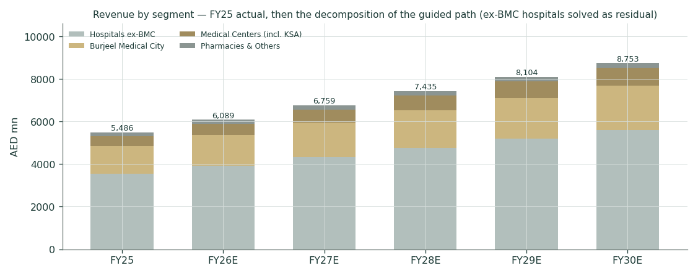
Figure 4 — the segment build: ex-BMC hospitals solved as the residual of the guided path.
Measures the disclosure does not support — per-hospital revenue, payer mix by segment, segment capex, KSA revenue as a line — are flagged rather than estimated; the corporate line is solved as the residual and shown, not hidden.
Burjeel Medical City — the flagship, four years in
BMC | FY2022 | FY2023 | FY2024 | FY2025
Revenue (AED mn) | ~740 | 1,017 | 1,204 | 1,290
Growth | — | +37.4% | +18.4% | +7.1%
EBITDA (AED mn) / margin | 54 / 7.4% | 158 / 15.6% | 193 / 16.0% | 241 / 18.7%
Occupancy | 34% | 48% | 62% | 61%
The flagship’s ramp is real — margin from 7.4% to 18.7% in three years — but decelerating: FY25 revenue grew 7.1% against a Mar-2024 guide of “30%+ p.a. toward AED 2bn+”, with volumes +18.3% and realization moderating (the payer squeezing price as utilization rises). BMC is simultaneously the best evidence for the operating-leverage thesis and the best evidence that guidance runs hot.
The healthcare dashboard — the operating measures that distinguish a hospital read from a generic industrial one
Operating KPI | Value | Reading
Beds / occupancy | 1,784 / 67% | vs the company’s own “normalized peak” of 80–85% — the leverage is real and unused
Patients / revenue per patient | 7.0 mn / AED 784 | complex-care mix: quaternary work on a mass-volume base
Revenue per occupied bed-day | AED ~12,600 | group blended; BMC’s quaternary mix sits far above
Physicians / net adds | 1,776 / +32 (FY25) vs +188 (FY24) | the FY24 hiring wave is done — capacity is bought and paid for
DSO / DPO | 135 days (from 123) / 211 days | the crux: the company borrows from suppliers to lend to insurers
OpFCF (EBITDA − capex), FY25 | AED ~432 mn | path to AED 1,582 mn by FY30E as capex fades
OpFCF margin path FY26E→30E | 12% → 14% → 15% → 17% → 18% | the capex fade does half the work; the margin does the rest
ROIC vs WACC (FY25) | 15.4% vs 8.16% | +7.2pp — value-creating even in a depressed-margin year
ROE — total / attributable | 23.2% / 22.7% | high-teens-to-low-20s equity returns at 1.8× leverage
Interest cover (und. EBITDA / net finance) | 6.3× → 5.6× post-sukuk | ample, but the direction is down at a 7.00% marginal cost
Leverage — ex-leases / incl. leases | 1.8× / 2.6× | both framings stated; guided ceiling 2.5× on the ex-leases basis
FCF yield — company-def / model FCFF | 7.8% / 6.2% | the company’s definition excludes growth capex; the model’s does not
Payout on company-def FCF (FY25) | 27% | the dividend is cash-covered three times — underpayment is a choice
Employees | ~14,100 | staff costs are the margin; scale without price power is the risk
Five quarters under the microscope
 | Revenue | EBITDA rep. | One-off | EBITDA und. / margin | Net profit | Note
Q1-25 | 1,274 | 181 | — | 181 / 14.2% | 39 | Ramadan-in-March dip; util 65%
Q2-25 | 1,403 | 306 | 72 | 234 / 16.7% | 148 | Medeor building acquired (+72 one-off); util 68%
Q3-25* | 1,420 | 320 | — | 320 / 22.5% | 175 | derived residual; insurer dispute + UPP start Aug
Q4-25 | 1,389 | 282 | — | 282 / 20.3% | 141 | margin 20.3%; NP +160% YoY
Q1-26 | 1,339 | 201 | — | 201 / 15.0% | 57 | UPP optical drag ~4.6pp; +9.7% ex-UPP
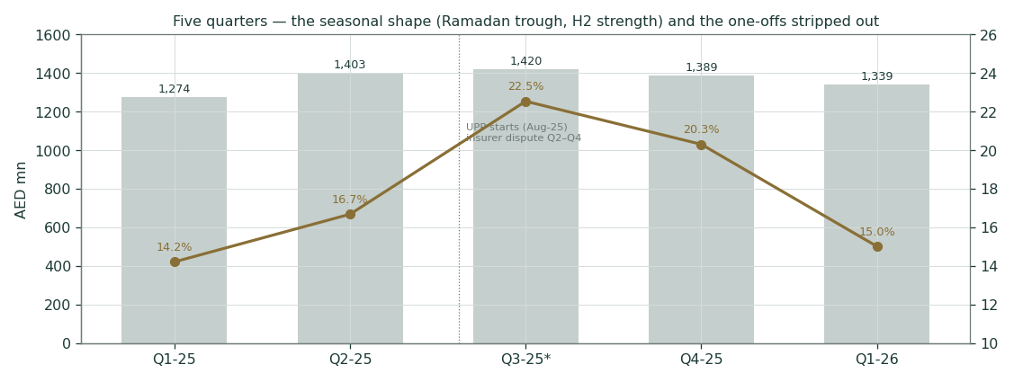
Figure 5 — five quarters: the Ramadan trough, the H2 engine, the one-offs stripped.
*Q3-25 is derived as the FY-minus-disclosed-quarters residual and flagged as such. The seasonal shape matters for reading 2026: Q1’s 15.0% margin is the trough, not the trend — Q1-25 printed 14.2% and the year still delivered 18.5% underlying. The quarter that decides the year is Q3, when the UPP optics lapse and the insurer-dispute base effect clears simultaneously.
Cash-conversion forensics — the bear case, itemized
FY2025 reported net profit rose 39.5% to AED 503 mn while operating cash flow fell 19.5% to AED 402 mn. The walk: profit 503 + D&A 386 + net finance 162 ≈ AED 1,051 mn of gross operating surplus, of which AED ~649 mn never arrived as cash — absorbed by the receivables build (the book stands at AED 2,057 mn, DSO 123→135 days), the first full cash-tax year, and other working capital. The company’s own FCF-conversion metric (EBITDA less maintenance capex less ΔWC, over EBITDA) tells the same story across four years: 42% (FY22) → 52% (FY23) → n.d. (FY24) → 41% (FY25). A hospital group at these margins should convert 60–70%; the 20-point gap is the receivables clock, and it is exactly what the June sukuk’s 7.00% price is charging for.
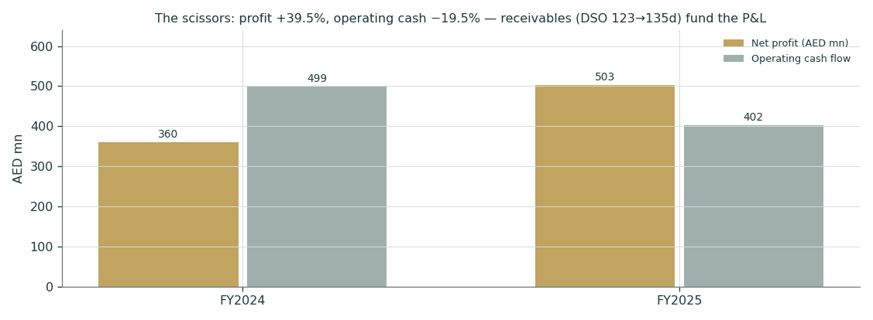
Figure 6 — the scissors: profit up 39.5%, operating cash down 19.5%.
The guidance record — every promise, against every delivery
Metric | Guided (when) | Delivered | Verdict
FY24 revenue | mid-teens growth (Mar-24) | +10.5% | MISS
FY24 EBITDA margin | 23.5% (Mar-24) | 18.1% reported / 19.1% ex-one-offs | MISS −4.4pp
FY24 BMC revenue | >+30% (Mar-24) | +18.4% | MISS
Mid-term margin | high-20s (Mar-24) | guide cut to "low-20s blended" by Mar-26 | WITHDRAWN
FY25 revenue | mid-teens growth (Mar-25) | +9.5% | MISS
FY25 EBITDA margin | expansion (Mar-25) | 19.8% rep (+1.7pp) / 18.5% underlying | MET (soft target)
Maintenance capex | ≤2.5% of revenue | in line, every year | MET
Net debt / EBITDA | <2.5× | 1.1→1.3→1.8× | MET
KSA revenue | >AED 1bn p.a. mid-term (Mar-24) | physio + day-surgery scale; not disclosed, far below | NOT ON TRACK
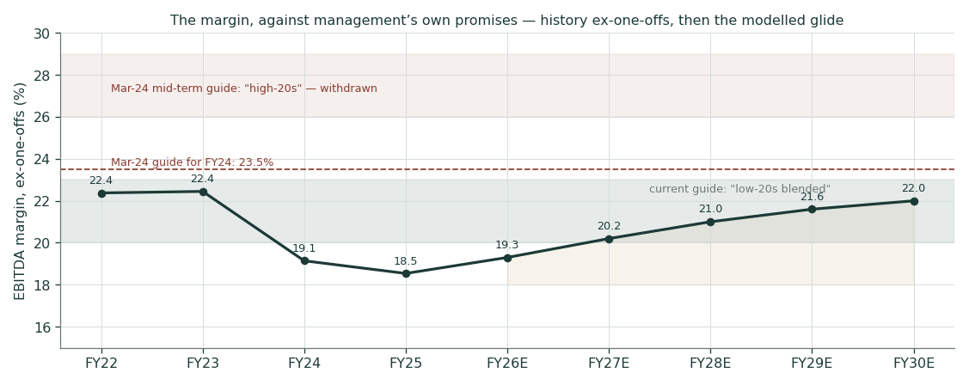
Figure 7 — the margin against management’s own promises: the 23.5% guide, the withdrawn high-20s, the current low-20s corridor, and this study’s glide.
This table is why the modelled margin stops at 22.0% and the modelled growth starts one notch below guidance. It is also why the bear case deserves its 35–40% of the probability mass: a management team two-for-two on missing revenue guides and one withdrawn margin promise has forfeited the benefit of the doubt — the study extends credit only to the guides with a met record (maintenance capex, the leverage ceiling) and to arithmetic (occupancy 67% against mature assets at 80%+).

1.7 The crux — tax, margin, cash, and the Saudi option, each in real units
Leg 1 — the DMTT step, priced directly
The UAE’s domestic minimum top-up tax (Cabinet Decision 142/2024, OECD-qualified Aug-2025) applies from FY2025 to groups above €750 mn of revenue — Burjeel’s AED 5.5 bn (≈ €1.36 bn) is over the line. But the 15% headline is not the mechanics. The top-up is 15% minus the jurisdictional rate, charged only on EXCESS PROFIT — GloBE income less the substance-based income exclusion (SBIE): 9.4% of eligible payroll plus 7.4% of tangible-asset carrying value in 2026, stepping down to 5%/5% by 2033. A hospital group is exactly what the carve-out was built for — ~14,000 staff and a heavy asset base — and the audited evidence agrees: FY2025’s effective rate was 7.0% (tax AED 38 mn on PBT 541) in the DMTT’s first effective year, with only a small top-up accrued, and the transitional CbCR safe harbour can deem the top-up zero outright for years starting before 2027. The modelled base is therefore a 10→13% effective path — the observed single-digit reality gliding up as the carve-out percentages decline and income outgrows them — never reaching the flat 15%, which is retained as the bear rung. The ladder prices every position:
Effective tax on EBIT | DCF value (AED/sh) | Δ vs base | Reading
7% (FY25 actual ETR persists) | 2.87 | +0.23 | no top-up ever lands — not the base for a €750mn+ group
9% (initial-phase exclusion) | 2.79 | +0.15 | exclusion granted on the FY25 return
12% (partial / phased) | 2.67 | +0.03 | substance-based carve-outs bite
10→13% SBIE path — modelled base | 2.64 | 0.00 | the mechanics above; each +1pp of terminal ETR ≈ −0.04
15% flat — the bear rung | 2.55 | −0.09 | full assessment, no substance relief — the prior base, now the stress
18% (base broadened) | 2.43 | −0.21 | stress only; no such proposal exists
Exclusion or safe-harbour persistence is worth +AED 0.15 vs the path; a full flat-15% assessment costs −0.09 — every lens, since all four tax the same EBIT. The FY2025 DMTT return (filed by mid-2027) is still the single document that moves the whole study; the SBIE workings inside it are the thing to read.
Leg 2 — the margin destination, and the mix problem underneath it
FY30E exit margin | 19.0% | 20.5% | 22.0% (base) | 23.5% | 25.0%
DCF value (AED/sh) | 2.05 | 2.35 | 2.65 | 2.94 | 3.24
Each 1.5pp of exit margin is worth ~AED 0.29 per share. The base 22.0% is a recovery to below the company’s own FY23 print (22.4%) — but the recovery is not free: the revenue growing fastest is oncology (consumables +40% FY24, ~38% H1-25), which carries pharmacy-style gross margins, not surgical ones. If the mix shift is structural, the FY23 level may be the ceiling, not the waypoint — which is precisely why the withdrawn “high-20s” guide is given zero weight anywhere in this study. One arithmetic honesty cuts the other way, surfaced in review: on the post-UPP net-revenue base, 22.0% corresponds to roughly 21.1% on the old gross basis — the UPP rebasing hands the margin ~0.9pp mechanically — so the glide is slightly less ambitious than it reads, and management’s “low-20s” guide sits on the same rebased footing.
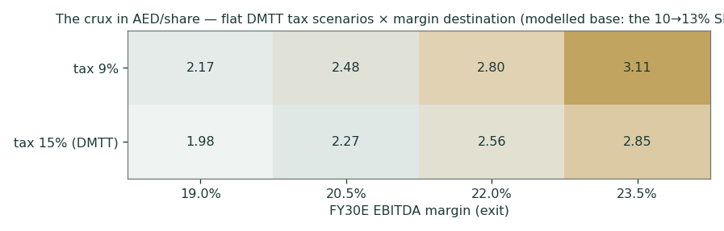
Figure 8 — the crux grid: the tax row-step and the margin column-walk, in AED per share.
Leg 3 — the cash-conversion stress: can the FY26E cash flow carry its obligations?
EAND-style second test, in Burjeel’s own units — the DSO. FY26E revenue of AED 6,089 mn means each 15 days of DSO is AED ~250 mn of working capital. Against the FY26E cash obligations — the ~AED 138 mn modelled dividend plus ~AED 152 mn of net bank interest ≈ AED 290 mn:
FY26E DSO scenario | ΔWC vs base | FCFF (AED mn) | Cover of dividend + interest
120 days (normalizing) | −250 (release) | 607 | 2.09×
135 days (base — flat) | — | 357 | 1.23×
150 days (deteriorating) | +250 (build) | 107 | 0.37×
At DSO 150 the year’s free cash flow covers barely a third of the dividend-plus-interest bill — the rest is borrowed at 7.00%. This single table is the bear case, the sukuk price, and the FY25 dividend cut, unified.
Leg 4 — what the bull is actually made of
Bull component | Δ AED/sh | The observable that unlocks it
Tax lands at 9% (exclusion) | +0.15 | the FY2025 DMTT return, filed 2026–27
Margin reaches 23.5%, not 22.0% | +0.29 | quarterly margin prints through 2027; oncology mix stabilizing
Growth runs 13→10% (KSA scale) | +0.35 | a signed Saudi PPP hospital or equivalent anchor by end-2027
Terminal g 3.0% (KSA duration) | +0.15 | same anchor — Saudi turns a UAE story into a GCC one
Bull DCF | 3.58 (= 2.64 + 0.94) | all four together — a conjunction, not a single event
Saudi Arabia carries the growth and terminal legs jointly (~AED 0.50): today it is 29 physiotherapy centres, two day-surgery and two radiation-oncology units under build, the PhysioTrio acquisition and the Keralty JV — deliberately asset-light and, per the segment table, still loss-making inside Medical Centers. The base case prices exactly that and nothing more.

1.8 Macro and country — rates, the peg, the payer state, and the sourced cost of capital
The AED peg makes UAE rates a USD derivative: the CBUAE base rate has tracked the Fed’s hold at 3.63% since June, 3-month EIBOR prints 3.66–3.90%, and the Ministry of Finance’s dirham T-Sukuk programme — the study’s risk-free source, since no 10-year AED bond exists — cleared its ~7-year Feb-2033 tranche at 3.78–3.90% through H1-2026. On the fiscal side the 9% corporate tax (2024) is in the numbers and the 15% DMTT (2025) is the open crux with its own section. The payer state is the industry’s real macro: Abu Dhabi’s DoH sets tariffs and runs Thiqa (nationals) through Daman alongside mandatory private cover; the Northern Emirates’ basic-cover mandate (Jan-2025) structurally expands the insured pool; and the UPP centralizes drug procurement — each a revenue tailwind that is simultaneously a price-power constraint, which is why no pricing-led growth appears anywhere in the build. The market’s own verdict on Burjeel’s credit closes the loop: 7.000% for five-year money, 310bp over the sovereign, at a BB+/Ba2 rating with a 3.2× book.
Sourced market input | Value | Date | Source
CBUAE Base Rate (MC carry anchor) | 3.63% | 17-Jun-2026 (held) | CBUAE, tracked in the live market profile
3M EIBOR | 3.66–3.90% | Jul-2026 | CBUAE via market data
AED 7yr T-Sukuk Feb-2033 (DCF rf) | 3.78–3.90% | H1-2026 auctions | UAE MoF T-Sukuk programme
US 10Y (peg-parity check) | ~4.55% | Jul-2026 | US Treasury
UAE ERP (mature + CRP) | 4.23% + 0.66% = 4.99% | 5-Jan-2026 | Damodaran original country-risk file
BURJEEL USD 500mn 5yr sukuk | 7.000% profit rate | Jun-2026 | company announcement; BB+/Ba2; 3.2× book; $250m refis DIB loan
Dr. Sulaiman Al Habib | EV/EBITDA ~24×, P/E ~31× | Jul-2026 | aggregator (multiples.vc/FactSet) — flagged
Dallah / Care (Saudi tier-2) | P/E ~25× / ~20× | mid-2026 | aggregator/broker — flagged
WACC build | AED basis (primary) | Peg-parity basis
Risk-free | 3.90% (7yr T-Sukuk) | 4.75% (UST 10Y + Aa2 spread)
ERP (Damodaran original) | 4.99% | 4.99%
Beta | 1.00 (documented default) | 1.00
Cost of equity | 8.89% | 9.74%
Kd pre-tax (marginal, sukuk) | 7.00% | 7.00%
Weights E / D | 75% / 25% | market equity / borrowings 1,918
WACC | 8.16% | 8.80%
The beta, documented: a regression was genuinely attempted and failed the usability gate — no daily FADGI (ADX General) series was reachable this session, and aggregator betas (0.21–0.80) are mutually inconsistent on a ~11–15% float. Default 1.0, grid 0.8–1.3 published in §1.9. A pointed observation the model keeps: the market charges Burjeel 310bp over the sovereign for five-year money — a credit read that beta 1.0 arguably under-prices; the bear case runs the WACC 50bp higher for exactly this reason.
Three conventions, stated so no reader has to reverse-engineer them: (i) the AED 210 mn finance line is NET — roughly 255 gross (legacy facilities plus the 7.00% sukuk and lease interest) less ~45 of interest income on the cash pile, including the ~AED 918 mn of undeployed sukuk proceeds; (ii) WACC weights use the 31-Dec-2025 balance sheet — post-sukuk weights would cut the WACC ~20bp, inside the published grid; (iii) the Kd tax shield is held at the 15% marginal rate (the top-up binds at the margin) while the effective-average path applies to EBIT — deliberately conservative on the rate side.

1.9 Sensitivity — the rate, the growth, the margin, the tax, and the beta
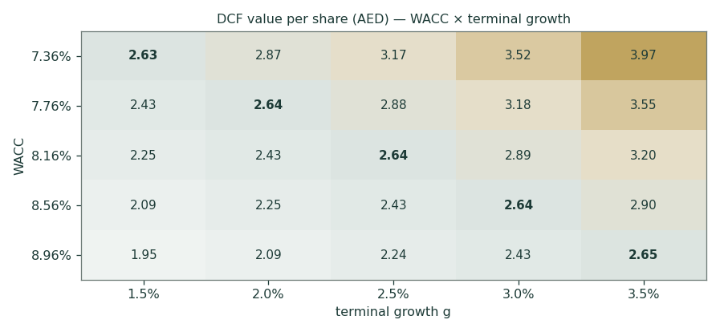
Figure 9 — DCF per share across WACC × terminal growth; the base cell bolded.
Beta grid (DCF per share at base drivers): β 0.8 → 3.13 · 0.9 → 2.87 · 1.0 → 2.64 · 1.1 → 2.44 · 1.2 → 2.27 · 1.3 → 2.11. The valuation is duration-heavy (TV 83% of EV), so the rate row matters more than any operating driver except the margin itself; the tax and margin ladders live in §1.7, and the maintenance-capex honesty check (§1.1) is worth ~AED 0.25 if the guided 2.5% proves optimistic.

2 Technical and price structure
Indicator | Value | Reading
Price vs SMA 20 / 50 | 1.131 / 1.090 | below / above — the short stack is mixed
Price vs SMA 100 / 200 | 1.127 / 1.228 | below / below — the long base still caps the chart
RSI (14) | 49.7 | neutral — no stretch either way
MACD (12,26,9) | 0.0060 / 0.0121 / -0.0061 | negative histogram — bearish momentum
52-week range | 1.00 – 1.57 | spot sits 19% up the range; all-time low 1.01 printed 07-Apr-2026
YTD / 1-year move | -15.3% / -24.5% | the 2026 de-rating is the entry point this study prices
vs IPO (2.00) / vs ATH (3.55) | -44% / -69% | listed Oct-2022; high 27-Nov-2023; max drawdown −71%, current −68%
Realized vol (252d) | 30.8% | wide-cone regime — consistent with the Monte-Carlo width in §3
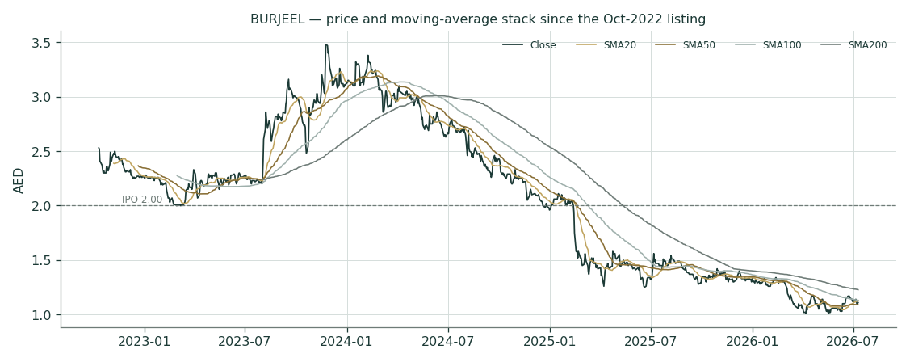
Figure 10 — price and the moving-average stack since listing.
Structure: after the 2023 spike to 3.55 the stock spent 2024–26 grinding into a long base, printing its all-time low of 1.01 this April before reclaiming the short averages. 1.00–1.05 is the shelf the April low built; 1.20 is the near overhead reference where the spring rallies stalled; 1.30–1.35 gates the post-2024 range above. A caution that outranks any indicator: the genuine float is ~11–15% (IPO floated 11%; VPS ~70%, IHC ~15%), and a 10% buyback was announced against it in March 2025 with undisclosed execution — on a float that thin, technical signals are suggestions, price gaps are structural, and both entry and exit are thinner than the fundamentals discussion implies. Volume, not pattern, is the tell: sustained turnover above the 2026 average alongside a DSO improvement is the combination worth respecting.

3 Monte Carlo — a probabilistic price map
This section answers a different question from §1: not “what is it worth” but “where can the price actually be in 20 and 60 trading sessions”. The engine is the production carry-anchored YZ-HAR-t: 50,000 paths, seed 42, drift = the money-market carry (CBUAE 3.63% less the 1.8% dividend yield), width = a bias-corrected HAR variance forecast scaled by the UAE panel’s fitted width calibration (×1.049), shape = Student-t(10) — both read from the live market profile, refit 11-Jul-2026 on the 14-name UAE panel. The one-month reversal signal is OFF for this market (ablated on evidence at the panel level), so the centre is pure carry: the fundamental gap in §1 never enters the drift. For scale: the model’s 60-session σ of 17.6% annualizes to ~36%, modestly above the trailing realized 30.8% — the cone is deliberately a touch wider than recent history, which is what the fitted width calibration and the t-tails are for.
The probability read (T+60)
P(price above spot) | 50.8%
P(close > +5%) / P(close < −5%) | 39.0% / 36.6%
P(close > +10%) / P(close < −10%) | 28.7% / 25.1%
Median (drift = carry) | 1.11 (+0.4%)
90% interval | 0.84 – 1.49 (−25% / +34%)
Continuous factors. Risk-free carry +3.63% annual (CBUAE base rate, held 17-Jun-2026) · dividend yield −1.80% · net drift +0.42% over 60 sessions (log 0.0042) · σ(60d) 17.6% · tail t(10) × 1.049 width.
Discrete factors inside the windows. H1-2026 results (~12-Aug-2026) fall AFTER the T+20 grade date (07-Aug) but inside the T+60 window — the single largest known discrete event the 60-day distribution must carry, and a triple test in one print: the margin trend, the DSO line, and the first UPP-clean growth comparison. Also inside T+60: any Saudi announcements, the seasonal Q3 volume recovery, buyback-execution disclosure, and index-flow noise on a thin float. The FY2025 DMTT return (the tax crux) resolves on the fiscal calendar, not inside these windows.
Percentile map
T+20 | P1 0.86 | P5 0.94 | P10 0.98 | P25 1.04 | P50 1.11 | P75 1.18 | P90 1.26 | P95 1.31 | P99 1.42
T+60 | P1 0.72 | P5 0.84 | P10 0.90 | P25 1.00 | P50 1.11 | P75 1.24 | P90 1.39 | P95 1.49 | P99 1.71
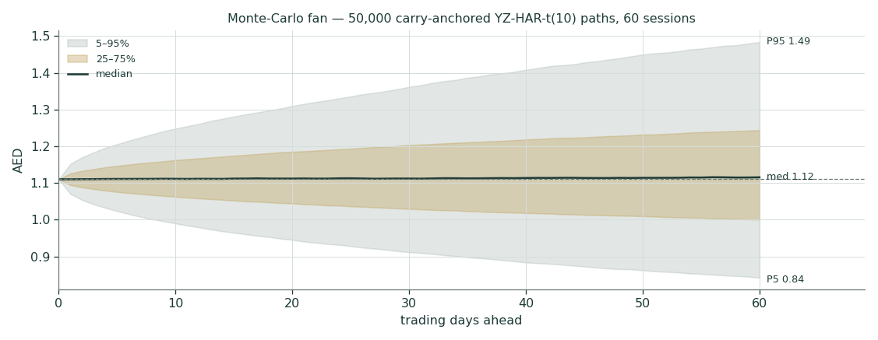
Figure 11 — the 60-session fan: 5–95% and 25–75% bands around the carry-anchored median.
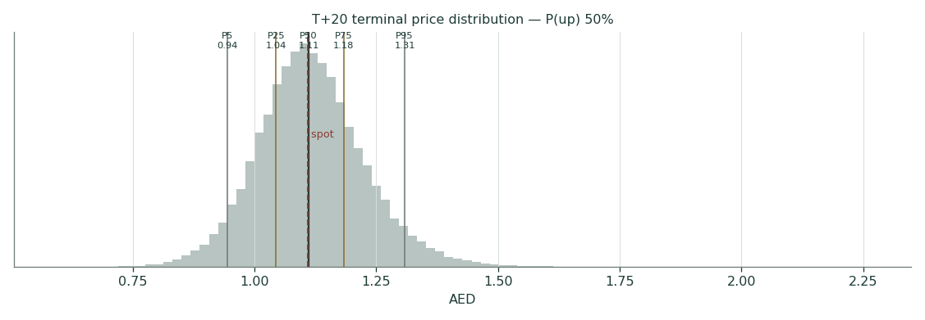
Figure 12 — T+20 terminal distribution (grades 07-Aug-2026).
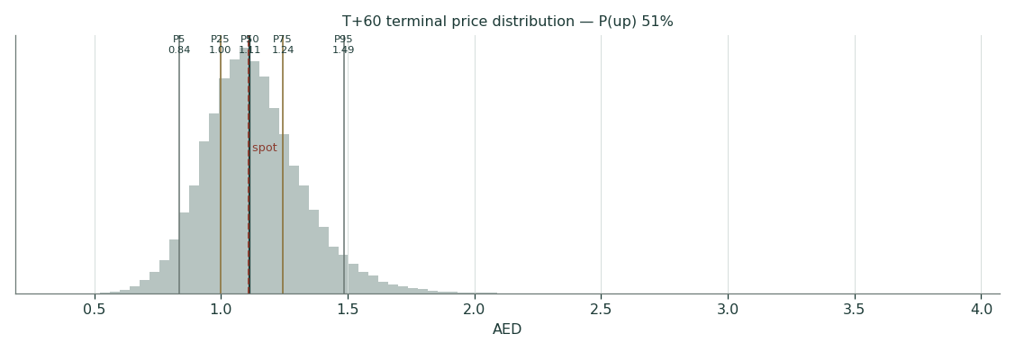
Figure 13 — T+60 terminal distribution (grades 02-Oct-2026).
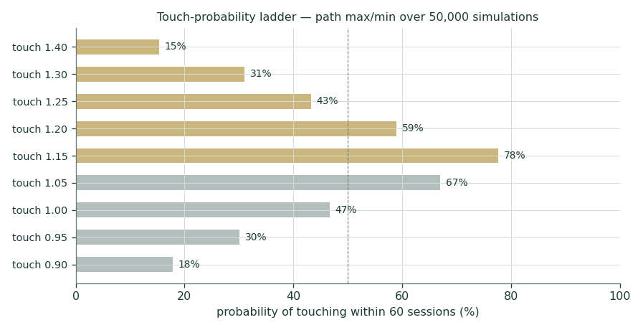
Figure 14 — touch probabilities within 60 sessions (path max/min over 50,000 simulations).
Engine and calibration transparency. Before this forecast was allowed to exist, the same engine was walked forward over BURJEEL’s own history: 11 non-overlapping 60-session windows since 2023, each scored against a carry-anchored random-walk benchmark on scale-normalized CRPS. Verdict: PARITY — pooled skill +0.85%, 90% CI [-1.69%, +2.53%], robust across bootstrap block sizes {2,3,4}; interval coverage 50/80/90 = 46/91/91% (one 90%-band miss in eleven), PIT mean 0.32. The market gate — the 14-name UAE panel this profile was fitted on — also reads PARITY (+0.49%). Parity tier means exactly what it says: the distribution is calibrated and market-panel validated, with no demonstrated single-name edge over the carry benchmark. The three-panel calibration figure publishes with the Ledger entry. Both cohorts below are frozen at publication and will be graded against these exact percentiles — never rewritten — on 07-Aug-2026 (T+20) and 02-Oct-2026 (T+60), then rolled forward under whatever engine is then current.

4 Comparison of the lenses, and a verdict
Line the five reads up and the market’s position becomes legible. Spot 1.11 sits just BELOW the weighted bear case of 1.14: the price assumes the margin never leaves the 18s, the full 15% is assessed with no substance relief, receivables stay at 135 days, Saudi stays a rounding error, guidance keeps its two-for-two miss record — and then takes a few fils more off. The normalized-earnings lens (1.49) says the market pays ~12.6× clean forward earnings for double-digit guided growth — cheap unless the earnings are not cash, and §1.6’s forensics show AED 649 mn of FY25 operating surplus that never arrived as cash. The DCF (2.64) is the honest capitalization of a margin recovery to below the company’s own 2023 level, taxed on the Pillar-Two mechanics rather than the headline, at a pegged-currency discount rate; it is not the expectation, it is the prize if the recovery is real and collected. The dividend lens (0.56) is the floor of what has actually been promised — and FY25 underpaid even that promise. Fair value is a range, not a point:
AED 1.14 – 2.35, weighted central 1.85 — conditional, above the bear leg, on cash conversion: the DSO print is the referee, and the H1-2026 release (~12-Aug) is the next whistle.

5 Catalysts to watch
When | Event | Why it matters
~12-Aug-2026 | H1-2026 results | the triple test: margin trend, the DSO line, first UPP-clean comparison; inside the T+60 window
Q3-2026 prints onward | UPP lapping | reported and economic growth reconverge; the ~4.6pp optical drag disappears
2026–27 filing window | The FY2025 DMTT return | the tax crux: exclusion/safe-harbour persistence = +AED 0.15 vs the path; a full flat-15% assessment − 0.09
Any 2026 statement | Buyback execution / treasury disclosure | up to 10% announced Mar-25 against an ~11% IPO float — the float math changes everything technical
H2-2026 | Post-sukuk balance sheet | where the AED 1.84 bn landed: refinancing vs growth; leverage vs the 2.5× ceiling
End-2027 horizon | A signed Saudi PPP hospital | activates the bull’s growth and terminal legs (~AED 0.50/share); until then KSA is priced as-is
Feb–Mar 2027 | FY26 results + dividend declaration | payout vs the stated 40–70% policy — a second sub-40% year makes the policy fiction
Ongoing | CBUAE / Fed path | the carry anchor and the WACC row of the grid both move with it

6 Reading the probability zones
The §3 distribution is a 3-month price map, not a fair-value opinion. Read it as zones, each with its trigger:
T+60 zone | Probability | What being there would mean
below 0.95 | 16.8% | bear-case tape: a discrete negative (H1 miss, insurer, DSO worse) — carry cannot produce it alone
0.95 – 1.05 | 18.8% | nothing happened: the base persists, volatility noise only
1.05 – 1.20 | 32.1% | constructive drift: H1 in line, DSO stable — still explainable by vol
1.20 – 1.35 | 19.5% | a discrete positive is being priced: margin print, Saudi signing, or flows
above 1.35 | 12.7% | the re-rating started: needs a named cause; check the falsifier table
Touch level (any time in 60 sessions) | vs spot | T+20 | T+60
1.30 | +17.1% | 8% | 31%
1.25 | +12.6% | 18% | 43%
1.20 | +8.1% | 34% | 59%
1.15 | +3.6% | 61% | 78%
1.05 | -5.4% | 46% | 67%
1.00 | -9.9% | 22% | 47%
0.95 | -14.4% | 9% | 30%
0.90 | -18.9% | 3% | 18%
The touch ladder is the honest version of “can it reach X”: a 1.20 touch inside 60 sessions is a 59% event and a 1.00 touch is 47% — this is what a wide-cone, thin-float name looks like, and none of it embeds the §1 upside. That is the point.

7 Caveats, and what would change our mind
Named, dated, falsifiable:
# | Trigger | Consequence for this study
1 | Group occupancy below 68% for two consecutive quarters while beds grow (first test ~12-Aug-2026) | the operating-leverage leg dies; the margin glide loses its mechanism
2 | DSO printed below 120 days in any FY2026 statement | the bear thesis and Expert 2’s cap break — the cash was real; the central migrates toward the DCF
3 | The FY2025 DMTT return granting the initial-phase exclusion (2026–27) | +AED 0.15/share vs the modelled path (a flat-15% assessment costs −0.09); Expert 3’s tree reweights
4 | Net leverage above 2.5× in any 2026 statement | the one credibility anchor guidance still holds, gone; bear WACC becomes base
5 | A signed Saudi PPP hospital by end-2027 | the asset-light-only assumption breaks upward — the bull’s growth and terminal legs activate
6 | FY2026 payout again below the 40% policy floor (declared Feb–Mar 2027) | the policy lens re-anchors on paid reality; the DDM bear becomes its base
7 | Q2/Q3-2026 underlying margin below ~18% | the recovery-not-leap premise fails; every lens re-bases on the FY24–25 plateau
Structural caveats, each named where it bites: Q3-25 is a derived residual (flagged in §1.6); FY24 beds are derived from the FY25 net-adds disclosure; the segment corporate line is solved as a residual and shown; the Al Shahama reclassification (Dec-23) moved a unit from Medical Centers to Hospitals, so segment growth rates straddle a seam; the asset count changed methodology between the FY25 release (115) and Q1-26 (89) — a counting change, not disposals, with hospitals and beds consistent across both; the beta is a documented default after a failed regression; peer multiples are aggregator-sourced and flagged; and D&A exceeding capex through the forecast window is a modelling honesty the bear case partly carries. Added in this reissue: the 10→13% tax path is a mechanics-anchored judgment — the carve-out sizing is not disclosed, and the FY25 top-up accrual is cited from the fact-check pending line-item re-verification against the Annual Report; the FY25 company-defined FCF prints as 451 (results release) and 447 (May-2026 investor presentation) — immaterial, both stated; and an ADX notice counts the network at 111 assets — a third count alongside the 115 (FY25 release) and 89 (Q1-26), with hospitals and beds consistent across all three.

Appendix A — Financial statements (4 reported, 5 modelled)

A.1 Income statement — official history, then the model
AED mn | FY22 | FY23 | FY24 | FY25 | FY26E | FY27E | FY28E | FY29E | FY30E
Revenue | 3,924 | 4,535 | 5,010 | 5,486 | 6,089 | 6,759 | 7,435 | 8,104 | 8,753
EBITDA — reported | 878 | 1,033 | 908 | 1,089 | — | — | — | — | —
EBITDA — ex-one-offs | 878 | 1,018 | 959 | 1,017 | 1,175 | 1,365 | 1,561 | 1,751 | 1,926
margin (ex-one-offs) | 22.4% | 22.4% | 19.1% | 18.5% | 19.3% | 20.2% | 21.0% | 21.6% | 22.0%
D&A | n/d | 352 | 360 | 386 | 426 | 466 | 506 | 543 | 578
Net finance costs | n/d | 141 | 149 | 162 | 210 | 210 | 210 | 210 | 210
Tax | — | — | 39 | 38 | 54 | 76 | 101 | 125 | 148
Net profit | 355 | 540 | 360 | 503 | 485 | 613 | 744 | 873 | 990
attributable (owners) | n/d | 516 | 347 | 475 | 458 | 579 | 703 | 824 | 935
EPS (AED) | n/d | 0.099 | 0.067 | 0.091 | 0.088 | 0.111 | 0.135 | 0.158 | 0.179
FY22–25 are the company’s official releases; the ex-one-offs line uses the company’s own basis (FY23 excludes fair-value gains later divested; FY24 adds back the FY23 bonus payments; FY25 excludes the AED 72 mn Medeor gain). FY24–25 were the first corporate-tax years. Forecast tax is the 10→13% Pillar-Two effective path (§1.7); the flat 15% lives in the bear case.

A.2 Balance sheet — condensed house layout
AED mn | Dec-2024 | Dec-2025
Interest-bearing borrowings | 1,208 | 1,918
Cash & equivalents | n/d | 281
Net debt — ex leases | ~1,180 | 1,637 (1.8×)
IFRS-16 lease liabilities | n/d | 1,191
Net debt — incl leases | n/d | 2,828 (2.6×)
Trade receivables | ~1,690 (DSO 123d) | 2,057 (DSO 135d)
Trade payables | n/d | 738 (DPO 211d)
Total equity / of which NCI | n/d | 2,165 / 68
Debt maturities at 31-Dec-25 (pre-sukuk, AED mn): 2026: 83 · 2027: 346 · 2028: 414 · 2029: 526 · 2030: 340 · 2031+: 208. Post-period event: the Jun-2026 USD 500 mn (AED 1,836) 5-year sukuk at 7.000% — USD 250 mn refinances the DIB facility, USD 250 mn funds growth; gross debt and cash rise together, net debt unchanged until deployed.
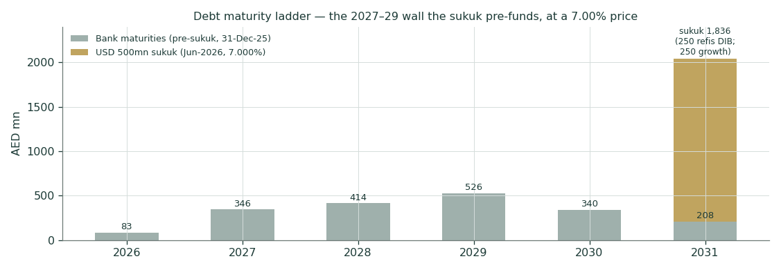
Figure 15 — the maturity wall the sukuk pre-funds, at its 7.00% price.

A.3 Cash flow, the FCF framings, and where the profit went
AED mn | FY23 | FY24 | FY25
Net cash from operating activities | n/d (+57.9% YoY) | ~499* | 402
Capex (maintenance + growth) | n/d | n/d | (585)
Company-defined FCF conversion | 52% | n.d. | 41%
Dividends paid | (160) | (170) | (120)
*FY24 operating cash flow derived from the FY25 disclosure (“OCF −19.5%”). Two FCF framings, both stated: the company’s definition (EBITDA − maintenance capex − ΔWC) gave AED 451 mn in FY25 — a 7.8% yield on the market cap — while the model’s all-in FCFF (after growth capex and leases) gives AED 357 mn for FY26E, a 6.2% yield. The gap IS the growth programme. The FY25 walk in §1.6 shows AED ~649 mn of gross operating surplus absorbed before cash — the single number that unifies the sukuk price, the dividend cut, and the discount to peers.

Appendix B — Peers, sector, risks, and the research register

B.1 Peers and the sector frame
Name | Market | EV/EBITDA | P/E | EBITDA margin | Note
Burjeel — this study | ADX | ~8.4× | ~12.6× | 18.5% | at spot 1.11; the discount this study prices
Dr. Sulaiman Al Habib | Tadawul | ~24–34× | ~31–35× | ~26% | the premium: ROE ~33%, deep float (Bloomberg/U Capital May-24; multiples.vc Jul-26)
Dallah Healthcare | Tadawul | ~22–26× | ~25–31× | high | Riyadh expansion cycle (U Capital May-24; MarketScreener Jan-25)
Mouwasat | Tadawul | ~18–19× | ~26–27× | ~30%+ | Eastern-Province leader; FY24 growth +6.4% (U Capital; MarketScreener)
Al Hammadi Holding | Tadawul | ~17.5× | ~22–25× | moderate | Riyadh capacity build (Bloomberg/U Capital May-24)
Middle East Healthcare | Tadawul | ~13× | ~28× | low-teens | the cheapest verifiable comp — the floor the 11.5× discounts from
National Medical Care / Fakeeh | Tadawul | n/d | ~20× / elevated | n/d / 12.9% | delivery benchmark / the cautionary tale (Sahm May-25)
PureHealth | ADX | n/m | n/m | n/m | payer + provider aggregate — not a clean comp
Marks are broker/Bloomberg- and aggregator-sourced, dated per row, and flagged; none is an input beyond the 9.5–13.0× band judgment. The pattern that matters: delivered margin buys the multiple — Al Habib’s 26% earns 24×+, MEH’s low-teens margin earns 13× — and 11.5× is a discount to that verifiable floor. Burjeel’s path from 8× to the floor and beyond runs through the margin print, not the story.

B.2 The sector and the payer machine
UAE private healthcare compounds on three engines: population growth with an ageing expatriate cohort; mandatory insurance — Abu Dhabi and Dubai long-standing, the Northern Emirates’ basic cover from 1-Jan-2025 structurally expanding the insured pool; and medical inflation (2026 gross trend ~11% MEA per the global insurer surveys) — a tailwind that is simultaneously a cost stress for any operator without pricing power against payers. And none of them has pricing power: Abu Dhabi’s DoH sets the tariff frame and runs Thiqa (nationals) through Daman alongside the private schemes; the UPP centralizes drug procurement (margin-dilutive ~1–2% at EBITDA, optics-dilutive ~4.6pp on reported growth through mid-2026); a single insurer dispute restricted patient access for six months of 2025. The competitive map: PureHealth is the state-scale payer-provider aggregate (SEHA hospitals + Daman insurance); M42 is the Mubadala–G42 tech-health venture; Mediclinic Middle East and Aster hold the premium and mid-market Dubai franchises; NMC’s restructured estate competes on price. Burjeel’s lane — private quaternary complexity in Abu Dhabi — is the most defensible and the most payer-exposed simultaneously. Saudi Arabia is the volume story: Vision-2030 targets lifting the private share of provision from ~25% toward 35%, the first hospital PPP (Al Ansar, Madinah) reached award only in 2025, and Burjeel’s entry is deliberately capital-light: 29 physiotherapy centres across 10 cities, the PhysioTrio acquisition (~$46 mn), two day-surgery and two radiation-oncology units under build, and the Keralty value-based-care JV. The option is real; the base case refuses to capitalize it.

B.3 Risk register
Risk | Mechanism | Where it is priced
Payer concentration | one emirate’s payer ecosystem dominates revenue; a single dispute cut access for six months of 2025 | bear margin path; §1.7 leg 3
Receivables credit | DSO 135 and rising; the receivable is the P&L until collected | the crux itself; ΔWC 22–24%
Guidance credibility | two revenue misses, one withdrawn margin promise | growth haircut; margin capped at 22.0%
Leverage & rates | 7.00% marginal money against an 18.5% margin business | Kd; bear WACC +50bp
Key-man & governance | founder became CEO + Chairman Feb-2026 after both co-CEOs exited within three months | unpriced — flagged; no discount is honest, only disclosure
Float & liquidity | ~11% IPO float; 10% buyback announced against it, execution undisclosed | §2; technical reads demoted
Regulatory | DMTT scope; DoH tariff resets; UPP scope expansion | §1.7 ladders
Mix | oncology consumables outgrowing surgery — structurally lower margin | the 22.0% ceiling argument

B.4 Information Sweep Register — four rings, dated, negative searches included
Ring | Category | Class | Finding (condensed) | Source | Date
Global | Rate cycle | S | Fed held 3.50–3.75% (Jun-26, fourth hold); CBUAE 3.63% tracks; 3M EIBOR 3.66–3.90% | CBUAE / FOMC | Jul-26
Global | Medical inflation | B | 2026 gross trend +10.3% global, ~11.3% MEA | WTW Global Medical Trends | 2026
Global | Sector multiples | C | premium GCC hospital tier ~24× EV/EBITDA; global 10–14× | aggregators — flagged | Jul-26
Country | UAE macro | B | IMF 2026: GDP +3.1%, CPI ~2.5% | IMF WEO | Apr-26
Country | DMTT mechanics | S | 15% top-up on POST-SBIE excess profit only; carve-outs 9.4%/7.4% (2026) → 5%/5% (2033); TCSH deems top-up zero for FYs starting pre-2027; UAE QDMTT OECD-qualified Aug-25 | CD 142/2024; MD 88/2025; OECD; PwC/EY | 2025–26
Country | Mandatory insurance | B | Northern Emirates basic cover from 1-Jan-2025 | UAE gov / insurers | 2025
Country | AED risk-free | S | no 10yr AED bond; ~7yr T-Sukuk 3.78–3.90% | UAE MoF auctions | H1-26
Country | ERP | S | UAE 4.99% (4.23% mature + 0.66% CRP) | Damodaran original file | 5-Jan-26
Industry | UPP | S | Aug-2025 net-basis medicine revenue; ~4.6pp optical drag Q1-26; 1–2% EBITDA dilution | company Q1-26 release | May-26
Industry | Insurer dispute | S | major Abu Dhabi insurer access restriction May–Nov-2025; resolved 1-Nov-2025 | company / press | Nov-25
Industry | Saudi PPP | C | private share 25→35% by 2030 target; first hospital PPP (Al Ansar) awarded 2025; pace is sovereign-speed | MoH / press | 2025
Industry | Competitor map | C | PureHealth (payer+provider), M42, Mediclinic ME, Aster, NMC restructured; du-style price war absent | public filings / press | Jul-26
Industry | Peer numbers | S | EV/EBITDA: Al Habib 24–34× · Dallah 22–26× · Mouwasat 18–19× · Hammadi 17.5× · MEH 13× (floor); P/E: Al Habib 31–35× · Dallah 25–31× · Care 20× | Bloomberg via U Capital (May-24); MarketScreener (Jan-25); multiples.vc (Jul-26) | dated per row
Company | FY2023 officials | B | rev 4,535 (+15.6%); EBITDA 1,033 rep / 1,018 ex-oo (22.4%); NP 540/516 attr; occ 61%; div 160 | FY23 results release | 6-Mar-24
Company | FY2024 officials | B | rev 5,010 (+10.5%); EBITDA 908 rep / 959 ex-oo (19.1%); NP 360/347; occ 67%; 188 physicians added; div 170 (47%) | FY24 results release | 5-Mar-25
Company | FY2025 officials | B | rev 5,486 (+9.5%); EBITDA 1,089 rep / 1,017 und (18.5%); NP 503/475; occ 67%; div 120 (24%) | FY25 results release + MD&A | 4-Mar-26
Company | Quarterlies | D | Q1-25 1,274/181; Q2-25 1,403/306 (72 one-off); Q3-25 derived 1,420/320; Q4-25 1,389/282; Q1-26 1,339/201 | H1-25 + FY25 + Q1-26 releases | 2025–26
Company | Guidance record | S | FY24 guided mid-teens/23.5% → +10.5%/18.1%; FY25 guided mid-teens → +9.5%; high-20s mid-term guide withdrawn → low-20s | FY23/FY24/FY25 releases compared | Mar-24→Mar-26
Company | Dividend policy | S | stated 40–70% of NI; paid 30% → 47% → 24% — FY25 below the floor | FY24 release; AGM 17-Apr-26 | Apr-26
Company | Buyback & float | S | IPO floated 11% (Oct-22); 10% buyback announced Mar-25, OCF-funded; execution/treasury not separately disclosed — OPEN ITEM | company announcement / press | Mar-25
Company | Sukuk | S | USD 500mn 5yr at 7.000%, BB+/Ba2, 3.2× book; 250 refi DIB + 250 growth | issue announcement | Jun-26
Company | KSA build | S | 29 physio centres / 10 cities; PhysioTrio ~$46mn; 2 day-surgery + 2 radiation-oncology under build; Keralty JV; NO PPP hospital signed | company releases | 2024–26
Company | Governance | S | founder became CEO + Chairman Feb-2026; both co-CEOs exited Dec-2025 | company / press | Feb-26
Company | Pillar-Two accrual | S | FY25 total tax 38 on PBT 541 (ETR 7.0%) in the DMTT’s first year; small top-up accrued (~AED 6mn, fact-check-cited, pending AR line-item re-verification) — post-SBIE excess profit is small | FY25 FS / external fact-check | Mar-26
Company | FCF dual print | S | FY25 company-defined FCF: 451 (results release) vs 447 (May-26 investor presentation) — immaterial; both framings stated | PR / Investor Presentation | 2026
Company | Network third count | S | ADX notice: 111 assets (20 hospitals, 36 MCs, 30 physio, 15 pharmacies, 10 allied) alongside 115 (FY25 PR) and 89 (Q1-26) | ADX filing | 2026
Internal | Sourcing failures | S | SF-1: FY23 EBITDA first taken ≈830 vs official 1,033/1,018 — caught and fixed pre-publication; SF-2: peer multiples logged n/d while dated broker data existed — both logged to the Fundamental Driver Ledger | internal review | 12-Jul-26
Register validated: four rings closed · 27 rows · every row classed B/S/D/C · FS provenance company-official only · negative searches logged (buyback execution: searched, not disclosed — an open item) · two sourcing failures self-logged as SF rows · the sweep ran before §1.6 set a single driver, and the reissue re-ran it before resetting one.

Appendix C — The expert panel: three methods, shown workings, a falsifier each
Personas from the Testahil Expert Persona Library, labeled Expert 1/2/3 only. Each applies a genuinely different method; each states the assumption that would break it; then they argue.

C.1 Expert 1 — the operating-leverage analyst: value from beds
Step | Working | Result
Unused capacity | 1,784 beds × (78% − 67%) occupancy, at FY25 revenue per occupied bed-day | +AED ~795 mn revenue
Incremental margin | staff hired (adds fell 188→32), premises open → ~45% drop-through | +AED ~358 mn EBITDA
Look-through EBITDA | 1,017 underlying + 358 | AED ~1,375 mn
Ceiling value | 11.5× (the recalibrated base), same net-debt bridge | AED 2.33/share
Execution weight | × 60% (guidance record; payer realization squeeze) | working read AED 1.84
Falsifier: two consecutive quarters of group occupancy below 68% while beds grow — the thesis dies on utilization, not on price.

C.2 Expert 2 — the balance-sheet skeptic: cap equity at delivered cash
Step | Working | Result
Delivered cash | company-defined FY25 FCF | AED 451 mn
Required yield | de-risked 8% — between the sukuk’s 7.00% and the cost of equity
Cash-supported equity | 451 / 8% | AED ~5,638 mn → AED 1.08/share
The one-time kicker | DSO 135→120 releases ~AED 225 mn once | +~0.04/share, then re-rate
Working read: AED 1.08–1.35 — which is where the stock trades; the market IS Expert 2. Falsifier: DSO printed below 120 days in any FY2026 statement, or net leverage below 1.5× post-sukuk — either breaks the working-capital-drag cap.

C.3 Expert 3 — the regime-tree strategist: price the branches, not the argument
Tax | Margin | Saudi | p | DCF (AED/sh)
9% | margin lands 22.0% | PPP signed | 5.8% | 2.91
9% | margin lands 22.0% | asset-light only | 10.7% | 2.80
9% | margin stuck 19.0% | PPP signed | 4.7% | 1.64
9% | margin stuck 19.0% | asset-light only | 8.8% | 1.61
NaN% | margin lands 22.0% | PPP signed | 13.5% | 2.75
NaN% | margin lands 22.0% | asset-light only | 25.0% | 2.65
NaN% | margin stuck 19.0% | PPP signed | 11.0% | 1.54
NaN% | margin stuck 19.0% | asset-light only | 20.5% | 1.51
Probabilities: DMTT applies 0.70 / exclusion 0.30; margin lands ≥21.5% by FY28 0.55 / stuck 0.45; PPP signed by end-2027 0.35 / asset-light-only 0.65 — each leg’s probability is disciplined by the guidance record in §1.6. Probability-weighted value: AED 2.20. Falsifier: the FY2025 DMTT return — that single document reweights the whole tree by ~±AED 0.17.

C.4 Cross-examination
Expert 2 attacks 1 and 3 at the same joint: operating leverage on paper is leverage on receivables until collected — filling beds at 135-day terms just grows the receivable faster, and the FY25 scissors (profit +39.5%, cash −19.5%) is exactly that mechanism in the audited numbers. Expert 1’s rejoinder: occupancy-led EBITDA carries ~45% incremental margins, high enough to fund the WC build internally from FY2027 — and the FY25 dividend cut, read charitably, is management choosing to fund the receivable rather than borrow more at 7%. Expert 3 absorbs both by refusing to pick: the branches are priced, the record sets the weights.

C.5 The three in one room
Force a single number from the panel and the geometry does it: Expert 1’s 1.84 and Expert 3’s 2.20 bracket the study’s weighted central (1.85) from either side, while Expert 2’s 1.08–1.35 sits on spot and explains why the market pays it. The panel’s midpoint is not a coincidence — all three price the same three observables (the DSO, the margin print, the tax return) with different machinery, and the machinery agrees to within a dirham-tenth everywhere except on how much credit unexecuted guidance deserves.

C.6 Reading the divergence
The spread between Expert 2’s cap (1.08) and Expert 1’s ceiling (2.33) is not model risk — it is the price of one variable: whether reported EBITDA converts to cash. Every dirham between spot and the central is a bet on the DSO line, which is why §5 puts the H1-2026 release first and why falsifier #2 is the study’s single most important sentence.

Disclosure & Disclaimer
1. No advice. This document is educational and analytical commentary. It is not investment advice, not a recommendation, not an offer or solicitation to buy or sell any security, and not directed at the circumstances of any person.
2. No licence. The preparer is not licensed or registered with any securities regulator in any jurisdiction (including the FRA, SCA and CMA), holds no advisory or brokerage authorisation, provides no consultancy, manages no client money, and accepts no fees, funds or clients.
3. Sources. Company figures are Burjeel Holdings’ own published disclosure — the FY2023 results release (6-Mar-2024), the FY2024 results release (5-Mar-2025), the H1-2025 results release (6-Aug-2025), the FY2025 results release and MD&A (4-Mar-2026), the Q1-2026 results release (6-May-2026), the AGM notice, and ADX filings — via burjeelholdings.com and adx.ae. Market data is the uploaded ADX price series. Macro and rate anchors are cited inline and in §1.8. Peer multiples marked aggregator-sourced are exactly that, and are flagged. Q3-2025 figures are derived residuals, flagged where used.
4. Judgment. Every forward-looking input — growth, margins, capex, working capital, tax scenarios, the cost of capital, terminal growth, multiples, scenario probabilities and lens weights — is the preparer’s judgment, flagged as such, and logged where unsourced to the public Fundamental Driver Ledger.
5. Risk. Securities prices can fall as well as rise; ranges and probability distributions in this study are model outputs, not guarantees; past calibration (including a PARITY verdict) is no assurance of future accuracy. Anyone considering an investment should consult a licensed financial advisor.
6. Position. Testahil publishes under brand only, with no personal byline. As of the study date the preparer holds no position in BURJEEL and has received no compensation from the company, its shareholders or any related party. The Calibration Ledger is append-only: this study’s T+20 and T+60 cohorts will be graded publicly against the exact percentiles printed here.
TESTAHIL · testahil.com · distributions, not tips · © 2026

