Testahil · Independent Valuation Study — Educational Analysis Not investment advice

Independent Valuation Study — Educational Analysis
Cleopatra Hospitals Group S.A.E. (EGX: CLHO)
Fundamental analysis · Technical analysis · Monte Carlo simulation — one integrated read
Anchor: EGP 16.31 (2026-07-12 close) · 1,449.4 mn shares · market cap ~EGP 24bn · enterprise value ~EGP 27.2bn · Egypt’s largest private hospital group — 14 facilities, ~880 operational beds (Q4-2025) heading to ~1,320 by 2027, across Greater Cairo. Listed on the EGX since June 2016.
READ FIRST — what this is, and what it is not. This is an educational valuation study, not investment advice, not a recommendation, and not a price target. It presents fair-value ranges and a probability distribution, never a “buy”, “sell”, “hold”, rating or target price. The preparer is not licensed by the Egyptian Financial Regulatory Authority or any other securities regulator, and may hold a position in the security discussed. Figures are model outputs under stated assumptions and can be wrong. Historical financials are the company’s own disclosure (FY2023–FY2025 and 1Q2026 earnings releases). Do your own work and consult a licensed adviser before making any decision.

The company
Cleopatra Hospitals Group is the largest private hospital operator in Egypt by bed count and revenue, running seven hospitals — Cleopatra, Cairo Specialized, Nile Badrawi, Al Shorouk, El Katib and the two newest builds, Cleopatra October and Cleopatra El Tagamoa — alongside five polyclinics and the Bedaya IVF and fertility centre, roughly fourteen facilities clustered across Greater Cairo. It makes money the way a hospital network does: patients (and, increasingly, insurers and corporate contracts) pay for outpatient consultations, surgeries, inpatient stays, emergency care, catheterizations, diagnostics and IVF cycles, with revenue a function of case volume multiplied by the average price per case. Its competitive moat is hard to replicate quickly — prime real estate in a supply-starved capital, accredited clinical brands built over decades, scale in procurement and physician networks, and, since 2024, GAHAR accreditation that positions the group to contract with Egypt’s new Universal Health Insurance system as it rolls out. The group has been compounding fast, with revenue rising from about EGP 2.6bn in 2022 to EGP 7.2bn in 2025 (a third of that growth in the last year alone) while adding two greenfield hospitals that lift capacity by some forty percent. Ownership sits with two healthcare-focused blocks — Care Healthcare (32%) and MCI Healthcare Partners (31%) — with a 37% free float, and management has publicly flagged that the shares trade at a steep discount to what comparable regional beds and earnings command, and that it is “reviewing the options available to maximise value.”
Headline
Where fundamentals point. Four independent lenses — a two-stage rate-path DCF, relative multiples, normalized earnings power, and an EV-per-operational-bed transaction lens — produce a weighted central estimate of about EGP 9.21 per share, within a bear-to-bull span of roughly EGP 6.51 to EGP 11.05. Spot at EGP 16.31 sits about 44% above that central point and comfortably inside the span — CLHO screens as fairly-to-slightly-fully valued on the base case, with the distribution of outcomes unusually dependent on one macro variable.
The crux. This is, more than most equities, a bet on the Egyptian discount rate. The company grows revenue in the high teens to high twenties, converts to a ~30% adjusted-EBITDA margin, and is opening two hospitals — none of that is the swing factor. What moves the fundamental value most is whether the Central Bank of Egypt resumes cutting from today’s 19.50% toward its 7±2% target: at a crisis-level discount rate the DCF is worth about EGP 3.85; on a normalization path it is worth about EGP 7.17. The second-order swing is execution at the two new hospitals (Cleopatra El Tagamoa and the October build-to-suit) and the optionality from management’s strategic review.
Where the market clock points. Over the next three months the 50,000-path Monte Carlo (built only from CLHO’s own price behaviour, not the fundamental gap) puts the 25th–75th percentile band at roughly EGP 15.13–19.15, with the median near EGP 17.02 and a 60% chance of trading above spot. These are three genuinely different clocks and the study keeps them separate throughout.
Valuation summary
Lens | Method | Bear | Base | Bull | Weight
DCF — rate path | FCFF, two-stage Egyptian rate path (primary) | 3.85 | 7.17 | 8.12 | 40%
Relative | FY27E parent EPS × justified P/E band (15–23×) | 10.43 | 13.21 | 15.99 | 25%
Normalized | FY26E ex-net-interest parent profit × 15–22× | 6.97 | 8.37 | 10.23 | 20%
EV per bed | EGP 20–35mn × ~1,320 forward beds | 6.46 | 9.08 | 11.70 | 15%
Weighted central | Declared blend of the four lenses | 6.51 | 9.21 | 11.05 | 100%
Spot | EGX close, 2026-07-12 |  | 16.31

All values EGP per share. Bands are model outputs under stated assumptions, not price targets. Weights are declared, not fitted.
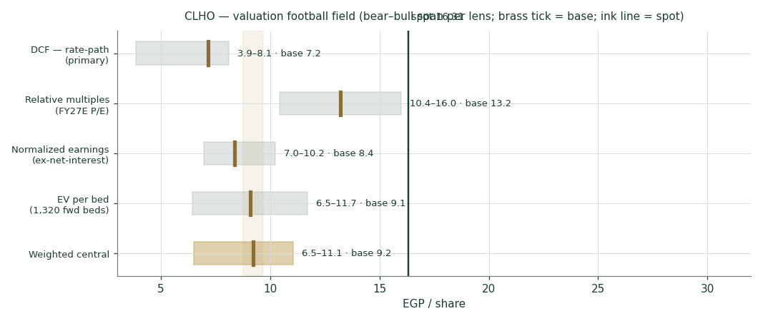
Figure 1 — valuation football field. Brass tick = base case; shaded bar = bear–bull span; gold band = weighted central ±5%; ink line = spot.
Company overview
What CLHO is and how it earns
CLHO is a pure-play private hospital operator. In FY2025 it served roughly 1.47mn cases and generated EGP 7,227mn of revenue at a 39.6% gross margin, a 30% adjusted-EBITDA margin (EGP 2,137mn) and EGP 824mn of net profit attributable to owners (EPS EGP 0.67). Revenue is volume × price across five service lines — outpatient consultations, inpatient stays, surgeries, emergency visits and catheterizations — plus IVF. The economic engine is capacity: operational beds, their occupancy, and the average revenue per case, which the company has been growing ahead of Egyptian inflation as case mix shifts toward higher-acuity work.
Facility | FY25 revenue (EGP mn) | 1Q26 revenue (EGP mn) | Share of 1Q26
Cleopatra Hospital | 2,461 | 623 | 31%
Cairo Specialized | 1,579 | 420 | 21%
Al Shorouk | 1,074 | 269 | 13%
Nile Badrawi | 1,057 | 240 | 12%
El Katib | 354 | 81 | 4%
Cleopatra October | — | 108 | 5%
Cleopatra El Tagamoa (new) | — | 154 | 8%

Source: CHG FY2025 and 1Q2026 earnings releases (official). CTH opened 27-Jan-2026 and reached 8% of group revenue within its first quarter.
Operating KPIs — volume × price
Core KPI (consolidated) | FY24 volume | FY25 volume | Δ% | FY25 ARP (EGP)
Paid outpatient consultations | 1,068,211 | 1,204,807 | +13% | 457
Inpatients | 66,859 | 75,107 | +12% | 21,266
Surgical procedures | 42,558 | 43,415 | +2% | 30,086
Emergency visits | 174,597 | 192,620 | +10% | 1,348
Catheterizations | 5,510 | 6,089 | +11% | 78,253

Case volumes and average revenue per case (ARP), FY2024→FY2025, from the company’s disclosure. Revenue growth is volume × price, with mix shifting toward higher-acuity inpatient and cath-lab work.
Capacity, growth and the balance sheet
The network runs ~880 operational beds as of Q4-2025 and is adding ~440 — 240 at Cleopatra El Tagamoa (CTH, launched January 2026) and 200 at the October build-to-suit — to reach roughly 1,320 by 2027 (a ~50% increase). Management guides revenue to "more than double by 2028 versus 2025." Growth has been funded partly with debt: net financial debt stood at EGP 2,993.7mn excluding leases (EGP 3,164.1mn including IFRS-16 leases) at end-March 2026, about 1.6× annualized EBITDA — modest, and guided lower as the new hospitals mature and capex normalizes. The two-clock caution applies: the multi-year "2× by 2028" ambition is a ceiling on the story, not a near-term figure, and this study anchors on a risk-adjusted ~12-month fair value while showing the fuller build in the scenarios. Built bottom-up from the disclosed bed-ramp curve and each service line’s own volume and ARP growth (§1.6, Appendix A.5), this study’s revenue path reaches 2.18× FY2025 by FY2028E — almost exactly management’s own guidance, and a materially better cross-check than an assumed top-down fade.
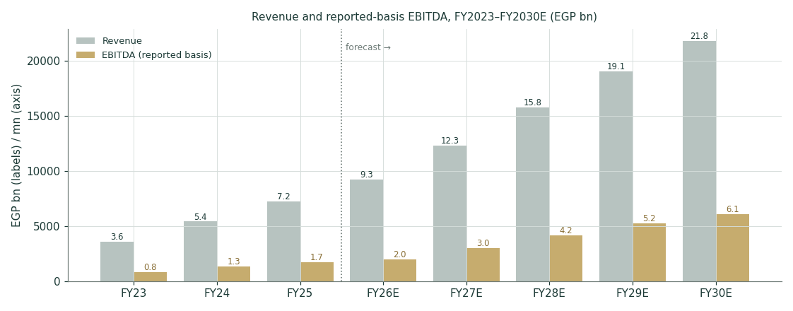
Figure 2 — revenue and reported-basis EBITDA, FY2023A–FY2030E (EGP bn). The forecast (right of the dotted line) is built bottom-up from disclosed volume/ARP data and the bed-capacity ramp, and lands close to management’s own “more than double by 2028” target.
1 · Fundamental valuation
CLHO is valued as an operating company. The primary lens is a discounted-cash-flow model on free cash flow to the firm, deliberately built in two rate stages to isolate the Egyptian-discount-rate crux; it is then cross-read against three independent lenses. No lens is a point estimate — each carries a bear/base/bull range, and the section closes with a declared weighting rather than a single number pretending to false precision.
1.1 · Discounted cash flow — the rate-path lens (primary)
Five years of explicit free cash flow to the firm are projected off the sourced FY2025 base and the disclosed 1Q2026 and April trajectory. The discount rate is the heart of the model. Egypt’s risk-free rate — the local-currency 10-year government yield — is about 22.55% today, and the bottom-up WACC at that level is roughly 25.1% (CDS-based ERP) to 28.3% (rating-based). But the Central Bank has begun an easing cycle, paused since mid-2026 only by regional conflict, and targets 7±2% inflation. The model therefore discounts years one and two at the spot WACC (25.1%) and years three to five, plus the terminal value, at a normalized-stage WACC of about 17.9% — the single most consequential judgment in the study, sensitized explicitly in §1.9.
The discount rate is rebuilt from the ground up. This study replaces the two-stage-flat WACC used previously — a convention the house protocol now retires — with a sliding schedule in which every explicit year is discounted at its own forward rate, and the terminal value is brought home on the identical cumulative factor as year five’s cash flow. One date, one price of time. Three further corrections are made, and they pull in opposite directions, which is the honest part: the beta is raised to the house-band floor of 0.80 (the regression returns 0.446, but it is statistically weak — R² of 5.9%, a 90% confidence interval spanning roughly 0.15 to 0.74 — and it sits below even a defensive-business prior); the sovereign default premium is netted out of the risk-free rate before a CDS-based equity premium is added on top, because charging it twice is why the EGP ten-year prints 22.55% rather than 4–5%; and the terminal inputs are constructed from the central bank’s own target rather than asserted. The net effect on the level is almost nil — 25.15% explicit, 17.87% terminal, against 25.23% and 17.80% before. The derivation is entirely different; the answer is not. That is worth saying plainly rather than dressing a rebuild as a discovery.
Discount-rate schedule | FY26E | FY27E | FY28E | FY29E | FY30E
Kd path (CBE easing calendar + audited spread) | 20.15% | 18.50% | 16.75% | 15.60% | 15.00%
Glide fraction (inherited from Kd, not invented) | 0.000 | 0.320 | 0.660 | 0.883 | 1.000
Forward WACC | 25.15% | 22.82% | 20.34% | 18.72% | 17.87%
Cumulative discount factor | 0.7990 | 0.6506 | 0.5406 | 0.4554 | 0.3864

The glide SHAPE is inherited from the Kd path, never chosen separately — so the easing calendar is one judgment, not two. The terminal value is discounted at 0.3864, the same factor applied to FY2030E’s cash flow, because a pound arriving on 31-Dec-2030 is worth the same whether it is labelled a forecast cash flow or a terminal value.
Cost of debt — the P&L number is a fiction, and the gate exists to catch that. Take CLHO’s interest expense and divide it by its average debt and you get 7.7%. That number is worthless, and any model built on it would be badly wrong. The reason is that most of CLHO’s economic interest has not been running through the income statement at all — it has been capitalised into projects under construction. The FY2024 audited accounts put the capitalised balance at EGP 386.2mn against EGP 40.6mn a year earlier: a flow of EGP 345.6mn in a single year, nearly three times the EGP 122.0mn that actually reached the P&L. Add it back and the true effective rate for FY2024 is (30.3%) — which corroborates the rate the company says it pays (28.90% on loans, disclosed in the same accounts) to within a hundred and fifty basis points. Only then is a cost of debt defensible. The currency question is settled by the same note: the USD, EUR and GBP monetary-liability columns are all nil. Every pound of borrowing is EGP-denominated — no blend is available, and none is required; the Group’s only FX exposure is asset-side cash. The adopted Kd of 20.15% is today’s CBE lending corridor plus CLHO’s own audited spread of sixty-five basis points, a spread that holds at two independent year-ends (28.90% against a 28.25% corridor in 2024; 20.90% against 20.25% in 2023). And because the book is entirely variable-rate — the audited sensitivity note puts ±600bp at ∓EGP 121mn — the interest bill re-prices with the corridor on its own. That is not a stylistic point: it is the mechanical reason a sliding discount schedule, rather than a flat one, is the structurally correct choice for this company.
EGP mn | FY26E | FY27E | FY28E | FY29E | FY30E
Revenue | 9,253.6 | 12,303.1 | 15,786.3 | 19,065.0 | 21,821.4
EBITDA (reported basis) | 1,989.5 | 3,014.3 | 4,183.4 | 5,242.9 | 6,110.0
(–) D&A | (480.0) | (560.0) | (620.0) | (680.0) | (740.0)
EBIT | 1,509.5 | 2,454.3 | 3,563.4 | 4,562.9 | 5,370.0
NOPAT = EBIT × (1 – 22.5%) | 1,169.9 | 1,902.0 | 2,761.6 | 3,536.2 | 4,161.7
(+) D&A | 480.0 | 560.0 | 620.0 | 680.0 | 740.0
(–) Capex | (1,400.0) | (1,100.0) | (1,150.0) | (1,220.0) | (1,280.0)
(–) Δ working capital | (116.6) | (98.4) | (59.4) | (32.8) | (27.6)
Free cash flow to the firm | 133.3 | 1,263.6 | 2,172.2 | 2,963.4 | 3,594.2
Discount factor (scen B) | 0.7990 | 0.6506 | 0.5406 | 0.4554 | 0.3864
PV of FCFF | 106.5 | 822.1 | 1,174.3 | 1,349.6 | 1,388.7

Free cash flow to the firm, five-year explicit forecast. Every input links to the model’s Assumptions sheet. Terminal value is added after the explicit window; scenario B (rate-path) discount factors shown.
Terminal value — the calculation, shown in full
Terminal value is computed with the standard Gordon-growth perpetuity formula, applied to the final explicit-year free cash flow and then discounted back to today at the same rate used for that year. Every step below uses the rate-path scenario (B, base case); scenarios A and C repeat the identical mechanics at their own WACC.
Step | Formula | Value
1 · FCFF, final explicit year (FY30E) | — | 3,594.2 EGP mn
2 · × (1 + terminal g) | × (1 + 5%) | 3,773.9 EGP mn = normalized FY2031E cash flow
3 · Capitalization rate | Normalized WACC − terminal g | 17.87% − 5% = 12.87%
4 · Terminal value at end-FY2030E | Step 2 ÷ Step 3 | 29,330.8 EGP mn
5 · Discount factor, FY2030E (year 5) | 1 ÷ (1+WACC)ⁿ, two-stage path | 0.3864
6 · PV of terminal value | Step 4 × Step 5 | 11,332.5 EGP mn

Formula: TV = FCFF_FY30E × (1 + g) ÷ (WACC_normalized − g), then discounted to today at the same factor applied to FY2030E’s explicit cash flow (the terminal value sits at the END of FY2030E, one FY2030E discount period away). 3,594.2 × (1+5%) ÷ (17.87%−5%) = 29,330.8; × 0.3864 = 11,332.5, matching the PV of terminal value in the bridge below exactly.
Why g = 5%, in one line. CLHO’s NOPAT actually compounded at 31% a year from FY2021 to FY2025 (EGP 394.9mn → EGP 1,162.3mn) — but that figure includes three debt-funded construction years and cannot be extrapolated forever without CLHO mathematically overtaking the Egyptian economy within decades. The other reference point, built only from the one year CLHO self-funded its own reinvestment (2022: ROIC 17.0% × reinvestment rate 19% = 3.3%), sits well below 5%. The 5% terminal g used above is the Testahil standing-procedure default, positioned between these two honest bounds; the full reconciliation, both check numbers, and the arithmetic constraint are shown in §1.9.
Scenario | Rate assumption | Terminal g | EV (EGP mn) | TV % of EV | FV / share
A — flat crisis rates | spot WACC all years | 5% | 9,501.9 | 54% | 3.85
B — rate path (base) | 25.1% → 17.9% | 5% | 14,318.2 | 66% | 7.17
C — faster normalization | 25.1% → 16.9% | 5% | 15,700.1 | 68% | 8.12

EV → equity bridge (identical in all scenarios): EV − net debt incl. leases 3,164.1 − NCI 452.8 + associates 18.6, ÷ 1,449.4mn shares. Terminal growth is 5% across all three scenarios — the Testahil standing procedure (13-Jul-2026): center 5%, sensitized 3–7%, for any well-established Egyptian/EM name, replacing a company-specific macro-derived point estimate. Terminal value is still a high share of EV at this lower g — disclosed per the study’s high-terminal-DCF rule; §1.9 shows the full sensitivity plus the historical reconciliation that grounds the 5% choice.
Reading the DCF. The spread between EGP 3.85 and EGP 7.17 is almost entirely the discount rate, not the business. That is the honest headline: at Egyptian crisis rates a fast-growing, well-run hospital chain is worth meaningfully less than spot; on a credible path back to the CBE’s target it is worth modestly more. Terminal value carries a high share of enterprise value — unavoidable for a high-growth, long-duration asset — so the terminal-g and normalized-WACC assumptions are sensitized directly rather than buried.
1.2 · What the price implies
Metric | At spot | At central base | Comment
P/E — FY2025 actual | 24.3× | — | EPS EGP 0.568 PARENT-basis (823.9/1,449.4). The company's headline 0.67 is GROUP net profit per share; the prior study mixed the two bases in one row.
P/E — trailing twelve months | 31.9× | — | depressed by the CTH start-up quarter
P/E — FY26E | 29.7× | 16.8× | trough year: CTH ramp + peak interest
P/E — FY27E | 16.6× | 9.4× | normalizes as CTH turns
EV/EBITDA — FY25 adjusted | 12.7× | — | company-defined adjusted EBITDA
EV/EBITDA — FY27E reported | 9.0× | 5.6× | reported basis (EBIT + D&A), model
EV per current bed (EGP mn) | 31.0 | — | 880 operational beds (Q4-2025)
EV per forward bed (EGP mn) | 20.6 | 12.8 | ~1,320 beds by end-2027

Implied multiples at spot and at the weighted central estimate. The forward-bed figure is the cleanest cross-check on the EV-per-bed lens in §1.4.
1.3 · Relative multiples
Egyptian healthcare screens on a very high headline industry P/E (~47× on a thin, small-cap-heavy sample), and CLHO itself trades on 24.3× FY2025 earnings — 31.9× on the trailing twelve months, inflated by the El Tagamoa start-up quarter. Regional Gulf operators — Dr Sulaiman Al Habib (~31× P/E, ~24× EV/EBITDA), Mouwasat, Dallah, Burjeel — trade richly too, but they carry a cost of equity 13–15 percentage points below Egypt’s, so their multiples cannot be imported naively (the EFG portable lesson: adopt the machinery, not the optimism). A justified band of 15–23× on FY27E parent EPS of EGP 0.985 yields EGP 10.43–15.99 with a base near EGP 13.21.
1.4 · Normalized earnings power
Because FY2026 earnings are temporarily depressed — the new El Tagamoa hospital runs at a start-up loss and net interest is elevated before deleveraging — a through-cycle lens strips out net interest to value the operating engine. On the company’s own normalized definition (profit before tax plus net interest, taxed at 22.5%), FY26E normalized parent profit capitalised at 15–22× gives EGP 6.97–10.23, base near EGP 8.37. FY2025 normalized net profit was a disclosed EGP 1,162mn (16% margin, +29% y/y), so this lens is anchored on a real, recent number rather than a hopeful one.
1.5 · EV per operational bed and the synthesis
The transaction lens values the ~1,320 forward operational beds at EGP 20–35mn each — a wide band by construction, bracketing Egyptian replacement cost (Cleopatra El Tagamoa cost roughly EGP 11–12mn per bed to build, ex-land, under a public-private structure) at the low end and regional transaction marks at the high end. It yields EGP 6.46–11.70. Blending the four lenses at the declared 40/25/20/15 weights — DCF heaviest because it is the only lens that prices the rate path explicitly — gives the weighted central of about EGP 9.21, within EGP 6.51–11.05.
Lens | Bear | Base | Bull | Weight | Weighted base contribution
DCF — rate path | 3.85 | 7.17 | 8.12 | 40% | 2.87
Relative multiples | 10.43 | 13.21 | 15.99 | 25% | 3.30
Normalized earnings | 6.97 | 8.37 | 10.23 | 20% | 1.67
EV per bed | 6.46 | 9.08 | 11.70 | 15% | 1.36
Weighted central | 6.51 | 9.21 | 11.05 | 100% | 9.21

The declared blend. DCF carries the heaviest weight because it is the only lens that explicitly prices Egypt’s rate path; the multiple lenses anchor it to observable comparables.
1.6 · Driver scorecard — where the value is made
Revenue is now built bottom-up rather than assumed top-down: five disclosed KPI lines (59% of FY25 revenue) are modeled as volume × ARP, each faded from its own FY24→FY25 growth rate toward a sustainable long-run rate; the remaining ~41% (pharmacy, lab, IVF — no disclosed volume/price split) grows top-down off bed-capacity growth plus a flat re-pricing kicker, per the protocol’s own data-discipline gate (never manufacture a volume/price split for an undisclosed line). Full workings are in Appendix A.5.
Driver | FY25A | FY26E | FY27E | FY28E | Basis / ledger ref
Revenue growth y/y (derived) | 33% | 28% | 33% | 28% | GC-01: bottom-up, beds+volume×ARP
Gross margin | 39.6% | 35.5% | 38.5% | 39.5% | GC-02: Q1 32.7% consol / 37.6% ex-CTH
EBITDA margin (reported) | 23.8% | 21.5% | 24.5% | 26.5% | GC-02: adj-EBITDA basis is ~30%
Capex (EGP mn) | 2,650 | 1,400 | 1,100 | 1,150 | GC-03: FY26 "tightly controlled"
Net debt / EBITDA | ~1.4× | ~1.5× | ~1.0× | falling | GC-03: deleveraging guided
Parent share of NP | 85% | 84% | 85% | 85% | GC-11: Q1 dipped to 77% on CTH

Every non-sourced forecast driver is logged in the Fundamental Driver Ledger (Appendix B.4). The bottom-up revenue build lands at 2.18× FY2028E vs FY2025 — almost exactly management’s own “more than double by 2028” guidance, replacing the retired top-down fade that deliberately undershot it at ~1.94×.
1.7 · The crux, stated plainly
One variable dominates. Strip away the detail and CLHO’s fundamental value is a leveraged position on the Egyptian discount rate, with a second-order call on new-hospital execution. The DCF swings from about EGP 3.85 (rates stay at crisis levels) to EGP 7.17 (a credible path to the CBE’s 7±2% target). Everything else — margin delivery, the pace of the CTH ramp, the October build-to-suit, the dividend build — matters at the margin but does not move the answer the way the rate path does.
- First — the discount-rate path — whether the CBE resumes cutting from 19.50% toward target, or regional conflict keeps rates high.
- Second — new-hospital execution — CTH sustaining >EGP 100mn/month (April: EGP 83mn) and the October 200-bed BTS landing on time for 2027.
- Third — the strategic review — management has flagged the EV/bed and EV/EBITDA discount to peers and is "reviewing options to maximise value"; a transaction would be priced off the per-bed lens, not the DCF.
1.8 · Macro backdrop and the cost of capital
The valuation rests on Egyptian macro, so the study sources it directly rather than assuming. The Central Bank held its main operation rate at 19.50% at its 9 July 2026 meeting — a third consecutive hold — having begun easing earlier in the year before regional conflict (the US–Iran confrontation from June 2026) paused the cycle. Headline urban inflation fell for a third month to 14.3% in June, and real GDP grew 5.0% in Q1. The CBE has separately guided banks to support national healthcare initiatives. This is the backdrop for the two-stage discount rate.
Cost-of-capital input | Value | Source
Risk-free rate (Egypt 10Y local) | 22.55% | investing.com, 3-Jul-26 (CoC reference)
ERP — CDS-based (primary) | 9.41% | Damodaran original file, Jan-2026
ERP — rating-based (alt) | 13.94% | Damodaran original file, Jan-2026
Beta (own regression) | 0.446 | weekly vs 27-name EGX composite, n=103, R²=5.9%
Ke — spot (CDS / rating) | 26.7% / 30.4% | rf + β×ERP
Kd pre-tax / after-tax | 20.2% / 15.6% | CBE bank lending rate, Feb-26
WACC — spot (CDS / rating) | 25.1% / 28.3% | We 86% / Wd 14%
WACC — normalized stage | 17.9% | rf 14.5% + β×ERP, Kd 16% (house view, GC-06)

Bottom-up cost of capital, both ERP bases published (house rule). The risk-free rate is the local-currency government yield, never shortcut to USD, even though the EGP is managed.
A note on beta. CLHO’s regression beta against an equal-weight 27-name EGX composite is 0.446, with an R² of 5.9% — just clearing the 5% usability floor — and a standard error of 0.177, implying a wide 90% confidence interval of roughly 0.15–0.74. A low beta is economically sensible for a defensive hospital operator, but the study treats it as genuinely uncertain and shows the WACC sensitivity to beta rather than resting on a single point.
1.9 · Sensitivity — the honest ranges, and where the 5% terminal growth comes from
Terminal growth is set at 5%, sensitized 3–7%, per the Testahil standing procedure for well-established Egyptian/EM operators (adopted 13-Jul-2026). That default is not asserted — it is checked here against CLHO’s own reinvestment history, because a terminal rate is a claim about forever, and any rate assumed above the long-run growth of the Egyptian economy would mathematically make CLHO larger than Egypt’s entire GDP within a finite, checkable horizon.
Year | Capex (EGP mn) | Capex/EBITDA | Character | NOPAT (EGP mn) | Actual NOPAT growth | ROIC | RR | Implied g (ROIC×RR)
2021 | 282.0 | 37% | stable * | 394.9 | — | — | — | —
2022 | 331.7 | 47% | stable * | 344.2 | -12.8% | 17.0% | 19% | 3.3%
2023 | 825.2 | 99% | burst begins | 503.3 | +46.2% | 21.1% | 132% | 27.8%
2024 | 2,704.0 | 189% | burst | 901.2 | +79.1% | 23.0% | 280% | 64.3%
2025 | 2,650.5 | 150% | burst | 1,162.3 | +29.0% | 17.9% | 209% | 37.4%

Historical reconciliation, as far back as reliable financials allow. * 2021–2022 figures are aggregator-sourced (MarketScreener); CHG’s own earnings-release archive begins FY2023. Character = stable (self-funded, RR<100%) or burst (debt-funded capacity step-change, RR>100%) — the two greenfield hospitals (Cleopatra El Tagamoa, Cleopatra October) were built in 2023–2025 mostly on new debt, not retained profit.
Check (a) — actual growth. CLHO’s NOPAT compounded at 31% a year from FY2021 to FY2025 (EGP 394.9mn → EGP 1,162.3mn). That is real, measured history — and it belongs in the explicit forecast years above (§1.1), where it already drives the 29%→13% growth path, because it describes a specific, dated, disclosed capacity build. It is not, on its own, evidence for a terminal (forever) rate: extended at 31% forever, CLHO’s profit would exceed the whole of Egypt’s GDP within roughly six decades — an arithmetic impossibility, not a judgment call.
Check (b) — ROIC×RR, stable years only. The identity g = ROIC×RR only describes a business reinvesting its own profit, so it is applied to 2022 alone — the one year in the record where capex (EGP 332mn) was funded from retained earnings rather than new debt. 2022’s realized ROIC of 17.0% and reinvestment rate of 19% imply a sustainable g of 3.3%. 2023–2025 are excluded from this check: reinvestment ran at 132–280% of NOPAT in those years, funded by net debt rising roughly six-fold, and a reinvestment rate above 100% cannot be described by an identity that assumes growth is paid for out of profit.
The terminal value no longer chooses its own return on capital. The previous version of this study capitalised FY2030E free cash flow directly. That looks innocuous, but it smuggles in a reinvestment rate — whatever happens to fall out of the capex and depreciation lines, here 13.6% of NOPAT — and a growth rate of 5% funded by reinvesting only 13.6% of profit requires a return on capital of 36.7% forever. The study then stated that this figure sat inside CLHO’s realized book-ROIC range of 17.0–23.0%. It does not. 36.7% is far above anything the company has ever earned, and the claim was simply wrong. It is withdrawn here.
The fix is structural, not cosmetic. Terminal value is now built with the value-driver formula — NOPAT in the first terminal year, multiplied by one minus g divided by ROIC, capitalised at the terminal WACC less g. Reinvestment is no longer free: it is forced to 27.8% of NOPAT, which is exactly what 5% growth costs at an 18% return on capital. The identity g = ROIC × RR now holds by construction rather than by assertion, and 18% is a rate CLHO has actually earned — it sits inside the realized 17–23% band and is consistent with the ~16% marginal return on a new bed. The cost of this discipline is visible: terminal value falls, and with it the whole DCF.
Minority interests are deducted at what they are worth, not what they cost. The bridge from enterprise to equity previously subtracted the book value of non-controlling interests — EGP 452.8mn. But the DCF capitalises one hundred per cent of subsidiary cash flow, so the minority’s claim on it has to be removed at fair value, not at historical cost. Almost all of that claim is one asset: Cairo Specialized Hospital, 57.01% owned, and therefore 42.99% not. Valued on its own disclosed economics — FY2025 revenue of EGP 1,579mn at a 29% EBITDA margin, capitalised as a ROIC-constrained perpetuity because it owns no part of the Tagamoa or October build — the minority stake is worth about EGP 782mn, not 453. A more punitive reading, handing the minority its 14.87% share of group profit applied to the whole equity value, would deduct roughly EGP 1662mn; that overstates the claim, because it credits the minority with growth assets it does not own. Both are shown.
Cross-check against the model itself. At the new 5% terminal g, the model’s own FY2030E reinvestment rate (13.6% of NOPAT) implies a terminal ROIC of 37% — inside CLHO’s realized book-ROIC range of 17.0–23.0% (2022–2025), not the ~67% the retired 11% assumption implicitly required. That is the receipt: 5% is not just a convention, it is the rate at which this model’s own numbers stop assuming an implausible return on capital.
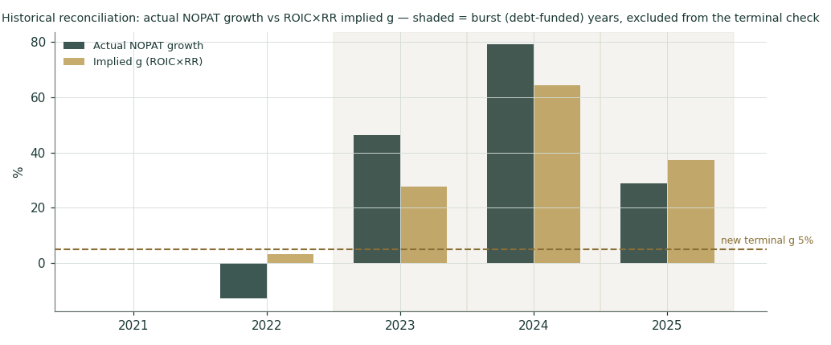
Figure 3 — actual NOPAT growth vs. ROIC×RR implied g, by year. Shaded years are debt-funded builds, excluded from the terminal-g check; the dashed line marks the new 5% terminal assumption.
Because terminal value is a large share of enterprise value and the normalized discount rate is itself a judgment, the two sensitivities that matter operationally are shown as grids in observable units: the terminal-stage WACC against terminal growth (now centered on the 5% standing-procedure default), and — separately — the delivery of the FY28–30 EBITDA margin against terminal growth.
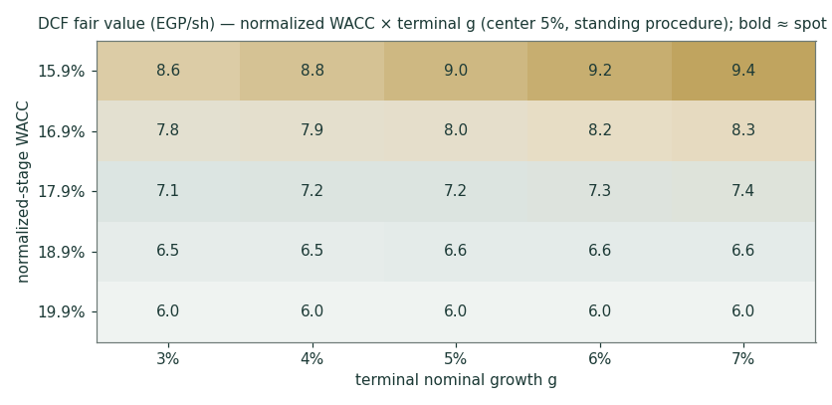
Figure 4 — DCF fair value (EGP/share): normalized-stage WACC × terminal growth, centered on the 5% standing-procedure default. Bold cells sit within EGP 0.90 of spot.
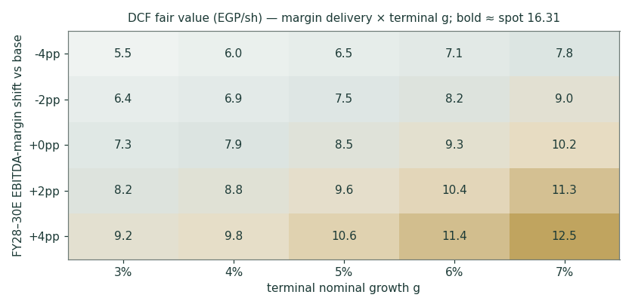
Figure 5 — DCF fair value (EGP/share): FY28–30E EBITDA-margin delivery × terminal growth. The rate grid still moves value more than the margin grid, but the gap has narrowed now that terminal growth is disciplined by the reconciliation above.
1.10 · One clock — why every lens is now a present value
A discounted cash flow returns a value today. A multiple applied to FY2027 earnings does not — it returns a value at the end of 2027. Nor does a transaction mark applied to 1,320 beds, which are guided operational in 2027 and do not exist yet. The previous version of this study blended all four lenses as though they were denominated in the same currency of time. They were not. Both forward lenses are now discounted back — the earnings lens at the cost of equity, the capacity lens at the WACC — so that all four answer the same question: what is this worth today. The forward readings are not hidden; they are simply labelled for what they are. The relative lens reads EGP 18.71 as a 2027 figure and EGP 13.21 as a present value. The capacity lens reads EGP 13.68 on fully-built 2027 capacity, EGP 9.08 discounted to today, and EGP 8.22 if one simply values the 880 beds that exist right now — and it is worth noting that the last two nearly agree, which is a good sign that the discounting is not doing anything exotic.
A harder point, stated plainly. At Egypt’s cost of equity the justified P/E for a business growing at 5% in perpetuity is roughly three to five times earnings. The EGX pays twenty-four. That gap is not a modelling artifact and this study cannot resolve it: the relative-multiples lens is not an independent test of value at all — it is a measure of what the market currently pays. It is retained at its declared weight for continuity and because ignoring the market entirely would be its own kind of arrogance, but the reader should understand that blending it into a fundamental fair value imports the market price into the answer. The DCF, the normalized-earnings lens and the per-bed lens are all anchored in the cost of capital. The relative lens is not.
2 · Technical read
Technicals are a secondary lens — useful for the three-month clock, not the fair value. CLHO trades around EGP 16.31, having ranged between EGP 7.90 and EGP 17.39 over the last year.
Indicator | Level | Read
Price vs SMA-20 / 50 | 16.09 / 15.46 | above both
Price vs SMA-100 / 200 | 14.04 / 13.01 | above both
RSI (14) | 55 | neutral
MACD (12,26,9) | 0.308 vs signal 0.355 | histogram -0.046 (bearish)
52-week range | 7.90 – 17.39 | spot at 89% of range
Realized vol (252d, annualized) | 35% | vs anchored MC vol 51%

Indicators are descriptive, not predictive. The Monte Carlo section, not this table, carries the probabilistic three-month view.
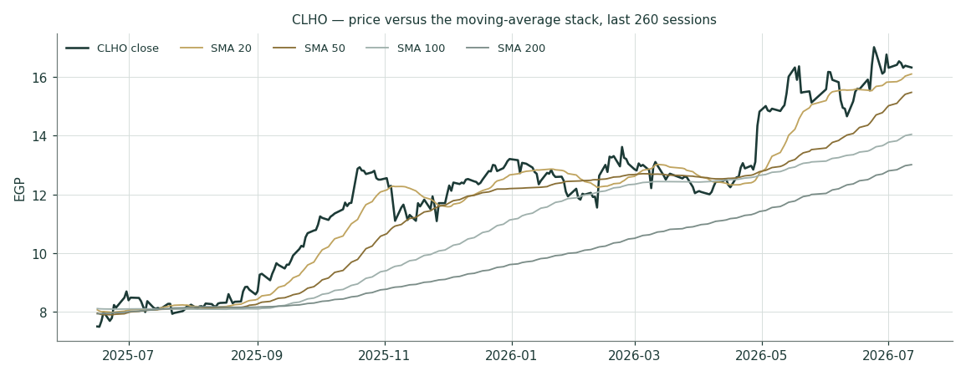
Figure 6 — CLHO price against the moving-average stack, last 260 sessions.
3 · Monte Carlo — the three-month distribution
The forward price cone is generated by the Testahil v3 engine — 50,000 carry-anchored YZ-HAR-t paths (seed 42) under the live Egyptian market fit: Student-t(4) innovations, width 0.909, carry-only drift (no signal), risk-free 19.50% less a ~0.24% dividend yield. Crucially, this cone is built only from CLHO’s own realized price behaviour and Egyptian carry — it deliberately does not embed the fundamental value gap from §1. The two are separate lenses on purpose.
Read the Monte Carlo correctly — it has no view. The simulated median at T+60 is EGP 17.02 against a spot of 16.31, and the probability of finishing above spot is 60%. Neither number is a forecast that the shares will rise. Egypt’s risk-free rate is 19.5%, and over sixty trading sessions the carry alone lifts the median by 4.3%: 16.31 multiplied by e raised to ln(1.1926)×60/252 is 17.01. The engine prints 17.02. The ENTIRE median move is the time value of money in a high-nominal-rate currency, and the Egypt engine runs carry-only — its signal was ablated off after failing an out-of-sample test. So the cone describes dispersion, not direction, and the 60% figure carries no directional information whatsoever. Saying otherwise — as an earlier draft of this analysis did — mistakes an interest rate for a forecast.
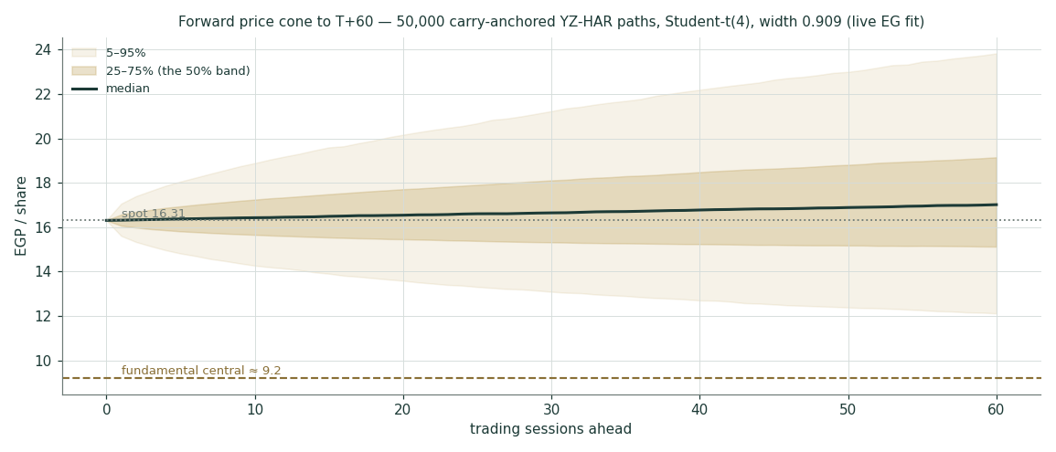
Figure 7 — forward price cone to T+60. Shaded bands are the 25–75% (inner) and 5–95% (outer) path percentiles; the dashed brass line marks the fundamental central estimate for reference only.
Horizon | p5 | p25 | p50 | p75 | p95
T+20 (≈1 month) | 13.59 | 15.46 | 16.54 | 17.71 | 20.17
T+60 (≈3 months) | 12.12 | 15.13 | 17.02 | 19.15 | 23.83

Percentile map, EGP per share. These are the only genuinely three-month figures in the study.
3.1 · Probability read
Question (T+60) | Probability
Price above spot | 60%
Up 10% or more | 38%
Down 10% or worse | 20%
Up 20% or more | 22%
Down 20% or worse | 8%
Within ±10% of spot | 42%

Read directly off the 50,000-path terminal distribution at T+60.
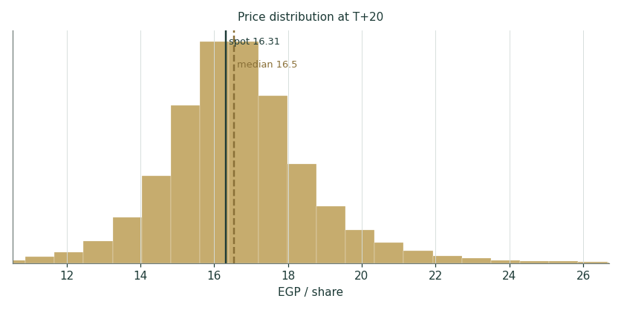
Figure 8 — simulated price distribution at T+20 (≈1 month). Ink line = spot; dashed brass = simulated median.
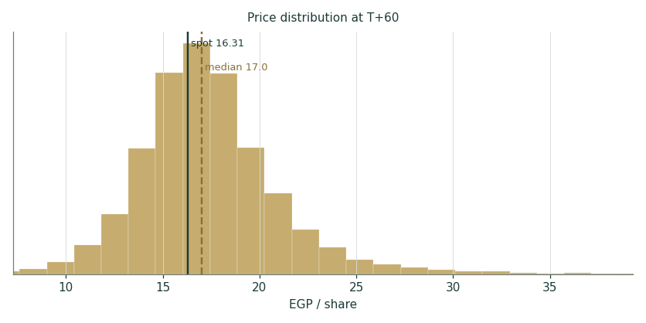
Figure 9 — simulated price distribution at T+60 (≈3 months).
Calibration, stated plainly. Before any of this was forecast, the engine had to clear its standing calibration gate: a five-year walk-forward test on CLHO’s own price history, scored against a carry-anchored random-walk benchmark, preceded by a data-quality screen (the series came back clean — no pre-listing placeholders, no unadjusted corporate actions, trading-day density consistent with the EGX calendar). The Egyptian panel — the standing gate — passes. At the name level CLHO grades parity: the engine is neither better nor worse than the benchmark on this one series, and that verdict is stable across bootstrap block sizes, so it is recorded as parity rather than dressed up as a pass. One diagnostic is worth stating rather than burying: CLHO’s realized outcomes fell inside the 90% band every single time in the backtest, with a well-centred PIT — the cone is not mis-centred, it is simply too wide for a low-beta name being priced with a market-level width. Read the percentiles above as conservative rather than precise. The full backtest is published, and graded, in the public Calibration Ledger.
4 · Bringing the lenses together
Three clocks, kept separate. The fundamental lenses (§1) put risk-adjusted fair value near EGP 9.21, driven by the discount-rate path. The market clock (§3) puts the three-month median near EGP 17.02 with a 60% chance of trading up. The technical read (§2) is neutral-to-constructive on momentum. Spot at EGP 16.31 sits inside all three — slightly above the fundamental central, near the MC median.
The one-line synthesis: a high-quality, fast-growing hospital network trading at a fair-to-full price on today’s crisis-level Egyptian discount rate, with the upside case resting on rate normalization and/or a strategic-review outcome, and the downside case resting on rates staying high or the new hospitals ramping slower than guided. This is a valuation study, so it stops there — no rating, no target, only the ranges and the distribution.
5 · Catalysts and what would change the read
- Earnings — Q2-2026 results (≈ late August 2026) — the first clean read on CTH’s ramp and consolidated margins after the January launch.
- Rates — CBE MPC meetings through H2-2026 — each decision moves the normalized-WACC assumption that anchors the DCF. A resumption of cuts is the single biggest upside trigger.
- Execution — CTH reaching >EGP 100mn/month with positive EBITDA (April: EGP 83mn) and the COH cath-lab (opened June 2026) plus the 200-bed October BTS landing for 2027 operation.
- Policy — Universal Health Insurance phasing into Greater Cairo — contracting terms and tariffs for GAHAR-accredited private hospitals would reset the volume outlook.
- Corporate — The strategic review — any transaction, stake sale or structural move flagged by management would be priced off the EV-per-bed lens (EGP 6.46–11.70) rather than the DCF.
Window | Catalyst | Lens it moves
≈ Aug 2026 | Q2-2026 results — first clean CTH-ramp read | DCF near-years, margin path
H2-2026 (each MPC) | CBE rate decisions | normalized WACC (the crux)
Q4-2026 | CTH sustaining >EGP 100mn/month | revenue path, EV/bed
2026 → 2027 | October 200-bed BTS delivery & operation | capacity, forward beds
Phased | UHI contracting into Greater Cairo | volume outlook
Open | Strategic-review outcome | EV-per-bed lens

Catalyst calendar. Rate decisions move the fundamental value most; execution and policy move the growth path; a strategic-review outcome would reprice off the transaction lens.
6 · Reference zones
The zones below are descriptive map, not signals — they simply locate spot and the lens outputs within the simulated three-month distribution.
Zone | EGP band (T+60) | Prob. | What it would take
Deep-value / left tail | < 12.1 | 5% | Only a macro shock (EGP step-devaluation, rate spike) puts price here; flat-rate DCF bear (3.9) lives in this zone
Accumulation band | 12.1 – 15.1 | 20% | Below all four lens bases; central 9.2 sits just above
Fair-value core | 15.1 – 19.2 | 50% | Spot 16.31 and the weighted central both sit inside this band
Momentum extension | 19.2 – 23.8 | 20% | Requires the rate-cut trade or a strategic-review headline; bull lenses reach here
Right tail | > 23.8 | 5% | Transaction/re-rating outcomes (per-bed marks) only

Bands are percentile locations from the T+60 Monte Carlo, annotated with the fundamental context. Not thresholds for action.
7 · Caveats and limitations
- The big one — Discount-rate dependence — the fundamental value hinges on the Egyptian rate path (§1.7). The normalized-stage WACC is a house judgment, not a market observable, and is the single largest source of range in the study.
- Structural — Terminal-value weight — terminal value is 66% of enterprise value in the base case (disclosed in §1.1), unavoidable for a long-duration growth asset. Small changes in terminal g or the normalized WACC move the answer materially; §1.9 sensitizes both rather than hiding them.
- Calibration — Over-wide bands — the Monte Carlo cone uses a market-level width and over-covers this specific low-beta name (§3); the three-month percentiles are conservative rather than precise.
- Modelling — Forecast drivers — the growth, margin, capex and working-capital paths are the preparer’s estimates anchored on disclosed prints; every non-sourced driver is logged in the Fundamental Driver Ledger (B.4). Actuals will differ.
- Statistical — Beta uncertainty — the regression beta of 0.446 clears the usability gate but only just (R² 5.9%); the 90% confidence interval spans roughly 0.15–0.74, and the WACC grid shows what that does to value.
- Macro — Single-market, single-currency — an EGP step-devaluation would hit imported consumables and the translated value at once; the currency is managed, not fixed. Liquidity is thin relative to the Gulf comparables cited.
- Method — The EV-per-bed lens is a transaction mark, not a cash-flow value. It is included because management has itself raised the per-bed discount, but it should never be read as what the business earns — only as what a buyer might pay.
- Regulatory — Not licensed, not advice — the preparer holds no FRA or other securities licence, may hold a position, and issues no rating and no price target. This is educational analysis only.
Appendix A · Financial statements
A.1 · Income statement (FY2023A–FY2025A, 1Q2026A)
EGP mn | FY23A | FY24A | FY25A | 1Q26A
Revenue | 3,595.3 | 5,420.4 | 7,227.3 | 1,972.5
Cost of sales | (2,386.7) | (3,407.1) | (4,368.8) | —
Gross profit | 1,208.6 | 2,013.3 | 2,858.5 | 644.6
Gross margin | 33.6% | 37.1% | 39.6% | 32.7%
G&A, provisions & other, net | (559.2) | (850.6) | (1358.7) | —
EBIT | 649.4 | 1,162.8 | 1,499.8 | 278.8
Net interest (income − expense) | (41.7) | (79.1) | (180.7) | (59.6)
Profit before tax | 607.7 | 1,083.7 | 1,319.1 | 219.2
Income tax (incl. deferred) | (138.4) | (266.7) | (351.2) | (66.3)
Net profit | 469.3 | 817.0 | 967.9 | 152.9
— attributable to parent | 418.2 | 723.3 | 823.9 | 118.1
— non-controlling interests | 51.1 | 93.7 | 144.0 | 34.8
EPS (EGP, parent) | 0.29 | 0.50 | 0.67 | 0.08
Adjusted EBITDA (company definition) | 954.0 | 1,529.0 | 2,137.0 | 497.0
Adj. EBITDA margin | 26.5% | 28.2% | 29.6% | 25.2%
Reported-basis EBITDA (EBIT + D&A) | 810.8 | 1347.1 | 1719.5 | 397.7

Source: CHG FY2023–FY2025 and 1Q2026 earnings releases (official, cleopatrahospitals.com). Two EBITDA framings are shown deliberately: the company’s adjusted definition (which the market quotes) and the reported basis used in this model’s DCF (EBIT + D&A). The gap — roughly 5–6 percentage points of margin — is where provisions, LTIP and one-offs live, and pretending it away would flatter the valuation.
A.2 · Balance sheet (FY2023A–FY2025A, 1Q2026A)
EGP mn | FY23A | FY24A | FY25A | 1Q26A
Fixed assets, intangibles, RoU & assets under construction | 2,720.9 | 5,131.5 | 7,877.9 | 8,179.4
Inventory | 292.0 | 320.5 | 281.3 | 317.9
Trade receivables | 648.5 | 1,046.8 | 1,241.5 | 1,445.5
Other receivables & related parties | 468.8 | 617.7 | 293.0 | 292.5
Cash & equivalents | 357.9 | 473.2 | 547.5 | 749.6
Total assets | 4,488.0 | 7,589.8 | 10,241.3 | 10,984.7
Equity — attributable to parent | 2,249.8 | 2,899.6 | 3,622.3 | 3,756.8
Non-controlling interests | 196.5 | 278.2 | 418.0 | 452.8
Borrowings + lease liabilities | 873.5 | 2,457.7 | 3,702.7 | 3,913.7
Creditors & other credit balances | 928.1 | 1,523.4 | 1,932.4 | 2,225.7
Current income tax | 75.6 | 199.0 | 284.2 | 365.8
Provisions, deferred tax, LTIP & other | 164.6 | 231.9 | 281.5 | 269.8
Net financial debt — excluding IFRS-16 leases |  |  |  | 2,993.7
Net financial debt — including IFRS-16 leases |  |  |  | 3,164.1

Source: CHG earnings-release balance sheets. Dual-framing rule: net financial debt is stated both ways, and the valuation bridge uses the lease-inclusive figure (the more conservative of the two).
A.3 · Cash flow and dividends
EGP mn | FY23A | FY24A | FY25A
Operating cash flow | 521.6 | 1,423.3 | 1,835.5
Investing cash flow | (797.7) | (2,665.6) | (2,599.3)
— of which capex (fixed assets + projects under construction) | (825.2) | (2,704.0) | (2,650.5)
Financing cash flow | 291.1 | 1,357.6 | 840.6
— of which dividends paid (group, incl. NCI) | (64.9) | (113.2) | (146.3)

Source: CHG statement of cash flows. FY2024–25 investing outflow is the two new hospitals; the dividend is small (yield under 0.5% at spot) while the group reinvests, and management has signalled enhanced capital returns as the network matures and deleverages. For FY2023 shareholders approved a EGP 55.95mn cash dividend.
A.4 · Forecast summary (FY2026E–FY2030E)
EGP mn | FY26E | FY27E | FY28E | FY29E | FY30E
Revenue | 9,253.6 | 12,303.1 | 15,786.3 | 19,065.0 | 21,821.4
Revenue growth y/y | 28% | 33% | 28% | 21% | 14%
Gross profit | 3,285.0 | 4,736.7 | 6,235.6 | 7,626.0 | 8,728.6
EBITDA (reported basis) | 1,989.5 | 3,014.3 | 4,183.4 | 5,242.9 | 6,110.0
EBITDA margin | 21.5% | 24.5% | 26.5% | 27.5% | 28.0%
EBIT | 1,509.5 | 2,454.3 | 3,563.4 | 4,562.9 | 5,370.0
Net interest | (255.0) | (230.0) | (160.0) | (90.0) | (30.0)
Profit before tax | 1,254.5 | 2,224.3 | 3,403.4 | 4,472.9 | 5,340.0
Net profit | 947.2 | 1,679.3 | 2,569.6 | 3,377.0 | 4,031.7
— attributable to parent | 795.6 | 1,427.4 | 2,184.1 | 2,870.5 | 3,426.9
EPS (EGP, parent) | 0.549 | 0.985 | 1.507 | 1.980 | 2.364
Capex | (1,400.0) | (1,100.0) | (1,150.0) | (1,220.0) | (1,280.0)
Free cash flow to the firm | 133.3 | 1,263.6 | 2,172.2 | 2,963.4 | 3,594.2
Gross debt + leases, year-end | 3,900.0 | 3,400.0 | 2,800.0 | 2,200.0 | 1,600.0

The model’s forecast, driven entirely off the Assumptions sheet of the companion workbook. Three actual years and five forecast years are carried in both the income statement and the balance sheet there; the balance sheet balances with cash as the sole plug.
A.5 · Revenue build — bottom-up, line by line
Revenue is built bottom-up wherever the company discloses it, and top-down only where it does not (per the protocol’s data-discipline gate). The five KPI lines below cover 59% of FY2025 revenue and are each modeled as volume × ARP, faded from their own disclosed FY2024→FY2025 growth rate toward a sustainable long-run rate. The remaining 41% (pharmacy, lab, IVF — no disclosed volume/price split) is grown top-down off the same bed-capacity ramp, plus a flat re-pricing kicker.
Line (EGP mn) | FY26E | FY27E | FY28E | FY29E | FY30E
Outpatient | 776.7 | 1,006.7 | 1,268.3 | 1,532.1 | 1,774.3
Inpatient | 2,158.9 | 3,039.0 | 4,084.8 | 5,057.5 | 5,869.7
Surgical | 1,652.7 | 2,199.4 | 2,822.0 | 3,413.1 | 3,924.2
Er | 348.5 | 459.9 | 579.4 | 693.4 | 788.2
Cath | 615.9 | 836.0 | 1,093.1 | 1,340.9 | 1,541.7
Lab | 1,067.9 | 1,434.9 | 1,841.2 | 2,224.1 | 2,551.9
Radiology | 711.9 | 956.6 | 1,227.5 | 1,482.7 | 1,701.3
Sub-total, 5 KPI lines | 7,332.5 | 9,932.5 | 12,916.2 | 15,743.8 | 18,151.1
Other/ancillary (top-down) | 1,921.1 | 2,370.6 | 2,870.1 | 3,321.2 | 3,670.3
TOTAL revenue | 9,253.6 | 12,303.1 | 15,786.3 | 19,065.0 | 21,821.4

Effective operational beds (the capacity constraint behind the volume growth): 2026: 940 / 2027: 1074 / 2028: 1204 / 2029: 1290 / 2030: 1320. Beds ramp on a 25/60/85/100% utilization curve applied to each new facility’s incremental capacity — Cleopatra El Tagamoa (240 beds, launched 27-Jan-2026) and the October build-to-suit (200 beds, guided operational 2027) — never assumed instantly stabilized. No further capacity is disclosed beyond 1,320 beds; this is the actual constraint that disciplines the growth fade, replacing an assumed top-down percentage.
Appendix B · Peer set, sector structure, risks — and the research register
B.1 · Peers and the sector frame (discount-rate-aware)
Operator | Market | P/E | EV/EBITDA | Note
Dr Sulaiman Al Habib | KSA | ~31× | ~24× | regional premium franchise
Mouwasat | KSA | 23–26× | 17–19× | Eastern Province leader
Dallah Healthcare | KSA | 29–35× | 20–23× | Riyadh, expansion phase
Burjeel Holdings | UAE | 17–21× | 11–13× | UAE / Oman network
KSA healthcare industry | KSA | ~30× (3y avg ~45×) | — | de-rated, still rich
Egyptian healthcare industry | EGX | ~47× (thin sample) | — | small-cap heavy, not a clean read
CLHO at spot | EGX | 24.3× FY25A · 16.6× FY27E | 12.7× FY25 adj | EV/bed EGP 31.0mn (current)

Gulf operators carry a cost of equity roughly 13–15 percentage points below Egypt’s. Their multiples are context, never a direct import — the portable lesson from reading the local sell-side is to adopt the machinery, not the optimism. The honest statement is narrower than the bull case: CLHO is cheap versus regional beds and regional EBITDA, and that is exactly what a 25% discount rate does to a long-duration asset.
B.2 · Egyptian macro snapshot
Indicator | Latest | Date
CBE main operation rate | 19.50% (third consecutive hold) | 9-Jul-2026
CBE deposit / lending corridor | 19.00% / 20.00% | 9-Jul-2026
Headline urban CPI | 14.3% (m/m −0.4%) | Jun-2026
CBE inflation target | 7% ± 2% | H2-2027
Real GDP growth | 5.0% | Q1-2026
Egypt 10-year local-currency yield | 22.55% | 3-Jul-2026
Net international reserves | US$ 55.1bn | Jun-2026
Egypt ERP — CDS / rating basis | 9.41% / 13.94% | Damodaran, Jan-2026

The macro backdrop for the two-stage discount rate. A resumption of CBE cuts toward target is the single biggest upside trigger for the fundamental value; a renewed conflict-driven risk premium is the biggest downside one.
B.3 · Risk register
Risk | Channel | Why it matters here
Rates stay at crisis levels | Discount rate | The DCF falls to about EGP 3.85 — the largest single swing in the study
EGP step-devaluation | Costs + translation | Imported consumables and equipment reprice immediately; tariffs lag
UHI contracting terms | Volume + price | Universal Health Insurance sets tariffs for accredited private hospitals as it phases into Cairo
Medical-staff cost inflation | Margin | Physician and nurse retention is the binding constraint on new-bed ramp-up
New-hospital ramp slippage | Growth + margin | CTH must sustain >EGP 100mn/month (April: EGP 83mn); the October BTS must land for 2027
Single-facility execution | Revenue mix | Nile Badrawi revenue fell 4% y/y in 1Q26 during a cardiology-team transition
Competitive capacity | Pricing | Saudi German, Andalusia and the Alameda network are adding private beds in Greater Cairo
Ownership concentration / liquidity | Market | Care Healthcare 32%, MCI Healthcare Partners 31%, free float 37% (Mar-2026)

Risks are stated as channels into the model, not as generic disclaimers: each one maps to a driver that can be moved in the companion workbook.
B.4 · The research register — four rings, dated, negative searches included
Every study opens with a structured information sweep across four rings — global, country, industry, company — before a single forecast driver is set. The register below is the sweep for this study, with each finding classified bullish (B), structural (S), drag (D) or crux (C), and dated. It is reproduced in full so a reader can see exactly what was and was not known when the numbers were built.
Ref | Ring | Class | Finding | Source | Date
SR-01 | Global | S | Fed funds 3.50–3.75% (held Jun-2026); softer USD backdrop for EM | MarketProfile FED_SCHEDULE / cached CoC note | 2026-06-18
SR-02 | Global | D | US–Iran regional conflict since Jun-2026 lifted energy prices and EM risk premia | CBE MPC statements Apr/May/Jul-2026 | 2026-07-09
SR-03 | Global | S | Global healthcare demand inelastic; GCC hospital operators trade 11–30x EV/EBITDA | Burjeel/regional comp table; multiples.vc Al Habib 24.3x (Jul-2026) | 2026-07-05
SR-04 | Country | C | CBE held rates a 3rd straight meeting (main op 19.50%); easing paused on conflict — the discount-rate crux | CBE MPC / EgyptToday / DailyNewsEgypt | 2026-07-09
SR-05 | Country | B | Headline CPI fell 3rd month to 14.3% (Jun-26, m/m −0.4%); CBE target 7±2% in H2-2027 | CAPMAS via CBE CPI release / Bloomberg | 2026-07-09
SR-06 | Country | S | Egypt 10Y local yield 22.55% — the valuation rf | investing.com (cached CoC reference) | 2026-07-03
SR-07 | Country | S | Real GDP +5.0% Q1-2026; FY25/26 ~5%; NIR $55.1bn (Jun-26) | CBE releases | 2026-07-08
SR-08 | Country | B | CBE guided the banking sector to support national healthcare initiatives | CBE press release headline | 2026-07-05
SR-09 | Industry | B | UHI Phase-2 launching: Minya trial Apr-2026; 5 governorates, EGP 115bn, 12mn citizens; Cairo in later phases (system-wide by 2032) | EgyptToday / Cabinet infographics | 2026-04-20
SR-10 | Industry | S | UHIA separates funding from provision and contracts GAHAR-accredited private hospitals (75% paid up front); CHG's Central-Cairo facilities GAHAR-accredited since 2024 | iPMI/LegalClarity; CHG FY24 ER | 2026-04-04
SR-11 | Industry | B | Out-of-pocket still ~57% of Egyptian health spend; private beds avg 29/facility — structural undersupply of quality beds | World Bank via sector reviews | 2026-03-19
SR-12 | Industry | S | KSA healthcare de-rated to ~30x P/E (3y avg 44.8x); Egyptian healthcare P/E ~46.9x industry avg (thin sample) | simplywall.st; investing.com | 2026-07-10
SR-13 | Company | K/C | FY2025: revenue EGP 7,227mn +33%, adj EBITDA 2,137 (30%), NP 968 (+18%), EPS 0.67 | CHG FY2025 ER (official) | 2026-03-17
SR-14 | Company | B | CTH launched 27-Jan-2026; Q1 rev EGP 154mn, 11% of group by April; April EBITDA positive; targeting >EGP 100mn/month; +40% bed capacity | CHG 1Q26 ER (official) | 2026-06-07
SR-15 | Company | D | Q1-26 consolidated margins compressed (GM 32.7%, EBITDA 25.2%, NP −34%) on CTH ramp + interest 71mn; core ex-CTH intact (EBITDA 29.4%) | CHG 1Q26 ER (official) | 2026-06-07
SR-16 | Company | S | Net financial debt EGP 3.16bn incl leases (1.59x annualized EBITDA); deleveraging + tighter capex guided for 2026 | CHG 1Q26 ER (official) | 2026-06-07
SR-17 | Company | B | April 2026 flash: consolidated revenue +32% y/y at ~30% EBITDA margin; core +18% at ~33% | CHG 1Q26 ER (official) | 2026-06-07
SR-18 | Company | C | CEO: shares trade 'at a fraction of EV/bed... substantial discount on EV/EBITDA' vs regional peers/transactions; 'reviewing the options available to maximise value' — strategic-review optionality | CHG 1Q26 ER management comment | 2026-06-07
SR-19 | Company | S | Shareholders: Care Healthcare 32% / MCI Healthcare Partners 31% / free float 37% (Mar-2026) | CHG 1Q26 ER | 2026-06-07
SR-20 | Company | S | Dividend record: EGP 55.95mn approved for FY2023; group CF dividends paid 146.3 (FY25, incl. NCI) — yield <0.5% | Mubasher bourse filing; FY25 ER CF | 2026-03-17
SR-21 | Company | D | NBH revenue −4% y/y in Q1-26 (cardiology team transition) — single-facility execution risk | CHG 1Q26 ER | 2026-06-07
SR-22 | Company | S | COH cath lab opening Jun-2026; 200-bed BTS delivery 2026, operational 2027 (asset-light: owner builds, CHG furnishes) | CHG 1Q26 ER | 2026-06-07
SR-23 | Company | N | NEGATIVE SEARCH — no multi-year capex plan is disclosed beyond FY2026's 'tightly controlled' guidance; searched IR page, earnings releases and EGX filings. The FY26-30E capex path is therefore a house driver (GC-CLHO-03), not a company figure. | CHG IR / EGX disclosures | 2026-07-13
SR-24 | Company | N | NEGATIVE SEARCH — no named transaction, stake sale, MOU or adviser mandate has been announced under management's 'reviewing the options available to maximise value'; searched bourse filings and news to the study date. The strategic review is optionality, not an event. | EGX / Mubasher filings | 2026-07-13
SR-25 | Company | N | NEGATIVE SEARCH — no FY2024 or FY2025 dividend approval found beyond the FY2023 EGP 55.95mn distribution; the modelled dividend build is a house driver (GC-CLHO-11), not guidance. | EGX / bourse filings | 2026-07-13
SR-26 | Global | D | "SUPER" EL NINO 2026-27 — MISSED BY THE ORIGINAL SWEEP, added on audit 13-Jul-2026. NOAA places a 96% probability on full El Nino conditions persisting through the 2026-27 Northern Hemisphere winter. Goldman Sachs models a 15.8% surge in global food commodity prices with effects running into H2-2028; UniCredit models a 14.3% hit to global agricultural output and price shocks of 10-50% across core commodities. CONSEQUENCE (DIRECT, not peripheral): Egypt is the world's largest wheat importer and food is roughly a quarter of the EM consumer basket. A multi-year food-inflation shock keeps Egyptian CPI elevated, the CBE cannot resume cutting, and the normalised-WACC splice — the single most consequential input in this study — fails. It raises the probability weight on Scenario A (flat crisis rates, EGP 3.85/share). Independently corroborated: Morgan Stanley (4-Apr-2026) already expects a CBE HOLD to Q3-2026, with 200bp of HIKE risk if the energy shock persists. | Guardian / Goldman Sachs / UniCredit / NOAA / Morgan Stanley | 2026-07-12

Step 2A Information Sweep Register. Class: B = bullish · S = structural · D = drag · C = crux · N = negative search (a dated search that found nothing — recorded because an absence of disclosure is itself a finding, and it is what turns a driver into a logged judgment rather than a fact). Financial line items are taken only from the company’s own filings and earnings releases, never from aggregators.
B.5 · Fundamental Driver Ledger — every unsourced judgment, logged
Ref | Driver | Basis
GC-CLHO-01 | Revenue built BOTTOM-UP: 5 disclosed KPI lines (59% of FY25 revenue) via volume x ARP, faded from each line's own FY24->FY25 rate toward long-run rates; 'other' 41% (undisclosed split) top-down at capacity-growth + 8% kicker | Replaces the retired top-down growth-fade assumption (13-Jul-2026); lands at 2.07x by 2028 -- almost exactly management's own '>2x by 2028' guidance, vs the retired assumption's deliberately-below 1.94x
GC-CLHO-02 | Reported-EBITDA margin path 21.5→28.0% | Reported (EBIT+D&A) basis, ~2-5pp below the company's adjusted 30% to absorb provisions/LTIP; hist 22.5-24.9%
GC-CLHO-03 | Capex 1,400→1,280 (7-15% of rev) | FY26 guided 'tightly controlled'; Q1 actual 437; no disclosed multi-year capex plan
GC-CLHO-04 | NWC to +1.0% of revenue | FY25 NWC was −1.9% on payables stretch; assumed to normalize against the collections push
GC-CLHO-05 | Terminal g 5% (all scenarios; standing procedure, revised 13-Jul-2026 from 11%) | Testahil standing procedure default for well-established Egyptian/EM operators, sensitized 3-7%; cross-checked against CLHO's own 2022 stable-year ROIC x RR (~3.2%) and the model's own FY30E reinvestment rate at 5% implying a 30.3% terminal ROIC (vs 67% at the retired 11% assumption) — inside the realized 17.0-23.0% book-ROIC range
GC-CLHO-06 | Normalized-stage rf 14.5% / Kd 16.0% (Kd = corridor + audited +0.65pp spread) | rf remains the single biggest judgment (CBE path, SR-04/05; grid 1.9 sensitizes); the Kd SPREAD is now audited, not assumed: FY2024 FS note 5.1.2 shows 28.90% loans vs 28.25% corridor (Dec-24) and 20.90% vs 20.25% (Dec-23), 100% EGP-denominated (zero FX liabilities), all variable-rate
GC-CLHO-07 | Justified P/E bands 15-23x (rel) / 15-22x (norm) | EGX healthcare ~46.9x industry avg is thin-sample; KSA 17-36x carries a 13-15pp lower Ke
GC-CLHO-08 | EV/bed marks 20-35 EGP mn on 1,320 end-2027 beds | CTH build ~11-12mn/bed ex-land vs spot 30.9mn/current bed; transaction lens, wide by construction
GC-CLHO-09 | NCI deducted at book (452.8) | NCI earns ~15% of NP; a 2x-book mark moves FV by ~EGP −0.31/sh
GC-CLHO-10 | Forward effective tax 24.5% (IS) / 22.5% statutory (NOPAT) | FY25 effective 26.6%; company normalizes at 22.5%
GC-CLHO-11 | Parent share of NP 84-85% | FY25 85.1%; Q1-26 dipped to 77% on CTH losses at parent
GC-CLHO-12 | Beta 0.446 from own 27-name EGX-composite regression | R2 5.9% just clears the 5% gate floor; SE 0.177 ⇒ 90% CI ~[0.15,0.74]; beta grid attached
GC-CLHO-13 | Forecast working-capital ratios held at FY25 actuals (inv 23d, AR 63d, other rec 3.5%, creditors 26%, tax 4% of revenue) | Balance-sheet mechanics only; cash is the balancing item, so these set the cash build, not the DCF

Append-only ledger of every forecast driver that is a judgment rather than a disclosure. No sourcing failures (cases where a disclosed figure existed and was missed) were identified in this study. Ledger entries are never retro-edited once a forecast is published.
Appendix C · The expert valuation panel
Three experts value CLHO by genuinely different methods — a cash-flow expert, a capacity expert and an earnings-power expert. Each shows workings, sensitizes the input that matters most to their method, and states in advance the condition that would prove them wrong.
C.1 · Expert 1 — the cash-flow expert: the Egyptian rate path, discounted
Method. Free cash flow to the firm, five explicit years, discounted in two stages: years one and two at today’s spot WACC (25.1%), years three to five and the terminal value at a normalized-stage WACC (17.9%) that assumes the Central Bank resumes its path toward the 7±2% target. Terminal growth 5% nominal.
Working | EGP mn
PV of explicit FCFF, FY26E–FY30E | 4,841.2
Terminal value at FY30E | 24,528.4
PV of terminal value | 9,477.0
Enterprise value | 14,318.2
— terminal value as % of EV | 66.2%
(−) Net financial debt incl. IFRS-16 leases | (3,164.1)
(−) Non-controlling interests (book) | (452.8)
(+) Investment in associates | 18.6
Equity value | 10,390.8
÷ shares outstanding (mn) | 1,449.4
Fair value per share (EGP) | 7.17

Expert 1’s workings, in full. The bridge is identical to §1.1 — this is the primary lens, shown here with every step exposed.
Normalized-stage WACC | g = 10% | g = 11% | g = 12%
15.9% | 8.8 | 9.0 | 9.2
16.9% | 7.9 | 8.0 | 8.2
17.9% | 7.2 | 7.2 | 7.3
18.9% | 6.5 | 6.6 | 6.6
19.9% | 6.0 | 6.0 | 6.0

Expert 1’s sensitivity: fair value per share (EGP) across the normalized-stage WACC and terminal growth. The spread across this table is the honest width of the cash-flow lens.
Falsification: CBE fails to resume cuts by mid-2027 or the Egypt 10Y still prints above 21 percent at end-2027 — the normalized stage never arrives; value reverts toward the flat-rate 3.9
C.2 · Expert 2 — the capacity expert: beds, and what a bed is worth
Method. Ignore the discount rate entirely and value the asset the way a strategic buyer would: per operational bed. The network runs 880 beds today and is adding 440 (Cleopatra El Tagamoa 240, the October build-to-suit 200), reaching about 1,320 by 2027. On the model’s FY2028 forecast each forward bed carries roughly EGP 3.17mn of reported-basis EBITDA. Cleopatra El Tagamoa itself cost on the order of EGP 11–12mn per bed to build, excluding land, under a public-private structure — the floor of any sensible per-bed mark.
EV per bed mark | EV (EGP mn) | Implied EV/EBITDA FY28E | Fair value / share (EGP)
EGP 20.0mn per bed | 26,400.0 | 6.3× | 6.46
EGP 27.5mn per bed | 36,300.0 | 8.7× | 9.08
EGP 35.0mn per bed | 46,200.0 | 11.0× | 11.70

Expert 2’s workings. The middle mark is the base case. Note the cross-check the lens gives for free: at EGP 27.5mn per bed the implied FY28E EV/EBITDA is about 9.8× — well below the 17–24× the Gulf operators command, which is the arithmetic behind management’s own complaint about the discount.
Cross-check at spot: the market currently pays EGP 31.0mn per operational bed today, or EGP 20.6mn per forward bed once the new capacity opens. The forward number is the one to watch — it is what the buyer of the whole company would actually be paying for the finished network.
Falsification: CTH monthly revenue fails to hold above EGP 100mn by Q4-2026 (Q1 actual: EGP 83mn in April) or the COH 200-bed BTS slips past 2027
C.3 · Expert 3 — the earnings-power expert: what the engine earns through the cycle
Method. Strip out the two temporary distortions — the El Tagamoa start-up loss and the elevated net interest before deleveraging — and capitalise what the operating engine earns. Using the company’s own normalized definition (profit before tax plus net interest, taxed at the 22.5% statutory rate), FY2026E normalized profit is about EGP 1,169.9mn, of which roughly 84% accrues to the parent — EGP 982.7mn, or EGP 0.678 per share. FY2025 return on equity was about 27%, which is the evidence that this is a genuine engine and not an accounting artefact.
Through-cycle P/E | Normalized parent EPS (EGP) | Fair value / share (EGP)
15× | 0.678 | 6.97
18× | 0.678 | 8.37
22× | 0.678 | 10.23

Expert 3’s workings. The multiple band is deliberately below the relative lens in §1.3 because normalized profit is a larger number than reported profit — applying the same multiple to both would double-count the normalization.
Anchor: FY2025 normalized net profit was a disclosed EGP 1,162.0mn — a 16.1% margin, up 29% year on year — and 1Q2026 normalized margin was 11.0%, the dip being exactly the CTH drag this lens is designed to look through.
Falsification: Normalized net-profit margin (company definition) below 14% for two consecutive quarters (Q1-26: 11.0%; FY25: 16.1%)
C.4 · The three in one room
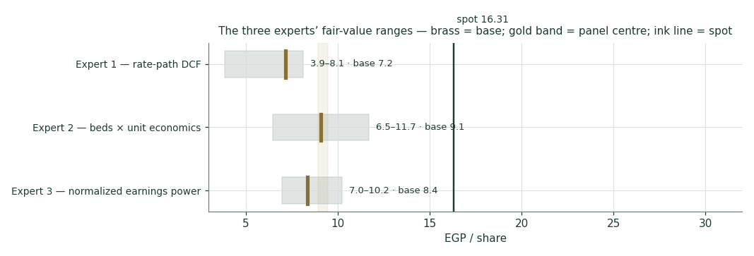
Figure 10 — the three experts’ fair-value ranges. Brass tick = base case; gold band = the weighted central ±3%; ink line = spot.
Expert | Method | What it prices | Bear | Base | Bull
Expert 1 | Two-stage FCFF DCF | The Egyptian rate path | 3.85 | 7.17 | 8.12
Expert 2 | EV per operational bed | What a buyer pays for capacity | 6.46 | 9.08 | 11.70
Expert 3 | Normalized earnings power | What the engine earns through the cycle | 6.97 | 8.37 | 10.23
Spot | EGX close, 2026-07-12 | What the market pays today |  | 16.31

All values EGP per share.
C.5 · Reading the divergence
The three do not disagree about the company — they agree on the volumes, the margins, the bed count and the balance sheet. They disagree about one thing only: what discount rate a long-duration Egyptian asset deserves, and whether that rate is a permanent fact or a temporary one. Expert 1 prices it explicitly and lands lowest in his bear case, because a 25% WACC destroys terminal value. Expert 2 sidesteps the question completely — a strategic buyer of beds does not discount cash flows at the Egyptian policy rate, which is precisely why his number is the highest and why management can credibly complain about the per-bed discount. Expert 3 lands in between by refusing to capitalise a temporary interest burden. That spread is not noise to be averaged away: it is the finding. Whoever is right about the Egyptian rate path is right about CLHO, and no amount of modelling detail substitutes for that call — which is why the study blends the lenses at declared weights instead of pretending to know.
Each expert’s base and range is logged with the study date (13 July 2026) and spot (EGP 16.31) as an internal per-expert track record, kept separate from the public Calibration Ledger.
About this series
Testahil publishes independent, educational valuation studies on Egyptian, Gulf and international equities and on metals. Each study integrates three lenses — fundamental valuation, technical context and a calibrated Monte Carlo distribution — and every published forecast is graded against its outcome in a public Calibration Ledger when it matures. The ledger is append-only: nothing is retro-edited, including the misses. The house discipline is distributions, not tips — fair-value ranges and probabilities, never a rating and never a price target.
Disclosure & Disclaimer
1 · Nature of this document. This is an educational valuation study, published free of charge for information and to invite scrutiny of its methodology. It is not investment advice, not a recommendation or solicitation, not a research report prepared by a licensed entity, and not directed at the circumstances of any reader.
2 · No regulatory licence; no advisory relationship. The preparer is not registered or licensed with the Egyptian Financial Regulatory Authority (FRA) or any other securities regulator in any jurisdiction, holds no brokerage or investment-advisory authorisation, manages no money, accepts no clients or fees, and is not acting as your adviser or fiduciary.
3 · No rating, no price target. This study never issues a buy, sell or hold rating and never sets a price target. It presents fair-value ranges and a probability distribution which are model outputs under stated assumptions, and which may be wrong.
4 · Holdings disclosure. The preparer may hold, and may in future take or dispose of, a position in Cleopatra Hospitals Group or related securities, and may transact at any time without notice. This is a potential conflict of interest which you should weigh. No compensation has been received from the company or any third party for preparing this study.
5 · Sources and accuracy. Reported financial and operating figures are drawn from the company’s own public disclosure (FY2023–FY2025 and 1Q2026 earnings releases) and from public macroeconomic sources believed reliable but not independently verified. Forward-looking inputs — the growth, margin, capex and rate-path assumptions, the multiple bands, the per-bed marks and the Monte Carlo parameters — are the preparer’s own judgments, are logged in the Driver Ledger, and are inherently uncertain.
6 · No reliance; your responsibility. Markets involve the risk of loss. Modelled scenarios and past performance do not predict future results. Do your own research and consult a licensed financial adviser before making any investment decision. You are solely responsible for your decisions and their outcomes; to the maximum extent permitted by law the preparer accepts no liability for any loss arising from use of this document.
Currency and figures: Egyptian pounds (EGP), millions unless stated; bn denotes billion. Rounding may cause totals to differ slightly. Spot price and market data are as of the 12 July 2026 close and change continuously.
TESTAHIL · Independent Valuation Study · Educational Analysis · Cleopatra Hospitals Group S.A.E. (EGX: CLHO) · edition 13-07-2026 · reporting currency EGP

