Testahil · Independent Valuation Study — Educational Analysis Not investment advice

Independent Valuation Study — Educational Analysis
Commercial International Bank (EGX: COMI)
Fundamental analysis · Technical analysis · Monte Carlo simulation — one integrated read
Anchor: EGP 129.25 (29 Jun 2026 close) · ~3.071bn shares · market cap ~EGP 397bn (~USD 8.3bn) · Egypt's largest private-sector bank by assets · a deposit-funded sovereign-carry franchise (≈52% of assets in Egyptian government securities) with a high-quality loan book on top · prices & probabilities computed 29 Jun 2026 from the attached daily price history · primary lens: bank justified price-to-book / residual income on a sustainable ROE · the cost of equity and the durability of the post-devaluation ROE are the swing factors.
READ FIRST — what this document is, and is not. This study is a valuation exercise and an expression of personal analytical opinion, published free of charge for educational purposes: it shows how one analyst applies fundamental, technical and probabilistic methods to a listed company, and invites scrutiny of that methodology. It is NOT investment advice, NOT a recommendation or solicitation to buy, sell or hold any security, and NOT directed at the circumstances of any reader. The preparer is not licensed by any securities regulator in any jurisdiction, holds no brokerage or investment-advisory authorisation, provides no financial consultancy, manages no money, and accepts no fees, funds or clients. See the Disclosure & Disclaimer at the end. All values are model outputs presented as ranges and distributions because no single number should be relied on. Reported financials are CIB's own disclosure; forward-looking inputs — the sustainable ROE, the cost of equity, the terminal growth, the multiples, the dividend-discount build and the Monte-Carlo factor probabilities — are the preparer's judgments and are flagged throughout. Consult a licensed financial advisor before any investment decision.

Headline
The model's read: roughly fairly valued, a touch rich, with the entire case resting on whether the post-devaluation ~30% ROE survives the rate-cut cycle. At EGP 129.25 the shares trade about 5% above our weighted central estimate of EGP 123.3; spot sits within a few percent of most fundamental lenses. CIB is Egypt's largest and best-run private-sector bank — a 27% capital-adequacy ratio, a 62% low-cost-deposit base, a 1.7% non-performing-loan ratio and, in 2025, the first Egyptian private bank to clear a USD 1.7bn bottom line. But the franchise is, structurally, a sovereign-carry machine: roughly 52% of its assets sit in Egyptian government securities, so its extraordinary recent returns are as much a product of post-devaluation policy rates near 27% as of the franchise itself. The question is not whether CIB is a great bank — it plainly is — but whether the market's ~1.74x book is the right price for a return that is already fading as the Central Bank cuts.
Five independent lenses cluster between EGP 104 and EGP 170; the weighted central estimate is EGP 123.3, about 5% below spot. The primary lens — a bank justified price-to-book built from a sustainable ROE of ~29.5%, a nominal cost of equity of ~24% and terminal growth of ~16% — lands at EGP 125.3 (-3%), essentially at fair value. A two-stage dividend-discount model on distributable earnings, deliberately conservative because CIB's near-term payout is low, lands well below at EGP 104.3 (-19%). Relative multiples (EGP 120.7) and normalized through-cycle earnings power (EGP 114.7) sit a touch under spot. Only the bull case — ROE holding near 32% as the cost of equity compresses to 23% — reaches EGP 169.7 (+40%); the bear case, ROE normalising to 24% while the cost of equity widens to 27.5%, collapses to EGP 53.5 (-59%). We adopt neither tail as the base.
This is a statement about valuation, not direction. CIB's tape is constructive, not extended — the shares sit ~10% off their 52-week high, above a rising 200-day average but below the falling 20- and 50-day, with a neutral RSI near 48. A single 16-factor Monte Carlo (the carry, the rate path, EGP, EGX flows, credit growth, plus nine discrete events including a capital return, a sovereign/IMF event and the ECL-release normalisation; 50,000 paths, seed 42) puts both the T+20 and T+60 medians within 1% of spot (~EGP 128.9 and ~127.8) inside a wide cone — CIB's calibrated three-month volatility, after the Step-0 regime-floor uplift, is ~41% annualised. What a buyer at this level underwrites is not a margin of safety on book value but a view on the spread between return on equity and cost of equity: that CIB defends a premium ROE through the rate-cut cycle — helped by capital return from its 27% CAR, durable CASA funding and fee growth — rather than letting the carry compress and capital balloon. The downside tail belongs to a faster-than-expected ROE normalisation, a sovereign or currency shock, or Stage-2 loan migration; the upside to a special dividend or buyback, an EM re-rating, and rates settling higher for longer.

Company overview — CIB at a glance
Commercial International Bank (Egypt) S.A.E. (EGX: COMI) is the country's largest private-sector bank by assets and the most liquid single name on the Egyptian Exchange — the de facto equity proxy through which foreign investors express a view on Egypt. Its profit engine is twofold: a high-margin net-interest business that earns the spread between an exceptionally cheap deposit base (62% current and savings accounts) and the yield on its assets, and a growing fee-and-commission stream from trade finance, cards and cash management. The defining feature for valuation is structural: roughly 52% of CIB's ~EGP 1.5 trillion balance sheet is invested in Egyptian government securities — treasury bills and bonds — so the bank is best read as a deposit-funded sovereign-carry franchise with a high-quality, conservatively-provisioned loan book on top, rather than as a conventional lending bank. Two forces dominate the forward picture: the Central Bank of Egypt has cut policy rates by 825 basis points and paused, which compresses the carry; and CIB carries enormous excess capital (a 27% capital-adequacy ratio against a ~12.5% requirement), which gives it room to lend, acquire, or return cash.
Item | Value (as disclosed / derived)
Listing / sector | EGX: COMI · banks (largest private-sector bank in Egypt)
Leadership | Hisham Ezz Al-Arab (CEO); Islam Zekry (Group CFO)
Share price (29 Jun 2026 close) | EGP 129.25
Shares outstanding | ~3.071bn (issued capital EGP 30.71bn / par EGP 10)
Market capitalisation | ~EGP 397bn (~USD 8.3bn)
FY2025 revenue / net income | EGP 117bn / EGP 82.2bn (record; ~USD 1.7bn)
FY2025 ROAE | 48.3% reported · 41.5% ex-ECL recalibration
Q1 2026 net income / ROAE | EGP 17.8bn (+7% YoY) / 31.9%
Net interest margin (FY25 / Q1-26) | 8.95% / 8.88%
Government securities / assets | ~EGP 700bn ≈ 52% of assets
Customer deposits | EGP 1.21trn (Q1-26); CASA 62%
Loan book / NPL / coverage | gross ~EGP 645bn; NPL 1.7%; coverage ~340%
Capital (CAR / CET1) | 27% / 23% (FY25)
Book value per share (Dec-2025e) | ~EGP 74 (P/B ~1.74x)
Dividend payout (FY25) | 25% of net profit (30% of distributable)
52-week range (from OHLC) | ~EGP 95 – 143.5 (spot ~10% off the high)
Company-level figures are sourced from CIB's public disclosure (CIB Investor Relations, the 30 Sep 2025 interim financial statements, and the FY2024/FY2025 and Q1 2026 earnings releases) and other public sources; forward-looking inputs — the sustainable ROE, the cost of equity, the 2026e-2030e projections, the multiples, the dividend-discount build and the Monte-Carlo factor probabilities — are the preparer's derived estimates, not company disclosure, and are flagged throughout.

1 Fundamental valuation
A bank is not valued like a property developer or a platform holding company: there is no land bank to revalue and no portfolio of listed stakes to mark, but a book of equity capital that earns a return, and a loan book whose quality determines whether that capital is real. The primary lens is therefore the one bank analysts have used for decades — a justified price-to-book derived from the return the bank sustainably earns on its equity versus its cost of equity: a bank is worth its book value plus the present value of the returns it earns above the cost of that capital, which collapses to the familiar relation P/B = (ROE − g)/(CoE − g). We then cross-check that figure four ways — an explicit excess-return DCF on the projected book, a multi-stage dividend-discount model on distributable earnings, relative multiples against peers, and a through-cycle normalized-earnings calculation. Reported financials are CIB's disclosure; the sustainable ROE, the cost of equity and the growth rate are our judgments, shown explicitly so you can disagree.

1.1 Justified price-to-book / residual income — the primary lens
The crux of the whole exercise is the spread between return on equity and cost of equity, and the nominal arithmetic makes it knife-edge. On a Dec-2025 book value of ~EGP 74.2 per share, a sustainable ROE of 29.5%, a nominal cost of equity of 24% and terminal growth of 16% imply a justified price-to-book of (29.5−16)/(24−16) = 1.69x, or a fair value of EGP 125.3 — about 3% below spot, essentially fair. The sensitivity of that answer to its inputs is the entire story. Because everything is in high-inflation nominal terms, the denominator (CoE − g) is a small number, so a one-percentage-point move in either the ROE or the cost of equity swings fair value by 15 to 25 percent. The base case below is our central judgment; the bull and bear are not stress scenarios so much as a measure of how little the answer is pinned down.
Justified P/B case | Base | Bull | Bear
Sustainable ROE | 29.5% | 32.0% | 24.0%
Cost of equity (nominal) | 24.0% | 23.0% | 27.5%
Terminal growth g (nominal) | 16.0% | 16.0% | 15.0%
Justified P/B | 1.69x | 2.29x | 0.72x
BVPS Dec-2025e (EGP) | 74.2 | 74.2 | 74.2
Fair value / share (EGP) | 125.3 | 169.7 | 53.5
vs spot | -3% | +31% | -59%
Why the base ROE is 29.5%, not the reported 48%. CIB's reported FY2025 return on average equity was 48.3% — but 41.5% excluding a one-off release of credit provisions, and the Q1 2026 run-rate had already fallen to 31.9%. These are extraordinary numbers, the product of post-devaluation policy rates near 27% on a balance sheet half-invested in government paper, and they are fading as the Central Bank cuts. Our 29.5% base is a judgment about the ROE CIB can sustain through the cycle under sensible capital management — not the rate-peak figure, and not the mechanical fade our own forecast produces (see below), but the return a best-in-class deposit franchise should earn on a leaner, well-managed equity base. A bull will argue CIB defends 32%+ via capital return and fee growth; a bear will argue the carry compresses it toward the cost of equity. Both are in the table, and the width between them — EGP 53 to EGP 170 — is the honest measure of how much the answer depends on a single spread the market does not observe directly.

1.2 Excess-return DCF — the explicit discounted-forecast valuation
For a bank there is no free cash flow to the firm to discount — debt is raw material, not financing — so the discounted-cash-flow valuation is built on the return earned above the cost of equity. This is the explicit, year-by-year companion to the steady-state justified price-to-book of 1.1: rather than assume the return-versus-cost spread holds forever, we take the actual projected book value and earnings for 2026e-2030e, charge each year's opening equity at the 24% cost of equity, and discount the residual income — the profit above that charge — back at the same rate, adding a terminal. It is the bank analogue of a DCF, and it is the most honest test of the franchise because it lets the forecast speak rather than a single steady-state assumption.
Excess-return DCF (EGP/share) | 2026e | 2027e | 2028e | 2029e | 2030e
Attributable EPS | 25.1 | 27.1 | 29.6 | 32.5 | 35.6
Opening BVPS | 74.2 | 94.1 | 114.7 | 136.3 | 158.9
Equity charge @ 24% CoE | 17.8 | 22.6 | 27.5 | 32.7 | 38.1
Residual income / share | 7.3 | 4.5 | 2.1 | (0.2) | (2.6)
PV of residual income | 5.9 | 2.9 | 1.1 | (0.1) | (0.9)
Value bridge | EGP / share
Book value Dec-2025e | 74.2
PV of explicit residual income (2026e-2030e) | 8.9
PV of terminal value (terminal ROE 25%, g 16%) | 7.8
Excess-return DCF value / share | 90.9
vs spot | -30%
Memo: steady-state justified P/B (spread holds) | 125.3
Gap — the capital-discipline question | 34.4
What the fade shows. Residual income starts firmly positive (EGP 7.3 per share in 2026e) but turns negative by 2029e — not because CIB stops being profitable, but because, at the current low payout, retained earnings compound the equity base faster than earnings grow, so the return on opening equity slips below the 24% cost of equity. The explicit model therefore lands at EGP 90.9, well below both spot and the steady-state justified price-to-book of EGP 125.3. That EGP 34 gap is the most important number in this study restated as cash: it is the distance between CIB defending its premium return by returning excess capital (the EGP 125 world of 1.1) and letting capital balloon while the carry compresses (the EGP 91 world the forecast actually produces). We carry the explicit DCF as the downside anchor of the primary lens — not as an independent sixth method — because it values the same construct under a less generous capital assumption.
The terminal assumes a long-run sustainable ROE of 25%, a small spread over the 24% cost of equity, reflecting that a best-in-class franchise retains some pricing power. Setting terminal ROE equal to the cost of equity (a full fade) lowers the value to ~EGP 83; a wider sustained spread raises it. The Excel's Excess-Return DCF tab makes the terminal ROE and the payout path editable.

1.3 Multi-stage dividend-discount model — the distributed-cash cross-check
The justified price-to-book values CIB on the returns it earns; a dividend-discount model asks a narrower, more demanding question — what is the cash the bank actually distributes worth? We project net income for 2026e-2030e (tied to the income statement in Appendix A), apply a payout ratio that rises from 27% toward 40% as growth slows and the excess capital is released, discount the dividend stream at the 24% base cost of equity, and add a Gordon terminal value at 16% growth. The result, EGP 104.3, sits well below both spot and the justified-P/B figure — and that gap is instructive rather than alarming: it is the signature of a high-return bank that retains most of its earnings. The DDM only captures what is paid out; the residual-income lens captures the value of everything retained and reinvested above the cost of capital. We treat the DDM as a conservative floor, not the primary anchor.
DDM build (EGP) | 2026e | 2027e | 2028e | 2029e | 2030e
Net income (EGP bn) | 83.7 | 94.0 | 104.7 | 115.9 | 127.7
Payout ratio | 27% | 30% | 33% | 36% | 40%
DPS (EGP) | 7.4 | 9.2 | 11.3 | 13.6 | 16.6
PV of DPS @ 24% (EGP) | 5.9 | 6.0 | 5.9 | 5.8 | 5.7
DDM bridge to value | EGP / share
PV of explicit DPS (2026e-2030e) | 29.4
PV of terminal value (Gordon, g 16%) | 74.9
DDM value / share | 104.3
vs spot | -19%

1.4 Relative multiples
On reported earnings CIB screens cheap; the comparison flatters it. At EGP 129.25 the shares trade at ~7.1x FY2025 reported earnings and ~1.74x book — optically inexpensive against developed-market banks. But the P/E denominator is inflated by the ECL provision release, and the more telling number is the price-to-book against the return: at ~1.74x book on a fading ~30% ROE, CIB is priced richer than most Egyptian and emerging-market bank peers, which trade ~1.0-1.5x. Blending a justified price-to-book of 1.55x (a premium to peers, earned by best-in-class asset quality and the scarcity/liquidity premium) with a peer price-to-earnings of 6.6x on normalized earnings gives EGP 120.7, about 7% below spot. The relative lens is the least precise for a bank whose returns are mid-normalisation, and is included mainly to anchor CIB's premium to its peer set.
Relative lens | Metric | Multiple | Implied / sh
Justified P/B | BVPS EGP 74.2 | 1.55x | EGP ~115
P/E (normalized) | EPS ~EGP 19.1 | 6.6x | EGP ~126
Relative blended value |  |  | EGP 120.7

1.5 Normalized earnings power
Strip out the provision release and the rate-peak and ask what CIB earns in a normal year. Normalising the cost of risk back to a through-cycle charge of ~70-90 basis points (rather than the 2025 release), and settling the return on equity at a sustainable ~28%, a defensible normalized attributable earnings figure is ~EGP 19 per share — below the reported figure that the release flattered. At a through-cycle fair multiple of 6.0x — conservative, reflecting that a 28% nominal ROE in a high-inflation economy is a high but not infinitely durable return — that is EGP 114.7, about 11% below spot. Like the relative lens, this measures the operating earnings power and is included as a discipline against the rate-peak optics, not as the primary anchor.

1.6 Synthesis — five lenses
The five methods and weights are below. We lean on the justified price-to-book (the right structure for a bank) and the relative and normalized lenses, with a modest weight on the bull case and the conservative DDM carried as a corroborating floor.
Method | EGP / sh | vs spot | Weight
Justified P/B — base | 125.3 | -3% | 30%
Justified P/B — bull (spread holds) | 169.7 | +31% | 10%
Dividend-discount (2-stage) | 104.3 | -19% | 15%
Relative multiples (blended) | 120.7 | -7% | 25%
Normalized earnings power | 114.7 | -11% | 20%
WEIGHTED CENTRAL | 123.3 | -5% | 100%
Excess-return DCF (explicit fade, memo) | 90.9 | -30% | —
Monte Carlo T+60 median | 127.8 | -1% | —
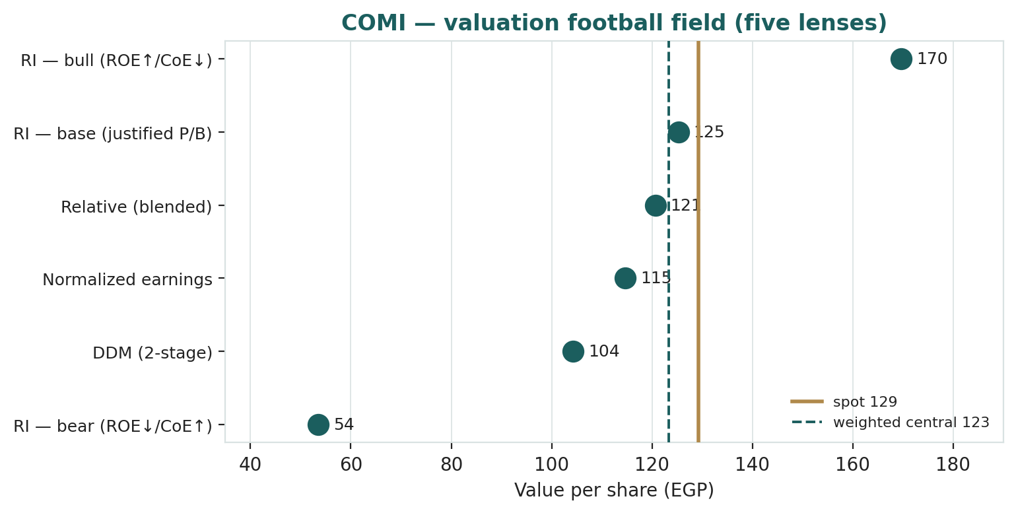
Figure 1 · Valuation football field — five lenses. Spot sits just above the weighted central and inside the cluster; the DDM sits lowest (it captures only distributed cash), the bull case highest.
How to read this. The clustering is tight and straddles spot — the signature of a roughly fairly valued stock rather than an obvious bargain or short. The dispersion is driven almost entirely by one input, the spread between return on equity and cost of equity: at a sustainable ~30% ROE and a ~24% cost of equity the stock is fair; let the ROE fade toward the cost of equity and it is expensive; let it hold while the cost of equity compresses and it is cheap. None of this forecasts direction — the next sections describe a constructive but two-sided price process — it states that, on the fundamentals, the debate is about the durability of the return, not the quality of the bank.

1.7 The bank's drivers — a deeper look
The valuation rests on a handful of operating judgments. For each major driver we set out what it is, how it behaves, and why it matters. One fact recurs: CIB's returns are dominated by the sovereign carry, so the genuine swing factors are the rate path and the durability of the deposit franchise, not loan growth.
Driver | What it is | Key tension
Sovereign-carry book | ~EGP 700bn of T-bills + government bonds ≈ 52% of assets | reprices lower as the CBE cuts (825bps done)
Deposit franchise (CASA) | 62% current & savings accounts; deposits EGP 1.21trn | the cheap funding that makes the carry profitable
Customer loan book | net ~EGP 490bn; gross +52% YoY; LDR ~53% | CAPEX-led demand vs a still-cautious private sector
Asset quality | NPL 1.7%, coverage ~340% | Stage-2 exposures ~24% of the book — the watch item
Capital | CAR 27%, CET1 23% — vast excess | return it (bull) or let it drag ROE (bear)
Fee & non-interest income | trade finance, cards, FX; ~8% of revenue, +12% | diversifier, but small next to the carry
The carry is the crux. Because roughly 52% of assets sit in Egyptian government securities, CIB's earnings power is, first and foremost, the spread between its ~CASA-driven cost of funds and the yield on treasury bills and bonds. That spread was enormous when bills yielded ~27%; it compresses as the Central Bank cuts. Net interest margin has already edged from 8.95% to 8.88%, but the larger effect comes with a lag as the securities book rolls over into lower-yielding paper. The 62% CASA base is the cushion — the cheaper the funding, the more of the carry CIB keeps as rates fall — but it does not eliminate the headwind. This is why the sustainable ROE, not the loan-growth rate, is the number the whole valuation turns on.

1.8 The cost of equity and the durability of the ROE — the crux
Because the valuation reduces to one spread, it is worth stating plainly the two judgments inside it.
The cost of equity is high, nominal, and the dominant lever. CIB is an Egyptian-pound earner, so its cost of equity must be nominal and is anchored to the Egyptian long-bond yield — on the order of 18-22% as the rate cycle matures — plus an equity risk premium of ~5-6%, giving ~24-28%. We use 24% in the base, a touch below a generic Egypt figure, to reflect CIB's quality, liquidity and its role as the foreign-investor proxy (a scarcity premium that lowers the return investors demand). A widening of the sovereign risk premium — a stalled IMF review, a disorderly currency move, a rating downgrade — pushes the cost of equity up and the valuation sharply down; a credible disinflation and a stable pound pull it the other way.
The ROE is fading, and our own forecast shows how. Held at the current low payout, CIB's return on equity falls mechanically in our model — from ~48% in 2025 to ~33% in 2026e, ~26% in 2028e and ~20% by 2030e — not because profitability collapses but because retained earnings compound the equity base faster than earnings grow, while the carry compresses. That fade is the bear case made concrete: over-retention plus rate cuts drag the return toward the cost of equity, and at ~book value the stock would be worth EGP ~55-60. The base case requires CIB to break that arithmetic — by returning its excess capital (the 27% CAR makes this entirely feasible) so the same earnings sit on a leaner equity base, sustaining a premium ROE. The whole valuation, restated, is a bet on capital discipline and the rate path, not on the bank's operating quality, which is not in doubt.

1.9 Egypt — the pound, the rate path, the IMF and the sovereign
A valuation of CIB that ignores the Egyptian macro is incomplete, because the bank is, in large part, a leveraged position in the Egyptian sovereign and the policy path bears directly on every line of the thesis.
The rate path is the earnings story. The Central Bank of Egypt raised rates aggressively through the 2022-24 adjustment and has since cut by 825 basis points, pausing in early 2026 as regional tensions revived inflation risk. For CIB the direction is double-edged: cuts compress the sovereign carry that drives net interest income, but they also relieve the broader economy, support loan demand and asset quality, and can trigger the equity re-rating that a falling discount rate brings. The base case assumes a measured continuation of easing; a pause-for-longer is, paradoxically, good for CIB's near-term earnings.
The pound and the IMF are the tail. The pound depreciated by EGP 6.9 against the dollar in the first quarter of 2026 alone, and S&P holds Egypt at "B" with a stable outlook under an ongoing IMF programme. CIB benefits modestly from a weaker pound through treasury translation gains on its foreign-currency book, but the real exposure is indirect: a disorderly devaluation or a stalled IMF review would widen the sovereign risk premium, lift the cost of equity, and pressure asset quality — the single largest source of downside in the Monte Carlo and the bear case. The dominant Egypt factor for CIB is not the currency level but the credibility of the adjustment.

1.10 Justified-P/B sensitivity — how much the answer moves
The base justified-P/B lands at EGP 125.3. The grid shows how the per-share figure moves with the cost of equity and the sustainable ROE, holding terminal growth at the 16% base. The steepness is the point: a two-percentage-point move in the cost of equity, or a three-point move in the ROE, re-rates CIB by roughly a third.
CoE ↓ / ROE → | 24% | 27% | 30% | 33% | 36%
21% | 99 | 144 | 189 | 234 | 279
23% | 85 | 117 | 148 | 180 | 212
25% | 74 | 98 | 123 | 148 | 173
27% | 65 | 85 | 104 | 124 | 144
29% | 57 | 74 | 91 | 108 | 124
Each cell is the fair value per share (EGP) at that ROE / cost-of-equity pair, terminal growth held at 16%. The base sits near the centre. The gradient — value rising fast up and to the right — is why this study insists the spread, not any single point estimate, is the honest output.

2 Technical and price structure
Technicals describe the price, not the value. They matter here for context: CIB is in a mild pullback within an intact longer uptrend — the shares are above a rising 200-day average but below the falling 20- and 50-day, with momentum neutral. This is neither the melt-up of an extended name nor the capitulation of a broken one.
Indicator | Reading | Interpretation
Spot vs 52-week range | 129.25 / ~95 – 143.5 | mid-to-upper range; ~10% off the high
SMA 20 / 50 / 200 | 132.8 / 135.2 / 116.0 | below the 20/50 (falling), above the 200 (rising)
RSI (14) | ~48 | neutral — neither overbought nor oversold
ATR (14) | 2.17 (1.7%) | contained daily range
Realized vol 60d / 252d | ~29% / ~30% | moderate (the MC uses a calibrated 41%, see App. B)
Skew / excess kurtosis (252d) | +0.46 / +1.0 | mild right skew, modest fat tails
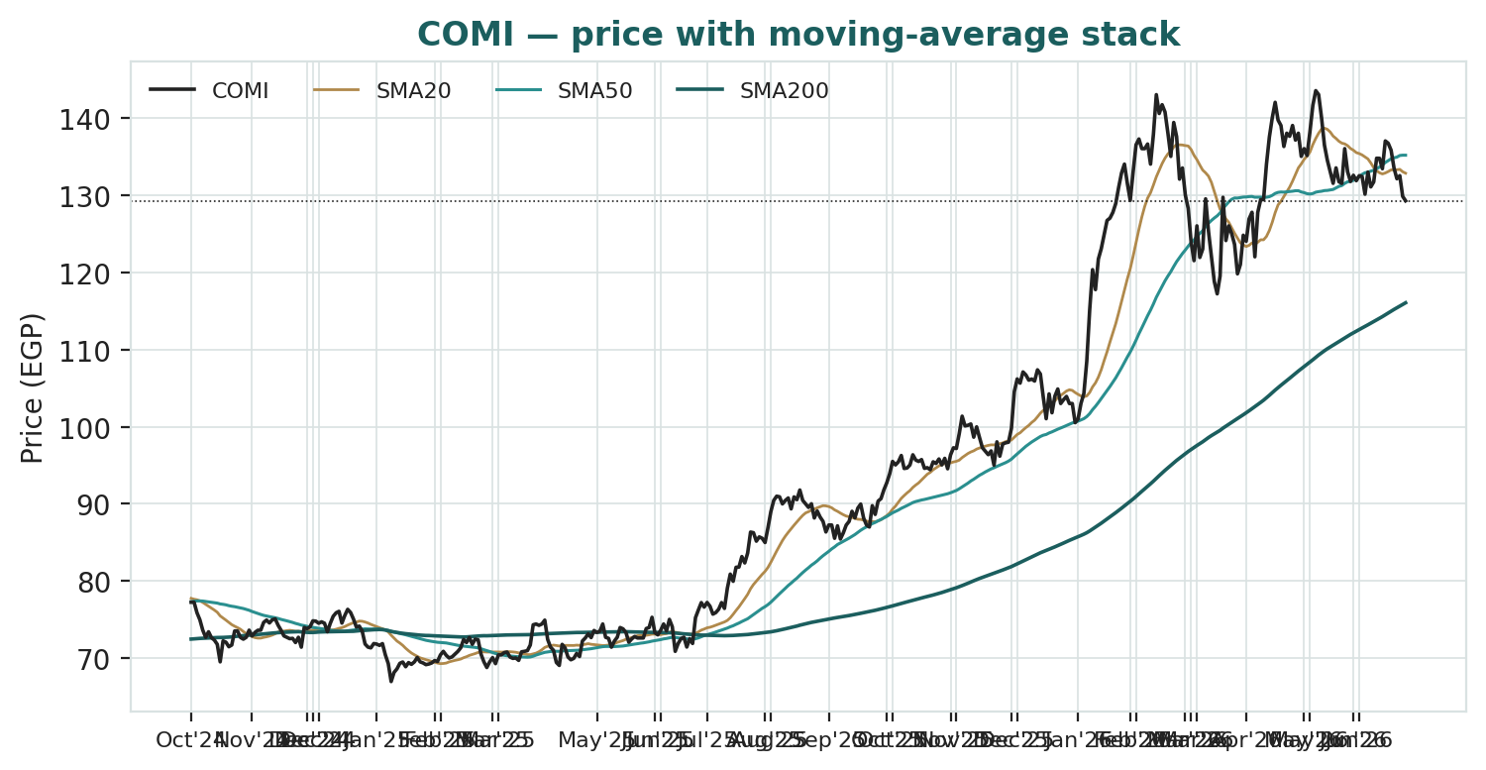
Figure 2 · Price with moving-average stack — a rising 200-day beneath a recent pullback below the falling 20- and 50-day.
The honest technical read. The longer trend is up — price holds above a rising 200-day average — but the shares have rolled over beneath the 20- and 50-day in the recent pullback, and momentum is neutral. Nearest overhead resistance is the falling 20-day around EGP 133, then the 50-day near EGP 135; the rising 200-day around EGP 116 is the first meaningful support. The technical and fundamental pictures are consistent: a high-quality asset in a mild consolidation, where the fundamental question is the durability of the return, not a broken chart.

3 Monte Carlo — a probabilistic price map
This models the price over the next three months, not value. We simulate 50,000 paths (seed 42) from a 16-factor structure — seven continuous drivers and nine discrete event risks — with the diffusion calibrated to CIB's own volatility after the Step-0 regime-floor uplift (Appendix B). It answers "where could the price plausibly be, and with what probability", not "what is CIB worth". The paths diffuse from spot as a near-term price process and deliberately do not embed the fundamental value — the price-versus-value gap of Section 1 is kept out of the drift, so the fundamental and probabilistic lenses stay independent.
The 16 factors. Continuous (7): the CBE rate path and net-interest-margin carry, the pound, inflation and nominal balance-sheet growth, EGX flows (CIB as the Egypt proxy), private-sector credit growth, the government-securities yield, and fee income. Discrete events (9): a special dividend or buyback from the 27% CAR (p~0.30, +4%), a sovereign/IMF/rating event (p~0.30, ±), a two-sided quarterly earnings surprise (p~0.50, ±), an EM re-rating or foreign-flow swing (p~0.30, ±), an M&A or digital-bank-licence action (p~0.30, +3%), the normalisation of the 2025 ECL release (p~0.35, -2%), an EGP devaluation step (p~0.25, ±), a geopolitical/regional-security shock (p~0.30, -10%), and an asset-quality/Stage-2 migration (p~0.30, -6%).
Net three-month drift is roughly flat (~+1.4%), the simulated three-month path volatility ~24% (~48% annualised, a touch above the diffusion input because the discrete events widen the distribution), and the distribution is mildly two-sided. The drift is built from these forward factors rather than from trailing momentum: the recent ~10% pullback is carried only as one editable factor among sixteen, not assumed to continue.
Horizon | 5% | 25% | Median | 75% | 95%
T + 20 sessions (~1m) | 103.4 | 117.9 | 128.9 | 140.9 | 159.9
T + 60 sessions (~3m) | 87.9 | 109.9 | 127.8 | 148.9 | 185.4
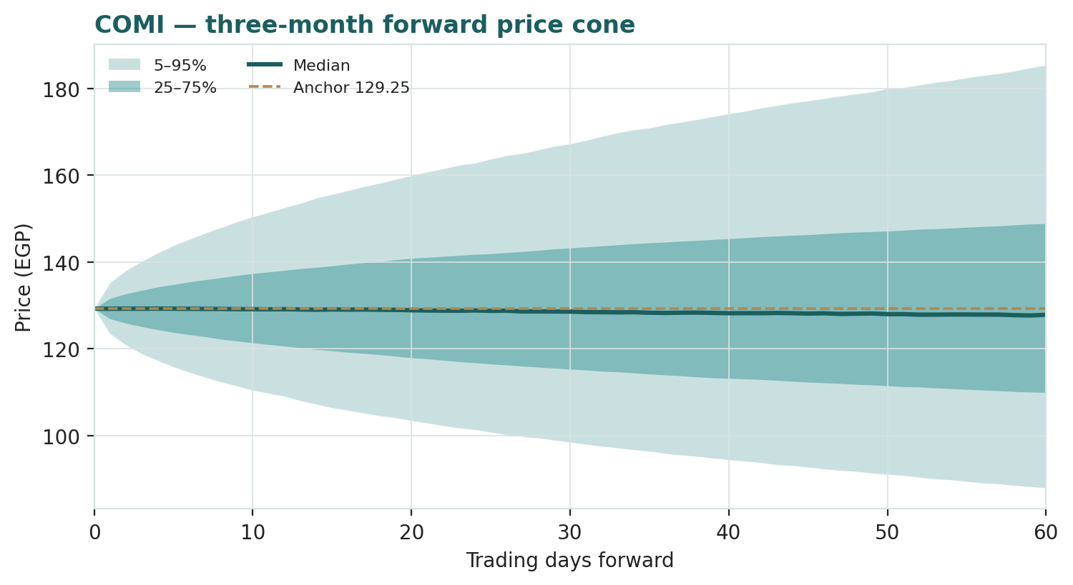
Figure 3 · Three-month fan chart — percentile cone of simulated paths from spot; median ~flat, a wide band.
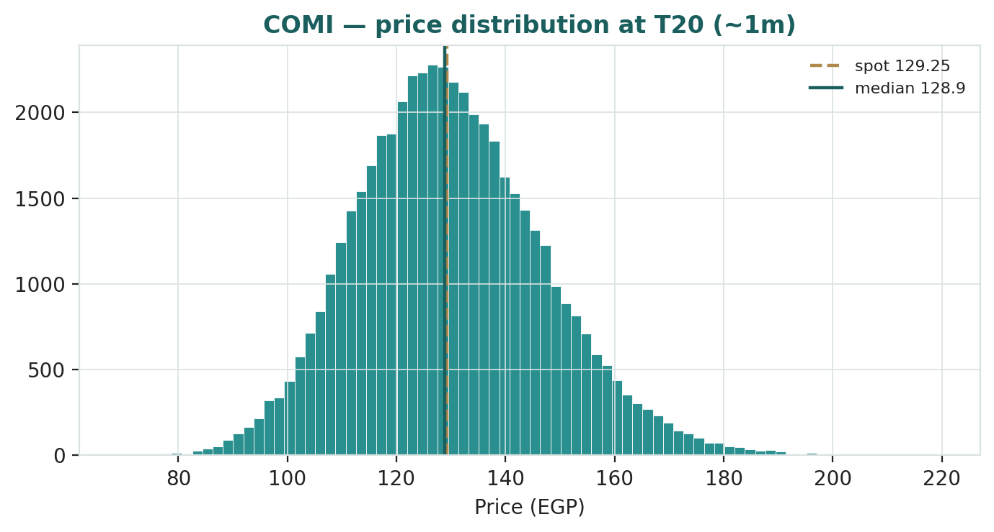
Figure 4 · Distribution of the price at T+20 (~1 month) — roughly two-sided around spot.
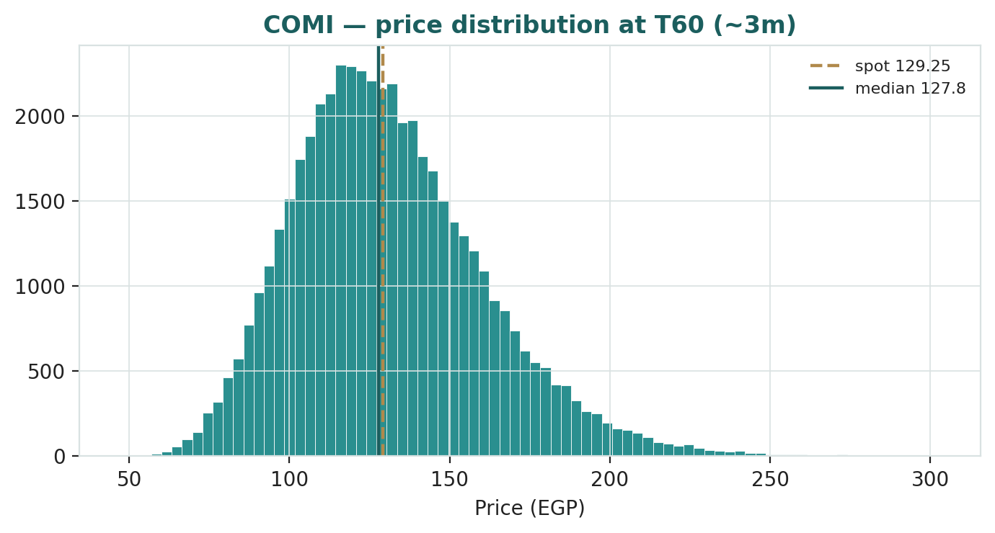
Figure 5 · Distribution of the price at T+60 (~3 months); note the mild right skew and fat tails from the event set.
Touch probabilities — chance the price reaches a level at any point in the window
Level (EGP) | by T+20 | by T+60 | Note
135 | 63% | 78% | toward the 50-day
140 | 45% | 65% | toward the 52-week high
150 | 20% | 45% | new-high territory
125 | 70% | 83% | first support test
120 | 49% | 70% | shallow pullback
110 | 18% | 45% | toward the rising 200-day
100 | 5% | 24% | deeper / bear zone
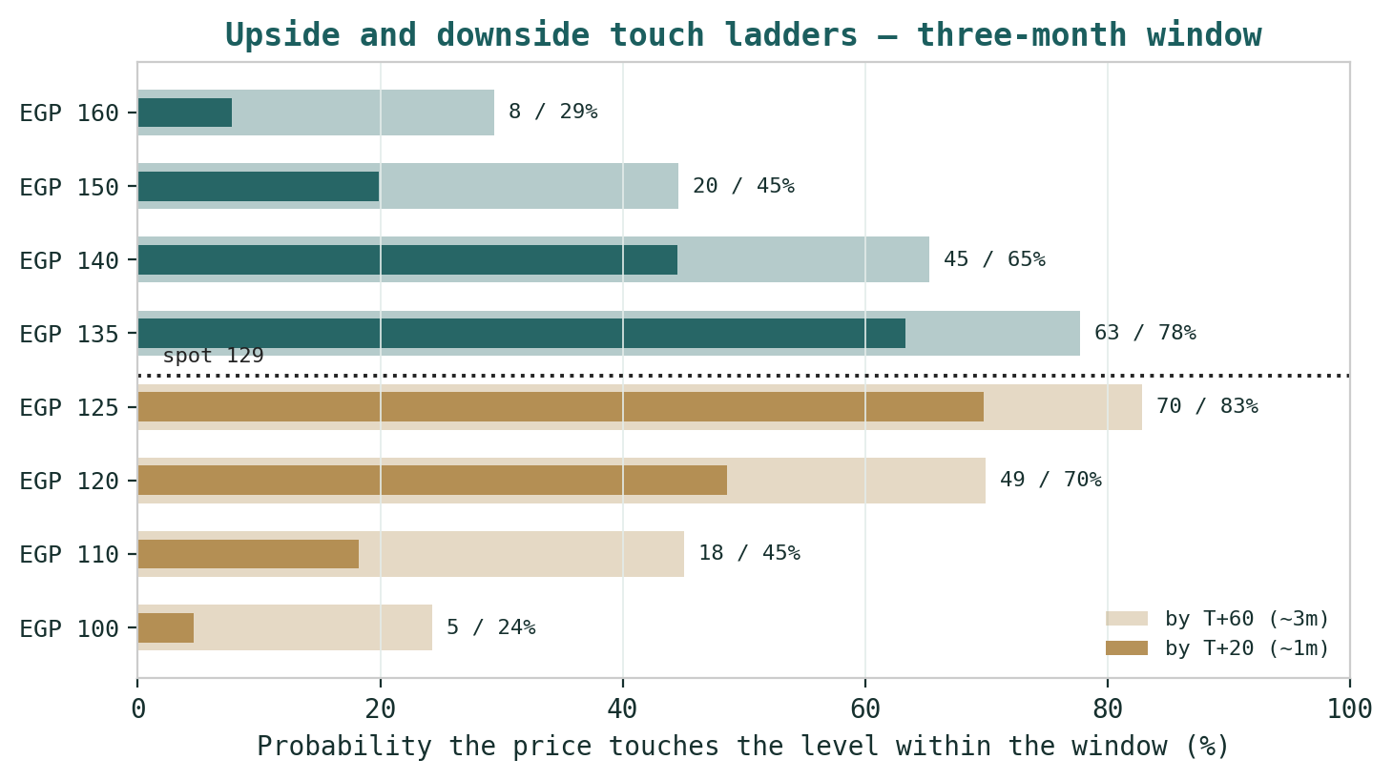
Figure 6 · Upside and downside touch ladders — probability the price touches each level by T+20 (~1m) and T+60 (~3m).
What the map says. Over three months a move up toward the falling 50-day around EGP 135 is more likely than not (~78%), while a push to a new high above EGP 150 is a lower-probability ~45%. On the downside, a retest toward EGP 120 is likely (~70%) and a slide to the rising 200-day near EGP 110 a non-trivial ~45%. Crucially, this near-term map and the fundamental finding are not in conflict: the price can wander within a wide band over three months while value sits a few percent below price. The Monte Carlo describes the former; Section 1 describes the latter.

4 Comparison of the lenses, and a verdict
Lens | What it measures | Output | vs spot
Justified P/B base (primary) | return vs cost of equity | EGP 125.3 | -3%
Justified P/B bull | the ROE spread holds/widens | EGP 169.7 | +31%
Excess-return DCF (explicit) | the spread, with the forecast fade | EGP 90.9 | -30%
Dividend-discount (2-stage) | distributed cash only | EGP 104.3 | -19%
Relative multiples | vs Egyptian & EM banks | EGP 120.7 | -7%
Normalized earnings | through-cycle profit | EGP 114.7 | -11%
WEIGHTED CENTRAL | triangulated estimate | EGP 123.3 | -5%
Monte Carlo T+60 median | likely 3-month price | EGP 127.8 | -1%
Verdict — roughly fairly valued, a touch rich; the whole case is a bet on the return spread. The fundamental lenses agree that EGP 129.25 is close to fair: the central estimate is EGP 123.3 (-5%), and the lenses straddle spot. The dividend-discount cross-check, which captures only distributed cash, is the most conservative and shows how much of the value is retained-earnings compounding. The technical picture is constructive but two-sided, and the three-month price map is wide and roughly centred on spot. A buyer at this level is not buying an obvious discount to book, nor an obvious overvaluation, but is underwriting one proposition: that CIB defends a premium return on equity through the rate-cut cycle — helped by capital return from its 27% CAR, durable low-cost funding and fee growth — rather than letting the sovereign carry compress the return toward its cost of equity while retained capital balloons. If the spread holds, the bull case at EGP 170 is reachable; if it narrows, the downside to the bear case is large. This study expresses a valuation, not a trade, and certainly not advice.

5 Catalysts to watch
Capital return — special dividend or buyback (↑, high impact). With a 27% capital-adequacy ratio against a ~12.5% requirement, CIB carries vast excess capital. A step-up in payout, a special dividend or a buyback would both lift the dividend-discount value and raise the return on equity by shrinking the equity base — the single most powerful self-help lever on the valuation.
The rate path and net interest margin (↑/↓). The pace of CBE easing is the clearest read on the sovereign carry; a pause-for-longer supports near-term earnings, a faster cutting cycle compresses them.
Quarterly net interest margin, cost of risk and fees (↑/↓). The direction of the margin and whether the cost of risk normalises up from the 2025 release are the clearest reads on the operating engine.
Sovereign / IMF / rating (↑/↓). Because CIB is half-invested in Egyptian government paper, an IMF-review outcome, a rating action or a move in treasury yields flows straight into both earnings and the cost of equity.
EGP and foreign flows (↑/↓). As the most liquid Egypt proxy, CIB re-rates with EM and frontier positioning and with the credibility of the currency adjustment.
Asset quality / Stage-2 migration (↓). Stage-2 exposures at ~24% of the loan book are the watch item; a migration to non-performing would lift the cost of risk and pressure both earnings and capital.

6 Reading the probability zones
Combining the fundamental anchors with the three-month price map gives a set of zones — descriptive, not directive.
Zone | Range (EGP) | What it would mean
Re-rating / spread holds | 150+ | ROE durability + capital return + EM re-rating
Upper-fair | 135 – 150 | toward the bull; rates higher-for-longer
Central / fair | 120 – 135 | where spot and the justified-P/B base sit
Spread compresses | 110 – 120 | ROE fades; carry compresses; toward the 200-day
Bear / re-rate down | < 110 | ROE toward CoE; sovereign or asset-quality stress

7 Caveats and what would change our mind
The sustainable ROE is a judgment, and our own forecast disagrees with it. The base assumes CIB defends a ~29.5% return on equity; held at the current low payout, the mechanical forecast fades to ~20% by 2030e as capital balloons. If CIB does not return capital, fair value migrates toward the bear case. This is the single biggest source of error in the valuation, and the Excel companion lets you change the ROE, the cost of equity and the payout.
The cost of equity is high and unobservable. A nominal cost of equity of 24% is a judgment; a one-point change swings fair value 15-25%. If the sovereign risk premium widens, the valuation falls sharply regardless of operating performance.
The carry is rate-dependent. Roughly 52% of assets are Egyptian government securities; the pace of CBE cuts, which we cannot forecast precisely, sets the trajectory of net interest income.
Asset quality looks pristine but Stage-2 is high. Headline NPLs of 1.7% with ~340% coverage are excellent, but Stage-2 exposures near 24% of the book mean a credit-cycle turn could lift the cost of risk materially from the 2025 release.
The Monte Carlo is a price model, not a forecast. It encodes our probability estimates for events that have not happened. The factor probabilities are inputs, not facts, and the model says nothing about value.
Momentum reminder. The chart is constructive but two-sided; a high-quality bank can de-rate on a macro shock. Do not mistake a rising 200-day for a margin of safety; the margin of safety, if any, is in the return spread, not the indicator.

Appendix A Financial statements (EGP bn)
Actuals are CIB's consolidated disclosure under the Central Bank of Egypt's IFRS-9 basis (FY2024 and 9M2025 per the 30 Sep 2025 interim statements; FY2025 and Q1 2026 per the earnings releases). FY2023 figures and balance-sheet sub-lines are approximate allocations to the reported totals; net income for 2023a-2025a ties to CIB's reported consolidated figures. Forecast columns (2026e-2030e) are the preparer's illustrative build that ties to the Excel companion. FY2025 carries a one-off ECL recalibration release (~EGP 6bn) that the forecast normalises away.
A.1 Consolidated income statement (EGP bn)
Income statement | 2023a | 2024a | 2025a | 2026e | 2027e | 2028e | 2029e | 2030e
Net interest income | 58 | 88 | 112 | 120 | 132 | 146 | 161 | 177
Net fee & commission | 6.0 | 7.0 | 8.5 | 9.5 | 10.7 | 12.0 | 13.4 | 14.9
Net trading & other | 3.5 | 6.0 | 5.0 | 4.0 | 4.3 | 4.6 | 4.9 | 5.2
Total operating income | 67.5 | 101 | 125.5 | 133.5 | 147 | 162.6 | 179.3 | 197.1
Operating expenses | (13) | (16) | (18.5) | (22) | (25) | (28) | (31) | (34)
Pre-provision profit | 54.5 | 85 | 107 | 111.5 | 122 | 134.6 | 148.3 | 163.1
ECL charge/(release) | (4.3) | (4.5) | 6.0 | (3.5) | (5.5) | (7.0) | (8.5) | (10)
Profit before tax | 50.2 | 80.5 | 113 | 108 | 116.5 | 127.6 | 139.8 | 153.1
Income tax, profit share & other | (20.5) | (25.3) | (30.8) | (24.3) | (26.2) | (28.7) | (31.5) | (34.4)
Net profit (attributable) | 29.7 | 55.2 | 82.2 | 83.7 | 90.3 | 98.9 | 108.3 | 118.7
Attributable EPS (EGP) | 8.9 | 16.5 | 24.6 | 25.1 | 27.1 | 29.6 | 32.5 | 35.6
Note. Net interest income — driven by the ~52%-of-assets government-securities carry and a 62% CASA deposit base — is the dominant line. FY2025's reported net income of EGP 82.2bn (+49%) was flattered by an ECL provision release; the forecast normalises the cost of risk to a charge. EPS is net of staff and board profit share. Reported net income (2023a-2025a) is CIB's consolidated figure; sub-lines for 2023 are estimated.
A.2 Consolidated balance sheet (EGP bn)
Balance sheet | 2023a | 2024a | 2025a | 2026e | 2027e | 2028e | 2029e | 2030e
Cash & balances at CBE | 80 | 137 | 25 | 30 | 32 | 35 | 38 | 41
Due from banks (net) | 150 | 271 | 230 | 250 | 270 | 292 | 315 | 340
Net loans to customers | 300 | 344 | 490 | 560 | 638 | 720 | 807 | 900
Government securities | 290 | 395 | 658 | 751 | 830 | 906 | 983 | 1,064
Other assets | 50 | 68 | 75 | 80 | 86 | 92 | 98 | 105
Total assets | 870 | 1,215 | 1,478 | 1,671 | 1,856 | 2,045 | 2,241 | 2,450
Deposits | 720 | 973 | 1,110 | 1,230 | 1,340 | 1,450 | 1,565 | 1,690
Other liabilities | 60 | 89 | 140 | 152 | 164 | 176 | 188 | 201
Total equity (attributable) | 90 | 153 | 228 | 289 | 352 | 419 | 488 | 559
BVPS (EGP) | 29.3 | 49.8 | 74.2 | 94.1 | 114.7 | 136.3 | 158.9 | 182.0
CAR (reported, memo) | — | 24.1% | 27.0% | — | — | — | — | —
Note. Totals are anchored to CIB's reported balance sheet (total assets ~EGP 1.21trn and equity ~EGP 153bn at Dec-2024 per the interim statements; ~EGP 1.36trn assets and ~EGP 208bn equity at Sep-2025). The government-securities line is the residual funding bucket so the balance sheet balances by construction. Forecast equity rolls forward by retained earnings; the rapid book-value growth at a low payout is precisely why return on equity fades in the forecast — and why capital return is the key value lever.
A.3 Simplified flows (EGP bn)
Flows | 2023a | 2024a | 2025a | 2026e | 2027e | 2028e | 2029e | 2030e
Net income | 29.7 | 55.2 | 82.2 | 83.7 | 90.3 | 98.9 | 108.3 | 118.7
Dividends paid | (5) | (9) | (15) | (22.6) | (27.1) | (32.6) | (39.0) | (47.5)
Retained (to capital) | 24.7 | 46.2 | 67.2 | 61.1 | 63.2 | 66.3 | 69.3 | 71.2
For a bank, free cash flow is not the right lens — capital adequacy and distributable earnings are. CIB retains most of its earnings (low payout against a 27% CAR), which builds capital quickly and, mechanically, dilutes the return on equity over time — retained earnings reconcile exactly to the equity roll-forward in A.2. The dividend-discount model in 1.3 captures only the distributed portion (hence its conservative EGP 104), while the excess-return DCF in 1.2 discounts the full above-cost return on the growing book and lands at EGP 91 as that return fades.

Appendix B Step 0 — calibration backtest
Before publishing any probabilistic price map we test the engine against CIB's own five-year history: does a lognormal three-month price model, fed with calibrated volatility, produce well-calibrated intervals?
Result. Run naively on trailing realized volatility, the cone was too narrow — over non-overlapping three-month windows the 50/80/90% bands covered the realized price only ~33/60/67% of the time, with a probability-integral-transform (PIT) mean of ~0.60, because CIB's 2024 devaluation-and-rate-hike re-rating produced forward moves that trailing volatility under-estimated. We therefore recalibrate within the engine — no change of distribution — to a regime-aware volatility floor (the greater of the trailing 126-day and 252-day realized volatility) with a 1.15x emerging-market-bank tail buffer, which lands the diffusion volatility at ~41% annualised. On that spec the coverage rises to ~53/73/87% (non-overlapping) and ~60/79/86% (monthly windows), with a PIT mean of ~0.59 — a mild residual lean within one standard error of 0.50 at this sample size, not a material skew. The engine passes; the residual lean reflects CIB's strong five-year uptrend and is left uncorrected, since the Monte-Carlo drift is built from forward factors rather than trailing momentum. Figures B1 and B2 show the probability-integral-transform histogram and the band-coverage check.
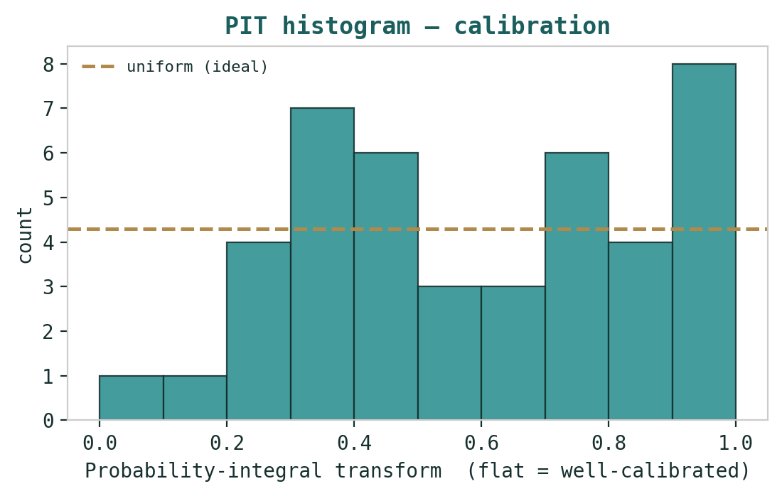
Figure B1 · PIT histogram — a flat profile indicates well-calibrated three-month intervals; the dashed line is the uniform ideal.
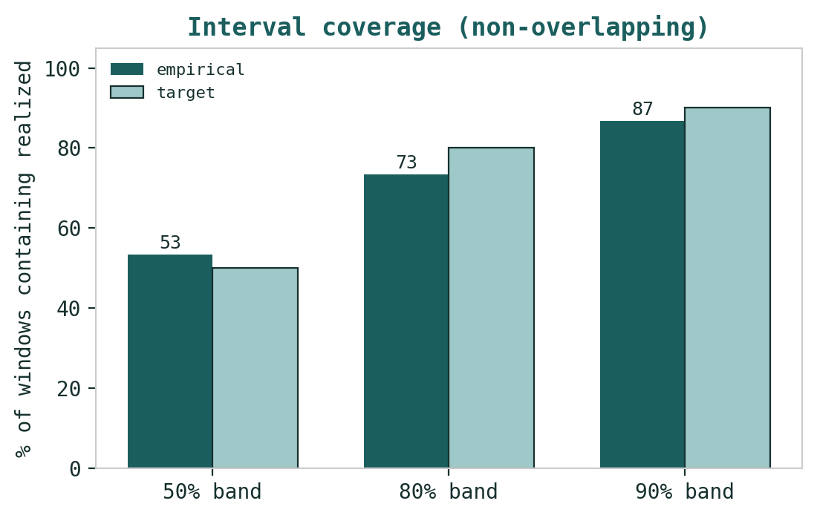
Figure B2 · Interval coverage — share of non-overlapping three-month windows in which the realized price fell inside each band, against its target.

Appendix C Peer set, sector structure, and risks
C.1 The competitive map
Metric | CIB (COMI) | EGX bank peers | EM bank median
Position | largest private bank | ADIB-Egypt, Faisal, QNBAA | frontier / EM lenders
P/B | ~1.74x | ~1.0-1.4x | ~1.1-1.5x
P/E (reported) | ~7x (ECL-flattered) | ~4-6x | ~6-8x
ROE | ~30%+ (falling) | ~25-35% | ~15-22%
NPL / coverage | 1.7% / ~340% | 2-5% / lower | 3-6%
CAR | 27% | 18-22% | 15-18%
CASA | 62% | 40-55% | 45-60%
Gov-securities / assets | ~52% | high (Egypt banks) | varies
CIB screens at a premium to peers on price-to-book — justified by best-in-class asset quality, a 62% low-cost deposit base, and the scarcity/liquidity premium it carries as the foreign-investor proxy for Egypt. The premium is defensible while the return on equity stays high; it is the durability of that return, not the bank's standing, that the premium puts at risk.
C.2 Principal risks
Return normalisation — the dominant factor. A faster-than-expected fade in the return on equity, as the sovereign carry compresses and retained capital balloons, would pull fair value toward the bear case regardless of operating quality.
Sovereign and currency. Roughly half the balance sheet is Egyptian government paper; a stalled IMF review, a rating downgrade or a disorderly pound would lift the cost of equity and pressure asset quality.
Rate path. The pace of CBE easing sets the trajectory of net interest income; the bank's earnings are, in part, a position in the level of Egyptian rates.
Asset quality. Stage-2 exposures near 24% of the loan book are the watch item; a credit-cycle turn would lift the cost of risk from the 2025 release.
Capital allocation. The vast excess capital is a double-edged sword: returned, it lifts the ROE and the valuation; hoarded, it drags both.

Appendix D Three experts value CIB
The same bank, valued three ways by three standing analysts whose methods genuinely disagree. Expert 1 values the capital and its returns; Expert 2 values the credit through the cycle; Expert 3 weights the policy worlds. Each derives a fair value from shown workings, states what would prove the method wrong, and cross-examines the other two. The personas are drawn from the Testahil Expert Persona Library and recur across studies, so each builds a track record; this is an instance, not a re-training.

D.1 Expert 1 — the Capital & returns analyst
Worldview and tradition. A bank is worth its book value plus the present value of the returns it earns above its cost of equity. Value flows from a sustainable return on equity, capital strength, and the ability to grow without dilution. Expert 1 reasons in residual income and justified price-to-book; reported earnings interest her only as a guide to the sustainable return.
When it works / when it fails. Best for well-capitalised banks with stable returns — exactly CIB on the surface. It fails through credit shocks, because book value is not real if the assets behind it are impaired; there she defers to Expert 2.
Standard workings — shown. Step 1 — capital. CIB runs a ~23% CET1 and ~27% total ratio on roughly EGP 990bn of risk-weighted assets (a ~67% risk density on EGP 1.48trn of assets). Against a managed target of ~15%, that is ~EGP 79bn of spare capital — about EGP 26 of every share's book value — earning the sovereign carry but not a franchise return. Step 2 — sustainable ROE. Reported ROE is ~48% (41.5% ex-ECL) and Q1-26 annualises near 32%. Stripping the provision release and the peak real-rate carry — real policy rates compress from ~12% toward ~5%, margin from ~8.95% toward ~6.5% — but volume growth and a 62% CASA base defend it, so she settles at ~29.5% through-cycle. Step 3 — value. Justified P/B = (29.5% − 16%)/(24% − 16%) = 13.5/8 = 1.69x; on book of EGP 74.2 that is EGP 125. The explicit excess-return DCF of 1.2 (EGP 91) is her downside check — where the stock sits if the spread fades rather than holds. Step 4 — sensitivity, below.
Expert 1's base/bull/bear | Base | Bull | Bear
Sustainable ROE | 29.5% | 32% | 26%
Cost of equity | 24% | 23% | 26%
Terminal growth | 16% | 16% | 16%
Justified P/B | 1.69x | 2.29x | 1.00x
Fair value (EGP) | 125 | 170 | 90
Fair value (EGP/share) across sustainable ROE and cost of equity, g = 16%:
ROE ↓ / CoE → | 23% | 24% | 25% | 26%
26% | 106 | 93 | 82 | 74
29.5% (base) | 143 | 125 | 111 | 100
33% | 180 | 158 | 140 | 126
Worked example and the swing input. Her swing input is the sustainable ROE: at a 24% cost of equity each point of ROE is worth ~EGP 9 per share (read across the base row). The capital ratio is the second lever and she prices it explicitly — returning the ~EGP 79bn of excess via buy-backs below 1.7x book would retire ~8% of the shares and lift EPS and the ROE on a leaner base by a similar ~8%, worth ~EGP 10 per share. That is precisely why she will not mark the sustainable return down to the forecast's mechanical ~20%: the over-retention that drags the explicit DCF is a choice CIB can reverse, not a law of nature.
Expert 1 cross-examines. To Expert 2: "Your stress is real but you are double-counting — the 340% coverage already absorbs a credit turn, and the capital ratio is built to take a shock without touching the return I am valuing." To Expert 3: "Your scenario tree is a fine description of the cost of equity, but it is agnostic on the franchise; my ROE is the thing that survives across your policy worlds."
Verdict, falsification, and what the price implies. Fair value EGP 125 — roughly fair. Falsified by a structural ROE shift or a capital event (a large raise, or a return that resets the base). The market's ~1.74x book implies a sustainable ROE a touch above her base at her cost of equity — a small premium she finds defensible but not generous.

D.2 Expert 2 — the Credit-cycle analyst
Worldview and tradition. A bank's value is dominated by the credit it underwrites: through-cycle losses, not peak-cycle profits, set the floor. Reported book value is only as real as the loan book behind it, and a provision release is a loan against the future, not income.
When it works / when it fails. Best late-cycle, in rising-rate or stressed environments, and with opaque books. It fails by being too bearish in benign credit cycles, missing genuine franchise value — a charge Expert 1 will press.
Standard workings — shown. Step 1 — asset quality. Headline NPLs are ~1.7% with ~340% coverage — pristine on the surface — but Stage-2 loans are ~24% of the ~EGP 490bn book, roughly EGP 118bn on the watch-list, concentrated in large-corporate and sovereign-linked names. Step 2 — normalized cost of risk. 2025 booked a release (negative cost of risk); through the cycle CIB has run ~85bps. On the ~EGP 560bn 2026e book that is a ~EGP 4.8bn charge, and it pulls normalized attributable EPS from the reported ~24.6 to ~EGP 19. Step 3 — stress. Migrate ~15% of the Stage-2 book (~EGP 18bn) toward non-performing at ~50% loss-given-default — ~EGP 9bn of incremental loss — and the cost of risk runs to ~200bps; stressed EPS falls to ~EGP 14. Step 4 — value off normalized and stressed earnings on a through-cycle 5.0-5.5x, never off the reported peak.
Expert 2's working | Reported 2025 | Normalized | Stressed
Cost of risk | release (~negative) | ~85 bps | ~200 bps
Implied attributable EPS (EGP) | ~24.6 | ~19 | ~14
Fair multiple | — | ~5.5x | ~5.0x
Fair value (EGP) | — | 105 | 70
Fair value (EGP/share) across the through-cycle cost of risk and the exit multiple:
Cost of risk ↓ / multiple → | 5.0x | 5.5x | Implied EPS
~0 bps (release world) | 123 | 135 | ~24.6
~85 bps (normalized) | 95 | 105 | ~19
~150 bps | 80 | 88 | ~16
~200 bps (stressed) | 70 | 77 | ~14
Worked example and the swing input. His swing input is the through-cycle cost of risk, and the ~24% Stage-2 share is the coiled spring: the distance between the release world (EGP 123-135) and a genuine downturn (EGP 70-77) is the entire valuation. His point estimate, EGP 100, blends the normalized case with a haircut for that migration risk and sits below spot precisely because the reported return is, to him, a provision-flattered carry peak rather than a clean run-rate.
Expert 2 cross-examines. To Expert 1: "Your 29.5% ROE is the release and the carry talking; normalise the cost of risk and re-base the rate and it is closer to 24%, which is your bear." To Expert 3: "Your sovereign tail is my credit tail by another name — a disorderly pound is exactly what migrates the Stage-2 book."
Verdict, falsification, and what the price implies. Fair value EGP 100 — modestly overvalued. Falsified by a sustained improvement in asset quality or proven underwriting discipline through a real downturn. The market's price implies the cost of risk stays near its released trough — a bet he is unwilling to make at ~1.74x book.

D.3 Expert 3 — the Macro-Policy strategist
Worldview and tradition. In frontier and emerging markets, policy outranks fundamentals — the currency regime, the rate path, the IMF programme and sovereign action move value more than management does. He prices CIB as a set of options on which policy world arrives.
When it works / when it fails. Best in policy-driven markets with binary catalysts and an FX/rate regime in flux — Egypt today. It fails through false precision: the probabilities are judgments, and a tree can miss the branch that grows.
Standard workings — shown. Step 1 — levers. Three set the value: the real policy rate (the carry), the pound (a managed float since the March-2024 devaluation, now ~EGP 48-50/USD), and the IMF/sovereign track (the ~USD 8bn Extended Fund Facility and large inflows of the Ras-El-Hekma type). Step 2 — define the worlds as configurations of those levers. Step 3 — run each through the same justified-P/B machinery with a world-specific ROE and cost of equity: the bull keeps rates higher-for-longer (carry intact, ROE ~31.5%) while a credible adjustment compresses the risk premium (CoE ~23%), giving ~2.2x book; the base eases gradually (ROE ~29%, CoE ~24%, ~1.6x); the bear is a stalled review and a disorderly pound (ROE ~26.5%, CoE ~27%, ~0.95x). Step 4 — probability-weight. Step 5 — stress the weights, below.
Expert 3's policy worlds | Prob. | ROE / CoE | Fair value
Bull — adjustment holds | 30% | 31.5% / 23% | 165
Base — measured easing | 45% | 29% / 24% | 120
Bear — sovereign stress | 25% | 26.5% / 27% | 70
Probability-weighted |  | 0.30·165 + 0.45·120 + 0.25·70 | 120
Weighted fair value as the scenario weights shift (bull / base / bear):
Weighting | Weighted FV (EGP)
35% / 45% / 20% (constructive) | 126
30% / 45% / 25% (base) | 120
25% / 40% / 35% (cautious) | 114
20% / 40% / 40% (defensive) | 109
Worked example and the swing input. His swing input is the probability set itself: the fair value moves more with the weight on the sovereign tail than with any single lever — the honest admission of the method, which prices a distribution of policy worlds rather than a forecast. He reads the market's ~EGP 130 as sitting between his base and bull, pricing a benign policy path with, in his view, too little weight on the bear.
Expert 3 cross-examines. To Expert 1: "Your sustainable ROE is not a constant — it is different in each of my worlds; you are pricing my base case and calling it structural." To Expert 2: "Your stressed case is my bear world; we agree on the downside, we disagree on its probability."
Verdict, falsification, and what the price implies. Fair value EGP 120 — roughly fair, with a fat downside tail. Falsified by a fourth, unmodelled policy shock dominating, or by the scenario set being mis-specified. The market's price sits between his base and bull — pricing, he would say, a benign policy path with too little weight on the sovereign tail.

D.4 The three in one room
Put them at one table and the argument narrows to a single question: is CIB's ~30% return on equity a durable franchise return or a provision-flattered carry peak? Expert 1: "It is a franchise return — 62% CASA, best-in-class quality, and a capital ratio that lets them return cash and hold the ROE. The market's 1.74x is fair." Expert 2: "It is a carry peak with a provision release on top. Normalise the cost of risk and re-base the rate and you are at 1.0-1.2x book, not 1.74x." Expert 3: "You are both right, in different worlds. If the adjustment holds, Expert 1 wins and the stock re-rates; if it breaks, Expert 2's stressed book arrives through my currency channel. The price is a weighted bet, and the market is weighting the good worlds a little too heavily." They do not converge — but they agree on the fulcrum: the durability of the return, conditional on the policy path.

D.5 Reading the divergence
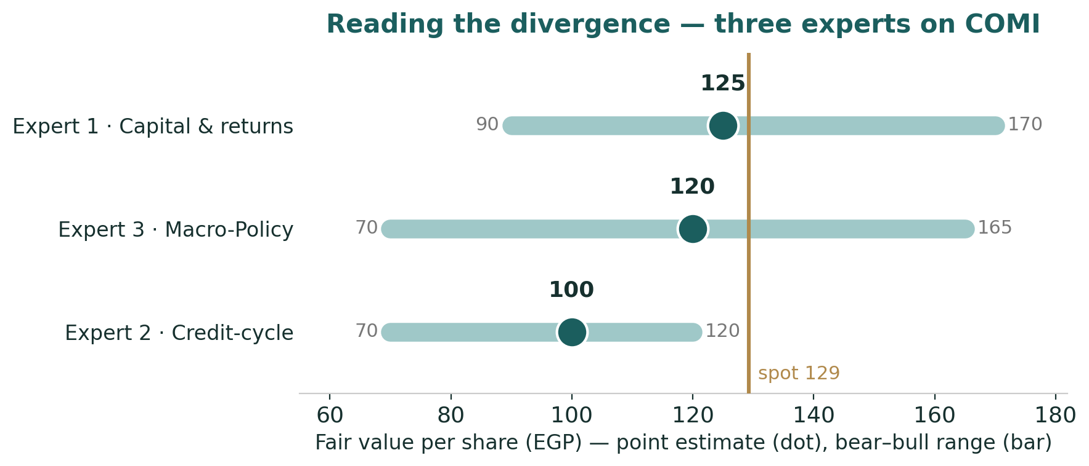
Figure D1 · The three experts' fair values — point estimate (dot) and bear–bull range (bar), against spot.
Expert | Fair value | The one assumption that drives it
Expert 1 · Capital & returns | EGP 125 | sustainable ROE of ~29.5% (capital returned, base defended)
Expert 3 · Macro-Policy | EGP 120 | 45% weight on a measured-easing base world
Expert 2 · Credit-cycle | EGP 100 | cost of risk normalised to ~85bps, off a provision-flattered 2025
What the spread measures. The EGP 100-to-125 gap between Expert 2 and Expert 1 is not a disagreement about CIB's quality — all three call it the best bank in Egypt — but about what its recent returns represent. Expert 1 reads the ~30% ROE as a sustainable franchise return that justifies a premium to book; Expert 2 reads it as a carry peak with a provision release on top, worth closer to book once normalised; Expert 3 prices the policy path that decides between them. The spread, in one line, is the price of the question this entire study turns on: how much of the post-devaluation return is franchise, and how much is the sovereign carry — and the market, at ~1.74x book and EGP 129, sits at the optimistic end of the three, pricing the franchise reading with only a modest discount for the carry and the policy tail.

About this series
Testahil publishes independent, educational valuation studies. Each is an attempt to reason transparently about what a security is worth, with every assumption shown and a companion model so readers can disagree productively. The house style is distributions, not tips: we describe ranges and probabilities, not targets, and we do not tell anyone what to do. Studies are framed as educational analysis, the preparer is not licensed by any securities regulator, and holdings are disclosed.

Disclosure & Disclaimer
Not investment advice. This document is educational and informational only. It is not, and must not be relied upon as, investment, financial, legal, accounting or tax advice, nor an offer, solicitation or recommendation to buy, sell or hold any security. It contains no price target and no rating.
No licence; no advisory relationship. The preparer is not registered or licensed with any securities or financial regulator in any jurisdiction, holds no brokerage or investment-advisory authorisation, and is not acting as your adviser or fiduciary. Nothing here is personalised to your circumstances.
Holdings disclosure. The preparer may hold, and may in the future take or dispose of, a position in the security discussed in this report, and may transact at any time without notice. This is a potential conflict of interest you should weigh.
Sources & accuracy. Reported financial and operating figures are drawn from CIB's public disclosure and other public sources believed reliable but not independently verified; they may contain errors or be superseded. Forward-looking inputs — the sustainable ROE, the cost of equity, the projections, the multiples, the dividend-discount build and the Monte-Carlo factor probabilities — are the preparer's own judgments and are inherently uncertain.
Forward-looking statements. Any statements about the future are estimates subject to risks and uncertainties; actual results may differ materially. The Monte Carlo models price, not value, and encodes subjective probabilities for events that have not occurred.
No reliance; your responsibility. Do your own research and consult a licensed professional before making any decision. You are solely responsible for your investment decisions and their outcomes. To the maximum extent permitted by law, the preparer accepts no liability for any loss arising from use of this document.
Currency & figures. All figures are in Egyptian pounds (EGP) unless stated; bn denotes billion, trn trillion. Rounding may cause totals to differ slightly. Spot price and market data are as of 29 June 2026 and change continuously.
TESTAHIL · Independent Valuation Study · Educational Analysis · Commercial International Bank (EGX: COMI) · edition 29-06-2026 · reporting currency EGP

