Testahil · Independent Valuation Study — Educational Analysis Not investment advice

DEWA — Dubai Electricity and Water Authority (PJSC)
Fundamental analysis · Technical analysis · Monte Carlo simulation — one integrated read
Anchor: AED 2.79 (10-Jul-2026 close) · 50,000 mn shares · market cap AED 139.5 bn (~US$38.0 bn) · the exclusive electricity and water utility of the Emirate of Dubai — generation (17,979 MW installed, 21.5% clean), transmission and distribution, seawater desalination (555 MIGD), plus consolidated subsidiaries: Empower 80% (district cooling, DFM-listed, bought up from 56% on 10-Feb-2026), Mai Dubai, Digital DEWA / Moro, Etihad ESCO (all 100%) and eight partly-owned IPP/IWP project companies. Reporting currency AED (pegged to USD at 3.6725) · prices and probabilities computed 11-Jul-2026 from the attached daily history · primary lens: the dividend-policy DDM, cross-checked by a full FCFF DCF (framed as a ceiling), relative EV/EBITDA and a justified price-to-book · the swing factor: what the board does with the dividend after the AED 6.2bn-a-year IPO policy window closes in October 2027.
READ FIRST — what this document is, and is not. This study is a valuation exercise and an expression of analytical opinion, published free of charge for educational purposes: it shows how one research house applies fundamental, technical and probabilistic methods to a listed company, and invites scrutiny of that methodology. It is NOT investment advice, NOT a recommendation or solicitation to buy, sell or hold any security, and NOT directed at the circumstances of any reader. Testahil is not licensed by any securities regulator in any jurisdiction, holds no brokerage or advisory authorisation, manages no money, and accepts no fees or clients. All values are model outputs presented as ranges and distributions because no single number should be relied on.
Sources. Reported financials are the company’s own disclosure: the FY2025 consolidated financial statements audited by KPMG Lower Gulf (signed 27-Feb-2026), the FY2024 comparatives within them, the Q1-2026 results release (12-May-2026), the Empower stake-transaction announcements (10-Feb-2026), and DEWA’s investor-relations disclosures. Forward-looking inputs — the growth, margin and capex paths, the cost of capital, terminal growth, the dividend-policy scenarios and the Monte-Carlo factor probabilities — are the preparer’s judgments and are flagged throughout.
The one-line read. Weighted fundamental central AED 3.32 (bear 2.18 / bull 4.92) against spot AED 2.79 — a 19% gap on a ~12-month basis. The genuine 3-month Monte Carlo median is AED 2.81 (+0.6%): the two clocks answer different questions and are never blended.
The crux in one sentence. Everything turns on what the board does with the dividend after the AED 6.2bn-a-year policy window closes in October 2027 — at spot, the market is paying for that coupon growing about 1.3% forever, below UAE inflation and far below Dubai nominal GDP.
Calibration. The Monte Carlo engine publishes under the parity tier for DEWA: calibrated and market-panel validated, with no demonstrated single-name edge claimed. Every forecast in this study is registered in the public Calibration Ledger and will be graded when it matures — pass or fail.

The company
Dubai Electricity and Water Authority is the exclusive supplier of electricity and water to the Emirate of Dubai — every home, tower, hotel, mall and factory in the city is its customer, 1.33 million accounts and counting, growing 4-5% a year because Dubai grows every year. It generates power (increasingly from the giant Mohammed bin Rashid Al Maktoum Solar Park), desalinates seawater at one of the largest municipal scales anywhere, and owns the wires and pipes that deliver both; its 80%-owned, separately-listed subsidiary Empower does the same job for the chilled water that cools the city’s buildings — the largest district-cooling operator in the world. The Government of Dubai, through the Dubai Investment Fund, still owns 82% of the shares after the April-2022 IPO, and the company was listed explicitly as an income instrument: a policy promising at least AED 6.2 billion a year in dividends for its first five years. It earns a regulated-style return on an enormous asset base — AED 195 billion of plant and infrastructure — behind a legal monopoly, with world-record operating metrics (2% electricity line losses, 4.4% water losses, 0.82 customer-minutes lost a year) that no competitor is permitted to attack. The investment question is almost entirely about one decision: what the dividend becomes once the five-year promise expires in October 2027.
DEWA at a glance — how the machine is put together
Origins and structure. DEWA was created by decree in 1992 from the merger of the Dubai Electricity Company and the Dubai Water Department, and operated for thirty years as a wholly-government authority before the Government of Dubai sold 18% through an April-2022 IPO at AED 2.48 per share — an offer that drew US$85 billion of demand and 37 times oversubscription, at the time the largest listing the Dubai Financial Market had ever hosted. In 2023 the government’s 82% was transferred to the newly-created Dubai Investment Fund under Law No. (25) of 2023; the ultimate controlling party remains the Government of Dubai. The group generates through a mix of wholly-owned plant and eight partly-owned independent power and water producer (IPP/IWP) companies — Shuaa Energy 1/2/3/4, Noor Energy 1, Hassyan Energy Phase 1 and the two Hassyan Water companies, held at 51-60% with international partners funding the minority share — which is why non-controlling interests appear throughout the accounts and why NCI capital contributions of AED 2.1bn arrived in each of the last two years: the partners pay their share of the build as it happens.
Regulation and the tariff. There is no formal RAB-style price control. Retail slab tariffs are set by the Dubai Supreme Council of Energy and have been unchanged since 2011; movements in fuel cost pass through a fuel surcharge measured against a 2010 base year, with over- and under-collections parked in a regulatory deferral account on the balance sheet (AED 699mn credit at FY25) and settled against future tariff decisions. In practice DEWA’s realised return is protected by three things: the pass-through mechanism, a falling fuel bill as the clean-energy share rises, and an owner who collects 82% of every dirham distributed. Moody’s upgraded the credit to A3 (stable) from Baa2 on 30-May-2024, citing the dominant market position, strong credit metrics, a tariff structure that supports healthy cash generation, and liquidity.
The listing promise. The IPO prospectus committed to a minimum AED 6.2 billion of dividends a year — AED 0.124 per share — for five years from October 2022, paid semi-annually each April and October. Every instalment has been paid on schedule. That floor expires in October 2027 and the board has said nothing about what follows; section 1.8 prices every branch of that question, because it is the valuation.
Q1-2026 update (verified against source, post-anchor)
DEWA reported Q1-2026 on 12-May-2026. Revenue reached AED 6,450mn (+8.2% y/y) — the seasonal trough quarter, since cooling load peaks in summer — with EBITDA of AED 2,880mn (+18.4%) and operating profit of AED 1,290mn (+53.6%). Group profit after tax was AED 1,050mn, of which AED 940mn attributable to owners (+89.9% on a soft base); operating cash flow reached AED 3,890mn. Customer accounts crossed 1,347,000 (+5.1% LTM), generation reached 11.09 TWh with 2.06 TWh clean, and desalinated water supplied 37.6 bn imperial gallons. Empower’s own Q1 — its first as an 80% subsidiary — printed revenue +16.8% to AED 631mn and net profit +44% to AED 208mn at a 56.8% EBITDA margin, adding 34,000 refrigeration tons of connected capacity. The FY26E driver set (revenue +7.5%, margin 54.2%) is held below the Q1 run-rate rather than extrapolating a single seasonal quarter.
Headline
The weighted fundamental central sits at AED 3.32 against a 2.79 spot — about 19% above the market — inside a bear-bull span of 2.18-4.92. The gap is not a secret: the market prices the unresolved post-2027 dividend regime, an 18% free float inside an 82% government holding, and four years of sideways trading since the IPO; the model prices an Aa2-country cost of equity against a legal monopoly that covers its coupon 1.23-1.35 times and carries roughly AED 21bn of unused distribution headroom. The 60-session Monte Carlo is close to flat (median 2.81, +0.6%), because the engine’s price centre is the money-market carry — the fundamental gap never enters the drift.
Valuation summary — every read at a glance
Lens | Bear | Base | Bull | Weight | One-line read
§1.1 Dividend-policy DDM (primary) | 2.09 | 3.83 | 5.90 | 35% | the cash a holder actually receives; the policy IS the instrument
§1.2 FCFF DCF (ceiling framing) | 1.55 | 3.36 | 6.49 | 20% | full waterfall shown; TV 86.7% of EV — disclosed, hence a ceiling
§1.3 Relative EV/EBITDA | 2.55 | 2.93 | 3.31 | 25% | 9-11x FY26E vs TAQA ~13x, SEC ~11x — a deliberate float discount
§1.4 Justified P/B | 2.50 | 2.91 | 3.65 | 20% | ROE 9.3% vs Ke 6.7% justifies 1.60x book vs 1.53x paid
Weighted fundamental central | 2.18 | 3.32 | 4.92 | 100% | +19% vs spot; the crux is the post-2027 dividend

Monte Carlo (genuine 3-month) | Value
Median T+60 | AED 2.81 (+0.6%)
P(close above spot) | 52.1%
P(≥ +10%) / P(≤ −10%) | 20.3% / 15.5% — odds 1.31:1
90% band T+60 | AED 2.33 – 3.39
50% band T+60 | AED 2.61 – 3.02

Fundamental ranges are a ~12-month basis; the MC band is a genuine 3-month distribution; the DCF bull leg is a multi-year ceiling. Three clocks — never blended, never averaged. The weighted central of 3.32 is the disclosed-weight midpoint of the lens field, always read with the 2.18-4.92 range around it; the football field carries the divergence and §4 reads it.
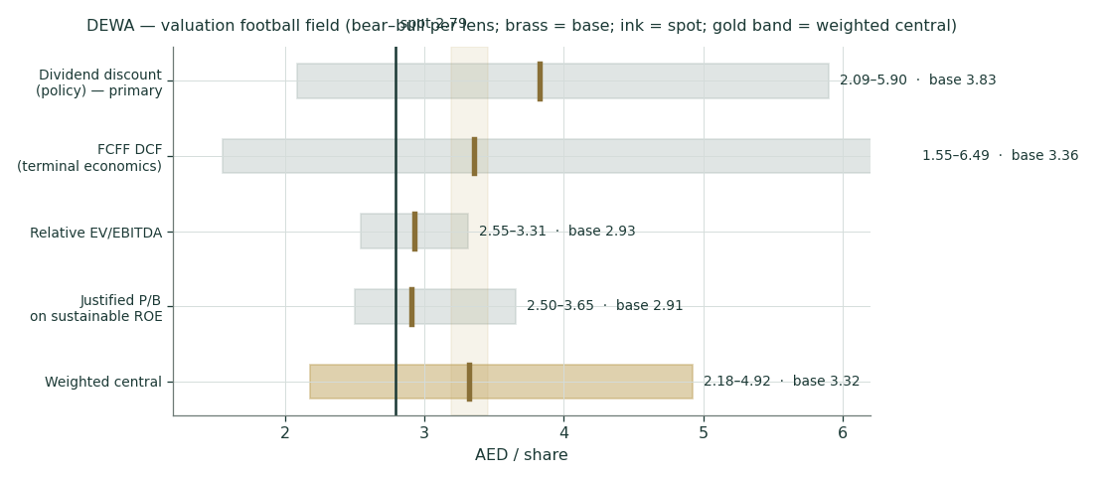
Figure 1. The football field — bear-bull span per lens, brass tick = base, dark line = spot AED 2.79, gold band = the weighted central.
Company overview — DEWA at a glance
Item | Value | Item | Value
Exchange / ticker | DFM : DEWA | Spot / 52-wk range | 2.79 / 2.47–3.15
Shares / market cap | 50,000 mn / AED 139.5 bn | Free float | 18% (DIF holds 82%)
FY25 revenue / EBITDA | AED 32,842 / 17,661 mn engine (17,329 company — dual-framed) | FY25 profit (owners) | AED 8,347 mn · EPS 0.167
Net debt FY25 | AED 31,089 mn strict · 36,273 PF post-Empower | Rating | Moody's A3 stable (from Baa2, 30-May-2024)
DPS policy | AED 0.124/yr floor (6.2bn) to Oct-2027; semi-annual | Yield at spot | 4.4%
IPO | Apr-2022 at AED 2.48; US$85bn demand, 37x covered | Since IPO | +276.0% price — the return has been the dividend
Customers | 1,327,182 (+4.5%); Q1-26 1,347,000 | Regulator | Dubai Supreme Council of Energy; slab tariffs since 2011
Subsidiaries | Empower 80% (listed) · Mai Dubai, Digital DEWA/Moro, Etihad ESCO 100% | IPP/IWP stakes | Shuaa 1-4, Noor 1, Hassyan Energy/Water at 51-60%

Operating footprint — the physical machine (FY25 audited / directors’ report)
Metric | FY25 | y/y | Note
Installed power capacity | 17,979 MW | +4.7% | of which 3,860 MW clean (21.5%)
Power generated | 62.21 TWh | +5.1% | clean 10.10 TWh = 16.2% of output (+52.4%)
Peak power demand | 11.391 GW | +5.8% | the summer cooling peak — the capacity-planning anchor
Desalination capacity | 555 MIGD | — | Hassyan SWRO 180 MIGD in early production
Water demanded | 161.5 bn IG | +6.6% | peak day 487 MIGD (from 455)
Customer accounts | 1,327,182 | +4.5% | ~57,000 net adds
Line losses — electricity / water | 2.0% / 4.4% | — | world-lowest disclosed; CML 0.82 min/customer/yr
2030 targets | >23,000 MW · 735 MIGD | — | 8,300 MW renewable (36.1%); 308 MIGD SWRO

Source: FY25 audited financial statements and directors’ report (KPMG, 27-Feb-2026); Q1-26 results release. The 2030 programme — capacity, renewables share and reverse-osmosis water — is the capex driver behind §1.2 and the execution risk in Appendix B.
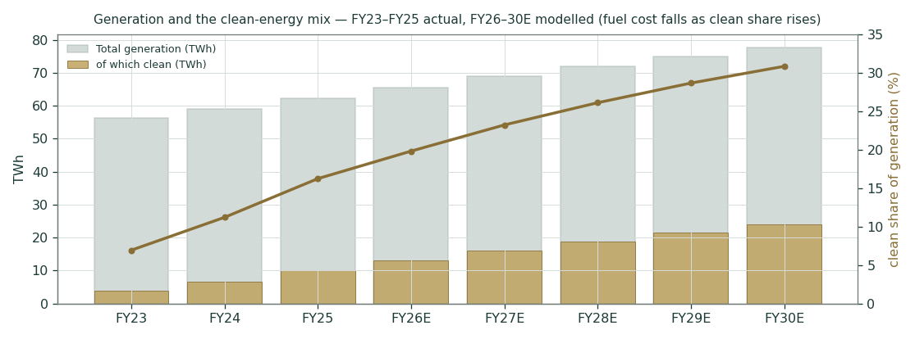
Figure 2. Generation and the clean-energy mix, FY23–FY30E — fuel cost per unit falls as the solar share rises; the model carries that through the margin line.
1 Fundamental valuation
DEWA is an income instrument with a regulated-asset engine behind it, so the primary lens is the dividend itself: the thing the company was listed to pay, the thing 82% of which returns to the owner who sets the policy. The FCFF DCF is shown in full — every line of the waterfall, per our standing rule — but explicitly framed as a ceiling, because 86.7% of its value sits in a terminal claim about post-2030 economics. Two market-family lenses discipline both: a relative EV/EBITDA read against the GCC utility set, and a justified price-to-book that converts the return-on-equity spread into a multiple. The weights are 35 / 20 / 25 / 20. Nothing is blended across methods that answer different questions; each lens carries its own bear-base-bull span, and §1.5 reads the field.
1.1 The dividend-policy DDM — the primary lens (35%)
The listing promise is AED 6.2bn a year — AED 0.124 per share — through October 2027, paid semi-annually without a miss since the IPO. The base case grows that coupon 5.5% a year for five years (tracking earnings growth with rising payout capacity: the FY26E payout would be only ~65% of attributable earnings) and 3.0% in perpetuity — roughly Dubai’s long-run inflation, well below its nominal GDP trend — discounted at Ke 6.735% (rf 4.30% + β 0.50 × ERP 4.87%, built bottom-up in §1.6). Year by year, in full:
Base path | Yr 1 | Yr 2 | Yr 3 | Yr 4 | Yr 5 | Terminal
DPS (AED) | 0.1308 | 0.1380 | 0.1456 | 0.1536 | 0.1621 | TV = 4.469
Discount factor @ 6.735% | 0.9369 | 0.8778 | 0.8224 | 0.7705 | 0.7219 | 0.7219
PV (AED) | 0.1226 | 0.1211 | 0.1197 | 0.1184 | 0.1170 | 3.226

Sum of explicit PVs 0.599 + PV of the terminal 3.226 = AED 3.83 — the base value, of which 84% is the terminal: disclosed, and exactly why the perpetual growth assumption is the crux. The bear case freezes the coupon (policy rolled flat at 0.124, 1.0% perpetual drift) — AED 2.09, below spot. The bull case steps the payout up 9% a year post-2027 toward a 75-80% payout ratio, 4.0% perpetual — AED 5.90.
Scenario | Stage-1 g | Perpetual g | Value (AED) | vs spot
Bear — policy frozen | 0.0% | 1.0% | 2.09 | -25%
Base — modest step-ups | 5.5% | 3.0% | 3.83 | +37%
Bull — payout re-rating | 9.0% | 4.0% | 5.90 | +111%
Deep bear — cut to fund the build | −20% step | 0.0% | 1.47 | −47%

The fourth leg is the one nobody prices: a board that cuts the coupon ~20% to AED 4.96bn to fund the 2030 programme, then holds it flat, is worth AED 1.47. Its absence from market conversation is itself information — at 2.79 the market assigns the cut leg roughly nothing, consistent with an 82% owner collecting AED 5.1bn a year from the floor. The crux, stated in full: one October-2027 communication selects among values spanning AED 1.47-5.90.
The market-implied read is the sharpest single number in this study. Hold the base stage-1 path fixed and solve the two-stage model for the perpetual growth that makes the DDM equal spot: at AED 2.79 it is 1.33%. (Dual-framed, because the number depends on the frame: the single-stage read — Ke minus the spot dividend yield, shown in the companion Excel — is 2.29%; the two-stage 1.33% is lower because the base stage-1 path already grows the coupon 5.5% a year.) The market is pricing DEWA’s dividend as a coupon that grows below UAE inflation forever — for a monopoly whose customer count compounds at 4-5% and whose owner collects four-fifths of every distribution. Any post-2027 policy that merely keeps pace with the city is upside against that price. That asymmetry, not any heroic forecast, is why this lens leads the weighting.
1.2 The FCFF DCF — shown in full, framed as a ceiling (20%)
The full waterfall is printed because it shows exactly where the value sits. The drivers (detailed in §1.7): revenue grows 7.5% in FY26E — held below the +8.2% Q1 actual — fading to 4.5% by FY30E as the customer base matures; the EBITDA margin walks 54.2% to 55.5% as the clean-generation share cuts the fuel line (every solar megawatt-hour displaces purchased gas at near-zero marginal cost); D&A holds near 21% of revenue on the growing asset base; capex runs AED 12.5-14.0bn a year against the 2030 capacity and water programme, consistent with the AED 11.7bn invested in FY25; working capital absorbs 1% of incremental revenue; tax at the 9.5% effective rate (UAE 9% corporate tax plus DMTT drag). Terminal growth 2.5% at the rating-basis WACC of 6.24%.
AED mn | FY26E | FY27E | FY28E | FY29E | FY30E
Revenue | 35,305 | 37,423 | 39,482 | 41,456 | 43,321
EBITDA | 19,135 | 20,433 | 21,715 | 22,925 | 24,043
– D&A | (7,273) | (7,784) | (8,291) | (8,789) | (9,227)
EBIT | 11,862 | 12,649 | 13,424 | 14,136 | 14,816
NOPAT (t 9.5%) | 10,736 | 11,447 | 12,148 | 12,793 | 13,408
+ D&A | 7,273 | 7,784 | 8,291 | 8,789 | 9,227
– Capex | (12,500) | (13,500) | (14,000) | (14,000) | (13,500)
– ΔWC | (25) | (21) | (21) | (20) | (19)
FCFF | 5,484 | 5,710 | 6,419 | 7,562 | 9,117
Discount factor | 0.9412 | 0.8859 | 0.8339 | 0.7849 | 0.7388
PV of FCFF | 5,162 | 5,059 | 5,353 | 5,936 | 6,736

The full waterfall: Revenue → EBITDA → −D&A → EBIT → NOPAT → +D&A → −Capex → −ΔWC → FCFF → discount factor → PV of FCFF. Nothing is hidden between the operating line and the present value.
Bridge to equity | AED mn
Sum PV of explicit FCFF (FY26-30E) | 28,245
PV of terminal value (g 2.5%, WACC 6.24%) | 184,501
Enterprise value | 212,746
TV as % of EV — disclosed | 86.7%
– Net debt (pro forma, post-Empower payment) | (36,273)
– Non-controlling interests (Empower 20% at DFM market cap; IPP minorities at book) | (8,598)
Equity value | 167,875
Fair value per share | AED 3.36
Alt framing: adding AED 6,631mn term deposits + treasury investments | AED 3.49

How the NCI deduction of 8,598 is built | AED mn
NCI book value, audited (31-Dec-25) | 6,753
− Empower NCI component at 44% of Empower book equity (derived from segment disclosure — not a stated FS line) | (1,355)
+ Empower 20% residual minority marked at DFM market cap (0.20 × 16,000) | +3,200
= NCI as deducted in the bridge | 8,598

Only the listed Empower stub is marked to its DFM price; IPP and other minorities stay at audited book. The 1,355 Empower-at-book component is derived, not stated line-by-line in the FS — the derivation is shown above and will be revisited if Empower’s own disclosure sharpens.
Read honestly: with 87% of enterprise value in the terminal, this lens is a statement about DEWA’s economics beyond 2030 — the 23-GW system, the 735-MIGD water platform, whatever tariff regime then applies — not about the next five years. That is why it carries 20% weight and the explicit ceiling label, and why the study never blends it with the market lenses into one point. The bear leg discounts at the CDS-basis WACC with 2.0% terminal growth and a 10% heavier capex bill (AED 1.55); the bull leg takes 5.75% and 3.0% with the capex programme delivered 8% under budget (AED 6.49). The AED 5.2bn Empower payment sits in pro-forma net debt; the corresponding earnings pickup (the 24% minority DEWA no longer pays away) arrives in the FY26E attributable line.
1.3 Relative EV/EBITDA — the market’s own yardstick (25%)
DEWA’s spot enterprise value (market cap + pro-forma net debt + NCI at the marked bridge) is AED 184,371mn — 9.6x FY26E EBITDA of AED 19,135mn. The GCC utility shelf around it: TAQA trades near 13x with an Abu Dhabi scarcity premium and a 1.6% yield; Saudi Electricity near 11x under an explicit regulated-WACC framework; Tabreed near 11x; DEWA’s own 80% subsidiary Empower changes hands near 12.7x with a 5.4% yield. ACWA Power’s ~20x is developer economics, not a utility comp — it marks the boundary of the set rather than belonging to it.
Multiple applied to FY26E EBITDA | 9.0x (bear) | 10.0x (base) | 11.0x (bull)
Implied EV (AED mn) | 172,218 | 191,353 | 210,488
– Net debt PF – NCI | (44,871) | (44,871) | (44,871)
Equity / per share | 2.55 | 2.93 | 3.31

The lens prices DEWA at 9-11x — deliberately below TAQA despite better disclosed operating metrics, acknowledging the 18% free float, the DFM index weight, and the absence of TAQA’s implicit Abu Dhabi consolidation story. Even at that discounted band the base sits above spot: the market currently pays 9.6x for a monopoly growing volumes at 5-6% a year, a multiple the region reserves for cyclical industrials.
1.4 Justified price-to-book on sustainable ROE (20%)
Owners’ book value is AED 1.82 per share. The justified multiple converts the return spread into a price: P/B = (ROE − g) / (Ke − g). At the sustainable ROE of 9.26% (FY25 delivered 9.26% on average equity and 9.17% on closing; the forecast walks toward 10% as the margin builds), Ke 6.735% and growth 2.5%, the justified multiple is (0.0926 − 0.025) / (0.06735 − 0.025) = 1.60x book — AED 2.91 against the 1.53x the market pays. Bear (ROE 8.5%, g 2.0%) gives AED 2.50; bull (ROE 10.5%, g 3.0%) AED 3.65. The spread between spot and justified multiple carries the same message as the DDM’s implied growth: the market prices DEWA as barely value-creating, while it persistently earns ~250bp over its cost of equity on a book that regulation protects.
1.5 Synthesis — four lenses, one field
Look at Figure 1 with the weights in mind. The two income-anchored lenses — the DDM at 3.83 and the justified P/B at 2.91 — say the same thing from different directions: price the cash policy or price the equity spread, and DEWA is worth about a dirham more than the market asks. The relative lens, built on the market’s own comparables and a deliberately discounted multiple, lands at 2.93 — above spot but the most conservative base in the set, because it inherits whatever pessimism is already in GCC utility multiples. The DCF spans the widest (1.55-6.49) precisely because it is the most terminal-dependent — its base 3.36 happens to sit almost exactly on the weighted central, but the study treats that as coincidence, not confirmation.
Two families, one message. The DCF-and-DDM family answers “what is the machine worth if you hold it”; the relative-and-P/B family answers “what does the market pay for machines like this.” Here — unusually — the families overlap: every base case sits in a AED 2.9-3.8 corridor, every bear case except the frozen-coupon DDM sits at or above spot, and no lens requires growth assumptions beyond what the city’s own population plan implies. The weighted central of AED 3.32 (bear 2.18 / bull 4.92) is therefore not an average of disagreements; it is the centre of an agreement, with one explicit dissent — the bear DDM — that prices exactly one event: a board choosing to freeze the coupon of a growing monopoly. §1.8 takes that event apart in real money.
1.6 Cost of capital — bottom-up, both ERP bases published
Our standing rule: the risk-free rate is the local-currency government bond even for a pegged currency — the AED curve is not the UST curve, however tight the peg — and the equity risk premium comes from Damodaran’s original country file, never a secondary summary. Both the rating-based and CDS-based ERP produce a published WACC; the DCF base uses the rating basis and the bear leg uses the CDS basis, so the choice is displayed rather than buried.
Component | Rating basis | CDS basis | Source
Risk-free (AED) | 4.30% | 4.30% | UAE MoF AED T-Bond Jan-2031 auction yield, 23-May-2026
ERP | 4.87% | 4.93% | Damodaran ctryprem original file, Jan-2026 vintage: UAE Aa2 / Abu Dhabi CDS
Beta | 0.50 | 0.50 | Regression 0.42 weekly (n=221, R² 20.5%, SE 0.055) — clears our usability test; 0.50 used
Ke | 6.74% | 6.77% | CAPM
Kd pre-tax | 4.90% | 4.90% | blended sukuk / loan book per FY25 borrowing notes
Tax shield | 9.0% | 9.0% | UAE corporate tax
Weights E / D | 78.3% / 21.7% | 78.3% / 21.7% | market cap vs disclosed total borrowings (AED 38,576mn, gross)
WACC | 6.24% | 6.27% | both published; base DCF on the rating basis

Three honesty notes. First, the beta: the DFM General Index itself is not programmatically retrievable, so the regression ran against an equal-weight proxy of fourteen UAE large caps with DEWA excluded from the regressor. That weekly regression genuinely cleared our usability test (n=221 ≥ 24, R² 20.5% ≥ 5%, SE 0.055 < |β|) and returned 0.42; the study rounds up to 0.50 for conservatism given the proxy’s bank-heavy composition, and §1.10 prices the value at 0.40 and 0.70 so nothing hangs on the choice. Second, the debt weight uses disclosed total borrowings — AED 38,576mn gross, per our standing rule — not the pro-forma net debt the equity bridge uses; the two framings answer different questions and both are stated. Third, the equity weight uses the market price of the equity, which mechanically embeds the discount the study is questioning; re-solving the WACC at the central value would lower it and raise the DCF — a conservatism left in place rather than iterated.
1.7 The drivers — sourced, then built
Every driver below was set only after a systematic review across the global, country, industry, and company levels, and each one carries a documented source, logged in our Forecast-Assumptions Log. Bottom-up builds are used only where every input is disclosed; the two model-estimated paths (the margin walk and the capex phasing) will be revisited against actuals as they print.
Driver | FY26E | Path to FY30E | Basis
Revenue growth | 7.5% | fading to 4.5% | Bottom-up: customer growth + demand/peak trends + Empower consolidation; Q1 +8.2% actual held below
EBITDA margin | 54.2% | to 55.5% | Bottom-up: clean-share fuel savings on the engine basis (company basis dual-framed throughout)
D&A % revenue | 20.6% | to 21.3% | Top-down: growing asset base × historical depreciation rate
Capex | AED 12,500mn | to ~14,000mn | Bottom-up: 2030 capacity + Hassyan water programme phasing; FY25 actual 11,720
Net finance cost | AED 700mn | rising with capex | Top-down: PF debt × blended Kd less deposit income
Tax | 9.5% | stable | Structural: UAE CT 9% + DMTT drag
NCI share of PAT | 6.0% | stable | Structural: Empower 20% minority + IPP partners, post-Feb-26
ΔWC | 1% of Δrevenue | stable | Top-down: receivables/payables history; utility working-capital cycle
DPS floor | AED 0.124 | policy to Oct-27 | Structural: IPO policy — the crux thereafter (§1.8)

Class key for the register: B = base-rate/quantitative, S = structural, D = directional, C = colour. Every financial-statement line item comes from the audited statements only, never an aggregator.
The forecast-vs-actual scorecard is N/A by design on this page: this is an initiation, so there is no prior Testahil forecast to grade. The scorecard opens at the first 3-month update, graded line-by-line against the driver set frozen above.
1.8 The crux — the post-October-2027 dividend policy, in real money
One decision dominates this valuation, so it gets its own arithmetic. The AED 6.2bn floor expires in October 2027; the board has said nothing about what follows. Price each branch: frozen forever, the DDM says AED 2.09 — below spot, and consistent with the 1.33% growth the market currently implies. Grown like a utility coupon in a growing city, AED 3.83; re-rated toward a 75-80% payout ratio, AED 5.90. The spread between the frozen branch and the base branch is AED 1.74 a share — AED 87bn of market value hanging on one board communication.
Now the capacity question, because a policy is only credible if the balance sheet can carry it. The FY26E payout at the floor would be ~65% of attributable earnings. FY25 cash cover was 1.23x on the gross framing (total PAT 9,055 / total dividends paid 7,360, NCI included) and 1.35x on the owner framing (attributable 8,347 / owner dividends 6,200) — both stated everywhere the cover appears; measured against the AED 6.2bn policy floor alone, group earnings cover it 1.46x. Net debt to engine-basis EBITDA runs 1.76x strict and 2.05x pro-forma for the Empower payment, against an A3 balance sheet that comparable regulated utilities lever to 3.0x. The difference between 2.05x and 3.0x on FY26E EBITDA is roughly AED 21bn of unused distribution headroom — AED 0.42 per share, more than three years of the current coupon, before counting a single dirham of earnings growth. Capacity is not the constraint; policy is. And the policy-setter owns 82% of every dirham distributed — the strongest structural alignment in the study. Figure 3 turns the whole argument into one line.
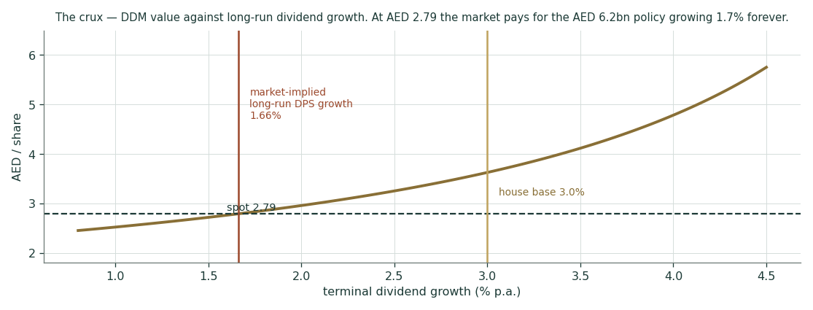
Figure 3. The crux — DDM value against long-run dividend growth. The rust line is what spot implies (~1.3% forever); the gold line is the house base (3.0%). The distance between them is the valuation.
1.9 Macro and country — the peg, the rates, the city, the neighbourhood
Four macro forces matter, in order. First, the peg: the dirham’s 3.6725 fix to the dollar means the CBUAE base rate (3.65%, held at the 17-Jun-2026 meeting) imports US policy — with cuts priced for H2-2026, every 25bp trims the cost of equity on a bond-proxy whose value is mostly a discounted perpetuity; §1.10 shows the grid. Second, the city: Dubai’s population has passed 3.7 million on its way to the D33 plan’s 5.8 million by 2033, and every arrival is a mandatory customer — the volume driver is demographic, not cyclical, which is why revenue has never printed a down year. Third, the fuel line: Brent in the $65-80 strip passes through the fuel surcharge and the regulatory deferral account rather than the P&L, while every new solar megawatt structurally shrinks the exposure — the clean share of generation rose from 10.6% to 16.2% of output in one year. Fourth, the neighbourhood: the March-2026 regional escalation closed the DFM for two sessions and cut the stock 13.7% peak-to-trough, fully recovered within weeks — a live demonstration that the tail risk is geopolitical, not operational, and it is carried in the Monte Carlo’s market-fitted left tail rather than assumed away.
1.10 Sensitivity — read your own number off these grids
The two grids below carry the two decisions that matter: the DCF on WACC × terminal growth, and the DDM on Ke × perpetual dividend growth. A reader who disagrees with the house 3.0% perpetual growth can read the value at their own number directly — that is the point of publishing the grid rather than the point estimate.
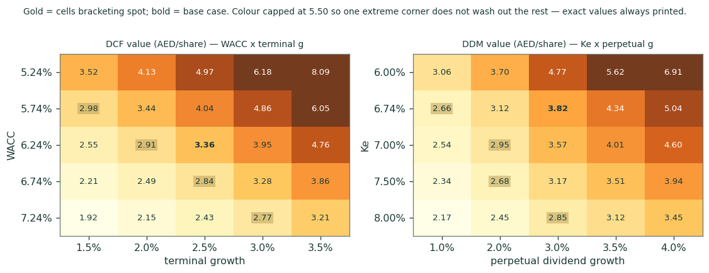
Figure 4. Left: DCF/share on WACC × terminal growth. Right: DDM/share on Ke × perpetual dividend growth — the grid that decides this study.
Beta grid (DCF base) | β 0.40 | β 0.50 (used) | β 0.70
Ke | 6.25% | 6.74% | 7.71%
WACC | 5.86% | 6.24% | 7.00%
DCF value/share | AED 4.33 | AED 3.36 | AED 2.26

The regression said 0.42; the study uses 0.50. Even at β 0.70 — a level the data does not support — the weighted central only falls toward spot, not below it.
2 Technical and price structure
The chart is the market’s counter-argument, and it deserves a fair reading: DEWA has spent four years going sideways. The shares came to market at AED 2.48 in April 2022, spiked, and have oscillated in a 2.47-3.15 band for the past year; the price return since the IPO is +276.0%, which is to say the entire realised return has been the dividend — precisely what the listing promised and nothing more. Realised volatility of 22.3% annualised is the lowest in the Testahil coverage, consistent with a bond-proxy whose marginal buyer is an income fund. The moving-average stack is flat and interlaced, momentum is drift rather than trend, and the one violent episode in the sample — the March-2026 escalation gap — was retraced within weeks. Nothing in the price structure argues for or against the fundamental case; it simply records that the market has not yet been asked the 2027 question.
Indicator | Reading | Interpretation
Spot / 52-week range | AED 2.79 · 2.47 – 3.15 | upper-middle of the range
SMA 20 / 50 | 2.79 / 2.71 | price marginally above both — no trend
SMA 100 / 200 | 2.77 / 2.79 | stack mixed and flat; a sideways instrument
RSI (14) | 54.6 | neutral
MACD (12,26,9) | 0.021 / 0.025 / -0.004 | MACD a hair under signal — histogram mildly negative, momentum flat
Momentum 1m / 3m / 12m | +5.3% / +1.1% / +0.0% | drift, not trend
Realised vol (252d) | 22.3% | lowest in coverage — a bond-proxy
Since IPO (Apr-2022, AED 2.48) | +276.0% price | the return has been the dividend — as designed

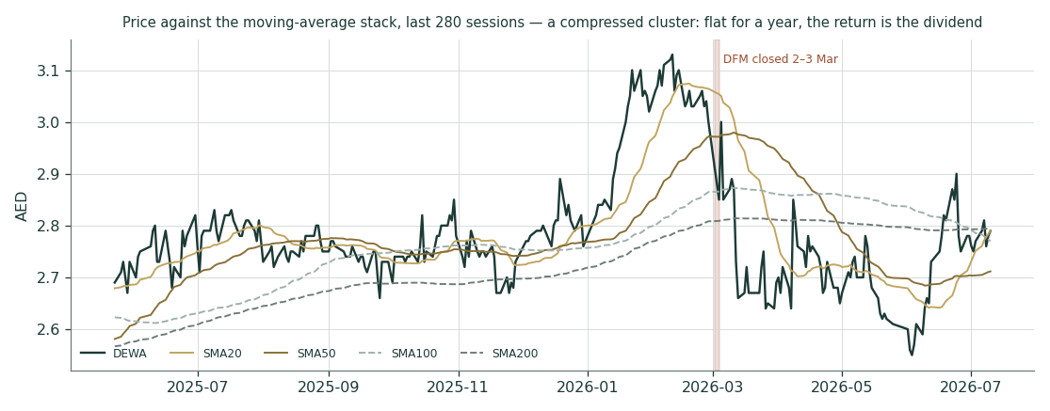
Figure 5. Two years of price with the moving-average stack, volume, RSI and MACD panels — a sideways income instrument, not a momentum name.
3 Monte Carlo — a probabilistic price map
Five numbers first, then the machinery, then the ledger of events that shapes the tails.
The probability read (T+60, ~2-Oct-2026)
P(close above spot) | 52.1%
P(≥ +10%) vs P(≤ −10%) | 20.3% vs 15.5% — odds 1.31:1 to the upside
Median | AED 2.81 (+0.6%)
50% of paths finish inside | AED 2.61 – 3.02 (94% – 108% of spot)
Touch ±10% inside the window | AED 3.07 touched in 36% of paths, AED 2.51 in 28% (by T+20: 12% / 8%)

What the machine is. The engine is the carry-anchored YZ-HAR-t (v3): 50,000 paths, seed 42, identical for every name in the coverage. The price centre is the cash-and-carry anchor — what a money-market holder earns versus what a shareholder collects: CBUAE 3.65% funding against the 4.44% dividend yield gives -0.18% over 60 sessions, mildly negative because the stock out-yields cash and a holder is literally paid to wait. On top of that sits a nine-event probability ledger (below) contributing +0.70%, for a total drift of +0.52%. Width comes from the gap-aware Yang-Zhang HAR estimate of realised volatility (22.7% annualised — the calmest series in the coverage), shrunk toward the trailing 252-day proxy and scaled by the UAE market fit, whose tail shape ν and width calibration are read live from the production fit at run time rather than hard-coded. The fundamental +19% gap is never injected into this drift: the Monte Carlo answers “where can the price be in three months,” not “what is the company worth” — different clocks, by construction.
Continuous forces (drift & width) | Direction
Cash-and-carry (rf 3.65% vs yield 4.44%) | mildly negative drift — holders are paid to wait
HAR volatility regime | low (23% ann.) — the tightest bands in the coverage
DFM flow environment | index near records; passive income-fund flow supportive
March-2026 tail memory | a fat left tail carried by the market-fit ν, not assumed away

The event ledger prices the discrete calendar: each row is a named event inside the 60-session window, a probability, and a price impact conditional on it happening; the expected contribution is their product. The rows are judgments and are flagged as such — but they are published, dated and graded, which is the difference between a judgment and a vibe.
Event ledger (60-day window) | P | Impact | E[contribution]
H1-2026 results (~mid-Aug) | 90% | +0.4% | +0.36%
Oct-2026 dividend (AED 3.1bn, H1-26) confirmed | 90% | +0.2% | +0.18%
Post-2027 dividend policy signalled at/above AED 6.2bn with growth | 20% | +1.5% | +0.30%
Post-2027 policy signalled frozen or cut | 10% | -2.0% | -0.20%
Fed/CBUAE cut >=25bp (Sep FOMC) | 55% | +0.6% | +0.33%
Regional geopolitical re-escalation (Mar-26 precedent) | 20% | -3.0% | -0.60%
DSCE tariff / fuel-surcharge pass-through decision | 15% | +0.8% | +0.12%
Record summer peak demand (Q3 is DEWA's strongest quarter) | 80% | +0.3% | +0.24%
Further debt-funded energy-sector M&A (capital-allocation concern) | 10% | -0.3% | -0.03%

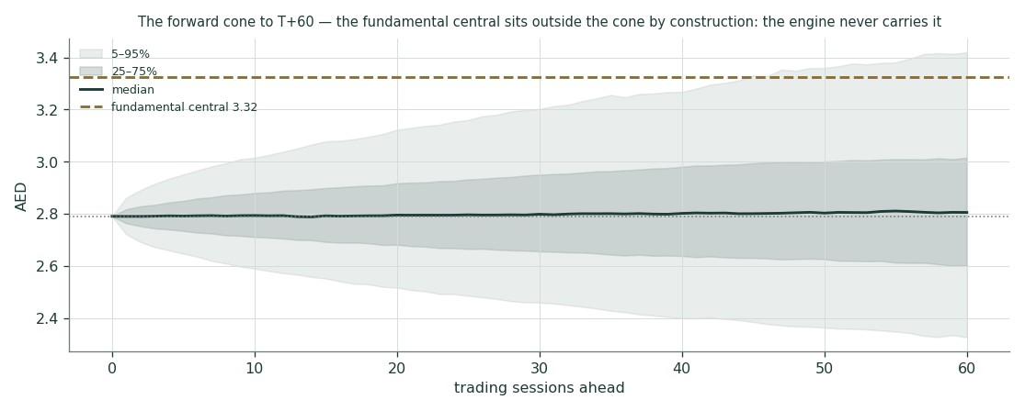
Figure 6. The forward cone to T+60 with the percentile fan. The fundamental central AED 3.32 sits outside the cone by construction — the engine never carries it.
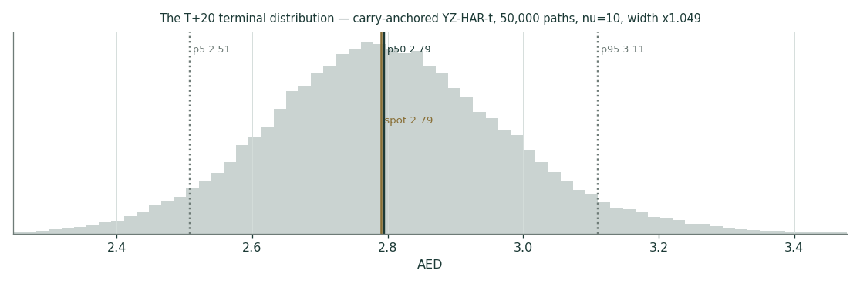
Figure 7. T+20 distribution (matures ~7-Aug-2026): 90% band AED 2.51–3.11.
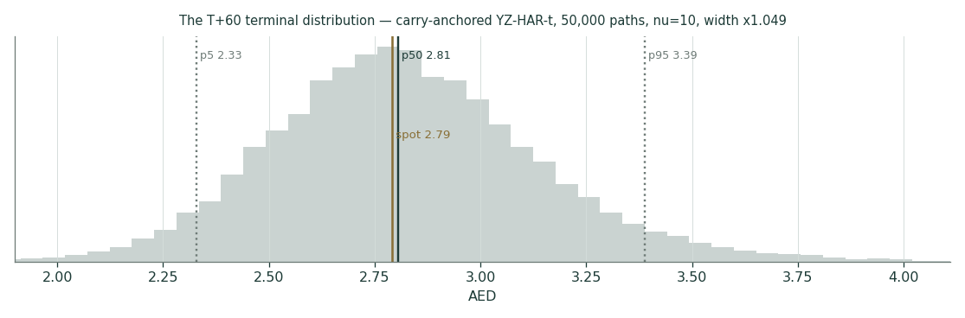
Figure 8. T+60 distribution (matures ~2-Oct-2026): note the heavier left shoulder from the market-fit tails.
The touch ladder answers the trader’s question the terminal distribution cannot: the probability of the price reaching a level at any point inside the horizon, not just finishing there. Up-levels read “any close at or above”; down-levels “at or below.”
Level (AED) | P(touch ≤ T+20) | P(touch ≤ T+60)
3.30 | 1% | 13%
3.20 | 4% | 20%
3.10 | 9% | 31%
3.00 | 22% | 47%
2.90 | 46% | 68%
2.80 | 84% | 91%
2.70 | 50% | 69%
2.60 | 21% | 45%
2.50 | 7% | 27%
2.40 | 2% | 14%

Calibration transparency. DEWA was scored through the calibration back-test — a full five-year walk-forward against the carry-anchored benchmark — before a word of this study was written; only names that clear it are published. The name-level verdict here is BOUNDARY — the confidence interval’s sign flips across bootstrap block sizes — so DEWA publishes under the parity tier: calibrated, market-panel validated, with no demonstrated single-name edge claimed. The UAE market panel passes. The underlying numbers live in the public Calibration Ledger rather than in this study body, alongside the three-panel calibration figure; the two cohorts registered here (T+20 and T+60) will be graded against the frozen percentiles above — never rewritten — and the grades published whichever way they fall. That ledger, not this paragraph, is the reason to take the bands seriously.
4 Comparison of the lenses, and a verdict
Clock | Horizon | Answer
Monte Carlo distribution | 3 months (genuine) | median 2.81; 90% band 2.33–3.39; 52% above spot
Fundamental fair value | ~12-month basis | weighted central 3.32 (bear 2.18 / bull 4.92) — +19% vs spot
Full-execution ceiling | multi-year | DCF bull leg 6.49 if the 2030 build-out earns its keep and the payout re-rates

The gap between clock one and clock two is not a contradiction — it is the finding. Nothing inside the next sixty sessions forces the market to reprice a decision the board will make in 2027; the distribution therefore sits near spot while the fundamental range sits materially above it. The verdict, stated the only way this house states verdicts: at AED 2.79 the market prices DEWA’s dividend as a frozen coupon (implied perpetual growth 1.33%) on a monopoly whose customer base compounds at 4-5%, whose payout is covered 1.23-1.35 times, and whose policy-setter collects 82% of every distribution. The weighted fair-value range is AED 2.18-4.92 with a central of 3.32. The catalysts in §5 are the specific, dated events that would move price from the first clock toward the second; the falsifiers in §7 are the specific, dated events that would prove this study wrong instead.
5 Catalysts to watch
When | What | Why it matters
~mid-Aug 2026 | H1-2026 results + interim dividend declaration | first read on whether FY26 tracks the +8% Q1 run-rate; AED 3.1bn interim expected
Oct-2026 | Interim dividend payment | the mechanical income event; confirms the floor
H2-2026 | CBUAE follows Fed cuts | every 25bp trims Ke on a bond-proxy; supports the DDM leg
2026 | Hassyan SWRO +120 MIGD commissioning; 1,800 MW solar IPP (86% complete) connects | water and clean-mix margin proof-points for the 2030 programme
Anytime to mid-2027 | Board language on the post-Oct-2027 dividend policy | THE catalyst — the crux resolves; §1.8 quantifies every branch
Ongoing | DSCE tariff / pass-through decisions | the regulated-return spread that Expert 4 prices
Tail | Regional escalation | March-2026 template: −14% fast, recovered; the left tail in the MC fit

Note what is absent: no product launches, no contract wins, no commodity calls. A monopoly utility’s calendar is policy, rates and execution — three forces, all named above, all datable.
6 Reading the probability zones (T+60 close)
Zone (AED) | Probability | Reading
< 2.40 | 8% | deep left tail — escalation replay; the March-2026 template
2.40 – 2.60 | 16% | soft zone — carry drag dominates; income holders accumulate
2.60 – 2.95 | 44% | the fat middle — sideways income; the base case of the tape
2.95 – 3.20 | 21% | firm zone — rate-cut or results bid; first step toward the fundamental range
> 3.20 | 12% | breakout — an early policy signal; only the crux gets the price here this fast

7 Caveats — and what would change our mind
Every claim in this study is falsifiable, and the honest version of a valuation names its own kill-switches. Six, each dated and observable:
1. A post-2027 policy statement. Any board or government communication pointing to a frozen or reduced dividend after October 2027 collapses the DDM base and bull branches and pulls the weighted central toward the AED 2.09 bear anchor. This is the single largest exposure in the study — roughly AED 1.15 of the central hangs on the policy not being frozen — and it can resolve on any earnings call between now and mid-2027.
2. An October-2026 interim below the run-rate. The mechanics assume AED 3.1bn semi-annual instalments through the policy window. A declared interim below that breaks the floor assumption itself, not merely the growth assumption, and would force the bear DDM to be re-based below 2.09.
3. The H1-2026 print (~mid-August). Revenue growth below ~5% or an engine-basis EBITDA margin below 53% falsifies the FY26 driver set within one print; both drivers were deliberately set below the Q1 actuals precisely so that a miss would be informative rather than noise.
4. A DSCE tariff decision that compresses the spread. The justified-P/B lens and Expert 4 both price a persistent ~250bp ROE-over-Ke spread. A pass-through or tariff ruling that pushes the realised spread below ~100bp invalidates that multiple — and, because the government owns 82% of the dividend it would be squeezing, would also be genuinely new information about state priorities.
5. A regional re-escalation that does not recover. March-2026 cut the stock 13.7% and closed the exchange for two sessions; the recovery took weeks. A repeat that is not retraced within a quarter would force the Monte Carlo market fit, the ERP basis and the risk-free anchor to be re-read before any number in this study is reused.
6. A risk-free shift of ±100bp. The UAE MoF AED curve at 4.30% anchors every lens; a 100bp move mechanically reprices a bond-proxy, and §1.10’s grids carry the exact values. This is the falsifier a reader can monitor weekly without waiting for the company to speak.
Appendix A Financial statements — 3 years history, 5 years forecast
Every historical line below comes from the company’s audited consolidated financial statements, never an aggregator — FY25 and its FY24 comparatives from the KPMG-audited FY2025 statements (signed 27-Feb-2026); FY23 from the KPMG-audited FY2024 statements’ comparatives (signed 27-Feb-2025), with the FY23 balance-sheet face taken from the audited FY2023 statements as reproduced in DEWA’s Integrated Report 2023. One restatement note: the FY24 statements regrouped certain FY23 cash-flow lines (≈AED 536mn moved between operating and investing); the restated — most recent audited — presentation is used throughout, which is why the FY23 cash-flow figures here differ from the FY23 original release. The forecast columns are the §1.7 driver set, live-linked in the companion Excel.
A.1 Income statement
AED mn | FY23 | FY24 | FY25 | FY26E | FY27E | FY28E | FY29E | FY30E
Revenue | 29,178 | 30,977 | 32,842 | 35,305 | 37,423 | 39,482 | 41,456 | 43,321
EBITDA (engine basis) | 14,884 | 15,892 | 17,661 | 19,135 | 20,433 | 21,715 | 22,925 | 24,043
EBITDA margin | 51.0% | 51.3% | 53.8% | 54.2% | 54.6% | 55.0% | 55.3% | 55.5%
– D&A | (6,127) | (6,568) | (6,709) | (7,273) | (7,784) | (8,291) | (8,789) | (9,227)
Operating profit (EBIT) | 8,757 | 9,325 | 10,952 | 11,862 | 12,649 | 13,424 | 14,136 | 14,816
– Net finance cost | (811) | (1,174) | (617) | (700) | (780) | (850) | (910) | (950)
– Regulatory deferral mvt | (105) | (167) | (331) | 0 | 0 | 0 | 0 | 0
Profit before tax | 7,842 | 7,983 | 10,003 | 11,162 | 11,869 | 12,574 | 13,226 | 13,866
– Income tax | +92 | (749) | (948) | (1,060) | (1,128) | (1,195) | (1,257) | (1,317)
Profit after tax | 7,934 | 7,234 | 9,055 | 10,102 | 10,742 | 11,379 | 11,970 | 12,549
Attributable to owners | 7,701 | 7,013 | 8,347 | 9,496 | 10,097 | 10,696 | 11,252 | 11,796
EPS (AED) | 0.154 | 0.140 | 0.167 | 0.190 | 0.202 | 0.214 | 0.225 | 0.236

FY25 EBITDA dual-framed everywhere it appears: engine basis AED 17,661mn (EBIT + D&A as modelled) vs company-stated AED 17,329mn (which nets the regulatory deferral movement). The FY23 column is the FY24 statements’ audited comparatives in full; its engine EBITDA of 14,884mn reconciles to DEWA’s own stated “EBITDA of AED 14.8 billion” for 2023. FY23 income tax was a +92mn deferred-tax credit, the year the UAE corporate-tax regime was first recognised.
A.2 Balance sheet (audited three-year view)
AED mn | FY23 | FY24 | FY25
Non-current assets | 162,239 | 165,466 | 171,451
Current assets | 18,924 | 19,290 | 23,688
Total assets | 181,164 | 184,755 | 195,139
Equity — owners | 89,212 | 89,349 | 91,017
Equity — non-controlling interests | 3,489 | 5,639 | 6,753
Total equity | 92,701 | 94,988 | 97,770
Borrowings — non-current | 27,342 | 28,829 | 31,922
Borrowings — current | 11,546 | 7,142 | 6,654
Total liabilities | 88,262 | 89,400 | 96,671
Regulatory deferral credit balance | 200 | 367 | 699
Cash & equivalents (CF basis) | 4,658 | 5,374 | 7,487
Net debt — strict | 33,588 | 30,597 | 31,089
Net debt — pro forma (post-Empower, Feb-26) | — | — | 36,273

Every column ties the audited identity exactly: total assets = total liabilities + total equity + regulatory deferral credit (FY23: 88,262 + 92,701 + 200 = 181,164). FY23 cash is the CF-basis year-end figure; AED 642mn of overdraft-style balances sat inside FY23 current borrowings, so net debt is identical on either cash basis.
A.3 Cash flow (audited three-year view)
AED mn | FY23 | FY24 | FY25
Cash generated from operations | 16,518 | 17,435 | 21,850
– Capex (cash, net of capital payables) | (6,805) | (9,267) | (10,590)
Free cash flow (CFO − capex) | 9,713 | 8,168 | 11,260
– Interest paid on borrowings | (2,378) | (2,577) | (2,203)
– Dividends — owners | (7,870) | (6,200) | (6,200)
– Dividends — NCI | (378) | (385) | (1,160)
Net cash used in investing | (4,776) | (6,933) | (14,415)
Net cash used in financing | (11,806) | (9,787) | (5,322)
Cash & equivalents, year-end | 4,658 | 5,374 | 7,487

FY23 owner dividends of 7,870 include a one-off catch-up above the 6,200 floor. Dividend cover FY25, dual-framed: 1.23x gross (total PAT 9,055 / total dividends paid 7,360, NCI included) and 1.35x owner (attributable 8,347 / owner dividends 6,200); against the AED 6.2bn policy floor alone, group earnings cover it 1.46x. All framings appear wherever the cover is cited.
A.4 Reading the statements — what the accounts actually say
Three mechanics matter more than any single line. First, the regulatory deferral: DEWA bills fuel-cost increases against a 2010 base year, and the difference between what it collects and what the regulator ultimately allows sits in a deferral account — a AED 699mn credit at FY25, up from 367 — presented outside liabilities. The company nets the year’s movement (AED −331mn in FY25) out of its stated EBITDA of 17,329; this study’s engine basis of 17,661 leaves it in the operating line and discloses both, because a valuation model needs the gross economics and the reader needs the reconciliation.
Second, the NCI machinery. Non-controlling interests contributed AED 2,118mn of capital in FY25 (and 2,120 in FY24) — that is the IPP partners funding their 40-49% share of the Shuaa, Noor and Hassyan builds as construction progresses — while taking out AED 1,160mn of dividends, tripled from 385 as the newer plants entered service. The Empower transaction reverses part of this structure: from February 2026 DEWA keeps 80% of the cooling profit stream it previously shared at 56%, which is why the FY26E attributable line grows faster than group PAT.
Third, the funding of the machine. FY25 operating cash of AED 21.9bn covered AED 10.6bn of cash capex, AED 2.2bn of interest and the full AED 7.4bn of dividends with room to spare; the large FY25 investing outflow (14.4bn) is mostly term-deposit placement — AED 14.7bn placed against 10.2bn matured — not spending. Gross borrowings rose only AED 2.6bn in a year the company invested 11.7bn; the balance sheet is deleveraging in ratio terms even mid-programme, which is the quantitative backbone of the §1.8 headroom argument. One audit note completes the picture: KPMG’s key audit matters were the estimation of accrued unbilled revenue (AED 1,216mn at FY25) and the expected-credit-loss allowance (AED 376mn against 3,049mn of receivables) — both routine for a metered utility, and the opinion is unqualified.
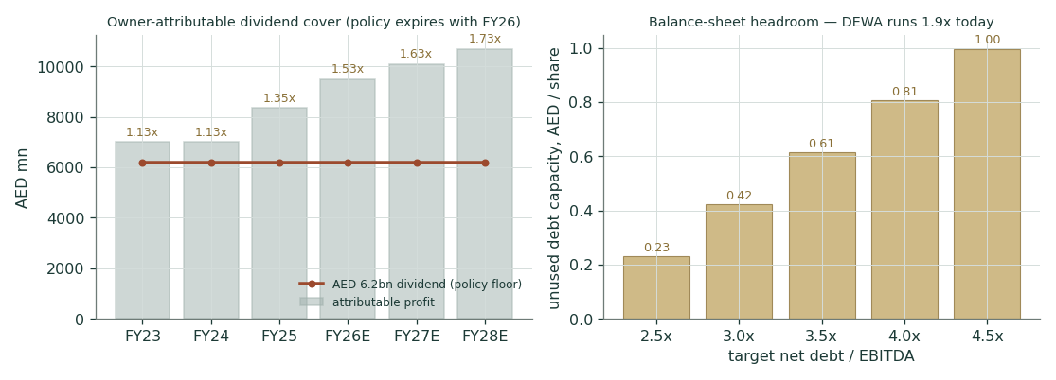
Figure 9. Dividend against earnings and free cash flow — the AED 6.2bn floor is comfortably covered on every framing; the question is policy, not capacity.
A.5 Group structure — who owns what
Entity | Held | What it does
Empower (Emirates Central Cooling) — DFM listed | 80% | world’s largest district cooling; bought up from 56% for AED 5,184mn, 10-Feb-2026
Mai Dubai | 100% | bottled water manufacture and distribution
Digital DEWA / Moro (Data Hub Integrated Solutions) | 100% | data centres, IT infrastructure — the digital vertical
Etihad ESCO / Etihad Clean Energy | 100% | building energy-efficiency retrofits, solar rental
Shuaa Energy 1 / 2 / 3 / 4 (solar IPPs) | 51-60% | MBR Solar Park phases; partners fund the minority share
Noor Energy 1 (950 MW CSP hybrid) | 51% | concentrated solar + PV — fully grid-connected in FY25
Hassyan Energy Phase 1 | 51% | the Hassyan power complex
Hassyan Water 1 / A (SWRO) | 60% | 180 MIGD reverse-osmosis desalination; early production achieved
Etihad Energy Services, InfraX, Digital X, Space-D, Dubai Green Fund, others | 100% | services, networks, satellite telemetry, green investment vehicles

Source: note 1 to the FY25 audited statements. The 51-60% IPP/IWP holdings are why NCI runs through every statement — and why the group can build a 23-GW system while its own borrowings barely rise.
A.6 FY25 equity walk — where the AED 2.8bn of equity growth came from
AED mn | Owners | NCI | Total
Opening equity (1-Jan-25) | 89,349 | 5,639 | 94,988
Profit for the year | +8,347 | +708 | +9,055
Other comprehensive income (hedges, remeasurements) | (528) | (519) | (1,046)
Capital contributions (NCI: IPP partners; owners: land) | +48 | +2,118 | +2,166
Capital repayment to NCI | — | (32) | (32)
Dividends paid | (6,200) | (1,160) | (7,360)
Closing equity (31-Dec-25) | 91,017 | 6,753 | 97,770

Appendix B Peer set, sector structure, risks — and the research register
B.1 Peer table
Name | Mkt | EV/EBITDA | P/E | Yield | P/B
DEWA (this study, FY26E) | DFM | 9.6x | 14.7x | 4.4% | 1.53x
TAQA | ADX | ~13x | ~26x | ~1.6% | ~2.9x
Empower (80% subsidiary) | DFM | 12.7x | ~18x | 5.4% | ~3.4x
Saudi Electricity | Tadawul | ~11x | ~15x | ~4.0% | ~1.1x
ACWA Power (boundary marker) | Tadawul | ~20x | ~35x | ~0.8% | ~4.5x
Tabreed | DFM | ~11x | ~14x | ~4.7% | ~1.5x

Peer levels are dated aggregator screens (~Jul-2026) used for context only; DEWA is priced on its own audited financials — aggregator numbers are excluded from the model itself, by design. ACWA is developer economics, not a utility comp: shown to mark where the set ends. Two mix cautions before comparing multiples: TAQA’s ~13x buys a different book — a material slice of its earnings is upstream oil & gas alongside the regulated Abu Dhabi networks, a mix pure utilities do not carry; and Empower’s 12.7x prices a capital-light district-cooling franchise whose core plants are largely built, against a parent still mid-way through a 23-GW programme — part of the subsidiary premium is a capex-cycle artefact, not a quality verdict. The oddity worth a sentence stands: DEWA trades below its own 80%-held subsidiary on EV/EBITDA while out-yielding half the table.
B.2 Risk register
- Policy: Post-2027 dividend policy set below expectations — the crux, both ways: the same decision that carries the upside carries the downside.
- Regulatory: DSCE tariff / pass-through decisions compress the realised return spread; slab tariffs unchanged since 2011 could in principle be cut as well as raised.
- Geopolitical: Regional escalation replays March-2026: DFM closure and a fast −10-15% drawdown; the MC left tail carries it, a portfolio cannot diversify it inside the UAE.
- Ownership: Government 82% ownership: alignment is strong for the dividend, but the 18% float caps index weight, liquidity and the multiple the market will pay.
- Execution: 2030 capacity and Hassyan phasing slip; capex overruns squeeze FCF cover exactly when the policy window closes.
- Rates: A hawkish rate surprise lifts Ke on a bond-proxy faster than earnings compensate; the §1.10 grids price it.
B.3 Research register (four rings, classified)
# | Ring | Finding | Class | Source (dated)
1 | Global | Fed funds path: cuts priced H2-26; the UAE peg imports US policy | B | CME/FedWatch via press, Jun-2026
2 | Global | Brent ~$65-80; fuel pass-through via the regulatory deferral | D | market strip, Jul-2026
3 | Global | Data-centre power demand supercycle; GCC positioning | S | Wood Mackenzie, 2025-26
4 | Country | UAE MoF AED T-Bond Jan-2031 YTM 4.30% — the DCF risk-free | B | MoF auction result, 23-May-2026
5 | Country | CBUAE base rate 3.65%, held — the MC carry anchor | B | CBUAE, 17-Jun-2026
6 | Country | Damodaran UAE Aa2 ERP 4.87% / Abu Dhabi CDS 4.93% | B | ctryprem original file, Jan-2026
7 | Country | Dubai D33: Industry-Friendly Power Policy; Shams rooftop cap ~2MW; no corporate PPAs | S | Dubai govt releases, 2025-26
8 | Country | DFM closed 2-3 Mar-2026 (escalation); −13.7% drawdown, recovered | C | DFM notices; price history
9 | Industry | UAE data-centre load 3 TWh → >6 TWh by 2030; Stargate UAE; AWS-e& $1bn | S | WoodMac; company announcements
10 | Industry | UAE power demand → 225 TWh by 2040 scenario | D | sector studies, 2025
11 | Industry | Tariff pass-through discussions ongoing; DSCE regulates | D | Empower CFO remarks, May-2026
12 | Company | FY25 audited: rev 32,842; EBITDA 17,661 engine / 17,329 company; att 8,347; ND 31,089 | B | KPMG-audited FS, 27-Feb-2026
13 | Company | Q1-26: rev 6,450 (+8.2%); EBITDA 2,880 (+18.4%); NP att 940 (+89.9%) | B | results release, 12-May-2026
14 | Company | Empower 24% bought from Dubai Holding for AED 5,184mn → 80% | B | named transaction, 10-Feb-2026 filing
15 | Company | Dividend: min AED 6.2bn/yr, five years from Oct-2022. Post-2027 = the crux | S | IPO prospectus + IR page
16 | Company | Moody's A3 stable (upgraded from Baa2, 30-May-2024) | B | Moody's rating action
17 | Company | 2030: >23GW (8.3GW renewable), 735 MIGD; Hassyan +60 live, +120 due 2026; 1,800MW solar IPP 86% complete | S | company releases; FY25 directors’ report
18 | Company | FY2024 audited FS retrieved (KPMG, 27-Feb-2025): FY23 restated comparatives supersede all pre-restatement FY23 anchors | B | DFM-hosted FY2024 consolidated FS, fetched 12-Jul-2026
19 | Company | Audited FY2023 balance-sheet face obtained via Integrated Report 2023 (standalone FY23/FY24 FS PDFs are image-only scans) | B | DEWA Integrated Report 2023, fetched 12-Jul-2026

Class key: B = base-rate/quantitative · S = structural · D = directional · C = colour. All four rings — Global, Country, Industry, Company — were reviewed and classified before any forecast driver was set, and each driver in §1.7 carries a documented source. The register also lives as a machine-readable sheet in the companion Excel.
Appendix C The expert valuation panel — four methods, shown workings, a falsifier each
Four experts from our standing expert panel, cast for this class of business: the industrial/utility trio — forensic accountant, earnings-power analyst, macro-policy strategist — plus the cash-returns analyst, added because the name is capital-heavy and his DCF/ROIC machine overlaps none of the other three. Labels only — Expert 1-4. Each states a tradition, shows the working, names its own weakest assumption, and posts a falsifier: the observable event that would prove it wrong.
C.1 Expert 1 — the forensic accountant: audit the book before pricing it
The tradition. Before any multiple or model, verify that the stated numbers are real: cash-back the earnings, stress the accruals, test whether the equity would survive contact with a sceptic. Only then price the verified book.
Working | Reading
Cash conversion: CFO 21,850 vs engine EBITDA 17,661 | 124% — the earnings arrive as cash, with room
Accruals check: PAT 9,055 vs CFO 21,850 | deeply cash-backed; the deferred-income add-back (−1,164) even understates it
Customer-funded build: connection advances and deferred revenue inside AED 33.4bn of other long-term liabilities | a liability that never consumes cash — customers pre-pay the network
Book verification: total equity 97,770 = 94,988 opening + 9,055 profit − 1,046 OCI + 2,166 contributions − 32 repayment − 7,360 dividends | ties the audited equity statement exactly
Verified owners’ book value per share | AED 1.820
His multiple: (ROE − g) / (Ke − g) on his own conservative ROE band 8.8-10.0%, g 2.25-2.75% | 1.29x / 1.57x / 1.81x
Value: 1.820 × the band | 2.35 / 2.85 / 3.30

Published range: bear 2.35 / base 2.85 / bull 3.30. On today’s price: the market pays 1.53x a book this expert certifies as conservatively stated and cash-generative; spot is defensible only if the return spread compresses. Weakest assumption: the Land-Department fair values inside the capital contribution — appraisal marks on land a utility can never sell; he haircuts the multiple rather than the book for it. Falsifier: cash conversion below 90% or a receivables accrual build for two consecutive halves — the book stops being self-verifying and the floor under the multiple goes with it.
C.2 Expert 2 — the earnings-power analyst: normalise, then multiply
The tradition. Strip the noise, find the earnings power a private buyer could underwrite, and pay a through-cycle multiple for it — nothing exotic, ruthlessly anchored to what comparable regulated earnings actually fetch.
Working | Reading
Normalised forward earnings: FY26E EPS (post-Empower, 9.5% tax) | AED 0.190
Quality check: FY25 delivered 0.167; the customer base compounds 4-5% | the 0.190 is growth, not adjustment
Through-cycle regulated-utility P/E band (SEC ~15x, Tabreed ~14x; TAQA ~26x excluded as scarcity pricing) | 13x / 16x / 18x
Value: 0.190 × the band | 2.47 / 3.04 / 3.42
Cross-check at 10x FY26E EV/EBITDA, net of PF debt and the marked NCI | lands ≈AED 2.9 — the two yardsticks agree

Published range: bear 2.47 / base 3.04 / bull 3.42. On today’s price: spot at 14.7x FY26E sits inside his band but below his base — the market pays a low-teens multiple for mid-single-digit regulated growth with a 4.4% yield attached, which he reads as the multiple pricing the policy silence, not the earnings. Weakest assumption: the band itself — GCC utility multiples are thin, dispersed and partly policy-set; ±1x moves the base ±AED 0.19. Falsifier: an H1-2026 print with attributable EPS growth below ~8% year-on-year, which would mean the “normalised” 0.190 was optimism and the base slides to 15x on a lower number.
C.3 Expert 3 — the macro-policy strategist: price the state tree
The tradition. When the binding constraint on a valuation is a single policy decision — here the October-2027 reset — the honest method is to name the states, price the whole instrument under each, and weight them. This is the only expert in the room whose machine prices the October-2027 decision explicitly, state by state, rather than through a growth rate or a multiple.
Regime | P | What it does | AED/sh
A — frozen floor: 0.124 rolled flat indefinitely | 35% | the bear DDM; the market’s current price of the future | 2.09
B — CPI-linked step-ups: policy grows with the city | 40% | the base DDM; the modal outcome for an 82% owner | 3.83
C — payout-ratio policy at 75-80% of earnings | 25% | the bull DDM, haircut for transition conservatism | 4.60
Probability-weighted value |  | 0.35×2.09 + 0.40×3.83 + 0.25×4.60 | 3.42

Published base 3.52 (the tree plus the option value of an early signal), bear/bull 2.30/4.60. Sensitivity, in real units — the asymmetry is the finding: shifting 10 points of probability from B to A cuts the value AED 0.17; the same 10 points from B to C adds 0.08 — but shifting from A to C swings 0.25. On today’s price: spot is approximately this tree with regimes B and C deleted — the market is assigning nearly zero to any policy that grows. Weakest assumption: the weights themselves; policy timing is genuinely unknowable. Falsifier: an H1-2026 or FY-2026 results call that explicitly defers all policy guidance past 2027 kills the early-signal leg and collapses the tree toward Regime A.
C.4 Expert 4 — the cash-returns analyst: price the machine’s cash, not its story
The tradition. Utility value lives in the asset base and the spread it is allowed to earn — and the proof of a spread is cash, not accruals: an invested-capital engine of AED 128.9bn earning ROIC 7.69% against a WACC of 6.24%, a ~145bp spread on a quasi-regulated base, protected by pass-through mechanics and an owner-regulator with no incentive to squeeze its own dividend.
Working | Value
Invested capital (equity + net debt, FY25) | AED 128,859mn
ROIC (NOPAT / IC) | 7.69%
Value-driver EV: IC × (ROIC − g) / (WACC − g), g 2.5% | AED 178,700mn
+ margin-walk uplift demonstrated in the FY26-30 build | + ~AED 22,000mn
Cash cross-check — FCF yield: (CFO 21,850 − capex 10,590) / market cap 139,500 | 8.1% against a 6.7% Ke — the machine pays for itself
– Net debt PF – NCI → equity per share (base) | AED 3.11
Range: spread −100bp / base / spread +80bp and g 3.0% | 2.55 / 3.11 / 3.75

On today’s price: spot pays for the asset base at roughly a zero-spread valuation — as if the machine earned exactly its cost of capital, which the audited numbers contradict by ~145bp. Weakest assumption: spread persistence; a regulator can compress in one ruling what took a decade to build. Falsifier: a DSCE tariff decision compressing the realised spread below ~100bp — the same falsifier as the justified-P/B lens, because they are cousins.
C.5 Cross-examination
Expert 1 to the room: “I certify the book; I do not certify your futures. The earnings man pays sixteen times a number that embeds a policy the board has not made, and the strategist’s tree waters three branches when only one will exist. Price what the auditor signed: 1.82 dirhams of verified equity earning 250 basis points over its cost. Everything above 3.30 is a press release.”
Expert 2 to the room: “The accountant prices the past and calls it prudence — earnings power is not a story, it is customer meters already installed and billing. And to the strategist: your Regime C is my 18x bull case wearing a costume; we agree far more than the room admits.”
Expert 3 to the room: “You are all extrapolating a regime whose expiry date is printed in the prospectus. Pricing DEWA off the current coupon through October 2027 is precise about the past and silent about the only question that matters. My weights may be wrong; refusing to weight the states at all is not caution — it is a 100% bet on Regime A, which is exactly the bet the market has on at 2.79.”
Expert 4 to the room: “The accountant’s floor and my machine are the same object measured differently — his verified book earns my spread. Where I break with the earnings man is the denominator: multiples inherit the market’s mood, cash yields do not. An 8% free-cash yield on a monopoly against a 6.7% cost of equity is the one number in this appendix that requires no belief about 2027 at all.”
C.6 The four in one room
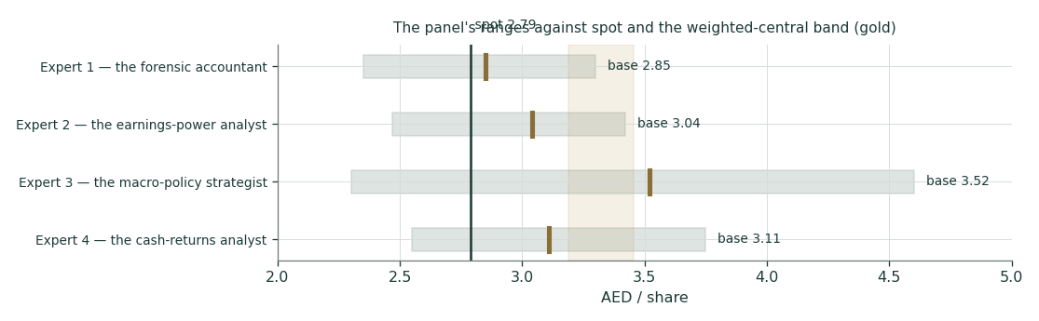
Figure 10. The panel’s ranges against spot and the weighted-central band. Bases 2.85 / 3.04 / 3.52 / 3.11 straddle the study central 3.32; no expert sits below spot at base.
Convergence reading. Four genuinely different machines — a verified book, an earnings multiple, a policy tree, a cash-returns engine — land their base cases within AED 0.67 of one another and all above spot; the study’s weighted central 3.32 sits inside the panel’s span rather than at its edge. Note what did not happen: no expert lands below AED 2.30 even on bear settings, because every downside case is about paying too much for policy optionality, never about impairment of the operating franchise. The disagreement in the room is not whether DEWA is cheap at 2.79; it is how much of the post-2027 upside to pay for today — and each expert has posted the dated event that would settle the argument against him.
About this series
Testahil publishes independent, bilingual equity research built on fair-value ranges and probability distributions — never ratings, buy/sell calls or price targets. Every published forecast is registered in a public, append-only Calibration Ledger and graded when it matures; the grades are published whether they flatter us or not. Every forecast is preceded by a five-year rolling backtest of the engine on the stock’s own history; this one recorded a parity verdict — calibrated and market-panel validated, no single-name edge claimed — and is published under that tier. This study registers two cohorts: T+20 maturing ~7-Aug-2026 and T+60 maturing ~2-Oct-2026, each against the frozen percentiles printed in §3.
Disclosure & disclaimer
1. Testahil is not licensed by the UAE Securities and Commodities Authority, the DFSA, the Egyptian Financial Regulatory Authority, or any other financial regulator. 2. This document is educational analysis only and is not investment advice, an offer, or a solicitation; it presents fair-value ranges and probability distributions, never recommendations or price targets. 3. All financial-statement figures derive from the company’s official audited financial statements and disclosures; market data are dated where used and may have changed. 4. Forecasts are uncertain by construction; the Monte Carlo bands are calibrated estimates, not guarantees, and the calibration status of every name is published in the public Ledger. 5. The preparer may hold, and may in the future take or dispose of, a position in the security discussed in this report; no compensation is received from any issuer. 6. Nothing here considers any reader’s objectives or circumstances; readers must take their own advice. © Testahil 2026 — testahil.com

