Testahil · Independent Valuation Study — Educational Analysis Not investment advice

Dubai Islamic Bank PJSC (DFM: DIB)
Fundamental analysis · Technical analysis · Monte Carlo simulation — one integrated read
Independent valuation study · 11 July 2026 · spot AED 7.72 (03-Jul close) · 7,227mn shares · market cap ~AED 55.8bn (~US$15.2bn) · the UAE's largest Islamic bank · −24% from its February high, and the market did that before the war started.
READ FIRST — THE CALIBRATION GATE FAILED. DIB did not pass our pre-publication calibration test. Under the fitted UAE market model, DIB's own five-year backtest does not beat a naive random walk. The skill score is −0.025, with the confidence interval entirely below zero under every resampling scheme tested. Accordingly no price forecast is published for DIB. §3 is an illustrative volatility map only — not a skill-validated forecast — and no Calibration-Ledger cohorts are anchored. The diagnosis is set out in full and in the open in §3.1: nothing structural is wrong with the data, and on higher-powered designs the engine is at parity. But the test is the test, and it failed, so the forecast is withheld. The fundamental work in §1 does not depend on that test and stands on its own. What this is. An independent, educational valuation study published under the Testahil brand. Not investment advice, not a recommendation, no rating and no price target — fair-value ranges only. Who we are not. The preparer is not licensed by the FRA, the SCA, or any securities regulator, holds no CFA charter, and this document has not been reviewed by any authority. The two clocks. The weighted central (AED 10.18) is a risk-adjusted ~12-month anchor. The peace-time reference (AED 11.86, conflict adder stripped) is a multi-year ceiling. Neither is a three-month figure. Never read one clock as another. Provenance. Every financial-statement line item comes from DIB's own disclosures — the FY25 audited consolidated financial statements, the results releases and the earnings presentations. Aggregators are used for market data only (price, index levels, peer multiples) and are labelled as such. Figures we derived rather than took are flagged inline and logged in the public Fundamental Driver Ledger. Sources. A companion document, "Sources & Bibliography", lists every source used in this study, what was taken from each one, and where it appears — including the three searches that came back empty and what we did instead. Price note. Spot is the AED 7.72 close of 03-Jul-2026, the last bar of the price history this study is built on. The stock has since traded to ~AED 7.54 (09-Jul, aggregator quote) on the Hormuz re-escalation of 7–9 July. Both figures are stated wherever the gap to fair value appears.

The company
Dubai Islamic Bank was founded in 1975 as the world's first full-service Islamic bank, and it is still the largest one in the UAE — AED 420bn of assets, 11 million customers, a D-SIB designation, and about 8% of the entire UAE banking system. It makes money the way any bank does, but without interest: instead of lending at a rate, it buys an asset and sells it on at a mark-up (murabaha), or leases it (ijara), or funds its construction (istisna'a), and it funds itself with profit-sharing deposits and sukuk rather than interest-bearing ones. The spread it earns is called the net profit margin rather than the net interest margin, but it behaves identically — and because the dirham is pegged to the dollar, that spread is set in Washington, not Dubai. Around the core UAE franchise sits a genuine international business (DIB Pakistan, a 29.5% stake in Bank of Khartoum, banks in Kenya, Bosnia, Indonesia and Türkiye) and a 44.9% holding in the listed developer Deyaar; the 2020 acquisition of Noor Bank made it the scale player it is today. Its anchor shareholder is Investment Corporation of Dubai, the emirate's sovereign investment arm, with 27.97% — and DIB's chairman is ICD's managing director, which tells you most of what you need to know about where this bank sits in Dubai Inc.
At a glance
 | Value |  | Value
Spot (03-Jul-2026) | AED 7.72 | Weighted central | AED 10.18 (+32%)
Shares outstanding | 7,227mn | Range across lenses | AED 8.14 – 11.20
Market cap | AED 55.8bn (~US$15.2bn) | Ke (war-adjusted) | 10.57% (rf 4.70% + β 1.00 × ERP 4.87% + 1.0pt)
FY25 net profit | AED 7,807mn (−4% rep. / +18% norm.) | Trailing P/E · P/B | 7.9x · 1.31x
FY25 EPS · BVPS | AED 0.98 · AED 5.89 | FY25 DPS · yield | AED 0.35 (cut from 0.45) · 4.5%
FY25 RoTE (DIB disclosed) | 19% post-tax · 22% pre-tax | Calibration tier | FAILED — no forecast published
CET1 / CAR (Q1-26) | 12.6% / 15.8% | RWA / CET1 capital (Dec-25) | AED 298.9bn / 36.9bn (disclosed)
NPF / total cov / cash cov (Q1-26) | 2.5% / 160% / 122% | From the Feb-2026 high | -24.3%

Shaded pink: the test failed on this design (see §3.1).
Sources: DIB FY2025 audited consolidated financial statements, FY25 and Q1-2026 results releases; Testahil model. Per-share figures on 7,227mn shares (7,240.7mn issued less treasury).
Headline
Five independent lenses put DIB between AED 8.14 and AED 11.20, with a weighted central of AED 10.18 — some 32% above the 03-July close of AED 7.72, and that is after charging a full percentage point of war-risk premium to the cost of equity. What makes DIB unusual is that every lens sits above the price, including the market-anchored one: at AED 7.72 the bank trades on 1.31× book and 7.9× trailing earnings, against a 19% return on tangible equity (DIB's own disclosure; 22% pre-tax). Abu Dhabi Commercial Bank, on a comparable return, traded at 1.52× book on the identical day.
The de-rating is real and it is recent. DIB hit an all-time high of AED 10.20 on 9 February 2026. The FY25 results landed the next morning, and the session after that the stock fell 8.6% on 33 million shares — five times normal volume. That happened on 11 February. The war did not start until 28 February. So the first, and larger, leg of this de-rating was not geopolitics: it was the market reading a headline that said net profit fell 4%, a net profit margin down from 3.0% to 2.6%, CET1 down to 12.3%, and a dividend cut from 45 fils to 35. Then the war took it the rest of the way, to AED 7.09 in April.
The honest counter-argument is the capital equation, and it is a real one (§1.8). DIB cut its dividend once already, to fund 21% asset growth, and it did so from a CET1 ratio that is thin by UAE standards. Margin is still falling and the cost of risk has already tripled off a benign base. If both squeeze at once, the buffer goes — and the board faces a second cut. That is the question this study is really about.
Valuation summary
The whole answer in one view. Five independent methods value DIB; the table shows what each is worth, the weighted central that combines them, and how that sits against today's price.
The bottom line
Fair-value range across the five lenses | AED 8.14 – 11.20
Weighted central (risk-adjusted, ~12-month anchor) | AED 10.18
Current price (03-Jul-2026 close) | AED 7.72
Implied gap to central | +32%
Price since the data cut (09-Jul, aggregator) | AED 7.54 → gap +35%
Upper reference — peace-time cost of equity (adder = 0) | AED 11.86
Lower reference — the market-anchored relative lens | AED 8.14
Three-month view | NOT PUBLISHED — the calibration test failed (§3)

Shaded cream: today's actual price, for reference against the fair-value rows above and below it. Shaded pink: the calibration test failed, so no three-month forecast is published.
Lens | Value (AED) | What it prices
Residual income | 11.20 | Today's book value plus the value of returns above the cost of equity
Dividend discount model | 10.90 | The dividend the board will actually pay, after the cut
Equity DCF (FCFE) | 10.44 | Cash the bank could distribute after funding its own growth
Normalized (through-cycle) | 9.86 | Mid-cycle earnings at the multiple their return on equity warrants
Relative multiples | 8.14 | What comparable UAE banks trade at right now

The three fundamental lenses cluster tightly at AED 10.44–11.20 — they are all counting the same excess-return engine three different ways. The two market-anchored lenses land lower, at AED 8.14 and AED 9.86, and they are the honest counterweight. The relative lens is built on a same-day, like-for-like comparison (§1.4): on the identical 03-July close, DIB traded at 1.31× book while ADCB — a bank with a comparable return on tangible equity — traded at 1.52×. That ~14% discount is struck on the same day at the same prices — not an artefact of comparing today's DIB price against an older set of peer multiples. The weighted central of AED 10.18 is a probability-weighted judgement across those regimes, not a claim that the truth lies politely in the middle.
1. Valuation
1.1 Dividend discount model — the primary lens
For a bank, deposits are an operating input rather than a financing choice, so enterprise-value arithmetic is meaningless: everything discounts at the cost of equity. The DDM leads for DIB because the dividend is the thing the market just repriced. The board cut it from 45 fils to 35 for FY25 — a 22% cut against a 6% fall in earnings — and paid AED 2.53bn at the April AGM. The payout has now fallen three years running, from 48% of attributable profit to 41% to 34%, because a balance sheet growing 21% a year eats retained earnings.
The schedule below does not let the dividend fall out as a plug. It holds DPS flat at the rebased 35 fils through the FY26 earnings dip — boards do not cut twice — and then lets it grow as financing growth halves from 22% to the guided ~10% and stops consuming so much capital. The payout stays in a narrow 40–44% band throughout. CET1 is then the output of that policy, not an input to it (§1.6).
AED / share | FY26E | FY27E | FY28E | FY29E | FY30E
EPS | 0.86 | 0.92 | 1.05 | 1.18 | 1.30
Payout | 41% | 42% | 43% | 44% | 45%
DPS | 0.35 | 0.39 | 0.45 | 0.52 | 0.59
Discount factor @ Ke 10.57% | 0.904 | 0.818 | 0.740 | 0.669 | 0.605
PV of dividend | 0.317 | 0.319 | 0.333 | 0.348 | 0.357

Terminal block | Value
Terminal payout = 1 − g / terminal ROE = 1 − 4.0 / 15.5 | 74%
Terminal DPS (FY31) | AED 1.00
Terminal value at (Ke − g) | AED 15.25
PV of terminal value | AED 9.23
Σ PV of explicit dividends (FY26–30) | AED 1.67
DDM fair value | AED 10.90
Terminal value as % of total (dependency disclosure) | 85%

Shaded gold: the headline figure this table is building toward — or, in a grid of alternatives, the row we actually use rather than the sensitivities shown around it.
Terminal-value dependency: 85% of the DDM sits in the terminal block. That is normal for a bank paying out 40% and retaining the rest, but it means this number is a claim about DIB's steady state — a 15.5% return on equity growing at 4% — rather than about the next five dividends. §1.10 stresses exactly that claim.
1.2 Equity DCF (FCFE) — the full build, from revenue to cash
The equity DCF asks a different question from the DDM: not what the board chooses to pay, but what the bank could pay after funding its own growth. For a bank the top line is operating revenue — funded income (the spread on financing and sukuk) plus non-funded income (fees, FX, trade, treasury). From there the waterfall runs through costs, impairment and tax to net profit; then it subtracts the one item a bank cannot avoid, which is the fresh equity it must retain each year to hold its capital ratio as the balance sheet grows. That retention is the analogue of capex. What remains is genuinely distributable.
Critically, the retention line here is set by the capital requirement — RWA growth at a 12.75% CET1 target, above Fitch's 12% downgrade trigger and the new 0.5% counter-cyclical buffer — and not by the board's dividend. That keeps this lens independent of §1.1. FY26 carries the catch-up from the 12.3% December print.
AED mn | FY26E | FY27E | FY28E | FY29E | FY30E
Funded income (the spread) | 9,114 | 9,891 | 10,918 | 11,995 | 13,111
Non-funded income | 4,707 | 5,036 | 5,389 | 5,766 | 6,170
Operating revenue | 13,821 | 14,928 | 16,307 | 17,761 | 19,281
Operating expenses | -3,870 | -4,150 | -4,484 | -4,849 | -5,206
Pre-provision operating profit | 9,951 | 10,778 | 11,823 | 12,912 | 14,075
Impairment charge | -1,666 | -1,824 | -1,759 | -1,662 | -1,787
Profit before tax | 8,285 | 8,954 | 10,064 | 11,250 | 12,288
Tax | -1,243 | -1,343 | -1,510 | -1,688 | -1,843
Net profit after tax | 7,042 | 7,611 | 8,554 | 9,563 | 10,445
less: non-controlling interests | -278 | -300 | -337 | -377 | -412
less: AT1 sukuk distributions | -553 | -649 | -649 | -649 | -649
Earnings to common | 6,212 | 6,661 | 7,568 | 8,536 | 9,384
less: equity retained for RWA growth | -4,625 | -3,306 | -3,121 | -3,333 | -3,052
Free cash flow to equity | 1,586 | 3,355 | 4,447 | 5,203 | 6,332
Discount factor @ Ke 10.57% | 0.904 | 0.818 | 0.740 | 0.669 | 0.605
PV of FCFE | 1,435 | 2,745 | 3,290 | 3,481 | 3,832

Terminal value & bridge to per-share | AED mn
Sum of PV of explicit FCFE (FY26–30) | 14,782
Terminal FCFE (FY31) = FY30 × (1 + g) | 6,586
Terminal value = terminal FCFE ÷ (Ke − g) | 100,237
PV of terminal value | 60,652
Equity value = Σ PV explicit + PV terminal | 75,433
÷ shares outstanding (mn) | 7,227
FCFE value per share | AED 10.44
Memo: terminal value as % of equity value | 80%

Shaded gold: the headline figure this table is building toward — or, in a grid of alternatives, the row we actually use rather than the sensitivities shown around it.
A note on why FCFE (AED 10.44) and the DDM (AED 10.90) land so close together. They should not, normally — the FCFE usually runs well ahead, because it counts capital the board is hoarding rather than paying. Here it does not, and that is informative: DIB's dividend policy and its capital requirement are currently pulling almost exactly the same amount of cash out of the bank. There is no large pile of trapped excess capital in this story. What the bank earns, growth and the dividend consume.
1.3 Residual income — book value plus the value of excess returns
Residual income starts from what shareholders already own — common book value of AED 42,550mn at December 2025, after deducting the AED 7,350mn of Tier-1 sukuk that sit inside reported equity but belong to sukuk-holders rather than shareholders — and adds only the present value of returns earned above the cost of equity. It is the lens least dependent on terminal assumptions, and the natural cross-check on both discounted-cash-flow methods.
AED mn | FY26E | FY27E | FY28E | FY29E | FY30E
Opening common equity | 42,550 | 46,244 | 50,087 | 54,402 | 59,181
Equity charge (Ke × opening) | -4,498 | -4,888 | -5,294 | -5,750 | -6,255
Net profit to common | 6,212 | 6,661 | 7,568 | 8,536 | 9,384
Residual income | 1,713 | 1,773 | 2,274 | 2,786 | 3,129
PV of residual income | 1,549 | 1,451 | 1,682 | 1,864 | 1,893

Book AED 42,550mn + PV of explicit residual income AED 8,438mn + PV of terminal residual income AED 29,966mn = AED 80,954mn, or AED 11.20 per share — an implied 1.90× on current common book. Because DIB earns roughly 15–16% against a 10.57% cost of equity, a large share of this value is already sitting on the balance sheet today rather than depending on a distant terminal year. That is why residual income is the highest of the five lenses, and why it is the hardest one to argue away.
1.4 Relative multiples — what the sector will pay today
This is the disciplining lens — the one that drags an over-enthusiastic discounted-cash-flow model back to what the market is actually paying. It only works, though, if the comparison is struck on the same day. Applying a peer multiple from several months ago to today's share price manufactures cheapness out of nothing more than the passage of time, and in a market that has been through a war that error would be large.
So the lens is anchored on the only rigorous same-day comparator available: our own study of Abu Dhabi Commercial Bank, published one day earlier and struck at the identical 03-July close. ADCB traded that day at 1.52× common book and 8.7× forward earnings. DIB traded at 1.31× and 9.0×. Both banks earn a comparable return on tangible equity — ADCB reported 18.1% at the first quarter, DIB 19% after tax for FY25 (22% before tax). The discount is therefore like-for-like, and it is about 14%.
Bank | P/B | Fwd P/E | RoTE | Basis
Abu Dhabi Commercial Bank | 1.52x | 8.7x | 18.1% (Q1-26) | SAME DAY (03-Jul close), house-computed — the anchor
Dubai Islamic Bank | 1.31x | 9.0x | 19% / 22% pre-tax | SAME DAY (03-Jul close), house-computed
ADIB · FAB · Emirates NBD | — | — | — | Third-party Feb-2026 marks only — STALE, demoted, not used in the lens

Shaded gold: DIB's own multiple — the figure this table exists to establish.
Third-party peer tables struck earlier in the year are not used in this lens. One widely circulated set carried ADCB at 11.4% return on tangible equity when ADCB's own first-quarter disclosure is 18.1% — a source that misses a comparable's return by seven points is not one to weight at a fifth of a valuation.
The sector marks are therefore cut to 1.45× book and 9.0× forward earnings — below the same-day ADCB observation, deliberately. On DIB's book value per share of AED 5.89 that is AED 8.54; on FY26E earnings per share of AED 0.86 it is AED 7.74; the blend is AED 8.14, or +5% against the current price. Note what that means, because it is a deliberately modest claim: on forward earnings this lens says DIB is fairly valued. It is only on book value that it says cheap.
Sector P/B mark | 1.30x | 1.40x | 1.45x | 1.52x | 1.60x
Relative-lens value (AED) | 7.70 | 7.99 | 8.14 | 8.34 | 8.58

The lens carries 20% of the weighted central, so the mark is sensitized rather than asserted. Even at 1.30× — below anything observed in the UAE large-cap band — the lens still lands above the current price, because the forward-earnings leg does not move.
1.5 Normalized-earnings value — the conservative, through-cycle case
This lens sets aside the current profitability and asks what DIB is worth on mid-cycle earnings — but values those earnings at the multiple they actually warrant rather than an arbitrarily low one. On the corrected normalisation, DIB's return on common equity was 15.5% in FY24 (stripping the disclosed legacy recovery) and 17.2% in FY25 — a two-year average of 16.3%. We take 15.0% — a deliberate haircut for a structurally lower rate regime and a normalised cost of risk — which on book value per share of AED 5.89 gives normalized earnings of AED 0.88. A bank sustainably earning 15.0% and growing at 4% is worth a price-to-book of (15.0 − 4) ÷ (10.57 − 4) = 1.67×, which is AED 9.86 per share — an implied 11.2× on those normalized earnings, and still 28% above the current price.
Valuing the earnings at the price-to-book their return justifies keeps this lens internally consistent with the other four, which all discount at the same cost of equity. The reading is deliberately sober — and it still does not get to today's price. To justify AED 7.72 on this arithmetic you need a through-cycle return on equity of about 12.6%, against a normalised three-year history of 17.9% and a forecast path that already troughs at 14.1%. That is the bear case in one number, and it is stated plainly rather than buried.
The through-cycle assumption of 15.0% sits below the normalised history of 16.3%, and the forecast path itself troughs at 13.8%. The lens is conservative by construction.
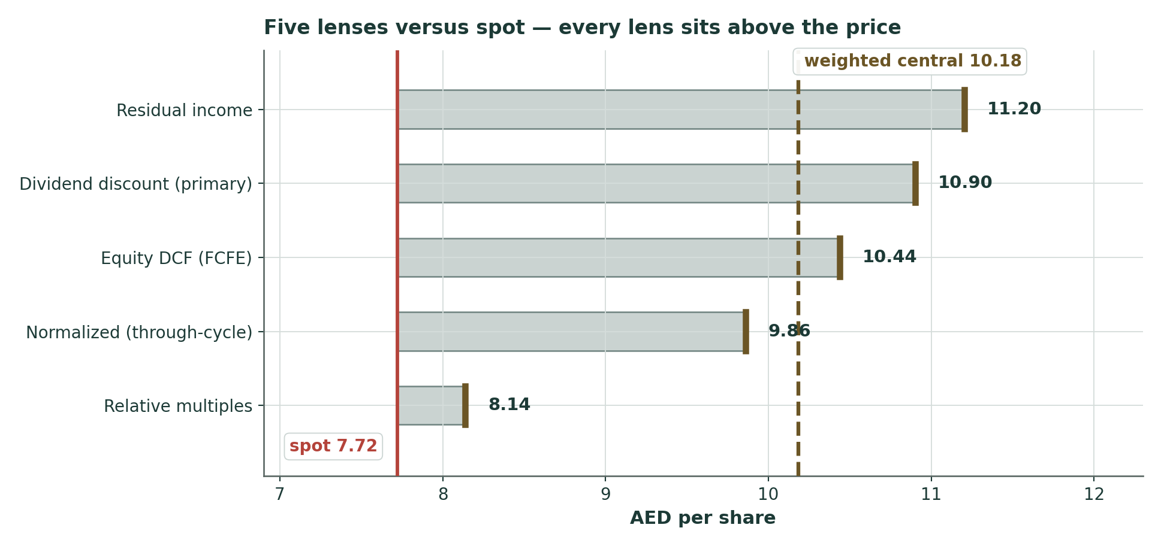
Figure 1 — Five lenses versus spot. The gold span marks the full lens range; the dashed line is the weighted central; spot in red. What is unusual here is that the relative lens — the market-anchored one — sits above the price rather than on it.
1.6 The driver build — how each assumption was set, then the machinery
Every forecast driver below is tagged by how it was derived and by the line of the research register in Appendix B that justifies it. Wherever a company discloses the underlying components, we prefer to build a driver up from them. DIB does not: it reports blended outcomes — a net profit margin, a cost-to-income ratio, a cost of risk — rather than the deposit-repricing betas, product unit economics or fee volumes that a bottom-up build would need. So every driver here is set top-down from the outcomes the bank does report and the guidance it has given, and each one names the evidence it rests on.
Driver | Mode | Justification and supporting evidence
Financing + sukuk growth (10% → 7%) | Top-down | FY26 IS management guidance (~10%, already halved from FY25's 22%). No unit-level pipeline disclosure. FY27–30 fade is ours. (F05, F14)
NPM (2.30% → trough 2.28% → 2.40%) | Top-down | FY26 IS guidance (~2.3%). DIB publishes NO rate-sensitivity table — dated negative search (F09). Path anchored on the disclosed quarterly NPM series: 3.0 → 2.6 → 2.5 (Q1-26). (F01, F09, F15)
Non-funded income (+10%, then +7%) | Top-down | The Q1-26 +30% headline is ONE line: other income 105 → 587. Fee income FELL 505 → 427; property income fell 274 → 162. The recurring lines are shrinking, so the headline is not extrapolated. (F24)
Cost-to-income (28.0% → 27.0%) | Top-down | FY26 IS guidance (28%). Reported quarterly; unit economics are not. The glide beyond FY26 is held deliberately shallow — assumed operating leverage is the most common way a forecast flatters itself. (F22)
Cost of risk (45bp → 35bp) | Top-down | FY26 IS the Q1-26 print (45bp) — not a forecast. Steps up hard from FY25's 14bp. Asset quality is IMPROVING, not deteriorating: Q1-26 NPF 2.5% (vs FY25 2.65%), total coverage 160% (flat), cash coverage 122% (vs 120%). (F11, F15, F26)
Effective tax rate (15.0% flat) | Top-down | Q1-26 printed 15.4%, so we take the 15% minimum-tax rate as the base. Note this is a CHOSEN floor, not a legal necessity: FY25 actually printed 13.3%, in the first year the top-up tax applied. See the discussion below. (F06)
DPS (35 fils held, then progressive) | Board policy | FY25 DPS of 35 fils is disclosed and AGM-approved. Held flat through the FY26 dip (no second cut), then progressive. CET1 is the OUTPUT, not an input. (F17)
RWA density (84.8%, −0.8pt/yr) | Disclosed | Risk-weighted assets and CET1 capital are BOTH published — the regulatory-capital slide of each investor presentation. RWA 257.2 → 298.9 → 305.0bn; CET1 capital 34.0 → 36.9 → 38.5bn. Only the forward density FADE is our own assumption. (F19)
Beta (1.00) | Fallback | A regression against the DFM index was genuinely attempted: β 0.796, R² 29.9%, standard error 0.296 — on only 19 observations, below our 24-observation minimum. Beta therefore defaults to 1.00 and is sensitized 0.8–1.3. (F20)

The build itself — fully live in the companion Excel's Driver Build sheet:
The margin. Anchors on the disclosed quarterly series (3.0% FY24 → 2.6% FY25 → 2.5% in Q1-26) and takes management's ~2.3% FY26 guide at face value, troughing at 2.28% in FY27 before CASA (34% of deposits) and asset repricing pull it back to 2.40%. Note the direction of the risk here: that guide was set in February, before the Fed turned hawkish. If US rates hold rather than fall, the guide is the conservative case, and every 10bp of NPM is worth AED 0.34 a share.
The provisions. 45bp in FY26 — which is not a forecast at all, it is what Q1 actually printed as management put war overlays through. That is more than triple FY25's 14bp. Held at 45bp through FY27 for the credit lag, then normalising to 35bp. This single line costs about AED 1.0bn of pre-tax profit a year versus FY25. Two things are worth saying against our own assumption, both of them disclosed: DIB's asset quality is improving, not deteriorating (first-quarter non-performing financing fell to 2.5%, a decade low, with cash coverage rising to 122%), and management guides the full year to 2.5% with coverage at 160% — i.e. stable. If they are right, our 45bp is too harsh, and the normalised FY24 charge of 58bp is the through-cycle number rather than a floor to fear.
The tax. DIB is inside the 15% domestic minimum top-up tax, and its effective rate has climbed from 9.3% in FY24 to 13.3% in FY25 to 15.4% in the first quarter of 2026. We model 15.0% flat. One point is worth making carefully here, because it is widely misunderstood: a sub-15% consolidated tax rate is not impossible for an in-scope group, and DIB's own accounts prove it — FY25 printed 13.3%, in the first year the top-up tax applied. The global minimum tax sets a floor on a jurisdictional effective rate computed under its own rules, not on a group's consolidated accounting tax rate. Profits from equity-accounted associates (AED 381mn in FY25) enter pre-tax profit already net of their own tax, which mechanically dilutes the consolidated ratio. Note too that the first quarter of 2025 ran 14.8% against a 13.3% full year — the first quarter runs above the year. So our 15.0% is a conservative floor we have chosen, not a legal necessity, and it may well prove too high. Management's stated aim of restoring 9% sits in the sensitivity grid as upside worth AED 0.70 a share.
The capital. This is the load-bearing part, and it runs entirely on published figures. Risk-weighted assets are disclosed — AED 257.2bn at December 2024, 298.9bn at December 2025 and 305bn at the first quarter — as is CET1 capital (34.0, 36.9 and 38.5bn), on the regulatory-capital slide of each investor presentation. From there: risk-weighted assets grow with financing at a density of 84.8%, fading 0.8 of a point a year. The dividend is board policy; CET1 is what falls out of it. Run it forward and the ratio rebuilds from 12.46% to 13.76% by FY30 while the dividend per share climbs from 35 to 59 fils. The growth slowdown is what pays for both.
Driver build (AED mn) | FY26E | FY27E | FY28E | FY29E | FY30E
Net financing + sukuk | 387,908 | 422,820 | 456,646 | 493,177 | 527,700
Operating revenue | 13,821 | 14,928 | 16,307 | 17,761 | 19,281
Pre-provision operating profit | 9,951 | 10,778 | 11,823 | 12,912 | 14,075
Impairment charge | -1,666 | -1,824 | -1,759 | -1,662 | -1,787
Profit before tax | 8,285 | 8,954 | 10,064 | 11,250 | 12,288
Earnings to common | 6,212 | 6,661 | 7,568 | 8,536 | 9,384
EPS (AED) | 0.86 | 0.92 | 1.05 | 1.18 | 1.30
DPS (AED) | 0.35 | 0.39 | 0.45 | 0.52 | 0.59
ROE % | 14.0% | 13.8% | 14.5% | 15.0% | 15.2%
CET1 % (output) | 12.46% | 12.63% | 12.96% | 13.31% | 13.76%

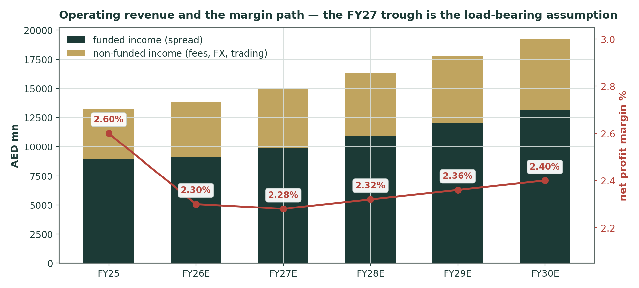
Figure 2 — Operating revenue build: funded income plus non-funded, with the net profit margin on the right axis. The FY27 trough is the single most consequential assumption in the model.
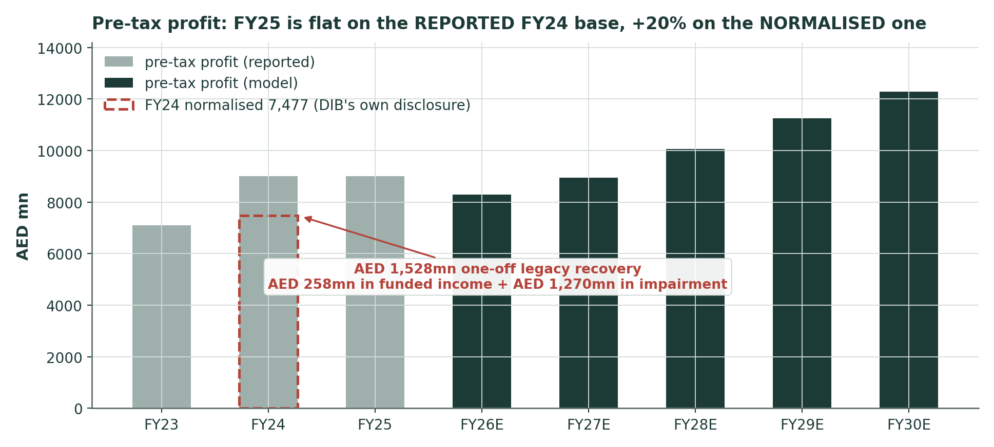
Figure 3 — Pre-tax profit, history and model. FY25 is flat against the REPORTED FY24 base and +20% against the NORMALISED one — the FY24 print is flattered by a one-off legacy recovery of roughly AED 1.5bn. Both framings are stated wherever this growth rate appears.
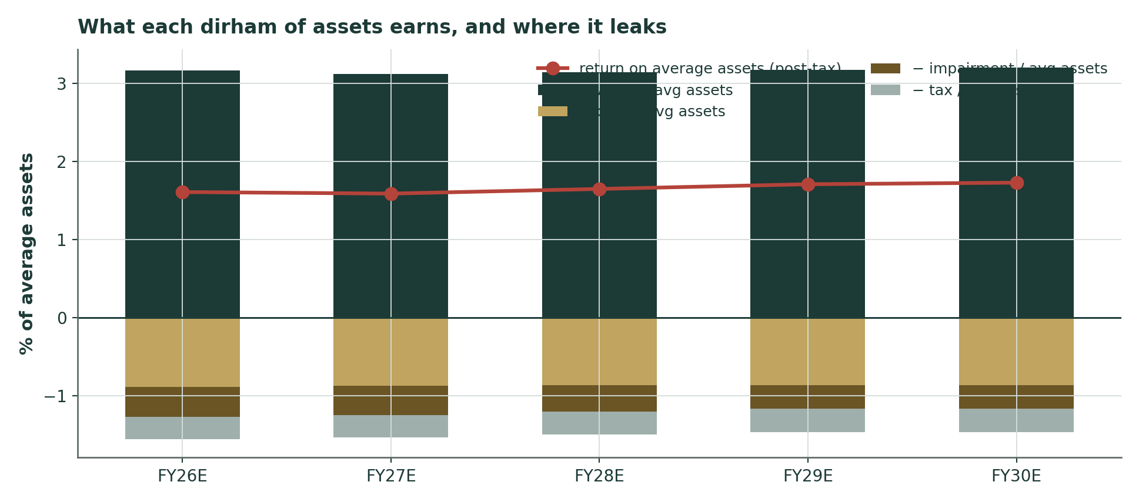
Figure 4 — DuPont: what each dirham of assets earns, and where it leaks. The impairment and tax bars are the two that widened in 2026.
1.7 Synthesis — weights and the football field
Weights reflect how far each lens can be trusted for a bank of this kind. The dividend model leads because the dividend is what the market just repriced and what a minority shareholder actually receives. Residual income takes the second-largest weight because it is the least terminal-dependent of the three fundamental lenses. The relative lens earns real weight — 20% — because it is the only one anchored in prices being set today, and because for DIB it is saying something genuinely informative rather than merely restating the share price. The through-cycle lens keeps the whole set honest.
Lens | Value (AED) | Weight | Contribution
DDM (primary) | 10.90 | 30% | 3.27
Residual income | 11.20 | 20% | 2.24
Equity DCF (FCFE) | 10.44 | 15% | 1.57
Relative multiples | 8.14 | 20% | 1.63
Normalized (through-cycle) | 9.86 | 15% | 1.48
Weighted central |  |  | 10.18

Shaded gold: the headline figure this table is building toward — or, in a grid of alternatives, the row we actually use rather than the sensitivities shown around it.
Unusually, the lenses do not split into two irreconcilable families here. The spread from AED 8.14 to AED 11.20 is 38% — narrow, by the standards of this house. So the weighted central of AED 10.18 is not the arbitrary blend of divergent methods that our protocol warns against; it is a genuine convergence. That convergence is itself the finding.
1.8 The crux — the margin is falling, the provisions are rising, and the capital is thin
Every bank study has one load-bearing tension. DIB's is a three-way squeeze on a capital base that has already been stretched once, and it is best stated in real units rather than as an abstract margin percentage.
The crux, in real units | Effect on the central
NPM +10bp across the path (≈ AED 0.47bn of revenue a year) | +0.32 / share
NPM −10bp | -0.32 / share
NPM −20bp (the deeper-cuts path) | -0.65 / share
Cost of risk +10bp (≈ AED 0.44bn pre-tax a year) | -0.42 / share
Cost of risk −10bp | +0.42 / share
Cost of risk to 60bp (the NORMALISED FY24 charge was 58bp) | -0.62 / share
Effective tax back to 9% (management's stated aim) | +0.70 / share
Conflict adder → 0 (peace holds) | +1.68 / share
Conflict adder → 2.5pt (renewed Hormuz closure) | -1.73 / share

Shaded pink: both rows are the Iran-war risk premium, which can swing fair value up (peace) or down (a renewed Hormuz closure) — it is flagged because neither DIB nor this model controls it, not because it is necessarily bad news.
Read the provision rows carefully. The cost of risk is the single most powerful lever in this model — more powerful than the margin — because DIB is coming off a 14bp base that is about as benign as a bank's provisioning ever gets, and Q1 has already tripled it to 45bp. The FY24 comparison is worse than the headline: that year's reported 14bp was flattered by the disclosed legacy recovery, and DIB's own normalised FY24 impairment charge is AED 1,677mn — a normalised cost of risk of 58bp. The market is not wrong to watch this line. But the honest reading is that a 60bp through-cycle charge is DIB's own recent normalised experience, not a stress scenario.
But the crux proper is what those two squeezes do to capital, and this is why the dividend cut mattered so much. DIB ended 2025 with CET1 at 12.3% — against a Fitch downgrade trigger at 12%, and a new 0.5% counter-cyclical buffer from 2026 that makes the effective floor 12.5%. It got there by cutting the dividend. The chart below runs the capital equation forward under three paths.
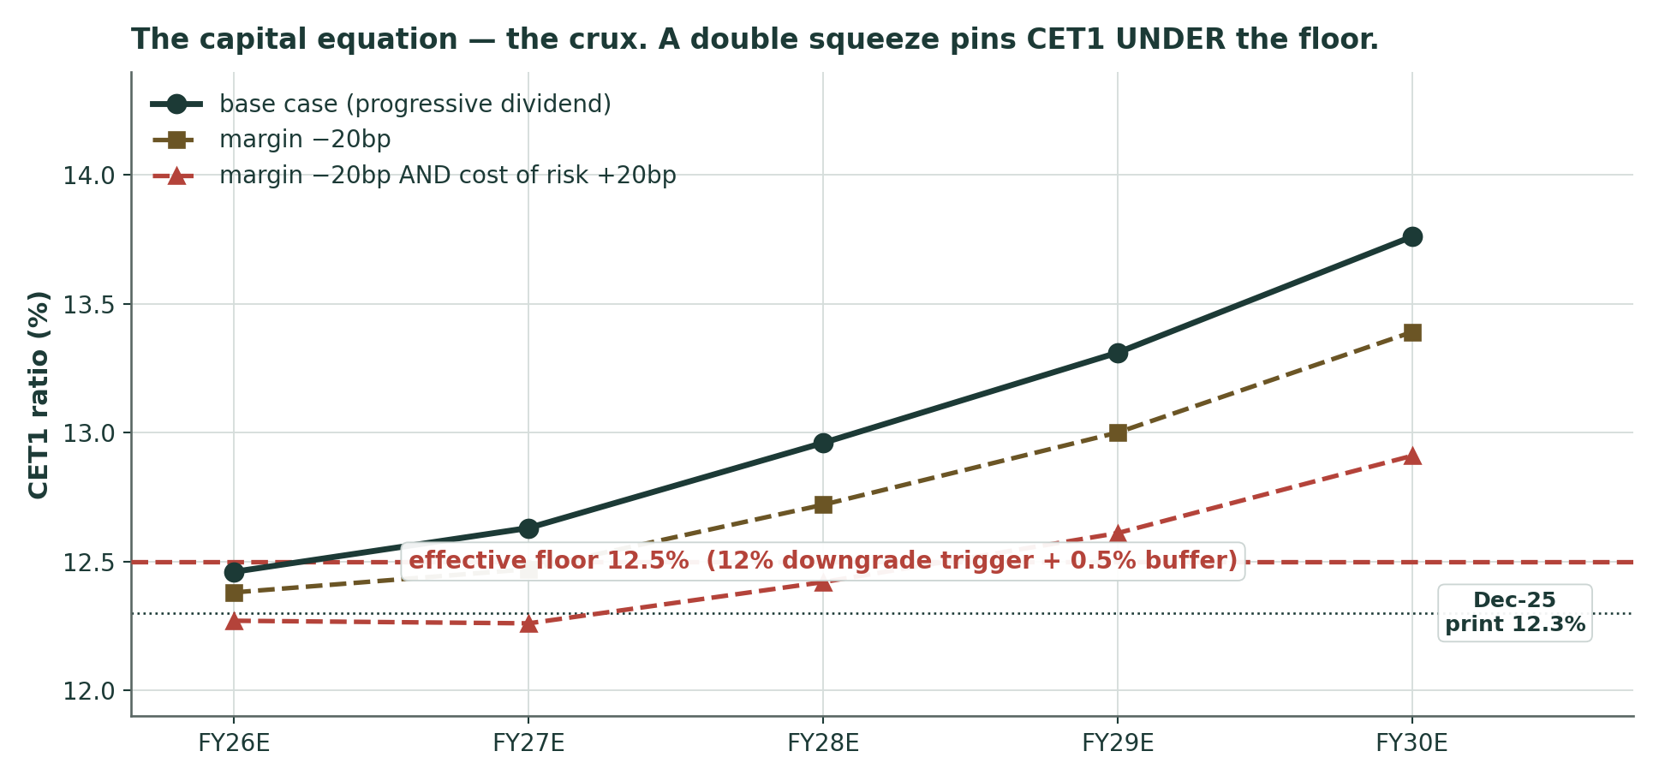
Figure 5 — The capital equation. On the base path, halving growth to 10% lets DIB rebuild CET1 from 12.45% to 14.0% while paying a rising dividend. Under a double squeeze — margin −20bp AND cost of risk +20bp — CET1 sits at 12.25–12.28% through FY26–27, THROUGH the effective 12.5% floor. The buffer is one bad year deep.
That is the honest bear case, and it is not a valuation argument at all — it is a capital argument. If margin and provisions squeeze together, DIB does not go anywhere near insolvency; it simply runs out of room to pay a progressive dividend, and the board cuts again. A second cut, coming eighteen months after the first, would tell the market that the FY25 cut had not bought enough — and the DDM, which carries 30% of the weight here, would have to be rebuilt on a lower payout. That, and not the war, is the risk this share price is really expressing.
1.9 Macro & regime
The backdrop is a bruised macro sitting on top of a strong micro, and it moved materially in the days around this study. The UAE grew 5.6% in 2025. On 2 July the central bank cut its 2026 forecast to 1.7% — from 5.6% — and called it the war's bill: hydrocarbon growth +0.8%, non-hydrocarbon +1.9%, with a snap-back to 9.8% pencilled in for 2027. The war itself began on 28 February when the US and Israel struck Iran; the Strait of Hormuz was effectively closed, in what the IEA has called the largest supply disruption in the history of the oil market. A ceasefire was agreed on 7 April and a 60-day memorandum in mid-June.
That memorandum broke while this study was being written. On 7 July Iran attacked three commercial vessels in the strait; the US revoked its oil-sanctions waiver and struck around 90 Iranian targets; on 8 July, at the NATO summit in Ankara, President Trump declared the ceasefire "over"; Iran retaliated against US bases in Bahrain and Kuwait. Talks resumed in Oman on 11 July — the day of this study. DIB's own price traces it: AED 7.72 on 3 July, roughly AED 7.54 by 9 July. The 1.0-point conflict adder in the cost of equity was calibrated on a ceasefire that is now, at best, provisional. That is why the adder sits at the top of the crux table rather than in a footnote: it is worth AED 1.63 up and AED 1.80 down, and neither management nor this model controls it.
Against that, the banking system has been conspicuously resilient. UAE bank assets reached AED 5.56tn in Q1-2026, up 17.7%; loans grew 20.3% and deposits 17.4%; the sector's capital adequacy is 16.8% and net NPLs 1.5%. The central bank held its base rate at 3.65% and rolled out a resilience package. DIB itself booked the disruption as provisions, not losses. The rate cycle is the thing that actually matters for the model, and it has turned: the Fed held at 3.50–3.75% with a hawkish new chair, which means the margin guidance DIB set in February may prove conservative.
1.10 Sensitivity — Ke × terminal growth, and the beta we could not regress
Weighted central (AED) | g 3.0% | g 3.5% | g 4.0% | g 4.5%
Ke 9.57% | 10.99 | 11.39 | 11.86 | 12.43
Ke 10.07% | 10.26 | 10.58 | 10.95 | 11.39
Ke 10.57% | 9.63 | 9.89 | 10.18 | 10.53
Ke 11.07% | 9.08 | 9.29 | 9.52 | 9.79
Ke 11.57% | 8.59 | 8.76 | 8.95 | 9.17
Ke 12.07% | 8.16 | 8.30 | 8.45 | 8.62

Shaded gold: the combination of cost of equity and terminal growth actually used in the base case (§1.10 states both).
DDM alone (AED) | g 3.0% | g 3.5% | g 4.0% | g 4.5%
Ke 9.57% | 12.12 | 12.57 | 13.11 | 13.75
Ke 10.07% | 11.14 | 11.50 | 11.91 | 12.40
Ke 10.57% | 10.29 | 10.58 | 10.90 | 11.27
Ke 11.07% | 9.56 | 9.78 | 10.03 | 10.32
Ke 11.57% | 8.91 | 9.09 | 9.28 | 9.51
Ke 12.07% | 8.33 | 8.47 | 8.63 | 8.80

Beta (assumed 1.0 — the regression failed the sample gate) | 0.80 | 0.90 | 1.00 | 1.10 | 1.20 | 1.30
Weighted central (AED) | 11.81 | 10.93 | 10.18 | 9.54 | 8.98 | 8.49

The beta grid is not decoration. We genuinely attempted the regression against the DFM General Index and got β = 0.796 with an R² of 29.9% and a standard error of 0.296 — a respectable fit whose R², standard error and sign all clear the house usability gate. It fails on one criterion only: nineteen observations, against a minimum of twenty-four. That is not a modelling choice, it is a data wall — investing.com serves a fixed twenty-row table and the DFM's own historical page renders client-side. So the our fallback rule applies and beta defaults to 1.00. But note where the attempted 0.80 lands in the grid: at AED 11.81, above the published central, not below it. The fallback is the conservative choice here.
Both ERP bases are carried: rating-based Ke 10.57% and CDS-based 10.63%. The published central uses the rating basis. Full grids are live in the companion Excel.
2. Technical & positioning read
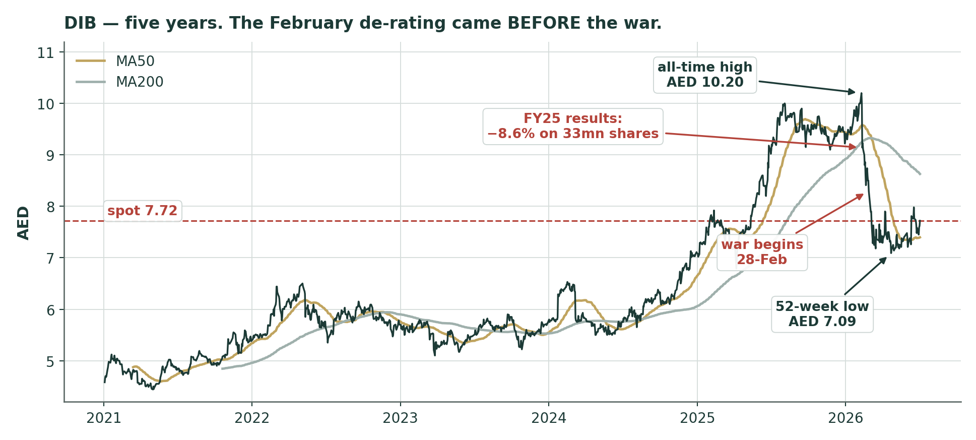
Figure 6 — Five years of DIB. The February 2026 peak at AED 10.20, the −8.6% results session on 33mn shares, the war leg down to AED 7.09 in April, and a base building since.
Price at AED 7.72 sits above the 20-day (7.59) and 50-day (7.40) moving averages but still below the 100-day (7.76) and well below the 200-day (8.63). That is the signature of a downtrend in repair rather than a trend restored — the opposite of what we found at ADCB last week, which sat above every average. RSI-14 at 57 is neutral. MACD (12,26,9) reads 0.055 / 0.063 / -0.008: the line is above zero, so the regime has turned constructive, but the histogram is marginally negative — momentum is pausing rather than accelerating.
The positioning context is what matters. The stock is 24% below its February high and only 9% above its April low. Realized volatility is running at 30% over sixty days against 27% over the year — elevated, not extreme. Average daily volume is about 6.4mn shares, roughly AED 47mn a day, so the name is genuinely liquid. The technical read and the §1 value gap point the same way, which is precisely the moment at which the discipline of §3 would matter most — and §3, for this name, has nothing to offer.
Indicator | Level | Read
MA20 / MA50 / MA100 / MA200 | 7.59 / 7.40 / 7.76 / 8.63 | Above the short pair, below the long pair — a base, not a repaired trend
RSI-14 | 57 | Neutral
MACD 12 26 9 | 0.055 / 0.063 / -0.008 | Positive regime, momentum pausing
52-week range | 7.09 – 10.20 | Spot 20% up the range
All-time high | 10.20 (09-Feb-2026) | -24.3% below
Realized vol (60d / 252d, ann.) | 30% / 27% | Elevated, not extreme

3. Monte Carlo — no forecast is published for this name
THE CALIBRATION TEST FAILED. Under the fitted UAE market model, DIB's five-year backtest does not beat a naive random walk. The skill score is −0.025, and the 90% confidence interval sits entirely below zero under every resampling scheme we tried. Our rule is simple and it is not negotiable: if the engine cannot demonstrate an edge on a name, we publish no forecast for it. So there is no probability read, no percentile forecast, no touch ladder and no Calibration-Ledger entry for DIB. What follows is the diagnosis, in the open, and an illustrative volatility map — a picture of how wide the cone is, not a claim about where the price is going.

3.1 Engine & calibration — the backtest in the open
The engine models daily volatility with a gap-aware Yang-Zhang estimator and a heterogeneous-autoregressive forecast, draws shocks from a fat-tailed Student-t distribution, and centres the paths on carry alone — no momentum or reversal signal is used, because none tested reliably on the UAE panel. Tail heaviness and cone width are fitted to a panel of nine UAE names, not to DIB itself. History starts in January 2022, after the UAE moved its trading week to Monday–Friday, so the volatility estimate rests on a consistent calendar.
Five-year backtest — walk-forward, 60-day horizon, non-overlapping
Windows | 14 (post-2022 calendar change)
Skill score vs the naive random walk (distribution accuracy) | -0.0247
Skill score on median placement | +0.0030
Skill score on interval width | -0.0308
Coverage 50 / 80 / 90 | 0.43 / 0.79 / 1.00
Calibration mean (0.50 = perfectly centred) | 0.58
Bootstrap 90% confidence interval — three resampling schemes | [-0.035, -0.003] · [-0.035, -0.003] · [-0.034, -0.001]
Robust verdict (all blocks agree) | FAIL

Shaded pink: the test failed on this design (see §3.1).
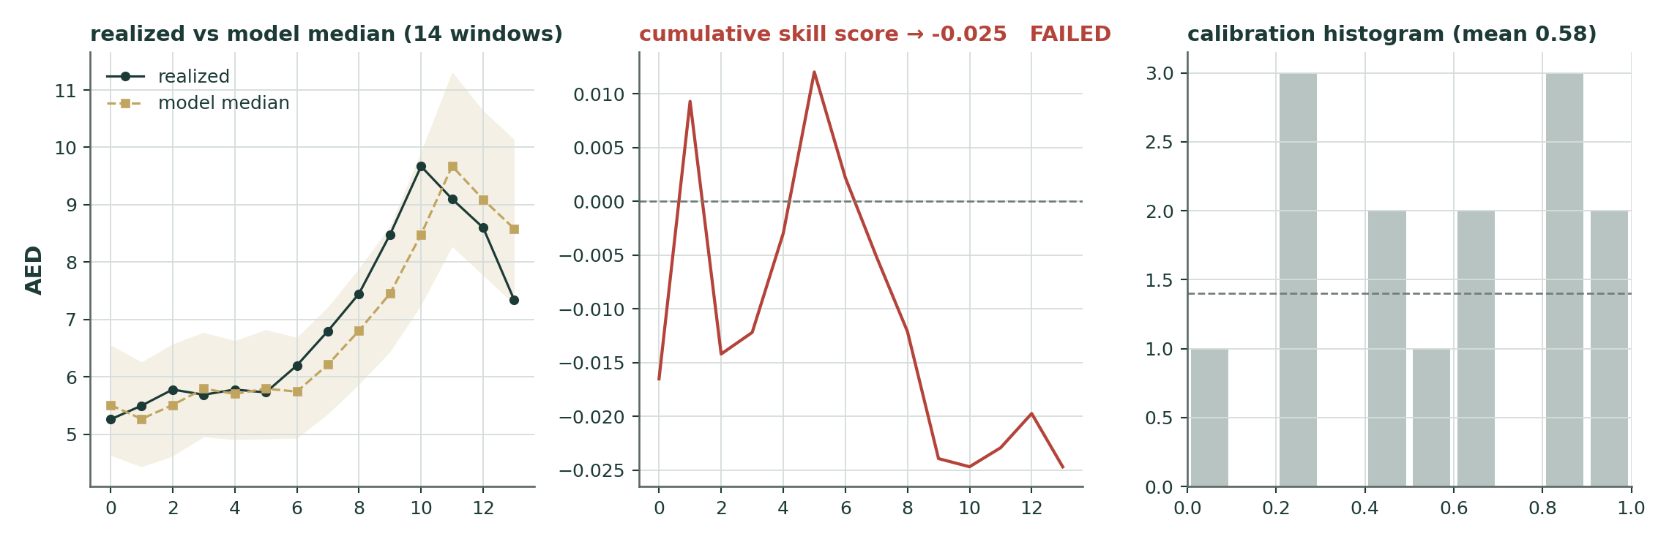
Figure 7 — Calibration in three panels: realized versus model median per window; the cumulative skill score (it never gets above zero); and the calibration histogram. Every one of the fourteen realized outcomes fell inside the 90% band — which is the clue.
Now the diagnosis, because "failed" and "broken" are not the same thing and the difference matters.
A failure of this test is meant to flag something structurally wrong — price-limit censoring, degenerate volatility, bad data. None of those is present. There is no limit-hitting (the largest daily move in the pool is 8.99%). Zero-return days run at 9.2%, normal for a DFM large-cap. And the Yang-Zhang variance proxy is unbiased, at 1.017× realized close-to-close volatility. The data is clean.
What actually happened is this. The UAE profile is carry-only — no signal survived the panel — and DIB's carry is essentially zero, because its dividend yield (4.53%) almost exactly offsets the risk-free rate (3.65%). So the engine and the benchmark have an identical centre. The pinball-0.50 skill of +0.000 confirms it: on median placement they are a dead heat, by construction. The test therefore collapses to a pure contest about width — and on width the engine is not wrong. Its 60-day sigma of 0.105 tracks the full-sample realized 60-day dispersion (0.114) far better than the trailing-volatility benchmark does at 0.093, which is about 19% too narrow. DIB's 60-day variance ratio against square-root-of-time scaling is 1.23, so the benchmark's independent-increments assumption systematically under-disperses.
But the fourteen non-overlapping windows our test specifies happened to draw a quiet sample: realized dispersion of 0.083 against 0.114 for the full period. Against quiet outcomes, the narrower — and mis-specified — benchmark wins. Widen the sample and the two converge:
Design | Windows | Skill score | Verdict
Non-overlapping (our specified test) | 14 | -0.0247 | FAIL
Monthly origins | 39 | +0.0025 | parity
Bi-weekly origins | 81 | -0.0002 | parity

Shaded pink: the test design we specify in advance, and the one whose result is reported throughout this study. It fails; the other two rows are shown only to explain why.
The honest reading is that DIB has no demonstrable single-name edge — it is a dead heat on any adequately powered design. It is not that the model is broken. But we do not get to choose the design after seeing the result. Our test specifies non-overlapping windows; on that design the name fails; the forecast is therefore withheld. Re-specifying a test until it passes is precisely the self-deception this whole exercise exists to prevent, so it was not done.
Nor does narrowing the cone rescue it, before anyone suggests it: at a cone width of 0.90 the skill score gets worse (−0.039), and at 0.85 worse again (−0.045). Every rung of the ladder — Student-t degrees of freedom of 4, 6 and 12, width calibrations from 0.85 to 1.07 — is negative. There is no setting of this engine that beats a random walk on DIB's fourteen windows, and pretending otherwise by tuning would be dishonest.
What this costs the reader is real and should be stated plainly: you get no three-month distribution for DIB, no probability of being above spot, no touch ladder. What you get instead is the fundamental work in §1, which does not depend on the Monte Carlo engine at all, and the knowledge that when our forecast engine cannot demonstrate an edge, we say so and publish nothing rather than dress up a random walk as a forecast.
3.2 Illustrative volatility map (not a forecast)
For completeness, and clearly labelled: the following describes the width of the engine's cone on today's data. It is a volatility map. It is not a forecast, it is not graded, and nothing is entered on the Calibration Ledger against it. Read it as "how much does this thing typically move in three months", nothing more.
Percentile | T+20 (AED) | T+60 (AED)
5th | 6.97 | 6.46
25th | 7.45 | 7.25
50th | 7.72 | 7.71
75th | 7.99 | 8.19
95th | 8.55 | 9.18

The centre sits a hair below spot — AED 7.71, or -0.2% — and that is an explained flat, not a view. Carry over sixty days is ln(1 + rf 3.65%) − ln(1 + dividend yield 4.53%) = -0.20%. For a dividend-payer whose yield exceeds the risk-free rate, the expected total return is delivered as dividend rather than as price drift, so the price centre is flat-to-marginally-negative by arithmetic. Lens independence holds regardless: the §1 value gap never enters this drift. If it closes, it closes as a surprise to this distribution, not inside it.
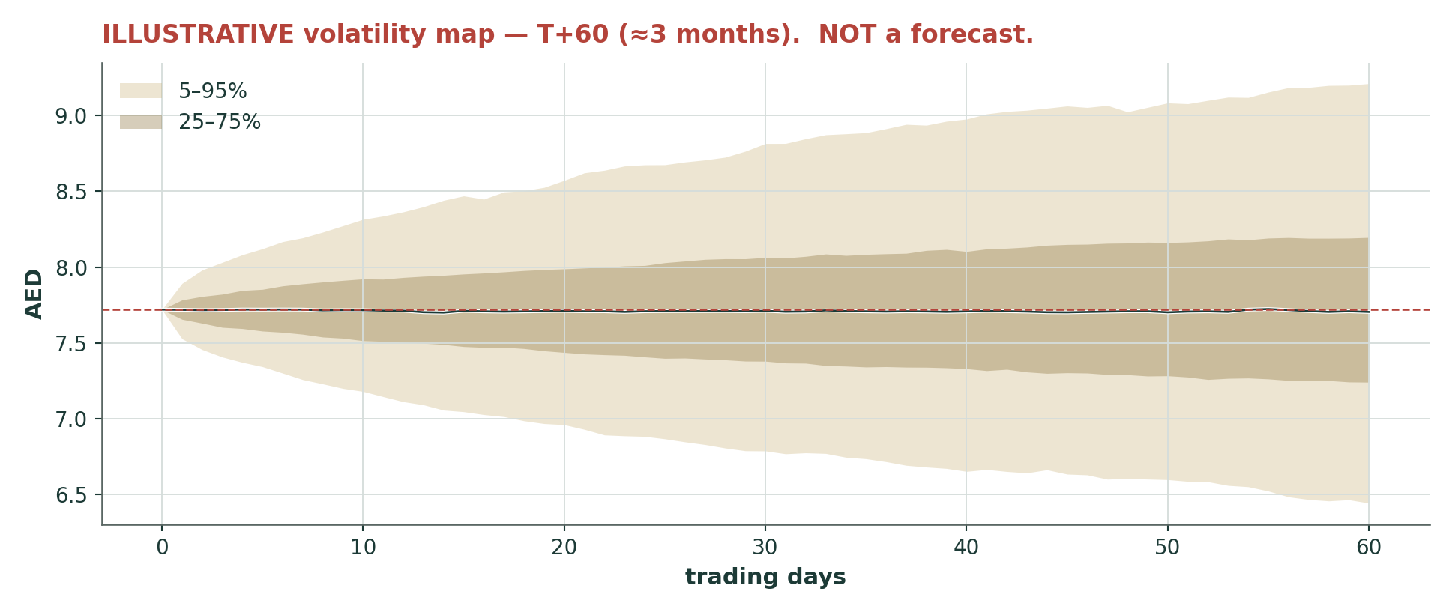
Figure 8 — Illustrative T+60 cone. 50,000 paths, Student-t(4) shocks, seed 42. NOT A FORECAST.
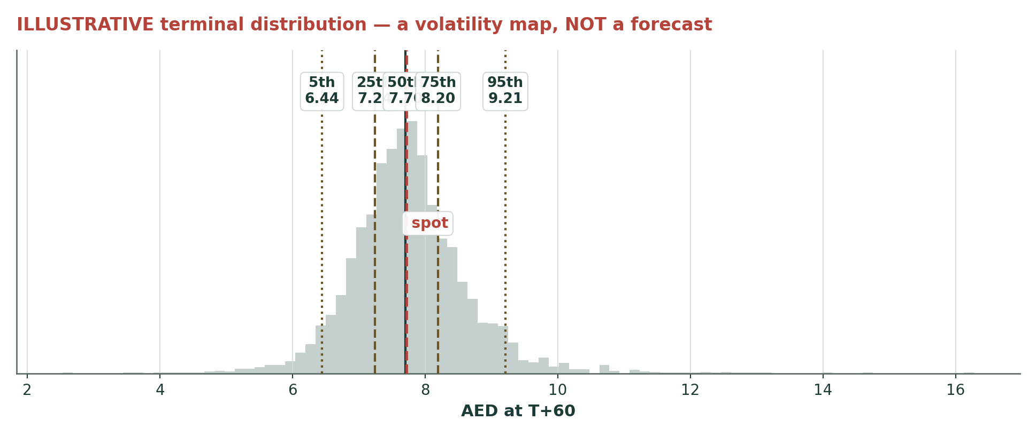
Figure 9 — Illustrative terminal distribution at T+60. NOT A FORECAST.
4. What would change our mind
Falsifier 1 — H1-2026 results, due in days. The first live test of everything in §1.6. A net profit margin printing below 2.20%, or a cost of risk above 60bp, and the FY27 trough assumption is too kind: the central falls toward AED 9.5 and the capital equation tightens. Equally, an NPM at or above 2.40% — plausible now that the Fed has turned hawkish — and the guide was the conservative case, as we suspect.
Falsifier 2 — a second dividend cut. The DDM carries 30% of the weight and assumes 35 fils is the floor. If the board cuts again at the FY26 results, the thesis that the FY25 cut bought enough capital is simply wrong, and the primary lens must be rebuilt on a lower payout.
Falsifier 3 — CET1 printing below 12.3% at H1 without an RWA surge to explain it. The capital equation is tighter than modelled and the progressive-dividend path is not affordable. This is the crux failing in the direction the market is already pricing. Both sides of that ratio are disclosed quarterly — CET1 capital and risk-weighted assets are both published — so this falsifier is directly checkable against the half-year print, with no derivation in between.
Falsifier 4 — the Hormuz re-escalation hardening into a sustained closure. The 1.0-point conflict adder is a ceasefire-holding assumption, and the ceasefire was declared "over" on 8 July. At 2.5 points the central falls to roughly AED 8.8 — still above spot, but the margin of safety is largely gone. This is the live risk, not a tail footnote.
Falsifier 5 — the effective tax rate stays at 15% into 2028 and management quietly drops the 9% ambition. Worth about AED 0.72 a share against our base, which already assumes they fail. If they succeed instead, that is upside we have deliberately excluded.
Falsifier 6 — the pleasant failure mode. The UAE bank complex re-rates on de-escalation and DIB merely tracks it. The relative lens converges upward on the cash-flow lenses and the gap closes without DIB doing anything at all.
5. How to use this study
Read the central as a probability-weighted anchor, not a target — it is not a target, and this document contains no rating and no price target by design. If you wanted a three-month view, there isn't one for DIB: the engine could not demonstrate an edge on this name and we published nothing rather than dress a random walk up as a forecast. If you disagree with an input, the companion Excel reprices the entire study from one blue cell — change the NPM path, the cost of risk, the conflict adder or the beta, and every lens, the capital schedule and the weighted central all move. That is what the file is for. And grade us: the fundamental drivers in this study are logged as open rows on the public Fundamental Driver Ledger and will be closed against the actual prints.
6. Coverage & ledger integration
DIB joins Testahil's UAE coverage alongside Abu Dhabi Commercial Bank and Alpha Dhabi. Its fourteen backtest windows are added to the UAE sample our market calibration is estimated on, where they will pull the pooled estimate down and, more usefully, sharpen a real question: whether the model is right to centre a UAE bank on carry alone when these names pay out their entire carry as dividend. No forecast entries are made on the Calibration Ledger for DIB — there is nothing to grade, because no forecast was published, and that absence is itself the honest entry. The forecast drivers in §1.6 are logged on the public driver ledger and resolve against the FY26 prints.
7. The one-paragraph version
Dubai Islamic Bank is the UAE's largest Islamic bank, earning an 18%-plus return on tangible equity, and it trades at 1.31× book and 7.9× earnings — cheaper than every UAE peer, on a better return than most of them. It got there in two steps: an 8.6% collapse the session after February's results, when it cut the dividend from 45 fils to 35, and then the war. Five lenses put it between AED 8.14 and AED 11.20, central AED 10.18, and unusually the market-anchored lens sits above the price too — this is not merely a cheap DCF. The counter is capital, not valuation: CET1 at 12.3% against a 12.5% effective floor, a margin still falling and a cost of risk that has already tripled off a benign base. Squeeze both and the buffer is gone and the board cuts again. As for the three-month distribution: there isn't one. The engine failed its calibration gate on this name, we say so on the front page, and we publish no forecast rather than a dressed-up random walk.

Appendix A — Financials (3-year history + 5-year model)
AED mn unless noted. History from DIB's FY2025 audited consolidated financial statements and its results releases. Forecast lines follow the driver build in §1.6. FY24 is shown BOTH ways — as reported, and normalised for the one-off legacy recovery — per the house dual-framing rule, because the entire growth narrative depends on which base you use.
A.1 Income statement
Income statement | FY23 | FY24 | FY25 | FY26E | FY27E | FY28E | FY29E | FY30E
Funded income (the spread) | — | 8,949 | 8,972 | 9,114 | 9,891 | 10,918 | 11,995 | 13,111
Non-funded income | — | 3,887 | 4,279 | 4,707 | 5,036 | 5,389 | 5,766 | 6,170
Operating revenue | 11,665 | 12,837 | 13,251 | 13,821 | 14,928 | 16,307 | 17,761 | 19,281
Operating expenses | -3,161 | -3,425 | -3,763 | -3,870 | -4,150 | -4,484 | -4,849 | -5,206
Pre-provision operating profit | 8,504 | 9,412 | 9,488 | 9,951 | 10,778 | 11,823 | 12,912 | 14,075
Impairment charge (net) | -1,396 | -407 | -485 | -1,666 | -1,824 | -1,759 | -1,662 | -1,787
Profit before tax | 7,108 | 9,005 | 9,003 | 8,285 | 8,954 | 10,064 | 11,250 | 12,288
Tax | -98 | -840 | -1,195 | -1,243 | -1,343 | -1,510 | -1,688 | -1,843
Net profit after tax | 7,010 | 8,165 | 7,808 | 7,042 | 7,611 | 8,554 | 9,563 | 10,445
less: non-controlling interests | -200 | -231 | -308 | -278 | -300 | -337 | -377 | -412
less: AT1 sukuk distributions | -576 | -576 | -419 | -553 | -649 | -649 | -649 | -649
Earnings to common | 6,234 | 7,358 | 7,081 | 6,212 | 6,661 | 7,568 | 8,536 | 9,384
EPS (AED) | 0.86 | 1.02 | 0.98 | 0.86 | 0.92 | 1.05 | 1.18 | 1.30
DPS (AED) | 0.45 | 0.45 | 0.35 | 0.35 | 0.39 | 0.45 | 0.52 | 0.59

The FY24 normalisation — as DIB discloses it, not as we derived it
AED mn | FY24 reported | FY24 normalised | One-off legacy recovery
Net funded income | 8,949 | 8,691 | 258
Non-funded income | 3,887 | 3,887 | —
Operating revenue | 12,837 | 12,579 | 258
Operating expenses | -3,425 | -3,425 | —
Pre-provision operating profit | 9,412 | 9,154 | 258
Net impairment charge | -407 | -1,677 | 1,270
Profit before tax | 9,005 | 7,477 | 1,528
Net profit after tax | 8,165 | 6,637 | 1,528
Implied cost of risk | 14bp (reported) | 58bp (normalised) | —

Shaded gold: profit before tax — the line the +20%-versus-normalised, flat-versus-reported comparison in this study is built on.
Source: DIB FY2025 investor presentation, income-statement slide. This table is DIB's own disclosure, not our derivation. It matters because the cost-of-risk debate in this study turns on it: the reported FY24 charge of 14 basis points is flattered by the one-off, and the bank's own normalised charge is AED 1,677mn — 58 basis points. That is the number Expert 2's bear case is built on in Appendix C, and it is the number the crux in §1.8 is measured against.
THE DUAL FRAME. FY25 pre-tax profit of AED 9,003 is FLAT against the REPORTED FY24 base (9,005) and +20% against the NORMALISED one (7,477). Net profit reads −4% or +18% on the same two bases. Operating revenue is +3% reported and +5% normalised. Every one of those framings is stated wherever the figure appears in this study — none of them alone is the truth.
A.2 Balance sheet & capital
Balance sheet & capital | FY23 | FY24 | FY25 | FY26E | FY27E | FY28E | FY29E | FY30E
Total assets | 314,000 | 344,687 | 415,948 | 457,543 | 498,722 | 538,619 | 581,709 | 622,429
Net financing + sukuk | 274,000 | 294,588 | 352,644 | 387,908 | 422,820 | 456,646 | 493,177 | 527,700
Customer deposits | 222,000 | 248,546 | 320,184 | 352,202 | 383,901 | 414,613 | 447,782 | 479,126
Common equity (ex-AT1) | 35,618 | 39,724 | 42,562 | 46,244 | 50,087 | 54,402 | 59,181 | 64,301
CET1 capital | — | 34,000 | 36,900 | 40,582 | 44,425 | 48,740 | 53,519 | 58,639
Risk-weighted assets | — | 257,200 | 298,900 | 325,687 | 351,616 | 376,092 | 402,234 | 426,169
CET1 % | — | 13.20% | 12.35% | 12.46% | 12.63% | 12.96% | 13.31% | 13.76%
NPM % | 3.00% | 3.00% | 2.60% | 2.30% | 2.28% | 2.32% | 2.36% | 2.40%
Cost-to-income % | 27.1% | 26.7% | 28.4% | 28.0% | 27.8% | 27.5% | 27.3% | 27.0%
Cost of risk (bp) | 57 | 14 | 14 | 45 | 45 | 40 | 35 | 35
Effective tax rate % | 1.4% | 9.3% | 13.3% | 15.0% | 15.0% | 15.0% | 15.0% | 15.0%

Risk-weighted assets and CET1 capital are both published, and this study uses the published figures. They appear on the regulatory-capital slide of DIB's FY2025 and Q1-2026 investor presentations, which carry an explicit risk-weighted-asset movement bridge and a CET1 capital bridge. Risk-weighted assets: AED 257,200mn at December 2024, 298,900mn at December 2025, 305,000mn at the first quarter of 2026. CET1 capital: 34,000mn, 36,900mn and 38,500mn. The check ties: 36,900 ÷ 298,900 = 12.35%, against the 12.3% CET1 ratio the bank reports. That matters, because the capital crux in §1.8 is the load-bearing argument of this study and it rests on these two numbers. Only the forward density fade (−0.8 of a point a year) is our own assumption.
Q1-2026 anchors (official): total assets 419,916 · financing + sukuk 363,860 · deposits 322,000 · CET1 12.6% · CAR 15.8% · NPF 2.5% · total coverage 160% · cash coverage 122% · LCR 121% · NSFR 106%.
A.3 Cash flow — the capital walk
A bank has no capex line and no working-capital line. The item it cannot avoid is the fresh equity it must retain to hold its capital ratio as the balance sheet grows — the analogue of capex — and that is the line that decides whether the dividend is affordable. The gap between free cash flow to equity and the declared dividend is the capital DIB is accumulating.
AED mn | FY26E | FY27E | FY28E | FY29E | FY30E
Earnings to common | 6,212 | 6,661 | 7,568 | 8,536 | 9,384
less: dividends paid (board policy) | -2,529 | -2,819 | -3,252 | -3,758 | -4,264
Retained earnings → CET1 | 3,682 | 3,843 | 4,316 | 4,778 | 5,120
Capital absorbed by RWA growth (at target CET1) | -4,625 | -3,306 | -3,121 | -3,333 | -3,052
Free cash flow to equity | 1,586 | 3,355 | 4,447 | 5,203 | 6,332
Dividend cover (FCFE / dividends) | 0.63x | 1.19x | 1.37x | 1.38x | 1.49x

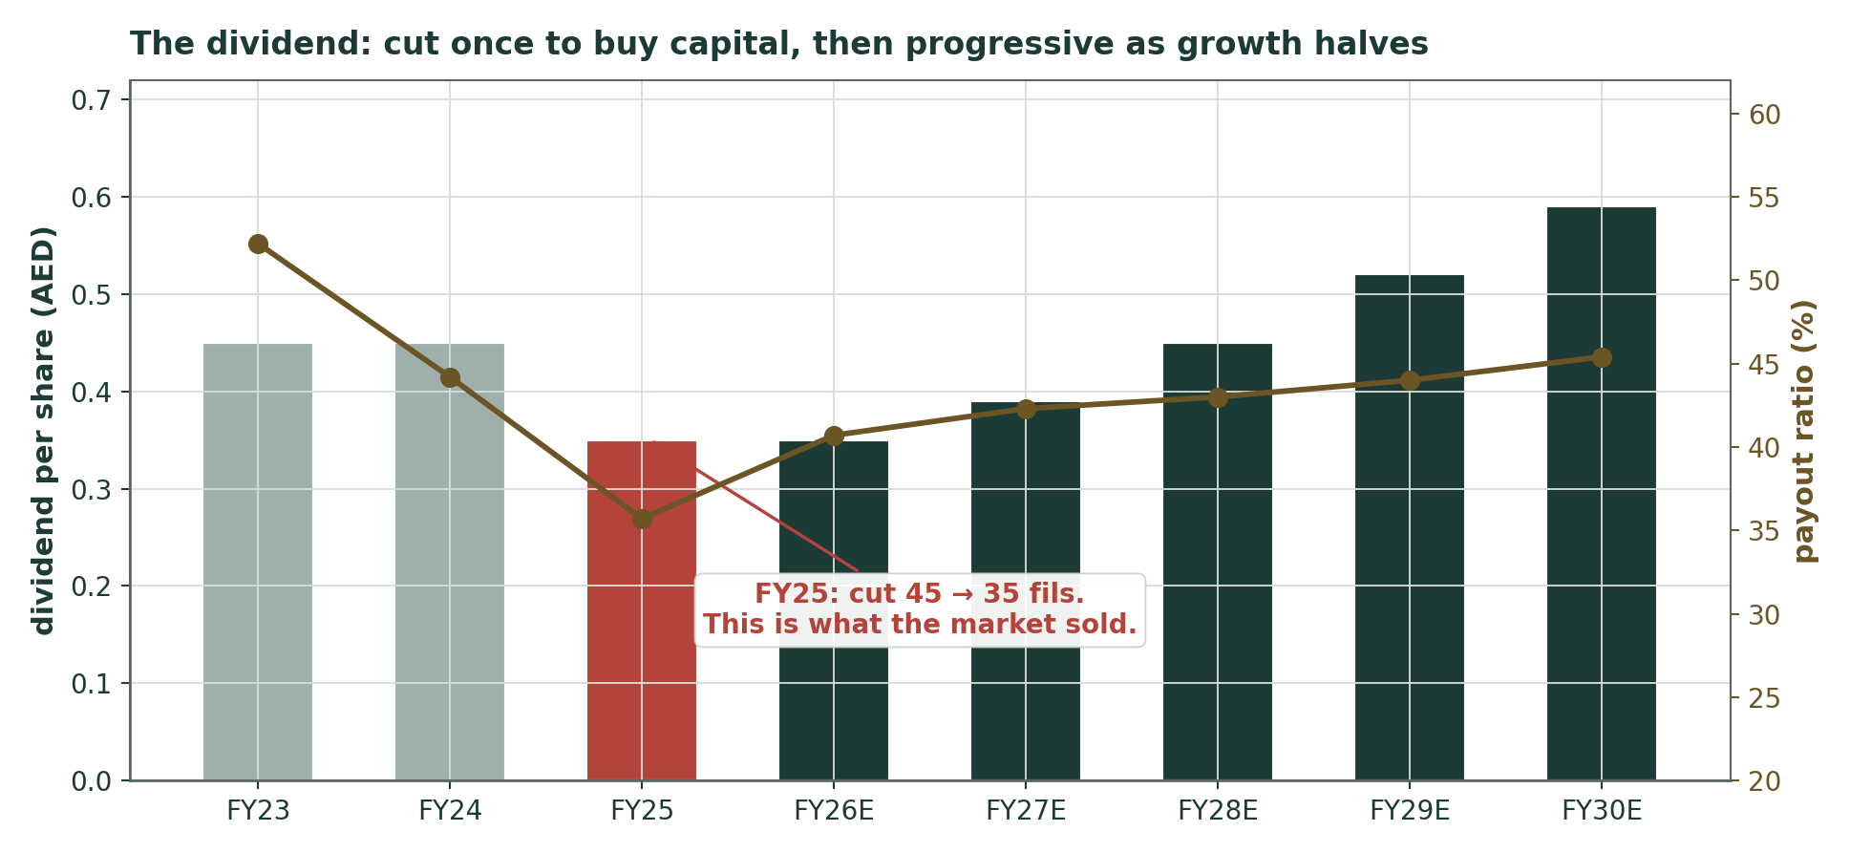
Figure 10 — The dividend: cut once to buy capital, then progressive as growth halves. The red bar is what the market sold.

Appendix B — Peers, sector, risks, and the research register
B.1 Peer set and sector
Bank | Latest sourced print | Read vs DIB
Abu Dhabi Islamic Bank | FY25 RoTE 25.8%; P/B ~3.5x | The premium Islamic peer. A 2.7x P/B gap on a 7pt RoTE gap.
First Abu Dhabi Bank | Q1-26 net income AED 4.75bn; P/B ~1.9x | Sector ceiling by size — on a LOWER RoTE than DIB.
Emirates NBD | RoTE 20.4%; P/B ~1.65x | Dubai flagship and DIB's closest home comparator.
Abu Dhabi Commercial Bank | Q1-26 NPAT AED 3.36bn; RoAE 16.3%; P/B 1.52x (03-Jul) | Testahil coverage, 10-Jul-2026 study. Same-day P/B comparison.
Dubai Islamic Bank (this study) | FY25 NPAT AED 7.81bn; RoTE 18-19%; P/B 1.31x (03-Jul) | Cheapest in the set on the second-best return.

Shaded gold: Dubai Islamic Bank — the subject of this study, shown against the peers it is being read alongside.
Sector: UAE bank assets AED 5.56tn (Q1-2026, +17.7% YoY); loans +20.3%; deposits +17.4%; sector CAR 16.8%; net NPL 1.5%. CBUAE base rate 3.65%, held. A 0.5% counter-cyclical buffer on UAE private-sector credit applies from 2026. DIB ratings: Moody's A3 (stable, with five notches of government-support uplift over a ba2 standalone assessment) and Fitch A. Fitch's downgrade triggers are impaired financing at 7% or CET1 sustainably below 12% — the second of which is the floor the §1.8 crux is measured against.
B.2 Risk table
Risk | Channel | Model treatment
A second dividend cut | DDM (30% of the weight) | 35 fils assumed to be the floor and held through the FY26 dip. Falsifier 2.
Margin compression beyond guidance | NPM → revenue | Base takes the 2.3% guide; ±10bp ≈ ∓AED 0.34/sh. The Fed's hawkish turn is upside.
Cost of risk normalising further | Impairment | FY26 set AT the Q1 print (45bp) vs FY25's 14bp. ±10bp ≈ ∓AED 0.42/sh.
Capital: the effective 12.5% floor | CET1, payout, growth | Explicit CET1 glide as an OUTPUT. Double-stress pins it at 12.25%. The crux, §1.8.
Hormuz re-escalation (live, 7–9 July) | Ke, sentiment, sector | 1.0pt adder; §1.8 maps 0 ↔ 2.5pt = AED 12.34 ↔ 8.80. Falsifier 4.
DMTT tax drag | Net profit −6% | Held at 15%. Management's 9% aim is modelled as upside only (+AED 0.72/sh).
Overseas concentration | Asset quality | Fitch notes ~40% of 2025 growth was overseas-driven. Qualitative; not separately provisioned.
Derived RWA and goodwill | The whole capital block | Both DERIVED from the disclosed CET1 ratio. Flagged; Ledger rows. Stated, not hidden.

B.3 Research register — everything we checked before setting a single forecast driver
This register is a transparency device. Before setting a single forward assumption we work outward from the world to the company — the global rate cycle and the war, the UAE macro and tax regime, the competitive landscape, and finally DIB's own disclosures — and we record what we found, with a date and a source against every line. It is the reason the FY24 legacy recovery and the 7–9 July escalation are in this study at all.
Crucially, it also records what we looked for and did not find. A line marked as a negative search means we went hunting for something — a published rate-sensitivity table, a usable index price series — confirmed it was not there, and then said so, rather than quietly inventing a number to fill the hole. The purpose is to let you audit the inputs and not just the outputs: you can see the full set of factors considered, judge for yourself whether anything material was missed, and see exactly which public source each fact came from. Every financial-statement figure below comes from DIB's own disclosures. Market data (prices, index levels) is labelled as such. A full source list is published in the companion bibliography.
# | Area | Type | Finding (with source and date)
F01 | Global | Structural | Fed held 3.50-3.75% through mid-2026 after three 2025 cuts; new chair Warsh struck a HAWKISH tone with nine policymakers backing higher rates in 2026. The AED is pegged, so CBUAE tracks the Fed: base rate cut to 3.65% in Dec-2025 and HELD Jan/Mar/Jun-2026. EIBOR o/n 3.45%. — CBUAE press releases; CBUAE Quarterly Economic Review Jun-2026; Federal Reserve rate decisions, 2026-07-06
F02 | Global | Base-changer | 2026 Iran war: US/Israel struck Iran 28-Feb-2026. Strait of Hormuz effectively CLOSED; IEA calls it the largest supply disruption in the history of the oil market (14mb/d lost at peak). Ceasefire 07-Apr; a 60-day MoU agreed mid-June to ~18-Aug. Brent spiked >$100, settled ~$73-89. — IMF Regional Economic Outlook Apr-2026; IEA; UNCTAD Hormuz brief; Dallas Fed 20-Mar-2026, 2026-07-10
F03 | Global | Base-changer | RE-ESCALATION 07-09 JULY 2026 — AFTER this study's price cut. Iran attacked three commercial vessels in Hormuz (07-Jul); US revoked the oil-sanctions waiver and struck ~90 Iranian targets; Trump declared the ceasefire 'OVER' at the NATO summit (08-Jul); Iran hit US bases in Bahrain/Kuwait. Talks resumed in Oman 11-Jul. Oil +4-6%. — CNBC / CNN / Washington Post / Al Jazeera / CBS live coverage, 07-11 Jul 2026, 2026-07-11
F04 | Global | Context | IMF cut 2026 Middle East growth to 0.7% (-1.2pt); global growth ~3.0%. Global bank NIMs compressing as easing cycles mature. Basel III finalization filtering into UAE capital rules. — IMF WEO update via The National, 08-Jul-2026; CBUAE QER Jun-2026, 2026-07-08
F05 | Country | Structural | CBUAE CUT its 2026 UAE real-GDP forecast to 1.7% from 5.6% (June-2026 QER, released ~02-Jul) - hydrocarbon +0.8%, non-hydrocarbon +1.9%; inflation 2.3%; rebound to 9.8% in 2027. UAE grew 5.6% in 2025. World Bank has UAE 2026 at 2.4%. UAE oil exports back to ~85% of pre-war via Habshan-Fujairah. — CBUAE Quarterly Economic Review June-2026; World Bank Global Economic Prospects, 2026-07-02
F06 | Country | Structural | UAE 9% federal corporate tax (financial years from 1-Jun-2023) PLUS the 15% Domestic Minimum Top-up Tax effective 01-Jan-2025 for groups with EUR750mn+ global revenue. DIB IS IN SCOPE. This is why the FY25 ETR printed 13.3% and Q1-26 ran 15.4% against a 9% headline. Management states it is working to restore 9% in 2026. — UAE Ministry of Finance DMTT rules; DIB Q4-25 earnings call; DIB Q1-2026 results, 2026-04-28
F07 | Country | Structural | CBUAE imposes a 0.5% counter-cyclical capital buffer on UAE private-sector credit exposures from 2026. CBUAE also rolled out a Financial Resilience Package during the war. DIB is a D-SIB. — DIB Q4-2025 earnings call; CBUAE, 2026-02-10
F08 | Country | Context | Dubai residential real estate remained solid through 2025-26 on population growth and investor demand. DIB holds a 44.9% stake in Deyaar Development and carries material real-estate financing exposure. — CBUAE QER Mar-2026; DIB FY25 investor presentation, 2026-03-24
F09 | Industry | New disclosure | NEGATIVE SEARCH, DATED. DIB does NOT publish a quantified NPM sensitivity to a 25bp or 100bp rate move. Searched: the FY25 earnings presentation, the FY25 results press release, the FY25 audited consolidated financial statements (market-risk note) and Pillar 3. Not found. — DIB FY25 audited FS; FY25 earnings presentation; FY25 results release - searched, NOT FOUND, 2026-07-11
F10 | Industry | Structural | UAE peers on P/B, ROTE, yield (KAMCO Invest, prices 12-Feb-2026): ADIB 3.3-3.8x / 25.8% / 3.8%; FAB ~1.9x / 15.3% / 4.3%; ENBD ~1.65x / 20.4% / 3.2%; ADCB ~1.6x / 11.4% / 4.3%; RAKBANK ~1.5x / 21.2% / 5.4%. DIB at spot trades 1.31x book on an 18.4% ROTE. — KAMCO Invest GCC banking research (market data - aggregator, labelled), 2026-02-12
F11 | Industry | Structural | UAE banking sector: total assets AED 5.56tn (+17.7% YoY), loans +20.3%, deposits +17.4%, sector CAR 16.8%, net NPL 1.5% (Q1-2026). Credit demand held up through the war. — CBUAE Quarterly Economic Review June-2026, 2026-06-30
F12 | Company | Base-changer | FY25 (audited): operating revenue AED 13,251mn (+3%); pre-tax profit 9,003mn; net profit 7,807mn; attributable to owners 7,500mn; EPS 0.98; total assets 416bn (+21%); financing+sukuk 353bn; deposits 320bn (+29%); CASA 110bn; NPM 2.6%; C/I 28.4%; CoR 14bp; NPF 2.65%; coverage 160%; CET1 12.3%; CAR 15.5%; equity attributable 49,900mn; Tier-1 sukuk 7,350mn. — DIB FY2025 audited consolidated financial statements + results release, 10-Feb-2026 (COMPANY-OFFICIAL), 2026-02-10
F13 | Company | Base-changer | BASE-CHANGER, DISCLOSED LINE BY LINE. DIB's FY25 investor presentation (slide 10) prints a full normalised FY24 income statement. The one-off legacy recovery is AED 1,528mn, SPLIT: AED 258mn inflated NET FUNDED INCOME (8,949 reported vs 8,691 normalised) and AED 1,270mn suppressed NET IMPAIRMENT (407 reported vs 1,677 normalised). Normalised FY24: revenue 12,579, PBT 7,477, NPAT 6,637. So FY25 revenue is +5% on the normalised base (DIB's own words), and FY25 PBT +20%. — DIB FY2025 investor presentation, slide 10 - normalised FY24 income statement (COMPANY-OFFICIAL), 2026-02-10
F14 | Company | Structural | FY26 guidance (Q4-25 call): financing+sukuk growth ~10% (down from FY25's 20%+); NPM ~2.3%; NPF <3.5%; pre-tax RoTE ~21%; ETR target back to 9%. — DIB Q4-2025 earnings call (COMPANY-OFFICIAL), 2026-02-10
F15 | Company | Base-changer | Q1-2026: operating revenue 3,548mn (+13% YoY); pre-tax 2,126mn; net profit 1,799mn (FLAT vs 1,798mn); NPM 2.5% (-40bp YoY); non-funded income 1,249mn (+30%); CoR 45bp (up from 14bp on management overlays); ETR 15.4%; CET1 12.6%; CAR 15.8%; NPF 2.5%; assets 420bn. DIB itself attributes the flat profit to 'a contraction in net profit margin, driven by a declining rate environment'. — DIB Q1-2026 results release, 28-Apr-2026 (COMPANY-OFFICIAL), 2026-04-28
F16 | Company | Base-changer | 10-Jun-2026: DIB priced a USD 1bn Additional Tier 1 Perpetual Non-Call 6-Year sukuk at a 6.250% profit rate (reset spread 191.1bp over interpolated UST); orderbook peaked >USD 2.3bn (2.3x covered). In 2025 DIB REDEEMED AED 2.75bn of Tier 1 with no new issuance, taking Tier 1 to AED 7,350mn - which is why CAR fell from 18.3% to 15.5%. — DIB press release, 10-Jun-2026 (COMPANY-OFFICIAL), 2026-06-10
F17 | Company | Base-changer | BASE-CHANGER. FY25 dividend CUT to 35 fils from 45 fils (FY23 and FY24 both 45). AGM approved AED 2.53bn on 02-Apr-2026. Payout fell 48% -> 41% -> 34% of profit attributable over three years as the balance sheet grew 21%. — DIB FY25 results release; AGM outcome 02-Apr-2026 (COMPANY-OFFICIAL), 2026-04-02
F18 | Company | Context | Investment Corporation of Dubai holds 27.9661% (indirect). No named transaction found changing the register in 2025-26. Group stakes: Deyaar 44.9%; DIB Pakistan 100%; Bank of Khartoum 29.5%; Bosna Bank International 27.3%; Panin Dubai Syariah 25.1% (DIB's subsidiaries page says 38.3% - CONFLICT, unresolved); DIB Kenya 100%; T.O.M. Group 25%. — DIB FY25 investor presentation; DIB corporate website (COMPANY-OFFICIAL), 2026-07-11
F19 | Company | New disclosure | RWA AND CET1 CAPITAL ARE DISCLOSED. Both the FY25 and Q1-26 investor presentations carry a Regulatory Capital slide (18) with an explicit RWA movement bridge and a CET1 capital bridge. RWA: 257.2bn (Dec-24) -> 298.9bn (Dec-25) -> 305.0bn (Q1-26). CET1 capital: 34.0bn -> 36.9bn -> 38.5bn. Cross-check: 36.9/298.9 = 12.35%, matching the disclosed 12.3% CET1 ratio. — DIB FY2025 and Q1-2026 investor presentations, slide 18 (COMPANY-OFFICIAL), 2026-04-28
F20 | Company | New disclosure | NEGATIVE SEARCH, DATED. A usable DFM General Index daily series is NOT programmatically obtainable. investing.com serves a fixed 20-row server-rendered table (date-range query params are ignored); dfm.ae's official historical-data page renders client-side with no data in the HTML. — investing.com DFMGI historical table; dfm.ae historical-data page - both attempted, 2026-07-11
F24 | Company | Structural | Q1-26's headline +30% YoY non-funded income growth is ALMOST ENTIRELY ONE LINE. Composition (AED mn, Q1-25 -> Q1-26): Fees, Commission & FX 505 -> 427 (FELL 15%); Income from properties 274 -> 162 (FELL 41%); Share of associates & JVs 77 -> 73 (FELL 5%); OTHER INCOME 105 -> 587 (+459%). Other Income alone is 47% of Q1-26 non-funded income. FY25 Other Income was 1,004mn for the whole year; Q1-26 alone booked 587mn. — DIB Q1-2026 investor presentation, slide 11 + consolidated income statement (COMPANY-OFFICIAL), 2026-04-28
F25 | Company | Structural | FY26 GUIDANCE, all seven metrics (FY25 deck slide 27, reaffirmed Q1-26 deck slide 26): net financing + sukuk growth 10%; net profit margin 2.3%; cost-to-income 28%; RoTE (pre-tax) 21%; RoA (pre-tax) 2.2%; NPF ratio 2.5%; total coverage 160%. Q1-26 actuals were ON or AHEAD of every one of them. — DIB FY2025 investor presentation slide 27; Q1-2026 slide 26 (COMPANY-OFFICIAL), 2026-04-28
F26 | Company | Context | Q1-26 asset quality IMPROVED on every metric. NPF ratio 2.65% -> 2.5% (a decade low); TOTAL coverage 160% -> 160% (flat); CASH coverage 120% -> 122% (improved). Stage 2 exposure fell 10bn -> 9bn; Stage 3 7bn -> 7bn. DIB's own slide is titled 'Asset Quality strengthened further by low NPF and higher coverage'. — DIB Q1-2026 investor presentation, slide 15 (COMPANY-OFFICIAL), 2026-04-28
F21 | Company | Context | Moody's A3 (issuer, stable) - five notches of government-support uplift over a ba2 BCA. Fitch A. Fitch flags 22% financing growth in 2025 (above the sector's 18%, ~40% overseas-driven) and expects further margin moderation in 2026. Fitch downgrade triggers: impaired financing to 7%, or CET1 SUSTAINABLY BELOW 12%. — Moody's; Fitch Ratings, 2026-07-11
F22 | Company | Context | Group CEO Dr. Adnan Chilwan; Chairman H.E. Mohammed Ibrahim Al Shaibani (also MD of ICD). No management change found. Debut sustainability-linked sukuk Nov-2025; sustainable assets doubled to AED 19.5bn. 97% of transactions digital; digital users +33% YoY. — DIB FY25 results release; DIB IR (COMPANY-OFFICIAL), 2026-07-11
F23 | Company | Context | H1-2026 results due late July 2026 (Q1-2026 landed 28-Apr; H1-2025 landed 22-Jul-2025). — DIB IR calendar, 2026-07-11

A base-changer resets the starting point of the forecast and is modelled as an explicit, dated event rather than smoothed into a growth rate — the FY24 legacy recovery (F13) and the dividend cut (F17) are the two that shaped this study most. A structural finding breaks a forward assumption and forces the affected driver to be re-set or shown as a range. Context is logged and changes no number.

Appendix C — Expert panel (three independent workings)
Cast from the Testahil Expert Persona Library by instrument class. For a bank the standing trio is the capital-and-returns analyst, the credit-cycle analyst and the macro-policy analyst. Each runs a genuinely different method, shows their workings, and states a falsification condition. They are labelled Expert 1/2/3 only.
Expert 1 — the capital-and-returns analyst
Worldview. A bank is a machine for turning equity into a spread, and its value is entirely determined by three numbers: the return it earns on that equity, the cost of that equity, and how fast it can grow without needing more. Everything else is commentary. The method works when returns are stable and the capital position is honest; it fails badly when the reported equity is not the real equity — when goodwill is stale, when the loan book is under-provisioned, or when a regulator is about to move the goalposts.
Workings. The justified price-to-book is (ROE − g) ÷ (Ke − g). I use the normalised FY23–25 average ROE of 17.9%, not the flattered reported one, and I do not believe the run-rate holds: I take 15.5% through the cycle. With g at 4.0% and Ke at 10.57%, that is (15.5 − 4.0) ÷ (10.57 − 4.0) = 1.75×. On book value per share of AED 5.89 that gives AED 10.31.
Expert 1 — sensitivity on the swing input (through-cycle ROE)
ROE 13.0% → justified P/B 1.37x | AED 8.07
ROE 14.0% → justified P/B 1.52x | AED 8.96
ROE 15.5% → justified P/B 1.75x (base) | AED 10.31
ROE 17.0% → justified P/B 1.98x | AED 11.65
ROE 17.9% (the normalised history) → 2.12x | AED 12.46

Shaded gold: the assumption Expert 1 actually uses; the other rows are shown only as sensitivities around it.
Cross-examination. I say to Expert 2 that he is double-counting: he wants a higher cost of risk AND a lower multiple, but the multiple already embeds the return, and the return already embeds the provisions. Pick one. To Expert 3 I say that a cost-of-equity adder is the laziest instrument in finance — it lets you express a worry without ever specifying what goes wrong on the income statement.
Verdict AED 10.31. Falsification: if through-cycle ROE settles below 12.6%, the justified multiple falls to today's 1.31× and I am simply wrong — the market has priced it correctly and I have mistaken a structural decline for a cyclical one.
Expert 2 — the credit-cycle analyst
Worldview. Banks do not die of low margins; they die of credit. Every number on the income statement is a rounding error next to the provisions line, and the provisions line always looks best immediately before it looks worst. My method is to normalise the cost of risk to the cycle and re-earn the bank on that basis. It works at cyclical turns, which is where most bank valuations fail. It fails in long benign expansions, where I am early and wrong for years at a time.
Workings. DIB's reported cost of risk was 14bp in both FY24 and FY25. I accept neither, and I do not have to guess at why: DIB itself publishes a normalised FY24 income statement, and its normalised impairment charge is AED 1,677mn — a through-cycle-looking 58 basis points, against the 14bp the headline showed. That is the number I build on. FY25's 14bp is a genuinely clean print, but it is the bottom of a cycle; DIB's own history through 2022–23 ran 57–80bp; and Q1-2026 has already tripled it to 45bp. I take 60bp as the through-cycle charge — which, note, is barely above what this bank actually earned through FY24 once its own one-off is stripped out. I am not stressing this bank. I am simply refusing to use its best year as the base.
Expert 2 — normalised earnings at a through-cycle 60bp cost of risk | AED mn
FY27E pre-provision operating profit (from the model) | 10,778
less: impairment at 60bp on avg financing + sukuk of 405,364 | −2,432
Profit before tax | 8,346
less: tax at 15%, minorities at 3.94%, AT1 distributions | −2,180
Normalised earnings to common | 6,165
÷ 7,227mn shares → normalised EPS | AED 0.85
Normalised ROE 14.5% → justified P/B 1.60× → justified P/E 11.0× (self-consistent) | AED 9.40
less: my own under-provisioning charge (see below) | −AED 0.51
Expert 2 fair value | AED 8.89

Shaded gold: Expert 2's final fair-value verdict — the number this working builds toward.
On that last line, I want to be honest about what it is. Management guides FY26 non-performing financing to 2.5% and total coverage to 160% — i.e. stable — and Q1 delivered exactly that. So when I run NPF up to 3.5%, I am not applying their guidance ceiling. I am disagreeing with their guidance, which is my job. AED 3,526mn of additional impaired financing at DIB's own 122% cash coverage needs AED 4,302mn of fresh provisions — AED 0.51 a share after tax, straight off book. If management is right and I am wrong, my number goes to AED 9.40 and I am the least useful person in this appendix.
Cross-examination. To Expert 1: your justified-price-to-book formula is a perpetuity that assumes the return you plug into it survives a downturn. It does not. To Expert 3: the war is not my problem — a one-point cost-of-equity adder is worth about AED 1.7 a share, whereas a genuine Dubai property correction feeding DIB's real-estate book would be worth several times that.
Verdict AED 8.89. Falsification: if the cost of risk is still at or below 30bp at the end of FY27 with NPF under 3%, then the 14bp base was not a cyclical low but a structurally better book than I credited, and my method has mis-fired. Note that even my bear case sits 15% above the current price — which remains the most uncomfortable fact in this appendix, because I am the bear.
Expert 3 — the macro-policy analyst
Worldview. A pegged-currency bank is a leveraged bet on someone else's central bank. DIB does not set its own margin — the Federal Reserve does, via the peg — and it does not set its own risk premium either, because that is set in the Strait of Hormuz. My method is to model the two exogenous variables that actually move the answer, and to treat the bank's own management as largely a spectator. It works in regime shifts. It fails in quiet years, when the idiosyncratic stuff I ignore is all that matters.
Workings. Two variables, four states. The rate path: the Fed held at 3.50–3.75% with a hawkish new chair and nine policymakers backing higher rates — so the 2.3% NPM guide, set in February when cuts were priced, is more likely to be beaten than missed. The conflict: the 7 April ceasefire was declared over on 8 July, and talks resumed on 11 July. I weight the states and value each on the model's own machinery.
State | Prob. | NPM | Ke adder | Value (AED)
Rates hold + de-escalation | 30% | 2.40% | 0.0pt | 12.19
Rates hold + war grinds on | 30% | 2.40% | 1.0pt | 10.51
Rates cut + war grinds on (the base) | 25% | 2.30% | 1.0pt | 10.18
Rates cut + Hormuz closes again | 15% | 2.10% | 2.5pt | 7.80
Probability-weighted |  |  |  | 10.52

Shaded gold: the probability-weighted verdict across all four states — Expert 3's final number.
Note what the fourth row says. Even in my genuinely bad state — deeper Fed cuts AND a re-closed strait — the model gives AED 7.80, which is still 1% ABOVE today's price of AED 7.72. I cannot construct a state of the world, out of the two variables that actually drive this bank, in which AED 7.72 is the right answer. That does not make me right. It does mean the market is pricing something my framework does not contain — and the honest candidates are a second dividend cut (Expert 2's territory) or a permanent Islamic-bank de-rating that none of us has modelled.
Cross-examination. To Expert 1: your single ROE number is an average across regimes that will never occur simultaneously; the variance is the point. To Expert 2: your through-cycle cost of risk is a UAE-property call dressed up as a methodology, and Dubai property is currently strong — you are borrowing a 2009 memory and charging DIB for it.
Verdict AED 10.52. Falsification: if the Fed cuts twice more in 2026 AND the strait closes again, my base states collapse into the tail and I converge on the market at AED 7.72 — at which point I have added nothing.
The three in one room
Put them together and they disagree about exactly one thing: what the cost of risk does next. Expert 1 embeds it inside a return on equity and never looks at it directly. Expert 2 says it is the only thing that matters and takes it to 60bp. Expert 3 says it is downstream of the Fed and the strait, and that the war premium is doing the work everyone is attributing to credit. The margin, strikingly, they broadly agree on — all three now think February's 2.3% guide is more likely to be beaten than missed, because the Fed turned. And all three, including the most bearish, put fair value above the current price.
Reading the divergence. The spread — AED 8.89 to AED 10.52, around a study central of AED 10.18 — is AED 1.63 wide. That is narrow for this panel, and it is narrow for a specific reason: the three are not arguing about the bank, they are arguing about the provisions line. And that line is now bounded by disclosure rather than by guesswork — below by what DIB actually printed (14bp, with non-performing financing at a decade low of 2.5% and cash coverage rising to 122%), and above by its own normalised FY24 charge of 58bp. What the spread measures is therefore not uncertainty about DIB at all. It is uncertainty about the UAE credit cycle, and it is worth about AED 1.6 a share.
Which leaves the uncomfortable observation that all three experts, running three genuinely different methods, and including the one whose entire job is to be pessimistic about credit, land between AED 8.89 and AED 10.52 — every one of them above the AED 7.72 the market is paying. When a panel converges like that, one of two things is true: the market is wrong, or all three experts share a blind spot. The candidate blind spot is named in Expert 3's falsifier and in §1.8 — a second dividend cut, which none of the three models, and which is precisely what a bank with 12.3% CET1, a falling margin and a rising cost of risk does next if the squeeze arrives together.
Expert | The one assumption driving the answer | Fair value (AED)
Expert 1 — capital & returns | Through-cycle ROE of 15.5% | 10.31
Expert 2 — credit cycle | Cost of risk to 60bp (vs a normalised FY24 charge of 58bp), plus NPF to 3.5% AGAINST guidance | 8.89
Expert 3 — macro & policy | Fed holds; the war grinds on but the strait stays open | 10.52
This study (five lenses, weighted) | All of the above, weighted | 10.18
The market (03-Jul close) | Something none of the three has modelled | 7.72

Shaded gold: this study's own weighted verdict. Shaded pink: the actual market price, shown for contrast — not a risk or a failed test.

About this series
Testahil publishes independent, educational equity-research studies in English and Arabic. Every study states its assumptions, logs every unsourced driver on a public ledger, and — where a forecast distribution is published — grades it after the fact on a public, append-only Calibration Ledger. We publish fair-value ranges and probability distributions, never ratings, never price targets, never tips. When our forecast engine cannot demonstrate an edge on a name, as here, we say so on the front page and publish no forecast at all. The graded record, not the prose, is the product.
Disclosure & Disclaimer
• This document is an independent, educational valuation study. It is NOT investment advice, NOT a recommendation, and NOT an offer or solicitation to buy or sell any security. It contains no rating and no price target.
• The preparer is NOT licensed by the Financial Regulatory Authority (Egypt), the Securities and Commodities Authority (UAE), or any other securities regulator; holds no CFA charter; and this document has not been reviewed or approved by any regulatory authority, exchange, or the subject company.
• All figures are model outputs under stated assumptions. Assumptions may be wrong. Models may be wrong. Every unsourced driver is disclosed and logged in a public ledger precisely so that it can be checked, and later graded, by the reader.
• The Monte Carlo section of this study contains NO forecast. The engine failed its calibration test on this name and the forecast was withheld. Nothing in §3 should be read as a prediction of DIB's price at any horizon.
• Past performance and past calibration are not indicative of future results. Distributions are base rates, not promises.
• The preparer may hold, and may in the future take or dispose of, a position in the security discussed in this report.

Testahil · Independent Valuation Study · Dubai Islamic Bank PJSC (DFM: DIB) · 11 July 2026 · spot AED 7.72 (03-Jul-2026 close) · calibration tier: FAILED — no forecast published · Edition 1.0

