Testahil · Independent Valuation Study — Educational Analysis Not investment advice
Independent Valuation Study — Educational Analysis
Dice For Ready-Made Garments SAE (EGX: DSCW)
Fundamental analysis · Technical analysis · Monte Carlo simulation — one integrated read
Anchor: EGP 1.94 (19 Jul 2026 close) · 2,680 mn shares · mkt cap ~EGP 5.2 bn (~US$99 mn) · a vertically integrated Egyptian apparel group: knitting, dyeing, printing and sewing across 13–14 plants feeding two engines — a USD export book (US$95.2 mn, 21.6 mn pieces in FY25, ~65% of revenue) and the Dice retail chain (402 stores in 20 governorates) — plus third-party dyeing and printing capacity sold to the local industry. Reporting currency EGP · prices and probabilities computed 19 Jul 2026 from the attached daily history · primary lens: an integrated three-statement FCFF DCF with a value-driver terminal, cross-checked by normalized earnings power and relative EV/EBITDA · the swing factors: the Egyptian cost of capital, and a working-capital cycle that consumed the whole of FY25's EBITDA.
READ FIRST — what this document is, and is not. This study is a valuation exercise and an expression of personal analytical opinion, published free of charge for educational purposes: it shows how one analyst applies fundamental, technical and probabilistic methods to a listed company, and invites scrutiny of that methodology. It is NOT investment advice, NOT a recommendation or solicitation to buy, sell or hold any security, and NOT directed at the circumstances of any reader. The preparer is not licensed by any securities regulator in any jurisdiction, holds no brokerage or advisory authorisation, provides no financial consultancy, manages no money, and accepts no fees, funds or clients. See the Disclosure & Disclaimer at the end. All values are model outputs presented as ranges and distributions because no single number should be relied on. Reported financials are the company's own disclosure — the FY2025 earnings release with its full income statement, balance sheet, cash flow and segment tables, from dice.eg. The Q1-2026 figures are the company's EGX filing as carried by wire services (the release was not yet posted on dice.eg when this study was prepared — a dated negative search, flagged in Appendix B). Forward-looking inputs — the growth and margin paths, the working-capital normalisation, capex, the cost of capital, terminal growth, the multiples and the Monte-Carlo factor probabilities — are the preparer's judgments and are flagged throughout. Consult a licensed financial advisor before any investment decision.
Q1-2026 update (post-FY25 print, verified against the filing as carried). Consolidated revenue EGP 1,709.0 mn (+19.6% y/y) — the top line is on the modelled track — but the group swung to a net loss of EGP 159.7 mn attributable (LPS −0.06) against a profit of 90.5 mn a year earlier; the standalone parent lost 184.6 mn while the dyeing subsidiaries stayed profitable. The loss is the study's FY26E starting condition: it is what a 248-day cash-conversion cycle plus an EGP 3.9 bn debt stack costs at Egyptian interest rates once the FY24 devaluation windfall margin has normalised away. Section 1.6 prices exactly this.
Headline
The weighted fundamental central sits at EGP 0.88 against a 1.94 spot — the market trades above the whole bear–bull span of 0.59–1.20 at today's sourced cost of capital. That sentence is the study. At the bottom-up WACC of 23.53% the DCF value of the equity is negative (−0.51/share, floored at zero in the blend and disclosed); the price only meets the model when the discount rate falls to 13.05% — the market-implied WACC — a rate consistent with a completed CBE easing cycle and a normalised Egypt risk premium, not with the 22.55% ten-year that exists today. The market is not mispricing the company's operations; it is pre-paying the policy path. The 60-session Monte Carlo is a separate clock and near-flat in real terms: median 2.02 (+4.3%), which is almost exactly the 19.5% money-market carry — the fundamental gap never enters the drift.
Valuation summary — every read at a glance
Lens | Bear | Base | Bull | Weight | One-line read
FCFF DCF @ sourced WACC (primary) | 0.00 | 0.00 | 0.06 | 35% | raw -0.51: negative at WACC 23.53%; TV 94% of EV — disclosed
Normalized earnings power | 1.47 | 1.83 | 2.20 | 35% | 7.5% through-cycle margin × FY26E revenue × 6–9×
Relative EV/EBITDA (FY27E) | 0.25 | 0.80 | 1.35 | 30% | 4.5–6.5× FY27E EBITDA less FY27E net debt 5,999
Weighted central | 0.59 | 0.88 | 1.20 | 100% | spot 1.94 sits ~62% above even the bull central
The DCF and the market lenses are deliberately not blended into one point: the football field in §1.4 carries the divergence, and §4 reads it. The easing-path DCF (WACC 20.5%: -0.17) is dual-framed in §1.6 and never averaged in.
The company. Dice — founded 1989 in Cairo by Nagy Sameer Touma Tomas, still founder-led and family-controlled — makes clothes twice over: it knits, dyes, prints and sews garments for export clients in the US, UK and Europe (21.6 mn pieces in FY2025 at an average US$4.41 a piece, earning dollars against Egyptian-pound costs), and it sells its own Dice and Dice Underwear labels through 402 shops across 20 Egyptian governorates. Around the core sit dyeing and printing plants large enough to sell surplus capacity to third parties, roughly 12,000 employees, and an expansion programme — a leased Helwan complex adding ~30% sewing capacity plus ~266 mn of land bought in 2025 under a 200,000-sqm memorandum — that management is funding, so far, with bank overdrafts. Revenue has more than doubled in two years (2.08×, FY23→FY25) on the devaluation and the export push; the cash has gone the other way: FY25 operating cash flow was negative 719 mn against positive EBITDA of 1,086 mn, because inventory and receivables absorb roughly 58 piastres of every revenue pound. The question this study prices is whether that machine — genuinely growing, structurally dollarised on the revenue line, punishingly financed in pounds — is worth its EGP 5.2 bn tag before the cost of money falls.
Company overview — Dice at a glance
Item | Value | Item | Value
Exchange / ticker | EGX : DSCW (ISIN EGS33321C018) | Spot / 52-wk range | 1.94 / 1.45–2.23
Shares / market cap | 2,680 mn / EGP 5.20 bn | Free float | family-controlled; ESIH bought 8.06% in Jan-21, reaching 10.0%; 2023 MTO lapsed
FY25 revenue / EBITDA | EGP 7,129.7 / 1,086.0 mn (15.2%) | FY25 net profit | EGP 366.6 mn · EPS 0.137 (−59% y/y)
Q1-26 | rev 1,709 (+19.6%) · net loss −159.7 | Net debt (Dec-25) | EGP 3,967 mn · 3.65× EBITDA (incl. leases)
Segments FY25 | export 65% · retail 25% · dyeing/printing 5% · local 5% | Capacity / util. | 29.7 mn pieces · 72.7% (Helwan ramping)
Founder / CEO | Nagy Sameer Touma Tomas (1989) | Dividend | none paid FY25; none modelled through FY27
1 Fundamental valuation
Dice is an operating company with one balance sheet and two currencies: dollar revenue on the export line, pound costs and pound debt everywhere else. The house method for this class is an integrated three-statement FCFF DCF — income statement to balance sheet to cash flow, with the revolver as the plug and the cash tie-out asserted every year — then a bridge that subtracts every claim. Two market lenses cross-check it. Nothing in the build is a guess with a name attached: every driver passes the sourcing gate in §1.5, and the two that lean hardest on judgment (the margin glide and the working-capital normalisation) are stress-tested in §1.6 and §1.8.
The industry — what kind of business this is
Before any driver is set, name the business. Dice sells the most defensive product in apparel — underwear and basic knitwear: replacement-driven, low fashion risk, low ticket; its own retail grew 46.6% through Egypt's worst inflation squeeze in decades, and its closest listed comp (KABO, Appendix B.1) grew revenue 72% through the same storm. But the product's defensiveness is not the equity's. The export book (65% of revenue) supplies a cyclical value chain — US and EU apparel retail — where Egypt is a structural share-gainer (China+1 sourcing, a ~10pp tariff advantage, duty-free EU access), which mutes the demand cycle without removing it; the domestic retail arm sells defensive volumes into an inflation-squeezed wallet with nominal pricing power; and the whole machine sits on a 248-day cash cycle funded by a floating-rate overdraft that is 89% of the debt stack.
Layer | Demand character | What actually moves it
Product: underwear / basic knitwear | the most defensive apparel category — replacement-driven, low obsolescence | population, real wages (mildly)
Export manufacturing (65% of rev) | cyclical end-demand, structural Egyptian share gain | US/EU retail orders & inventories; China+1 sourcing; the ~10pp tariff differential; freight
Domestic retail (25%) | defensive volumes, nominal pricing power | Egyptian CPI & real wages; the 402-store rollout
Third-party dyeing / printing (5%) | industrial services to the local cluster, near-full utilisation | local textile activity; administered energy resets
Inputs | commodity + administered | cotton/yarn (USDA 26/27 ~90c); energy; labor
The equity itself | rates- and FX-cyclical, not demand-cyclical | the CBE path (floating overdraft = 89% of debt); the EGP regime
Classification, then: a defensive product, inside a cyclical supply chain, carried on a rates-cyclical balance sheet. Demand is not what moves this equity — the CBE and the pound are; that is why the crux (§1.6) is a discount-rate ladder rather than an order-book forecast, and why demand risk enters only as modest event-ledger weights in §3. The KABO cross-check adds the sectoral proof: its net margin collapsed 14.7%→1.8% across the same window that Dice's fell 15.6%→5.1%→a Q1 loss — the squeeze is industry-wide, a currency-windfall normalisation plus a financing bill, not a management failure — which is exactly why the margin glide caps at 26% and never trends back to anyone's 2024.
1.1 The FCFF DCF — the primary lens, with the full waterfall
Five explicit years from the FY2025 base. Revenue is built bottom-up by segment (§1.5): export pieces +12% in FY26E fading to +5%, USD price +2% a year, the pound sliding gently to 58.5 by FY30E; retail decelerating from +46.6% to +12%; the dyeing and printing books compounding low-teens. The gross margin starts at 22.5% — below FY25's 25.2%, because Q1-26 says so — and recovers only to 26.0%, deliberately never to FY24's 34.0% devaluation-windfall peak. Capex runs 800 fading to 550; inventory days normalise from 202 to 160. The terminal value uses the value-driver formula with g 5% against a terminal ROIC of 22% — §1.7 reconciles both against the company's own history.
EGP mn | FY26E | FY27E | FY28E | FY29E | FY30E
Revenue | 8,742 | 10,236 | 11,693 | 13,071 | 14,462
EBITDA | 1,073 | 1,481 | 1,843 | 2,164 | 2,423
− D&A | (181) | (239) | (287) | (328) | (364)
EBIT | 892 | 1,242 | 1,556 | 1,836 | 2,059
NOPAT (EBIT × (1−t 22.5%)) | 692 | 963 | 1,206 | 1,423 | 1,596
+ D&A | 181 | 239 | 287 | 328 | 364
− Capex | (800) | (700) | (650) | (600) | (550)
− Δ working capital | (754) | (538) | (537) | (521) | (517)
Free cash flow to firm | -682 | -37 | 306 | 630 | 893
Discount factor @ 23.53% | 0.810 | 0.655 | 0.530 | 0.429 | 0.348
PV of FCFF | -552 | -24 | 163 | 271 | 311
Sum of PV (FY26–30E) EGP 168 mn · PV of terminal value EGP 2,430 mn · enterprise value EGP 2,598 mn. Terminal value is 94% of EV — an extreme duration, disclosed deliberately: the explicit years are nearly self-cancelling (two of five FCFFs are negative), so the DCF is almost entirely a statement about terminal economics discounted at Egyptian rates. §1.8 stresses exactly that.
The bridge from EV to equity — and the finding:
Bridge line | EGP mn | Source / note
Enterprise value (DCF above) | 2,598 | this model, WACC 23.53% (CDS basis)
− Net debt (Dec-25) | (3,967) | overdraft 3,438.8 + CPLTD 105.8 + LTD 310.5 + leases & ROU 288.1 − cash 157.0 − funds 19.0 — FY25 BS
− Minority interest | (1.0) | at ~fair = book; immaterial (0.06% of equity)
Equity value / per share | -1,370 / -0.51 | negative at today's sourced WACC — floored at 0.00 in the blend, stated raw here
Read that plainly: discounted at the cost of capital Egypt actually charges today, five years of this expansion plus its terminal value are worth less than the debt already drawn to fund it. That is not a solvency statement — the company services its book, interest cover 1.79× — it is a rate statement, and §1.6 turns it into the study's crux.
Cost of capital — bottom-up and sourced:
Component | Value | Source
Risk-free (EGP 10Y) | 22.55% | Egypt 10-yr local-currency govt yield, investing.com, 3-Jul-26 — local even for EGP (house rule)
ERP — CDS basis (primary) | 9.41% | Damodaran original country file, 5-Jan-26 (Egypt CDS column)
ERP — rating basis (alt.) | 13.94% | same file, rating-based (B3/CRP 9.71%)
Beta | 1.00 | regression attempted: n=19 daily obs vs EGX30 (May–Jun-26) → 1.034, R² 0.281, SE 0.401 — fails the n≥24 usability gate; 1.00 assumed (floor 0.80 respected), grid 0.8–1.3 in §1.8
Ke = rf + β·ERP | 31.96% / 36.49% | CDS / rating basis — published explicitly
Kd pre-tax | 15.68% | company-implied: FY25 net interest 516.0 / avg IBD 3,291; cash interest paid 523.5 = P&L expense — no capitalised-interest wedge. CBE lending benchmark 20.7% dual-framed; the ~5pp gap reads as subsidised export/industrial facilities
Weights E / D | 57% / 43% | mkt cap 5,199 vs interest-bearing debt 3,855 (leases in the bridge, not the weights)
WACC | 23.53% / 26.13% | CDS / rating basis — both published, deliberately
1.2 Normalized earnings power
Strip the regime noise — FY23's 13.0% and FY24's 15.6% net margins were devaluation windfalls; FY25's 5.1% and FY26E's ~1% are the financing squeeze — and ask what this asset earns through a cycle. The study's judgment is 7.5% of revenue: EGP 656 mn on FY26E revenue, EPS 0.245, at 6–9× (Dice's own trailing multiple has ranged 5.8× on FY24 earnings to 14.2× on FY25's). Both the margin and the band are logged to the Fundamental Driver Ledger as judgment drivers.
Clean EPS × P/E | 6.0× (bear) | 7.5× (base) | 9.0× (bull)
EPS 0.245 (7.5% margin) | 1.47 | 1.83 | 2.20
vs spot | -24.2% | -5.7% | 13.4%
This is the lens most loyal to what the market already pays for Egyptian consumer earnings — and its base lands 6% below spot. The market is not paying for current earnings; it is paying for normalized earnings arriving intact through the leverage.
1.3 Relative EV/EBITDA
On the FY27E recovery year (EBITDA 1,481 mn), through the same net-debt bridge rolled forward (FY27E net debt 5,999 mn — it rises before it falls, because FY26–27 free cash flow is still negative):
EV/EBITDA on FY27E | 4.5× (bear) | 5.5× (base) | 6.5× (bull)
Implied equity / share | 0.25 | 0.80 | 1.35
vs spot | -87.1% | -58.8% | -30.4%
Spot implies ~7.56× FY27E EV/EBITDA (full basis, leases included in net debt per the lens's own bridge) — a full multiple for a name whose FY27E cash conversion is still roughly zero. The relative lens agrees with the DCF's direction, more politely.
1.4 Synthesis — three lenses, one field
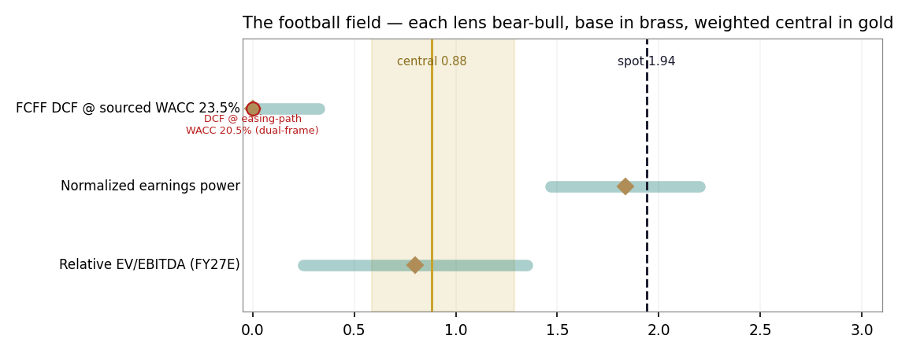
Figure 1 · The football field: each lens's bear–bull span, its base (brass), spot (ink), the weighted central band (gold), and the easing-path DCF dual-framed in red.
The reading is one-sided by construction and honest about it: all three lenses' base cases sit below spot, and the weighted central of 0.88 says the market already pays for the normalized world. The returns test explains why the enterprise lens is the harshest: FY25 ROIC of 15.9% against a 23.53% WACC is a −7.7pp spread — at today's rates this is a value-consuming capital base, however fast it grows. FY24's 39.4% shows what the same machine earns when the currency does the pricing. The crux, then, is not the revenue line — it is which of those two worlds the discount rate belongs to.
1.5 The drivers — sourcing gate first, then the build
Before the gate, the base year's own evidence — because the FY26E earnings path is built on what Q1-2026 disclosed, that disclosure belongs here in full, alongside the question any careful reader should ask: is a bad first quarter just what this company does?
Q1-2026 as disclosed (EGX filing as carried; the full interim statements were not on dice.eg at the study date — dated negative search, Appendix B):
EGP mn, consolidated | Q1-2025 | Q1-2026 | Read
Revenue | 1,429.1 | 1,709.0 | +19.6% — the top line is on the modelled track
Net profit attributable | +90.5 | (159.7) | a 250 mn swing into loss; LPS −0.06 vs EPS +0.034
Standalone parent | +69.1 | (184.6) | the dyeing subsidiaries stayed profitable
Gross profit · EBITDA · interest | in H1-25 release | not carried | the wire print is headline-lines only
Cash-flow statement | in H1-25 release | not carried | Q1-26 FCF not computable from available disclosure — stated plainly, not estimated
The seasonality check. The quarterly record, assembled from the company's own Q1/9M/H1 earnings releases (dice.eg) and the EGX filings as carried — Q1-2024's 993.4 revenue and 30.4% GPM are the company's own prints, not estimates — with period differences shown as derived:
Period | Revenue | Net profit | NPM | GPM | Net interest
Q1-2024 | 993.4 | +119.2 | 12.0% | 30.4% | (54.4)
Q2-2024 | 1,390.7 | +366.6 | 26.4% | 44.0% | (77.2)
Q3-2024 | 1,668.1 | +318.9 | 19.1% | 33.8% | n/d
Q4-2024 (der.) | 1,716.5 | +96.3 | 5.6% | — | n/d
Q1-2025 | 1,429.1 | +90.5 | 6.3% | 24.7% | (104.6)
Q2-2025 | 1,754.9 | +101.5 | 5.8% | 26.0% | (126.0)
Q3-2025 | 1,946.0 | +109.6 | 5.6% | — | n/d
Q4-2025 (der.) | 1,999.7 | +64.9 | 3.2% | — | n/d
Q1-2026 | 1,709.0 | (159.7) | −9.3% | n/d | n/d
Three findings, stated plainly. First: Q1 is historically the smallest quarter but not a loss quarter — Q1-2024 earned +119.2 mn at a 12.0% margin, Q1-2025 +90.5 mn at 6.3%, and even 2021's recovery Q1 was positive (+4.1 mn); the only prior loss quarters in the record are 2020–21 (pandemic and its standalone-level recovery). Eid al-Fitr fell inside Q1 in both 2025 (late March) and 2026 (mid-March), so there is no calendar-shift excuse either. The Q1-2026 loss is therefore not a seasonal dip that mechanically recovers — it is the first loss quarter since the pandemic-era 2020–21 stretch, and it deserves to be treated as news. Second: what the record shows instead of seasonality is a two-year decay from the Q2-2024 devaluation-windfall peak, with named mechanisms — from that 26.4% peak the net margin ran 19.1% → 5.6% → 6.3% → 5.8% → 5.6% → 3.2% → −9.3%, and no quarter after the peak ever recovered its own prior-year margin; the quarterly net-interest bill ran 54 → 77 → 105 → 126 and kept climbing. Q4-2025's 64.9 mn at a 3.2% margin shows the deterioration was already accelerating before Q1-2026 printed — the loss is the continuation of that gross-margin normalisation plus financing-cost trend, not an outlier against a stable base. Third — and this is the part that answers the fair question of whether the study extrapolates doom from one bad quarter — it does the opposite: FY26E of +95.4 mn after a −159.7 first quarter requires Q2–Q4 to earn +255.1 mn, against the +276.0 mn the company actually earned over the same nine months of FY2025. The base case assumes the loss quarter is transient and the rest of the year roughly repeats last year's rest-of-year despite the weaker margin start; the full-year-loss branch lives in the bear case, and the low central value is a cost-of-capital statement (§1.6's ladder), not an earnings-collapse forecast.
The interim cash flow, from the official H1-2025 release since Q1-2026's was not carried: operating cash flow was −609.1 mn in H1-2025 — and −602.5 mn in H1-2024, the record-profit half — with capex plus projects-under-construction of ~129.5 mn taking the half-year free cash flow to roughly −738.6 mn (H1-2024: ~−779 mn on the same basis). The cash burn is chronic and predates the loss quarter entirely: it is the working-capital engine §1.6 prices, running in every half of the record regardless of whether the P&L printed a profit.
Every forecast driver passes a sourcing gate before it is used: bottom-up only where the research produced a disclosed figure or a dated market quote; top-down, and flagged as such, everywhere else. The full research register closes Appendix B.
Driver | Mode | Justification | Register ref.
Export pieces +12% → +5% | bottom-up (disclosed) | FY25 volumes/capacity disclosed; Q4-25 +21.4%; Helwan +30% capacity ramping; sector Jan–Apr-26 +15% | Company + Industry
USD ASP +2%/yr | top-down | FY25 $4.41 (+12.3% was mix); normalised | Company/Segments
EGP/USD 52.0 → 58.5 | top-down (sourced) | H1-26 actual 48→52.9; TE 12-mo ~51.7–52.8; contained-slide path, +3%/yr | Country/FX
Retail +30% → +12% | top-down | +46.6% FY25 on 402 stores; store economics not disclosed — glide, flagged | Company/Segments
GPM 22.5% → 26.0% | judgment (bounded) | Q1-26 loss print starts it low; FY24 34.0% = deval peak, never re-adopted (house rule); FY25 25.2% is the mid-cycle anchor | Company + One-offs
Capex 800 → 550 | bottom-up (partial) | FY25 580.8 + disclosed land programme (~266 mn spent, 40% tranches due) + Helwan fit-out | Company/Outlook
Inventory days 202 → 160 | judgment (bounded) | FY23 ran 161.6; the expansion stocking unwinds as Helwan ships | Company/BS
Kd forward 16.5% → 10.5% | top-down (sourced) | CBE easing path (19.50% now, cut table in the FY25 release itself) less the observed ~5pp facility discount | Country/Monetary
Terminal g 5.0% / ROIC 22% | judgment (override, disclosed) | §1.7 — set below all three reconciliation anchors (12–16%); gap disclosed, not reconciled | Country/Sovereign
The forecast in driver terms:
Driver | FY26E | FY27E | FY28E | FY29E | FY30E
Export pieces growth | 12% | 10% | 8% | 6% | 5%
Retail growth | 30% | 24% | 18% | 14% | 12%
Gross margin | 22.5% | 24.5% | 25.5% | 26% | 26%
EBITDA margin | 12.3% | 14.5% | 15.8% | 16.6% | 16.8%
Capex (EGP mn) | 800 | 700 | 650 | 600 | 550
Inventory days
Cost of debt | 16.5% | 13.5% | 12% | 11% | 10.5%
EGP/USD (avg) | 52.0 | 53.6 | 55.2 | 56.8 | 58.5
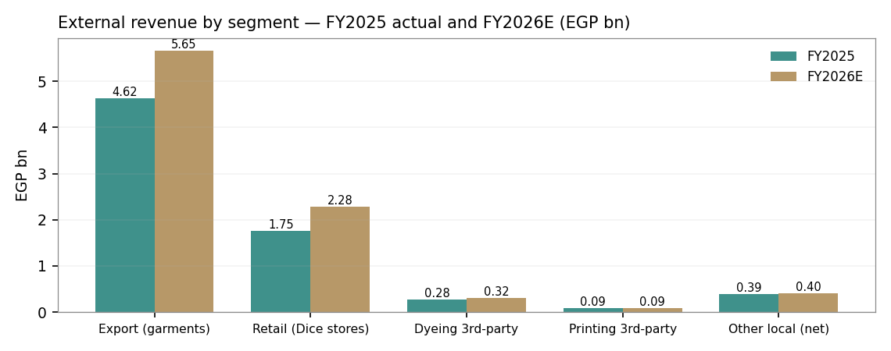
Figure 2 · External revenue by segment, FY2025 actual and FY2026E. The export book is two-thirds of the group; the segment sum ties to consolidated revenue (asserted).
The apparel dashboard — the operating measures that distinguish this read from a generic industrial one:
Operating KPI | Value | Reading
Export pieces / capacity / utilisation | 21.6 mn / 29.7 mn / 72.7% | the Helwan ramp is the volume story; utilisation has headroom
USD ASP per piece | $4.41 (+12.3% y/y) | mix and inflation pass-through; modelled +2%/yr only
Implied EGP/USD earned | 48.59 (FY25) | each 1 EGP of depreciation ≈ +95 mn of export revenue at flat volume
Retail stores / growth | 402 / +46.6% | the second engine; store economics undisclosed — flagged
Dyeing: tons capacity / util. / price | 18,300 t / 84.6% / 63.9k EGP/t (+27%) | near-full; third-party sales are the overflow
Cash-conversion cycle | 248 days | the crux: inventory 202d + receivables 73d − payables 27d
OCF / net income (FY25) | −719 / +367 = −1.96× | earnings did not arrive as cash — the accountant's exhibit in Appendix C
Net debt / EBITDA · interest cover | 3.65× · 1.79× | serviceable, not comfortable; the overdraft is 89% of debt and floats
ROIC vs WACC (FY25) | 15.9% vs 23.53% | −7.7pp spread at today's rates; +15.9pp at FY24's windfall economics
The DCF bear/bull re-runs quoted in the valuation summary are full model re-executions, not a single-line haircut — the driver deltas, disclosed here for the first time so the 0.59–1.20 central range is fully auditable:
Driver | Bear (−) | Bull (+)
Gross margin | −1.5pp vs base path | +1.5pp vs base path
WACC | +200bp vs sourced (25.53%) | −200bp vs sourced (21.53%)
Terminal growth (g) | −1.0pp (4.0%) | +1.0pp (6.0%)
EGP/USD path | frozen at the FY26E starting rate (no further slide — removes the dollar-revenue translation tailwind) | path scaled +2% faster depreciation (a revenue tailwind on the dollar-denominated export line)
Terminal ROIC | −3.0pp (19.0%) | +3.0pp (25.0%)
Each case re-runs the full segment build, three statements, and DCF chain with these six deltas applied together — not a sensitivity table read in isolation.
1.6 The crux — the cost of money, in real units
Two numbers own this valuation, and neither is a garment. The first is the discount rate. The ladder prices it directly:
WACC | DCF (EGP/sh) | The world it belongs to
23.53% | -0.51 | today's sourced rate — 10Y 22.55%, CDS-basis ERP
21.50% | -0.30 | −200bp: the first year of real easing
19.50% | -0.02 | −400bp: mid-cycle; DCF turns positive
17.50% | 0.36 | −600bp: late-easing Egypt
13.05% | 1.94 | the market-implied rate — what a 1.94 spot assumes
15.00% | 1.07 | full easing plus a re-rated risk premium
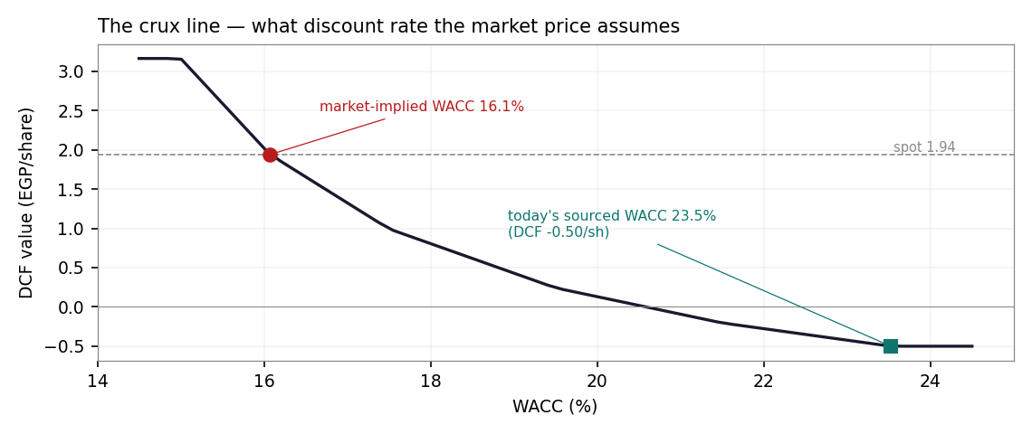
Figure 3 · The crux line: DCF fair value against the WACC. The market price and the sourced rate sit ~7.5 points of WACC apart.
The second number is the working-capital engine that makes the leverage necessary in the first place. In FY25 the company earned 1,086 mn of EBITDA and produced −719 mn of operating cash flow: the growth itself consumed ~1.3 bn of cash into inventory and receivables — the rest of that 1.8 bn EBITDA-to-CFO wedge is the interest (~524 mn) and tax (~100 mn) bill. In real units: every 10 days of inventory is ~185 mn of cash at FY26E cost of sales; every 100 bp on the overdraft book is ~39 mn of pre-tax profit; the FY26E interest bill (~726 mn) is roughly 7.6× the year's expected net profit. The model's normalisation — inventory 202→160 days — releases ~1.0 bn of cash across the window and is the single assumption doing the most work after the WACC; §1.8 stresses it via the margin×WACC grid, and caveat #5 names its falsification.
1.7 Terminal value — the mandatory reconciliation
The terminal uses the value-driver formula TV = NOPAT₆ × (1 − g/ROIC) / (WACC − g); capitalising FCFF directly is banned house-wide because it silently assumes free growth. With g 5% and terminal ROIC 22%, the reinvestment rate is 52.3% — the terminal firm reinvests roughly a fifth of its NOPAT, forever, to grow at 5% nominal. This is a deliberate conservative override (set 20-Jul-2026), not a figure the company's own record produces — the table below shows the gap plainly rather than reconciling around it:
Anchor | Value | Note
NOPAT CAGR FY23→FY25 | 12.3% | through the full deval cycle (FY23 EBIT approximated, D&A ~70 — disclosed)
ROIC × retention, FY25 | 15.9% implied g | retention ~100% (no dividend); ROIC 15.9% is the expansion-trough read
ROIC, FY24 (windfall) | 39.4% | what the machine earns when the currency does the pricing — not a terminal assumption
Egypt long-run nominal GDP | ~11–13% | real ~4% + inflation converging toward the CBE 7%±2 target band — the level every anchor above clusters near
Terminal g adopted | 5% | well below all three anchors and below the nominal-GDP band — an explicit conservative override, not a reconciled figure; WACC−g spread widens to ~18.5pp
All three anchors point to 12–16%; the adopted 5% sits materially below every one of them by design. This is disclosed as a gap, not papered over — a reader who thinks the anchors are the better guide should re-run §1.1 at a higher g using the sensitivity grid in Figure 4.
1.8 Macro and country — rates, the pound, and the sourced inputs
Egypt's monetary cycle is the study's weather. The CBE has cut to 19.50% (reached Feb-26; held at the 2-Apr, 21-May and ~9-Jul MPCs — three consecutive holds) from the mid-20s; the FY25 release itself tabulates the path. The pound slid from ~48 to ~52.9 across Feb–Mar-26 and has held ~52.7 since — for Dice a revenue event before it is a risk event, since two-thirds of the top line is invoiced in dollars against pound costs. Cotton is the input-side watch item: ICE ~79c in mid-June against 63c a year earlier, with the USDA's 2026/27 world price near 90c — a FY27 COGS headwind the margin glide deliberately does not ignore. The US tariff table currently favours Egypt (~10% vs ~20% on competing origins) — an advantage the discrete-event ledger prices as reversible.
Sourced market input | Value · date | Source
CBE main operation rate (carry anchor) | 19.50% · reached Feb-26, held 3× since (2-Apr/21-May/9-Jul) | live engine profile, read 19-Jul-26
Egypt 10Y (DCF rf) | 22.55% · 3-Jul-26 | investing.com (Cost-of-Capital reference)
ERP — CDS / rating | 9.41% / 13.94% · 5-Jan-26 | Damodaran original country file
EGP/USD | ~52.7–52.9 · Mar→Jul-26 | TradingEconomics; Wise mid-market
Cotton (ICE Oct / USDA 26-27 world) | ~79c · 18-Jun-26 / ~90c | USDA via trade press
Egypt RMG exports | $1.15bn Jan–Apr-26, +15% | AEC via Daily News Egypt, 8-Jun-26
US tariff differential | ~10% Egypt vs ~20% peers · Apr-26 | hgi.io trade analysis
1.9 Sensitivity — the rate, the growth, the margin, and the beta
WACC \ g | 3.0% | 4.0% | 5.0% | 6.0% | 7.0%
20.53% | -0.21 | -0.19 | -0.17 | -0.15 | -0.13
21.53% | -0.32 | -0.31 | -0.30 | -0.29 | -0.27
22.53% | -0.43 | -0.42 | -0.41 | -0.40 | -0.40
23.53% | -0.52 | -0.52 | -0.51 | -0.51 | -0.50
24.53% | -0.60 | -0.60 | -0.60 | -0.60 | -0.60
25.53% | -0.68 | -0.68 | -0.68 | -0.68 | -0.68
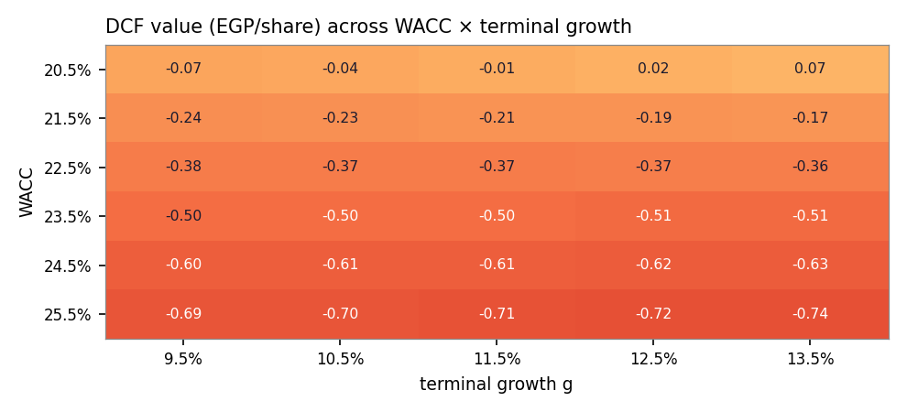
Figure 4 · DCF value across WACC × terminal growth. The value is a rates trade wearing a garment factory.
Beta | Ke (CDS) | WACC | DCF (EGP/sh)
0.8 | 30.08% | 22.45% | -0.40
0.9 | 31.02% | 22.99% | -0.46
1.0 | 31.96% | 23.53% | -0.51
1.1 | 32.90% | 24.07% | -0.56
1.2 | 33.84% | 24.61% | -0.61
1.3 | 34.78% | 25.15% | -0.65
The beta row is the honesty tax for an assumed 1.0: even at 0.8 — the house floor — the DCF stays negative at today's rf. No beta rescues the valuation from the rate; only the rate does. The gross-margin × WACC grid (Excel companion, Sensitivity sheet) says the same: ±2pp of margin moves the DCF ~±0.33/share, roughly one 200bp WACC step.
2 Technical and price structure
Indicator | Value | Reading
Price vs SMA 20 / 50 | 1.80 / 1.83 | above both — the July rebound is intact
Price vs SMA 100 / 200 | 1.82 / 1.79 | above both — the full stack has been reclaimed
RSI (14) | 70 | overbought band — the rebound is extended
MACD (12,26,9) | 0.022 / -0.000 / +0.023 | fresh positive cross — momentum has just turned
52-week range | 1.45 – 2.23 | spot sits 63% up the range
Moves 20d / 60d / 252d | +5.4% / -4.4% / -10.5% | a sharp rebound inside a down year
Realised vol (252d) | 32.4% | small-cap EGX regime; the cone in §3 is built from it
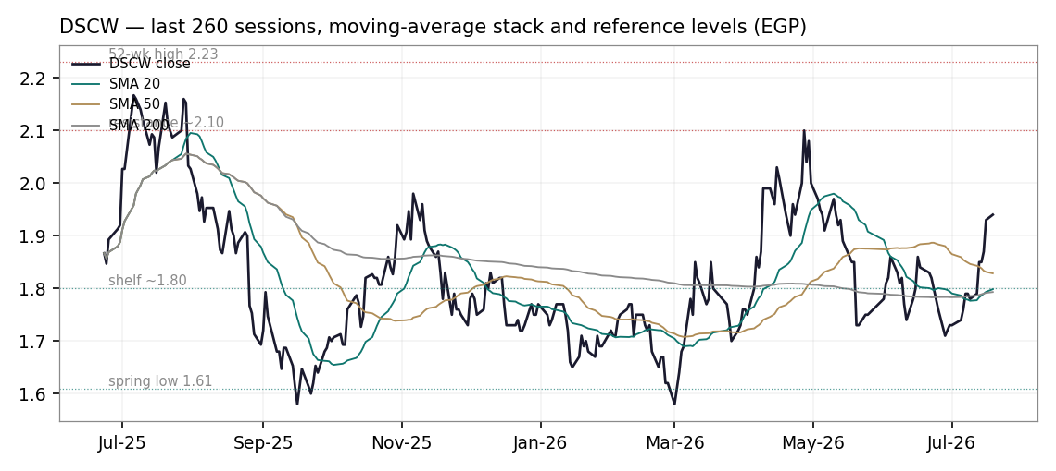
Figure 5 · Price against the moving-average stack, last 260 sessions, with the study's reference levels.
Structure: the stock fell from the 2.23 high (Aug-25) to a 1.45–1.61 base across the spring, and has spent June–July repairing the damage — through the 200-day at 1.79, through the shelf at 1.80, to a close at 1.94. Overhead, 2.10 is the last distribution zone before the 52-week high at 2.23; below, 1.80 is now the first support and 1.61 the spring low that must hold for the repair to stand. The technical read is constructive-but-stretched: RSI 70 into a results window, on a tape where the Q1 loss is public and H1 is due.
3 Monte Carlo — a probabilistic price map
The probability read, before anything else:
Question | Answer
P(price above spot at T+60)? | 61.1%
P(≥ +10%) vs P(≤ −10%) — the odds | 36.4% vs 17.7% → odds 2.05
Median path | EGP 2.02 (+4.3%)
The 50% band (25th–75th) | 1.82 – 2.25 (-6.2% / +16.0%)
Touch ±10% anytime within T+60 | up 58% / down 37%
Where the centre comes from, in one line: the price-only centre is the 19.50% money-market carry — +4.24% over 60 sessions — and the external event ledger nets -0.05% per quarter: the tape's hopes (rate cuts, capacity news) and its fears (the H1 print, an equity raise) cancel almost exactly. The apparent "drift" is Egypt's cost of money, not a view.
Engine. Carry-anchored YZ-HAR with a Student-t(4) shape and a 0.972 width calibration — the live pooled fit for the Egyptian market panel, read from the production engine on the study date — 50,000 paths, 60 sessions, seed 42. The gap-aware Yang-Zhang variance proxy feeds a HAR forecast (daily/weekly/monthly lags); the drift is the sourced EGP carry (the CBE 19.50% money rate less a zero dividend yield — no common dividend was paid in FY25, flagged) plus the external event ledger below, never a view. Independence note: these paths diffuse from spot as near-term price and deliberately do not embed the fundamental value gap of §1 — if they did, the cone would just restate the DCF; the fundamental and probabilistic lenses stay independent. Backtest verdict: DSCW's own five-year walk-forward under this exact configuration scored a small positive skill with a boundary-parity robustness flag — the engine is market-validated with no single-name edge claimed; the full backtest is published, pass or fail, on the public Calibration Ledger rather than in this document.
The seven continuous forces (tilt, not certainty):
# | Force | Sign
1 | CBE easing path (funding cost on the overdraft book) | +
2 | EGP/USD drift (USD export translation; EGP costs) | +
3 | US/EU apparel demand & Egypt RMG export momentum | +
4 | Egypt consumer purchasing power (retail leg) | ±
5 | Cotton / yarn input costs (ICE ~79c, USDA 26/27 ~90c) | −
6 | Fuel & energy administered-price resets | −
7 | EGX liquidity, flows & small-cap risk appetite | ±
The nine discrete events (probability-weighted jumps):
# | Event | P | Impact
1 | H1-2026 results release (~Sep) | 85% | -0.4%
2 | CBE cut >=100bp (Aug/Oct MPC) | 55% | 0.8%
3 | EGP step-slide >=5% (serial-deval regime) | 15% | 1.0%
4 | Helwan land MoU final contracts/registration | 50% | 0.4%
5 | New export client / capacity announcement | 35% | 0.6%
6 | FY26 dividend initiation signalled | 15% | 0.6%
7 | US tariff regime turns against Egypt | 15% | -1.2%
8 | Regional / Red Sea re-escalation | 25% | -1.0%
9 | Equity raise to fund working capital | 25% | -1.5%
Net event-ledger drift: -0.05% per quarter — an unusually balanced ledger. The single largest downside mass is the equity-raise scenario (25% × −1.5%): FY25 operating cash flow was −719 mn and the model's own net-debt path rises into FY29, so the funding question is priced as live, not hypothetical.
Percentile map (EGP/share)
Percentile | T+20 | T+60 | move at T+60
5th | 1.65 | 1.50 | -22.7%
25th | 1.85 | 1.82 | -6.2%
50th | 1.97 | 2.02 | +4.1%
75th | 2.09 | 2.25 | +16.0%
95th | 2.34 | 2.73 | +40.7%
The ledger-grade cohort (pure carry, no event ledger — the configuration the public Calibration Ledger grades) is nearly identical: T+60 median 2.03, 5th 1.50, 95th 2.73. Projected grading sessions (Sun–Thu calendar, display targets): T+20 ≈ 2026-08-16, T+60 ≈ 2026-10-11.
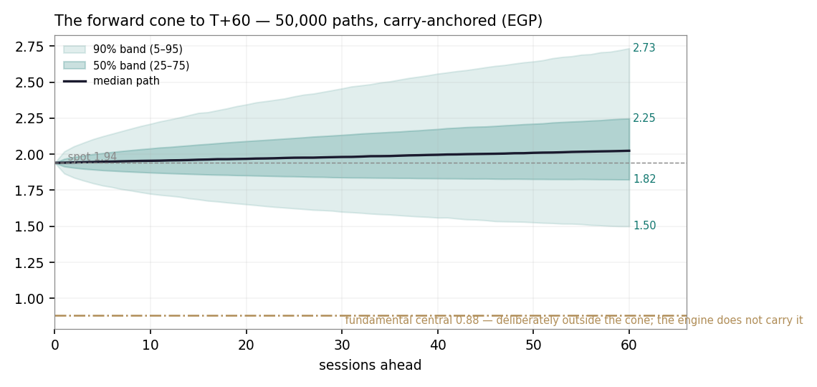
Figure 6 · The forward cone to T+60: 5–95% and the 50% band, median in ink — and the fundamental central in brass, deliberately far outside the cone, because the engine does not carry it.
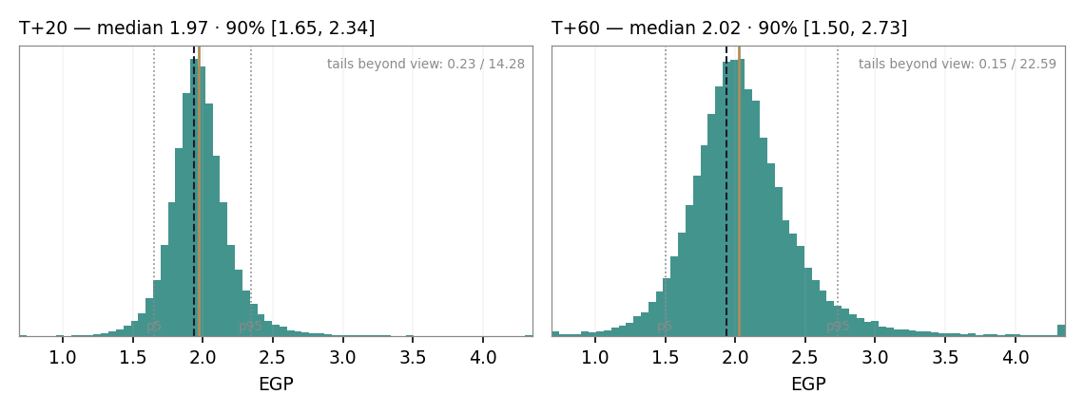
Figure 7 · The T+20 and T+60 distributions on a shared axis clipped at the 0.1–99.7 percentile band for readability (the t(4) tails run far beyond it — extremes annotated in-panel): right-skewed by construction (lognormal carry), fat-tailed by calibration.
Level-touch ladder
Level | vs spot | P(touch by T+20) | P(touch by T+60)
2.40 | 23.7% | 6% | 24%
2.30 | 18.6% | 10% | 34%
2.20 | 13.4% | 19% | 47%
2.10 | 8.2% | 37% | 65%
2.00 | 3.1% | 69% | 85%
1.90 | -2.1% | 67% | 78%
1.80 | -7.2% | 30% | 49%
1.70 | -12.4% | 13% | 29%
1.60 | -17.5% | 5% | 17%
4 Comparison of the lenses, and a verdict
Three clocks, kept deliberately separate. The 60-session clock is the Monte Carlo's: a +4% centre that is precisely the money-market carry, 61.1% above spot, odds 2.05 on ±10% — an event tape (the H1 print, the August and October MPCs, the funding question) around Egypt's cost of money. The ~12-month clock is the weighted fundamental central of 0.88: the market trades roughly double it, which at today's sourced rates is a statement about the discount rate the market has chosen to use, not about demand for garments. The multi-year clock is the conditional one: at the market-implied WACC of 13.05% — a completed easing cycle — the same model is worth spot; at 15% it is worth 1.07. The stock is, functionally, a leveraged option on Egyptian disinflation with a garment factory attached.
Clock | Figure | What it is | What it is not
T+60 sessions | median 2.02 · 50% band 1.82–2.25 | calibrated price probabilities | a forecast of the news
~12 months | central 0.88 (0.59–1.20) | risk-adjusted fair-value range at the sourced WACC | a price target
Multi-year / conditional | 1.94 at WACC 13.05% · 1.07 at 15% | what the price assumes about the easing cycle | a 2026 expectation
Verdict, in the house's only permitted form: the distribution says fully priced at today's cost of capital, with the value locked behind a monetary-policy outcome — a fair-value range of roughly EGP 0.6–1.3 with its weight near 0.88, against a market at 1.94 that has already paid for the easing cycle finishing and the balance sheet surviving the wait. If the CBE delivers and the working capital unwinds, the market was early, not wrong; if either stalls, the range is where gravity points. Both statements are published here so the Calibration Ledger can grade them.
5 Catalysts to watch
When | Event | Why it matters
28 Aug / Oct 2026 | CBE MPC decisions | the carry anchor, the overdraft cost, and the entire crux ladder move with these
~Sep 2026 | H1-2026 results | the first test of the FY26E base: a second loss quarter deeper than ~−90 breaks it (caveat #1)
H2 2026 | Helwan / land-MoU registration & contracts | converts the 2025 land spend into disclosed capacity; the 40% registration tranches fall due
Continuous | EGP tape | each 1 EGP of depreciation ≈ +95 mn export revenue; a step-slide is priced at 15% in the ledger
Q4-26 / Q1-27 | Any equity raise announcement | the 25%-probability event; dilution at these prices re-cuts every per-share figure
Mar 2027 | FY26 results + dividend decision | a first dividend would re-open the DDM lens and shift the carry (q > 0)
2026/27 season | Cotton (USDA ~90c world) | the FY27 COGS headwind inside the margin glide
Ongoing | US tariff review | the ~10pp differential advantage is priced as reversible (15% × −1.2%)
6 Reading the probability zones
Zone (EGP at T+60) | Probability | The world in which it happens
below 1.60 | 8.5% | a funding shock or a deep H1 miss; the spring low gives way
1.60–1.80 | 14.1% | the rebound fails at the 200-day; the tape re-prices the Q1 loss as the run-rate
1.80–2.10 | 37.1% | the base world: carry does the work, the H1 print is survivable, the MPC cuts
2.10–2.40 | 25.4% | a clean H1 plus a 100bp+ cut; the 52-week high is retested
above 2.40 | 14.9% | the easing trade runs ahead of the fundamentals — the market-implied WACC falls further
7 Caveats and what would change our mind
Named, dated, falsifiable:
# | Trigger | Consequence for this study
1 | H1-26 cumulative loss deeper than ~EGP −250 mn (i.e. Q2 worse than ~−90) | the FY26E recovery base fails; bear becomes base and the central falls toward 0.6
2 | An equity raise is announced | per-share values re-cut for dilution; the 25% ledger event realises
3 | CBE still at ≥19.5% by Q1-2027 | the easing-path framing dies; the DCF stays negative and the market-implied gap must close from the price side
4 | Gross margin prints below 21% for two consecutive quarters | the 22.5→26% glide was optimistic; every lens re-bases
5 | Inventory days above 210 at FY26 close | the working-capital normalisation — the model's biggest cash assumption — is falsified
6 | EGP appreciates and holds below 48 | the export EGP line and the FX-gain history both reverse; the deval tailwind becomes a headwind
7 | The US tariff differential is removed | the priced advantage (15% × −1.2% in the ledger) realises against the export book
Structural caveats, stated where they bite: FY2023 income-statement lines are derived from the company's own stated FY24 growth rates (method shown in Appendix A) and its FY23 balance-sheet column — the release's "+91%" net-profit headline and the statement column disagree by ~24 mn, disclosed, statement kept. The Q1-2026 figures come from the EGX filing as carried by wire services because dice.eg had not posted the release at the study date (dated negative search). The company's own FY25 presentation carries a 13–23 mn definitional wedge between balance-sheet cash and cash-flow ending cash — disclosed; the forecast uses one cash definition and ties internally, asserted every year. The debt book is not split by currency in the release; an undisclosed USD trade facility is plausible for a 65%-USD-revenue exporter and was searched for without result (dated). The Egyptian volatility calibration is a pooled market fit (ν=4, width 0.972) — DSCW's own backtest verdict is boundary-parity and is published on the Ledger. And the minority put/ownership overhang is history, not structure: the September-2023 preliminary MTO at EGP 0.65 lapsed; the family control it evidenced remains.

Appendix A Financial statements
Historicals are the company's own FY2025 earnings release (dice.eg). FY23 derived rows are marked (d): revenue = FY24 / 1.681, gross profit = FY24 / 1.92, EBITDA = FY24 / 1.91 — the release's own stated growth rates; FY23 net profit is the FY25 balance-sheet column. Forecast columns reproduce the model's integrated income statement; the valuation itself taxes EBIT at the explicit 22.5%.
A.1 Income statement — 3-year historical + 5-year forecast (EGP mn)
EGP mn | FY23 | FY24 | FY25 | FY26E | FY27E | FY28E | FY29E | FY30E
Revenue | 3,432 (d) | 5,769 | 7,130 | 8,742 | 10,236 | 11,693 | 13,071 | 14,462
Gross profit | 1,022 (d) | 1,962 | 1,794 | 1,967 | 2,508 | 2,982 | 3,398 | 3,760
Gross margin | 29.8% | 34.0% | 25.2% | 22.5% | 24.5% | 25.5% | 26.0% | 26.0%
EBITDA | 835 (d) | 1,595 | 1,086 | 1,073 | 1,481 | 1,843 | 2,164 | 2,423
EBITDA margin | 24.3% | 27.7% | 15.2% | 12.3% | 14.5% | 15.8% | 16.6% | 16.8%
D&A | ~(70) | (86) | (120) | (181) | (239) | (287) | (328) | (364)
EBIT | 765 (d) | 1,510 | 966 | 892 | 1,242 | 1,556 | 1,836 | 2,059
Net interest + lease | n/d | (332) | (541) | (739) | (740) | (719) | (678) | (631)
FX / other | n/d | (21) | 42 | (30) | (30) | (30) | (30) | (30)
EBT | n/d | 1,158 | 467 | 123 | 472 | 807 | 1,128 | 1,398
Tax | n/d | (257) | (100) | (28) | (106) | (182) | (254) | (315)
Net profit (attributable) | 448 | 901 | 367 | 95 | 366 | 625 | 874 | 1,083
EPS (EGP) | 0.167 | 0.336 | 0.137 | 0.036 | 0.136 | 0.233 | 0.326 | 0.404
A.2 Balance sheet — condensed house layout (EGP mn)
EGP mn | Dec-23 | Dec-24 | Dec-25 | Dec-30E
Net fixed assets + ROU | 636.1 | 986.3 | 1,370.7 | 3,631
Inventory | 1,066.7 | 2,183.2 | 2,951.1 | 4,691
Trade receivables + debtors | 915.7 | 1,642.9 | 2,201.4 | 4,422
Cash + funds | 315.0 | 240.6 | 176.0 | 169
Total assets | 2,959.4 | 5,193.7 | 6,990.3 | —
Banks overdraft (the revolver) | 1,184.4 | 2,299.5 | 3,438.8 | 5,427
Term debt + leases + ROU liab. | 170.8 | 505.1 | 704.4 | 854
Net debt | 1,060.4 | 2,582.0 | 3,967.2 | 6,112
Total equity | 1,034.9 | 1,258.2 | 1,601.6 | 4,646
BS cash 157.0 vs CF ending 133.7 (FY25) and 240.6 vs 227.5 (FY24) — a 13-23mn definitional wedge in the company's own presentation, disclosed; the forecast uses one cash definition and ties internally
A.3 Cash flow, the FCF framings, and the dividend record
EGP mn | FY2024 | FY2025
Net cash from operating activities | n/d | (718.9)
Capex (purchase of fixed assets) | (76.3) | (580.8)
Interest paid (= P&L financing expense — no capitalised-interest wedge) | n/d | (523.5)
Common dividends paid | (330.0) — re FY23 | 0.0
Simple FCF (operating − capex) | n/d | (1,299.7)
Two FCF framings, both stated: simple FCF (CFO − capex) was −1,300 mn in FY25; the model's FCFF framing (NOPAT + D&A − capex − ΔWC, pre-financing) was similarly negative and stays negative through FY27E before turning. Dividends: 330 mn was paid in FY24 in respect of FY23 (~0.185/share on the pre-bonus 1,787 mn shares); nothing since — consistent with the expansion, the leverage, and the modelled zero payout through FY27E. The FY25 capital move was a bonus capitalisation, 357→536 mn paid-in (1.787→2.680 bn shares), not a cash event.
A.4 The FY26E earnings bridge — and what Q1-2026 actually said
Why does modelled EPS fall from 0.137 to 0.036? Because Q1-2026 already happened. The quarter is the direct evidence for the drop — and, read carefully, the FY26E base is a recovery assumption, not a pessimistic one:
The Q1-2026 disclosure itself — the line-by-line table, the quarterly record back to Q1-2024, and the seasonality verdict — now sits in the main body at the head of §1.5, alongside the official H1-2025 interim cash-flow figures. This appendix keeps the arithmetic bridge.
The FY2025 → FY2026E bridge, in the model's own numbers (attributable, EGP mn): FY25 net profit 366.6; EBITDA −12.8 (the gross margin gives back 2.7pp — 25.2% to 22.5% — which almost exactly eats the +22.6% of revenue); depreciation −60.4 (the capex programme arriving on the P&L); net financing −198.6 (the interest bill grows to ~739 mn as the overdraft peaks at still-high rates — roughly 7.7× the year's expected profit); FX and other −71.5 (FY25 carried an 85.7 mn FX gain on net USD receivables that the model does not assume repeats); tax +72.2 → FY2026E ≈ 95.4, EPS 0.036. Every term of that bridge is what Q1 printed in miniature: revenue up strongly, margin down, financing costs devouring the operating result.
The phasing makes the assumption explicit. FY26E of +95.4 after a −159.7 first quarter requires +255.1 across Q2–Q4 — against the +276.1 the company actually earned across the same nine months of FY2025. The base therefore assumes the remaining year roughly repeats last year's remaining year despite the weaker margin start, carried by the CBE cuts flowing into the overdraft cost and the announced price actions — a borderline-neutral judgment, logged as Driver-Ledger row #10, with the full-year-loss branch living in the bear case (central 0.59) and caveat #1 naming its falsification (a Q2 loss deeper than ~90 mn).

Appendix B Peer frame, risk register — and the research register
B.1 Peers and the sector frame
Listed Egyptian pure-play apparel is thin, and the one true product comp is diagnostic rather than usable — both companies manufacture knitted underwear, and the numbers say everything about what the EGX pays for:
Item | DSCW (Dice) | KABO (El Nasr Clothing & Textiles)
Product | knitted garments + underwear; USD export book + 402-store retail | knitted underwear, loungewear, intimates — Alexandria, founded 1940
Fiscal year | December | June — periods overlap but do not align; flagged
Revenue | EGP 7,130 mn CY25 (+23.6%); FY24 +68.1% | ~EGP 1,020 mn FY-Jun-24 (+72.5%); TTM to Dec-24 ~1,130 (+37%)
Gross margin | 25.2% FY25 (34.0% FY24 peak) | ~16.1% TTM
Net margin | 5.1% FY25 → Q1-26 loss | 1.8% TTM, down from 14.7% — 9M FY-Jun-25 NP 9.4 vs 193.1 prior
Market cap / cap-to-revenue | EGP 5,199 mn / 0.73× | ~EGP 3,350 mn / ~2.9× (price 5.94; snapshot retrieved 19-Jul-26)
Trailing P/E | 14.2× (FY25 EPS) | ~108× (TTM EPS 0.055)
Dividend | none in respect of FY25 | never paid
Workforce / balance sheet | ~12,000 · net debt 3.97 bn, expansion-levered | ~3,000 · legacy asset base: Alexandria land, 26.55% of Spinalex (trimmed Dec-25); export-lines expansion announced Dec-25
Three readings. First, no usable earnings anchor: the closest comp trades near 100× trailing earnings and ~3× revenue because the market is pricing its Nasser-era Alexandria land bank and its Spinalex stake, not its P&L — so the relative band in §1.3 stays a judgment call, now with the reason evidenced rather than asserted. Second, sectoral corroboration: KABO's margin collapse across the identical window (14.7%→1.8% net) mirrors Dice's (15.6%→5.1%→loss) — independent evidence that the 2024 margins were a currency event industry-wide and that the squeeze since is the sector's financing bill, which is the study's margin-glide rule and its industry classification (§1) proving themselves on a second company. Third, scale inversion: Dice runs roughly six times KABO's revenue at nine points more gross margin and four times the workforce, yet trades at only ~1.6× its market value — on this exchange the smaller asset story out-prices the larger operating story, a fact about the EGX's pricing of legacy textile paper that a reader of either name should hold onto. Around the pair, Oriental Weavers (ORWE) frames the sector-flagship economics (rugs, export-heavy, the same FX physics at ~7× the scale), and the consumer-staples names (Edita, Juhayna, Obour Land) frame what the EGX pays for genuinely defensive consumer earnings — high single-digit to low-teens P/E — which is where the normalized lens's 6–9× band lives, deliberately below the staples because Dice carries leverage they do not.
B.2 Risk register
Risk | Where it bites
Funding & refinancing | the overdraft is 89% of debt, floats with the CBE, and rolled 3.4 bn at FY25; an appetite change at the banks is the fastest route to the equity-raise event
Working capital | 248-day CCC; the normalisation to 160 inventory days is the model's biggest cash assumption (caveat #5)
FX regime | two-sided: depreciation lifts export EGP revenue and the FX line (net USD receivables), appreciation below ~48 reverses both; a step-deval also re-prices the whole EGX tape
Input costs | cotton (USDA 26/27 ~90c) and administered fuel/energy resets — both named in the company's own release
Trade policy | the ~10pp US tariff advantage is a policy artifact, priced as reversible
Customer concentration | export clients are not disclosed — flagged; a single-client loss would be invisible until it printed
Governance / control | founder-family control; the 2023 preliminary MTO at 0.65 (lapsed) evidences both the control and the historical willingness to take it further
Liquidity of the stock | small-cap EGX; the pre-2018 tape barely traded — position exit is itself a risk
B.3 The research register — four rings, dated, negative searches included
Ring | Category | Finding (dated)
Global | Rates / commodities | Fed on hold ~3.6%; cotton ICE ~79c (18-Jun-26) vs 63c y/a, USDA 26/27 world ~90c; freight normal — Red Sea risk kept as a priced event
Country | Monetary / sovereign | CBE 19.50% since Feb-26, held at 3 consecutive MPCs (2-Apr/21-May/9-Jul); Egypt 10Y 22.55% (3-Jul-26); EGP 48→52.9 Feb–Mar-26, ~52.7 since
Country | Trade regime | US ~10% on Egyptian RMG vs ~20% on competing origins (hgi.io, Apr-26); EU access duty-free
Industry | Demand / capacity | Egypt RMG exports $1.15bn Jan–Apr-26, +15% (AEC via Daily News Egypt, 8-Jun-26); 2026 target $4.4bn; US the largest market
Company | Official FS (the base) | FY2025 earnings release, dice.eg: full IS/BS/CF, five-segment split with volumes, capacity, prices; land purchases ~266 mn under the 200k-sqm MoU; Helwan lease (+30% capacity)
Company | Q1-2026 (colour) | EGX filing via Arab Finance / Zawya (late Jun-26): rev 1,709 (+19.6%), net loss −159.7 attributable; standalone −184.6, subsidiaries profitable
Company | Ownership / capital | Sep-2023 preliminary MTO — Toma consortium, up to 90% at EGP 0.65 indicative — lapsed, never completed; ESIH 8.06% (Jan-21); Feb-22 capital increase (1.25 bn sh at ~0.201); FY25 bonus 1.787→2.680 bn shares
Negative searches | all dated 19-Jul-26 | Q1-26 release on dice.eg: NOT FOUND (wire print used, flagged) · FX-denominated debt tranche: none disclosed · a named new listed entrant in Egyptian garments: none · technology-substitution threat to the make: none material · an FY25 cash dividend announcement: none found (AGM 18-Jun-26 noted)

Appendix C The expert valuation panel
Three independent experts, three genuinely different methods, none seeing the others; the divergence is the signal and is not averaged away. Each fair value is derived from shown workings; each expert states a falsification condition.
C.1 Expert 1 — the accountant: realizable assets and cash quality
Worldview: a company is worth what its balance sheet would fetch, adjusted for whether the earnings arrive as cash. Workings: (1) mark each asset to conservative realizable value — plant 85% (specialized apparel machinery), inventory 80% (fashion stock ages), receivables 92%, debtors 75%, cash and funds at par, other non-current 50%, right-of-use netted against its own liability; (2) earnings-quality test: FY25 operating cash flow / net income = −719 / +367 = −1.96× — the profits did not arrive as cash, so no going-concern premium is added; (3) bridge: realizable assets ≈ 5,634 less all non-ROU claims ≈ 5,243 → realizable equity ≈ EGP 391 mn ≈ 0.15/share; (4) sensitivity: the inventory mark alone (70–90%) swings the answer 0.04–0.26. When it works / when it fails: best exactly here — capital-intensive, working-capital-heavy, leverage rising, value resting on unrealized stock; it fails by systematically undervaluing a genuine compounding franchise.
Expert 1 workings | EGP mn | Mark
Fixed assets @ 85% | 1,058 | specialized plant
Inventory @ 80% | 2,361 | the swing input
Receivables 92% + debtors 75% | 1,894 | export AR is bank-intermediated
Cash + funds + other | 322 | par / 50%
− Claims (ex-ROU, offset) | (5,243) | overdraft, term, leases, payables, provisions
Realizable equity / per share | 391 / 0.15 | range 0.04–0.26 on the inventory mark
The marks are not generic haircuts. At 202 inventory days roughly half the stock is yarn and greige — commodity-marked, saleable near 90% — while the finished branded half carries seasonal risk nearer 70%, blending to the 80% used. Export receivables clear through bank channels against confirmed orders (92%). The 2025 land purchases sit at cost with the 40% registration tranches still owed — no appreciation assumed. And one structural point sharpens everything: the overdraft funding this working capital is, in the ordinary Egyptian way, secured against it — the realizable equity is what remains after the banks take the very assets being marked. That is why the going-concern premium is withheld until cash actually arrives: three years of headline growth have ended with OCF/NI at −1.96×, and an accountant pays for cash, not accruals.
Verdict 0.15 (0.04–0.26). Falsification: two consecutive quarters of positive operating cash flow with inventory days below 180 — cash arriving would prove the book is a machine, not a warehouse.
C.2 Expert 2 — earnings power: the normalized machine at a fair multiple
Worldview: an operating company is worth a fair multiple of its sustainable mid-cycle earnings; strip the peaks and the squeezes alike. Workings: (1) sustainable EBIT margin ~13.5% of revenue — between FY25's 13.5% and the forecast plateau, ignoring FY24's 26.2% windfall; on FY27E revenue of ~10,236 that is EBIT ~1,382; (2) normalized financing: a de-stocked balance sheet carries ~4.5 bn of debt at a mid-cycle 12% — interest ~540, leases ~35; (3) EBT ~805 × (1−22.5%) → ~624 of net profit, EPS ~0.233; (4) multiple: 7× — the EGX consumer mid-band for a leveraged small-cap — giving 1.63; the 6–8× grid spans 1.40–1.86. When it works / when it fails: best for operating businesses with a track record and in relative-value contexts; it fails at structural breaks or where book and cash diverge sharply from earnings — the −1.96× cash conversion is precisely that warning, which is why this is the panel's ceiling, not its centre.
Two cross-checks discipline the multiple. KABO — the only product comp — is unusable at ~100× trailing (an asset play, B.1), so the 7× is built down from the EGX defensive-consumer band (8–12× for the staples) with explicit deductions for Dice's leverage, its zero dividend, and its negative free cash flow through FY27E. And the retail caveat is owned: with no store-level disclosure, the 13.5% sustainable EBIT margin blends manufacturer and retailer economics on the assumption the 402-store chain is at least margin-neutral — if retail is structurally thinner than export, the normalized figure has a soft floor nearer 12%, which is why the falsification below is written against exactly that line.
Verdict 1.63 (1.40–1.86). Falsification: FY27 EBIT margin failing to hold above 12%, or net debt failing to fall below 5.5 bn by end-FY27 — either breaks the "normalized" in normalized earnings.
C.3 Expert 3 — macro-policy: pricing the regime tree
Worldview: in Egypt, policy outranks fundamentals — the rate path and the FX regime move this equity more than management can. Workings: three states, each a full re-run of the base model, probability-weighted. (a) Full easing (35%): the CBE reaches low-teens by 2028, the 10Y settles ~16.5% — re-running the base model at that WACC (~20.0%) still gives a DCF of −0.10 at the now-lower terminal growth; floored, blended ~0.88. (b) Partial easing (45%): rates fall but the 10Y holds ~19.5%; the DCF is ~−0.02, essentially the crossover point — floored, blended ~0.88. (c) Stall or funding shock (20%): easing pauses, the equity raise happens at depressed prices; the branch prices the pre-money value's decline but not the cash raised — a conservative, explicitly stated choice, not a standard treatment — landing near 0.35. Weighted: 0.35×0.88 + 0.45×0.88 + 0.20×0.35 = 0.78. At the 5% terminal growth now in force, branches (a) and (b) have converged — the DCF only clears zero below ~19% WACC, a materially harder bar than under the study's earlier 11.5% terminal assumption. When it works / when it fails: best in policy-driven markets with binary catalysts and FX/rate regimes in flux; it fails through false precision — the probabilities are judgements, and the tree can miss the branch that grows.
The stall branch is not hand-waved: a 1.5 bn raise at a stressed ~1.50 issues ~1.0 bn new shares — 27% dilution — turning a ~1.3 pre-money model value into ~0.95 before the confidence discount such recapitalisations carry on this exchange, which is how the branch lands near 0.35. The tree's clock is explicit: the 28-August and October MPC meetings decide which branch the FY26 exit rate belongs to, and the H1 print (~September) decides whether the funding question stays theoretical.
Verdict 0.78 (0.72–0.83 on ±10pp probability shifts). Falsification: a fourth, unmodelled policy branch dominating — a capital-control regime or an IMF-programme rupture would invalidate the tree, not just re-weight it.
C.4 Cross-examination
Expert 1 to the others: "You are both discounting cash that has never once arrived. This company has grown revenue threefold and its operating cash flow is negative; my warehouse marks are at least things you can touch. Until the inventory turns into money, an earnings multiple is a multiple of an accrual."
Expert 2 to the others: "The accountant is pricing a liquidation nobody has announced for a company growing 20% a year, and the strategist is paying today for a central bank's 2028 diary. Mid-cycle margins on real volumes at a boring multiple is the only method here that doesn't require a forecast of the Governor."
Expert 3 to the others: "You are both valuing this company as if the discount rate were a constant of nature. It is the single variable that moved the answer from negative to 1.07 inside one table. Refusing to weight the policy states is not caution — it is a 100% bet on today's rate lasting forever."
C.5 The three in one room
Expert 1 (0.15) prices the balance sheet, Expert 2 (1.63) prices the machine, Expert 3 (0.78) prices the regime — and none of the three reaches the market's 1.94. That is the finding: spot requires Expert 2's normalized earnings AND Expert 3's full-easing branch to both come true, simultaneously, with no funding accident on the way. The study's central (0.88) sits between the accountant and the strategist, which is where a leveraged, cash-hungry, genuinely growing exporter belongs while the policy question is open.
C.6 Reading the divergence
The 0.15–1.63 spread is not disagreement about Dice; it is disagreement about what survives. The accountant assumes only the assets survive; the earnings analyst assumes the franchise survives; the strategist assumes the state decides. On a 248-day cash cycle with a floating-rate overdraft, all three are describing the same company from different distances — and the market, at 1.94, is standing further out than any of them.

About this series
Testahil publishes independent, educational valuation studies on EGX, GCC and international names, and metals — fair-value ranges and probability distributions, never ratings or price targets. Every Monte Carlo forecast is logged, graded at T+20 and T+60 against realized prices, and published pass or fail on the public Calibration Ledger at testahil.com. The methodology — the calibration gate, the carry-anchored engine, the sourcing discipline, the expert panel — is applied identically across coverage so the track record is comparable. Studies are published under the Testahil name only.
Disclosure & Disclaimer
1. No advice. This document is educational analysis and personal opinion. It is not investment advice, a recommendation, an offer, or a solicitation to buy or sell any security, and it is not directed at the circumstances of any person.
2. No licence. The preparer is not licensed by the FRA or any other securities regulator, holds no advisory or brokerage authorisation, manages no client money, and accepts no fees or clients in connection with this work.
3. Sources. Company figures are Dice's own published disclosure (the FY2025 earnings release and its financial statements); the Q1-2026 figures are the company's EGX filing as carried by wire services, flagged as such; market data are dated quotes from the named venues and vendors. Errors are possible; the preparer corrects them publicly when found.
4. Judgments. All forecasts, drivers, multiples, probabilities and scenario weights are the preparer's judgments, flagged as such, and will be wrong in ways that matter. Ranges and distributions are the only honest output format; no single number in this document is a prediction.
5. Risk. Securities involve risk of loss, including total loss. Small-cap Egyptian equities carry additional liquidity and currency risk. Past calibration performance — including the public ledger — does not guarantee future forecast quality. Consult a licensed financial advisor before any investment decision.
6. Positions. The preparer may hold, or may take, a position in the security discussed, and owes readers no duty to update this document. Publication date: 19 July 2026.
testahil.com DSCW · Independent Valuation Study · 19 July 2026

